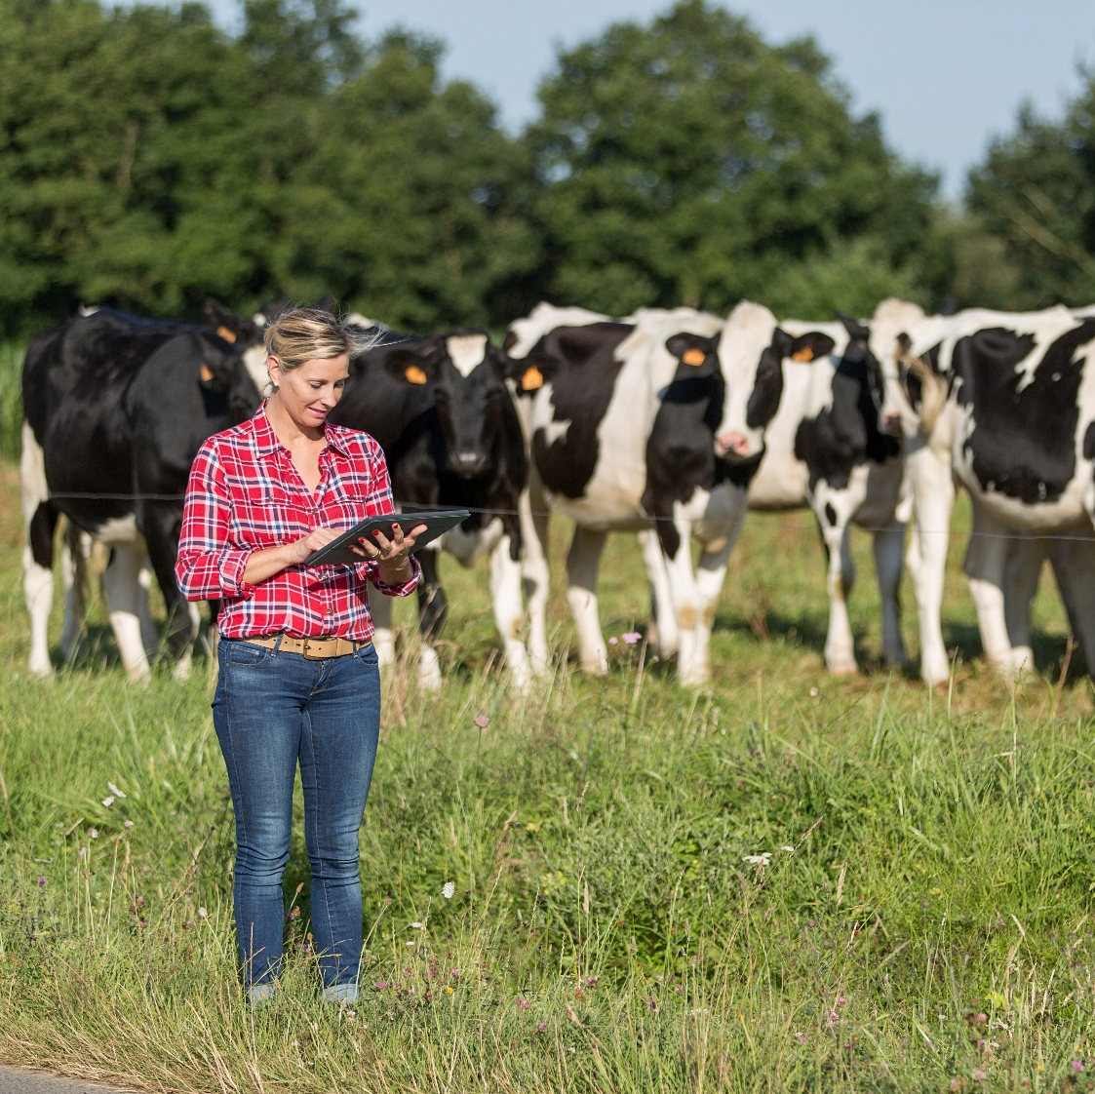
Companion Volume
Implementation Guide

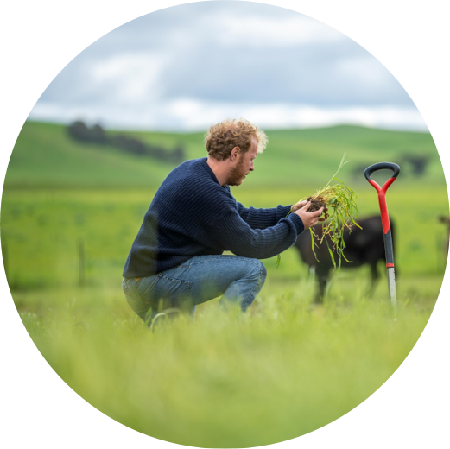
AHC Agriculture, Horticulture and Conservation and Land Management Training Package
Version 10.0
2023
Contents
Disclaimer 5
Introduction 7
Overview 8
Endorsed products 9
Non-endorsed products 9
Training package development 10
Key stakeholder roles 10
The development process 11
Unit of competency codes 18
Key work and training requirements in the industry 19
Sector description 19
Implementation information 25
Sector overview 26
Pathways charts - progression between qualifications 51
Entry requirements for qualifications 63
Diploma of Arboriculture 65
Advanced Diploma of Arboriculture and Graduate Diploma of Arboriculture 66
Entry requirements for the Diploma of Sports Turf Management 66
Entry requirements for the Certificate IV in Nursery Operations 67
Entry requirements for the Diploma of Horticulture Management 67
Entry requirements for the Diploma of Nursery Management 67
Selecting electives to enable different occupational outcomes 68
Choosing electives 68
Mandatory electives 68
Mandatory requirements for specialisations 70
Choosing electives for specialisations 70
Training package delivery and assessment 84
Amount of training and volume of learning 85
Access and equity considerations 86
Reasonable adjustment for learners with disabilities 86
Foundation skills in units of competency 88
Other legislative requirements 92
Industry regulations and standards 92
Arboriculture 92
Permaculture 93
Environmental regulations 93
Food regulations 94
Landscape Construction and Design including Green infrastructure 94
Grape growing legislation 95
Animal reproduction 95
Livestock management legislation 95
Australian ruminant feed ban 96
Biosecurity legislation 96
Live-animal export legislation 97
Conservation legislation 97
Legislation relevant to agricultural chemical use 97
Legislation for beekeeping 98
Legislation for pest animals and weeds 98
Grain trade standards and legislation 100
International regulations and access to markets 100
Industry certification programs 100
Regulated occupations in the industry 100
Industry codes of practice 101
Codes of practice relevant to agriculture chemical use 102
Codes of practice for beekeeping 102
Codes of practice for pest animals and weeds 103
Training and assessing environments 104
Training and assessment environments for Pork Sector Units. 104
Mandatory Workplace Requirements 104
Assessment Conditions 104
Training and assessment environments for Poultry Sector Units 108
Legal considerations for learners in the workplace/on placements 108
Resources and equipment lists 109
Other information relevant to the implementation of the training package 109
Assessment requirements for Agribusiness and Business sectors 110
Links 113
Agronomy 113
Green Infrastructure 117
Arboriculture 118
Beekeeping 119
Carbon Farming 120
Composting, Organic Production and Permaculture 120
Medicinal cannabis 124
Nursery Production and Production Horticulture 124
On Country Management 131
Pork and Poultry 134
Sales and Merchandising 134
Sports Turf Management 137
Viticulture 138
Water Trading 139
State and Territory Training Authorities 142
General 143

Disclaimer
This work has been produced with the assistance of funding provided by the Commonwealth Government through the Department of Employment and Workplace Relations (DEWR).
The views expressed in this work do not necessarily represent the views of the DEWR. In addition, the DEWR does not give warranty or accept any legal liability in relation to the content of this work.
For further information about this Companion Volume or any other work being undertaken by Skills Insight, please visit:
www.skillsinsight.com.au

Skills Insight Ltd
ABN: 58 006 212 693

Level 1, 165 Bouverie Street
Carlton 3053
PO Box 466
NORTH MELBOURNE VIC 3051

p. (03) 9321 3526
e. inquiry@skillsinsight.com.au
w. www.skillsinsight.com.au

Introduction
About this Guide
This Companion Volume Implementation Guide (Implementation Guide) is designed to assist assessors, trainers, Registered Training Organisations (RTOs) and enterprises to use the Training Package.
Structure of this Guide
This Implementation Guide contains two sections.
1. Overview
This section includes information about:
- what training packages are, and how they are developed
- the qualifications, skill sets and units of competency (including imported and prerequisite units of competency) in the training package
- mapping between previous and current versions of the qualifications and units of competency
- key work, training and regulatory/licensing requirements in the industry.
Note: Lists of qualifications, skill sets and units of competency, together with mapping information for qualifications, skill sets and units of competency, are in the Appendices section.
2. Implementation
This section explains some of the key features of the AHC Agriculture, Horticulture and Conservation and Land Management Training Package and the industry that will impact on the use of the Training Package. It includes information about:
- training pathways
- occupational outcomes of qualifications
- entry requirements for qualifications
- access and equity considerations
- resources and equipment requirements
- mandatory workplace requirements

Overview
About training packages
Training packages specify the skills and knowledge (known as competencies) that individuals need in order to perform effectively in workplaces. Training packages:
- reflect identified workplace outcomes
- support national (and international) portability of skills and competencies
- reflect the core, job-specific and transferable skills, required for job roles
- enable the awarding of nationally recognised qualifications
- facilitate recognition of peoples’ skills and knowledge, and support movement between school, VET and higher education sectors
- promote flexible modes of training to suit individual and industry requirements.
Note: To make them easy to interpret, training packages are written in simple, concise language, with delivery and assessment requirements clearly described. Training package products do not prescribe how an individual should be trained so that users can develop training and assessment strategies to suit the needs of their particular learners.
Training package products
Training packages consist of endorsed and non-endorsed products.
Although all products must be developed to comply with the Standards for Training Packages 2022, endorsed products must be submitted for approval by the Australian Industry and Skills Committee before they are released for use.
A summary of endorsed and non-endorsed products is provided on the following page.

Endorsed products
Product | Description
Qualification | A qualification combines the skills standards (called units of competency) into meaningful groups that meet workplace roles and align to the Australian Qualifications Framework (AQF).
Unit of competency | A unit of competency describes the requirements for effective performance in a discrete area of work, work function, activity or process. They specify the standard against which training delivery and assessment of competency can take place.
Assessment requirements | Assessment requirements accompany each unit of competency and include the performance evidence, knowledge evidence and conditions for assessment.
Credit arrangements | Credit arrangements provide details of existing arrangements between training package qualifications and higher education qualifications in accordance with the AQF.  Note: There are currently no nationally applicable credit arrangements between any Skills Insight training package qualification and higher education qualification.

Non-endorsed products
Product | Description
Skill set | A skill set addresses a particular industry need or a licensing or regulatory requirement. A skill set is not endorsed but includes endorsed units of competency.
Companion volume | This general term refers to any quality assured product (including this Implementation Guide) which supports training and assessment.

Training package development
Training packages are developed through a process of national consultation with industry. There are some key stakeholders that drive training package development.

Key stakeholder roles
Stakeholder | Role
Skills Ministers | Skills Ministers work with the VET sector on reforms to improve VET quality and relevance, strengthen engagement, and deliver more meaningful evidence to inform skills policy.
Jobs and Skills Council (JSC) | JSCs identify skills and workforce needs, map career pathways across education sectors, develop VET training products, support collaboration between industry and training providers to improve training and assessment practice and act as a source of intelligence on issues affecting their industries. (Australian Government, 2023)
Commonwealth and state/territory Senior Responsible Officers | Senior government official nominated by a Commonwealth, state or territory department with responsibility for skills and training policy.
Assurance Body | The Assurance Body is responsible for assessing training products for compliance with the Training Package Organising Framework (TPOF), using the completed submission pack as the main source of evidence
State /Territory Training Authorities (STAs/TTAs) | STAs/TTAs canvass stakeholder views about training packages, provide implementation advice, identify issues and develop purchasing guides for training providers.
Australian Skills Quality Authority (ASQA) | ASQA are responsible for regulating VET providers in all states except Victoria and Western Australia unless they offer courses to interstate and overseas students.
Vocational education and training regulators | A VET Regulator, as defined by the National Vocational Education and Training Regulator Act 2011 means:  the National VET Regulator; and  a body of a non-referring State that is responsible for the kinds of matters dealt with by this Act.

The development process
package products are validated by industry
The process used to develop and endorse training products is based on the following principles:
- open and inclusive industry participation in development and endorsement of training products
- strong stakeholder engagement and the opportunity for industry to drive change
- highly responsive and capable of meeting industry needs and priorities for new skills
- clear and transparent arrangements for resolving disputes
- accountability of all stakeholders for the role that they play in the process.

The following diagram summarises the process of training product development.

Contents of this training package
The AHC Agriculture, Horticulture and Conservation and Land Management Training Package contains AQF aligned qualifications, skill sets and units of competency.
Prerequisite requirements
Some units of competency have prerequisite requirements. This means that an individual must be competent in the prerequisite unit(s) of competency before undertaking any assessment in the unit containing the prerequisite(s).
Imported units
Qualifications include units of competency from different training packages, including:
- ACM Animal Care and Management
- AMP Australian Meat Processing
- AUM Automotive Manufacturing
- AVI Aviation
- BSB Business Services
- CHC Community Services
- CPP Property Services
- CUA Creative Arts and Culture
- FBP Food, Beverage and Pharmaceutical
- FWP Forest and Wood Products
- HLT Health
- LGA Local Government
- MSL Laboratory Operations
- MSM Manufacturing
- MSS Sustainability
- PSP Public Sector
- PUA Public Safety
- RII Resources and Infrastructure Industry
- SIR Retail Services
- SIS Spport, Fitness and Recreation
- SIT Tourism, Travel and Hospitality
- TAE Training and Education
- TLI Transport and Logistics.
Please refer to the AHC Agriculture, Horticulture and Conservation and Land Management Training Package Implementation Guide Release 13 Part 2: Component Details file for lists of:
- qualifications, skill sets and units of competency in the AHC Agriculture, Horticulture and Conservation and Land Management Training Package V9.0
- units of competency with prerequisite requirements
- imported units of competency.
This file can be downloaded from VETNet at: https://vetnet.gov.au/Pages/TrainingDocs.aspx?q=c6399549-9c62-4a5e-bf1a-524b2322cf72
Mapping information
Mapping to previous versions of a training package can be useful for delivery and assessment because it:
- outlines the changes between current and previous versions of qualifications, skill sets and units of competency
- states whether the vocational outcomes of the current and previous versions of units of competency and qualifications are equivalent
- shows any products that have been added to, or removed from, the training package.
Note: The mapping tables are summary documents only and cannot be used alone to determine an individual’s competence.
Please refer to the AHC Agriculture, Horticulture and Conservation and Land Management Training Package Implementation Guide Release 13 Part 2: Component Details file for details of mapping between previous and current qualifications, skill sets and units of competency
This file can be downloaded from VETNet at: https://vetnet.gov.au/Pages/TrainingDocs.aspx?q=c6399549-9c62-4a5e-bf1a-524b2322cf72
Registered Training Organisation (RTO) use
An RTO may use the mapping information to help design training and assessment strategies, including recognition of prior learning (RPL) systems. In addition to the mapping information, RPL processes must take into account other evidence of current competency, for example, how long ago an individual was awarded a superseded unit of competency and current work experience.
Employer use
An employer might use the mapping information to determine whether there are gaps between a qualification held by workers and the current expectations of a job role. Once gaps are identified, this could assist in planning professional development activities.
Credit arrangements
There are no credit arrangements in the AHC training package at the time of publication.

How equivalence is determined
Units of Competency
The training package developer determines equivalence based on the definition provided in the Training Package Products Policy which state that:
“Training package developers are responsible for mapping units and determining their equivalent or not equivalent status.
- Where a unit of competency is superseded and the workplace outcome of the unit has changed, the superseding unit must be deemed ‘Not Equivalent’.
- The workplace outcome can be determined to have changed when the skills and knowledge (reflected through the elements, performance criteria and assessment requirements) required to achieve the workplace outcome of the superseded and superseding units cannot be mapped to each other.
- Determinations of ‘Not Equivalent’ may also be used to support licensing, regulatory, legislative or certification requirements. The equivalence table must list the units of competency and clearly identify the status of each unit according to the following categories:
- Equivalent - the workplace outcomes of the superseded and superseding units are equivalent
- Not Equivalent - the workplace outcomes of the superseded and superseding units are not equivalent (refer Section 2.5)
- Newly created - the unit has been created to address an emerging skill or task required by industry
- Deleted - the unit is deleted as the skill or task is no longer required by industry”
If two units are determined to be equivalent, an RTO can recognise an ‘old’ unit as satisfying the outcomes of a new unit (including RPL). However, an RTO cannot assume that no changes are needed for the training and assessment of the new unit.
If a unit of competency is not equivalent to its predecessor, this means that there are significant changes in the new unit. These changes would need to be addressed, for example, through training, providing additional RPL evidence.

Qualifications
‘Training package developers are responsible for mapping qualifications and determining their equivalent or not equivalent status.
- Where a qualification is superseded and the occupational outcome and/or the AQF level of the qualification has changed, the superseding qualification must be deemed ’Not Equivalent’.
- The occupational outcome can be determined to have changed when the skills and knowledge required to achieve the occupational outcome of the superseded and superseding qualifications cannot be mapped to each other.
- Determinations of ‘Not Equivalent’ may also be used to support licensing, regulatory, legislative or certification requirements.
- The equivalence table must list the qualifications and clearly identify the equivalence status of each qualification according to the following categories:
  - Equivalent - the occupational outcomes of the superseded and superseding qualifications are equivalent
  - Not Equivalent - the occupational outcomes of the superseded and superseding qualifications are not equivalent
  - Newly Created - the qualification has been created to address an original skill or occupational outcome required by industry
  - Deleted - the qualification is deleted as the skill or occupational outcome is no longer required by industry.’
Superseded and deleted training package products
A product is superseded when another training product replaces it. This happens if the skill needs of industry change so training package developers need to alter a qualification, unit of competency or skill set.
A product is deleted when another training product does not replace it. This happens if industry determines that there is no longer sufficient demand for a qualification, unit of competency or skill set.
The rules for the use of superseded and deleted products for training purposes are in Clause 1.26 of the Standards for Registered Training Organisation (RTOs) 2015.
This can be accessed from: <https://www.legislation.gov.au/Details/F2019C00503>

Coding conventions
There are agreed conventions for the national codes used for training packages and their products.
Training package codes
Each training package has a unique three-letter national code assigned when the Training Package is endorsed, for example, AHC is the code used for the Agriculture, Horticulture and Conservation and Land Management Training Package
The practice of assigning two numbers to identify the year of endorsement is no longer used as it is not consistent with national policy.
Qualification codes
Within the training package, each qualification has a unique eight-character code that is used to identify the qualification, along with its title. The table explains the format of a qualification code for the Agriculture, Horticulture and Conservation and Land Management Training Package.

Identifiers | Description | Example for AHC31522
Training package identifier | Three letters | = AHC
AQF level identifier | One number identifying the Australian Qualifications Framework level | = 3
Sequence identifier | Two numbers identifying the sequence of the qualification at that level in the Training Package | = 15
Version identifier | Two numbers identifying the year in which the qualification was endorsed. | = 22

Unit of competency codes
Within the training package, each unit of competency has a unique code (up to 12 characters). The code, as well as the title, is used to identify the unit of competency. The table explains the format of a unit of competency code for the Agriculture, Horticulture and Conservation and Land Management Training Package.
Identifiers | Description | Example for AHCIRG401X
Training package identifier | Three letters | = AHC (Agriculture, Horticulture and Conservation and Land Management)
Sector identifier | Two to four letters | = IRG (irrigation)
AQF level indicator | One number that is a guide as to the type and depth of skills and knowledge described in the unit. This identifier is loosely tied to the Australian Qualifications Framework and can range from 1 (indicates Certificate 1) to 8 (indicates Graduate Certificate/Graduate Diploma) | = 4
Sequence identifier | The final numbers identify the sequence of the unit in the particular unit sector and AQF level, and allows each unit to have a unique code | = 01
Cross sector unit | Cross-sector units must have ‘X’ as the final character | = X

In training.gov.au the release history of each unit is shown in both the web view of the unit and in the unit modification history and mapping tables.

Key work and training requirements in the industry
Agriculture, Horticulture, Conservation and Land Management play vital roles in Australia, contributing to the social, economic and environmental sustainability of the nation. The industry has been at the forefront of Federal, State and Territory Government policies and Australian economic growth throughout the modern history of Australia.
The Agriculture, Horticulture and Conservation and Land Management (AHC) Training Package covers the majority of training in the businesses and operations that underpin the overwhelming majority of Australia’s regional, rural and Indigenous communities. The sector employs almost 350,000 people, with more than 72,000 learners serviced by 643 Registered Training Organisations (2017 figures).
Table 1: Industry snapshot
Revenue | Industry Value Added | Exports | Imports | Wages | Domestic Demand
$144.4bn | $39.1bn | $18.4bn | $1.5bn | $11.2bn | $127.4bn

Source: IBISWorld Industry Wizard
The AHC Training Package has 1008 Units of Competency across 79 qualifications and 54 Unit Sectors. Each qualification within this Training Package typically includes units crossing several different industry sectors.
More than 80 per cent of Australian land hosts activities related to the AHC Training Package, with dominant uses including livestock grazing of native vegetation, grazing of modified pastures, conservation and parks, and dryland cropping. This excludes horticulture, micro-production, landscaping and gardening work within Australia’s urban areas.

Sector description
The agriculture, horticulture and conservation and land management industry sector is highly diverse, encompassing businesses that operate in the following sub-sectors:
Amenity horticulture  - Arboriculture  - Landscape services  - Gardening services  - Turf and sports turf management  - Permaculture  - Green infrastructure  Production horticulture  - Turf production (commercial)  - Nursery production  - Retail nursery  - Floriculture production  - Vegetable growing  - Fruit tree growing  - Nut tree growing  - Seed processing  Broadacre farming  - Grain growing  - Fodder growing  - Sugar cane growing  - Cotton growing  - Seed production  Livestock farming  - Sheep farming  - Beef cattle farming  - Sheep-beef cattle farming  - Dairy cattle farming  - Poultry farming  - Other livestock farming  Mixed crop and livestock farming  - Grain-sheep farming  - Grain-beef cattle farming  - Lifestyle block farming | Agriculture support services  - Shearing, cropping and agricultural support service  - Water trading  - Grain storage services  - Agronomy  Agricultural product wholesaling  - Fruit and vegetable wholesaling  - Cereal grain wholesaling  - Wool wholesaling  - Fish and seafood wholesaling  Conservation & Land Management  - National parks  - Nature reserves  - Council reserves  - Cultural and Heritage Sites  - On Country lands, waterways and seas  - Corridors (national, state and local)  - Botanical gardens  - Landcare  - Coastcare  - Rivercare  - Seed banks  - Private land  Landscaping  - Landscaping construction  - Public and private space design and scoping  - Feature installation and design  - Lawn and garden installation and design  - Residential, office & commercial building landscaping and maintenance services  - Watering systems and features

Businesses
As at June 2019, there were 179,231 businesses across agriculture, horticulture, agricultural product wholesaling and parks and gardens operations. Over 70 per cent (125,971) of businesses were non-employing, and 28 per cent (50,692) were small businesses, employing fewer than 20 people. There were 2,434 medium businesses (between 20 and 199 employees) and 101 large businesses (over 200 employees).
Figure 1: Business locations by state
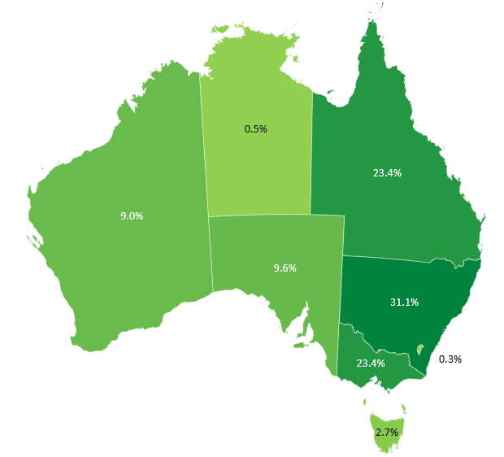 | Source: Australian Bureau of Statistics, 2020, 8165.0 Counts of Australian Businesses, including Entries and Exits, June 2015 to June 2019
AHC-related activities are a significant source of employment, particularly in regional, rural and remote areas, and make an important contribution to the Australian economy (see Figure 2).

Figure 2: AHC Industry Sector Performance, 2019-2020
Australian Industry Sector | Employment | Wages ($m) | Revenue ($m) | Contribution to GDP ($m)
Floriculture Production | 2,090 | 85.3 | 276.8 | 105.2
Under Cover Vegetable Growing | 2,473 | 156.8 | 757.7 | 340.5
Outdoor Vegetable Growing | 12,911 | 564.8 | 4,313.1 | 1,277.4
Rice Growing | 290 | 3.3 | 27.2 | 7.2
Grain Growing | 27,537 | 387.8 | 13,044.8 | 4,043.9
Sugar Cane Growing | 9,179 | 132.4 | 1,037.5 | 380.9
Cotton Growing | 4,783 | 184.0 | 1,398.6 | 564.6
Hay and Other Crop Growing | 4,239 | 114.7 | 2,100.7 | 380.9
Apple, Pear and Stone Fruit Growing | 6,856 | 107.8 | 954.1 | 201.5
Grape Growing | 11,993 | 263.6 | 1,559.8 | 627.1
Olive Growing | 1,394 | 15.0 | 119.3 | 41.7
Citrus Fruit, Nut and Other Fruit Growing | 12,858 | 397.3 | 3,972.8 | 948.2
Egg Farming | 3,994 | 97.6 | 868.2 | 157.4
Poultry Meat Farming | 2,201 | 56.0 | 580.7 | 140.6
Sheep Farming | 18,273 | 213.0 | 4,561.1 | 1,590.3
Beef Cattle Farming | 76,902 | 1,077.6 | 16,623.8 | 6,932.1
Beef Cattle Feedlots | 1,994 | 66.4 | 4,676.5 | 651.6
Sheep-Beef Cattle Farming | 22,949 | 194.4 | 6,184.2 | 2,554.1
Grain-Sheep or Grain-Beef Cattle Farming | 37,209 | 301.3 | 11,595.3 | 4,297.5
Dairy Cattle Farming | 17,237 | 253.1 | 4,573.9 | 1,138.6
Pig Farming | 2,253 | 126.8 | 1,138.3 | 253.2
Grain Storage | 7,051 | 411.2 | 2,717.4 | 747.7
Hydroponic Crop Farming | 2,789 | 170.7 | 458.5 | 269.9
Organic Crop Farming | 5,171 | 92.7 | 1,130.2 | 373.3
Organic Livestock and Poultry Farming | 676 | 12.7 | 1,384.7 | 559.4
Shearing, Cropping & Agricultural Support Services | 30,051 | 708.4 | 3,909.8 | 1,321.3
Nursery Production | 2,898 | 133.1 | 746.7 | 216.0
Turf Growing | 1,139 | 51.5 | 259.8 | 79.1
Landscaping Services | 34,463 | 1,669.5 | 5,934.5 | 2,550.4
Gardening Services | 41,530 | 1,308.2 | 2,667.5 | 2,019.9
Nature Reserves and Conservation Parks | 12,392 | 588.1 | 1,618.4 | 841.6
Zoological and Botanical Gardens | 7,207 | 326.4 | 850.9 | 443.4
Organic Farming | 6,078 | 142.4 | 2,564.2 | 956.4
Wool Wholesaling | 647 | 36.4 | 3,806.7 | 171.3
Cereal Grain Wholesaling | 3,266 | 216.1 | 21,504.1 | 824.3
Fruit and Vegetable Wholesaling | 14,226 | 750.9 | 12,344.0 | 1,530.7
Source: IBISWorld Australia Industry Wizard
Figure 3: The industry in a ‘nutshell’
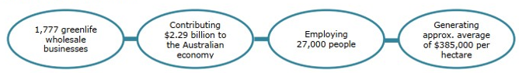
Source: Hort Innovation, 2018, Nursery Industry Statistics and Research, p.3
In addition to businesses, each level of government and a number of Non-Government Organisations are employers of graduates from the AHC Training Package.
The breadth of the scope of work undertaken by these businesses and operations can be illustrated by Australian Land Use mapping, which is regularly undertaken at various levels of government as information required for current and future policies and strategies. The complexity of activities covered is illustrated in the size and training coverage of the AHC Training Package.

Figure 4: Land use in Australia
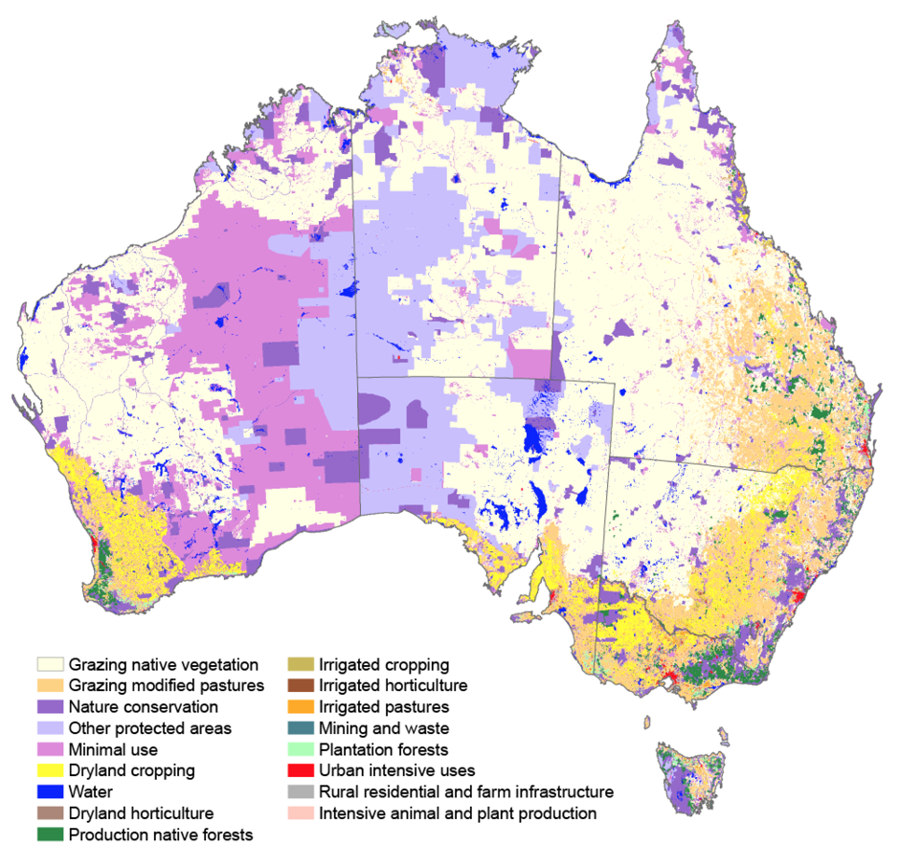
Source: Australian State of the Environment 2016 <https://soe.environment.gov.au/theme/land/topic/2016/land-use-and-management>
It should be noted that many activities in Horticulture, Conservation & Land Management, Landscaping and micro-production also take place in urban intensive areas.
AgriFutures Australia has identified the decline in land used for farming in Australia as a current trend which is likely to be ongoing.
Skills Insight has responsibility for overseeing the development of industry units of competency, skill sets and qualifications relative to the following sectors:
- Agricultural chemicals.
- Agricultural irrigation
- Agricultural support services
- Broadacre cropping and farming
- Floriculture production
- Fruit growing
- Livestock farming
- Nut growing
- Vegetable growing.

Implementation information
Industry sectors and occupational outcomes of qualifications
The AHC Agriculture, Horticulture and Conservation and Land Management Training Package includes units of competency from the following industry sectors.
Sector Code | Sector | Sector Code | Sector
AGB | Agribusiness | LSK | Livestock
AIS | Artificial Insemination | MAR | Marine
ARB | Arboriculture | MDC | Medicinal Crops
BAC | Broad Acre Cropping | MER | Merchandising and Sales
BEK | Beekeeping | MKH | Milk Harvesting
BER | Biosecurity Emergency Response | MOM | Machinery Operation and Maintenance
BIO | Biosecurity | NRM | Natural Resource Management
BUS | Business | NSY | Nursery
CCF | Community Coordination and Facilitation | OCM | On Country Management
CFP | Carbon Farming | ORG | Organic Production
CHM | Chemicals | PCM | Plant Culture and Maintenance
CMN | Common | PER | Permaculture
COM | Composting | PGD | Parks and Gardens
CSW | Cultural Sites Work | PHT | Production Horticulture
DER | Deer | PLY | Poultry
DES | Design | PMG | Pest Management
DRG | Drainage | PRK | Pork
DRY | Dairy | SAW | Soil and Water Conservation
ECR | Ecological Restoration | SDT | Seed Processing
EXP | Explosives | SHG | Shearing
FAU | Fauna | SOL | Soils and Media
FIR | Fire | SPO | Seed Testing
GRI | Green Infrastructure | SUS | Sustainability
HYD | Hydroponics | THH | Therapeutic Horticulture
INF | Infrastructure | TRF | Turf Management
IRG | Irrigation | WAT | Water
LPW | Lands, Parks and Wildlife | WHS | Work Health and Safety
LSC | Landscaping | WOL | Wool
 |  | WRK | Work

Sector overview
Agriculture and agribusiness
Agriculture and Agribusiness are diverse sectors including both plant and animal-based production systems along with supporting Agribusiness enterprises that supply agriculture goods and services. Job roles within the sector range from farmhands, farm business managers and include numerous agricultural service roles. This sector is a leader in the uptake and development of new technologies and attracting investment on an international level.
Australian producers have a reputation for green and safe agricultural products which provides a marketing advantage that must be retained. As a result, biosecurity will be an important issue as Australia develops its export trade in agricultural goods. There is an increased interest in the area of carbon farming for land owners especially in the area of Emissions Reduction Fund projects which are supported by the Clean Energy Regulator.
Agricultural chemicals
Agricultural chemicals and veterinary medicines play an essential role in maintaining and improving productivity of agriculture and related industries. The registration of chemicals for use in Australia is controlled by the Australian Pesticides and Veterinary Medicines Authority (APVMA). State and territory governments control the use of pesticides and veterinary medicines. The various state jurisdictions have a range of training requirements for the use and purchase of various classes of pesticides and veterinary medicines.
Currently there is a National Agvet Chemical Task Force looking at developing a more harmonised approach to chemical training requirements. Once this work is complete, a more comprehensive review of Training Package products will be required to ensure vocational training options meet the needs of all stakeholders.
Animal Reproduction
Farmers need a range of skills and knowledge to manage the reproduction of animals, helping them to keep up with the high demand for products like meat, dairy and wool. Skills to identify breeding objectives, genetic influences, animal soundness and animal breeding health have been used for generations to increase livestock and poultry production and profitability. Recent developments in the availability of technologies have made this work even more effective and efficient, improving animal welfare, profitability and sustainability.
Arboriculture
Arborists work in private and government positions to foster the economic, ecological, environmental, health and social benefits of trees and professional tree care. Arborists provide for the care and management of trees in conservation and tree preservation roles, tree climbing, tree maintenance, and the diverse operations of vegetation management, power line clearance, professional tree management and urban forestry. Consulting arborists have professional consulting, expert witness, research and academic roles in diagnostic testing and tree assessment.
Beekeeping
Beekeeping is the maintenance of native and/or honey bee colonies, commonly in hives, by humans. A commercial beekeeper (or apiarist) keeps bees in order to collect their honey and other products that the hive produces (including beeswax, propolis, pollen, and royal jelly) for sale, to pollinate crops, and/or to produce bees for sale to other beekeepers. Beekeeping is a form of animal husbandry that involves providing feed when nectar and pollens are lacking, preventing infections from various microbes and diseases and dealing with parasitic mites.
Broadacre cropping
Broadacre cropping or faming on arable land exists in Australia wherever farming in the soil is possible, especially across the grain and wheat belts, and for more water intensive crops along the Murray river and in the tropics. Workers in the sector must be skilled in how to grow their crops and related tasks.
Carbon farming
Carbon farming is the process of changing agricultural practices or land use to increase the amount of carbon stored in the soil and vegetation (sequestration) and to reduce greenhouse gas emissions from livestock, soil or vegetation (avoidance). Carbon farming projects contribute to the reduction of Australia’s net greenhouse gas emissions by providing incentives to reduce emissions through the Emissions Reduction Fund and non-ERF markets such as voluntary markets (for example, enterprises such as Qantas and Shell) and secondary markets where carbon credits are sold to others who then on sell.
Community coordination and facilitation
Workers in this sector are generally responsible for fostering, promoting, organising and supporting community groups to undertake conservation activities.
Composting
There are approximately 140 businesses around Australia recovering more than 5.2 million tonnes of organic waste and turning it into useful products and services each year. New products are continuously being developed for environmental applications such as erosion control and storm water treatment.
Qualifications and units of competency enable workers to process material into compost-based products such as soil conditioners, mulches, garden soils, top dressing soils and potting mixes and tailored products to be developed for agricultural applications such as fruit and vegetables, grains, pasture improvement and forestry.
Employment in this industry is growing and the units in this Training Package will give employees a career pathway in this and related industries.
Conservation coordination and facilitation
The Conservation and Land Management sector is made up of workers from unskilled to professional levels and includes a large cohort of volunteer workers. There are a number of different areas people may work in the conservation and land management sector. Some examples are conservation earthworks which are involved in the design and implementation of earthworks associated with soil conservation on rural properties, erosion and sediment control on rural, urban and infrastructure construction sites.
Cultural Sites Work
Aboriginal and Torres Strait Islander cultures possess skills and knowledge that are crucial to land and sea management activities, including conservation and cultural heritage roles. Some of these skills are described in nationally endorsed qualifications, skill sets and units to equip leaners for jobs as council workers, rangers, conservation field officers, cultural and heritage officers, land council site officers and tourism operators and guides.
Dairy
The Dairy Industry is one of Australia’s major rural industries and is located across the temperate and some subtropical areas of Australia. The bulk of milk production occurs in south-eastern Australia with Victoria having the largest number of dairy farming enterprises. The associated downstream milk processing industry is also concentrated in the south-eastern regions. Dairy Industry enterprises range from large corporations through to small owner operators. The industry has had a long-term commitment to training which is promoted through its peak body Dairy Australia. This sector of training covers troubleshooting the machines used in large scale milk harvesting.
Ecological restoration
This sector is mostly involved in conservation and restoration of ecological areas in order to regenerate bushlands and improve the ecological integrity and biodiversity of an area. This sector employs a high proportion of volunteers.
Environmental Sustainability
Sustainability in the broadest sense refers to the ability to maintain or support a process continuously over time. While sustainability can be broken into three areas; economic, social and environmental, with respect to agriculture and horticulture, sustainability should perhaps be considered as actions that seek to prevent depletion of natural, physical, human and economic resources, so they will remain available for the long term. This is all encompassing for a successful business.
As key drivers for all industry sectors, the importance of environment and sustainability or environmental sustainability must be explicitly taught. The units of competency pertaining directly to this are now core units of competency in both agriculture and horticulture general qualifications.
Students are most likely to engage if this is taught in a meaningful and connected manner. Every enterprise uses resources, and those resources need to be looked at from the point of view of sustainability.
It is the role of the RTO to contextualise sustainability to ensure the student engages. Likely engagement occurs where the student is asked to consider the topic of environmental sustainability from their own perspective in their own workplace. It must be emphasised that the sustainability conversation is not simply about ‘organic, green, recycling and careful water use’. Ask students to consider every item, machine, consumable, worker, animal, soil additive and chemical. The list of items, actions and inputs that can be considered in order to improve environmental sustainability is endless.
The RTO has achieved a competent outcome when the student capably understands how they, as an individual, can contribute to and improve any aspect of environmental sustainability in their workplace.
Explosives
These units are strictly regulated and are mostly for use in the pest management industry, primarily for the destruction of rabbit warrens.
Fauna
This sector units are utilised across the Conservation and Ecosystem certificates and relate to identifying and monitoring fauna. This sector is of use for rangers and organisations that require ranger like tasks to be performed.
Feedlot
Feedlot operational employees fall into three main classifications: pen riders; feeding and milling operators and feedlot maintenance workers. The Certificate III in Feedlot Operations is divided into three streams to reflect these job roles while providing maximum transferability of core and common skills.
Fire
The Fire sector in the AHC training package focuses on burning for ecological purposes. It uses the knowledge of First Nations People, who work closely with Skills Impact to make sure the units are culturally appropriate, and the knowledge adequately captured. The Country Fire Association has also been heavily consulted to make sure these units are distinctly ecological in nature, as opposed to the Public Safety (PUA) training package which focuses on fire extermination for a professional fire fighter.
Floriculture
Floriculture or flower growing involves the growing, harvesting and preparing flowers and foliage for sale. Floriculture businesses produce fresh and dried flowers and foliage for wholesale flower markets, florists and retail outlets, and increasingly for overseas exporting. The range of different flowers and foliage is immense and could include roses, carnations, orchids, native flowers, bulb and annual flowers, and tropical flowers. Some flower farms also grow flowers in open fields for their essential oils.
Green Infrastructure
Roof garden, vertical wall and green facade infrastructure is a subset of the ‘green infrastructure’ or ‘living infrastructure’ industry sector, which is of increasing significance to a range of stakeholders (product suppliers, government policy makers, builders/property developers, landscapers/horticulturalists and the community) as increasing urbanisation motivates green infrastructure projects in urban development for aesthetic, environmental, economic and/or social reasons.
Irrigation
Irrigation is the artificial application of water to the land or soil. It is used to assist in the growing of agricultural and horticultural crops, maintenance of landscapes, and revegetation of disturbed soils in areas to replicate the natural rainfall during dry periods. Irrigation systems are also used for dust suppression, disposal of sewage, and in mining. Irrigation is often associated with drainage, which is the natural or artificial removal of surface and sub-­surface water from a given area. The irrigation qualifications and units of competency support the skills base of the industry’s retailers, designers, managers, installers and maintenance workers.
The irrigation industry design, manage, install, maintain and monitor irrigation systems ranging from domestic systems through to large commercial irrigation systems. This may include open irrigation and drainage, pressurised or gravity fed irrigation systems. Job roles within the sector range from irrigation installation assistant to irrigation system designer. This sector is a leader in the uptake of technology such as applications (APP) based technology, controller and sensor technology and drones.
Lands, parks and wildlife
Lands parks and wildlife officers, rangers and managers are involved in the management and maintenance of areas of native and cultural significance. They may be employed by government or non-government organisations. Roles will generally involve a mixture of conservation and restoration tasks as well as tourism, education, construction and pest management.
Landscape Construction and Design
A skilled workforce of landscape professionals design, construct and maintain the gardens and green spaces in our public spaces and backyards. As urban city blocks get smaller, people are looking to landscapers to create and deliver outcomes where they can get the most out of their garden space. Many backyards these days are an extension to the living room, so it is important they offer a safe, comfortable, and sustainable space for entertainment and enjoyment. Well-designed public gardens, parks, and streetscapes increase the liveability of local communities.
Marine
The Marine sector is a group of units that focus on ecological work being undertaken at sea. It recognises the unique needs of these rangers who work in marine environments, as there are skills unique to working in the ocean, even separate from other aquatic environments.
Medicinal Cannabis
Working in the medicinal cannabis industry in Australia involves working in medium to large sized protected cropping facilities where a range of skilled work is undertaken in controlled growing, licensed medicinal cannabis operations. Workers in this sector are required to be over 18 years of age must comply with strict workplace security and regulatory employment obligations while undertaking cultivation and production practices. Tasks may be associated with the propagation, growth and harvesting of the plant and job roles include cultivation technicians and cultivation supervisors and managers. The Australian medicinal cannabis industry is expected to undergo major developments over the next couple of years and significant production and manufacturing capacity coming online from the licensed sector.
On Country Management
On Country Land Managers, as the title suggests, are responsible for the management of Aboriginal and/or Torres Strait Islander owned/held lands. These lands are used for a range of activities including tourism, horticulture and agriculture. On Country management job roles may include a range of these activities as well as conservation and restoration of cultural and heritage sites. Aboriginal and/or Torres Strait Island On Country Management officers generally use a combination of traditional and contemporary approaches to land management.
Organic production
Organic farming focuses on utilising natural, non-synthetic farming techniques. These include crop rotation, the use of green manure and biological pest control. Organic farms aim to be sustainable with an emphasis on the use of renewable resources. The considerations of energy, soil and water resources as well as the maintenance of environmental quality are key attributes of organic farming.
Parks and Gardens
The Australian parks and gardens industry maintains and manages public green spaces for recreation and leisure that benefit all Australians. Many parks and gardens areas are home to native and unique plant species, animals and historic structures. They hold cultural and social importance and are visited by thousands of locals and tourists every year. The diversity, beauty, safety and sustainability of these parks and gardens is managed and maintained by a skilled workforce of grounds keepers and gardeners. Park managers are responsible for staff and park operations as well as managing contracts for outsourced services
Permaculture
Permaculture is a multi-disciplinary ecological design science focussed on care for the earth, care for people and all species, sharing of surpluses and setting limits to industrial and exploitative growth and consumption. It is based on the premise that the planet is a finite ecological system with limited energy and material resources to be shared and managed in a manner inspired by nature.
Pest management
This covers non­urban pest management roles. Integrated pest management requires workers in this field to be able to apply several management options strategically in order to reduce pest damage levels. Pest management officers may be employed by government agencies or private organisations. Pest management may also be undertaken by workers in other industry sectors such as: agriculture; horticulture; conservation and land management; parks and wildlife services; parks and gardens; viticulture and wine grape growing. Pest management covers both plant and animal pests.
Pork
The Australian Pork Industry is spread throughout Australia with a range of enterprise sizes and production systems. There are three main types of pig farming systems: Indoor Housing, Outdoor Bred and Free Range. The pork industry is particularly focused on addressing the welfare needs of pigs, environmental stewardship and the education of stock persons who handle pigs.
Poultry
The Poultry Industry is established in all states of Australia with the focus of the industry in the three eastern states. It is located around capital cities or major provincial centres that are close to cereal grain cropping areas. It comprises two main sectors: poultry meat and egg layer industries. Poultry industry enterprises range from large corporations through to small owner operators. Animal welfare and biosecurity are two key issues which the industry is seeking to address through training.
Production horticulture
Production horticulture is a diverse industry which involves growing and harvesting fruit or vegetables. Production horticulture businesses produce fresh and dried fruit and vegetables for local markets, processing and exporting. The range of produce is vast and could include many varieties of different fruits, nuts and vegetables. Many production horticulture businesses operate as farms growing vegetables, while others are based on extensive orchards. Some businesses are intensive and grow fruit, vegetables and mushrooms in controlled environments.
Production nursery
Production or wholesale nurseries propagate and supply plants to supermarkets, retail nurseries, garden centres and landscapers. They are often large and are generally located on the outskirts of major cities. They may employ from ten to 100 staff. Some also maintain retail outlets.
Production nurseries can also be found in some municipal councils, government departments, landscape companies and ‘greening’ or revegetation organisations. These nurseries grow plants for local landscape and revegetation projects. Other businesses allied to the nursery industry include indoor plant hire and maintenance companies and suppliers of garden products.
Protected horticulture
Protected Horticulture is a fast growing diverse sector which includes the production of vegetables, and flowers using a ranged of protected horticulture facilities ranging from commercial hydroponics and greenhouse facilities through to covered crops. Job roles within the sector range from picker, packer, crop and nursery worker through to senior grower and integrated pest manager (IPM). This sector is a leader in the uptake of technology such as controlled environment technology, robotics and automated technology.
Retail nursery
Retail nurseries, also called Garden Centres, sell plants and gardening products to the general public. They employ workers with a good knowledge of plants and gardening products. Most importantly they require workers who can communicate well with customers.
Rural Merchandising
Rural merchandising supports diverse sectors of the agricultural industry, including production horticulture, broad acre crop production, nursery production and protected cropping. Job roles within the sector range from rural sales assistants to specialist rural merchandisers in areas such as farm machinery, irrigation, livestock, farm chemicals, fertiliser and soil ameliorant sales.
Seed processing
Seed processing involves the cleaning and grading of seed after it has been harvested and dried to meet required levels of physical purity and germination. Cleaning removes extraneous material while grading aims at removal of less developed, dead and diseased seeds. Careful handling and specific procedures are necessary to maintain seed vigour and a satisfactory shelf life in storage. Workers in this industry operate seed processing equipment and machinery, pack and store seed including the operation of vehicles such as a forklift.
Seed testing
Seed testing is the science of evaluating seed quality for agricultural and horticultural purposes. This includes the physical quality of a seed lot including freedom from unwanted seeds and material, and evaluation of the germination potential of the seed. Seed may also be tested for freedom from seed-borne diseases. Seed testing plays a major role in the international trade in seed.
Shearing and wool handling
Professional shearers and wool handlers work as trades’ people within the wool harvesting industry sector. Regardless of level they are required to be physically fit, work quickly and consistently with their hands, work confidently with sheep and work as part of a team.
Sports turf management
The Sports Turf Management Industry involves the construction and maintenance of grassed and lawn areas which are used for sport and recreation. The sports turf management industry employs people who care for and manage turf playing surfaces. There are several major employers including local councils, sporting clubs, golf clubs and horse racecourses. The workplaces include bowling greens, lawn tennis courts, cricket wickets, sports fields and ovals, recreational parks and grounds, domestic and commercial mowing and lawn maintenance operations and commercial turf farms. Work in the sports turf management industry focuses on the maintenance of these surfaces and preparation for play.
The work may involve early starting times and some weekend work. Skills in the operation of specialist machinery and equipment are required for work in this industry. At the supervisory and management level, there is also emphasis on agronomy, greens reconstruction and renovation, irrigation management, chemical use and healthy turf growth. Managers are responsible for budgets and may have to report to club committees.
Viticulture
Viticulture is a diverse sector including production of grapes for wine production and table grapes. Job roles within the sector range from pickers, technical scouts to vineyard manager. This sector is a leader in the uptake of technology such as drone and automation.
Water Trading
Water trading is a part of the WAT training sector and refers to the trading of water and understanding of water entitlements that are attached to parcels of land. This includes carryover water and buying and selling water on approved platforms as well as private sales.
Wool
Wool classers normally work in shearing sheds as a member of a wool harvesting and preparation team. Some work as wool valuers and assess the value of the wool on behalf of wool buyers, brokers and domestic and overseas woollen mills or in wool rehandling facilities.
Occupational outcomes of qualifications
The units of competency, skill sets and qualifications in the AHC Agriculture, Horticulture and Conservation and Land Management Training Package cover a diverse range of work activities within the industry. The following table lists the qualifications and provides an overview of occupational outcomes for each qualification.
Qualification | Overview of occupational outcomes
Graduate Diploma  AHC80120 Graduate Diploma of Arboriculture | The Graduate Certificate reflects the role of advanced practitioners who require high-level knowledge in a range of contexts to carry out highly skilled/specialist work, including research.  It is also a pathway to further learning.
Advanced Diploma  AHC60319 Advanced Diploma of Agribusiness Management  AHC60422 Advanced Diploma of Conservation and Ecosystem Management  AHC60524 Advanced Diploma of Arboriculture | The Advanced Diploma reflects the role of managers, consultants and leaders who are required to apply specialised knowledge in a range of contexts and undertake advanced skilled or paraprofessional work.  The Advanced Diploma serves also as a pathway for further learning.
Diploma  AHC50122 Diploma of Agriculture  AHC50324 Diploma of Production Horticulture  AHC50422 Diploma of Horticulture Management  AHC50524 Diploma of Arboriculture  AHC50621 Diploma of Landscape Design  AHC50820 Diploma of Nursery Management  AHC51019 Diploma of Sports Turf Management  AHC51120 Diploma of Conservation and Ecosystem Management  AHC51222 Diploma of Community Coordination and Facilitation  AHC51324 Diploma of Pest Management  AHC51424 Diploma of Agribusiness Management  AHC51524 Diploma of Viticulture  AHC51624 Diploma of Irrigation Design  AHC51920 Diploma of Applied Agronomy  AHC50621 Diploma of Landscape Design  AHC52021 Diploma of Landscape Construction Management  AHC52122 Diploma of Permaculture | The Diploma qualification reflects the role of individuals who apply integrated technical and theoretical concepts in a broad range of contexts and undertake skilled or paraprofessional work. The Diploma is suitable for supervisors, managers, consultants and specialist job roles.  The Diploma serves also as a pathway for further learning.
Certificate IV  AHC40122 Certificate IV in Agriculture  AHC40224 Certificate IV in Protected Horticulture  AHC40324 Certificate IV in Production Horticulture  AHC40422 Certificate IV in Horticulture  AHC40624 Certificate IV in Nursery Operations  AHC40924 Certificate IV in Conservation and Ecosystem Management  AHC41024 Certificate IV in Agribusiness  AHC41124 Certificate IV in Irrigation Management  AHC41316 Certificate IV in Wool Classing  AHC41724 Certificate IV in Pest Management  AHC42021 Certificate IV in Landscape Construction Management  AHC42122 Certificate IV in Permaculture  AHC42324 Certificate IV in Medicinal Cannabis Cultivation and Production  AHC42421 Certificate IV in Landscape Design | The Certificate IV qualification reflects the role of individuals to undertake work in varied contexts using a broad range of specialised knowledge and skills. Certificate IV is suitable for senior workers and technicians who supervise or lead teams. Certificate IV also serves as a pathway for further learning.
Certificate III  AHC30122 Certificate III in Agriculture  AHC30224 Certificate III in Dairy Production  AHC30324 Certificate III in Rural and Environmental Pest Management  AHC30422 Certificate III in Pork Production  AHC30522 Certificate III in Poultry Production  AHC30624 Certificate III in Production Horticulture  AHC30722 Certificate III in Horticulture  AHC30824 Certificate III in Arboriculture  AHC30921 Certificate III in Landscape Construction  AHC31024 Certificate III in Parks and Gardens  AHC31124 Certificate III in Nursery Operations  AHC313124 Certificate III in Sports Turf Management  AHC31424 Certificate III in Conservation and Ecosystem Management  AHC31522 Certificate III in on Country Management  AHC31824 Certificate III in Beekeeping  AHC32424 Certificate III in Irrigation Technology  AHC32522 Certificate III in Cultural Sites Work  AHC32720 Certificate III in Rural Merchandising  AHC32824 Certificate III in Rural Operations  AHC32916 Certificate III in Shearing  AHC33016 Certificate III in Wool Clip Preparation  AHC33116 Certificate III in Advanced Wool Handling  AHC33316 Certificate III in Feedlot Operations  AHC33722 Certificate III in Protected Horticulture  AHC33822 Certificate III in Permaculture  AHC33924 Certificate III in Medicinal Cannabis Cultivation and Production | The Certificate III qualification reflects the role of individuals required to apply a broad range of knowledge and skills in varied contexts and undertake skilled work. Certificate III is suitable for experienced operators, technicians and trades workers. Certificate III serves also as a pathway for further learning.
Certificate II  AHC20122 Certificate II in Agriculture  AHC20324 Certificate II in Production Horticulture  AHC20422 Certificate II in Horticulture  AHC20520 Certificate II in Arboriculture  AHC20624 Certificate II in Parks and Gardens  AHC20724 Certificate II in Nursery Operations  AHC20919 Certificate II in Sports Turf Management  AHC21024 Certificate II in Conservation and Ecosystem Management  AHC211124 Certificate II in Irrigation  AHC21216 Certificate II in Rural Operations  AHC21316 Certificate II in Shearing  AHC21416 Certificate II in Wool Handling  AHC21624 Certificate II in Landscaping  AHC21722 Certificate II in Permaculture  AHC218124 Certificate II in Protected Horticulture | The Certificate II qualification reflects the role of individuals who undertake mainly routine work. Generally, Certificate II is used as an induction into the industry and is aligned to operator, production and assistant roles. Certificate II serves also to offer a pathway for further learning.
Certificate I  AHC10124 Certificate I in Conservation and Ecosystem Management  AHC10222 Certificate I in Agriculture  AHC10322 Certificate I in Horticulture  AHC10422 Certificate I in Permaculture | The purpose of Certificate I qualifications is to provide individuals with basic functional knowledge and skills to undertake work, further learning, and community involvement in the industry. Certificate I may be used as an induction into to the industry.

Occupational outcomes for industry sectors
The following tables provide typical occupational outcomes of each AQF qualification in each industry sector.
Agribusiness
Qualification | Typical occupational outcomes
AHC41024 Certificate IV in Agribusiness | - Agribusiness team leader/supervisor  - Agribusiness administrator
AHC51422 Diploma of Agribusiness Management | - Farm manager/administrator  - Production unit manager/administrator  - Station/property manager  - Agribusiness manager/administrator  - Horticulture production manager
AHC60319 Advanced Diploma of Agribusiness Management | - Rural and regional agribusiness manager or advisor (including lending managers, insurance brokers, machinery dealers, chemical resellers, stock agents, grain marketers)  - Agribusiness advisor/consultant  - Agriculture enterprise business manager  - Production horticulture enterprise business manager
Agronomy
Qualification | Typical occupational outcomes
AHC51920 Diploma of Applied Agronomy | - Agronomist
Animal and other livestock production
Qualification | Typical occupational outcomes
AHC20122 Certificate II in Agriculture | - Assistant animal attendant/stockperson  - Assistant farm or station hand/worker/labourer  - Assistant farm fencing contractor  - Farm machinery worker  - Jillaroo/Jackaroo  - Saleyard livestock worker
AHC30122 Certificate III in Agriculture | - Farm or station hand  - Farm or station worker  - Livestock transport driver
AHC31824 Certificate III in Beekeeping | - Beekeeper
AHC30224 Certificate III in Dairy Production | - Dairy farmhand
AHC30422 Certificate III in Pork Production | - Piggery attendant  - Pork stock person
AHC30522 Certificate III in Poultry Production | - Poultry Farm Technician  - Poultry Breeding Technician  - Egg Grading Technician  - Poultry Services Provider  - Hatchery Technician
AHC33316 Certificate III in Feedlot Operations | - Feedlot feeding and milling hand  - Feedlot maintenance hand
AHC40122 Certificate IV in Agriculture | - Dairy farm supervisor  - Farm supervisor (sheep)  - Head stockperson (beef cattle)  - Stud farm supervisor/manager
AHC50122 Diploma of Agriculture | - Farm production manager (beef cattle)  - Station manager (sheep and grain)
AHC60319 Advanced Diploma of Agribusiness Management | - Agribusiness enterprise business manager
Arboriculture
Qualification | Typical occupational outcomes
AHC20520 Certificate II in Arboriculture | - Ground-based tree worker
AHC30824 Certificate III in Arboriculture | - Climbing arborist  - Elevated work platform arborist  - Crane specialist arborist  - Environmental arborist  - Arborist works coordinator
AHC50524 Diploma of Arboriculture | - Tree manager  - Consulting arborist
AHC60524 Advanced Diploma of Arboriculture | - Consulting arborist  - Specialist consulting arborist  - Senior tree manager
AHC80120 Graduate Diploma of Arboriculture | - Senior consulting arborist  - Specialist consulting arborist  - Senior tree manager  - Senior technical/research arborist
Conservation and ecosystem management
Qualification | Typical occupational outcomes
AHC21024 Certificate II in Conservation and Ecosystem Management | - Conservation worker - land management  - Conservation worker - parks and wildlife  - Earthworks conservation worker
AHC30324 Certificate III in Rural and Environmental Pest Management | - Pest management field officer  - Pest management contracting  - Vertebrate pest management field officer  - Weed management field officer in the pest  - management industry
AHC31424 Certificate III in Conservation and Ecosystem Management | - Land rehabilitation worker  - National parks worker  - Revegetation worker  - National parks ranger  - Land rehabilitation worker  - Revegetation worker  - Earthworks conservation technician  - Rehabilitation of mined land worker
AHC40924 Certificate IV in Conservation and Ecosystem Management | - Senior conservation worker
AHC41724 Certificate IV in Pest Management | - Senior field officer – pest management  - Supervisor – pest management
AHC51120 Diploma of Conservation and Ecosystem Management | - Senior park ranger
AHC51222 Diploma of Community Group Coordination and Facilitation | - Community project coordinator (land care)
AHC51324 Diploma of Pest Management | - Senior officer – pest management  - Manager – pest management
AHC60422 Advanced Diploma of Conservation and Ecosystem Management | - Regional and senior management roles in conservation and ecosystem management
Dairy
Qualification | Typical occupational outcomes
AHC30224 Certificate III in Dairy Production | - Dairy worker
Gardening
Qualification | Typical occupational outcomes
AHC20624 Certificate II in Parks and Gardens | - Park and gardens assistant
AHC20919 Certificate II in Sports Turf Management | - Sports turf support person  - Sports turf volunteer
AHC21624 Certificate II in Landscaping | - Landscaping assistant
AHC30921 Certificate III in Landscape Construction | - Landscape gardener
AHC31021 Certificate III in Parks and Gardens4 | - Parks and gardens tradesperson
AHC31324 Certificate III in Sports Turf Management | - Sports turf tradesperson including green keeper and grounds person
AHC42021 Certificate IV in Landscape Construction Management | - Landscape contractor supervisor
AHC42421 Certificate IV in Landscape Design | - Landscape designer
AHC50422 Diploma of Horticulture Management | - Management job roles in the horticulture industry
AHC50621 Diploma of Landscape Design | - Landscape designer
AHC51019 Diploma of Sports Turf Management | - Sports turf manager, including golf course superintendent, grounds manager, golf course curator, head bowling greenkeeper, race track manager  - Sports turf management consultant
AHC52021 Diploma of Landscape Construction Management | - Landscape project manager
Grain production
Qualification | Typical occupational outcomes
AHC10222 Certificate I in Agriculture | - Entry level roles in the agriculture, and conservation and ecosystem management industries
AHC30116 Certificate III in Agriculture | - Farmhand (grain)  - Station hand (sheep and wheat)
AHC40116 Certificate IV in Agriculture | - Farm supervisor (grain)
AHC50116 Diploma of Agriculture | - Farm manager (rice)  - Station manager (sheep and grain)
AHC60319 Advanced Diploma of Agribusiness Management | - Agribusiness enterprise business manager
Horticulture
Qualification | Typical occupational outcomes
AHC10322 Certificate I in Horticulture | - Entry level job roles in the horticulture industry
AHC20422 Certificate II in Horticulture | - Horticulture assistant
AHC30722 Certificate III in Horticulture | - Horticulturalist
AHC40422 Certificate IV in Horticulture | - Horticulture team leader
AHC50422 Diploma of Horticulture Management | - Horticultural manager
Irrigation
Qualification | Typical occupational outcomes
AHC21124 Certificate II in Irrigation | - Irrigation installation assistant
AHC32424 Certificate III in Irrigation Technology | - Irrigation installer  - Irrigation maintainer
AHC41119 Certificate IV in Irrigation Management | - Irrigation installation supervisor  - Irrigation installation site manager  - Irrigation manager  - Irrigation sales management
AHC51624 Diploma of Irrigation Design | - Irrigation system designer  - Irrigation business manager  - Irrigation system assessor
Medicinal Cannabis
Qualification | Typical occupational outcomes
AHC33924 Certificate III in Medicinal Cannabis Cultivation and Production | - Cultivation technician
AHC42324 Certificate IV in Medicinal Cannabis Cultivation and Production | - Cultivation supervisor/manager
On Country Management
Qualification | Typical occupational outcomes
AHC21024 Certificate II in Conservation and Ecosystem Management | - Conservation worker  - Indigenous land management
AHC31522 Certificate III in On Country Management | - Rangers (Park, on Country, Discovery)  - Tour guides  - Council workers  - Land management corporations' employees  - Bushland management officers  - Aboriginal and Torres Strait Islander Cultural and Heritage officers.
AHC32522 Certificate III in Aboriginal and/or Torres Strait Islander Cultural Sites Work | - Rangers (National Park, Discovery, On Country)  - Tour Guides  - Rural fire service field officers  - Aboriginal and/or Torres Strait Islander cultural sites officers  - Local authorities' and/or services' employees  - Bushland management officers  - Cultural heritage officers  - Aboriginal and/or Torres Strait Islander Land council workers.
AHC40924 Certificate IV in Conservation and Ecosystem Management | - Senior conservation worker
AHC51120 Diploma of Conservation and Ecosystem Management | - Aboriginal and/or Torres Strait Islander land manager
Permaculture
Qualification | Typical occupational outcomes
AHC10422 Certificate I in Permaculture | - Permaculture Assistants:  - permaculture farm hand  - nursery worker in a community nursery  - recycling centre helper  - helper in a community or school garden  - teacher’s assistant
AHC21722 Certificate II in Permaculture | - Permaculture Support Workers:  - urban food growing assistant  - permaculture farmworker/field worker  - community nursery worker  - waste management worker  - school garden assistant
AHC33822 Certificate III in Permaculture | - Permaculture System Coordinators:  - permaculture urban garden worker  - permaculture farm worker  - worker in a permaculture enterprise  - small business owner/operator  - community support
AHC42122 Certificate IV in Permaculture | - Permaculture Project Supervisors and/or Designers:  - supervisor of a food growing enterprise  - school or community garden supervisor  - developer and supervisor of sustainability projects including overseas aid projects  - permaculture trainers  - community support  - small business owner/operator
AHC52122 Diploma of Permaculture | - Permaculture Project Managers, Consultants and Designers:  - sustainability officer in an organisation, school, local government office or NGO  - sustainable education manager  - design manager on large permaculture projects or developments  - designer or manager of a local government sustainability projects  - designer or manager of workplace change for sustainability.  - trainer in permaculture or sustainability  - overseas aid and development officer
AHC33822 Certificate III in Permaculture | - Permaculture farm hand
AHC42122 Certificate IV in Permaculture | - Permaculture project supervisor
AHC52122 Diploma of Permaculture | - Permaculture specialist
Production horticulture
Qualification | Typical occupational outcomes
AHC20122 Certificate II in Agriculture | - Assistant grain farmhand  - Assistant horticultural crop farmhand
AHC20324 Certificate II in Production Horticulture | - Field worker  - Picker  - Pruner  - Packer
AHC20724 Certificate II in Nursery Operations | - Production nursery assistant
AHC21824Certificate II in Protected Horticulture | - Supervised picker  - Production nursery worker  - Retail nursery sales assistant  - Retail nursery maintainer
AHC30624 Certificate III in Production Horticulture | - Field worker  - Seeding person  - Operator  - Irrigation maintainer  - Machinery maintainer  - Leading hand vegetable grower
AHC31124 Certificate III in Nursery Operations | - Trade level roles in the nursery production and retail nursery industry
AHC40122 Certificate IV in Agriculture | - Cotton farm supervisor
AHC40324 Certificate IV in Production Horticulture | - Production horticulture;  - Grower  - Field manager  - Supervisor  - Crop grower  - Plant manager  - Integrated pest manager  - Quality assurance  - Compliance manager  - Human resources manager
AHC33722 Certificate III in Protected Horticulture | - Picker  - Packer  - Crop worker  - Nursery assistant
AHC40624 Certificate IV in Nursery Operations | - Integrated pest manager  - Production nursery  - Irrigation manager  - Dispatch manager  - Head grower  - Sales manager  - Site manager  - Quality assurance manager  - Retail nursery  - Stock supervisor  - Sales manager  - Green life buyer  - Nursery manager  - Merchandiser
AHC40224 Certificate IV in Protected Horticulture | - Leading hand/Coordinator  - Supervisor  - Trainer
AHC50324 Diploma of Production Horticulture | - Owner  - Farm manager  - Production horticulture  - Head grower  - Crop manager  - Section manager  - Dispatch manager  - Sales manager  - Marketing manager  - Specialist consultants
AHC50820 Diploma of Nursery Management | - Owner  - Farm manager  - Production or retail nursery  - Head grower  - Crop manager  - Sales manager  - Marketing manager  - Specialist consultants
AHC51519 Diploma of Viticulture | - Viticulturalist  - Vineyard manager  - Foliage manager  - Irrigation manager  - Sprayer/chemical manager
AHC60319 Advanced Diploma of Agribusiness Management | - Agribusiness enterprise business manager
Rural and general operations
Qualification | Typical occupational outcomes
AHC21216 Certificate II in Rural Operations | - Rural operations worker
AHC32724 Certificate III in Rural Merchandising | - Rural merchandiser  - Rural sales assistant
AHC32822 Certificate III in Rural Operations | - Senior rural operations farmhand
AHC41024 Certificate IV in Agribusiness | - Agribusiness administrator
AHC51422 Diploma of Agribusiness Management | - Agribusiness manager
AHC60319 Advanced Diploma of Agribusiness Management | - Agribusiness enterprise business manager
Shearing/Wool harvesting & handling
Qualification | Typical occupational outcomes
AHC21316 Certificate II in Shearing | - Shearer novice level
AHC21416 Certificate II in Wool Handling | - Wool handling assistant
AHC32916 Certificate III in Shearing | - Shearer - professional level
AHC33016 Certificate III in Wool Clip Preparation | - Owner wool classer
AHC33116 Certificate III in Advanced Wool Handling | - Shearing shed hand
AHC41316 Certificate IV in Wool Classing | - Wool classer

Key features of the training package and the industry that will impact on the selection of training pathways
A pathway is the route or course of action taken to get to a destination. A training pathway describes learning activities or experiences used to attain the competencies needed to achieve career goals.
AQF Qualifications Pathways Policy Requirements
The AQF Qualifications Pathways Policy, as part of the Australian Qualifications Framework, supports students’ lifelong learning by aiming to:
- recognise the multiple pathways that students take to gain AQF qualifications and that learning can be formal and informal
- enhance student progression into and between AQF qualifications, both horizontally (across AQF qualifications at the same level) and vertically (between qualifications at different levels).
- support the development of clear pathways in the design of qualifications.
Multiple pathways to gain qualifications
In line with requirements of the AQF Pathways Policy, the AQF Pathways Policy, the AHC Agriculture, Horticulture and Conservation and Land Management Training Package allows for individuals to follow a training and assessment pathway, or recognition of prior learning (RPL) pathway (or combinations of each pathway) to complete the units of competency needed to be awarded a qualification. These pathways are shown in the following diagram.
Units of competency
Training and assessment pathway
RPL pathway
Record of results
Statement of Attainment
AQF Qualification

Training and assessment pathway
Training and assessment pathways usually incorporate a mix of formal, structured training and workplace experience to build skills and knowledge together with formative and summative assessment activities through which individuals can demonstrate their skills and knowledge. Structured training and assessment courses may be conducted:
- face-to-face
- by distance or e-learning
- in the workplace.
- by combining face-to-face, distance, e-learning and/or workplace delivery.

The AQF Qualifications Pathways Policy is available to download form the Australian Qualifications Framework website: <https://www.aqf.edu.au/sites/aqf/files/aqf_pathways_jan2013.pdf>
RPL pathway
RPL acknowledges that individuals may already have the skills and knowledge required for all or part of a qualification. Individuals can gain credit towards a qualification by providing evidence of their current competency, which may have been gained through formal or informal learning, work experience or general life experience.
Australian apprenticeships/traineeships
Apprenticeships and traineeships are legally binding training arrangements, between an employer and employee, which combine training with paid employment. Australian Apprenticeships are delivered through a cooperative arrangement between the Australian Government, state and territory governments, industry employers and RTOs. Each State or Territory Training Authority (STA/TTA) is responsible for apprenticeships and traineeships in its jurisdiction.
RTOs should contact relevant jurisdictional agencies to clarify available support for implementation of particular qualifications.

The Australian Apprenticeships website has information about traineeships and apprenticeships. Visit <www.australianapprenticeships.gov.au> for more information.
STA contact details are provided in the Links section of this Implementation Guide.

VET for secondary students
Vocational Education and Training (VET) programs enable students to acquire workplace skills and knowledge while they are still at school. Successful completion of a VET program provides a student with a nationally recognised AQF qualification (or particular units of competency), usually as part of a senior secondary certificate. VET programs are packaged and delivered in various ways across Australia. The three main delivery arrangements used are:
- schools hold RTO status
- school sectoral bodies (such as Boards of Studies or regional offices) hold RTO status on behalf of a group of schools
- schools work in partnership with RTOs.
The following qualifications may be suitable for delivery to secondary students:
- Certificate I in Agriculture
- Certificate I in Conservation and Ecosystem Management
- Certificate I in Horticulture
- Certificate I in Permaculture
- Certificate II in Agriculture
- Certificate II in Arboriculture
- Certificate II in Conservation and Ecosystem Management
- Certificate II in Horticulture
- Certificate II in Irrigation
- Certificate II in Landscaping
- Certificate II in Parks and Gardens
- Certificate II in Permaculture
- Certificate II in Production Horticulture
- Certificate II in Nursery Operations
- Certificate II in Protected Horticulture
- Certificate II in Rural Operations
- Certificate II in Shearing
- Certificate II in Sports Turf Management
- Certificate II in Wool Handling
- Certificate III Beekeeping
- Certificate III in Conservation and Ecosystem Management
- Certificate III in Certificate III in Aboriginal and/or Torres Strait Islander Cultural Sites Work
- Certificate III in On Country Management

Pathways charts - progression between qualifications
Qualifications have been designed to allow learners to progress into and between qualifications. The following diagram shows the various options for movement into and between qualifications in the AHC Agriculture, Horticulture and Conservation and Land Management Training Package

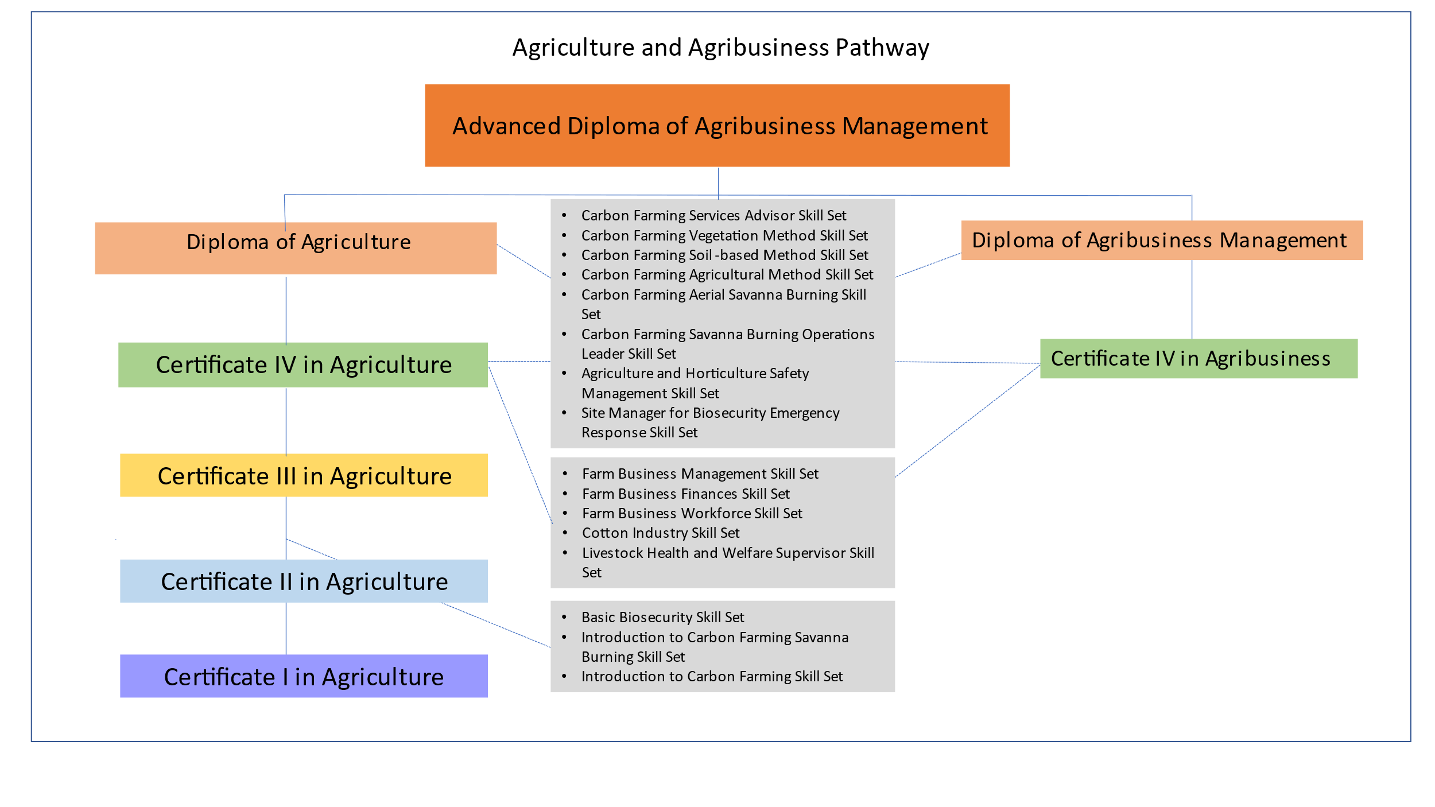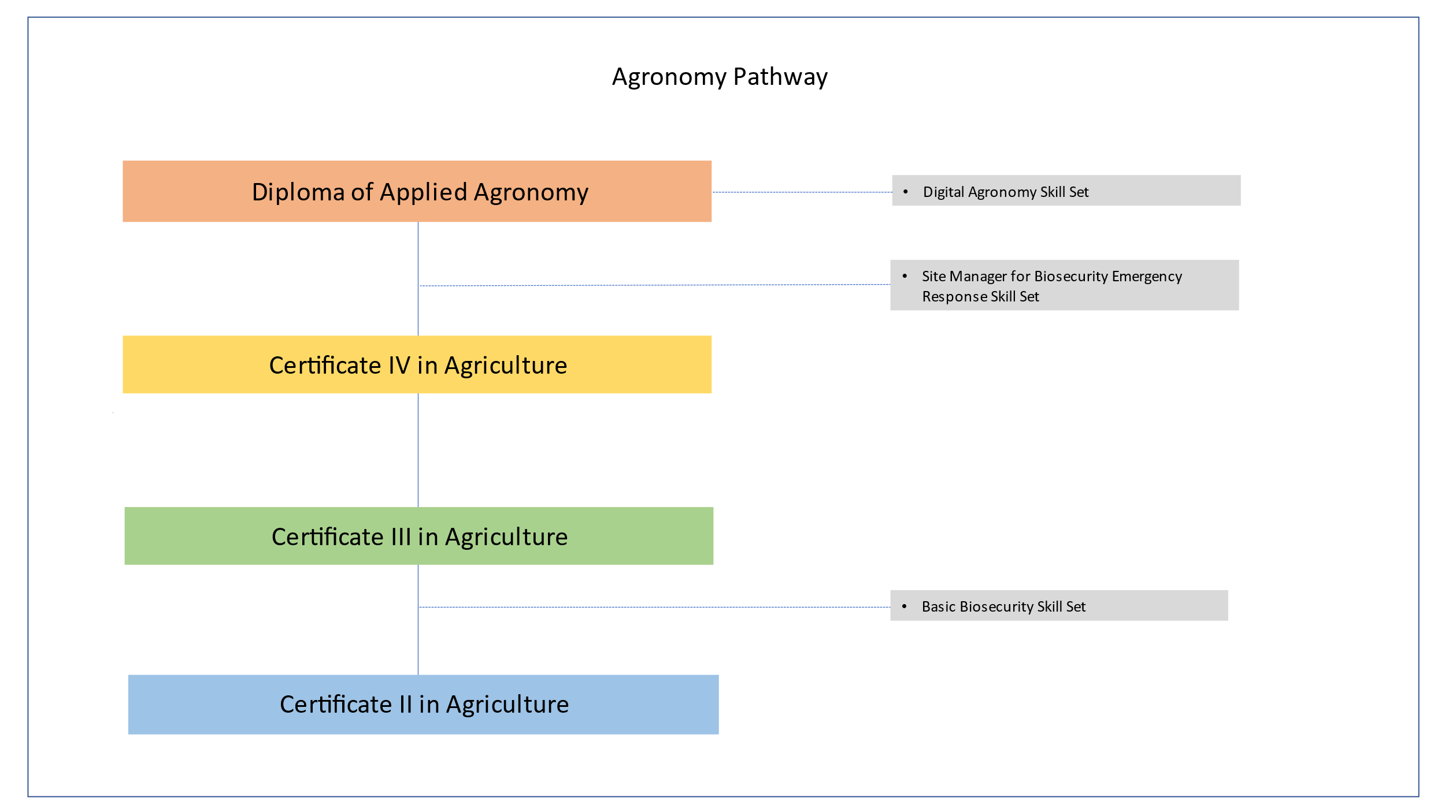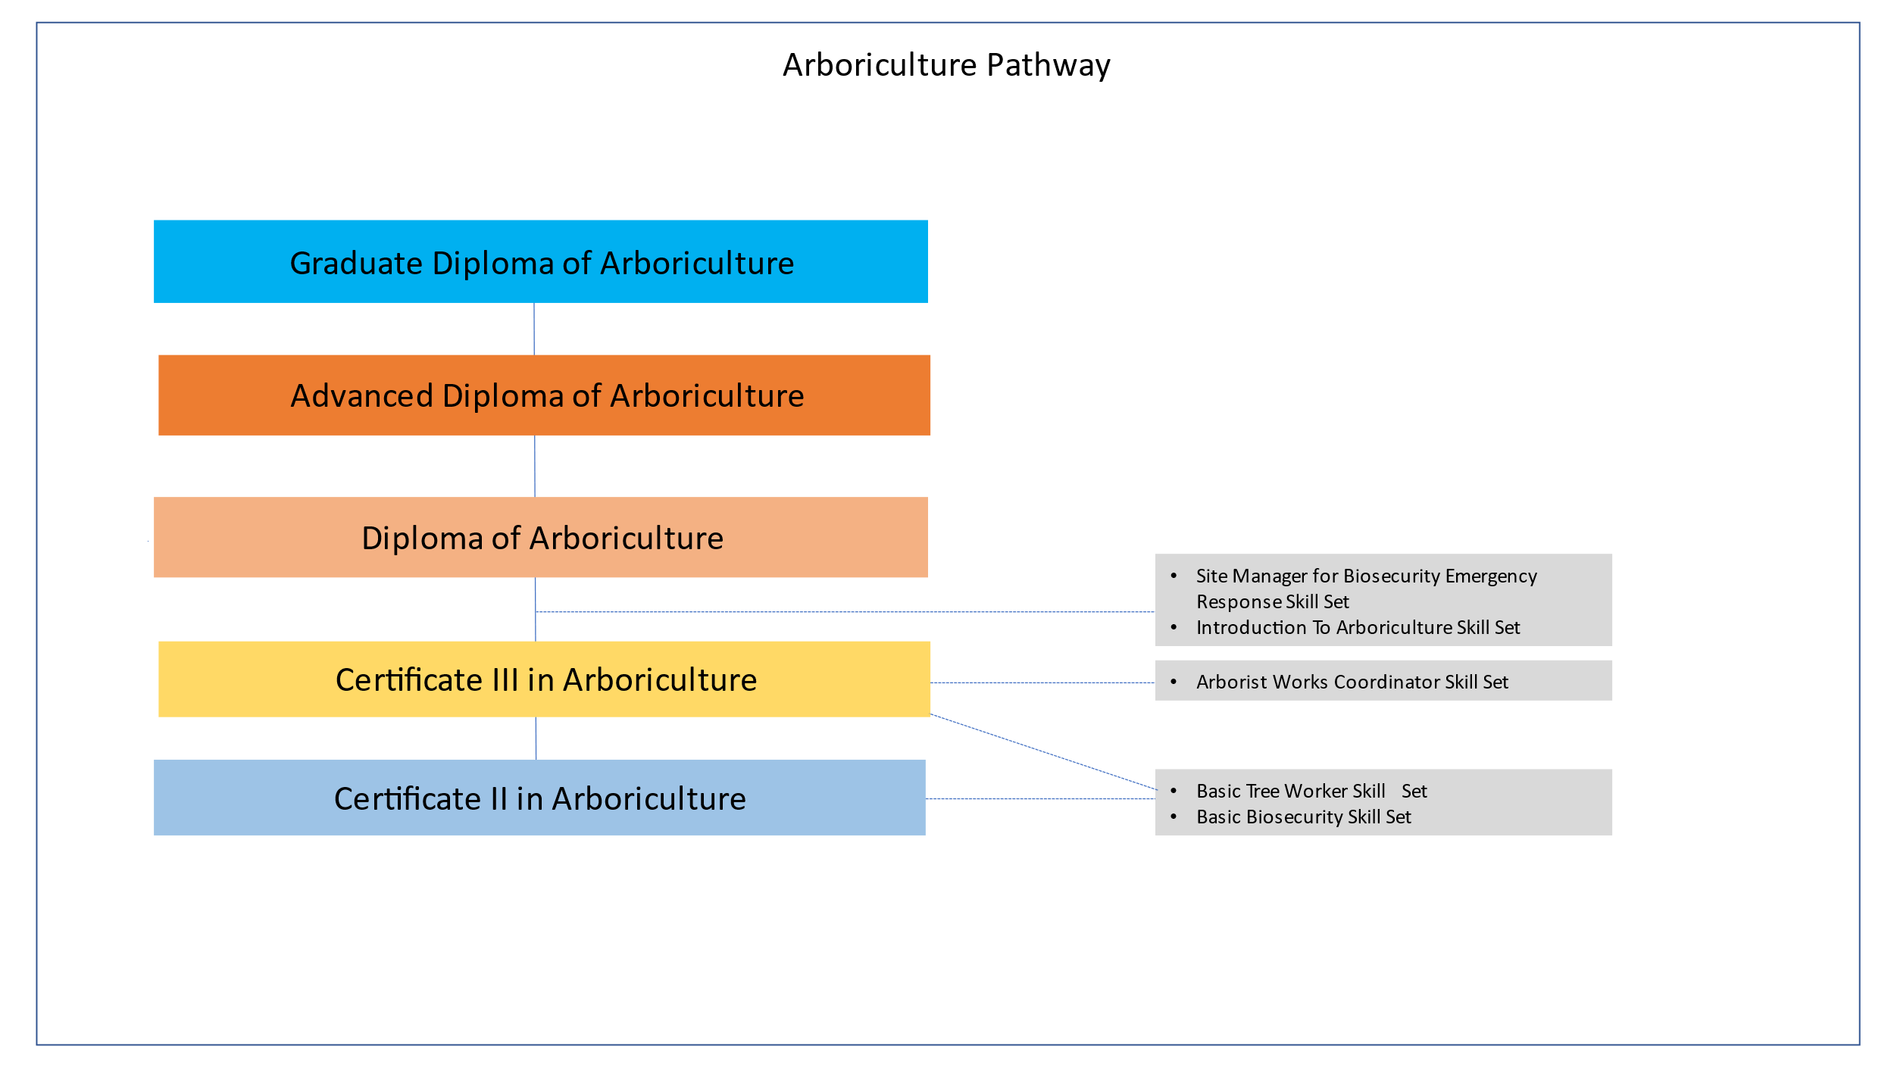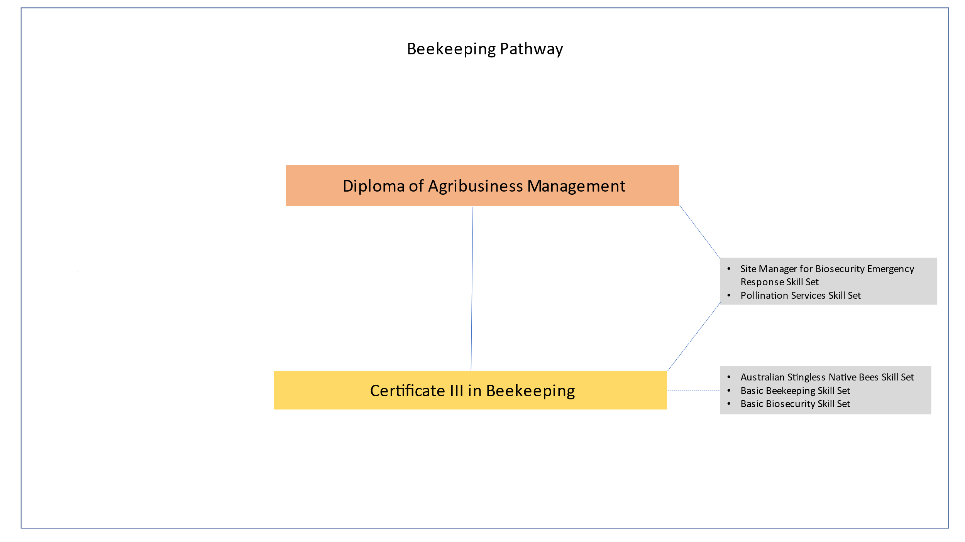
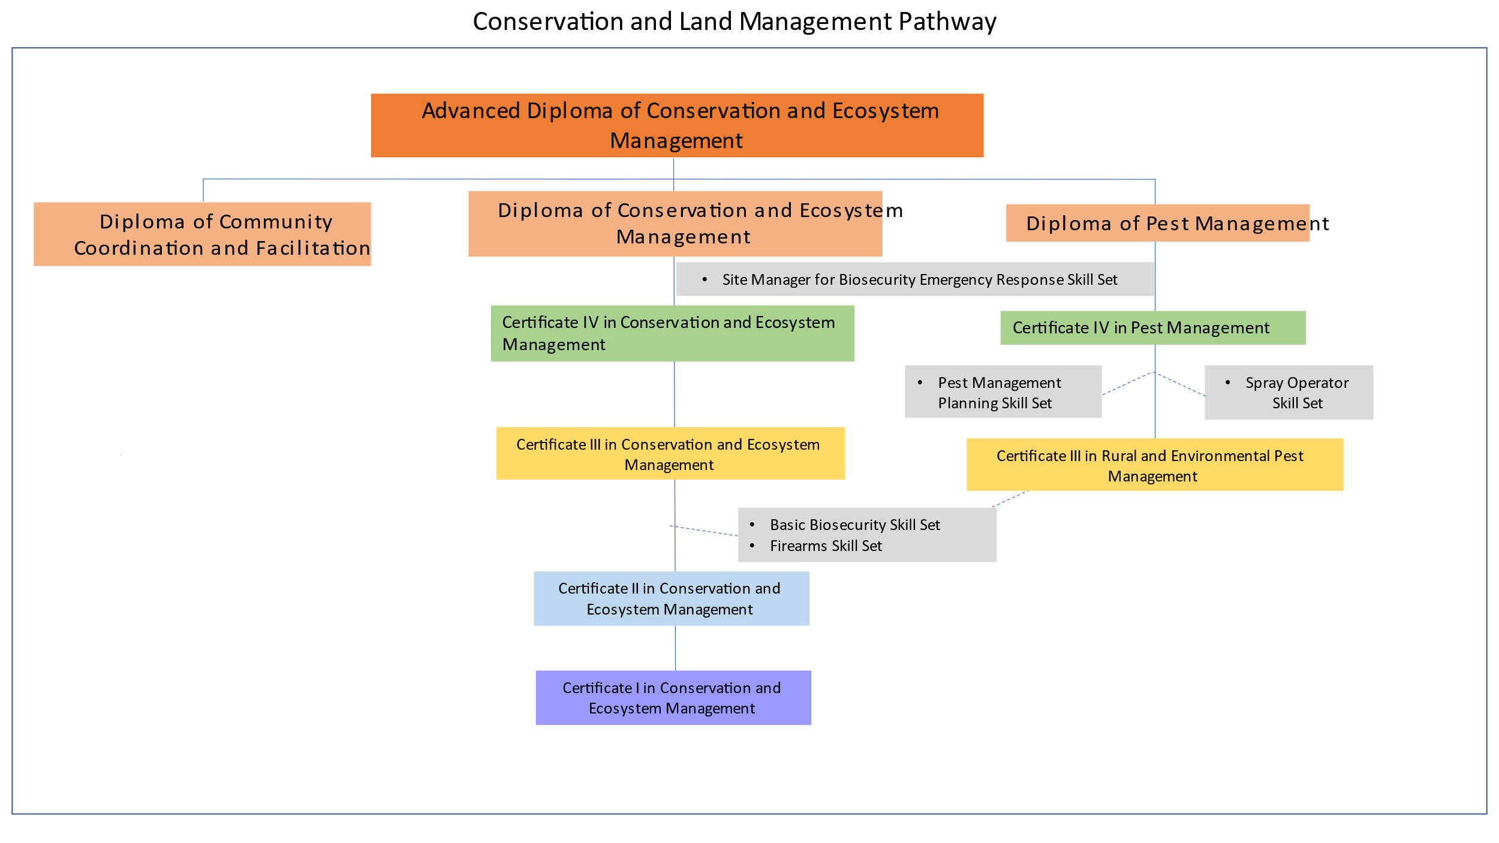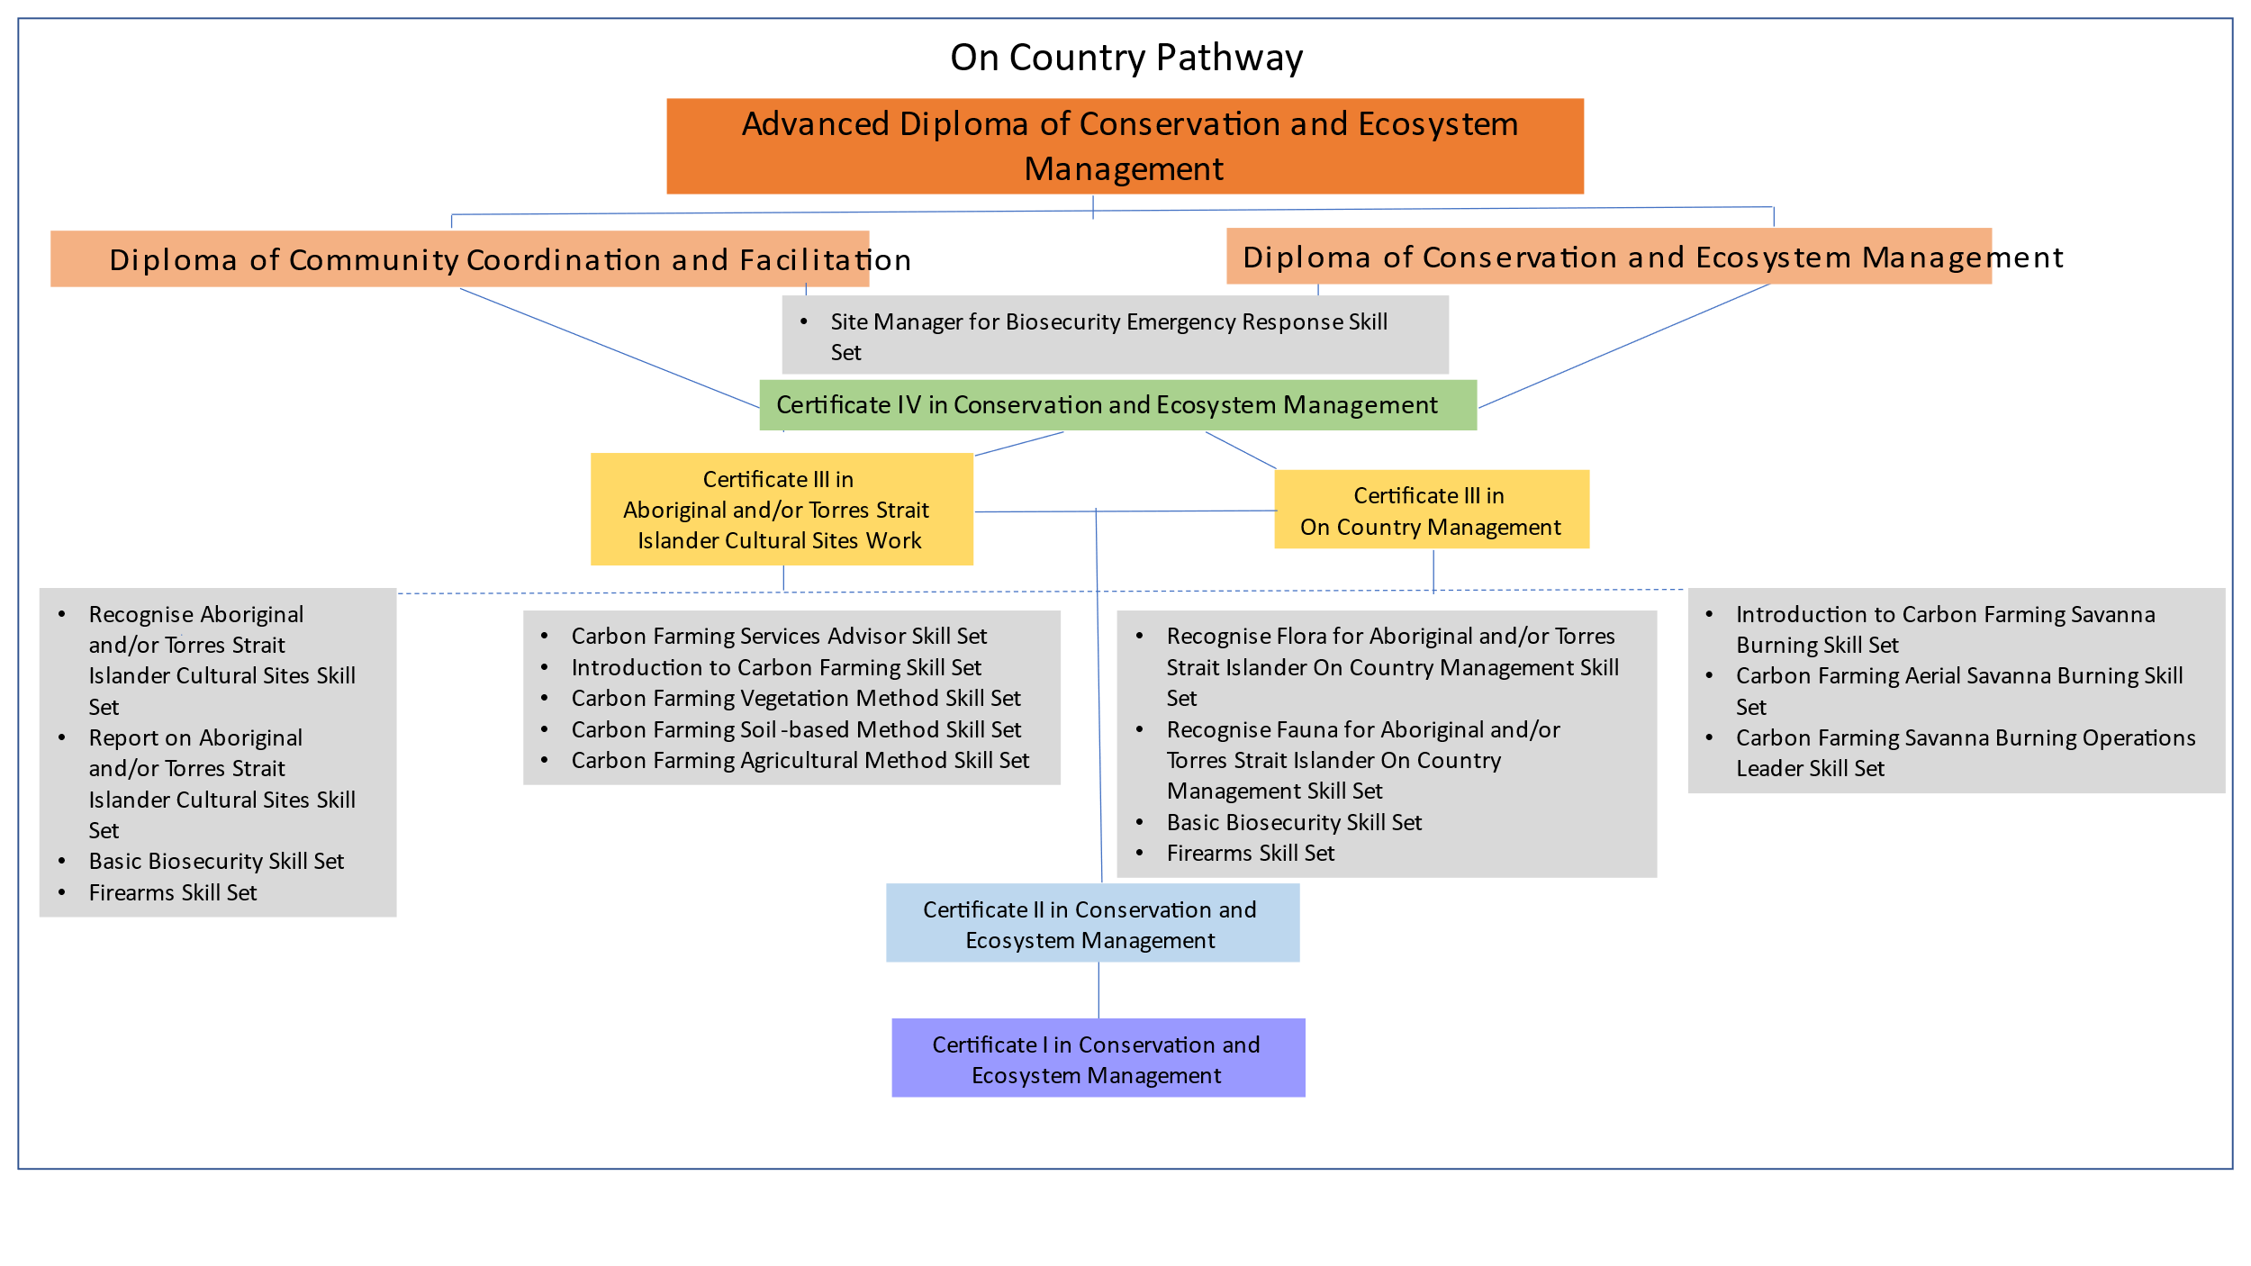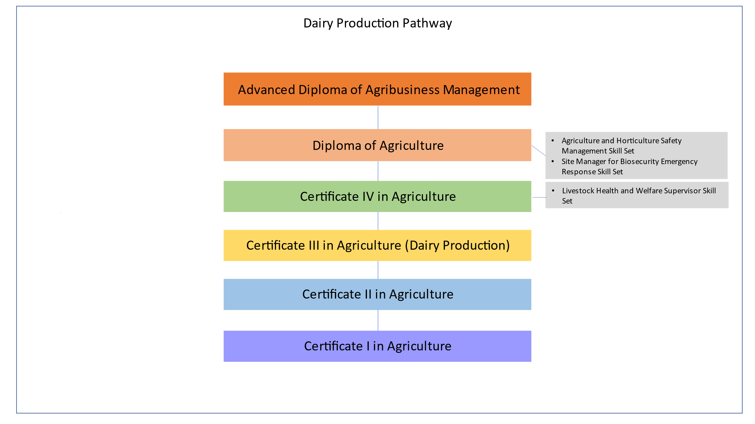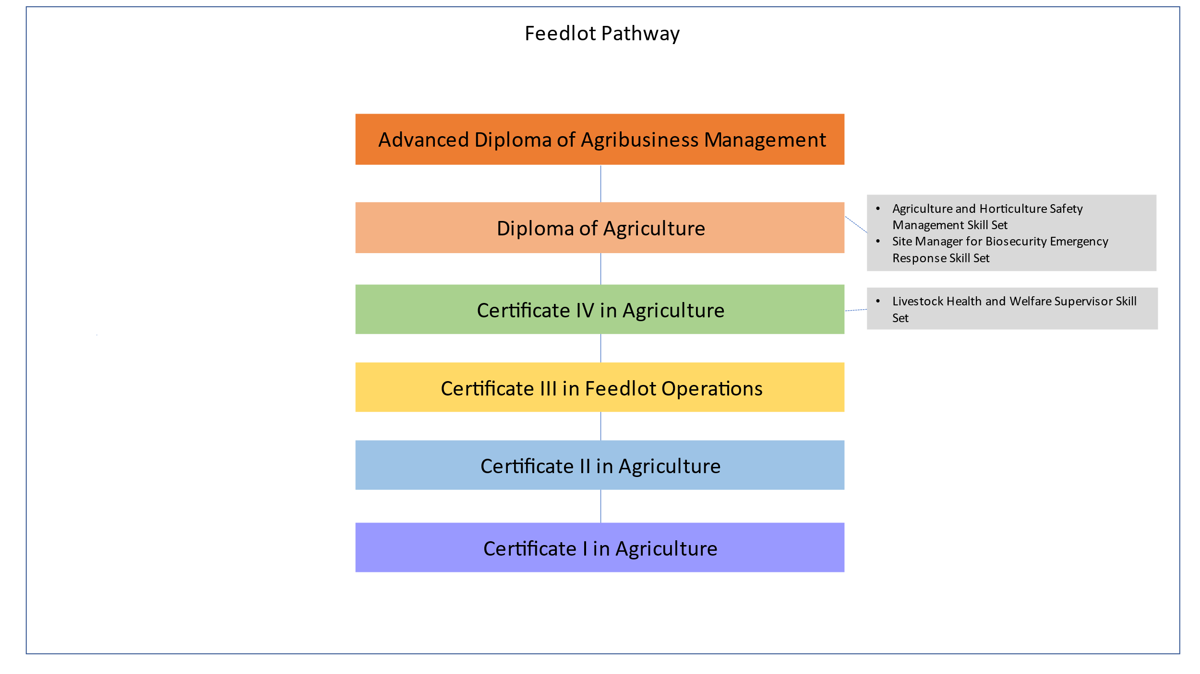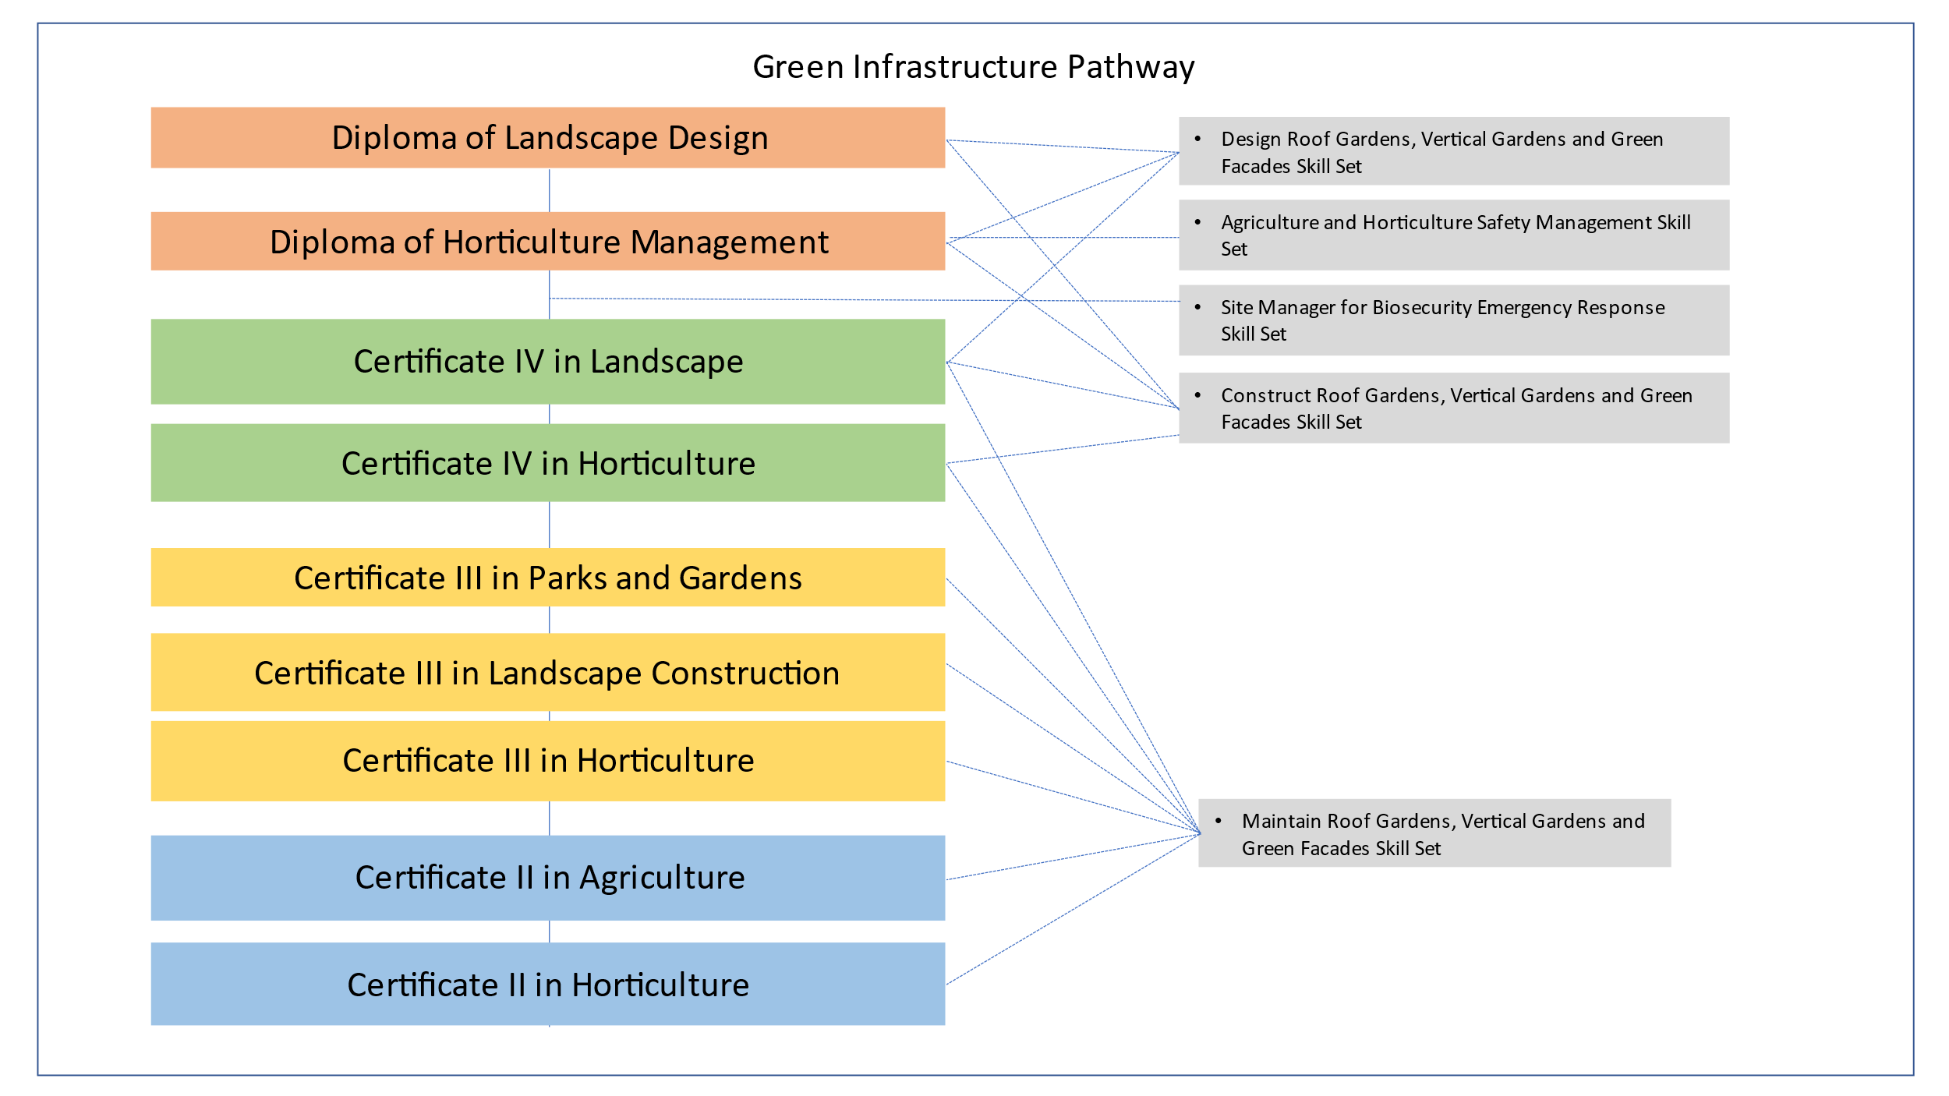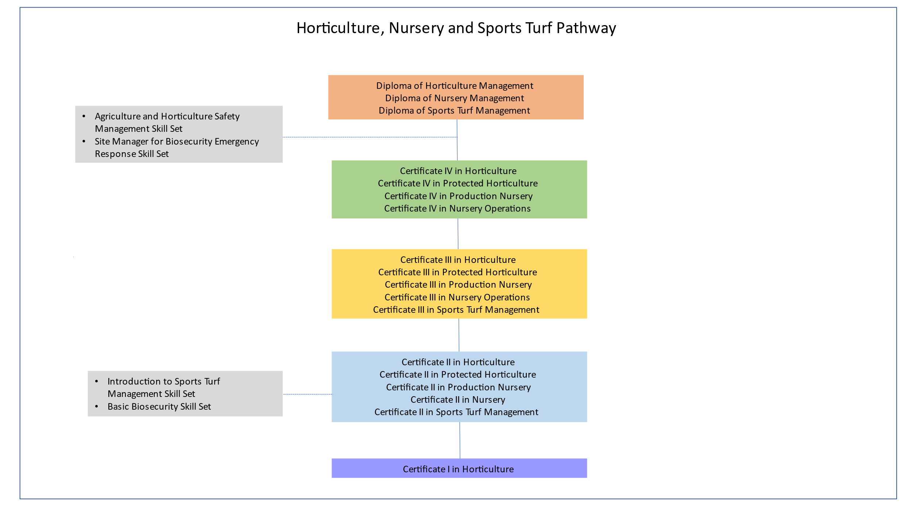
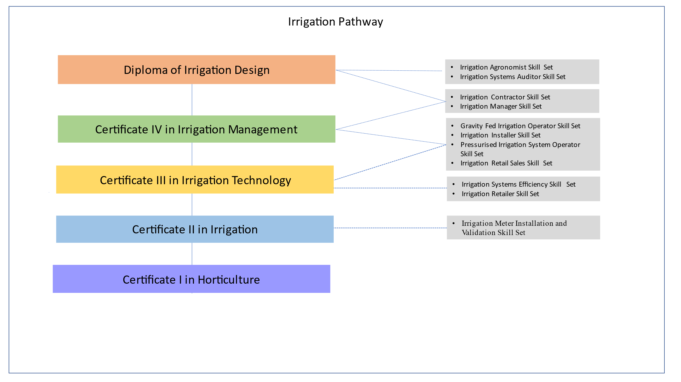
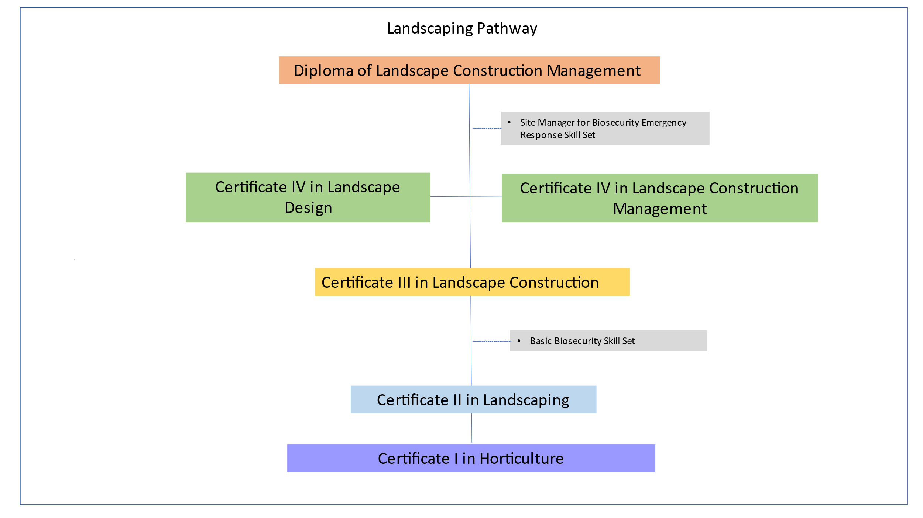
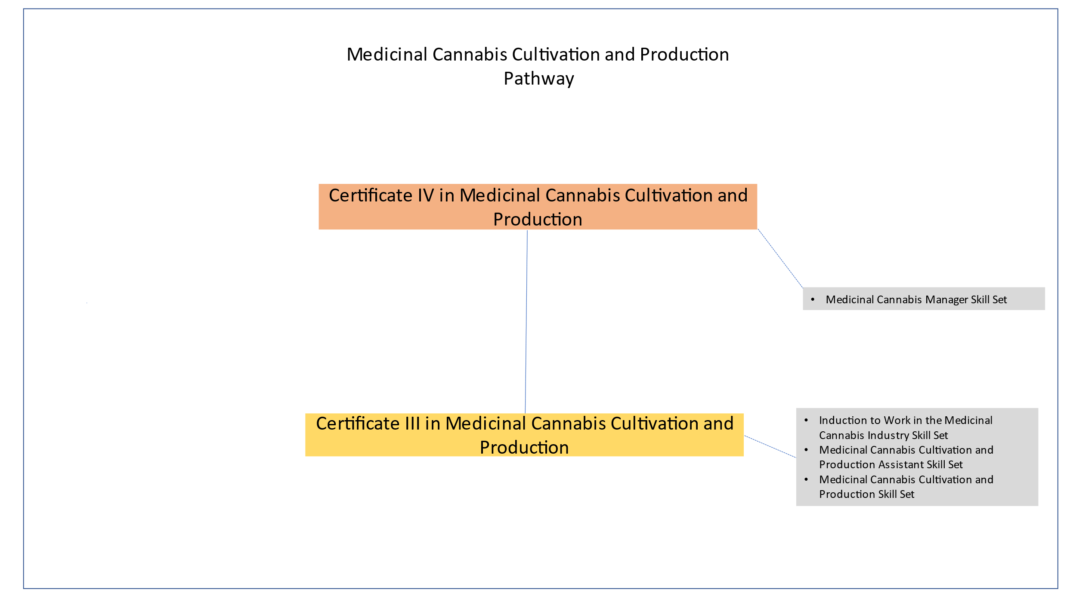
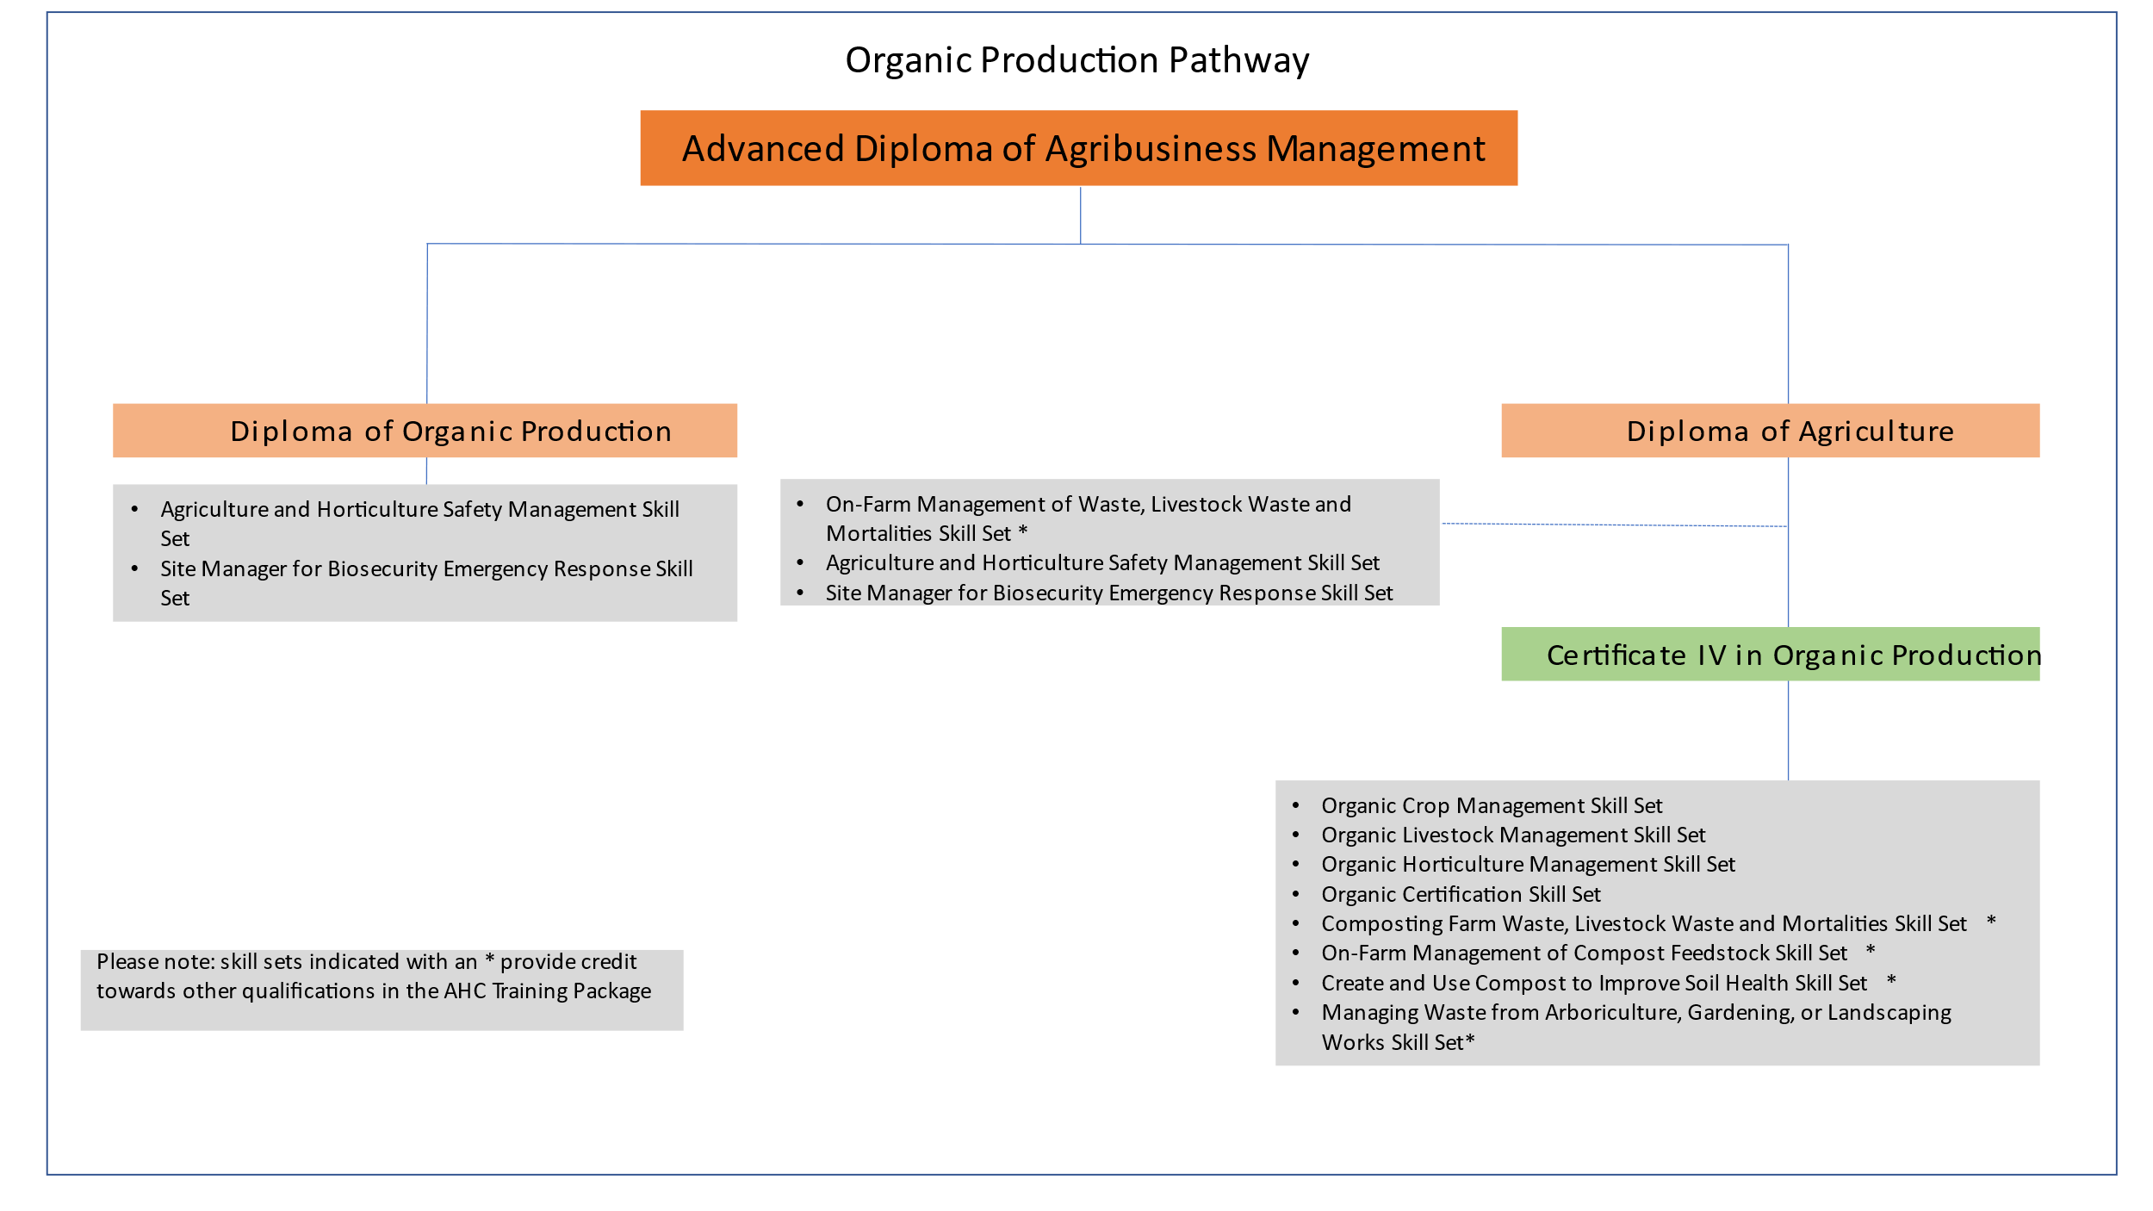
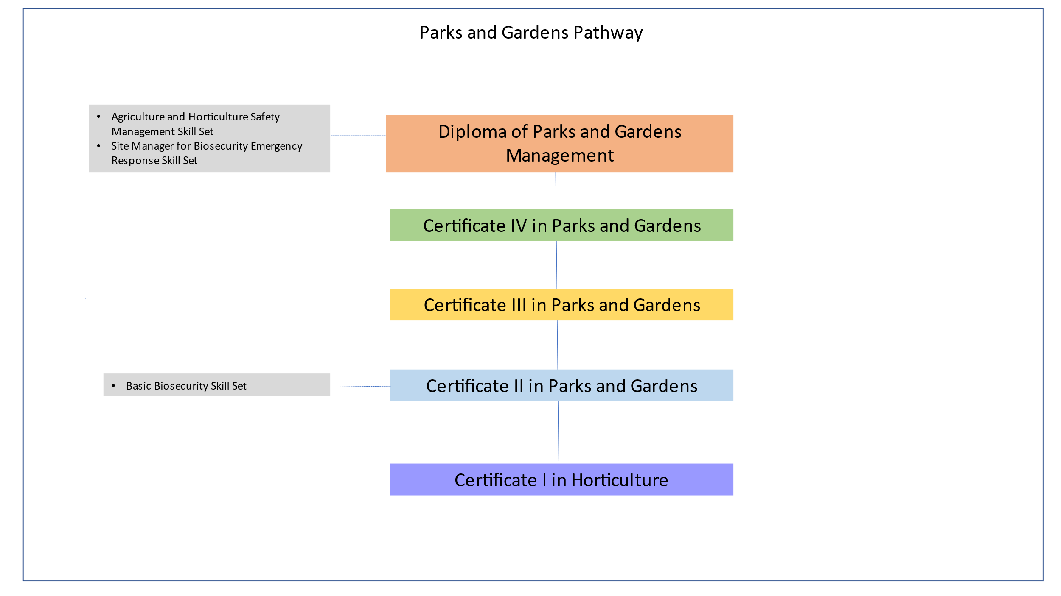
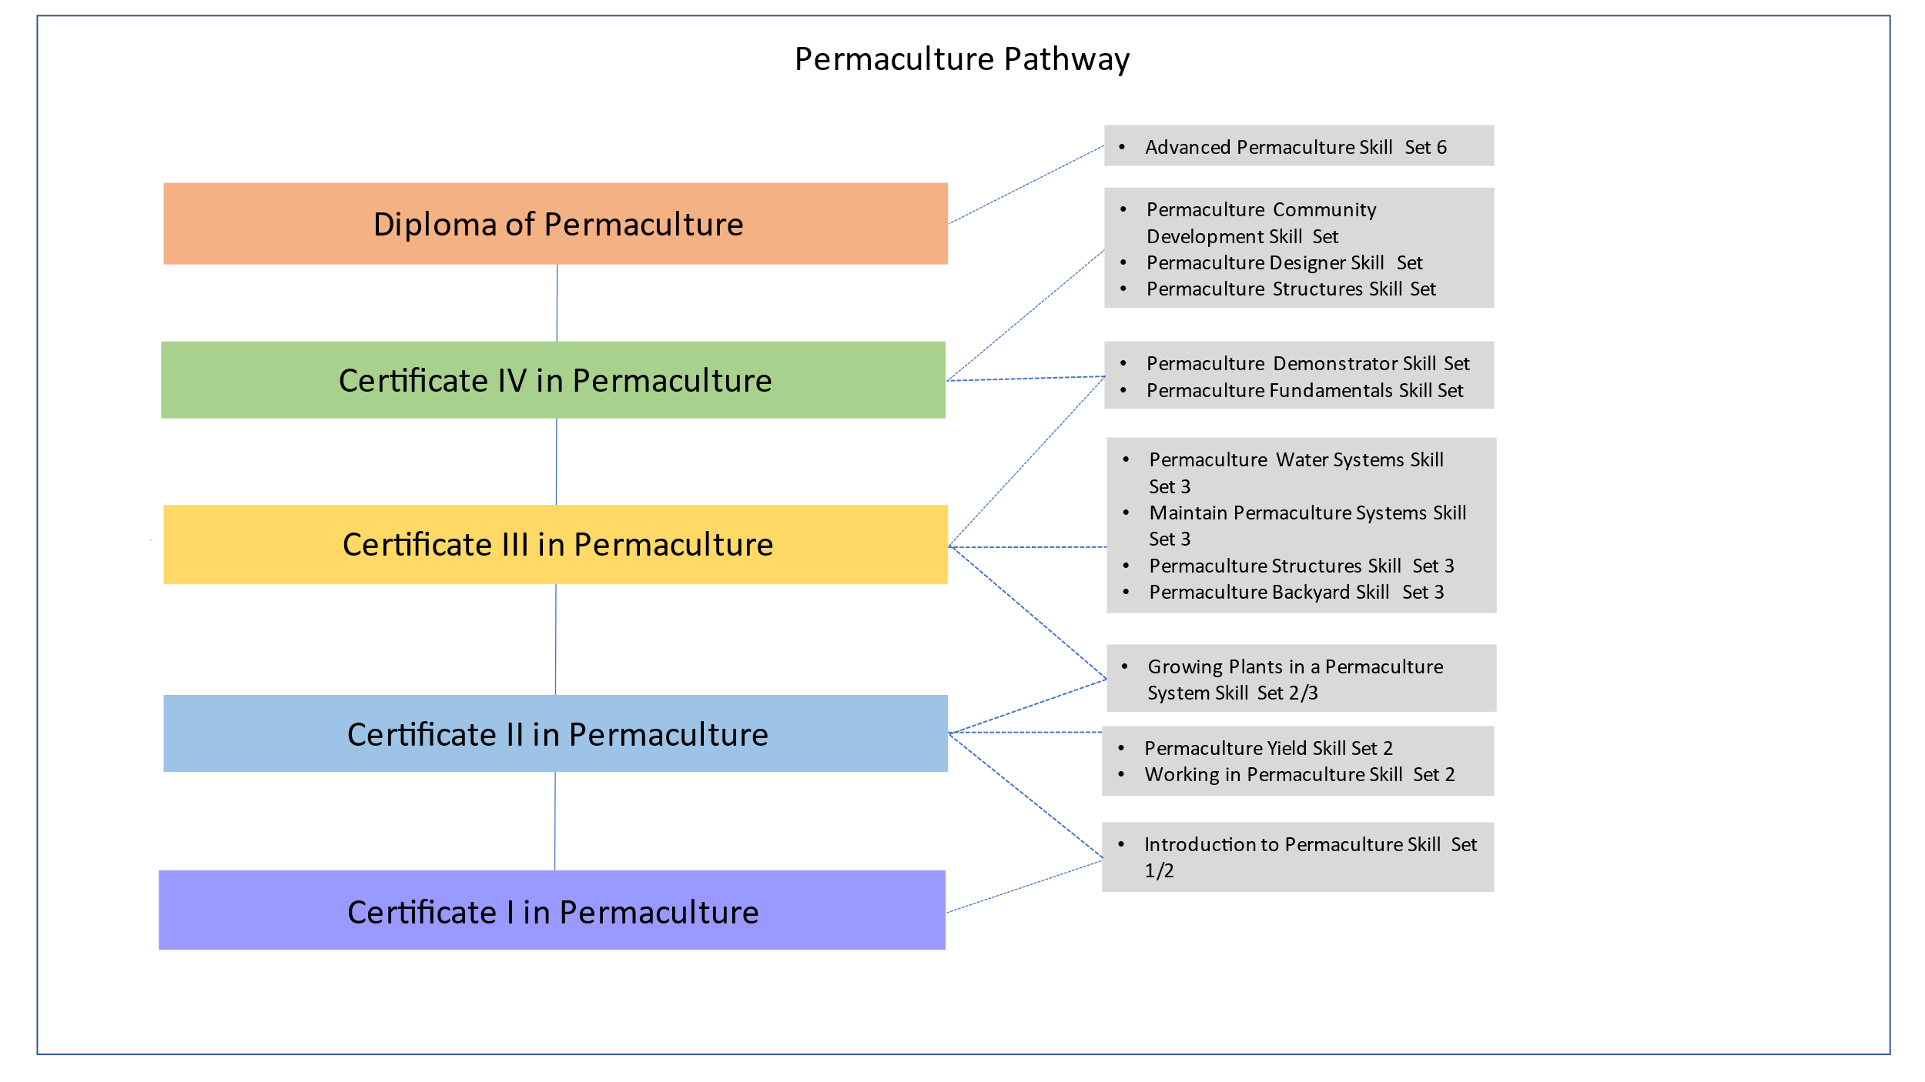
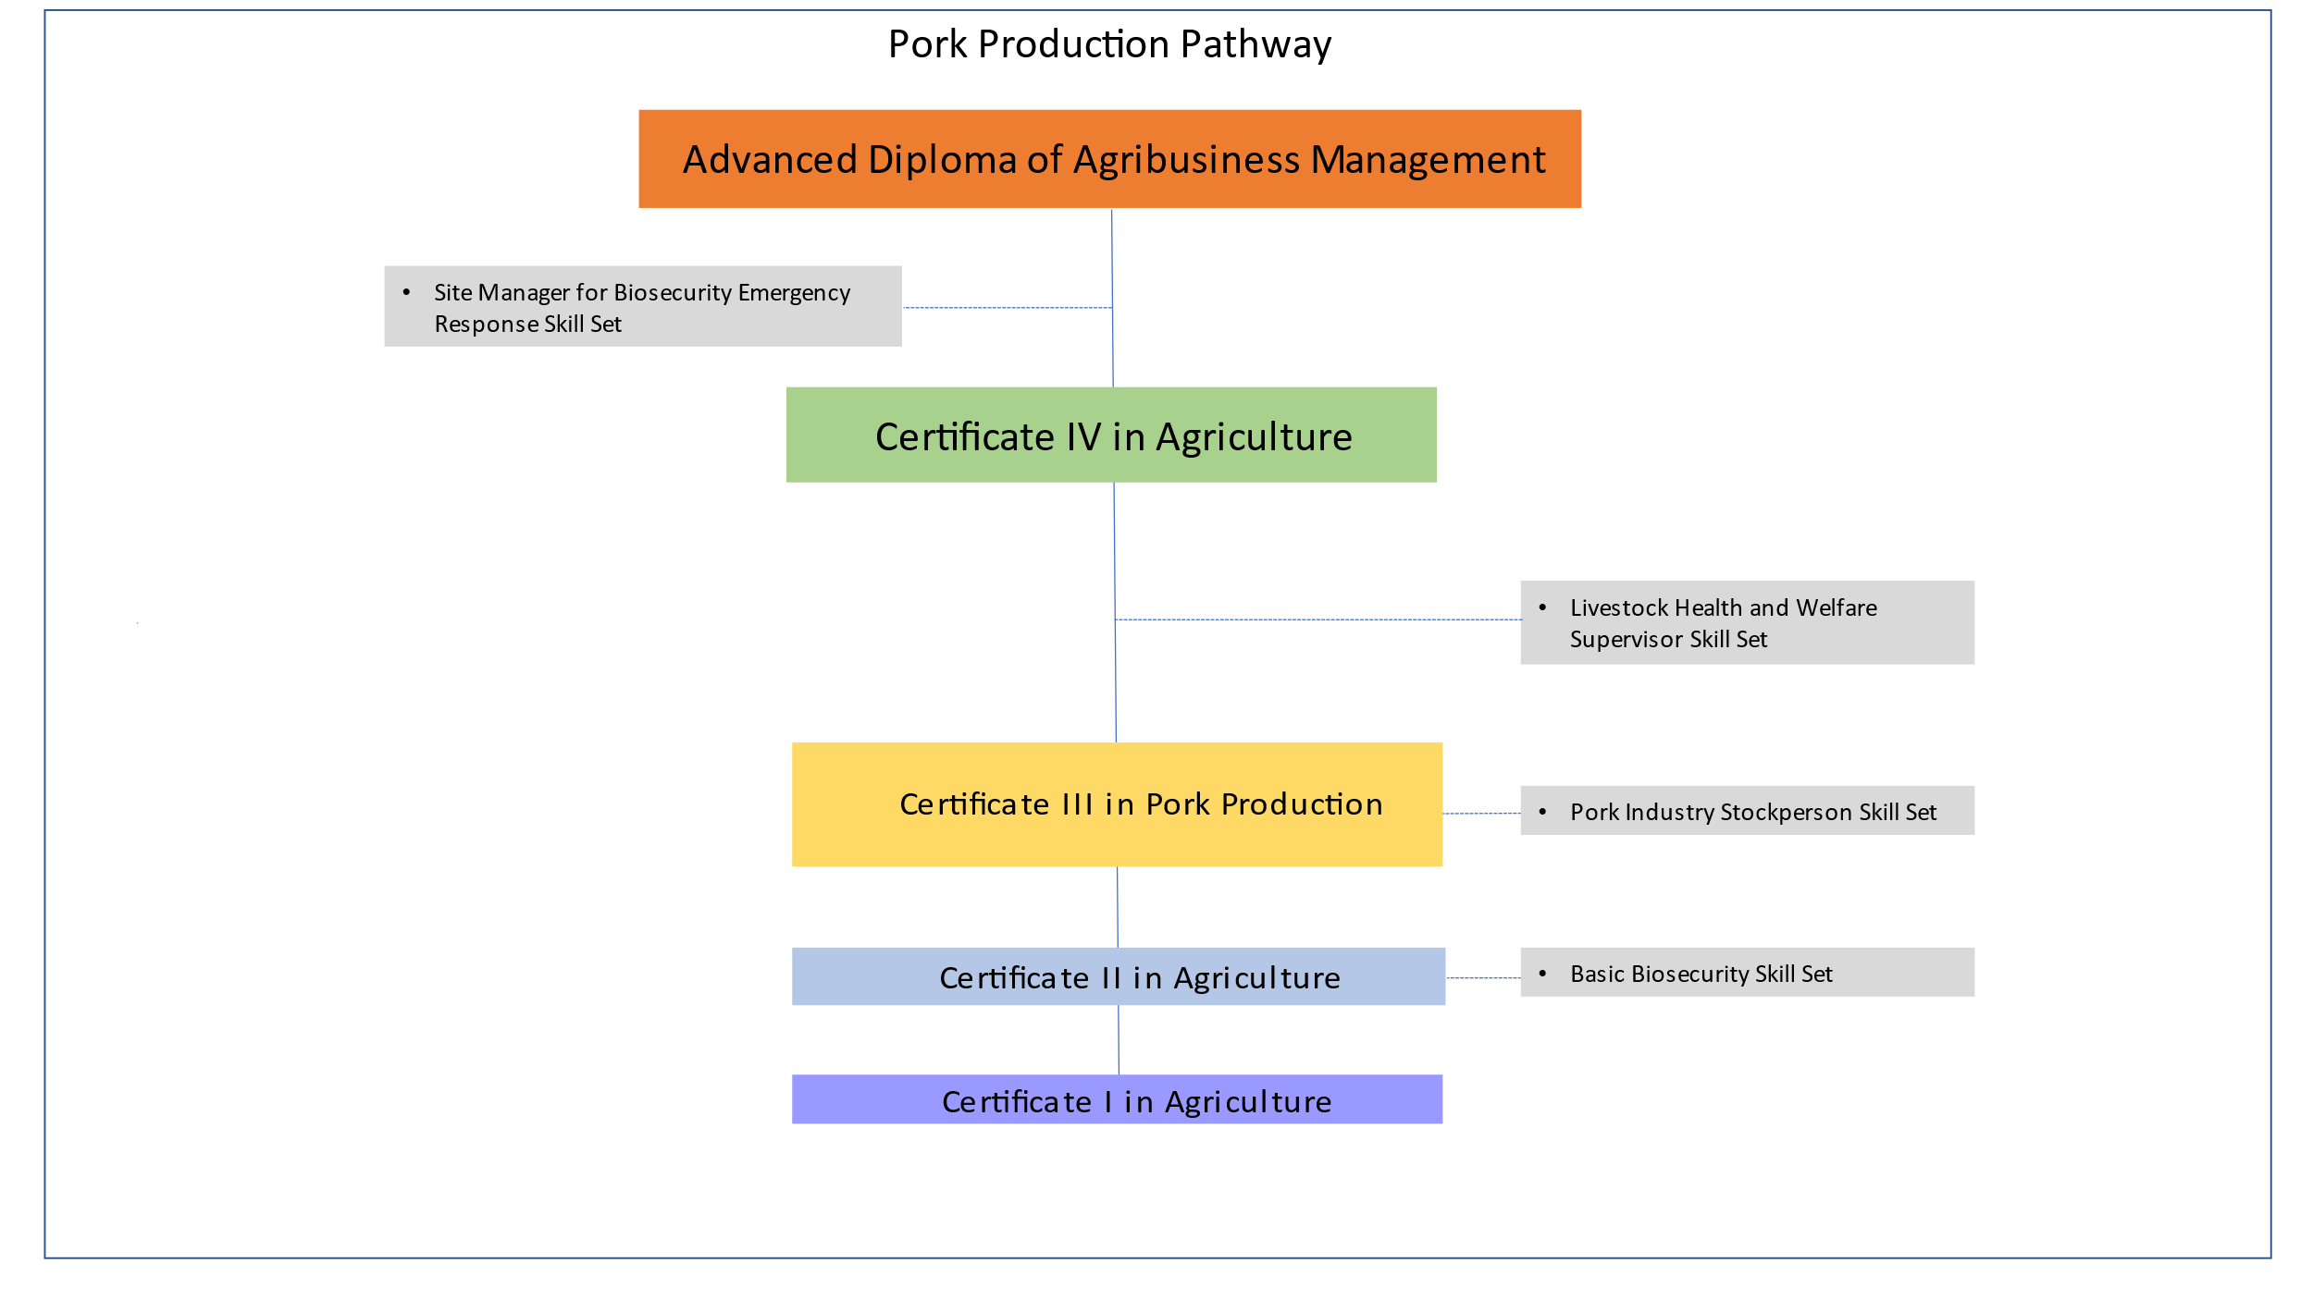
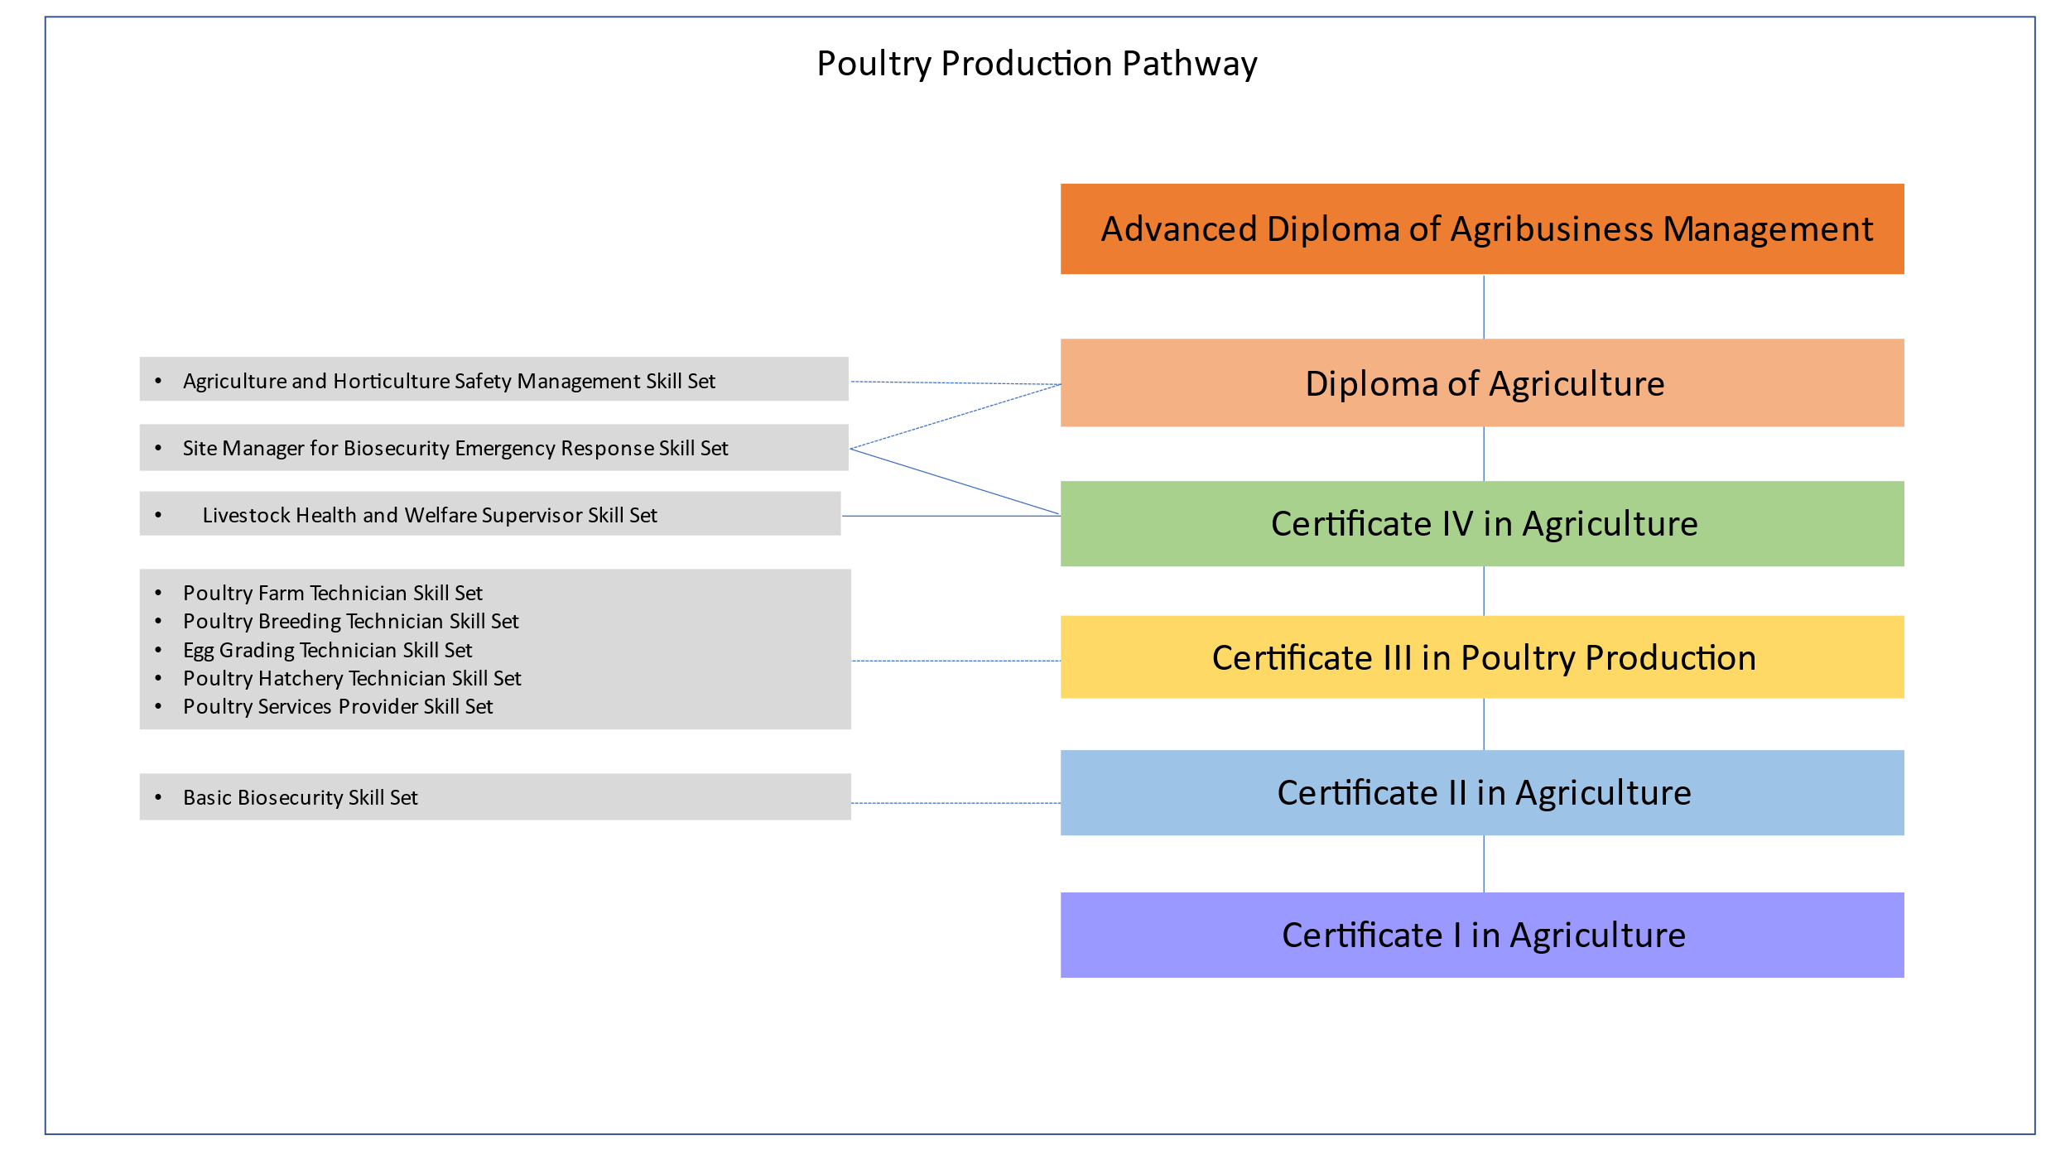
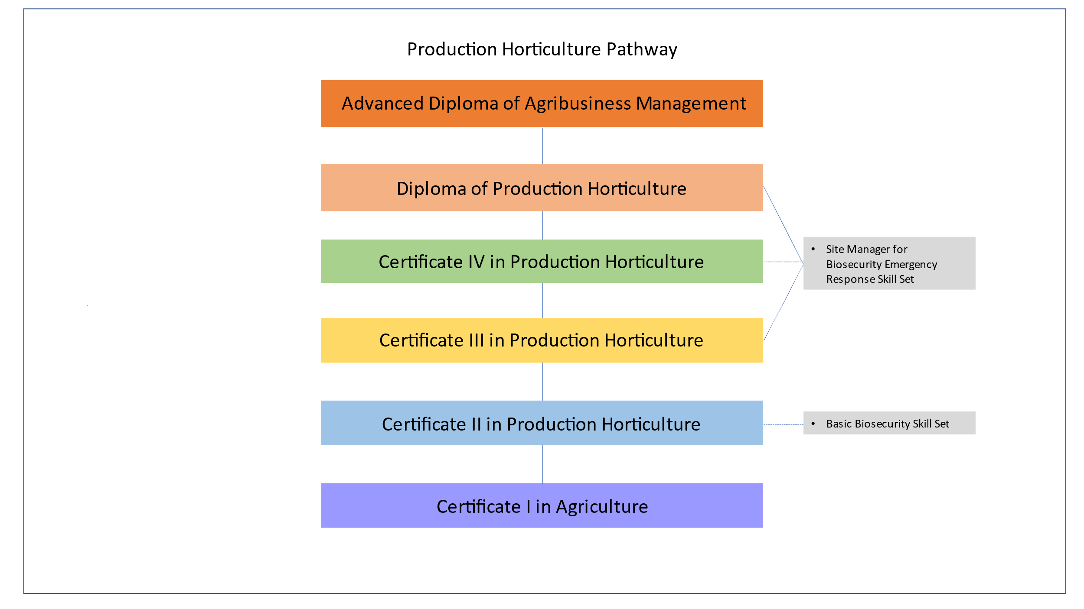
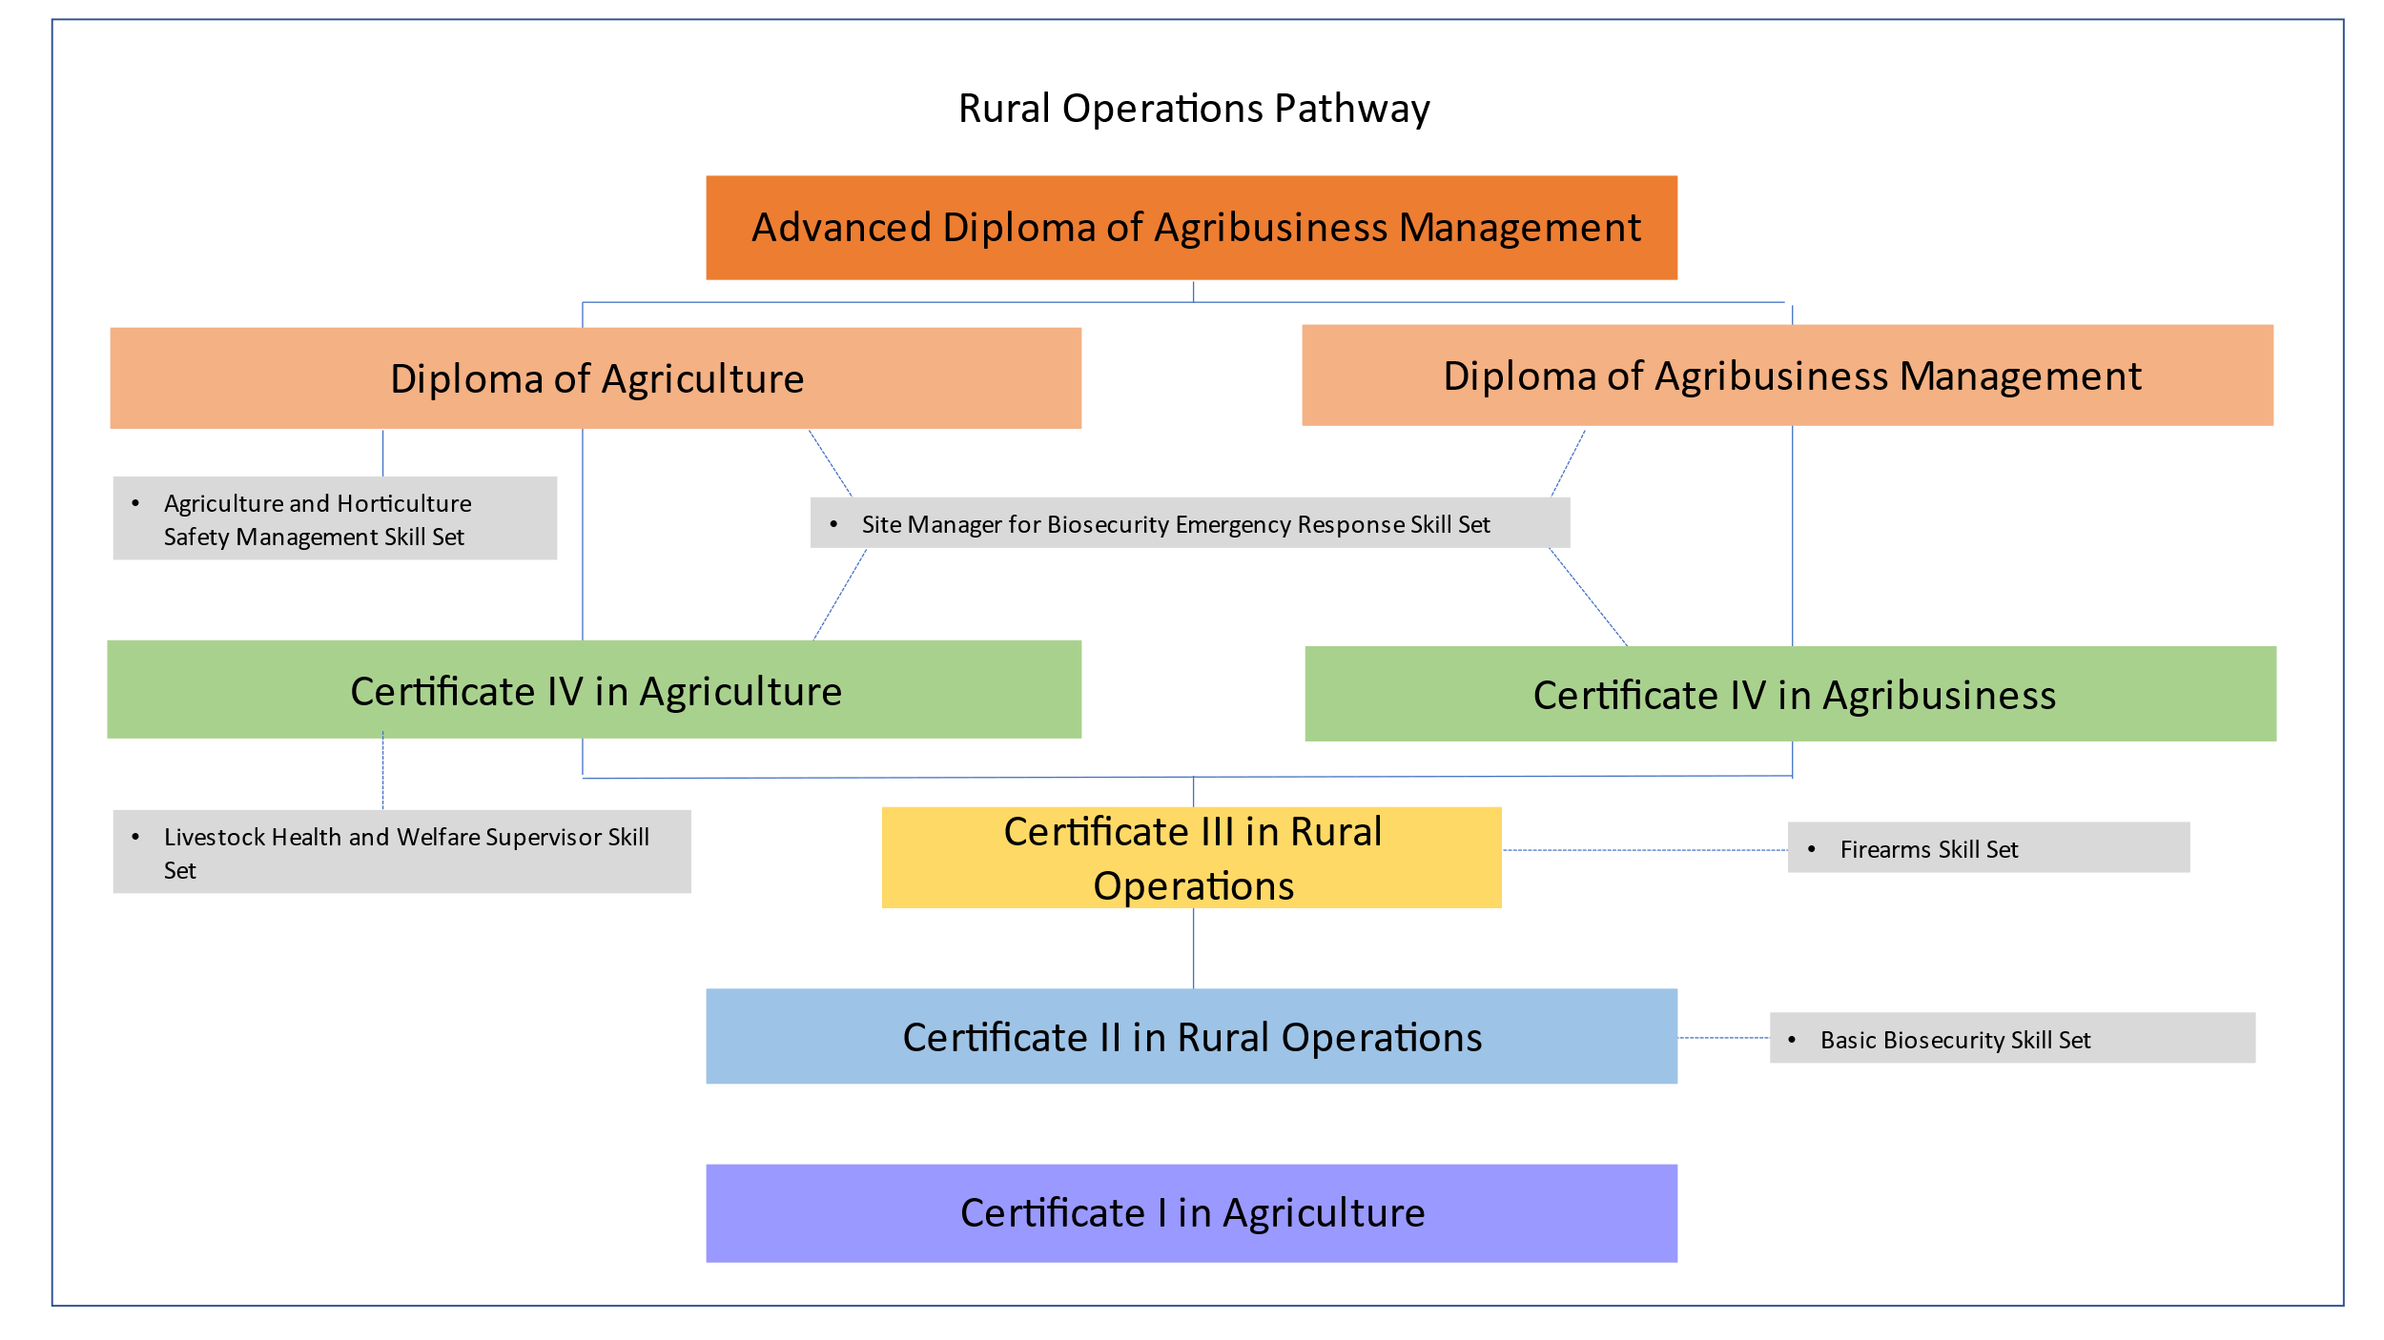
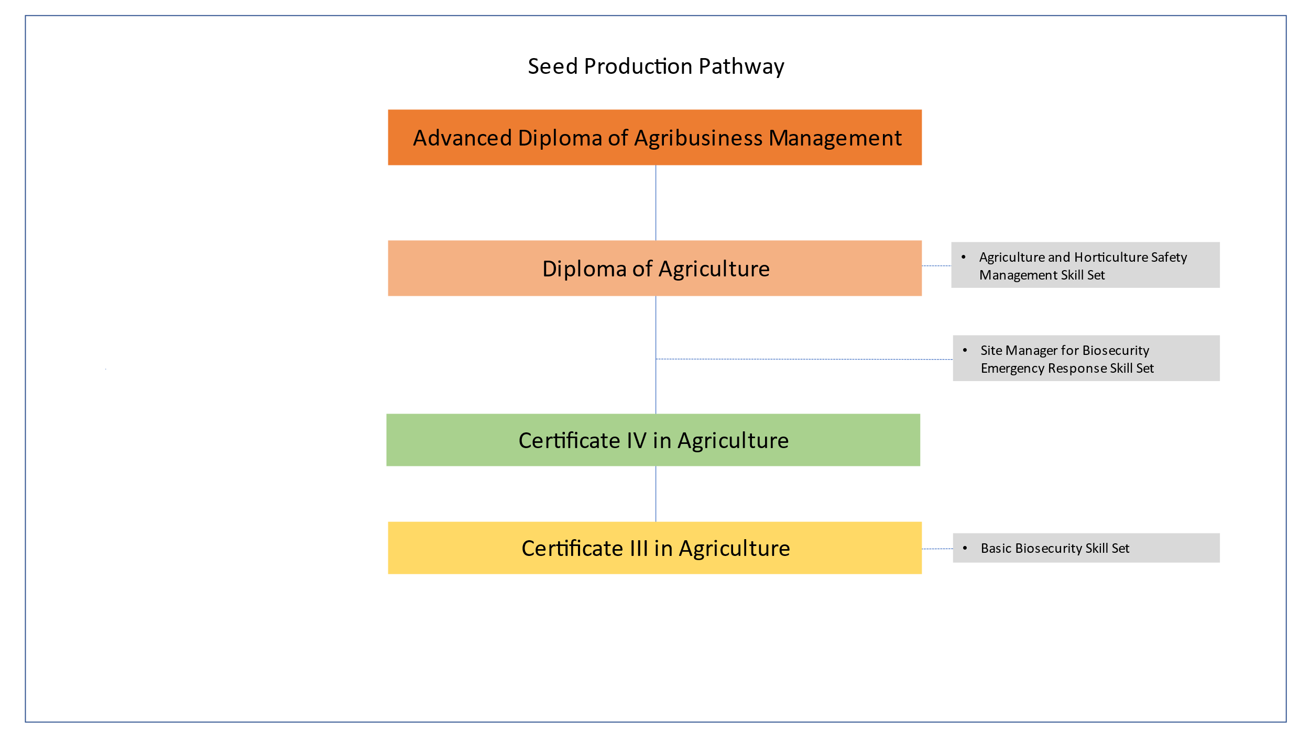
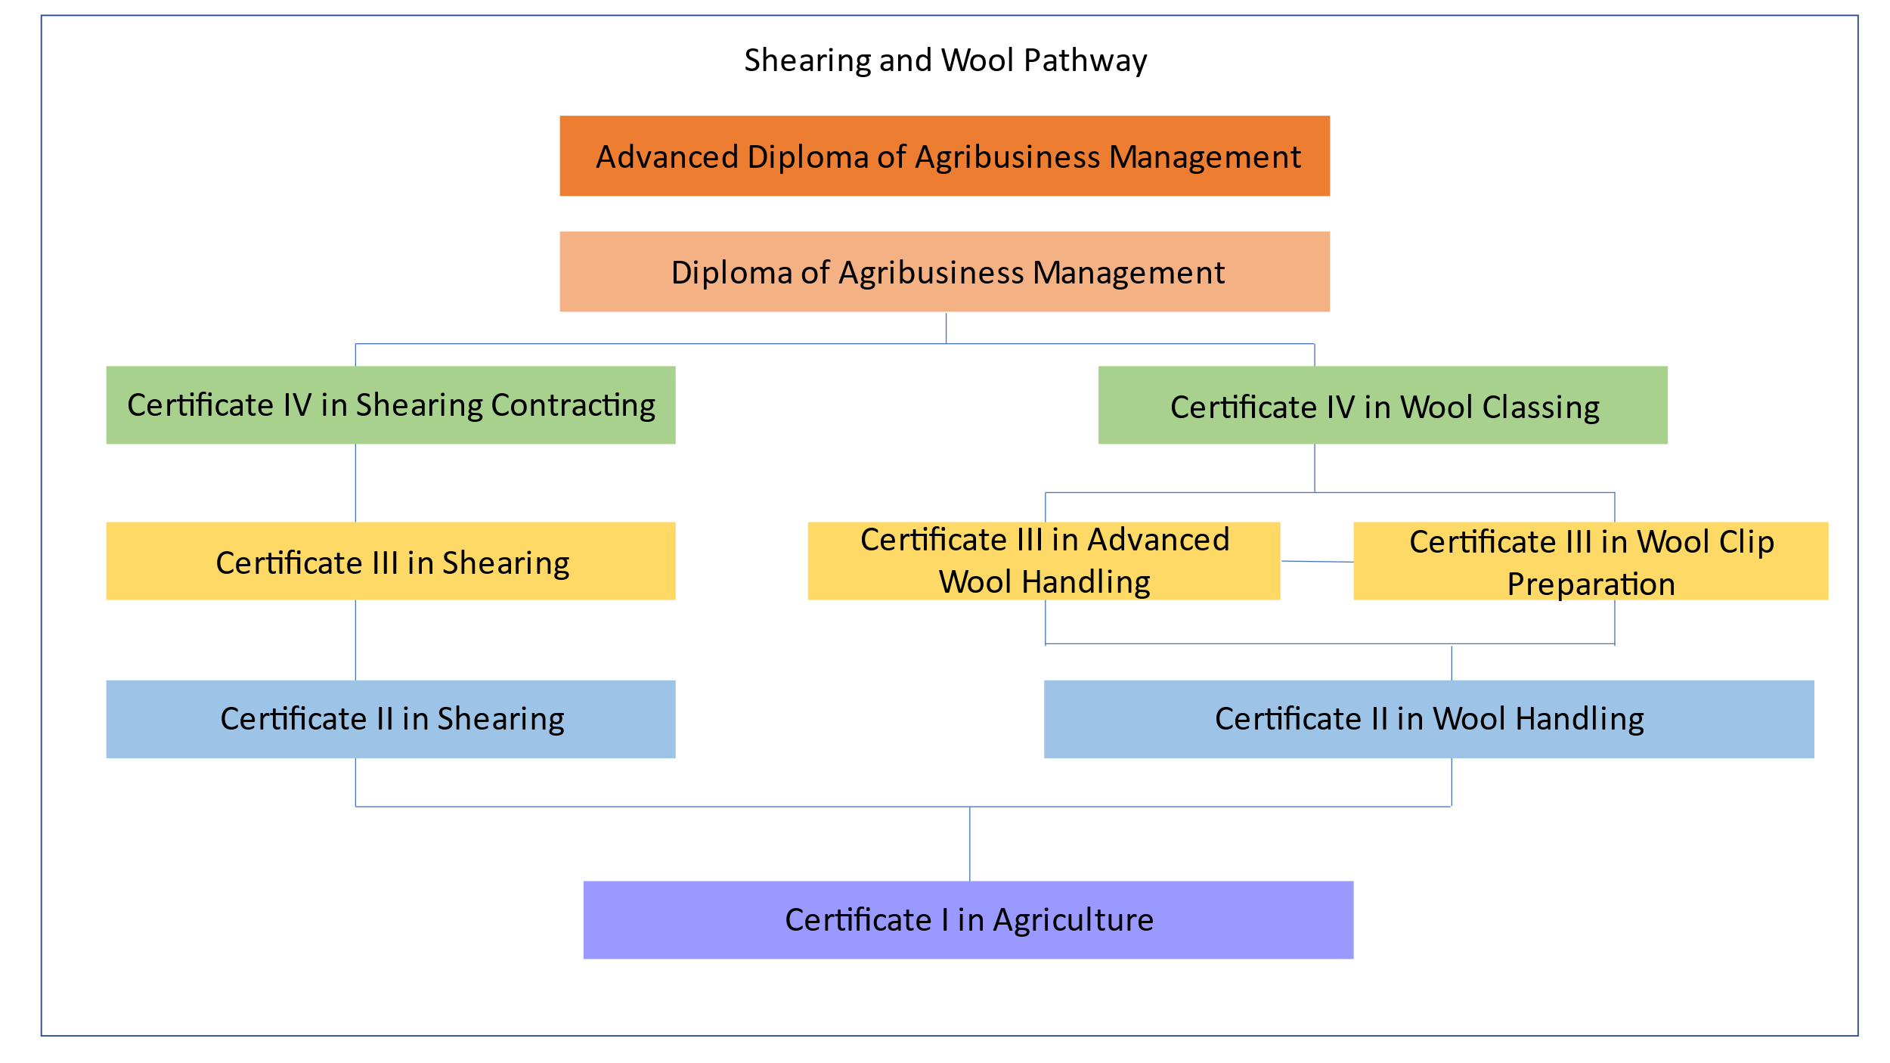
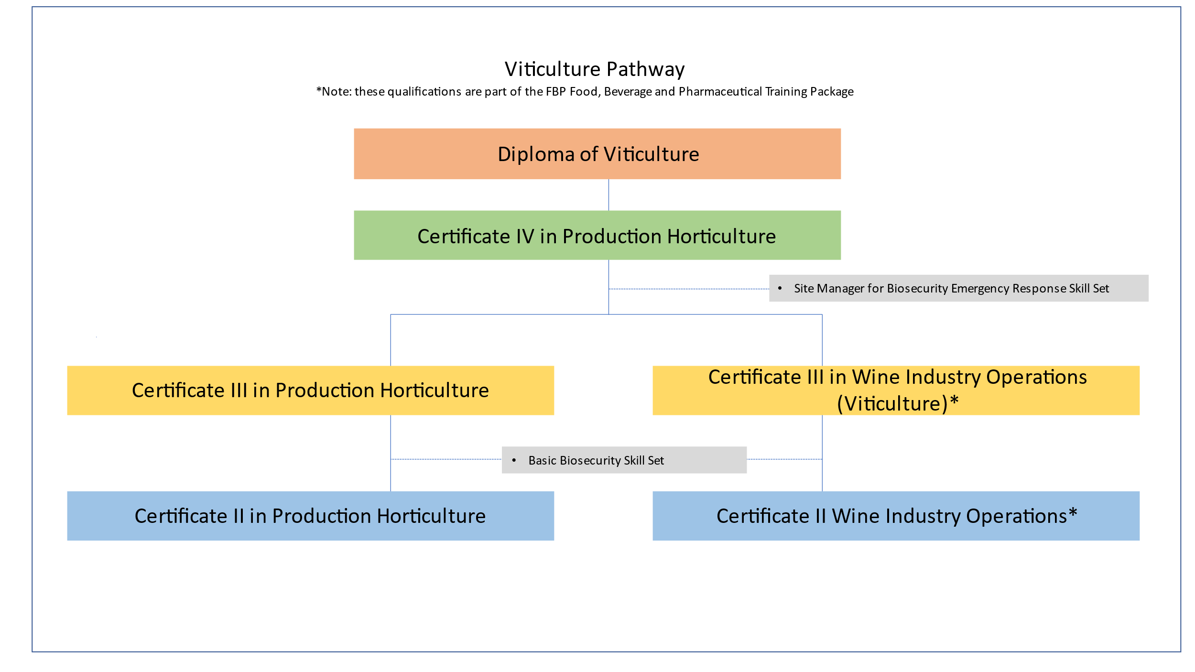

Entry requirements for qualifications
Any specific entry requirements for qualifications in the AHC Agriculture, Horticulture and Conservation and Land Management Training Package are included in each qualification. The entry requirements ensure an individual has the skills and knowledge required to undertake the qualification.

Qualification Code and Title | Entry Requirements
AHC32916 Certificate III in Shearing | Industry requirements for participation in Certificate III in Shearing is to demonstrate shearing skills and knowledge at Certificate II in Shearing level.
AHC51024 Diploma of Sports Turf Management | To commence this qualification an individual must have:  - completed a Certificate III in Sports Turf Management or an equivalent turf management trade level qualification  or  - a certificate III level qualification in amenity horticulture combined with two years current work experience in a trade level role at a sports turf facility.
AHC50524 Diploma of Arboriculture | To commence this qualification an individual must have achieved the following units of competency or their equivalent:  - AHCARB314 Implement a tree maintenance program  - AHCARB316 Perform pruning operations  - AHCARB323 Identify trees.
AHC60524 Advanced Diploma of Arboriculture | Prior to commencing the qualification, an individual must have:  - a diploma of arboriculture  or  - a diploma or higher qualification in a field related to arboriculture* plus 2 years current work experience as a consulting arborist or a municipal tree manager.
AHC80120 Graduate Diploma of Arboriculture | Prior to commencing the qualification, an individual must have:  - an advanced diploma of arboriculture  or  - an advanced diploma or higher qualification in a field related to arboriculture* plus 3 years current work experience as a consulting arborist or a municipal tree manager.
AHC40624 Certificate IV in Nursery Operations | To commence this qualification, individuals must demonstrate they have skills and knowledge in the application of:  - cultivating, growing and harvesting/production skills for a variety of plant types, including pest and disease control  - technology and equipment that apply in a production nursery or retail nursery workplace  - health and safety, pest management and biosecurity processes and regulations that apply in a production nursery or retail nursery workplace  The skills and knowledge may have been acquired through completion of a Certificate III or higher qualification relating to nursery or horticulture, or industry experience.
AHC50422 Diploma of Horticulture Management | Prior to commencing this qualification an individual must:  - have completed the following units of competency (or equivalent):  - AHCCHM304 Transport and store chemicals  - AHCCHM307 Prepare and apply chemicals to control pest, weeds and diseases  - AHCPCM308 Identify and select plants  - AHCPMG301 Control weeds  - AHCPMG302 Control plant pests, diseases and disorders  - AHCSOL304 Implement soil improvements for garden and turf areas  - AHCWHS302 Contribute to workplace health and safety processes  OR  have relevant equivalent skills and knowledge acquired through participation in the horticulture industry.
AHC50820 Diploma of Nursery Management | To commence this qualification, individuals must demonstrate they have skills and knowledge in the application of:  - cultivating, growing and harvesting/production skills for a variety of plant types, including pest and disease control  - technology and equipment that apply in a production nursery or retail nursery workplace  - health and safety, pest management and biosecurity processes and regulations that apply in a production nursery or retail nursery workplace  - The skills and knowledge may have been acquired through completion of a Certificate III or higher qualification relating to nursery or horticulture, or industry experience.
Entry requirements for the post trade qualifications in Arboriculture

Diploma of Arboriculture
The entry requirements for AHC50524 Diploma of Arboriculture are three units from the Certificate III that provide a foundation of arborist skills and knowledge. The entry requirement has been added to ensure that prospective learners can successfully complete the Diploma. Industry experts advised that individuals must have attained enough practical tree skills and knowledge for them to be able to provide sound advice when employed as a Consultant or Tree Manager. This concern was also reflected in the Case for Change that states “arborists are not regulated, and so certified companies are losing business to inadequately qualified traders, whose lack of knowledge undermines the industry and can be harmful to trees, plants and the wider environment.”
The industry is keen to attract people from related sectors such as Amenity Horticulture and Forestry, and industry experts warned of the dangers of allowing people without sufficient tree care experience to complete a Diploma and become self-employed consultants. The experts agreed that the following entry requirement would be sufficient to provide a sound foundation of arborist skills and knowledge prior to commencing the revised Diploma:
To commence this qualification an individual must have achieved the following units of competency or their equivalent:
- AHCARB314 Implement a tree maintenance program
- AHCARB316 Perform pruning operations
- AHCARB323 Identify trees.

It should be noted that the three units above are in the core of the revised Certificate III and have also been packaged in to the new AHCSS00104 Introduction to Arboriculture Skill Set. People undertaking this skill set from non-arboriculture backgrounds may choose to enrol in the Diploma or decide to complete the Certificate III prior to embarking on the Diploma. Whichever pathway an individual decides to take, industry will have the confidence that these individuals have the necessary skills and experience to be competent consultants or tree managers.

Advanced Diploma of Arboriculture and Graduate Diploma of Arboriculture
These qualifications build on specialist skills and knowledge acquired through learning and experience from working in the arboriculture industry. Without this knowledge and experience the prospective student would not have sufficient understanding of the complexities of arboriculture work to complete this qualification.
As of July 2019, there have been no enrolments in the existing AHC60524 Advanced Diploma of Arboriculture and AHC80116 Graduate Diploma of Arboriculture since their release in 2016, largely due to the restrictive structure and rigid wording of the entry requirement in each qualification. Industry experts advised that industry practitioners have expressed a need for these qualifications. For example, the University of Melbourne offers a Graduate Certificate in Arboriculture that has been running successfully for almost a decade, with at least 35 enrolments per year. In comparison to the AHC level 6 and 8 arboriculture qualifications, the entry requirements for the university’s Graduate Certificate in Arboriculture are very flexible.
Therefore, a major change to the revised Advanced Diploma of Arboriculture and Graduate Diploma of Arboriculture has been to make the entry requirements more flexible. As advised by the industry experts, the entry requirements for the revised Advanced Diploma are:

- a diploma of arboriculture
- or
- a diploma or higher qualification in a field related to arboriculture plus 2 years current work experience as a consulting arborist or a municipal tree manager.
As advised by the SMEs, the entry requirements for the revised Graduate Diploma are:
- an advanced diploma of arboriculture
- or
- an advanced diploma or higher qualification in a field related to arboriculture plus 3 years current work experience as a consulting arborist or a municipal tree manager.
* A field related to arboriculture, for the purpose of the entry requirements of both qualifications, includes, but is not limited to: agronomy, arboriculture, biology, biomechanics, botany, conservation and land management, ecology, economics, engineering, entomology, environmental science, forestry, landscape architecture, mycology and soil science.

Entry requirements for the Diploma of Sports Turf Management
The Sports turf industry is a specialised sector of the Horticulture industry. Prior to commencing the Diploma, industry expects individuals to possess practical understanding of working safely with sports turf machinery, tools and equipment, as well as experience in the application of the science of horticulture at a technical level for growing and maintaining sports turf. This prior knowledge and experience will help ensure individuals enrolling in the Diploma are able to transition and extend these applied skills and knowledge into the effective design and development of sports turf management activities.
In recognition of various pathways to competence, the entry requirements in AHC51024 Diploma of Sports Turf Management have been relaxed to allow entry to individuals with “a certificate III level qualification in amenity horticulture combined with two years current work experience in a trade level role at a sports turf facility”.
The following qualifications do not have entry requirements but do have recommendations:

Qualification Code and Title | Entry Requirements
Certificate III in Cultural Sites Work | It is recommended that applicants should seek the endorsement of their local Aboriginal and/or Torres Strait Islander Community and local Aboriginal and/or Torres Strait Islander leadership when enrolling in this Qualification
Certificate III in Seed Testing | It is recommended that applicants should be working under supervision in a seed testing laboratory

Entry requirements for the Certificate IV in Nursery Operations
The job roles for this qualification require an individual to be able to provide technical support and supervise technical staff. This requires the individual to have underpinning technical skills in order to successfully undertake the qualification. As such it is critical that an individual has the skills and knowledge in the application of:
- cultivating, growing and harvesting/production skills for a variety of plant types, including pest and disease control
- technology and equipment that apply in a production nursery or retail nursery workplace
- health and safety, pest management and biosecurity processes and regulations that apply in a production nursery or retail nursery workplace
The skills and knowledge may have been acquired through completion of a Certificate III or higher qualification relating to nursery or horticulture, or industry experience.

Entry requirements for the Diploma of Horticulture Management
The job roles for this qualification require an individual to be able to provide technical support and manage technical staff. This requires the individual to have underpinning technical skills in order to successfully undertake the qualification. As such it is critical that an individual has either completed the listed units of competency or have relevant equivalent skills and knowledge acquired through participation in the horticulture industry.

Entry requirements for the Diploma of Nursery Management
The job roles for this qualification require an individual to be able to provide technical support and manage technical staff. This requires the individual to have underpinning technical skills in order to successfully undertake the qualification. As such it is critical that an individual has the skills and knowledge in the application of:
- • cultivating, growing and harvesting/production skills for a variety of plant types, including pest and disease control
- • technology and equipment that apply in a production nursery or retail nursery workplace
- • health and safety, pest management and biosecurity processes and regulations that apply in a production nursery or retail nursery workplace
The skills and knowledge may have been acquired through completion of a Certificate III or higher qualification relating to nursery or horticulture, or industry experience.

Selecting electives to enable different occupational outcomes
Qualifications include elective units that should be selected according to the needs of the learner. The choice of elective units may be negotiated between the learner and/or employer, and the RTO conducting the training program.
Some qualifications allow electives to be selected from within the training package, and also from other training packages and accredited courses. Wherever they are selected from, elective units should provide a vocational focus for the qualification and be relevant to the:
- AQF qualification level
- job role
- work outcomes
- local industry needs
- area of specialisation (if required).

Choosing electives
Electives should be chosen through collaboration with the learner, the RTO and the employer to suit current or future employment needs. The packaging rules must always be followed, but within the rules there may be flexibility to choose electives from beyond the electives listed and outside of the qualification and the AHC Agriculture, Horticulture and Conservation and Land Management Training Package. However, the electives chosen must always be relevant to the overall vocational outcome of the qualification, and unless it is stated otherwise, it is possible to select units with an AQF identifier within one AQF level, up or down, of the qualification being undertaken.

Mandatory electives
The following qualifications do not have specialisations, however, to ensure the relevance and integrity of the qualifications, mandatory electives have been identified and grouped. They are as follows:

Qualification | Mandatory elective choices
AHC31522 Certificate III in Aboriginal and/or Torres Strait Islander Cultural Sites Work | An asterisk (*) next to the unit code indicates that there are prerequisite requirements which must be met when packaging the qualification.  4 units must be selected from Group A Cultural Sites Work  - AHCCSW302 * Relate Aboriginal and/or Torres Strait Islander culture to sites work  - AHCCSW303 * Identify and record sites, objects and cultural landscapes on Country  - AHCCSW304 * Identify Aboriginal and/or Torres Strait Islander culturally significant plants  - AHCCSW305 * Work with Aboriginal and/or Torres Strait Islander ceremonial and sacred materials  - AHCCSW306 * Use technology in Aboriginal and/or Torres Strait Islander sites work  - AHCCSW307 * Support the documentation of Aboriginal and/or Torres Strait Islander cultural landscapes  - AHCCSW308 * Apply cultural significance to Aboriginal and/or Torres Strait Islander sites and landscapes  - AHCCSW309 * Interpret Aboriginal and/or Torres Strait Islander cultural landscapes  - AHCCSW310 * Move and store Aboriginal and/or Torres Strait Islander cultural material  - AHCCSW311 * Maintain an Aboriginal and/or Torres Strait Islander cultural site  - AHCCSW312 Apply knowledge of relevant legislation to Aboriginal and/or Torres Strait Islander sites work  - AHCCSW401 Contribute to the development of cultural safety processes
AHC32522 Certificate III in On Country Management | An asterisk (*) next to the unit code indicates that there are prerequisite requirements which must be met when packaging the qualification.  4 units must be selected from Group A On Country Management  - AHCOCM201 Maintain cultural sites  - AHCOCM202 Observe and report plants or animals  - AHCOCM203 Record information about Country  - AHCOCM301 Provide information on Aboriginal and/or Torres Strait Islander Peoples' cultural practice  - AHCOCM302 * Work with an Aboriginal and/or Torres Strait Islander Community or organisation  - AHCOCM304 * Implement cultural burning practices on Country  - AHCOCM305 Identify traditional customs and land rights for an Aboriginal and/or Torres Strait Islander Community  - AHCOCM401 Protect places of cultural significance  - AHCOCM402 Report on place of potential cultural significance  - AHCOCM403 Contribute to a proposal for a negotiated outcome related to Country  - AHCOCM404 Record and document Aboriginal and/or Torres Strait Islander Community history  - AHCOCM405 Develop work practices to accommodate cultural identity

Mandatory requirements for specialisations
Some qualifications in the Agriculture, Horticulture and Conservation and Land Management Training Package have been designed to allow specialisations. The area of specialisation can be included on a testamur to certify attainment of an AQF qualification as shown in the example.

This is to certify that
John Smith
has fulfilled the requirements for
AHC30318 Certificate III in Rural and Environmental Pest Management
(Weed Controller)

Choosing electives for specialisations
Qualification | Specialisation | Mandatory elective choices
AHC30318 Certificate III in Rural and Environmental Pest Management | Pest animal controller | - AHCFAU201 Recognise fauna  - AHCPMG304 Use firearms to humanely destroy animals  - AHCPMG307 Apply animal trapping techniques  - AHCPMG309 Apply pest animal control techniques  - AHCPMG312 Apply poison baits for vertebrate pest control in rural and environmental landscapes, plus,  - 1 unit from elective groups C or E, plus,  - 2 units from electives in groups C and E or any currently endorsed Training Package or accredited course packaged at Certificate II, III or IV
AHC30318 Certificate III in Rural and Environmental Pest Management | Weed Controller | - AHCPCM303 Identify plant specimens  - AHCPMG301 Control weeds  - AHCBIO201 Inspect and clean machinery for plant, animal and soil material, plus,  - 3 units must be selected from the elective group D or E, plus,  - 2 units must be selected from remaining group D or E or any currently endorsed Training Package or accredited course packaged at Certificate II, III or IV
AHC30522 Certificate III in Poultry Production | Poultry farm technician | - AHCPLY303 Maintain health and welfare of poultry  - AHCPLY311 Clean and disinfect poultry production sheds  - Plus at least 2 of the following:  - AHCLSK304 Carry out post-mortem examination of livestock  - AHCLSK307 Euthanase livestock  - AHCLSK310 Implement feeding plans for intensive production  - AHCLSK313 Monitor livestock production growing environments  - AHCPLY210 Catch and load poultry  - AHCPLY309 Brood poultry  - AHCPMG308 Implement pest management strategies
 | Poultry breeding technician | - AHCLSK313 Monitor livestock production growing environments  - AHCPLY210 Catch and load poultry  - AHCPLY211 Collect store and handle eggs from breeder flocks  - AHCPLY303 Maintain health and welfare of poultry  - Plus at least 1 of the following:  - AHCAIS304 Artificially inseminate livestock  - AHCLSK304 Carry out post-mortem examination of livestock  - AHCLSK307 Euthanase livestock  - AHCPLY209 Grade and pack eggs for human consumption  - AHCPLY309 Brood poultry  - AHCPLY311 Clean and disinfect poultry production sheds  - AHCPMG308 Implement pest management strategies
 | Egg grading technician | - AHCPLY209 Grade and pack eggs for human consumption  - FBPEGG2004 Operate egg grading and packing floor equipment  - FBPFSY2002 Apply food safety procedures
 | Poultry services provider | - AHCCHM304 Transport and store chemicals  - AHCCHM307 Prepare and apply chemicals to control pest, weeds and diseases  - AHCPLY210 Catch and load poultry  - AHCPLY311 Clean and disinfect poultry production sheds  - Plus at least 1 of the following:  - AHCLSK301 Administer medication to livestock  - AHCAIS304 Artificially inseminate livestock  - AHCLSK307 Euthanase livestock  - AHCPMG409 Implement a pest management plan  - AHCPMG412 Develop a pest management plan  - BSBWHS411 Implement and monitor WHS policies, procedures and programs  - BSBWHS431 Develop processes and procedures for controlling hazardous chemicals in the workplace
 | Hatchery Technician | - AHCPLY210 Catch and load poultry  - AHCPLY303 Maintain health and welfare of poultry  - AHCLSK307 Euthanase livestock  - AHCPLY310 Incubate eggs  - Plus at least 1 of the following:  - AHCCHM304 Transport and store chemicals  - AHCCHM307 Prepare and apply chemicals to control pest, weeds and diseases  - AHCLSK304 Carry out post-mortem examination of livestock  - AHCLSK301 Administer medication to livestock  - AHCPLY309 Brood poultry  - AHCPMG308 Implement pest management strategies
AHC30820 Certificate III in Arboriculture | Climbing specialist | - AHCARB317 Dismantle trees  - AHCARB318 Undertake aerial rescue  - AHCARB319 Use arborist climbing techniques
AHC30820 Certificate III in Arboriculture | Crane specialist | - AHCARB317 Dismantle trees  - AHCARB324 Use cranes to access and dismantle trees  - CPCCDO3011A* Perform dogging
AHC30820 Certificate III in Arboriculture | Elevated Work Platform Specialist | - AHCARB317 Dismantle trees  - TLILIC0005 Licence to operate a boom-type elevating work platform (boom length 11 metres or more)  - UETTDRRF03B* Perform EWP rescue  - UETTDRRF08B Perform EWP controlled descent escape
AHC30820 Certificate III in Arboriculture | Environmental arborist (habitat protection and creation) | - AHCARB325 Manage trees to create and maintain habitat refuges  - AHCFAU201 Recognise fauna  - AHCLPW304 Carry out inspection of designated area  - AHCNAR202 Maintain wildlife habitat refuges
AHC30820 Certificate III in Arboriculture | Arborist works coordinator | - AHCARB407 Supervise and audit tree operations  - AHCARB408 Perform ground based tree defect evaluation  - AHCARB409 Conduct a safety audit
AHC20320 Certificate II in Production Horticulture | Horticulture | At least 3 of the following:  - AHCCHM201 Apply chemicals under supervision  - AHCMOM203 Operate basic machinery and equipment  - AHCPHT214 Support horticultural crop harvesting  - AHCPHT215 Plant horticultural crops  - AHCPHT218 Carry out post-harvest operations  - AHCSOL203 Assist with soil or growing media sampling and testing  - AHCWRK209 Participate in environmentally sustainable work practices  - FBPFSY2001 Implement the food safety program and procedures
 | Floriculture | At least 3 of the following:  - AHCNSY205 Pot up plants  - AHCNSY206 Care for nursery plants  - AHCNSY207 Undertake propagation activities  - AHCPCM204 Recognise plants  - AHCPHT214 Support horticultural crop harvesting  - AHCPHT215 Plant horticultural crops  - AHCPHT217 Undertake field budding and grafting  - AHCPHT218 Carry out post-harvest operations  - AHCSOL203 Assist with soil or growing media sampling and testing  - AHCWRK209 Participate in environmentally sustainable work practices
AHC20720 Certificate II in Nursery Operations | Nursery Production | At least 4 of the following:  - AHCCHM201 Apply chemicals under supervision  - AHCIRG221 Assist with pressurised irrigation operations  - AHCNSY205 Pot up plants  - AHCNSY207 Undertake propagation activities  - AHCPMG201 Treat weeds  - AHCPMG202 Treat plant pests, diseases and disorders  - AHCSOL203 Assist with soil or growing media sampling and testing  - AHCWRK207 Collect and record production data
 | Retail Nursery | At least 4 of the following:  - AHCNSY208 Maintain indoor plants  - AHCPGD202 Prepare and maintain plant displays  - SIRRINV001 Receive and handle retail stock  - SIRXIND002 Organise and maintain the store environment  - SIRXSLS001 Sell to the retail customer
AHC30620 Certificate III in Production Horticulture | Horticulture | At least 3 of the following:  - AHCBIO302 Identify and report unusual disease or plant pest signs  - AHCIRG346 Operate pressurised irrigation systems  - AHCMOM304 Operate machinery and equipment  - AHCPHT313 Implement a post-harvest program  - AHCPHT314 Harvest horticultural crops mechanically  - AHCPHT315 Establish horticultural crops  - AHCPHT317 Coordinate horticultural crop harvesting  - AHCWRK309 Apply environmentally sustainable work practices
 | Floriculture | At least 3 of the following:  - AHCBIO302 Identify and report unusual disease or plant pest signs  - AHCNSY308 Maintain nursery plants  - AHCNSY309 Receive and dispatch nursery products  - AHCPCM302 Provide information on plants and their culture  - AHCPCM305 Implement a plant nutrition program  - AHCSOL305 Prepare growing media
AHC31120 Certificate III in Nursery Operations | Nursery Production | All 4 of the following:  - AHCBIO305 Apply biosecurity measures  - AHCIRG347 Maintain pressurised irrigation systems  - AHCNSY309 Receive and dispatch nursery products  - AHCNSY313 Implement a propagation plan
 | Retail Nursery | All 4 of the following:  - AHCPCM303 Identify plant specimens  - BSBPRO301 Recommend products and services  - SIRXCEG001 Engage the customer  - SIRRMER001 Produce visual merchandising displays
AHC31421 Certificate III in Conservation and Ecosystem Management | Indigenous Land Management | - AHCECR301 Maintain native ecosystem area  - AHCFIR301 Undertake burning for fuel, ecological and cultural management  - AHCILM302 Provide appropriate information on cultural knowledge  - AHCILM305 Work with Aboriginal Community or organisation  - AHCILM306 Follow Aboriginal cultural protocols  - AHCILM307 Implement Aboriginal cultural burning practices  - AHCILM308 Identify traditional customs and land rights for an Indigenous Community  - AHCWRK305 Coordinate work site activities  - AHCWRK312 Operate in isolated and remote situations  - SITTGDE001 Interpret aspects of local Australian Indigenous culture
 | Ecological Restoration | - AHCECR301 Maintain native ecosystem areas  - AHCECR302 Collect and preserve biological samples  - AHCECR304 Undertake direct seeding  - AHCECR305 Collect native seed  - AHCECR307 Read and interpret maps  - AHCECR310 Implement assisted regeneration works  - AHCECR311 Implement ecosystem reconstruction works  - AHCLPW302 Implement a biodiversity monitoring plan  - AHCPCM302 Provide information on plants and their culture  - AHCPCM303 Identify plant specimens  - AHCPMG301 Control weeds  - AHCPMG302 Control plant pests, diseases and disorders  - AHCSAW202 Recognise landforms and soil types
 | Land, Parks and Wildlife | - AHCECR301 Maintain native ecosystem  - AHCECR307 Read and interpret maps  - AHCFAU302 Identify fauna in the field  - AHCINF301 Implement property improvement, construction and repair  - AHCINF303 Plan and construct conventional fencing  - AHCLPW301 Supervise park visitor activities  - AHCLPW302 Implement a biodiversity monitoring plan  - AHCLPW303 Construct access tracks  - AHCLPW304 Carry out inspection of designated area  - AHCLPW308 Coordinate and report on data collection  - AHCPCM303 Identify plant specimens  - AHCWRK305 Coordinate work site activities  - AHCWRK309 Apply environmentally sustainable work practices  - FWPCOT3202 Navigate in remote or trackless areas
 | Conservation Earth Works | - AHCBIO303 Apply biosecurity measures  - AHCLPW303 Construct access tracks  - AHCMOM302 Perform machinery maintenance  - AHCMOM304 Operate machinery and equipment  - AHCMOM314 Transport machinery  - AHCPCM201 Recognise plants  - AHCSAW202 Recognise landforms and soil types  - AHCSAW301 Construct conservation earthworks  - AHCSAW302 Implement erosion and sediment control measures  - AHCSAW401 Set out conservation earthworks  - AHCWRK311 Conduct site inspections  - FWPCOT3258 Comply with soil and water protection
 | Pest controller | - AHCPMG301 Control weeds  - AHCPMG302 Control plant pests, diseases and disorders  - AHCPMG304 Use firearms to humanely destroy animals  - AHCPMG305 Survey pests  - AHCPMG306 Determine pest control techniques  - AHCPMG307 Apply animal trapping techniques  - AHCPMG308 Implement pest management strategies  - AHCPMG312 Apply poison baits for vertebrate pest control in rural and environmental landscapes  - AHCPMG411 Ensure compliance with pest legislation  - AHCPMG414 Apply predator trapping techniques
 | Marine | - AHCMAR301 Conduct a subtidal marine monitoring operation from a vessel or platform  - AHCMAR302 Conduct intertidal marine monitoring  - AHCMAR303 Coordinate marine conservation activities on small vessels  - AHCMAR304 Identify and collect marine life  - AHCMAR305 Monitor ocean conditions and marine environmental quality  - AHCMARC037 Operate inboard and outboard motors  - AHCMARF027 Apply basic survival skills in the event of vessel abandonment  - AHCMARF028 Follow procedures to minimise and fight fires on board a vessel  - AHCMARF030 Survive at sea using survival craft  - AHCMARN008 Apply seamanship skills aboard a vessel up to 12 metres
 | Fire | - AHCFIR301* Undertake burning for fuel, ecological and cultural resource management  - AHCILM307 Implement Aboriginal cultural burning practices  - AHCMOM304 Operate machinery and equipment  - AHCWRK302 Monitor weather conditions  - FWPCOT3259 Operate a four wheel drive on unsealed roads  - PUAFIR204* Respond to wildfire  - PUAFIR215 Prevent injury  - PUAFIR303* Suppress wildfire  - PUAFIR310 Operate specialist appliance  - PUAFIR312 Operate aerial ignition equipment in an aircraft
 | Mined Land Rehabilitation | - AHCECR301 Maintain native ecosystem areas  - AHCECR304 Undertake direct seeding  - AHCECR308 Conduct a site inspection for ecological restoration  - AHCECR310 Implement assisted regeneration works  - AHCFAU302 Identify fauna in the field  - AHCILM305 Work with an Aboriginal Community or organisation  - AHCMOM304 Operate machinery and equipment  - AHCMOM315 Operate chemical application machinery and equipment  - AHCPCM303 Identify plant specimens  - AHCPCM201 Recognise plants  - CPCCWHS1001 Prepare to work safely in the construction industry  - CPPWMT3004 Comply with environmental protection requirements when transporting waste  - RIICAR302D Rehabilitate small mine site
AHC33722 Certificate III in Protected Horticulture | Picking | At least 3 of the following:  - AHCBIO203 Inspect and clean machinery, tools and equipment to preserve biosecurity  - AHCBIO301 Identify and report signs of unusual disease or plant pest  - AHCPHT214 Support horticultural crop harvesting  - AHCPHT317 Coordinate horticultural crop harvesting
 | Packing | At least 3 of the following:  - AHCWRK215 Collect and record production data  - FBPBPG2002 Operate the carton erection process  - FBPBPG2004 Operate the palletising process  - FBPBPG2008 Perform basic packaging tests and inspections  - FBPBPG3002 Operate the labelling process  - FBPOPR2068 Operate a process control interface  - FBPOPR3004 Set up a production or packaging line for operation  - FBPOPR3019 Operate and monitor interrelated processes in a production or packaging system  - FBPTEC4002 Apply principles of food packaging  - SIRRINV002 Control stock  - TLIA0015 Organise receival and despatch operations  - TLIA2014 Use product knowledge to complete work operations  - TLIX0004X Administer inventory systems  - TLIX0013X Maintain stock control and receivals
 | Crop Work | At least 3 of the following:  - AHCBIO301 Identify and report signs of unusual disease or plant pest  - AHCHYD301 Implement a maintenance program for hydroponic systems  - AHCHYD302 Install hydroponic systems  - AHCHYD401 Establish and monitor hydroponic crops  - AHCNSY314 Operate fertigation equipment  - AHCPCM305 Implement a plant nutrition program  - AHCPHT211 Maintain crop  - AHCPHT212 Perform manual pollination of crops  - AHCPHT311 Install and maintain vertical hanging trellis  - AHCPHT312 Implement a crop regulation program  - AHCPHT315 Establish horticultural crops  - AHCPMG302 Control plant pests, diseases and disorders
 | Nursery | At least 3 of the following:  - AHCBIO301 Identify and report signs of unusual disease or plant pest  - AHCNSY207 Undertake propagation activities  - AHCNSY308 Maintain nursery plants  - AHCNSY314 Operate fertigation equipment  - AHCPCM305 Implement a plant nutrition program  - AHCPHT213 Perform plant blocking on  - AHCPHT217 Undertake field budding and grafting  - AHCPMG302 Control plant pests, diseases and disorders  - FBPVIT2001 Bench graft vines
AHC40122 Certificate IV in Agriculture | Organic Production | 4 units from the following:  - AHCORG401 Manage biodynamic production  - AHCORG402 Manage organic livestock production  - AHCORG403 Manage organic soil improvement  - AHCORG404 Arrange selling through community based marketing  - AHCORG405 Implement sustainable practices in the organic farm based business  - AHCORG406 Oversee compliance with an organic certification scheme  - AHCORG408 Manage on farm composting
AHC40620 Certificate IV in Nursery Operations | Retail Nursery | At least 4 of the following:  - AHCMER408 Coordinate customer service and networking activities  - AHCPCM404 Recommend plants and cultural practices  - AHCPGD401 Design plant displays  - AHCSOL405 Provide information on fertilisers and soil ameliorants  - SIRRINV002 Control stock
AHC50122 Diploma of Agriculture | Organic Production | 4 units from the following (one of which must be AHCORG506 Manage an agroecology production system)  - AHCORG503 Design and document an organic farm landscape  - AHCORG504 Develop and manage a community based marketing supply chain  - AHCORG505 Develop and monitor a sustainable production plan  - AHCORG506 Manage an agroecology production system  - AHCORG507 Develop an organic or biodynamic management plan  - AHCORG509 Prepare and manage organic or biodynamic certification

Training package delivery and assessment
RTOs must ensure that both training and assessment complies with the relevant standards. In general terms, training and assessment must be conducted by individuals who:
- have the necessary training and assessment competencies
- have the relevant vocational competencies at least to the level being delivered or assessed
- can demonstrate current industry skills directly relevant to the training/assessment being delivered
- continue to develop their VET knowledge and skills, industry currency and trainer/assessor competence.
Assessors of some units of competency may have to meet requirements in addition to those of the Standards for Registered Training Organisations (RTOs) 2015/AQTF requirements for assessors.
Check the Assessment Conditions section (provided in the assessment requirements that accompany each unit of competency) for specific assessor requirements.
Some specific considerations in relation to the AHC Agriculture, Horticulture and Conservation and Land Management Training Package are summarised below

Amount of training and volume of learning
RTOs must create a training and assessment strategy for delivery of AQF qualifications that reflects the complexity required of that qualification. An essential consideration in the training and assessment strategy is to ensure the amount of training provided is sufficient so that the learner can:
- meet the requirements of each qualification
- gain the skills and knowledge specified in the units of competency.
The amount of training involves all the formal learning activities provided to a learner, for example, classes, tutorials, field-work, lectures, online or self-paced study, as well as workplace learning.
Training should take into account the need to allow learners to reflect on and absorb the knowledge, to practise the skills in different contexts and to learn to apply the skills and knowledge in the varied environments that the ‘real world’ offers before being assessed.
AQF qualifications differ in terms of their complexity. The complexity of a qualification is defined by:
- the breadth and depth of the knowledge
- skills required
- application of knowledge and skills, and
- the AQF volume of learning.
The AQF volume of learning describes how long a learner, without any competencies identified in the qualification, would normally take to develop all the required skills and knowledge at that qualification level. The volume of learning includes all teaching, learning and assessment activities that are undertaken by the typical student to achieve the learning outcomes of the particular qualification.

Access and equity considerations
Training and assessment practices should minimise any barriers to training and assessment by considering the individual needs of learners. Some needs that could affect an individual’s participation in training and assessment include:
- age
- gender
- cultural or ethnic background
- disability
- sexuality
- language, literacy or numeracy skills
- employment status
- geographical location.
While the design and content of this training package supports equitable access and progression for all learners, it is the responsibility of the RTO delivering and assessing qualifications to:
- ensure that training and assessment processes and methods do not disadvantage individual learners
- determine the needs of individual learners and to provide access to any educational and support services necessary.
Some practical ways that access and equity issues could be addressed include:
- modifying assessment processes for learners who are located at a distance from a campus location
- checking that materials are culturally appropriate for learners and amending, as necessary
- making sure that activities and assessments are suitable for the language, literacy and numeracy skill levels of learners (while meeting the requirements of the unit of competency).

Reasonable adjustment for learners with disabilities
A legislative framework underpins and supports the delivery of vocational education and training across Australia. Under this framework, RTOs must take steps to provide enrolled learners with recognised disabilities access to same training as learners without disabilities.
In some cases, ‘reasonable adjustments’ are made to the training environment, training delivery, learning resources and/or assessment tasks to meet the needs of a learner with a disability. An adjustment is ‘reasonable’ if it can accommodate the learner’s particular needs, while also taking into account factors such as:
- the views of the learner
- the potential effects of the adjustment on the learner and others
- the costs and benefits of making the adjustment to the RTO.
Adjustments must:
- be discussed and agreed to by the learner with a disability
- benefit the learner with a disability
- maintain the competency standards
- be reasonable to expect in a workplace.

Foundation skills in units of competency
Foundation skills are the ‘non-technical skills’ that individuals need so they can participate effectively in workplaces, in education and training, and in their communities.
Under the Standards for Training Packages 2012, training package developers must include foundation skills in units of competency, however, the method and format for doing this has not been prescribed.
In the AHC Agriculture, Horticulture and Conservation and Land Management Training Package (and all training packages developed by Skills Impact) the foundation skills are shown in a table format as shown in the following example.
Foundation Skills
This section describes those language, literacy, numeracy and employment skills that are essential for performance in this unit of competency but are not explicit in the performance criteria.
Skill | Description
Reading | - Interpret information in workplace procedures and legislative documents
Writing | - Record data and observations about livestock in workplace forms accurately and legibly
Oral communication | - Use open and closed questions to gather information  - Interpret verbal and non-verbal communication
Numeracy | - Make calculations, including distance, area, volume and ratio
Frameworks used
The foundation skills are derived from two national frameworks:
- The Australian Core Skills Framework (ACSF) is used to identify learning, language, literacy and numeracy (LLN) skills.
- The Core Skills for Work Developmental Framework (CSfW) is used to identify employability/employment skills.
The skills included in these two frameworks are summarised in the table below.
ACSF | CSfW
Skills | Skills clusters | Skills or focus area
- Learning  - Reading  - Writing  - Oral Communication  - Numeracy | Navigate the world of work | - Managing one’s own career and work life  - Understanding one’s own work role, and the associated rights and obligations
 | Interact with others | - Communicating in the workplace  - Connecting and working with others  - Recognising, respecting and using diverse perspectives
 | Get the work done | - Planning and organising workplace tasks  - Making decisions  - Identifying and solving problems  - Being creative and innovate  - Working with digital systems/technologies

The five skills from the ACSF are identified separately with descriptions explaining how the skill underpins the performance criteria. The three skill clusters from the CSfW are identified with descriptions explaining how the respective skill or focus area(s) underpin the performance criteria.
The foundation skills table in each unit:
- identifies applicable underpinning skills
- describes the application of each skill in the context of the performance criteria.
Only those foundation skills that ARE NOT explicit in the performance criteria appear in the foundation skills mapping table.
The foundation skills are an integrated part of the unit for training and assessment purposes. Therefore, it is important that users look closely at both the foundation skills and the performance criteria, to make sure that all foundation skills are considered during delivery and assessment.
Key legislative implications for implementation
Regulatory or licensing requirements are identified in the Application field of units of competency and the Qualification description field in qualifications. If there are no particular requirements, then the statement ‘No occupational licensing, legislative or certification requirements apply to this unit/qualification at the time of publication’ will appear.
Health and safety requirements
In general, health and safety requirements are addressed in specific work health and safety units of competency or embedded in particular units of competency in the AHC Agriculture, Horticulture and Conservation and Land Management Training Package.
RTOs must make sure that delivery of health and safety content is contextualised to comply with the relevant legislation in the state/territory in which they are training. Details of state and territory regulators, together with some useful workplace health and safety organisations, have been included in the following tables.
State/Territory Regulators
State/Territory | Regulating Body | Website
Australian Capital Territory | WorkSafe ACT | http://www.worksafe.act.gov.au
New South Wales | SafeWork NSW | http://www.safework.nsw.gov.au
Northern Territory | NT WorkSafe | http://www.worksafe.nt.gov.au
Queensland | Workplace Health and Safety Queensland (WHSQ) | http://www.worksafe.qld.gov.au
South Australia | SafeWork SA | http://www.safework.sa.gov.au
Tasmania | WorkSafe Tasmania | http://worksafe.tas.gov.au
Victoria | WorkSafe Victoria | http://www.worksafe.vic.gov.au
Western Australia | WorkSafe WA | http://www.commerce.wa.gov.au/WorkSafe

National organisations
Name | Function | Website
Safe Work Australia | Leads the development of national policy to improve work health and safety and workers’ compensation arrangements across Australia. | http://www.safeworkaustralia.gov.au
Comcare | The Comcare scheme provides rehabilitation and workers' compensation and occupational health and safety arrangements for Australian Government employees and for the employees of organisations which self-insure under the scheme. | http://www.comcare.gov.au
National Industrial Chemicals Notification and Assessment Scheme (NICNAS) | NICNAS is the Australian Government regulator of industrial chemicals. NICNAS is responsible for:  - providing a national notification and assessment scheme to protect the health of the public, workers and the environment from the harmful effect of industrial chemicals, and  - assessing all chemicals new to Australia and those chemicals already used (existing chemicals) on a priority basis, in response to concerns about their safety on health and environmental grounds. | http://www.nicnas.gov.au

Other legislative requirements
The industry operates under a range of acts, regulations and standards. Following is a summary of key requirements; however, users of this Implementation Guide are advised to check with the relevant regulatory authority as legislation is subject to change.

Industry regulations and standards

Arboriculture
The following statement is included in all the arboriculture qualifications and some arboriculture units of competency; “Legislation, regulations and by-laws relating to the treatment and removal of trees apply in some States and Territories”. RTOs should check with the local regulatory bodies before undertaking tree work or tree removal.
The following is an example of a statement contained within the application of one of the arboriculture units of competency whereby; “The arboriculture industry requires that all tree work operations are undertaken according to “preferred industry practices (as outlined in the Companion Volume).”
The industry defines "preferred industry practices" as documented methods or techniques that have been generally accepted as superior to alternatives because they produce outcomes that are more effective while maintaining high standards of safety and care, and as a result, have become a standard way of undertaking work. They will often have undergone a complete current industry validation process and have a system and process in place for regular reviews to be conducted.
One method of ascertaining current best industry practices is to utilise published standards from reputable government and industry sources.
An example of a reputable published standard, which was examined and considered in the drafting of the Arboriculture qualifications and units, is the Minimum Industry Standard produced by the national peak industry body, Arboriculture Australia Ltd. This body has worked with industry organisations and experts in each state and territory to create and maintain current industry best practices, known as Minimum Industry Standards (MIS) for arboriculture industry work tasks and/or processes.
These MIS have been through an industry validation process involving review by subject matter experts and state and territory industry bodies and are an accurate representation of the minimum standard expected for a task. RTOs should ensure that their training and assessment strategies meet or exceed the level described in these standards, and that terminology and practices align with those described in the relevant MIS. These standards are a great educational resource for RTOs to develop training materials. More information is provided about the MIS in the Companion Volume User Guide: Arboriculture.
In addition, numerous Federal, State and Territory bodies publish standards covering arboriculture, and these should be examined at a local level. Safe Work Australia have published the Guide to Managing Risks of Tree Trimming and Removal Work. Some states and territories have bodies that have also published relevant standards. Where appropriate, Australian Standards have been referenced by their code in selected units of competency."

Permaculture
Licensing, legislative or certification requirements may apply to units AHCPER218 Prepare and store products from a permaculture system and AHCPER329 Coordinate preparation and storage of produce from a permaculture system, where handling, processing and distribution of permaculture products are used for human consumption. Users are advised to check with relevant regulatory authority for the units.
Legislation, regulations and by-laws may apply to the units AHCPER216 Harvest and store seed and AHCPER416 Manage a seed bank for the collection and removal of plant materials from public and private land both nationally and in some states, territories and jurisdictions. Users are advised to check with the local relevant authority for training delivery of these units.
Regulation of genetically modified crops
Genetically modified (GM) crops in Australia, including seeds, are regulated under the Gene Technology Act 2000 (Cth.) through the Office of the Gene Technology Regulator. The regulatory policy seeks to protect the health and safety of both people and the environment. The regulator identifies risks posed by, or posed as a result of, gene technology, and manages these risks. This Act regulates all dealings with live and viable genetically modified organisms (GMOs) in Australia, including research, manufacture, import, production, propagation, transport and disposal of GMOs. There is also corresponding legislation in each state and territory.

Environmental regulations
Most horticultural production systems are highly reliant on irrigation, fertilisers and pesticides. Laws governing environmental protection and management by horticultural producers include numerous federal, state and local Acts and regulations. Generally, these regulations relate to fertiliser and pesticide supply, handling, usage and storage; disposal of empty chemical containers and contaminated wastes; water usage; wastewater generation and the treatment of waste arising from production; biodiversity; and land and soil management.
National environmental legislation and regulations relevant to the industry include:
- Environment Protection and Biodiversity Conservation Act 1999 (Cth.)
- Hazardous Waste (Regulation of Exports and Imports) Act 1989 (Cth.)
- Ozone Protection and Synthetic Greenhouse Gas Management Act 1989 (Cth.)
- Water Act 2007, Water Amendment Act 2008 (Cth.) and associated water regulations
- National Water Quality Management Strategy
- National Environment Protection (Assessment of Site Contamination) Measure
- Australian and New Zealand Guidelines for Fresh and Marine Water Quality (2000)
- Australian Drinking Water Guidelines (2011)
- Australia New Zealand Food Standards Code
- National Residue Survey
- National Environment Protection (Air Toxics) Measure.
State/territory government agencies regulate water usage via the allocation of water licences and dam management. They also decide on the timing and amount of water able to be accessed by irrigators. Water legislation focuses on developing efficient water usage for agriculture while limiting its environmental effect, particularly in the Murray–Darling Basin, which supports a large proportion of Australia’s fruit and vegetable crops.

Food regulations
Food Standards Australia New Zealand (FSANZ) establish standards relevant to the agriculture industry, particularly for poultry, meat, dairy, eggs and egg products, and seed sprout. FSANZ aims to strengthen food safety by reducing the incidence of foodborne illness associated with seed sprouts and eggs or egg products. In addition, dairy standards outline the implementation of documented food safety programs for primary dairy production and for the collection, transportation and processing of raw milk, as designed to protect public health across all jurisdictions.
The majority of fresh horticultural produce in Australia is grown under industry-based food safety schemes. These schemes, and several state/territory regulations and guidelines, work to minimise risks linked to microbiological, chemical and physical factors that may be present in fresh produce for sale in Australia.
State/territory government regulations and guidelines follow.
- The Food (Plant Products Food Safety Scheme) Regulation (2005) (NSW) provides specific control measures to manage the safe production and supply of seed sprouts, fresh-cut fruit and vegetables, and juices.
- The Food Production (Safety) Regulation (2014) (QLD) sets out requirements for the transport and processing of fresh primary produce.
- The NSW Food Authority’s Industry Guide for the Development of a Food Safety Program (High Priority Plant Products Industry) (2005) covers seed sprouts, fresh-cut fruits and vegetables, unpasteurised juice, and vegetables in oil.
- Guidelines for On-Farm Food Safety for Fresh Produce (2004) was published by the Australian Government Department of Agriculture, Fisheries and Forestry, now the Federal Department of Agriculture and Water Resources.
Industry food safety schemes in Australia include:
- HACCP Australia
- Freshcare
- GlobalGAP
- supermarket quality and food safety schemes.

Landscape Construction and Design including Green infrastructure
Licencing requirements for approval of designs and specifications and landscape construction work depending on the value of the work, and certification requirements of operators using specific plant and equipment varies across state and territory jurisdictions. For example, not all green infrastructure work, construction or maintenance, will require use of high-risk work equipment (such as working at heights, using elevating work platforms or scissor lifts, or be on a construction site requiring a White Card).
As these requirements will vary nationwide, a general licensing statement was placed in the skill sets and units stating the following:
“Licensing, legislative or certification requirements may apply to the work undertaken in this [unit/skill set] in some jurisdictions. Users are advised to check with the relevant regulatory authorities.”
This statement meets the need to satisfy any possible future regulatory/licencing changes.

Grape growing legislation
The Australian viticulture sub-sector is subject to a number of federal and state/territory laws and regulations, including the Australian Grape and Wine Authority Act 2013 (Cth.) and the Australian Grape and Wine Authority Regulations 1981 (Cth.). These Acts provide for, among other things, the Label Integrity Program and the Register of Protected Geographical Indications and Other Terms.

Animal reproduction
Registered Training Organisations are advised to check the legislative and regulatory requirements for units related to artificial insemination/animal reproduction. These units include statements such as the following from AHCLSK338 Conduct dropped ovary technique procedures for spaying cattle:
“Regulatory requirements apply in some jurisdictions restricting the conduct of the DOT procedure to registered veterinarians. Users are advised to check with the relevant State or Territory regulatory authority.”
Note: A national accreditation scheme for cattle spayers is currently being finalised and will be implemented in Queensland in 2022. It is anticipated this accreditation scheme will be taken up by other states and territories once established. This accreditation scheme may impact the regulatory requirements of units related to artificial insemination/animal reproduction.

Livestock management legislation
The Department of Agriculture and Water Resources (DAWR) provides policies and legislation concerning aspects of livestock management and biosecurity, including live exports and supply of agricultural chemicals. DAWR is responsible for Australia's livestock export licences, and regularly carries out inspections to ensure that biosecurity, traceability and animal welfare requirements are being met for both export-licensing and importing countries. DAWR also manages quarantine controls at borders and provides import and export inspection and certification.
In addition, state/territory governments are responsible for livestock management, disease response and welfare arrangements within their jurisdictions, in terms of both enforcing national standards and agreements and administering state/territory legislation.
Legislation relating to livestock management includes:
- Agricultural and Veterinary Chemicals (Control of Use) Act 1992 (IC)
- Agricultural and Veterinary Chemicals (Control of Use) Regulations 2007 (VIC)
- Impounding of Livestock Act 1994 (VIC)
- Impounding of Livestock Regulations 2008 (VIC)
- Livestock Disease Control Act 1994 (VIC)
- Livestock Disease Control Regulations 2006 (VIC)
- Livestock Management Act 2010 (VIC)
- Livestock Management Regulations 2011 (VIC).

Australian ruminant feed ban
Australia has an inclusive ban on the feeding of restricted animal material (RAM), including meat and bone meal (MBM) derived from all vertebrates including fish and birds, to all ruminant animals. An enforceable ban seeks to minimise the risk of spreading the infectious agent in mad cow disease, in the unlikely event that it is introduced to Australia. The ruminant feed ban is nationally coordinated by Animal Health Australia (AHA) and is part of a comprehensive national TSE Freedom Assurance Project. The prohibition and the program target livestock producers and other end users of manufactured stockfeed, retailers of manufactured stockfeed, and stockfeed manufacturers. Each Australian state/territory adopted the ruminant feed ban in legislation, indicating feeding prohibition and requirements for labelling and RAM content.
In addition, the industry implements the FeedSafe accreditation program through the Stock Feed Manufacturers’ Council of Australia (SFMCA). To achieve FeedSafe accreditation, feed manufacturing sites are required to address the elements of the Code of Good Manufacturing Practice for the Feed Milling Industry, particularly methods to ensure effective cleaning, flushing and sequencing between different types of stockfeed, to minimise the possibility of cross-contamination.

Biosecurity legislation
The Department of Agriculture and Water Resources is responsible for developing and reviewing biosecurity policies for the safe importation of animals and animal products. The Department will co-administer the new Biosecurity Act 2015 (Cth.) with the Department of Health from 16 June 2016, replacing the Quarantine Act 1908 (Cth.).
In addition, state/territory biosecurity agencies develop policy, standards, delivery systems and services that reduce the threat of invasive plants and animals to agriculture and the natural environment; protect animals and plants from pests and diseases; enhance food safety; ensure minimal and effective chemical use; protect the welfare of animals; and preserve and expand market access for primary industries.

Live-animal export legislation
Two bills were enforced in Australia to amend the Australian Meat and Live-stock Industry Act 1997 (Cth.) and Export Control Act 1982 (Cth.) in response to animal welfare concerns in the live-cattle export trade.
The Live Animal Export Prohibition (Ending Cruelty) Bill 2014 (Cth.) and the Live Animal Export (Slaughter) Prohibition Bill 2014 (Cth.) were introduced to prohibit the export of livestock for slaughter on or after 1 July 2017, and to compel export licence holders to ensure all live stock are treated satisfactorily prior to slaughter.

Conservation legislation
Government-managed nature reserves, including marine reserves, and conservation parks are licensed and regulated by federal, state and territory environment and conservation departments under the Environment Protection and Biodiversity Conservation Act 1999 (Cth.) (EPBC) and the National Parks and Wildlife Act 1975 (Cth.). The EPBC Act contains an extensive regimen for the conservation of biodiversity.

Legislation relevant to agricultural chemical use
Context | Legislation
Commonwealth Government | Agricultural and Veterinary Chemicals Code Act 1994 ACT
Australian Capital Territory | Environment Protection Act 1997
New South Wales | Environmentally Hazardous Chemicals Act 1985
Northern Territory | Agricultural and veterinary chemicals (control of use) act
Queensland | Chemical Usage (Agricultural and Veterinary) Control Act 1988
South Australia | Agricultural and Veterinary Chemicals (South Australia) Act 1994  Tasmania
Tasmania | Agricultural and Veterinary Chemicals Code Act 1994
Victoria | Agricultural and Veterinary Chemicals (Control of Use) Act 1992  Agricultural and Veterinary Chemicals (Control of Use) Regulations 2017  Agricultural and Veterinary Chemicals (Control of Use) (Fertilisers) Regulations 2013
Western Australia | Agricultural and Veterinary Chemicals (WA) Act 1995

Legislation for beekeeping
Context | Legislation
Australian Capital Territory | Animal Diseases Act 2005 of the Australian Capital Territory  Animal Diseases (Beekeeping) Amendment Act 2015
New South Wales | Apiaries Act 1985
Northern Territory | Livestock Act of the Northern Territory
Queensland | Apiaries Act 1982
South Australia | Livestock Act 1997  Apiaries Act 1931
Tasmania | Animal Health Act 1995
Victoria | Livestock Disease Control Act 1994
Western Australia | Beekeepers Act 1963  Biosecurity and Agriculture Management (Identification and Movement of Stock and Apiaries) Regulations 2013

Legislation for pest animals and weeds
Context | Legislation
Commonwealth Government | Agricultural and Veterinary Chemicals Code Act 1994  Biological Control Act 1984  Environment Quarantine Act 1908  Environmental Protection and Biodiversity Conservation Act 1999
Australian Capital Territory | Pesticides Act 1989 under the Agricultural and Veterinary Chemicals (Administration) Act 1992 and Agricultural and Veterinary Chemicals (Code) Act 1994  Pest Plants and Animals Act 2005  Nature Conservation Act 2014  Animal Welfare Act 1992  Prohibited Weapons Act 1996  Firearms Act 1996  Environment Protection Act 1997
New South Wales | Biosecurity Act 2015  Game and Feral Animal Control Act 2002  Local Land Services Act 2013  National Parks and Wildlife Act 1974  Noxious Weeds Act 1993  Pesticides Act 1999  Pesticides Act 1999  Prevention of Cruelty to Animals Act 1979  Threatened Species Conservation Act 1995  Wild Dog Destruction Act 1921
Northern Territory | Territory Parks and Wildlife Conservation Act 2006  Animal Welfare Act  Weeds Management Act
Queensland | Land Protection (Pest and Stock Route Management) Act 2002  Animal Care and Protection Act 2001  Nature Conservation Act 1992  Biosecurity Act 2014
South Australia | Animal Welfare Act 1985  Dog Fence Act 1946  National Parks and Wildlife Act 1972  Natural Resources Management Act 2004
Tasmania | Agricultural and Veterinary Chemical (Control of Use) Act 1995  Animal Welfare Act 1993  Cat Management Act 2009  Nature Conservation Act 2002  Poisons Act 1971  Vermin Control Act 2000  Weed Management Act 1999
Victoria | Agricultural and Veterinary Chemicals (Control of Use) Act 1992  Agricultural and Veterinary Chemicals (Control of Use) Act 1992  Catchment and Land Protections Act 1994  Drugs, Poisons and Controlled Substances Act 1981  Firearms Act 1996  Flora and Fauna Guarantee Act 1988  National Parks Act 1975  Prevention of Cruelty to Animals Act 1986 (POCTA)  Public Health and Wellbeing Act 2008  Wildlife Act 1975
Western Australia | Agriculture and Related Resources Protection Act 1976  Animal Welfare Act 2002  Biological Control Act 1986  Biosecurity and Agriculture Management Act 2007  Poisons Act 1964  Wildlife Conservation Act 1950

Grain trade standards and legislation
Grain Trade Australia oversees standards for wheat and coarse grain trade in the domestic and international markets.

International regulations and access to markets
To ensure access to European markets, Australian beef producers must follow a series of European Union regulations, laws and other rules governing beef cattle farming. These measures take the form of chain-of-custody certification involving cattle properties, feedlots and processors, and integrate the National Livestock Identification Scheme, which allows for the permanent identification of cattle using electronic microchips.

Industry certification programs
The industry has developed and implemented integrity systems to verify and assure food safety and other quality attributes of livestock. Examples of industry certification programs include:
- Livestock Production Assurance, an on-farm food safety certification program for cattle, sheep and goats
- National Feedlot Accreditation Scheme, which encompasses animal health and welfare, environmental conservation, food safety and product integrity
- Australian Dairy Food Safety Scheme, which monitors compliance with food standards to ensure the integrity of the dairy supply chain
- Australian Pork Industry Quality Assurance Program, which provides standards for Australian pig producers
- Egg Corp Assured, a quality assurance program administered by the National Egg Corporation
- Q-Alpaca, a quality assurance program for voluntary use by Australian alpaca breeders and owners
- B-Qual, a voluntary program for apiarists and honey-processing businesses that ensures that the honey bee industry’s standards meet best practice, and domestic and international market demands.
- FeedSafe, the quality assurance program for the Australian stockfeed industry
- Freshcare, the largest on-farm HACCP assurance program.

Regulated occupations in the industry
Regulated occupations are bound by legal (or industry) requirements or restrictions to perform the work. Regulated occupations require a licence from, or registration by, a professional association or occupational licensing authority.
The industry does not have any specific trade-licensed occupations. However, it involves different professional accreditation structures overseen by industry bodies. For example, in Victoria, landscapers are required by the Domestic Building Contracts Act 1995 (Vic) to be registered with the state Building Practitioners Board in order to carry out large-scale structural landscaping. Qualifications include completion of Certificate III courses in landscape construction or horticulture.
Similarly, arborists do not need a licence to practise arboriculture in Australia, yet WorkCover, the Tree Contractors Association of Australia, Arboriculture Australia and the Local Government Tree Resources Association recommend that professional arborists meet several requirements. Arborists practising in Australia should represent a professional business, hold proper worker’s compensation insurance, and have minimum qualifications of Certificate II in Horticulture (Arboriculture) for carrying out ground and climbing work, and Certificate III in Horticulture (Arboriculture) for supervising climbing work.

Industry codes of practice
A number of codes of practice have been developed across the industry sub-sectors to set out industry standards of conduct, including the following:
- Horticulture Code of Conduct
- Growing Australian Grain
- Mandatory Port Access Code of Conduct for Grain Export Terminals
- Food and Grocery Code of Conduct
- The Animal Welfare Codes of Practice
- Australian Animal Welfare Standards and Guidelines (for cattle and sheep)
- RSPCA Approved Farming Scheme
- Australian Wine Industry Code of Conduct
- Code of Good Manufacturing Practice for the Feed Milling Industry
- The Australian Aquaculture Code of Conduct
- Code of Practice: Amenity Tree Industry (WorkCover)
- Model Code of Practice for the Welfare of Animals – Domestic Poultry
- National Farm Biosecurity Manual – Poultry Production
- Farm Biosecurity Manual for the Duck Meat Industry
- National Standard for Organic and Bio-Dynamic Produce.

Codes of practice relevant to agriculture chemical use
Context | Code
Commonwealth Government | Managing risks of hazardous chemicals in the workplace - code of practice
Australian Capital Territory | Agricultural and Veterinary Chemicals Code - Australian Capital Territory
New South Wales | Code of practice managing risks of hazardous chemicals in the workplace
Northern Territory | Code of practice for handling pesticides
Queensland | Managing risks of hazardous chemicals in the workplace Code of Practice 2013
South Australia | Managing Risks of Hazardous Chemicals in the Workplace
Tasmania | Code of Practice for Aerial Spraying  Code of Practice for Ground Spraying  Code of Practice for Spraying in Public Places  Code of Practice for Spraying in Public Places by means other than aerial spraying.  Code of Practice for the Use of 1080 Poison
Victoria | AgVet Code of Victoria
Western Australia | Code of practice: use of agricultural and veterinary chemicals in W.A.

Codes of practice for beekeeping
Context | Code
Commonwealth Government | The Australian honey bee industry biosecurity code of practice
Australian Capital Territory | Code of Practice for Beekeeping in Residential Areas of the ACT – 2016
New South Wales | Bee Biosecurity Code of Practice
Northern Territory | Northern Territory beekeepers biosecurity manual – Northern Territory Government
Queensland | Code of Practice for Urban Beekeeping in Queensland
South Australia | CFS Code of Practice – Apiary fire Safety (Draft for comment)
Tasmania | Code of Practice for Urban Beekeeping in Southern Tasmania  Code of Practice Honey Bees and Pollination
Victoria | Apiary code of practice – Department of Planning and Community Development Victoria

Codes of practice for pest animals and weeds
Context | Code
New South Wales | Humane pest animal control: Code of Practice and Standard Operating Procedures
Tasmania | Code of Practice for Ground Spraying
Victoria | Victorian Codes of Practice for Animal Welfare
Western Australia | Code of practice for the use of agricultural and veterinary chemicals in Western Australia

Training and assessing environments
The Assessment Conditions section of the Assessment Requirements states whether assessment must take place in a real workplace or whether an environment that ‘accurately represents workplace conditions’ can be used.
An environment that accurately represents workplace conditions is one which offers real life working conditions with the actual characteristics of that working environment, including equipment, interactions with other people and completion of tasks within timeframes, if these are requirements of the working environment.
Sometimes conducting training and assessment in a real workplace is not possible or practical. If conducting training and assessment in a non-workplace environment, trainers and assessors must make sure that learners have opportunities to complete tasks:
- to the quality standards, and within the acceptable timeframes, required by the industry
- in a manner that meets the industry’s safety standards.

Training and assessment environments for Pork Sector Units.

Mandatory Workplace Requirements
Mandatory Workplace Requirements (MWR) are defined as those “assessment components that must be completed in a workplace and cannot be achieved in a simulated environment”. (Source: Mandatory Workplace Requirements: On the Mark: 5 Good Practice Principles). The following units of competency released with AHC Version 9.0 include Mandatory Workplace Requirements that state the Performance Evidence must be demonstrated in a pork production site:
- AHCPRK202 Move and handle pigs
- AHCPRK311 Care for health and welfare of pigs
- AHCPRK312 Care for weaner pigs
- AHCPRK313 Treat rectal prolapse in pigs
- AHCPRK314 Care for grower and finisher pigs
- AHCPRK315 Care for sows prior, during and after farrowing
- AHCPRK403 Implement a feeding plan for pig production
To alert users of MWR, the Application of these units includes the statement – “Mandatory workplace requirements apply to the assessment of this unit.”
MWR have been clearly articulated in the Performance Evidence and Assessment Conditions of each of these units of competency. The Performance Evidence states that “All performance evidence specified above must be demonstrated in a pork production site”. The Assessment Conditions state the “Assessment of the skills in the unit must take place on a pork production site”. Italicised text is used to clearly show the parts of Assessment Conditions that are MWR. The Assessment Conditions below for AHCPRK202 Move and handle pigs are shown as an example.

Assessment Conditions
Assessment of the skills in this unit of competency must take place under the following conditions:
physical conditions:
- a pork production site
- resources, equipment and materials:
- live pigs specified in performance evidence
- materials, resources, passageways, tools and equipment, including PPE, specified in the performance evidence
specifications:
- enterprise procedures for pig handling, movement and care, worker health and safety, and biosecurity activities specified in the performance evidence.

Assessors of this unit must satisfy the requirements for assessors in applicable vocational education and
training legislation, frameworks and/or standards.

Mandatory workplace requirements
Mandatory workplace requirements are shown in italic text. Refer to the Companion Volume Implementation Guide for further information.

AHC30422 Certificate III in Pork Production includes units of competency with MWR. To alert users to these units, the Packaging Rules of the qualification includes a visual indicator - a hash (#) has been inserted beside the code of any unit with MWR, and an instruction for users to refer to the individual unit of competency for further information.
AHCSS00151 Pork Industry Stockperson Skill Set includes two units with MWR. To alert users to these units, Skill Set Requirements includes a visual indicator - a hash (#) has been inserted beside the code of any unit with MWR, and an instruction for users to refer to the individual unit of competency for further information.
The Performance Evidence and Assessment Conditions (including the MWR) were developed with industry and RTO advice to allow them to be contextualised across a range of pork production sites, without compromising the skill outcomes and the biosecurity status of these sites. The Performance Evidence and Assessment Conditions can be implemented using:
- a variety of pig breeds and life stages
- breeder and/or grower farms and facilities
- indoor and outdoor production systems
- small, medium and large enterprises.

MWR are necessary because the Performance Evidence includes holistic tasks that require the application of knowledge, judgement and skills when handling and caring for live pigs according to enterprise procedures. Experience has shown employers that people trained and assessed without live animals increase both worker and pig safety and welfare risks. The work environment is highly controlled and plays a critical role in the undertaking of these tasks, and it cannot be simulated to the standard required by the industry. Biosecurity, animal welfare, worker health and safety, and public health are better protected when the Performance Evidence is undertaken on a pork production site, because pork production enterprises apply regulations, codes, procedures, equipment and other resources to control and minimise risks. These typically include controlling the movement of people, pigs, other animals, pests, vehicles, equipment, feed, water, bedding and other materials that can harbour pathogens, and isolation/removal of pathogens where appropriate.
Employers and RTOs strongly support MWR for the assessment of the Performance Evidence on pork production sites, because it:
- Ensure graduates are competent to work safely and productively with live animals in commercial production environments.
- Reduces worker health and safety, animal health and welfare and biosecurity risks, all of which are critical to the viability of the pork industry, and in turn the RTOs that service this industry.
- Reduces costs for RTOs related to the provision of animals, materials and farming infrastructure and equipment.
- Reduces RTO costs related to animal welfare compliance in jurisdictions that require Animal Ethics Committee for animal husbandry tasks, when these tasks are performed outside of a pig farm.
- Reduces productivity losses by getting production tasks completed, and preventing down time due to quarantine requirements (between 24 to 72 hours) if workers come into contact with pigs outside their own farm.
- Assists with completion of qualifications, especially as the employer is paying for the training and worker’s time.
MWR does not mean that an assessor must be physically present at all times during the demonstration of the Performance Evidence. For example, RTOs and assessors can also collect ‘live evidence of skills in real time’ using video technology, as well as observation by third parties such as the employee’s supervisor.
Australian Pork Limited (APL) is willing to facilitate introductions for RTOs to farmers that can provide access to their worksites for delivery of the revised units. APL’s website has a resource library (including pig health and welfare, and a pig farming glossary) and other resources related to training and development, including accredited training.
Other pork industry advice
In response to stakeholder questions during the development of the pork sector products released with AHC Version 9.0, the following additional advice has been added to this guide.
Performance Evidence and pig requirements
The Performance Evidence in some revised AHCRRK units requires care for a number of different groups of pigs. For example, in AHCPRK311 Care for health and welfare of pigs, it states that “the individual has safely and effectively cared for at least four different groups of pigs over a period of at least five days. Each group must include at least three pigs”. This means that a total of at least 12 pigs are required (4 groups with 3 pigs in each group). It does not mean the 12 pigs need to be of different from each other in terms of breed, sex or life stage. For example, all 12 pigs can be weaners if that is what is available on the farm. The number of groups and group sizes are expressed as ‘at least’ which means the evidence can be collected with more groups and more pigs in each group if that is more convenient on the farm where the evidence is being demonstrated. The Assessment Conditions also make it clear that the “the five days specified in the performance evidence can be consecutive or non-consecutive”, which means the evidence collection can be spread over several weeks if required.
Industry encourages using different types of pigs in the demonstration of the Performance Evidence, if different pig types (breed, sex, and life stage) are available on the pig farm where the individual is being assessed. For example, the Performance Evidence in AHCPRK202 Move and handle pigs, requires “the individual has safely, efficiently and calmly moved pigs from one location to another, including at least:
- four groups of pigs, with each group to include at least three pigs
- an individual pig.”
While it is compliant to undertake demonstrate the Performance Evidence of AHCPRK202 with only one type of pig, it is better to demonstrate competency in these skills with more than one type, if these are available on the farm, because pig behaviour varies across these types. The following types have been suggested by industry stakeholders as suitable for this unit:
- gilts
- sows (farrowed, gestating, oestrus)
- boars
- weaners
- growers
- finishers
Selection of electives in Certificate III in Pork Production
In response to industry feedback, the revised AHC30422 Certificate III in Pork Production is designed to promote the achievement of more Pork sector units (coded AHCPRK), as these units provide the breadth and depth of knowledge and skills required by a piggery attendant or stock person. The Core has two AHCPRK units and nine AHCPRK units have been listed in Group A - Pork Production. Elective Group B Livestock Husbandry lists several generic livestock sector units (coded AHCLSK) that also provide relevant knowledge and skills required by workers on some pork production sites. The Packaging Rules of this qualification require 11 elective units to be achieve, as follows:
- at least 2 units must be from elective group A
- at least 5 units must be from elective group B
- the remaining units may be selected from Groups A, B or C
- 1 unit may be selected from any currently endorsed Training Package or accredited course
While it is possible to select a total of seven electives from Groups A and B, industry strongly recommends individuals select as many as possible from these two groups, as these units reflect the knowledge and skills required on pork production sites.

Training and assessment environments for Poultry Sector Units
Industry experts strongly recommend the skills in the revised Poultry sector units (released with AHC Version 9.0) be trained and assessed in a commercial poultry production site. The units were created with robust consultation with industry and RTO representatives and designed to ensure graduates are competent to work safely and productively in the commercial poultry production, noting that “Competency is the consistent application of knowledge and skill to the standard of performance required in the workplace. It embodies the ability to transfer and apply skills and knowledge to new situations and environments”. (ASQA Glossary)
The Performance Evidence in these units includes holistic tasks that require the application of knowledge and judgement when performing skills with live poultry. The work environment plays a critical role in the undertaking of these tasks. Whether the assessment environment is a commercial poultry production site or a simulated site, the resources specified in the Assessment Conditions, including live poultry are critical to demonstration of skills to the level of competency required by industry.
The revised poultry units typically cover poultry husbandry activities that are covered by animal welfare legislation, regulations and state or territory regulated codes of practice. When these units are trained on a commercial poultry production site, the animal welfare requirements are covered by the current edition of the Poultry industry code of practice which these farms are required to follow. RTOs seeking to train and assess the poultry units may approach commercial poultry producers in their area to create partnerships to train and assess workers on a farm site. Australian Eggs has links to all known Australian egg farmers and is willing to assist RTOs seeking to contact local poultry farmers.
When live animals are used in the training and assessment of these (and other livestock units) outside of a commercial primary production site, RTOs will need to consider animal welfare requirements. More information on animal welfare requirements can be obtained from state and territory animal welfare authorities.

Legal considerations for learners in the workplace/on placements
Legal requirements that apply to specific sectors covered by this Training Package vary across each state and territory and can change from time to time. Contact the relevant state or territory authorities to check. STA contact details are provided in the Links section of this Implementation Guide. The Fair Work Ombudsman has some general guidelines and fact sheets about unpaid work.
Work placements should always involve the appropriate supervision and guidance from individuals in the workplace and trainers and assessors from the RTO and must adhere to required legislation that applies in the jurisdiction e.g., learners must be supplied with the appropriate personal protective equipment (PPE) and training on how to use the PPE effectively prior to undertaking tasks that include health and safety risks.

Resources and equipment lists
RTOs must make sure that all resources and equipment required to train and assess units of competency are available. Details of specific resources, including equipment and materials essential for assessment, are listed in the Assessment Conditions sections of Assessment Requirements documents. Where units of competency require assessment in the workplace, the workplace must include the full range of equipment required to do the task, as listed in the Assessment Conditions.

Other information relevant to the implementation of the training package

General Assessment Conditions
Language used in the Assessment Requirements of most units is ‘singular’ (i.e. ‘a work environment’ or ‘an environment that…’). However, it should be noted that in some instances it may be relevant or necessary for both ‘a’ workplace and ‘an environment that…’, or multiple workplaces be utilised where the range of work or resources to access may be limited.

Machinery operation and maintenance units
Industry has provided the following advice for RTOs that deliver AHC31024 Certificate III in Parks and Gardens with regard to machinery operation and maintenance.
The use of equipment with two stroke engines for assessment of engine oil in AHCMOM304 Operate machinery and equipment.
The Range Statement requires that engine oil must be checked as part of the pre-operational checks. While 2 stroke engines do not generally have a sump containing engine oil, the fuel mixture does contain an amount of oil required to lubricate the engine. In order to comply with the range statement, it is essential that the individual being assessed should check that the oil and fuel mixture be correct according to the ratios specified in the manufacturer manual for the equipment.
It should also be noted that if only one piece of equipment is to be used for assessment and this equipment has a 2 stroke motor, that in order to comply with the Range Statement the 2 stroke engine must be used on one of the types of machinery/equipment listed.
Machinery without an internal combustion engine for AHCMOM203 Operate basic machinery and equipment and AHCMOM304 Operate machinery and equipment assessment.
Equipment that does not use an internal combustion engine such as, power take off, pneumatic, electrical, or battery operated machinery, won’t meet all of the assessment requirements for pre-operational checks listed in the Range Statement. Additional equipment will be required to address those pre-operational check items not assessed.
Note: The unit Application explicitly states that ‘This unit does not apply to chainsaws, tractors, vehicles, and earth moving equipment’ as these types of equipment are deemed more specialised and are addressed in specific units of competency.

Green Infrastructure
It is envisaged that units of competency AHCGRI501 Design roof gardens, AHCGRI502 Design vertical walls and green facades, AHCGRI401 Construct roof gardens and AHCGRI402 Construct vertical gardens and green facades and the related skill sets are undertaken by persons with experience in landscaping work, landscape design, horticulture and/or building and construction.
Individuals must effectively communicate/consult with clients and relevant industry experts such as contractors, architects, engineers, growing media specialists and suppliers to determine such things as design and regulatory requirements for green infrastructure.

Agronomy
It is envisaged that AHC51920 Diploma of Applied Agronomy would be delivered either off the job or on the job with access to the types of resources, machinery and equipment that are present in the typical agronomy workplace.

Assessment requirements for Agribusiness and Business sectors
Prior to the release of AHC Version 4, the assessment requirements of several units of competency in Agribusiness sector (coded AHCAGB) and Business sector (coded AHCBUS) lacked specificity regarding the volume and frequency of performance evidence. The release of AHC Version 4 has addressed this issue, by updating and clarifying the detail in the Performance Evidence of all AHCAGB and AHCBUS units. The Performance Evidence of some revised units include details about the number of times tasks that should be performed, and other units specify the requirement to use records from a period of time, such as a financial quarter or a production period. Industry considered this to be an important part of the revised units, to ensure quality assessment outcomes specific to the work for job roles targeted at AQF levels 4, 5 and 6. Training organisations will need to ensure their assessments are updated to incorporate these requirements.

Note: Time periods specified relate to the type of work or activities that would be carried out in a business within that timeframe. They do not require the assessment to cover the actual time.

For example, the performance evidence of AHCBUS406 Administer finance, insurance and legal requirements requires evidence that the individual has administered the finance, insurance and legal requirements of a business covering a period of at least six months. The assessment for this unit should incorporate performance of tasks that utilise business data and activity for a six-month period.
The assessment task does not need to cover six months of actual time. If this assessment is not carried out in a real workplace, the business data and activities should accurately represent real workplace data and records.

Precision Agriculture Terminology
Precision Agriculture is an emerging terminology that broadly refers to agriculture technologies, which previously had been referred to individually (i.e. use of GNSS to monitor crop, or use of laser grids to uncovers pests within crop). The use of Precision Agriculture seeks to unify technology terminology under one banner.

Sport Turf Management
It is envisaged that training and assessment of many of the Sports Turf Management units (coded AHCTRF) will occur in the workplace, as these units require access to resources, materials and equipment that are present in a typical sports turf facility. The Assessment Conditions in the Assessment Requirements for each of these units of competency specifies these requirements. Due to the variety of subsectors in the industry, an individual undertaking the Certificate III in Sports Turf Management will need access to a variety of sports turf surfaces.

Arboriculture
It is envisaged that training and assessment of many of the Arboriculture units (coded AHCARB) will occur in the workplace, as these units require access to resources, materials and equipment that are present in an arboriculture worksite. The Assessment Conditions in the Assessment Requirements for each of these units of competency specifies these requirements. More information is provided in the Companion Volume User Guide: Arboriculture.

Permaculture
Additional information with regard to the implementation of this training package has been provided in the Companion Volume User Guide: Permaculture.

Diploma of Pest Management
Industry has provided the following advice for RTOs that deliver the AHC51324 Diploma of Pest Management concerning the selection of elective units.
Imported units:
- For agency staff and contractors who carry out Biosecurity Surveillance, it is highly recommended that the RTO imports AHCBER402 Carry out field surveillance for a specific emergency disease or plant pest from the AHC41724 Certificate IV in Pest Management as part of the elective option to meet the needs of this group.
- For agency pest and weed officers who are authorised under legislation to enforce legislation such as the Biosecurity Act 2015, it is highly recommended that AHCNRM512 Investigate suspected breaches of natural resource management legislation is imported from the AHC51120 Diploma of Conservation and Ecosystem Management.
It is also highly recommended that the following Group B units are selected:
- AHCPMG413 Define the pest problem, as defining the pest problem is core to developing a pest management plan
- AHCCCF505 Contribute to regional planning process, as pest managers are required to engage in regional planning processes.
AHCNRM605 Develop a monitoring, evaluation and reporting program and AHCNRM603 Implement a monitoring, evaluation and reporting program from Group A are not deemed by industry as essential knowledge for pest managers, and therefore other Group A units should be considered before the selection of these two units.

Aboriginal and/or Torres Strait Islander Cultural Sites Work and On Country Management
Industry has provided the following mandatory requirement for all RTOs assessing units in the Cultural Sites Work (CSW) and On Country Management (OCM) sectors:
Assessment must be undertaken by a workplace assessor who has expertise in this unit of competency and who is:
- an Aboriginal and/or Torres Strait Islander Elder and/or Custodian
or:
- accompanied by, and/or in communication with, an Aboriginal and/or Torres Strait Islander person who is a recognised member of the community with experience and knowledge of local cultural protocols.
This information is found in the Assessment Conditions for each unit and is additional to the requirement for assessors satisfying requirements for assessors in applicable vocational education and training legislation, frameworks and/or standards.
In addition, to the additional Assessment Conditions, there are terms which have been included in some units referring to the concepts of law and lore. In Aboriginal and/or Torres Strait Islander culture, law refers to the legal systems and practices unique to Aboriginal and/or Torres Strait Islander Peoples. Lore is the passing down of knowledge and traditions, a way of life.
The word ‘law’ may not be as widely used across Australia in these modern times; however, it is important to remember that it is still referred to in some cultures today.
Assessing ‘respect’ and ‘acknowledgement’
Several units in Cultural Sites Work and On Country Management include Performance Criteria where an individual is required to ‘respect’ or ‘acknowledge’. For example, the unit AHCOCM303 Follow Aboriginal and/or Torres Strait Islander cultural protocols, refers to ‘Acknowledge the rights of individuals’ or ‘Acknowledge and respect traditional knowledge’ etc. Difficulties may arise when considering how these might be assessed, however, acknowledgement and respect are an integral part of showing support for Aboriginal and/or Torres Strait Islander culture and can be demonstrated in the way an individual interacts with local Community members or Cultural Authorities. It can also be demonstrated through showing support for decisions being made by Aboriginal and/or Torres Strait Islander Peoples or groups and complying with those decisions.
Choosing electives
When choosing electives for the qualification AHC31522 Certificate III in Aboriginal and/or Torres Strait Islander Cultural Sites Work, consideration should be given to the selection of the following units of competency as they may be determined to be too closely related to each other if chosen together:
- AHCCSW401 Contribute to the development of cultural safety processes (Group A Cultural Sites Work) and
- CHCDIV002 Promote Aboriginal and/or Torres Strait Islander cultural safety (Group B General electives)

Links

Agronomy
Organisation | Detail | Contact
Ag Excellence Alliance (Ag Ex) | Ag Ex was established in 2005 to help increase the viability of South Australian farmers through providing leadership and effective linkages between grower groups and key stakeholders. | https://agex.org.au
Australian Industry Group | A peak body representing employer organisations in traditional, innovative and emerging industry sectors. | http://www.aigroup.com.au
Australian Society of Agronomy | The Australian Society of Agronomy Inc. is the professional body for agronomists in Australia and New Zealand. | https://www.agronomyaustralia.org
Australian Sports Turf Managers Association (formerly the Australian Golf Course Superintendents' Association (AGCSA). | The Australian Sports Turf Managers Association is a not-for-profit industry association, committed to the ongoing education, development and support of all professionals involved in Turf Management. | https://www.agcsa.com.au
Australian Workers Union (AWU) | The AWU represents blue-collar workers in the manufacturing, steel, aluminium, glass, oil & gas, aviation, agriculture, construction, state public services, local government, health, plastics, hospitality, food, paper, resources, aquaculture, events and racing industries. | https://www.awu.net.au
Birchip Cropping Group (BCG) | BCG is a not-for-profit agricultural research and extension organisation led by farmers from the Wimmera and Mallee regions of Victoria. BCG’s research and communication activities provide evidence, support and tools for improving farm management practices and profitability. | https://www.bcg.org.au
Cotton Australia | Cotton Australia is the peak body for Australia’s cotton producers, supporting more than 1200 cotton farming families in NSW, Queensland and now into Victoria. | https://cottonaustralia.com.au
Crop Consultants Australia (CCA) | CCA is primarily an association for those that provide agronomic advice to cotton, grains, pulse and oilseed producers in Australia. | https://cropconsultants.com.au
FarmLink Research Limited (FarmLink) | FarmLink is a not for profit agricultural research and extension organisation in southern NSW owned by growers and involves advisers and researchers. FarmLink’s main objective is to coordinate and communicate private, public and grower group funded research and development activities within in the region. | http://www.farmlink.com.au
Grain Producers Australia (GPA) | GPA represents Australia's broadacre, grain, pulse and oilseed producers at the national level. Broadly stated, GPA was created to foster a strong, innovative, profitable, globally competitive and environmentally sustainable grains industry in Australia. | https://www.grainproducers.com.au
Hart Field-Site Group (Hart) | Hart is South Australia’s premier agronomic field site, managed by farmers to provide independent information and skills to the broad-acre cropping industry. | http://www.hartfieldsite.org.au
National Farmers’ Federation (NFF) | A peak body representing farmers, and more broadly, agriculture across Australia. | http://www.nff.org.au
National Parks Australia Council (NPAC) | The NPAC are a national body that coordinates and represents the view of a range of State and Territory non-government organisations concerned with protecting the natural environment and furthering national parks. | https://npac.org.au
National Union of Workers (NUW) | The NUW empowers all workers to stand together – casual, permanent, part time or contract – and unite to improve their working lives and build stronger communities that can prioritise people and planet. | https://www.nuw.org.au
NT WorkSafe | The work health and safety, dangerous goods, electrical safety, and rehabilitation and workers compensation division of the Northern Territory government. | http://www.worksafe.nt.gov.au
Parks and Leisure Australia (PLA) | PLA are the leading industry association for professionals in the sector. Their aim is to build, serve and develop a strong and united parks and leisure industry in Australia. | https://www.parksleisure.com.au
RMCG | RMCG is an environmental and agricultural consultancy, providing advice to government agencies, water authorities, institutions and private sector clients in the fields of environment, water, agriculture, economics and communities. | http://www.rmcg.com.au
SafeWork NSW | The New South Wales workplace health and safety regulator. | http://www.safework.nsw.gov.au
SafeWork SA | The South Australian work health and safety, public safety and worker relations regulator. | http://www.safework.sa.gov.au
Society of Precision Agriculture Australia (SPAA) | SPAA is Australia’s leading independent precision agriculture research, development and extension organisation. | https://spaa.com.au
Tasmanian Agricultural Productivity Group (TAPG) | TAPG was established in 1989 to provide advocacy around responsible regulation of pesticides in the agricultural sector. TAPG is in a unique position to address issues that are of common concern to primary, secondary and service levels of Tasmanian agriculture. | https://tapg.net
Thomas Elder Institute (TEI) | TEI is Elders’ research and development arm, comprising of key partnerships with industry bodies and education institutions. TEI aims to drive greater productivity for clients and the industry by bridging disconnect between research findings and practical application on-farm. | https://eldersrural.com.au/tech-services/thomas-elder-institute
Workplace Health and Safety Queensland (WHSQ) | The Queensland work health and safety regulator. | http://www.worksafe.qld.gov.au
WorkSafe ACT | The Australian Capital Territory’s health and safety and workers’ compensation regulator. | http://www.worksafe.act.gov.au
WorkSafe Tasmania | The Tasmanian workplace safety, health and return to work regulator. | http://worksafe.tas.gov.au
WorkSafe Victoria | The Victorian occupational health and safety regulator. | http://www.worksafe.vic.gov.au
WorkSafe WA | The Western Australia occupational safety and health regulator. | https://www.commerce.wa.gov.au/worksafe

Green Infrastructure
Organisation | Detail | Contact
Australian Institute of Horticulture Inc | A peak body representing horticulturalists in Australia and Southeast Asia. | https://aih.org.au
CFMMEU | The main trade union representing workers in the construction, forestry, mining and energy industries | https://www.cfmmeu.org.au
Greenlife Industry Australia | Greenlife Industry Australia are the peak industry body for businesses and organisations that provide products and services for greenlife production, produce, supply and retail greenlife or promote the benefits of and share greenlife with the community. | https://www.greenlifeindustry.com.au
Landscape Association | A peak body representing landscaping professionals in NSW and the ACT | https://www.landscapeassociation.com.au
Landscape Industries Association WA | A not for profit membership association representing those involved in the landscape industry in WA | https://landscaping.net.au
Landscape Queensland | A peak industry body that represents the interests of Queensland’s landscape and garden maintenance contractors, designers and suppliers of products and services | https://www.landscapequeensland.com.au
Landscaping Victoria Master Landscapers | A professional association of commercial and residential landscape contractors, landscape designers, students, educators and landscape service and product suppliers | https://www.landscapingvictoria.com.au
Master Builders Australia (MBA) | A peak body representing the building and construction industry | http://www.masterbuilders.com.au

Arboriculture
Organisation | Detail | Contact
Arboriculture Australia | National peak body representing a broad spectrum of arborists across all state of Australia | http://arboriculture.org.au/
Australian Capital Tree Community | Peak body for Arborists in ACT | https://arboriculture.org.au/about-us/committees/australian-capital-tree-community
Institute of Australian Consulting Arborists | IACA a national organisation for professional Consulting Arborists. | https://www.iaca.org.au/
Northern Territory Arboriculture Association | Established to promote professional Arboriculture and tree management throughout the Northern Territory. | https://arboriculture.org.au/about-us/committees/northern-territory-arboriculture-association
Queensland Arboricultural Association Inc | An organisation representing arborists in Queensland with an aim to preserve, protect, maintain and enhance the value of trees | https://qaa.net.au/
Safe Work Australia (SWA) | SWA provides a guide on managing risks of tree trimming and removal work. | https://www.safeworkaustralia.gov.au/doc/guide-managing-risks-tree-trimming-and-removal-work
Society of Municipal Arborists | A peak body representing municipal arborists | https://www.urban-forestry.com/
South Australia Society of Arborists | SASA is a non-for-profit organisation of professional arborists | https://www.facebook.com/pg/South-Australian-Society-of-Arboriculture-407411203421891/about/?ref=page_internal
Tasmanian Association of Arboriculture | Peak body for Arborists in ACT | https://arboriculture.org.au/about-us/committees/tasmanian-arboricultural-organisation#:~:text=The%20role%20of%20the%20Tasmanian,promote%20the%20value%20of%20trees.
Tree Contractors Association of Australia | A peak body representing tree contractors whose mission is to promote professional tree services of safety, experience and trust | https://www.tcaa.com.au/
The tree guild Western Australia | An organisation of tree contractors dedicated to improving the professionalism of the tree industry | http://treeguildwa.asn.au/
Utility Arborist Association Australia | A peak body for the utility arborists structured to represent utility arborists and vegetation managers | https://arboriculture.org.au/about-us/committees/UAAA-committee
Women in Arboriculture | Founded in 1999 as a sub-committee of the International Society of Arboriculture Australia (ISAAC) | https://arboriculture.org.au/about-us/committees/women-in-arboriculture-committee

Beekeeping
Organisation | Detail | Contact
Australian Honey Bee Industry Council (AHBIC) | The main role of the AHBIC is to protect and promote the Australian honey bee industry. Its members are made up of representatives of various sections of the beekeeping industry in Australia. | https://honeybee.org.au/
Amateur Beekeepers Association of NSW | The ABA has 20 clubs/branches throughout NSW, providing information and support to over 1,600 amateur beekeepers. The support includes access to training, equipment and books. | https://www.beekeepers.asn.au
BeeAware | BeeAware is a website that provides information on beekeeping in Australia, and links to several state based beekeeping associations located in NSW, QLD, SA, TAS, VIC, and WA | http://beeaware.org.au/industry/beekeeping-associations/

Carbon Farming
Organisation | Detail | Contact
Carbon Market Institute (CMI) | Carbon farming professional association | http://carbonmarketinstitute.org/about
Clean Energy Regulator | The Clean Energy Regulator was established in 2012, as an independent statutory authority by the Clean Energy Regulator Act 2011 and operates as part of the Environment portfolio. | http://www.cleanenergyregulator.gov.au
Emissions Reduction Fund | Through the Emissions Reduction Fund, the Australian Government will purchase lowest cost abatement (in the form of Australian carbon credit units) from a wide range of sources, providing an incentive to businesses, households and landowners to proactively reduce their emissions. | http://www.cleanenergyregulator.gov.au/ERF

Composting, Organic Production and Permaculture
Organisation | Detail | Contact
AORA - Australian Organics Recycling Association | The Australian Organics Recycling Association Limited (AORA) works with stakeholders to facilitate the conditions through which surplus organic material can be sustainably and cost-effectively recycled.  They also promote the beneficial use of compost, soil conditioners and mulches in primary industries | https://www.aora.org.au/
Australian organic farmers | Is a collaboration between organic farmers around Australia with the aim to grow, package and distribute fresh produce nationwide. They also facilitate the building of relationships and share their learning for better organic production | https://www.australianorganicfarmers.com.au/
Australian Organic Limited (AOL) | Australian Organic Limited is the leading peak industry body engaging with government and industry to promote the commercial and social interests of those who are certified and protect the integrity of the certified industry | https://austorganic.com
Ballarat Permaculture Guild | The purpose of the association is to protect and enhance the natural environment through the promotion and application of permaculture ethics, design principles and associated practices. | https://ballaratpermacultureguild.org
Centre for organic research (CORE) | The Centre for Organic Research & Education (CORE) is a collaborative network supporting and promoting the beneficial reuse of recovered organic resources. CORE encourages and facilitates the highest sustainable reuse of recovered resources, to minimise disposal of precious resources while maximising beneficial reuse. | https://core.asn.au
CERES | CERES is an environmental education centre, community garden, urban farm and social enterprise hub spread across four locations in Melbourne. | https://ceres.org.au/
Community gardens Australia | Community gardens Australia is a networking organisation connecting community gardeners in each of the States and Territories around Australia | https://www.communitygarden.org.au
Compost connect | Compost Connect helps Australian and New Zealand business' and individuals to access composting services for their compostable food packaging and food waste with an aim to reduce organic waste from entering landfill and to minimise the effect of waste on our environment. | https://www.compostconnect.org
Compost revolution | A non-government organisation working with local government across Australia to inspire, educate and equip households to recover and convert their food waste to reduce the burden on landfill. | https://compostrevolution.com.au/
NASAA Certified Organic | NCO is Australia’s pre-eminent organic certification organisation that enables and supports global market access. They maintain and deliver organic certification services and maintain accreditations and a credible reputation as a leading Australian organic certifier. | https://ncocertifiedorganic.com.au
National Association for Sustainable Agriculture Australia | The National Association for Sustainable Agriculture Australia (NASAA) supports and promotes the adoption of sustainable agricultural practices that lead to safer and more sustainable food production systems.  The association supports the development and education of the organic industry and consumers about organic, biodynamic and sustainable agricultural practices. | https://nasaaorganic.org.au
National Farmers Federation (NFF) | The National Farmers’ Federation is the peak national body representing and advocating for farmers and, more broadly, agriculture across Australia. They have a broad industry membership, including organic farming organisations. | https://nff.org.au
Permaculture Association of South Australia | An association of like-minded people in South Australia's permaculture sector offering training, workshops, information and resources to lead a more sustainable lifestyle | https://permaculturesa.org.au
Permaculture Australia | Permaculture Australia (PA) is a registered charity and environmental organisation, responsible for the management of the Permafund grants and supporting Vocational Training in Permaculture.  PA also has a key role in informing society about the value of permaculture | https://permacultureaustralia.org.au
Permaculture Research Institute | The Permaculture Research Institute is a not-for-profit organisation located on a Permaculture demonstration site in NSW. They specialise in education and training and provide permaculture news and information. | https://www.permaculturenews.org
Permaculture Tasmania | Permaculture Tasmania is a not-for-profit organisation who promote permaculture knowledge and practices. They aim to encourage discussion on permaculture practices and activities across Tasmania and Australia and building community networks. | https://permaculturetasmania.com
Permaculture Victoria Inc. | Permaculture Victoria is a member-based non-profit association, established in 1981 as Permaculture Melbourne Inc. They promote and support sustainable development in Victoria and is an umbrella organisation supporting local and special interest groups across Victoria. | https://www.permaculturevictoria.org.au
Sustainable living foundation | SLF is a leader in applying and adopting progressive management practices addressing, environmental and social impact of events, with a focus on energy, transport, water, waste and procurement. | http://www.slf.org.au/
Urban Food Garden web site | The aim of this website is to help and encourage people to grow their own food. | https://urbanfoodgarden.org
WWOOF Australia | WWOOF is a worldwide network linking volunteers with organic producers to promote cultural and educational experience and help to build a sustainable global community | https://wwoof.com.au/

Medicinal cannabis
Organisation | Detail | Contact
Medicinal Cannabis Industry Australia | The peak industry organisation for Australia’s licensed medicinal cannabis industry | https://mcia.org.au

Nursery Production and Production Horticulture
Organisation | Detail | Contact
Ag Excellence Alliance (Ag Ex) | Ag Ex was established in 2005 to help increase the viability of South Australian farmers through providing leadership and effective linkages between grower groups and key stakeholders. | https://agex.org.au
Australian Industry Group | A peak body representing employer organisations in traditional, innovative and emerging industry sectors. | http://www.aigroup.com.au
Australian Society of Agronomy | The Australian Society of Agronomy Inc. is the professional body for agronomists in Australia and New Zealand. | https://www.agronomyaustralia.org
Australian Workers Union (AWU) | The AWU represents blue-collar workers in the manufacturing, steel, aluminium, glass, oil & gas, aviation, agriculture, construction, state public services, local government, health, plastics, hospitality, food, paper, resources, aquaculture, events and racing industries. | https://www.awu.net.au
Birchip Cropping Group (BCG) | BCG is a not-for-profit agricultural research and extension organisation led by farmers from the Wimmera and Mallee regions of Victoria. BCG’s research and communication activities provide evidence, support and tools for improving farm management practices and profitability. | https://www.bcg.org.au
Bowen Gumlu Growers Association | The Bowen Gumlu Growers Association represents Australia’s largest winter vegetable growing region, located in the Whitsunday region of North Queensland. | https://www.bowengumlugrowers.com.au
Cotton Australia | Cotton Australia is the peak body for Australia’s cotton producers, supporting more than 1200 cotton farming families in NSW, Queensland and now into Victoria. | https://cottonaustralia.com.au
Crop Consultants Australia (CCA) | CCA is primarily an association for those that provide agronomic advice to cotton, grains, pulse and oilseed producers in Australia. | https://cropconsultants.com.au
FarmLink Research Limited (FarmLink) | FarmLink is a not for profit agricultural research and extension organisation in southern NSW owned by growers and involves advisers and researchers. FarmLink’s main objective is to coordinate and communicate private, public and grower group funded research and development activities within in the region. | http://www.farmlink.com.au
Farm Machinery and Industry Association of WA (FMIA) | FMIA represents the farm mechanisation industry in Western Australia. | http://www.fmia.org.au
Greenlife Industry Australia (formerly NGIA) | Greenlife Industry Australia is the peak industry body for businesses and organisations that provide products and services for greenlife production; produce, supply and retail greenlife or promote the benefits of and share greenlife with the community. | https://www.greenlifeindustry.com.au/
Grain Producers Australia (GPA) | GPA represents Australia's broadacre, grain, pulse and oilseed producers at the national level. Broadly stated, GPA was created to foster a strong, innovative, profitable, globally competitive and environmentally sustainable grains industry in Australia. | https://www.grainproducers.com.au
Hart Field-Site Group (Hart) | Hart is South Australia’s premier agronomic field site, managed by farmers to provide independent information and skills to the broad-acre cropping industry. | http://www.hartfieldsite.org.au
Hort Innovation | A grower-owned, not-for-profit research and development corporation for Australia’s horticulture industry, Hort Innovation’s primary function is creating value for horticulture growers and those across the horticulture supply chain. | https://www.horticulture.com.au/
Irrigated Cropping Council (ICC) | ICC is a not-for-profit Organisation established in 1999. The constitutional objectives of the entity are focussed on advancing the understanding of the mixed farming sector commitment to innovative research. | https://www.irrigatedcroppingcouncil.com.au
Irrigation Australia (IAL) | IAL is the peak national organisation representing the Australian irrigation industry in all sectors from water users, consultants, designers and installers through to educational institutions, government, manufacturers and retailers. IAL is also the Australian representative body of the International Commission on Irrigation and Drainage (ICID). | https://www.irrigationaustralia.com.au
National Farmers’ Federation (NFF) | A peak body representing farmers, and more broadly, agriculture across Australia. | http://www.nff.org.au
National Irrigators’ Council (NIC) | NIC is the voice of irrigators across Australia. The NIC was created in 2008 to represent the interests of irrigation entitlement holders across Australia. | https://www.irrigators.org.au
National Union of Workers (NUW) | The NUW empowers all workers to stand together – casual, permanent, part time or contract – and unite to improve their working lives and build stronger communities that can prioritise people and planet. | https://www.nuw.org.au
National Vegetable Extension Network (VegNET) | The aim of VegNET is to effectively communicate information to growers through 10 regionally-based extension projects, with coordination and support provided by Applied Horticultural Research. | http://ahr.com.au/news/vegnet/
NT WorkSafe | The work health and safety, dangerous goods, electrical safety, and rehabilitation and workers compensation division of the Northern Territory government. | http://www.worksafe.nt.gov.au
Protected Cropping Australia (PCA) | PCA is the peak industry body representing commercial hydroponic and greenhouse growers Australia wide. | https://protectedcropping.net.au/
Raspberries and Blackberries Australia (RABA) | RABA is a non-profit, incorporated association which represents all members national and aims to foster the continued innovation and development of skills to the advantage of all growers. | https://berries.net.au/
Ricegrowers Association of Australia (RGA) | The RGA represents farmers in the main rice growing areas of New South Wales and Victoria. | http://www.rga.org.au
RMCG | RMCG is an environmental and agricultural consultancy, providing advice to government agencies, water authorities, institutions and private sector clients in the fields of environment, water, agriculture, economics and communities. | http://www.rmcg.com.au
SafeWork NSW | The New South Wales workplace health and safety regulator. | http://www.safework.nsw.gov.au
SafeWork SA | The South Australian work health and safety, public safety and worker relations regulator. | http://www.safework.sa.gov.au
Society of Precision Agriculture Australia (SPAA) | SPAA is Australia’s leading independent precision agriculture research, development and extension organisation. | https://spaa.com.au
Tasmanian Agricultural Productivity Group (TAPG) | TAPG was established in 1989 to provide advocacy around responsible regulation of pesticides in the agricultural sector. TAPG is in a unique position to address issues that are of common concern to primary, secondary and service levels of Tasmanian agriculture. | https://tapg.net
Thomas Elder Institute (TEI) | TEI is Elders’ research and development arm, comprising of key partnerships with industry bodies and education institutions. TEI aims to drive greater productivity for clients and the industry by bridging disconnect between research findings and practical application on-farm. | https://eldersrural.com.au/tech-services/thomas-elder-institute
VegetablesWA | VegetablesWA purpose is to assist vegetable growers, industry and government to maintain a profitable and sustainable vegetable industry. | https://www.vegetableswa.com.au
Workplace Health and Safety Queensland (WHSQ) | The Queensland work health and safety regulator. | http://www.worksafe.qld.gov.au
WorkSafe ACT | The Australian Capital Territory’s health and safety and workers’ compensation regulator. | http://www.worksafe.act.gov.au
WorkSafe Tasmania | The Tasmanian workplace safety, health and return to work regulator. | http://worksafe.tas.gov.au
WorkSafe Victoria | The Victorian occupational health and safety regulator. | http://www.worksafe.vic.gov.au
WorkSafe WA | The Western Australia occupational safety and health regulator. | https://www.commerce.wa.gov.au/worksafe

On Country Management

Organisation | Detail | Contact
Central Land Council | A council of 90 Aboriginal women and men elected by their communities in Central Australia to represent them | https://www.clc.org.au/
Centrefarm Aboriginal Horticulture | Centrefarm is a company established to provide benefit to Aboriginal Landowners in the NT through driving the commercial and sustainable development of their lands. | https://centrefarm.com/
Country Needs People | Country Needs People is an alliance of over 41 Aboriginal and Torres Strait Islander land and sea management organisations | https://www.countryneedspeople.org.au/
Kanyirninpa Jukurrpa | Kanyirninpa Jukurrpa (KJ) is a Martu organisation that was established in 2005 to work with Martu to build strong, sustainable communities. | https://www.kj.org.au/
Indigenous Desert Alliance | A network of Indigenous rangers sharing information, practices and working together to provide the highest standard of stewardship and care for the desert. | https://www.indigenousdesertalliance.com/
Indigenous Land and Sea Corporation ILSC | The ILSC aims to support Aboriginal and Torres Strait Islander people to enjoy the rightful entitlements, opportunities and benefits that the return of country and its management brings. | https://www.ilsc.gov.au/
New South Wales Aboriginal Land Council | The peak representative body in Aboriginal Affairs, it aims to protect the interests and further the aspirations of its members and the broader Aboriginal community. | https://alc.org.au/
NSW National Parks & Wildlife Service | NPWS manages more than 9 per cent of the land area in NSW. | https://www.nationalparks.nsw.gov.au/
Noongar Land Enterprise Group WA | A leading Aboriginal grower group, developing commercially viable, land-based businesses. | https://www.noongarlandenterprise.com.au
Northern Land Council (NLC) | The NLC is an independent statutory authority of the Commonwealth. It is responsible for assisting Aboriginal peoples in the Top End of the Northern Territory to acquire and manage their traditional lands and seas. | https://www.nlc.org.au/
North Australian Indigenous Land & Sea Management Alliance Ltd | NAILSMA supports Indigenous Land and Sea Managers across north Australia through the delivery of small and large scale projects across a diverse range of issues affecting Indigenous communities. | https://nailsma.org.au/
Northern Australia Indigenous Reference Group | The Northern Australia Indigenous Reference Group (IRG) advises the Australian Government on northern development, maximising benefits and implementation outcomes for Indigenous Australians. | https://www.infrastructure.gov.au/territories-regions-cities/regional-australia/office-northern-australia/northern-australia-indigenous-reference-group
Nyamba Buru Yawuru | Nyamba Buru Yawuru Limited (NBY) is Yawuru’s development and investment company and is charged with the responsibility to generate long term income for the Yawuru community. | http://www.yawuru.org.au
Parks & Wildlife Commission NT | The Parks and Wildlife Commission of the Northern Territory (Parks and Wildlife) manages 85 areas as parks and reserves. Of these 33 are subject to formal joint management with Aboriginal traditional owners. | https://depws.nt.gov.au/parks-and-wildlife-commission/park-management-strategies/joint-management
South East Tasmania Aboriginal Corporation | The South East Tasmanian Aboriginal Corporation (SETAC) exists to facilitate the empowerment of the Aboriginal people of South East Tasmania | https://setac.org.au/
Torres Strait Island Regional Council | The Torres Strait Island Regional Council is Australia's most northernly municipality, representing 15 unique island communities, spread across 42,000km2 of sea, and an international border with Papua New Guinea. | https://www.tsirc.qld.gov.au/
Victorian Aboriginal Heritage Council | The Victorian Aboriginal Heritage Council was created to ensure the preservation and protection of Victoria’s Aboriginal Cultural Heritage. With important decision-making responsibilities and entirely Victorian Traditional Owner membership, the Council is the only statutory body of its kind in Australia | https://www.aboriginalheritagecouncil.vic.gov.au/

Pork and Poultry
Organisation | Detail | Contact
Australian Pork Limited (APL) | A producer owned industry body. It conducts research to innovate sustainable practices, markets Australian pork and develops strategic policy. APL’s website has a range of useful resources for pork producers and RTOs. | https://www.australianpork.com.au/  https://australianpork.com.au/about-pig-farming/glossary
Australian Eggs | A member owned not-for-profit company providing marketing and research & development (R&D) services for the benefit of Australian egg farmers. It services all known Australian egg farmers irrespective of their size, location or farming system. The website includes teaching resources for secondary schools. | https://www.australianeggs.org.au/

Sales and Merchandising
Organisation | Detail | Contact
Australian Industry Group | A peak body representing employer organisations in traditional, innovative and emerging industry sectors. | http://www.aigroup.com.au
Australian Workers Union (AWU) | The AWU represents blue-collar workers in the manufacturing, steel, aluminium, glass, oil & gas, aviation, agriculture, construction, state public services, local government, health, plastics, hospitality, food, paper, resources, aquaculture, events and racing industries. | https://www.awu.net.au
Farm Machinery and Industry Association of WA (FMIA) | FMIA represents the farm mechanisation industry in Western Australia. | http://www.fmia.org.au
Irrigation Australia (IAL) | IAL is the peak national organisation representing the Australian irrigation industry in all sectors from water users, consultants, designers and installers through to educational institutions, government, manufacturers and retailers. IAL is also the Australian representative body of the International Commission on Irrigation and Drainage (ICID). | https://www.irrigationaustralia.com.au
National Farmers’ Federation (NFF) | A peak body representing farmers, and more broadly, agriculture across Australia. | http://www.nff.org.au
National Union of Workers (NUW) | The NUW empowers all workers to stand together – casual, permanent, part time or contract – and unite to improve their working lives and build stronger communities that can prioritise people and planet. | https://www.nuw.org.au
NT WorkSafe | The work health and safety, dangerous goods, electrical safety, and rehabilitation and workers compensation division of the Northern Territory government. | http://www.worksafe.nt.gov.au
Rural Skills Australia (RSA) | RSA is a not-for-profit organisation that has worked over many years in conjunction with the National Farmers’ Federation and its member bodies, and related industry bodies to foster improved rural and related industry involvement in structured education and training, with a view to enhancing the skills and capabilities of new entrants, existing workers and primary producers alike. | http://www.ruralskills.com.au
SafeWork NSW | The New South Wales workplace health and safety regulator. | http://www.safework.nsw.gov.au
SafeWork SA | The South Australian work health and safety, public safety and worker relations regulator. | http://www.safework.sa.gov.au
Workplace Health and Safety Queensland (WHSQ) | The Queensland work health and safety regulator. | http://www.worksafe.qld.gov.au
WorkSafe ACT | The Australian Capital Territory’s health and safety and workers’ compensation regulator. | http://www.worksafe.act.gov.au
WorkSafe Tasmania | The Tasmanian workplace safety, health and return to work regulator. | http://worksafe.tas.gov.au
WorkSafe Victoria | The Victorian occupational health and safety regulator. | http://www.worksafe.vic.gov.au
WorkSafe WA | The Western Australia occupational safety and health regulator. | https://www.commerce.wa.gov.au/worksafe

Sports Turf Management
Organisation | Detail |  | Contact
Australian Golf Course Superintendents Association |  | The Australian Golf Course Superintendents' Association (AGCSA) was formed in 1981 to further the profession of Golf Course and Sports field Management in Australia and the Pacific Region | www.agcsa.com.au/
Cricket Australia |  | The national governing body for professional and amateur cricket in Australia | https://www.cricketaustralia.com.au
Golf Course Superintendents Association of Western Australia |  | The GCSAWA is the professional association for those involved in the golf course maintenance industry in WA | http://www.gcsawa.com.au/
New South Wales Golf Course Superintendents Association |  | The Association is a fraternal conglomerate of Professional Turf Managers, their assistants and a wide range of other turf related specialists who have a direct connection with the Golf Course Industry | http://www.nswgcsa.com.au/
Queensland Golf Course Superintendents Association |  | The Golf Course Superintendents Association of Queensland (GCSAQ) are a supporting association of the golf course industry | https://gcsaq.com.au
South Australia Golf Course Superintendents Association |  | The professional association of Golf Course and Sports field Management in South Australia | info.sagcsa@gmail.com
Tasmania Golf Course Superintendents Association |  | The professional association of Golf Course and Sports field Management in Tasmania | www.agcsa.com.au/
Victorian Golf Course Superintendents Association |  | The Victorian Golf Course Superintendents Association (VGCSA) provides training and education services to members throughout Victoria | https://www.vgcsa.com.au/

Viticulture
Organisation | Detail | Contact
Australian Grape and Wine | A peak body representing Australia’s grape and wine producers. | https://www.agw.org.au
New South Wales Wine Industry Association (NSWWIA) | A peak body representing the New South Wales wine industry. | https://www.nswwine.com.au
Queensland Wine Industry Association (QWIA) | A peak body representing Queensland wine businesses. | https://queenslandwine.com.au
South Australia Wine Industry Association (SAWIA) | A peak body representing the viticultural and winemaking interests of South Australia. | https://www.winesa.asn.au/
Wine Australia | An Australian Government statutory authority governed by the Wine Australia Act 2013. | https://www.wineaustralia.com
Wine Grape Council of South Australia (WGCSA) | A peak body representing South Australian grape growers. | https://www.wgcsa.com.au/
Wine Tasmania | A peak body representing Tasmanian grape growers and winemakers. | http://winetasmania.com.au
Wine Victoria | A peak body representing the Victorian wine industry. | https://www.winevictoria.org.au/
Wines of Western Australia | A peak body representing the Western Australia wine industry. | https://www.winewa.asn.au

Water Trading
Organisation | Detail | Contact
Bureau of Meteorology | Australian government agency that provides climate, weather and water information, including historical data and forecasts, including the Australian Water Outlook. | http://www.bom.gov.au/water/?ref=ftr  https://awo.bom.gov.au/products/historical/soilMoisture-rootZone/4,-25.125,137.505/riv,-25.609,134.362/r/d/2022-03-16
Access Canberra - Water resources licensing | This ACT Government website provides information on water legislation, water licences, entitlements, and other topics related to accessing and trading water, including groundwater. | https://www.accesscanberra.act.gov.au/s/article/water-resources-licensing-tab-overview
Business Queensland - Water Allocations Register | This is an accurate and secure register that records water allocation ownership and other attributes of water allocations, provided by the Queensland Government. | https://www.business.qld.gov.au/industries/mining-energy-water/water/water-markets/register
Murray–Darling Basin Authority (MDBA) | Under the Commonwealth Water Act 2007, the MDBA was established as an independent expertise-based statutory agency. It has several functions, including providing water rights information to facilitate water trading across the Basin. | https://www.mdba.gov.au/about-us
WaterNSW  NSW Water Register | Operates the state’s rivers and water supply systems in accordance with the rules set out by regulators.  NSW Water Register provides public access to information about water licences, approvals, water trading, water dealings, environmental water and other matters related to water entitlements in NSW. | https://www.waternsw.com.au/customer-service/water-licensing/nsw-water-register  https://www.waternsw.com.au/about
Northern Territory - Water Website and Trade Register produced by the Dept of Environment, Parks and Water Security. | A government website that has information on water, including resources, legislation, permits and licences, water allocations and a register of trades in the Northern Territory. | https://depws.nt.gov.au/water
South Australian Water Register | South Australia’s Water Register records relevant information about water licences, water access entitlements and forest water licences. | https://www.environment.sa.gov.au/topics/water/water-markets-and-trade/water-register
Tasmanian Irrigation and the Water Entitlements Register | A State-owned Company, Tasmanian Irrigation owns, operates, designs and develops irrigation schemes to deliver high-surety irrigation water to Tasmanian landowners. It also manages the Water Entitlement Register | https://www.tasmanianirrigation.com.au/water-entitlement-register  https://www.tasmanianirrigation.com.au/water-entitlement-register-2
Victorian Water Register, produced by Department of Environment, Land, Water and Planning | A public register of water-related entitlements. The website includes several data, resources and tools to help people to trade water in Victoria, a water dictionary. | https://www.waterregister.vic.gov.au/
Western Australian Water Register produced by the Dept of Water and Environment Regulation | The Water Register is a web-based application that allows you to search, view and print information about water availability and licences, free of charge. | https://www.water.wa.gov.au/maps-and-data/maps/water-register

State and Territory Training Authorities
Australian Capital Territory | https://www.education.act.gov.au/
New South Wales | https://www.education.nsw.gov.au/
Northern Territory | http://www.education.nt.gov.au/
Queensland | https://desbt.qld.gov.au/training
South Australia | http://www.education.sa.gov.au/
Tasmania | http://www.skills.tas.gov.au/
Victoria | http://www.education.vic.gov.au/
Western Australia | http://www.dtwd.wa.gov.au

General
Organisation/Resource | Details | Website
Australian Apprenticeships | Quick and easy access to information about Australian apprenticeships | www.australianapprenticeships.gov.au
Australian Industry Group | A peak body representing employer organisations in traditional, innovative and emerging industry sectors. | http://www.aigroup.com.au
Australian Qualifications Framework | National policy for regulated qualifications in Australian education and training | http://www.aqf.edu.au/
Australian Skills Quality Authority (ASQA) | National regulator for Australia’s vocational education and training sector | http://www.asqa.gov.au
Australian Workers' Union (AWU) | The AWU represents blue-collar workers in the manufacturing, steel, aluminium, glass, oil & gas, aviation, agriculture, construction, state public services, local government, health, plastics, hospitality, food, paper, resources, aquaculture, events and racing industries. | https://www.awu.net.au
National Farmers’ Federation (NFF) | A peak body representing farmers, and more broadly, agriculture across Australia. | http://www.nff.org.au
National Union of Workers (NUW) | The NUW empowers all workers to stand together – casual, permanent, part time or contract – and unite to improve their working lives and build stronger communities that can prioritise people and planet. | https://www.nuw.org.au
Safe Work Australia | Leads the development of national policy to improve work health and safety and workers’ compensation arrangements | http://www.safeworkaustralia.gov.au/sites/SWA
Training Accreditation Council Western Australia (WA TAC) | Regulates vocational education and training in WA | http://www.tac.wa.gov.au
Training.gov.au | National register of training packages | http://www.training.gov.au/
Victorian Registration and Qualifications Authority (VRQA) | Regulates vocational education and training, apprenticeships and traineeships in Victoria | http://www.vrqa.vic.gov.au/

The training package development and endorsement process policy can be downloaded from the Department of Employment and Workplace Relations website < https://www.DEWR.gov.au/aisc/resources/training-package-development-and-endorsement-process-policy>
The policy is available from the Department of Employment and Workplace Relations website at <https://www.DEWR.gov.au/skills-support-individuals/resources/training-package-products-policy>
Industry value added (IVA) is the contribution by businesses in each industry to gross domestic product (GDP). Put another way, IVA records the market value of the goods and services produced by the industry, with the cost of goods and services used in production subtracted from the total.
Australian Bureau of Statistics, 2020, 8165.0 Counts of Australian Businesses, including Entries and Exits, June 2015 to June 2019
Information provided as a guide only. Some information is sourced from The Australian Apprenticeships & Traineeships Information Service <aapathways.com.au/jpc> which is funded by the Australian Government Department of Education and Training. Information in the tables is based on <http://www.aapathways.com.au/Career-Resources/Job-Pathway-Charts-Link/Job-Pathways-Charts-PDF>.
RTOs regulated by Australian Skills Quality Authority (ASQA) must comply with the Standards for Registered Training Organisations (RTOs) 2015. RTOs regulated by the Western Australian Training Accreditation Council (WA TAC) or the Victorian Registration and Qualifications Authority (VRQA) must check with their regulator for current requirements.
Information sourced from Australian Government, ASQA, Fact Sheet: Determining the amount of training, < https://www.asqa.gov.au/news-publications/publications/fact-sheets/amount-training> viewed April 2018:
The Disability Standards for Education, 2005 and accompanying guidance notes can be downloaded at <http://education.gov.au/disability-standards-education>.
Horticulture for Tomorrow and Horticulture Australia Limited, 2014, Guidelines for Environmental Assurance in Australian Horticulture, viewed April 2017, http://horticulturefortomorrow.com.au/manage/wp-content/uploads/2014/05/EnvironmentalAssurance-Guidelines-2014-full-version-2.pdf.
Food Standards Australia New Zeeland, 2014, ‘Horticulture’, viewed April 2017, http://www.foodstandards.gov.au/code/primaryproduction/horticulture/Pages/default.aspx
Agriculture Victoria, 2016, ‘Livestock management’, viewed April 2017, http://agriculture.vic.gov.au/agriculture/farmmanagement/legal-information-for-victorian-landholders/livestock-management
Fair Work Ombudsman: < http://www.fairwork.gov.au/how-we-will-help/templates-and-guides/fact-sheets/unpaid-work)>

