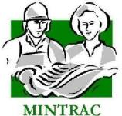

AMPCOM301
Communicate effectively at work
Training support materials

Australian Meat Processing Training Package
Certificate III in Meat Safety

Required Knowledge:
Topic | Covered on pages
An individual must be able to demonstrate the knowledge required to perform the tasks outlined in the elements and performance criteria of this unit. This includes knowledge of:
- sources of information relevant to own work, including workplace health and safety, regulatory information, work instructions, food or meat processing SOPs and workplace requirements | X
- structure of the organisation | X
- characteristics of an effective worker/team member in the food or meat processing industry | X
- effective communication for workplace meetings or toolbox meetings | X
- effective communication methods to interact with people from diverse backgrounds | X
- workplace policies that guide acceptable behaviour in the workplace, codes of conduct | X
- key principles of cross-cultural communication and communication with individuals from backgrounds different to own one's. | X

Elements and performance criteria

Element | Performance Criteria | Covered on pages

1. Identify and plan individual work | 1.1 Identify own responsibilities according to workplace policies and procedures in the food or meat processing industry  1.2 Identify own role and task requirements within team or work area  1.3 Identify roles of others in work area and lines of supervision for self and work team  1.4 Plan and prioritise own tasks according to given timeframes and work team requirements | X  X  X
2. Use effective oral communication skills | 2.1 Communicate clearly and respectfully with team members and supervisors  2.2 Actively participate in meetings and discussions  2.3 Ask questions and clarify information as required  2.4 Communicate with others to explore and resolve workplace problems  2.5 Provide assistance to others to achieve team goals and performance standards  2.6 Contribute positively to workplace relations | X  X  X

3. Use effective reading and writing skills for work | 3.1 Locate work instructions, food or meat processing standard operating procedures (SOPs) and other documentation that guides routine work activities  3.2 Read and follow detail included in workplace documents  3.3 Complete workplace forms and records accurately, using appropriate industry terms, using digital tools as required  3.4 Communicate with others about work issues using workplace systems | X  X  X  X

Training support materials for
AMPCOM301 Communicate effectively at work
These materials are for training in AMPCOM301 Communicate effectively at work in the Certificate III in Meat Safety.
What communication is involved in the meat safety inspector’s role?
Communication is part of the job for all workers in meat processing areas. These core communication tasks include :
- read the signs and posters in the work place
- reading and follow your work instruction and SOPs
- reading importing country requirements
- reading industry animal welfare standards and guidelines
- preparing and reading ante mortem cards
- reading the Australian Standard AS4696 2023
- receiving verbal instructions from the supervising inspector and/or the OPV
- providing feedback to production supervisors about sanitary dressing issues
- reporting animal health conditions in the stock inspected
- reporting an accident or equipment breakdown
- filling in a holiday or sick leave forms
- using touch screens to record computerised control panel.
Communication is also part of working well with other people. You are communicating when you:
- providing support to fellow inspectors
- completing professional development with your team
- participating in internal and external audits.
When you communicate you get the information you need for your job. When you communicate you also give other people the information they need to do their jobs.
WI | What information do you need to perform meat safety inspection duties?
Written instruction and information on the meat safety inspectors duties
Meat safety inspection is based on a range of written documents that include:
- The Australian Standard AS4696 2023
- The AMIC industry animal welfare standards
- The workplace requirements for hygiene and workplace health and safety
- Meat safety inspection work instructions and SOPs.
In addition to work instructions and SOPs meat inspectors need information on:
- the management structure of the processing company
- the role of managers roles
- the role of the relevant regulatory bodies eg DAFF, State DPIs, etc .
Standard Operating Procedures (SOPs)
Standard Operating Procedures are part of a meat processing plant’s Quality Assurance system. They are instructions about:
- cleaning and sanitation
- personal hygiene
- waste disposal
- water supply
- pest and vermin control
- chemicals including additives.
Abattoirs can also have SOPs to cover:
- maintenance including preventative maintenance
- livestock including animal care
- slaughter/animal welfare
- boning refrigeration
- product traceability and recall
- management review
- internal audit
- training
- calibration.
Standard Operating Procedures are written down and are usually kept in a manual in each work area. Copies are also kept in the Quality Assurance department.
You must know the SOPs for your work area. Your training will cover what is in the SOP and why it is important. If you need to check, you can ask a supervisor or look in the manual.
Work instructions and task descriptions
Work instructions or task descriptions are the instructions for each job or task a meat safety inspector undertakes.
Work instructions:
- describe the tasks to be performed
- identify the order, if necessary, in which operations are to be performed
- detail what should be done if errors occur
- highlight the most important part of the task, if any
- define the standard the job has to be done to
- be written in simple language.
When you follow the work instructions you are making sure that the products are quality products.
Work instructions are written down and kept in the manual in each work area. You can check your work against the work instructions. Your supervisor will explain the work instructions to you, to make sure you understand.

Student exercise

Process flowcharts
The processing company’s quality assurance program will include flowcharts which identify the various steps in the slaughtering and dressing processes as well as carcase chilling boning, packing, cold storage and loadout.
This diagram shows a typical flow of work through an abattoir up to dressing.
A typical workflow

Stock delivered
Cattle wash
Run-up
Stun
Weasand tie and shackle
Stick
Rod

Information about the lairage, slaughtering dressing and evisceration processes allow the meat inspector to understand animal welfare and sanitary dressing and where problems may occur.

Student exercise

The people in your workplace
In order to give and obtain accurate and appropriate information it is essential that you know the roles of those who work around you.
If your company is bigger, it’s sometimes a bit harder to get information about who’s who and who does what. But it’s very important to know. People depend on each other to get the job done.
You need to have information about:
- who makes decisions about production and processes
- who the supervisors are
- who the QA officers are and their role
- regulatory officers (the FSMA and OPV)
- who you get information from about pay, holiday and sickness leave
- who to report an incident, accident or injury to
- who to report sanitary dressing defects to
- who to see if you need to do professional development
- who to talk to if you have a good idea to make the job easier or safer.

The information you need for work often comes in a written format and requires you to be able to comprehend and implement the directions.

Student exercise
In addition to written instructions and documents there are a variety of other sources of information:
- talk
- photos/pictures/diagrams
- symbols and signs
- numbers
- colour coding
- graphs and charts
- sign language and hand signals
- body language.

Student exercise
In one day you might get information from:
- an induction manual
- the personal hygiene SOP
- a discussion with a supervisor
- feedback from the FSMA
- the ‘days lost’ graph on the safety notice board
- tags, labels, brands or stamps
- work instruction
- a meeting.
Standard Operating Procedures (SOPs)
Standard Operating Procedures are part of the Quality Assurance system. They are instructions about:
- cleaning and sanitation
- personal hygiene
- waste disposal
- water supply
- pest and vermin control
- chemicals including additives.
Abattoirs can also have SOPs to cover:
- maintenance including preventative maintenance
- livestock including animal care
- slaughter
- boning refrigeration
- product traceability and recall
- management review
- internal audit
- training
- calibration.
Standard Operating Procedures are written down and are usually kept in a manual in each work area. Copies are also kept in the Quality Assurance department.
You must know the SOPs for your work area. Your training will cover what is in the SOP and why it is important. If you need to check, you can ask a supervisor or look in the manual.
Work instructions and task descriptions
Work instructions or task descriptions are the instructions for each job or task in the plant.
Work instructions:
- describe the tasks to be performed
- identify the order, if necessary, in which operations are to be performed
- detail what should be done if errors occur
- highlight the most important part of the task, if any
- define the standard the job has to be done to
- be written in simple language.
When you follow the work instructions you are making sure that the products are quality products.
Work instructions are written down and kept in the manual in each work area. You can check your work against the work instructions. Your supervisor will explain the work instructions to you, to make sure you understand.

Student exercise

Reports as part of SOPs or work instruction
SOPs and work instructions often ask you to report to your supervisor or a plant supervisor, especially if things go wrong. Most of the time you will only need to tell the supervisor what has happened.
In some cases meat safety inspectors are required to gather animal health and disposition data. Some processors make this information available to producers.
Verbal reports
When you tell your supervisor or a company supervisor you are making a verbal report. You must:
- speak clearly
- explain clearly what is wrong or what has been done
- use the correct name of the department, section or work area
- give the correct name of the correct position involved
- use the correct words for the work processes
- make sure the supervisor can hear you
- make sure the supervisor understands what you’ve said.

D | Written reports, checklists and proformas

When you make a written report or fill in a checklist or proforma it will usually be on a form that is always used for this type of report.
Some of these reports and checklists are:
- accident reports
- condemnation reports
- ante mortem cards
- animal health reports.
What are the best ways to exchange information?
Clear and accurate information is very important in lairage or on the slaughter floor. If information is wrong, or not given at the right time, there are the dangers of contamination, disease and injury. If animal health reports are given to livestock producers then the information must be accurate
People communicate information through speaking, writing, body language and visual signs. To give clear, logical and accurate information you need to ask yourself:
- What’s the message?
- Who is it for?

Written information
Everyone has struggled with badly-written instructions and diagrams. Just think about the instructions you get when you buy a new video recorder.
Look at these accident reports. One is a lot clearer than the other.

Accident/Incident report
Time: Afternoon
Date: Wednesday
Place: Beef chain
Description of incident
Bob Foley slipped and hurt shoulder and arm.
Suspected cause: Accident
Witnesses: Other workers
Signed: M. Roche

Accident/Incident report
Time: 3.30pm
Date: 14 August 2007
Place: Kill floor
Description of incident
Bob Foley slipped on pool of liquid on steps of knocking box. He fell against the wall, jarring and grazing his right shoulder. First aid officer called and treated cut on the spot then in sick bay. Checked tetanus injections up to date.
Cause: Slippery steps (blood?). Non slip surface badly worn.
Witnesses: Mike Dowling, supervisor and Hal Roberts.
Signed: M. Roche

The second report:
- is clear
- is accurate
- has full information.
It may help stop this type of incident happening again.
There may be other kinds of forms you need to use in your workplace. Always make sure you write information that is clear and easy to read.
Spoken information
If you've ever had to ask someone for directions on how to get from A to B, you know that people find it hard to give clear and accurate instructions.
When you give people spoken information, remember to:
- talk to people calmly and with respect
- use the correct words for work processes
- make sure people can hear you
- make sure people understand what you’ve said, especially the jargon.

When you give people instructions, you also need to:
- break the information into sections or steps
- explain the steps in order – try using numbers or words like first, next…
- repeat or demonstrate things if you need to
- be patient.
Non verbal communication
Non verbal communication is used to make messages clearer or to add information.
Non verbal communication includes:
- body language
- hand signals
- colour
- volume, tone and emphasis of voice.
Body language
Body language includes stamping your feet if you are angry, standing up straight while talking to someone important or turning your back on someone you don’t like or you are angry with. It also includes frowning, smiling, winking and nodding. Body language can be friendly, aggressive, angry or relaxed.
Hand signals
Hand signals are often used in noisy workplaces instead of talking or to ‘repeat’ what you are saying. Some hand signals are used instead of words. These include the ‘thumbs up’ sign, waving, or pointing.
Colour
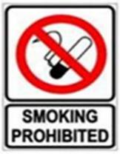
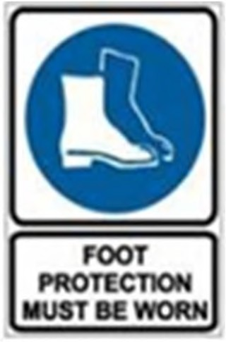
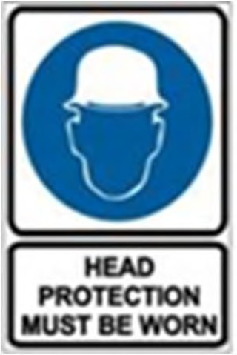
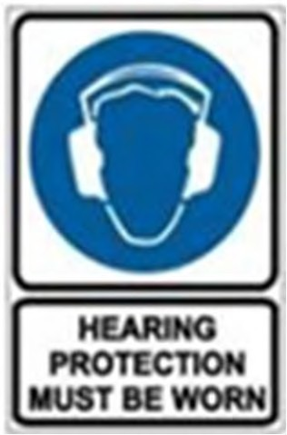
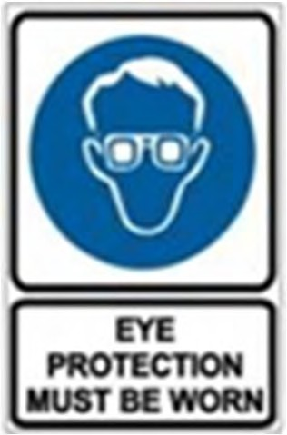
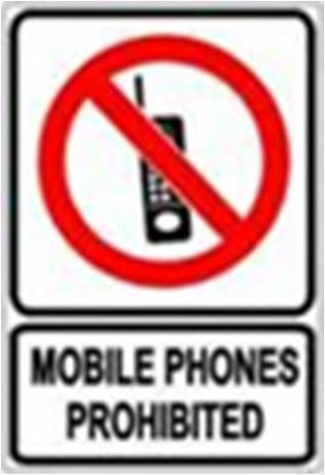
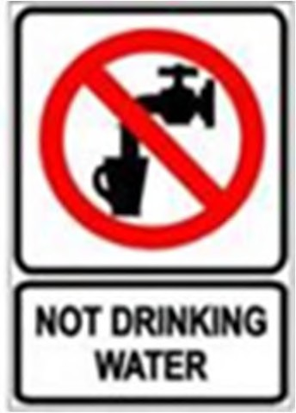
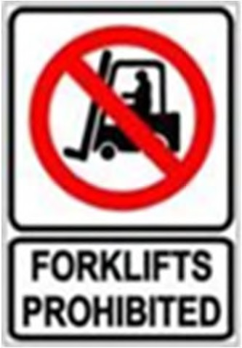
Colours are used to distinguish one thing from another. In meatworks colour coded signs for warning, mandating and banning direct workers While coloured bins, chutes and tubs are used to distinguish edible and non edible or condemned products and areas. Colours are also used as warning lights – green for go, red for stop and amber or orange for caution.

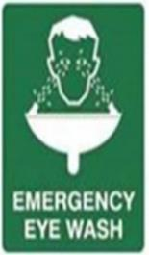
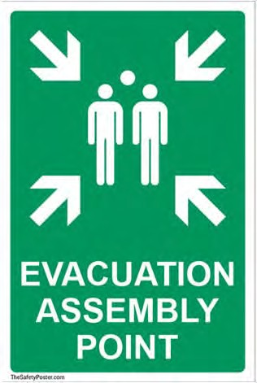
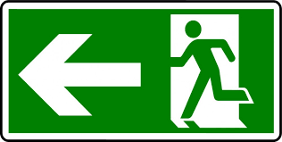

Voice
The way we use our voice can also add to the meaning of what we are saying. How often do you use ‘mmm’, ‘uh-huh’, ‘um’ and ‘ahh’ when you are bored or not really listening.
The tone of voice – angry, snarling or cheerful – shows how we really feel about what we are saying. We often use a different volume, emphasis or tone of voice for training the dog, disciplining children, persuading a friend to do something they don’t want to do or when we are happy, frightened or excited.
Meetings
Meetings are a way of communicating to give or get information. Your company might have different kinds of meetings, including
- Plant meetings where everyone in the plant comes. The CEO or the general manager or the site manager usually give information about what’s happening with the whole plant.
- Departmental meetings where people from one department participate – maintenance, manufacturing, packaging or quality. These meetings are about what is happening in your department.
- Team meetings. The team is usually from your work area – the boning room or the smokehouse.
- Committee and Special Team meetings. These are groups of people from different departments or sections who get together for a special reason. Some of these teams are the consultative committee, the WHS committee and process improvement or problem solving teams.
Meetings can be a good way of exchanging information between a lot of people. Understanding how a meeting works and everybody’s role helps you make sense of the meeting.

Title or role | Tasks
Chairperson  (sometimes called the facilitator) | Makes sure:  - people know the reason for the meeting  - people know where the meeting is up to  - everyone is able to have a say  - everyone has a say in the decision  - actions and decisions are followed up.
Minute taker  (sometimes called the secretary) | Writes the minutes – a summary – of the meeting, including all the decisions that are made. Everyone should get a copy of the minutes as a reminder of what happened at the meeting.

In formal meetings, the chairperson might also be responsible for making sure:
- there are enough people at the meeting
- decisions are voted on and votes for and against counted.

Participants
Participants have an important role in making meetings work. They:
- are clear about the reason for the meeting and follow the agenda
- listen to the speakers
- take a turn in giving ideas or opinions
- ask questions
- have a say in the decision.
What you have to do at these meetings will depend on the purpose of the meeting. You:
- might be given some information to take away
- might be asked to vote or make a decision
- could ask a question – to make sure you understand, for more information
- could be asked a question.
Sometimes meetings don't work because participants have bad meeting habits. Some of these poor meeting habits are:
- coming late or leaving to go home early
- talking, whispering or laughing throughout the meeting
- using negative body language including shaking your head, rolling your eyes, slamming papers together, yawning, making loud sighing noises
- making negative comments – ‘that'll never work’, ‘oh yeah’, ‘huh’, ‘I don't believe it’
- repeating the same point again and again, even when it is no longer being discussed
- dominating the discussion, interrupting others, talking in a loud voice as they are talking.
All these habits stop other people listening, following the discussion and having their say. They make people feel that the meeting is a waste of time.
How do you solve problems?
Some companies have a particular method of problem solving, some only use informal ways of solving problems. Whatever method is used, good communication is the important factor.
All kinds of problems happen at work. They are usually about the production processes or about how people are interacting. In the past, people thought the problem would go away if you ignored it! They thought ‘she’ll be right’. Today workplaces take a more active approach. If something's wrong, it needs fixing. This problem solving approach can make the workplace a better and safer environment. It can even save lives.
In some companies all employees are encouraged to use a particular problem solving method. Here is a simple problem solving method.

The 5 steps to problem solving
What's the problem?
What are the causes?
What's the best solution?
Take action.
Check the problem is solved.

When there were problems with too many injuries on the slaughter floor, one work team used this method to get a solution that everyone was happy with.
The high pressure hose
Simon was worried about the number of injuries on the second beef chain. When Jacko broke his wrist, Simon spoke to the leading hand. The leading hand called a work team meeting to talk about the problem.
- What’s the problem?
Too many falls in the work area. The injuries include bruises, sprains, one broken wrist, grazes.
The leading hand asked every one to ‘brainstorm’ and think about the possible causes. Simon and the others took turns to give their ideas.
- What are the causes?
High pressure hose for clean up is lying across the floor. People have to step over it.
Hose leaks and people slip in water lying on floor.
The area is too dark, people can’t see where they are going.
The team talked about the suggested causes. Most people thought the cause was the hose, but everyone still listened to Simon, who was the only one who thought the area was too dark.
- What's the best solution?
Check the hose and repair it if necessary.
Coil the hose and put it away after the hose down. A storage area to be marked on the floor near the tap. The hose to be kept there when not used.
The work team had another brainstorm to work out and make a list of solutions. There were lots of ideas. Some of the ideas were not practical or did not fit the problem. The team had to decide the best possible solution.
- Take action
Hose checked for leaks. No leaks found.
Storage area marked on floor for hose.
The leading hand asked maintenance to check the hose for leaks and to paint an area on the floor to store the hose. Simon and a couple of others talked to maintenance about the best place, out of the way of people.
- Check the problem is solved
After 3 weeks, fewer falls and trips and injuries (bruises, sprains, grazes)
The work team decided that Simon and the leading hand should check that the problem was solved. The leading hand then gave a report to the safety committee.

Simon was able to be part of the problem solving process. He was able to give his ideas and have people listen to them. Although nobody agreed with Simon's ideas, he was still part of the team.

Student exercise

Unacceptable behaviour
Why is it important for people to communicate well in the workplace?
Everyone would agree that work is a better place if everyone gets on well. The way people communicate with each other is often what makes the difference between a ‘good’ and ‘bad’ workplace.
Some companies have policies and codes about acceptable behaviour and language at work. Here is a typical one. Notice how many points are about communicating.

Keller’s Abattoir
Code of Behaviour
Treat fellow workers and customers with respect and courtesy.
If you are absent from work, ring the office.
All injuries must be reported to the supervisor.
Always use safety equipment.
You must wear the company whites on the job.
No smoking in any building.
Always ask for help if you need it.
Always follow work procedures.
Follow the hygiene and safety rules at all times.

Breaking the accepted rules of behaviour could result in:
- injury or even death
- an unpleasant workplace atmosphere
- losing your job.
As well as the company's policies and rules, there are also laws about the way people treat each other. They include workplace behaviour. In Australia it is illegal to treat people differently because of their race, ethnicity, religion or gender.
Many companies have developed:
- anti discrimination policies
- sexual harassment policies
- equal opportunity or affirmative action policies.
What can you do to communicate well with people in your work area?
Policies and laws exist to protect people and are useful, but it takes much more than policies and laws to make interaction in the workplace positive. Everyone in a company needs to know what they can do to ensure a good working environment.
Understanding different ways of behaving and communicating
When we are children we learn customs and rules about the way we speak and things like body language, such as winking, smiling and slapping your mates on the back.
People from different backgrounds have different ways of behaving and communicating. For example:
- men and women
- city and country people
- abattoir workers and politicians
- people from different language backgrounds and countries.
Some people don't eat pork, some people will only eat halal meat and some people don't eat meat at all. This depends on what they have learnt in their families and communities.
Our own ways of doing things become built-in and ‘automatic’, so when we come across people who communicate or do things in a different way, we can sometimes think of them as ‘strange’. But if we are aware of, and respect, these differences, there will be fewer misunderstandings and a better workplace atmosphere.
Using communication to get on with others
How do people in your work area like to be treated? Are they people who like to joke and chat a lot? Different people prefer different ways of relating to each other. You need to be sensitive to how people like to be treated.
This team worked well together because:
- they knew each person had a different way of working and communicating
- everyone could have a say
- they saw that each person could give something to the group
- they all had a common goal – to do their job well and safely.
Groups
Groups are an important part of the workplace. Some of the groups you might belong to are:
- a work team
- department
- union
- social club
- problem solving team
- group who always sits at the corner table in the lunch room.
When you communicate as part of a group you need to:
- understand that people have different ways of communicating
- listen to others without interruption
- take turns in asking questions, giving opinions
- share problems and solutions.
What is included in a workplace behaviour policies?
These policies can explain what good behaviour is and outline what is unacceptable behaviour. The policies will outline the types of behaviours that are not acceptable including;
- bullying an individual or group such as verbal and physical acts used to intimidate or humiliate a person in the workplace or on-line
- sexist behaviour that can take the form of harassment, lewd behaviour, unwanted questioning about people’s personal life, touching and suggestive comments
- racist behaviour such as disparaging comments about a person’s race, country of origin or religion either verbally or on-line
- gossiping about people is also unacceptable behaviour be it by word or on-line
- fighting or physical intimidation is also unacceptable in the workplace or outside
- swearing in the workplace can also be considered offensive by some workers and be regarded as a form of harassment
Who do you talk to about bad workplace behaviour?
There are a number of people you can talk to about bad workplace behaviour . You can report this to:
- a supervisor
- HR manager at your plant or company
- Plant manager
- Union representative

Why is this type of unacceptable behaviour banned in the workplace?
It is not in the interest of the company to have unhappy workers. Unhappy workers are less productive, they leave jobs, they tell other people about their experiences in the workplace and importantly this behaviour is against the law.
The meat processing industry has made great strides in improving conditions and attitudes in the workplace. Some companies have up to 35 different nationalities on site and nearly half the workers are women. For this reason alone bad behaviour has no place in the modern meat processing plant.
How do individuals contribute to good teamwork?
Meat safety inspectors usually work as part of a team of inspectors. In export works Australian Authorised Officers are part of the government inspection team that includes the Food Safety Meat Assessor (FSMA) and the On- Plant Veterinary Officer (OPV). In addition meat safety inspectors are part of a broader team that works to process livestock.
As a member of an inspection team the individual inspector has to help achieve the team’s regulatory objectives to ensure that the meat passed as fit for human consumption is wholesome and free of pathology. Team members do this by ensuring they:
- Follow work instructions and SOPs
- take responsibility for their own work
- Are on the chain in time to ensure all product is inspected
- Complete all records accurately
- Remain up to date with professional development requirements
- Support other team members.
- Report issues to their supervisor and where appropriate the slaughter floor supervisor.

Periodically team members have to participate in team meetings and they should participate actively in these meetings to their level of responsibility so they understand the group’s plans and objectives.
The performance of the team is going to be assessed by processing workers, company management, the regulator and external bodies such as customers and overseas reviewers. The way the inspection team is viewed is going to be a function of their:
- professionalism
- punctuality
- communication skills with workers and management
- cooperation with audits
- accuracy of the records they prepare.
Inspection team members will from time to time have to have discussions with the company supervisors. It is vital that the inspector explain clearly and in a calm way what the issue is such as poor carcase dressing techniques. Likewise supervisor’s may approach inspectors to discuss dispositions again. It is important that the inspector state their position clearly and if the issue is unresolved the inspector should refer the supervisor to the inspection team leader. At all times the inspector must remain calm and polite.

