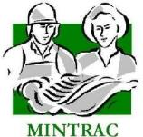

AMPLSK201
Apply animal welfare and handling requirements
Training support materials

Australian Meat Processing Training Package
Certificate II in Meat Processing

Table of contents
Training support materials for AMPLSK201 Apply animal welfare and handling requirements 3
Animal welfare 3
What is Animal welfare? 3
Why must animals be handled humanely? 3
How can poor handling affect meat quality? 5
What factors affect animal welfare at a processing plant? 7
Who has responsibility for animal welfare at a slaughtering plant? 8
What are the animal welfare requirements when preparing animals for slaughter? 8
The Australian Standards and Codes of Practice 9
What requirements are there when receiving animals for slaughter? 12
Where are animal welfare needs managed at a processing plant? 14
What is the role of an Animal Welfare Officer? 15
How do you know if animals are stressed? 15
How do I know that I am not causing unnecessary suffering to animals? 17
How do facilities affect animal welfare at a processing plant? 17
How are animals managed in lairage at a meat processing plant? 18
Animal handling 20
What methods can be used to assist with the movement of livestock? 20
What aspects of natural animal behaviour have to be considered when handling livestock? 22
Why do stock baulk and suddenly become difficult to move? 25
How can WHS risks be limited during animal handling? 27
What makes a good stock handler? 28
How and why are animals identified at abattoirs? 29
What forms of documentation are used for livestock identification? 32
What is the consequence of incorrect lot identification? 33
Why is it important to maintain the flow of stock at the abattoir? 33
Bibliography 34
Additional resources 35

Training support materials for AMPLSK201 Apply animal welfare and handling requirements
Animal welfare
What is Animal welfare?
It is very difficult to define exactly what animal welfare is because people’s attitudes to animals vary so much in our community. However, it is generally accepted in the community and by regulators that people have a responsibility for animals in their care and must ensure they are free from distress and that they are content.
Perhaps the easiest guide to understanding animal welfare is the five freedoms approach developed in the UK. This defines welfare in terms of:
- freedom from hunger and thirst
- freedom from discomfort
- freedom from pain, injury and disease
- freedom to express normal behaviour
- freedom from fear and distress.
Why must animals be handled humanely?
There are six main reasons why animals should be handled humanely at slaughtering plants:
- ethical reasons
- product quality
- product safety
- legal requirements
- customer expectations
- company profitability.
Ethical reasons
What society considers right and wrong is changing all the time. Animal handling practices that were considered acceptable 25 years ago are no longer acceptable to society as a whole. Society takes a grim view of the mistreatment of animals and the meat processing industry’s reputation can be badly affected by poor animal welfare practices.
Animals do not understand that they are about to be slaughtered. The stress they feel at slaughtering plants is largely due to the way people handle them in the strange environment. The infliction of unnecessary stress and pain to animals is becoming less acceptable morally to society, so measures are now required to limit this pain, particularly in the process of slaughter.
Product quality
Inhumane handling, causing animal stress, results in an inferior meat product and causes, for example, pale soft exudative pork and dark cutting beef. Both of these are a direct result of stress prior to slaughter.
Product safety
Inhumane handling, causing animal stress, results in a weakened immune system that can show up as a growth of gut bacteria such as Salmonella and E. Coli. For example, under stressful conditions the number of animals shedding Salmonella can increase from 5% to 85% of the mob within a matter of hours. These bacteria are potential food poisoning agents or pathogens and the risk of potentially dangerous contamination during dressing is greatly increased.
Legal requirement
Animal protection and its enforcement is a legislated requirement of Commonwealth, state and territory governments.
Ensuring the welfare of animals in lairage and yards at an abattoir is the responsibility of all those working with those animals. Failure to treat and manage these animals properly is against the law and each state has specific legislation dealing with the prevention of cruelty to animals. In addition the abattoirs registration/licensing is dependent on compliance with both this legislation and the Industry Animal Welfare Standards.
You need to know the animal handling requirements at your workplace. There are national and state laws and codes for animal welfare, so what your workplace follows will depend on your State or Territory, the species you slaughter and if your enterprise is export-registered or domestic-registered.
In 2005 the National Animal Welfare Standards for establishments processing animals for human consumption were first produced (and have since been revised to the Industry Animal Welfare Standards). These now form the basis for all animal welfare regulatory requirements at slaughtering plants.
Customer expectations
For these reasons the workplace animal welfare SOPs and the relevant work instructions incorporate all of these requirements.
Customers such as the major retail chains and fast food outlets are becoming increasingly concerned about the animal welfare aspects of meat production as adverse perceptions could impinge on their sales of meat. For these reasons the workplace animal welfare SOPs and the relevant work instructions incorporate all of these requirements.
Countries importing our meat are also increasingly insistent on good animal welfare practices at livestock processing plants.
Failure to treat animals properly can cause a meat processing plant to be fined, loose its customers and/or its registration. Workers also have responsibilities and can be fined for acts of cruelty or can be dismissed for not following the company’s animal welfare practice requirements.
Company profitability
There is a direct relationship between animal welfare and the profits that a processing plant makes. Stock that is poorly treated:
- gets injured more often causing bruising and therefore decreases the value of the carcase
- is more stressed and this results in a poorer eating quality of the meat
- results in hides and pelts being damaged and reduces their market value
- are more dangerous and cause more injury to other animals and stock handling staff.
How can poor handling affect meat quality?
By following workplace procedures you will:
- make sure animals are handled humanely and safely
- prevent injury and stress
- make sure welfare requirements are covered.
Good handling helps to produce a quality product. Poor handling of animals can cause stress and/or injury to animals. Stress or injury to animals will significantly affect the quality of the end product.
Stress
Stress on animals through poor handling can make meat tough and can also cause a condition called ‘dark cutting’ with high levels of pH (lactic acid levels).
Dark cutting will affect the meat quality in a number of ways:
- meat becomes darker
- meat becomes tougher
- meat will lose flavour
- shelf life of the product will be shorter.
Stress can also result in pig meat having defects such as PSE (pale, soft, exudative) or DFD (dark, firm, dry). Stressed stock may also produce meat that while normal in colour is tougher and produce excessive drip.
Bruising and injury
Injury to animals can occur during transit, when they are being trucked, when they are moved around at the abattoir, or in lairage facilities. Lairage facilities are holding facilities and may include pens, yards, paddocks or sheds. The types of injury that can result include:
- bruising
- fractures or breaks
- wounds, cuts, lacerations.
Bruising is evidence of poor animal welfare practices and is most commonly associated with poor handling of livestock. Bruising on cattle is usually on the shoulders, hips, hindquarters and top of the back. For lambs bruising is usually on the hind leg and foreleg. For pigs, bruises can be less common, but are often found at the femur and hind leg regions.
Bruising is most likely to occur during transport. It is important that when being transported the animals need to be stocked reasonably in the vehicle to avoid slipping, falling and crashing into each other.
Bruising can also occur during loading and unloading, particularly if livestock are rushed or they panic. Careful handling is required to move cattle from transport vehicles to avoid bruising, particularly as on most road-trains and B-double vehicles, cattle need to manoeuvre around to be able to walk down from the vehicle.
Transport vehicles often need to be fitted with rubber flaps to ensure that livestock leaving the vehicle do not crash into the doors or slip between the ramp and the truck, which could cause the animal to injure itself.
In the processing plant, bruising might occur when livestock are, drafted, moved into yards or if animals slip and fall in races and forcing pens. Gentle handling and well-constructed facilities can reduce bruising dramatically.
Livestock need to be calmly and quietly moved throughout the plant, so that they do not push into each other or strike gates and fences. Another way to ensure bruising is reduced is provide rubber or foam padding around gate edges and posts, and also ensure that fences are constructed to not contain any protrusions.
Bruises tend to be more common in livestock sold through saleyards, or livestock that have had several transport journeys to reach their destination, including a series of loading and unloading points. The increase in bruising in these instances mostly results from the increase in handling that has to occur. In addition, bruising can be more common in; unshorn sheep from wool-pull bruises, entire male pigs that are allowed to fight, stock in light condition or reduced body weights, cattle that mount each other, (especially pens of heifers in oestrus), horned livestock, livestock stocked loosely on the truck and livestock that have travelled long journeys.
Other injuries that impact on animal welfare and meat quality include:
- bone damage
- joint or ligament injury
- injection site blemishes
- fractures.
When there may be fracture or bone damage or any other serious injury it is important that this is reported immediately so an emergency kill can be organised or prioritised promptly. In no circumstance, should conscious animals that cannot walk or have severe injuries be taken through the normal slaughter line.
Skin injuries and injection blemishes can occur during mustering, loading, unloading and penning, where contact with barbed wire, fighting, rubbing against facilities or contact with sharp objects may cause these injuries.
The cost of bruising and injuries
Injuries such as cuts and bruises require trimming. After the injured animal has been slaughtered, the affected area must be trimmed before any boning and slicing can take place.
Millions of dollars are lost to the industry every year as a result of injury to animals. This is because injury can reduce the yield from carcases and extra time needs to be spent trimming the carcase.
In addition hides are often damaged and these cuts and nicks in the hides/pelts dramatically reduce the market value of these products.
What factors affect animal welfare at a processing plant?
General factors that impact on animal welfare on a processing plant may include:
- animal health
- species, classes of stock, number and nature of mobs
- transport arrangements
- state and design of the facilities e.g. yards, pens etc.
- exposure
- space allowance and time in lairage, saleyards or in transport
- stockperson behaviours/training.
Who has responsibility for animal welfare at a slaughtering plant?
All people involved in the handling of animals have an obligation to ensure that animals are not mistreated or placed under stress. This includes truck drivers, Animal Welfare Officers, stockmen and slaughtering personnel involved in stunning and sticking.
All supervisors including lairage foreman, slaughter-floor foremen, QA officers, meat safety inspectors and senior management also have a strong obligation to ensure that animals are not mistreated.
Other individuals at the plant also have a responsibility to report any mistreatment or animals obviously in pain that they observe, to their supervisors.
Following animal welfare regulatory requirements will ensure you handle animals to the standard set in the codes. This will prevent cruelty to animals.
WI | What are the animal welfare requirements when preparing animals for slaughter?
You need to know the animal handling requirements at your workplace. There are also National and State laws and codes. What your workplace follows will depend on your State or Territory, the species you slaughter and the details of your “Approved Arrangement”.
All people who handle animals must make sure that animals are not mistreated or placed under stress. By following the relevant work instructions and SOPs at your plant you will handle animals to the standard set out in the relevant codes for the meat industry in Australia. This will prevent cruelty to animals.
The basic welfare needs of animal are:
- facilities that allow animals to be unloaded and moved to pens safely
- water – an adequate supply of clean drinking water so that animals don't dehydrate
- air – free from contamination and chemicals
- food – to help the animals maintain well-being (not required if animals are held for short periods)
- space – sufficient room to moves around, lie down and access water (and feed if provided)
- shelter – so animals are not stressed by environmental conditions eg heat humidity, cold rain etc.
The requirements of the relevant Standards and Codes will be written into the establishment work instructions (WI) and SOPs. For this reason the monitoring and auditing of humane handling is done against WIs and SOPs.
The Australian Standards and Codes of Practice
All people involved in the handling of animals have an obligation to ensure that stress in livestock is minimised and that animals are well managed.
There are two Standards that are relevant to all red meat and pig abattoirs. They are:
- the Australian Animal Welfare Standards and Guidelines — Land Transport of Livestock
- the AS4696:2023 Australian Standard for the hygienic production and transportation of meat and meat products for human consumption
The Land Transport Standard apply to the major commercial livestock species and also apply to horses, buffalo, camels and ratites. This standard covers the transport of livestock by road and rail, and by livestock transport vehicles aboard a ship. The Land Transport Standard applies to the :
- The consignor for :
- preparation of livestock
- selection of animals that are 'fit to load”
- feed and water provisions before loading.
- The transporter for
- the loading
- the final inspection for 'fit to load'
- the loading density
- inspections during the trip
- spelling periods during the journey, and unloading.
- The receiver after unloading.
AS4696:2023 Australian Standard
Compliance with the AS4696:2023 Australian Standard for the Hygienic Production and Transportation of Meat and Meat Products for Human Consumption is mandatory for all abattoirs.
Its animal welfare objective is: “The minimisation of the risk of injury, pin and suffering and the least practical disturbance to the animals” The animal welfare requirements are set out in Part 3 Section 7 of the Standard.
The Standard requirements for animal welfare are grouped under the following headings:
Handling of animals
• premises and equipment
• animal handling
• segregation of different classes of stock
• provision of feed and water
• provision of shelter and protection from the elements
Young, injured, sick or stress susceptible animals
The Standard requirements for this section require:
• prevention of unnecessary pain, injury and suffering
• animals to be stunned before sticking
• animals to be restrained before stunning.
Ritual
- the provision of unstunned ritual slaughter under an approved arrangement.
Working animals in lairage including:
• the use and accommodation of working animals
• working animals are accommodated separately from slaughter animals
• dogs are effectively muzzled and are restrained when not working.
The requirements of the Australian Standard AS4696 2023 are mandatory for all establishments slaughtering animals for human consumption. The implementation of animal welfare measures and outcomes will be assessed by the QA staff in a plant when they do internal process monitoring and auditing.
Additionally, key regulatory authorities (such as Department of Agriculture and State DPIs) will monitor and or audit against the AS4696: 2023.
In addition to AS4696 2023 a mandatory national animal welfare standard for all slaughtering establishments is currently being developed.

AMIC Industry Animal Welfare Standard for Livestock Processing Establishments Edition 3
This is a voluntary standard that most larger plants also comply with. This standard aims to assist industry to continually improve animal welfare outcomes for Australian livestock. The Standard has an Implementation guide, a separate document, which helps establishments to identify best practice performance indicators for animal welfare inputs and outcomes.
The documents assist companies to clearly define:
- the animal welfare standards they are aiming for in terms of measurable performance criteria
- how these will be achieved through work instructions and standard operating procedures
- how they will be monitored and audited.
The AMIC Industry Standard also assists company in meeting the requirements of corporate customers, such as supermarkets or fast food chains, have specific animal welfare requirements.
The AMIC Industry Standard cover the features of a system that needs to be in place to achieve the required animal welfare standards:
Management systems
This standard covers the development of a documented system including :
- work instructions and SOPs which deal with the management of livestock on a daily basis
- document control
- monitoring and auditing of animal welfare performance measures and indicators
- non conformities and corrective measures
- contingencies to deal with emergencies to minimise risks to animal welfare
- reviewing of management system.
Resource requirements
The establishment has to ensure it has adequate
- HR resources of trained workers competent in the tasks including:
- livestock receival
- livestock handling and management in lairage
- emergency slaughter and humane killing
- animal welfare monitors
- animal welfare officer(s)
- documented training for personnel, supervised training and competency assessment
- infrastructure and equipment that assist in delivering the desired animal welfare outcomes including;
- adequate lairage facilities
- flooring
- lighting
- maintenance programs
- adequate pen size and access to water and feed (where applicable)
- yards/pens available for appropriate segregation of livestock
- equipment for emergency kills or humane destruction
- video surveillance at unloading, laneways, forcings pens restraint and stunning
sticking.

The management and care of livestock
These management systems will cover:
- sourcing of suitable livestock
- receival of livestock
- low stress livestock handling
- monitoring animal handling and animal welfare outcomes including slips and falls and vocalisations
- goad use
- working animals
- adverse weather conditions
- water and feeding of livestock
- initial and ongoing inspection of livestock during their time in lairage
- treatment of weak, ill or injured livestock animals.
Humane stunning and sticking
The requirements for humane stunning and sticking include:
- effective restraint
- stunning
- monitoring of effective stunning
- re-stunning arrangements
- sticking
- bleed chain monitoring
- foetal blood recovery.
WI | What requirements are there when receiving animals for slaughter?
Stock should have access to clean, potable drinking water immediately when they arrive at a plant so they can rehydrate after being transported. It is an important part of a stock handler’s duties to ensure that there is an adequate water supply available for stock while in lairage.
The AMIC Industry Animal Welfare Standards also identify additional stock handlers responsibilities:
- assess animals upon arrival
- injured ill or weak animals are assessed and prompt action is taken
- livestock that are to be humanely destroyed or placed for emergency slaughter must be handled promptly
- weak, ill or injured stock are to be segregated from other animals for rest and/or assessment
- all stock are observed regularly to identify and segregate injured, ill or weak stock for emergency kill, treatment or humane disposal.
The Standard also requires the company to have in place contingency plans to deal with issues such as strikes, power failures and stock being delivered for salvage slaughter after bush fires.
It is an important part of the role of the stock person to identify any stock that were not fit to load. Meat Livestock Australia has put out a guide on “fit to load’. It can be accessed on-line. https://www.mla.com.au/extension-training-and-tools/resource-hubs/fit-to-load/

Australian Pork Limited has produced a similar guide entitled “is it fit for its intended Journey and can be found on-line at https://australianpork.com.au/it-fit-intended-journey.
Where are animal welfare needs managed at a processing plant?
Key areas where animal welfare needs to be managed and safeguarded at the processing plant include:
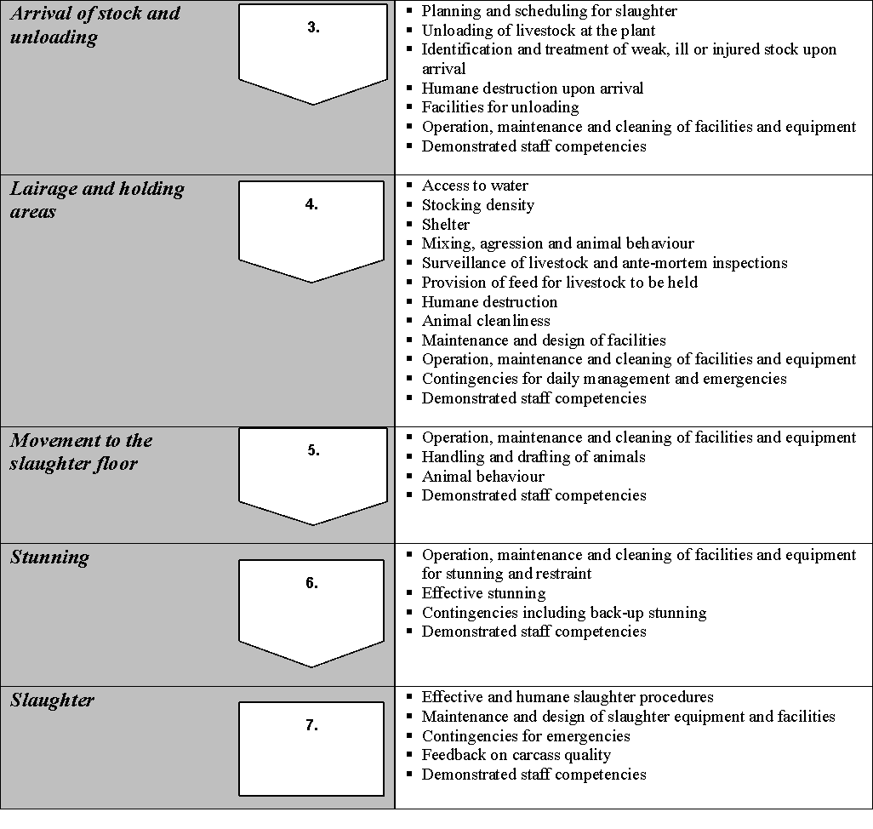

What is the role of an Animal Welfare Officer?
Typically the Animal Welfare Officer is a company employee who manages the company's animal welfare team and therefore is able to:
- understand and articulate the regulatory and technical issues associated with animal welfare
- represent the company with regard to the approach taken to address animal welfare issues
- influence company policies, procedures, training regimes, Key Performance Indicators (KPIs) and Quality Assurance (QA) documentation as they relate to procedures impacting on animal welfare
- review, as part of their duties, the results of the routine monitoring of procedures impacting on animal welfare
- review the results of internal and external audits to assess the performance of the company in relation to animal welfare
- oversee the implementation of corrective actions and preventative measures
- monitor the effectiveness of corrective actions and preventative measures
- implement animal welfare assessment criteria and perform an abattoir animal welfare assessment
- recognise operative training needs and implement training for animal handlers.
How do you know if animals are stressed?
The following details from the Livestock Transport – Handbook for Drivers, outline the symptoms of stress in the major food animals:
Cattle
- increased movement | - shivering
- bellowing | - sweating
- unresponsiveness | - panting
- twitching tail | - charging
- increased excreting | - collapsing
- fighting (normally bulls) | - lying down
- not seeing objects
Sheep
- bleating | - panting
- mobbing | - running into things
- unresponsiveness | - collapse
- butting (normally rams)
Pigs
- becoming agitated | - collapsing
- squealing | - change in skin colour
- increasing excreting
- panting/trembling
Horses
- sweating | - stamping feet
- rearing | - increased breathing rate
- kicking | - increased excreting
- flicking tail | - running into things
- whinnying
- becoming agitated.
Vocalisations
Vocalisations, such as squealing in pigs and bellowing in cattle is a good sign of stress, however is less useful to assess stress in sheep as they may not vocalise and when they do, it may not always be in response to stress.
If livestock appear stressed then you must report the matter to your supervisor. Stressed or agitated livestock should be rested to allow the animals to settle and recover.
The rate of vocalisation of cattle and pigs is currently used as a measure of animal welfare by commercial auditors for key international customers. There is substantial evidence that the measure of vocalisations can be applied in a practical way to pinpoint animal welfare problems in processing plants. In studies carried out by Grandin, (1998), it was observed that in well managed processing plants, less than 3% of cattle vocalised when they were being moved through the forcing pen leadup race and stunning box.
It was observed that excessive electric prodding, slipping on the floor, too much pressure being applied by a restraining device and missed captive bolt stuns were associated with 98.2% of vocalisations, thus these events were regarded as adverse to welfare during the handling of cattle at the processing plants examined. It was also shown that 90-95% of cattle could be moved through the processing system without the use of the electric prod and that prodders were the greatest cause of vocalisation in cattle.
How do I know that I am not causing unnecessary suffering to animals?
It is inevitable that some stress will occur to animals during the process of slaughter. This is because animals vary, the facilities vary, and the competency of people handling livestock varies. In recognition of this, the Industry Animal Welfare Standards have set targets on various parameters to act as a measure of the amount of stress that is being inflicted on animals and to act as a measure of compliance to the Standard for animal welfare.
In the forcing pen, race and the restrainer the targets are as follows:
- no more than 3% of cattle vocalizing
- no more than 10% of pigs vocalizing
- an electric goad being used on less than 25% of animals.
Note: Vocalization in sheep is a normal group activity and not an indicator of stress.
You should monitor your own performance. If you find that you cannot meet these targets you should discuss it with your supervisor. The QA Manager and regulators will also be checking you against these parameters, so if there is a structural problem or other problem that is causing animals to baulk or vocalize, you need to make management aware of this or otherwise the blame will rest with you.
People deliberately causing unnecessary pain to animals risk being prosecuted.
How do facilities affect animal welfare at a processing plant?
Facilities and equipment can contribute to stress and injury if not well designed, constructed, operated and maintained. People handing livestock should take note of any problems to do with the construction and facilities at the abattoir that could put the animal or handler at risk of injury.
These problems should be reported to the person who is responsible. Problems may include:
- faulty gates and fences
- broken gates or drain covers
- catch points where stock may get their hooves stuck, e.g. under edges of loose grates
- slippery floors or surfaces
- pointed or sharp objects that protrude and could cause injury
- leaking or broken water devices
- distracting shadows, uneven lighting, or high pitched noises
- long straight races, sharp corners and congested areas that make it difficult to move livestock along.
Housekeeping around the yards is also important to ensure that hoses, rags, clothing etc. are not left where they cause animals to baulk.
How are animals managed in lairage at a meat processing plant?
Animals are kept in lairage to allow them to recover and rest following transport. The process of transport involves a series of stressful events:
- mustering and yarding
- loading, transport
- handling
- weather conditions
- road conditions
- time off feed and water
- mixing, aggression
- unloading in a new environment and placement in lairage pens.
Therefore, time in lairage needs to provide an environment where livestock can recover from any stress incurred from transport, both for animal welfare and meat quality reasons. Therefore lairage time provides an opportunity to reduce this stress as much as possible and allow the animal to re-hydrate and recover.
Lairage facilities need to:
- provide access to clean drinking water for the livestock
- well maintained flooring that will not cause injury
- enough room for animals to lie down
- secure fencing and gates that do not have any protrusions that may cause slips or injury
- have adequate height on fences and gates
- protection from weather extremes.
Lairage facilities need to provide effective space for livestock to be able to lie down and recover as required. Therefore recommended stocking densities in pens should be observed and additional consideration should be given to assess the ease by which livestock can move freely and reach watering facilities.
There are no recommended stocking densities in the Standards but the performance target is:
“Livestock have sufficient space in holding pens to be able to move freely”
This can vary with the species and size of the livestock. As a guide the “Construction and Equipment Guidelines for Export Meat” recommend the following densities:
- pigs 0.67 m²/head
- heavy cattle 1.8 m²/head
- calves 0.5m²/head
The Standards also require feed and water facilities to be freely available.
The feed and water requirements should be as follows:
- cattle 5 kilograms of hay and 45 litres of water per day
- sheep 1 kilogram of hay and 4 litres of water per day.
Feed should be provided as per regulatory requirements.
As part of the preparations for slaughter, washing or fasting of the animals may be needed. The washing or spraying may be partial or whole. Even if fasting, animals must have unlimited 24hr access to water. Whether the animal needs washing or fasting will depend on the species and the age of stock being processed. The access that stock have to feed and water will be set out in the workplace SOP and work instructions.
Activity suggestion one: Animal welfare
Materials and specialist personnel
Company work instruction and standard operating procedures for animal welfare.
Relevant sections of animal welfare and handling codes and government regulations.
Quality assurance manager.
Plant veterinary officer or meat inspector.
Method
Discuss the relevant animal welfare requirements for animals in lairage at abattoirs, identifying:
- feed and water provision
- the correct use of approved goads
- the correct use of working animals where applicable
- correct handling techniques.
Ask the quality assurance manager to talk about the impact of poor handling on meat quality and hides.
Ask the plant veterinary officer or meat inspector to identify regulatory requirements for animal welfare.
Trainee activities
Ask the trainee to explain the work instruction and standard operating procedures relevant to animal handling.
Ask the trainee to develop an animal welfare checklist. Tour the yards and pens to ‘audit’ compliance against the checklist.
Animal handling
E | What methods can be used to assist with the movement of livestock?
There are a number of implements or aids to help you move animals. You must always remember to use such aids or implements correctly. This is because overuse of aids may cause stress or injury to livestock.
Aids for moving livestock
Aids used to assist when handling and moving livestock through the facility prior to slaughter may include:
Body position – use of the animal’s flight zone
This is probably the most effective and least stressful tool. When used with a good understanding of an animal's flight zone and point of balance it is possible to keep noise and most other causes of stress to a minimum (refer to Figure 1).
Voice – quiet low pitched and reassuring
Voice is a most effective aid in communicating with and working yarded livestock, particularly if used with body position.
A competent handler using a quiet reassuring voice can move more livestock per hour than one who makes unnecessary loud noises which only serve to confuse and frighten livestock.
Hands – extending the arm
When dealing with livestock, moving hands to block or encourage movement is very useful and tricks the livestock into thinking that the handler is much bigger and more dominant.
Hands are useful to draw the attention of an animal if it becomes frightened. Hand movements may gain the attention of an animal that is so stressed that it may not otherwise see the handler.
Implements: including flags / poles with flapper of soft canvas or other material, shields/backing boards for pigs, rattles – metal or plastic or soft canes or plastic pipe can be used as an extension of the arm.
All handling implements used should be constructed of material that will not injure livestock and should be used in an appropriate manner. Canes, flags, poles or plastic pipes are seen by animals as simply an extension to the arm of the handler. These aids can assist communication with the livestock through their sense of vision, hearing and/or touch. Flags attached to the end of the cane can attract the attention of livestock while the handler keeps a safe distance from them. These are effective for drafting or moving livestock along races and lanes. These aids should never be used to hit animals as this may lead to significant carcase damage through bruising. This can also encourage the animals to kick.
Flappers, pipes or rattles can be used to encourage livestock to move, however overuse of these aids may actually hinder livestock movement. Pipes should be made of soft polythene. Flappers should be made of canvas or leather. Flappers and rattles should only be used to create sufficient noise to encourage livestock to move. To prevent injury, metal or wooden pipes, sticks or pointed objects to move livestock should not be used. In general, all contact implements should be used as little as possible.
Shields or boards can be used to assist in moving pigs. These must be positioned in front of the handler as the handler moves behind the pig to facilitate the forward movement of the pig. These must not, at any time, be used to strike or hit the animals.
Electric goads
These must be used very minimally and only where livestock have room to move. Electric goads should not be used on sensitive parts of the animal (eyes, muzzle, anus or vulva) and not on animals less than three months of age.
The use of goads and working animals is also covered by government regulation and workplace instructions. Unnecessary use of goads increases stress which in turn affects the quality of the final product.
If premises are well designed and operators are well trained in the use of flight zone techniques, goads should not be necessary. In fact, the only area of the plant they may need to be used is in the run-up race to the knocking box. These electric goads are powered by battery or low voltage electricity.
Goads should be regularly checked to ensure that the voltage is correct and preferably set to a timer that allows a three-second prod then switches off. They should be regulated to the lowest possible voltage and should not exceed 32 volts.
The best handling practice with respect to the use of goads is to have a ‘resting’ place for the goad on the wall or fence and place it there in between using it. In particular when using electric prodders, if the prod is in the person’s hand at all times, the instinctive action is to use it on each animal. In most establishments, the only place an electric goad would be needed is at the entrance of the restrainer/stunning box. Many well managed plants have eliminated the need for the use of electric prodders in holding pens and crowd pens. Certainly, processing plants that supply certain customers, particularly export plants and domestic plants supplying large supermarket chains, are required to use the prodder on less than 25% of animals or fewer.
Dogs and other working animals
Different kinds of work animals have different uses. Work animals should be chosen carefully and trained and supervised for the specific livestock moving task required.
- Judas or leader sheep or goats – used to lead goats, sheep and lambs from lairage into sticking pens
- horses – used for rounding up sheep and cattle in holding paddocks
- dogs – used to help move some animals but not horses, deer, pigs and young calves. Dogs should be trained and supervised whilst working.
The number and use of working dogs on an abattoir should be kept to a minimum. Dogs should be controlled and should not cause slaughter animals to be unduly disturbed or stressed. When dogs are not being used, they should be securely restrained or placed in kennels.
All working dogs must be:
- effectively muzzled so that they cannot injure the animal or damage the carcase or pelts
- housed away from slaughter animals
- healthy and regularly wormed.
Work animals should have access to clean drinking water when they are not being used. As well, they should not be worked for long time periods without having access to clean drinking water.
What aspects of natural animal behaviour have to be considered when handling livestock?
Natural animal behaviour
When you are handling animals you need to understand their natural herding behaviour and instincts. By understanding and anticipating livestock behaviour, livestock will respond predictably to your handling and the risk of stress and injury is reduced.
Herd instinct
Most species of livestock look for safety in the group and tend to follow a leader. Animals that are separated from the herd or group are stressed and become agitated. Such animals are a danger to themselves and handlers. Herd animals when put under pressure will tend to circle and this is especially true of sheep.
Dominance and aggression
Animals from different groups, if mixed, will often fight to gain dominance in the new group.
Mating seasons
Females in season will cause adjacent males to fight or exhibit mounting behaviours. They can also cause other females to exhibit mounting behaviours.
Maternal behaviour
Cows and mares can be extremely protective of their offspring and will become highly stressed if separated or mixed with strange animals.
Vision
Sheep, cattle and horses have their eyes set high and on the sides of the heads to give them ‘all round’ vision. They also have bi- or tri- focal vision which gives them good distance vision but poor depth vision. They tend to baulk at moving into and out of bright light. They also lower their heads to improve their forward vision. Animals also react to sharp sudden movements, particularly at their eye level.
Flight zone
Herding and prey animals have flight zones both as individuals and as a mob. This is the distance from an animal that a handler can reach without making the animal take flight. Livestock see the handler as a predator because of past experience.
Livestock will react to a handler in the same way as herd prey animals would react to a predator. If the handler is quiet and moves slowly toward the livestock they will tend to face up or move calmly away. As more pressure is applied to the individual or mob they will tend to circle or move away (take flight) as a means of escape.
Very quiet livestock or livestock that are accustomed to handling (i.e. dairy cattle) will allow a handler in close and are said to have a small flight zone – that is, they will not move far as the handler approaches. Livestock not accustomed to handling (e.g. station cattle) have a larger flight zone – that is they will attempt to move away quickly as the handler approaches.
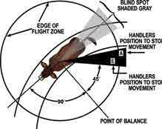
Figure 1: flight zones
In this flight zone, animals have driving zones and a point of balance. The point of balance is at right angles or 90° to the shoulder of the animal. The livestock handler should stay at, or near, this position when moving livestock. Then by moving backward from the point of balance, the animal can be made to move forwards. The livestock will tend to move in the opposite direction to that in which the pressure is being applied. In this way a livestock handler that moves down alongside a race will be encouraging livestock to move up the race in the opposite direction. The following diagram provides a summary:
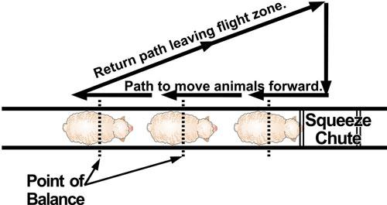
Source: T Grandin, Livestock Handling Practices, 2000.
The idea of utilising the flight zone to move livestock is to trigger only a small amount of the flight in the animal. In the same way that antelope will move steadily away from a lion that is stalking so we want livestock to move steadily away from us without a full blown fear reaction.
By moving toward or retreating from a flight zone or backward and forward from the point of balance a skilled livestock handler can move livestock without excessive handling (i.e. touching, shouting or hitting livestock).
Stressed or agitated animals may react violently and unpredictably to a handler entering its flight zone through either a fight or flight response. By anticipating the animal’s behaviour and carefully using the flight zone, a good handler can make the animal move without stressing the animal by being too close.
One of the other considerations when moving livestock is the facility design and construction. Some facilities are well designed and incorporate features that make handling animals much easier such as:
- curved raceways
- races with solid sides
- flooring that is even without items that cause baulking
- even lighting which will assist in moving livestock from area to area.
Clearly not all facilities will be new and designed specifically to take advantage of the new research into livestock movement. However people managing and handling livestock can assist in improving the movement of livestock through any facility by removing items that may cause baulking and by applying good handling practices.
Why do stock baulk and suddenly become difficult to move?
Livestock are easily distracted or scared when they are in a new environment. They will baulk at anything that is new or different in the environment. The following things can make stock baulk:
- people moving in or around where the stock are meant to be going, light or shadows
- changes in lighting
- changes in grates or flooring
- reflections off widows or cars
- changes in fences or the colour of the background
- sudden or loud noises
- fly strips, chains or clothing flapping
- dark areas
- puddles of water
- birds.
Often if stock are consistently difficult to move at a particular spot go to that spot and see if you identify what in the environment is spooking the livestock. It may be as simple as a gate not tied back or a workers jumper left hanging on a post.
Bad handling habits such as hitting livestock can easily become engrained and frustration levels can be raised without a great deal of thought going into why livestock are baulking.
Races, ramps, stunning boxes and restrainers should be uniformly lit and free of distractions including drains, moving or flapping objects. Calm and quiet handling can be difficult if animals are stopping in groups.
Races with solid sides to prevent animals from seeing other distractions have been shown to be effective in maintaining animal flow because cattle became much more agitated in the race where they could see out. This design is useful for sections of the race that lead from lairage to the stunning and restraint facilities.
Livestock handlers need to observe livestock movement regularly to identify problems in animal movement and be able to take action to improve the situation.
Vision
Livestock have a very wide range of vision, being able to see almost all the way behind their head. In fact livestock can see much further around themselves than humans. Research has also shown that livestock have only a moderate ability to judge distance, which can affect their willingness to move up and down steps and ramps. For example, livestock find particular ramp slopes easier to negotiate than if ramps are too steep (note – the maximum slope must be no greater than 20°). The ability of the animal to somewhat judge distance in front of them is a key factor in their behavioural response to obstacles, such as uneven flooring. For example, the animal may not be able to judge how uneven flooring will affect the surface upon which it is moving. Humans can see and judge obstacles and distances very well. The more limited ability of livestock to judge distance indicates the importance of providing even lighting, especially as animals also cannot judge depth – a shadow can be perceived as a whole.
Understanding the visual abilities of livestock allows us to design handling facilities that aid the stockperson in moving their animals. It is also recommended that stock handlers remove high visibility vests when around animals.
The ability of livestock to see almost all the way behind as well as in front of their head means that they are capable of seeing a lot more of their environment compared with humans who have a much more limited field of vision. Therefore, livestock may be easily distracted by changes to their environment, changes that the handler may not be able to see without turning around. For example, the livestock may see other animals or other people moving through the facility that their handler does not notice. The ability to see these other things around the facility could distract the animals making handling surprisingly difficult.
Livestock are also capable of recognising changes in light levels. In fact, research has shown that animals prefer well lit areas over areas with low light levels, and will move more easily to brighter areas. Livestock may also be sensitive to contrasting patterns on the floor. Animals may avoid material changes in floors and avoid crossing floors with changing light patterns such as drain grates, steps, puddles of water, and gutters.
The wide angle of vision of livestock means that solid walls for corridors, pen fronts, loading ramps, races and gates are useful ways to prevent livestock from being distracted while being moved. Walkways, corridors, races and pens should be well lit and have even lighting. Lighting should be erected in such a way as to reduce the appearance of shadows in areas where livestock are often required to walk.
Noise and smell
Livestock have sensitive hearing. They tend to avoid excessive, loud and unfamiliar noises. Reducing noise levels, such as shouting, whistling and banging of gates as much as possible, particularly at times when livestock are being moved, may help improve ease of handling. It is also useful to avoid moving livestock during times when facilities on the plant are creating loud and/or unfamiliar noises. High pitched noises can also disturb livestock and make them difficult to handle.
Lighting
Animals tend to move more readily from a darker area towards a lighter one provided that light is not directed into their eyes. In practice, animals may refuse or baulk when forced to enter a dark area.
The lighting inside and immediately outside the transport vehicle and on the unloading ramp can have a marked influence on the ease of unloading. Providing a well-lit unloading area or platform will facilitate easier unloading. The need to use handling aids or electric goads at the point of unloading may be an indication that the lighting should be examined.
Also a shadow that falls across a race/floor may prevent the flow of animals, with leading animals stopping or refusing to cross. Puddles of water, drains and bright or blinding sections of sunlight can have a similar effect
Calves and other young animals
Bobby calves are calves sent for slaughter, generally within their first week or life. Calves intended for slaughter should be in their fifth day of life or older, have been fed within six hours of loading and be slaughtered first in line at the processing plant.
Calves and other young animals have often not developed following behaviour by the time they are sent for slaughter, therefore they can often be difficult to move in groups. Young animals are often difficult to shift and tend to stand in groups rather than move, so that dealing with them is often time consuming and frustrating for personnel involved. Stockpeople unloading calves need to be patient, as forcing calves to move quickly can often lead to calves falling and slipping or simply not responding to the handler trying to move them. This signifies the importance of correct handling procedures, especially in situations that involve restraint, movement or re-grouping.
Calves presented for sale must:
- be in their fifth day of life or older
- have a withered, dry navel cord;
- have been fed within six hours prior to transport
- be at least 23 kg in liveweight
- be able to rise, walk and stand on their own and be bright, healthy and alert.
The bobby calf declaration is used to document the drug residue status of each animal and to meet the animal welfare requirements for bobby calves consigned for sale or slaughter. Bobby calves must be tagged prior to sale for reasons of traceback, disease control and meat quality. The official bobby calf ear tag is required on selection for sale and calves that are not for immediate slaughter should also be tagged with an NLIS tag.
Time in lairage for bobby calves should be kept to a minimum. Ideally they should be the first slaughter of the day, to ensure that in any event, calves are fed once every 24 hours, taking into account the time they left the farm.
WI | How can WHS risks be limited during animal handling?
Many people have been killed or severely injured while handling stock in lairage at abattoirs. Animals may have gone through several changes in environment before arriving at the abattoir, so their behaviour may be unsettled. You must be alert at all times and follow your required workplace procedures. If you do this, you will limit the WHS risks associated with handling animals.
Issues you need to be aware of to limit WHS risks are:
- the need to understand the normal behaviour patterns of the animals being handled, for example how they will respond to movement
- handling requirements for different ages, sex, breeds, for example cattle from large northern properties
- the need to move animals quietly, without causing fear or excitement
- ensuring animals have sufficient space to move into, for example from the open to the race
- the correct use of implements such as prodders or goads, because overuse of goads will excite animals and make them unpredictable and dangerous
- the layout of yards, such as gates, exits and races, in case you need to get out of the way suddenly
- problems relating to the physical surroundings, such as wet conditions, broken gates and poor lighting.
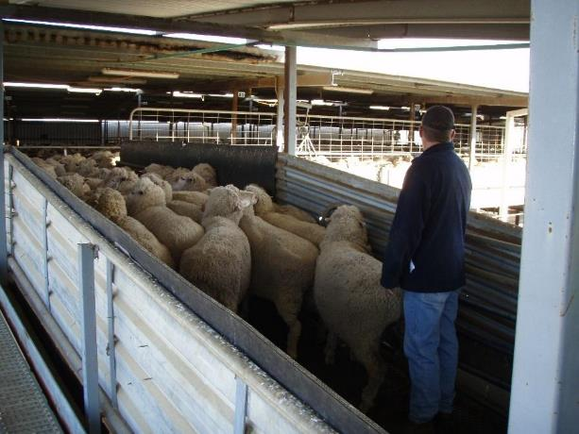
Stockman moving sheep in pens
© S. Fitzgerald
What makes a good stock handler?
There are three essential elements that make for good stock handling:
- the animals
- the facilities
- the competency of the stock handler.
The animals can vary from the quiet to the wild. The latter being more difficult to handle.
Facilities need to be the best available. Poorly designed facilities can make the work of the stock handler very difficult and also dangerous.
But an equally important part is the competency of the stock handler.
Competency and training of stock handlers is given high priority in the Industry Animal Welfare Standards. This training material is designed to help ensure that all stock handlers are competent to do their jobs.
Effective stock-handlers should have a good understanding of animal behaviour and show an awareness and respect for animals when working with yarded stock. Respect for an animal's speed and power to inflict injury on itself and other is essential. Close proximity to animals in yards or trucks increases the risk of injury to the handler.
Communication
When there is good communication between animal and handlers there are fewer injuries for both. You can do this by understanding and using the behaviour of animals, including their flight zones. Shouting or hitting or too many helpers make communication difficult.
Confidence
A calm and confident stock-handler will get the job done with a reduced risk of stress and injury to stock or staff. Confident handling includes calm, predictable reactions, ability to be firm with both stock and staff as well as a willingness to get in and mix with animals if necessary.
Awareness
Stock handlers will be aware of the many situations which may influence the behaviour of yarded stock. For example, weather conditions may upset animals and make them difficult to work with. Stock are usually easier to work with in the morning when they are fresh, especially during hot weather.
Overcrowding will increase the stress in animals. Overcrowding is poor handling, since even cooperative animals are unable to move.
Patience
Stock handlers need to be patient when stock are having difficulty dealing with a change in their situation such as moving up a race or moving onto a slippery wet surface. It is essential that the stock handler stop and assess why there is a problem, work out how to help the stock cope with the problem and give them time to deal with the change in environment.
WI | How and why are animals identified at abattoirs?
Animals at abattoirs are identified in three ways:
- individual identification
- property identification
- lot identification.
Individual identification
Cattle are the main animals that are individually identified. This was originally to meet the requirements of importing countries, in particular the European Union (EU) but now forms an important part of Australia’s strategy to combat the outbreak of any exotic diseases.
The National Livestock Identification System (NLIS) was initially introduced to ensure that individual animals could be identified from birth. In 2006 the use of NLIS tags was made compulsory for all cattle in most circumstances.
The NLIS tag is an electronic ear radio frequency device that has an electronic number embedded in it. This number can be read by a scanner and stays with the animal for life. There is also a number imprinted on the ear tag that can be read physically. This number includes the Property Identification Code (PIC).
All numbers are stored in a central database and every movement to a new PIC is recorded until the animal is slaughtered.
There are two types of electronic devices, an ear tag and a rumen bolus. The ear tag has proved to be the most popular to date, due to individual tags being cheaper. They are also the processors’ preference due to the difficulty of the bolus recovery.
White tags are for animals that have been tagged from birth.
Orange tags are for animals that have been purchased untagged or have lost tags after purchase and need to be re-tagged.
It is illegal to remove white tags and replace them with orange tags.
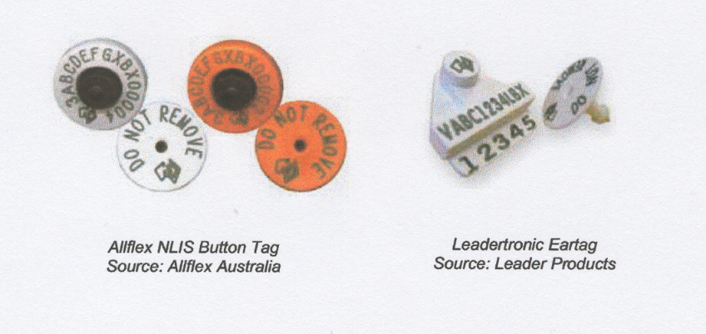
At saleyards and at slaughtering plants the tags and boluses can be read by an electronic reader and the number checked on the NLIS data base.

Note: The white tag that is used with the bolus does not contain a radio frequency device (RFD). The RFD is located in the rumen bolus. This is popular with cattle producers in areas that have a high level of cattle rustling, as the bolus cannot be removed from the live animal
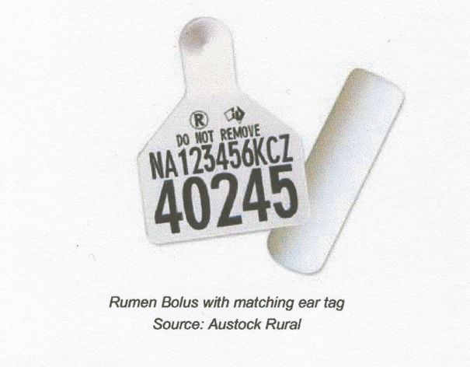
The system has also recently being extended to sheep but sheep are identified by property not individual animal. Tags are colour coded for the year of birth with pink tags reserved for post-breeder tags. The ears tags can be electronic or visual tags (not RFDs). Every movement must have an accompanying NVD and be recorded on the NLIS database.
The identification of animals electronically is covered in the training material for AMPA2023 Identify animals using electronic systems.
Tail tags and brands are now redundant in cattle. But may be used for additional identification. For example, regulatory authorities wishing to identify animals from quarantined properties may still use tail tags and brands are still registered by State Authorities. Tail tags are still required for some markets, such as the European Union.
Property identification
This is the most common form of identification. All animals at the point of slaughter must be able to be identified to the last owner or property.
Cattle have NLIS tags attached by the owner, sheep are identified by ear tags and pigs are tattooed.
All brands and tattoos are registered by State Authorities.
The main purpose of this identification system is to enable a trace back to the property of origin, if disease or chemical residues are detected at slaughter.
Lot identification
Livestock delivered to an abattoir are also identified by the company's lot identification system. There are a number of reasons for lot identification:
- to match numbers of livestock to individual owners, particularly if the animals are being slaughtered ‘over the hooks’, i.e. the owner is being paid on a price per kilo after weighing at the scales
- to help the company buyer in checking the ‘guesstimate’ of weight and condition, when they buy animals 'on the hoof' on the farm or in the saleyards
- to box up similar lines to avoid fighting and animal welfare issues, for example cows separated from steers and bulls.
Lots are identified in a number of ways. They may be identified by numbered brands or tattoos applied at the point of purchase, particularly at saleyards for cattle, sheep and pigs.
Cattle in particular may also be identified by paint applied at various points on the animal. The common points used are:
- the poll
- the shoulder
- the back
- across the pins
- the tail.
You should check your work instructions and have a good understanding of the system in use on your plant.
What forms of documentation are used for livestock identification?
In addition to the brands, mark, tail tags and tattoos used to identify livestock, all livestock delivered to an abattoir usually have some form of documentation. The minimum requirement is generally a delivery docket.
In most States, the State Authorities require some form of permit to move stock. This permit may be a delivery docket or a specific form issued by the State Authorities. This measure helps control disease as animals from properties under quarantine for certain diseases may not be allowed to be moved, without a specific permit.
Vendor declarations
Vendor declarations are a legal document and are becoming more important as most States have legislation making vendor declarations compulsory. Most abattoirs insist on vendor declarations for cattle, to cover themselves in case chemical residues are found in the meat.
On vendor declarations farmers generally declare that they have not treated their animals with certain drugs and veterinary chemicals within stated periods.
All animals exported to the European Union market must have an EU vendor declaration, as well as the permanent NLIS electronic marker.
Vendor declarations have also been introduced for sheep. The sheep industry has also adopted a permanent individual identification ear tag identifying the property of origin to facilitate traceback.
Livestock Production Authority (LPA) approved NVDs also indicate that the property providing the NVD has records and systems in place to back up the declaration made on the NVD.
What is the consequence of incorrect lot identification?
If cattle tags are lost and a serious disease is detected in the animal such as tuberculosis, it may not be possible to trace back to the property of origin and control the disease.
If the animals are identified with the wrong lot number the wrong owner will be paid for livestock sold ‘over the hooks’.
Why is it important to maintain the flow of stock at the abattoir?
It is important that the flow of stock to the knocking box is maintained. This is because any gaps in the chain slow down production and the day's work may not be able to be completed in the required time. Workers may have to work longer hours just to complete the day's kill.
Abattoirs are expensive places to operate. Large plants can cost $200 per minute to run, when you include labour costs, power costs and overheads. So every minute becomes valuable.
Stockmen must make sure that the flow of stock is maintained to the knocking box, but the flow of stock should not be at the expense of animal welfare.
Careful design and planning of facilities and good handling practices can ensure a steady flow of stock without causing pain and suffering to animals.
Bibliography
These publications were used to develop this training material.
Andriessen, E.H., 2006, Meat Safety Quality and Veterinary Health in Australia, eighth edition, Penny Farthing Publishing PO Box 3322, Port Adelaide South Australia 5015
Animals are not things- Dr Temple Grandin (2002)
Agriculture and Resource Management Council of Australia and New Zealand, AS4696:2023 Australian Standard for the hygienic production and transportation of meat and meat products for human consumption, CSIRO publishing, Collingwood, Vic.
Industry Animal Welfare Standards for Livestock Processing Establishments Preparing Meat for Human Consumption (2009) – Australian Meat Industry Council. This can be downloaded free from www.amic.org.au
Standing Committee on Agriculture and Resource Management 1998 Australian Code of Practice for the Welfare of Animals: No 10, CSIRO Publishing, Collingwood, Vic.
Export Control (Meat & Meat Products) Orders 2005
Meat Manual Volume 2 – Requirements for overseas countries
Operational Guidelines for the Welfare of Animals at Abattoirs and Slaughterhouses.
Construction and Equipment Guidelines for Export Meat, second edition
Department of Agriculture Meat Notices
All can be downloaded from the Department of Agriculture website.
The protection of animals at the time of slaughter and killing – 9/119/EC
Tasmanian Animal Welfare Act 1993
Queensland Animal Protection Act 1993
Western Australian Prevention of Cruelty to Animals Act 1920
New South Wales Prevention of Cruelty to Animals Act 1997
South Australian Prevention of Cruelty to Animals Act 1985
Victorian Prevention of Cruelty to Animals Act 1960
Northern Territory Prevention of Cruelty to Animals Act 1996

Additional resources
Registered Training Organisations (RTOs) should refer to the Unit-by-Unit listing of resources on the MINTRAC website www.mintrac.com.au for additional resources to support the delivery of this Unit.
RTOs which develop or identify additional resources are encouraged to advise MINTRAC so that these can also be added to the Unit-by-Unit listing.
CD Animal welfare – Sheep
CD Animal welfare – Cattle
Food Safety and Inspection Service (USDA)
CD – For the Welfare of Livestock Version 1.0 1998
As Easy as Leading Lamb, video, 1990, CSIRO, Queensland.
Good Handling Makes Good Sense, video, 1991, CSIRO Meat Research Laboratory, Queensland.
All It Takes is a Little Understanding, 1990, CSIRO, Cannon Hill.
Handling Cattle from Farm to Abattoir, NSW Agriculture, Sydney.
Livestock Transport – Handbook for Drivers, TAFE, NSW.

