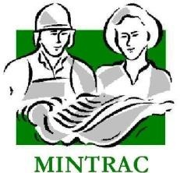

AMPLSK301
Handle animals humanely while conducting ante-mortem inspection
Training support materials

Australian Meat Processing Training Package
Certificate III in Meat Processing

Table of contents
Note to users 5
Companion Volume 5
Please help to keep these materials current 5
Using these support materials 6
What are the materials for? 6
How can they be used? 6
How are the materials organised? 6
Additional resources 7
Customising the MINTRAC Training and Assessment materials 7
Adding company-specific information 7
Incorporating changes to legislation and regulations 8
1. Training support materials 8
2. Suggested activities 9
3. Sample assessment tools 9
Australian Core Skills Framework information 12
What is the Australian Core Skills Framework? 12
Skills checks for the meat processing qualifications 13
Training support materials for AMPA3002 Handle animals humanely while conducting ante-mortem inspection 14
Animal breeds and species 14
Why is it important to know the different breeds and species of animals that you are handling? 14
What are the different species of animals? 14
What behavioural characteristics need to be taken into account when handling animals? 21
Animal welfare 24
Why must animals be handled humanely? 24
Who has responsibility for animal welfare at a slaughtering plant? 25
What are the regulatory animal welfare requirements when preparing animals for slaughter? 26
What general principles apply to animal welfare at abattoirs? 28
How can poor handling affect meat quality? 30
How do you know if animals are stressed? 32
Animal handling 34
What methods can be used to assist with the movement of livestock? 34
What aspects of natural animal behaviour have to be considered when handling stock? 36
What should you do if you observe cruel actions or situations during ante-mortem inspection? 38
What are the requirements when handling sick or injured stock? 38
How should wild or uncooperative animals be handled and how can WHS risks be minimised? 40
How do I know when animals are suffering undue stress? 43
Training record sheet 44
Bibliography 45
Additional resources 46
Assessment materials for AMPA3002 Handle animals humanely while conducting ante-mortem inspection 47
Information about range 47
Selecting and briefing Workplace Referees 48
What to consider when using a Workplace Referee 48
Recording assessment information 50
Notations 50
Photos 50
Recordings 50
Addressing the Language, Literacy and Numeracy (LLN) requirements of this unit 51
Reasonable adjustment 51
The MINTRAC sample assessment tools 52
Key assessment requirements for this Unit of Competency 52
Are the MINTRAC sample assessment tools ‘validated’? 52
How to use the sample assessment tools 52
The Evidence Guide 54
Evidence guide 54
AMPA3002 Handle animals humanely while conducting ante-mortem inspection 54
Workplace referee's report 57
AMPA3002 Handle animals humanely while conducting ante-mortem inspection 57
Test or quiz 60
AMPA3002 Handle animals humanely while conducting ante-mortem inspection 60
Answer sheet (for assessor use only) 63
Assignment 68
AMPA3002 Handle animals humanely while conducting ante-mortem inspection 68
On-the-job demonstration with assessor observation 70
AMPA3002 Handle animals humanely while conducting ante-mortem inspection 70
Record of completed assessment 73
AMPA3002 Handle animals humanely while conducting ante-mortem inspection 73

Training support materials for AMPLSK301 Handle animals humanely while conducting ante-mortem inspection
These materials are for training in AMPA3002 Handle animals humanely while conducting ante-mortem inspection in the Certificate III in Meat Processing.
Animal breeds and species
Why is it important to know the different breeds and species of animals that you are handling?
The identification of different species and breeds is the first step in the process of handling animals. Through understanding the animals’ characteristics, you will learn to handle them effectively.
It is important that you consider all the requirements for handling animals when conducting ante-mortem inspection. This will ensure that the animals are handled according to regulatory requirements, and that they will not be injured during ante-mortem inspection.
What are the different species of animals?
The three main domestic animal species processed in Australia are:
- sheep
- cattle
- pigs.
Sheep
Sheep are grown for wool and meat production.
Merino breeds have traditionally been produced for their fine wool. Those not used to breed are sent to the abattoirs when they have reached maturity.
There are numerous breeds that are grown specifically for meat production.

Merino
The merino is the most common breed of sheep found in Australia and is usually bred for wool production. Selected mature merino sheep are used for mutton production. The merino is a large framed animal with longer legs than most breeds of sheep. They generally dress out at slaughter as a leaner carcase.

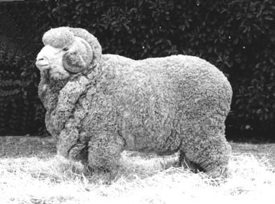
Merino
Dorset Horn/Poll Dorset
This breed of sheep forms the bulk of lamb production in Australia due to a well-conformed body and muscle content. The lambs produced are larger than most breeds which makes them perfect for the local lamb trade.

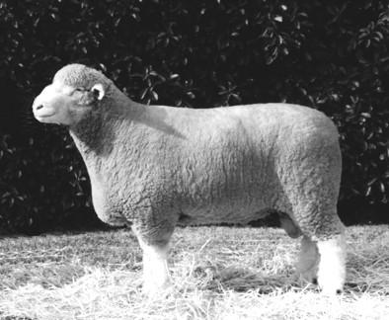
Poll Dorset
Southdown
The Southdown is a small framed, short-legged sheep. The body has a well-defined muscle structure.
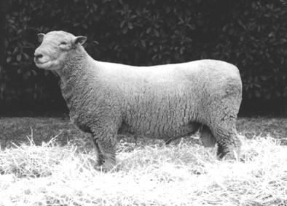
Southdown
Border Leicester
This breed is one of the largest framed sheep breeds with good wool producing qualities. The distinguishing feature of the Border Leicester is the prominent wool-less, hook-nosed head.
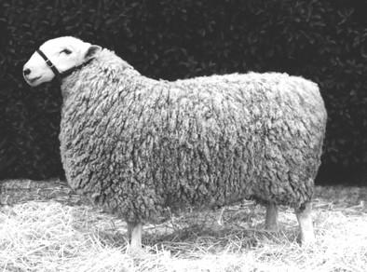
Border Leicester
These are the most common breeds of sheep seen at an abattoir. However, there are numerous other breeds of sheep grown for meat production, such as Romney Marsh and the Suffolk breeds.

Dorpers
The breed was developed in South Africa in the 1930s by crossing Blackhead Persian ewes with a Dorset Horn ram. They were bred to produce a high quality carcass under extensive conditions. The Blackhead Persian was selected for its non-selective grazing, coat shedding, hardiness and good mothering abilities. The Dorset Horn was selected for its rapid growth rates and carcase attributes.
The breeding program resulted in the development of the black headed and white headed Dorper. Successive Dorper breeding has shown it to be a fixed breed type, giving a reliable reproduction of features and characteristics.
The breed was introduced into Australia in 1996 and has the potential to be developed for domestic and export meat markets.
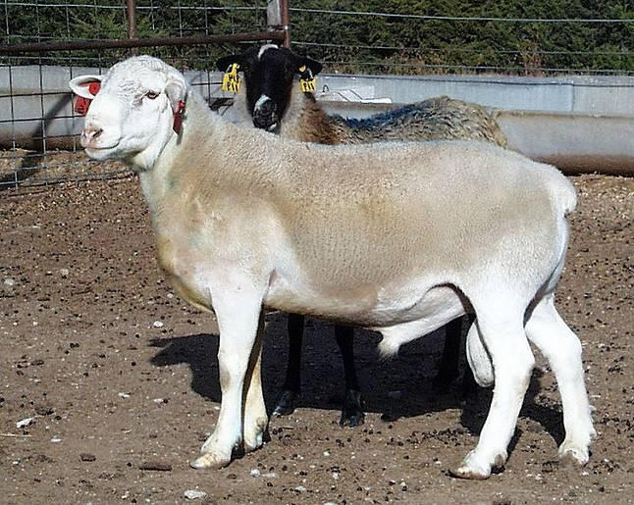
Dorper
Wiltshire Horn
The Wiltshire Horn has a short fleece that naturally sheds in the spring leaving a short hair coat, as the picture shows. The fleece then starts to grow again in the autumn to provide protection for the winter months. This self-shedding ability eliminates the time and cost involved in shearing, crutching and dipping.
The Wiltshire Horn produces fabulously full flavoured meat as now demanded by an increasingly discerning public. Lambs have the ability to grow to heavy weights without putting on excess fat to meet modern grading requirements and are able to finish off grass. The exceptional quality of the meat is ideally suited to niche market outlets such as farmers markets.

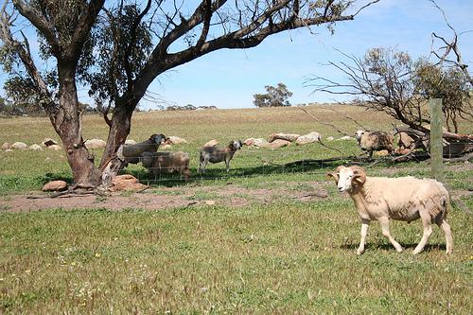
Wiltshire Horn sheep © Annie Kavanagh, Spencer's Brook Farm
Damara
The Damara is a unique breed of meat sheep ideally suited to our Australian climate.
Damara’s originated in East Asia and Egypt circa 3000BC and were introduced to Australia from South Africa in 1996. They have adapted to extreme climates and harsh environments as they have migrated to many countries.
Damara sheep tolerate heat well and are able to walk long distances, making use of feed away from watering points. They have been performing successfully in wheatbelt regions and pastoral country of Australia. Damaras can be adapted to existing farming infrastructures and provide an excellent commercial opportunity to increase meat production and live export into alternative world markets.
Cattle
Cattle are produced for milk or meat production.
Meat producing cattle have a greater ability to grow faster and mature more quickly than the dairy cattle. Dairy cattle are usually sent to the abattoirs for slaughter after their dairy production is completed.
There are a large number of breeds of cattle represented in the Australian herd. These are run either as pure bred or crossbred herds depending on the environment in which the cattle are run and the market that the cattle will be sold into.
All breeds are slightly different, but in general they are usually split into two types: Bos Indicus and Bos Taurus.
Bos Taurus
Bos Taurus includes those breeds usually described as British and European.
British breeds are generally earlier maturing and are thus able to fatten on less feed. They include Angus, Hereford, Poll Hereford, Shorthorn, Galloway, Murray Grey and Devon breeds.
The European breeds include Simmental, Charolais, Limousin, Belgian Blue and Piedmontese.
Bos Indicus
The Bos indicus breeds include Brahman, Sahiwal and the composite breeds include Santa Gertrudis, Braford, Bos indicus Brangus, Droughtmaster, Charbray and Belmont Red.
These cattle breeds are dominate the herds in the north of the country.
Pigs
Pigs are now farmed in intensive, disease-free environments for quicker and greater meat production. They are fed on a diet that has reduced the growth rate from approximately eight months under traditional methods, to about six months under the intensive farming methods.
Large white
This is the most common breed of pig in Australia. This breed of pig is pure white in colour with the ears pricked straight up.
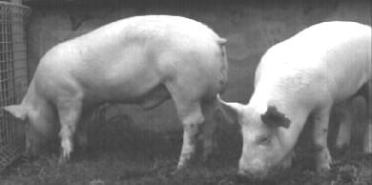
Large White
Pietrain
This is an extremely fast growing pig that is white in colour with black spots. The advantage of this pig is that it is extremely lean and so suitable for the local trade.
Duroc
The Duroc is becoming more popular in Australia because it produces a lean carcase. It is a red haired breed of pig.

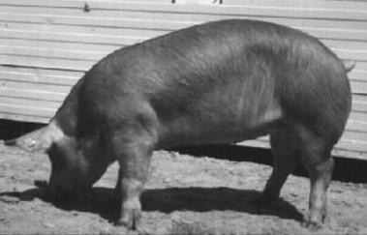
Duroc
These are the most common breeds of pigs seen at an abattoir. There are numerous other breeds of pig grown for meat production, such as the Berkshire, Landrace and Tamworth breeds.
What behavioural characteristics need to be taken into account when handling animals?
Behaviour when yarding
To avoid injuring the animals and to make ante-mortem inspection easier, you need to consider the following when yarding animals.
Animals of different species should not be mixed. Within species, the following categories should be kept separate:
- young calves
- females with suckling offspring
- animals that are significantly different in size
- hornless (polled) cattle from horned cattle
- mature entire males
- females in advanced pregnancy.
The easiest way to handle sheep at ante-mortem is to run them through a drafting race. This is because sheep tend to ‘bunch’ together. Cattle may need to be run past the inspecting officer both ways to complete the inspection process.
Behaviour when moving
There are numerous points about animal behaviour that you should observe. You can use these to make moving them easier and therefore more humane.
The main animal behaviour characteristics that are important in ensuring easy movement of livestock are:
- vision
- reaction to noise
- flight zone
- fear
- age
- natural strength.
Vision
Animals have differing abilities when it comes to vision. Cattle and sheep have their eyes located high in the head. This means that cattle and sheep have a large area of vision, including peripheral vision. They can see up to 300 degrees, which means they can see objects or humans approaching from nearly all angles. When moving these animals, this good vision can be an advantage as well as a disadvantage. Moving stock can be easier. However, cattle may become more agitated or ‘flightier’.
Long wool sheep have a smaller field of vision, sometimes being virtually restricted to tunnel-vision due to the wool around the eyes. These animals must be approached carefully so as to not cause them to react quickly from fright. This may lead to injury to the animals or handlers.
Although cattle and sheep have good peripheral vision they lack depth perception. This means that they will often lower their heads in order to see better in dark and restricted spaces.
It also means that they will baulk easily with changes in light, floor surfaces and at overhead structures such as walkways.
Ante-mortem inspection requires a well-lit area to facilitate the inspection process. However, the lights should not be directed into the eyes of the animals as this may cause them to baulk and not move. This will slow down the inspection process.
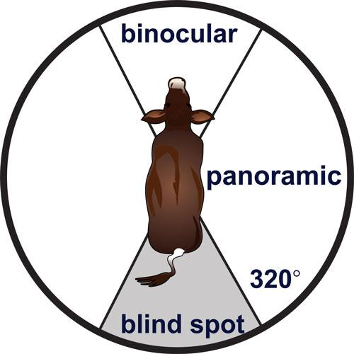

Cattle vision © MINTRAC
Noise
Cattle and sheep are very sensitive to loud and high-pitched noises. These should be avoided when performing ante-mortem inspection. Items that may produce these noises include banging gates, barking dogs, air hoses and flappers.
Pigs are less sensitive to these noises and are therefore easier to handle at ante-mortem.
Flight zone
During ante-mortem inspection it is essential to observe the animal’s flight zone. The flight zone is the animal’s personal space. The flight zone is an important consideration, both for your safety and the safety of the animals.
When the flight zone is not entered, the animal will move freely and calmly. If the flight zone is approached quickly, the animal may view this as an attack and become aggressive. Slow movement during ante-mortem inspection is essential.
The use of the flight zone is an important tool in moving animals. By moving into the flight zone slightly ahead of the animal's shoulder, the animal will move back. Conversely, by moving into the flight zone behind the shoulder, the animal will move forward.
Nature of the breed
There are differences in behaviour between the various breeds of cattle. These differences may influence the way you approach certain animals e.g. Friesian cattle tend to move very slowly. In contrast, Brahman cattle are very excitable and an electric prod should never be used on them. The Aberdeen Angus breed is also very excitable.
There tends to be little difference in the behaviour patterns of sheep and pig breeds. All sheep tend to be excitable and flighty. Pigs tend to be more stubborn and harder to move. They are known to fight when intimidated. Boars and old sows have the potential to be extremely dangerous and must be treated carefully.
Age of the animal
Young animals are usually full of energy, easily frightened, nervous, prone to make sharp and sudden movements and, above all, unpredictable. Very young animals such as calves have not developed a herd behaviour and will not follow one another as older animals will do. These can be frustrating to move and need a lot more care and patience by the stock handler.
Natural strength of the animal
Apart from the obvious strength of bulls, a cow can crush you against a stockyard fence or gate, causing severe injury, especially if it is running. Even small stock such as sheep running at speed can knock you over.
Un-husbanded animals
You will have to be especially careful of animals that have had little human contact, such as those brought in from large properties and those that are not used to handling. These are far more unpredictable.
Fear and stress
Even animals which are docile under normal conditions can become aggressive as a result of the stresses encountered during transportation.
All animals have a survival instinct – it is the oldest and most basic of instincts. It affects every animal on earth. Your actions or movements can cause an animal to feel endangered.
Treat animals with care. Move slowly when handling them. Make no sharp or sudden movements. Look out for the cow with her calf – her maternal instinct is strong and so is she.
Bad handling causes fear, desperation and panic and can make a usually docile animal quite dangerous. Animals which may have been repeatedly mistreated are likely to respond badly to any attempts to control their movements.
Unexpected behaviour
Seemingly docile animals can behave unpredictably. It can also be easy to overlook or discount the obvious. You may be watching the bulls and discount the cows. This is when accidents can happen.
Animal welfare
Why must animals be handled humanely?
There are four main reasons why animals should be handled humanely at slaughtering plants.
- Ethical reasons.
- Product quality.
- Product safety.
- Legal requirements.
Ethical reasons
Animals are not ‘things’ (Temple Grandin, 2002) because all animals feel pain.
Animals do not understand that they are about to be slaughtered. The stress they feel at slaughtering plants is largely due to the way people handle them in the strange environment.
The ethical imperative of treating animals in a humane manner is increasing as a social expectation. The infliction of unnecessary stress and pain to animals is becoming less acceptable morally to society, so measures are now required to limit this pain, particularly in the process of slaughter.
This moral stance of society is changing all the time and practices that were considered acceptable 25 years ago are no longer acceptable now.
Cultural influences can affect what is considered to be acceptable animal welfare practices.
Western concepts of animal welfare based on science are being applied more often as the standard worldwide, through such mechanisms as the World Trade Organization, bilateral trade agreements and international standards.
Product quality
Inhumane handling, causing animal stress, results in an inferior meat product and causes, for example, pale soft exudative (PSE) meat, dark, firm, dry (DFD) meat and dark cutting beef as a direct result of stress at slaughter.
Product safety
Inhumane handling, causing animal stress, results in a weakened immune system that can show up as a growth of gut bacteria such as Salmonella and E. Coli. For example, under stressful conditions the number of animals infected with Salmonella can increase from 5% to 85% of the mob within a matter of hours. These bacteria are potential food poisoning agents or pathogens and the risk of potentially dangerous contamination during dressing is greatly increased.
Legal requirement
Animal protection and its enforcement is a legislated requirement of State and Territory governments, and in the case of the ACT, the Commonwealth government.
You need to know the animal handling requirements at your workplace. There are national and state laws and codes for animal welfare, so what your workplace follows will depend on your State or Territory, the species you slaughter and if your enterprise is export-registered or domestic-registered.
In 2005 a National Animal Welfare Standard for establishments processing animals for human consumption was produced. This now forms the basis for all animal welfare regulatory requirements at slaughtering plants.
Who has responsibility for animal welfare at a slaughtering plant?
All people involved in the handling of animals have an obligation to ensure that animals are not mistreated or placed under stress. This includes truck drivers, stockmen and slaughtering personnel involved in stunning and sticking.
All supervisors including lairage foreman, slaughter-floor foremen, QA officers, meat safety inspectors and senior management also have a strong obligation to ensure that animals are not mistreated.
Other individuals at the plant also have a responsibility to report any mistreatment or animals obviously in pain, to their supervisors.
Following animal welfare regulatory requirements will ensure you handle animals to the standard set in the codes. This will prevent cruelty to animals.
On the day of slaughter, animals are inspected by a qualified person, usually a meat safety inspector or veterinarian, to see if they are suitable for processing as food for human consumption. Each animal must be individually inspected. Any abnormality which can be seen is noted. Animals with abnormalities are segregated and then examined further.
All animals that are to be presented for slaughter must be handled in a humane manner and adequately rested.
Every person who handles stock before slaughter has an obligation by law and an ethical responsibility to handle them in a way that avoids injury or stress.
In addition, poor handling of stock that results in injury can have a big impact on the quality of the end product. For example, unmuzzled working dogs that bite sheep can injure the animal. This is against the law and it can also result in extensive trimming at the end of the line. This costs money.
Movement from pen to pen, overcrowding or bunching in raceways or pens may also result in injury to stock. Animals that get excited try to get out of pens and yards, which can result in bruising. This again means heavy trimming, which will be necessary at the end of the line – a cost that can easily be avoided.
Each species of animal should be handled in a way that avoids possible injury. This can be done by respecting the animal's behavioural characteristics and by following the regulatory requirements.
Stress
Animals must also be handled at ante-mortem inspection in a way that prevents stress. Stress may include:
- exposure to infectious diseases
- insufficient care in procedures leading up to slaughter
- crowding, mixing or bunching of animals
- isolation from the herd
- restricted access to food and water
- unfamiliar sounds, noises or smells
- rough yarding and handling.
Stress results in the end product being darker in colour, coarser in texture and not as flavoursome. The shelf life of the meat is also reduced. The dark colour of the meat is commonly referred to as ‘dark cutting’. Well-rested and unstressed animals generally do not produce dark cutting meat.

WI | What are the regulatory animal welfare requirements when preparing animals for slaughter?

There are National and State laws and codes for animal welfare that must be adhered to whether animals are slaughtered at export or domestic abattoirs. These include:
- Tasmanian Animal Welfare Act 1993
- Queensland Animal Care and Protection Act 2001
- Western Australian Animal Welfare Act 2002
- New South Wales Prevention of cruelty to Animals Act 1997
- South Australian Prevention of cruelty to Animals Act 1985
- Victorian Prevention of Cruelty to Animals Act 1986
- Northern Territory Prevention of cruelty to Animals Act 1996
- Australian Capital Territory Animal Welfare Act 1992
- Export Control (Meat & Meat Products) Orders (EMOs) if the abattoir is an export registered plant
- Industry Animal Welfare Standards at Livestock Processing Establishments (2009).
The AS 4696:2023 Australian Standard for the hygienic production and transportation of meat and meat products for human consumption details the requirements for animal welfare at abattoirs and slaughterhouses, both export and domestic in Australia.
The outcome required by the standard is:
“The minimisation of the risk of injury, pain and suffering and the least practical disturbance of animals”.
The Standard requires meat companies to have an “Approved Arrangement” with their relevant controlling authority for all aspects of meat production.
This “Approved Arrangement” requires a meat company to include animal welfare as a policy objective in their “Approved Arrangement” and to demonstrate commitment to this policy.
To meet this requirement regulators and the meat industry have developed the following standard and guidelines:
The Industry Animal Welfare Standards for Livestock Processing Establishments Preparing Meat for Human Consumption (2009)
This Standard is based on the animal welfare codes, international standards and the “five freedoms”.
There are five internationally recognised freedoms that underpin all animal welfare:
- freedom from hunger and thirst by ready access to fresh water and a diet to maintain full health and vigour
- freedom from discomfort by providing an appropriate environment including shelter and a comfortable resting place
- freedom from pain, injury or disease by prevention and rapid diagnosis and treatment
- freedom to express normal behaviour by providing sufficient space, proper facilities and the company of animals of its own kind
- freedom from fear and distress by ensuring conditions and treatment which avoid mental suffering.
Based on these “freedoms” the animal welfare standard has six required outcomes:
- Planning and Contingencies.
- Maintenance and design of equipment and facilities.
- Staff Competency.
- Management and humane destruction of weak, ill or injured livestock.
- Management of livestock to minimise stress and injuries.
- Humane slaughter procedures.
Separate to the Standard is a working manual that effectively acts as a guideline as to how the outcomes of the Standard are to be achieved. Different but equivalent procedures and practices can be used so long as an equivalent outcome is demonstrated and proven.
This Animal welfare standard is based on the following codes:
- Australian Model Code of Practice for the Welfare of Animals, Number 10: Animals at Slaughtering Establishments
- Operational Guidelines for the Welfare of Animals at Abattoirs and Slaughterhouses.
What general principles apply to animal welfare at abattoirs?
The basic welfare needs of animals are:
- water – an adequate supply of drinking water so that animals don't dehydrate
- air – free from contamination and chemicals
- food – to help the animals maintain well-being
- space – sufficient room
- shelter – See section 7.4 of the Standard.
There are three main factors that contribute to the welfare of animals at slaughtering plants:
- the animals
- the facilities
- the people handling the animals.
They can all vary, but stress to animals can be minimised by adhering to the following six required outcomes of the Animal Welfare Standard.
1. Planning and Contingencies
Adequate planning needs to be carried out for management of stock on a daily basis and contingencies are in place to for emergencies to minimise risks to animal welfare. Contingencies include such issues as strikes, power failures and salvage stock slaughter as the result of bush fires etc.
2. Maintenance and design of equipment and facilities
Facilities and equipment need to be well designed, maintained and operated to ensure minimal interference or stress is incurred by livestock.
Animal handlers must take note of any problems to do with the construction of the abattoir that could put the animal or handler at risk of injury. You must report any construction problems to the person who is responsible. Problems may include:
- faulty gates and fences
- broken gates or drain covers
- slippery floors or surfaces
- pointed or sharp objects leaking or broken water devices.
The use of goads and working animals is also covered by government regulation and workplace instructions. The incorrect use of goads on animals causes unnecessary suffering and is illegal.
There are no recommended stocking densities in the Industry Animal Welfare Standard but the performance target is:
“Livestock have sufficient space in holding pens to be able to move freely”.
This can vary with the species and size of the livestock. As a guide the “Construction and Equipment Guidelines for Export Meat” recommend the following densities:
- pigs 0.67 m²/head
- heavy cattle 1.8 m²/head
- calves 0.5m²/head.
The Standard also requires feed and water facilities to be freely available.
3. Staff Competency
All persons responsible for the management of livestock or handling livestock are competent in their tasks and fulfil the requirements of this standard. This means training and on the job assessment of competency of the individual.
4. Management and humane destruction of weak, ill or injured livestock
Weak, ill or injured livestock must be identified and treated in a humane manner promptly. This means that responsible stock handlers:
- assess animals upon arrival
- injured, sick or weak animals are assessed and prompt action is taken
- livestock that are to be humanely destroyed or placed for emergency slaughter must be handled promptly
- weak, sick or injured stock are to be segregated from other animals for rest and/or assessment
- all stock are observed regularly to identify and segregate injured, ill or weak stock for emergency kill, treatment or humane disposal.
5. Management of livestock to minimise stress and injuries
Livestock must be routinely managed to minimize stress and injuries. This means that:
- animals are routinely and regularly monitored as to health and condition
- sick, weak or injured animals are removed and segregated
- sick, weak or injured animals are promptly assessed, treated and humanely disposed of without delay (emergency kill or humane slaughter).
As part of the preparations for slaughter, washing or fasting of the animals may be needed. The washing or spraying may be partial or whole. The fasting may be food only or food and water. Whether the animal needs washing or fasting will depend on the species and the age of stock being processed.
The access that stock have to feed and water will be set out in the workplace SOP and work instructions.
Stock should have access to water immediately they arrive at a plant so they can rehydrate after being transported. It is an important part of a stock handler’s duties to ensure that there is an adequate water supply available for stock while in lairages.
6. Humane slaughter procedures
Procedures for humane slaughter, including restraint, stunning and slaughter of livestock must be carried out to minimise stress and in an efficient and effective manner.
How can poor handling affect meat quality?
By following workplace procedures you will:
- make sure animals are handled humanely and safely
- prevent injury and stress
- make sure welfare requirements are covered.
Good handling helps to produce a quality product. Poor handling of animals can cause stress and/or injury to animals.
Stress or injury to animals will significantly affect the quality of the end product.
Stress
Stress on animals through poor handling can make meat tough and can also cause a condition called ‘dark cutting’ with high levels of pH (lactic acid levels).
Dark cutting will affect the meat quality in a number of ways:
- meat becomes darker
- meat becomes tougher
- meat will lose flavour
- shelf life of the product will be shorter.
Stress can also result in pig meat having defects such as PSE (pale, soft, exudative) or DFD (dark, firm, dry). Stressed stock may also produce meat that while normal in colour is tougher and produce excessive drip.
Bruising and Injury
Injury to animals can occur during transit, when they are being trucked, when they are moved around at the abattoir, or in lairage facilities. Lairage facilities are holding facilities and may include pens, yards, paddocks or sheds. The types of injury that can result include:
- bruising
- fractures
- wounds, cuts, lacerations.
Bruising is evidence of poor animal welfare practices and is most commonly associated with poor handling of livestock. Bruising on cattle is usually on the hips, hindquarters and top of the back. For lambs bruising is usually on the hind leg and foreleg. For pigs, bruises can be less common, but are often found at the femur and hind leg regions.
Bruising is most likely to occur during transport. It is important that when being transported that the animals need to be stocked reasonably in the vehicle to avoid slipping, falling and crashing into each other.
Bruising can also occur during unloading, particularly if livestock are rushed or they panic. Careful handling is required to move cattle from transport vehicles to avoid bruising, particularly as on most road-trains and B-double vehicles, cattle need to manoeuvre around to be able to walk down from the vehicle.
Transport vehicles often need to be fitted with rubber flaps to ensure that livestock leaving the vehicle do not crash into the doors or slip between the ramp and the truck, which could cause the animal to injure itself.
In the processing plant, bruising might occur when livestock are, drafted, moved into yards and if animals slip and fall in races and forcing pens. Gentle handling and well constructed facilities can reduce bruising dramatically.
Livestock need to be calmly and quietly moved throughout the plant, so that they do not push into each other or strike gates and fences. Another way to ensure bruising is reduced is provide rubber or foam padding around gate edges and posts, and also ensure that fences are constructed to not contain any protrusions.
Bruises tend to be more common in livestock sold through saleyards, or livestock that have had several transport journeys to reach their destination, including a series of loading and unloading points. The increase in bruising in these instances mostly results from the increase in handling that has to occur. In addition, bruising can be more common in; unshorn sheep from wool-pull bruises, entire male pigs that are allowed to flight, stock in light condition or reduced body weights, cattle that mount each other, horned livestock, livestock stocked loosely on the truck and livestock that have travelled long journeys.
Other injuries that impact on animal welfare and meat quality include:
- bone damage
- joint or ligament injury
- injection site blemishes
- fractures.
When there may be fracture or bone damage or any other serious injury it is important that this is reported immediately so an emergency kill can be organised promptly. In no circumstance, should conscious animals that cannot walk or have severe injuries be taken through the normal slaughter line.
Skin injuries and injection blemishes can occur during mustering, loading, unloading and penning, where contact with barbed wire, fighting, rubbing against facilities or contact with sharp objects may cause these injuries.
The cost of bruising and injuries
Injuries such as cuts and bruises require trimming. After the injured animal has been slaughtered, the affected area must be trimmed before any boning and slicing can take place. Millions of dollars are lost to the industry every year as a result of injury to animals. This is because injury can reduce the yield from carcases and extra time needs to be spent trimming the carcase. In addition hides are often damaged and these cuts and nicks in the hides or pelts dramatically reduce the market value of these products.
How do you know if animals are stressed?
The following details from the Livestock Transport – Handbook for Drivers, outline the symptoms of stress in the major food animals:

Cattle
- increased movement | - shivering
- bellowing | - sweating
- unresponsiveness | - panting
- twitching tail | - charging
- increased excreting | - collapsing
- fighting (normally bulls) | - lying down
- not seeing objects
Sheep
- bleating | - panting
- mobbing | - running into things
- unresponsiveness | - collapse
- butting (normally rams)
Pigs
- becoming agitated | - collapsing
- squealing | - change in skin colour
- increasing excreting
- panting/trembling
Horses
- sweating | - stamping feet
- rearing | - increased breathing rate
- kicking | - increased excreting
- flicking tail | - running into things
- whinnying
- becoming agitated
Vocalisation or squealing in pigs and bellowing in cattle during handling is a sign of stress.
It is not a good indicator of stress in sheep, as they vocalise or bleat all the time, even if not stressed.
If stock appears stressed then you must report the matter to your supervisor. Such stock should be rested to allow the animals to settle and the pH levels to return to normal.
The rate of vocalisation of cattle and pigs is used as a measure of animal welfare by auditors and QA staff monitoring animal handling practices.
Effective stock handling in the yards and the level of stress in animals can be measured by the following parameters:
- no more than 3% of cattle vocalizing during handling
- no more than 10% of pigs vocalizing during handling
- no more than 25% of animals being prodded
- no more than 3 prods per animal
- dogs are not used on animals less than three months old
- dogs are not used on calves or pigs
- dogs are muzzled when working in the vicinity of animals.
Animal handling
Animal behaviour
All the major food animals processed in Australia are ‘prey’ and ‘herd’ animals that evolved with very strong ‘flight’ instincts. When confronted with anything new or threatening they all have fairly predictable behaviour patterns. You must develop a good understanding of this behaviour, if you are to move, and handle animals with the least possible stress to the animal.

E | What methods can be used to assist with the movement of livestock?

There are number of implements or aids to help move animals. It is important to remember to use such aids or implements correctly. This is because overuse of implements or aids may cause stress or injury to stock.
Aids for moving livestock
Body position
This is probably the most effective and least stressful tool. When used with a good understanding of an animal's flight zone and point of balance it is possible to keep noise and most other causes of stress to a minimum.

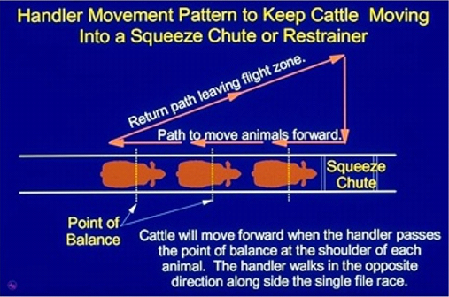
Source: T Grandin, Livestock Handling Practices, 2000.
Voice
Voice is a most effective aid in communicating with and working yarded stock, particularly if used with body position.
A competent handler using a quiet reassuring voice can move more stock per hour than one who makes unnecessary loud noises, which only serve to confuse and frighten stock.
Hands
Moving hands to block or encourage movement of stock is very useful. It leads the stock into thinking that the handler is much bigger and more dominant.
Hands are useful to draw the attention of an animal if it becomes frightened. Hand movements may gain the attention of an animal that is so stressed that it may not otherwise see the handler.
Canes
Canes are seen by animals as an extension to the arm of the handler. Canes can help aid communication with the stock through their sense of vision, hearing and/or touch. Flags attached to the end of the cane can attract the attention of stock while the handler keeps a safe distance from them. These are effective for drafting or moving stock along races and lanes. Canes should not be used to hit animals as this can lead to significant carcase damage through bruising.
Shields or boards
You can use shields or boards to help move pigs. You must not, at any time, use these shields or boards to strike or hit the animals.
Electric goads
If premises are well designed and operators are well trained in the use of flight zone techniques, goads should not be necessary. In fact, the only area of the plant they may need to be used is in the run-up race to the knocking box. These electric goads are powered by battery or low voltage electricity.
Goads should be regularly checked to ensure that the voltage is correct, so that they do not unnecessarily stress the animals and to stop holes being burnt into the pelt. They should be regulated to the lowest possible voltage and should not exceed 32 volts. Goads should never be used on sensitive parts of the animals such as the eyes, muzzle, anus or vulva.
Goads should only be used in accordance with the relevant work instruction.
Flappers, pipes, or rattles
You must only use flappers, pipes or rattles to encourage livestock to move. If you overuse these aids, you may actually hinder their movements.
Pipes should be made of soft polythene. Flappers should be made of canvas or leather. Flappers and rattles should only be used to create sufficient noise to encourage stock to move. To prevent injury, you should not use metal or wooden pipes or sticks or pointed objects to move stock. All contact implements should be used as little as possible.
Work animals
Different kinds of work animals have different uses. Work animals should be chosen carefully for the specific stock moving task required.
- Judas or leader sheep or goats – used to lead mutton and lambs from lairage into sticking pens
- horses – used for rounding up sheep and cattle in holding paddocks
- dogs – used to help move some animals but not horses, deer, pigs and young calves.
The number and use of work dogs on an abattoir should be kept to a minimum. Dogs should be controlled and should not cause slaughter animals to be unduly disturbed or stressed. When dogs are not being used they should be securely restrained or placed in kennels.
All working dogs must be:
- effectively muzzled so that they do not damage the pelts
- housed away from slaughter animals
- healthy and regularly wormed.
Work animals should have access to drinking water when they are not being used. As well, they should not be worked for long time periods without having access to drinking water.
It is easier to carry out ante-mortem inspection if dogs are not used. Dogs make sheep and cattle ‘flighty’ which makes their safe handling during ante-mortem nearly impossible.
What aspects of natural animal behaviour have to be considered when handling stock?
Natural animal behaviour
When you are handling animals you need to understand their natural behaviour and instincts. For example, using a Judas sheep works because other sheep will follow.
You must be able to understand and anticipate stock behaviour then you can use this knowledge to get them to move to where you want.
Herd instinct
Most species of stock look for safety in the group and tend to follow a leader. Animals that are separated from the herd or group are stressed and become agitated. Such animals are a danger to themselves and handlers.
Dominance
Animals from different groups, if mixed, will often fight to gain dominance.
Mating seasons
Females in season will cause nearby males to fight.
Maternal behaviour
Cows and mares can be extremely protective of their offspring and will become highly stressed if separated or mixed with strange animals.
Vision
Prey animals such as sheep, cattle and horses have their eyes set high and on the sides of the heads to give them ‘all round’ vision. They also have vision that gives them good distance vision but poor depth vision. This means they baulk at moving into and out of bright light and tend to lower their heads to improve their forward vision. Animals also react to sharp sudden movements particularly at their eye level.
Flight zone
This is the distance from an animal that a handler can reach without making the animal take flight. Very quiet stock will allow a handler in close and are said to have a small flight zone. In this flight zone animals have driving zones and a point of balance. The point of balance is at right angles or 90° to the shoulder of the animal. By moving to various spots in the flight zone an animal can be made to move backwards. By moving behind the point of balance, the animal can be made to move forwards.
Remember, stressed or agitated animals can react violently and unpredictably to a handler entering its flight zone. By understanding the flight zone a good handler can make the animal move without overly stressing the animal by being too close. This will minimise personal risk.
Circling behaviour
A combination of factors cause most herd animals to circle if a way of escape is not immediately apparent. This can cause significant handling problems if animals are rushed or hurried out of yards.
Noise and smell
All ‘prey’ animals have well developed hearing and smell. Loud, sharp noises or strange smells such as blood will rapidly cause animals to become agitated and difficult to handle.
These factors are explained in detail in the Livestock Transport – Handbook for Drivers.

WI | What should you do if you observe cruel actions or situations during ante-mortem inspection?

All meat safety inspectors have an ethical obligation to ensure that humane practices are followed at all times. If you observe ill-treatment of livestock during slaughter you should take the following steps.
- Advise the person causing the cruelty and the lairage supervisor immediately of the cruelty occurring and stop the cruel practice, or if it is a structural issue, cease the use of those facilities. The significance of this action is that if they should persist with their actions and the matter should eventually come to court, they would not be able to claim as a defence that they were not aware that what they were doing was cruel.
- If the non conformance is not addressed immediately, or if the problem is repeated regularly, notify the Royal Society for the Prevention of Cruelty of Animals (RSPCA).
- Record full details in your diary at the time. If you consider the case serious, make every effort to obtain photographs.
What are the requirements when handling sick or injured stock?
Animals that have been identified at ante-mortem inspection as being sick or injured must be dealt with in the manner required by workplace and regulatory requirements.
There are several ways to handle animals that are sick or injured. The following are options for handling disabled or diseased stock. An authorised person will decide which option to take.
If animals are disabled or diseased they may be:
- held for further treatment so the animal can be passed fit for human consumption
- classed as unfit for slaughter and destroyed humanely, and then disposed of appropriately
- put up for emergency slaughter
- processed under restrictions to prevent unacceptable contamination of the processing floor – this permits a more detailed post-mortem inspection (restricted slaughter/suspect animals).
Injured or disabled animals showing obvious signs of distress or suffering must be humanely destroyed immediately or be put up for emergency slaughter.
If an animal is too injured to walk up the race or from pen to pen, you must find a humane means of moving the animal to the sticking area or to the suspect pen for further examination. The animal may be treated as an emergency kill or destroyed humanely.
Suspect animals/restricted slaughter
The officer in charge of the ante-mortem procedure will identify suspect animals to the person moving them. These animals are put into a special suspect pen. They can then be examined in more detail by an appropriately qualified person. In export-registered plants, this must be a veterinary officer.
If these animals are passed as fit for slaughter, they must be ear-tagged or identified according to the workplace system. It is important that the system used to identify animals is known to all workers.
Suspect animals may be segregated from all healthy animals and then slaughtered at the end of a production run. This is so that any contamination they leave on work surfaces cannot be transferred onto other carcases.
Some animals may be passed for restricted slaughter. These may be animals that are:
- affected with a disease or condition that might mean the carcase is condemned at post-mortem inspection
- soiled to an extent that would normally mean they would not be allowed up for slaughter and so must go through strictly controlled and modified slaughtering and dressing procedures.
Animals that have been identified for restricted slaughter are segregated from all healthy animals. They are then slaughtered after the slaughter of all animals not subject to restricted slaughter.
Some conditions found at ante-mortem inspection which require specialised handling are:
- cripple – an animal that moves with a limp
- hanging head, depressed state, lack of interest in surroundings – a loner
- discharges from the eyes, nose or other body openings
- coughs, wheezes, snorting or rapid heavy breathing
- reluctance to move – lethargy
- abnormal movement in circles, wobbly, weak, chewing excessively, scratching
- abnormal lumps or growths.
There are many more signs that you may notice for detecting abnormalities.
Condemned
There are many diseases or conditions that require animals to be immediately condemned. This is particularly important for animals that are found dead or dying at the ante-mortem inspection, or those animals in a coma or semi-comatose state. Any such animals must be identified and the appropriate person notified.

WI | How should wild or uncooperative animals be handled and how can WHS risks be minimised?

Many staff have been killed or severely injured while handling stock in lairages at abattoirs. Animals may have gone through several changes in environment before arriving at the abattoir, so their behaviour may be unsettled. You must be alert at all times and follow your required workplace procedures. If you do this, you will limit the WHS risks associated with handling animals.
Wild or uncooperative animals can pose a potential danger to themselves, other animals and people. These animals must never be approached. They should be left alone until they settle down. This usually makes them easier to handle.
It is part of all handlers' job to let animals rest before slaughter. They should not be put up for slaughter when stressed or agitated.
Issues you need to be aware of to limit WHS risks are:
- the need to understand the normal behaviour patterns of the animals being handled, e.g. how they will respond to movement
- handling requirements for different ages, sex, breeds, e.g. Brahman or other northern cattle
- the need to move animals quietly, without causing fear or excitement
- ensuring animals have sufficient space to move into, e.g. from the pen into the race
- the correct use of implements such as prodders or goads, because overuse of goads will excite animals and make them unpredictable and dangerous
- the layout of yards, such as gates, exists and races in case you need to get out of the way suddenly
- problems relating to the physical surroundings such as wet conditions, broken grates and poor lighting.
Your safety is very important. During ante-mortem inspection, you must be aware of the potential dangers of handling wild and uncooperative animals and remain constantly alert.
Consider:
- possible dangers
- the sources of these dangers.
You must also advise those assisting you of potential dangers to that they may protect themselves.
While your employers and establishment managers have a responsibility for your safety, you are also responsible. You must know the relevant workplace safety procedures and policies and follow them, and you must use equipment safely. You must also take all available precautions to protect yourself.
Appropriate clothing
Always be sure that you wear appropriate clothing and footwear. Tight or restrictive clothing may not allow you to escape quickly to avoid danger. The same applies to clothing that is too large for you. Wearing boots that are the wrong size can make it impossible for you to avoid potential dangers.
If you have to move quickly, your clothing must not impede your escape.
Safety escapes
Know the exact location of all safety escapes from the ante-mortem inspection areas. Be sure that you have an escape route planned. Make sure that you are able to climb the fence, fit through the rail space, and can pass easily through the safety exists.
Give warning/move slowly and quietly
Make sure animals know you are there and know where you are. A sudden approach will frighten them. This may cause them to stampede away from you or, in the case of cattle, they may charge you.
Never make loud or sudden noises. If an animal becomes excited or frightened, they may also become potentially dangerous.
Be careful where you stand
Never stand behind the gate leading to a pen or yard, especially if there is the possibility that a rushing animal could hit the gate and crush you against the fence.
Never stand in a gateway or an alleyway where the animal will see you as an obstruction in their path or as a potential threat.
How do I know when animals are suffering undue stress?
It is inevitable that some stress to animals occurs during the process of ante-mortem inspection. This is because animals vary, the facilities vary, and the competency of people handling livestock varies. In recognition of this, the National Animal Welfare Standards have set targets on various parameters to act as a measure of the amount of stress that is being inflicted on animals and to act as a measure of compliance to the Standard for animal welfare.
In the yards, race and the restrainer the targets are as follows:
- no more than 3% of cattle and 10% of pigs should vocalise when being moved in lairage
- less than 3% of animals slipping
- no more than 5% of animals vocalizing in the restrainer
- an electric goad being used on less than 25% of animals.
Note: Vocalization in sheep is a normal group activity and not an indicator of stress.
You should monitor your own performance and those of the people handling stock around you. If you find that these targets cannot be met or that unacceptable handling procedures exist you will need to raise the issue with management.
People deliberately causing unnecessary pain to animals risk being prosecuted.
Bibliography
These publications were used to develop this training material.
Andriessen, E.H., 2006, Meat Safety Quality and Veterinary Health in Australia, eighth edition, Penny Farthing Publishing PO Box 3322, Port Adelaide South Australia 5015
Agriculture and Resource Management Council of Australia and New Zealand, AS 4696:2023 Australian Standard for the hygienic production and transportation of meat and meat products for human consumption, CSIRO publishing, Collingwood, Vic.
Animal Health Australia AUSVETPLAN, Animal Health Australia, Canberra. See Animal Health Australia www.aahc.com.au
Export Control (Meat & Meat Products) Orders 2005
Meat Manual Volume 2 – Requirements for overseas countries
AQIS 1995 Operational Guidelines for the Welfare of Animals at Abattoirs and Slaugtherhouses, AGPS, Canberra.
Department of Agriculture Meat Notices
Department of Agriculture website
Standing Committee on Agriculture and Resource Management 1998 Australian Code of Practice for the Welfare of Animals No 10: Animals at Slaughtering Establishments, CSIRO, Collingwood, Vic.
W.A. Geering, A.J. Forman and M.J. Nunn Exotic Diseases of Animals – A Field Guide for Australian Veterinarians.
Emergency animal disease hotline 1800 675888.

Additional resources
Registered Training Organisations (RTOs) should refer to the Unit-by-Unit listing of resources on the MINTRAC website www.mintrac.com.au for additional resources to support the delivery of this Unit.
RTOs which develop or identify additional resources are encouraged to advise MINTRAC so that these can also be added to the Unit-by-Unit listing.
CSIRO Animal Health Division Exotic Diseases, CSIRO, Geelong. Titles in this video series include:
- Exotic disease – Think the Worst First
- Exotic disease – The Nation's Nightmare
- Exotic disease – Stop the Spread
- Exotic disease – To Market to Market
- Exotic disease – Vital Signs
TAFE NSW 51 Wentworth Rd Strathfield NSW CD Meat Safety Toolbox
SafeFood Qld PO Box 440 Spring Hill Qld 4004 CD - A guide to the diseases and conditions of Australian livestock
Food Safety and Inspection Service (USDA) CD -For the Welfare of Livestock Version 1.0 1998
MINTRAC resources:
- CD: Animal welfare – Sheep
- CD: Animal welfare – Cattle
- As Easy as Leading Lamb, video, 1990, CSIRO, Queensland.
- Good Handling Makes Good Sense, video, 1991, CSIRO Meat Research Laboratory, Queensland.
- All It Takes is a Little Understanding, 1990, CSIRO, Cannon Hill.
Handling Cattle from Farm to Abattoir, NSW Agriculture, Sydney.
Livestock Transport – Handbook for Drivers, TAFE, NSW.

