AMPMSY301
Apply food animal anatomy and physiology to inspection processes
Training support materials

Australian Meat Industry Training Package
Certificate III Meat Safety

Materials Development sheet for:

AMPMSY301 Apply food animal anatomy and physiology to inspection processes
Required Knowledge:
Topic | Covered on pages
1.Species of food animal processed at workplace
2. The function and parts of each of the body systems of species identified
3. References to food animal carcase parts and viscera consistent with relevant Australian Standard for meat processing, for human and/or pet consumption.

Elements and performance criteria

Element | Performance Criteria | Covered on pages
1. Identify cells, body tissue and body plan of food animal species | 1.1 Identify the function of cells in food animal  1.2 Identify the different body tissues of food animal  1.3 Recognise the general body plan of food animal
2. Recognise the skeletal and muscular system of food animal species | 2.1 Identify and explain the skeletal structure of food animal and its function  2.2 Recognise the key muscle types of food animal and their function
3. Identify the blood and circulatory system of food animal species | 3.1 Identify the function of blood in food animal  3.2 Identify and explain the parts and function of the circulatory system

Element | Performance Criteria | Covered on pages

4. Recognise the lymphatic system of food animal species | 4.1 Recognise the lymph nodes of food animal  4.2 Identify and explain the function of the lymph nodes in a food animal  4.3 Identify the regional and terminal lymph nodes and their importance
5. Identify the respiratory system of food animal species | 5.1 Recognise the major elements of the respiratory system of food animal  5.2 Identify and explain the function of respiratory parts in a food animal
6. Recognise the digestive system of food animal species | 6.1 Recognise the major elements of the digestive system of food animal  6.2 Identify and explain the function of digestive parts in a food animal
7. Identify the excretory system of food animal species | 7.1 Recognise the major elements of the excretory system of food animal  7.2 Identify and explain the function of excretory parts in a food animal
8. Recognise the reproductive system of food animal species | 8.1 Recognise the major elements of the reproductive system of food animal  8.2 Identify and explain the function of the reproductive parts in a food animal
9. Identify the nervous system of food animal species | 9.1 Recognise two nervous systems of food animal  9.2 Identify and explain the function of the nerves in a food animal
10. Recognise skin and the endocrine glands of food animal species | 10.1 Recognise the function of animal skin  10.2 Identify and explain major endocrine glands and their function

Chapter 1. Species of food animals processed in Australia
Topic 1. Species and breeds of food animals processed.
Food animal species include
Topic 2. Categories of livestock processed.
Sheep are sold and processed in the following categories:
Lambs
Hoggets
Mutton
Ewes
Rams
Wethers

Cattle are sold and processed in the following categories:
Calves
Steers
Cows
Bulls
don’t use the term ox its the same as steer except an ox is used to pull carts etc
Goats
to the best of my knowledge there are no categories for goats Pigs
Camels
Llamas and alpacas
Poultry
Crocodiles
horses
Game meat including kangaroos, wallabies, rabbits, deer and pigs

Chapter 2. The function and parts of the body’s systems

Cells, body tissue and general body plan of food animals
What is the connection between cells, body tissues, organs and systems?
Each food-producing animal is made up of cells, body tissue, organs and body systems. A number of cells make up body tissue and a number of body tissues make up an organ and a number of organs make up a body system.
Tissues, organs and systems are grouped by their function. That is:
- body tissues is a group of cells with the same function
- an organ is a group of body tissues
- a body system is a group of organs.
So, cells with the same function group together to form tissue. This tissue links with other tissue to form an organ.
Organs work together to form body systems with a certain functional in the body.
What are cells?
The cell is the basic unit of life. All living things, from the smallest bacterium (unicellular) to the largest tree or the biggest whale (multicellular) are made up of cells.
We know a cell is living if it is:
- reproducing
- metabolising – obtaining energy gained by ingesting and assimilating food and excreting waste
irritable – responding to stimuli.
Living things vary greatly in complexity, size, shape and function. Similarly, cells show the same range of variation.
The simplest living things are microscopic, single cell organisms that we know as microorganisms, e.g. germs. The range and variation of cells increase in complexity up to higher mammals. These are made up of billions of cells of different shapes, sizes and functions.
There is no such thing as the ‘typical’ cell. However, cells do have a number of common features and structures.
Animal cells
Animal cells consist of a:
- cell membrane – maintains integrity of the cell, nutrients and waste have to pass through the cell wall to enter and leave or be excreted
- cytoplasm – intracellular fluid
- mitochondria – provide energy for the cell
- nucleus – contains the genetic material (DNA)
- vacuole – a storage capsule within the cell
- centrioles – which are important in cell reproduction.
What are tissues?
All living animals start out as a single cell. Between then and birth, they develop into beings consisting of billions of cells. This happens through cell reproduction. There are two forms of cells that develop:
mitosis – simple cell replication through binary fission, i.e. resulting cells have the same number of chromosomes as the originating cell and are identical to the originating cell
meiosis – cell division results in gametes (sperm or eggs) with half the number of the chromosomes of the parent cell, occurring only in reproductive cells of testes and ovaries.
Cells within the body become specialised, depending on their role. These cells with the same role or function are grouped together as tissues.
Types of tissue
There are six main types of tissue in animal bodies:
- epithelial – the coverings and linings of all body parts
- muscle:
- striated, voluntary muscle (red skeletal muscle)
- smooth, involuntary muscle (white, found in stomach, intestines, artery walls, etc.)
- cardiac (heart) muscle, striated but involuntary
- connective:
- fibrous
- cartilage
- bone
- reticular
- adipose
- elastic
- blood
- nerve
- glandular – produces a wide variety of substances necessary for the body’s normal functioning
- reproductive – responsible for sexual reproduction (the testes and ovaries).
What are organs?
An organ is a group of tissues arranged together to perform a specific task. For example, the brain is a group of nerve tissue, reticular connective tissue, epithelial tissue and some glandular tissue that monitors, controls and regulates all bodily functions.
Other organs made up of different types of tissue are:
- skin – epithelial, connective, glandular, muscular tissue
- lung – epithelial, connective, glandular tissue
- heart – epithelial, connective, muscular, nerve tissue.
What are tissues?
All living animals start out as a single cell. Between then and birth, they develop into beings consisting of billions of cells. This happens through cell reproduction. There are two forms of cells that develop:
mitosis – simple cell replication through binary fission, i.e. resulting cells have the same number of chromosomes as the originating cell and are identical to the originating cell
meiosis – cell division results in gametes (sperm or eggs) with half the number of the chromosomes of the parent cell, occurring only in reproductive cells of testes and ovaries.
Cells within the body become specialised, depending on their role. These cells with the same role or function are grouped together as tissues.
Types of tissue
There are six main types of tissue in animal bodies:
- epithelial – the coverings and linings of all body parts
- muscle:
- striated, voluntary muscle (red skeletal muscle)
- smooth, involuntary muscle (white, found in stomach, intestines, artery walls, etc.)
- cardiac (heart) muscle, striated but involuntary
- connective:
- fibrous
- cartilage
- bone
- reticular
- adipose
- elastic
- blood
- nerve
- glandular – produces a wide variety of substances necessary for the body’s normal functioning
- reproductive – responsible for sexual reproduction (the testes and ovaries).
What are organs?
An organ is a group of tissues arranged together to perform a specific task. For example, the brain is a group of nerve tissue, reticular connective tissue, epithelial tissue and some glandular tissue that monitors, controls and regulates all bodily functions.
Other organs made up of different types of tissue are:
- skin – epithelial, connective, glandular, muscular tissue
- lung – epithelial, connective, glandular tissue
- heart – epithelial, connective, muscular, nerve tissue.
What are body systems?
Organs are grouped together to form body systems. Each system performs a particular body function. For example, blood is transported around the body by the circulatory system, consisting of the heart, arteries, capillaries and veins.
There are nine principal systems that make up the body.
They are:
- the musculoskeletal system – bones and muscles
- blood, the circulatory system and the lymphatic system
- the respiratory system
- the digestive system
- the urinary system
- the reproductive system
- the central nervous system
- the endocrine system
- the skin or integumental system.
These body systems exist in all animals and birds performing their particular function. The body systems depend on each other for the body as a whole to be healthy. Between different species or types of animals and birds there are differences in the organs and the body systems although still performing the function.
Where in the body are the different body systems and organs?
An animal’s body consists of an external structure consisting of the muscles and bones covered with hide or skin. This covers and protects four body cavities containing the vital organs and systems.
These cavities are:
- cranial cavity – contains the brain
- thoracic cavity – contains the organs of respiration or the lungs and the heart
- abdominal cavity – contains the kidneys and spleen and the organs of digestion or the stomach, the intestines, the liver and the pancreas.
- pelvic cavity – contains the organs of excretion (the rectum and bladder) and the organs of reproduction i.e. the ovaries and uterus in females or the accessory male glands in males.
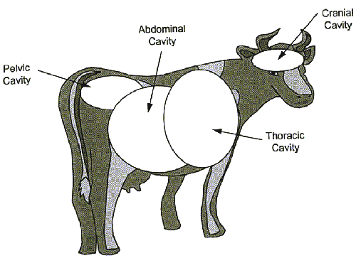
Body cavities

Topic 2. The skeletal and muscular system of food animal species
Skeletal and muscular system of food animals
What does the musculoskeletal system do?
The function of the musculoskeletal system is to:
- enable movement
- provide protection for the internal organs
- give the animal shape and form
- produce blood cells
- support the circulatory and lymphatic systems.
What is the musculoskeletal system made up of?
The main components of the musculoskeletal system are:
- skeleton – consisting of the bones, cartilage and ligaments of the body
- flesh – consisting of the muscles and tendons of the body.
Bone and cartilage
Bone is a dense substance made of two main materials:
- a calcium salt (tricalcium phosphate Ca₃{PO₄}₂) provides strength and rigidity
- a jelly-like protein called ossein gives resilience and flexibility.
Cartilage is a gristly, flexible tissue commonly found on the joint surfaces of bones or forming the framework for softer structures such as the outer ear. It also occurs at growth centres on growing bones. Bones are constructed of specialised cells called osteocytes situated throughout the bone.
Bones are classified according to shape:
- long bones, e.g. leg bones
- short bones, e.g. wrist bones
- flat bones, e.g. shoulder blade
- irregular bones, e.g. vertebrae or backbones.
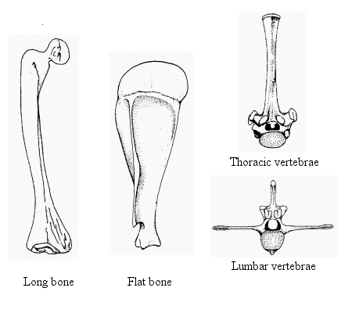indicate the top of the flat bone is cartilage
Bone structure
The basic parts of a long bone are:
epiphysis (epiphyses) – articular ends
- periosteum – outer lining
- endosteum – inner lining
- medullary cavity – containing marrow
- marrow – fatty inner substance containing red, white and platelet blood-cell forming tissue
- nutrient foramen – hole through which blood and lymph vessels and nerves pass
- shaft – main body of the bone.
Skeleton
The skeleton is the supporting framework of the body. It is divided into two sections:
- axial skeleton:
- the skull
- the spine or vertebral column
- the skeleton of the thorax or chest
appendicular skeleton:
- the bones of the fore-limbs
- the bones of the hind-limbs.
Skull
The skull consists of:
- the cranium – contains the brain
- the face – contains the nose and mouth cavities.
The bones of the skull requiring mention are:
- the occipital bone – situated at the back of the skull, with a large hole (foramen magnum) through which the spinal cord emerges
- the frontal plates – the broad, flat area above the eyes, the site for captive bolt stunning
- the maxilla – the part of the skull that forms the upper jaw
- the mandible – the lower jaw bone, the largest and the only movable bone in the skull.
Spine or vertebral column
The bones of the spine are in five regions:
- the cervical region – neck
- the thoracic region – back
- the lumbar region – loins
- the sacral region – pelvis
- the coccygeal region – tail.
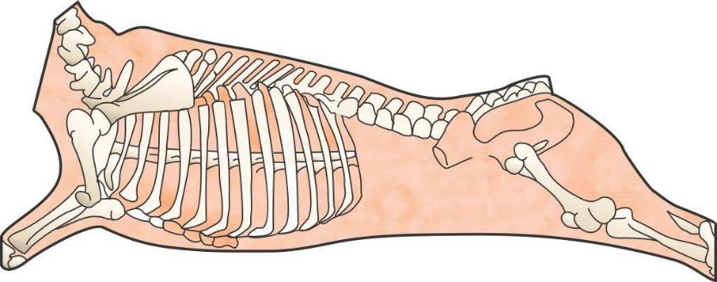
Spine of a bovine

All vertebrae, except for the coccygeal, have a neural or spinal canal along which the spinal cord passes.
All the bones of the spine are irregular bones.
Distinguishing features of vertebrae are:
- cervical – all markedly irregular in shape, all animals have seven
- thoracic – very prominent dorsal process
- lumbar – very prominent transverse processes
- sacral – composed of several bones completely fused, which don’t move
- coccygeal – round, cylinder-like, progressively smaller, without a neural canal.
Skeleton of the chest (thorax)
The skeleton of the chest is made up of the thoracic vertebrae, ribs and breastbone or sternum.
Cattle and sheep have thirteen pairs of ribs – eight pairs attached to the sternum and five pairs not attached to the sternum.
Pigs normally have fourteen pairs of ribs – seven pairs attached to the sternum and seven pairs unattached. It is not unusual, however, to find a pig with up to seventeen pairs of ribs.
Bones of the fore-limb
Consist of the:
- scapula – the shoulder blade
- humerus – upper arm bone
- radius and ulna – bones of the forearm
- carpal bones – six knee bones in cattle and sheep, eight in pigs, corresponding with the wrist in humans
- metacarpal – the hock in sheep and cattle; four metacarpal bones corresponding with hand bones in humans
- digits/phalanges – bones of the hoof, corresponding with fingers in humans.
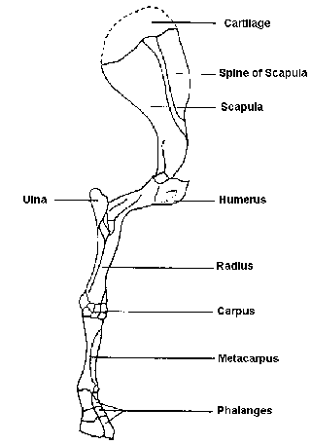
Fore-limb of an Bovine ovine caprine porcine
Bones of the hind limb
The bones of the hind limb consist of:
- pelvis – two hip bones which are attached to the sacrum and fused together vertically to form the pelvic canal or channel; each hipbone consists of three bones fused together
- femur – thigh bone
- patella – kneecap
- tibia – shin/shank bone for sheep and cattle (remnants of fibula may be found in shin meat during boning) in pigs the shin consists of a two bone arrangement of tibia and fibula, the same as humans
- tarsal bones – five in cattle and sheep, seven in pigs; one tarsal bone, the os calcis, has a large process that extends backwards and forms the point of the hock, corresponding to the heel on humans
- metatarsal – hind hock in cattle, corresponding with the foot bones in humans
- digits/phalanges – bones of the hind hoof, corresponding with toes in humans.

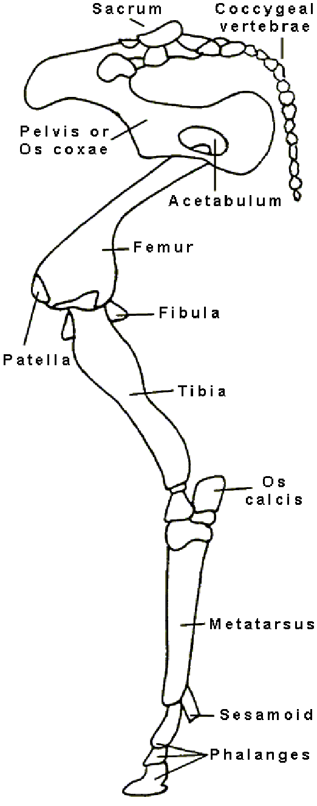
Hind-limb of a sheepbovine caprine porcine
Joints
A joint, also called an articulation, is the place of union between two or more bones. There are basically three types of joint: immovable, movable, partially moveable.
Immovable joints
Immovable joints or synarthroses are where the bones are in actual contact and are either interlocked or fused together by fibrous tissue, cartilage or a mixture of both. This makes them incapable of moving against one another. An example is the joints between the bones of the skull and the bones of the sacrum.
Moveable joints
Moveable joints or diarthroses are where the bones can move against each other. All true moveable joints have articular surfaces, articular cartilages, a joint capsule and a joint cavity.
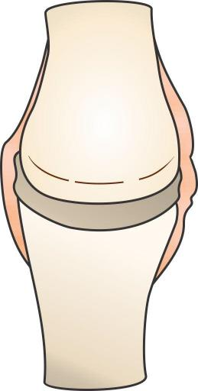
Fibrous layer
Synovial layer

Joint capsule
Moveable joint

There are four main types of movable joint:
- ball and socket (enarthrosis) – hip joint
- hinge joint (ginglymus) – elbow joint
- gliding joint (arthrodia) – wrist joint
- pivot joint (trochoid) – atlas and axis joint, first and second cervical – neck joint.
Partially moveable joints
Partially moveable joints (amphiarthroses) occur where a layer of cartilage separates the bones from each other. In these joints the bones do not move on each other. Movement is from the flexibility of the cartilage that joins them. The joints between the bones of the spine, the vertebrae, are partially moveable.
Bones and joints are bound together by fibrous bands called ligaments.
Muscle is bound to bone by fibrous bands called tendons.
Muscles
All muscles are made of muscle fibres that are able to contract. They are therefore the organs of movement. There are three different types of muscle in the animal body.
Voluntary (striated) muscle
Voluntary muscles are controlled by the animal. All the skeletal muscles are voluntary muscles. Skeletal muscles are attached to bones at both ends by fibrous bands called tendons. They make up 30%– 45% of the live weight of an animal and up to 70% of carcase weight.
All voluntary muscles that bend a limb work in pairs as muscles can only contract and relax. One muscle contracts to bend the limb and another relaxes whilst the reverse happends to straighten the limb. The bending muscle is called the flexor and the straightening muscle is called the extensor. As an example, the bicep muscle in the upper arm is the flexor muscle and the tricep is the extensor muscle.
Involuntary (smooth) muscle
Involuntary muscles are not under the control of the animal. They are found in the walls of the stomach, the intestines, the arteries, bladder, uterus and many other places. They are mainly in the vital organs.
Cardiac (heart) muscle
The heart muscle is composed entirely of cardiac muscle and is not under the control of the animal however is striated muscle.
Muscle composition
Muscles consist of a number of proteins. The main ones include:
- sarcoplasmic proteins – water soluble and leave the meat as drip
- myoglobin proteins – similar to haemoglobin in red blood cells, gives meat its characteristic colour and taste
- myofibrilla proteins – including myosin, actin and actinomycin, are important in muscle contraction
- albumin – important constituent of all cells.
Muscle structure
Muscles contain:
- bundles
- fibres
- myofibrils
- filaments – two types of contractile protein, actin and myosin.
Contraction is caused by electrical and chemical reactions in the muscle, stimulated by nerve impulses.

Topic 3. The blood and circulatory system of food animals
What is the connection between the blood and circulatory systems?
The function of the circulatory system is to distribute blood through the body.
The circulatory system of the body is a bit like the road system of a rural community. The community is usually centred around a town or city and the roads radiate out from it into the surrounding countryside. Produce from the countryside is brought into the city, via roads, to be processed. Processed goods are taken from the city, via roads, out into the country. In this analogy, the city’s businesses can be likened to the heart, providing the force to keep the blood/goods flowing along the arteries and veins, the roads.
What does blood do?
Blood:
- carries oxygen from the lungs to tissues
- carries nutrients around the body
- carries the body’s waste products from tissues to lungs and kidneys
- helps the body’s defence system
- regulates body temperature and heat distribution.
What is blood made up of?
Blood is a red, opaque, somewhat viscous liquid. It is made up of five distinct parts.
Plasma
Plasma is a straw-coloured fluid that makes up about 65% of the total blood. It consists of water, minerals, nutrients, cell waste products and a mixture of three proteins. One of the three proteins fibrinogen, is needed to form clots. The other two, albumin and globulin help with the body’s immune system.
Cellular material
Cellular material is the red blood cells, white blood cells and platelets.
Red blood cells - erythrocytes
The characteristics of red blood cells are that they:
- are circular, disc-shaped, concaved in centre
- have no nucleus.
The primary function of red blood cells is to transport oxygen from the lungs to the cells of the body for cellular respiration, and to transport carbon dioxide (CO₂₎, the waste product of cellular respiration, from the cells of the body to the lungs for excretion.
Oxygen and CO₂ are carried in the blood by a red pigment called haemoglobin. The body requires iron to make haemoglobin.
White blood cells – leucocytes
The characteristics of white blood cells are that they:
- have a nucleus
- can change shape, enabling them to squeeze through small gaps.
The primary function of the white blood cells is to produce anti-bodies and to defend the body against invading, disease-causing pathogens. White blood cells which destroy pathogens are called phagocytes.
There are two types of leucocytes:
- granular leucocytes:
- neutrophils
- eosinophils
- basephils
- non-granular leucocytes:
- lymphocytes
- monocytes.
Neutrophils and monocytes are the principal phagocytic or pathogen destroying white blood cells.
Platelets – thrombocytes
The primary function of platelets is to aid the clotting of blood.
The characteristics of platelets are that they:
- have no nucleus
- are small, colourless granules.
What is the circulatory system?
The circulatory system moves blood around the body. It consists of:
- the heart
- the arteries and arterioles
- the veins and venules
the capillaries.
The heart
The heart is situated in the centre of the thoracic cavity between the lungs. It is enclosed within a sac called the pericardium. Its primary function is to act as a pump that pushes the blood around the body.
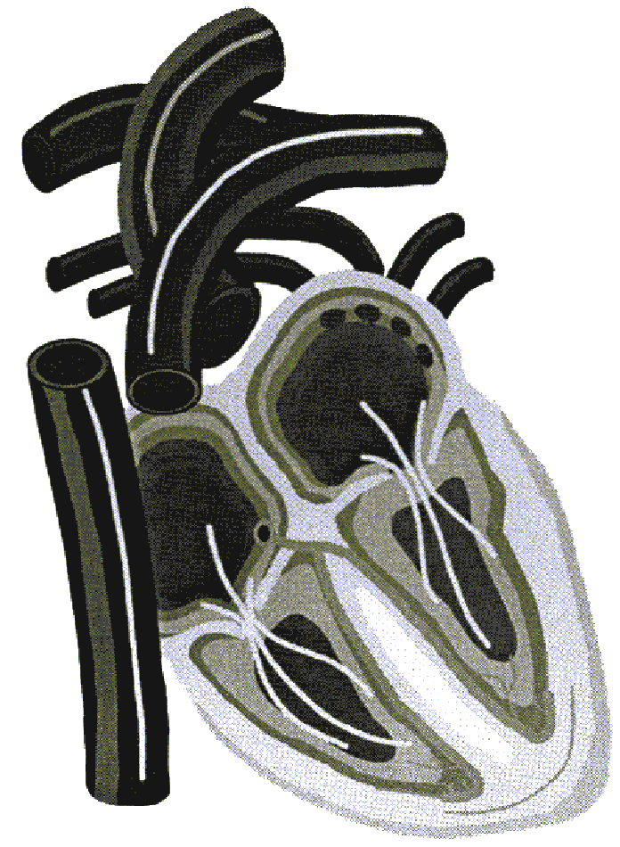
The heart

The heart consists of four chambers:
- right atrium – receives de-oxygenated blood from the vena cava, and pumps it into the right ventricle by contracting
- right ventricle – pumps de-oxygenated blood to lungs through the pulmonary arteries
- left atrium – receives oxygenated blood from lungs via the pulmonary veins and pumps it, by contracting, into the left ventricle
- left ventricle – pumps oxygenated blood throughout the body via the aorta; the walls of the left ventricle are thicker than those of the right ventricle due to greater work load.
The heart contains four sets of valves that only permit the flow of blood in one direction.
Cattle
The heart in bovines has three ventricular furrows on the surface. There are generally two ossa cordi, which are irregularly Y-shaped bones at the base of the heart near the aorta. The bovine heart weighs between 1.8 and 2.2 kg.

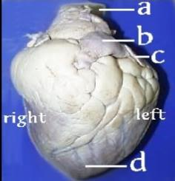

Legend: a-Aorta b- Pulmonary artery c- Left Auricle d-Apex of the heart
Beef Heart

Note: The location of the various parts of the heart, as described above, is the same for all species.
Horses
The heart in equines has two ventricular furrows. The aortic cartilage becomes slightly ossified in older animals.
The weight of the heart varies from 2-5 kg. The fat is generally more scanty than that on a bovine heart and has a rather oily appearance.
Sheep
The ovine heart has three ventricular furrows. A small os cordis is present in older sheep. The heart weighs about 80-120 grams. The fat is very white and sets firm.

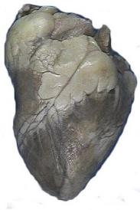

Sheep heart
© Eddie Andriessen
Goats
The caprine (goat) heart has generally only two ventricular furrows and not three as in sheep. The apex is more rounded than in a sheep. The heart cartilage is ossified in older animals. It weighs 150-200 g. In feral goats with narrow chests the heart also tends to be narrow, lacks the fat cover of sheep hearts and tends to be smaller than in the same sized sheep. The picture below is from a well-fed domestic goat not a feral goat
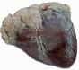

Goat heart
© Eddie Andriessen
Pigs
The pig's heart often has three ventricular furrows. The apex is more rounded than that of the sheep and has less fat in the ventricular furrows. The heart appears more globular overall. It weighs 150-200 g.
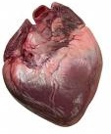
Pig heart
© Eddie Andriessen

Kangaroo
Similar in size and shape to a sheep heart, but there is no fat around the base of the heart or in the ventricular furrows.

Arteries and arterioles
The primary function of arteries and arterioles is to transport the blood from the heart to the other regions of the body. The largest artery is called the aorta. Arterioles are smaller arteries connecting to capillaries.
Characteristics of an artery are:
their walls are much thicker than veins
their walls contain smooth muscle and elastic tissue
they do not collapse – the hole or lumen is always evident
their blood flow is under positive pressure due to the action of the heart.
Veins and venules
The primary function of veins and venules is to transport blood from the body back to the heart. The largest vein is the vena cava. Venules are smaller veins connecting to capillaries.
Characteristics of veins are that they:
have thin walls, without a smooth muscle layer and very little elastic tissue
collapse when empty
contain one-way valves that prevent the backflow of blood
are situated closer to the skin surface than arteries
have blood flow which is passive; the flow is caused by the movement of muscle against the veins and the action of the one-way valves in the extremities (limbs) and by the suction (negative pressure) of the thorax (chest), particularly during inspiration.
Capillaries
In the capillaries, the oxygen and the nutrients are transferred from the blood to the tissues, and the carbon dioxide and metabolic waste products are transferred from the tissues to the blood.
The characteristics of capillaries are that:
they form the interconnecting link between arterioles and venules
their walls are only one cell thick
they form networks through the tissues, ensuring uniform distribution of blood
the smallest capillaries have a diameter approximately the same as a red blood cell.

Topic 4. The lymphatic system of food animals
What is lymph?
Lymph is simply tissue fluid that has been absorbed into the lymphatic system. The lymph consists of water, minerals, nutrients, cell waste products and, in the case of the lymphatics draining the intestines or lacteals, fat. It is very similar in composition to the blood plasma. However, the large proteins (albumin, globulin and fibrinogen) found in plasma are too large to pass through the capillary wall and so are not present in lymph and tissue fluid.
The lymphatic system is a system of ducts, vessels and nodes that run in-parallel to the venous blood circulatory system. The lymphatic system can be likened to a drainage system that drains away excess body fluids. Because blood, under pressure due to the pumping of the heart, passes through the capillaries, part of the plasma is constantly leaving the circulatory system and moving into the tissue spaces, carrying nutrients etc. to the tissues. Very little of this fluid is reabsorbed by the capillaries, so a system is needed to drain the excess tissue fluid. This need is filled by the lymphatic system.
What does the lymphatic system do?
The lymphatic system:
- drains excess fluid from tissues
- filters bacteria which helps white blood cells to kill the bacteria
- produces white blood cells that are part of the body’s defence
- absorbs and transports fats from the intestines to the blood stream.
What is the lymphatic system made up of?
The lymphatic system is made up of:
- lymph capillaries
- lymph ducts and lymph vessels
- lymph nodes
- tonsils
- haemolymph nodes
- spleen.
There are no lymph nodes in poultry. Lymph plexuses (network of capillaries) are found instead of the lymph nodes seen in mammals.
In poultry the thymus, Bursa of Fabricius and bone marrow are primary lymphoid organs whereas the spleen and mucosal associated lymphoid tissues are secondary lymphoid organs
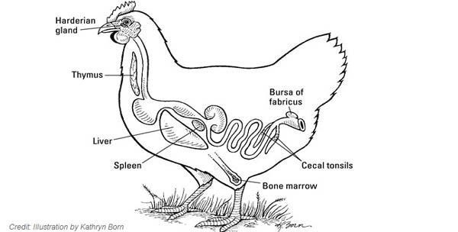
Lymph capillaries
The primary function of the lymph capillaries is to:
- remove excess fluid from tissue spaces
- remove harmful material from tissue spaces
- remove substances from the tissue space that cannot be readily absorbed by the blood stream.
Characteristics of lymph capillaries are that:
- they begin ‘blindly’
- they are one cell thick
- they are far more permeable than blood capillaries.
Lymph ducts and vessels
Lymph ducts and vessels transport lymph back to the heart.
The characteristics of lymph ducts and vessels are that:
- they are similar in structure to veins
- they are thin walled and collapse when empty
- they have a series of one-way valves to prevent backflow
- the passive flow is caused by the movement of muscle against the vessels and the action of the one-way valves and by the suction of the thorax during inspiration
- the vessels become progressively larger as they near the heart and finally empty into the vena cava or jugular veins, through the largest lymph vessel called the Cisterna Chyli.
Lymph nodes
Lymph nodes filter harmful bacteria from the lymph. They are also one of the body’s major sources of white blood cells.
The characteristics of lymph nodes are that:
- afferent lymph vessels deliver lymph to a lymph node
- efferent lymph vessels drain lymph away from a lymph node
- regional lymph nodes drain specific areas of the body
- terminal lymph nodes receive lymph from other lymph nodes and empty lymph into a major lymph duct or trunk
- evidence of infection in a specific lymph node indicates infection in the area that node drains
- lymph nodes are a major indicator of the health of an animal at post-mortem inspection
- all lymph passes through at least one lymph node
- lymph nodes vary greatly in size and shape, colour and texture between species and within species and within individual animals.
Tonsils
The tonsils are the first line of defence against incoming harmful bacteria.
The characteristics of tonsils are that:
- they are an accumulation of lymphoid tissue
- they are situated in pairs at the back of the throat, with a duct leading directly to the outside environment
- 85% of tonsils contain pathogenic or disease causing bacteria.
Haemolymph nodes
The primary function of haemolymph nodes is to break down old red blood cells.
Haemolymph nodes are:
- smaller than normal lymph nodes
- red through purple to black in colour
- have an arterial blood supply.
Spleen
The spleen is a reservoir for blood and a site for destruction of aged red blood cells.
The characteristics of the spleen are that:
- it is reddish brown in young animals but becomes bluish as the animal ages
- in cattle it is elongated and strap-like
- in sheep it is roughly triangular
- in sheep and cattle the spleen is located on the rumen, the first and largest compartment of the stomach
- in pigs it is located on the stomach, and is elongated and tongue-like with a flattened triangular cross-section.
- Different species have different shaped spleens.
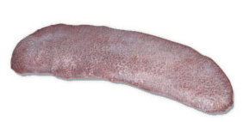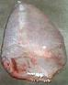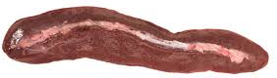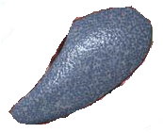
Bovine Ovine Porcine Equine
Topic 5. The The respiratory system
What is the function of the respiratory system?
The respiratory system:
- oxygenates blood
- removes carbon dioxide from blood
- helps to control the temperature and moisture content of the body.
Oxygenating blood and removing carbon dioxide
Red blood cells contain a protein called haemoglobin. Haemoglobin is able to loosely bind oxygen (O₂) and carbon dioxide (CO₂). The process is simple diffusion, i.e. substances in solution move from high concentration to low concentration.
Therefore:
- blood returning to the lungs has a higher proportion of CO₂ than the air in the lungs, and so gives up some of the CO₂ it is carrying to the air
- the blood has a lower concentration of O₂ than the air in the lungs and so it takes up extra O₂ from the air.
The reverse of this process occurs in the tissue spaces, i.e.:
- blood arriving at the tissues from the lungs has a higher concentration of O₂ then the tissue fluid, and so gives up O₂ to the tissue fluid
- the tissue fluid has a higher concentration of CO₂ than the blood and so gives up CO₂ to the blood.
The composition of exhaled air is approximately:
- 79% nitrogen
- 17% oxygen
- 4% carbon dioxide.
Controlling temperature and moisture content
This is not one of the major functions of the respiratory system. However, it helps to regulate body temperature and moisture levels.
What makes up the respiratory system?
The respiratory system is made up of:
- nostrils, nasal cavities and mouth
- pharynx
- epiglottis
- larynx
- trachea
- lungs containing:
- bronchi
- bronchioles
- alveoli.
Nostrils and nasal passages
The primary function of the nostrils and nasal passages is as an entry point for air into the body. Air is also moistened and warmed as it passes through the nasal passages.
Characteristics of the nasal passages are that:
- they contain folded, very vascular (i.e. good blood supply to help warm the air) structures called turbinate bones, which increase surface area of the nose, giving better filtration of air
- they contain lymphatic tissue, adenoids and tonsils, as the first line of defence against disease
- the entire surface of the nasal passages are covered by a mucous membrane, to trap inhaled particles such as dust, micro-organisms, pollen, etc.
- they contain a region of specialised nerve cells responsible for the sense of smell.
Pharynx
The pharynx directs food down the oesophagus to the stomach, and air down the larynx (windpipe) to the lungs.
Characteristics of the pharynx are:
- it is a muscular organ shared by both the respiratory and digestive systems
- it has seven openings:
- two nasal passages
- two eustachian tubes which connect to the middle ear
- the mouth
- the oesophagus
- the larynx.
Larynx
The larynx guards the entrance of the windpipe. It prevents the inhalation of foreign objects and is the vocal organ in higher mammals.
Characteristics of the larynx are that it:
- consists of muscles and cartilage
- supports the epiglottis which is a thin, leaf-shaped structure that covers the entrance of the larynx and prevents food or liquid from entering the airway when the animal swallows
- contains the vocal cords.
Trachea
The trachea provides an open structure for the passage of air to the lungs.
Characteristics of the trachea are:
- closely spaced C-shaped rings of cartilage linked with mucous membrane
- kept open by cartilage rings so that the flow of air is not stopped
- ends in the region of the heart where it divides into the bronchi which supply air to the various lobes of the lungs.
Lungs
The lungs are the major organ of respiration.
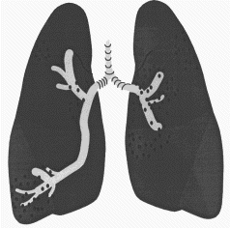
Lungs
The lungs have six main characteristics.
- They are a light pink colour and multi-lobed, the number of lobes varying with the species. Lobes are apical, cardiac, diaphragmatic and intermediate.
- Lungs maintain permanent contact with walls of the thoracic cavity – both lungs and thoracic cavity are coated with a lubricated serous membrane called the pleura. This allows lungs to slide easily over the chest wall during respiration.
- They consist of a framework of branching and ever-diminishing in diameter tubes, called bronchi and bronchioles. The tissue surrounding this framework of tubes is a proliferation of tiny sacs, each with a dense network of capillaries called alveoli.
- Inspiration and expiration of the lungs are passive actions brought by the expansion and contraction of the chest cavity.
- When the chest cavity expands, due to the muscles of the diaphragm and the intercostal muscles (between the ribs) flexing, the lung capacity increases, drawing air into the lungs.
- When the chest cavity contracts due to the relaxation of the diaphragm and intercostal muscles, the lung capacity is decreased and air is expelled. This is why a person or animal with a penetrating chest injury has a great deal of difficulty breathing. Air may be sucked in through the hole when the chest expands, instead of down the trachea.

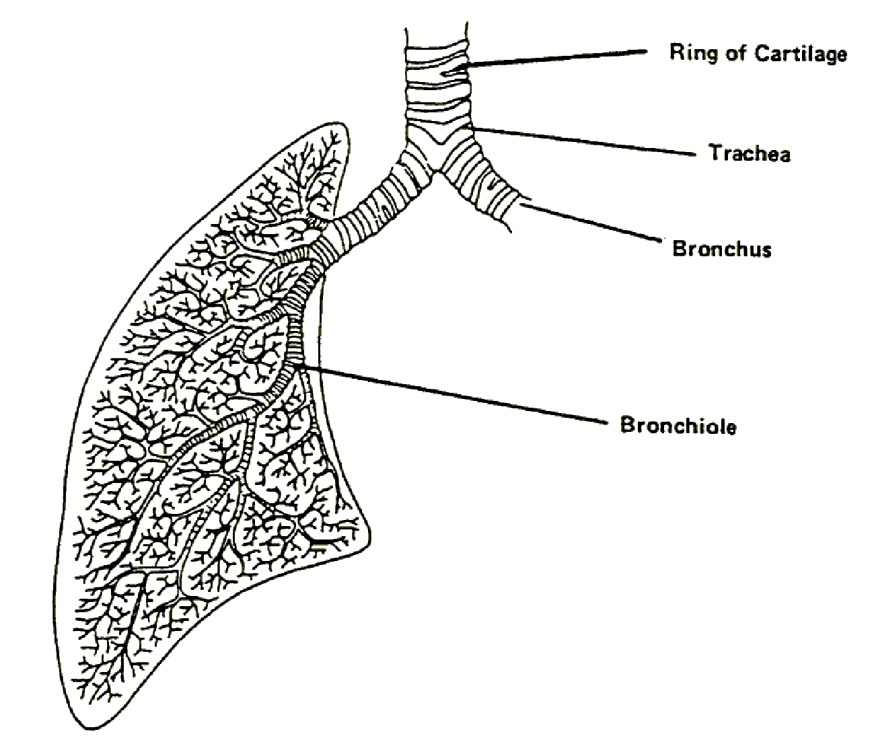
Air passages in the lung
Bronchi and bronchioles
The bronchi and bronchioles provide an unobstructed passage for air to reach the areas of gaseous exchange.
Characteristics of bronchi and bronchioles are:
- bronchi branch off into progressively smaller branches, similar to the branches of a tree, which become the bronchioles
- bronchi contain cartilaginous plates that maintain the opening in the tube and prevent collapse, to ensure the unobstructed passage of air
- bronchioles do not possess any cartilage
- all respiratory structures after the bronchioles are too small to be seen by the naked eye.
Alveoli
Alveoli are the functional unit of the lung. The primary function is gaseous exchange, i.e. oxygenation of blood and the removal of carbon dioxide.
Characteristics of the alveoli are that:
- they are very thin walled, sac-like structures
- they are entwined with a dense network of blood capillaries
- they are masses of alveoli (tiny air sacs) which greatly increase the surface area available for gaseous exchange.

Air passage
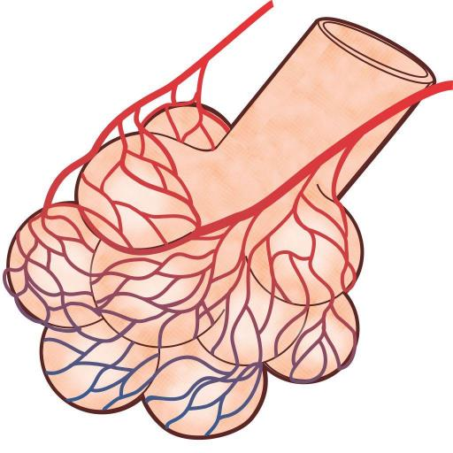
To pulmonary vein
Alveolus
Capillary
From pulmonary artery
Relation of blood vessels to alveoli
Animal | Trachea | Bronchi | Lungs Description | No of R. lobes | No of L. lobes
Cattle | Ends of cartilage form a ridge along the trachea | Two on the right and one on the left | Firm bright and red with distinct interlobular septa | 4-5 | 3
Horse | Cartilage rings overlap on the ends | One on the right and one on the left | Lungs are long, lobules are poorly defined | 3 | 2
Sheep | Similar to cattle but smaller | Two on the right and one on the left | Dense and leathery | 4-4 | 3
Goat | Similar to sheep | Two on the right and one on the left | Lungs appear smaller and the interlobular fissures deeper than in sheep | 4-5 | 3
Pig | Similar to cattle but much shorter | Two on the right and one on the left | Long broad and spongy with lobules well marked in squares | 3-4 | 2-3

Poultry respiratory system is different from that of mammals, with birds having relatively small lungs plus nine air sacs that play an important role in respiration (but are not directly involved in the exchange of gases)
The air sacs permit a unidirectional flow of air through the lungs. Unidirectional flow means that air moving through bird lungs is largely 'fresh' air & has a higher oxygen content. In contrast, air flow is 'bidirectional' in mammals, moving back and forth into and out of the lungs. As a result, air coming into a mammal's lungs is mixed with 'old' air (air that has been in the lungs for a while) & this 'mixed air' has less oxygen. So, in bird lungs, more oxygen is available to diffuse into the blood
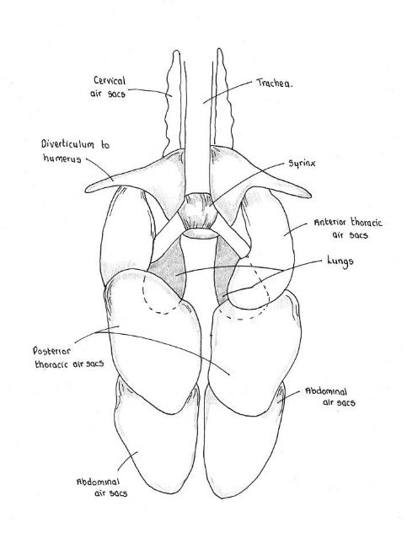
Avian air sacs
© Leisha Hewitt
Topic 6. The digestive system
What does the digestive system do?
The digestive system:
- breaks down and absorbs food and water
- expels wastes.
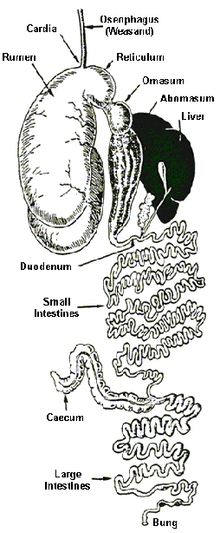

Digestive system of a sheep
Nutrition
Food is made up of six main components. They are:
- proteins – made up of amino acids proteins are the body’s building blocks
- carbohydrates – provide the body’s primary source of energy
- fats – provide the body with a source of stored energy
- vitamins – the chemicals necessary for normal bodily functions
- minerals – are important components of normal bodily functions, e.g. iron for blood, calcium for bones, potassium, sodium and chlorine for muscular functioning etc.
- water – the largest and single most important component of food.
What makes up the digestive system and how does it work?
The digestive system is made up of:
- mouth – teeth and tongue
- pharynx
- oesophagus
- stomach – in ruminants these are the rumen, reticulum, omasum and abomasum
- in single stomach animals - pigs there is one stomach compartment.
- small intestine – consisting of the duodenum, jejunum and ileum
- large intestine – consisting of the ascending, transverse and descending colons
- rectum
- anus
- accessory glands, organs:
- liver and gall bladder
- salivary glands
- pancreas
- peritoneum – a lubricated serous membrane which lines all the abdominal viscera, that is stomach, small and large intestines and the abdominal cavity.
- the lubrication is from a serous fluid produced by the serous membrane
Mouth – teeth and tongue
Mouth
The mouth is the entry point for food and the site of initial mechanical and physical breakdown of food by chewing.
Teeth
Animals have four types of teeth. These are:
- incisors – for cutting
- canines – for grasping and tearing
- pre-molars – for grinding
- molars – for grinding.
Tongue
The tongue varies widely among the various domestic animals
Horse | Long thin and narrow with a spatulate end; no dorsal ridge  and a pointed epiglottis; never has any black pigmentation
Cattle | Thick, tapering with a pointed end; a marked dorsal ridge;  often has black pigmentation; epiglottis is semi-circular
Sheep | Thick and short with rounded tip; the centre of the tip is slightly  grooved; 18-24 circumvallate papillae on the back edge of the tongue
Goats | Very similar to the sheep; the groove in the centre of the tip is  slightly deeper; 12 circumvallate papillae on the tongue
Pigs | Long and thin with a pointed end; no dorsal ridge; smooth surface and  a broad and rounded epiglottis.
Cattle use their tongue as a prehensile organ, i.e. they actually grasp grass with their tongue, and then pull the grass into their mouth. The lower incisors then cut off the grass.
The tongue also forms the food into the bolus or balls of food for swallowing.

Pharynx
The pharynx directs food down the oesophagus to the stomach. It also directs air down the larynx to the lungs.
Characteristics of the pharynx are:
- it is a muscular organ shared by both the respiratory and digestive systems
- it has seven openings:
- two nasal passages
- two eustachian tubes connected to the middle ear
- the mouth
- the larynx
- the oesophagus.
Oesophagus
The oesophagus is the passage by which food travels from the mouth to the stomach. In cattle, the oesophagus also enables the regurgitation of food, i.e. from the stomach to the mouth for further chewing in cattle.
A characteristic of the oesophagus is that it has an outer layer of voluntary muscle which moves food with a wave-like series of contractions called peristalsis.
Stomach
The primary function of the stomach is to completely break down food through the action of micro-organisms and gastric juices.
Pigs, horses and humans have a single stomach and as such are monogastics.

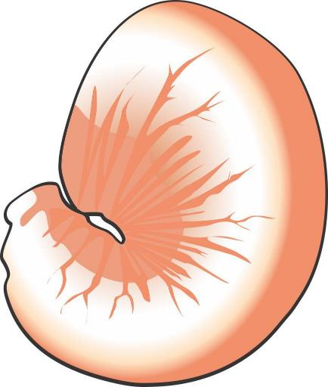
Left extremity
Oesophagus
Duodenum
Pylorus
Stomach of a horse
Poultry
The digestive system of birds differs considerably from that of other animals. Because there are no teeth, food is not chewed in the mouth. Instead the food is taken up by the beak and is passed to the crop where it is stored and partially softened. Food then moves to the Proventriculus (glandular stomach) is saturated with gastric juice before passing onto gizzard which substitutes for teeth and acts as a mechanical grinder of food. The food travels through the digestive canal and is excreted as faeces. The structure and function of the digestive canal is summarised below.
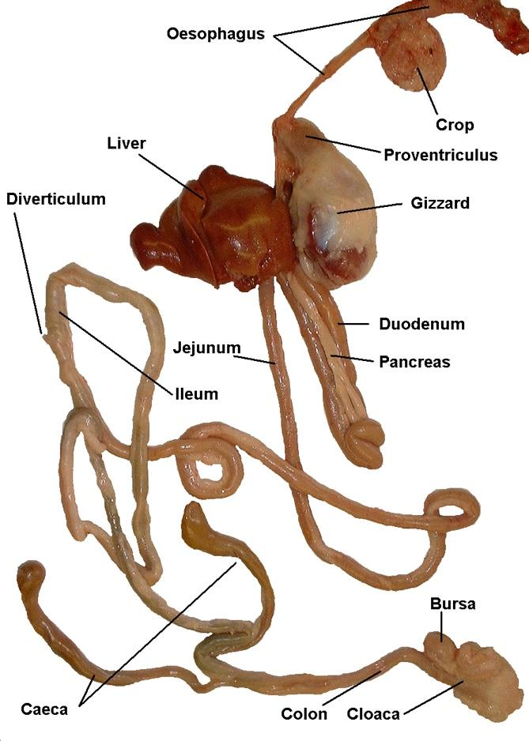
The digestive system of birds. The intestines are divided into regions, but these are not as distinct as in mammals
© Leisha Hewitt
Macropods are not true ruminants and have a long tubular, colon-like stomach that is made up of two sections, the enlarged fore stomach and the hind stomach. The fore stomach is split into two sections, the sacciform which is a storage compartment and the tubiform where fermentation mostly takes place. As food ferments, it passes into the hind stomach, where acids and enzymes finish digestion.
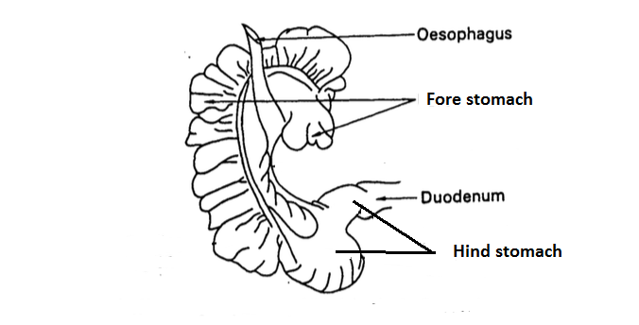
Macropod stomach
Cattle, buffalo, sheep, goats and deer are ruminants and have four compartments in their stomachs, the rumen, reticulum, omasum and abomasum.
The first three chambers are for fermentation of food (grass or grain) where bacteria breakdown the cellulose in grasses into simpler compounds for digestion. The final chamber, the abomasum, is where the gastric juices are made and secreted and where true digestion takes place.
Gastric juices contain a very strong acid and a variety of enzymes that breakdown the food to their components.
The walls of the stomach are protected from the acid by mucus.
Pseudoruminant such as camels, llamas and alpacas are like ruminants and use foregut fermentation to break down cellulose in fibrous plant species. However unlike ruminant they only have three stomachs.

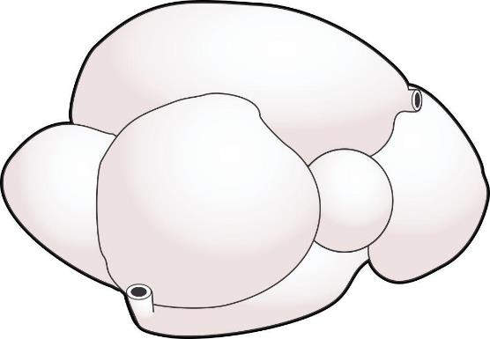
Dorsal curvature
Right longitudinal grooves
Oesophagus
Neck
Reticulum
Abomasum
Ventral curvature
Pylorus
Duodenum
Ventral sac of Rumen
Intestines of a sheep
Small intestine
The primary function of the small intestine is the absorption of food components into the blood stream and lymph, although additional digestion of food does occur in the first part of the small intestine, the duodenum.
The small intestine is divided into three sections, the duodenum, jejunum and ileum.
The small intestine has a very folded structure. The internal lining has tiny, finger-like projections called villi. These greatly increase the surface area available for absorption.
Bile from the gall bladder and pancreatic juices enter at the beginning of the small intestine. These assist digestion and also help to neutralise the strong acid from the stomach.
The small intestine in cattle is about 40 metres long, in sheep about 24 metres, and in pigs about 19 metres.
Large intestine
The primary function of the large intestine is the reabsorption of water.
Characteristics of the large intestine are:
- the large intestine in cattle is about 11 metres long, in sheep about 4.5 metres, and in pigs about 4.5 metres
- it does not contain villi
- includes the caecum a small pouch at the beginning of the large intestine where the small intestine meets the large intestine. It is important in the digestive process for monogastric animals like pigs and horses.
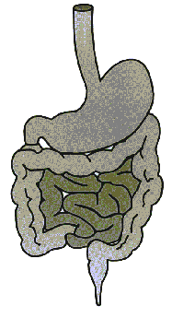
Intestines
Rectum and anus
The primary function of the rectum and anus is the expulsion of indigestible food components.
Both poultry and macropods have a cloaca which is a common terminus for the intestine, the ureters and the genital canals

What other accessory organs aid digestion?
The accessory organs which aid digestion are:
- salivary glands
- pancreas
- liver.
Salivary glands
The salivary glands produce saliva, a lubricant for food thus assisting the animal in chewing and swallowing.
Characteristics of salivary glands are that:
- they are located in the mouth
- all species have three paired sets of salivary glands:
- parotid
- sub-mandibular
- sub-lingual.
Pancreas
The primary digestive function of the pancreas is to secrete three powerful digestive enzymes to assist in the digestion of proteins, fats and carbohydrates. The pancreas also produces the hormone insulin. This regulates the level of sugar in the blood.
Characteristics of the pancreas are that it:
- is located near the liver
- discharges its enzymes into the duodenum
- is pale brown in colour and lobulated in appearance.
Liver
The liver has many functions, including:
- converting excess sugar into glycogen and storing it for later use
- breaking down surplus proteins and manufacturing others when required
- detoxifying poisons
- breaking down fats, and assembling others for storage
- storing iron for blood production
- producing bile that assists the digestion of fats and also the neutralisation of gastric juice.
Characteristics of the liver are that it:
- is a large, reddish-brown organ located in the abdominal cavity
- is the heaviest organ in the body
- has a bag/bladder attached containing yellow or greenish liquid called gall or bile, which is secreted into the duodenum (horses do not have a gall bladder)
- has incredible regenerative powers and, depending on the extent of the damage rapidly replaces tissue
- has dual sources of blood supply – the hepatic artery provides the liver with nutrient and oxygen, and the portal vein brings blood from the intestines to be processed by the liver.
The livers of various domestic species vary considerably in size and shape.
Horses - The horse liver is composed of three distinct lobes and a thumb piece, which ends in a point. There is no gall bladder and the average weight is about 4.5 kg.
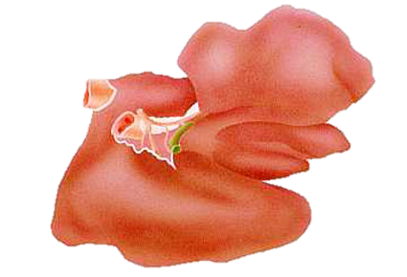
Horse liver
© Eddie Andriessen

Cattle - The beef liver is indistinctly divided into two major lobes. The right lobe is larger and thicker than the left lobe. There is also a poorly defined caudate lobe, which has a rounded shape and often extends beyond the lower edge of the liver. The beef liver has a pear-shaped gall bladder.
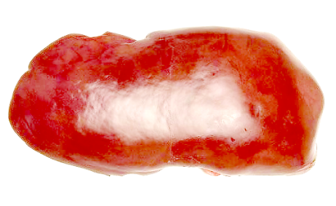
Beef liver (back surface)
© Eddie Andriessen
Sheep - The sheep liver is similar in shape to beef livers but can be differentiated from calf liver by the blunt pointed caudate lobe which does not exist in beef livers. It weighs about 0.5 kg. There is also a small thumb piece near the hilus.
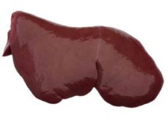
Goats - The goat liver is very similar to that of the sheep. It is slightly thinner and has a sharp-pointed caudate lobe, which also appears to be narrower than that in the sheep. There is no thumb piece. Livers from feral goats often have adhesions on the surface.
Pigs - The pig's liver has five distinct lobes and is distinguished by the large amount of interlobular tissue, creating a distinct pattern on the surface of the liver. The gall bladder is partly embedded in the liver substance rather than sitting on the surface as in sheep.
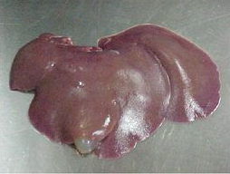
Deer - The liver is similar to that in sheep, but it is generally larger and has no gall bladder.
Camel - The liver is similar to that in horses in that it is multilobulated and has no gall bladder. It also has a frilly appearance around the edges.
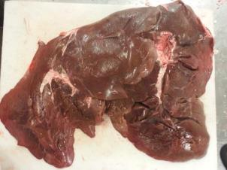

Topic 7 The excretory system
Many of the waste products from metabolism are potentially poisonous to animals if allowed to accumulate within the body. An example of a waste product is carbon dioxide, which is expelled through the lungs.
Other waste products include:
- nitrogen (in the form of urea), from metabolism of proteins in the liver
- surplus water
- surplus inorganic salts
- soluble foreign substances, e.g. antibodies.
Once these waste products have been made, they must be removed from the blood and excreted from the body. This is the job of the excretory of urinary system.
What is the function of the excretory system?
The excretory or urinary system:
- filters the blood and removes and excretes the waste products of metabolism, i.e. salts, urea and water
- regulates body fluid balance (homeostasis)
- maintains/regulates the concentration of salts in the blood.
Homeostasis is the maintenance of the internal body environment. Mammals require a stable internal body environment. The excretory system is vital in maintaining this.
What are the components of the excretory system?
The excretory or urinary system is made up of:
- kidneys
- ureters
- bladder
- urethra
- penis/vagina.
Kidneys
The primary function of the kidneys is the selective filtration of the blood to remove and excrete unwanted waste products, and the retention of desired plasma components.
The functional unit of the kidney is the nephron. The nephron consists of:
- the glomerulus and bowman’s capsule, where the blood is filtered and then convoluted
- uriniferous tubule where water and nutrients are reabsorbed into the blood stream.
Surplus water and salts plus urea and other substances not required by the body, continue down the tubule. This remaining fluid is excreted as urine.

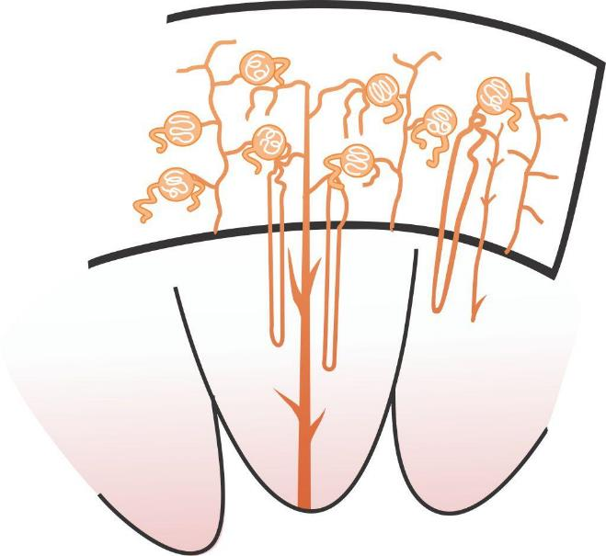
Glomerulus and Bowman’s capsule
Branch of renal artery
Pyramid
Pelvis of kidney
Urialiferous tubula
Medulla
Cortex

Cross-section of a kidney and bowman’s capsule
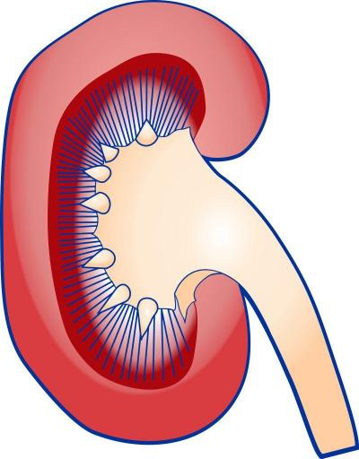
Connective tissue
Ureter

Kidney as an example of a generalised organ
Characteristics of the kidney are:
- there are two, situated on either side of the backbone in the abdominal cavity
- they are dark reddish-brown in colour. In the body they are covered with a thin fibrous capsule that can be easily stripped off
- the beef kidney is lobulated (about 20 lobes), the sheep kidney is bean shaped and not divided into lobes, and the pig kidney is bean shaped but flattened and not divided into lobes
- they have three distinct areas – the pelvis, the medulla and the corte
- each kidney has three vessels entering the pelvis – the renal artery which supplies blood to the kidney, the renal vein which takes filtered, deoxygenated blood away from the kidney and the ureter which conveys urine to the bladder.
Species Variations
The kidneys in different domestic species vary considerably in shape and appearance.
Cattle - The kidneys in cattle are distinctly lobulated, each kidney consisting of 15-20 lobules. The weight of each kidney is approximately 200-300 g.
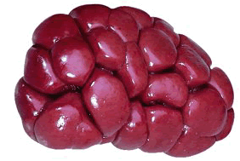
Pigs - The pig's kidneys are smooth and bean-shaped but flatter and larger than those in sheep. They each weigh about 100- 150 g.
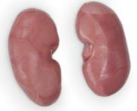
Sheep and goats - The kidneys in these two species are extremely similar. They are both bean-shaped, dark-red organs. The goat's kidneys appear slightly more rounded and globular. Each kidney weighs about 60-80g.
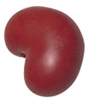
Horses – The right kidney is heart-shaped and the left kidney is bean-shaped and longer than it is broad. They are each indistinctly broken up into about 3 to 5 lobules. Each kidney weighs about 700 g.
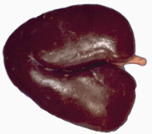
Camels - Their kidneys are shaped like a sheep’s kidney but are the size of a horse’s kidney.
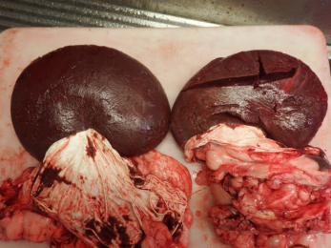
Kangaroos - The kangaroo’s kidneys are bean shaped dark red organs about 50-70gms in weight.
Ureters
The primary function of the ureters is to move urine from the kidneys to the bladder.
Characteristics of the ureters are:
- there are two
- the kidneys produce urine drop by drop, and this collects in the renal pelvis and flows through the ureters to the bladder
- they enter the bottom of the bladder at an angle to prevent urine from flowing back into the ureters.
Bladder
The urinary bladder collects urine until a sufficient amount has been collected to bring about urination.
Characteristics of the bladder are that:
- it is situated in the abdominal cavity and partly in the pelvic cavity
- the wall is mostly smooth muscle, with the inner surface lined with mucous membrane, and the outer surface coated with a serous membrane (the peritoneum).
Urethra
The primary function of the urethra is to convey urine from the bladder to the outside. Characteristics of the urethra are:
it exits via the penis in males and the vagina in females
it is solely urinary in function in females, but in males it is urinary and genital.

Topic 8. The reproductive system
What is the female reproductive system made up of?
The functions of the female reproductive system are:
- to receive the penis and move the sperm to the egg (or ovum)
- to produce eggs or ova
- to carry and nourish the foetus through to gestation
- to nourish infant through to weaning.
The female reproductive system is made up of:
- ovaries
- oviducts – fallopian tubes
- uterus
- cervix
- vagina
- vulva
- mammary glands (udders).
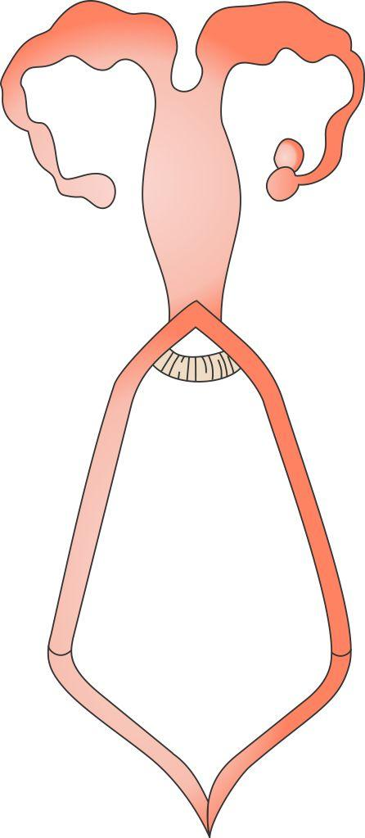
Horn of uterus
Colyodone
Ovary
Fallopian tube
Abdominal opening
Cervix
Vagina
Clitoris
Lips of vulva (labium)
Body of uterus

Female reproductive system
Ovaries
The primary function of the ovaries is to produce eggs or ova. They also produce the female hormones oestrogen and progesterone, which control ovulation.
Characteristics of the ovaries are that:
- there are two
they are located at the tips of the horns of the uterus in the abdominal cavity.
Oviducts/fallopian tubes
The oviducts/fallopian tubes convey mature ova into the uterus, so fertilisation can take place.
Oviducts contain tiny, hair-like structures that move the ova in a wave-like motion.
Uterus
The primary function of the uterus is to support the foetus during development, and then expel it when it reaches full term.
Characteristics of the uterus are that it is:
- a hollow, muscular organ, consisting of a body, cervix and two horns
- situated mostly in the abdominal cavity, but extends into the pelvic cavity.
Vagina
The primary function of the vagina is to receive the penis of the male during copulation.
Characteristics of the vagina are that it:
- is a muscular tube lined with mucous membrane
- extends from the uterus to the vulva.
Vulva
The vulva is the external opening of the vagina.
Mammary glands
The primary function of the mammary glands is to produce milk to sustain and nourish the young.
Characteristics of the mammary glands are that they:
- are located on the posterior abdominal wall in the flanks, between the hind legs
- in cows, consist of four separate glands or quarters, each with its own teat
- in ewes and nanny goats, consist of two halves, each with its own teat
- in sows, consist of 10–14 mammary glands, each with a teat in two parallel lines along the abdomen.
What is the male reproductive system made up of?
The functions of the male reproductive system are:
- to produce sperm and impregnate the female
- to produce the male sex hormone, testosterone.
The male reproductive system consists of:
- testicles
- epididymis
- vas deferens
- accessory glands
- penis.
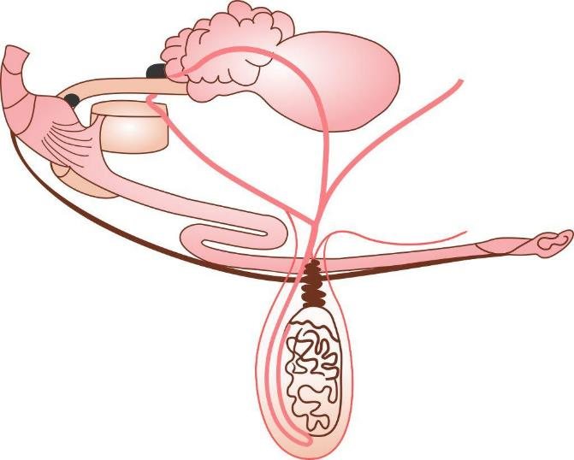
Male reproductive system of a bull
Testicles
The primary function of the testicles is the production of sperm and the male sex hormone, testosterone.
Characteristics of the testicles are that:
there are two, oval in shape
- they are suspended in a loose sac of skin called the scrotum, between hind limbs.
Epididymis
The primary function of the epididymis is to store sperm for ejaculation.
Characteristics of the epididymis are that:
- it is attached to the testicle on three sides
- it consists of a head, body and tail.
Vas deferens
Vas deferens connects the epididymis to the urethra. Its primary function is to convey sperm to the urethra at the time of ejaculation.
Characteristics of the vas deferens are that:
- there are two – one from each testicle
- it is a hollow, muscular tube.
Accessory glands
The primary function of the accessory male glands is to produce seminal fluid, which makes up the bulk of the ejaculate. Seminal fluids nourish and protect the sperm from adverse conditions.
The accessory male glands are four separate pairs of glands:
- bulbo-urethral
- prostrate glands
- seminal vesicles
- ampullae of the urethra.
Penis
The primary function of the penis is to introduce sperm into the vagina of a female.
The penis is a fibro-muscular organ, capable of erection when engorged with blood.
Topic 9. The nervous system
What controls the body systems?
We have looked at the major body systems that carry out the basic functions of life. But what organises and controls them all?
The nervous and endocrine systems work together to maintain, control and organise the functions of the body. However, they both function in entirely different ways.
The nervous system sends and receives electrical messages (impulses) via nerve cells. The endocrine system monitors the blood and sends out chemical messages (hormones) through the blood to the target organ.
What are the components of the nervous system?
The function of the nervous system is to:
- control and organise bodily processes and activities
- provide sensory perception.
The components of the nervous system are:
- neurones
- nerves
- brain
- spinal cord
- sensory organs.
Neurones
The neurone is the basic nerve cell. The function of neurones is to transmit electrical impulses. It is unknown exactly how they achieve some of the higher mental processes, such as intellect and memory.
Characteristics of neurones are that:
- they are the most highly specialised cells in the body
- they have very limited powers of regeneration, i.e. an animal born with its full complement of neurones cannot replace or repair any that are, or become, damaged
- they consist of three parts:
- the cyton – the cell body containing the nucleus
- the dendrite – the impulse-receiving fibre
- the axon – the impulse-sending fibre
- both dendrites and axons have branched ends
- there are two basic types of neurone:
- sensory nerves which carry information to the brain from the body
- motor nerves which carry information from the brain to the body to cause some action
- they use impulse transmission – along nerves (electro-chemical) and between nerves (chemical).
Nerves
The primary function of nerves is to convey nerve impulses.
Characteristics of nerves are that:
- they are fibres composed of bundles of nerve cell axons
- they are covered with a sheath, which protects and insulates them.
Brain
The brain is the body’s control centre for all voluntary and many involuntary bodily functions and activities.
Characteristics of the brain are that it:
- is located in the cranial cavity
- consists of three main parts:
- the cerebrum – which is the main upper part of the brain and controls intelligence, will, emotions and sensations
- the cerebellum – which is smaller and situated below and behind the cerebrum; it is responsible for controlling and coordinating the movements of voluntary muscles
- the medulla oblongata – which is the thick cord that connects the brain with the spinal cord and controls the acts of swallowing and breathing
- is covered with a serous membrane called the meninges
- is constantly bathed in a lymph-like fluid – cerebro-spinal fluid.
Spinal cord
The spinal cord is the main communication link between the brain and the body.
Characteristics of the spinal cord are that it:
- is located in the spinal canal – the tube that runs down the centre of the spinal column
- is basically an extension of the brain
- is covered with a serous membrane called meninges
- is constantly bathed in a lymph-like fluid – cerebro-spinal fluid
- has approximately 40 nerve branches leaving it over the course of its length.
Sensory organs
These are peripheral structures (skin, eyes, nose, ears, tongue) which contain specialised cells that monitor environmental conditions (temperature/pressure, light, smell, sound, taste). They then convert them into electrical impulses and transmit them to the brain for interpretation.

Topic 10. The function of skin and the endocrine glands
Functions of the skin
The skin possesses a variety of different functions. It:
- provides a protective covering to the body
- excretes metabolic waste products
- regulates the animal’s body temperature
- is a sensory organ
- produces Vitamin D under the action of sunlight.
Protection
The skin is tough, resilient, elastic and waterproof. Its thickness varies according to the areas greatest wear. It provides a barrier against physical injury and microbiological invaders.
Excretion
The skin excretes water, salt, urea and carbon dioxide. Capillary networks surround the sweat glands and remove the wastes from the blood, then excrete them to the surface of the skin via the sweat ducts.
Regulation of body temperature
Energy is a product of metabolism. This energy is given off as heat. If this heat was not lost in some way, the body temperature would continually rise and the animal would literally cook from the inside out.
The skin, with its large surface area in contact with the external environment, is the principal organ for regulating body heat. It shares this function with the lungs, the kidneys and, to a minor extent, the bowel.
The skin loses heat by radiation, conduction, convection and evaporation. Evaporation of sweat is the major source of heat loss. Not all animals have sweat glands. Horses and sheep possess sweat glands. Cattle only sweat from the muzzle and pigs only sweat from the snout.
Sensory organ
The skin is an important organ of touch. Even in areas where the skin is very thick, animals still show great sensitivity to physical contact. This is because the skin has an extensive network of nerve endings.
Production of vitamin D
Vitamin D prevents the soft bone disorder rickets in young animals, and osteoporosis in adults. Vitamin D is formed by the action of sunlight on naturally occurring skin compounds called sterols.
The components of the skin
Skin is basically a two layered structure:
- the outer layer being the epidermis
- the inner layer being the dermis.
Epidermis
The primary function of the epidermis is to act as a protective layer for the softer tissues underneath.
Characteristics of the epidermis are that:
- it consists of several layers of cells
- the outermost layers are dead cells that are continually shed as scurf
- the outermost layers are constantly replaced by cells from the lower levels
- it has no blood vessels as nourishment is supplied by tissue fluid from the dermis.
Dermis – the true skin
The dermis has a number of major functions:
- maintaining the epidermis
- preventing heat loss
- excreting waste
- sensoring the environment to relay information to the nerves.
Characteristics of the dermis are that:
- it is composed of a tough, interwoven mesh of fibrous and elastic connective tissue
- it has an extensive network of blood capillaries and nerve endings
- it contains sweat glands and sebaceous glands, which produce sweat and a moisturising and waterproofing oil called sebum.
Skin appendages
The skin’s appendages are:
- hair, wool, fur etc
- hooves
- horns and claws.
Hair
The hair insulates the animal against excessive heat loss or again and provides extra protection.
Characteristics of hair are:
- it covers almost the entire body of a domestic animal
- each hair consists of a root and a shaft, with the root embedded in a hole in the skin called the hair follicle; this is supplied with oil by a duct from a sebaceous gland
small muscles in the skin allow some animals to ‘make their hair stand on end’, thus providing a defence against the cold by increasing the insulation effect. This also acts as a defence mechanism as the animal appears larger to its potential attacker.
Hooves
Hooves provide a hard, stable platform on which to stand.
Characteristics of hooves are that they:
- originated from epidermal cells
- are modified hairs bound together with keratin
- possess internal nutrition and blood supply
- possess a bony support base.
Horns and claws
Horns are defensive weapons for females, and aggressive weapons for males fighting for mating rights.
Characteristics of horns are that they:
- are modified hairs bound together with keratin
- possess internal nutrition and blood supply
- possess a bony support base.
Feathers
Feathers provide insulation, warmth, waterproofing and are essential for flight. They have additional functions such as;-
- Courtship displays
- Cleanliness
- Defence
- Cryptic colouring (camouflage)
- Colour mimicking
- Dominance/subdominance conflicts
- Sound production
- Aggressive territorial behaviour
The function of the endocrine system
The endocrine system consists of a series of ductless glands that secrete hormones directly into the bloodstream. The function of some of the components of the endocrine system is to produce hormones. For other components, hormone production is secondary.
Hormones are very powerful and only small amounts are required to obtain a response. Hormones are chemical messengers either stimulating or suppressing specific bodily activities.
The components of the endocrine system
The main components of the endocrine system are the:
- pituitary gland
- thyroid gland
- thymus gland
- adrenal gland
- testes
- ovaries
- pancreas.
Pituitary gland
The pituitary gland is the ‘master gland’ of the body. A major part of its function is to produce hormones that regulate the activity of the other endocrine organs.
Characteristics of the pituitary gland are that it:
- is situated in the cranial cavity, attached to the floor of the brain
- produces:
- growth hormone, which regulates the growth of the animal
- a hormone that stimulates the production of eggs in the ovary of females and sperm in the testes of males
- a hormone that controls ovulation in females
- a hormone that controls lactation and milk production
- a hormone that regulates the activity of the thyroid gland
- a hormone that is essential to the proper functioning of the adrenal glands.
Thyroid gland
The primary function of the thyroid gland is to produce a hormone (thyroxine) that regulates the rate of cell metabolism.
Characteristics of the thyroid gland are that:
- it is situated in the throat region, on the upper part of the larynx
- the thyroid gland and hormone are rich in iodine (an iodine deficient diet can result in thyroid disorders)
- too much hormone results in increased body temperature, blood pressure, heart rate, panting; individuals also exhibit increased mental activity demonstrated in nervousness and irritability
- too little hormone results in sluggishness, lowered body temperature, blood pressure, heart rate and breathing.
Thymus gland
The primary function of the thymus gland is to produce a hormone that stimulates the immune system of very young animals.
Characteristics of the thymus gland are that:
- its main body is situated in the front of the chest, while two branches extend up on either side of the trachea
- it is sold as ‘sweetbreads’, with the body of the thymus known by butchers as the ‘heart bread’ and the two branches as ‘neck breads’
- it increases in size from birth to sexual maturity, after this its tissue degenerates and becomes infiltrated with fat.
Adrenal gland
The adrenal gland produces two hormones, both quite well known and used in medicine. One is cortisone which reduces inflammation. The other is adrenalin which produces the ‘flight or fight’ response, i.e. increased heart rate, increased blood pressure, and the associated general rush.
Characteristics of the adrenal glands are that:
- there are two, situated just in front of the kidneys
- they are reddish-brown in colour
- when cut, they show a definite cortex (outer layer) and medulla (inner layer)
- the cortex is reddish-brown and the medulla is golden orange.
Testes
The primary endocrine function is to produce the male sex hormone, testosterone.
Characteristics of the testes are that:
- there are two, oval in shape
- they are suspended in a loose sac of skin called the scrotum, between hind limbs
- the endocrine function is secondary to the primary function of producing sperm
- testicular activity is controlled by hormonal secretions from the pituitary gland.
Ovaries
Primary endocrine function is to produce the female hormones, oestrogen and progesterone.
Characteristics of the ovaries are that:
- there are two
- they are located at the tips of the horns of the uterus in the abdominal cavity
- the endocrine function is secondary to primary function of producing ova or eggs
- ovarian activity is controlled by hormonal secretions from the pituitary gland.
Pancreas
The primary endocrine function is producing the hormones responsible for regulating blood sugar levels, insulin and glucagon.
Characteristics of the pancreas are that:
- it is located near the liver
- it is pale brown in colour, lobulated in appearance
- it also produces powerful digestive enzymes which are secreted into the duodenum via the pancreatic duct
- insulin deficiency leads to hyperglycaemia (excess sugar in the blood) and results in the condition known as diabetes mellitus
- glucagon deficiency results in hypoglycaemia (low blood sugar).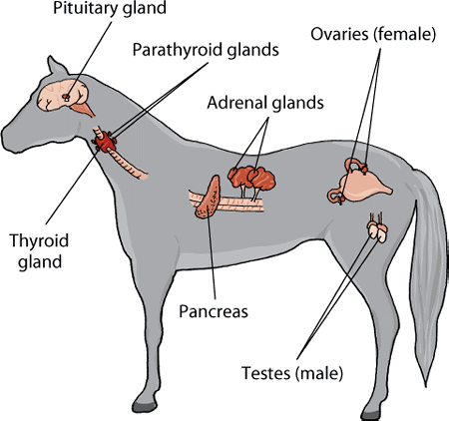

Equine endocrine system

Chapter 3. Food animal carcase parts and viscera and the Australian Standards.

Topic 1. The relevant Australian Standards and authorities
Topic 2. Inspection procedures and the Australian Standards
Applying knowledge of anatomy and physiology to the interpretation of post mortem procedures
What are the physiological and anatomical features required to be inspected in the Australian Standard for the major food species?
The AS4696:2023 Australian Standard for the hygienic production and transportation of meat and meat products for human consumption and the Australian Standards for other species detail the post-mortem inspection requirements for all animals slaughtered at abattoirs both domestic and export.
There are extra inspection procedures to meet certain export market requirements that are in addition to those detailed in the standard. These extra requirements will be provided by the company work instructions.
Important note: In 2020 the Australian Meat Regulators Group (AMRG) approved 14 alternative techniques and procedures for post mortem-inspection and dispositions outlined in Schedules 2 and 3 of the Australian Standard. AMRG released the following guidelines Guideline 2020:1. Post-Mortem Meat Inspection – Alternative techniques to Schedule 2 and 3 of AS 4696:2007 which for domestic abattoirs means there are changes to some current inspection and disposition practices. These changes include more visual inspections and less requirements for incisions in Schedule 2 as well as more detail regarding acute and chronic nature of conditions with regard to disposition judgements in Schedule 3
In export plants the amendments set out in the guidelines will apply only after the standard AS4696: 2007 is formally amended. However, for export plants even after standard is formally modified the matter of importing country requirements means that an equivalence argument will have to be had on a market by market basis before the changes to Schedule 2 and 3 can be implemented.
More information about this Guideline and associated Fact Sheets can be found on the MINTRAC website: www.mintrac.com.au
The carcase and viscera must be inspected. Only the heads of cattle and buffalo require inspecting unless part of the head including the tongue is going to be kept for human consumption.
Heads of small stock put up as suspects must be correlated with the carcase up to the point of final inspection
In the Schedule 2 of the Australian Standard details are given in table form as below:
buffalo means any bubaline greater than 50kg dressed weight
calf means a young bovine or bubaline no greater than 50kg dressed weight
cattle means any bovine greater than 50kg dressed weight
incise means to examine by observation and multiple slicing
palpate means to examine by observation and palpation.
Note #1: Equivalent procedures are simpler procedures that can be used when either product is not being kept for human consumption or certain diseases have been officially declared as not present in the particular State or Territory.
Note #2: Additional procedures are procedures carried out when disease is detected or suspected. It also includes procedures for product that is not normally kept for human consumption.
Table 1. Carcase
 | Cattle & buffalo | Calves | Sheep & goats | Lambs | Pigs | Horses | Deer
All carcases | Observe internal and external surfaces of carcase (including tail, musculature, exposed bone, joints, serous membranes).
Lymph nodes
Superficial inguinal | See note #1 | Observe | See note #2 | Observe | See note #3 | Incise | Observe
Internal iliac | See note #1 | Observe | Palpate | Observe | Observe | Observe | Observe
Lumbar | — | — | Palpate | Observe | Observe | — | —
Ischiatic | — | — | Palpate | Observe | — | — | —
Precrural | — | — | See note #2 | Observe | — | Palpate | —
Superficial cervical | — | — | See note #2 | Observe | — | Palpate | —
Popliteal | — | — | Palpate | Observe | — | — | —
Prepectoral | — | — | — | — | — | Incise | —
Equivalent procedures
Note #1: Cattle and buffalo – Palpate the superficial inguinal and internal iliac lymph nodes or, for animals in an area in relation to which the relevant Commonwealth, State or Territory Authority requires minimal risk inspection for tuberculosis (other than animals subject to conditional slaughter or emergency slaughter), an equivalent procedure is to observe the nodes (other than in bulls and mature females).
Note #2 : Sheep and goats – Palpate the superficial cervical, precrural and superficial inguinal lymph nodes or, other than animals subject to conditional slaughter or emergency slaughter, an equivalent procedure is to excise and discard these nodes without inspection.

Note #3: Pigs – Observe the superficial inguinal lymph nodes or, other than animals subject to conditional slaughter or emergency slaughter, an equivalent procedure is to excise and discard these nodes without inspection.
Table 2. Viscera
 | Cattle & buffalo | Calves | Sheep & goats | Lambs | Pigs | Horses | Deer
Lymph nodes
Bronchial & mediastinal | See note #1 | Palpate | Palpate | Observe | Palpate | Incise | Palpate
Portal | Palpate | Palpate | Observe | Observe | Palpate | Palpate | Observe
Mesenteric | Observe | Observe | Observe | Observe | Observe | Observe | Observe
Lungs | Palpate, except in lambs where observe. Additionally, bronchi opened and internal surfaces observed when saved for human consumption.
Heart | Palpate. Incise internal musculature 3-4 times in cattle and buffalo.
Liver | Palpate, except in lambs where observe. Incise main bile ducts transversely and observe contents, except in pigs where inspection of bile ducts not required (see note #2 for option).
Gastrointestinal tract | Observe. Observation of oesophagus not required in cattle, buffalo, calves or deer unless recovered for human consumption.
Spleen | Observe | Observe | Palpate | Observe | Observe | Palpate | Observe
Kidney (enucleated) | Palpate | Palpate | Observe | Observe | Palpate | Palpate | Palpate
Other tissues and organs | Thymus, pancreas, non-gravid uterus, bladder, testicles and penis observed when recovered for human consumption.
Equivalent procedures
Note #1: Cattle and buffalo – Incise bronchial and mediastinal lymph nodes or, for animals in an area in relation to which the relevant Commonwealth, State or Territory Authority requires minimal risk inspection for tuberculosis (other than animals subject to conditional slaughter or emergency slaughter), an equivalent procedure is to observe the nodes.
Note #2 : All animals – Procedures for the incision of main bile ducts and observation of contents may not be required at a meat business by the controlling authority.
Table 3. Head
 | Cattle & buffalo (see note #3) | Calves (see note #1) | Sheep & goats (see note #1) | Lambs (see note #1) | Pigs (see note #1) | Horses (see note #1) | Deer (see note #1)
All carcases | Observe external surfaces. For cattle, buffalo and horses observe the oral, buccal and nasal cavities.
Lymph nodes
Submaxillary | See note #2 | — | — | — | See note #4 | Incise | —
Parotid | See note #2 | — | — | — | — | Incise | —
Retropharyngeal | See note #2 | — | — | — | — | Incise | —
Cervical | — | — | — | — | See note #4 | — | —
Masticatory muscles (internal and external) | Incise | — | — | — | — | — | —
Tongue | Palpate | — | — | — | — | Palpate | —
Gutteral pouch | — | — | — | — | — | Palpate | —
Other tissues | Tongue roots in cattle, buffalo and horses observed when recovered for human consumption
Equivalent procedures
Note #1: All animals – Other than cattle, buffalo, horses and animals subject to conditional slaughter or emergency slaughter, an equivalent procedure is to remove and discard the head without inspection where tissues, including tongue, are not recovered for human consumption.
Note #2: Cattle and buffalo – Incise submaxillary, parotid and retropharyngeal lymph nodes or, for animals in an area in relation to which the relevant Commonwealth, State or Territory Authority requires minimal risk inspection for tuberculosis (other than animals subject to conditional slaughter or emergency slaughter), equivalent procedures are:
1. observe only, or
2. excise and discard these nodes without inspection.
Note #3: Cattle and buffalo – Other than animals subject to conditional slaughter or emergency slaughter, for animals in an area in relation to which the relevant Commonwealth, State or Territory Authority requires minimal risk inspection for tuberculosis, an equivalent procedure is to discard the head without inspection when tissues, including tongue, are not recovered for human consumption.
Note #4: Pigs – Incise and observe submaxillary and cervical lymph nodes or, other than animals subject to conditional slaughter or emergency slaughter, equivalent procedures are:
1. observe only, or
2. excise and discard these nodes without inspection.
Table 4. Additional procedures when specific diseases are detected or suspected
Disease | Inspection procedure
Tuberculosis in cattle and buffalo | Incise atlantal, prescapular, prepectoral, suprasternal, superficial inguinal, iliacs, ischiatic, precrural, portal and mesenteric lymph nodes. Incise popliteal lymph node where necessary to determine the extent of infection. All viscera, serous membranes, spinal cord and severed vertebral column inspected by observation, palpation and, where necessary, incision. Udders incised and observed.
Tuberculosis in pigs | Incise retropharyngeal, parotid, bronchial, mediastinal, portal, gastric, mesenteric, superficial inguinal, , lumbar, precrural, prescapular and deep inguinal lymph nodes. Viscera and serous membranes inspected as above for cattle.
Tuberculosis in horses | As above for cattle.
Tuberculosis in deer | Incise submaxillary, retropharyngeal, parotid, bronchial, mediastinal, mesenteric, portal, superficial inguinal, iliac, ischiatic and suprasternal lymph nodes. Incise popliteal lymph node where necessary to determine the extent of infection. Viscera and serous membranes inspected as above for cattle.
Cysticercus bovis In cattle, buffalo and deer | Incise masseter and heart muscles, incise tongue, incise diaphragm after removal of serous membranes and observe all exposed muscle surfaces.
Cysticercus celluosae in pigs | As above for C. bovis.
Sparganosis in pigs | Observe retro-peritoneal tissues after removal of the peritoneum. Where further evidence of infestation revealed, also observe main muscle seams of the hind limbs. Incise as necessary to determine extent of infection.
When carrying out post mortem inspection there are four basic procedures used in meat inspection:
- observation or visual inspection
- smell
- palpation
- incision.
Note: observation is sometimes referred to as visual inspection.
Important note: In 2020 the Australian Meat Regulators Group (AMRG) approved 14 alternative techniques and procedures for post mortem-inspection and dispositions outlined in Schedules 2 and 3 of the Australian Standard. AMRG released the following guidelines Guideline 2020:1. Post-Mortem Meat Inspection – Alternative techniques to Schedule 2 and 3 of AS 4696:2007 which for domestic abattoirs means there are changes to some current inspection and disposition practices. These changes include more visual inspections and less requirements for incisions in Schedule 2 as well as more detail regarding acute and chronic nature of conditions with regard to disposition judgements in Schedule 3
In export plants the amendments set out in the guidelines will apply only after the standard AS4696: 2007 is formally amended. However, for export plants even after standard is formally modified the matter of importing country requirements means that an equivalence argument will have to be had on a market by market basis before the changes to Schedule 2 and 3 can be implemented.
More information about this Guideline and associated Fact Sheets can be found on the MINTRAC website: www.mintrac.com.au
Observation
The Department of Agriculture Water and the Environment definition of observation is “To visually inspect a carcase and its parts in such a manner that abnormalities capable of being located are detected. In all instances observation refers to each surface of the item being observed. Observation may require the physical handling and/or incision of the carcase and/or carcase parts to allow complete observation of all surfaces. Observation also includes the use of the sense of smell to detect abnormal odours.
All parts of an animal must at least be visually observed. It is important to look for changes in colour and symmetry and variations to the norm. The importance of this aspect of inspection is the main reason why people with colour blindness are generally not accepted as meat inspectors. Visual inspection cannot be done from a distance. Since all surfaces of the carcass and organs need to be visually inspected it is necessary as part of the inspection procedure to handle and turn organs and parts as appropriate. Carcases must be carefully observed, paying particular attention to:
- colour
- odour
- symmetry
- general condition.
- age.
In the case of the internal surfaces particular attention should be paid to:
- the pelvic cavity
- the peritoneum and pleura
- the thoracic and abdominal surfaces of the thick and thin skirts
- the cut surfaces of the sternum and spine
- the ribs.
In the case of external surfaces particular attention should be paid to:
- the hocks and trotters
- the tail
- the sticking area
- the axillary regions
- the anus.
All surfaces of offal presented for inspection must be visually inspected, this means offal must be turned during inspection.
Incision
The Department of Agriculture Water and the Environment definition (Meat Manual Volume 3) of an incision is “To cut with a knife. Wherever incisions are specified the inspecting officer is also required to observe incised surfaces and may also be required to palpate cut/exposed surfaces”.
It may be for access purposes to improve observation or it may be a specific incision required by legislation to detect disease. It is essential that proper equipment be used for incision. Such equipment includes a keen knife, a safety hook and a well-dressed steel. Lymph nodes that require incision should be carefully sliced such that the cut surfaces are laid open for examination like the leaves of a book.
Unnecessary mutilation must be avoided and to facilitate a tidy `job' different knives may be used for different inspection procedures, for example a short thin blade may be used for pig-head inspection, whilst a long broad blade may be preferred for cattle-carcass inspection.
Palpation
The Department of Agriculture Water and the Environment definition (Meat Manual Volume 3) of palpation is “To examine by the sense of touch and feel all surfaces of any carcase and/or carcase parts so that any abnormality on or within the carcase or carcase part which is able to be detected by palpation is detected. Palpation refers to every surface of the carcase or carcase parts being palpated”
Palpation is equally as important as observation and incision and must be carried out diligently. Organ palpation requires firm pressure by the fingers and palms of the hand over the entire organ surface. Organs palpated include the kidneys, liver, spleen and lungs.
Lymph-node palpation requires firm pressure with the fingers and thumbs, rolling the nodes between them.
Laboratory analysis
Sometimes samples may need to be sent to a laboratory for diagnosis. This may be:
because the cause of the condition is unknown
for laboratory confirmation of notifiable diseases such as hydatids in Tasmania
as part of routine sampling for residue sampling programmes etc.
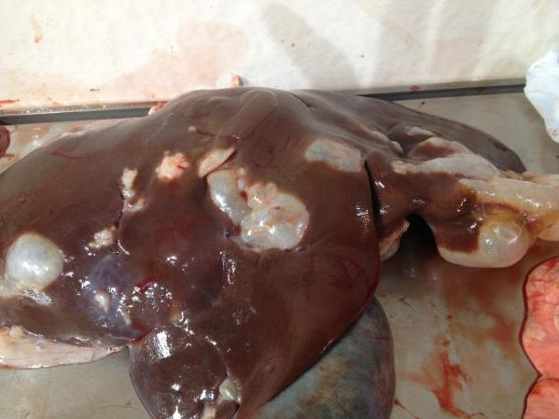
Evidence of hydatids in a liver
© MINTRAC
General requirements
Action | Explanatory notes
Identifying incoming carcases by viewing | - appropriate ante-mortem card  - approved correlation system, e.g. tag, ticket, pencil marking.

Action | Explanatory notes
Monitor presentation | - correlation of carcases and head with offal until final disposition  - dressed carcases:  - except for kidneys, with thoracic & abdominal viscera removed  - except for pigs, with the extremities separated from the carcase at a point distal to the carpal and tarsal joints  - if presented with the kidneys in situ, the kidneys must be separated from the kidney capsule and perirenal fat  - viscera and internal organs:  - with, if practicable, the alimentary tract separate from other viscera intended to be saved for human consumption  - with the heart separated from the pericardial sac  - with the enucleated kidneys separated from the perirenal fat  - in the case of cattle, buffalo and solipeds, with the liver separated from other viscera  - in the case of mature males or castrates, the associated parts of the reproductive system completely removed  - heads if being inspected  - must be skinned to the extent necessary to remove the brain or completely skinned if head meat is to be saved  - if nothing is saved the head must be skinned sufficiently to allow inspection to take place  - tongues of calves, sheep, lambs or goats:  - if separated from the head and presented on a viscera table, must be washed clean and trimmed free of any pieces of hide or skin.
Carry out inspection | - routine:  - observe  - palpate  - incise  - smell  - sample and analyse  - options as detailed in the Standard  - additional requirements for particular conditions as detailed in the Standard  - Special procedures for specific export markets  - carry out a complete inspection of all carcases and/or carcase parts, even if grossly contaminated and ultimately condemned
Make disposition | - according to Schedule 3 of the AS 4696:2007 Australian Standard for the hygienic production and transportation of meat and meat products for human consumption and according to the any specific market requirements on export registered plants
Retain, where applicable | - total carcase – including its parts  - For disposition by a veterinarian on export registered establishments or for laboratory diagnosis
Report deficiencies | - to management and request corrective action.
The precise requirement of what has to be inspected during a post-mortem inspection will depend on whether the plant is domestic or export-registered. However, the general requirements that the meat safety officer must meet when carrying out the inspection are:
- ensuring only animals that have undergone ante-mortem inspection are presented for post-mortem inspection
- ensuring carcases and carcase parts are correctly identified and correlated for post-mortem inspection
- ensuring carcases and carcase parts are correctly presented for post-mortem inspection
- ensuring the resources and conditions necessary to effectively conduct post-mortem inspection are provided
- undertaking post-mortem inspection of carcases and/or carcase parts as directed
- making a disposition to the suitability of the carcase and its parts for human consumption
- retaining carcases and carcase parts for veterinary examination (export plants only) or laboratory examination
- ensuring, where appropriate, the quality and integrity of the product is maintained.
Post mortem inspection is:
- to identify diseased and unwholesome meat, to prevent it from being sold for human and animal consumption
- to identify and break the cycle of many parasitic diseases, preventing transmission between humans and animals, and animals to animals
- to assist with the trace-back of diseases to the property of origin
- to assess whether hygiene and good manufacturing practices are being followed during slaughter and dressing, to maintain the wholesomeness of the product.
It ensures that only clean and disease-free carcases or parts are accepted for human consumption.
Post-mortem inspection is also important for ensuring that animals are handled humanely. For example, a post-mortem inspection can find out if multiple stuns have occurred to the one animal. Likewise post-mortem inspection can reveal evidence of dog bites or signs of recent bruising.

