AMPMSY302
Recognise signs of emergency and notifiable animal diseases
Training support materials

Australian Meat Processing Training Package
Certificate III in Meat Safety

Materials Development sheet for:
AMPMSY302 Recognise signs of emergency and notifiable animal diseases

Required Knowledge:
Topic | Covered on pages
The major EADs that affect food animal species groups, including:
- foot and mouth disease (FMD)
- bovine spongiform encephalopathy (BSE)
- tuberculosis (TB)
- African swine fever (ASF)
- anthrax
- Japanese encephalitis
- scrapie
- transmissible gastroenteritis (TGE)
- lumpy skin disease
Major notifiable diseases
- contagious pustular dermatitis (also known as scabby mouth or Orf)
- Cysticercus bovis
Access to the state/territory emergency list of notifiable diseases
The impact of EADs on the meat processing industry
Signs of EADs as they may be seen at post-mortem
Reporting requirements when an emergency disease is suspected in livestock or carcases
Steps to be taken by a meat processing workplace in the event of a suspected outbreak of an emergency disease, and how they are to be implemented
Purpose of the national Emergency Animal Disease Response Agreement (EADRA)
The Australian Veterinary Emergency Plan (AUSVETPLAN) and the role of regulators, companies and producers in the event of a suspected EAD
Reporting requirements when an EAD is suspected in animals or carcases
The workplace EAD preparedness plan
Steps to be taken by state/territory regulators when there is a suspected outbreak of an EAD
Sources of current information and updates about EADs
Key information about EAD responses for the meat processing industry, included in AUSVETPLAN manuals.

Elements and performance criteria

Element | Performance Criteria | Covered on pages
1. Identify the major EADs related to food animals | 1.1 Locate and identify the purpose of the Emergency Animal Disease Response Agreement (EADRA)  1.2 Identify the major EADs of food animals processed in Australia  1.3 Identify and describe the signs of major EADs as they may be seen at ante-mortem  1.4 Identify and describe the signs of major EADs as typically seen at post-mortem if present
2. Identify the reporting process for suspected EADs | 2.1 Identify the responsibilities for reporting EAD suspects as set out in the workplace emergency disease preparedness plan  2.2 Identify the meat processing workplace’s responsibilities after reporting a suspected EAD outbreak  2.3 Identify and explain the role of the Australian Veterinary Emergency Plan (AUSVETPLAN) in controlling EADs  2.4 Describe the potential impact of EADs on the livestock and meat industry

Training support materials for AMPMSY302 Recognise signs of emergency and notifiable animal diseases
Introduction
Australia as an island with an effective quarantine and animal health system and this has enabled us to remain free from many of the world’s most significant animal diseases. This animal health system is supported by commonwealth and state legislation.
There are exotic and endemic animal health diseases. Exotic diseases are those found overseas such as foot and mouth disease. An endemic disease is a disease that is normally seen in animals in Australia. However it may only occur in certain areas or states or in very few animals. Anthrax is an endemic disease in Australia.
Significant animal diseases are also divided into emergency animal diseases and notifiable animal diseases.
What is an emergency animal disease?
The AUSVETPLAN defines an emergency animal disease as:
'A disease that is (a) exotic to Australia or (b) a variant of an endemic disease or (c) a serious infectious disease of unknown or uncertain cause or (d) a severe outbreak of a known endemic disease, and that is considered to be of national significance with serious social or trade implications.’
Specific animal diseases are termed as emergency because of their potential, in most cases, for very serious and rapid spread causing major economic impact to livestock industries and the economy. Some of these diseases can also be spread from animals to humans (zoonoses). These diseases would also have a major impact on our international markets. An outbreak of an emergency disease would mean the immediate closure of all our international markets. Depending on the market and disease it could take Australia years to regain access.
All emergency animal diseases are also ‘notifiable diseases’.
What is a notifiable disease?
Notifiable diseases are diseases in animals that by law must be notified or reported to the relevant State or Territory authorities.
As a meat inspector it will be your legal obligation, to notify the Emergency Animal Disease Hotline 1800 675 888 or state authorities if you know or suspect that an animal has a notifiable disease. The full list of state and territory notifiable animal diseases can be found on the Department of Agriculture website.
All emergency diseases are notifiable diseases but not all notifiable diseases are emergency diseases. For instance liver fluke is a notifiable disease in WA but it is not an emergency disease. Again for instance hydatids is a notifiable disease in Tasmania but it is not an emergency disease.
What is the potential impact of emergency diseases on the meat industry?
According to Australian Bureau of Agricultural and Resource Economics and Sciences (ABARES) estimated that Australia’s red meat and livestock industry’s turnover totalled $67.7 billion in FY2020–2021, accounting for approximately 1.7% of Australia’s total key industry turnover(1). Industry turnover is defined as income generated by businesses within the industry from the sales of goods and services. Importantly the Australian red meat and livestock industry employed approximately 428,000 people. The pork industry is worth an additional $5.2 billion.
In 2023, Australia exported a total volume of 1.84 million tonnes of red meat to over 100 countries worth a record A$17.08 billion. The identification of an Emergency Animal Disease (EAD), whether major, such as foot-and-mouth disease, or minor, would have a major impact on Australia. Dependant on which disease it is the impacts could be all or any combination of the following.
The economy would be affect because Australian meat and meat products would not meet importing country requirements any more and trade restrictions would occur, therefore less product would be sold. Trade restrictions last for a period after the outbreak has been cleared. Meat processing companies may suffer long term effects of not meeting customer orders and losing customers.
An increase in meat onto the domestic market would lower the price of meat. The herd numbers for the country would be depleted, potentially increasing the price of cattle after the outbreak was cleared. The impact of these factors on the meat processing companies may result in job losses which in turn affect Australia’s rural economy.
An outbreak of an emergency animal disease would also require an animal movement restriction to prevent the spread of the disease. This would mean that there are no saleyard sales, no movement of animals between properties and no movement off properties to abattoirs without approval from the state or territory department of agriculture or equivalent. This could reduce slaughter numbers and stop breeding shows and competitions, agriculture festivities and fetes.
People movement restriction can also be part of the response to an emergency animal disease outbreak to prevent the spread of the disease. This means that people cannot go on to or off properties without quarantine procedures such as foot washes, tyre washes and changing clothes in some cases of emergency animal diseases. This can affect the rural community’s normal life, community events and tourism. Tourism or homestays have become more popular in Australia as properties have diversified to try and ensure a continuous income in bad weather years.
Tourism from overseas should also be considered as the perception from media broadcasts can mean that people cancel holidays or choice a different location. Tourism has a large effect on the Australian economy. It is estimated by the Australian Bureau of Agricultural and Resource Economics and Sciences (ABARES) in $2020-21 that
‘A large multi-state foot and mouth disease outbreak has an estimated direct economic impact over 10 years of around $80 billion’.
Because of the economic impact an emergency disease could have on animal production and processing industries, animal health laboratories and state, territory and federal governments have developed plans (AUSVETPLAN) explaining how to respond including how the response is paid for.
Most emergency disease outbreaks throughout the world have been identified at abattoirs as every animal is inspected. To manage and potentially reduce the impact of an emergency animal disease it is very important that meat inspectors and company staff always consider emergency animal diseases when inspecting animals at ante- and post-mortem and act quickly if they think an animal has an emergency animal disease. The important thing to keep in mind is: if in doubt, check or ask.
What are the major emergency animal diseases for Australia?
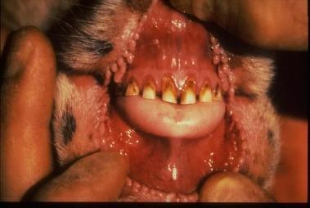
Bluetongue
In this document we will concentrate on those emergency diseases that currently represent the greatest threat to Australia’s livestock and processing industry. A complete list of emergency diseases is in Appendix 1 of these materials.

EADS OF CONCERN | SPECIES AFFECTED
 | Cattle | Sheep | Goats | Pigs | Horses | Humans
African swine fever |  |  |  | ✔
African horse sickness |  |  |  | ✔ | ✔
Anthrax | ✔ | ✔ | ✔ | ✔ | ✔ | ✔
Aujeszky’s disease | ✔ | ✔ | ✔ | ✔
Bluetongue | ✔ | ✔ | ✔
Bovine spongiform encephalopathy | ✔ |  |  |  |  | ✔
Classical swine fever |  |  |  | ✔
Foot and mouth disease | ✔ | ✔ | ✔ | ✔
Hendra virus |  |  |  |  | ✔ | ✔
Lumpy skin disease | ✔
Peste des petits ruminants |  | ✔ | ✔
Porcine epidemic diarrhoea |  |  |  | ✔
Porcine teschovirus encephalomyelitis |  |  |  | ✔
Rabies | ✔ | ✔ | ✔ | ✔ | ✔ | ✔
Rift valley fever | ✔ | ✔ | ✔ |  | ✔ | ✔
Scrapie |  | ✔ | ✔
Screw worm fly | ✔ | ✔ | ✔ | ✔ | ✔ | ✔
Sheep and goat pox |  | ✔ | ✔
Transmissible gastroenteritis |  |  |  | ✔
Vesicular stomatitis | ✔ |  |  | ✔ | ✔ | ✔

What are the major notifiable animal diseases for Australia?
The complete list of notifiable diseases can be found in Attachment 2. This list includes all the major emergency diseases. However, the list varies a little from State to State depending on local circumstances. Please note this list can vary from time to time. Contact the relevant State or Territory animal health authority for further information on the most likely or common notifiable diseases in the state. In these training materials
Signs of the major emergency animal diseases as they relate to food animals
What signs should alert inspectors to a possible emergency animal disease at ante mortem?
There are a range of symptoms that should alert inspectors and stock handlers to a possible emergency diseases. Blisters and/or lesions on lips, muzzle, tongue, teats and above or between claws of the hoof can be signs of an emergency disease.

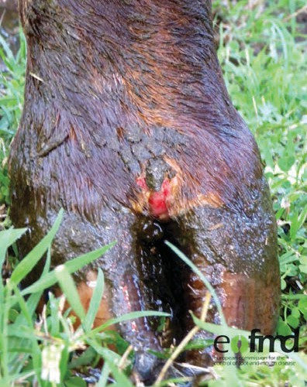
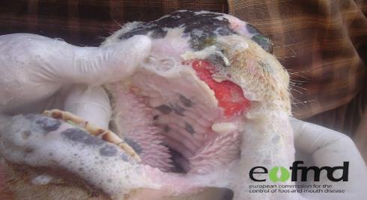
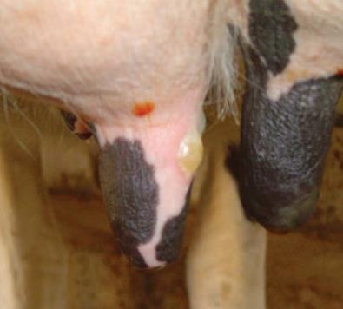
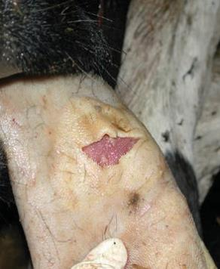
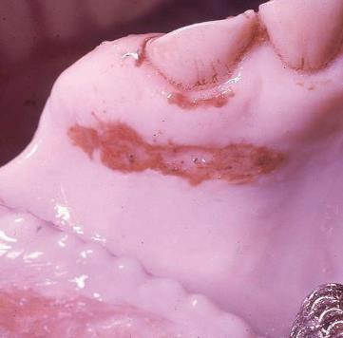
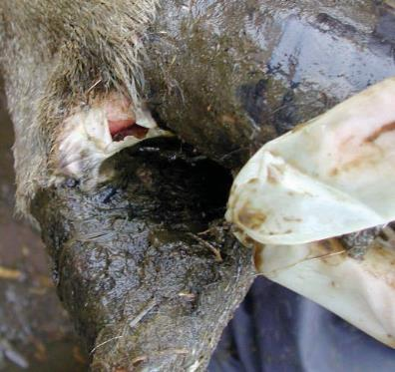
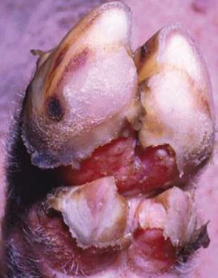
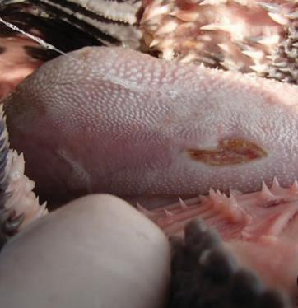

1

1

1

2

3

2

19

1
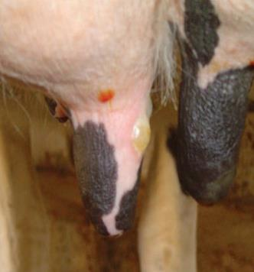
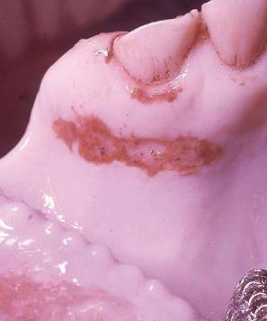

1

2

3

One of the major problems with this exotic disease is lesions can be very similar to these caused by grass seeds or thorns are seen commonly in domestic animals. This condition would be very easy to misdiagnose. With cattle and sheep feet are removed prior to postmortem inspection.

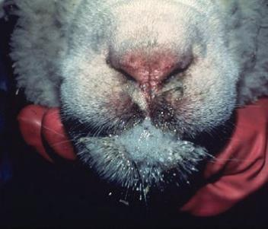
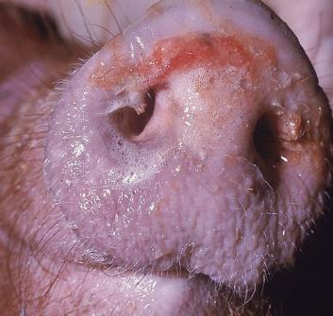
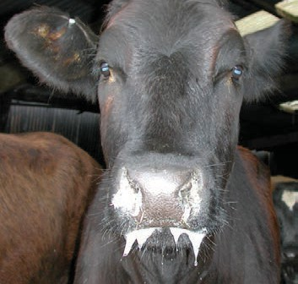
Excessive ropey salivation, mucus, foaming and/or nasal discharge can also be signs of an emergency disease.

3

3

2
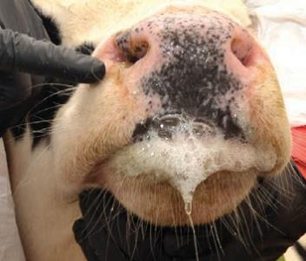

21

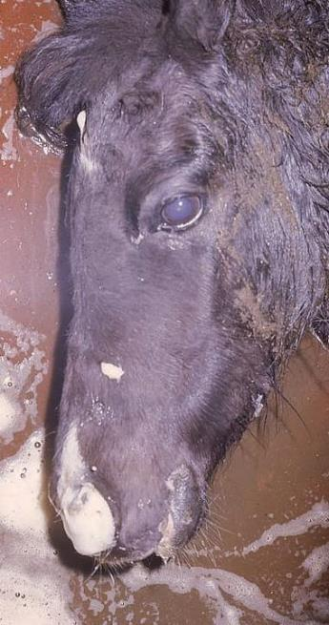

Lameness, stiffness, abnormal posture, trembling and loss of coordination can also be a sign of an emergency disease.
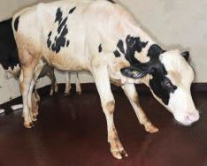
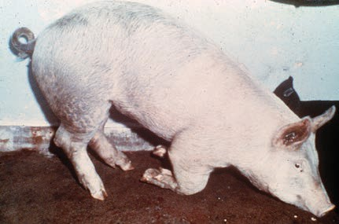
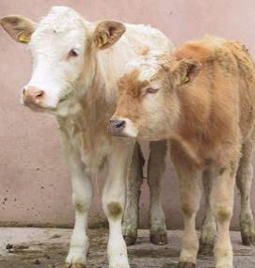

21

4

2
Abnormal hair loss, skin lumps, maggot infested wounds can also be a sign of an emergency disease at ante mortem.
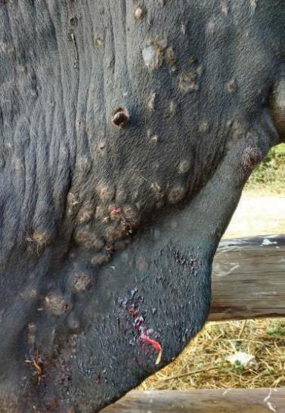

2
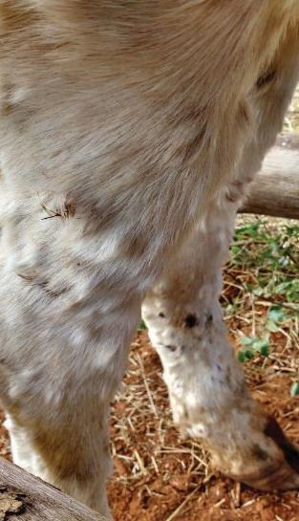
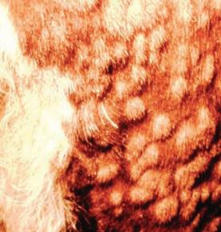
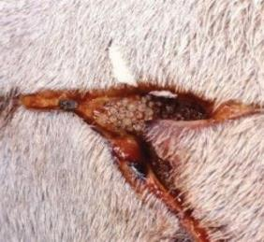

2

5

6

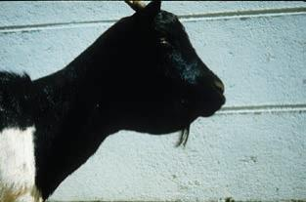
The swelling of lymph glands, lips and tongues can also be signs of possible emergency diseases.

7
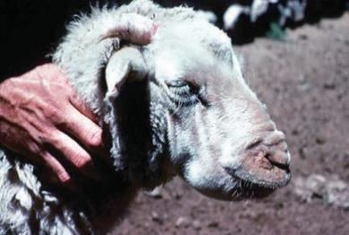
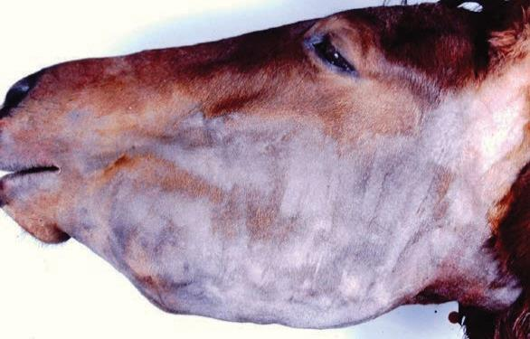
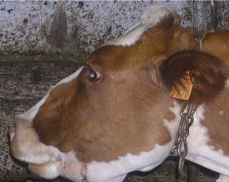
v

7

8

2

Discharge or blood from eyes, nose, anus or diarrhoea with blood

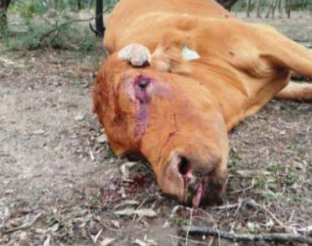
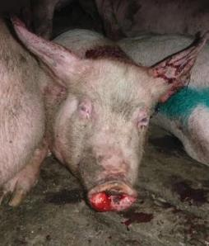
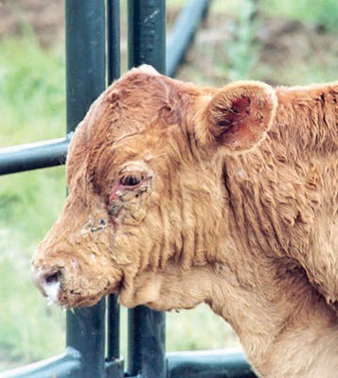
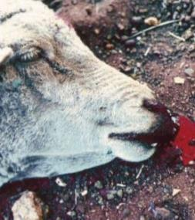
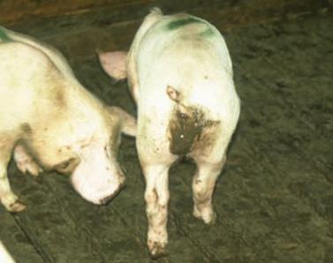
The discharge of fluids or blood from the nose, eyes or anus or bloody diarrhoea can also be signs of an emergency disease. Other signs of an emergency disease include

10

2

9

10

2

sudden deaths, high mortality and morbidity reates and unusual vocalisations.

There are also animal behaviours at ante mortem which can be signs of an emergency disease and these include:
- depression i.e. head down, loss of appetite, isolated from herd
- disorientation, nervousness, aggressive behaviour
- hypersensitivity to sound, touch, light
- reluctance to move
- sensory changes i.e. head tossing, teeth grinding, tongue licking, licking feet, muscle tremors.

What signs should alert inspectors to a possible emergency animal disease at post mortem?
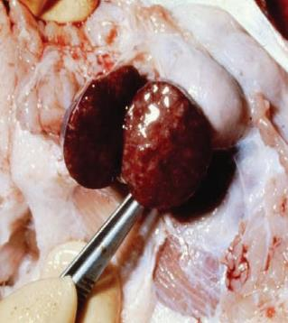
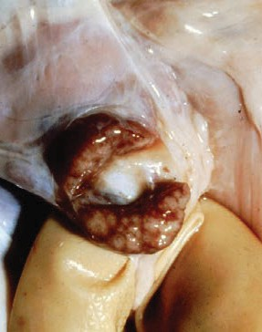
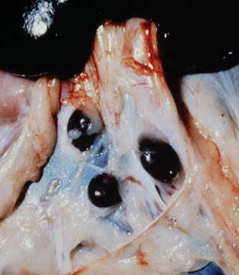
Swelling or congestion of lymph nodes can also be signs of an emergency disease.

11

11

11

Blisters and/or lesions and abnormal structures can be signs of an emergency disease at post mortem. In addition, abnormal size or colour of organs and abnormal smell can also signs of an emergency disease.
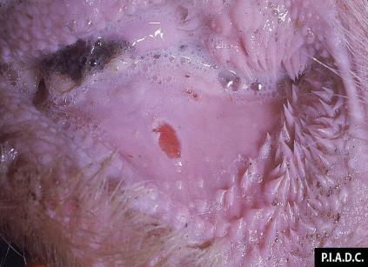
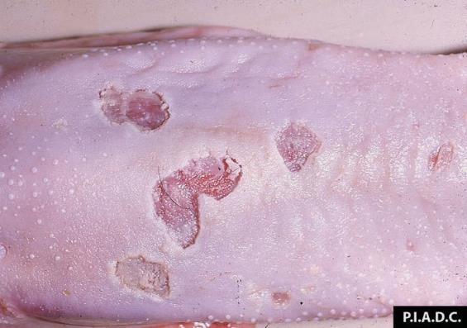
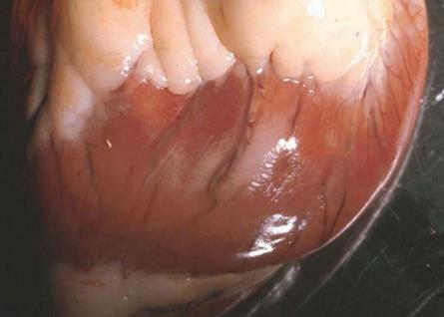
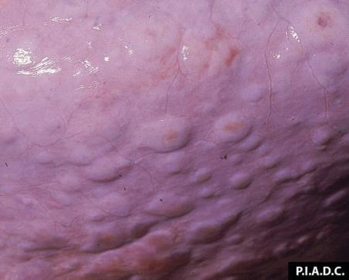
and/or lesions, abnormal structures blisters and/or lesions, abnormal structures blisters and/or lesions, abnormal structures

3

3

19

3
Haemorrhaging, congestion and/or inflammation of internal organs can be a sign of an emergency disease.
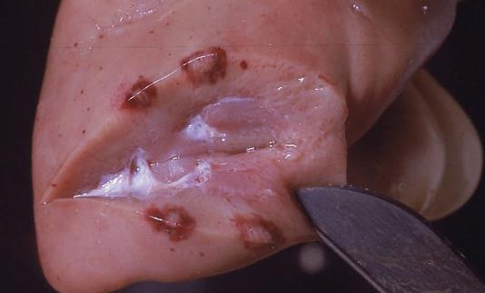

3
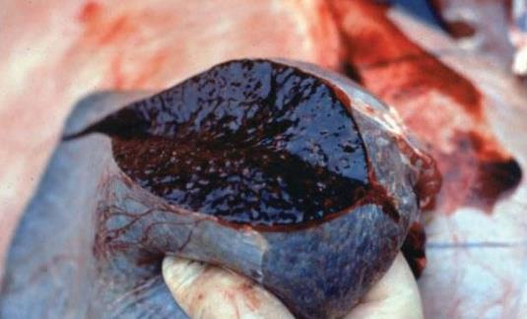
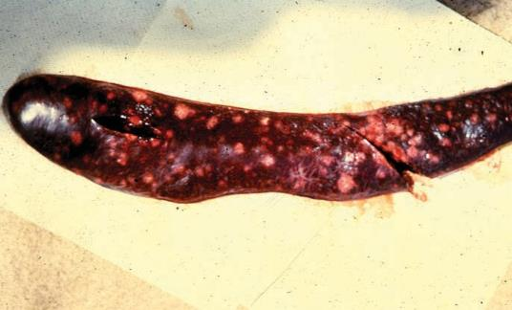
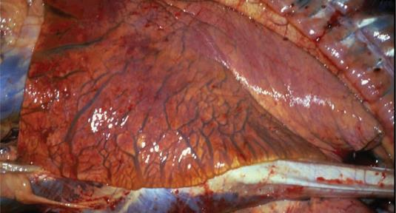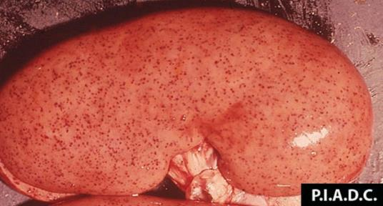

20

3

12

12

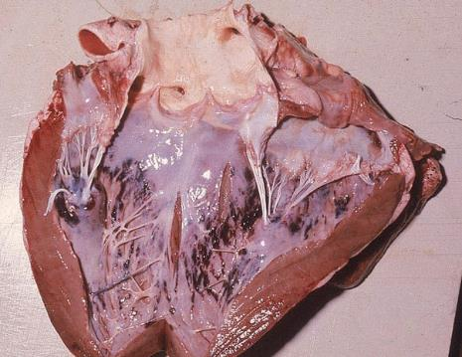

3

Again abnormal mucus and fluid filled structures
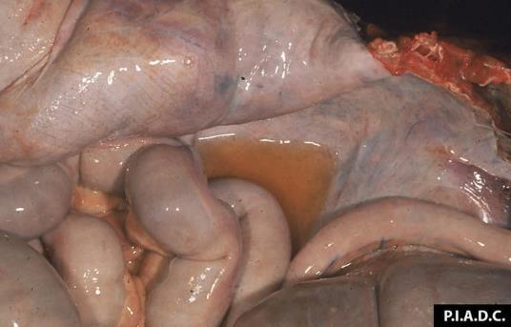

3
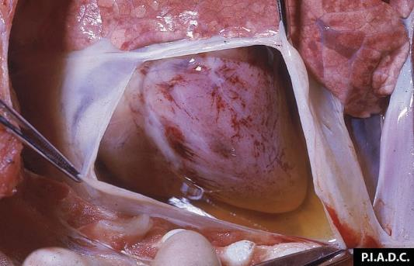

3
What are the specific signs of the emergency diseases as they may be seen at ante-mortem?
Not all emergency diseases will be evident at ante-mortem. However, the majority of signs are at ante-mortem dependant on the length of the infection. The signs at ante-mortem may be one or a combination of the signs listed against each disease below.
Disease | Ante-mortem
African horse sickness | frothy nasal discharge, difficulty breathing, abdominal breathing, coughing, sweating, swelling of the forehead
African swine fever | lying down, reluctant to move, blue-ish blotching skin, diarrhoea, abortion, lameness, ulcers,
Anthrax (major outbreak) | staggering, trembling, collapsing, difficulty breathing, convulsive movements, abortion, dark bloody discharge from the eyes, ears, nose mouth, anus, swelling of neck, thorax, shoulders, lower abdomen, depression, bloody diarrhoea, sudden deaths
Avian influenza | depression, ruffled feathers, weakness, staggering, heads touching the ground, blue-ish, swelling combs and wattles, petechial or ecchymotic haemorrhages at their tips, watery diarrhoea, excessively thirsty, laboured breathing, coughing, sneezing,
Blue tongue | dullness and listlessness, water discharge from nose, difficulty in moving, lips and tongue have a blue-ish colour, swelling of lips and tongue, excessive salivation, swelling in the head, difficulty breathing, bloody diarrhoea, vomiting, reddening and petechial haemorrhages on feet, stand with arch backs
Bovine spongiform encephalopathy | abnormal posture, development of violent behaviour, apprehension, nervousness and frenzy when confronted by doorways, gateways and obstacles, abnormality in posture and gait, hind limbs not moving, swaying of legs, tremors, falling and lying down, sensitivity to sound and touch
Brucellosis (due to Brucella abortus) | abortion, joint enlargement carpal or bursa, lameness and discharge from the nose in horses
Brucellosis (due to Brucella melitensis) | discharge from the vagina, lameness, chronic cough
Classical swine fever | dullness and listlessness, poor co-ordination, difficulty in moving, discharge containing pus from eyes, purplish discolouration of skin around abdomen, ears, legs and snout, dead tissue on tips of ear and tail, diarrhoea, hurdling together, stagger when moved, convulsions and trembling, diarrhoea and vomiting, coughing, gummed eyelids with conjunctivitis, depression, pustulated or encrusted skin lesions,
Contagious bovine pleuropneumonia | depression, dullness and listlessness, poor condition, rapid, shallow breathing and difficulty of breathing in later stages, arched back, coughs when moved, grunts when breathing out, lameness in calves
Encephalitides (tick-bourne) | dullness, lower head, uncoordinated movement, hopping gait, muscle tremors of lips and neck, champing of the jaw, tongue stuck out, excess salivation
Foot-and-mouth disease | vesicles to ulcers in the mouth, teats udders and between the hooves, lameness and reluctant to move, lying down, saliva running from mouth, depression, dull and listless, sloughing of the hoof and abortion in pigs.
Glanders | coughing, thick grey-yellow, blood-flecked discharge from the nose
Hendra virus | clear to frothy discharge from the nose, difficulty breathing, wobbly gait, lose of vision, aimless walking, head tilt, circling, muscle twitching, lying down, unable to stand or walk, collapse, depression, swelling of the face, muscle trembling
Japanese encephalitis | abortion, fever, blindness, collapse, sluggish movement, lethargy, difficulty swallowing, jaundice, petechial haemorrhages in mucous membranes, incoordination, staggering, falling, wandering violent, demented behaviour, profuse sweating muscle trembling
Lumpy skin disease | reluctance to move, salivation, discharge from the eyes and nose, firm, round, raised, flat-topped intradermal skin lesions with hair standing erect over the lump, lesions on muzzle or mucous membrane yellow-grey and soft surrounded by inflammation, can progress to ulcers. Swelling of the superficial lymph nodes, difficulty breathing, swelling of the legs
Menangle virus (porcine paramyxovirus) | head and spine deformities
Newcastle disease | depression, increased breathing, lying on the ground, bright green diarrhoea, swelling of the head, blue-ish colouring of the comb, coughing, gasping, difficulty breathing, head tremors, wing and leg paralysis
Nipah virus | coughing, discharge for the nose, open mouth breathing, rapid and laboured breathing, trembling, twitching, muscle spasms, weakness in the hind limbs, lameness, uncoordinated movement, head pressing, seizures, abortion
Peste des petits ruminants | depression, discharge from the nose that can crust blocking the nostrils, difficulty breathing, conjunctivitis with discharge from the eyes, diarrhoea, emaciation
Rabies | horses: marked excitement and aggressiveness alternating with periods of relative calm, signs of excitement include restless, stare, paw, moving ears, drawing lips back and forth and excessive salivation, sexual excitement, teeth grinding, whinny, signs of colic, lashing out, biting and charging other animals or moving objects, bite or rub at site of exposure causing self-mutilation, paralysis, falling and leg thrashing, wandering and staggering.  cattle: depression, paralysis of throat muscles, teeth grinding, excess salivation, bellow, sexual excitement, attack other animals or objects charging and butting, knuckle over, stumble and fall paralysis.  sheep: excitement with restless movement, salivate and teeth grinding, lip twitching, oscillation of the tongue, wool pulling, aggressive butting, sexual excitement, bleats, depression, weakness, paralysis and lying down.  pigs: trembling, standing in a darkened corner, rush out and bite, rub and gnaw at the bite site, abnormal deep grunting, alternate activity with lying down, dullness, incoordination and paralysis
Rift Valley fever | dullness and listlessness, abortion, bloody diarrhoea, saliva drooling from the mouth of cattle, blood and pus discharge from the nose of sheep, collapsing, unsteady gait, vomiting, hunching from abdominal pain
Rinderpest | depression, dullness and listlessness, discharge from nose and eyes, saliva dripping from mouth, restlessness, rapid and swallow laboured breathing, grunting noise on expiration, enlarged lymph nodes, profuse dark, mucus, blood diarrhoea
Scrapie | compulsive nibbling, rubbing against objects skin damage and incoordination of hind legs and ataxia progress to depression, lying down, stand apart, hyper excitable, head carried high, stare, run in high-stepping gait, fine tremors and convulsion, unable to stand
Screw worm fly | fly eggs in wounds or navels of new born animals, smell of dead tissue, reddish brown fluid around the wound.
Sheep and goat pox | excess salivation, discharge from eyes and nose, arch back, reluctant to move, skin lesions (reddening, vesicle, encrust, scab) most obvious where the wool or hair is shortest e.g. head, neck, ears, groin and on mucous membranes, in the mouth, nostrils, may have breathing difficulty
Swine vesicular disease | vesicles on the feet, lower limbs and abdomen, occasionally on the snout, lameness.
Trichinellosis | none
Vesicular exanthema | depression, by vesicles/ulcers on the snout, in the mouth and on the feet, oedematous swelling on the legs and joints, lameness, diarrhoea, abortion
Vesicular stomatitis | dullness and listlessness, saliva running from mouth, vesicles/ulcers in mouth, tongue, nostrils, feet and teats of dairy cattle, lameness, loss of condition
Western, Eastern and Venezuelan equine encephalomyelitis | hypersensitivity to sound and touch, involuntary muscle movement including tremors of the shoulder and facial muscles, walk aimlessly in circles or into object, periods of excitement followed by depression, paralysis, diarhoea
What are the signs of the emergency diseases as they may be seen at post-mortem?
At post-mortem the most common sign may be fever, however other clinical signs can be present. The signs at post-mortem may be one or a combination of the signs listed against each disease below.
Disease | Post-mortem
African horse sickness | fever, oedema of the lungs, lips, cheeks, tongue, neck, brisket, abdomen; palpation of the viscera lack elasticity, frothy fluid, clear yellow fluid from the thoracic cavity, dark liver, gelatinous material in the intermuscular tissue, pericardium filled with yellow to red-brown fluid, petechial haemorrhages in the abdominal cavity
African swine fever | fever, petechial and ecchymosis haemorrhage of internal organs, swollen reddened haemorrhagic lymph nodes, engorged spleen, oedematous lungs with fluid in the pleura, pericardium and peritoneal cavity, fibrinous pericarditis, pleurisy, small hard nodular white masses in the lungs, ulcers, arthritis
Anthrax (major outbreak) | fever, dark thick blood, haemorrhages on the surfaces of organs, oedematous organs, ulcers on the gastrointestinal tract, enlarged, dark red or black soft, semifluid spleen, liver, kidney and lymph nodes, congested and enlarged, in pigs salmon pink to red enlarged lymph nodes and tonsil, ulcers on the tonsils, area around lymph nodes is gelatinous and oedematous
Avian influenza | fever, haemorrhages on the skin, dehydration, petechial and ecchymotic haemorrhages throughout the body, subcutaneous oedema, yellow/grey necrotic lesions on the spleen, liver, kidneys and lungs, exudate in the air sacs, enlarged and haemorrhagic spleen
Blue tongue | fever, inflammation of the mucous membranes, widespread haemorrhages and oedema, necrotic/haemorrhagic lesions on the gums, cheeks and tongue, congestion, catarrhal inflammation and petechial haemorrhages in small and large intestines, hyperaemia, oedema and haemorrhages in body tissues, enlarged and haemorrhagic lymph nodes and spleen, laminitis, catarrhal inflammation of the upper respiratory tract and oedema of the lungs
Bovine spongiform encephalopathy | none
Brucellosis (due to Brucella abortus) | uterine lesions including endometritis, retained placenta with grey cotyledons, metritis, orchitis, epididymitis, lymphadenitis
Brucellosis (due to Brucella melitensis) | mastitis, orchitis, cotyledons of retained placenta may be grey
Classical swine fever | pneumonia and fever, petechial haemorrhages in kidney, bladder, larynx, and trachea, petechial or ecchymotic haemorrhages in the small intestines, haemorrhagic or necrotic gastroenteritis, congested and enlarged spleen, necrotic or ulcerated tonsils, bronchopneumonia and pleurisy, swollen, congested and haemorrhagic lymph nodes,
Contagious bovine pleuropneumonia | fever, fibrinous pneumonia, pleural exudate, 'marbled' consolidated lungs covered in yellow fibrin, pleural adhesions, lesions of necrotic tissue in the lungs, enlarged, oedematous, necrotic lymph nodes
Encephalitides (tick-bourne) | none
Foot-and-mouth disease | fever and vesicles in the mouth and nose and on the feet and teats, udder, rumen, grey necrotic lesion on the heart 'tiger heart' and skeletal muscle, mastitis, panting
Glanders | fever, deep ulcers in the nasal cavity, pharynx, larynx, trachea, nodules, abscesses and ulcers on the skin, ulcers leave white scars, oedema in the larynx, swollen, ruptured submaxillary lymph nodes, oedema and swelling of legs and joints, lesions in the lungs, catarrhal bronchopneumonia, enlargement of bronchial lymph nodes, nodules in the liver, spleen, kidney
Hendra virus | fever, pulmonary oedema and congestion enlarged lymph nodes, froth with blood in airways, increased pleural and pericardial fluid, haemorrhages in organs and slight jaundice
Japanese encephalitis | none
Lumpy skin disease | fever, nodular grey-pink masses with caseous necrotic cores with red serous fluid through the nasopharynx, trachea, bronchi, lungs, rumen, abomasum, renal cortex, testicles and uterus
Menangle virus (porcine paramyxovirus) | incomplete development of the lungs
Newcastle disease | haemorrhages and necrosis in the proventriculus, gizzard and small intestinal wall, petechial haemorrhages in the internal organs, laryngitis, tracheitis with congestion, catarrhal exudate and haemorrhages, air sacs thickened and cloudy, thrombosis, oedema and haemorrhages in all organs
Nipah virus | consolidation, petechial or ecchymotic haemorrhage and emphysema of lungs, containing frothy, blood stained fluid, congested kidneys
Peste des petits ruminants | fever, enteritis, mouth lesions, small necrotic/erosion lesions on the mucosa of the lower gums, dental pad, hard palate, cheeks and tongue, abomasum and large intestine, bronchopneumonia
Rabies | none
Rift Valley fever | fever, petechial or ecchymotic haemorrhage on mucous membranes and internal organs, jaundice, pale grey to yellow/brown liver swollen and capsule tense however on incision tissue falls apart and congested with haemorrhages, grey-white lesions , oedematous and petechial/ecchymotic haemorrhages in gall bladder, gastroenteritis catarrhal to haemorrhagic and necrotic, pulmonary oedema
Rinderpest | fever, nasal and ocular discharges, raised necrotic pinpoints to enlarged lesions on the mouth, nostrils and urogenital tract, mucosal erosion of the mouth pharynx and oesophagus, abomasal mucosa - congested, oedematous and eroded, bleeding ulcers, severe congestion, ulceration and haemorrhages in the large intestine 'tiger striped' appearance, emphysemic lungs, lymph nodes and tonsils swollen oedematous and congested
Scrapie | none
Screw worm fly | myiasis - fly eggs in wounds or navels of new born animals, smell of dead tissue, reddish brown fluid around the wound
Sheep and goat pox | fever, nasal and ocular discharge, skin lesions (reddening, vesicle, encrust, scab) and lesions on mucous membranes in the mouth, nostrils, trachea and gastrointestinal tract maybe septicaemia, haemorrhage and mucous membrane ulceration, small grey/white nodules in the lungs, omentum and kidneys
Swine vesicular disease | fever and lameness caused by vesicles on the feet, lower limbs and abdomen, occasionally on the snout
Trichinellosis | spindle shaped cysts in voluntary muscle such as the diaphragm, old lesions calcify
Vesicular exanthema | fever, vesicles/ulcers on the snout, in the mouth and on the feet, oedematous swelling on the legs and joints
Vesicular stomatitis | fever, vesicles/ulcers in mouth, tongue, nostrils, feet and teats of dairy cattle, loss of condition, mastitis
Western, Eastern and Venezuelan equine encephalomyelitis | fever

What are the signs of some of the major EADS?

Foot and mouth disease FMD
Foot-and-mouth disease or hoof-and-mouth disease is an infectious and sometimes fatal viral disease that affects cloven-hoofed animals, including domestic and wild bovids. The virus causes a high fever lasting two to six days, followed by blisters inside the mouth and on the feet that may rupture and cause lameness. It’s a zoonosis so is transmissible to man.
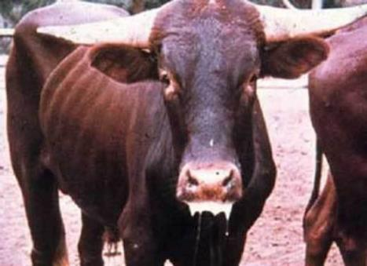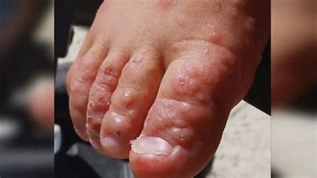
Ropey salivation and poor condition at ante mortem

FMD needs to be confirmed in a laboratory as visually it is exactly the same as Vesicular Stomatitis which is simply inflamed vesicles in the mouth (stoma). If a meat
Inspector suspects a FMD case then their best course of action is to alert the OPV or State DPI. A veterinary officer will make then make a disposition and if necessary take samples for sampling. If a case is suspected then as a minimum the carcase and all its parts will be retained.

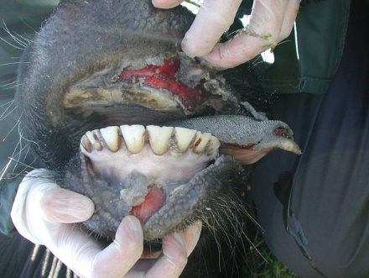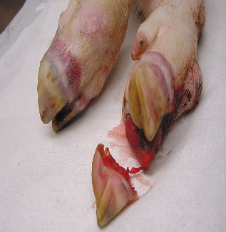
Vesicles in bovine mouth vesicles on the corneal band in pigs
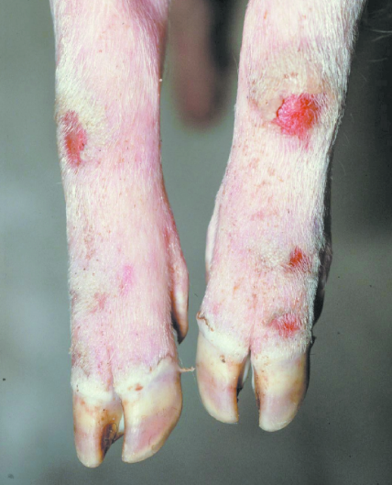
Porcine leg lesions

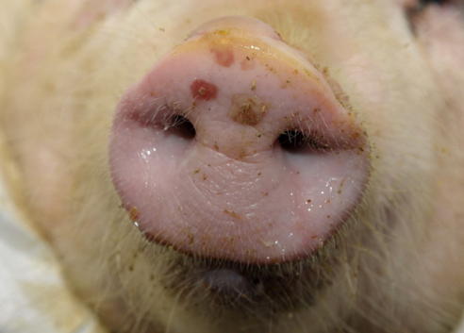

Porcine snout lesions
In this image it is a beast with Vesicular stomatitis note the ropy saliva and vesicles in the mouth identical to FMD.
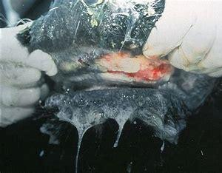

Bovine spongiform encephalopathy (BSE or mad cow disease)
BSE (bovine spongiform encephalopathy) is a progressive neurological disorder that affects the central nervous system of cattle. The disease results from infection by an unusual transmissible agent called a prion. Prion refers to abnormal pathogenic agents that are transmissible and are able to induce abnormalities in normal cellular proteins in the brain of cattle.
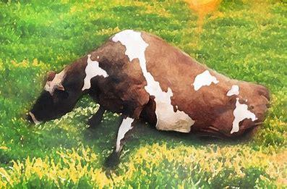
At ante mortem the animal has no muscle control and is unable to stand. It’s a fatal disease of cattle that affects the nervous system and resembles Scrapie (scabies) in sheep.
Variant Creutzfeldt-Jakob disease is a disease that emerged in the UK in the 1990s. Variant CJD is linked to the consumption of meat products from cattle infected with bovine spongiform encephalopathy (BSE, or "mad cow disease"). No cases of variant CJD have been identified in Australia to date. Australian cattle remain free of BSE.

Despite Australia being BSE free some corporate customers regard the brain and the spinal cord of cattle as “specified risk” material and require it to be removed from carcases.

Tuberculosis (TB)
Tuberculosis is a chronic contagious (physical contact) and Infectious (air born breathed in) disease which in the early stages is characterized the formation by the formation of small nonvascular (no vessels that carry blood) nodules or tubercules which turn a cheesy colour. This pus has an appearance like Actinobasilosis, except the pus is smoother without the rosettes of club like structures.

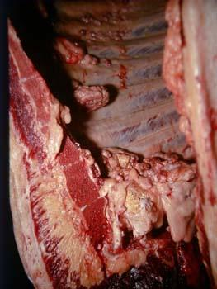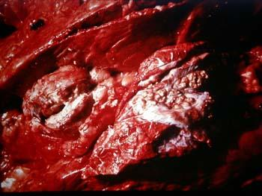
Grapes TB in the mediastinal (lung) lymph node
Grapes is a term used to describe how TB lesions hang from the ribs like small bunches of grapes.

African swine fever
African swine fever virus (ASFV) is a virus in the Asfarviridae family. The virus causes a haemorrhagic fever with high mortality rates in domestic pigs; some isolates can cause death of animals as quickly as a week after infection. ASF cases have been detected as close to Australia as Papua New Guinea.
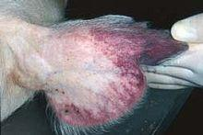
Typical ear lesion

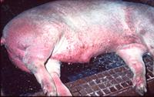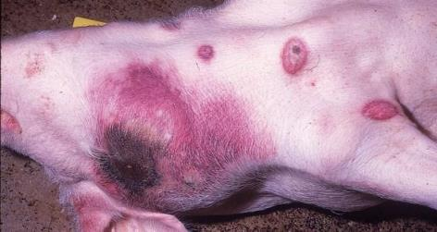
Typical African swine fever lesions seen at ante mortem.

Anthrax.
Anthrax is caused by exposure to the spores of the bacteria Bacillus anthracis a spore forming bacteria that can survive in soil for sixty years. When the environmental conditions are right the spore come to the surface and grazing animals become infected. The spore become entrenched in the host body and produce lethal poisons. Death is usually sudden with no overt signs of ill health.

It is primarily a disease of grazing animals such as cattle, sheep, goats, and horses. There have been outbreaks in Australia but usually limited to areas of Victoria and New South Wales.

Anthrax is considered an emergency and a notifiable disease in all states and it is a zoonosis.

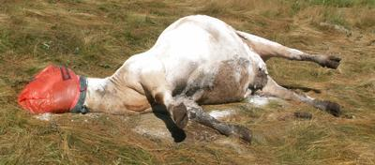
Note the head has been sealed to avoid leakage of blood containing bacillus anthracis

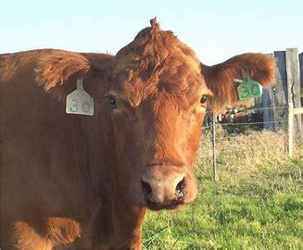
Note thick black blood discharge from nose

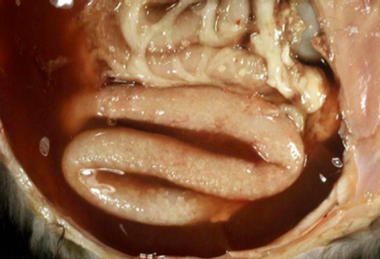
Bloody oedema in abdominal cavity.

At ante mortem signs in acute cases are:
- high temperature
- abdominal pain
- blood-stained diarrhea.
Pigs show acute pharyngitis swelling of the throat and difficulty breathing.
In subacute cases the signs are:
- subcutaneous swellings on the neck, breast and abdomen
- flanks hot to touch and pit on pressure.

Japanese encephalitis

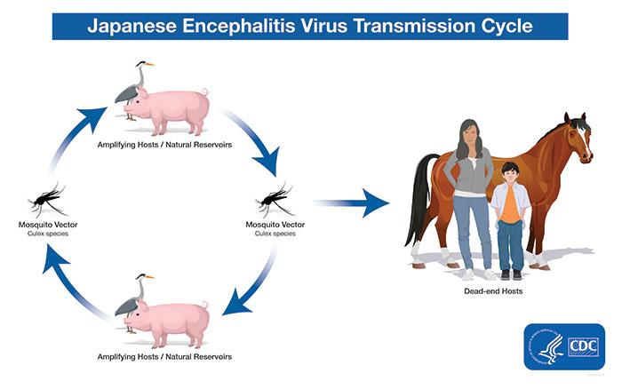

Japanese encephalitis is caused by the Japanese encephalitis virus (JEV). It is spread through bites from mosquitos. JEV is endemic to parts of Asia and the Torres Strait region of Australia. JEV has now also been detected in humans, animals and mosquitos in mainland Australia as far south as Victoria.

Infection in humans is most commonly asymptomatic, but on rare occasions it can result in severe disease and even death.

Animals can be infected with JEV but they cannot transmit the virus to humans. It cannot be transmitted from human to human, or by eating meat from an infected animal.

In pigs the virus affects reproductive performance. Adult sows do not appear to be ill but if infected they may abort or give birth to mummified, stillborn or weak piglets with neurological signs. Boars may experience infertility and swollen testicles.

Scrapie
Scrapie is a fatal, degenerative disease affecting the nervous systems of sheep and goats. It is one of several transmissible spongiform encephalopathies (TSEs), and as such it is thought to be caused by a prion. Scrapie has been known since at least 1732 and does not appear to be transmissible to humans and is not endemic in Australia.
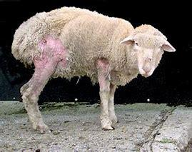

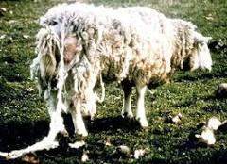

The name scrapie is derived from the sign that affected animals will compulsively scrape off their fleeces against rocks, trees or fences. The disease apparently causes an itching sensation in the animals. Other clinical signs include excessive lip smacking, altered gaits and convulsive collapse.

Transmissible gastroenteritis
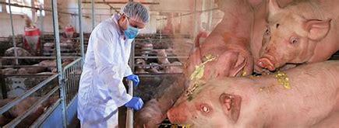

Transmissible gastroenteritis (TGE) is an acute, rapidly spreading, viral disease od swine of all ages, characterised by diarrhea, vomiting and death in young pigs, particularly those less than 10 days old. It is relatively common in pig-producing countries, but has not been diagnosed in Australia or New Zealand.

Lumpy skin disease
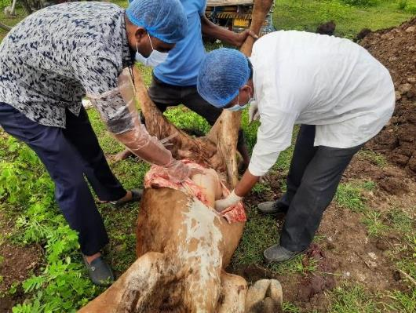

Lumpy skin disease (LSD) is an infectious disease affecting cattle. It is caused by a virus belonging to the family Poxviridae specifically known as the lumpy skin disease virus. The disease is more likely to be detected ante mortem.

Ante mortem symptoms are:
- fever often exceeding 41deg C which persists for a week
- multiple skin nodules measuring 2-5 centimeters in diameter appear on the skin and mucous membranes
- nodules can occur on the head, neck, udder, scrotum, vulva and peritoneum
- Oedematose swelling in the limbs leading to lameness.
Post mortem symptoms include liver abscess.
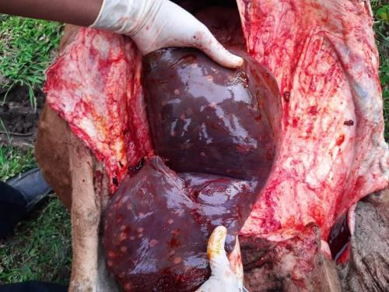

What are the signs of the more important non-emergency notifiable diseases.
Depending on the state there are a range of notifiable disease that an inspector may see at ante or post mortem inspection.

Contagious pustular dermatitis AKA ORF or Scabby Mouth
This is a highly infectious disease of sheep. It is a zoonosis and can be transmitted to humans. The main cause is grazing on rough pasture skin gets scratched virus enters through skin. It is a Notifiable Disease in all states.

At ante mortem lesions are most commonly found on the skin of the muzzle and the skin proper on the legs. Lesions can be found on the udder of lactating ewes infected by suckling lambs. Lesions in the early stages of the infection can look like FMD lesions.

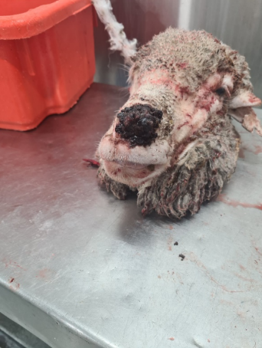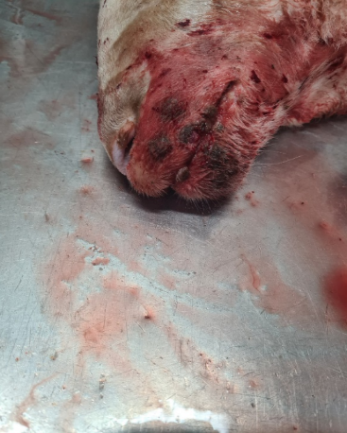
Later stage crusty scab formation Early stage FMD like lesions on face

Information about suspect animals being put up for slaughter should be conveyed to the slaughter floor supervisor so he/she can issue gloves to any worker that may come in contact with the head or leg lesions as it is transmissible to humans.

Cysticercus bovis
Cysticercus bovis (comonly known as Beef Measles) causes small cysts in the muscles of cattle and their presence can lead to all or part of the carcass being condemned.

Cattle are infected with Cysticercus bovis from ingesting foodstuffs contaminated with tape worms eggs passed from humans. The worm taenia saginata or beef tapeworm lives in the human gut and eggs pass out with the faeces and get onto grass. The most common way in which pasture gets contaminated is when sewer water is used to irrigate pasture or fodder crops. Water from domestic septic tank overflows can also contaminate pasture. Cysticercus bovis is a notifiable disease in all states.

In cattle, C. bovis infection appears as small, whitish cysts filled with fluid that contain an immature worm. They are the size of a pea and infected beef can have dozens of such cysts. They are most commonly detected in the heart and head meat.

In export works an affected carcase must be retained for boning under OPV supervision. The relevant meat cartons are identified and retained using ECA4 tags then frozen for 20 days at -12 deg C if the whole carcase is frozen it can be released after 10 days at -12 deg C.

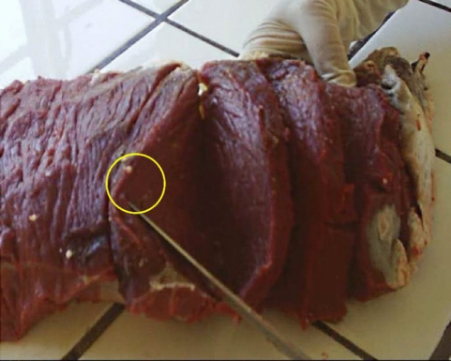
White lesions in cardiac muscle

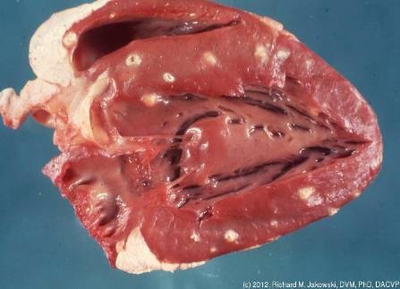
Old white lesions in muscle

What actions are required of inspection staff in the event of a case of a suspected emergency animal disease?
The first step when an emergency animal disease is suspected is to immediately notify
- the on plant veterinary officer (OPV) in an export works
- the state DPI via the emergency disease hot line in a domestic works
The District Veterinary Officer, Regional Veterinary Officer or Chief Veterinary Officer in that state will take control of the situation. The national hotline number for emergency animal diseases is 1800 675 888.
Inspectors must talk and work with the company to manage the situation. There should be an Emergency Animal Disease Preparedness (EADP) plan on every abattoir in Australia. This plan should be based on the AUSVETPLAN Enterprise Manual - Meat-processing.
AUSVETPLAN is the master plan for dealing with emergency disease. It has been designed by experts from state and commonwealth departments responsible for animal health in Australia.
The EADP plan on the abattoir should contain the following:
- action measures detailed as job cards for all responsible key personnel
- a map showing perimeter fences, drainage, yards, adjoining properties, suitable areas for burial and ponds and waste water disposal
- an up to date list of notifiable diseases
- phone numbers both home and at work of key personnel e.g. on-plant vet, senior meat safety inspector, plant manager, engineer, stock person
- location and condition of a supply of soda ash and decontamination equipment
- instructions on how disinfectants and chemicals on site may be used for disinfecting people, equipment and vehicles
- where there are reasonable grounds to suspect an emergency disease has been found, the qualified person, i.e. a veterinarian or meat safety inspector, must implement the control procedures detailed in the plan until the State or Territory animal health authority advises otherwise, or takes control of the situation.
Control measures
Once the authority has been notified they will explain the action to be taken. The following is the standard procedure to gain control of a suspected emergency disease at an abattoir.
Slaughtering/dressing
All slaughtering and dressing procedures may cease depending on the advice from the State veterinarian. It is sometimes preferable to keep slaughtering to keep people occupied otherwise they will want to go home and may spread the disease. All carcases and parts that might have been affected or contaminated must be secured and isolated in secure storage areas and kept separate from all unaffected carcases and parts. It should be noted that until the Chief Veterinary Officer of the State or Territory has confirmed an Emergency Animal Disease Response, financial support and compensation is not available so inspectors must ensure they have company support for their actions.
There may be times when the relevant authority may not be available or able to reach the establishment within two hours. If this is the case, in consultation with the authority, the veterinarian or inspector in charge can permit the dressing of unaffected carcases, provided their identity can be maintained and all parts of the carcases can be isolated in a secure area. The veterinarian or inspector in charge may also allow the slaughtering of carcases that might have been affected, provided the carcases and parts can be also held in a secure location and readily identified.

Access and movement
The plant manager must control the access to and movement within the abattoir. This includes preventing the movement of animals, vehicles, people, working animals and meat products onto or off the abattoir. Animals must be prevented from being moved around the abattoir. Access to all affected animals must also be prevented and strictly controlled. The company can call the police for assistance with these movement restrictions.
Any animal, meat product, vehicle or person that may have left the abattoir since the suspected animals came into the abattoir must be identified and their location known.
Inspection
Carcases that have been slaughtered, but have not had a post-mortem inspection, must be inspected immediately. An ante-mortem inspection must also be carried out on all other animals awaiting slaughter on the abattoir.
Isolation and trace back
The veterinarian or inspector must then identify all affected animals, carcases and carcase parts. These must be isolated and secured to prevent them from being interfered with. The origin of the animals must then be determined.
All animals that are suspected of having an exotic or notifiable disease, or any that may have been in contact with these animals, must be isolated and secured.
Decontamination
The identification of any personnel who may have been exposed to the affected animal is essential. These personnel must be kept within their workplace so that their decontamination can take place. All possibly contaminated equipment must be identified and disinfected.
Water usage
The plant manager must minimise and control the water use in the abattoir. Wastewater from all areas in the abattoir must be contained.
All these control measures must be in place until the State or Territory authority takes control of the suspected situation or advises that control measures may cease.
These are only guidelines and will vary according to the disease. The Chief Veterinary Officer in each State or Territory has the final say on what and how control measures are to be implemented.
How are emergency animal diseases confirmed?
The state authority will provide specific guidance dependant on the disease suspected. In the AUSVETPLAN Enterprise Manual – Meat Processing Appendix 2 it states that an inspector or veterinarian is to:
Carry out a thorough clinical examination of the suspect animal(s) in the suspect pen crush. In the case of a slaughtered animal, take all practical steps to recover any identifying tags, skin, hide or other parts that have been removed and examine all available organs and tissues. Record details of lesions. Keep lesioned tissues for examination and possible sampling by state/territory authorities. Records, especially photographic records, should be made where possible; digital images can be readily shared with relevant experts.
Precautionary PPE should be used and/or this discussed with the state authorities if the disease is zoonotic such as anthrax, and Hendra virus.
The AUSVETPLAN policy brief stated that for diagnosis and therefore confirmation of the disease that samples from the first cases:
‘should be submitted to the state laboratory for exclusion testing and to AAHL for confirmation. Appropriate samples should include nasal, oral or respiratory swabs from active clinical cases (preferably within 48 hours of the development of clinical signs) and serum samples from recovered cases.’
Reporting suspected emergency diseases
Who has responsibility for reporting emergency disease suspects?
As explained above and in the Enterprise Manual – Meat Processing Appendix 2,
‘Any person suspecting an Emergency Animal Disease, either on the slaughter floor or in the yards, must immediately notify the plant veterinarian or, in the absence of that officer, the senior meat inspector. In abattoirs operating under a quality assurance arrangement with no government officers on site, the responsible company employee must be notified; that employee must immediately notify the state authority.
The veterinarian or the most senior meat inspector on site will be responsible for advice to the state or territory veterinary authorities, and will also facilitate communications with management and on-site personnel. State and territory staff are responsible for quarantine, tracing procedures and overall disease control. ‘
This means that everyone is responsible for reporting a suspected emergency disease.
What are a meat processing enterprise’s responsibilities after reporting a suspected emergency disease outbreak?
In the AUSVETPLAN Enterprise Manual – Meat Processing there are lists of Procedures for key roles, including plant management and stockyard managers. These should be followed and everyone involved should work together. The extent and possible spread of the disease and therefore its impact on Australia as a whole can depend on the initial response and teamwork used. The key tasks from the Enterprise Manual – Meat Processing follow:
Plant manager action list
- Refer to the abattoir code to check on responsibilities. In consultation with the plant veterinarian or other appropriate government official, prioritise actions after a risk assessment.
- Organise a gatekeeper to maintain a record (names, addresses and telephone numbers) of all visits and departures of personnel as directed by the veterinary authorities. A record is also to be maintained of whether visitors or personnel own or are in contact with susceptible animals outside the abattoir. Vehicles leaving the premises, including those owned by employees, should be cleaned and disinfected, paying particular attention to the tyres.
- Where necessary, facilitate the cessation of any further slaughtering, and of processing other than that necessary for the inspection of carcases of animals that have already been slaughtered.
- Ensure that senior staff help government officials to maintain control over all carcases, by-products, offal, bulk trimmings, blood, hides and any other possibly infected material by preventing access to those products by unauthorised personnel.
- Keep the employees advised and occupied to lessen their inclination to leave without clearance (videos could be used). Liaison with unions, workers associations and visitors is recommended.
Stockyards manager action list
- Under the direction of the inspection staff, isolate all animals on the premises that are suspected to be infected or that may have had contact with suspect animals.
- Liaise with the chief engineer to ensure adequate disposal of all wastewater. All stock should be denied access to such water, and it should not be used for irrigation.
- Ensure that all dogs and working horses in the stockyards area are properly restrained.
- Brief stock-truck drivers on cleaning and disinfection and standstill requirements, after being given this information by the veterinary officer.
- Ensure that good animal welfare standards are maintained, in consultation with the plant veterinarian or inspector.
When a disease is confirmed the following tasks are required:
Plant manager action list
- Stop all movement into, out of and within the works (refer to the quarantine notice).
- Discuss arrangements for cremation, burial or treatment by rendering with the chief engineer and IPSS. Ensure that full safety precautions are taken if stock are shot in the yards rather than the knocking box.
- Arrange cleaning of the killing floor, all contaminated storage areas, yards and change rooms as appropriate. This will be followed by planned, detailed disinfection under the instructions of the IPSS.
- Facilitate trace-forward by the authorities of all vehicles, products and people that have left the premises since the affected animal(s) entered the premises.
- Make provisions to provide a full list of stock (as well as names and addresses of owners and transport) arriving at the works, for a period going as far back as the plant normally holds pens of livestock, and for a list to be compiled of all products held in storage, their types and the amount of processing to which they have been subjected.
- Make arrangements for all workers who are likely to have had contact with suspect animals to go to the amenities, leave their boots inside the door, shower, put on a complete change of clothing and go to the canteen to await an explanatory meeting.
- Organise for all suspect contaminated clothing to be laundered on the premises, or held in secure plastic bags until appropriate cleaning under supervision can be carried out.
- Instruct senior staff to supervise the cleaning and disinfection of all equipment identified as potentially contaminated.
- If necessary, organise for footbaths containing appropriate disinfectant at the prescribed concentration to be provided at strategic points (particularly exit/entry to stockyards) for use by all staff. Brief section managers to ensure that footbaths are used and replenished regularly.
- Place a standstill order on all vehicles on the abattoir grounds that were used in the transport of livestock, carcases or parts of carcases. Facilitate thorough cleaning and disinfection of all transport vehicles.
- Intensify the rodent and feral animal control program.
Activity five: Enterprise’s EAD Plan
Ask the trainee to obtain a copy of the enterprise’s EAD plan and compare the lists of responsibilities to the requirements above.

What is the role of AUSVET Plan in controlling emergency diseases?
The AUSVETPLAN is managed by Animal Health Australia and their website and documents provide helpful information and guidance on what the AUSVETPLAN is, why it has come to being and how it works.
What is the AUSVETPLAN?
The Australian Veterinary Emergency Plan (AUSVETPLAN) is a coordinated national response plan for the management and wherever possible, eradication of exotic disease incursions and outbreaks of certain emerging or endemic animal diseases. The term ‘emergency animal disease’ (EAD) is used in this manual to collectively describe all these disease categories.
The purpose of AUSVETPLAN is to ensure coherent operations and procedures among national, state and territory animal health authorities, and emergency management organisations in the management of an EAD incident by:
  - providing policy and guidelines for the consistent management of an EAD incident by appropriately trained personnel;
  - improving the technical validity of strategies to combat disease emergencies and improving deficiencies in technical knowledge;
  - assisting in identifying research priorities;
  - providing a focus for training; and
  - providing guidelines for the development of standard operating procedures.
Why it has come to being?
Effective responses to animal disease emergencies require planning at national, state/territory and district levels, as well as the involvement of animal health authorities, livestock industries and emergency management organisations.
The availability of agreed AUSVETPLAN Disease strategies ensures that informed decisions about the policies and procedures needed to manage an EAD incident in Australia are immediately at hand and there is no time lost in mounting the response. For this to occur, as many policy principles as possible should be agreed in ‘peacetime’.
How does it work?
The Emergency Animal Disease Response Agreement (EADRA) is a contractual arrangement that brings together the Commonwealth, state and territory governments and livestock industry groups to collectively and significantly increase Australia’s capacity to prepare for, and respond to, emergency animal disease (EAD) incursions.
The EADRA provides certainty of funding for the initial response to an EAD incursion or outbreak through a partnership of the Australian Government, state and territory governments, and major livestock industry organisations. The agreement was signed by all parties in 2002 and specifies 63 diseases, which are classified into four categories. The sharing of costs among governments and industries depends on who benefits most from control, assessed by the likely impact of the specific EAD on human health, socioeconomic concerns, the environment and livestock production. Categorisation can be reviewed and new diseases added as circumstances change.
The emergency response is initially funded by the affected state or territory, with refunds made by the Australian Government according to the formula for the particular disease category set out in the EADRA. The costs to each party are managed by applying an ‘agreed limit’ that ensures intensive examination of costs and benefits before further national resources are committed. Livestock industry contributions are obtained by means appropriate to the particular industry, usually through an agreed zero-based levy.
For all diseases listed in the EADRA, there is a preferred approach to an outbreak. These preferred approaches have been developed and agreed upon by governments and relevant industries in ‘peacetime’ – i.e. before any EAD outbreak – and are captured in the Australian Veterinary Emergency Plan (AUSVETPLAN) Disease strategies and response policy briefs.
The Emergency Animal Disease Preparedness (EADP) strategy is nationally coordinated through the Animal Health Council, although the individual states have the direct responsibility to control exotic disease in their states.

Attachment One
Below is a list of emergency animal disease of food animals processed in Australia by affected species.
Emergency Animal Disease | Alpacas | Cattle | Deer | Goats | Horses | Pigs | Poultry/ Birds | Sheep
African horse sickness |  |  |  |  | ✓
African swine fever |  |  |  |  |  | ✓
Anaplasmosis in tick free areas |  | ✓
Anthrax | ✓ | ✓ | ✓ | ✓ | ✓ | ✓ |  | ✓
Aujeszky's disease |  | ✓ |  | ✓ |  | ✓ |  | ✓
Avian Influenza |  |  |  |  |  |  | ✓
Avian paramyxovirus |  |  |  |  |  |  | ✓
Avian tuberculosis
Babesiosis in tick free areas |  | ✓
Bluetongue (clinical disease) | ✓ | ✓ | ✓ | ✓ |  |  |  | ✓
Borna disease |  | ✓ | ✓ | ✓ | ✓ |  |  | ✓
Bovine Virus DiarrhoeaType 2 |  | ✓
Brucella abortus |  | ✓
Brucella melitensis |  | ✓ |  | ✓ |  |  |  | ✓
Brucella suis |  |  |  |  |  | ✓
Camelpox
Cattle tick (Boophilus microplus) | ✓ | ✓ | ✓ | ✓ | ✓ |  |  | ✓
Chlamydiosis in poultry and other birds |  |  |  |  |  |  | ✓
Classical swine fever |  |  |  |  |  | ✓
Contagious agalactia |  |  |  | ✓ |  |  |  | ✓
Contagious bovine pleuropneumonia |  | ✓
Contagious caprine pleuropneumonia |  |  |  | ✓ |  |  |  | ✓
Contagious equine metritis |  |  |  |  | ✓
Crimean Congo Haemorrhagic Fever |  | ✓ |  | ✓ |  |  |  | ✓
Cysticercus bovis (Taenia saginata) |  | ✓
Dourine |  |  |  |  | ✓
Duck virus enteritis (duck plague) |  |  |  |  |  |  | ✓
Duck virus hepatitis |  |  |  |  |  |  | ✓
East Coast Fever (Theileria parva) and Meditteranean Theilerosis (Theileria annulata) |  | ✓
Egg drop syndrome (EDS 76) |  |  |  |  |  |  | ✓
Encephalitides (tick-borne) |  | ✓ | ✓
Enzootic bovine leucosis |  | ✓
Epizootic haemorrhagic disease (clinical disease) |  | ✓ | ✓ |  |  |  |  | ✓
Epizootic lymphangitis |  |  |  |  | ✓
Enzootic abortion of ewes |  |  |  |  |  |  |  | ✓
Equine encephalomyelitis (eastern, western and Venezuelan) |  |  |  |  | ✓
Equine encephalosis |  |  |  |  | ✓
Equine herpes-virus 1 (abortigenic and neurological strains) |  |  |  |  | ✓
Equine infectious anaemia |  |  |  |  | ✓
Equine influenza |  |  |  |  | ✓
Equine piroplasmosis (Babesia caballi and Theileria equi) |  |  |  |  | ✓
Equine viral arteritis |  |  |  |  | ✓
Foot and mouth disease | ✓ | ✓ | ✓ | ✓ |  | ✓ |  | ✓
Footrot in sheep and goats |  |  |  | ✓ |  |  |  | ✓
Fowl Typhoid (Salmonella gallinarum) |  |  |  |  |  |  | ✓
Getah virus infection |  |  |  |  | ✓ | ✓
Glanders |  |  |  |  | ✓
Goat pox |  |  |  | ✓ |  |  |  | ✓
Haemorrhagic septicaemia |  | ✓
Heartwater |  | ✓ |  | ✓ |  |  |  | ✓
Hendra virus infection |  |  |  |  | ✓
Infectious bursal disease (hypervirulent and exotic antigenic variant forms) |  |  |  |  |  |  | ✓
Infectious Laryngotracheitis |  |  |  |  |  |  | ✓
Influenza pandemic (H1N1) 2009 |  |  |  |  |  | ✓
Japanese encephalitis |  |  |  |  | ✓ | ✓ | ✓
Jembrana disease |  | ✓ |  |  |  |  |  | ✓
Louping ill |  |  |  |  |  |  |  | ✓
Lumpy skin disease |  | ✓
Maedi-visna |  |  |  | ✓ |  |  |  | ✓
Malignant catarrhal fever (wildebeest-associated) |  | ✓ | ✓
Menangle virus infection |  |  |  |  |  | ✓
Nairobi sheep disease |  |  |  | ✓ |  |  |  | ✓
Newcastle disease (virulent) |  |  |  |  |  |  | ✓
Nipah virus infection |  |  |  |  |  | ✓
Paramyxovirus PMV -1 in pigeons |  |  |  |  |  |  | ✓
Paratuberculosis (Johne's disease) | ✓ | ✓ | ✓ | ✓ |  |  |  | ✓
Peste des petits ruminants |  |  |  | ✓ |  |  |  | ✓
Porcine cysticercosis (C.cellulosae) |  |  |  |  |  | ✓
Porcine enterovirus encephalomyelitis (Teschen) |  |  |  |  |  | ✓
Porcine myocarditis (Bungowannah virus infection) |  |  |  |  |  | ✓
Porcine reproductive and respiratory syndrome |  |  |  |  |  | ✓
Post-weaning multi-systemic wasting syndrome |  |  |  |  |  | ✓
Potomac fever |  |  |  |  | ✓
Pullorum disease (Salmonella pullorum) |  |  |  |  |  |  | ✓
Pulmonary adenomatosis (Jaagsiekte) |  |  |  | ✓ |  |  |  | ✓
Rabies | ✓ | ✓ | ✓ | ✓ | ✓ | ✓ |  | ✓
Rift Valley fever |  | ✓ |  | ✓ |  |  |  | ✓
Rinderpest |  | ✓ |  | ✓ |  | ✓ |  | ✓
Salmonella enteritidis infection in poultry |  |  |  |  |  |  | ✓
Salmonellosis (S. abortus-equi) |  |  |  |  | ✓
Salmonellosis (S. abortus-ovis) |  |  |  |  |  |  |  | ✓
Screw-worm fly - New World (Cochliomyia hominivorax) | ✓ | ✓ | ✓ | ✓ | ✓ | ✓ |  | ✓
Screw-worm fly - Old World (Chrysomya bezziana) | ✓ | ✓ | ✓ | ✓ | ✓ | ✓ |  | ✓
Sheep pox |  |  |  |  |  |  |  | ✓
Sheep scab |  |  |  |  |  |  |  | ✓
Surra (Trypanosoma evansi) |  | ✓ | ✓ |  | ✓
Swine influenza |  |  |  |  |  | ✓
Swine vesicular disease |  |  |  |  |  | ✓
Transmissible gastroenteritis |  |  |  |  |  | ✓
Transmissible spongiform encephalopathies (bovine spongiform encephalopathy, chronic wasting disease of deer, feline spongiform encephalopathy, scrapie) |  | ✓ | ✓ | ✓ |  |  |  | ✓
Trichinellosis |  |  |  |  | ✓ | ✓
Trichomoniasis |  | ✓
Trypanosomosis (tsetse fly associated) | ✓ | ✓ | ✓ | ✓ | ✓ | ✓ |  | ✓
Tuberculosis (Mycobacterium bovis) |  | ✓
Tuberculosis (mammalian or avian) | ✓ | ✓ | ✓ | ✓ | ✓ | ✓ | ✓ | ✓
Tularaemia |  |  |  |  |  | ✓ |  | ✓
Turkey rhinotracheitis (avian metapneumovirus) |  |  |  |  |  |  | ✓✓
Vesicular exanthema |  |  |  |  |  | ✓
Vesicular stomatitis |  | ✓ |  |  | ✓ | ✓
Warble-fly myiasis |  | ✓ |  |  | ✓
Wesselsbron disease |  |  |  | ✓ |  |  |  | ✓
West Nile virus infection - clinical |  |  |  |  | ✓ |  | ✓

Attachment 2
Notifiable diseases | National | ACT | NSW | NT | QLD | SA | TAS | VIC | WA
African horse sickness | ✓ | ✓ | ✓ | ✓ | ✓ | ✓ | ✓ | ✓ | ✓
African swine fever | ✓ | ✓ | ✓ | ✓ | ✓ | ✓ | ✓ | ✓ | ✓
Aino disease |  |  |  |  |  | ✓
Akabane disease |  |  |  |  |  | ✓
Anaplasmosis in tick free areas | ✓ | ✓ | ✓ | ✓ | ✓ | ✓ | ✓ | ✓ | ✓
Anthrax | ✓ | ✓ | ✓ | ✓ | ✓ | ✓ | ✓ | ✓ | ✓
Aujeszky's disease | ✓ | ✓ | ✓ | ✓ | ✓ | ✓ | ✓ | ✓ | ✓
Australian bat lyssavirus | ✓ | ✓ | ✓ | ✓ | ✓ | ✓ | ✓ | ✓ | ✓
Avian Influenza | ✓ | ✓ | ✓ | ✓ | ✓ | ✓ | ✓ | ✓ | ✓
Avian mycoplasmosis (M. synoviae) |  |  |  |  | ✓
Avian paramyxovirus |  |  | ✓ | ✓ | ✓ |  |  | ✓
Avian psittacosis |  |  |  |  |  |  | ✓ | ✓
Avian tuberculosis | ✓ | ✓ |  | ✓ |  |  | ✓ |  | ✓
Babesiosis in tick free areas | ✓ | ✓ | ✓ | ✓ | ✓ | ✓ | ✓ | ✓ | ✓
Bluetongue (clinical disease) | ✓ | ✓ | ✓ | ✓ | ✓ | ✓ | ✓ | ✓ | ✓
Borna disease | ✓ | ✓ | ✓ | ✓ | ✓ | ✓ | ✓ | ✓ | ✓
Bovine genital campylobacteriosis |  |  |  |  |  |  |  | ✓
Bovine malignant catarrh |  |  |  |  |  |  |  | ✓
Bovine malignant tumour of the eye larger than 2cm |  |  |  |  |  |  |  | ✓
Bovine Virus DiarrhoeaType 2 | ✓ | ✓ | ✓ | ✓ | ✓ | ✓ | ✓ | ✓ | ✓
Brucella abortus | ✓ | ✓ | ✓ | ✓ | ✓ | ✓ | ✓ | ✓ | ✓
Brucella canis | ✓ | ✓ | ✓ |  | ✓ | ✓ | ✓ | ✓ | ✓
Brucella melitensis | ✓ | ✓ | ✓ |  | ✓ | ✓ | ✓ | ✓ | ✓
Ovine brucellosis (Brucella ovis & melitensis) |  |  |  | ✓ |  |  | ✓ | ✓
Brucella suis | ✓ | ✓ | ✓ | ✓ | ✓ | ✓ | ✓ | ✓ | ✓
Buffalo fly |  |  |  |  |  | ✓ |  | ✓
Camelpox | ✓ | ✓ | ✓ | ✓ | ✓ | ✓ | ✓ | ✓ | ✓
Caprine arthritis encephalitis |  |  |  |  |  |  |  | ✓
Cattle tick (Boophilus microplus) |  | ✓ | ✓ | ✓ | ✓ | ✓ |  | ✓ | ✓
Chagas’ disease (T cruzi) | ✓ | ✓ | ✓ | ✓ | ✓ | ✓ | ✓ | ✓ | ✓
Chlamydiosis in poultry and other birds |  |  | ✓
Classical swine fever | ✓ | ✓ | ✓ | ✓ | ✓ | ✓ | ✓ | ✓ | ✓
Coenurus cerebralis |  |  |  |  |  | ✓
Contagious agalactia | ✓ | ✓ | ✓ | ✓ | ✓ | ✓ | ✓ | ✓ | ✓
Contagious bovine pleuropneumonia | ✓ | ✓ | ✓ | ✓ | ✓ | ✓ | ✓ | ✓ | ✓
Contagious caprine pleuropneumonia | ✓ | ✓ | ✓ | ✓ | ✓ | ✓ | ✓ | ✓ | ✓
Contagious equine metritis | ✓ | ✓ | ✓ | ✓ | ✓ | ✓ | ✓ | ✓ | ✓
cowpox |  |  |  |  |  | ✓
Crimean Congo Haemorrhagic Fever | ✓ | ✓ | ✓ | ✓ | ✓ | ✓ | ✓ | ✓ | ✓
Cysticercus bovis (Taenia saginata) | ✓ | ✓ | ✓ | ✓ |  | ✓ | ✓ | ✓ | ✓
Cysticercus cellulosae (Taenia solium) |  |  |  |  |  |  |  | ✓
Devil Facial Tumour Disease | ✓ | ✓ |  | ✓ | ✓ | ✓ | ✓ | ✓ | ✓
Dourine | ✓ | ✓ | ✓ | ✓ | ✓ | ✓ | ✓ | ✓ | ✓
Duck virus enteritis (duck plague) | ✓ | ✓ | ✓ | ✓ | ✓ | ✓ | ✓ | ✓ | ✓
Duck virus hepatitis | ✓ | ✓ | ✓ | ✓ | ✓ | ✓ | ✓ | ✓ | ✓
East Coast Fever (Theileria parva) and Meditteranean Theilerosis (Theileria annulata) | ✓ | ✓ | ✓ | ✓ | ✓ | ✓ | ✓ | ✓ | ✓
Egg drop syndrome (EDS 76) |  |  | ✓
Ehrlichiosis |  |  |  |  |  | ✓
Elaphostrongylosis |  |  |  |  |  | ✓ |  | ✓
Encephalitides (tick-borne) | ✓ | ✓ | ✓ | ✓ | ✓ | ✓ | ✓ | ✓ | ✓
Enzootic bovine leucosis | ✓ | ✓ | ✓ | ✓ | ✓ | ✓ | ✓ | ✓ | ✓
Ephemeral fever |  |  |  |  |  | ✓
Epizootic haemorrhagic disease (clinical disease) | ✓ | ✓ | ✓ | ✓ |  | ✓ | ✓ | ✓ | ✓
Epizootic lymphangitis | ✓ | ✓ | ✓ | ✓ | ✓ | ✓ | ✓ | ✓ | ✓
Enzootic abortion of ewes | ✓ | ✓ | ✓ | ✓ |  | ✓ | ✓ | ✓ | ✓
Equine encephalomyelitis (eastern, western and Venezuelan) | ✓ | ✓ | ✓ | ✓ | ✓ | ✓ | ✓ | ✓ | ✓
Equine encephalosis | ✓ | ✓ | ✓ | ✓ | ✓ | ✓ | ✓ | ✓ | ✓
Equine herpes-virus 1 (abortigenic and neurological strains) | ✓ | ✓ | ✓ | ✓ | ✓ | ✓ | ✓ | ✓ | ✓
Equine infectious anaemia | ✓ | ✓ | ✓ | ✓ | ✓ | ✓ | ✓ | ✓ | ✓
Equine influenza | ✓ | ✓ | ✓ | ✓ | ✓ | ✓ | ✓ | ✓ | ✓
Equine piroplasmosis (Babesia caballi and Theileria equi) | ✓ | ✓ | ✓ | ✓ | ✓ |  | ✓ | ✓ | ✓
Equine viral arteritis | ✓ | ✓ | ✓ | ✓ | ✓ | ✓ | ✓ | ✓ | ✓
Foot and mouth disease | ✓ | ✓ | ✓ | ✓ | ✓ | ✓ | ✓ | ✓ | ✓
Footrot in sheep and goats |  | ✓ | ✓ |  |  | ✓ |  | ✓ | ✓
Fowl Typhoid (Salmonella gallinarum) |  | ✓ | ✓ | ✓ |  | ✓ | ✓ | ✓ | ✓
Getah virus infection | ✓ | ✓ | ✓ | ✓ | ✓ | ✓ | ✓ | ✓ | ✓
Glanders | ✓ | ✓ | ✓ | ✓ | ✓ | ✓ | ✓ | ✓ | ✓
Goat pox | ✓ | ✓ | ✓ | ✓ | ✓ | ✓ | ✓ | ✓ | ✓
Haemorrhagic septicaemia | ✓ | ✓ | ✓ | ✓ | ✓ | ✓ | ✓ | ✓ | ✓
Hantaan river virus |  |  |  |  |  | ✓
Heartwater | ✓ | ✓ | ✓ | ✓ | ✓ | ✓ | ✓ | ✓ | ✓
Hendra virus infection | ✓ | ✓ | ✓ | ✓ | ✓ | ✓ | ✓ | ✓ | ✓
Horsepox |  |  |  |  |  | ✓
Hydatid disease / Fasciola gigantica |  |  |  | ✓ |  | ✓ | ✓ | ✓ | ✓
Ibaraki disease |  |  |  |  |  | ✓
Infectious bovine rhinotracheitis |  |  |  |  |  |  |  | ✓
Infectious bursal disease (hypervirulent and exotic antigenic variant forms) | ✓ |  | ✓ | ✓ | ✓ | ✓ | ✓ | ✓ | ✓
Infectious Laryngotracheitis |  |  | ✓ |  | ✓ | ✓ |  | ✓
Influenza pandemic (H1N1) 2009 |  |  | ✓
Japanese encephalitis | ✓ | ✓ | ✓ | ✓ | ✓ | ✓ | ✓ | ✓ | ✓
Jembrana disease | ✓ | ✓ | ✓ | ✓ | ✓ | ✓ | ✓ | ✓ | ✓
Lead Poisoning (in food production animals) |  |  |  |  |  |  |  | ✓
Leishmaniosis of any species | ✓ | ✓ | ✓ | ✓ | ✓ | ✓ | ✓ | ✓ | ✓
Leptospira canicola
Leptospira interrogans serovar Hardjo |  |  |  |  |  |  | ✓ | ✓
Leptospira interrogans serovar Pomona |  |  |  |  |  |  | ✓ | ✓
Listeria monocytogenes infection |  |  |  |  |  | ✓ | ✓ | ✓
Louping ill | ✓ | ✓ | ✓ | ✓ | ✓ | ✓ | ✓ | ✓ | ✓
Lumpy skin disease | ✓ | ✓ | ✓ | ✓ | ✓ | ✓ | ✓ | ✓ | ✓
Lyme disease |  |  |  |  |  | ✓
Lyssaviruses other than Australian Bat Lyssavirus and Rabies |  |  | ✓
Maedi-visna | ✓ | ✓ | ✓ | ✓ | ✓ | ✓ | ✓ | ✓ | ✓
Malignant catarrhal fever (wildebeest-associated) | ✓ | ✓ | ✓ | ✓ | ✓ | ✓ | ✓ | ✓ | ✓
Mediterranean theileriosis (Theileria annulata) |  |  |  |  | ✓ | ✓
Melioidosis |  |  |  |  |  | ✓
Menangle virus infection | ✓ | ✓ | ✓ | ✓ | ✓ | ✓ | ✓ | ✓ | ✓
Mucosal disease |  |  |  |  |  |  |  | ✓
Nairobi sheep disease | ✓ | ✓ | ✓ | ✓ | ✓ | ✓ | ✓ | ✓ | ✓
Newcastle disease (virulent) | ✓ |  | ✓ | ✓ | ✓ | ✓ | ✓ | ✓ | ✓
Nipah virus infection | ✓ | ✓ | ✓ | ✓ | ✓ | ✓ | ✓ | ✓ | ✓
Ovine ked |  |  |  |  |  |  |  | ✓
Ovine lice |  |  |  |  |  |  |  | ✓
Paramyxovirus PMV -1 in pigeons |  | ✓ | ✓ |  |  |  |  |  | ✓
Paratuberculosis (Johne's disease) | ✓ | ✓ | ✓ | ✓ | ✓ | ✓ | ✓ | ✓ | ✓
Peste des petits ruminants | ✓ | ✓ | ✓ | ✓ |  | ✓ | ✓ | ✓ | ✓
Porcine cysticercosis (C.cellulosae) | ✓ | ✓ | ✓ | ✓ | ✓ | ✓ | ✓ |  | ✓
Porcine endemic diarrhoea |  |  |  |  |  | ✓
Porcine enterovirus encephalomyelitis (Teschen) | ✓ | ✓ | ✓ | ✓ | ✓ | ✓ | ✓ | ✓ | ✓
Porcine epidemic diarrhoea |  |  |  |  |  | ✓
Porcine myocarditis (Bungowannah virus infection) | ✓ | ✓ | ✓ | ✓ | ✓ | ✓ | ✓ | ✓ | ✓
Porcine reproductive and respiratory syndrome | ✓ | ✓ | ✓ | ✓ | ✓ | ✓ | ✓ | ✓ | ✓
Post-weaning multi-systemic wasting syndrome | ✓ | ✓ | ✓ | ✓ | ✓ |  | ✓ | ✓ | ✓
Potomac fever | ✓ | ✓ | ✓ | ✓ | ✓ | ✓ | ✓ | ✓ | ✓
Proventricular dilatation syndrome |  |  |  |  |  | ✓
Pullorum disease (Salmonella pullorum) | ✓ | ✓ | ✓ | ✓ | ✓ | ✓ | ✓ | ✓ | ✓
Pulmonary adenomatosis (Jaagsiekte) | ✓ | ✓ | ✓ | ✓ | ✓ | ✓ | ✓ | ✓ | ✓
Q fever (Coxiella burnetii) |  |  |  |  |  |  | ✓
Rabies | ✓ | ✓ | ✓ | ✓ | ✓ | ✓ | ✓ | ✓ | ✓
Residue disease |  |  |  |  | ✓
Rift Valley fever | ✓ | ✓ | ✓ | ✓ | ✓ | ✓ | ✓ | ✓ | ✓
Rinderpest | ✓ | ✓ | ✓ | ✓ | ✓ |  | ✓ | ✓ | ✓
Salmonellosis (clinical disease) |  |  |  |  |  |  | ✓ | ✓
Salmonella enteritidis infection in poultry | ✓ | ✓ | ✓ | ✓ | ✓ | ✓ | ✓ | ✓ | ✓
Salmonellosis (S. abortus-equi) | ✓ | ✓ | ✓ | ✓ | ✓ | ✓ | ✓ | ✓ | ✓
Salmonellosis (S. abortus-ovis) | ✓ | ✓ | ✓ | ✓ | ✓ | ✓ | ✓ | ✓ | ✓
Screw-worm fly - New World (Cochliomyia hominivorax) | ✓ | ✓ | ✓ | ✓ | ✓ | ✓ | ✓ | ✓ | ✓
Screw-worm fly - Old World (Chrysomya bezziana) | ✓ | ✓ | ✓ | ✓ | ✓ | ✓ | ✓ | ✓ | ✓
Sheep pox | ✓ | ✓ | ✓ | ✓ | ✓ | ✓ | ✓ | ✓ | ✓
Sheep scab | ✓ | ✓ | ✓ | ✓ | ✓ | ✓ | ✓ | ✓ | ✓
Shope's fibroma virus |  |  |  |  |  | ✓
Strangles |  |  |  |  |  | ✓ |  | ✓
Surra (Trypanosoma evansi) | ✓ | ✓ | ✓ | ✓ | ✓ | ✓ | ✓ | ✓ | ✓
Swine influenza | ✓ | ✓ | ✓ | ✓ | ✓ | ✓ | ✓ | ✓ | ✓
Swine plague |  |  |  |  |  | ✓
Swine vesicular disease | ✓ | ✓ | ✓ | ✓ | ✓ | ✓ | ✓ | ✓ | ✓
Transmissible gastroenteritis | ✓ | ✓ | ✓ | ✓ | ✓ | ✓ | ✓ | ✓ | ✓
Transmissible spongiform encephalopathies (bovine spongiform encephalopathy, chronic wasting disease of deer, feline spongiform encephalopathy, scrapie) | ✓ | ✓ | ✓ | ✓ | ✓ | ✓ | ✓ | ✓ | ✓
Trichinellosis | ✓ | ✓ | ✓ | ✓ | ✓ | ✓ | ✓ | ✓ | ✓
Trichomoniasis |  |  | ✓ |  |  |  |  | ✓
Trypanosomosis (tsetse fly associated) | ✓ | ✓ | ✓ | ✓ |  | ✓ | ✓ | ✓ | ✓
Tuberculosis (Mycobacterium bovis) | ✓ | ✓ | ✓ | ✓ |  | ✓ | ✓ | ✓ | ✓
Tuberculosis (mammalian or avian) |  | ✓ | ✓ |  | ✓ | ✓ | ✓ | ✓
Tularaemia | ✓ | ✓ | ✓ | ✓ | ✓ | ✓ | ✓ | ✓ | ✓
Turkey rhinotracheitis (avian metapneumovirus) | ✓ | ✓ | ✓ | ✓ |  | ✓ | ✓ | ✓ | ✓
Verotoxic E coli |  |  |  |  |  | ✓ | ✓ | ✓
Vesicular exanthema | ✓ | ✓ | ✓ | ✓ | ✓ | ✓ | ✓ | ✓ | ✓
Vesicular stomatitis | ✓ | ✓ | ✓ | ✓ | ✓ | ✓ | ✓ | ✓ | ✓
Virulent porcine circovirus |  | ✓
Warble-fly myiasis | ✓ | ✓ | ✓ | ✓ | ✓ | ✓ | ✓ | ✓ | ✓
Wesselsbron disease | ✓ | ✓ | ✓ | ✓ | ✓ | ✓ | ✓ | ✓ | ✓
West Nile virus infection - clinical | ✓ | ✓ | ✓ | ✓ | ✓ | ✓ | ✓ | ✓ | ✓

