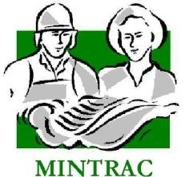

AMPMSY303
Conduct ante-mortem inspection and make disposition
Training support materials

Australian Meat Industry Training Package
Certificate III in Meat Processing

Contents
Training support materials for AMPMSY303 Conduct ante-mortem inspection and make disposition 3
The pork industry in Australia 3
What are the major features of the pork industry in Australia? 3
Conducting ante-mortem inspection of pigs 4
What are the main reasons for ante-mortem inspection? 4
What regulatory requirements apply when conducting ante-mortem inspection? 5
What are the principles and procedures for the humane handling of pigs? 9
What are the signs of common conditions responsible for abnormalities at ante-mortem and how can they be detected? 9
What are the procedures for emergency kill and humane destruction? 13
What are the procedures for emergency and suspect slaughter? 13
What WHS requirements apply when conducting ante-mortem inspection? 14
What are the QA aspects of ante-mortem inspection? 15
Making an ante-mortem disposition 15
What dispositions can be made at ante-mortem? 15
What are common diseases and conditions responsible for abnormalities in pigs? 16
What are the potential sources of chemical contamination and how is the risk addressed? 18
What are the requirements for segregating stock? 20
What is an emergency animal disease? 21
What are the signs of emergency or notifiable diseases? 21
What is a notifiable disease? 22
What are the notification procedures for emergency or notifiable diseases? 24
Bibliography 26
Additional resources 26

Training support materials for AMPMSY303 Conduct ante-mortem inspection and make disposition
NB :This Unit is designed for stock persons who are required to undertake ante-mortem inspection of livestock as part of their duties. This might be to meet regulatory requirements at export pork processing plants or domestic works processing any species when this meets the requirements of the controlling authority.
The materials below are customised for the pork industry but RTOs can easily customise the materials for any species.
The pork industry in Australia
What are the major features of the pork industry in Australia?
The pig meat industry is located largely in the southern and eastern states close to sources of grain. Approximately 5.5 million pigs are slaughtered annually in Australian abattoirs producing about 360,000 tonnes of pork.
Most are slaughtered in seven major export registered abattoirs. The remainder are slaughtered in a number of small abattoirs in every state. About 8% of the pork is exported with the bulk going to the domestic market.
Exports of pig meat had averaged about 11,000 tonnes per year for many years but rose to high of 63,000 tonnes in 2002/3, but has now stabilised at about 40-45,000 tonnes annually. Most pigmeat exports from Australia go to Singapore for the fresh meat trade. Traditionally Singapore will only import female pigs due to the boar odour associated with males. New Zealand, Hong Kong and the Philippines are other important markets.
Countering this about 170,000 tonnes per year of pork that is imported mainly from Canada, USA and Denmark.
In order to prevent the import of exotic diseases with this meat, strict quarantine rules apply and the meat must be imported frozen in boneless form and fully processed before being distributed to the public.
Approximately 65% of the ham, bacon and other smallgoods consumed in Australia is made from this imported pigmeat.
All the raw pork sold in Australia is Australian grown. If the consumer wants to be assured that the ham and bacon they are eating has been grown in Australia, they must purchase only bone-in product or product that is clearly labelled ‘Australian grown’.
The pork industry in Australia is based on three main breeds.
- Large white
- Landrace
- Duroc
There are about four primary herds in Australia that produce all the breeders for the growers. These primary herds maintain pure herds of the above three breeds.
The large whites and Landrace are bred to produce a large white/landrace cross with heterosis vigour. The crossing of these pure breeds results in a faster growing pig just due to the cross breeding. These cross bred females are sold to producers for their breeding sow lines.
In addition purebred Duroc males are sold to the producers for their males breeding lines. This means that the pigs being raised for slaughter are large white/ Landrace/ Duroc crosses with the vigour of heterosis being maximised.
Most pigs are sold for a dressed weight between 55-85Kg (Baconer/finisher). In addition there is a small domestic market for pork from pigs under 55Kg dressed weight. There is also a significant trade in large mature adult pigs known as ‘backfatters’ in the trade. These carcases are used as manufacturing pork in the smallgoods industry.
Conducting ante-mortem inspection of pigs
What are the main reasons for ante-mortem inspection?
The main reason for ante-mortem inspection is to detect those animals that may not be suitable for slaughter due to a disease or condition that could render the carcase unfit for human consumption.
Ante mortem inspection is particularly important for those conditions that may not be detectable at post-mortem inspection.
Ante-mortem inspection can be separated into two parts:
- examining animals before slaughter so that you can identify and segregate animals that show signs of a disease, condition or abnormality
- deciding what action will be taken with those animals that do have a disease, condition or abnormality.
When carrying out ante-mortem inspections, the inspector must:
- detect the presence of suspected exotic or notifiable diseases
- prevent the slaughter of any animal that shows signs of a condition or disease which would make the carcase unsuitable for human consumption
- segregate animals that are injured or ill that must be killed immediately for animal welfare reasons; if the carcase is to be salvaged then the animal is put up for an emergency kill and if the carcase is not salvaged then the animal is humanely destroyed
- segregate animals that show signs of, or are suspected of, having a disease or condition, so they can be slaughtered separately and given detailed post-mortem inspection
- prevent animals that are grossly contaminated with faeces, dirt, dust or other material from entering the slaughter floor
- ensure animal welfare standards are maintained at all times.
Workplaces will have different ways of carrying out ante-mortem inspections. Inspectors must follow workplace procedures and instructions. Quality Assurance (QA) and Hazard Analysis Critical Control Point (HACCP) procedures must also be followed to prevent obviously diseased or contaminated stock entering the slaughter floor.
What regulatory requirements apply when conducting ante-mortem inspection?
Australian Standards
Part 3 of the AS4696:2023 Australian Standard for hygienic production and transportation of meat and meat products for human consumption details the requirements for:
- the supply and admission of animals for slaughter
- animal welfare
- and ante-mortem inspection and disposition.
These requirements apply to all abattoirs, both export and domestic.
Clause 6 of this Standard details the requirements for the supply and admission of animals for slaughter
The outcomes required are:
- animals are sourced from holdings where the management of animals ensures that the wholesomeness of meat and meat products derived from the animals is not jeopardised
- animals affected by a disease or other abnormality do not contaminate other animals or jeopardise the wholesomeness of meat and meat products
- animals are fit to load on livestock transport.
In practice this means that:
- the animals are correctly identified with ear tags, tattoos etc. so as to identify the property of origin
- vendor declarations (PigPass) show that the animals have not been recently treated with any chemical or drugs
- animals are not from a property that is under quarantine restrictions, without approval from the relevant authority.
On arrival at the abattoir the meat safety inspector or other suitably qualified staff are responsible for deciding either not to admit animals that do not meet these requirements, or admitting them under strict controls, until the above issues are clarified.
The meat safety inspector must have access to the vendor declarations to check that:
- the animals have not been grazing on sewage affected pastures or fed materials that may recycle human or animal pathogens
- the animals have not got a notifiable or contagious disease
- the animals have not been treated with any drugs, chemicals or radiation.
All of these items are to be checked prior to the physical ante-mortem inspection by an examination of the Vendor Declaration/Waybill.
The collection and inspection of vendor declarations is generally done by the senior stockman at the abattoir. The meat safety inspector needs to ensure that there is a system in place to advise him/her of any animals that arrive without a vendor declaration or any animals where the vendor declaration shows that there is some doubt as to the suitability of a lot of animals for slaughter for human consumption.
The usual practice at abattoirs in Australia, both export and domestic, is for the head stockman to provide the nominated and suitably qualified company employee stockman or the veterinarian at export abattoirs with a kill sheet that shows the order of the animals to be slaughtered, the number in each lot and any other relevant details from the vendor declarations or waybills.
Although it is up to the company to ensure all vendor declarations are correct, it is a requirement on export abattoirs for the veterinarian to oversee the ante-mortem operations and check a number of the vendor declarations on a regular basis to ensure that all animals are accounted for, and that particular market eligibilities have been met. Some tier one export plants have a Pork Ante-Mortem Inspector (PAMI) qualified to do the ante mortem inspection, however all suspects and emergency slaughter animals are to be referred to the OPV.
The person performing the ante-mortem will then note on the kill sheet those lots that have been inspected and any animals that may have been segregated as suspects or emergency kill by the stockman or the inspector. This kill sheet will then be passed to the meat safety inspectors on the slaughter floor for reference.
On export abattoirs an ante-mortem card is prepared for each lot and accompanies the first animal of each lot to the slaughter floor.
If the meat safety inspector decides that the animals may be slaughtered, this section of the Australian Standard requires the company to have in place a system of correlation so that if any disease is found, the animal(s) can be traced back to the property of origin.
Vendor declarations
PigPass is a national tracking system which provides real time information on the movements of all pigs in Australia. This enables authorities to quickly determine the source of a disease outbreak and notify people with pigs in the affected area to stop the spread of disease.
A PigPass National Vendor Declaration (NVD) form must be completed when you move pigs from your property. This applies to all pig owners and producers.
In some states, waybills issued by state authorities are also compulsory.
The basis for a farmer/producer signing the form is participation in an on-farm quality assurance system Australian Pork Industry Quality Programme (APIQP) for pigs.
The PigPass in the pig industry is the equivalent to the National Vendor Declaration form for the beef and sheep meat industries. It is currently mainly used for farm to abattoir movements but is being expanded to farm to farm movements as well. This will make trace back even more effective for the industry.
It depends largely on the property of origin tattoo applied to every pig that is sent to slaughter.
In addition a new system called ‘Physi-Trace’ is being introduced. It uses trace element profiles and chemical and biological markers to discriminate between pork samples based on the region of origin. It require the sampling and storage of between 0.5–1.5 per cent of annual slaughter by each establishment and 5 per cent of these samples are randomly selected on a monthly basis for Physi-Trace analysis to build the database for raw pork. Physi-Trace is also being used to differentiate between ham and bacon made from Australian or imported pork, supported by the Physi-Trace ham and bacon database.
This will make trace back in the case of suspected chemical residue or exotic disease even more effective and more accurate.
The emphasis in the quality systems such as APQIP is mainly on the residue status of livestock, including source of fodder, pastures and any treatments and withholding periods, but they are also designed to offer broader assurance of the status of the animals on a whole range of food safety and commercial issues.
All meat processors have made the PigPass/vendor declarations from the farmer an essential condition for the purchase of livestock. Participating farmers have real price advantages when they participate in these programmes. The programmes are supported by vendor liability legislation in some states. The programmes require producers to follow certain best practice procedures including:
- stock identification records
- staff training
- transaction and movement records
- proper labelling, storage and use of chemicals
- treatment records
- good husbandry practices including care with loading, handling and transport
- conducting internal audits of their system on a regular basis.
Australian Pork Industry Quality Programme (APIQP) is the equivalent to LPA for the cattle and sheep industry.
Correlation
Correlation is the requirement to identify all parts of a particular animal during slaughter until after all the parts have passed post-mortem inspection. This includes carcases, hides, offal and heads.
Routine correlation is achieved by recording the property identification against the carcase number allocated at slaughter.
This property identification is tail tags in cattle and buffalo, brands in pigs and ear tags in sheep.
If a carcase is to be retained correlation is achieved by the use of either temporary tags attached to the various parts, and/or visually at the point of inspection.
The carcase and all its parts must be able to be retrieved and correlated to the animal’s property identification/ear tag.
Export requirements
Export workplace ante-mortem practices differ only marginally from the Australian Standard requirements, depending on the importing country's requirements. Also most overseas countries insist on veterinary oversight of ante-mortem inspection.
The Export Control (Meat & Meat Products) Orders and overseas countries' requirements must be followed. Details of these can be found in the company workplace instructions.
Clause 8 of the Australian AS4696:2023 covers ante-mortem inspection and disposition.
The outcome required is:
Only animals fit for slaughter for the purpose of producing meat and meat products for human consumption are slaughtered.
This clause basically states the following:
Ante-mortem inspection must be carried out by a meat safety inspector.
The meat safety inspector must carry out the inspection within 24 hours of slaughter
The meat business must supply the inspector with all the relevant information about the animals to be slaughtered as specified in clause 6.
The dispositions of animals after inspection are:
- passed for unconditional slaughter
- passed for slaughter subject to conditions set by the meat safety inspector (suspect and emergency kill animals)
- withheld from slaughter
- condemned.
This clause also specifies the action to be taken when disease or abnormality is suspected in that all dispositions are to be in according to Schedule 3 of the Standard.
What are the principles and procedures for the humane handling of pigs?
The principles and procedures for the humane handling of pigs are detailed in the AS4696:2023 Australian Standard for hygienic production and transportation of meat and meat products for human consumption Clause 7.
The outcome required is:
The minimisation of the risk of injury, pain and suffering and the least practical disturbance of animals.
The AS4696:2023 Australian Standard for hygienic production and transportation of meat and meat products for human consumption requires meat companies to have an ‘Approved Arrangement’ with their relevant controlling authority for all aspects of meat production. This Approved Arrangement requires a meat company to include animal welfare as a policy objective in their “Approved Arrangement” and to demonstrate commitment to this policy.
To meet this requirement some plants implement the provisions of the AMIC National Animal Welfare Standards for Livestock Processing Establishments Preparing Meat for Human Consumption (3rd Edition). This voluntary Standard is based on the Australian animal welfare codes and international best practice standards.
Animal welfare is described in greater detail in the following animal welfare module, which is a core Unit and co-requisite for this training Unit: AMPA3002 Handle animals humanely while conducting ante-mortem inspection.
What are the signs of common conditions responsible for abnormalities at ante-mortem and how can they be detected?
In order to maximize the ability to detect common visible diseases and conditions responsible for abnormalities ant ante-mortem inspection it is important that effective procedures are carried out. The AS4696:2023 Australian Standard for hygienic production and transportation of meat and meat products for human consumption does not specify how ante-mortem inspection is to be conducted, but there are ‘best practice’ procedures that should be followed.
The meat safety inspector can vary these procedures according to:
- regulatory requirements e.g. ante-mortem at export plants must be conducted under direct veterinary supervision
- company requirements
- type of animal e.g. young animals are less likely to have disease than older animals
- lines of uniform animals such as pigs from a single source where documentation indicates that the farmer has inspected the animals and identified suspects, under these circumstances only a representative number of animals need be inspected.
When carrying out ante-mortem inspection, the animals should firstly be examined when at rest. This is because some signs of sickness or disease will not be seen when the animals are being moved. It is also very important that the inspector look for any animal that is not displaying ‘normal’ behaviour i.e. if it is doing something different to the rest of the mob. In this case pigs tend to separate themselves from other pigs.
After observing the animals at rest, the inspector must then examine them when they are moving. When doing this the inspector should observe the sides, head and rear of the animals. This is so any abnormality, disease or condition can be detected.
Humane handling
It is very important that any handling or moving of animals is done quietly and humanely.
Animals that are not handled or moved correctly may become stressed. Stress can affect meat quality. A stressed, flighty or nervous animal can also injure you or stir up other animals in the same pen, resulting in injury to stock.
Signs of common conditions
Signs which may indicate disease, conditions or abnormality in livestock include:
- separating themselves from the rest of the stock
- lying down when the rest are standing
- dullness, listlessness, head down, not alert
- drooping ears
- very poor condition – emaciated
- short, shallow, rapid or loud breathing
- hunched up
- scouring, bloody diarrhoea i.e. dysentery
- excessive salivation
- tongue protruding
- excitement, i.e. excessively active and erratic behaviour
- lameness and/or swollen joints
- blood, pus or other abnormal discharges from nose, mouth, anus, vulva or penis
- enlargement or abnormality of scrotum, anus, vulva, penis or udder
- swelling cysts, abscesses or abnormal growths
- skin irritation
- skin blotching
- abnormal enlargement of belly
- broken limbs
- wounds
- faecal contamination.
Following are some examples of some diseases and conditions seem at ante mortem.
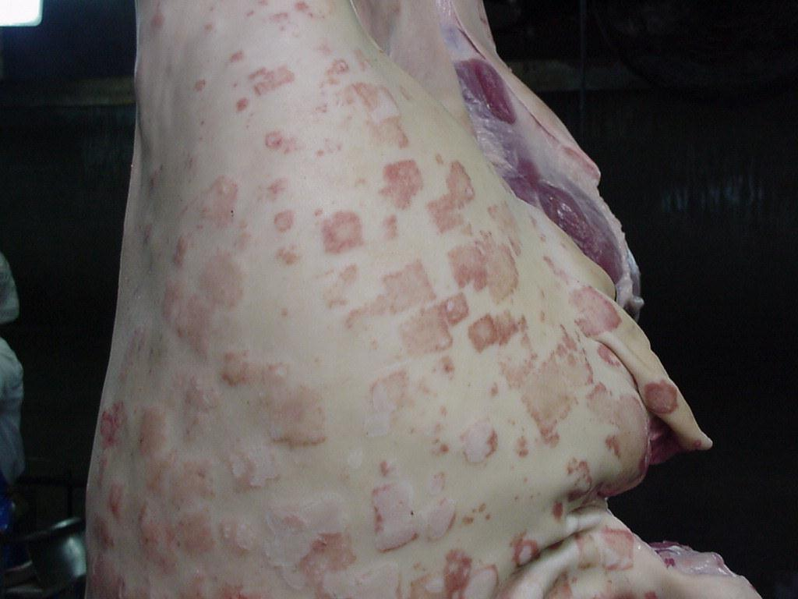
Swine erysipelas AKA diamonds disease (contagious to humans) © Tom Collyer

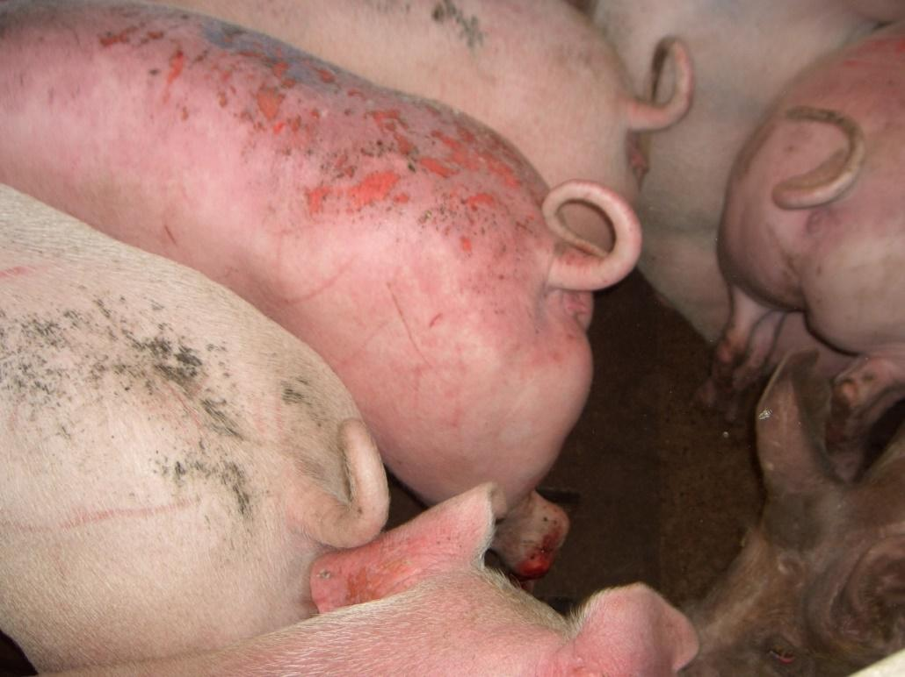
Sunburn
© Tom Collyer

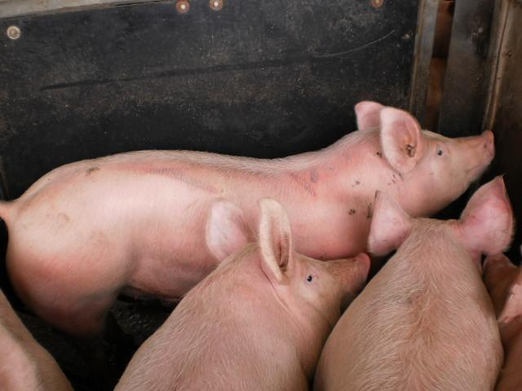
Welts (animal welfare issue)
© Tom Collyer

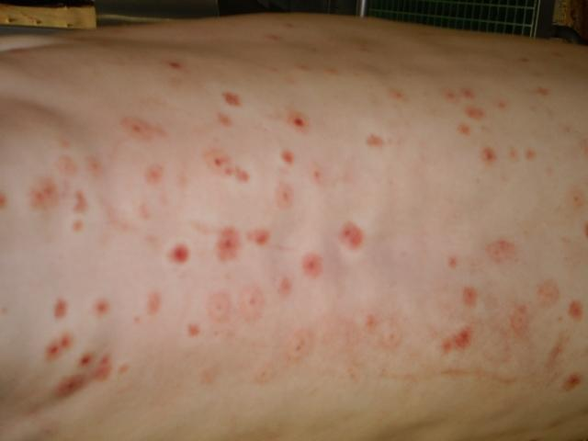
Insect bites – probably mosquitos
© Tom Collyer

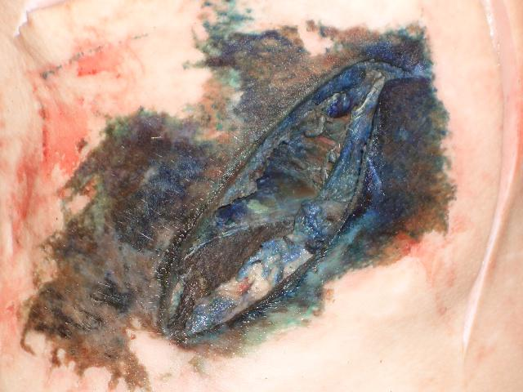
Fly blown wound
© Tom Collyer
What are the procedures for emergency kill and humane destruction?
Regardless of the circumstances animals that are in lairage and are suffering must be euthanized. This is a matter of animal welfare and companies must ensure that arrangements are in place for the animal to be euthanized in as short a time as is possible.
Suffering animals where it is possible to salvage the carcase need to be put up for emergency slaughter. These cases include animals with severe injuries such as broken legs.
Other animals that may be suffering include animals that are moribund or near death, these need to be destroyed immediately and the body condemned.
At abattoirs, euthanasia of animals in the yards is usually achieved by use of a firearm or captive bolt. Only suitably trained and qualified people may use a firearm/ captive bolt.
Workplace instructions must be followed for this procedure.
What are the procedures for emergency and suspect slaughter?
Emergency slaughter animals are slaughtered as soon as possible. They are usually killed in the yards and enter the slaughter floor through the emergency slaughter door close to the knocking box.
Only injured animals should be handled in this way.
Sick animals should be rejected from slaughter and either disposed of humanely or withheld from slaughter for treatment.
Animals are that are to be treated may not leave the abattoir premises for treatment as abattoirs are considered by all state authorities to be quarantine areas.
After successful treatment particular care needs to be taken to ensure that no chemical residues are present in the animals. This is achieved by ensuring withholding periods for drugs administered are strictly met.
Some animals may be considered for suspect slaughter. These include animals that are considered suitable for processing but require more detailed post mortem inspection to determine the extent of the disease or condition.
Animals showing evidence of heavy faecal contamination should also be put up as a lot at the end of the shift so that special procedures can be put in place to ensure cross contamination is minimised. This also reduces the contamination of the scald water. The scald water is replaced at the end of a shift.
All suspects should be put up for slaughter at the bend of a shift/day
Prior notice should be given to the slaughter floor supervisor of any disease or condition likely to contaminate slaughter personnel or slaughter floor i.e. hernias, large swellings, acute arthritis. This allows precautions to be taken
Workplace instructions must be followed for these procedures.
What WHS requirements apply when conducting ante-mortem inspection?
The WHS principles for the meat industry are explained in the training material for AMPCOR204 Follow safe work policies and practices.
Possible WHS hazards when conducting ante-mortem inspection could be:
- zoonotic diseases i.e. diseases transmissible from animals to humans
- slips, trips and falls
- injury from animals
- severe weather.
Ways of preventing or controlling these hazards are contained in workplace WHS policies and procedures. Some examples of these may be:
- wearing and using appropriate Personal Protective Equipment (PPE)
- vaccination against zoonotic diseases
- wearing appropriate footwear
- using walkways where provided
- being aware of the behaviour of animals at all times
- being aware of the location of animals at all times
- knowing the location of exit gates, ladders and steps.
It is important to note that Swine erysipelas (diamonds disease) is contagious to humans. Other common names are: nettle rash, and urticaria.
What are the QA aspects of ante-mortem inspection?
The QA practices that apply to the meat industry are explained in the training material for AMPCOR203 Apply quality assurance practices.
All personnel conducting ante-mortem inspections and making dispositions must have a good understanding of and follow instructions detailed in the company quality assurance manual and Hazard Analysis Critical Control Points (HACCP) plan. Some of these could include:
- identification of hazards, such as faecal contamination
- preventative action
- control methods
- record keeping
- ante-mortem cards
- traceback to property of origin
- compliance with tattoo, ear tag or tail tag requirements
- delivery dockets
- vendor declarations
- Australian Pork Industry Quality Programme.
Making an ante-mortem disposition
What dispositions can be made at ante-mortem?
The disposition for diseases is described in Schedule 3 of the AS4696:2023 Australian Standard for hygienic production and transportation of meat and meat products for human consumption.
After ante-mortem inspection, one of the following dispositions will be made about each animal. The animal will be:
- passed as fit for routine processing
- withheld from processing pending treatment for or recovery from an abnormal condition. These animals may be resubmitted for another ante-mortem inspection at a time specified by an inspector. Note: on export abattoirs suspect animals must be held for veterinary inspection
- subjected to immediate emergency slaughter to prevent deterioration of an abnormal condition, provided the condition would allow all or part to be passed for human consumption and processing would not jeopardise the hygienic production of meat
- processed under restrictions which prevent unacceptable contamination of the processing floor and which permit more detailed post-mortem inspection
- rejected as unfit for processing and destroyed by humane means and then disposed of in an approved manner.
The AS4696:2023 Australian Standard for hygienic production and transportation of meat and meat products for human consumption requires the following actions to be taken after ante-mortem inspection:
- a record of ante-mortem inspection of animals rejected for human consumption or passed as suspect or emergency slaughter must be maintained
- animals that are deemed to be affected by diseases or conditions should be segregated from healthy animals while awaiting slaughter
- groups of stock that exhibit signs or symptoms of stress must be rested before slaughter - this is of particular importance with pigs as stress can induce Pale Soft Exudate (PSE)
- animals that are known to have been treated with, or exposed to a drug, chemical or biological substance, shall not be slaughtered unless any withholding period recommended on the product label has lapsed
- animals that are condemned must be humanely slaughtered
- dead animals are removed quickly for disposal.
- some importing countries i.e. USA reject non ambulatory animals from USA product. These carcasses are stamped non USA when being processed.
What are common diseases and conditions responsible for abnormalities in pigs?
The identification of different diseases and conditions that can affect an animal's suitability for human consumption is the first step in producing safe meat products. It is essential that these conditions are identified and the correct disposition made as to whether to slaughter the animal.
The purpose of ante-mortem is to detect any:
- visible physical abnormalities
- invisible abnormalities such as chemical residues.
Schedule 3 of the AS4696:2023 Australian Standard for hygienic production and transportation of meat and meat products for human consumption details the diseases and conditions and dispositions.
It includes conditions that may be detected at ante-mortem and at post-mortem inspection. The ante- mortem conditions are reproduced below.
Swine erysipelas commonly seen ante and post mortem

Diseases and other abnormalities | Dispositions for animals, carcases and carcase parts
 | The symbol [1] means carcase or carcase parts unfit for human consumption may be recovered for animal food subject to heat sterilisation. The symbol [2] means carcase or carcase parts unfit for human consumption may be saved either for animal food subject to heat sterilisation or for animal food subject to staining.
1. General findings
Dead animal |  | Animal condemned. If anthrax suspected see 2.1.1.
Dying animal or moribund state with subnormal temperature, weak pulse and disturbed senses. |  | Animal condemned
Fever, debility and general signs indicating acute disease |  | Animal condemned. Alternatively, withhold from slaughter until recovered provided no risk of spread of disease; no undue suffering and recovery considered likely with treatment.
Advanced chronic conditions with generalised signs such as cachexia or loathsome appearance |  | Animal condemned
Injury or accidental trauma during transport to or while in vicinity of abattoir |  | Animal subject to emergency slaughter or condemned
Excitement, exhaustion without signs of acute disease |  | Animal withheld from slaughter and ante-mortem repeated after adequate rest
Slight odour
2. Disease listing
2.1 Bacterial and related diseases |  | Dispositions
Anthrax |  | Affected animals should not be admitted to an abattoir. When detected at ante-mortem, affected animal condemned. Companion animals isolated and withheld from slaughter
Cutaneous lesions |  | Affected areas of skin condemned
Myiasis |  | Animal condemned in severe cases with sepsis or necrosis. Otherwise withhold from slaughter for treatment and resubmit for ante-mortem after recovery.
Ephemeral fever |  | Animals withheld from slaughter for treatment. Resubmitted for ante-mortem after recovery.
Metabolic disorders (transit tetany, ketosis, etc) |  | Animal condemned in severe cases. Withheld from slaughter in milder cases and resubmitted for ante-mortem after recovery.
Faecal contamination
There is a high human health risk of faecal contamination containing pathogenic bacteria such as E.coli and Salmonella. Only stock that can be slaughtered without risk of faecal contamination should be processed.
What are the potential sources of chemical contamination and how is the risk addressed?
The provision of wholesome meat to the consumer requires an assurance that the product does not contain residues of chemicals which may be harmful to human health.
Residues may result from intentional treatment of an animal, or if its feed, with a drug or chemical, such as pesticide for therapeutic or other purposes; or from environmental contamination.
This assurance is provided on the basis of measures designed to ensure that the product contains no residues which exceed the Maximum Residue Limit (MRL), for that chemical as set by the Food Safety Council of Australia through the National Foods Authority. Similarly, maximum permitted concentrations (MPC's) have been established for contaminants, such as heavy metals. These limits are based on scientific evaluation, and toxicology. Some importing countries have more stringent requirements for chemicals, so it is important to always check destinations in MICOR.
The National Residue Survey (NRS) provides an unbiased estimate of the frequency of residues of a range of agricultural and veterinary chemicals, and environmental contaminants in the individual commodities for targeted surveys and extension.
The NRS provides assurances to Australia's trading partners and domestic consumers of the low residue status of these commodities. Inclusion of chemical and commodity combinations is based on risk profiling.
Residue compliance of meat produced at abattoirs is based on:
- participation in the NRS
- systems of animal identification and trace back when violative residues are detected
- identification and quarantine, or other appropriate management strategies, of farms known to produce animals with violative residues.
The invisible abnormalities that may be present at ante- mortem inspection such as chemical residues can only be assessed by a detailed inspection of the paper work accompanying the animals such a way bills and vendor declarations, or by individual testing of samples from slaughtered animals.
Individual testing of animals is only conducted if there are some doubts as to the chemical residue status of animals. For routine processing the vendor declarations are considered sufficient.
Inspection of the vendor declarations is an essential part of the ante-mortem inspection process.
Random survey
The random survey is conducted at all abattoirs in Australia. Meat safety inspectors collect samples in a randomised manner from a range of animals. The samples are sent to specific laboratories where they are tested for a range of chemical residues.
The results are collated to develop a picture of residue contamination in food across Australia.
If residues of a particular chemical appear to be a problem a targeted testing programme is initiated for that problem chemical.
Targeted survey
A targeted survey is initiated when a particular chemical appears to be a problem. The main targeted chemical at the moment is organochlorines in meat.
Unacceptable levels were found in beef in 1987 and this chemical has been continually targeted since that date.
The long half-life of the chemical means that it may take some years for the chemical to disappear from the environment even though the chemical itself has been banned for some years.
Note: The half-life of a chemical is the length of time it takes for quantity of the chemical in the environment to break down to half the original level.
In this targeted programme all properties have been classed into seven different categories according to the risk of organochlorin contamination on the property.
Most properties are in class C (clear) and require no targeted testing. The rest are graded according to risk:
- T1: require only one in ten animals to be tested
- T2: require one in five testing
- T3-T5: require all animals to be tested.
The latter are generally under state-controlled quarantine and require specific approval from the authorities for animals to be sent to slaughter.
In 1988 there were thousands of beef properties in the T5 category. There are now very few.
The Commonwealth Department of Agriculture maintains a database of properties requiring targeted testing.
Management of the company are required to access the database, prior to animals being slaughtered, to see if the property identification number is one where testing is required.
Although it is the responsibility of the company to collect samples, they must inform the relevant veterinarian or meat safety inspector of the testing requirement.
If the animals come from T1-T2 properties the carcases are sampled and released.
If the animals come from T3-T5 properties the carcases are held pending the results.
Rodents like rats and mice are significant pests on piggeries. They can transmit diseases and also cause significant damage to shed infrastructure and wiring. For this reason piggeries have used rodenticides to kill these rodents. Pigs can then eat these dead rodents. In the past this caused issues with residues. To address this problem piggeries now implement the ‘Industry Rodenticide Stewardship Plan” as a guide for producers on best practice management of on-farm rodenticide use.
What are the requirements for segregating stock?
It is important for humane reasons that various categories of animals are segregated during transport and in the yards. For example:
- boars should not be mixed with any other animals
- ideally boars should be segregated into individual pens as they will tend to fight
- young pigs should be penned separately to adult animals
- pigs should be maintained in their lots from the farm(s) as different groups will tend to fight if mixed in the yards.
After performing ante-mortem inspection, any animals that are showing signs of a disease, condition or abnormality must be segregated from the healthy animals for further detailed inspection. This will also include animals with faecal contamination. The veterinary officer, inspector or authorised person must then make a disposition and decide what action to take. Animals are segregated in four ways after ante-mortem inspection:
- injured animals are identified for immediate emergency slaughter or humane killing
- the bulk of the animals will be passed as fit for human consumption
- animals with localized disease e.g. lameness or with a vendor declaration that indicates exposure to chemicals are identified as suspect for separate slaughter preferably at the end of the shift. these animals may also be withheld from slaughter until their condition improves or their chemical residue status is confirmed or abated i.e. after the relevant with holding period has passed
- animals with generalized disease that render them unfit for human consumption are condemned.
What is an emergency animal disease?
The AUSVETPLAN defines an emergency animal disease as:
'A disease that is (a) exotic to Australia or (b) a variant of an endemic disease or (c) a serious infectious disease of unknown or uncertain cause or (d) a severe outbreak of a known endemic disease, and that is considered to be of national significance with serious social or trade implications.’

Specific animal diseases are termed as emergency because of their potential, in most cases, for very serious and rapid spread causing major economic impact to livestock industries and the economy. Some of these diseases can also be spread from animals to humans (zoonoses). These diseases would also have a major impact on our international markets. An outbreak of an emergency disease would mean the immediate closure of all our international markets. Depending on the market and disease it could take Australia years to regain access.

What are the signs of emergency or notifiable diseases?
Meat inspectors need to be alert to and recognise the signs of some of the more serious notifiable diseases.
There are also animal behaviours at ante mortem which can be signs of an emergency disease and these include:
- depression i.e. head down, loss of appetite, isolated from herd
- disorientation, nervousness, aggressive behaviour
- hypersensitivity to sound, touch, light
- reluctance to move
- sensory changes i.e. head tossing, teeth grinding, tongue licking, licking feet, muscle tremors.
There are a range of signs that should alert inspectors and stock handlers to a possible emergency diseases:
- blisters and/or lesions on lips, muzzle, tongue, teats
- blisters and/or lesions above or between claws of the hoof can be signs of an emergency disease
- excessive ropey salivation, mucus, foaming and/or nasal discharge
- lameness, stiffness, abnormal posture, trembling and loss of coordination
- abnormal hair loss, skin lumps, maggot infested wounds
- the swelling of lymph glands, lips and tongues can also be signs of possible emergency diseases.
- discharge or blood from eyes, nose, anus or diarrhoea with blood
- discharge of fluids or blood from the nose, eyes or anus or bloody diarrhoea
- sudden deaths, high mortality and morbidity rates and unusual vocalisations.

One of the major problems with this exotic disease is lesions can be very similar to these caused by grass seeds or thorns are seen commonly in domestic animals. This condition would be very easy to misdiagnose. With cattle and sheep feet are removed prior to postmortem inspection.

All emergency animal diseases are also ‘notifiable diseases’.
What is a notifiable disease?
Notifiable diseases are diseases in animals that by law must be notified or reported to the relevant State or Territory authorities.

As a meat inspector it will be your legal obligation, to notify the Emergency Animal Disease Hotline 1800 675 888 or state authorities if you know or suspect that an animal has a notifiable disease. The full list of state and territory notifiable animal diseases can be found on the Department of Agriculture website.
All emergency diseases are notifiable diseases but not all notifiable diseases are emergency diseases.
Since notifiable diseases vary from State to State the inspector will need to contact the relevant State animal health authority for further information on the most likely or common notifiable diseases in the state.
Note: Not all notifiable diseases will be evident at ante-mortem a few are detectable only at post-mortem.
The following chart lists some of the notifiable diseases of animals in Australia that may be evident at ante-mortem.
The list is provided for general information only and can vary from time to time. Some of the notifiable diseases are exotic to Australia, but most are endemic.
Notifiable disease | ACT | WA | NSW | NT | QLD | SA | TAS | VIC
Anthrax | Y | Y | Y | Y | Y | Y | Y | Y
Atrophic rhinitis |  | Y |  | Y
Black disease |  |  |  | Y | Y
Blackleg |  |  |  | Y
Botulism |  |  |  | Y
Classical swine fever | Y |  |  | Y |  |  | Y | Y
Fasciola gigantica | Y |  | Y |  |  | Y |  | Y
Foot-and-mouth disease | Y | Y | Y | Y | Y | Y | Y | Y
Infectious atrophic rhinitis |  |  |  |  | Y
Lumpy skin disease | Y | Y | Y | Y | Y | Y | Y | Y
Malignant tumour |  |  |  |  |  |  |  | Y
Other spongiform encephalophathies |  | Y
Rinderpest | Y | Y | Y | Y | Y | Y | Y | Y
Screw-worm (Cochliomyia hominivorax) | Y | Y | Y | Y | Y | Y | Y | Y
Spongiform encephalopathies | Y |  |  | Y | Y
Swine dysentery |  | Y
Swine erysipelas |  | Y
Swine fever |  |  |  |  | Y | Y
Swine influenza | Y | Y | Y | Y | Y | Y |  | Y
Swine plague |  |  |  |  |  | Y
Swine pox |  | Y
Teschen disease (Porcine polioencephalomyelitis) | Y | Y | Y |  | Y
Toxoplasmosis |  | Y
Transmissible gastroenteritis of pigs | Y | Y | Y | Y |  | Y |  | Y
Transmissible spongiform encephalophathies |  |  | Y |  |  |  |  | Y
What are the notification procedures for emergency or notifiable diseases?
The identification and notification procedures that apply to emergency animal diseases are explained in the training material for AMPMSY302 Recognise signs of emergency and notifiable animal diseases.
The procedures for identification and reporting on each abattoir should be detailed in the abattoir Emergency Animal Disease Preparedness (EADP) plan.
There should be an Emergency Animal Disease Preparedness (EADP) plan on every abattoir in Australia. Check the plan at the workplace. This plan should detail the notification procedures for emergency or notifiable diseases.
This plan should be based on the meat-processing manual of AUSVETPLAN.
AUSVETPLAN is the master plan for dealing with exotic disease. It has been designed by experts from state and commonwealth departments responsible for animal health in Australia.
The EADP plan on the abattoir should contain the following:
- action measures detailed as job cards for all responsible key personnel
- a map showing perimeter fences, drainage, yards, adjoining properties, suitable areas for burial and ponds and waste water disposal
- an up to date list of notifiable diseases
- phone numbers both home and at work of key personnel e.g. on-plant vet, senior meat safety inspector, plant manager, engineer, stock person
- location and condition of a supply of soda ash and decontamination equipment
- instructions on how disinfectants and chemicals on site may be used for disinfecting people, equipment and vehicles
- where there are reasonable grounds to suspect an exotic or notifiable disease has been found, the qualified person, i.e. a veterinarian or meat safety inspector, must implement the control procedures detailed in the plan until the State or Territory animal health authority advises otherwise, or takes control of the situation.
The first step when an exotic or notifiable disease is suspected, is to immediately notify the state or territory animal health authority, e.g. the state department of agriculture.
The District Veterinary Officer, Regional Veterinary Officer or Chief Veterinary Officer in that state will take control of the situation. The national hotline number for emergency animal diseases is 1800 675 888.
Once the authority has been notified they will be able to provide further advice.
The AUSVET plan should be practiced with enough frequency so that all participants know their role.

Bibliography
These publications were used to develop this training material.
Eddie Andriessen Meat Safety Quality and Veterinary Public Health in Australia 11th edition Penny Farthing Publishing PO Box 190 Woodville SA
Food Standards Australia New Zealand Australian Standard for the Hygienic Production and Transportation of Meat and Meat Products for Human Consumption FRSC technical report No 3 AS 4696:2023 CSIRO Publishing
AMIC National Animal Welfare Standards for Livestock Processing Establishments Preparing Meat for Human Consumption 2nd Edition (2010)
Model Code of Practice for the Welfare of animals: Livestock at Slaughtering Establishments
Commonwealth Department of Agriculture
Export Control Act 1982
Export Control (Prescribed good General) Order 2005
Export Control (Meat & Meat Products) Orders 2005
Manual of Importing Country Requirements – European Union
United States
National Residue Survey – Approved Laboratories for Chemical Residue Testing
Note: Other than Eddie Andriessen’s book all of the above can be accessed at Elmer 3
http://www.agriculture.gov.au/export/food/meat/elmer-3

Additional resources
Registered Training Organisations (RTOs) should refer to the Unit-by-Unit listing of resources on the MINTRAC website www.mintrac.com.au for additional resources to support the delivery of this Unit.
RTOs which develop or identify additional resources are encouraged to advise MINTRAC so that these can also be added to the Unit-by-Unit listing.
The Exam Generator
The Exam Generator is a question bank containing hundreds of questions related to meat safety and Quality Assurance. There are two CDs in the set – one for RTOs (Albert) to create the exams and a student CD (Eddie) that creates electronic practice exams containing all the same questions.
Meat Inspection Currency tool
The Meat Inspector Currency exam generator generates quizzes for the assessment of the currency of a meat inspector’s knowledge.

