AMPMSY401
Perform ante and post-mortem inspection - Ovine and Caprine
Training support materials

Australian Meat Processing Training Package
Certificate III in Meat Processing

Table of contents
Training support materials for AMPMSY401 Perform ante and post-mortem inspection - Ovine and Caprine 4
What are the major breeds of commonly slaughtered sheep and what are their distinguishing features? 4
What are the market requirements for sheep and goats? 7
The goat industry 10
Conducting ante-mortem inspection of sheep and goats 11
What are the main reasons for ante-mortem inspection? 11
What regulatory requirements apply when conducting ante-mortem inspection? 12
What are the principles and procedures for the humane handling of sheep and goats? 15
What are the signs of common conditions responsible for abnormalities at ante-mortem and how can they be detected? 16
What are the procedures for humane destruction? 19
What are the procedures for emergency and suspect slaughter? 20
What WHS requirements apply when conducting ante-mortem inspection? 20
What are the QA aspects of ante-mortem inspection? 21
Making an ante-mortem disposition 21
What are common diseases and conditions responsible for abnormalities in sheep and goats? 21
What dispositions can be made at ante-mortem? 24
What are the requirements for segregating stock? 25
What are the signs of emergency or notifiable diseases? 26
What are the notification procedures for emergency or notifiable diseases? 29
Monitoring the stunning and slaughter of sheep and goats 30
What are the types of stunning equipment that are used on sheep and goats? 30
What are the requirements for effective stunning and slaughter? 32
How is the effectiveness of stunning assessed? 34
What corrective action must be taken in the event of ineffective stunning or bleeding? 35
What regulatory requirements apply to the assessment of stunning and bleeding? 35
The basic skeletal structure of ovine and caprine species relevant to post mortem inspection 36
The features of the lymphatic system of sheep and goats relevant to post mortem inspection 38
The elements of ovine/caprine internal organs that are different to other domestic animals 41
Conducting post-mortem inspection of sheep and goats 53
What are the main reasons for post-mortem inspection? 53
What are regulatory requirements associated with post-mortem inspection? 53
What are the procedures for conducting post-mortem inspection? 53
What is the process for identifying and detecting abnormalities? 56
What WHS, hygiene and sanitation requirements apply when conducting post-mortem inspection? 61
What QA issues relate to post-mortem inspection? 62
What are the signs of common conditions responsible for abnormalities at post-mortem and how are they detected? 62
Grass seed contamination in sheep and lamb carcases 73
What are the types and symptoms of emergency diseases that can be detected at post-mortem? 76
What regulatory requirements apply when handling an affected carcase? 76
What hygiene and sanitation and WHS requirements apply when handling an affected carcase? 78
Retaining carcases 79
What are the procedures for retaining carcases on the slaughter floor? 79
What are the procedures for retaining carcases in a chiller? 79
PPE requirements for post-mortem inspection 80
What PPE is required to perform post-mortem inspection? 80
What workplace requirements apply when using PPE? 80
How should PPE be used, maintained and stored? 81
Taking pathological and residue samples 82
How are lesions and tissues necessary for determining dispositions identified? 82
What are the requirements for collecting and submitting specimens? 82
How are specimens for residue testing taken? 83
How are results interpreted? 83
What are the requirements for retaining carcases while waiting for results? 84
Bibliography 85
Additional resources 85

Training support materials for AMPMSY401 Perform ante and post-mortem inspection - Ovine and Caprine
What are the major breeds of commonly slaughtered sheep and what are their distinguishing features?
Merino
The Merino is the most common breed of sheep found in Australia and is usually bred for wool production. Selected mature Merino sheep are used for mutton production. The Merino is a large framed animal with longer legs than most breeds of sheep. They generally dress out at slaughter as a leaner carcase.

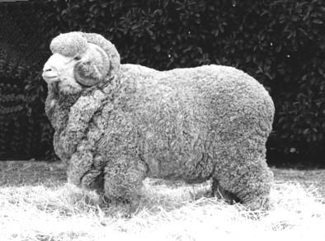
Merino

Dorset Horn/Poll Dorset
This breed of sheep forms the bulk of lamb production in Australia due to a well-formed body and muscle content. The lambs produced are larger than most breeds which makes them suitable for the local lamb trade.
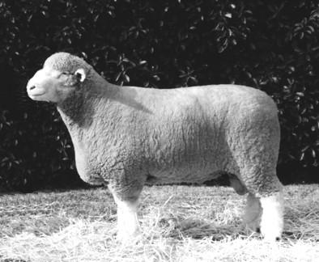
Poll Dorset
Southdown
The Southdown is a small framed, short-legged sheep. The body has a well-defined muscle structure.

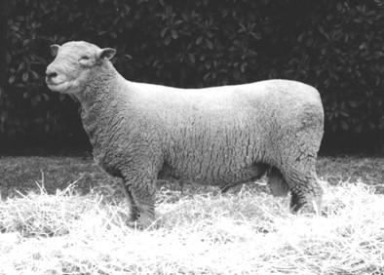
Southdown
Border Leicester
This breed is one of the larger framed sheep breeds with good wool producing qualities. The distinguishing feature of the Border Leicester is the prominent wool-less, hook-nosed head.
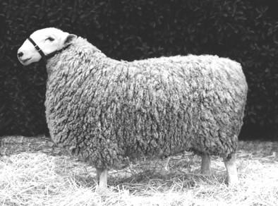
Border Leicester
These are the most common breeds of sheep seen at an abattoir. However, there are numerous other breeds of sheep grown for meat production usually by cross breeding with merinos e.g. Coopworth, East Frisian, Finn sheep (Finnish Landrace),Romney Marsh, Suffolk and their cross-breeds.
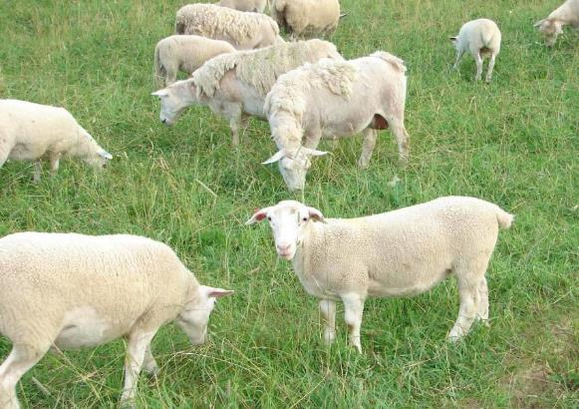

The Dorper is a breed that originated from South Africa. It can produce an excellent carcase under extensive rangeland conditions and does not need to be moved to higher rainfall areas to finish off. It is a shedding sheep and does not near shearing or crutching.
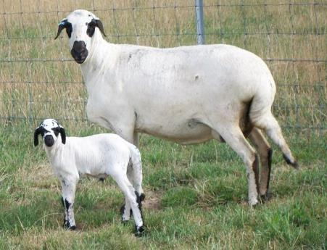
The Damara is a breed of shedding meat sheep ideally suited to the Australian climate.
The breed comes from Namibia and South Africa. The breed came to Australia in the mid 1990s and the sheep is now established particularly in the drier arid regions.

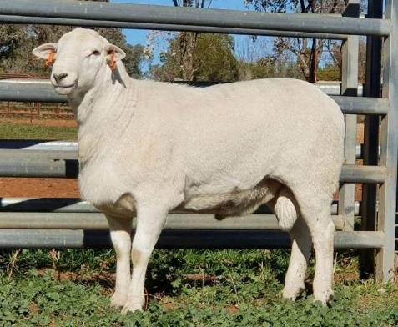

The Australian White - also known as the "Aussie White" - is a relatively new breed developed to suit Australian conditions and modern Australian lamb market demands.
What are the markets for Australian sheep and goat meat?
The sheep meat industry changed greatly in the last 40 years as the nation ‘s flock has fallen from 170 million sheep to around 70 million sheep today. Last century the national flock was predominately Merino sheep while today there are a lot of dual purpose merinos and also a lot of prime lamb operations utilising cross bred and shedding sheep.
Many sheep farmers will cross those ewes that are surplus to their requirements for replacement stock, to a meat breed especially Border Leicester, to produce a large carcase with good conformation.
Many of these cross bred ewes will end up as breeders in the higher rainfall areas of NSW, Victoria and South Australia where they are mated predominantly to Dorset horn, Suffolk, Coopworth, East Friesian, and Finnsheep rams to produce the ideal carcase for the high priced European and United States market.
A large number of the lambs from this mating will be finished in feed lots to improve carcase weight and carcase score.
Carcase weights can vary widely form 18-40Kg depending on age at slaughter and market requirements. The smaller carcases will generally go to the domestic market. Larger carcases are boned out for export to produce the larger meat portions favoured by the high end trade overseas.
The sheep export market
The sheep industry is concentrated in the eastern and southern states with Victoria and NSW, producing about 70% of Australia’s annual production of lamb and mutton. Australia is the second largest producer of sheep meat in the world, responsible for about 8% of the world’s production.
China produces four times as much sheep meat as Australia but exports none and in fact China is now the largest export market for Australian mutton and lamb.
Only Australia and New Zealand are major exporters of sheep meat as most other countries consume their sheep meat locally.
Approximately 75% of Australia’s sheep meat production is lamb, with the remainder being mutton. Australians are large consumers of sheep meat with 40% of the lamb and mutton produced being consumed domestically. The remaining production is exported. Australia produces 5% of the world’s sheep meat but exports 36% of the world’s sheep meat trade. Australia was in 2023 the largest supplier to the global market just slightly ahead of New Zealand.
The value of Australian sheep meat exports in Australian sheep industry exports totalled $4.79 billion in 2022/23 while the annual value of live sheep exports is $143 million.
The sheep meat trade is quite different to the beef trade. Australia exports approximately 50% of its lamb and 95% of its mutton production to more than 100 countries, meeting and exceeding differing market requirements. The domestic market in Australia still features lamb as an important part of the diet. The average Australian consumes about 10 Kg of lamb and mutton annually.
There are two major markets for sheep meats internationally. The first is the high value speciality cuts market to Europe and America. Lamb and mutton to this market are prepared to tight specifications which are then prepared as retail type packs for the hotel and hospitality industry trade overseas. It is a high value product and attracts a high premium.
The second major market internationally is the Halal market in Asia and the Middle East. The Halal market is also a specialised market especially for mutton, as it must all be slaughtered to Halal requirements. This is achieved by all sheep being slaughtered by a recognised Halal slaughterman. The controls to avoid substitution and contamination from non-halal meat are maintained by the Department of Agriculture and the final certification as to its religious status is supplied by registered Muslim authorities.

The main market destinations for sheep meat are described in the charts below.

Australian sheepmeat exports by destination
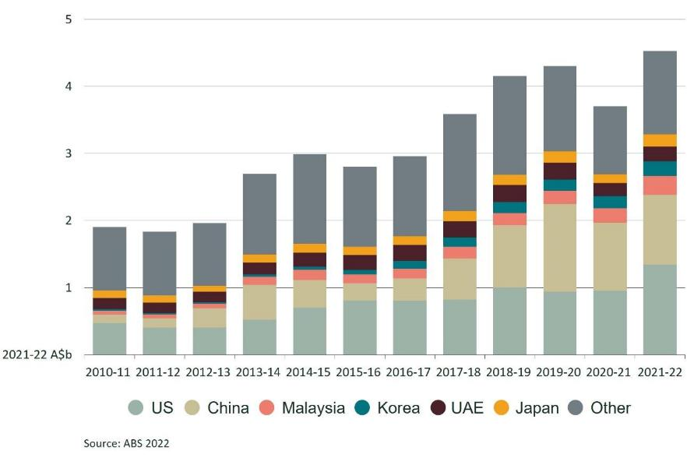

Australian sheepmeat Exports
(2021/22 DAFF)

Almost all sheep slaughter in export sheep processing abattoirs is halal, even if the meat is not to be exported to Muslim destination. This is done to maximise market opportunity for the sheep meat.
The Middle East is also an important market for live sheep for slaughter. Although these countries accept our halal system there is still a market for live sheep to enable them slaughter their own meat. This is not only for religious reasons but also for the reason that refrigeration is not universal in many of these countries so it is easier there to have meat ‘on the hoof’ until it is needed for slaughter and consumption. However, the Commonwealth Government has recently announced that the live sheep trade will be brought to an end in the coming years.
The trade of lamb to China, US and EU markets has been good for the industry as it is high value product as opposed to the mutton which is a low value product in most markets. The rapid decline in the American sheep flock stimulated demand for lamb from Australia. The European Union provides the highest return for sheep meat but quota restrictions limit the market to only about 18,000 tonne.
High quality lamb, as opposed to cheaper mutton, largely fills this market.

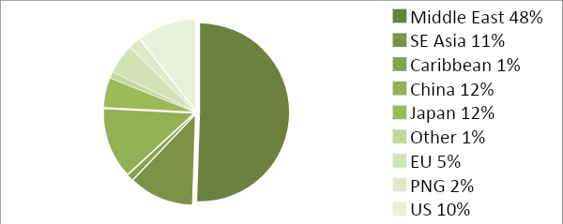

Australian Mutton Exports
(2010/11 DAFF)
The goat industry
The goat meat industry is largely based on the harvest of rangeland goats, although there are now about 200,000 goats being farmed in Australia. The rangeland goat population varies between 1-3 million head. This number varies because it is largely dependent on seasonal conditions and harvesting rates. Australia slaughters about one to two million goats annually. In 2010/11 the number slaughtered was 1.7 million head generating $125 million in exports. In addition in most years about 75,000 head are exported live mainly to Malaysia. These live goat exports are valued at almost $10 million.
Ninety-eight percent of goat meat production is exported. Approximately 40% are processed skin on like pigs and the remainder are processed skin off. The United States and Taiwan account for over 80% of Australian goat meat exports. Lesser markets include the Caribbean, Malaysia, Japan and Korea.
The goat is the fifth most consumed animal in the world. Unlike some other animals, there are practically no religious taboos on the consumption of goat meat. In fact goat meat is an important part of the diet in both Hindu and Muslim countries.
The largest producers of goat meat are the largest consumers but not the largest importers or exporters. The largest goat populations according to the FAO (2009) are in China (150 m.), India (125), Pakistan (60m) and Sudan (40m). Only China, France and Pakistan export any substantial quantities of goat meat, with each exporting about 3,000 tonnes annually.
Although Australia produces only 0.4% of the world’s goat meat, it has 57% of the world trade in goat meat and is thus the largest exporter of goat meat in the world.
The amount exported in 2010/11 was almost 26,000 tonnes for a return of $125 million (MLA 2010).
The number of goats being farmed in Australia is slowly growing because there is an increasing tendency by some farmers to breed goats for slaughter and reduce the dependency on rangeland goat sources.
There is also an increasing trend to farm rangeland goats more effectively, by controlling water and feed and by introducing high meat producing males such as Boer goats, into the rangeland population to improve yield.
Skin-on goats
Beef, mutton and lamb in Australia is all processed ‘skin-off’ which means the hide or pelt is removed on the slaughter floor. While the majority of goats are processed in the same way there is a growing international demand for ‘skin-on’ goats. This is mainly being driven by Asian and North American markets.
Skin-on goats are processed in much the same way as pigs with a scalding process followed by shaving before evisceration. The similarities between pig and skin on goat processing will be explored further in this Unit and the comparisons between the processes are critical to visually assessing the hygiene of the product.
After dispatch from the slaughter floor the skin-on carcases are further processed and exported as:
- full skin on carcases that are bagged
- ‘brown goat’ (carcase is further singed)
- six way cut skin-on goat boxed
- nine way cut skin-on goat boxed
- chilled or frozen
- cube portions.
Conducting ante-mortem inspection of sheep and goats
What are the main reasons for ante-mortem inspection?
The main reason for ante-mortem inspection is to detect those animals that may not be suitable for slaughter due to disease or other reason such as chemical residue that could render the carcase unfit for human consumption.
It is particularly important for those conditions that may not be detectable at post-mortem inspection.
Ante-mortem inspection can be separated into two parts:
- examining animals before slaughter so that you can identify and segregate animals that show signs of a disease, condition or abnormality
- deciding what action will be taken with those animals that do have a disease, condition or abnormality.
When carrying out ante-mortem inspections, it is essential to:
- detect the presence of suspected emergency or notifiable diseases
- prevent the slaughter of any animal that shows signs of a condition or disease which would make the carcase or carcase parts unsuitable for human consumption
- segregate animals that show signs of, or are suspected of, having a disease or condition, so they can be slaughtered separately and given detailed post-mortem inspection
- prevent animals that are grossly contaminated with faeces, dirt, dust or other material from entering the slaughter floor
- ensure animal welfare standards are maintained at all times.
Workplaces will have different ways of carrying out ante-mortem inspections. Inspectors must follow workplace procedures and instructions. Quality Assurance (QA) and Hazard Analysis Critical Control Point (HACCP) procedures must also be followed to prevent obviously diseased or contaminated stock entering the slaughter floor.
What regulatory requirements apply when conducting ante-mortem inspection?
Australian Standards
Part 3 of the Australian Standard for hygienic production and transportation of meat and meat products for human consumption details the requirements for:
- the supply and admission of animals for slaughter
- animal welfare
- and ante-mortem inspection and disposition.
These requirements apply to all abattoirs, both export and domestic.
Clause 6 The supply and admission of animals for slaughter
The outcomes required are:
- animals are sourced from holdings where the management of animals ensures that the wholesomeness of meat and meat products derived from the animals is not jeopardised
- animals affected by a disease or other abnormality do not contaminate other animals or jeopardise the wholesomeness of meat and meat products.
In practice this means that:
- the animals are correctly identified with ear tags so as to identify the property of origin (PIC) or if they are rangeland goats the area in which they were captured can be identified
- vendor declarations show that the animals have not been recently treated with any chemical or drugs
- animals are not from a property that is under quarantine restrictions, without approval from the relevant authority.
On arrival at the abattoir the meat safety inspector is responsible for deciding either not to admit animals that do not meet these requirements, or admitting them under strict controls, until any issues are clarified.
The meat safety inspector is also to check that:
- the animals have not been grazing on sewage affected pastures or fed materials that may recycle human or animal pathogens
- the animals have not got a notifiable or contagious disease.
All of these items are to be checked prior to the physical ante-mortem inspection by an examination of the Vendor Declaration/Waybill.
The collection and inspection of vendor declarations is generally done by the senior stock handler or livestock manager at the abattoir. The meat safety inspector needs to ensure that there is a system in place to advise them of any animals that arrive without a vendor declaration or any animals where the vendor declaration shows that there is some doubt as to the suitability of a lot of animals for slaughter for human consumption.
The usual practice at abattoirs in Australia, both export and domestic, is for the head stockman to provide the meat safety inspector or the veterinarian at export abattoirs with a kill sheet that shows the order of the animals to be slaughtered, the number in each lot, Property Identification Code (PIC) numbers and any other relevant details from the vendor declarations or waybills.
Although it is up to the company to ensure all vendor declarations are correct, it is a requirement on export abattoirs for the veterinarian to check a number of the vendor declarations on a regular basis to ensure that all animals are accounted for, and that particular market eligibilities (such as EU requirements) have been met.
On domestic abattoirs the meat safety inspector will then indicate on the kill sheet those lots that have been inspected and any animals that may have been segregated as suspects or emergency kill by the stockman or the inspector. This kill sheet will then be passed to the meat safety inspectors on the slaughter floor for reference.
On export abattoirs an ante-mortem card is prepared for each lot and accompanies the first animal of each lot to the slaughter floor.
If the meat safety inspector or OPV decides that the animals may be slaughtered, this section of the Australian Standard requires the company to have in place a system of correlation so that if any disease is found, the animal(s) can be traced back to the property of origin. This is achieved by numbering each lot as it enters the slaughter floor and relating that to a PIC.
Vendor declarations
The National Vendor Declaration (NVD) form is managed and obtained by the producer from Meat and Livestock Australia (MLA). This form accompanies animals to sale/slaughter and acts as a guarantee from the farmer to the purchaser of the livestock that the conditions detailed on the form have been met. In some states, waybills issued by state authorities are also compulsory.
The basis for a farmer/producer signing the form is participation in an on-farm quality assurance system. For sheep producers this is the Livestock Production Assurance managed by MLA.
The emphasis in the quality systems is mainly on the residue status of livestock, including source of fodder, pastures and any treatments and withholding periods, but they are also designed to offer broader assurance of the status of the animals on a whole range of food safety and commercial issues.
All meat processors have made vendor declarations from the farmer mandatory for the purchase of livestock. The programmes are supported by vendor liability legislation in the states. The programmes require producers to follow certain best practice procedures including:
- stock identification records
- staff training
- transaction and movement records
- proper labelling, storage and use of chemicals
- treatment records
- good husbandry practices including care with loading, handling and transport
- conducting internal audits of their system on a regular basis.
Correlation on the slaughter floor
Correlation is the requirement to identify all parts of a particular animal during slaughter until after all the parts have passed post-mortem inspection. This includes carcases, hides, offal and heads.
Routine correlation is achieved by recording the property identification against the lot number allocated at slaughter. With the introduction of Electronic Identification Devices to the national flock the movement of each animal will be able to be recorded. Until that is universal sheep and goats will be moved as mobs and ear tags in sheep will in theory give some guide to properties of origin.
If a carcase is to be retained correlation is achieved by the use of either temporary tags attached to the carcase at the point of inspection.
The carcase and all its parts must be able to be retrieved and correlated to the animal’s property identification code (PIC of origin).
Export requirements
Export workplace ante-mortem practices differ only marginally from the Australian Standard requirements, depending on the importing country's requirements. For example animals which are to be processed for the European market must be slaughtered first in the day or shift.
Also most overseas countries insist on veterinary ante-mortem inspection.
The Export Control (Meat & Meat Products) Rules and overseas countries' requirements must be followed. You will find details of these in the company workplace instructions.
Clause 8 Ante-mortem inspection and disposition
The outcome required is:
- only animals fit for slaughter for the purpose of producing meat and meat products for human consumption are slaughtered.
This clause basically states the following:
- Ante-mortem inspection must be carried out by a meat safety inspector.
- The meat safety inspector must carry out the inspection within 24 hours of slaughter.
- The meat business must supply the inspector with all the relevant information about the animals to be slaughtered as specified in clause 6.
The dispositions of animals after inspector are:
- passed for unconditional slaughter
- passed for slaughter subject to conditions set by the meat safety inspector (suspect and emergency kill animals)
- withheld from slaughter
- condemned.
This clause also specifies the action to be taken when disease or abnormality is suspected in that all dispositions are to be in according to Schedule 3 of the Standard AS 4696:2023.
What are the principles and procedures for the humane handling of sheep and goats?
The principles and procedures for the humane handling of sheep and goats are detailed in The Australian Standard for hygienic production and transportation of meat and meat products for human consumption clause 7.
Clause 7 Animal welfare
The outcome required is:
The minimisation of the risk of injury, pain and suffering and the least practical disturbance of animals.
The Australian Standard for hygienic production and transportation of meat and meat products for human consumption requires meat companies to have an ‘Approved Arrangement’ with their relevant controlling authority for all aspects of meat production. This Approved Arrangement requires a meat company to include animal welfare as a policy objective in their Approved Arrangement and to demonstrate commitment to this policy.
Most export slaughtering establishments meet this requirement by implementing the voluntary AMIC Industry Animal Welfare Standards for Livestock Processing Establishments Preparing Meat for Human Consumption (3nd Edition).
This Standard is based on the Australian animal welfare codes and international best practice standards.
The Animal Welfare Standard has four required outcomes in:
- management
- resources
- care of livestock
- humane stunning and sticking processes.
The Standard is supported by an Implementation Guide. The Guide identifies welfare considerations at the various steps in the slaughtering process. It provides guidance on how plants can provide evidence that they are achieving animal welfare requirements and target or animal welfare outcomes and processes.
This guideline is based on the following codes:
- Australian Model Code of Practice for the Welfare of Animals, Number 10: Animals at Slaughtering Establishments
- Operational Guidelines for the Welfare of Animals at Abattoirs and Slaughterhouses
Animal welfare is described in greater detail in the following animal welfare module, which is a core module and co-requisite for this training module AMPA3002 Handle animals humanely while conducting ante-mortem inspection.
What are the signs of common conditions responsible for abnormalities at ante-mortem and how can they be detected?
There are two types of abnormalities that need to be detected at ante-mortem inspection.
- invisible abnormalities such as chemical residues
- visible physical abnormalities.
Invisible abnormalities
The provision of wholesome meat to the consumer requires an assurance that the product does not contain residues of chemicals which may be harmful to human health.
Residues may result from intentional treatment of an animal, or if it’s fed with a drug or chemical such as pesticide for therapeutic or other purposes; or from environmental contamination.
This assurance is provided on the basis of measures designed to ensure that the product contains no residues which exceed the Maximum Residue Limit (MRL), for that chemical as set by the Food Safety Council of Australia through the National Foods Authority. Similarly, maximum permitted concentrations (MPC's) have been established for contaminants, such as heavy metals. These limits are based on scientific evaluation, and toxicology.
The National Residue Survey (NRS) provides an unbiased estimate of the frequency of residues of a range of agricultural and veterinary chemicals, and environmental contaminants in the individual commodities for targeted surveys and extension.
The NRS provides assurances to Australia's trading partners and domestic consumers of the low residue status of these commodities.
Residue compliance of meat produced at the domestic abattoirs is based on:
- participation in the NRS
- systems of animal identification and trace back when violative residues are detected
- identification and quarantine, or other appropriate management strategies, of farms known to produce animals with violative residues.
The invisible abnormalities that may be present at ante- mortem inspection such as chemical residues can only be assessed by a detailed inspection of the paper work accompanying the animals such a way bills and vendor declarations, or by individual testing of samples from slaughtered animals.
Individual testing of animals is only conducted if there are some doubts as to the chemical residue status of animals. For routine processing the vendor declarations are considered sufficient.
Inspection of the vendor declarations is an essential part of the ante-mortem inspection process.
Visible abnormalities
In order to maximize the ability to detect common visible conditions responsible for abnormalities ant ante-mortem inspection it is important that effective procedures are carried out. The AS4696:2023 Australian Standard for hygienic production and transportation of meat and meat products for human consumption does not specify how ante-mortem inspection is to be conducted, but there are ‘best practice’ procedures that should be followed.
The meat safety inspector can vary these procedures according to:
- regulatory requirements e.g. ante-mortem at export plants must be conducted under direct veterinary supervision
- company requirements
- type of animal e.g. lambs and other young animals are less likely to have disease than older animals.
When carrying out ante-mortem inspection, the animals should firstly be examined when at rest. This is because some signs of sickness or disease will not be seen when the animals are being moved. It is also very important that you look for any animal that is not displaying ‘normal’ behaviour i.e. if it is doing something different to the rest of the mob.
After observing the animals at rest, you must then examine them when they are moving. When doing this you should observe the sides, head and rear of the animals. This is so you can detect any abnormality, disease or condition.
Humane handling
It is very important that any handling or moving of animals is done quietly and humanely.
Animals that are not handled or moved correctly may become stressed. Stress can affect meat quality. A stressed, flighty or nervous animal can also injure you or stir up other animals in the same pen, resulting in injury to stock.
Signs of common conditions
Signs which may indicate disease, conditions or abnormality in livestock include:
- separating themselves from the rest of the stock
- lying down when the rest are standing
- dullness, listlessness, head down, not alert
- drooping ears
- very poor condition – emaciated
- short, shallow, rapid or loud breathing
- hunched up
- tail flicking, moistness around tail area – flystrike in sheep
- scouring, bloody diarrhoea i.e. dysentery
- excessive salivation
- tongue protruding
- enlargement of jaw bones
- excitement, i.e. excessively active and erratic behaviour
- lameness and/or swollen joints
- lesions in or around eye, i.e. cancer eye
- blood, pus or other abnormal discharges from nose, mouth, anus, vulva or penis
- enlargement or abnormality of scrotum, anus, vulva, penis or udder
- swelling cysts, abscesses or abnormal growths
- skin irritation
- skin blotching
- abnormal enlargement of belly
- broken limbs
- wounds
- faecal contamination.

What are the procedures for humane killing?
If animals are suffering it is vital that they are euthanized as soon as possible.
Suffering animals include animals with severe injuries such as broken legs. These need to be put up for emergency slaughter.
Other animals that may be suffering include animals that are moribund or near death, these need to be humanely killed immediately and the body condemned.
At abattoirs the humane killing of animals in the lairage, is usually achieved by use of a firearm. Only suitably trained and qualified people may use a firearm.
Workplace instructions must be followed for this procedure.
What are the procedures for emergency and suspect slaughter?
Emergency slaughter animals are slaughtered as soon as possible. They are usually humanely killed in the yards and enter the slaughter floor through the emergency slaughter door close to the knocking box.
Only injured animals should be handled in this way.
Sick animals should be rejected from slaughter and either killed humanely or withheld from slaughter for treatment.
Animals that are to be treated may not leave the abattoir premises for treatment as abattoirs are considered by all state authorities to be quarantine areas.
After successful treatment particular care needs to be taken to ensure that no chemical residues are present in the animals. This is achieved by ensuring withholding periods for drugs administered are strictly met.
Some animals may be considered for suspect slaughter. Animals showing evidence of heavy faecal contamination should also be put up as a lot at the end of the shift so that special procedures can be put in place to ensure cross contamination is minimised. All suspects should be put up for slaughter at the end of a shift/day. Workplace instructions must be followed for these procedures.

What WHS requirements apply when conducting ante-mortem inspection?
The WHS principles for the meat industry are explained in the training material for AMPCOR204 Follow safe work policies and practices.
Possible WHS hazards when conducting ante-mortem inspection could be:
- zoonotic diseases i.e. diseases transmissible from animals to humans
- slips, trips and falls
- injury from animals
- severe weather.
Ways of preventing or controlling these hazards are contained in workplace WHS policies and procedures. Some examples of these may be:
- wearing and using appropriate Personal Protective Equipment (PPE)
- vaccination against zoonotic diseases
- wearing appropriate footwear
- using walkways where provided
- being aware of the behaviour of animals at all times
- being aware of the location of animals at all times
- knowing the location of exit gates, ladders and steps.
What are the QA aspects of ante-mortem inspection?
The QA practices that apply to the meat industry are explained in the training material for AMPQUA302 Maintain food safety and quality programs.
All personnel conducting ante-mortem inspections and making dispositions must have a good understanding of and follow instructions detailed in the company quality assurance manual and Hazard Analysis Critical Control Points (HACCP) plan. Some of these could include:
- identification of hazards, such as faecal contamination
- preventative action
- control methods
- record keeping
- ante-mortem cards
- traceback to property of origin
- compliance with tattoo, ear tag or tail tag requirements
- delivery dockets
- vendor declarations
- LPA.
Making an ante-mortem disposition
What are common diseases and conditions responsible for abnormalities in sheep and goats?
The identification of different diseases and conditions that can affect an animal's suitability for human consumption is the first step in producing safe meat products. It is essential that these conditions are identified and the correct disposition made as to whether to slaughter the animal.
There are two types of abnormalities that need to be handled at ante-mortem inspection.
- visible physical abnormalities
- invisible abnormalities such as chemical residues.
Visible abnormalities
Schedule 3 of the AS4696:2023 Australian Standard for hygienic production and transportation of meat and meat products for human consumption details the diseases and conditions and dispositions.
It includes conditions that may be detected at ante-mortem and at post-mortem inspection. The ante-mortem conditions are reproduced below.

Diseases and other abnormalities | Dispositions for animals, carcases and carcase parts
 | The symbol [1] means carcase or carcase parts unfit for human consumption may be recovered for animal food subject to heat sterilisation. The symbol [2] means carcase or carcase parts unfit for human consumption may be saved either for animal food subject to heat sterilisation or for animal food subject to staining.
1. General findings
Dead animal |  | Animal condemned. If anthrax suspected see 2.1.1.
Dying animal or moribund state with subnormal temperature, weak pulse and disturbed senses. |  | Animal condemned
Fever, debility and general signs indicating acute disease |  | Animal condemned. Alternatively, withhold from slaughter until recovered provided no risk of spread of disease; no undue suffering and recovery considered likely with treatment.
Advanced chronic conditions with generalised signs such as cachexia or loathsome appearance |  | Animal condemned
Injury or accidental trauma during transport to or while in vicinity of abattoir |  | Animal subject to emergency slaughter or condemned
Excitement, exhaustion without signs of acute disease |  | Animal withheld from slaughter and ante-mortem repeated after adequate rest
Slight odour
2. Aetiological listing
2.1 Bacterial and related diseases
Anthrax |  | Affected animals should not be admitted to an abattoir. When detected at ante-mortem, affected animal condemned. Companion animals isolated and withheld from slaughter
Cutaneous lesions |  | Affected areas of skin condemned
Myiasis |  | Animal condemned in severe cases with sepsis or necrosis. Otherwise withhold from slaughter for treatment and resubmit for ante-mortem after recovery.
Ephemeral fever |  | Animals withheld from slaughter for treatment. Resubmitted for ante-mortem after recovery.
Metabolic disorders (transit tetany, ketosis, etc) |  | Animal condemned in severe cases. Withheld from slaughter in milder cases and resubmitted for ante-mortem after recovery.
Faecal contamination
There is a high human health risk of faecal contamination containing pathogenic bacteria such as E.coli and Salmonella. Only stock that can be slaughtered without risk of faecal contamination should be processed.
Invisible abnormalities
The Australian Standard requires the abattoir operator to advise the meat safety inspector if any animals have been exposed to chemical residues or require testing under any official residue-testing programme.
The vendor declaration forms accompanying animals should detail any restrictions such as animals having been treated or exposed to chemical and drugs and the relevant withholding period not having been met.
In addition some animals may require to be tested as part of the National Residue Survey.
The National Residue Survey is a survey managed by the Department of Agriculture where a range of foodstuffs that may be exported, including meat are surveyed for chemical residues.
There are two types of survey conducted:
- random monitoring of a range of chemicals
- targeted monitoring of specific problem chemicals.
Random survey
The random survey is conducted at all abattoirs in Australia. Meat safety inspectors collect samples in a randomised manner from a range of animals. The samples are sent to specific laboratories where they are tested for a range of chemical residues.
The results are collated to develop a picture of residue contamination in food across Australia.
If residues of a particular chemical appear to be a problem a targeted testing programme is initiated for that problem chemical.
Targeted survey
A targeted survey is initiated when a particular chemical appears to be a problem. The main targeted chemical at the moment is organochlorines in meat.
Unacceptable levels were found in beef in 1987 and this chemical has been continually targeted since that date.
The long half-life of the chemical means that it may take some years for the chemical to disappear from the environment even though the chemical itself has been banned for some years.
Note: The half-life of a chemical is the length of time it takes for quantity of the chemical in the environment to break down to half the original level.
In this targeted programme all properties have been classed into seven different categories according to the risk of organochlorin contamination on the property.
Most properties are in class C (clear) and require no targeted testing. The rest are graded according to risk:
- T1: require only one in ten animals to be tested
- T2: require one in five testing
- T3-T5: require all animals to be tested.
The latter are generally under state-controlled quarantine and require specific approval from the authorities for animals to be sent to slaughter.
In 1988 there were thousands of properties in the T5 category. There are now very few.
The Commonwealth Department of Agriculture maintains a database of properties requiring targeted testing.
Management of the company are required to access the database, prior to animals being slaughtered, to see if the property identification number is one where testing is required.
Although it is the responsibility of the company to collect samples, they must inform the relevant veterinarian or meat safety inspector of the testing requirement.
- If the animals come from T1-T2 properties the carcases are sampled and released.
- If the animals come from T3-T5 properties the carcases are held pending the results.
What dispositions can be made at ante-mortem?
The disposition for diseases is described in Schedule 3 of the AS4696:2023 Australian Standard for hygienic production and transportation of meat and meat products for human consumption.
After ante-mortem inspection, one of the following dispositions will be made about each animal. The animal will be:
- passed as fit for routine processing
- withheld from processing pending treatment for or recovery from an abnormal condition. These animals may be resubmitted for another ante-mortem inspection at a time specified by an inspector. Note: on export abattoirs suspect animals must be held for veterinary inspection
- subjected to immediate emergency slaughter to prevent deterioration of an abnormal condition, provided the condition would allow all or part to be passed for human consumption and processing would not jeopardise the hygienic production of meat
- processed under restrictions which prevent unacceptable contamination of the processing floor and which permit more detailed post-mortem inspection
- rejected as unfit for processing and destroyed by humane means and then disposed of in an approved manner.
The AS4696:2023 Australian Standard for hygienic production and transportation of meat and meat products for human consumption requires the following actions to be taken after ante-mortem inspection:
- a record of ante-mortem inspection of animals rejected for human consumption or passed as suspect or emergency slaughter must be maintained
- animals that are deemed to be affected by diseases or conditions should be segregated from healthy animals while awaiting slaughter
- groups of stock that exhibit signs or symptoms of stress must be rested before slaughter
- animals that are known to have been treated with, or exposed to a drug, chemical or biological substance, shall not be slaughtered unless any withholding period recommended on the product label has lapsed
- animals that are condemned must be humanely slaughtered
- dead animals are removed quickly for disposal.
What are the requirements for segregating stock?
It is important for humane reasons that various categories of animals are segregated during transport and in the lairage. For example:
- bulls should not be placed with cows
- ideally bulls should be segregated into individual pens as they will tend to fight.
- young animals such as lambs should be penned separately to adult animals.
After performing ante-mortem inspection, any animals that are showing signs of a disease, condition or abnormality must be segregated from the healthy animals for further detailed inspection. This will also include animals with faecal contamination. The veterinary officer, inspector or authorised person must then make a disposition and decide what action to take. Animals are segregated in four ways after ante-mortem inspection.
- Injured animals are identified for immediate emergency slaughter.
- The bulk of the animals will be passed as fit for human consumption.
- Animals with localized disease e.g. lameness or with a vendor declaration that indicates exposure to chemicals are identified as suspect for separate slaughter preferably at the end of the shift. These animals may also be withheld from slaughter until their condition improves or their chemical residue status is confirmed or abated i.e. after the relevant with holding period has passed.
- Animals with generalized disease that render them unfit for human consumption are condemned.
What are the signs of emergency or notifiable diseases?
Notifiable diseases are diseases in animals that by law must be notified or reported to relevant State or Territory authorities. It includes a number of diseases are endemic to the country e.g. anthrax and many diseases that do not exist in this country.
Animal diseases that do not exist in this country are called exotic diseases.
The list of notifiable diseases varies a little from State to State depending on local circumstances. The following list details the more common notifiable diseases in Australia. This list can vary from time to time.
Note: Although all exotic diseases are notifiable not all notifiable diseases are exotic diseases.
You need to be alert to and recognise the signs of some of the more serious notifiable diseases.
Since notifiable diseases vary from State to State you will need to contact the relevant State animal health authority for further information on the most likely or common notifiable diseases in the state.
Note: Not all notifiable diseases will be evident at ante-mortem; a few are detectable only at post-mortem.
The following chart lists some of the notifiable diseases of animals in Australia that may be evident at ante-mortem.
The list is provided for general information only and can vary from time to time. Some of the notifiable diseases are exotic to Australia, but most are endemic.
Notifiable disease | ACT | WA | NSW | NT | QLD | SA | TAS | VIC
Actinobacillosis |  |  |  | Y
Actinomycosis |  |  |  | Y
Annual ryegrass toxicity |  | Y
Anthrax | Y | Y | Y | Y | Y | Y | Y | Y
Atrophic rhinitis |  | Y |  | Y
Babesiosis (bovine) | Y | Y | Y | Y | Y | Y |  | Y
Birdsville horse disease |  |  |  | Y
Black disease |  |  |  | Y | Y
Blackleg |  |  |  | Y
Bluetongue | Y | Y | Y | Y | Y | Y | Y | Y
Botulism |  |  |  | Y
Bovine spongiform encephalopathy | Y | Y | Y | Y |  | Y | Y | Y
Buffalo fly |  |  |  |  | Y | Y |  | Y
Caprine footrot |  |  |  |  |  |  |  | Y
Cattle tick infestation due to Boophilus microplus | Y | Y | Y | Y |  |  |  | Y
Classical swine fever | Y |  |  | Y |  |  | Y | Y
Contagious pustular dermatitis (contagious ecthyma) |  |  |  | Y
Cow pox |  |  |  |  |  | Y
Equine morbillivirus | Y | Y |  | Y |  | Y | Y | Y
Fasciola gigantica | Y |  | Y |  |  | Y |  | Y
Foot-and-mouth disease | Y | Y | Y | Y | Y | Y | Y | Y
Footrot in sheep, goat and deer | Y | Y | Y |  | Y | Y
Fowl cholera |  | Y
Fowl plague |  |  |  | Y
Fowl typhoid (S. gallinarum) | Y |  | Y |  | Y |  |  | Y
Glanders | Y | Y | Y | Y | Y | Y
Goat pox | Y | Y | Y | Y | Y | Y | Y | Y
Infectious atrophic rhinitis |  |  |  |  | Y
Infectious bovine rhinotracheitis |  | Y | Y | Y |  |  |  | Y
Lumpy skin disease | Y | Y | Y | Y | Y | Y | Y | Y
Malignant tumour |  |  |  |  |  |  |  | Y
Other spongiform encephalophathies |  | Y
Ovine footrot |  |  |  |  |  |  |  | Y
Ovine ked |  |  |  |  |  |  |  | Y
Ovine lice |  |  |  |  |  |  |  | Y
Rabies | Y | Y | Y | Y | Y | Y | Y | Y
Rift Valley fever | Y | Y | Y | Y | Y | Y | Y | Y
Rinderpest | Y | Y | Y | Y | Y | Y | Y | Y
Scrapie | Y | Y | Y | Y | Y | Y | Y | Y
Screw-worm (Cochliomyia hominivorax) | Y | Y | Y | Y | Y | Y | Y | Y
Sheep ked infestation | Y |  | Y
Sheep pox | Y | Y | Y | Y | Y | Y | Y | Y
Sheep scab | Y | Y | Y | Y | Y | Y |  | Y
Spongiform encephalopathies | Y |  |  | Y | Y
Sporadic bovine encephalomyelitis |  |  |  | Y |  | Y
Strangles |  |  |  |  |  | Y
Swine dysentery |  | Y
Swine erysipelas |  | Y
Swine fever |  |  |  |  | Y | Y
Swine influenza | Y | Y | Y | Y | Y | Y |  | Y
Swine plague |  |  |  |  |  | Y
Swine pox |  | Y
Teschen disease (Porcine polioencephalomyelitis) | Y | Y | Y |  | Y
Toxoplasmosis |  | Y
Transmissible gastroenteritis of pigs | Y | Y | Y | Y |  | Y |  | Y
Transmissible spongiform encephalophathies |  |  | Y |  |  |  |  | Y
Warble-fly myiasis infestation | Y | Y | Y | Y | Y | Y |  | Y
What are the notification procedures for emergency or notifiable diseases?
The identification and notification procedures that apply of emergency animal diseases are explained in the training material for AMPMSY302 Recognise signs of emergency and notifiable animal diseases.
The procedures for identification and reporting on each abattoir should be detailed in the abattoir Emergency Animal Disease Preparedness (EADP) plan.
There should be an Emergency Animal Disease Preparedness (EADP) plan on every abattoir in Australia. Check the plan at your workplace. This plan should detail the notification procedures for emergency or notifiable diseases.
This plan should be based on the meat-processing manual of AUSVETPLAN.
AUSVETPLAN is the master plan for dealing with exotic disease. It has been designed by experts from state and commonwealth departments responsible for animal health in Australia.
The EADP plan on the abattoir should contain the following:
- action measures detailed as job cards for all responsible key personnel
- a map showing perimeter fences, drainage, yards, adjoining properties, suitable areas for burial and ponds and waste water disposal
- an up to date list of notifiable diseases
- phone numbers both home and at work of key personnel e.g. on-plant vet, senior meat safety inspector, plant manager, engineer, stock person
- location and condition of a supply of soda ash and decontamination equipment
- instructions on how disinfectants and chemicals on site may be used for disinfecting people, equipment and vehicles
- where there are reasonable grounds to suspect an exotic or notifiable disease has been found, the qualified person, i.e. a veterinarian or meat safety inspector, must implement the control procedures detailed in the plan until the State or Territory animal health authority advises otherwise, or takes control of the situation.
The first step when an exotic or notifiable disease is suspected, is to immediately notify the state or territory animal health authority, e.g. the state department of agriculture.
The District Veterinary Officer, Regional Veterinary Officer or Chief Veterinary Officer in that state will take control of the situation. The national hotline number for emergency animal diseases is 1800 675 888.
Once the authority has been notified they will tell you what to do.

Activity three – responsibilities under the company Emergency Animal Disease Preparedness (EADP) plan
Provide the trainee with a copy of the company’s EADP plan.
Ask the trainee to identify all the personnel with listed responsibilities under the plan, and to explain the role and responsibilities of each person.

Monitoring the stunning and slaughter of sheep and goats
What are the types of stunning equipment that are used on sheep and goats?
A range of equipment can be used to stun animals. The type of equipment used at each site will depend on the type and size of stock or species being processed.
It is important that the correct workplace procedures for using the stunning equipment at your site are followed.
There are four main categories of stunning equipment used:
- mechanical stunners
- electrical stunners
- controlled atmosphere or gas stunners
- firearms.
Gas stunners are not usually used on sheep; they are mainly used on pigs.
Electrical stunning
Electrical stunning is the most common form of stunning used in sheep and goats.
During electrical stunning an alternating current is passed through the animal's brain, causing loss of consciousness. The two prong stunner applied to the head is the most common one used.
This is because it is reversible and is thus favoured for halal slaughter.
There are a number of factors that affect the effective operation of electric stunners
- voltage and current
- duration and frequency of electric charge
- age and size of animal
- proper placement of electrodes
- training of operator
- adequacy of restraint.
Electric stunning induces a ‘grand mal’ fit similar to that experienced by an epileptic person. This ‘grand mal’ fit causes instantaneous unconsciousness before any pain stimulus associated with the application of the equipment can be registered on the brain. The seizure causes rigid spasms that last for 10-20 seconds.
Scientific work has shown that an electrical stunner must have sufficient current (amps) to induce a ‘grand mal’ fit for it to be effective. If the current is too low it only causes paralysis.
The relationship between current and voltage can be expressed by the following equation:
A = V⎟R where:

A current
V voltage
R resistance in ohms

Resistance is caused by the skin, wool and hair of the animal. Wetting of the skin and ensuring good contact of the electrodes with the animal reduces the resistance.
Reducing the resistance increases the current flow at the same voltage and thus makes the stun more effective. Voltage (V) and frequencies (hertz) should be in the ranges detailed below. Higher frequencies have been used to minimise blood splash, but over 500 hz the current fails to provide insensibility and can cause pain and is thus of animal welfare concern.
Note: The normal electricity supply in Australia is 240 volt and 50Hz.
The time the current is applied is also critical and varies according to the size of the animal and the voltage applied. The total electric load (current ⋅ time) for a particular weight of animal is thus also important in ensuring an effective stun.
In order to ensure that the operator knows at all times that the equipment is operating correctly and that a sufficient current is being applied to the animal the following should be provided:
- an amp meter and a volt meter in full view of the operator
- a device which prevents operation of the stunning equipment if the minimum current cannot be passed
- an visible and/or audible device that operates the whole time the current is applied to the animal.
Typical parameters for stunning as detailed in the National Animal welfare Standard for Livestock Processing Establishments are detailed below but the manufacturer’s instructions for equipment, or other expert advice, should be followed at all times.

Species | Voltage | Freq. | Minimum  Amps | Minimum stun duration
Sheep | 240 | 50 hz | 1.0 | 1 seconds
Lambs | 240 | 50 hz | 0.7 | 1 seconds
Firearms
In some circumstances, firearms are the preferred method of destruction, e.g. large boars or sows, escaped animals and emergency destruction in stockyards, paddocks or stock transports.
Firearms work on the same principal as captive bolts except that the mass of the projectile is smaller, the projectile is not restrained and the velocity is higher than a captive bolt. The firearm delivers far more impact than the captive bolt and is thus considered the most effective means of killing livestock. However, WHS issues preclude its routine use in abattoirs.
The bullet has both a concussive and a destructive effect on the brain and effectively kills the animal. There is no stipulated maximum stun–stick interval for animals shot by firearm, as the animal is effectively already dead. However, a stick as soon as possible after shooting is considered best practice to achieve a good bleed.
New developments
A new method of stunning being devised by CSIRO is showing some promise, it is called Diathermic Syncope™.
This has been used for many years by laboratories to humanely euthanize small laboratory animals such as rats. It works on the principle that heating the brain to a temperature over 42°C results in fainting or syncope.
The heating is achieved by the use of microwaves.
Early trials in cattle indicate that Diathermic Syncope is completely reversible at 42°C, and so is attractive to halal authorities.
In addition, during these trials biochemical testing of blood parameters show that it is as humane as captive bolt stunning.
Laboratory animals are euthanized painlessly at a higher temperature above 50°C.
What are the requirements for effective stunning and slaughter?
The stunning operations at each site will be governed by the site workplace procedures. These workplace procedures and policies will depend on the species and category of stock being processed.
To achieve an effective electric stun, workers need to have an understanding of the stunning process and be trained in the correct use of the stunning equipment.
There are a number of factors that affect the effectiveness of electrical stunning:
- applied voltage and current
- stun duration
- frequency of applied current
- proper placement of electrodes on the animal’s head/body (spanning the brain)
- training of operator
- animal factors (that can affect resistance to current flow).
In order to ensure that the equipment is operating correctly stunning operatives should check the amp and voltmeter regularly.
The operator should never attempt to stun animals if the equipment is not working to the specifications in the work instruction or operating procedures.
Common causes of an ineffective stun (head only) include:
- wrong positioning of the electrode
- amperage that is too low
- dirty wool and skin (increases resistance)
- stray current
- poor electrode contact with the animal
- dirty electrodes
- electrode contact areas that are too small
- animal dehydration
- long hair or wool
- interrupted contact during a stun.
The correct positioning of the electrodes is a vital component for getting an effective stun. The electrodes must be positioned across the brain and not the brain stem. To achieve this, the electrodes must be placed forward of the ears. If this does not occur the animal is only paralysed and not stunned.
Horns in adult rams can make it difficult to apply the electrodes in the correct position, so extra care needs to be taken with these animals or a captive bolt used instead.

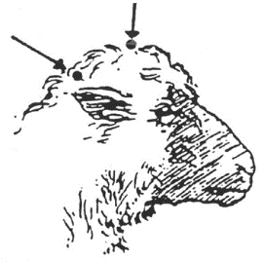
How is the effectiveness of stunning assessed?
Certain physical signs should be observed in the electrically stunned animal in order to satisfy the operator that the stun has been effective. These signs of an effective electrical stun are characterised by two phases:
- immediate epileptiform seizure with all limbs extended (tonic phase)(10-20 seconds). Eyelids clamped shut, jaws clamped shut
- a clonic (kicking) phase (15-45 seconds).
The presence of these two phases in sequence is a sign of a good stun.
When the current is applied to the animal it becomes rigid and normal breathing ceases. During the tonic phase the head becomes raised and the hind legs are flexed into the body. The forelegs may be flexed to begin with and then gradually straighten out. Rigidity lasts for 10-20 seconds followed by a relaxation phase and the onset of the kicking (clonic) phase.
If the animal shows paddling or kicking movements with its legs as soon as the current stops it is probably not properly stunned. There is no point in trying to assess corneal reflexes and other signs during these two phases as the electrical stunning process masks them. Any recommencement of breathing is a sign of a bad stun.
Sticking and bleeding
Animals are stuck and bled immediately after stunning in order to stop the blood supply to the brain. This is necessary to make them brain dead before further dressing procedures commence. Death is usually considered to have occurred when the electrical potential of the brain has dropped below 10 micro-volts as measured by an electroencephalogram. This usually occurs within 10 seconds for sheep and goats.
So for humane reasons it is vital that the stun stick interval is a short as possible and no further dressing occurs until after the required time to reach death has occurred. The main purpose of bleeding is to ensure death of the animal before it recovers from the stun.
For these reasons the maximum stun to stick intervals as detailed in the National Animal Welfare Standard for Livestock Processing Establishments should not exceed 25 seconds in sheep and goats.
Further details about monitoring stunning can be found in the unit AMPA3003 Assess effective stunning and bleeding.
What corrective action must be taken in the event of ineffective stunning or bleeding?
Animals may suffer when stunning procedures fail.
There must be provision for appropriate back-up stunning equipment to be available to minimise pain, distress or suffering to the animals.
If the initial stun is not fully effective then a number of actions have to be taken. These will be described in the work instructions. They must cover both corrective action (i.e. resolving the immediate issue) and preventive action (i.e. preventing it from happening again).
The immediate action, upon the discovery of an ineffectively stunned animal or an animal showing signs of sensibility on the bleed-line, must be to re-stun. Animals showing signs of sensibility on the bleed-line must also be re-stuck after re-stunning.
If ineffective stunning becomes a recurring or consistent problem then it is important to:
- report this to the supervisor
- check the voltage/charges/air pressure being used
- check the placement of the stunner
- check the routine maintenance of the stunner.
In most plants, stunning is monitored daily to ensure:
- that the animals are being stunned effectively first time
- that the stun/stick intervals are observed
- that excessive numbers do not build up in the stun/stick areas
- the use of incorrect voltages, cartridges, air pressure or gas levels or the incorrect placement of stunning equipment.
What regulatory requirements apply to the assessment of stunning and bleeding?
The AS4696:2023 Australian Standard for Hygienic Production and Transportation of Meat and Meat Products for Human Consumption requires meat companies to have an Approved Arrangement with their relevant controlling authority for all aspects of meat production. This Approved Arrangement requires a meat company to include animal welfare as a policy objective in their Approved Arrangement and to demonstrate commitment to this policy.
To meet this requirement many abattoirs are implementing the provisions of the AMIC Industry Animal Welfare Standards for Livestock Processing Establishments Preparing Meat for Human Consumption (3rd Edition).
This Standard is based on the Australian animal welfare codes and international best practice standards.
The AMIC Animal Welfare Standard has four requirements in terms of:
- management
- resources
- management and care of livestock
- humane stunning and sticking processes.
The Standard is supported by an Implementation Guide. The Guide identifies welfare considerations at the various steps in the slaughtering process. It provides guidance on how plants can provide evidence that they are achieving animal welfare requirements and target or animal welfare outcomes and processes.
This guideline is based on the following codes:
- Australian Model Code of Practice for the Welfare of Animals, Number 10: Animals at Slaughtering Establishments
- Operational Guidelines for the Welfare of Animals at Abattoirs and Slaughterhouses
Animal welfare is described in greater detail in the following animal welfare module, which is a core module and co-requisite for this training module AMPA3002 Handle animals humanely while conducting ante-mortem inspection.
Anatomical structure of sheep and goats
The basic skeletal structure of ovine and caprine species relevant to post mortem inspection
The core unit AMPA3119 Apply food animal anatomy and physiology to inspection processes details the anatomical and physiological elements that apply to all species.
The skeleton provides the basic structure of the animal, and helps to protect the delicate internal organs. The bones articulate with one another at joints. They are joined at these joints by strong bonds of fibrous tissue and are held in place by a system of ligaments and muscles. The skeleton of animals can be divided into two major parts:
- the axial skeleton, which includes the vertebral column, the ribs, the sternum and the skull
- the appendicular skeleton, which includes all the bones of the limbs
- in the fore limb, the scapula, humerus, radius and ulna, carpus, metacarpus and phalanges;
- in the hind limb, the pelvis (ilium, ischium, pubis, acetabulum), the femur, tibia and fibula, tarsus, metatarsus and phalanges.

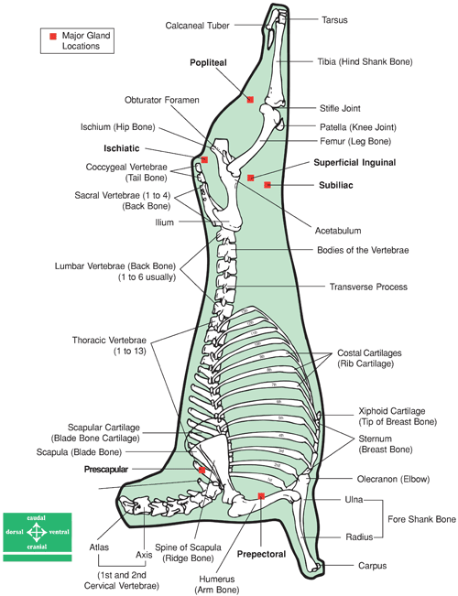
A sheep side showing skeleton and main lymph nodes
© AUSMEAT

At slaughter the head is removed and the fore and hind legs are removed at the carpal and tarsal joints respectively. The carcase is also split in half as in the diagram prior to meat inspection.
This skeletal framework carries the muscle systems that form the complete carcase. In addition the half carcase or side at inspection includes blood vessels and the lymphatic system. The lymphatic system is probably the most important part of the carcase as any disease causing organisms or abnormalities such as cancerous tumours will tend to show up there. For this reason the lymph nodes should get particular attention during post mortem inspection.
The internal organs of the animal (viscera) will have been removed during slaughter and will need to be inspected separately.
The features of the lymphatic system of sheep and goats relevant to post mortem inspection
The lymphatic system is a system of ducts, vessels and nodes that run parallel to the venous blood circulatory system. The lymphatic system can be likened to a drainage system that drains away excess body fluids. Because blood, under pressure due to the pumping of the heart, passes through the capillaries, part of the plasma is constantly leaving the circulatory system and moving into the tissue spaces, carrying nutrients etc. to the tissues. Very little of this fluid is reabsorbed by the capillaries, so a system is needed to drain the excess tissue fluid. This need is filled by the lymphatic system.
The lymphatic system:
- drains excess fluid from tissues
- filters and kills bacteria
- produces white blood cells that are part of the body’s defence
- absorbs and transports fats from the intestines to the blood stream.
The lymphatic system is made up of:
- lymph capillaries
- lymph ducts and lymph vessels
- lymph nodes
- tonsils
- haemolymph nodes
- spleen
- lymph nodes.
Lymph nodes filter harmful bacteria from the lymph. They are also one of the body’s major sources of white blood cells. The characteristics of lymph nodes are that:
- afferent lymph vessels deliver lymph to a lymph node
- efferent lymph vessels drain lymph away from a lymph node
- regional lymph nodes drain specific areas of the body
- terminal lymph nodes receive lymph from other lymph nodes and empty lymph into a major lymph duct or trunk
- evidence of infection in a specific lymph node indicates infection in the area that node drains
- lymph nodes are a major indicator of the health of an animal at post-mortem inspection
- all lymph passes through at least one lymph node
- lymph nodes vary greatly in size and shape, colour and texture between species and within species and within individual animals.
The inspection of lymph nodes is an essential part of meat inspection. Lymph nodes in all species are found in roughly the same position.
The following diagram shows the approximate position of key lymph nodes in the carcase and viscera of cattle, sheep, goats, pigs, horse, deer and camelids.
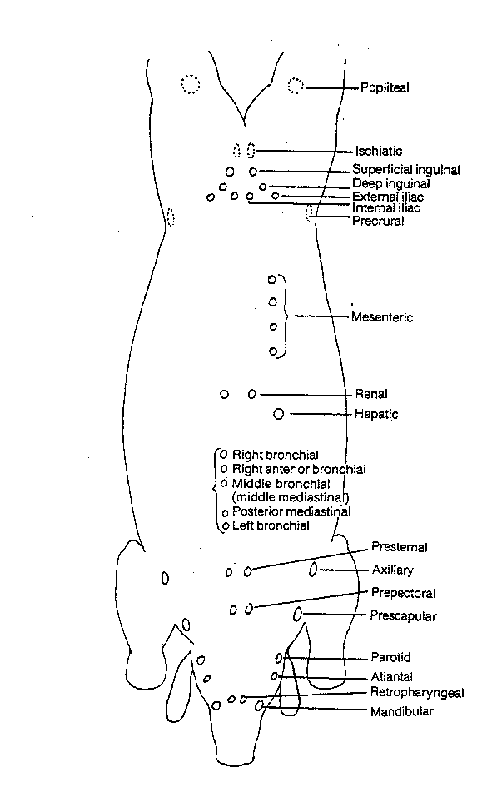
Diagram of the principal lymph nodes in the body of domestic animals
There is some variation in size and precise location between the species due to anatomical differences..
These differences are detailed in the ante-mortem and post-mortem inspection modules for each species.
The elements of ovine/caprine internal organs that are different to other domestic animals
The spleen
The spleen is a large lymphoid organ, but is supplied with blood. It acts as a store of blood and also functions to destroy aged red blood cells. In this process it saves iron from the haemoglobin to be reused in the manufacture of new red blood cells.
The spleen of a sheep (ovine) is firmly attached to the rumen and is roughly triangular in shape and is soft; it generally weighs less than 100g.
The spleen of a goat (caprine) is similar to the ovine spleen but tends to be more rectangular in shape. The weight is generally less than 100g.
The Heart
Sheep
The ovine heart has three ventricular furrows. A small os cordis is present in older sheep. The heart weighs about 80-120 grams. The fat is very white and sets firm.

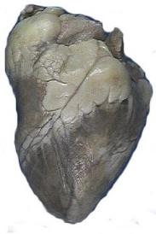

Sheep heart
Goats
The caprine (goat) heart has generally only two ventricular furrows and not three as in sheep. The apex is more rounded than in a sheep. The heart cartilage is ossified in older animals. It weighs 150-200 g. In rangeland goats with narrow chests the heart also tends to be narrow, lacks the fat cover of sheep hearts and tends to be smaller than in the same sized sheep. The picture below is from a well-fed domestic goat not a rangeland goat.
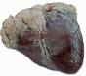

Goat heart

Respiratory system
The respiratory system and the lungs in particular is the common primary or first sites of infection. This is because it is:
- in direct contact with the external environment
- a moist and warm environment
- made up of a fine, tubular network in which bacteria and foreign materials can become lodged to set up sites of irritation, inflammation and bacterial infection.
The respiratory system is made up of nostrils, nasal cavities and mouth, pharynx, epiglottis, larynx, trachea and lungs.
In domestic animals there are two lungs, one on the right and one on the left-hand side of the chest. The lungs are further divided into lobes. These are the apical, cardiac and diaphragmatic lobes on each side.
The exact arrangement varies markedly between the species. (See Table below)
The bronchioles, carrying air to all parts of the lung, terminate in small air sacs called alveoli. The alveoli are lined by a thin epithelium and are extremely closely opposed to the small blood capillaries of the lung.
This enables oxygen to diffuse across to the red blood cells, and carbon dioxide to diffuse from the blood into the air.
Animal | Trachea | Bronchi | Lungs Description | No of R. lobes | No of L. lobes
Sheep | Similar to cattle but smaller | Two on the right and one on the left | Dense and leathery | 4-4 | 3
Goat | Similar to sheep | Two on the right and one on the left | Lungs appear smaller and the interlobular fissures deeper than in sheep | 4-5 | 3
The lungs in both species contain the following lymph nodes which are associated with the relevant bronchi:
- right bronchial lymph node
- right anterior bronchial lymph node
- middle bronchial lymph node (middle mediastinal lymph node)
- posterior mediastinal lymph node
- left bronchial lymph node.
Inspection of these nodes is an essential part of meat inspection of the lungs.
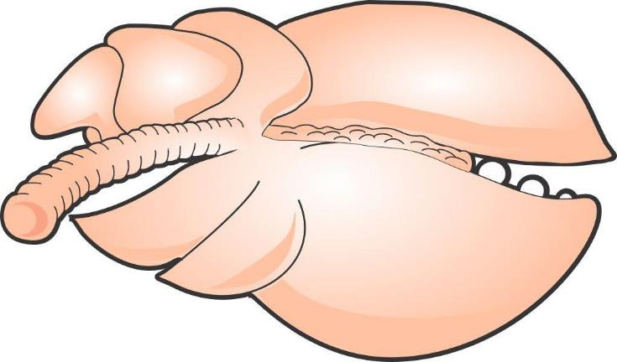
Right anterior bronchial
Left bronchial
Right bronchial
Middle bronchial
Posterior mediastina

Diagram bovine lung showing relevant lymph nodes
The digestive system
The prime function of the digestive system is to break down and absorbs food and water and to expel the wastes of digestion.
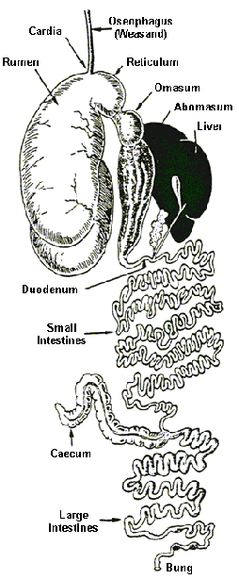
Ovine digestive system
Note: The digestive system of sheep, cattle and camelids are very similar as they are all ruminants and have four stomachs.
The digestive system is made up of:
- mouth – teeth and tongue
- pharynx
- oesophagus
- stomach – in ruminants these are the rumen, reticulum, omasum and abomasum
- small intestine – consisting of the duodenum, jejunum and ileum
- large intestine – consisting of the ascending, transverse and descending colons
- rectum
- anus
- accessory glands, organs:
- liver and gall bladder
- salivary glands
- pancreas
- peritoneum – a lubricated serous membrane which lines all the abdominal viscera, that is stomach, small and large intestines and the abdominal cavity.
Mouth teeth, tongue and pharynx
The mouth teeth tongue and pharynx are located in the head. Like the respiratory system, the head is the common primary or first sites of infection. This is because it is:
- in direct contact with the external environment
- a moist and warm environment.
This means that the lymph nodes of the head are an important indicator of disease, in particular the retro pharyngeal lymph nodes.
The tongue
The tongue varies widely among the various domestic animals.
Sheep | Thick and short with rounded tip; the centre of the tip is slightly  grooved; 18-24 circumvallate papillae on the back edge of the tongue
Goats | Very similar to the sheep; the groove in the centre of the tip is  slightly deeper; 12 circumvallate papillae on the tongue
Stomach
The primary function of the stomach is to completely break down food through the action of micro-organisms and gastric juices.
Sheep and goats are ruminants and have four compartments in their stomachs, the rumen, reticulum, omasum and abomasum.
The first three chambers are basically fermentation vats where bacteria breakdown the cellulose in grasses into simpler compounds for digestion. The final chamber, the abomasum, is where the gastric juices are made and secreted and where true digestion takes place.
Gastric juices contain a very strong acid and a variety of enzymes that breakdown the food to their components. The walls of the stomach are protected from the acid by mucus.

Dorsal curvature

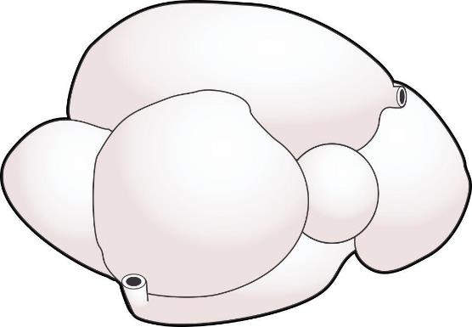
Right longitudinal grooves
Oesophagus
Neck
Reticulum
Abomasum
Pylorus
Duodenum
Ventral sac of Rumen
Ventral curvature
Ovine stomach
Small intestine
The primary function of the small intestine is the absorption of food components into the blood stream and lymph, although additional digestion of food does occur in the first part of the small intestine, the duodenum.
The small intestine is divided into three sections, the duodenum, jejunum and ileum.
The small intestine in sheep and goats is about 24 metres.
Large intestine
The primary function of the large intestine is the reabsorption of water.
Characteristics of the large intestine are:
- the large intestine in in sheep and goats is about 4.5 metres
- it does not contain villi ( finger-like projections that line the entire length of the small intestine)
- caecum (a pouch connected to the junction of the small and large intestines).
Rectum and anus
The primary function of the rectum and anus is the expulsion of indigestible food components.
Accessory organs of digestion
The accessory organs which aid digestion are:
- salivary glands
- pancreas
- liver.
The salivary glands produce saliva, a lubricant for food thus assisting the animal in chewing and swallowing.
Characteristics of salivary glands are that:
- they are located in the mouth
- sheep and goats have three paired sets of salivary glands:
- parotid
- sub-mandibular
- sub-lingual.
The pancreas has a primary digestive function of secreting digestive enzymes to help in the breakdown of foods. It is pale brown in colour and lobulated in appearance and is located near the start of the small intestine.
The liver has many functions, including:
- converting excess sugar into glycogen, storing it for later use
- breaking down surplus proteins and manufacturing others when required
- detoxifying poisons
- breaking down fats, and assembling others for storage
- storing iron for blood production
- producing bile that assists the digestion of fats and also the neutralisation of gastric juice.
The livers of various domestic species vary considerably in size and shape.

Sheep - The sheep liver is similar in shape to beef livers but can be differentiated from calf liver by the blunt pointed caudate lobe which does not exist in beef livers. It weighs about 0.5 kg. There is also a small thumb piece near the hilus.

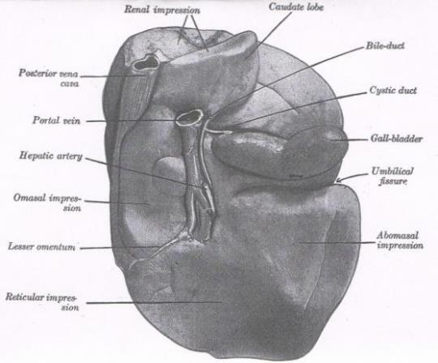

Sheep’s liver

Goats - The goat liver is very similar to that of the sheep. It is slightly thinner and has a sharp-pointed caudate lobe, which also appears to be narrower than that in the sheep. There is no thumb piece. Livers from rangeland goats often have adhesions on the surface.
The renal system
The renal system consists of the kidneys, ureters bladder and urethra. The purpose of the system is to eliminate the by-products of metabolism from the body.
The kidneys are often left in the carcase for inspection but they should be enucleated from their outer capsule so that the tissues can be properly inspected. Any infection in the blood stream can show itself in the kidneys.
There are two kidneys in sheep and goats. They are located one on each side, in the upper loin region in the abdomen at about the level of the third lumbar vertebrae. They are reddish in colour and surrounded by a capsule. They are often encased in a large quantity of fat, particularly in well fed animals.
Sheep and goat kidneys
The kidneys in these two species are extremely similar. They are both bean-shaped, dark-red organs. The goat's kidneys appear slightly more rounded and globular. Each kidney weighs about 60-80g.

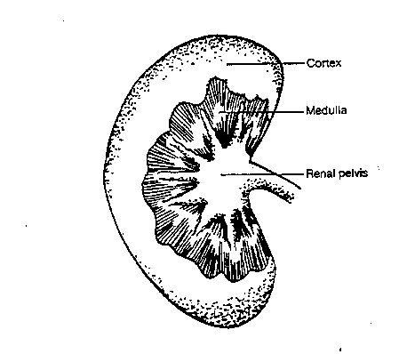
Sheep kidney cross section
Conducting post-mortem inspection of sheep and goats
What are the main reasons for post-mortem inspection?
The main reason for post mortem inspection is to identify those conditions that can affect the suitability of a carcase and its parts for human consumption.
It is an organoleptic inspection i.e. it is an inspection by physical means of a carcase and all its parts using all of an inspectors senses, including:
- visual inspection (observation)
- palpation
- incision and
- smell where appropriate.
If any doubts arise as to the suitability of the meat for human consumption the carcase and its parts can be retained and samples taken and sent to a laboratory for analysis.
What are regulatory requirements associated with post-mortem inspection?
Schedule 2 of the AS 4696:2023 Australian Standard for the hygienic production and transportation of meat and meat products for human consumption details the basic post mortem inspection procedures that must be applied to all animals slaughtered at abattoirs in Australia, both export and domestic.
Some export markets have additional requirements. These are detailed later.
Note #1: Equivalent procedures are simpler procedures that can be used when either product is not being kept for human consumption or certain diseases have been officially declared as not present in the particular State or Territory.
Note #2: Additional procedures are procedures carried out when disease is detected or suspected. These are detailed in Schedule 2 Table 4. It also includes procedures for product that is not normally kept for human consumption.
What are the procedures for conducting post-mortem inspection?
The precise procedure for what has to be inspected during a post-mortem inspection will depend on whether the plant is domestic or export-registered. However, the general requirements that the meat safety officer must meet when carrying out the inspection are:
- ensuring only animals that have undergone ante-mortem inspection are presented for post-mortem inspection
- ensuring carcases and carcase parts are correctly identified and correlated for post-mortem inspection
- ensuring carcases and carcase parts are correctly presented for post-mortem inspection
- ensuring the resources and conditions necessary to effectively conduct post-mortem inspection are provided
- undertaking post-mortem inspection of carcases and/or carcase parts as directed
- making a disposition to the suitability of the carcase and its parts for human consumption
- retaining carcases and carcase parts for veterinary examination (in export plants by the OPV and in domestic plants by the State DPI Veterinary Officer) or laboratory examination
- ensuring, where appropriate, the quality and integrity of the product is maintained.
There are four basic procedures used in meat inspection: Observation, smell, incision and palpation.
Note: observation is sometimes referred to as ‘visual inspection’.
Observation
The Department of Agriculture’s definition of observation is “To visually inspect a carcase and its parts in such a manner that abnormalities capable of being located are detected. In all instances observation refers to each surface of the item being observed. Observation may require the physical handling and/or incision of the carcase and/or carcase parts to allow complete observation of all surfaces. Observation also includes the use of the sense of smell to detect abnormal odours.
All parts of an animal must at least be visually observed. It is important to look for changes in colour and symmetry and variations to the norm. The importance of this aspect of inspection is the main reason why people with colour blindness are generally not accepted as meat inspectors.
Visual inspection cannot be done from a distance. Since all surfaces of the carcase and organs need to be visually inspected it is necessary as part of the inspection procedure to handle and turn organs and parts as appropriate. Carcases must be carefully observed, paying particular attention to:
- colour
- odour
- symmetry
- general condition
- age.
In the case of the internal surfaces particular attention should be paid to:
- the pelvic cavity
- the peritoneum and pleura
- the thoracic and abdominal surfaces of the thick and thin skirts
- the cut surfaces of the sternum and spine
- the ribs.
In the case of external surfaces particular attention should be paid to:
- the hocks and trotters
- the tail
- the sticking area
- the axillary regions
- the anus.
All surfaces of offal presented for inspection must be visually inspected, this means offal must be turned during inspection.
Incision
It may be for access purposes to improve observation or it may be a specific incision required by legislation to detect disease. It is essential that proper equipment be used for incision. Such equipment includes a keen knife, a safety hook and a well-dressed steel. Lymph nodes that require incision should be carefully sliced such that the cut surfaces are laid open for examination like the leaves of a book.
Unnecessary mutilation must be avoided and to facilitate a tidy `job', different knives may be used for different inspection procedures.
Palpation
Palpation is equally as important as observation and incision and must be carried out diligently. Organ palpation requires firm pressure by the fingers and palms of the hand over the entire organ surface. Organs palpated include the kidneys, liver, spleen and lungs.
Lymph-node palpation requires firm pressure with the fingers and thumbs, rolling the nodes between them.
Laboratory analysis
Sometimes samples may need to be sent to a laboratory for diagnosis. This may be because:
- the cause of the condition is unknown
- for laboratory confirmation of notifiable diseases such as hydatids in Tasmania
- as part of routine sampling for residue sampling programmes etc.

What is the process for identifying and detecting abnormalities?
The AS4696:2023 Australian Standard for the hygienic production and transportation of meat and meat products for human consumption specifies the inspection requirements for animals slaughtered in domestic and export abattoirs in Australia.
The following tables from that Standard detail the procedures that must be conducted to identify and detect abnormalities in all the relevant species.
In addition there are further procedures that need to be followed specifically for certain export markets. These are detailed after the tables.
Table 1. Carcase
 | Cattle & buffalo | Calves | Sheep & goats | Lambs | Pigs | Horses | Deer
All carcases | Observe internal and external surfaces of carcase (including tail, musculature, exposed bone, joints, serous membranes).
Lymph nodes
Superficial  Inguinal | See note #1 | Observe | See note #2 | Observe | See note #3 | Incise | Observe
Internal iliac | See note #1 | Observe | Palpate | Observe | Observe | Observe | Observe
Lumbar | — | — | Palpate | Observe | Observe | — | —
Ischiatic | — | — | Palpate | Observe | — | — | —
Precrural | — | — | See note #2 | Observe | — | Palpate | —
Superficial cervical | — | — | See note #2 | Observe | — | Palpate | —
Popliteal | — | — | Palpate | Observe | — | — | —
Prepectoral | — | — | — | — | — | Incise | —
Equivalent procedures
Note #1: Cattle and buffalo – Palpate the superficial inguinal and internal iliac lymph nodes or, for animals in an area in relation to which the relevant Commonwealth, State or Territory Authority requires minimal risk inspection for tuberculosis (other than animals subject to conditional slaughter or emergency slaughter), an equivalent procedure is to observe the nodes (other than in bulls and mature females).
Note #2 : Sheep and goats – Palpate the superficial cervical, precrural and superficial inguinal lymph nodes or, other than animals subject to conditional slaughter or emergency slaughter, an equivalent procedure is to excise and discard these nodes without inspection.
Note #3: Pigs – Observe the superficial inguinal lymph nodes or, other than animals subject to conditional slaughter or emergency slaughter, an equivalent procedure is to excise and discard these nodes without inspection.

Table 2. Viscera
 | Cattle & buffalo | Calves | Sheep & goats | Lambs | Pigs | Horses | Deer
Lymph nodes
Bronchial & mediastinal | See note #1 | Palpate | Palpate | Observe | Palpate | Incise | Palpate
Portal | Palpate | Palpate | Observe | Observe | Palpate | Palpate | Observe
Mesenteric | Observe | Observe | Observe | Observe | Observe | Observe | Observe
Lungs | Palpate, except in lambs where observe. Additionally, bronchi opened and internal surfaces observed when saved for human consumption.
Heart | Palpate. Incise internal musculature 3-4 times in cattle and buffalo.
Liver | Palpate, except in lambs where observe. Incise main bile ducts transversely and observe contents, except in pigs where inspection of bile ducts not required (see note #2 for option).
Gastrointestinal tract | Observe. Observation of oesophagus not required in cattle, buffalo, calves or deer unless recovered for human consumption.
Spleen | Observe | Observe | Palpate | Observe | Observe | Palpate | Observe
Kidney (enucleated) | Palpate | Palpate | Observe | Observe | Palpate | Palpate | Palpate
Other tissues and organs | Thymus, pancreas, non-gravid uterus, bladder, testicles and penis observed when recovered for human consumption.
Equivalent procedures
Note #1: Cattle and buffalo – Incise bronchial and mediastinal lymph nodes or, for animals in an area in relation to which the relevant Commonwealth, State or Territory Authority requires minimal risk inspection for tuberculosis (other than animals subject to conditional slaughter or emergency slaughter), an equivalent procedure is to observe the nodes.
Note #2 : All animals – Procedures for the incision of main bile ducts and observation of contents may not be required at a meat business by the controlling authority.

Table 3. Head
 | Cattle & buffalo (see note #3) | Calves (see note #1) | Sheep & goats (see note #1) | Lambs (see note #1) | Pigs (see note #1) | Horses (see note #1) | Deer (see note #1)
All carcases | Observe external surfaces. For cattle, buffalo and horses observe the oral, buccal and nasal cavities.
Lymph nodes
Submaxillary | See note #2 | — | — | — | See note #4 | Incise | —
Parotid | See note #2 | — | — | — | — | Incise | —
Retropharyngeal | See note #2 | — | — | — | — | Incise | —
Cervical | — | — | — | — | See note #4 | — | —
Masticatory muscles (internal and external) | Incise | — | — | — | — | — | —
Tongue | Palpate | — | — | — | — | Palpate | —
Gutteral pouch | — | — | — | — | — | Palpate | —
Other tissues | Tongue roots in cattle, buffalo and horses observed when recovered for human consumption
Equivalent procedures
Note #1: All animals – Other than cattle, buffalo, horses and animals subject to conditional slaughter or emergency slaughter, an equivalent procedure is to remove and discard the head without inspection where tissues, including tongue, are not recovered for human consumption.
Note #2: Cattle and buffalo – Incise submaxillary, parotid and retropharyngeal lymph nodes or, for animals in an area in relation to which the relevant Commonwealth, State or Territory Authority requires minimal risk inspection for tuberculosis (other than animals subject to conditional slaughter or emergency slaughter), equivalent procedures are:
1. observe only, or
2. excise and discard these nodes without inspection.
Note #3: Cattle and buffalo – Other than animals subject to conditional slaughter or emergency slaughter, for animals in an area in relation to which the relevant Commonwealth, State or Territory Authority requires minimal risk inspection for tuberculosis, an equivalent procedure is to discard the head without inspection when tissues, including tongue, are not recovered for human consumption.
Note #4: Pigs – Incise and observe submaxillary and cervical lymph nodes or, other than animals subject to conditional slaughter or emergency slaughter, equivalent procedures are:
1. observe only, or
2. excise and discard these nodes without inspection.

Table 4. Additional procedures when specific diseases are detected or suspected
Disease | Inspection procedure
Tuberculosis in cattle and buffalo | Incise atlantal, prescapular, prepectoral, suprasternal, superficial inguinal, iliacs, ischiatic, precrural, portal and mesenteric lymph nodes. Incise popliteal lymph node where necessary to determine the extent of infection. All viscera, serous membranes, spinal cord and severed vertebral column inspected by observation, palpation and, where necessary, incision. Udders incised and observed.
Tuberculosis in pigs | Incise retropharyngeal, parotid, bronchial, mediastinal, portal, gastric, mesenteric, superficial inguinal, , lumbar, precrural, prescapular and deep inguinal lymph nodes. Viscera and serous membranes inspected as above for cattle.
Tuberculosis in horses | As above for cattle.
Tuberculosis in deer | Incise submaxillary, retropharyngeal, parotid, bronchial, mediastinal, mesenteric, portal, superficial inguinal, iliac, ischiatic and suprasternal lymph nodes. Incise popliteal lymph node where necessary to determine the extent of infection. Viscera and serous membranes inspected as above for cattle.
Cysticercus bovis In cattle, buffalo and deer | Incise masseter and heart muscles, incise tongue, incise diaphragm after removal of serous membranes and observe all exposed muscle surfaces.
Cysticercus celluosae in pigs | As above for C. bovis.
Sparganosis in pigs | Observe retro-peritoneal tissues after removal of the peritoneum. Where further evidence of infestation revealed, also observe main muscle seams of the hind limbs. Incise as necessary to determine extent of infection.
Export inspection procedures
The AS 4696:2023 Australian Standard for the hygienic production and transportation of meat and meat products for human consumption specifies the inspection requirements for animals slaughtered in domestic and export abattoirs in Australia. These have been described above.
These requirements form the minimum standard of inspection. However, the inspection procedures at export registered plants may vary quite considerably from those specified in the Standard, as they have been negotiated with overseas countries over a number of years.
Basic inspection procedures according to the Australian Standard are required to be performed at all export registered plants for all basic markets.
The United States of America’s procedures are required to be performed at all times in US listed establishments.
European Union procedures are required to be performed when EU production is occurring, i.e. only when production is destined for the EU market and in EU listed plants.
It is worth noting that many markets insist on either the US or the EU standard for access to their markets.
For example Canada, Puerto Rico and Mexico require US listing before they will list an establishment.
EU listing is required by dependencies of most EU countries e.g. the Canary Islands a dependency of Spain requires EU listing before product will be accepted.
Other countries that require EU listing before product will be accepted or listing approved include Namibia, Switzerland and Mayotte.
Additional inspection procedures for US markets
There is only one additional inspection procedure for the United States market. It does not apply to sheep or goats
Additional inspection procedures for European markets
All species
Viscera
If lungs are to be collected for edible purposes, the trachea and the bronchi must be incised along the longitudinal axis.

What WHS, hygiene and sanitation requirements apply when conducting post-mortem inspection?
The company work instructions will set down all the WHS and hygiene and sanitation requirements for working on the slaughter floor and when conducting post mortem inspections.
These will require you to:
- wash your hands between carcases or when contaminated
- wear all your PPE like aprons and boots which can be cleaned regularly and easily
- follow the sanitary sequence which is to handle edible product (heart, lung, kidney) before handling inedible materials (intestines)
- sterilise your knife between carcases and when contaminated and after steeling
- change your uniform if it is grossly contaminated
- wash your hands before and after work.
These practices will protect your health and minimise cross contamination.
You should always wear the Personal Protective Equipment (PPE) set down in the company work instructions or WHS policy.
PPE will include all or some of these:
- hand protection like mesh and cut-resistant gloves
- hearing protection
- footwear
- aprons
- uniforms
- hair net
- helmet/bump hat.
It is important to handle diseased or contaminated product that may require trimming in a way that avoids contamination of clean parts of the carcase. This may involve holding the affected parts with a hook and trimming from a clean area to remove offending material.
The workplace will also have a ‘dropped meat policy’ for product that accidently contacts the floor. This will need to be followed if product is dropped.
What QA issues relate to post-mortem inspection?
There are a number of quality assurance issues that relate to post mortem inspection. They will be detailed in the Company’s Quality Assurance program and work instructions. Issues that will be covered include:
- ensuring carcases and carcase parts are correctly presented for post-mortem inspection
- performing the correct procedure according to the Australian Standard and export market requirements if applicable
- ensuring only wholesome product is passed for human consumption
- ensuring trace-back requirements to ante-mortem inspection is maintained
- ensuring correlation is maintained between head, carcase and viscera until after disposition has been made
- retaining carcases and carcase parts for veterinary examination (export plants only) or laboratory examination when required
- limiting cross contamination during inspection
- ensuring, where appropriate, the quality and integrity of the product is maintained
- the maintenance of records as required by the workplace instructions.
What are the common conditions responsible for abnormalities at post-mortem and what are the correct dispositions?
There are a range of conditions and abnormalities that can affect the wholesomeness of a carcase and its parts for human consumption. When passing judgement on a carcase and its parts during post mortem inspection, several points must be taken into consideration. They are:
- the nature of any abnormality
- whether it is localised or generalised
- whether it is chronic or acute
- the possible cause of the condition/disease
- the possible risk to human health from any abnormal condition.
The list of abnormalities and the disposition to be taken at post mortem inspection is detailed in the tables below reproduced from Schedule 3 of the AS4696:2023 Australian Standard for the hygienic production and transportation of meat and meat products for human consumption.
Note: words in italics have been added by the author for clarity.
Detection of these abnormalities is by following the stated procedures detailed previously.

Column 1 | Column 2
Diseases and other abnormalities | Dispositions for animals, carcases and carcase parts
 | The symbol [1] means carcase or carcase parts unfit for human consumption may be recovered for animal food subject to heat sterilisation. The symbol [2] means carcase or carcase parts unfit for human consumption may be saved either for animal food subject to heat sterilisation or for animal food subject to staining.
1. General findings
Dead animal |  | Animal condemned. If anthrax suspected see 2.1.
Dying animal or moribund state with subnormal temperature, weak pulse and disturbed senses. |  | Animal condemned
Fever, debility and general signs indicating acute disease |  | Animal condemned. Alternatively, withhold from slaughter until recovered provided no risk of spread of disease; no undue suffering and recovery considered likely with treatment.
When the above are detected at post-mortem |  | Carcase and all its carcase parts condemned
Advanced chronic conditions with generalised signs such as cachexia or loathsome appearance |  | Animal condemned
Injury or accidental trauma during transport to or while in vicinity of abattoir |  | Animal subject to emergency slaughter or condemned
Excitement, exhaustion without signs of acute disease |  | Animal withheld from slaughter and ante-mortem repeated after adequate rest
Generalised disease conditions such as emaciation, anaemia, oedema or degeneration of organs |  | Carcase and all its carcase parts condemned.
Septicaemia, pyaemia or toxaemia |  | Carcase and all its carcase parts condemned
Foetuses and undeveloped neonatal animals |  | Carcase and all its carcase parts condemned
Abnormal odour caused by metabolic conditions, feedstuff, chemicals or sexual odour
Pronounced odour |  | Carcase and all its carcase parts condemned[1]
Slight odour |  | Hold overnight, if odour dissipates it is fit for human consumption. May do a cooking test.
2 Aetiological listing
2.1 Bacterial and related diseases
Anthrax |  | Affected animals should not be admitted to an abattoir. When detected at ante-mortem, affected animal condemned. Companion animals isolated and withheld from slaughter
When detected at post-mortem, affected carcase and all its parts condemned
Blackleg |  | Carcase and all its carcase parts condemned
Botulism |  | Carcase and all its carcase parts condemned
Malignant oedema. |  | Carcase and all its carcase parts condemned
Enterotoxaemia |  | Carcase and all its carcase parts condemned
Tuberculosis:
In cattle and buffaloes
- Generalised with evidence of systemic involvement; more than one organ affected; miliary lesions in any organ; evidence of active infection or extensive infection of peritoneum or pleura. |  | Carcase and all its carcase parts condemned
- Localised infection |  | Affected carcase part, including drained part, condemned; or affected organ condemned
In pigs
- Generalised |  | Carcase and all its carcase parts condemned
- Localised in submaxillary or mesenteric lymph nodes (avian type) |  | Affected carcase part condemned
In horses and deer. |  | Carcase and all its carcase parts condemned
- Actinomycosis and Actinobacillosis:
- Localised in head |  | Head and tongue condemned
Evidence of generalisation such as lesions in lungs or other viscera, or other signs such as extreme loss of condition |  | Carcase and all its carcase parts condemned
Leptospirosis:
- Acute |  | Carcase and all its carcase parts condemned
- Chronic, localised |  | Affected kidneys condemned
Listeriosis |  | Carcase and all its carcase parts condemned
Salmonellosis |  | Carcase and all its carcase parts condemned
Swine erysipelas:
- Acute |  | Carcase and all its carcase parts condemned
- Localised arthritis or endocarditis without signs of systemic effects |  | Affected joint and associated lymph node condemned; when affected, heart condemned
Cutaneous lesions |  | Affected areas of skin condemned
White scours, omphalophlebitis, polyarthritis and other septicaemic conditions of new-born animals |  | Carcase and all its carcase parts condemned
Johne’s disease |  | Intestines and mesentery condemned
Strangles |  | Affected carcase parts condemned
Purpura haemorrhagica |  | Affected carcase parts condemned
Botryomycosis:
- Severe cases with evidence of systemic effects such as cachexia |  | Carcase and all its carcase parts condemned
- Less severe cases |  | Affected carcase parts condemned
Corynebacterial infections in submaxillary and cervical lymph nodes in pigs |  | Affected nodes condemned
Melioidosis |  | Carcase and all its carcase parts condemned
Caseous lymphadenitis:
- Generalised involvement in carcase and viscera with evidence of systemic effects such as cachexia |  | Carcase and all its carcase parts condemned
- Less extensive forms of the disease |  | Affected organs or carcase parts condemned
Infectious ovine epididymitis (B. ovis) |  | Affected testicles condemned
Necrobacillosis:
Acute with lesions in a number of sites or evidence of systemic involvement |  | Carcase and all its carcase parts condemned
Localised lesion in liver or other organ |  | Affected liver or organ condemned
Foot rot:
- Acute with secondary infection of organs or extreme loss of condition |  | Carcase and all its carcase parts condemned
- Chronic with encapsulated abscess in liver or lungs |  | Affected organs condemned
Anaplasmosis and Babesiosis:
- Acute with intense jaundice and other signs of systemic involvement including fever; liver enlargement; and kidney congestion |  | Carcase and all its carcase parts condemned
- Subacute with mild jaundice which dissipates within 24 hours of slaughter |  | Carcase parts condemned
Eperythrozoonosis:
- Acute with intense jaundice and other signs of systemic involvement including fever; liver enlargement; and kidney congestion. |  | Carcase and all its carcase parts condemned
- Subacute with mild jaundice which dissipates within 24 hours of slaughter |  | Carcase parts condemned
2.2 Parasitic conditions.
Cysticercus bovis:
- General infestation |  | Carcase and all its carcase parts condemned
- Light infestation, small number of degenerated cysticerci |  | Affected viscera condemned. Cysts and surrounding tissue trimmed from carcase and condemned. Remainder of carcase and parts passed conditionally fit for human consumption subject to treatment by freezing (no warmer than –12 °C deep muscle temperature for not less that 10 days in carcases and 20 days in boned meat)
Cysticercus cellulosae:
- General infestation |  | Carcase and all its carcase parts condemned
- Light infestation, small number of degenerated cysticerci |  | Affected viscera condemned. Cysts and surrounding tissue trimmed from carcase and condemned. Remainder of carcase and parts passed conditionally fit for human consumption subject to treatment by freezing (no warmer than –12 °C deep muscle temperature for not less than 5 days in carcases or boned meat).
Cysticercus ovis:
- General infestation (more than 5 cysts found in musculature). |  | Carcase and all its carcase parts condemned
- Light infestation, small number of degenerated cysticerci |  | Affected viscera condemned. Cysts and surrounding tissue trimmed from carcase and condemned.
Cysticercus tenuicollis |  | Cysts and affected serous membranes trimmed from carcase or carcase part and condemned
Sparganosis:
General infestation |  | Carcase and all its carcase parts condemned
Light infestation |  | Tissue trimmed from carcase and condemned. Remainder of carcase and parts passed conditionally fit for human consumption subject to treatment by freezing (no warmer than –12°C deep muscle temperature for not less than 5 days in carcases or boned meat).
Echinococcosis |  | Affected organs condemned
Pulmonary and gastrointestinal strongylosis |  | Affected organs condemned.[1] in case of lungs.
Oestrus ovis infestation in sheep
Myiasis |  | Animal condemned in severe cases with sepsis or necrosis. Otherwise withhold from slaughter for treatment and resubmit for ante-mortem after recovery.
Stephanurus dentatus |  | Affected carcase parts condemned
Onchocerciasis |  | Lesions and affected tissues trimmed from carcase and condemned
2.3 Protozoal diseases
Sarcosporidiosis |  | Affected carcase parts condemned
Coccidiosis |  | Affected intestines condemned
2.4 Viral diseases
Ephemeral fever |  | Animals withheld from slaughter for treatment. Resubmitted for ante-mortem after recovery.
Bovine virus diarrhoea/mucosal disease:
- Acute infection with evidence of systemic involvement |  | Carcase and all its carcase parts condemned
- Chronic infection with lesions localised to alimentary tract |  | Affected intestines condemned
- Bovine para-influenza |  | Affected lungs condemned
Bovine leucosis:
- Multiple lesions or lesions in multiple organs |  | Carcase and all its carcase parts condemned.
- Localised lesion (e.g. mesentery) |  | Affected gastrointestinal tract or other organs condemned
2.5 Fungal diseases
Aflatoxicosis:
- Acute with generalised signs including jaundice; swelling of liver; ascites and mesenteric oedema |  | Carcase and all its carcase parts condemned
- Subacute |  | Affected liver and kidneys condemned
Epizootic lymphangitis. |  | Affected skin and related tissues condemned. Any affected organs condemned.
2.6 Non-infectious conditions
Tumours:
- Circumscribed benign tumours; neurofibromas of intercostals nerves and nerve plexes |  | Depending on extent, lesion trimmed and condemned or affected carcase part condemned[1]
- Malignant tumours (carcinoma, sarcoma) |  | Carcase and all its carcase parts condemned[1]
- Multiple tumours (evidence of metastasis or multiple lesions in different organs) |  | Carcase and all its carcase parts condemned[1]  Note any sign of spread from a primary site is a sign of malignancy
Metabolic disorders (transit tetany, ketosis, etc) |  | Animal condemned in severe cases. Withheld from slaughter in milder cases and resubmitted for ante-mortem after recovery.
Jaundice:
- Haemolytic or toxic |  | Carcase and all its carcase parts condemned
- Obstructive (slight, dissipate within 24 hours of slaughter |  | Carcase parts condemned
- Obstructive (severe) |  | Carcase and all its carcase parts condemned.
- Residues in excess of nationally established maximum limits |  | Carcase and all its carcase parts condemned. Companion animals and carcases tested for residue levels.
Delay in Evisceration:
- Evidence of deterioration or putrefaction |  | Carcase and all its carcase parts condemned
- Localised changes in viscera |  | Viscera condemned
Ecchymosis |  | Affected carcase parts condemned[2]
Foreign objects, including grass seeds:
- Accompanied by generalised signs such as fever or sepsis |  | Carcase and all its carcase parts condemned
- No evidence of generalised signs |  | Foreign object removed; affected tissues trimmed from carcase and condemned
3 Topographic listing
3.1 Nervous system
Acute encephalitis and meningitis |  | Carcase and all its carcase parts condemned
Brain abscesses:
- Associated with pyaemia |  | Carcase and all its carcase parts condemned
- Localised lesion |  | Affected brain condemned
3.2 Cardiovascular system
Acute pericarditis with accumulation of exudate; septicaemia; degenerative changes in organs or abnormal odour |  | Carcase and all its carcase parts condemned
Chronic pericarditis |  | Affected heart and pericardium condemned
Endocarditis:
- Associated with generalised signs |  | Carcase and all its carcase parts condemned
- Without complications. |  | Affected heart condemned
Heart lesions of non-infectious nature |  | Affected heart condemned
Worm aneurisms in horses:
- Infarction confined to hind leg |  | Affected quarter condemned
- Peritonitis, circulatory disturbances in mesentery and intestines |  | Carcase and all its carcase parts condemned
3.3 Respiratory system
Sinusitis. |  | Affected head condemned
Peracute pneumonia such as severe purulent bronchopneumonia; gangrene of the lungs; or necrotic pneumonia. |  | Carcase and all its carcase parts condemned
Multiple pulmonary abscesses |  | Carcase and all its carcase parts condemned.
Bronchitis |  | Affected lungs condemned
Pneumonia or bronchopneumonia |  | Affected lungs condemned[1]
Atelectasis, emphysema, pigmentation, aspiration of blood, scalding water or ingesta |  | Affected lungs condemned[1]
3.4 Pleura
Diffuse serofibrinous, suppurative or gangrenous pleurisy |  | Carcase and all its carcase parts condemned.
Adhesions and patches of fibrinous tissue |  | Affected serous membranes stripped and affected parts condemned
3.5 Gastrointestinal tract
Acute enteritis:
Septic, diphtheritic or haemorrhagic enteritis’ enlargement of spleen or degeneration of organs |  | Carcase and all its carcase parts condemned
With congested mesenteric lymph nodes without other signs |  | Affected intestines condemned
Chronic gastro-intestinal catarrh |  | Affected intestines condemned
Emphysema of mesentery in pigs |  | Affected mesentery and intestines condemned
3.6 Peritoneum
Peritonitis:
- Acute, diffuse or extensive |  | Carcase and all its carcase parts condemned
- Localised |  | Affected serous membranes stripped and affected parts condemned
Adhesions and patches of fibrinous tissue, localised encapsulated abscesses |  | Affected parts condemned
3.7 Liver
Telangiectasis, cyst formation |  | Affected liver or part of liver condemned[1]
Fatty infiltration, parenchymatous infiltration |  | Affected liver condemned[1]
Hepatitis of toxic, parasitic or non-specific nature |  | Affected liver condemned[1] for parasitic and nonspecific causes
Miliary necrosis of liver in calves |  | Carcase and all its carcase parts condemned
Parasitic lesions/nodules |  | Affected parts of liver trimmed and condemned
Abscesses |  | Affected liver condemned
3.8 Kidney
Calculi, cyst formation, pigmentation |  | Affected kidneys condemned[1]
Nephritis (including parasitic nephritis):
- Acute with evidence of uraemia, oedema or abnormal odour of urine |  | Carcase and all its carcase parts condemned.
- Chronic with no systemic effects |  | Affected kidneys condemned
Bladder rupture |  | Carcase and all its carcase parts condemned.
3.9 Genital tract
Inflammation of uterus:
- Acute metritis (septic or necrotic, putrefied foetus). |  | Carcase and all its carcase parts condemned
- Chronic metritis |  | Affected uterus condemned
Retention of placenta:
- Accompanied by fever or evidence of other systemic effects |  | Carcase and all its carcase parts condemned
- With no signs of systemic effects |  | Affected uterus condemned
Prolapse, torsion or rupture of uterus accompanied by fever or peritonitis |  | Carcase and all its carcase parts condemned
Orchitis/epididymitis |  | Affected organ condemned
3.10 Udder Mastitis:
- Septic, gangrenous |  | Carcase and all its carcase parts condemned
- No signs of systemic involvement. |  | Udder condemned
Oedema |  | Udder condemned
3.11 Musculo-skeletal system
Fractures:
- Uncomplicated (recent or healing) |  | Fracture trimmed from carcase and condemned
- Infected with signs of generalised effects |  | Carcase and all its carcase parts condemned
Osteomyelitis:
- Gangrenous, suppurative or accompanied by metastasis |  | Carcase and all its carcase parts condemned
- Localised |  | Affected part trimmed from carcase and condemned
Myositis and Muscular Dystrophy |  | Affected parts condemned[1]
Abnormal pigmentation |  | Affected parts condemned[1]
Arthritis:
- Acute infectious |  | Carcase and all its carcase parts condemned
- Non-infectious, chronic with no systemic effects |  | Affected part condemned
3.12 Skin
Wounds and Cellulitis:
Infected wounds and discharging lesions accompanied by generalised signs such as fever or sepsis |  | Carcase and all its carcase parts condemned
Granulating wounds or no evidence of generalised signs |  | Affected tissues trimmed from carcase and condemned
Bruising:
- Generalised or secondary changes in carcase |  | Carcase and all its carcase parts condemned[2]
- Localised |  | Affected tissue trimmed from carcase and condemned. [2] for trimmings
Burns:
- With extensive oedema or systemic signs such as fever |  | Carcase and all its carcase parts condemned
- Localised |  | Affected tissue trimmed from carcase and condemned[1]
Eczema and chronic dermatitis in pigs |  | Affected skin trimmed from carcase and condemned
Erythema and acute dermatitis (e.g. photosensitisation):
- With systemic effects such as fever |  | Carcase and all its carcase parts condemned
- No evidence of systemic involvement |  | Affected skin trimmed from carcase and condemned[1]

Grass seed contamination in sheep and lamb carcases
How do sheep become contaminated by grass seeds?
The lambs and sheep become contaminated when grazing or travelling through paddocks or laneways that have a heavy seed load. Grasses that cause problems include:
- Barley grass
- Brome grass
- Chilean needle grass
- Erodium
- Silver grass
- Spear grass
- Wire grass.
The irony is that the better the season is feed-wise the worse the grass seed contamination risk is. In years with good spring rainfall and producers have to be vigilant in their management to ensure lambs remain seed-free.
Why is grass seed a problem for producers?
Grass seeds first infest the animal’s fleece and within days the seeds are imbedded in the skin and carcase of the animal. On farm seed infestation from grasses like brome grass, barley grass, spear grass, silver grass and geranium can result in poor animal growth rates, susceptibility to infections, tetanus, flystrike and damage to eyes, ears, feet and the mouth.
Sheep or lambs with even moderate grass seed infestation will not be as productive and put on less weight because of blindness, lameness or infections. These infections can increase significantly the mortality rates in a flock. In addition lambs with heavy grass seed infestation more easily lose their mothers and sick ewes make poor mothers. These problems associated with grass seed make the management of grass seed infestation in lambs not only an economic issue but also an animal welfare issue that should not be ignored.
If animals are shorn before sale the fleece from grass seed infested lambs and sheep are worth significantly less for the grazier.
However even after the lamb is unloaded at the abattoir the producer’s returns continue to be impacted by grass seed.
Firstly the worth of sheep skins are greatly reduced by the presence of seeds. Then the producer incurs further losses when selling over the hooks as the increased trimming reduces the carcases dressed weight and the carcases may also be downgraded.
In addition many processors charge a grass seed penalty typically further reducing the payment to producers.
Why is grass seed contamination scored?
The scoring of grass seed contamination is of use to both processors and producers.
Collecting data on grass seed contamination enables processors to identify producers that are suppling contaminated livestock. Processors can then take steps to protect themselves from the impact grass seeds can have on their profitability and market access.
This matter of losing market access through grass seed detection at Port of Entry inspection cannot be overstressed as it is a very real threat to meat processors and should never be underestimated. A number of plants have lost access to valuable markets because of physical contamination such as grass seeds being detected at Port of Entry.
The first step processors can take to protect themselves is to identify lots that are infested with grass seeds which may require modifying the slaughter floor process by:
- slowing the chain to enable trimmers to remove all the grass seed
- putting more trimmers on cope with the increased trimming required
- putting carcases on a retain rail for additional training
- redirecting the carcases to less sensitive markets
- downgrading infested carcase to boning and freezing.
If the lot is a direct consignment then the supplier is readily identified from the NVD and the livestock buyer or supply chain manager can contact the producer. The company may choose to impose a grass seed penalty and/or the producer can be advised of new consignment arrangements such as the plant only taking a very small trial consignment before accepting any more lambs from the producer.
In many cases the producer may be completely unaware of the extent of grass seed contamination and the impact it is having on the payment for their livestock.
With saleyard or boxed lots it is more difficult to identify the particular supplier or PIC. However by keeping grass seed records it is possible to identify the grass seed risk when purchasing stock from particular saleyards at particular times of the year.
WI | How is grass seed contamination scored?
The scoring system involves three steps.
The first step is to quickly assess a lot and decide if grass seed is an issue.
The second step involves assessing carcases against a measure of heavy, medium or light contamination which can also be described as heavy, medium and low impact on the carcase.
The third step requires the person assessing the carcases to record a summary of their assessment for the lot.
Step 1
When grass seed contamination is detected in a specific lot then a decision has to be made as to whether or not it requires
- extra trimming on the retain rail
- extra trimmers
- the chain speed to be decreased.
If any change to normal staffing or speed of the chain has to be made for a lot due to grass seed then contamination should be scored and recorded.
Step 2
Having decided that grass seeds are a problem in a particular Lot the person responsible for scoring the grass seed contamination has to look at the carcases and allocate scores
Any seed in Section 1 means the carcase is described as having heavy seed contamination or grass seed having heavy impact seed.
If there is no seed in Section 1 but there is seed in Section 2 then the carcase is described as having medium seed contamination or medium impact seed.
If there is only seed in Section 3 then the carcase is described as having light seed contamination or having low impact seed
It is important to note that the presence of infected grass seeds means the carcase is graded as heavily contaminated (heavy impact) regardless of the location of the grass seed.
Step 3
Grass seed for a lot is scored in two ways. Firstly the total percentage of carcases affected by grass seeds is noted e.g. 80% of carcases were affected by grass seeds.
Then secondly there will be a breakdown into categories e.g.
- 40% heavy impact
- 30% medium impact
- 10% light impact
- 20% no grass seed.
Realistically for high volume processing plants with fast chain speeds these figures will be estimates.
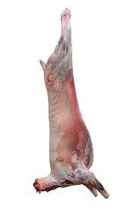

1
2
3
1
What are the types and symptoms of emergency diseases that can be detected at post-mortem?
The range of emergency diseases that should be considered during ante-mortem and post mortem inspection has been detailed earlier in this document in the ante-mortem section.
Most emergency diseases are more readily detectable at ante-mortem inspection rather than post mortem inspection.
But if at post mortem inspection a number of animals from one lot showing symptoms of fever are noted, serious consideration should be given to the suspicion of an emergency disease.
The disease may be an endemic disease such as Salmonella but it could also be an exotic disease.
The holding of carcases while a decision is made is an important part of the process.
Detailed notes on Emergency Diseases are available the training support materials for AMPMSY302 Recognise signs of emergency and notifiable animal diseases.
What regulatory requirements apply when handling an affected carcase?
Carcases may be identified at post-mortem inspection as having:
- a pathological condition
- gross contamination
- another abnormality requiring further treatment and/or a more detailed inspection.
They may be directed to the retain rail to undergo further treatment and inspection. The post-mortem inspector marks these carcases or carcase parts with the relevant retain tag, as per workplace procedures.
There needs to be an area set aside for re-inspection purposes. It should only be used for this purpose. The equipment needed is:
- lighting at 600 lux
- handwash and equipment sterilisation facilities and liquid soap
- condemned meat bin/barrow/chute
- cutting equipment – saw, knife etc.
- product wash facilities
- quartering facilities.
The requirements you need to meet when retaining a carcase will depend on whether the plant is domestic-registered or export-registered. The requirements are generally as follows.
Action | Explanatory notes
Supervise | retain rail personnel in the detection and removal of pathology, contamination or other abnormality requiring treatment.
Inspect | all external and internal carcase surfaces, including cut muscle, to ascertain if the reason for retaining has been rectified  all carcase parts (viscera) that have been retained to assist with disposition.
Palpate | lymph nodes and suspect lesions and, where necessary, incise to detect disease conditions and/or pathological change.
Sanitary sequence | observe  palpate  incise.  NB: Wash hands after handling material unfit for human consumption. Thoroughly sterilise knife after trimming material unfit for human consumption.
Note: for further information refer to AMPA3046 Undertake retain rail operations.
The question of disposition i.e. what to do with the retained carcase and its parts is a question that should be addressed in conjunction with AS4696:2023 Australian Standard for the hygienic production and transportation of meat and meat products for human consumption, which offers good guidelines on disposition.
But in the end it is up to you, the meat inspector to make the decision. The decision should be made on good scientific principles.
When making disposition on a carcase, an organ or any other parts you can make a disposition on:
- the total carcase (including its parts)
- a part of the carcase
- pass as suitable for human consumption and remove the retain tags
- retain requiring further inspection and apply a retain tag and supervise the segregation of the carcase and/or carcase parts in the retain facility
- retain requiring further treatment and apply a retain tag and supervise the segregation of the carcase and/or carcase parts in the chiller retain facility
- relegate to an inedible purpose other than condemnation, i.e. animal food or pharmaceutical purposes; identify the carcase and/or carcase parts as suitable for the designated purpose, e.g. pet food only and supervise the removal of the carcase and/or carcase parts to the designated processing area
- identify the carcase and/or carcase parts as condemned by the application of the condemned stamp or the application of ink and/or disposal in a condemned tub/bin or chute.
What hygiene and sanitation and WHS requirements apply when handling an affected carcase?
The company work instructions will set down all the hygiene requirements for working on the slaughter floor and for handling affected carcases.
These will require the inspector to:
- wash hands between carcases or when contaminated
- wear PPE like aprons and boots which can be cleaned regularly and easily
- follow the sanitary sequence which is to handle edible product (heart, lung, kidney) before handling inedible materials (intestines)
- sterilise knife between carcases and when contaminated and after steeling
- change uniform if it is grossly contaminated
- wash hands before and after work.
These practices will protect health and minimise cross contamination.
Inspectors should always wear the Personal Protective Equipment (PPE) set down in the company work instructions or WHS policy.
PPE will include:
- hand protection like mesh and cut-resistant gloves
- hearing protection
- footwear
- aprons
- uniforms
- hair net.
It is important to handle diseased or contaminated product that may require trimming in a way that avoids contamination of clean parts of the carcase. This may involve holding the affected parts with a hook and trimming from a clean area to remove offending material.
The workplace will also have a ‘dropped meat policy’ for product that accidently contacts the floor. This will need to be followed if product is dropped.
Retaining carcases
What are the procedures for retaining carcases on the slaughter floor?
When minor defects cannot be removed by an inspector on the slaughter floor or if a carcase requires a more detailed assessment the carcase may be passed onto the retain rail for further treatment and assessment.
Carcases on the chain can be identified in a number of ways to indicate the pathology or defects that need to be removed or re assessed in the retain rail. This includes knife cuts, tie-on tags, stick-on tickets, plastic tags and formal approved retain tags (ECA4) in export plants. Domestic plants may have their own tags for retaining product and workplace procedures will detail how this is to be done.
These tags are temporary tags and are removed by the trimmer on the retain rail after the defects have been addressed.
The ECA4 Tag or equivalent on the other hand can only be removed by an authorised person. It is generally used for more permanent control over product where more detailed assessments need to be done to determine the suitability of the product for human consumption.
What are the procedures for retaining carcases in a chiller?
If carcases are to be retained in the chiller because it may take some time for laboratory results to return, the carcases to be retained must not only be identified by tags but also need to be locked in such a way by a meat safety inspector or other authorised person, so that it cannot be used for human consumption until the results of tests have been received.
Carcases may be locked on the rail or in a special cage and records need to be maintained of any such actions. Workplace procedures will detail how this is to be done.

PPE requirements for post-mortem inspection
What PPE is required to perform post-mortem inspection?
Personal Protective Equipment to be used will be set down in the work instruction and WHS procedures. PPE may include:
- protective hand and arm covering
- protective head and hair covering
- head wear
- coat and apron
- work safety or waterproof footwear
- protective boot covers
- ear plugs/muffs
- eye and facial protection
- waterproof clothing.
What workplace requirements apply when using PPE?
According to the National Guidelines for Health and Safety in the Meat Industry:
‘ PPE and clothing are those items of equipment worm by an employee to minimise or eliminate exposure to specific occupational hazards’
The emphasis is always on eliminating the hazards thereby making it unnecessary for workers to wear Personal Protective Equipment (PPE). However, it is not always possible to eliminate the hazards, and PPE may be required to protect the worker from the consequences of exposure. For example, workers may be required to wear ear plugs to reduce the likelihood of deafness resulting from exposure to an excessively noisy environment. Workers in the meat industry are frequently required to wear PPE. In this case it is the employers responsibility to ensure PPE is:
- assigned to the worker for their exclusive use
- cleaned and maintained after use
- stored when not in use
- inspected and repaired regularly
- checked for continued functioning and effectiveness.
It is also the employer’s responsibility to ensure training is provided as appropriate. Workers should receive training about:
- proper use of PPE
- the deficiencies and restrictions of PPE
- fitting PPE and how to test for fit
- use of PPE
- maintenance of PPE
- storage of PPE
- identification of faults in PPE
- procedure for replacing PPE.
How should PPE be used, maintained and stored?
Workers are responsible to:
- wear PPE as instructed by the supervisor and as set out in the work instruction
- fit PPE to ensure it is used to maximum benefit
- check for any faults and replace it if faulty
- follow maintenance procedures as instructed by the supervisor and set out in work instructions
- store PPE as instructed.
Examples of specific PPE are included in the National Guidelines for Health and Safety in the Meat Industry.

Taking pathological and residue samples
How are lesions and tissues necessary for determining dispositions identified?
The type of lesions and tissues necessary for determining dispositions will depend on the nature of the abnormality and the nature of the suspected disease condition. For certain conditions such as granulomas, it is a regulatory requirement to take a sample for laboratory analysis for Bovine tuberculosis. It is vital under these circumstances that there is an accurate record of the property of origin of the animal so that trace back can be instituted if necessary.
For other conditions the list below indicates what suitable specimens should be taken.
What are the requirements for collecting and submitting specimens?
Sometimes in order to make a correct disposition on product at post mortem inspection or to confirm suspicion of a notifiable disease it will be necessary to take samples for laboratory analysis.
In each State or Territory there is usually a Veterinary Laboratory where samples can be sent for analysis. Detailed information on the collection and handling of samples for each laboratory should be obtained directly from the laboratory. Most Laboratories have a manual that will outline the collection and handling requirements. The following is a brief guide of the samples required for various types of tests.
Bacteriology
Swabs of tissue e.g. heart blood, intestinal content, in transport medium and /or 30 ml of chilled lesion, fluid or tissue e.g. liver, lung, intestine in a screw-capped container.
Biochemical tests
Full 10 ml plain and Lithium/ heparin blood tube.
Gross Pathology
Representative samples of affected tissue with any adjacent normal tissue.
Haematology
Full 10 ml EDTA blood tube and blood smear.
Histopathology
A representative sample of affected tissue with adjacent normal tissue. Tissue should be 1 cm thick in ten times their volume of buffered formalin solution.
Parasitology
Approximately 30g of faeces for faecal egg count.
Serology
A full 10 ml plain blood tube.
Toxicology
Approximately 50 ml of ingesta, faeces or flesh tissue.
Virology
Full 10 ml plain tube and EDTA blood tubes.
30 ml of fresh chilled tissue e.g. heart, spleen or swab of lesion or tissue in PBGS.
How are specimens for residue testing taken?
Specimens for residue testing will vary according to the type residue that is suspected. For example if cadmium is suspected kidney samples will be taken. If pesticides are suspected samples could include meat or offal such as livers.
It is vital under these circumstances that there is an accurate record of the property of origin of the animal so that trace back can be instituted if necessary.
The workplace instructions will describe what samples to take. If not the relevant authority responsible for meat safety in each state can provide advice.
The relevant laboratory doing the testing will also advise what type of specimen they require.
How are results interpreted?
The interpretation of the results of residue sampling will be determined by the laboratory. They will advise if the result is below or over the regulatory limit for that residue.
If the result is over the regulatory limit public health authorities will decide what is to happen to the carcase.
What are the requirements for retaining carcases while waiting for results?
If carcases are to be retained in the chiller because it may take some time for laboratory results to return, the carcases to be retained must not only be identified by tags but also need to be locked in such a way by a meat safety inspector or other authorised person, so that it cannot be used for human consumption until the results of tests have been received.
Records need to be maintained of any such actions and workplace procedures will detail how this is to be done.

Bibliography
These publications were used to develop this training material.
Eddie Andriessen Meat Safety Quality and Veterinary Public Health in Australia 11th edition Penny Farthing Publishing PO Box 190 Woodville SA
Food Standards Australia New Zealand Australian Standard for the Hygienic Production and Transportation of Meat and Meat Products for Human Consumption FRSC technical report No 3 AS 4696:2023 CSIRO Publishing
AMIC National Animal Welfare Standards for Livestock Processing Establishments Preparing Meat for Human Consumption 2nd Edition (2010)
Model Code of Practice for the Welfare of animals: Livestock at Slaughtering Establishments
Commonwealth Department of Agriculture
Export Control Act 2020
Export Control (Meat & Meat Products) Rules 2021
Manual of Importing Country Requirements – European Union
United States
National Residue Survey – Approved Laboratories for Chemical Residue Testing
Note: Other than Eddie Andriessen’s book all of the above can be accessed at Elmer 3
http://www.agriculture.gov.au/export/food/meat/elmer-3

Additional resources
Registered Training Organisations (RTOs) should refer to the Unit-by-Unit listing of resources on the MINTRAC website www.mintrac.com.au for additional resources to support the delivery of this Unit.
RTOs which develop or identify additional resources are encouraged to advise MINTRAC so that these can also be added to the Unit-by-Unit listing.
The Exam Generator
The Exam Generator is a question bank containing hundreds of questions related to meat safety and Quality Assurance. There are two CDs in the set – one for RTOs (Albert) to create the exams and a student CD (Eddie) that creates electronic practice exams containing all the same questions.
Meat Inspection Currency tool
The Meat Inspector Currency exam generator generates quizzes for the assessment of the currency of a meat inspector’s knowledge.

