AMPMSY 402

Perform ante and post-mortem Inspection Bovine

Training support materials

Australian Meat Processing Training Package
Certificate III in Meat Processing

Table of contents
AMPMSY 401 i
Perform ante and post-mortem Inspection Bovine i
Training support materials for 6
Breeds of cattle and/or buffalo and their market requirements 6
What are the major breeds of commonly slaughtered cattle and/or buffalo and what are their distinguishing features? 6
Beef cattle 6
Dairy cattle 10
Buffalo 12
What are the market requirements for cattle and/or buffalo? 12
What are the major husbandry systems used to raise cattle? 13
Conducting ante-mortem inspection of cattle and/or buffalo 14
What are the main reasons for ante-mortem inspection? 14
What regulatory requirements apply when conducting ante-mortem inspection? 15
What are the principles and procedures for the humane handling of cattle and/or buffalo? 18
What are the signs of common conditions responsible for abnormalities at ante-mortem and how can they be detected? 19
What are the procedures for humane destruction? 22
What are the procedures for emergency and suspect slaughter? 22
What WHS requirements apply when conducting ante-mortem inspection? 23
What are the QA aspects of ante-mortem inspection? 24
Making an ante-mortem disposition 24
What are common diseases and conditions responsible for abnormalities in, cattle and/or buffalo? 24
What dispositions can be made at ante-mortem? 27
What are the requirements for segregating stock? 28
What are the signs of emergency or notifiable diseases? 29
What are the notification procedures for emergency or notifiable diseases? 32
Monitoring the stunning and slaughter of cattle and/or buffalo 33
What are the types of stunning equipment that are used on cattle and buffalo? 33
What are the requirements for effective stunning and slaughter? 36
How is the effectiveness of stunning assessed? 37
What corrective action must be taken in the event of ineffective stunning or bleeding? 37
What regulatory requirements apply to the assessment of stunning and bleeding? 38
Identify the basic skeletal structure of bovine species relevant to post mortem inspection 39
The features of the lymphatic system of cattle and buffalo relevant to post mortem inspection 41
Conducting post-mortem inspection of cattle and/or buffalo 45
What are the main reasons for post-mortem inspection? 45
What are regulatory requirements associated with post-mortem inspection? 45
What are the procedures for conducting post-mortem inspection? 46
What is the process for identifying and detecting abnormalities? 48
What are the post mortem inspection procedures for cattle and buffalo? 49
Carcase inspection. 51
Additional EU requirements prior to inspection 52
What are the differences between export and domestic inspection procedures? 53
What WHS, hygiene and sanitation requirements apply when conducting post-mortem inspection? 54
What QA issues relate to post-mortem inspection? 55
What are the signs of common conditions responsible for abnormalities at post-mortem and what are the dispositions? 56
What are the types and symptoms of emergency diseases that can be detected at post-mortem? 65
What regulatory requirements apply when handling an affected carcase? 65
What hygiene and sanitation and WHS requirements apply when handling an affected carcase? 67
Retaining carcases 68
What are the procedures for retaining carcases on the slaughter floor? 68
What are the procedures for retaining carcases in a chiller? 68
PPE requirements for post-mortem inspection 69
What PPE is required to perform post-mortem inspection? 69
What workplace requirements apply when using PPE? 69
How should PPE be used, maintained and stored? 70
Taking pathological and residue samples 70
How are lesions and tissues necessary for determining dispositions identified? 70
What are the requirements for collecting and submitting specimens? 71
How are specimens for residue testing taken? 71
How are results interpreted? 72
What are the requirements for retaining carcases while waiting for results? 72
Bibliography 72
Additional resources 73

Training support materials for
Breeds of cattle and/or buffalo and their market requirements
What are the major breeds of commonly slaughtered cattle and/or buffalo and what are their distinguishing features?
The knowledge of the breeds of animals is useful for three reasons:
- to help in the identification of animals for records etc.
- to help in determining possible diseases e.g. cancer eye in Herefords
- to identify breeds and types that may be more difficult to handle e.g. Bos indicus breeds such as Brahmans and buffalo.
There are three major types of bovines:
- beef cattle breeds
- dairy cattle breeds
- buffalo.
Beef cattle
Aberdeen Angus
This breed is a small animal, polled and pure black in colour. The calves mature very quickly and are therefore used largely for veal markets. The Aberdeen Angus is grown in the milder climate areas.

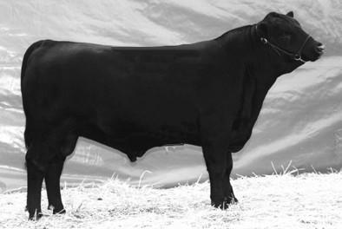
Aberdeen Angus
Shorthorn
This is a very popular breed in Australia. Shorthorns vary in colour from red through to white. They are found all over Australia as they are a hardy breed able to adapt to nearly all climates. Shorthorns may be polled or have horns.
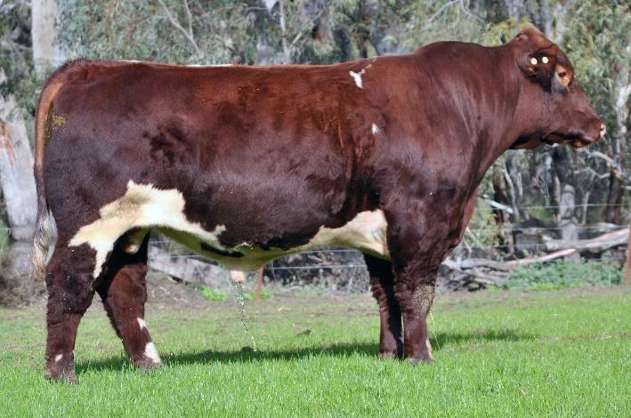
Wagyu
The word "Wagyu" translates to "Japanese Cow”. Four Japanese breeds were combined to make the modern Wagyu. In Australia the first genetics came in the early 1990s and frozen semen and embryos have been available here since 1991.
In 1997, the first five full-blood Japanese cattle were introduced to Australia. In 1999, a further 40 females and nine bulls were flown to Australia, some from Japan, others were full-bloods born from the USA.
Today, Australian Wagyu beef is sold globally, with 80-90% of products exported and 10-20% sold domestically .
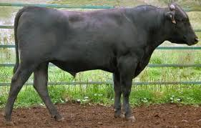
Hereford
With a red coat and white face and legs, Hereford cattle are one of the most common breeds of beef cattle. The most common type of Hereford processed in abattoirs is the Polled Hereford. This is because there is less risk of damage to the hide and muscle from horns. However, there is also a horned variety.
Herefords traditionally have a white face which can make them susceptible to uv rays and so cancer eye (epithelioma)> Farmers now are trying to breed them with brown patches around the eye to reduce this risk.
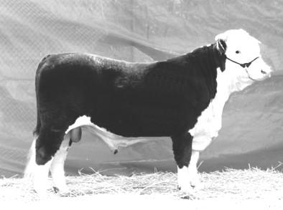
Hereford
Murray Grey
As the name suggests, this animal has a grey coat. It is a fast growing and quick maturing animal. This makes the Murray Grey one of the better beef producing animals found in Australia.

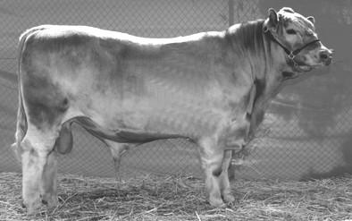
Murray Grey
French Charolais
These are fast growing and large animals. French Charolais are creamy-brown in colour and are found in areas of high rainfall.
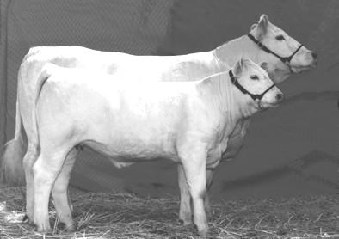
Charolais
Simmental
The simmental is similar in colour and features to the Hereford breed, with a red or white coat colour. The Simmental is both a beef and milk producer, with one of the most rapid growth patterns of all breeds of cattle.
Notre the brown patch around the eye – the same reason as with Herefords

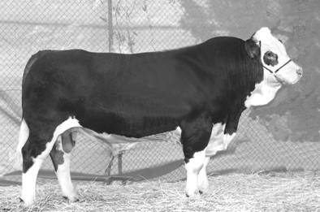
Simmental
Other breeds
In northern Australia there are numerous other breeds of cattle, such as the Santa Gertrudis, Brahman and Brahman crosses. These are grown for meat production.
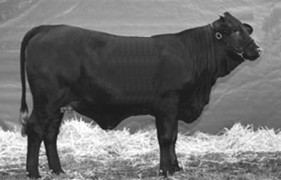
Santa Gertrudis
Brahman
The Brahman has developed as a major beef breed in the tropical humid and subtropical dry areas, particularly in Queensland, north-eastern Western Australia, the Northern Territory and the north coast of New South Wales.
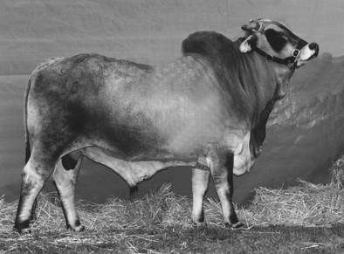
Brahman
Dairy cattle
Jersey
This breed is one of the calmest breeds of cattle produced. They are a fawn-brown colour and remarkably light boned in structure.

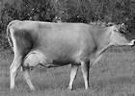
Jersey cow
Friesian
Friesians are a black and white coloured animal and the most common dairy breed in Australia. The bone structure of the animal is large compared to other breeds of cattle.

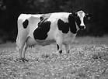
Friesian cow
Other breeds of dairy cattle seen at the abattoirs include Ayrshire and Guernsey.
Buffalo
There is only one type of buffalo slaughtered in Australia, the Asian water buffalo Bubalus bubalis. Although the domesticated buffalo in Asia appear docile, this is due to extensive handling from a young age. On the other hand Buffalo in Australia are mainly raised in the tropical areas of the north, especially the Northern Territory. Although domesticated they are raised under extensive rather than intensive conditions. As a result they can be semi wild and should always be treated with caution.

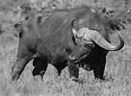
Buffalo
What are the market requirements for cattle and/or buffalo?
Stock must be presented for slaughter in a way that ensures that the customer will get exactly what they asked for.
At export abattoirs the customer requirements must include those set by the importing countries.
Specifications are descriptions of what a customer does and doesn't want. Specifications will depend on the market that the animal is going to.
Selection of the right stock for each customer is very important. Each workplace will be different. Selection of stock could be based on the following specifications:
- age
- sex
- weight
- leanness
- fatness
- conformation
- breed
- lot fed
- grain fed
- grass fed
- European Union (EU) status or eligibility.
Workplace procedures and instructions provide the criteria for selecting the correct stock for slaughter.
What are the major husbandry systems used to raise cattle?
Cattle and Buffalo in Australia are primarily raised on grassland. Beef cattle are raised on a range of size of farms from the very small with less than a dozen breeding cows in the higher rainfall parts of the country to large stations in the outback with herds numbering in the thousands.
Beef calves are usually weaned at between 9-12 months of age. Those that are in good condition with a live weight of 180-250 kg may be slaughtered mainly for the domestic market. Calves raised under more extensive conditions on the stations will generally be moved into feedlots for finishing.
In the feedlots they will be fed high energy rations consisting of grain such as wheat and high protein sources of legumes. They may remain in the feedlots for between 1- 6 months, depending on market requirements.
In Northern Australia most cattle remain in the feedlots until they have been accustomed to eating prepared rations and have reached a certain weight. The cattle are then shipped out live to South Eastern markets such as Indonesia, the Philippines and Vietnam .
One in every seven beef animal raised in Australia is shipped out live mainly to Indonesia. Most of these are shipped out from the Northern Territory, northern WA and northern Queensland .
Most other cattle in feed lots are slaughtered mainly at export abattoirs to service the export market for high quality beef particularly to Japan and the European Union.
Older animals such as cows at the end of their breeding life are also slaughtered mainly at export abattoirs to service the United States market for lean beef for grinding (mince) for hamburgers.
Culled dairy cows are also destined for that US market.
Unlike the United States and Europe where male dairy calves are placed into feedlots, dairy calves in Australia that are surplus to breeding requirements are generally slaughtered at about 2 week of age for the domestic market for veal.
In many cases dairy farmers will mate a certain proportion of their dairy cows to beef breed such as Aberdeen Angus so that the calves are more suitable for finishing in a feedlot. Smaller breeds such as Aberdeen Angus are preferred particularly for their young heifers for their first calf in order to minimize the risk of a difficult birth.
Wild buffalo were exterminated as part of the TB eradication programme 25 years ago. Some buffalo are now raised on farms and are generally slaughtered without going through a feedlot, mainly for the high end domestic market. However, there are now a growing number of feral buffalo that are rounded up and quietened before going to slaughter.
It is worth noting less than 45% of slaughter cattle in Australia pass through a feedlot. In The United States and Europe almost 100% of cattle are feed-lotted prior to slaughter.
Conducting ante-mortem inspection of cattle and/or buffalo
What are the main reasons for ante-mortem inspection?
The main reason for ante-mortem inspection is to detect those animals that may not be suitable for slaughter due to disease or other reason such as chemical residue that could render the carcase unfit for human consumption.
It is particularly important for those conditions that may not be detectable at post-mortem inspection.
Ante-mortem inspection can be separated into two parts:
- examining animals before slaughter so that the inspector can identify and segregate animals that show signs of a disease, condition or abnormality
- deciding what action will be taken with those animals that do have a disease, condition or abnormality.
When carrying out ante-mortem inspections, the inspector must:
- check the vendor declaration with particular reference to agricultural and veterinary chemicals withholding periods
- detect the presence of suspected emergency or notifiable diseases
- prevent the slaughter of any animal that shows signs of a condition or disease which would make the carcase or carcase parts unsuitable for human consumption
- segregate animals that show signs of, or are suspected of, having a disease or condition, so they can be slaughtered separately and given detailed post-mortem inspection
- prevent animals that are grossly contaminated with faeces, dirt, dust or other material from entering the slaughter floor
- ensure animal welfare standards are maintained at all times.
Workplaces will have different ways of carrying out ante-mortem inspections. Inspectors must follow workplace procedures and instructions. Quality Assurance (QA) and Hazard Analysis Critical Control Point (HACCP) procedures must also be followed to prevent obviously diseased or contaminated stock entering the slaughter floor.
What regulatory requirements apply when conducting ante-mortem inspection?
Australian Standards
Part 3 of the AS4696:2023 Australian Standard for hygienic production and transportation of meat and meat products for human consumption details the requirements for:
- the supply and admission of animals for slaughter
- animal welfare
- and ante-mortem inspection and disposition.
These requirements apply to all abattoirs, both export and domestic.
Clause 6 The supply and admission of animals for slaughter
The outcome required is:
- animals are sourced from holdings where the management of animals ensures that the wholesomeness of meat and meat products derived from the animals is not jeopardised
- animals affected by a disease or other abnormality does not contaminate other animals or jeopardise the wholesomeness of meat and meat products.
In practice this means that:
- the animals are correctly identified with ear tags, tattoos etc. so as to identify the property of origin or if they are wild animals such a goats or camels, the area in which they were captured can be identified
- vendor declarations show that the animals have not been recently treated with any chemical or drugs
- animals are not from a property that is under quarantine restrictions, without approval from the relevant authority.
On arrival at the abattoir the meat safety inspector is responsible for deciding either not to admit animals that do not meet these requirements, or admitting them under strict controls, until the above issues are clarified.
The meat safety inspector is also to check that:
- the animals have not been grazing on sewage affected pastures or fed materials that may recycle human or animal pathogens e.g. Cysticercus bovis (VBM CB is the PIC status for such properties)
- the animals have not got a notifiable, contagious disease or exotic disease
- the animals have not been treated with any drugs, chemicals or radiation.
All of these items are to be checked prior to the physical ante-mortem inspection by an examination of the Vendor Declaration/Waybill.
The collection and inspection of vendor declarations is generally done by the senior stockman at the abattoir. The meat safety inspector needs to ensure that there is a system in place to advise him/her of any animals that arrive without a vendor declaration or any animals where the vendor declaration shows that there is some doubt as to the suitability of a lot of animals for slaughter for human consumption.
The usual practice at slaughter premises in Australia, both export and domestic, is for the head stockman to provide the meat safety inspector or the veterinarian at export abattoirs with a kill sheet that shows the order of the animals to be slaughtered, the number in each lot, tail tag numbers and any other relevant details from the vendor declarations or waybills.
Although it is up to the company to ensure all vendor declarations are correct, it is a requirement on export abattoirs for the veterinarian to check a number of the vendor declarations on a regular basis to ensure that all animals are accounted for, and that particular market eligibilities (such as EU requirements) have been met.
On domestic abattoirs the meat safety inspector will then indicate on the kill sheet those lots that have been inspected and any animals that may have been segregated as suspects or emergency kill by the stockman or the inspector. This kill sheet will then be passed to the meat safety inspectors on the slaughter floor for reference.
On export abattoirs an ante-mortem card is prepared for each lot and accompanies the first animal of each lot to the slaughter floor.
If the meat safety inspector decides that the animals may be slaughtered, this section of the Australian standard requires the company to have in place a system of correlation so that if any disease is found, the animal(s) can be traced back to the property of origin. This is usually achieved by numbering each carcase as it enters the slaughter floor.
Vendor declarations
The National Vendor Declaration (NVD) form is managed and obtained by the producer from Meat and Livestock Australia (MLA). This form accompanies animals to sale/slaughter and acts as a guarantee from the farmer to the purchaser of the livestock that the conditions detailed on the form have been met. In some states, waybills issued by state authorities are also compulsory.
The basis for a farmer/producer signing the form is participation in an on-farm quality assurance system. There are four systems in place:
- Australian Pork Industry Quality Programme (APIQ) for pigs
- Cattlecare managed by the Cattle Council
- Sheepcare managed by the Sheep Council
- Livestock Production Assurance managed by MLA.
The MLA Livestock Production Assurance (LPA) system has basically taken over the running of the Cattlecare and Sheepcare. In effect there is now only one system for these species – LPA.
The emphasis in the quality systems is mainly on the residue status of livestock, including source of fodder, pastures and any treatments and withholding periods, but they are also designed to offer broader assurance of the status of the animals on a whole range of food safety and commercial issues.
All meat processors have made vendor declarations from the farmer an essential condition for the purchase of livestock. Participating farmers have real price advantages when they participate in these programmes. The programmes are supported by vendor liability legislation in some states. The programmes require producers to follow certain best practice procedures including:
- stock identification records
- staff training
- transaction and movement records
- proper labelling, storage and use of chemicals
- treatment records
- good husbandry practices including care with loading, handling and transport
- conducting internal audits of their system on a regular basis.
Correlation
Correlation is the requirement to identify all parts of a particular animal during slaughter until after all the parts have passed post-mortem inspection. This includes carcases, hides, offal and heads.
Routine correlation is achieved by recording the property identification against the carcase number allocated at slaughter.
This property identification is tail tags in cattle and buffalo, brands in pigs and ear tags in sheep.
If a carcase is to be retained correlation is achieved by the use of either temporary tags attached to the various parts, and/or visually at the point of inspection.
The carcase and all its parts must be able to be retrieved and correlated to the animal’s property identification/ear tag.
Export requirements
Export workplace ante-mortem practices differ only marginally from the Australian Standard requirements, depending on the importing country’s requirements. For example animals which are to be processed for the European market must be slaughtered first in the day or shift. AAOs must be notified when EU animals are being slaughtered so extra inspection techniques are applied. The AI stamp along with the E in the oval stamp are applied to carcases prior to going into the chiller.
Also most overseas countries insist on veterinary ante-mortem inspection.
The Export Control (Meat & Meat Products) Orders and overseas countries' requirements must be followed. Further details of these can be found in the company workplace instructions.
Clause 8 Ante-mortem inspection and disposition
The outcome required is:
only animals fit for slaughter for the purpose of producing meat and meat products for human consumption are slaughtered.
This clause basically states the following:
- ante-mortem inspection must be carried out by an On Plant Vet or meat safety inspector
- the meat safety inspector/OPV must carry out the inspection within 24 hours of slaughter after which time the ante-mortem inspection must be repeated.
- the meat business must supply the OPV/ meat safety inspector with all the relevant information about the animals to be slaughtered as specified in clause 6.
The dispositions of animals after inspector are:
- passed for unconditional slaughter
- passed for slaughter subject to conditions set by the OPV meat safety inspector (suspect and emergency kill animals)
- withheld from slaughter
- condemned.
This clause also specifies the action to be taken when disease or abnormality is suspected in that all dispositions are to be in according to Schedule 3 of the Standard.
What are the principles and procedures for the humane handling of cattle and/or buffalo?
The principles and procedures for the humane handling of cattle and buffalo are detailed in The Australian Standard for hygienic production and transportation of meat and meat products for human consumption clause 7.
Clause 7 Animal welfare
The outcome required is:
The minimisation of the risk of injury, pain and suffering and the least practical disturbance of animals.
The Australian Standard for hygienic production and transportation of meat and meat products for human consumption requires meat companies to have an ‘Approved Arrangement’ with their relevant controlling authority for all aspects of meat production. This Approved Arrangement requires a meat company to include animal welfare as a policy objective in their Approved Arrangement and to demonstrate commitment to this policy.
To meet this requirement the provisions of the AMIC National Animal Welfare Standards for Livestock Processing Establishments Preparing Meat for Human Consumption (2nd Edition-2010) need to be followed.
This Standard is based on the animal welfare codes, international standards and the ‘Five Freedoms’.
The Animal Welfare Standard has six required outcomes:
- planning and contingencies
- maintenance and design of equipment and facilities
- staff competency
- management and humane destruction of weak, ill or injured livestock:
- management of livestock to minimise stress and injuries
- humane slaughter procedures.
This guideline is based on the following codes:
- Australian Model Code of Practice for the Welfare of Animals, Number 10: Animals at Slaughtering Establishments
- Operational Guidelines for the Welfare of Animals at Abattoirs and Slaughterhouses
- Animal welfare is described in greater detail in the following animal welfare module, which is a core module and co-requisite for this training module
- AMPA3002 AMPLSK301 Handle animals humanely while conducting ante-mortem inspection.
What are the signs of common conditions responsible for abnormalities at ante-mortem and how can they be detected?
There are two types of abnormalities that need to be detected at ante-mortem inspection:
- invisible abnormalities such as chemical residues
- visible physical abnormalities.
Invisible abnormalities
The provision of wholesome meat to the consumer requires an assurance that the product does not contain residues of chemicals which may be harmful to human health.
Residues may result from intentional treatment of an animal, or if its feed, with a drug or chemical, such as pesticide for therapeutic or other purposes; or from environmental contamination.
This assurance is provided on the basis of measures designed to ensure that the product contains no residues which exceed the Maximum Residue Limit (MRL), for that chemical as set by the Food Safety Council of Australia through the National Foods Authority. Similarly, maximum permitted concentrations (MPC's) have been established for contaminants, such as heavy metals. These limits are based on scientific evaluation, and toxicology.
The National Residue Survey (NRS) provides an unbiased estimate of the frequency of residues of a range of agricultural and veterinary chemicals, and environmental contaminants in the individual commodities for targeted surveys and extension.
The NRS provides assurances to Australia's trading partners and domestic consumers of the low residue status of these commodities. Inclusion of chemical and commodity combinations is based on risk profiling.
Residue compliance of meat produced at the domestic abattoirs is based on:
- participation in the NRS
- systems of animal identification and trace back when violative residues are detected
- identification and quarantine, or other appropriate management strategies, of farms known to produce animals with violative residues.
The invisible abnormalities that may be present at ante- mortem inspection such as chemical residues can only be assessed by a detailed inspection of the paperwork accompanying the animals such a way bills and vendor declarations, or by individual testing of samples from slaughtered animals.
Individual testing of animals is only conducted if there are some doubts as to the chemical residue status of animals. For routine processing the vendor declarations are considered sufficient.
Inspection of the vendor declarations is an essential part of the ante-mortem inspection process.
Visible abnormalities
In order to maximize the ability to detect common visible conditions responsible for abnormalities at ante-mortem inspection it is important that effective procedures are carried out. The AS4696: 2023 Australian Standard for hygienic production and transportation of meat and meat products for human consumption does not specify how ante-mortem inspection is to be conducted, but there are ‘best practice’ procedures that should be followed.
The meat safety inspector can vary these procedures according to:
- regulatory requirements e.g. ante-mortem at export plants must be conducted under direct veterinary supervision
- company requirements
- type of animal e.g. lambs and other young animals are less likely to have disease than older animals
- lines of uniform animals such as pigs from a single source where documentation indicates that the farmer has inspected the animals and identified suspects, under these circumstances only a representative number of animals need be inspected.
- Lines of unhusbanded animals e.g. feral goats, wild cattle.
When carrying out ante-mortem inspection, the animals should firstly be examined when at rest. This is because some signs of sickness or disease will not be seen when the animals are being moved. It is also very important to look for any animal that is not displaying ‘normal’ behaviour i.e. if it is doing something different to the rest of the mob. In this case pigs tend to separate themselves from other pigs.
After observing the animals at rest, you must then examine them when they are moving. When doing this the inspector should observe the sides, head and rear of the animals. How much observation will depend on the type of animals, wild unhusbanded animals can only be observed either from the edge of the yards or above.This is so any abnormality, disease or condition can be detected.
Humane handling
It is very important that any handling or moving of animals is done quietly and humanely.
Animals that are not handled or moved correctly may become stressed. Stress can affect meat quality. A stressed, flighty or nervous animal can also cause injury or stir up other animals in the same pen, resulting in injury to stock.
Signs of common conditions
Signs which may indicate disease, conditions or abnormality in livestock include:
- separating themselves from the rest of the stock
- lying down when the rest are standing
- dullness, listlessness, head down, not alert
- drooping ears
- very poor condition – emaciated
- short, shallow, rapid or loud breathing
- hunched up
- tail flicking, moistness around tail area – flystrike in sheep
- scouring, bloody diarrhoea i.e. dysentery
- excessive salivation
- tongue protruding
- enlargement of jaw bones
- excitement, i.e. excessively active and erratic behaviour
- lameness and/or swollen joints
- lesions in or around eye, i.e. cancer eye
- blood, pus or other abnormal discharges from nose, mouth, anus, vulva or penis
- enlargement or abnormality of scrotum, anus, vulva, penis or udder
- swelling cysts, abscesses or abnormal growths
- skin irritation in pigs
- skin blotching
- abnormal enlargement of belly
- broken limbs
- wounds
- faecal contamination.

What are the procedures for humane destruction?
If animals are suffering it is vital that they are euthanized as soon as possible.
Suffering animals include animals with severe injuries such as broken legs. These need to be put up for emergency slaughter.
Other animals that may be suffering include animals that are moribund or near death, these need to be destroyed immediately and the body condemned.
At abattoirs euthanasia of animals in the yards, is usually achieved by use of a firearm. Only suitably trained and qualified people may use a firearm.
Workplace instructions must be followed for this procedure.
What are the procedures for emergency and suspect slaughter?
Emergency slaughter animals are slaughtered as soon as possible. They are usually killed in the lairage and enter the slaughter floor through the emergency slaughter door close to the knocking box.
Only injured animals should be handled in this way.
Sick animals should be rejected from slaughter and either disposed of humanely or withheld from slaughter for treatment.
Animals that are to be treated may not leave the abattoir premises for treatment as abattoirs are considered by all state authorities to be quarantine areas.
Once on the plant animals cannot leave except when the state department has issued permission and movement conditions.
After successful treatment particular care needs to be taken to ensure that no chemical residues are present in the animals. This is achieved by ensuring withholding periods for drugs administered are strictly met.
Some animals may be considered for suspect slaughter. These include cattle with small eye cancers where the inspecting officer believes that spread beyond the initial site is minimal.
Animals showing evidence of heavy faecal contamination should also be put up as a lot at the end of the shift so that special procedures can be put in place to ensure cross contamination is minimised.
All suspects should be put up for slaughter at the bend of a shift/day.

Workplace instructions must be followed for these procedures.
What WHS requirements apply when conducting ante-mortem inspection?
The WHS principles for the meat industry are explained in the training material for AMPCOR204 Follow safe work policies and practices.
Possible WHS hazards when conducting ante-mortem inspection could be:
- zoonotic diseases i.e. diseases transmissible from animals to humans
- slips, trips and falls
- injury from animals
- severe weather.
Ways of preventing or controlling these hazards are contained in workplace WHS policies and procedures. Some examples of these may be:
- wearing and using appropriate lose fitting Personal Protective Equipment (PPE)
- vaccination against zoonotic diseases
- wearing appropriate footwear steel capped boots.
- using walkways where provided
- being aware of the behaviour of animals at all times
- being aware of the location of animals at all times
- knowing the location of exit gates, ladders and steps.
What are the QA aspects of ante-mortem inspection?
The QA practices that apply to the meat industry are explained in the training material for AMPCOR203 Apply quality assurance practices.
All personnel conducting ante-mortem inspections and making dispositions must have a good understanding of and follow instructions detailed in the company quality assurance manual and Hazard Analysis Critical Control Points (HACCP) plan. Some of these could include:
- identification of hazards, such as faecal contamination
- preventative action
- control methods
- record keeping
- ante-mortem cards
- traceback to property of origin
- compliance with tattoo, ear tag or tail tag requirements
- delivery dockets
- vendor declarations
- cattle care and sheep care statements.
Making an ante-mortem disposition
What are common diseases and conditions responsible for abnormalities in cattle and/or buffalo?
The identification of different diseases and conditions that can affect an animal's suitability for human consumption is the first step in producing safe meat products. It is essential that these conditions are identified and the correct disposition made as to whether to slaughter the animal.
There are two types of abnormalities that need to be handled at ante-mortem inspection:
- visible physical abnormalities
- invisible abnormalities such as chemical residues.
Visible abnormalities
Schedule 3 of the AS4696:2023 Australian Standard for hygienic production and transportation of meat and meat products for human consumption details the diseases and conditions and dispositions.
It includes conditions that may be detected at ante-mortem and at post-mortem inspection. The ante- mortem conditions are reproduced below.

Diseases and other abnormalities | Dispositions for animals, carcases and carcase parts
 | The symbol [1] means carcase or carcase parts unfit for human consumption may be recovered for animal food subject to heat sterilisation. The symbol [2] means carcase or carcase parts unfit for human consumption may be saved either for animal food subject to heat sterilisation or for animal food subject to staining.
1. General findings
Dead animal |  | Animal condemned. If anthrax suspected see 2.1.1.
Dying animal or moribund state with subnormal temperature, weak pulse and disturbed senses. |  | Animal condemned
Fever, debility and general signs indicating acute disease |  | Animal condemned. Alternatively, withhold from slaughter until recovered provided no risk of spread of disease; no undue suffering and recovery considered likely with treatment.
Advanced chronic conditions with generalised signs such as cachexia or loathsome appearance |  | Animal condemned
Injury or accidental trauma during transport to or while in vicinity of abattoir |  | Animal subject to emergency slaughter or condemned
Excitement, exhaustion without signs of acute disease |  | Animal withheld from slaughter and ante-mortem repeated after adequate rest
Slight odour
2. Aetiological listing
2.1 Bacterial and related diseases
Anthrax |  | Affected animals should not be admitted to an abattoir. When detected at ante-mortem, affected animal condemned. Companion animals isolated and withheld from slaughter
Cutaneous lesions |  | Affected areas of skin condemned
Myiasis |  | Animal condemned in severe cases with sepsis or necrosis. Otherwise withhold from slaughter for treatment and resubmit for ante-mortem after recovery.
Ephemeral fever |  | Animals withheld from slaughter for treatment. Resubmitted for ante-mortem after recovery.
Metabolic disorders (transit tetany, ketosis, etc) |  | Animal condemned in severe cases. Withheld from slaughter in milder cases and resubmitted for ante-mortem after recovery.
Faecal contamination
There is a high human health risk of faecal contamination containing pathogenic bacteria such as E.coli and Salmonella. Only stock that can be slaughtered without risk of faecal contamination should be processed.
Invisible abnormalities
The Australian Standard requires the abattoir operator to advise the meat safety inspector if any animals have been exposed to chemical residues or require testing under any official residue-testing programme.
The vendor declaration forms accompanying animals should detail any restrictions such as animals having been treated or exposed to chemical and drugs and the relevant withholding period not having been met.
In addition some animals may require to be tested as part of the National Residue Survey.
The National Residue Survey is a survey managed by the Department of Agriculture Fisheries and Forestry (DAFF) where a range of foodstuffs that may be exported, including meat are surveyed for chemical residues.
There are two types of survey conducted:
- random monitoring of a range of chemicals
- targeted monitoring of specific problem chemicals.
Random survey
The random survey is conducted at all abattoirs in Australia. Meat safety inspectors collect samples in a randomised manner from a range of animals. The samples are sent to specific laboratories where they are tested for a range of chemical residues.
The results are collated to develop a picture of residue contamination in food across Australia.
If residues of a particular chemical appear to be a problem a targeted testing programme is initiated for that problem chemical.
Targeted survey
A targeted survey is initiated when a particular chemical appears to be a problem. The main targeted chemical at the moment is organochlorines in meat.
Unacceptable levels were found in beef in 1987 and this chemical has been continually targeted since that date.
The long half-life of the chemical means that it may take some years for the chemical to disappear from the environment even though the chemical itself has been banned for some years.
Note: The half-life of a chemical is the length of time it takes for the quantity of the chemical in the environment to break down to half the original level.
In this targeted programme all properties have been classed into seven different categories according to the risk of organochlorine contamination on the property.
Most properties are in class C (clear) and require no targeted testing. The rest are graded according to risk:
- T1: require only one in ten animals to be tested
- T2: require one in five testing
- T3-T5: require all animals to be tested.
The latter are generally under state-controlled quarantine and require specific approval from the authorities for animals to be sent to slaughter.
In 1988 there were thousands of properties in the T5 category. There are now very few.
The Commonwealth Department of Agriculture maintains a database of properties requiring targeted testing.
Management of the company are required to access the database, prior to animals being slaughtered, to see if the property identification number is one where testing is required.
Although it is the responsibility of the company to collect samples, they must inform the relevant veterinarian or meat safety inspector of the testing requirement.
If the animals come from T1-T2 properties the carcases are sampled and released.
If the animals come from T3-T5 properties the carcases are held pending the results.
What dispositions can be made at ante-mortem?
The disposition for diseases is described in Schedule 3 of the AS4696:2023 Australian Standard for hygienic production and transportation of meat and meat products for human consumption.
After ante-mortem inspection, one of the following dispositions will be made about each animal. The animal will be:
- passed as fit for routine processing
- withheld from processing pending treatment for or recovery from an abnormal condition. These animals may be resubmitted for another ante-mortem inspection at a time specified by an inspector. Note: on export abattoirs suspect animals must be held for veterinary inspection
- subjected to immediate emergency slaughter to prevent deterioration of an abnormal condition, provided the condition would allow all or part to be passed for human consumption and processing would not jeopardise the hygienic production of meat
- processed under restrictions which prevent unacceptable contamination of the processing floor and which permit more detailed post-mortem inspection
- rejected as unfit for processing and destroyed by humane means and then disposed of in an approved manner.
The AS4696:2023 Australian Standard for hygienic production and transportation of meat and meat products for human consumption requires the following actions to be taken after ante-mortem inspection:
- a record of ante-mortem inspection of animals rejected for human consumption or passed as suspect or emergency slaughter must be maintained
- animals that are deemed to be affected by diseases or conditions should be segregated usually into the suspect pen from healthy animals while awaiting slaughter
- groups of stock that exhibit signs or symptoms of stress must be rested before slaughter
- animals that are known to have been treated with, or exposed to a drug, chemical or biological substance, shall not be slaughtered unless any withholding period recommended on the product label has lapsed
- Also check the market as some countries have extended slaughter interval (ESI)
- animals that are condemned must be humanely slaughtered
- dead animals are removed quickly for disposal.
- Dead animals should be denatured or disposal supervised up to the time of going into the byproducts process.
What are the requirements for segregating stock?
It is important for humane reasons that various categories of animals are segregated during transport and in the lairage. For example:
- bulls should not be placed with cows
- ideally bulls should be segregated into individual pens as they will tend to fight
- young animals such as calves should be penned separately to adult animals
- pigs should be maintained in their lots from the farm(s) as different groups will tend to fight if mixed in the lairages.
After performing ante-mortem inspection, any animals that are showing signs of a disease, condition or abnormality must be segregated from the healthy animals for further detailed inspection. This will also include animals with faecal contamination. The veterinary officer, inspector or authorised person must then make a disposition and decide what action to take. Animals are segregated in four ways after ante-mortem inspection:
- injured animals are identified for immediate emergency slaughter
- the bulk of the animals will be passed as fit for human consumption
- animals with localized disease e.g. lameness or with a vendor declaration that indicates exposure to chemicals are identified as suspect for separate slaughter preferably at the end of the shift. These animals may also be withheld from slaughter until their condition improves or their chemical residue status is confirmed or abated i.e. after the relevant with holding period has passed
- animals with generalized disease that render them unfit for human consumption are condemned.
What are the signs of emergency or notifiable diseases?
Notifiable diseases are diseases in animals that by law must be notified or reported to relevant State or Territory authorities on 1800675888. It includes a number of diseases that are endemic to the country e.g. anthrax and many diseases that do not exist in this country.
Animal diseases that do not exist in this country are called exotic diseases.
The list of notifiable diseases varies a little from State to State depending on local circumstances. The following list details the more common notifiable diseases in Australia. This list can vary from time to time.
Note: Although all exotic diseases are notifiable not all notifiable diseases are exotic diseases.
Inspectors need to be alert to and recognise the signs of some of the more serious notifiable diseases.
Since notifiable diseases vary from State to State the inspector will need to contact the relevant State animal health authority for further information on the most likely or common notifiable diseases in the state.
Note: Not all notifiable diseases will be evident at ante-mortem, a few are detectable only at post-mortem.
The following chart lists some of the notifiable diseases of animals in Australia that may be evident at ante-mortem.
The list is provided for general information only and can vary from time to time. Some of the notifiable diseases are exotic to Australia, but most are endemic.

Notifiable disease | ACT | WA | NSW | NT | QLD | SA | TAS | VIC
Actinobacillosis |  |  |  | Y
Actinomycosis |  |  |  | Y
Annual ryegrass toxicity |  | Y
Anthrax | Y | Y | Y | Y | Y | Y | Y | Y
Atrophic rhinitis |  | Y |  | Y
Babesiosis (bovine) | Y | Y | Y | Y | Y | Y |  | Y
Birdsville horse disease |  |  |  | Y
Black disease |  |  |  | Y | Y
Blackleg |  |  |  | Y
Bluetongue | Y | Y | Y | Y | Y | Y | Y | Y
Botulism |  |  |  | Y
Bovine spongiform encephalopathy | Y | Y | Y | Y |  | Y | Y | Y
Buffalo fly |  |  |  |  | Y | Y |  | Y
Caprine footrot |  |  |  |  |  |  |  | Y
Cattle tick infestation due to Boophilus microplus | Y | Y | Y | Y |  |  |  | Y
Classical swine fever | Y |  |  | Y |  |  | Y | Y
Contagious pustular dermatitis (contagious ecthyma) |  |  |  | Y
Cow pox |  |  |  |  |  | Y
Equine morbillivirus | Y | Y |  | Y |  | Y | Y | Y
Fasciola gigantica | Y |  | Y |  |  | Y |  | Y
Foot-and-mouth disease | Y | Y | Y | Y | Y | Y | Y | Y
Footrot in sheep, goat and deer | Y | Y | Y |  | Y | Y
Fowl cholera |  | Y
Fowl plague |  |  |  | Y
Fowl typhoid (S. gallinarum) | Y |  | Y |  | Y |  |  | Y
Glanders | Y | Y | Y | Y | Y | Y
Goat pox | Y | Y | Y | Y | Y | Y | Y | Y
Infectious atrophic rhinitis |  |  |  |  | Y
Infectious bovine rhinotracheitis |  | Y | Y | Y |  |  |  | Y
Lumpy skin disease | Y | Y | Y | Y | Y | Y | Y | Y
Malignant tumour |  |  |  |  |  |  |  | Y
Other spongiform encephalophathies |  | Y
Ovine footrot |  |  |  |  |  |  |  | Y
Ovine ked |  |  |  |  |  |  |  | Y
Ovine lice |  |  |  |  |  |  |  | Y
Rabies | Y | Y | Y | Y | Y | Y | Y | Y
Rift Valley fever | Y | Y | Y | Y | Y | Y | Y | Y
Rinderpest | Y | Y | Y | Y | Y | Y | Y | Y
Scrapie | Y | Y | Y | Y | Y | Y | Y | Y
Screw-worm (Cochliomyia hominivorax) | Y | Y | Y | Y | Y | Y | Y | Y
Sheep ked infestation | Y |  | Y
Sheep pox | Y | Y | Y | Y | Y | Y | Y | Y
Sheep scab | Y | Y | Y | Y | Y | Y |  | Y
Spongiform encephalopathies | Y |  |  | Y | Y
Sporadic bovine encephalomyelitis |  |  |  | Y |  | Y
Strangles |  |  |  |  |  | Y
Swine dysentery |  | Y
Swine erysipelas |  | Y
Swine fever |  |  |  |  | Y | Y
Swine influenza | Y | Y | Y | Y | Y | Y |  | Y
Swine plague |  |  |  |  |  | Y
Swine pox |  | Y
Teschen disease (Porcine polioencephalomyelitis) | Y | Y | Y |  | Y
Toxoplasmosis |  | Y
Transmissible gastroenteritis of pigs | Y | Y | Y | Y |  | Y |  | Y
Transmissible spongiform encephalophathies |  |  | Y |  |  |  |  | Y
Warble-fly myiasis infestation | Y | Y | Y | Y | Y | Y |  | Y
What are the notification procedures for emergency or notifiable diseases?
The identification and notification procedures that apply to emergency animal diseases are explained in the training material for AMPMSY302Identify and report emergency diseases of food animals.
The procedures for identification and reporting on each abattoir should be detailed in the abattoir Emergency Animal Disease Preparedness (EADP) plan.
There should be an Emergency Animal Disease Preparedness (EADP) plan on every abattoir in Australia. Check the plan at the workplace. This plan should detail the notification procedures for emergency or notifiable diseases.
This plan should be based on the meat-processing manual of AUSVETPLAN.
AUSVETPLAN is the master plan for dealing with exotic disease. It has been designed by experts from state and commonwealth departments responsible for animal health in Australia.
The EADP plan on the abattoir should contain the following:
- action measures detailed as job cards for all responsible key personnel
- a map showing perimeter fences, drainage, yards, adjoining properties, suitable areas for burial and ponds and waste water disposal
- an up to date list of notifiable diseases
- phone numbers both home and at work of key personnel e.g. on-plant vet, senior meat safety inspector, plant manager, engineer, stock person
- location and condition of a supply of soda ash and decontamination equipment
- instructions on how disinfectants and chemicals on site may be used for disinfecting people, equipment and vehicles
- where there are reasonable grounds to suspect an exotic or notifiable disease has been found, the qualified person, i.e. a veterinarian or meat safety inspector, must implement the control procedures detailed in the plan until the State or Territory animal health authority advises otherwise, or takes control of the situation.
The first step when an exotic or notifiable disease is suspected, is to immediately notify the state or territory animal health authority, e.g. the state department of agriculture.
The District Veterinary Officer, Regional Veterinary Officer or Chief Veterinary Officer in that state will take control of the situation. The national hotline number for emergency animal diseases is 1800 675 888.
Once the authority has been notified they will explain what to do.
Monitoring the stunning and slaughter of cattle and/or buffalo
What are the types of stunning equipment that are used on cattle and buffalo?
A range of equipment can be used to stun animals. The type of equipment used at each site will depend on the type and size of stock or species being processed.
It is important that the correct workplace procedures for using the stunning equipment at the site are followed.
There are four main categories of stunning equipment used:
- mechanical stunners
- electrical stunners
- controlled atmosphere or gas stunners
- firearms.
Gas stunners are not used on cattle; they are mainly used on pigs.
Mechanical stunners are the main type of stunners used on cattle in Australia. There are two types:
- penetrating captive bolt
- non-penetrating captive bolt.
Penetrating captive bolt stunners
Penetrating captive bolts cause physical damage to the brain (by penetration) in addition to the concussion caused by the impact of the bolt onto the skull. Penetrating captive bolt stunning is therefore an effective stunning method that can result in the death of the animal when carried out correctly. However, this effect should not be relied upon and the method still requires proper bleeding of the animal to ensure its death. The use of penetrating captive bolts for the casualty slaughter of animals allows pithing (insertion of a rod through the bolt hole to destroy the brain) in the absence of sticking.
Non-penetrating captive bolt stunners
Non-penetrating captive bolts are designed to transfer their entire kinetic energy into movement of the skull and the resulting concussion (concussive stunning). This is achieved by using a bolt with a larger surface area or a steel plate at the tip of the bolt. The tip is convex in shape, which is why they are also called ‘mushroom head stunners’. Subsequent destruction of brain tissue is not a primary feature of concussive stunning, although this sometimes happens by bone fragments from the skull being driven into the brain or the sheer force of the impact. An effective stun results in a temporary loss of consciousness, which requires a fast and effective bleeding of the animal in order to prevent recovery.
Non-penetrating captive bolt stunners have a number of drawbacks in comparison with penetrating ones: there is a smaller margin for error in the application – due to its larger footprint more care needs to be taken to apply the stunner at a 90 degree angle to the forehead. Fracture to the skull during stunning (for example in young cattle, older cows) can absorb some of the energy of the impact, which can in turn have an effect on the success of the stun. If the skull is too thick (old bulls, buffalo) or has bony ridges over the area of the brain (sheep, goats) or is covered by thick, matted hair, then percussive forces may not be transferred effectively.
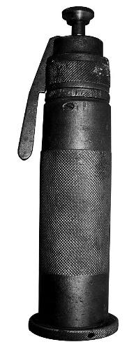
Captive bolt gun

Captive bolt power types
The vast majority of the captive bolt stunners in use are cartridge powered. They are usually powered by blank cartridges (.22 or .25 calibre) with a gunpowder load but no bullet. Cartridges of varying power loads (resulting in different bolt speeds) are used for different classes of stock. As a rule of thumb heavier powder loads are used for heavier/bigger animals with larger skulls. The advantages of cartridge powered captive bolt stunners are that they are relatively cheap, easy to handle and maintain, and most importantly very portable. They are therefore very flexible and can be used in almost any environment. This has made them the stunner of choice for small to medium sized cattle slaughter plants, for any application outside (yards, trucks, etc), and as a back-up device for other stunning equipment. In large cattle slaughter plants with high throughput the cost of ammunition and the mechanical strain on the equipment (resulting in overheating) has become a major drawback of these guns. Also the problem of recoil with non-penetrating stunners has become an WHS concern.
Compressed air (Pneumatic stunners)
Captive bolt stunners that are driven by compressed air were developed for large throughput plants. The major advantage of the pneumatic stunning devices is their low operating and maintenance cost per animal. The stunners are relatively large and heavy which gives them considerably less recoil but also makes them harder to operate and not as versatile in their application.
Electrical stunning of cattle
Electrical stunning of cattle is used at all export abattoirs in New Zealand and is used at about ten percent of export abattoirs in Australia. The uptake in Australia has been slow because CSIRO and Food Science Australia have not recommended it in the past because it has caused excessive blood splashing and ecchymosis during trials.
But these issues have now been addressed and the uptake of electrical stunning if cattle in Australia is growing.
Electrical stunning of cattle has a number of advantages:
- the stun is reversible as recovery can be demonstrated for halal purposes
- the equipment is designed to be semi- automatic so operator error with respect to placement is reduced.
But it also has the drawback that recovery can occur very quickly i.e. within 3 minutes, so it is important that the halal stick by cutting across the throat is quickly followed by a thoracic stick.
This means that the thoracic stick needs to be done in the dry landing area and not after the animal has been hoisted.
Firearms
In some circumstances, firearms are the preferred method of destruction, e.g. large boars or sows, escaped animals and emergency destruction in stockyards, paddocks or stock transports.
Firearms work on the same principal as captive bolts except that the mass of the projectile is smaller, the projectile is not restrained and the velocity is higher than a captive bolt. The firearm delivers far more impact than the captive bolt and is thus considered the most effective means of killing livestock. However, WHS issues preclude its routine use in abattoirs.
The bullet has both a concussive and a destructive effect on the brain and effectively kills the animal. There is no stipulated maximum stun–stick interval for animals shot by firearm, as the animal is effectively already dead. However, a stick as soon as possible after shooting is considered best practice to achieve a good bleed.
New developments
A new method of stunning being devised by CSIRO is showing some promise, it is called Diathermic Syncope™.
This has been used for many years by laboratories to humanely euthanize small laboratory animals such as rats. It works on the principle that heating the brain to a temperature over 42°C results in fainting or syncope.
The heating is achieved by the use of microwaves.
Early trials in cattle indicate that Diathermic Syncope is completely reversible at 42°C, and so is attractive to halal authorities.
In addition, during these trials biochemical testing of blood parameters show that it is as humane as captive bolt stunning.
Laboratory animals are euthanized painlessly at a higher temperature above 50°C.
What are the requirements for effective stunning and slaughter?
The stunning operations at each site will be governed by the site workplace procedures. These workplace procedures and policies will depend on the species and category of stock being processed.
To achieve an effective stun, workers need to have an understanding of the stunning process and be trained in the correct use of the stunning equipment. Effective stunning with a captive bolt stunner depends on five main factors:
- trained and competent operatives
- accurate positioning of the equipment over the target area
- use of the correct strength of cartridge/air pressure for the animal being stunned
- the velocity and diameter of the bolt
- proper maintenance and daily cleaning of the equipment.
The main cause of improper captive bolt stunning is incorrect positioning of the equipment. This is often due to the animal moving its head at the last moment so that the bolt is not in the correct spot when fired. To overcome this problem, operators must be adequately trained and the restraining equipment must be constructed so as to:
- prevent substantial movement of the animal forwards, backwards and sideways
- restrict movement of the animal's head
- allow for the stunning device to be applied to the target area on the animal’s head.
The use of the correct strength of cartridge/air pressure is vital for proper stunning and the manufacturer’s specific instructions should be followed at all times.
The explosive materials used in the cartridge powered captive bolt stunners will cause a residue that can reduce the performance of the device and will, if not removed, result in ineffective stunning and excessive wear of the equipment. So, daily checking and cleaning of the equipment is vital for proper use. If all these elements are addressed, stunning should be routinely effective.
How is the effectiveness of stunning assessed?
Certain physical signs should be observed in the stunned animal in order to satisfy the operator that the stun has been effective.
These are:
- the animal collapses immediately
- a tonic and clonic phase can be observed – at first the legs are all tucked under, and then the front legs will extend, but the hind legs will remain tucked under, and only slowly extend. This is the ‘tonic phase’. Over a period of time, the animal will start to convulse and the legs may kick violently. This is the ‘clonic phase’. Note that in pigs, the tonic phase is very short, and the violent kicking starts almost immediately.
- no rhythmic breathing
- fixed, glazed expression in the eyes
- no corneal reflex
- relaxed jaw
- tongue hanging out – mainly observed in cattle
In animals shot with a free projectile there may be additional signs:
- profuse bleeding from mouth, nose and/or entry wound
- after first being completely still, violent convulsions of the carcase may occur up to one minute after the shot (clonic phase).
There are more detailed notes on assessing stunning and bleeding operations in the training support materials for the Unit AMPQUA311 Assess effective stunning and bleeding.
What corrective action must be taken in the event of ineffective stunning or bleeding?
Animals may suffer when stunning procedures fail.
There must be provision for appropriate back-up stunning equipment to be available to minimise pain, distress or suffering to the animals.
If the initial stun is not fully effective then a number of actions have to be taken. These will be described in the work instructions. They must cover both corrective action (i.e. resolving the immediate issue) and preventive action (i.e. preventing it from happening again).
The immediate action, upon the discovery of an ineffectively stunned animal or an animal showing signs of sensibility on the bleed-line, must be to re-stun. Animals showing signs of sensibility on the bleed-line must also be re-stuck after re-stunning.
If ineffective stunning becomes a recurring or consistent problem then it is important to:
- report this to the supervisor
- check the voltage/charges/air pressure being used
- check the placement of the stunner
- check the routine maintenance of the stunner.
In most plants, stunning is monitored daily to ensure:
- that the animals are being stunned effectively first time
- that the stun/stick intervals are observed
- that excessive numbers do not build up in the stun/stick areas
- the use of incorrect voltages, cartridges, air pressure or gas levels or the incorrect placement of stunning equipment.
What regulatory requirements apply to the assessment of stunning and bleeding?
The AS4696:2023 Australian Standard for Hygienic Production and Transportation of Meat and Meat Products for Human Consumption requires meat companies to have an Approved Arrangement with their relevant controlling authority for all aspects of meat production. This Approved Arrangement requires a meat company to include animal welfare as a policy objective in their Approved Arrangement and to demonstrate commitment to this policy.
To meet this requirement many abattoirs implement the provisions of the AMIC National Animal Welfare Standards for Livestock Processing Establishments Preparing Meat for Human Consumption (3rd Edition).
Separate to the Standard is a working manual that effectively acts as a guideline as to how the outcomes of the Standard are to be achieved. Different but equivalent procedures and practices can be used so long as an equivalent outcome is demonstrated and proven.
This standard identifies five key areas that need to be covered in the relevant standard operating procedure(s)(SOPs) for animal welfare:
- arrival of stock and unloading
- lairage and holding areas
- movement of stock to the slaughter floor
- stunning
- slaughter.
The following items need to be addressed for stunning and slaughter at all abattoirs:
- the operation, maintenance and cleaning of facilities and equipment for stunning and restraint
- effective stunning
- contingencies for daily management and emergencies including back-up stunning
- the maintenance and design of slaughter equipment and facilities
- effective and humane slaughter procedures
- contingencies for daily management and emergencies
- feedback on carcase quality e.g. bruising
- staff training.
Stun/stick interval
An important part of the slaughter process from a humane point of view is the stun/stick interval.
Most animals are stunned by reversible means, so the stun/stick interval needs to be such that animal has no time to recover. The operational guidelines for the welfare of animals at abattoirs and slaughterhouses, specifies that the maximum stun/ stick interval for cattle and buffalo should be 30 seconds.
Further details on stunning and sticking can be found in the module AMPQUA311 Assess effective stunning and bleeding.
Anatomical structure of cattle and/or buffalo
Identify the basic skeletal structure of bovine species relevant to post mortem inspection
The unit AMPMSY301 Apply food animal anatomy and physiology to inspection processes details the anatomical and physiological elements that apply to all species.
In the live bovine animal there are more than two hundred bones in the skeleton. The skeleton provides the basic structure of the animal, and helps to protect the delicate internal organs. The bones articulate with one another at joints. They are joined at these joints by strong bonds of fibrous tissue and are held in place by a system of ligaments and muscles. The skeleton of animals can be divided into two major parts:
- the axial skeleton, which includes the vertebral column, the ribs, the sternum and the skull
- the appendicular skeleton, which includes all the bones of the limbs
  - in the fore limb, the scapula, humerus, radius and ulna, carpus, metacarpus and phalanges
  - in the hind limb, the pelvis (ilium, ischium, pubis, acetabulum), the femur, tibia and fibula, tarsus, metatarsus and phalanges.

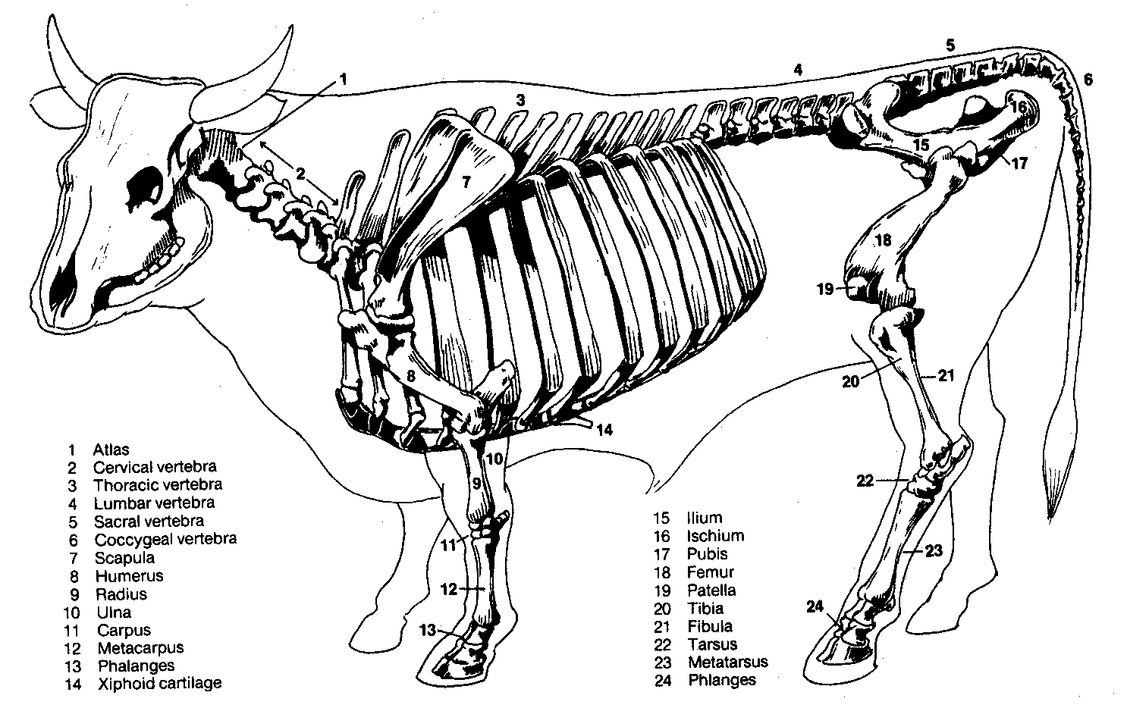

At slaughter the head is removed and the fore and hind legs are removed at the carpal and tarsal joints respectively. The carcase is also split in half as in the diagram below prior to meat inspection.
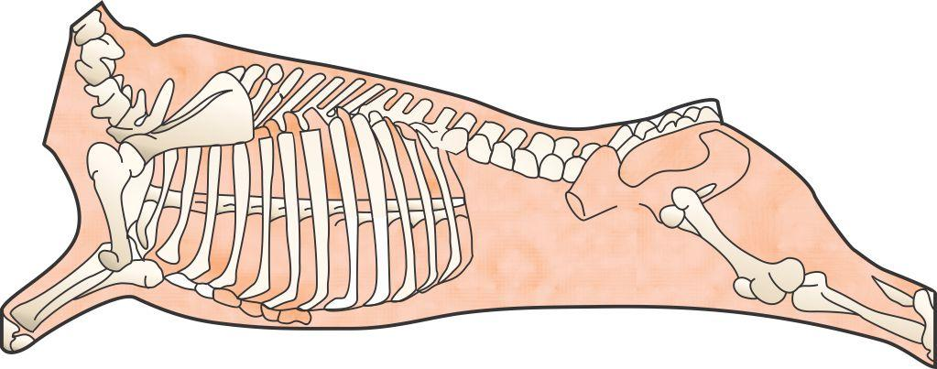
Bovine spine
This skeletal framework carries the muscle systems that form the complete carcase. In addition the half carcase or side at inspection includes blood vessels and the lymphatic system.
The lymphatic system is probably the most important part of the carcase as any disease causing organisms or abnormalities such as cancerous tumours will tend to show up there. For this reason the lymph nodes should get particular attention during post mortem inspection.
The internal organs of the animal (viscera) will have been removed during slaughter and will need to be inspected separately.
The features of the lymphatic system of cattle and buffalo relevant to post mortem inspection
The lymphatic system
The lymphatic system is a system of ducts, vessels and nodes that run parallel to the venous blood circulatory system. The lymphatic system can be likened to a drainage system that drains away excess body fluids. Because blood, under pressure due to the pumping of the heart, passes through the capillaries, part of the plasma is constantly leaving the circulatory system and moving into the tissue spaces, carrying nutrients etc. to the tissues. Very little of this fluid is reabsorbed by the capillaries, so a system is needed to drain the excess tissue fluid. This need is filled by the lymphatic system.
The lymphatic system:
- drains excess fluid from tissues
- filters and kills bacteria
- produces white blood cells that are part of the body’s defence
- absorbs and transports fats from the intestines to the blood stream.
The lymphatic system is made up of:
- lymph capillaries
- lymph ducts and lymph vessels
- lymph nodes
- tonsils
- haemolymph nodes
- spleen.
Lymph nodes
Lymph nodes filter harmful bacteria from the lymph. They are also one of the body’s major sources of white blood cells.
The characteristics of lymph nodes are that:
- afferent lymph vessels deliver lymph to a lymph node
- efferent lymph vessels drain lymph away from a lymph node
- regional lymph nodes drain specific areas of the body
- terminal lymph nodes receive lymph from other lymph nodes and empty lymph into a major lymph duct or trunk
- evidence of infection in a specific lymph node indicates infection in the area that node drains
- lymph nodes are a major indicator of the health of an animal at post-mortem inspection
- all lymph passes through at least one lymph node
- lymph nodes vary greatly in size and shape, colour and texture between species and within species and within individual animals.
The inspection of lymph nodes is an essential part of meat inspection. Lymph nodes in all species are found in roughly the same position.
The following diagram shows the approximate position of key lymph nodes in the carcase and viscera of cattle, sheep, goats, pigs, horse, deer and camelids.
There is some variation in size and precise location between the species due to anatomical differences. For example because pigs have a short neck the lymph nodes of the head and neck are difficult to separate.
These differences are detailed in the ante-mortem and post-mortem inspection modules for each species.
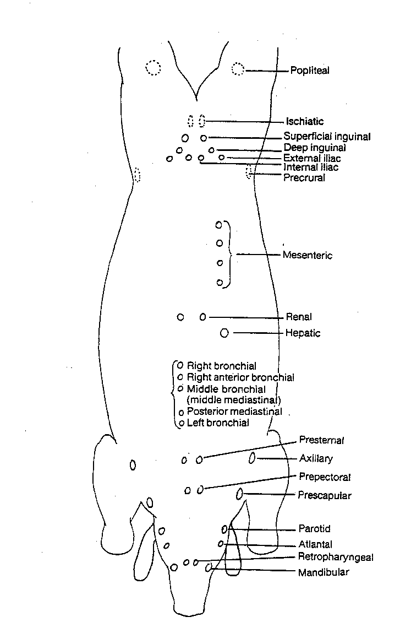
Diagram of the principal lymph nodes in the body of domestic animals
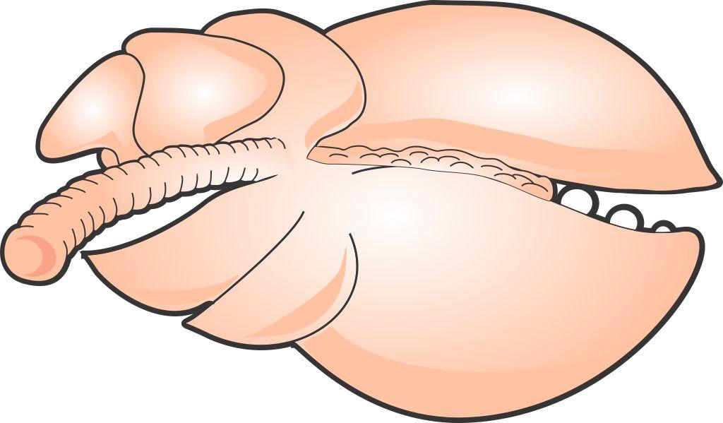
Right anterior bronchial
Left bronchial
Right bronchial
Middle bronchial
Posterior mediastina

Bovine lung showing relevant lymph nodes

Bovine digestive system
Note: The digestive system of sheep, cattle and camelids are very similar as they are all ruminants and have four stomachs.
The digestive system is made up of:
- mouth – teeth and tongue
- pharynx
- oesophagus
- stomach – in ruminants these are the rumen, reticulum, omasum and abomasum
- small intestine – consisting of the duodenum, jejunum and ileum
- large intestine – consisting of the ascending, transverse and descending colons
- rectum
- anus
- accessory glands, organs:
- liver and gall bladder
- salivary glands
- pancreas
- peritoneum – a lubricated serous membrane which lines all the abdominal viscera, that is stomach, small and large intestines and the abdominal cavity.
Mouth teeth, tongue and pharynx
The mouth teeth tongue and pharynx are located in the head. Like the respiratory system, the head is the common primary or first sites of infection. This is because it is:
- in direct contact with the external environment
- a moist and warm environment.
This means that the lymph nodes of the head are an important indicator of disease, in particular the retro pharyngeal lymph nodes.

Conducting post-mortem inspection of cattle and/or buffalo
What are the main reasons for post-mortem inspection?
The main reason for post mortem inspection is to identify those conditions that can affect the suitability of a carcase and its parts for human consumption.
It is an organoleptic inspection i.e. it is an inspection by physical means of a carcase and all its parts using all of an inspectors senses, including:
- visual inspection (observation)
- palpation
- incision and
- smell where appropriate.
If any doubts arise as to the suitability of the meat for human consumption the carcase and its parts can be retained and samples taken and sent to a laboratory for analysis.
What are regulatory requirements associated with post-mortem inspection?
Schedule 2 of the AS4696: 2023
Australian Standard for the hygienic production and transportation of meat and meat products for human consumption details the basic post mortem inspection procedures that must be applied to all animals slaughtered at abattoirs in Australia, both export and domestic.
Some export markets have additional requirements. These are detailed later.
In Schedule 2:
- buffalo means any bubaline greater than 50kg dressed weight
- calf means a young bovine or bubaline no greater than 50kg dressed weight
- cattle means any bovine greater than 50kg dressed weight
- incise means to examine by observation and multiple slicing
- palpate means to examine by observation and palpation.
Note #1: Equivalent procedures are simpler procedures that can be used when either product is not being kept for human consumption or certain diseases have been officially declared as not present in the particular State or Territory.
Note #2: Additional procedures are procedures carried out when disease is detected or suspected. It also includes procedures for product that is not normally kept for human consumption.
What are the procedures for conducting post-mortem inspection?
The first steps in the inspection procedure involves checking the area prior to starting inspection. This involves checking
- is the area safe and clean to work in
- have you got access to a copy of the kill sheet
- have you got access to the antemortem card for each lot and is it the correct colour- beige for normal stock light blue for EU
- are sterilisers at 82 deg c
- is hand wash soap available
- hand wash water is between 35 and 45 deg c
- is lighting 600 lux
The precise procedures for post-mortem inspection will depend on whether the plant is domestic or export-registered. However, the general requirements that the meat safety officer must meet when carrying out the inspection are:
- ensuring only animals that have undergone ante-mortem inspection are presented for post-mortem inspection
- ensuring carcases and carcase parts are correctly identified and correlated for post-mortem inspection
- ensuring carcases and carcase parts are correctly presented for post-mortem inspection
- ensuring the resources and conditions necessary to effectively conduct post-mortem inspection are provided
- undertaking post-mortem inspection of carcases and/or carcase parts as directed
- making a disposition to the suitability of the carcase and its parts for human consumption
- retaining carcases and carcase parts for veterinary examination (export plants only) or laboratory examination
- ensuring, where appropriate, the quality and integrity of the product is maintained.
There are four basic procedures used in meat inspection: observation, smell, incision and palpation.
Note: Observation is sometimes referred to as visual inspection.
Observation
The Department of Agriculture’s definition of observation is To visually inspect a carcase and its parts in such a manner that abnormalities capable of being located are detected. In all instances observation refers to each surface of the item being observed. Observation may require the physical handling and/or incision of the carcase and/or carcase parts to allow complete observation of all surfaces. Observation also includes the use of the sense of smell to detect abnormal odours.
All parts of an animal must at least be visually observed. It is important to look for changes in colour and symmetry and variations to the norm. The importance of this aspect of inspection is the main reason why people with colour blindness are generally not accepted as meat inspectors.
Visual inspection cannot be done from a distance. Since all surfaces of the carcase and organs need to be visually inspected it is necessary as part of the inspection procedure to handle and turn organs and parts as appropriate. Carcases must be carefully observed, paying particular attention to:
- colour
- odour
- symmetry
- general condition
- age.
In the case of the internal surfaces particular attention should be paid to:
- the pelvic cavity
- the peritoneum and pleura
- the thoracic and abdominal surfaces of the thick and thin skirts
- the cut surfaces of the sternum and spine
- the ribs.
In the case of external surfaces particular attention should be paid to:
- the hocks
- the tail
- the sticking area
- the axillary regions
- the anus.
All surfaces of offal presented for inspection must be visually inspected, this means offal must be turned during inspection.
Incision
It may be for access purposes to improve observation or it may be a specific incision required by legislation to detect disease. It is essential that proper equipment be used for incision. Such equipment includes a keen knife, a safety hook and a well-dressed steel. Lymph nodes that appear normal don’t require incision, however if they look abnormal then incision is required. Lymph nodes that require incision should be carefully sliced such that the cut surfaces are laid open for examination like the leaves of a book.
Unnecessary mutilation must be avoided and to facilitate a tidy `job', different knives may be used for different inspection procedures, for example a short thin blade may be used for pig-head inspection, whilst a long broad blade may be preferred for cattle-carcase inspection.
Palpation
Palpation is equally as important as observation and incision and must be carried out diligently. Organ palpation requires firm pressure by the fingers and palms of the hand over the entire organ surface. Organs palpated include the kidneys, liver, spleen and lungs.
Lymph-node palpation requires firm pressure with the fingers and thumbs, rolling the nodes between them.
Laboratory analysis
Sometimes samples may need to be sent to a laboratory for diagnosis. This may be:
- because the cause of the condition is unknown
- for laboratory confirmation of notifiable diseases such as hydatids in Tasmania
- as part of routine sampling for residue sampling programmes etc.

What is the process for identifying and detecting abnormalities?
The key to detecting any abnormalities is to know the difference between normal and abnormal, practice will enhance this skill.
All inspectors should have access to ECA 3 tags or company equivalent to retain a carcase and parts for veterinary disposition. They come in strips of five tags with identical numbers, one tag for the head, one for each side, one for the viscera and one for the OPV.
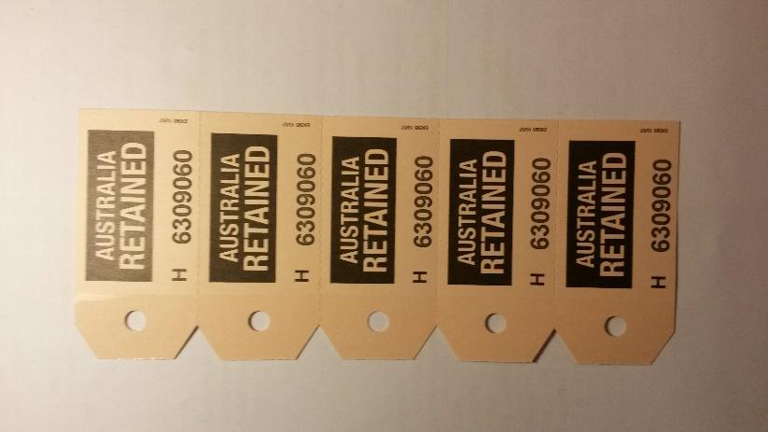
ECA 3 tags
The AS4696:20323 Australian Standard for the hygienic production and transportation of meat and meat products for human consumption specifies the inspection requirements for animals slaughtered in domestic and export abattoirs in Australia.
The following details the procedure for inspecting bovines .
What are the post mortem inspection procedures for cattle and buffalo?
These procedures are set out in Schedule 2 of AS 4696:2023 and cover the inspection of :
- carcases (Table 1)
- viscera (Table 2)
- heads (Table 3)
Additional procedures for gross abnormalities and specific diseases are detailed in Table 4 of Schedule 2.
Below is a general description of these procedures for domestic abattoirs and specific importing country requirements
Head inspection
You should be aware of what is happening around you including.
- head work up procedures.
  - is the nasal chamber being flushed prior to the buccal cavity.
  - Are any remnants of hide or eye lashes being trimmed off.
  - Are the tonsils being removed intact without cutting through them.
  - Is the head numbered in correlation with the carcase.
  - Is the correlation correct – the head should be inspected slightly prior to the carcase. This is because the head is considered a focal point of infection it gives you time to alert the viscera and carcase inspectors of any findings.

The inspection procedures for heads are as follows
- Observe the external surfaces including the oral, buccal, and nasal cavities. You’re looking for any abnormality, ingesta, hairs and hide pieces.
  - If you find minor hair/ hide pieces they can be trimmed off, consistent problems report to QA monitor.
- Observe the.
  - Submaxillary AK mandibular lymph nodes
  - Parotid lymph nodes
  - Retro Pharyngeal lymph nodes
  - Observe the lateral retropharyngeal AKA atlantal lymph nodes
  - Observe the tongue root if saved for human consumption.
  - Observe the internal and external masseter muscles but for export products currently the requirement is to make one incisions. In the domestic works the AS4696 2023 requirements are followed of just observing the muscles. However, if cattle present with an NLIS C.bovis device-based status techniques in Table 4 should apply (incise masseter and heart muscle, tongue and diaphragm after removal of serous membranes and observe all exposed muscles.

Note when cutting the external masseters make the cut as close to the outer surface as possible i.e. just under the skin to expose the red muscle this does the least damage to this primal cut. Cutting the masseters is called the bovis cut as masseters are predilection sites for Cysticercus bovis. You are more likely to see small green dots in these muscles this condition is called eosinophilic myositis and the carcase and parts should be retained for the OPV.

Note when observing lymph nodes if they look abnormal incise to determine the abnormality.

If the OPV (or meat inspector in a domestic works) puts up a suspect or emergency kill, then:
- the submaxillary, parotid and retropharyngeal lymph nodes must be incised
- bronchial and mediastinal lymph nodes must be incised
- the superficial inguinal and internal iliac lymph nodes must also be palpated.
Viscera inspection.
With viscera inspection there is a sanitary sequence that should be followed, basically you should always do the liver last. The reason for this is the liver is the detoxification organ of the body and could possibly have toxins in it. Always wash hand and sterilise knives after handling and after cutting lymph nodes.
- Bronchial and mediastinal lymph nodes
  - Observe incise if abnormal.
- Portal / hepatic lymph nodes
  - Palpate
- Trachea nothing specified.
  - if saved for human consumption open bronchia tubes and check for ingesta
- Oesophagus
  - Observe if saved for human consumption.
  - EU observe even if not saved.
- Heart
  - Observe; palpate heart incise internal musculature 3-4 times. However, if cattle are present with an NLIS C.bovis device-based status techniques in AS4696 2023 Schedule 2 Table 4 should apply (incise masseter and heart muscle, tongue and diaphragm after removal of serous membranes and observe all exposed muscles.

- Liver
  - Palpate, for USA listed plant incise large bile ducts longitudinally for about 75 mm from the hilus in the direction of the ventral border and about 25 mm in the opposite direction to allow observation of the duct and its contents.
  - For domestic plants a transverse cut across the main bile ducts is sufficient.
- Pancreatic and gastric lymph nodes
  - Note these are located at the junction of the oesophagus and rumen.
  - EU only observe unless there is evidence of disease then incise.
- Gastrointestinal tract.
  - Observe
- Mesenteric lymph nodes
  - Observe
  - EU if there is evidence of disease then incise.
- Spleen
  - Observe
- Kidney enucleated.
  - Observe
- Thymus, pancreas, bladder
  - Observe only if saved for human consumption.
- Non-gravid uterus, testes and penis.
  - Observe when save for human consumption..
- Udder
  - EU observe udder and associated lymph nodes if saved for human consumption.
Note if the OPV puts up a suspect or emergency kill then all the bronchial and mediastinal lymph nodes should be carefully incised for the OPV.

Carcase inspection.
- Carcase
  - Observe the internal and external surfaces including tail and musculature, exposed bone, joints, diaphragm, and serous membranes.
- Superficial inguinal / supra mammary lymph nodes
  - Observe or in bulls and mature cows observe and palpate.
- Internal iliac lymph nodes
  - Observe or in bulls and mature cows observe and palpate.
Note in addition to these procedures observe the cutting lines for any evidence of contamination. Contaminated carcases should be directed to the retain rail.

General notes
- Bovines less than six weeks of age are inspected as calves.

Inspecting a suspect or emergency kill
Check the suspect card to determine the reason for being a suspect or emergency kill.
Under veterinary supervision inspect and carefully incise submaxillary, parotid and retropharyngeal lymph nodes.

Incise all the lymph nodes of the lungs and palpate the superficial inguinal/suppra mammary, internal iliac lymph nodes
Inspection when a gross abnormality or a specific disease is detected or suspected
In addition there are further procedures that need to be followed when gross abnormalities and specific are detected or suspected. These are detailed in Schedule 2 Table 4.
If Cysticercus bovis lesions are suspected then the following inspection procedures are undertaken:
- incise the masseter and heart muscles
- remove the serous membrane from the diaphragm.
- incise the diaphragm and tongue
- observe all expose muscles
- retain the affected product and inform the OPV in export works.

Tuberculosis is suspected or detected.
- If your informed the animal/s have a TB status in the NLIS database, or you detect or suspect an abnormal lymph node to be affected by TB.
  - Retain the affected product and immediately inform the OPV
  - Incise the parotid, submaxillary, retropharyngeal, bronchial, mediastinal, atlantal, prescapular, prepectoral, suprasternal, superficial inguinal, iliac, ischiatic, precrural, portal and mesenteric lymph nodes.
  - Incise the popliteal lymph node if required by OPV
  - Inspect by observation, palpation and where necessary incise all viscera, serous membranes, spinal cord and exposed severed vertebral column.

Additional EU requirements prior to inspection
All EU eligible carcases must be palpated for hormonal growth implants and triangular ear punches during slaughter and dressing this must occur prior to hide removal prior to removal of the RFID device the palpation must focus on the base and back of the ear, caudal tail fold and brisket.
You must be informed immediately when implants or triangular ear punches are detected.

What are the differences between export and domestic inspection procedures?
Export inspection procedures
The AS4696:2023 Australian Standard for the hygienic production and transportation of meat and meat products for human consumption specifies the inspection requirements for animals slaughtered in domestic and export abattoirs in Australia. These have been described above.
These requirements form the minimum standard of inspection. However, the inspection procedures at export registered plants may vary quite considerably from those specified in the Standard , as they have been negotiated with overseas countries over a number of years.
Basic inspection procedures according to the Australian Standard are required to be performed at all export registered plants for all basic markets.
The United States of America’s procedures are required to be performed at all times in US listed establishments.
European Union procedures are required to be performed when EU production is occurring, i.e. only when production is destined for the EU market and in EU listed plants.
It is worth noting that many markets insist on either the US or the EU standard for access to their markets.
For example Canada, Puerto Rico and Mexico require US listing before they will list an establishment.
EU listing is required by dependencies of most EU countries e.g. the Canary Islands a dependency of Spain requires EU listing before product will be accepted. Some EU membership hopefuls, such Romania and Croatia also require EU listing.
Other countries that require EU listing before product will be accepted or listing approved include Namibia, Switzerland and Mayotte.
Additional inspection procedures for US markets
There is only one additional inspection procedure for the United States market.
In cattle and buffalo, the large bile ducts are opened longitudinally for about 75 mm from the hilus in the direction of the ventral border and 25mm from the hilus in the opposite direction.
Additional inspection procedures for European markets
All species
Viscera
If lungs are to be collected for edible purposes, the trachea and the bronchi must be incised along the longitudinal axis.
Cattle and buffalo
Viscera
Heart | Incise the heart longitudinally from base to apex splitting the wall of the left atrium and ventricle at ninety degree to the inter-ventricular septum, penetrating the septum so that the heart may be laid flat, thereby exposing the interior walls of the four chambers of the heart and the sets of valves. The muscle of the septum and the ventricles must then be deeply incised.  Observe the pericardial sac and its contents
Additional | Where Cysticercus bovis is detected at head or viscera inspection the serosa of the diaphragm must be stripped and the underlying muscles inspected
Carcase | Observe the cut surface of the muscles and bones of the spinal column of the split carcase.  Where Cysticercus bovis is detected at head or viscera inspection observe the thin skirt for Cysticercus bovis.  Observe the renal lymph nodes.
There is a new unit on calve inspection
Carcase
Palpate superficial inguinal/ supramammary, precrural and superficial cervical lymph (prescapular) lymph nodes.

What WHS, hygiene and sanitation requirements apply when conducting post-mortem inspection?
The company work instructions will set down all the WHS and hygiene and sanitation requirements for working on the slaughter floor and when conducting post mortem inspections.
These will require the inspector to:
- wash hands between carcases or when contaminated
- wear al PPE like aprons and boots which can be cleaned regularly and easily
- follow the sanitary sequence which is to handle edible product (heart, lung, kidney) before handling inedible materials (intestines)
- sterilise knife between carcases and when contaminated and after steeling
- change uniform if it is grossly contaminated
- wash hands before and after work.
These practices will protect health and minimise cross contamination.
Inspectors should always wear the Personal Protective Equipment (PPE) set down in the company work instructions or WHS policy.
PPE will include:
- hand protection like mesh and cut-resistant gloves
- hearing protection
- footwear
- aprons
- uniforms
- hair net.
It is important to handle diseased or contaminated product that may require trimming in a way that avoids contamination of clean parts of the carcase. This may involve holding the affected parts with a hook and trimming from a clean area to remove offending material.
The workplace will also have a ‘dropped meat policy’ for product that accidently contacts the floor. This will need to be followed if product is dropped.
What QA issues relate to post-mortem inspection?
There are a number of quality assurance issues that relate to post mortem inspection. They will be detailed in the Company’s Quality Assurance program and in the work instructions. Issues that will be covered include:
- ensuring carcases and carcase parts are correctly presented for post-mortem inspection
- performing the correct procedure according to the Australian Standard and export market requirements if applicable
- ensuring only wholesome product is passed for human consumption
- ensuring trace-back requirements to ante-mortem inspection is maintained
- ensuring correlation is maintained between head, carcase and viscera until after disposition has been made
- retaining carcases and carcase parts for veterinary examination (export plants only) or laboratory examination when required
- limiting cross contamination during inspection
- ensuring, where appropriate, the quality and integrity of the product is maintained
- the maintenance of records as required by the workplace instructions.
What are the signs of common conditions responsible for abnormalities at post-mortem and what are the dispositions?
There are a range of conditions and abnormalities that can affect the wholesomeness of a carcase and its parts for human consumption. When passing judgement on a carcase and its parts during post mortem inspection, several points must be taken into consideration. They are:
- the nature of any abnormality
- whether it is localised or generalised
- whether it is chromic or acute
- the possible cause of the condition/disease
- the possible risk to human health from any abnormal condition.
The list of abnormalities and the disposition to be taken at post mortem inspection is detailed in the tables below reproduced from Schedule 3 of the AS4696:2023 Australian Standard for the hygienic production and transportation of meat and meat products for human consumption.
Note: words in italics have been added by the author for clarity.
Detection of these abnormalities is by following the stated procedures detailed previously.
AS4696-2023 Schedule 3 Ante-mortem and post-mortem dispositions

Column 1 | Column 2
Diseases and other abnormalities | Dispositions for animals, carcases and carcase parts
 | The symbol [1] means carcase or carcase parts unfit for human consumption may be recovered for animal food subject to heat sterilisation. The symbol [2] means carcase or carcase parts unfit for human consumption may be saved either for animal food subject to heat sterilisation or for animal food subject to staining.
1. General findings
Dead animal |  | Animal condemned. If anthrax suspected see 2.1.
Dying animal or moribund state with subnormal temperature, weak pulse and disturbed senses. |  | Animal condemned
Fever, debility and general signs indicating acute disease |  | Animal condemned. Alternatively, withhold from slaughter until recovered provided no risk of spread of disease; no undue suffering and recovery considered likely with treatment
When the above are detected at post-mortem |  | Carcase and all its carcase parts condemned
Advanced chronic conditions with generalised signs such as cachexia or loathsome appearance |  | Animal condemned
Injury or accidental trauma during transport to or while in vicinity of abattoir |  | Animal subject to emergency slaughter or condemned
Excitement, exhaustion without signs of acute disease |  | Animal withheld from slaughter and ante-mortem repeated after adequate rest
Generalised disease conditions such as emaciation, anaemia, oedema or degeneration of organs |  | Carcase and all its carcase parts condemned.
Septicaemia, pyaemia or toxaemia |  | Carcase and all its carcase parts condemned
Foetuses and undeveloped neonatal animals |  | Carcase and all its carcase parts condemned
Abnormal odour caused by metabolic conditions, feedstuff, chemicals or sexual odour
Pronounced odour |  | Carcase and all its carcase parts condemned[1]
Slight odour |  | Hold overnight, if odour dissipates it is fit for human consumption. May do a cooking test.
2. Aetiological listing (causes of a disease)
2.1 Bacterial and related diseases
Anthrax |  | Affected animals should not be admitted to an abattoir. When detected at ante-mortem, affected animal condemned. Companion animals isolated and withheld from slaughter
 |  | When detected at post-mortem, affected carcase and all its parts condemned
Blackleg |  | Carcase and all its carcase parts condemned
Botulism |  | Carcase and all its carcase parts condemned
Malignant oedema. |  | Carcase and all its carcase parts condemned
Enterotoxaemia |  | Carcase and all its carcase parts condemned
Tuberculosis:
In cattle and buffaloes
- Generalised with evidence of systemic involvement; more than one organ affected; miliary lesions in any organ; evidence of active infection or extensive infection of peritoneum or pleura. |  | Carcase and all its carcase parts condemned
- Localised infection |  | Affected carcase part, including drained part, condemned; or affected organ condemned
White scours, omphalophlebitis, polyarthritis and other septicaemic conditions of new-born animals |  | Carcase and all its carcase parts condemned
Johne’s disease |  | Intestines and mesentery condemned
Strangles |  | Affected carcase parts condemned
Purpura haemorrhagica |  | Affected carcase parts condemned
Botryomycosis:
- Severe cases with evidence of systemic effects such as cachexia |  | Carcase and all its carcase parts condemned
- Less severe cases |  | Affected carcase parts condemned
Melioidosis |  | Carcase and all its carcase parts condemned
- Generalised involvement in carcase and viscera with evidence of systemic effects such as cachexia |  | Carcase and all its carcase parts condemned
- Less extensive forms of the disease |  | Affected organs or carcase parts condemned
Necrobacillosis:
- Acute with lesions in a number of sites or evidence of systemic involvement |  | Carcase and all its carcase parts condemned
- Localised lesion in liver or other organ |  | Affected liver or organ condemned
Anaplasmosis and Babesiosis:
- Acute with intense jaundice and other signs of systemic involvement including fever; liver enlargement; and kidney congestion |  | Carcase and all its carcase parts condemned
- Subacute with mild jaundice which dissipates within 24 hours of slaughter |  | Carcase parts condemned
Eperythrozoonosis:
- Acute with intense jaundice and other signs of systemic involvement including fever; liver enlargement; and kidney congestion. |  | Carcase and all its carcase parts condemned
- Subacute with mild jaundice which dissipates within 24 hours of slaughter |  | Carcase parts condemned
2.2 Parasitic conditions.
Cysticercus bovis:
- General infestation |  | Carcase and all its carcase parts condemned
- Light infestation, small number of degenerated cysticerci |  | Affected viscera condemned. Cysts and surrounding tissue trimmed from carcase and condemned. Remainder of carcase and parts passed conditionally fit for human consumption subject to treatment by freezing (no warmer than –12 °C deep muscle temperature for not less that 10 days in carcases and 20 days in boned meat)
- General infestation |  | Carcase and all its carcase parts condemned
- Light infestation |  | Tissue trimmed from carcase and condemned. Remainder of carcase and parts passed conditionally fit for human consumption subject to treatment by freezing (no warmer than –12°C deep muscle temperature for not less than 5 days in carcases or boned meat).
Echinococcosis |  | Affected organs condemned
Pulmonary and gastrointestinal strongylosis |  | Affected organs condemned.[1] in case of lungs.
Myiasis |  | Animal condemned in severe cases with sepsis or necrosis. Otherwise withhold from slaughter for treatment and resubmit for ante-mortem after recovery.
Stephanurus dentatus |  | Affected carcase parts condemned
Onchocerciasis |  | Lesions and affected tissues trimmed from carcase and condemned
2.3 Protozoal diseases
Sarcosporidiosis |  | Affected carcase parts condemned
Coccidiosis |  | Affected intestines condemned
2.4 Viral diseases
Ephemeral fever |  | Animals withheld from slaughter for treatment. Resubmitted for ante-mortem after recovery.
Bovine virus diarrhoea/mucosal disease:
- Acute infection with evidence of systemic involvement |  | Carcase and all its carcase parts condemned
- Chronic infection with lesions localised to alimentary tract |  | Affected intestines condemned
Bovine para-influenza |  | Affected lungs condemned
Bovine leucosis:
- Multiple lesions or lesions in multiple organs |  | Carcase and all its carcase parts condemned.
- Localised lesion (e.g. mesentery) |  | Affected gastrointestinal tract or other organs condemned
2.5 Fungal diseases
Aflatoxicosis:
Acute with generalised signs including jaundice; swelling of liver; ascites and mesenteric oedema |  | Carcase and all its carcase parts condemned
Subacute |  | Affected liver and kidneys condemned
Epizootic lymphangitis. |  | Affected skin and related tissues condemned. Any affected organs condemned.
2.6 Non-infectious conditions
Tumours:
- Circumscribed benign tumours; neurofibromas of intercostals nerves and nerve plexes |  | Depending on extent, lesion trimmed and condemned or affected carcase part condemned[1]
- Malignant tumours (carcinoma, sarcoma) |  | Carcase and all its carcase parts condemned[1]
- Multiple tumours (evidence of metastasis or multiple lesions in different organs) |  | Carcase and all its carcase parts condemned[1]  Note any sign of spread from a primary site is a sign of malignancy
Metabolic disorders (transit tetany, ketosis, etc) |  | Animal condemned in severe cases. Withheld from slaughter in milder cases and resubmitted for ante-mortem after recovery.
Jaundice:
- Haemolytic or toxic |  | Carcase and all its carcase parts condemned
- Obstructive (slight, dissipate within 24 hours of slaughter |  | Carcase parts condemned
- Obstructive (severe) |  | Carcase and all its carcase parts condemned.
Residues in excess of nationally established maximum limits |  | Carcase and all its carcase parts condemned. Companion animals and carcases tested for residue levels.
Delay in Evisceration:
- Evidence of deterioration or putrefaction |  | Carcase and all its carcase parts condemned
- Localised changes in viscera |  | Viscera condemned
Ecchymosis |  | Affected carcase parts condemned[2]
Foreign objects,
- Accompanied by generalised signs such as fever or sepsis |  | Carcase and all its carcase parts condemned
- No evidence of generalised signs |  | Foreign object removed; affected tissues trimmed from carcase and condemned
3. Topographic listing (by body part)
3.1 Nervous system
Acute encephalitis and meningitis |  | Carcase and all its carcase parts condemned
Brain abscesses:
- Associated with pyaemia |  | Carcase and all its carcase parts condemned
- Localised lesion |  | Affected brain condemned
3.2 Cardiovascular system
Acute pericarditis with accumulation of exudate; septicaemia; degenerative changes in organs or abnormal odour |  | Carcase and all its carcase parts condemned
Chronic pericarditis |  | Affected heart and pericardium condemned
Endocarditis:
- Associated with generalised signs |  | Carcase and all its carcase parts condemned
- Without complications. |  | Affected heart condemned
Heart lesions of non-infectious nature |  | Affected heart condemned
Worm aneurisms in horses:
- Infarction confined to hind leg |  | Affected quarter condemned
- Peritonitis, circulatory disturbances in mesentery and intestines |  | Carcase and all its carcase parts condemned
3.3 Respiratory system
Sinusitis. |  | Affected head condemned
Peracute pneumonia such as severe purulent bronchopneumonia; gangrene of the lungs; or necrotic pneumonia. |  | Carcase and all its carcase parts condemned
Multiple pulmonary abscesses |  | Carcase and all its carcase parts condemned.
Bronchitis |  | Affected lungs condemned
Pneumonia or bronchopneumonia  - Acute infectious with evidence of septicaemia, petechial haemorrhage polyserositis  - Chronic, may show multiple localiased abnormalities in lungs no evidence of septicaemia, petechial haemorrhage polyserositis |  | Carcase and all its parts condemned  Affected lungs condemned[1]
Atelectasis, emphysema, pigmentation, aspiration of blood, scalding water or ingesta |  | Affected lungs condemned[1]
3.4 Pleura
Pleurisy  - Acute infectious with evidence of septicaemia, petechial haemorrhage polyserositis  - Chronic with adhesions and patches of fibrous material, no evidence of septicaemia |  | Carcase and all its carcase parts condemned  Affected serous membranes removed and affected parts condemned
Adhesions and patches of fibrinous tissue |  | Affected serous membranes stripped and affected parts condemned
3.5 Gastrointestinal tract
Acute enteritis:
- Septic, diphtheritic or haemorrhagic enteritis’ enlargement of spleen or degeneration of organs |  | Carcase and all its carcase parts condemned
- With congested mesenteric lymph nodes without other signs |  | Affected intestines condemned
Chronic gastro-intestinal catarrh |  | Affected intestines condemned
3.6 Peritoneum
Peritonitis:
- Acute, diffuse or extensive |  | Carcase and all its carcase parts condemned
- Localised |  | Affected serous membranes stripped and affected parts condemned
Adhesions and patches of fibrinous tissue, localised encapsulated abscesses |  | Affected parts condemned
3.7 Liver
Telangiectasis, cyst formation |  | Affected liver or part of liver condemned[1]
Fatty infiltration, parenchymatous infiltration |  | Affected liver condemned[1]
Hepatitis of toxic, parasitic or non-specific nature |  | Affected liver condemned[1] for parasitic and nonspecific causes
Parasitic lesions/nodules |  | Affected parts of liver trimmed and condemned
Abscesses |  | Affected liver condemned
3.8 Kidney
Calculi, cyst formation, pigmentation |  | Affected kidneys condemned[1]
Nephritis (including parasitic nephritis):
- Acute with evidence of uraemia, oedema or abnormal odour of urine |  | Carcase and all its carcase parts condemned.
- Chronic with no systemic effects |  | Affected kidneys condemned
Bladder rupture |  | Carcase and all its carcase parts condemned.
3.9 Genital tract
Inflammation of uterus:
- Acute metritis (septic or necrotic, putrefied foetus). |  | Carcase and all its carcase parts condemned
- Chronic metritis |  | Affected uterus condemned
Retention of placenta:
- Accompanied by fever or evidence of other systemic effects |  | Carcase and all its carcase parts condemned
- With no signs of systemic effects. |  | Affected uterus condemned
Prolapse, torsion or rupture of uterus accompanied by fever or peritonitis |  | Carcase and all its carcase parts condemned
Orchitis/epididymitis |  | Affected organ condemned
3.10 Udder Mastitis:
Septic, gangrenous |  | Carcase and all its carcase parts condemned
No signs of systemic involvement. |  | Udder condemned
Oedema |  | Udder condemned
3.11 Musculo-skeletal system
Fractures:
- Uncomplicated (recent or healing) |  | Fracture trimmed from carcase and condemned
- Infected with signs of generalised effects |  | Carcase and all its carcase parts condemned
Osteomyelitis:
Gangrenous, suppurative or accompanied by metastasis |  | Carcase and all its carcase parts condemned
Localised |  | Affected part trimmed from carcase and condemned
Myositis and Muscular Dystrophy |  | Affected parts condemned[1]
Abnormal pigmentation |  | Affected parts condemned[1]
Arthritis:
- Acute infectious with evidence of septicaemia, petechial haemorrhage, polyserositis |  | Carcase and all its carcase parts condemned
- Chronic, may have multiple affected joints, no evidence of septicaemia, or cachexia |  | Affected part condemned
3.12 Skin
Wounds and Cellulitis:
- Infected wounds and discharging lesions accompanied by generalised signs such as fever or sepsis |  | Carcase and all its carcase parts condemned
- Granulating wounds or no evidence of generalised signs |  | Affected tissues trimmed from carcase and condemned
Bruising:
Generalised or secondary changes in carcase |  | Carcase and all its carcase parts condemned[2]
Localised |  | Affected tissue trimmed from carcase and condemned. [2] for trimmings
Burns:
- With extensive oedema or systemic signs such as fever |  | Carcase and all its carcase parts condemned
- Localised |  | Affected tissue trimmed from carcase and condemned[1]
Erythema and acute dermatitis (e.g. photosensitisation):
With systemic effects such as fever |  | Carcase and all its carcase parts condemned
No evidence of systemic involvement |  | Affected skin trimmed from carcase and condemned[1]
What are the types and symptoms of emergency diseases that can be detected at post-mortem?
The range of emergency diseases that should be considered during ante-mortem and post mortem inspection has been detailed earlier in this document in the ante-mortem section.
There are detailed notes and photographs that can be seen in the training materials for the Unit of competency AMPMSY302 Recognise signs of emergency and notifiable animal diseases.
Most emergency diseases are more readily detectable at ante-mortem inspection rather than post mortem inspection.
But if at post mortem inspection a number of animals from one lot showing symptoms of fever are noted, serious consideration should be given to the suspicion of an emergency disease.
The disease may be an endemic disease such as Salmonella but it could also be an exotic disease.
The holding of carcases while a decision is made is an important part of the process.
What regulatory requirements apply when handling an affected carcase?
Carcases may be identified at post-mortem inspection as having:
- a pathological condition
- gross contamination
- another abnormality requiring further treatment and/or a more detailed inspection.
They may be directed to the retain rail to undergo further treatment and inspection. The post-mortem inspector marks these carcases or carcase parts with the relevant retain tag, as per workplace procedures.
There needs to be an area set aside for re-inspection purposes. It should only be used for this purpose. The equipment needed is:
- lighting, to 600 lux
- handwash and equipment sterilisation facilities and liquid soap
- condemned meat bin/barrow/chute
- cutting equipment – saw, knife etc.
- product wash facilities
- quartering facilities.
The requirements to be met when retaining a carcase will depend on whether the plant is domestic-registered or export-registered. The requirements are generally as follows.
Action | Explanatory notes
Supervise | retain rail personnel in the detection and removal of pathology, contamination or other abnormality requiring treatment.
Inspect | all external and internal carcase surfaces, including cut muscle, to ascertain if the reason for retaining has been rectified  all carcase parts (viscera) that have been retained to assist with disposition.
Palpate | lymph nodes and suspect lesions and, where necessary, incise to detect disease conditions and/or pathological change.
Sanitary sequence | observe  palpate  incise.  NB: Wash hands after handling material unfit for human consumption. Thoroughly sterilise knife after trimming material unfit for human consumption.
Note: for further information refer to Undertake retain rail operations.
The question of disposition i.e. what to do with the retained carcase and its parts is a question that should be addressed in conjunction with AS4696:2023 Australian Standard for the hygienic production and transportation of meat and meat products for human consumption, which offers good guidelines on disposition.
But in the end it is up to the meat inspector to make the decision. The decision should be made on good scientific principles.
When making disposition on a carcase, an organ or any other parts a disposition can be made on:
- the total carcase (including its parts)
- a part of the carcase
- pass as suitable for human consumption and remove the retain tags
- retain requiring further inspection and apply a retain tag and supervise the segregation of the carcase and/or carcase parts in the retain facility
- retain requiring further treatment and apply a retain tag and supervise the segregation of the carcase and/or carcase parts in the chiller retain facility
- relegate to an inedible purpose other than condemnation, i.e. animal food or pharmaceutical purposes; identify the carcase and/or carcase parts as suitable for the designated purpose, e.g. pet food only and supervise the removal of the carcase and/or carcase parts to the designated processing area
- identify the carcase and/or carcase parts as condemned by the application of the condemned stamp or the application of ink and/or disposal in a condemned tub/bin or chute.
What hygiene and sanitation and WHS requirements apply when handling an affected carcase?
The company work instructions will set down all the hygiene requirements for working on the slaughter floor and for handling affected carcases.
These will require the meat inspector to:
- wash hands between carcases or when contaminated
- wear PPE like aprons and boots which can be cleaned regularly and easily
- follow the sanitary sequence which is to handle edible product (heart, lung, kidney) before handling inedible materials (intestines)
- sterilise knife between carcases and when contaminated and after steeling
- change uniform if it is grossly contaminated
- wash hands before and after work.
These practices will protect health and minimise cross contamination.
Inspectors should always wear the Personal Protective Equipment (PPE) set down in the company work instructions or WHS policy.
PPE will include:
- hand protection like mesh and cut-resistant gloves
- hearing protection
- footwear
- aprons
- uniforms
- hair net.
It is important to handle diseased or contaminated product that may require trimming in a way that avoids contamination of clean parts of the carcase. This may involve holding the affected parts with a hook and trimming from a clean area to remove offending material.
The workplace will also have a ‘dropped meat policy’ for product that accidently contacts the floor. This will need to be followed if product is dropped.
Retaining carcases
What are the procedures for retaining carcases on the slaughter floor?
When minor defects cannot be removed by an inspector on the slaughter floor or if a carcase requires a more detailed assessment the carcase may be passed onto the retain rail for further treatment and assessment.
Carcases on the chain can be identified in a number of ways to indicate the pathology or defects that need to be removed or re assessed in the retain rail. This includes knife cuts, tie-on tags, stick-on tickets, plastic tags and formal approved retain tags (ECA3).
ECA3 tags are used when carcase and parts are retained for Veterinary disposition there are 5 tags one on head one on each side one viscera and one for the OPV
Workplace procedures will detail how this is to be done.
These tags are temporary tags and are removed by the AAO except ECA3 tags they are removed by the OPV on the retain rail after the defects have been addressed.
The ECA4 Tag or equivalent on the other hand can only be removed by an authorised person. It is generally used for more permanent control over product where more detailed assessments need to be done to determine the suitability of the product for human consumption. They are generally used for retaining carcases in the locked retain cage in a chiller. These carcases are generally to be boned under supervision.
What are the procedures for retaining carcases in a chiller?
If carcases are to be retained in the chiller because it may take some time for laboratory results to return, the carcases to be retained must not only be identified by ECA$ tags but also need to be locked in such a way by a meat safety inspector or other authorised person, so that it cannot be used for human consumption until the results of tests have been received.
Carcases may be locked on the rail or in a special cage.
Records need to be maintained of any such actions. In the ECA4 register held by the OPV
Workplace procedures will detail how this is to be done.

PPE requirements for post-mortem inspection
What PPE is required to perform post-mortem inspection?
Personal Protective Equipment to be used will be set down in the work instruction and WHS procedures. PPE may include:
- protective hand and arm covering
- protective head and hair covering
- head wear
- coat and apron
- work safety or waterproof footwear
- protective boot covers
- ear plugs/muffs
- eye and facial protection
- waterproof clothing.
What workplace requirements apply when using PPE?
According to the National Guidelines for Health and Safety in the Meat Industry:
‘ PPE and clothing are those items of equipment worm by an employee to minimise or eliminate exposure to specific occupational hazards’
The emphasis is always on eliminating the hazards thereby making it unnecessary for workers to wear Personal Protective Equipment (PPE). However, it is not always possible to eliminate the hazards, and PPE may be required to protect the worker from the consequences of exposure. For example, workers may be required to wear ear plugs to reduce the likelihood of deafness resulting from exposure to an excessively noisy environment. Workers in the meat industry are frequently required to wear PPE. In this case it is the employer’s responsibility to ensure PPE is:
- assigned to the worker for their exclusive use
- cleaned and maintained after use
- stored when not in use
- inspected and repaired regularly
- checked for continued functioning and effectiveness.
It is also the employer’s responsibility to ensure training is provided as appropriate. Workers should receive training about:
- proper use of PPE
- the deficiencies and restrictions of PPE
- fitting PPE and how to test for fit
- use of PPE
- maintenance of PPE
- storage of PPE
- identification of faults in PPE
- procedure for replacing PPE.
How should PPE be used, maintained and stored?
Workers are responsible to:
- wear PPE as instructed by the supervisor and as set out in the work instruction
- fit PPE to ensure it is used to maximum benefit
- check for any faults and replace it if faulty
- follow maintenance procedures as instructed by the supervisor and set out in work instructions
- store PPE as instructed.
Examples of specific PPE are included in the National Guidelines for Health and Safety in the Meat Industry.
Taking pathological and residue samples
How are lesions and tissues necessary for determining dispositions identified?
The type of lesions and tissues necessary for determining dispositions will depend on the nature of the abnormality and the nature of the suspected disease condition. For certain conditions such as granulomas, it is a regulatory requirement to take a sample for laboratory analysis for Bovine tuberculosis. It is vital under these circumstances that there is an accurate record of the property of origin of the animal so that trace back can be instituted if necessary.
For other conditions the list below indicates what suitable specimens should be taken.
What are the requirements for collecting and submitting specimens?
Sometimes in order to make a correct disposition on product at post mortem inspection or to confirm suspicion of a notifiable disease it will be necessary to take samples for laboratory analysis.
In each State or Territory there is usually a Veterinary Laboratory where samples can be sent for analysis. Detailed information on the collection and handling of samples for each laboratory should be obtained directly from the laboratory. Most Laboratories have a manual that will outline the collection and handling requirements. The following is a brief guide of the samples required for various types of tests.
Bacteriology
Swabs of tissue e.g. heart blood, intestinal content, in transport medium and /or 30 ml of chilled lesion, fluid or tissue e.g. liver, lung, intestine in a screw-capped container.
Biochemical tests
Full 10 ml plain and Lithium/ heparin blood tube.
Gross Pathology
Representative samples of affected tissue with any adjacent normal tissue.
Haematology
Full 10 ml EDTA blood tube and blood smear.
Histopathology
A representative sample of affected tissue with adjacent normal tissue. Tissue should be 1 cm thick in ten times their volume of buffered formalin solution.
Parasitology
Approximately 30g of faeces for faecal egg count.
Serology
A full 10 ml plain blood tube.
Toxicology
Approximately 50 ml of ingesta, faeces or flesh tissue.
Virology
Full 10 ml plain tube and EDTA blood tubes.
30 ml of fresh chilled tissue e.g. heart, spleen or swab of lesion or tissue in PBGS.
How are specimens for residue testing taken?
Specimens for residue testing will vary according to the type residue that is suspected. For example if cadmium is suspected kidney samples will be taken. If pesticides are suspected samples could include meat or offal such as livers.
It is vital under these circumstances that there is an accurate record of the property of origin of the animal so that trace back can be instituted if necessary.
The workplace instructions will describe what samples to take. If not the relevant authority responsible for meat safety in each state will be able to provide advice.
The relevant laboratory doing the testing will also advise what type of specimen they require.
How are results interpreted?
The interpretation of the results of residue sampling will be determined by the laboratory. They will advise if the result is below or over the regulatory limit for that residue.
If the result is over the regulatory limit public health authorities will decide what is to happen to the carcase.
What are the requirements for retaining carcases while waiting for results?
If carcases are to be retained in the chiller because it may take some time for laboratory results to return, the carcases to be retained must not only be identified by tags but also need to be locked in such a way by a meat safety inspector or other authorised person, so that it cannot be used for human consumption until the results of tests have been received. ECA4 Tags in the retain cage
Records need to be maintained of any such actions.
Workplace procedures will detail how this is to be done.

Bibliography
These publications were used to develop this training material.
Eddie Andriessen Meat Safety Quality and Veterinary Public Health in Australia 11th edition Penny Farthing Publishing PO Box 190 Woodville SA
Food Standards Australia New Zealand Australian Standard for the Hygienic Production and Transportation of Meat and Meat Products for Human Consumption FRSC technical report No 3 AS 4696:2023 CSIRO Publishing
AMIC National Animal Welfare Standards for Livestock Processing Establishments Preparing Meat for Human Consumption 2nd Edition (2010)
Model Code of Practice for the Welfare of animals: Livestock at Slaughtering Establishments
Commonwealth Department of Agriculture
Export Control Act 1982
Export Control (Prescribed good General) Order 2005
Export Control (Meat & Meat Products) Orders 2005
Manual of Importing Country Requirements – European Union
United States
National Residue Survey – Approved Laboratories for Chemical Residue Testing
Note: Other than Eddie Andriessen’s book all of the above can be accessed at Elmer 3
http://www.agriculture.gov.au/export/food/meat/elmer-3

Additional resources
Registered Training Organisations (RTOs) should refer to the Unit-by-Unit listing of resources on the MINTRAC website www.mintrac.com.au for additional resources to support the delivery of this Unit.
RTOs which develop or identify additional resources are encouraged to advise MINTRAC so that these can also be added to the Unit-by-Unit listing.
The Exam Generator
The Exam Generator is a question bank containing hundreds of questions related to meat safety and Quality Assurance. There are two CDs in the set – one for RTOs (Albert) to create the exams and a student CD (Eddie) that creates electronic practice exams containing all the same questions.
Meat Inspection Currency tool
The Meat Inspector Currency exam generator generates quizzes for the assessment of the currency of a meat inspector’s knowledge.

