AMPMSY404
Perform ante and post-mortem inspection – Poultry
Training support materials

Australian Meat Processing Training Package
Certificate III in Meat Processing

Table of contents
Training support materials for AMPA3123 Perform ante and post-mortem inspection - Poultry 4
Breeds of poultry and their market requirements 4
What are the major breeds of commonly slaughtered poultry and what are their distinguishing features? 4
What are the market requirements for poultry? 5
Anatomical structure of poultry 7
The core unit AMPA3119 Apply food animal anatomy and physiology to inspection processes details the anatomical and physiological elements that apply to all species. 7
What are the key organs of poultry species? 7
The digestive system 7
The immune system 10
The circulatory system 11
The urogenital system 12
The nervous system 15
The respiratory system 16
The endocrine system 18
Basic skeletal structure of poultry species 18
Conducting ante-mortem inspection of poultry 21
What are the main reasons for ante-mortem inspection? 21
Identifying heat stress in the lairage 22
What regulatory requirements apply when conducting ante-mortem inspection? 23
What are the principles and procedures for the humane handling of poultry? 25
What are the signs of common conditions responsible for abnormalities at ante-mortem and how can they be detected? 25
What are the procedures for segregation and reporting after the identification of emergency disease? 25
What are the signs of emergency or notifiable diseases? 27
What are the procedures for humane destruction? 28
What are the QA aspects of ante-mortem inspection? 31
Making an ante-mortem disposition 32
Diseases and conditions in poultry 32
40
Monitoring the stunning and slaughter of poultry 42
What are the requirements for effective stunning and slaughter? 42
What regulatory requirements apply to stunning and bleeding? 44
What corrective action must be taken in the event of ineffective stunning or bleeding? 44
Conducting post-mortem inspection of poultry 45
What are the main reasons for post-mortem inspection? 45
What are regulatory requirements associated with post-mortem inspection? 46
What are the procedures for conducting post-mortem inspection and identifying and detecting abnormalities? 46
What QA issues relate to post-mortem inspection? 47
Making a post-mortem disposition 50
What is the process for identifying and documenting common diseases and conditions responsible for abnormalities? 50
How regulatory requirements apply when handling an affected carcase? 55
What are the procedures for retaining carcases on the slaughter floor? 56
Taking pathological and residue samples 56
How are lesions and tissues necessary for determining dispositions identified? 56
What are the requirements for collecting and submitting specimens? 56
How are results interpreted? 57
What are the requirements for retaining carcases while waiting for results? 57
WHS requirements relevant to ante-mortem and post-mortem inspections 57
How hygiene and sanitation and WHS requirements apply when handling an affected carcase? 58
PPE requirements for post-mortem inspection 59
What PPE is required to perform post-mortem inspection? 59
What QA and workplace requirements apply when using PPE? 60
How should PPE be used, maintained and stored? 60
Bibliography 61
Additional resources 61
Training support materials for AMPA3123 Perform ante and post-mortem inspection - Poultry
Breeds of poultry and their market requirements
What are the major breeds of commonly slaughtered poultry and what are their distinguishing features?
Poultry is the class of domesticated birds farmed for their meat, eggs or feathers. These most typically are members of the orders Galliformes (such as chickens and turkeys), and Anseriformes (waterfowl such as ducks and geese). Domesticated over 7000 years ago, the chicken is believed to have originated from the red jungle fowl (Gallus gallus). In commercial poultry production, in many parts of the world, there are two types of bird, an egg type (or layers) and a meat type (or broilers), with a number of breeds within each type.
The species of birds traditionally hunted in various parts of the world for food or sport are considered game birds. Game bird species farmed in Australia are pheasants, partridges, guinea fowl, quail and pigeons (squab). Table 1 provides a useful summary of the main breeds processed in Australia and their distinguishing features.
Table 1: Distinguishing features associated with the main poultry species and breeds processed in Australia
Poultry species | Distinguishing features and additional information
Chicken (Broiler) | Compared to their jungle fowl ancestors, domestic chickens are less active, have fewer social interactions, are less aggressive to would-be predators, and are less likely to go looking for foreign food sources. Physical changes that have resulted from domestication include increased growth rate and adult body weight, simplified plumage, earlier sexual maturity, more frequent egg laying and larger eggs.  Meat type birds (broilers) have been selectively bred for maximum meat production from minimum feed intake, with some producing 1 kg of live weight from less than 2 kg of feed. Usually slaughtered at 35 days onwards.
Turkey | The modern day meat birds are specially bred hybrids (a cross between two or more different breeds). Commercial turkey breeding has resulted in hybrid strains that grow much faster and convert feed to bodyweight much more efficiently than pure breeds. A modern white hybrid turkey can reach 6 kg in weight by 10 weeks of age. Commercial turkeys are bred specifically to have more meat in the breast and thighs. White feathered turkeys are generally preferred. The main commercial turkey used in Australia is the hybrid white bird which are the progeny of specially selected male and female parent stock. The males are chosen for their body conformation and fast growth rate while the females are chosen for their lack of broodiness, egg-production ability, and growth rate. Fast growth and a focus on breast muscle development, has led to an increase in skeletal disorders, especially tibial dyschondroplasia (TD).
Duck | The major breeds used for meat production in Australia are Pekin, Muscovy, Aylesbury and Rouen and crosses of these breeds. The Pekin duck (Anas Domesticus) being the predominant breed used for meat production in Australia.
Geese | Breeds of geese available in Australia include Embden, Toulouse and some Chinese varieties. There has been little attempt to improve the genetic and husbandry characteristics of geese in Australia. Geese are hardy birds and usually are not affected by severe outbreaks of disease.
Quail | The most common species of quail used in commercial enterprises is the Japanese Quail (Corturnix Corturnix japonica). Compared with other game birds, the growing of quail is done under intensive conditions, therefore less land is required for operation. Production and breeding sheds are usually naturally ventilated using fans for additional airflow, however larger enterprises use climate-controlled sheds. Quail tend to suffer the same diseases as poultry.
Pigeon (Squab) | Squab farming uses several different breeds, which are often cross breeds, but the most popular are the White King and Red Carneau.
Pheasant, partridge and guinea fowl | The breed of pheasant almost exclusively farmed in commercial operations in Australia is the Mongolian Ringneck Pheasant. Its carcase size, good reproductive output and ability to breed in its first year of life make it the preferred commercial breed. Pheasants, partridge and guinea fowl are hardy birds and usually are not affected by severe outbreaks of disease. The main diseases likely to affect pheasants are coccidiosis and blackhead.
What are the market requirements for poultry?
Chicken is by far the most popular poultry species utilised by Australians for both meat and egg production. Chicken meat consumption has replaced beef as the primary meat consumed and egg consumption is steady. In 2010, the total number of chickens slaughtered in Australia was 512.2 million, with 24,700 Tonne exported. The bulk of chicken meat exported is made up of frozen cuts and edible offal (including other edible parts of the carcase, such as feet).
The turkey industry in Australia is made up of five dedicated turkey processing premises and about six that process turkeys and chickens. White, hybrid turkeys are used almost exclusively and artificial insemination is practiced rather than natural mating. Demand for whole turkeys is mainly at Christmas and then for the smaller birds of 4.5kg – 6.5kg live weight. For large growers this may only be 10% of production. The rest of the year demand is for further processed products such as boned or semi de-boned products.
The duck industry is quite small in comparison to chicken and turkey meat production, though it is expanding rapidly at a growth rate of 10-15% annually. The Australian industry processes 8 million ducks annually and is worth an estimated $100 million.
Most of the larger companies within the poultry meat industry in Australia are vertically integrated. This vertical integration, where companies own or control most aspects of the supply and production chain, means that large chicken meat operations may include:
- breeder farms
- hatcheries
- growing farms
- processing and further processing premises
- laboratories
- feed mills.
Game bird species farmed in Australia are pheasants, partridges, guinea fowl, quail, geese and pigeons (squab). Game birds are produced for meat for human consumption, and in the case of quail for egg production as well. Each Australian state has a small game bird industry, with New South Wales and Victoria being the largest production centres. Quail represent the largest game bird industry in Australia. Recent figures (2011-2012) are 6.5 million quail processed annually, worth $14 million. The largest producer has 75-80% of the market and has been expanding steadily. After quail, the pigeon (squab) industry is the next largest. Approximately 323,000 squab were processed in Australia in 2011-12 with a value of approximately $12 million. Within Australia, Geese are not grown in a commercial or structured industry and therefore production information is limited. Except for quail, game birds are seasonal breeders, so the product is not available fresh all year round. The demand for all game birds, except for quail and squab, is seasonally based, with Christmas and Easter being the peak sales period domestically.
Anatomical structure of poultry
The core unit AMPA3119 Apply food animal anatomy and physiology to inspection processes details the anatomical and physiological elements that apply to all species.
What are the key organs of poultry species?
The key organs of poultry species are those associated with the lymphatic, circulatory, digestive, genito-urinary, nervous and respiratory systems. The structure and function of the organs will be discussed in each of the corresponding sections.
The digestive system
The digestive system of birds (see diagram below) differs considerably from that of other animals. Because there are no teeth, food is not chewed in the mouth. Instead the food is taken up by the beak and is passed by the tongue to the pharynx and then the oesophagus. It travels through the digestive canal and is excreted as faeces. The structure and function of the digestive canal is summarised in Table 2. The digestive canal is made up of the following parts:
- oesophagus
- crop
- proventriculus
- ventriculus (gizzard)
- pancreas
- intestines
  - duodenum
  - jejunum
  - ileum
  - caeca
  - colon (large intestine)
- cloaca.
The liver
The liver occupies a large area in the abdomen. It is usually a deep red colour (in mature birds) and consists of two lobes joined at the top by a narrow isthmus. The right lobe has the gall bladder (which stores bile) attached to the surface. Two bile ducts run from the liver to the small intestine near the point of entry of the pancreatic ducts.
The liver has many functions, including:
- production and secretion of bile
- filtration of the blood
- synthesis of chemicals, such as the conversion of sugars to glycogen
- thermoregulation.
The mesentery
The mesentery is a membranous sheet that attaches the intestines to the abdominal wall. It contains a network of blood vessels that join the portal system to transport digested nutrients to the liver.

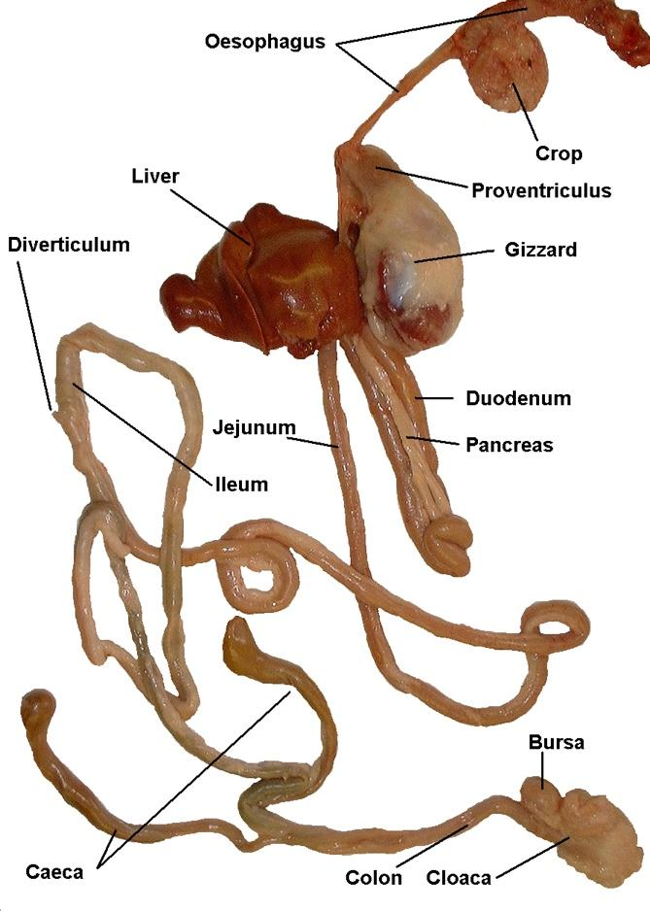

The digestive system of birds. The intestines are divided into regions, but these are not as distinct as in mammals
© Leisha Hewitt

Table 2 The appearance, structure and function of the avian digestive canal
Digestive system | Structure and appearance | Function
Oesophagus | Tube leading from the mouth to the crop. A further section of oesophagus connects the crop to the proventriculus within the thoracic cavity. | Bolus of food is mixed with saliva in the mouth and swallowed whole as a bolus. It moves down the oesophagus into the crop.
Crop | Dilatation of the oesophagus near its entry to the thoracic cavity. | Stores, softens and ferments food before it is passed into the proventriculus.
Proventriculus (True stomach) | Thick-walled and spindle-shaped. Located between the crop and the gizzard. The internal surface is lined with cells which produce hydrochloric acid and an enzyme (Pepsin). | Food is saturated with gastric juice before passing into the gizzard.
Ventriculus (Gizzard) | Heavy muscular organ with a tough horny lining (cutica gastrica). May contain numerous pebbles or bits of stone to assist in grinding of food. | Acts as a mechanical grinder of food and is a substitute for teeth. The food is ground by the cutica gastrica. The resulting paste is passed into the small intestine.
Pancreas | Exocrine gland contained within the duodenal loop. | Secretes pancreatic juice into the duodenum, which neutralises the acidity of the food from the stomach. Also secretes insulin.
Duodenum | Forms a loop around the pancreas. Ends where the ducts from the liver and the pancreas enter the intestine. | Absorption of soluble nutrients from food and reabsorption of water. Bile (produced in the liver) mixes with pancreatic juices to break down fats, carbohydrates and proteins.
Jejunum | Runs from the duodenum to the ileum. The junction between the jejunum and the ileum is very indistinct, but characterised by a small diverticulum on the surface of the intestine. | Absorption of soluble nutrients from food and reabsorption of water.
Ileum | Runs from the small diverticulum on the surface of the intestine to the ileo-caecal junction (where the two caeca join the intestine). | Absorption of soluble nutrients from food and reabsorption of water.
Caeca | Two blind pouches – extending towards the anterior of the body for about 23cm parallel to the ileum | Retain food material which has not been absorbed during the passage through the small intestine and reabsorb water. Empty approximately every 8 hours (brown frothy droppings).
Colon | Also known as the large intestine. Runs from the ileo-caecal junction to the large intestine. | Reabsorption of water
Cloaca | Comprises three sections - Common terminus for the intestine (cuprodeum), the ureters and the genital canals (urodeum) and the proctodeal gland (proctodeum) | Excretion of faeces
The immune system
The immune system is comprised:
- thymus
- cloacal bursa
- caecal tonsils, and
- spleen.
The thymus
The thymus consists of 6-8 pink lobes, running either side of the neck close to the jugular vein. The main function of the thymus is hormone secretion (see section on the endocrine system) and maturation and release of T-cells. T-cells are involved in cell mediated immunity and assist in the production of antibodies in B-cells.
The cloacal bursa
The cloacal bursa is a round structure found at the rear of the cloaca, sometimes referred to as the Bursa of Fabricius. The cloacal bursa functions as a lymph gland during the first two to three months after the chicken hatches after which it begins to atrophy. Like the thymus, the bursa in birds is believed to have some endocrine function in relation to growth and sexual development.
The spleen
See the section on the circulatory system.
The circulatory system
Birds have very efficient circulatory system that permits them to meet the metabolic demands of flight (and running, swimming, or diving). The cardiovascular system not only delivers oxygen to body cells (and removes metabolic wastes) but also plays an important role in maintaining a bird's body temperature. The circulatory system consists of a number of organs and an associated transport system. These include the:
- heart
- blood vessels
- spleen
- bone marrow
- blood
- lymph vessels.
The heart
The heart acts as the pump that pumps blood:
- to the lungs where the carbon dioxide in the blood is removed and the oxygen replaced
- to the rest of the body to deliver the nutrients and oxygen to the cells and to collect wastes and carbon dioxide.
The blood leaves the heart via arteries called the aorta (to the body) and the pulmonary artery (to the lungs). The blood enters the heart via the vena cava vein (from the body) and the pulmonary vein (from the lungs).
The heart is located in the thoracic cavity between in front of the liver (between the two lobes). It is relatively large and in general, is a conical shape (see diagram). It is enclosed in a thin membrane known as the pericardium. The avian heart has two atria and two ventricles (four chambers), as is found in mammals. The walls of the atria are thin while those of the ventricles are quite thick. This is because of the atria only have to move the blood from the atria to the ventricle while the ventricles are responsible for pumping blood around the body. The heart has its own blood supply via the two coronary arteries which divide from the aorta shortly after that artery leaves the left ventricle. The autonomous nervous system controls the pumping action of the heart.
The blood vessels
The vessels that carry the blood are:
- arteries – take blood from the heart either to the lungs as in the pulmonary system, or to all parts of the bird in the systemic system
- veins – return blood to the heart from the lungs in the pulmonary system or from all parts of the bird from the systemic system
- capillaries – discharge oxygen and nutrients to the cells and collect waste, which is eventually released from the blood in the lungs.
The spleen
The spleen is located adjacent to the proventriculus and the gizzard (ventriculus). The main function of the spleen is to filter out unwanted particles from the blood. The spleen contains a mixture of red and white pulp. The white pulp is made up of macrophages and phagocytes, which have the function of removing old blood cells. The spleen is also involved in the formation of lymphocytes. The spleen is reddish-brown in colour and round in shape.
The lymphatic system
This system operates alongside the circulatory system. It has the function of draining the body systems of the fluid that is left behind by the blood vessels. There are no lymph nodes in poultry. Lymph plexuses (network of capillaries) are found instead of the lymph nodes seen in mammals.
The urogenital system
The kidneys
Poultry have two kidneys, each with a ureter that carries the urine produced by the kidneys to the cloaca where it leaves the body. The functions of the kidneys are to:
- maintain the electrolyte balance
- maintain the water balance
- eliminate metabolic wastes, particularly nitrogen products of metabolism (except carbon dioxide).
The two reddish-brown kidneys are found immediately behind the lungs on each side of the vertebral column. A relatively straight, narrow tube called the ureter, leaves the medial border of each kidney and opens into the cloaca adjacent to the deferent duct of the male or the oviduct of the female. The ureter connects to many funnel shaped structures from each lobe of the kidney. There is no bladder in poultry; the ureters pass directly to the urodeum of the cloaca. There, more water is absorbed from the urate which is then passed as a white crystalline deposit with the faeces.
The male reproductive system
In the male, the testes are paired, yellowish coloured oval structures. They stay well inside the body close to the anterior lobe of the kidney, never descending into an outer sac.
Spermatozoa develop in these seminiferous tubules. The tissue generates the male sex hormone testosterone. In the breeding season these testes enlarge markedly.
The semen is discharged down two deferent ducts into the cloaca. In chickens and turkeys, the opening to the cloaca is conical, erictileduct or papillus within the vent. Birds that usually mate on water, for example ducks and geese, have a developed penis, which can enter the oviduct of the female.
The female reproductive system
In poultry only the left ovary is functional. It is a mass of cyst-like ova, ranging in size and colour. When ovulation takes place, the mature ovum is released and collected by the oviduct, a tube containing glands that form the egg and deliver it to the cloaca for laying. Over a 24-hour period the egg will increase in weight by about 70% on its way through the system.
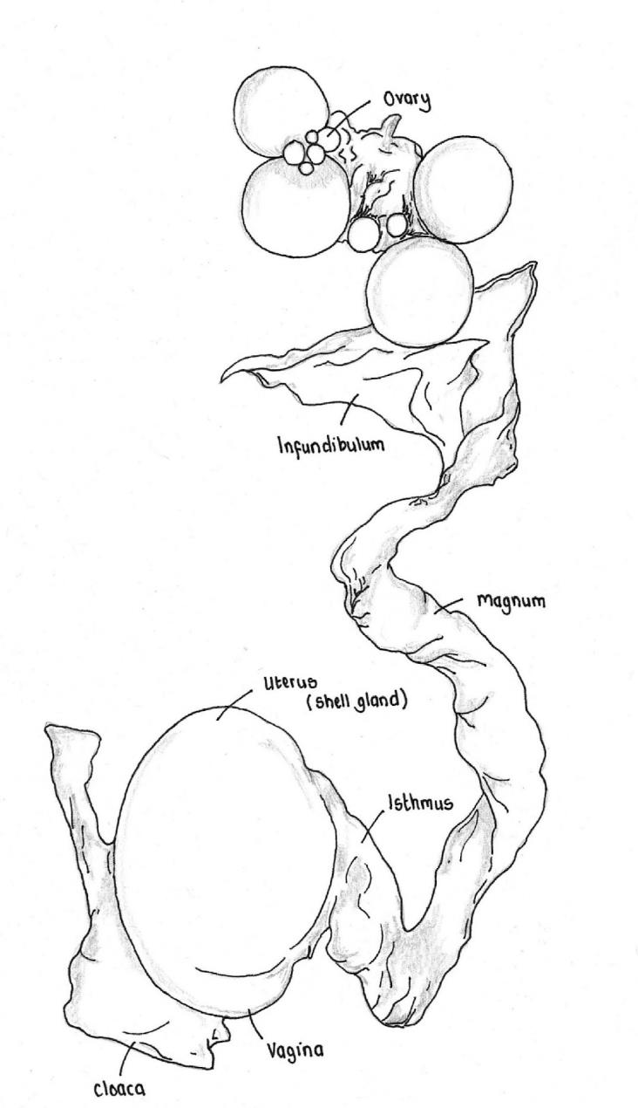
The female reproductive system
© Leisha Hewitt

The nervous system
The nervous system is made up of the central Nervous System (CNS), consisting of the brain and spinal cord; and the peripheral Nervous System, made up of the organs, muscles and skin which lie outside the brain and spinal cord and control the functions of the organs, muscles and skin. These systems function on two levels: The somatic (voluntary) nervous system involves impulses that are under conscious control, whilst the autonomic (involuntary) nervous system involves involuntary functions, such as heartbeat.
Central nervous system
The cranial cavity of the skull contains the brain.
The parts and major regions that make up the avian brain (see diagram below) are as follows:
- the forebrain which consists mainly of the cerebral hemispheres and the olfactory lobes; the hypothalamus and pituitary gland are located on the lower side of the forebrain
- the midbrain which mainly consists of the optic lobes
- the hindbrain which consists mainly of the cerebellum and the medulla oblongata.
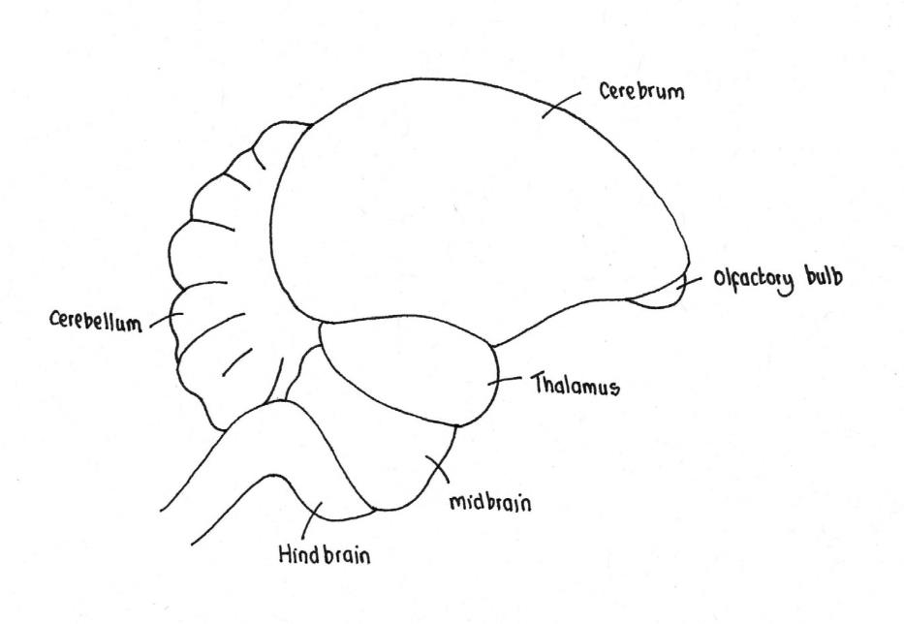
The avian brain
© Leisha Hewitt
The olfactory lobes of the forebrain are the receptor areas for the olfactory nerves and are the centre for smell, while the optic lobes are the receptor areas for the optic nerve and are the centre for sight. The optic lobes of poultry are very large in relation to total brain size, indicating that sight plays a major role in the normal behaviour of poultry.
The spinal cord originates from the medulla oblongata and runs through a channel formed by the hollow mid-section of the spinal vertebrae.
Peripheral nervous system
The peripheral nerves emanate symmetrically from the spinal cord. Two groups of nerves are particularly important in meat inspection; the brachial plexus (which branches out to the pectoral muscle and wings) and the sciatic nerve (which runs down the thigh). When an infectious disease, such as Marek’s disease, is present, these two nerve groups become thickened leading to paralysis.
The respiratory system
A bird breathes through the anterior nares or nostrils on both sides of its beak. The nares open into the nasal cavity, which opens into the pharynx. The larynx is not guarded by an epiglottis.
The bronchi lead to the lungs which are close to the dorsal surface of the thorax and have deep indentations into which the ribs fit. The lungs are of a similar proportion to to those of mammals, but have approximately 10% of the volume. The terminal branches of the bronchi continue into air sacs which are found in the thoracic cavity, the abdominal cavity and in various bones. The airsacs (9 in poultry) act like bellows, drawing in air through the lungs and expelling air.
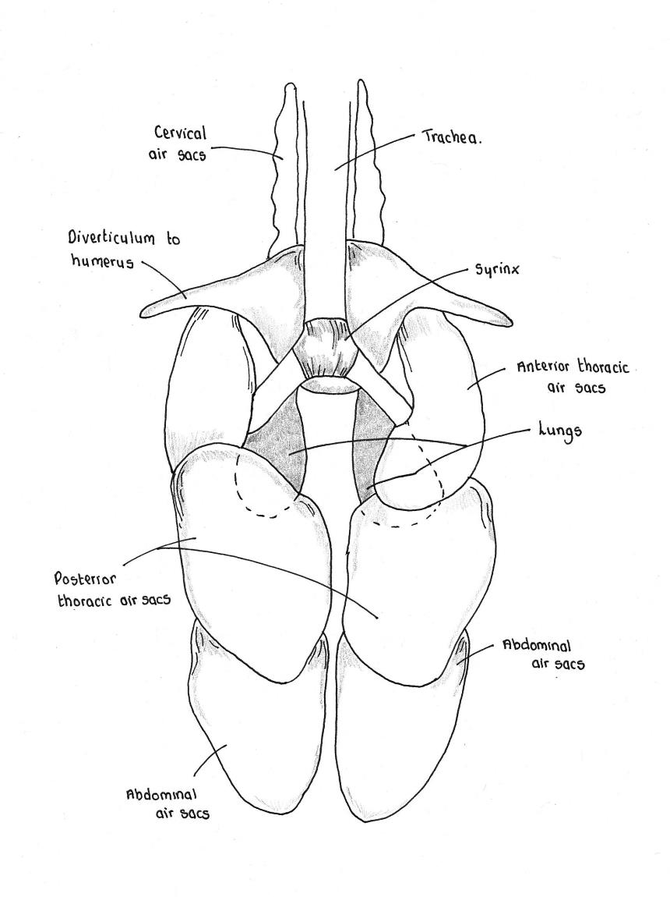
Avian air sacs
© Leisha Hewitt

The endocrine system
The endocrine system is involved with the production and secretion of hormones (chemical transmitters). Hormones are involved with the control of processes within the body. A summary of the endocrine glands, which make up the endocrine system, is shown in Table 3.
Table 3 Summary of location and the function of endocrine glands
Endocrine gland | Location | Function
Pancreas | Contained within the duodenal loop of the digestive system | Maintains blood sugar levels through the action of glucagon and insulin. Insulin affects the conversion and storage of glucose in liver and muscles. Glucagon affects the release of glucose.
Thymus | In the neck, associated with the jugular veins | Sexual development. Development of lymphocytes.
Adrenal cortex | Adrenal glands are found cranial to the anterior lobe of the kidneys. Each gland consists of a cortex and medulla. | Produces hormones which have various functions, such as maintaining blood volume and glucose levels, anti-inflammatory response and fat deposition.
Adrenal medulla | Adrenal glands are found cranial to the anterior lobe of the kidneys. Each gland consists of a cortex and medulla. | Secretes adrenalin and noradrenalin. Raises blood pressure by vaso-constriction.
Thyroid | Cranial to the crop near the thoracic inlet | Regulates metabolic rate, through production of thyroxin.
Parathyroid | Cranial to the thyroid gland | Influences the absorption of calcium into bone, through the release of parathyroid hormone.
Pituitary | In the cranium on the midline of the brain | Produces hormones in response to messages from the hypothalamus
Basic skeletal structure of poultry species
The skeleton of birds comprises:
- the axial skeleton (see below) - skull, vertebrae, ribs and sternum
- the appendicular skeleton (see below) - the limb bones (legs and wings).
The skull is light, the upper and lower mandible (jaw) contains no teeth. The eye socket is large relative to the size of the head. The vertebral column (spine) is comprised of vertebrae, many of which are fused together to provide strength and rigidity. There are seven pairs of ribs. The first two ribs are not fused with the sternum. The sternum (breast bone) is keel shaped allowing for the attachment of the large pectoral muscles (breast muscle). The overall structure of the skeleton has evolved to assist in flight. The bones themselves usually contain diverticula of the respiratory system, making them very light, but relatively strong. Table 4 provides a summary of the main components of the avian skeleton.
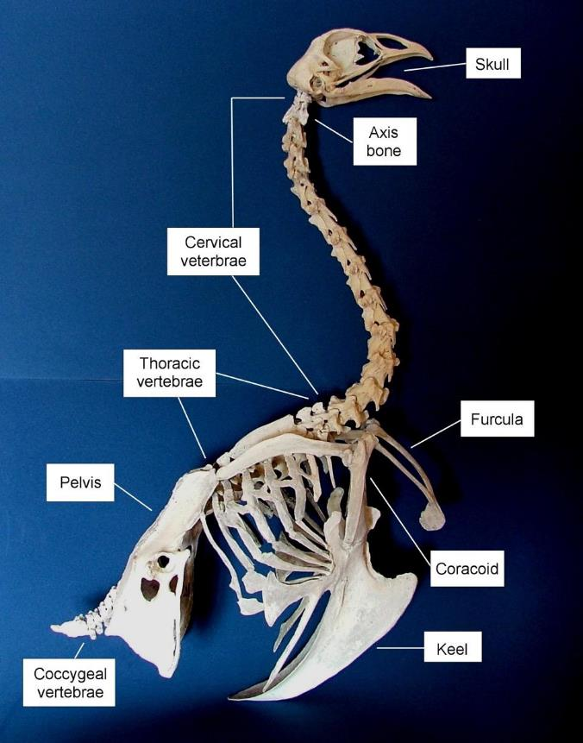

Avian axial skeleton
(photo courtesy of A. Grist)
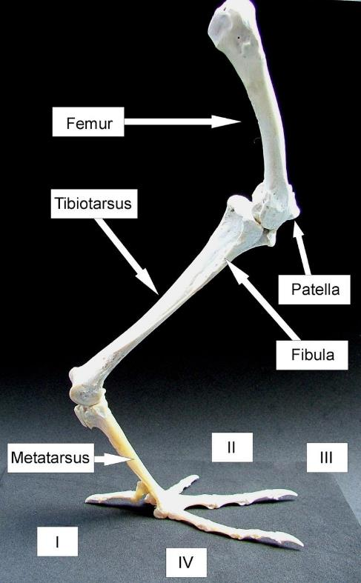
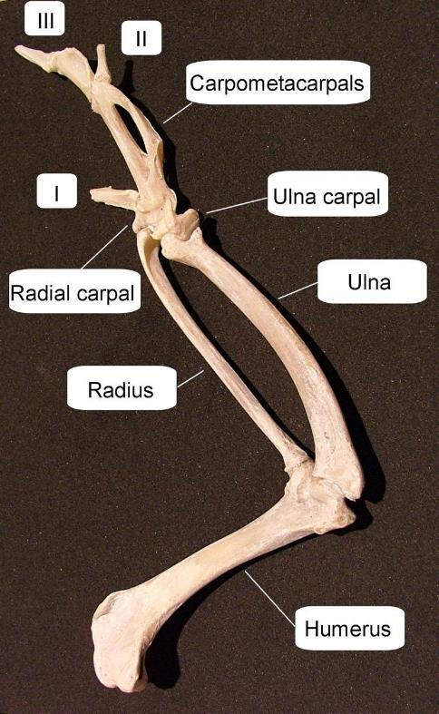
The bones of the avian limbs (leg and wing)
(Photos courtesy of A. Grist)

Table 4 Summary of the skeletal structure of birds
 | Comprises | Notes
Axial skeleton | - Skull  - 14 cervical vertebrae  - 7 thoracic vertebrae  - Ribs  - Pelvis  - Synsacral vertebrae  - 7 coccygeal vertebrae | - Last coccygeal vertebrae is the pygostyle
Pelvis | - Ilium  - Ischium  - Pubis  - Synsacral vertebrae | - Synsacral vertebrae are fused
Sternum and pectoral girdle | - 2 clavicles  - 2 scapula  - 2 coracoid | - The 2 clavicles produce the furcular
Wing | - Humerus  - Radius  - Ulna Radial carpal  - Ulnal carpal  - Metacarpals  - 3 digits | - Metacarpals are fused
Leg | - Femur  - Patella  - Tibiotarsus  - Fibula  - Metatarsus  - Phalanges | - Phalanges make up 4 digits

Conducting ante-mortem inspection of poultry
What are the main reasons for ante-mortem inspection?
The term ante-mortem means ‘before death’. An ante-mortem inspection is primarily a visual inspection of live poultry prior to processing. This inspection ensures, among other things, that poultry are screened before slaughter; clinical information and identification are obtained on site; poultry are treated humanely; reportable diseases are identified; and sick birds are handled appropriately.
Ante-mortem inspection therefore serves to identify poultry:
- showing clear evidence of being affected with a disease or condition that could render the carcase unfit for human consumption
- representing a threat to the health of personnel handling the carcases
- that may be suspected of having a disease or condition requiring segregation and separate slaughter
- which are suspected of having been treated with antibiotics or other veterinary products
- that may result in heavily contaminated carcases during the evisceration operations
- suspected of having an emergency or notifiable disease
- to make a disposition regarding the suitability of flocks for slaughter, and
- requiring special handling for humane reasons.
Identifying heat stress in the lairage
During the ante-mortem inspection, it is important that birds are observed for signs of heat stress and managed appropriately. It is well recognised within the poultry industry that thermal (heat) stress in birds in transport and lairage can have the following effects:
- an increase in mortality
- a reduction in product quality
- compromised poultry welfare.
There have been numerous studies addressing the problem of heat stress during transit, though very few which focus on the problem of heat stress in the lairage. Birds are able to regulate their body temperature by controlling heat loss through:
- their skin and feather cover
- evaporation by panting.
Control of body temperature is compromised if the birds are confined in close proximity to one another (for example, when they are held in crates), as this reduces their ability to lose heat by radiation, convection and conduction. Additionally, their ability to lose heat by evaporation is reduced if there is a high humidity. If the bird’s body temperature is raised by 4ºC or more, it will die.
Birds generally become heat stressed during transport and arrive at the lairage in an already heat stressed state. If heat stress birds are identified during the ante-mortem inspection, the following actions should be taken:
- Focus on removing heat from modules
- Place modules close to extraction fans where the fans are either over each stack of modules or at the apex of the roof to increase air movement through the crates.
- Improve radiated heat loss from the sides of a stack by leaving gaps between modules and lanes of modules.
- Where possible contain and control the environment within the modules separately (de-stacking if possible).
- Only use misters if humidity is low and air movement is very good. Adding humidity to the air can reduce heat loss from the birds.
- Place the crates in the coolest part of the lairage with the best air flow.
- Monitor the birds and their environment
- Inspect birds on arrival at lairage and if panting, distressed or exhausted they should be killed immediately.
- Involve the vet – bird temperatures (rectal) above 42ºC require immediate action eg. reduced lairage time and slaughter as soon as possible.
- Monitor the environment in the lairage and the modules using temperature and humidity sensors.
- Check fan operation and maintenance.
- Reduce the time in lairage
- Keep duration of lairage to a minimum and slaughter as soon as possible.
- Enforce maximum lairage times where possible.
What regulatory requirements apply when conducting ante-mortem inspection?
The Australian poultry industry operates under the AS 4465:2006 Australian Standard for the Construction of Premises and Hygienic Production of Poultry Meat for Human Consumption. Additionally, in order to export poultry, the industry must comply with the Export Control Act (1982) and relevant Orders and relevant importing country requirements. This means there may be differences in inspection requirements at poultry processing premises depending on the intended market for the meat or meat products.
Regarding ante-mortem inspection, the Australian Standard states:
16.1 Animal health surveillance and disease detection systems should be in place on-farm to ensure that only healthy poultry are presented for slaughter.
16.2 The operator of a processing premises shall have in place a system that ensures:
a) live poultry are treated humanely
b) poultry are dead before the commencement of processing and are not processed;
c) moribund, unhealthy or rejected birds are not processed; and
d) the presence of a notifiable (including exotic) disease, when present, could be detected
16.3 If the observations made at ante-mortem inspection suggest that poultry display symptoms of a notifiable disease, the relevant government veterinarian shall be contacted as soon as possible. The affected poultry shall be withheld from slaughter until a course of action has been determined under the relevant state or territory legislation for the control of exotic disease in animals.
16.4 Moribund, unhealthy or rejected poultry shall be humanely killed immediately and placed in containers provided with close-fitting lids which are clearly identified as inedible product.
16.5 Poultry found dead on arrival shall be disposed of as in clause 16.4.
To meet the requirements of the regulations and Australian Standard, a companies approved arrangement is required to include the following:
There is a sourcing program, that ensures that Incoming birds will be assessed to ensure that:
− Only correctly identified poultry with completed documentation (including ante mortem certification) are accepted for processing and that identification is maintained until final inspection for suitability for human consumption;
−Animal Welfare aspects of capturing and transportation have been followed;
−Receival inspection confirms the suitability for processing for human consumption (Poultry are not submitted for processing if they are affected by any disease or abnormality that could jeopardise the wholesomeness of poultry meats derived from it or the processing could contaminate other poultry meat).
−Notifiable Disease presence including exotic disease is detected.
Unlike red meat species, the main ante-mortem inspection in poultry (ie. declaring that the birds are fit for slaughter) is completed on the farm, before the birds are caught and loaded for transport. This outcome if this inspection is usually communicated to the processing premises by means of a ‘producer declaration’ or ‘ante-mortem certification’, the content of which is then verified upon arrival by the person responsible for ante-mortem inspection at the processing premises.
The Primary Production and Processing (PPP) Standard for Poultry Meat (Standard 4.2.2) is part of a series of national food safety standards that have recently been introduced, which have relevance for ante-mortem inspection processes. PPP Standards (which only apply in Australia) aim to strengthen food safety and traceability throughout the food supply chain from paddock to plate.
The Standard introduces new legal safeguards for growing live poultry and requires poultry growers to identify and control food safety hazards associated with poultry growing. Poultry processors will continue to be required to identify and control food safety hazards associated with poultry processing (which includes the slaughtering process) and verify the effectiveness of the control measures.
Once birds arrive at the processing premises, it is necessary to perform additional ante-mortem checks before they are placed on the processing line. This process should be detailed in the company approved arrangement. As a minimum, it will usually involve:
- a review of the flock sheet or documentation submitted from the farm - the review will look for completeness and accuracy, particularly where it concerns the health of the flock and the withdrawal from medication
- observation of birds in crates, for general signs of flock health, bird cleanliness, signs of stress, abnormal behavior and elevated levels of dead-on-arrivals (DOAs)
- completion of a record of ante-mortem examination with any corrective action taken - determine if immediate slaughter is required for humane reasons, or, if a disease is suspected, requirement for the flock to be held and tested or slaughtered separately.
What are the principles and procedures for the humane handling of poultry?
If ante-mortem procedures require birds to be caught and handled, it is essential that this is carried out carefully. Best practice seeks to minimise stress at all times, with work practices designed to reduce animal stress at all stages from catching through to slaughter. It is important to recognise that poor work practices at any stage of the process will have a negative impact on animal welfare and product quality.
On-farm inspection should be performed with a little disturbance to the birds, whilst being confident that the flock has been walked thoroughly. When performing ante-mortem inspection, personnel are to observe the overall condition of the birds including the head, with attention to the eyes, legs, and the body of the birds; and whether there are any unusual swellings or other abnormalities on the birds.
What are the signs of common conditions responsible for abnormalities at ante-mortem and how can they be detected?
Table 5 describes diseases and conditions that may be identified during an ante-mortem inspection. During the inspection of live birds, clinical signs may be observed. The clinical findings may be supported by post-mortem findings in the processing premises to make a final disposition (also described in Table 5).
What are the procedures for segregation and reporting after the identification of emergency disease?
Emergency animal diseases are those which are exotic to Australia. If established here, such diseases could impact severely on trade, human health, livestock production or the environment. Emergency diseases are generally notifiable, which means that there is a legal requirement for anyone who suspects or diagnoses a disease on the list, to immediately notify their relevant state or territory animal health authority. Many of these diseases are subject to an international obligation to notify if any cases occur. Others are notifiable because of an agreement between jurisdictions in Australia.
International standards for disease reporting are set by the World Organisation for Animal Health (OIE) and form the basis of Australia’s agreed National List of Notifiable Animal Diseases. The agreed national list is compiled by the national Animal Health Committee and reviewed biennially (or more often if required). The national list of notifiable diseases (as of November 2014), affecting poultry, is as follows:
- Avian influenza
- Avian tuberculosis
- Duck virus enteritis (duck plague)
- Duck virus hepatitis
- Infectious bursal disease (hypervirulent and exotic antigenic variant forms)
- Newcastle disease
- Salmonella enteritidis infection
- Turkey rhinotracheitis (avian metapneumovirus).
Each state and territory also has a list of 'notifiable' animal diseases. The requirement to report notifiable disease is contained in individual state and territory legislation. States and territory notifiable disease lists contain all the diseases in the national list and can include others specific to that state or territory. It is important that you are familiar with the individual state and territory lists of notifiable diseases.
The Stock Diseases Act 1923 and the Animal Diseases and Animal Pests (Emergency Outbreaks) Act 1991 require notification procedures for declaring animal diseases to be implemented. This means that there is a legal obligation on members of the public such as stock owners, veterinarians or other persons who are consulted about stock, to promptly notify authorities if they know or suspect an animal has a notifiable disease. If a notifiable disease is suspected during ante-mortem inspection, then procedures outlined in the relevant state or territory legislation must be followed. This information can be found by following the relevant links from the Department of Agriculture website (http://www.agriculture.gov.au/pests-diseases-weeds/animal/state-notifiable).
Avian influenza is currently the most likely exotic disease to affect Australia. Measures to prevent and manage potential outbreaks have been adopted by Australian Animal Health authorities. This disease is particularly important because it is a zoonosis and thus can affect humans. The controls initiated would be to prevent and control infection in both birds and humans.
There are national contingency plans in place for exotic diseases, which are detailed under AUSVETPLAN. In most cases an eradication policy is applied. The Emergency Animal Disease Preparedness (EADP) strategy is nationally coordinated through the Animal Health Council, although the individual States have the direct responsibility to control exotic disease in their States.
Although H5N1 does not usually infect humans, nearly 650 cases of human cases of H5N1 have been reported from 15 countries since 2003. Most human cases of ‘highly pathogenic’ H5N1 virus infection have occurred in people who had recent contact with sick or dead poultry that were infected with H5N1 viruses. About 60% of people infected with the virus died from their illness.
To date, there have been no reports of avian influenza in people in Australia and the Australian Government has many measures in place to prevent the emergence of avian influenza in Australia. It is very unlikely that anyone entering Australia with avian influenza will pass the disease to another person. But people who have arrived from overseas or travelled to countries where there are reports of avian influenza in birds or people should monitor their health carefully for seven (7) days (for other severe respiratory diseases this period of monitoring may be longer).
At present there is no evidence to suggest that the virus can spread readily from person to person. Simple controls such as avoiding infected birds, and simple hygiene measures such as washing of hands should be sufficient to avoid infection. The virus is also easily killed by heating. So poultry meat and eggs, even during an outbreak should be safe so long as they are cooked.
What are the signs of emergency or notifiable diseases?
As birds can fly long distances, diseases are spread easily through the wild population and to domestic poultry. Two diseases are of major concern due to their impact on the industry and in the case of AI on public health, they are:
- Avian influenza (AI)
- Newcastle disease.
The OIE have produced an on-line disease distribution map, which is useful for investigating the prevalence of diseases, such as AI and Newcastle disease, around the world. This can be found using the link:
http://www.oie.int/wahis_2/public/wahid.php/Diseaseinformation/Diseasedistributionmap
Avian influenza, also known as ‘bird flu’, is a highly contagious viral disease affecting mainly domestic fowl (chickens, turkeys and ducks) but also able to infect a wide range of other species of birds.
AI viruses (of which there are 15 types) infect wild bird populations, particularly water birds, typically without causing symptoms. The virus spreads through bird faeces and contaminated water or dust. When AI spreads to poultry or other birds, it can cause more severe disease. Outbreaks of AI have been recognised in poultry flocks in most countries of the world for many years.
The signs in birds are typical respiratory signs: fever, sneezing, swollen eyes and wattles. There are many causes of respiratory disease in birds and most kill only a few birds. This particular disease is to be suspected if large numbers of birds in a domestic flock or in the wild were to become infected and die from respiratory disease.
There are several types of AI. The strains that cause the greatest number of deaths are called highly pathogenic Avian influenza (HPAI).
Although caused by highly pathogenic strains of AI virus (HPAI) that have sometimes been shown to infect humans, this disease should not be confused with human influenza, a common human disease with varying degrees of severity. However, under certain circumstances AI could pose a serious threat to humans. A small number of both high and low pathogenic strains of AI virus have infected humans and caused disease, ranging from mild to fatal.
It was first recognised in 1997 in Hong Kong. At that time millions of chickens were slaughtered after the virus was found to cause disease in people exposed to infected birds. 18 people were known to be affected with the disease, with six deaths. Fortunately, the virus was not able to spread from person to person, and the outbreak was brought under control through the widespread slaughter of poultry.
Avian Influenza has reached Australia in the past and caused clinical disease in commercial poultry five times in Australia — in Victoria in 1976, ‘85, and ‘92; Qld in ‘94; and NSW in ‘97. Each time, there was severe disease in chicken flocks it was demonstrated that there had been contact with waterfowl.
Newcastle disease, which may be grouped together with Fowl Plague, Avian Orthomyxoviruses and Paramyxoviruses, is found in most countries of the world but the strains that are considered to be the most pathogenic are not in Australia.
The strain of the disease in Australia is considered to be a mild and therefore it is classified as an exotic disease (not endemic within Australia). The main consequence of this disease is the financial cost as the death rate of an infected flock can be up to 100%.
Australia is considered to be free from virulent ND, but this has not always been the case. In October 2001, Australia met international standards for freedom from virulent ND virus. An incident of virulent ND was confirmed in mid-2002 on a single property at Meredith, Victoria, and another in late 2002 on a property at Horsley Park, NSW. In both instances, disease eradication processes prescribed in Australia’s AUSVETPLAN disease strategy for the control and eradication of ND were applied. The link to this document is:
http://www.animalhealthaustralia.com.au/our-publications/ausvetplan-manuals-and-documents
What are the procedures for humane destruction?
The Australian Standards and Guidelines for the Welfare of Animals - Land Transport of Livestock contains specific standards for the transportation of poultry, including the requirement to ensure that birds are fit to transport to the processing premises. Within the standards and guidelines, the criteria for the assessment of fitness are the same for red meat species and poultry. Poultry must be assessed as fit for the intended journey at every loading (or as part of the ante-mortem process) by a person in charge.
A bird is not fit for a journey if it is:
- unable to walk on its own by bearing weight on both legs, or
- severely emaciated, or
- visibly dehydrated, or
- showing visible signs of severe injury or distress, or
- suffering from conditions that are likely to cause increased pain or distress during transport, or
- blind in both eyes.

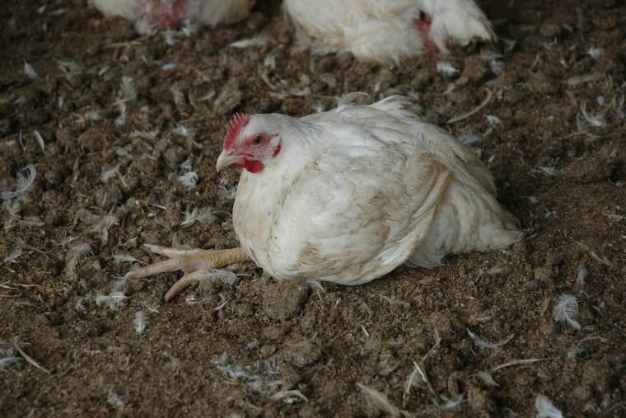
Birds that are off their legs must not be loaded for transport and
should be humanely killed
(Photo courtesy University of Bristol)
To summarise, birds which are unable to move independently without pain are unfit to travel. Poultry can suffer lesions to the feet which may be painful depending on the severity of the condition. Foot and leg health of the birds should be assessed before transportation and birds with severe, painful conditions are unfit for transport. In addition, birds with serious skin wounds, or any wound penetrating deep into the tissues or body cavities should not be transported. Any bird suffering from prolapsed tissues around the vent is also unfit for travel.
Any bird assessed to be not fit for the intended journey must only be transported under veterinary advice. If a bird is assessed to be not fit for the intended journey before loading, a person in charge must make appropriate arrangements for the care, treatment or humane destruction of the bird at the first reasonable opportunity. It is usually the responsibility of the producer (during a pre-pick-up inspection) or the pick-up operatives (during pick-up) to identify and humanely kill sick and injured birds.
Poultry should also be carefully observed in the holding area (whilst in their crates) and again at shackling. Any weak, ill or injured birds should be identified and humanely killed (as appropriate - according to workplace procedures). The normal method for humane killing in the holding area is by neck dislocation. Moribund birds (birds which exhibit signs of distress or insensibility with little chance of recovery) should be humanely killed as soon as they are identified.
Some conditions that might be observed during shackling include:
- Injuries - broken/dislocated wings and legs
- depressed state, fatigued, lack of interest in surroundings, lethargy
- discharges from the eyes, nose or other body openings
- wheezing or rapid heavy breathing
- abnormal behaviour
- abnormal lumps or growths
- disease or other health conditions
- moribund (close to death) birds.
Personnel hanging poultry onto the shackle line should be able to identify any birds that are injured or sick and take appropriate action.
Humane killing of poultry is detailed in the Australian Standard:

15.24 All poultry shall be humanely killed
15.25 Live poultry that are rejected at pre-slaughter examination shall be humanely killed in such a way to avoid contamination of floors, walls and equipment

Actual methods appropriate for birds rejected ante-mortem are not specified, although it does describe methods that must be used for ‘processing’ birds. They are as follows:

15.26 Poultry for processing shall be:
a) rendered unconscious by:
i) electric current
ii) approved inert gas; or
iii) dislocation of the head, and must not regain consciousness before slaughter
b) rendered unconscious or slaughtered by a method that has been approved in writing by the controlling authority

Most birds rejected at ante-mortem are killed using neck dislocation. Neck dislocation in poultry can be divided into two types of technique. The first involves neck stretching methods that stretch the spinal cord until it breaks. The second involves crushing the neck, for example with neck dislocation pliers. There are however concerns over the effectiveness of this type of device and some industry and private standards prohibit their use. Manual dislocation is generally only feasible with smaller birds, for example chickens. The procedure is more difficult on larger birds such as turkeys and geese and an alternative method should be sought, such as the use of an approved gas.
Another, recent development that is likely to become more popular as a method for dispatching casualty birds is a percussive device. A number of devices are available and can be operated by blank cartridges (see image) or by pressurised gas canisters. An example of gas-powered device can be seen at http://www.tedstunner.com/ted.html.

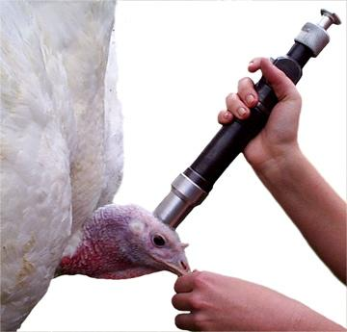
Cartridge-powered CASH poultry killing device
(Photo courtesy of L. Hewitt)
What are the QA aspects of ante-mortem inspection?
All poultry should come from an approved source, ensuring healthy birds that are free from chemical residues.
During the ante-mortem inspection at the processing premises, poultry should be checked for signs of contamination with dirty litter and faeces. It may be necessary to schedule the slaughter of dirty birds at the end of a run, in accordance with workplace arrangements.
Poultry reception areas should be clean and free from dust, feathers, or other extraneous matter that could become air borne and contaminate other areas. Any poultry found to be unhealthy should be killed and disposed of correctly and not slaughtered with healthy birds.
All coops, cages or similar containers for live poultry should be washed and sanitised in the designated area.
Most traceability systems within the poultry industry have been developed for productivity reasons rather than public health reasons. These systems are based principally on the identification of individual flocks, with birds in each flock having the same management inputs (for example, feed, environment and medication). Flock records will be maintained from placement (chicks moved from the hatchery and placed in the houses) through to dispatch to the processing premises. Once in the processing premises, ID is usually based on individual flocks separated into transport loads, and traceability through to processing is time based. Individual identification of poultry is not generally practiced commercially, except in elite breeding stock. Future development lies in the wider application of sophisticated computerised systems at primary and further processing levels, to ensure that traceability can be maintained.
Making an ante-mortem disposition
There are three possible outcomes, or dispositions, that follow observation of poultry in ante-mortem inspection:
- passed for unconditional slaughter
- passed for slaughter subject to conditions specified by a nominated qualified person (suspect)
- condemned (unfit for human consumption).
Passed for unconditional slaughter means that birds were determined to be fit for human food, though they may still be rejected post-mortem.
Poultry that clearly exhibit signs of diseases and conditions must be condemned. This means that they are clearly not fit for human food and must be segregated and handled in accordance with workplace and regulatory requirements.
Then there are those birds that may exhibit signs of the diseases or conditions described in Tables 5 and 7, but further investigation during post mortem inspection is needed before passing or condemning the carcase or a part of the carcase.
It is important that all suspect flocks be properly identified throughout the slaughter process, i.e. from the live bird receiving room to the final inspection. Except for immediate slaughter for humane reasons, it may be necessary to schedule suspects for separate slaughter, preferably at the end of the regular kill.
Any flocks condemned on ante-mortem inspection shall be identified by a tag or other device. In addition, full details (flock identification, owner's name and address, reason for condemnation), should be entered on the ante-mortem examination report. Action following condemnation could immediate stunning/killing and removal to the inedible section of the premises. Condemned birds and birds which are found dead should not pass through the evisceration floor or other edible areas of the premises.
Diseases and conditions in poultry
The World Organisation for Animal Health (OIE) provides detailed information on the worldwide distribution and importance of diseases affecting poultry, including their aetiology (classification of the causative agent), epidemiology (host species, clinical and pathological signs and modes of transmission), diagnosis, control and public health relevance. These can be found by following the link:
http://www.oie.int/en/animal-health-in-the-world/technical-disease-cards/
Table 5 describes some of the diseases and conditions found during ante-mortem inspection (on-farm and at arrival) and post-mortem. This table should be consulted in conjunction with Table 7, which is a similar table taken from the Australian Standard. The images following the table illustrate some of the conditions described.

Table 5 Diseases and conditions in poultry
Disease or condition (Synonyms) | Type and cause | Ante-mortem clinical signs | Post-mortem findings | Disposition | Other information
Ascites | Liver disease  cirrhosis | Poor development.  Dilated abdomen (waterbelly)  Panting  Cyanosis (blue discolouration of the skin, especially around the comb and wattles and muscle tissue) | clear yellow fluid and clots of fibrin in the abdomen  swollen and congested liver  increase fluid in the sac around the heart | Carcase and offal unfit for human consumption.
Aspergillosis  (Brooder pneumonia) | Fungal  Aspergillus flavus  Aspergillus fumigatus | Loss of appetite  Gasping  Emaciation | Grey-white nodules in lungs  Greenish moulds in airsacs | Carcase meat may be salvaged. Carcase and offal unfit for human consumption if emaciation or septicaemia present. | produces a yellowish semi-liquid or caseous mass (Aspergillus fumigatus).
Avian influenza (Fowl plague) | Viral  Orthomixovirus | Respiratory signs such as sneezing, coughing  Decreased appetite  Watery diarrhoea  Cyanosis of comb  Oedema of wattle  Swollen eyes and lacrimation | Highly virulent – Congestion and haemorrhages on skin and organs  Low virulent – lesions on respiratory tract | Carcase and offal unfit for human consumption. Notifiable disease | Many strains. The highly pathogenic strain (HPAI) involved in recent outbreaks is called H5N1
Avian Leucosis | - avian retroviruses | few typical clinical signs  Loss of appetite  weakness  diarrhoea  dehydration  emaciation | Focal grey to white tumours, initially in the bursa, then liver, spleen, kidney  Enlarged liver | Carcase and offal unfit for human consumption.
Avian salmonellosis (Paratyphoid) | - Bacterial  - Salmonella | Drooping wings  Shivering and muscular trembling | Enteritis  Dehydration  Congested livers  Nodules on pancreas  Lesions on intestine | Carcase and offal unfit for human consumption. | Probably the most important group of bacteria found in poultry, which can cause disease in man (Salmonellosis)  The genus consists of over 2,400 different types called serovars. The serovars that are most relevant to the poultry industry are of the species known as Salmonella enterica.  The most common paratyphoid Salmonella found in chickens is S. Sofia, though thus is rarely isolated from ill humans  S. Enteritidis (the serovar that has caused major problems in the European and North American poultry industry) is rarely detected in Australian chickens.
Avian tuberculosis (Avian TB) | - Bacterial  - Mycobacterium avium | Pale skin  Progressive emaciation  Ruffled feathers  Depressed | Grey-white nodular lesions on the liver and spleen | Carcase and offal unfit for human consumption.
Breast blister (Sternal bursitis) | - Caused by pressure on the sternum | The area over the blister may be devoid of feathers | Subcutaneous fluid-filled blister over the sternum | Trim affected parts and reject. Carcase and offal unfit for human consumption if secondary infection is present.
Candidiasis (Thrush, sour crop, crop mycosis) | - Fungal  - Candida albicans | Depressed  Emaciation | Thickened crop mucosa | Carcase and offal unfit for human consumption if emaciated
Coccidiosis | - Protozoan parasite  - Eimeria spp. | Blood-stained faeces  Emaciation |  |  | - Intercellular parasites of the cells that line the internal surface of the intestines (epithelial cells)  - Coccidiosis can account for 5-10% of deaths in untreated poultry flocks
Egg peritonitis | - E.coli | loss of appetite/anorexia, weakness, depression, respiratory distress, lethargy, fluffed feathers, lack of vocalizations,  yolk-colored droppings, swollen vent and/or abdomen (the swelling feels spongy to the touch), and ascites | inflamed abdomen  putrid smell with yolk. | Carcase and offal unfit for human consumption if emaciated
Erysipelas (Leatherhead) | - Bacterial  - Erisipelothrix rhusiopathiae | Cyanosis of the head  Diarrhoea  Pyrexia | Generalised septicaemia  Haemorrhages in muscle, fat and heart  Enlargement and congestion of liver and spleen | Carcase and offal unfit for human consumption. | - Mainly affects turkeys and ducks
Fowl pox | - Viral  - Poxvirus | Dry form - Small white bumps on skin (Predominantly wattles and comb), turning yellow, brown then scabby  Reduced egg production  Wet form – Breathing laboured, weight loss | Wet form – ulcerated mouth, throat and trachea | Carcase and offal unfit for human consumption if generalised or associated with emaciation | - Two forms – wet and dry pox
Gout | Nutritional & metabolic  buildup of urates in tissues | Joints enlarged, stiff, and painful  Bird shuffle  Loss of appetite  Lethargy  weight losss | visceral gout - deposition of urates in renal tubules and the serous coats of the heart, the liver, the mesentery, the air sacs or the peritoneum  Urate deposits on serous coats resemble a chalky white dust.  Visceral urate - deposits are generally due to renal failure | Carcase and offal unfit for human consumption.
Histomoniasis  (Blackhead) | - Protozoan parasite  - Histomonas meleagridis | Depressed  Ruffled feathers  Weight loss | Lesions are seen in the caeca, which are enlarged, and bloody necrotic lesions also occur in the liver. |  | - Affects chickens and turkeys
Infectious stunting syndrome  (Malabsorption syndrome) | - Viral  - Reovirus | Emaciation  Restricted growth  Appear active | Inflammation of proventriculus  Arthritis may occur | Rejection on grounds of welfare and possible processing difficulties | - Associated with poor hygiene and high stocking density  - Affects birds 1-6 weeks of age
Marek's disease virus  (MDV) | - Herpes virus | Paralysis of legs, wings and neck.  Loss of weight.  Grey iris or irregular pupil.  Vision impairment.  Skin around feather follicles raised and roughened. | Grey-white foci of neoplastic tissue in liver, spleen, kidney, lung, gonads, heart, and skeletal muscle.  Thickening of nerve trunks and loss of striation. | Carcase and offal unfit for human consumption.
Newcastle disease | - Viral  - Paramyxovirus | Gasping  Coughing  Huddling  Loss of appetite  Paralysis and other nervous symptoms | Death occurs usually before the onset of symptoms detectable at PM  Severe haemorrhaging and necrosis of digestive tract | Carcase and offal unfit for human consumption. Notifiable disease | - Transmission via vectors such as wild birds  - The endemic strain in Australia is known as "V4", which is avirulent (ie mild). However, avirulent strains can mutate into virulent (ie severe and highly infectious)  - Australia currently free from virulent form  - Chickens are considered to be the most susceptible to infection

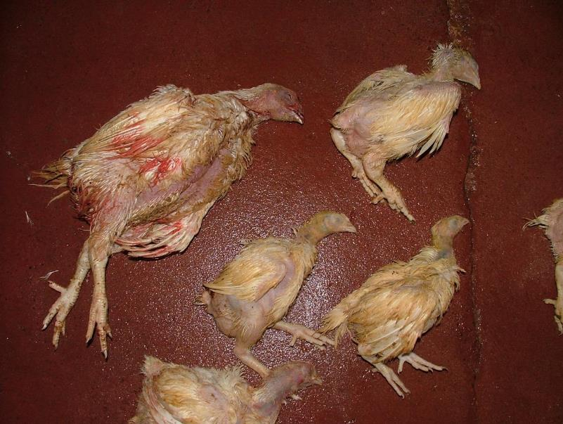
Runt birds pictured are the same age as the bird on the left
(Photo courtesy of A. Grist)
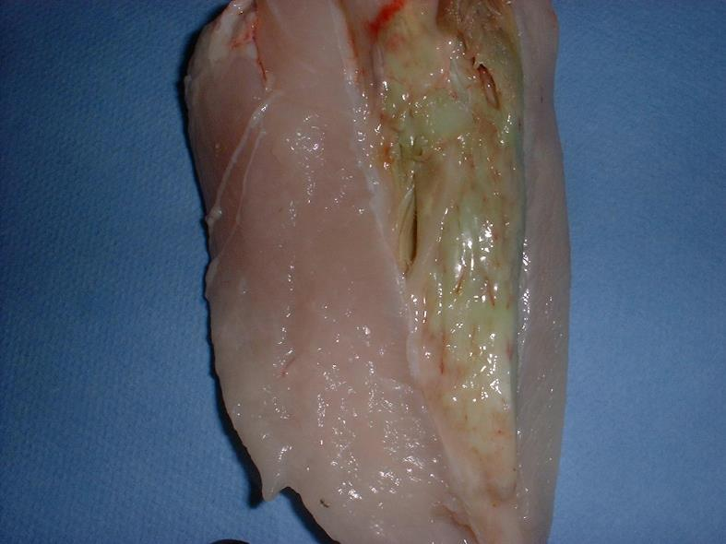

Deep pectoral myopathy (Green muscle disease, Oregon disease)
(Photo courtesy of A. Grist)
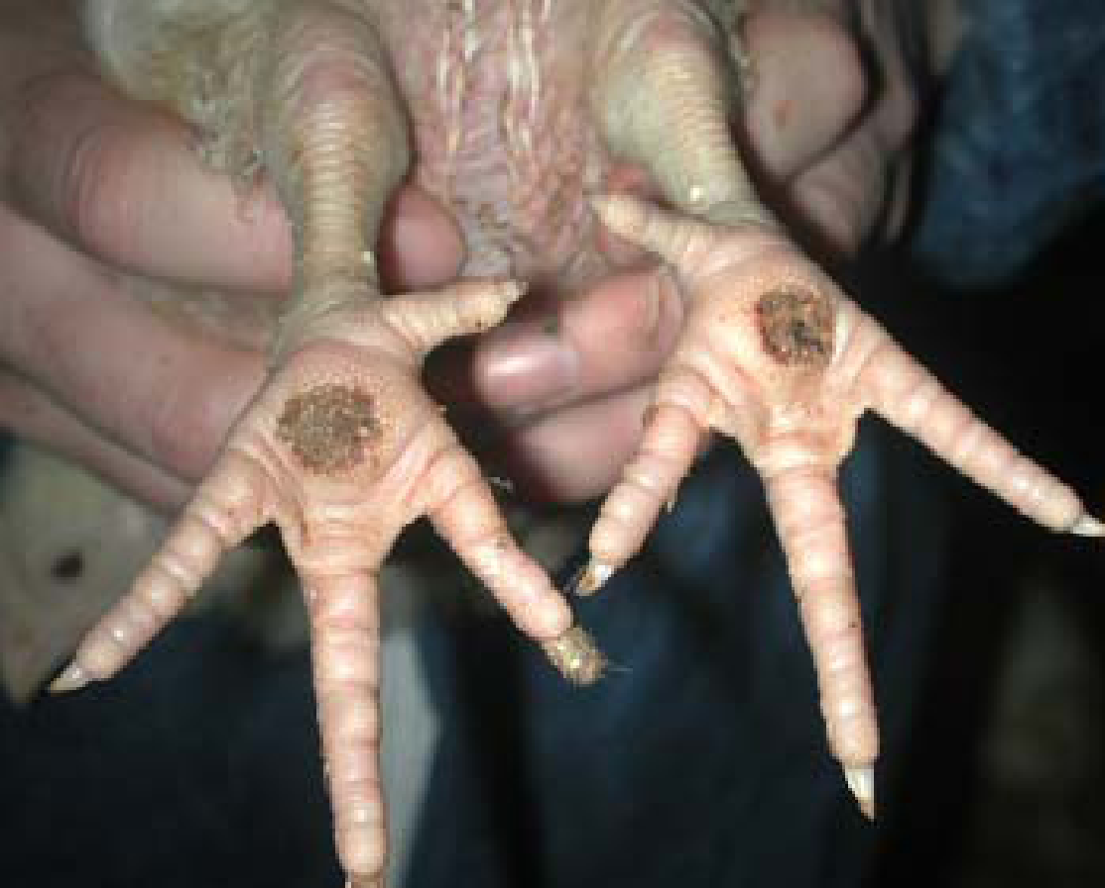

Pododermatitis - inflammation of the foot pad
(Photo courtesy of A. Grist)
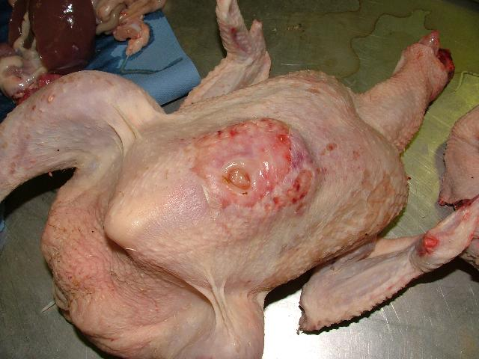

Breast blister
(Photo courtesy of L. Hewitt)
Monitoring the stunning and slaughter of poultry
What are the requirements for effective stunning and slaughter?
When poultry are killed, it is important for welfare and ethical reasons that pain and distress is minimised. To comply with this requirement, birds must be rendered unconscious and insensible to pain before slaughter. The period of unconsciousness must include the time when stunning is initiated to the point at which the animal bleeds to death. This is to ensure that requirements of the National Animal Welfare Standard, Codes of Practice and relevant legislation are met and animal welfare is protected.
Unconsciousness (and insensibility) is achieved by stunning the animals prior to slaughter. The stunning of animals prior to slaughter is normally a mandatory requirement, with the exception of certain forms of religious slaughter.
Different methods can be used to stun poultry. The type of system used will depend on the species being processed, the throughput of the facility (and other processing requirements) and the regulatory framework.
There are three main categories of stunning equipment used:
- mechanical stunners
- electrical stunners
- controlled atmosphere or gas stunners.
Only two methods of poultry stunning are in widespread use in Australia: multiple-bird waterbath electrical stunning and Controlled Atmosphere Stunning/Killing (Gas stunning/killing). Electrical stunning is used in most poultry processing premises, although there is a general shift towards the used of controlled atmosphere systems.
During electrical stunning, sufficient current must be applied to the brain to result in immediate unconsciousness. The use of electricity can have a number of physiological effects on an animal depending on the level of current and voltage, the waveform and frequency, and the pathway through the animal. These can range from a painful stimulus (when the stun is ineffective) to a loss of sensibility for varying durations and even death. It should be noted that the amount of current received by individual birds determines the effectiveness of the stun. Most commercial electrical waterbath stunners use a high frequency electrical current as it is thought to reduce the incidence of carcase damage in comparison to low frequency (50Hz) electrical stunning. When this type of system is used, the majority of birds are not killed in the stunner, but are stunned for a relatively short period of time. This means that neck cutting has to be performed quickly to ensure the birds die from loss of blood before recovery.
Controlled Atmosphere (gas) stunning (CAS) is a modern alternative to electrical or manual stunning methods. The advantages of the CAS system are that it removes the need to shackle live birds and in some systems allows the birds to be stunned without having to be removed from the containers in which they arrive at the processing premises.
Controlled atmosphere systems use inert gases such as argon, and nitrogen which are anoxic, i.e. they deny oxygen to the bird, or CO₂ (anaesthetic gas) can be used which results in unconsciousness followed by death. Stunning systems using CO₂ can be monophasic (one phase) or biphasic (two phases) depending on whether birds are rendered unconscious using lower CO₂ concentrations before concentrations are increased to induce death. Controlled atmosphere stunning includes several variations of gas mixtures given to induce an anaesthetic state.
After effective electrical or controlled atmosphere stunning, it is necessary to bleed birds to kill them. The duration of unconsciousness induced by the stunning period must be longer than the sum of the time taken to perform the neck cut and time to brain death through blood loss. Most scientific evidence supports the recommendation that neck cutting should take place within 15 seconds after electrical stunning and as quickly as possible after controlled atmosphere stunning. To optimise welfare and carcase quality, it is important to cut both carotid arteries (see image below).

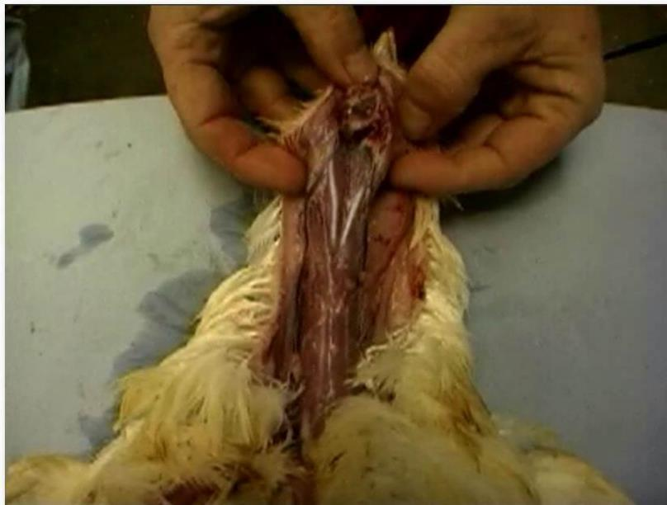

The position of the carotid arteries
(Photo courtesy of University of Bristol)
What regulatory requirements apply to stunning and bleeding?
All people involved in the handling of animals have an obligation to ensure that stress is minimised and that animals are well managed. There is National and State legislation for animal welfare (e.g. QLD Prevention of Cruelty to Animals Act 1986, NSW Prevention of Cruelty to Animals Act 1979) that covers aspects relating to animal cruelty and also several Codes of Practice that provide guidelines relating to livestock handling and animal welfare practices. The legislation can vary across States, therefore it is important that you are aware of the requirements within your State and the relevant requirements for the species processed at your workplace.
Additionally, the AS 4465:2006 Australian Standard for construction of premises and hygienic production of poultry meat for human consumption must be met. The Standard refers to the Australian Code of Practice for the Welfare of Animals No 10; Livestock (including poultry) at Slaughtering Establishments (Abattoirs, Slaughterhouses and Knackeries). The Code of Practice outlines the minimum requirements for the handling and slaughtering of animals at abattoirs.
What corrective action must be taken in the event of ineffective stunning or bleeding?
Following stunning and slaughter, birds need to be checked for signs of effective stunning. The signs that a bird has been effectively stunned (using gas, electrical or mechanical methods) include:
- no rhythmic breathing
- no neck tension
- there may be some wing flapping.
Death following slaughter can be confirmed by looking for:
- no breathing
- dilated pupils
- wings drooping
- the absence of a third eyelid (nictitating membrane) reflex.
Ineffective stunning can be observed through:
- rhythmic breathing (look at movements in the vent area)
- tension in the neck (able to control the movement of its neck and head)
- wing flapping (when other signs are also present)
- vocalisation.
If an ineffectively stunned bird (or one showing signs of recovery) is identified on the slaughter line then immediate corrective action must be taken. Firstly, a back-up method must be used. The methods available for use are described in the Australian Code of Practice for the Welfare of Animals No 10; Livestock (including poultry) at Slaughtering Establishments (Abattoirs, Slaughterhouses and Knackeries). They include decapitation, neck dislocation or severance of the carotid arteries by the back-up killing operative. It should however be noted that many customer standards do not permit neck cutting of ineffectively stunned birds without prior stunning.
Fast line speeds can make assessing birds for an effective stun difficult, therefore the second and equally important way to check the effectiveness of the stun is to test and monitor the efficiency of the stunning equipment. This should be done according to the relevant workplace procedure.
Conducting post-mortem inspection of poultry
What are the main reasons for post-mortem inspection?
Postmortem inspection covers the inspection of the carcases and parts of poultry used for human food. It takes place after ante-mortem inspection and after the poultry has been slaughtered, thus the term ‘Postmortem’, meaning ‘after death’ in Latin.
Post-mortem inspection of individual poultry is not routinely performed in Australia by government employed meat safety inspectors. Certain export markets insist on post-mortem inspection, but there is little export of poultry to these markets.
The high veterinary input into raising poultry, the generally low incidence of disease plus the fact that diseases that do occur are readily visible and easy to detect, means that relatively few diseases are found at post-mortem inspection.
The post-mortem inspection outcome required under the Australian Standard is that only wholesome poultry meat is passed for human consumption. This standard also states:
‘ Trained personnel shall ensure satisfactory removal of unhealthy, diseased or otherwise unacceptable poultry’.
Because the requirement does not stipulate the job title of the trained personnel in practice the inspection function is shared among a number of personnel, who also perform other functions on the chain. They are trained to identify the major conditions that can make the bird unfit for human consumption and remove it from the chain.
The main reasons for rejection are as follows, in decreasing order of frequency:
- dressing faults and contamination
- bruising and fractures
- emaciation
- red birds.
A full list of conditions that may affect product wholesomeness are detailed in Appendix B of the Australian standard for the construction of premises and the production of poultry meat for human consumption (This is reproduced in Table 7 of this material). Table 5 also provides additional detailed information on specific diseases that may be encountered.
What are regulatory requirements associated with post-mortem inspection?
The Australian Standard for the Construction of Premises and the Hygienic Production of Poultry Meat for Human Consumption SCARM 75(AS 4465: 2006), is the basis for all legislative requirements both export and domestic.
Part A details the construction requirements for poultry processing premises.
Part B details the processing procedures including inspection to ensure an acceptable standard of product.
Part B is divided into 5 main sections:
- Quality performance standards
- Quality Assurance programmes
- Operational Hygiene
- Ante mortem inspection
- Diseases and conditions.
The post-mortem inspection outcome required under the Australian Standard is that only wholesome poultry meat is passed for human consumption.
17.1 Operators of poultry processing establishments shall have in place systems to ensure that carcases and their parts:
a) are wholesome;
b) are not contaminated with foreign material during processing; and
c) if diseased or contaminated, are handled in a manner that ensures that other product is not contaminated
What are the procedures for conducting post-mortem inspection and identifying and detecting abnormalities?
As mentioned in the previous section, the post-mortem inspection process is usually shared amongst a number of personnel on the chain. Post-mortem inspection procedures can be performed on birds that are found dead at hang-on (to establish the cause of death) or on birds on the processing line (to establish fitness for human consumption). When performed as a method of diagnosing a pathological condition on birds discovered dead during the ante-mortem inspection, it is usually termed a post-mortem examination (necropsy) rather than inspection.
When performed on the line to determine fitness for human consumption it is important that birds can be observed in good lighting. A light level of 2000 lux ( (as measured at poultry height) is recommended. Any platforms should be positioned so that the inspector does not need to reach for carcases and can readily access birds. Anti-fatigue rubber matting ca be provided if personnel are often positioned at a particular point on the line.
What QA issues relate to post-mortem inspection?
The Australian Standard for the Construction of Premises and the Hygienic Production of Poultry Meat for Human Consumption SCARM 75(AS 4465: 2006) describes how carcases and parts of carcases should be handled during pot-mortem inspection processes.
During the post mortem inspection of red meat animals, many of the processes involve incision of organs and sometime muscle to expose lymph nodes etc. To preserve the quality of the product these tasks must be done in a way that does not disfigure the organ or muscle. For example, when opening up bile ducts to look for liver fluke, care must be taken to avoid cutting the liver tissue not to cut into the liver tissue. Meat inspection is about removing diseased or unacceptable meat but also about saving as much ‘good’ meat as possible. In the case of poultry, the impact of meat inspection on quality is less pronounced, with the exception of avoiding cross-contamination (between affected carcases and healthy carcases) and preserving as much of the carcase as possible when removing rejected parts.
General QA issues in the poultry processing premises are covered by the Approved Arrangement. A number of risk reduction measures should be in place, to ensure the quality of the product, as part of this Approved Arrangement.
- All poultry should come from an approved source, ensuring healthy birds that are free from chemical residues.
- Poultry reception areas should be clean and free from dust, feathers, or other extraneous matter that could become air borne and contaminate other areas. Any poultry found to be unhealthy should be killed and disposed of correctly and not slaughtered with healthy birds.
- All containers for live poultry should be washed and sanitised in the designated area.
- Stunning, killing and bleeding must be carried out in a humane manner that results in complete bleeding.
- Water at the correct temperature must be used during scalding operations. Water that is too hot will result in the tearing of flesh, while water below the required temperature of 52ºC will result in difficult removal of feathers.
- Equipment must be correctly maintained. Where automatic equipment is used for evisceration it must be maintained correctly, to ensure the removal of intestinal contents without breakage and cleaned continuously to prevent contamination.
- All cutting knives should be sharp, and sanitised between carcases. Where manual evisceration is performed, all equipment including benches should be kept clean to prevent contamination.
- Giblets, if recovered, should be free of contamination. This includes removing the thick horny lining of the gizzard.
- Washing must result in an acceptable level of microbial contamination. Various methods are used, applying controlled time and temperatures to minimise microbial growth, while removing all contamination.
- Chilling should achieve a temperature of 7ºC within six hours. Most large processors would have product packed and hard-frozen well within this time.
- Packaging of poultry varies depending on market requirements. Product is packed for large fast food outlets in plastic baskets with no primary packaging. Product is packed for retail sale individually wrapped and labelled, frozen or fresh. Other product is sold as primal cuts, for example wings, drumsticks, chicken breast.
- Transport of poultry should result in a temperature of no more than 5ºC for chilled product and no more than -15ºC for frozen product being maintained to the point of delivery.
- Gizzards should be cleaned separately from other offal. Offal should be cleaned in running water and chilled to 5ºC within one hour of removal from the bird, usually on ice.
Table 6 also describes some measures that can be applied to reduce the risk of contamination during poultry production and processing.
Table 6 Reducing the risk of contamination during poultry production and processing
Stage | Preventative Measures
On farm | Feed must be withdrawn 12 hours before transport
Live bird transport | Cages and vehicles must be properly cleaned and disinfected before re-use
Live bird holding | A minimum of two hours recovery after transport should be allowed before slaughter
Scalding | Use multi tank scalders to reduce cross contamination  Daily cleaning and disinfection of tank  Monitor scald water temperature regularly  Use counter current scalders  Maintain water pH at either below <6.5 or above >9
Plucking | Tail feather pulling should occur before plucking commences  Monitor condition of plucking fingers regularly, and replace broken or cracked fingers  Daily cleaning and disinfection of pluckers
Pre evisceration wash | Wash carcases thoroughly before evisceration  Best practice –wash water contain >5 ppm free chlorine
Evisceration | Ensure venting and opening occurs without damage to intestines  Monitor and adjust machines regularly to minimise damaged viscera  Immediate separation of viscera from carcase during evisceration  Non manual harvesting of giblets
Water chilling | Regular monitoring of chlorine levels (>5 ppm free chlorine)  Maintain water pH at or below 6.5  Use counter current chillers  Ensure a good overflow of water to waste to limit the build up of biological waste in the water
Air and Spray chilling | Good air control so that contaminated air from the plucking and evisceration area does not enter chiller
Boning and portioning | Control temperature of room (10° or less)  Replace cutting boards on a two hour basis  Sterilize knives regularly  Monitor to ensure product does not stay in room for an excessive period of time specially to ensure there is no temperature rise  Control condensation  Keep working area as dry as possible or cleaned regularly  Remove skin from carcases as late as possible
Verification | Regular microbiological checks of the final product
General | Keep carcases on line and avoid manual handling  Use automatic transfers between lines  Clear lines and product from rooms during breaks  Thorough clean up and disinfection of premises and equipment  Regular clean up of equipment and surfaces throughout the day  Continuous movement of product to cold storage
Personnel | Entry to processing areas to be controlled to ensure hand washing  Clean clothing to be issued daily or when soiled  The use of disposable or cleanable aprons  Good attention to personal hygiene e.g. hand washing at breaks  Adequate training in hygienic handling of product
Personnel conducting post-mortem inspection play a critical role in verifying good commercial practices by communicating findings to QA and production personnel. For example, if there is an increase in incidents or frequency of carcase contamination. The offline personnel can then verify the poultry slaughter premises is performing sanitary dressing procedures. Similarly, if an increase in production-related defects are noted, these should be reported to appropriate personnel. Such defects may include:
- external and internal contamination
- bile staining
- poultry meat falling from the line
- red birds (poor bleeding or uncut birds)
- machine damage, such as tears caused by plucker fingers etc
- overscald
- trauma
- improper evisceration
- presence of feathers.
Ante-mortem and post-mortem inspections involve handling suspect or condemned birds, carcases and other material. With this in mind it is important to:
- avoid spreading contamination to the healthy parts of the carcase
- avoid spreading contamination between the affected carcase and other healthy carcases
- observed workplace procedures for personal hygiene after handling an affected carcase
- clean and sterilise equipment after handling an affected carcase.
Making a post-mortem disposition
What is the process for identifying and documenting common diseases and conditions responsible for abnormalities?
The following chart of diseases and dispositions is taken from the Australian Standard (Table 7). Additional notes are in bold.
Note: Risk category is explained in section 17 of the Standard:
17.2 Operators shall ensure that any carcase or part is handled in one of the following ways:
a) carcases of their parts shall be passed for either human consumption, pet meat or be condemned;
b) emphasis should be placed on normal health carcases and parts. Departures from normal shall be dealt with according to dispositions described in Appendix B. Where it suits the purpose of the operator, a more severe disposition may be selected rather than that acceptable for the condition described;
c) a critical risk represents a condition which carries with it a significant risk to human health;
d) a major risk represents a condition that while not carrying a significant risk to human health, affects the wholesomeness of the product;
e) a minor risk represents a condition which does not carry a human health risk, but affects the wholesomeness of the product only that there may be defects recognised by objectionable consumers;
f) carcases and their parts may be retained pending laboratory confirmation or other examination before disposition;
g) carcases and their parts passed for animal food shall be clearly identified by approved methods; and
h) condemned carcases and their parts shall be clearly identified or denatures to prevent use for human consumption

Table 7 Observations and dispositions (taken from the Australian Standard)
Primary observation | Secondary observation | Tertiary observation | Disease/ condition | Disposition | Risk category
Abnormal Colouring | Bluish-reddish brown |  | Acute illness | Condemn carcase as unfit for human consumption | Major
 | Greenish- yellow | Slight | Faecal staining  Bile staining | Trim affected areas  Pass remainder as fit for human consumption | Major
 |  | Extensive | Faecal staining  Bile staining | Condemn carcase as unfit for human consumption | Critical
 | Red birds (see image) |  | Improper bleeding Toxaemia Septicaemia | Condemn carcase as unfit for human consumption | Critical
 | Yellow-orange |  | Liver condition | Condemn carcase as unfit for human consumption | Major
Abscess | Soft pus | No systemic involvement | Infection | Trim affected areas rest is fit for human consumption | Critical
 | Soft pus | Systemic involvement | Infection | Condemn carcase as unfit for human consumption | Critical
 | Multiple abscesses | Soft pus | Infection | Condemn carcase and parts as unfit for human consumption | Critical
Arthritis | Infection of joint | Pus in joint | Infection | Condemn limb as unfit for human consumption  If carcase is septicaemic or cachexic, the entire carcase and offal should be condemned | Critical
Ascites  (see below) | Fluid in abdominal cavity |  | Tumours  Egg peritonitis  Organ malfunction | Condemn carcase and parts as unfit for human consumption Background level of acites is present in many flocks. A higher percentage indicative of a poor rearing environment | Critical
Breast blisters | Watery fluid filled | No systemic involvement | Trauma | Trim affected areas, condemn trimmings rest fit for human consumption | Major
 | Fibrotic | No systemic involvement | Trauma | Trim affected areas, condemn trimmings rest fit for human consumption | Major
Bruising | Slight, less than 2cm diameter | No systemic involvement | Trauma | Trim affected areas, trimmings may be used as pet food rest fit for human consumption | Major
 | Extensive (Whole carcase) | No systemic involvement | Trauma | Condemn carcase as unfit for human consumption | Major
Cirrhosis of the liver |  |  | Past infection or toxic feed | Condemn organs as unfit for human consumption | Major
Contamination | Minor | Whole birds | Dropped birds  Minor intestinal spillage | Clean and sanitise whole birds save for human consumption | Critical
 | Minor | Meat pieces | Dropped meat | Trim affected pieces, condemn trimmings, save remainder for human consumption | Critical
 | Major | Internal surfaces | Improper evisceration | Clean and sanitise whole birds save for human consumption | Critical
Emaciation | Poorly fleshed  Cachexia is defined as wasting due to a pathological condition. Both conditions are extinguishable at inspection | Wasted thigh and breast muscles | Malnutrition  Leucosis | Save for petfood only  Emaciated birds should not be hung for slaughter | Major
Fibrinous deposits | Jelly-like film on heart or liver |  | E. coli  Chronic respiratory disease  Toxaemia  Septicaemia | Condemn organs as unfit for human consumption | Critical
 | Extensive lesions |  | Toxaemia  Septicaemia | Condemn carcase as unfit for human consumption | Critical
Haemorrhages | Blood spots | Localised to visceral organs body or leg | Trauma | Condemn affected organs or trim carcase parts and condemn trimmings as as unfit for human consumption and pass remainder as fit for human consumption | Major
 | Extensive |  | Toxaemia  Septicaemia | Condemn carcase as unfit for human consumption | Critical
Parasites | Heart or liver |  | Roundworms | Condemn organs as unfit for human consumption | Major
Peritonitis | Pus in abdominal cavity |  | Infection | Condemn carcase and organs as unfit for human consumption | Critical
Septicaemia | Systemic involvement |  | Infection | Condemn carcase as unfit for human consumption | Critical
Skin tear | No systemic involvement |  | Processing fault | Pass for human consumption | Minor
Tumors/ nodules | Localised |  | Mareks disease  Leucosis  Various | Trim affected part, condemn trimmings and pass remainder for human consumption | Major
 | Multiple |  | Mareks disease  Leucosis  Various | Condemn carcase as unfit for human consumption | Critical
Wounds | Slight abrasions | No systemic involvement | Trauma | Pass for human consumption | Minor
 | Localised injury | No systemic involvement | Trauma | Trim affected part, condemn trimmings and pass remainder for human consumption | Major
 | Systemic involvement |  | Bacteraemia | Condemn carcase as unfit for human consumption | Critical
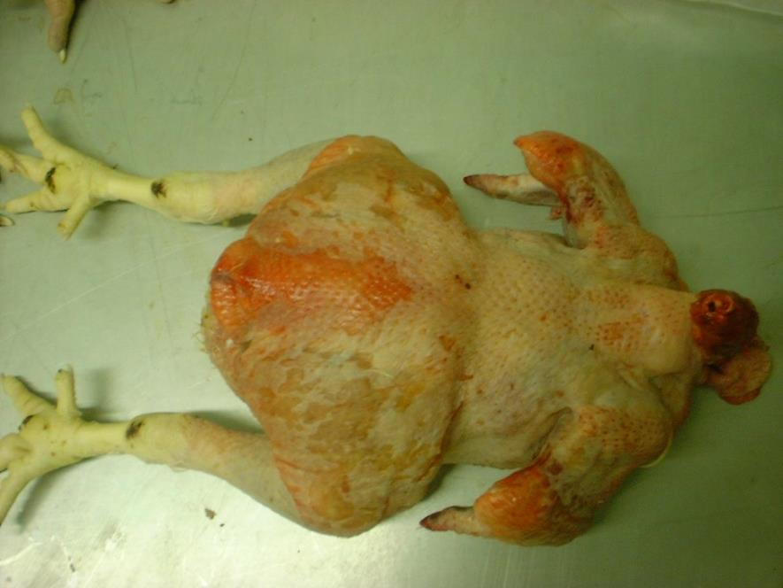
Red-skinned bird caused by poor bleeding
(Photo courtesy of A. Grist)

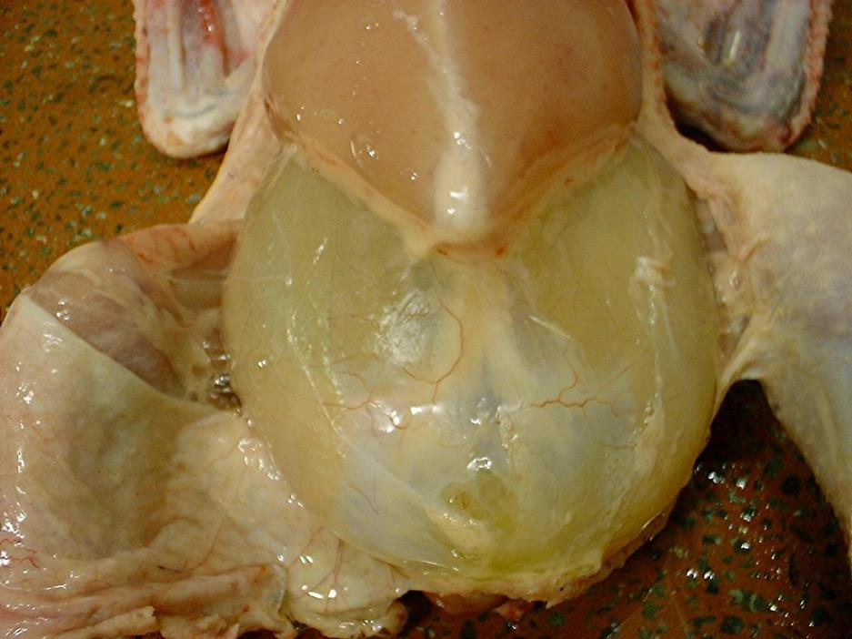
Acites - note the fluid filled abdominal cavity
(Photo courtesy of A. Grist)
How regulatory requirements apply when handling an affected carcase?
Affected carcases should be treated in accordance with regulatory, hygiene and sanitation, and workplace health and safety requirements. In the case of notifiable disease conditions there is a regulatory requirement for reporting processes to be undertaken.
Carcases and parts deemed unfit for human consumption shall be unloaded into an inedible container either automatically or discarded. Work stations are often designed such that the carcases can be discarded by dropping them into a bin, chute, or gutter directly below the rack, carousel or line. Some poultry processing premsies will have two types of condemned containers at the post-mortem inspection stations. One type is for parts and one is for the whole carcase.
Processing equipment which has been used to hold or move suspect or condemned flocks, should be thoroughly cleaned and disinfected, as judged to be necessary by the workplace procedures. Trucks and crates used to convey birds for slaughter should also be thoroughly cleaned and disinfected, before returning to farm.
What are the procedures for retaining carcases on the slaughter floor?
It is necessary to have a rack or similar on which to place suspect carcases for review and disposition.
Taking pathological and residue samples
How are lesions and tissues necessary for determining dispositions identified?
Regarding the presence of residues in poultry meat, the Department of Agriculture & Water Resources (formally AQIS) has a program that routinely samples poultry for residues of chemicals and veterinary drugs. Sample collection rates are based on production levels of the commodity in Australia, or are directed by overseas market access requirements if the product is to be exported. Poultry and egg products are sampled by quality assurance officers at the relevant processing premsies and samples are forwarded to the National Residue Survey (NRS) central receival and dispatch facility. The tissue usually selected for analysis is the one that is expected to contain the highest concentration of a residue. It may be inedible and does not necessarily represent the part most likely to be eaten. For example, fat is analysed for pesticides, kidney is analysed for antibiotics, liver is analysed for metals, and urine or faeces is analysed for some hormonal growth promotants.
The program is not as complex as the red meat industry program because of the intensive nature of the industry and the involvement of veterinarians in the administration and control of chemicals and drugs at farm level.
What are the requirements for collecting and submitting specimens?
For pathological sampling, samples should be collected as directed by your laboratory diagnostician or from organs/tissues that appear abnormal in size, shape, smell, contour, colour, consistency and content during the post-mortem inspection. It is important that the inspection personnel can relate the type of test being performed at the laboratory level (for example, histopathology, microbiology, parasitology etc) to the type of sample that needs to be collected.
If whole birds are being autopsied, then sample carcases can be placed in a bucket of cold water (except the head). This will allow for easier removal of feathers and also slow the rate of autolysis (by cooling the carcase). Cooling the carcase is particularly important if samples are to be sent to the laboratory for analysis.
How are results interpreted?
The interpretation of the results will depend on the tests undertaken and the information provided by the laboratory diagnostician. In the poultry industry, this process usually involves the company veterinarian. A knowledge of company procedures is required.
What are the requirements for retaining carcases while waiting for results?
It may be necessary for the processor to segregate and hold all edible product (and decide how to store it – for example, fresh or frozen) pending receipt of test results for a particular residue from a laboratory. Release of product is usually under the control of the company veterinarian, pending interpretation of results.
WHS requirements relevant to ante-mortem and post-mortem inspections
As well as the employer having a responsibility to make sure that workers have a safe environment to work in, employees, have a responsibility for their own and other's safety and wellbeing. It is important to report any existing hazards or potential hazards to the safety representative as required in company WHS policies. Some examples of WHS policies and procedures that may apply are:
- accident prevention
- emergency procedures in case of injury
- wearing of personal protective equipment (PPE)
- machinery operation
- forklift operation
- Manual handling - for example, lifting birds
- RSI from repetitive work
- reporting equipment malfunction or an electrical fault
- emergency evacuation procedures
- confined spaces policy and procedures
- exposure to dust (for example, during catching and shackling)
- heat/cold environment
- zoonoses.
How hygiene and sanitation and WHS requirements apply when handling an affected carcase?
Airborne contamination, if not controlled, may cause illness if inhaled by workers. This problem is greatest in the poultry reception area and in the shackling area. Personal Protective Equipment (PPE), such as face masks, should be provided in these areas.
Any cuts and sores should be covered to prevent the entry of organisms that may cause infection. This may be in the form of a bandage, with a waterproof covering such as a rubber glove.
Work clothes should not be taken home and washed with domestic clothing as harmful organisms may be transmitted to other clothing in the wash. The ideal situation is for clothes to be washed on site.
Zoonoses
Simply defined, zoonoses (plural of ‘zoonosis’) are animal diseases that are transmissible to humans. The risk of being affected by animal-borne disease can be reduced by attention to simple measures, based on personal hygiene and protection, reducing exposure to disease, and managing human and animal health. Persons with specific medical conditions such as a chronic illness, immunodeficiency and pregnancy may be at higher risk of developing disease or complications from a zoonotic disease and should consult with their physician before working with animals. When working with poultry, you need to consider the following zoonoses:
- Chlamydiosis is a disease caused by Chlamydia psittaci, and although it is normally found in caged and wild birds, it has been known to affect poultry. If transmitted to humans, the disease can range from a mild flu-like infection to serious pneumonia. Fever, headache, and loss of appetite are common signs. Many people report painful and difficult breathing. Since physicians rarely suspect chlamydiosis, it is important for people who have been exposed to pet birds or poultry to request appropriate blood tests. Symptoms in humans may include fever, headache, muscle aches, a dry cough and shortness of breath. Transmission is usually by inhalation of dried droppings, secretions and feather dust of infected birds, therefore at catching and shackling respiratory protection should be worn to reduce the risk of infection. This disease can be treated with antibiotics.
- Avian tuberculosis is a disease caused by Mycobacterium avium complex (MAC). The agent is found world wide in soil and droppings of infected birds. Avian tuberculosis generally is transmitted by direct contact with infected birds, ingestion of contaminated feed and water, or contact with a contaminated environment. Inhalation of the bacterium can cause respiratory tract infections.
- Erysipelas is a bacterial infection of chickens that is transmitted through direct contact with animals, tissues and droppings. The risk of infection increases if persons have unprotected cuts or abrasions on their hands. Disease in humans may present as cellulitis, bacteremia, endocarditis, encephalitis and arthritis.
- Salmonellosis, cryptosporidiosis and campylobacterosis are acquired by contact and accidental ingestion of fecal material or consumption of undercooked meat and egg products from infected birds. Birds infected with these diseases may have diarrhea and discolored droppings but some birds may show no symptoms of disease. Do not eat, drink, while handling birds or in animal housing areas. Wear gloves when handling poultry, body fluids and waste and wash hands after contact. Wear dedicated protective clothing when handling poultry.
Other zoonoses such as Avian influenza would be a risk to people working in the industry if an outbreak was to occur. Personnel most at risk would those handling live birds.
Simple hygiene measures such as wearing masks and washing hands and protective clothing regularly would minimize the risks greatly. These measures should be part of routine practices at all poultry processing premises to minimize the risk of any infections.
Personnel should also exercise caution when checking birds in the lairage, particularly around forklift trucks and moving equipment.
Slips, trips and falls
The meat industry has a high incidence of injuries caused by slips, trips and falls. Many slips and trips occur during manual handling activities.
The most common are:
- floor surfaces – slippery, uneven or damaged
- stairs – slippery, no hand rail support or barrier to stop people falling over the edge
- platforms – slippery, no barrier to stop people falling over the edge
- drains and gutters – differences in levels of adjoining surfaces, pooling or build up of material
- obstructions or obstacles in any work area or pathways, including electrical cords, hoses and any other piece of mobile equipment such as trolleys
- fat, blood, meat scraps, water and other waste products making floors, platforms and walkways slippery.
PPE requirements for post-mortem inspection
What PPE is required to perform post-mortem inspection?
PPE should be considered an essential line of defence for hazards that cannot be overcome with other preventative measures. PPE may include protective clothing, examination gloves, masks, protective eyewear and face shields. Performing a post-mortem inspection will require the use of knife, therefore, appropriate chainmail or protective gloves will be required.
What QA and workplace requirements apply when using PPE?
Effective use of PPE is dependent on appropriate education and compliance of all staff. Procedures for the use of PPE during post-mortem inspections should be developed as part of the company work instructions.
Work clothes should not be taken home and washed with domestic clothing as harmful organisms may be transmitted to other clothing in the wash. The ideal situation is for clothes to be washed on site.
How should PPE be used, maintained and stored?
PPE should be used, maintained and stored to workplace health and safety requirements. PPE and other equipment including knives, steels, pouches, mesh gloves and aprons must be sanitised after use.

Bibliography
These publications were used to develop this training material.
The National Animal Welfare Standards for Chicken Meat Industry.

Additional resources
Registered Training Organisations (RTOs) should refer to the Unit-by-Unit listing of resources on the MINTRAC website www.mintrac.com.au for additional resources to support the delivery of this Unit.
RTOs which develop or identify additional resources are encouraged to advise MINTRAC so that these can also be added to the Unit-by-Unit listing.
The Exam Generator
The Exam Generator is a question bank containing hundreds of questions related to meat safety and Quality Assurance. There are two CDs in the set – one for RTOs (Albert) to create the exams and a student CD (Eddie) that creates electronic practice exams containing all the same questions.
Meat Inspection Currency tool
The Meat Inspector Currency exam generator generates quizzes for the assessment of the currency of a meat inspector’s knowledge.

