AMPMSY410
Perform ante and post-mortem inspection – Equine
Training support materials

Australian Meat Processing Training Package
Certificate III in Meat Processing

Table of contents
Training support materials for AMPA3130 Perform ante and post-mortem inspection – Horses 4
Conducting ante-mortem inspection of Horses 4
What are the main reasons for ante-mortem inspection? 4
What regulatory requirements apply when conducting ante-mortem inspection? 5
What are the principles and procedures for the humane handling of horses? 10
What are the signs of common conditions responsible for abnormalities at ante-mortem and how can they be detected? 11
What are the procedures for humane destruction? 13
What are the procedures for emergency and suspect slaughter? 13
What WHS requirements apply when conducting ante- cryptosporidiosis The WHS principles for the meat industry are explained in the training material for AMPCOR204 Follow safe work policies and practices. 14
What are the QA aspects of ante-mortem inspection? 15
Making an ante-mortem disposition 16
What are common diseases and conditions responsible for abnormalities in horses? 16
What dispositions can be made at ante mortem? 17
What are the requirements for segregating animals? 18
What are the signs of emergency or notifiable diseases? 19
What are the notification procedures for emergency or notifiable diseases? 22
Monitoring the stunning and slaughter of horses 23
What are the types of stunning equipment that are used on horses? 23
What are the requirements for effective stunning and slaughter? 25
How is the effectiveness of stunning assessed? 25
What corrective action must be taken in the event of ineffective stunning or bleeding? 26
What regulatory requirements apply to the assessment of stunning and bleeding? 27
Anatomical structure of horses 28
Identify the basic skeletal structure of horses relevant to post mortem inspection 28
Identify the features of the lymphatic system of horses relevant to post-mortem inspection. 29
What are the elements of horse internal organs that are different to other food animals? 31
Pigs 34
Conducting post-mortem inspection of horses 44
What are the main reasons for post-mortem inspection? 44
What are regulatory requirements associated with post-mortem inspection? 44
What are the procedures for conducting post-mortem inspection? 45
What is the process for identifying and detecting abnormalities? 48
What WHS, hygiene and sanitation requirements apply when conducting post-mortem inspection? 53
What QA issues relate to post-mortem inspection? 53
What are the signs of common conditions responsible for abnormalities at post-mortem and how are they detected 54
What are the types and symptoms of emergency diseases that can be detected at post-mortem? 64
What regulatory requirements apply when handling an affected carcase? 64
What hygiene and sanitation and WHS requirements apply when handling an affected carcase? 66
Retaining carcases 67
What are the procedures for retaining carcases on the slaughter floor? 67
What are the procedures for retaining carcases in a chiller? 67
PPE requirements for post-mortem inspection 68
What PPE is required to perform post-mortem inspection? 68
What workplace requirements apply when using PPE? 68
How should PPE be used, maintained and stored? 69
Taking pathological and residue samples 70
How are lesions and tissues necessary for determining dispositions identified? 70
What are the requirements for collecting and submitting specimens? 70
Serology 71
How are specimens for residue testing taken? 71
How are results interpreted? 71
What are the requirements for retaining carcases while waiting for results? 71
Bibliography 73
Additional resources 73

Training support materials for AMPA3130 Perform ante and post-mortem inspection – Horses
Australian Government figures state that 40,000 horses are slaughtered each year in Australia.
Australian horse slaughter is a multi-million dollar industry, composed of the following.
- Two abattoirs that slaughter an estimated 700 horses a month between them (which equals 8,400 in a calendar year). The meat is exported for human consumption in a number of countries, including Russia, France, Italy, Switzerland, Luxembourg, Belgium, Singapore and Japan.
- Thirty three knackeries that slaughter somewhere in the range of 50 000 horses a year for pet food, meat meal, tallow, hair, hides and other products. Some of these are sold domestically and some are exported.
The content of this Unit and training materials apply only to establishments that process horses to prepare meat for human consumption.
Conducting ante-mortem inspection of Horses
What are the main reasons for ante-mortem inspection?
The main reason for ante-mortem inspection is to detect those animals that may not be suitable for slaughter due to disease or other reason such as chemical residue that could render the carcase unfit for human consumption or animals that need to be humanely killed due to injury or disease.
It is particularly important for those conditions that may not be detectable at post-mortem inspection.
Ante-mortem inspection can be separated into two parts:
- examining animals before slaughter in order to identify and segregate animals that show signs of a disease, condition or abnormality
- deciding what action will be taken with those animals that do have a disease, condition or abnormality.
When carrying out ante-mortem inspections, it is important to:
- detect the presence of suspected exotic or notifiable diseases
- prevent the slaughter of any animal that shows signs of a condition or disease which would make the carcase or carcase parts unsuitable for human consumption
- segregate animals that show signs of, or are suspected of, having a disease or condition, so they can be slaughtered separately and given detailed post-mortem inspection
- prevent animals that are grossly contaminated with faeces, dirt, dust or other material from entering the slaughter floor
- ensure animal welfare standards are maintained at all times.
Workplaces will have different ways of carrying out ante-mortem inspections. Inspectors must follow workplace procedures and instructions. Quality Assurance (QA) and Hazard Analysis Critical Control Point (HACCP) procedures must also be followed to prevent obviously diseased or contaminated stock entering the slaughter floor.
What regulatory requirements apply when conducting ante-mortem inspection?
Australian Standards
Part 3 of the AS4696:2023 Australian Standard for hygienic production and transportation of meat and meat products for human consumption details the requirements for:
- the supply and admission of animals for slaughter
- animal welfare
- and ante mortem inspection and disposition.
These requirements apply to all abattoirs, both export and domestic.
Clause 6 The supply and admission of animals for slaughter
The outcome required is:
- animals are sourced from holdings where the management of animals ensures that the wholesomeness of meat and meat products derived from the animals is not jeopardised
- animals affected by a disease or other abnormality does not contaminate other animals or jeopardise the wholesomeness of meat and meat products.
In practice this means that:
- the animals are correctly identified so as to identify the property of origin or if they are wild animals such as feral horses or donkeys, the area in which they were captured can be identified
- vendor declarations show that the animals have not been recently treated with any chemical or drugs
- animals are not from a property that is under quarantine restrictions, without approval from the relevant authority.
On arrival at the abattoir the meat safety inspector is responsible for deciding either not to admit animals that do not meet these requirements, or admit them under strict controls, until the above issues are clarified.
The meat safety inspector is also to check that:
- the animals have not been grazing on sewage affected pastures or fed materials that may recycle human or animal pathogens
- the animals do not have a notifiable or contagious disease
- the animals have not been treated with any drugs, chemicals or radiation.
All of these items are to be checked prior to the physical ante-mortem inspection by an examination of the Vendor Declaration/Waybill.
The collection and inspection of horse vendor declarations is generally done by the senior stockman at the abattoir. The meat safety inspector needs to ensure that there is a system in place to advise him/her of any animals that arrive without a vendor declaration or any animals where the vendor declaration shows that there is some doubt as to the suitability of the animals for slaughter for human consumption.
The usual practice at abattoirs in Australia, both export and domestic, is for the head stockman to provide the meat safety inspector or the veterinarian at export abattoirs with a kill sheet that shows the order of the animals to be slaughtered, the number in each lot, Property Identification Code (PIC) and any other relevant details from the vendor declarations or waybills.
On domestic abattoirs the meat safety inspector will then indicate on the kill sheet those lots that have been inspected and any animals that may have been segregated as suspects or emergency kill by the stockman or the inspector. This kill sheet will then be passed to the meat safety inspectors on the slaughter floor for reference.
On export abattoirs an ante mortem card is prepared for each lot and accompanies the first animal of each lot to the slaughter floor.
If the meat safety inspector decides that the animals may be slaughtered, this section of the Australian standard requires the company to have in place a system of correlation so that if any disease is found, the animal(s) can be traced back to the property of origin. This is usually achieved by numbering each carcase as it enters the slaughter floor.
Vendor declarations
Since most horse meat is destined for the European market there are specific traceback requirements for this market that need to be met. They are detailed in Meat Notice 2015-03- Revised horse traceability verification requirements for access to the European Union. An extract of the notice is detailed below:

Note: HVD is a Horse Vendor Declaration issued by the Department of Agriculture and Water Resources.
The EU eligibility criteria for slaughter horses consist of:
a. A fully completed HVD (Version 2015/02) must accompany all horses (domesticated and feral/brumbies) consigned to an abattoir for slaughter
- The EU eligibility of each horse must be confirmed prior to slaughter
- The latest version of the HVD template must be used
- Use of an agent for completion and signing of the HVD/s is not permitted i.e. the HVD/s can only be completed and signed by the horse owner.
b. For all domesticated horses consigned to an abattoir for slaughter:
- Either the horses must have been under the control of the consignor for the last six months or more, or
- The horses must have been owned for six months or more by the previous owner.
c. Where the consignor has owned the horse/s for less than 6 months, the consignor must present the originals of the HVD/s completed and signed by the previous owner/s confirming the treatment history of the horses for the last six months prior to slaughter.
d. The consignor must identify each horse at the time or point of purchase for slaughter using uniquely numbered identification collars and the number on the collar must link the horse to the HVD.
- If a horse loses its identification collar, it becomes EU ineligible unless there is an alternative identification management system in use.

- If an alternative unique identification management system is used and that alternative identification number is documented on the HVD in detail, then establishments may be able to replace a lost collar by confirming the identity. This applies in all cases irrespective of when the horse has lost its collar i.e. en route to establishment, in the lairage/yards before or after ante-mortem inspection or on the way to knocking box, etc.
- All actions taken in response to horses losing ID collars must be documented.
- If the horses are consigned directly from owner’s place (i.e. if the consignor is the owner of horse/s for last 6 months or more) to abattoir, then abattoir may be considered as the purchase point and horses must be identified with the uniquely numbered identity collars by the owner at this point.
- The collar numbers must be specific to the establishment (i.e. maintain unique collar numbers).
e. The farm of origin of the horse must be identified on the HVD:
- By the full street address of its location and,
(ii) If one is issued, by its property identification code (PIC).
f. For work health and safety reasons, feral horses and brumbies do not require identification collars, however a full description (e.g. mixed brumbies/feral and mob based physical characteristics etc) of the animal/s must be provided on the HVD.
- If the feral horses are consigned directly to abattoir from the property of origin the relevant feral horse section of HVD/s must be completed by the consignor (questions on the public health risk).
- Feral horses must not be mixed with the domestic horses.
- Each HVD consignment of brumbies/feral must not be mixed with horses from any other brumbies/feral HVD, i.e. one brumby HVD consignment on a HVD must remain discrete from all other brumbies/feral consignments on other HVD/s.
- The establishment management and horse supplier must confirm the eligibility of each horse for EU market before slaughter in accordance with the attached decision tree (refer Attachment 1 of the Meat Notice).
- For product to be eligible for export to the EU, horses must:
- not be slaughtered during a treatment withholding period;
(ii) not been treated with hormonal growth promotants (HPGs) or beta-agonists;
- not been treated with any of the prohibited products listed in the HVD explanatory notes
- be owned either by consignor or by previous owner for 6 months or more
- be presented with correctly completed HVD/s confirming EU eligibility and identified using uniquely numbered identification collar except feral horses (Note: the feral/brumby horses do not need identification collars for EU eligibility due to safety reasons).
Correlation
Correlation is the requirement to identify all parts of a particular animal during slaughter until after all the parts have passed post-mortem inspection. This includes carcases, hides, offal and heads.
Routine correlation is achieved by recording the property identification against the carcase number allocated at slaughter.
This property identification is the unique collar number in horses.
If a carcase is to be retained correlation is achieved by the use of either temporary tags attached to the various parts, and/or visually at the point of inspection.
The carcase and all its parts must be able to be retrieved and correlated to the animal’s property identification.
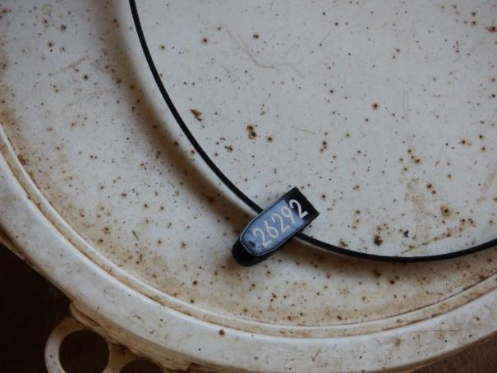
Horse identity tag
© Eddie Andriessen
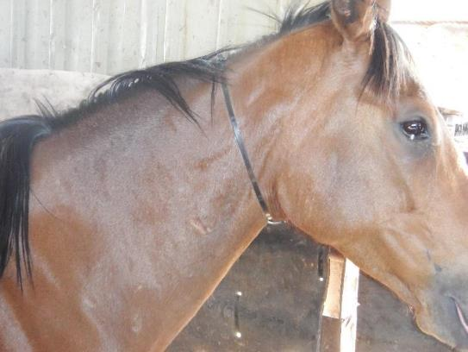
Horse with identity tag around neck
© Eddie Andriessen
Clause 8 Ante mortem inspection and disposition
The outcome required is:
only animals fit for slaughter for the purpose of producing meat and meat products for human consumption are slaughtered.
This clause basically states the following.
- Ante mortem inspection must be carried out by a meat safety inspector or OPV in an export plant.
- The ante mortem inspection must be carried out within 24 hours of slaughter.
- The meat business must supply the inspector with all the relevant information (NVDs/waybills) about the animals to be slaughtered as specified in clause 6.
- The dispositions of animals after inspector are:
  - passed for unconditional slaughter
  - passed for slaughter subject to conditions set by the meat safety inspector (suspect and emergency kill animals)
  - withheld from slaughter
  - condemned.
This clause also specifies the action to be taken when disease or abnormality is suspected in that all dispositions are to be in according to Schedule 3 of the Standard.
What are the principles and procedures for the humane handling of horses?
The principles and procedures for the humane handling of horses are detailed in the AS4696:2023 Australian Standard for hygienic production and transportation of meat and meat products for human consumption clause 7.
Clause 7 Animal welfare
The outcome required is:
The minimisation of the risk of injury, pain and suffering and the least practical disturbance of animals.
The Australian Standard for hygienic production and transportation of meat and meat products for human consumption requires meat companies to have an ‘Approved Arrangement’ with their relevant controlling authority for all aspects of meat production. This Approved Arrangement requires a meat company to include animal welfare as a policy objective in their Approved Arrangement and to demonstrate commitment to this policy.
To meet this requirement many abattoirs are implementing the provisions of the AMIC Industry Animal Welfare Standards for Livestock Processing Establishments Preparing Meat for Human Consumption (3rd Edition).
This Standard is based on the Australian animal welfare codes and international best practice standards.
The AMIC Animal Welfare Standard has four requirements in terms of:
- management
- resources
- management and care of livestock
- humane stunning and sticking processes.
The Standard is supported by an Implementation Guide. The Guide identifies welfare considerations at the various steps in the slaughtering process. It provides guidance on how plants can provide evidence that they are achieving animal welfare requirements and target or animal welfare outcomes and processes.
This guideline is based on the following codes:
- Australian Model Code of Practice for the Welfare of Animals, Number 10: Animals at Slaughtering Establishments
- Operational Guidelines for the Welfare of Animals at Abattoirs and Slaughterhouses
Animal welfare is described in greater detail in the following animal welfare module, which is a core module and co-requisite for this training module AMPA3002 Handle animals humanely while conducting ante-mortem inspection.
What are the signs of common conditions responsible for abnormalities at ante-mortem and how can they be detected?
There are two types of abnormalities that need to be detected at ante-mortem inspection:
- invisible abnormalities such as chemical residues
- visible physical abnormalities.
Invisible abnormalities
The invisible abnormalities that may be present at ante- mortem inspection such as chemical residues can only be assessed by a detailed inspection of the paper work accompanying the animals such a way bills and vendor declarations, or by individual testing of samples from slaughtered animals.
Individual testing of animals is only conducted if there are some doubts as to the chemical residue status of animals. For routine processing the vendor declarations are considered sufficient.
It is vital that the management of the abattoir supply this vendor declaration information either by hard copy or by electronic means to the meat safety inspector or veterinarian prior to ante-mortem inspection.
This is an essential part of the ante-mortem inspection process.
Visible abnormalities
In order to maximize the ability to detect common visible conditions responsible for abnormalities ant ante-mortem inspection it is important that effective procedures are carried out. The AS4696:2023 Australian Standard for hygienic production and transportation of meat and meat products for human consumption states that “animals are inspected to the extent necessary to determine the disposition to be applied to them” but does not specify how ante mortem inspection is to be conducted, but there are ‘best practice’ procedures that should be followed.
The meat safety inspector can vary these procedures according to:
- regulatory requirements e.g. ante-mortem at export abattoirs must be conducted under direct veterinary supervision
- company requirements
- type of animal e.g. young animals are less likely to have disease than older animals.
When carrying out ante-mortem inspection, the animals should firstly be examined when at rest. This is because some signs of sickness or disease will not be seen when the animals are being moved. It is also very important that inspectors look for any animal that is not displaying ‘normal’ behaviour i.e. if it is doing something different to the rest of the mob.
After observing the animals at rest, the inspector must then examine them when they are moving. When doing this the inspector should observe the sides, head and rear of the animals. This is so any abnormality, disease or condition can be detected.
Humane handling
It is very important that any handling or moving of horses is done quietly and humanely.
Horses that are not handled or moved correctly may become stressed. Dogs must not be used to move horses. Stress can affect meat quality. A stressed, flighty or nervous animal can cause injury or stir up other animals in the same pen, resulting in injury to itself and other horses.
Signs of common conditions
Signs which may indicate disease, conditions or abnormality in horses include:
- separating themselves from the rest of the animals
- lying down when the rest are standing
- dullness, listlessness, head down, not alert
- drooping ears
- very poor condition – emaciated
- short, shallow, rapid or loud breathing
- hunched up
- tail flicking, moistness around tail area
- scouring, bloody diarrhoea i.e. dysentery
- excessive salivation
- tongue protruding
- enlargement of jaw bones
- excitement, i.e. excessively active and erratic behaviour
- lameness and/or swollen joints
- lesions in or around eye, i.e. cancer eye
- blood, pus or other abnormal discharges from nose, mouth, anus, vulva or penis
- enlargement or abnormality of scrotum, anus, vulva, penis or udder
- swelling cysts, abscesses or abnormal growths
- skin blotching
- abnormal enlargement of belly
- broken limbs
- wounds
- faecal contamination.
What are the procedures for humane destruction?
If animals are suffering it is vital that they are humanely killed as soon as possible.
Suffering animals include animals with severe injuries such as broken legs. These need to be put up for emergency slaughter.
Other animals that may be suffering include animals that are moribund or near death and these need to be humanely killed immediately and the body condemned.
At abattoirs euthanasia of animals in the yards, is usually achieved by use of a firearm or a captive bolt. Only suitably trained and qualified people may use a firearm/ captive bolt. Workplace instructions must be followed for this procedure.
What are the procedures for emergency and suspect slaughter?
Emergency slaughter animals are slaughtered as soon as possible. They are usually killed in the yards and enter the slaughter floor through the emergency slaughter door close to the knocking box.
Only injured animals should be handled in this way.
Sick animals should be rejected from slaughter and either killed humanely or withheld from slaughter for treatment.
Animals are that are to be treated may not leave the abattoir premises for treatment as abattoirs are considered by all state authorities to be quarantine areas.
After successful treatment particular care needs to be taken to ensure that no chemical residues are present in the animals. This is achieved by ensuring withholding periods for drugs administered are strictly met.
Animals showing evidence of heavy faecal contamination should also be put up as a lot at the end of the shift so that special procedures can be put in place to ensure cross contamination is minimised.
All suspects should be put up for slaughter at the end of a shift/day and workplace instructions must be followed for these procedures.
What WHS requirements apply when conducting ante- cryptosporidiosis The WHS principles for the meat industry are explained in the training material for AMPCOR204 Follow safe work policies and practices.
Possible WHS hazards when conducting ante-mortem inspection could be:
- zoonotic diseases i.e. diseases transmissible from animals to humans including Hendra virus, ringworm, psittacosis, and salmonella
- slips, trips and falls
- injury from animals
- severe weather.
Ways of preventing or controlling these hazards are contained in workplace WHS policies and procedures. Some examples of these may be:
- wearing and using appropriate Personal Protective Equipment (PPE)
- vaccination against zoonotic diseases
- wearing appropriate footwear
- using walkways where provided
- being aware of the behaviour of animals at all times
- being aware of the location of animals at all times
- knowing the location of exit gates, ladders and steps.

Hendra virus is a highly dangerous zoonotic disease. The few cases in people in Australia were in people who had close contact with infected horses. However, there
is no cure, specific treatment or human vaccine for Hendra virus. The best defence against Hendra virus is to avoid contact with an infected horse.

The symptoms of Hendra in horses can include:
- frothy nasal mucus
- high temperature
- rapid heart rate
- difficulty and/or rapid breathing
- sweating
- muscle spasms and twitching
- muscle weakness
- balance difficulties including uncoordinated gait and head tilt
- apparent vision loss and/or aimless walking
- rapid deterioration
If you suspect a horse has Hendra virus report it immediately to the on plant veterinary officer or the Emergency Animal Disease Watch Hotline on Tel. 1800 675 888 (24/7).

What are the QA aspects of ante-mortem inspection?
The QA practices that apply to the meat industry are explained in the training material for AMPCOR203 Apply quality assurance practices.
All personnel conducting ante-mortem inspections and making dispositions must have a good understanding of and follow instructions detailed in the company quality assurance manual and Hazard Analysis Critical Control Points (HACCP) plan. Some of these could include:
- identification of hazards, such as faecal contamination
- preventative action
- control methods
- record keeping
- ante-mortem cards
- traceback to property of origin
- compliance with identification requirements
- delivery dockets
- vendor declarations.
Making an ante-mortem disposition
What are common diseases and conditions responsible for abnormalities in horses?
The identification of different diseases and conditions that can affect an animal's suitability for human consumption is the first step in producing safe meat products. It is essential that these conditions are identified and the correct disposition made as to whether to slaughter the animal. AS4696:2023 Schedule 3 sets out the diseases and abnormalities detected in animals at ante-mortem and the dispositions required.
The ante- mortem conditions from Schedule 3 are reproduced below.

Diseases and other abnormalities | Dispositions for animals, carcases and carcase parts
 | The symbol [1] means carcase or carcase parts unfit for human consumption may be recovered for animal food subject to heat sterilisation. The symbol [2] means carcase or carcase parts unfit for human consumption may be saved either for animal food subject to heat sterilisation or for animal food subject to staining.
1. General findings
Dead animal |  | Animal condemned. If anthrax suspected see 2.1.1.
Dying animal or moribund state with subnormal temperature, weak pulse and disturbed senses. |  | Animal condemned
Fever, debility and general signs indicating acute disease |  | Animal condemned. Alternatively, withhold from slaughter until recovered provided no risk of spread of disease; no undue suffering and recovery considered likely with treatment.
Advanced chronic conditions with generalised signs such as cachexia or loathsome appearance |  | Animal condemned
Injury or accidental trauma during transport to or while in vicinity of abattoir |  | Animal subject to emergency slaughter or condemned
Excitement, exhaustion without signs of acute disease |  | Animal withheld from slaughter and ante-mortem repeated after adequate rest
Slight odour
2. Aetiological listing
2.1 Bacterial and related diseases
Anthrax |  | Affected animals should not be admitted to an abattoir. When detected at ante-mortem, affected animal condemned. Companion animals isolated and withheld from slaughter
Cutaneous lesions |  | Affected areas of skin condemned
Myiasis |  | Animal condemned in severe cases with sepsis or necrosis. Otherwise withhold from slaughter for treatment and resubmit for ante-mortem after recovery.
Ephemeral fever |  | Animals withheld from slaughter for treatment. Resubmitted for ante-mortem after recovery.
Metabolic disorders (transit tetany, ketosis, etc) |  | Animal condemned in severe cases. Withheld from slaughter in milder cases and resubmitted for ante-mortem after recovery.
Faecal contamination
There is a high human health risk of faecal contamination containing pathogenic bacteria such as E.coli and Salmonella and parasites such as cryptosporidia. Only animals that can be slaughtered without risk of faecal contamination should be processed.
Invisible abnormalities
The Australian Standard requires the abattoir operator to advise the meat safety inspector if any animals have been exposed to chemical residues or require testing under any official residue-testing programme.
The horse vendor declaration (HVDs) forms accompanying animals should detail any restrictions such as animals having been treated or exposed to chemical and drugs and the relevant withholding period not having been met.
In addition some animals may require to be tested as part of the National Residue Survey.
The National Residue Survey is a survey managed by the Department of Agriculture and Water Resources where a range of foodstuffs that may be exported, including meat are surveyed for chemical residues.
What dispositions can be made at ante mortem?
The disposition for diseases is described in Schedule 3 of the Australian Standard for hygienic production and transportation of meat and meat products for human consumption.
After ante-mortem inspection, one of the following dispositions will be made about each animal. The animal will be:
- passed as fit for routine processing
- withheld from processing pending treatment for or recovery from an abnormal condition. These animals may be resubmitted for another ante-mortem inspection at a time specified by an inspector. Note: on export abattoirs suspect animals must be held for veterinary inspection
- subjected to immediate emergency slaughter to prevent deterioration of an abnormal condition, provided the condition would allow all or part to be passed for human consumption and processing would not jeopardise the hygienic production of meat
- processed under restrictions which prevent unacceptable contamination of the processing floor and which permit more detailed post-mortem inspection
- rejected as unfit for processing and destroyed by humane means and then disposed of in an approved manner.
The AS4696:2023 Australian Standard for hygienic production and transportation of meat and meat products for human consumption requires the following actions to be taken after ante mortem inspection:
- a record of ante mortem inspection of animals rejected for human consumption or passed as suspect or emergency slaughter must be maintained
- animals that are deemed to be affected by diseases or conditions should be segregated from healthy animals while awaiting slaughter
- groups of animals that exhibit signs or symptoms of stress must be rested before slaughter
- animals that are known to have been treated with, or exposed to a drug, chemical or biological substance, shall not be slaughtered unless any withholding period recommended on the product label has lapsed
- animals that are condemned must be humanely destroyed
- dead animals are removed quickly for disposal.

What are the requirements for segregating animals?
It is important for humane reasons that various categories of animals are segregated during transport and in the yards. For example:
- feral horses should not be mixed with domestic horses
- stallions should be kept completely separate as they will fight
- young horses should be penned separately to adult animals
- feral horses should be maintained in the in group which they were harvested as different groups will tend to fight if mixed in the yards.
After performing ante-mortem inspection, any animals that are showing signs of a disease, condition or abnormality must be segregated from the healthy animals for further detailed inspection. This will also include animals with faecal contamination. The veterinary officer, inspector or authorised person must then make a disposition and decide what action to take. Animals are segregated in four ways after ante-mortem inspection.
- Injured animals are identified for immediate emergency slaughter.
- The bulk of the animals will be passed as fit for human consumption.
- Animals with localized disease e.g. lameness or with a vendor declaration that indicates exposure to chemicals are identified as suspect for separate slaughter preferably at the end of the shift. These animals may also be withheld from slaughter until their condition improves or their chemical residue status is confirmed or abated i.e. after the relevant with holding period has passed.
- Animals with generalized disease that render them unfit for human consumption are condemned.
What are the signs of emergency or notifiable diseases?
Notifiable diseases are diseases in animals that by law must be notified or reported to relevant State or Territory authorities. It includes a number of diseases that are endemic to some parts of the country but not other parts e.g. hydatids.
Animal diseases that do not exist in this country are called exotic diseases.
The list of notifiable diseases varies a little from State to State depending on local circumstances. The following list details the more common notifiable diseases in Australia. This list can vary from time to time.
Note: Although all exotic diseases are notifiable not all notifiable diseases are exotic diseases.
Meat Safety Inspectors need to be alert to and recognise the signs of some of the more serious notifiable diseases.
Since notifiable diseases vary from State to State, Meat Safety Inspectors will need to contact the relevant State animal health authority for further information on the most likely or common notifiable diseases in the state.
Note: Not all notifiable diseases will be evident at ante-mortem, a few are detectable only at post-mortem.
The following chart lists some of the notifiable diseases of animals in Australia that may be evident at ante-mortem.
The list is provided for general information only and can vary from time to time. Some of the notifiable diseases are exotic to Australia, but most are endemic.

Notifiable disease | ACT | WA | NSW | NT | QLD | SA | TAS | VIC
Actinobacillosis |  |  |  | Y
Actinomycosis |  |  |  | Y
Annual ryegrass toxicity |  | Y
Anthrax | Y | Y | Y | Y | Y | Y | Y | Y
Atrophic rhinitis |  | Y |  | Y
Babesiosis (bovine) | Y | Y | Y | Y | Y | Y |  | Y
Birdsville horse disease |  |  |  | Y
Black disease |  |  |  | Y | Y
Blackleg |  |  |  | Y
Bluetongue | Y | Y | Y | Y | Y | Y | Y | Y
Botulism |  |  |  | Y
Bovine spongiform encephalopathy | Y | Y | Y | Y |  | Y | Y | Y
Buffalo fly |  |  |  |  | Y | Y |  | Y
Caprine footrot |  |  |  |  |  |  |  | Y
Cattle tick infestation due to Boophilus microplus | Y | Y | Y | Y |  |  |  | Y
Classical swine fever | Y |  |  | Y |  |  | Y | Y
Contagious pustular dermatitis (contagious ecthyma) |  |  |  | Y
Cow pox |  |  |  |  |  | Y
Equine morbillivirus | Y | Y |  | Y |  | Y | Y | Y
Fasciola gigantica | Y |  | Y |  |  | Y |  | Y
Foot-and-mouth disease | Y | Y | Y | Y | Y | Y | Y | Y
Footrot in sheep, goat and deer | Y | Y | Y |  | Y | Y
Fowl cholera |  | Y
Fowl plague |  |  |  | Y
Fowl typhoid (S. gallinarum) | Y |  | Y |  | Y |  |  | Y
Glanders | Y | Y | Y | Y | Y | Y
Goat pox | Y | Y | Y | Y | Y | Y | Y | Y
Infectious atrophic rhinitis |  |  |  |  | Y
Infectious bovine rhinotracheitis |  | Y | Y | Y |  |  |  | Y
Lumpy skin disease | Y | Y | Y | Y | Y | Y | Y | Y
Malignant tumour |  |  |  |  |  |  |  | Y
Other spongiform encephalophathies |  | Y
Ovine footrot |  |  |  |  |  |  |  | Y
Ovine ked |  |  |  |  |  |  |  | Y
Ovine lice |  |  |  |  |  |  |  | Y
Rabies | Y | Y | Y | Y | Y | Y | Y | Y
Rift Valley fever | Y | Y | Y | Y | Y | Y | Y | Y
Rinderpest | Y | Y | Y | Y | Y | Y | Y | Y
Scrapie | Y | Y | Y | Y | Y | Y | Y | Y
Screw-worm (Cochliomyia hominivorax) | Y | Y | Y | Y | Y | Y | Y | Y
Sheep ked infestation | Y |  | Y
Sheep pox | Y | Y | Y | Y | Y | Y | Y | Y
Sheep scab | Y | Y | Y | Y | Y | Y |  | Y
Spongiform encephalopathies | Y |  |  | Y | Y
Sporadic bovine encephalomyelitis |  |  |  | Y |  | Y
Strangles |  |  |  |  |  | Y
Swine dysentery |  | Y
Swine erysipelas |  | Y
Swine fever |  |  |  |  | Y | Y
Swine influenza | Y | Y | Y | Y | Y | Y |  | Y
Swine plague |  |  |  |  |  | Y
Swine pox |  | Y
Teschen disease (Porcine polioencephalomyelitis) | Y | Y | Y |  | Y
Toxoplasmosis |  | Y
Transmissible gastroenteritis of pigs | Y | Y | Y | Y |  | Y |  | Y
Transmissible spongiform encephalophathies |  |  | Y |  |  |  |  | Y
Warble-fly myiasis infestation | Y | Y | Y | Y | Y | Y |  | Y
What are the notification procedures for emergency or notifiable diseases?
The identification and notification procedures that apply of emergency animal diseases are explained in the training material for AMPMSY302 Recognise signs of emergency and notifiable animal diseases.
The procedures for identification and reporting on each abattoir should be detailed in the abattoir Emergency Animal Disease Preparedness (EADP) plan.
There should be an Emergency Animal Disease Preparedness (EADP) plan on every abattoir in Australia. Check the plan at the workplace. This plan should detail the notification procedures for emergency or notifiable diseases.
This plan should be based on the meat-processing manual of AUSVETPLAN.
AUSVETPLAN is the master plan for dealing with exotic disease. It has been designed by experts from state and commonwealth departments responsible for animal health in Australia.
The EADP plan on the abattoir should contain the following:
- action measures detailed as job cards for all responsible key personnel
- a map showing perimeter fences, drainage, yards, adjoining properties, suitable areas for burial and ponds and waste water disposal
- an up to date list of notifiable diseases
- phone numbers both home and at work of key personnel e.g. on-plant vet, senior meat safety inspector, plant manager, engineer, stock person
- location and condition of a supply of soda ash and decontamination equipment
- instructions on how disinfectants and chemicals on site may be used for disinfecting people, equipment and vehicles
- where there are reasonable grounds to suspect an exotic or notifiable disease has been found, the qualified person, i.e. a veterinarian or meat safety inspector, must implement the control procedures detailed in the plan until the State or Territory animal health authority advises otherwise, or takes control of the situation.
The first step when an exotic or notifiable disease is suspected, is to immediately notify the state or territory animal health authority, e.g. the state department of agriculture.
The District Veterinary Officer, Regional Veterinary Officer or Chief Veterinary Officer in that state will take control of the situation. The national hotline number for emergency animal diseases is 1800 675 888.
Once the authority has been notified they will provide further advice on the action to be taken.

Monitoring the stunning and slaughter of horses
What are the types of stunning equipment that are used on horses?
A range of equipment can be used to stun animals. The type of equipment used at each site will depend on the type and size of animals or species being processed.
It is important that the correct workplace procedures for using the stunning equipment at the site are followed.
There are four main categories of stunning equipment used:
- mechanical stunners – penetrating and non-penetrating
- electrical stunners
- controlled atmosphere or gas stunners
- firearms.
Gas stunners are not used on horses; they are mainly used on pigs.
Electrical stunning is not used on horses.
Non-penetrating captive bolts are mainly used to meet halal requirements. Horses are not slaughtered for this market so only the penetrating captive bolt is used in horses.
Penetrating captive bolt stunners
Penetrating captive bolts cause physical damage to the brain (by penetration) in addition to the concussion caused by the impact of the bolt onto the skull. Penetrating captive bolt stunning is therefore an effective stunning method that can result in the death of the animal when carried out correctly. However, this effect should not be relied upon and the method still requires proper bleeding of the animal to ensure its death. The use of penetrating captive bolts for the casualty slaughter of animals allows pithing (insertion of a rod through the bolt hole to destroy the brain) in the absence of sticking.
Penetrating captive bolt stunners
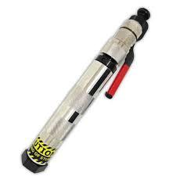

Captive bolt

Captive bolt power types
The vast majority of the captive bolt stunners in use are cartridge powered. They are usually powered by blank cartridges (.22 or .25 calibre) with a gunpowder load but no bullet. Cartridges of varying power loads (resulting in different bolt speeds) are used for different classes of animals. As a rule of thumb heavier powder loads are used for heavier/bigger animals with larger skulls. The advantages of cartridge powered captive bolt stunners are that they are relatively cheap, easy to handle and maintain, and most importantly very portable. They are therefore very flexible and can be used in almost any environment. This has made them the stunner of choice for small to medium sized abattoirs, for any application outside (yards, trucks, etc.), and as a back-up device for other stunning equipment.
Firearms
In some circumstances, firearms are the preferred method of destruction, e.g. escaped animals and emergency destruction in stockyards, paddocks or stock transports.
Firearms work on the same principal as captive bolts except that the mass of the projectile is smaller, the projectile is not restrained and the velocity is higher than a captive bolt. The firearm delivers far more impact than the captive bolt and is thus considered the most effective means of killing animals. However, WHS issues preclude its routine use in abattoirs.
The bullet has both a concussive and a destructive effect on the brain and effectively kills the animal. There is no stipulated maximum stun–stick interval for animals shot by firearm, as the animal is effectively already dead. However, a stick as soon as possible after shooting is considered best practice to achieve a good bleed.
What are the requirements for effective stunning and slaughter?
The stunning operations at each site will be governed by the site workplace procedures. These workplace procedures and policies will depend on the species and category of animals being processed.
To achieve an effective stun, workers need to have an understanding of the stunning process and be trained in the correct use of the stunning equipment. Effective stunning with a captive bolt stunner depends on five main factors:
- trained and competent operatives
- accurate positioning of the equipment over the target area
- use of the correct strength of cartridge for the animal being stunned
- the velocity and diameter of the bolt
- proper maintenance and daily cleaning of the equipment.
The main cause of ineffective captive bolt stunning is incorrect positioning of the equipment. This is often due to the animal moving its head at the last moment so that the bolt is not in the correct spot when fired. To overcome this problem, operators must be adequately trained and the restraining equipment must be constructed so as to:
- prevent substantial movement of the animal forwards, backwards and sideways
- restrict movement of the animal's head
- allow for the stunning device to be applied to the target area on the animal’s head.
The use of the correct strength of cartridge/air pressure is vital for proper stunning and the manufacturer’s specific instructions should be followed at all times.
The explosive materials used in the cartridge powered captive bolt stunners will cause a residue that can reduce the performance of the device and will, if not removed, result in ineffective stunning and excessive wear of the equipment. So, daily checking and cleaning of the equipment is vital for proper use. If all these elements are addressed, stunning should be routinely effective.
How is the effectiveness of stunning assessed?
Certain physical signs should be observed in the stunned animal in order to satisfy the operator that the stun has been effective.
These are:
- the animal collapses immediately
- a tonic and clonic phase can be observed – at first the legs are all tucked under, and then the front legs will extend, but the hind legs will remain tucked under, and only slowly extend. This is the ‘tonic phase’. Over a period of time, the animal will start to convulse and the legs may kick violently. This is the ‘clonic phase’.
- no rhythmic breathing
- fixed, glazed expression in the eyes
- no corneal reflex
- relaxed jaw
- tongue hanging out.
In animals shot with a free projectile there may be additional signs:
- profuse bleeding from mouth, nose and/or entry wound
- after first being completely still, violent convulsions of the carcase may occur up to one minute after the shot (clonic phase).
What corrective action must be taken in the event of ineffective stunning or bleeding?
Animals may suffer when stunning procedures fail. There must be provision for appropriate back-up stunning equipment to be available to minimise pain, distress or suffering to the animals.
If the initial stun is not fully effective then a number of actions have to be taken. These will be described in the work instructions. They must cover both corrective action (i.e. resolving the immediate issue) and preventive action (i.e. preventing it from happening again).
The immediate action, upon the discovery of an ineffectively stunned animal or an animal showing signs of sensibility on the bleed-line, must be to re-stun. Animals showing signs of sensibility on the bleed-line must also be re-stuck after re-stunning.
If ineffective stunning becomes a recurring or consistent problem then it is important to:
- report this to the supervisor
- charges being used
- check the placement of the stunner
- check the routine maintenance of the stunner.
In most plants, stunning is monitored daily to ensure:
- that the animals are being stunned effectively first time
- that the stun/stick intervals are observed
- that excessive numbers do not build up in the stun/stick areas
- the use of incorrect voltages, cartridges, air pressure or gas levels or the incorrect placement of stunning equipment.
What regulatory requirements apply to the assessment of stunning and bleeding?
The AS4696:2023 Australian Standard for Hygienic Production and Transportation of Meat and Meat Products for Human Consumption requires meat companies to have an Approved Arrangement with their relevant controlling authority for all aspects of meat production. This Approved Arrangement requires a meat company to include animal welfare as a policy objective in their Approved Arrangement and to demonstrate commitment to this policy.
To meet this requirement many abattoirs implement the provisions of the AMIC National Animal Welfare Standards for Livestock Processing Establishments Preparing Meat for Human Consumption (3rd Edition).
Separate to the Standard is a working manual that effectively acts as a guideline as to how the outcomes of the Standard are to be achieved. Different but equivalent procedures and practices can be used so long as an equivalent outcome is demonstrated and proven.
This standard identifies five key areas that need to be covered in the relevant standard operating procedure(s)(SOPs) for animal welfare:
- arrival of stock and unloading
- lairage and holding areas
- movement of stock to the slaughter floor
- stunning
- slaughter.
The following items need to be addressed for stunning and slaughter at all abattoirs:
- the operation, maintenance and cleaning of facilities and equipment for stunning and restraint
- effective stunning
- contingencies for daily management and emergencies including back-up stunning
- the maintenance and design of slaughter equipment and facilities
- effective and humane slaughter procedures
- contingencies for daily management and emergencies
- feedback on carcase quality e.g. bruising
- staff training.
Stun/stick interval
An important part of the slaughter process from a humane point of view is the stun/stick interval.
Most animals are stunned by reversible means, so the stun/stick interval needs to be such that animal has no time to recover. The operational guidelines for the welfare of animals at abattoirs and slaughterhouses specifies that the stun/stick interval for horses should be no more than 30 seconds.

Anatomical structure of horses
Identify the basic skeletal structure of horses relevant to post mortem inspection
The core unit AMPA3119 Apply food animal anatomy and physiology to inspection processes details the anatomical and physiological elements that apply to all species.
In the horse there are more than two hundred bones in the skeleton. The skeleton provides the basic structure of the animal, and helps to protect the delicate internal organs. The bones articulate with one another at joints. They are joined at these joints by strong bonds of fibrous tissue and are held in place by a system of ligaments and muscles. The skeleton of animals can be divided into two major parts:
- the axial skeleton, which includes the vertebral column, the ribs, the sternum and the skull
- the appendicular skeleton, which includes all the bones of the limbs
  - in the fore limb, the scapula, humerus, radius and ulna, carpus, metacarpus and phalanges;
  - in the hind limb, the pelvis (ilium, ischium, pubis, acetabulum), the femur, tibia and fibula, tarsus, metatarsus and phalanges.
At slaughter the head is removed and the fore and hind legs are removed at the carpal and tarsal joints respectively.
This skeletal framework carries the muscle systems that form the complete carcase. And includes blood vessels and the lymphatic system. From a meat inspection viewpoint the lymphatic system is probably the most important part of the carcase as any disease causing organisms or abnormalities such as cancerous tumours will tend to show up there. For this reason the lymph nodes should get particular attention during post mortem inspection.
The internal organs of the animal (viscera) will have been removed during slaughter and will need to be inspected separately.

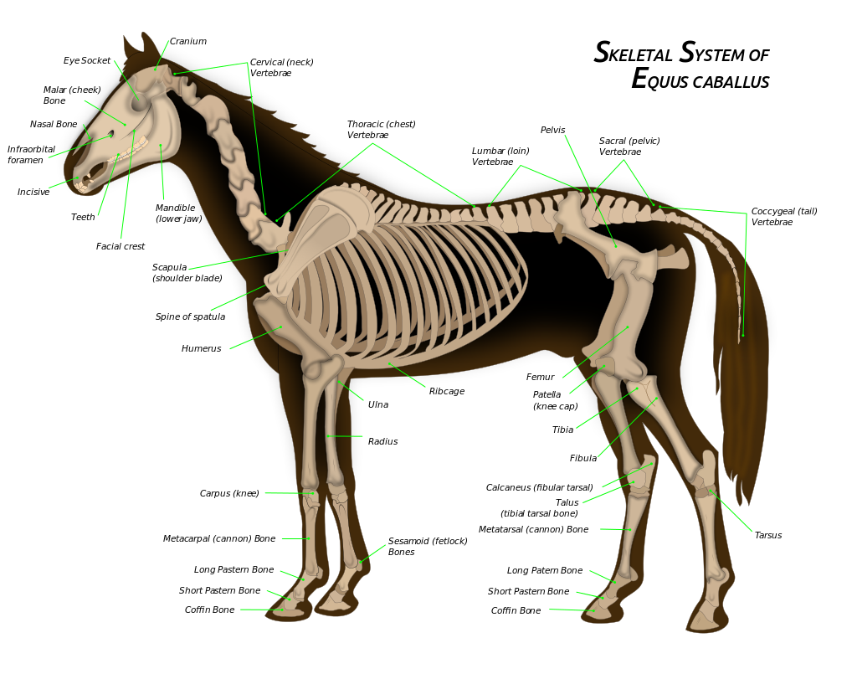
By Wikipedian Prolific, vectorization process by The Photographer
This vector image was created with Inkscape. - File:Horseanatomy.png, CC BY-SA 3.0, https://commons.wikimedia.org/w/index.php?curid=44546089

Identify the features of the lymphatic system of horses relevant to post-mortem inspection.
The lymphatic system is a system of ducts, vessels and nodes that run parallel to the venous blood circulatory system. The lymphatic system can be likened to a drainage system that drains away excess body fluids. Because blood, under pressure due to the pumping of the heart, passes through the capillaries, part of the plasma is constantly leaving the circulatory system and moving into the tissue spaces, carrying nutrients etc. to the tissues. Very little of this fluid is reabsorbed by the capillaries, so a system is needed to drain the excess tissue fluid. This need is filled by the lymphatic system.
The lymphatic system:
- drains excess fluid from tissues
- filters and kills bacteria
- produces white blood cells that are part of the body’s defence
- absorbs and transports fats from the intestines to the blood stream.
The lymphatic system is made up of:
- lymph capillaries
- lymph ducts and lymph vessels
- lymph nodes
- tonsils
- haemolymph nodes
- spleen.
Lymph nodes
Lymph nodes filter harmful bacteria from the lymph. They are also one of the body’s major sources of white blood cells. The characteristics of lymph nodes are that:
- afferent lymph vessels deliver lymph to a lymph node
- efferent lymph vessels drain lymph away from a lymph node
- regional lymph nodes drain specific areas of the body
- terminal lymph nodes receive lymph from other lymph nodes and empty lymph into a major lymph duct or trunk
- evidence of infection in a specific lymph node indicates infection in the area that node drains
- lymph nodes are a major indicator of the health of an animal at post-mortem inspection
- all lymph passes through at least one lymph node
- lymph nodes vary greatly in size and shape, colour and texture between species and within species and within individual animals.
The inspection of lymph nodes is an essential part of meat inspection. Lymph nodes in all species are found in roughly the same position.
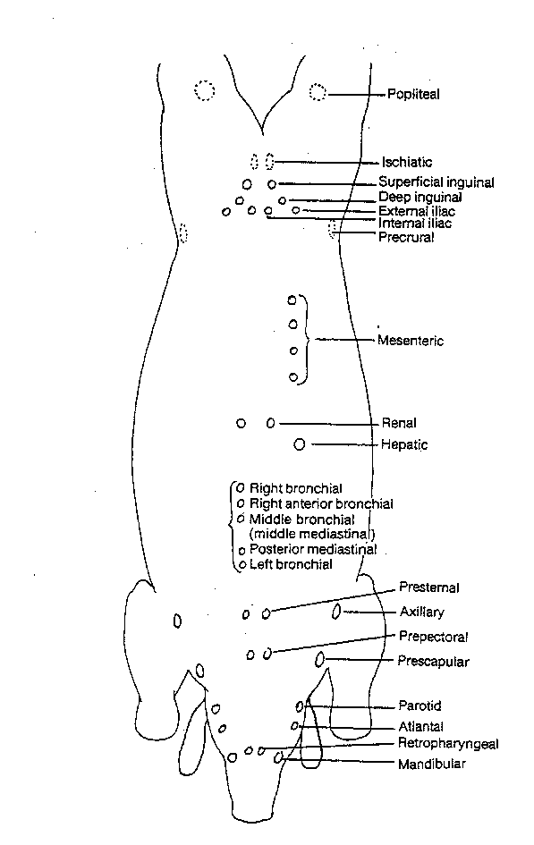
The following diagram shows the approximate position of key lymph nodes in the carcase and viscera of cattle, sheep, goats, pigs, horse, deer and camelids.
Diagram of the principal lymph nodes in the body of food animals
There is some variation in size and precise location between the species due to anatomical differences. For example because pigs have a short neck the lymph nodes of the head and neck are difficult to separate.
What are the elements of horse internal organs that are different to other food animals?
The spleen
The spleen is a large lymphoid organ, but is supplied with blood. It acts as a store of blood and also functions to destroy aged red blood cells. In this process it saves iron from the haemoglobin to be reused in the manufacture of new red blood cells.
The spleen in young cattle (bovine) is reddish brown and becomes bluish in colour as the animal ages. The spleen is found on the left upper side of the rumen, where it is firmly attached. It is an elongated strap-like organ, slightly convex, with rounded edges. It weighs about 1kg.
The equine (horse) spleen, on the other hand, is a flat, distinctly sickle-shaped organ weighing about 1kg.
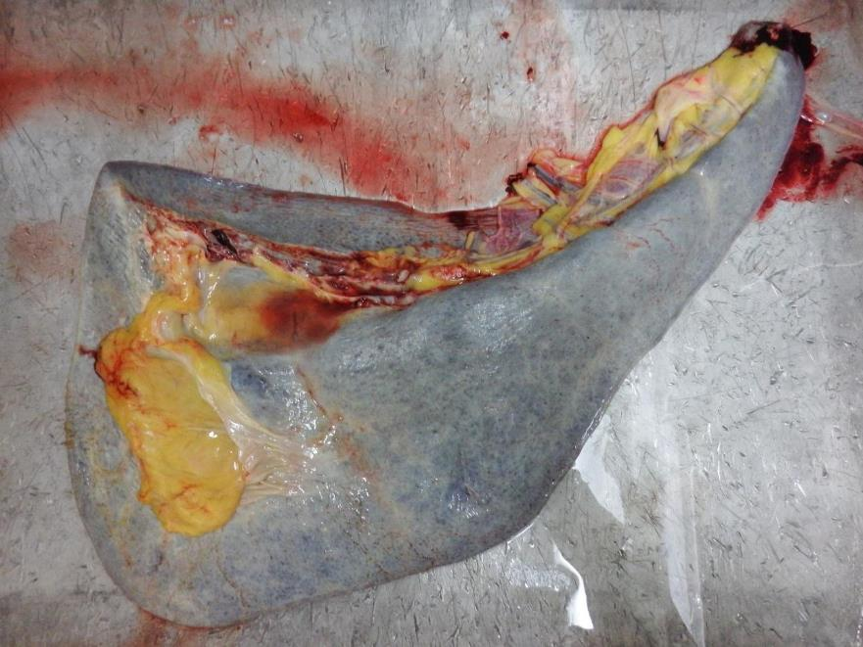
Horse spleen
© Eddie Andriessen
The spleen of a sheep (ovine) is firmly attached to the rumen and is roughly triangular in shape and is soft; it generally weighs less than 100g.
The spleen of a goat (caprine) is similar to the ovine spleen but tends to be more rectangular in shape. The weight is generally less than 100g.
The pig's (porcine) spleen is attached to the stomach; it is an elongated tongue-like structure with a triangular cross-section. It weighs up to 0.5kg. The pig's spleen is loosely attached to the stomach; as a consequence, it can rotate and partially cut off its blood supply. Spleens so affected may occasionally be seen on routine post-mortem inspection.
The kangaroos spleen is T shaped and attached to the greater curvature of the stomach.
The Heart
Horses
The heart in equines has two ventricular furrows. The aortic cartilage becomes slightly ossified in older animals.
The weight of the heart varies from 2-5kg. The fat is generally more scanty than that on a bovine heart and has a rather oily appearance.
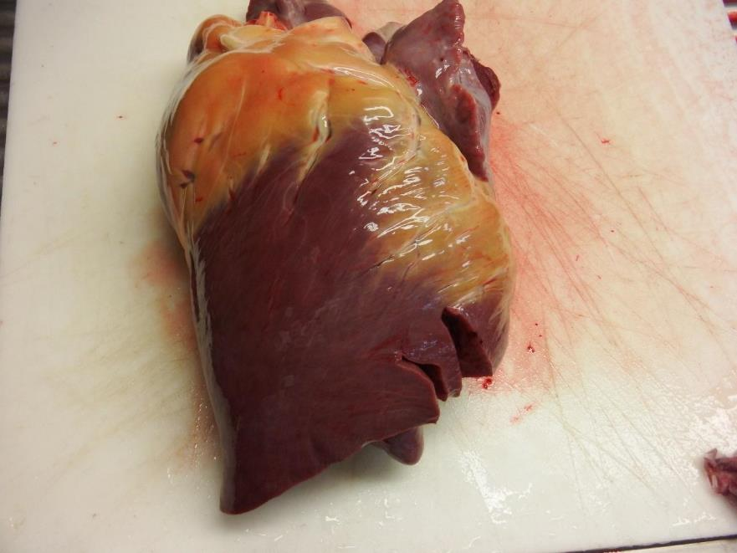
Horse heart
© Eddie Andriessen
Cattle
The heart in bovines has three ventricular furrows on the surface. There are generally two ossa cordi, which are irregularly Y-shaped bones at the base of the heart near the aorta. The bovine heart weighs between 1.8 and 2.2 kg.

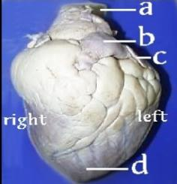

Legend: a-Aorta b- Pulmonary artery c- Left Auricle d-Apex of the heart
Beef Heart
Note: The location of the various parts of the heart, as described above, is the same for all species.
Sheep
The ovine heart has three ventricular furrows. A small os cordis is present in older sheep. The heart weighs about 80-120 grams. The fat is very white and sets firm.

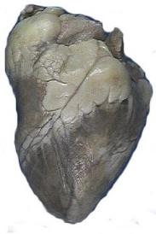

Sheep heart

Goats
The caprine (goat) heart has generally only two ventricular furrows and not three as in sheep. The apex is more rounded than in a sheep. The heart cartilage is ossified in older animals. It weighs 150-200 g. In feral goats with narrow chests the heart also tends to be narrow, lacks the fat cover of sheep hearts and tends to be smaller than in the same sized sheep. The picture below is from a well-fed domestic goat not a feral goat
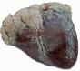

Goat heart

Pigs
The pig's heart often has three ventricular furrows. The apex is more rounded than that of the sheep and has less fat in the ventricular furrows. The heart appears more globular overall. It weighs 150-200 g.

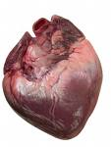
Pig heart
Kangaroo
The kangaroos heart is similar in size and shape to a sheep heart, but there is no fat around the base of the heart or in the ventricular furrows.
Respiratory system
The respiratory system and the lungs in particular is the common primary or first sites of infection. This is because it is:
- in direct contact with the external environment
- a moist and warm environment
- made up of a fine, tubular network in which bacteria and foreign materials can become lodged to set up sites of irritation, inflammation and bacterial infection.
The respiratory system is made up of nostrils, nasal cavities and mouth, pharynx, epiglottis, larynx, trachea and lungs.
In domestic animals there are two lungs, one on the right and one on the left-hand side of the chest. The lungs are further divided into lobes. These are the apical, cardiac and diaphragmatic lobes on each side.
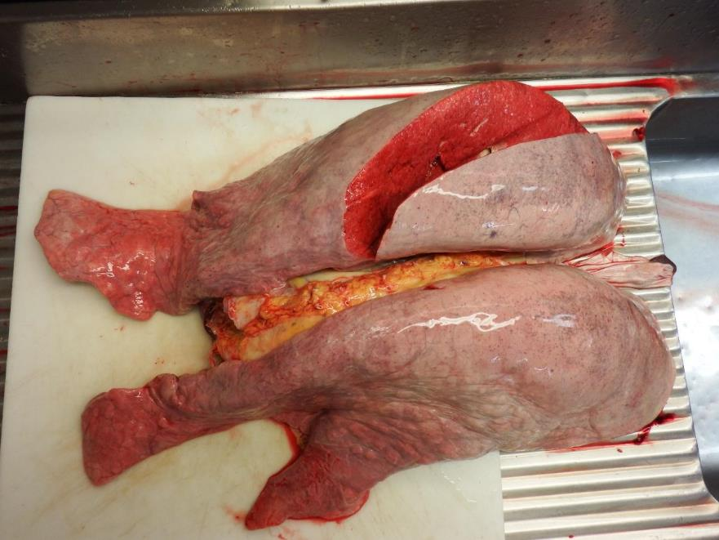
Horse lungs
© Eddie Andriessen
The exact arrangement varies markedly between the species. (See Table below)
The bronchioles, carrying air to all parts of the lung, terminate in small air sacs called alveoli. The alveoli are lined by a thin epithelium and are extremely closely opposed to the small blood capillaries of the lung.
This enables oxygen to diffuse across to the red blood cells, and carbon dioxide to diffuse from the blood into the air.
Animal | Trachea | Bronchi | Lungs Description | No of R. lobes | No of L. lobes
Cattle | Ends of cartilage form a ridge along the trachea | Two on the right and one on the left | Firm bright and red with distinct interlobular septa | 4-5 | 3
Horse | Cartilage rings overlap on the ends | One on the right and one on the left | Lungs are long, lobules are poorly defined | 3 | 2
Sheep | Similar to cattle but smaller | Two on the right and one on the left | Dense and leathery | 4-4 | 3
Goat | Similar to sheep | Two on the right and one on the left | Lungs appear smaller and the interlobular fissures deeper than in sheep | 4-5 | 3
Pig | Similar to cattle but much shorter | Two on the right and one on the left | Long broad and spongy with lobules well marked in squares | 3-4 | 2-3
The lungs in all species contain the following lymph nodes which are associated with the relevant bronchi:
- right bronchial lymph node
- right anterior bronchial lymph node
- middle bronchial lymph node (middle mediastinal lymph node)
- posterior mediastinal lymph node
- left bronchial lymph node.
Inspection of these nodes is an essential part of meat inspection of the lungs.
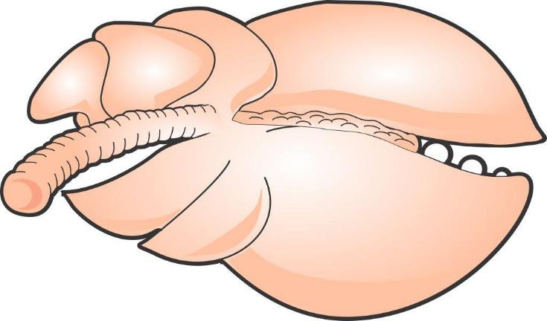
Right anterior bronchial
Left bronchial
Right bronchial
Middle bronchial
Posterior mediastina
Diagram horse lung showing relevant lymph nodes
The digestive system
The prime function of the digestive system is to break down and absorbs food and water and to expel the wastes of digestion.
The digestive system is made up of:
- mouth – teeth and tongue
- pharynx
- oesophagus
- stomach
- small intestine – consisting of the duodenum, jejunum and ileum
- large intestine – consisting of the ascending, transverse and descending colons
- rectum
- anus
- accessory glands, organs:
- liver and gall bladder
- salivary glands
- pancreas
- peritoneum – a lubricated serous membrane which lines all the abdominal viscera, that is stomach, small and large intestines and the abdominal cavity.
Mouth teeth, tongue and pharynx
The mouth teeth tongue and pharynx are located in the head. Like the respiratory system, the head is the common primary or first sites of infection. This is because it is:
- in direct contact with the external environment
- a moist and warm environment.
This means that the lymph nodes of the head are an important indicator of disease, in particular the retro pharyngeal lymph nodes.
The Tongue
The tongue varies widely among the various domestic animals.
Horse | Long thin and narrow with a spatulate end; no dorsal ridge  and a pointed epiglottis; never has any black pigmentation
Cattle | Thick, tapering with a pointed end; a marked dorsal ridge;  often has black pigmentation; epiglottis is semi-circular
Sheep | Thick and short with rounded tip; the centre of the tip is slightly  grooved; 18-24 circumvallate papillae on the back edge of the tongue
Goats | Very similar to the sheep; the groove in the centre of the tip is  slightly deeper; 12 circumvallate papillae on the tongue
Pigs | Long and thin with a pointed end; no dorsal ridge; smooth surface and  a broad and rounded epiglottis
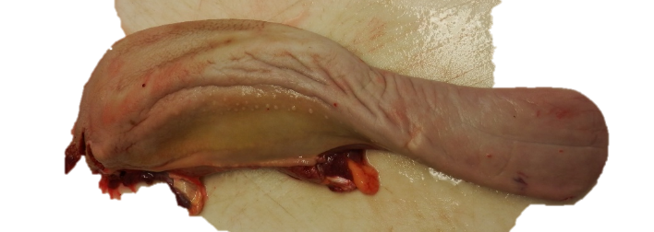
Horse tongue
© Eddie Andriessen
Stomach
The primary function of the stomach is to completely break down food through the action of micro-organisms and gastric juices.
The horse is a non-ruminant herbivore. Non-ruminant means that horses do not have multi-compartmented stomachs as cattle do. Instead, the horse has a simple stomach that works much like a human’s. The equine digestive tract is unique in that it digests portions of its feeds enzymatically first in the foregut and ferments in the hindgut.
The horse’s digestive system really should be thought of as being in two sections. The first section has similarities to the pre-caecal digestive system of a monogastric animal such as the dog, man or pig. The second section is more like the rumen of a cow.
.
Left extremity
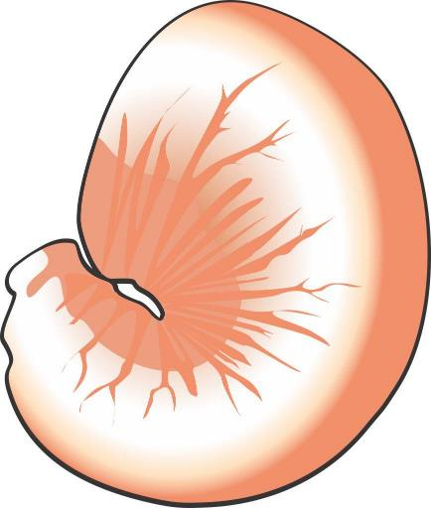
Oesophaguss
Duodenummmm
Pylorus
Stomach of a horse
Cattle, camelids, sheep and goats are ruminants and have four compartments in their stomachs, the rumen, reticulum, omasum and abomasum.
The first three chambers are basically fermentation vats where bacteria breakdown the cellulose in grasses into simpler compounds for digestion. The final chamber, the abomasum, is where the gastric juices are made and secreted and where true digestion takes place.
Gastric juices contain a very strong acid and a variety of enzymes that breakdown the food to their components.
The walls of the stomach are protected from the acid by mucus.
Small intestine
The primary function of the small intestine is the absorption of food components into the blood stream and lymph, although additional digestion of food does occur in the first part of the small intestine, the duodenum.
Digesta passes from the stomach into the small intestine. The small intestine is approximately 28% of the horses’ digestive tract, is 15-22m long and has a volume of 55-70 litres. This is the major site of digestion in the modern performance horse.
The small intestine is divided into three sections, the duodenum, jejunum and ileum.
Large intestine
The primary function of the large intestine is the reabsorption of water.
The hindgut or large intestine, to which it is commonly referred to, consists of the caecum, large (or ascending colon, small colon, rectum and anus. Here is where a bulk of the digestive more is done.
Characteristics of the large intestine are:
- it comprises of 62% of the entire gut and is approximately 7 metres in length and has a volume of 140-150L.
- it does not contain villi
- caecum – important in the digestive process for monogastric animals like pigs and horses.
Rectum and anus
The primary function of the rectum and anus is the expulsion of indigestible food components.
Accessory organs of digestion
The accessory organs which aid digestion are:
- salivary glands
- pancreas
- liver.
The salivary glands produce saliva, a lubricant for food thus assisting the animal in chewing and swallowing.
Characteristics of salivary glands are that:
- they are located in the mouth
- all species have three paired sets of salivary glands:
- parotid
- sub-mandibular
- sub-lingual.
The pancreas has a primary digestive function of secreting digestive enzymes to help in the breakdown of foods. It is pale brown in colour and lobulated in appearance and is located near the start of the small intestine.
The liver has many functions, including:
- converting excess sugar into glycogen, storing it for later use
- breaking down surplus proteins and manufacturing others when required
- detoxifying poisons
- breaking down fats, and assembling others for storage
- storing iron for blood production
- producing bile that assists the digestion of fats and also the neutralisation of gastric juice.
The livers of various domestic species vary considerably in size and shape.
Horses - the horse liver is composed of three distinct lobes and a thumb piece, which ends in a point. There is no gall bladder and the average weight is about 4.5 kg.

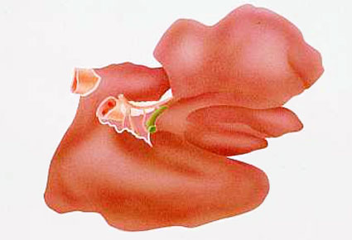
Horse liver
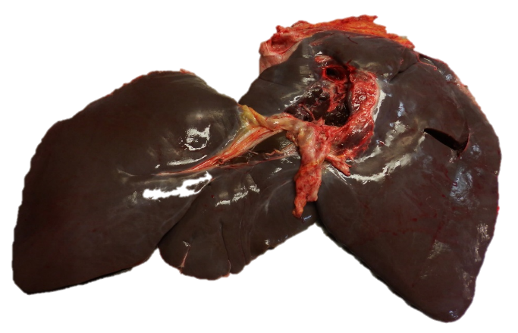
Horse liver
© Eddie Andriessen

Cattle - The beef liver is indistinctly divided into two major lobes. The right lobe is larger and thicker than the left lobe. There is also a poorly defined caudate lobe, which has a rounded shape and often extends beyond the lower edge of the liver. The beef liver has a pear-shaped gall bladder.
Sheep - The sheep liver is similar in shape to beef livers but can be differentiated from calf liver by the blunt pointed caudate lobe which does not exist in beef livers. It weighs about 0.5 kg. There is also a small thumb piece near the hilus.
Goats - The goat liver is very similar to that of the sheep. It is slightly thinner and has a sharp-pointed caudate lobe, which also appears to be narrower than that in the sheep. There is no thumb piece. Livers from feral goats often have adhesions on the surface.
Pigs - The pig's liver has five distinct lobes and is distinguished by the large amount of interlobular tissue, creating a distinct pattern on the surface of the liver. The gall bladder is partly embedded in the liver substance rather than sitting on the surface as in sheep.
Deer - The liver is similar to that in sheep, but it is generally larger and has no gall bladder.
Camel - The liver is similar to that in horses in that it is multilobulated and has no gall bladder. It also has a frilly appearance around the edges.
The renal system
The renal system consists of the kidneys, ureters bladder and urethra. The purpose of the system is to eliminate the by-products of metabolism from the body.
The kidneys are often left in the carcase for inspection but they should be enucleated from their outer capsule so that the tissues can be properly inspected. Any infection in the blood stream can show itself in the kidneys.
There are two kidneys in all domestic animal species. They are located one on each side, in the upper loin region in the abdomen at about the level of the third lumbar vertebrae. They are reddish in colour and surrounded by a capsule. They are often encased in a large quantity of fat, particularly in well fed animals.
Species variations
The kidneys in different domestic species vary considerably in shape and appearance.
Horses – The right kidney is heart-shaped and the left kidney is bean-shaped and longer than it is broad. They are each indistinctly broken up into about 3 to 5 lobules. Each kidney weighs about 700 g.
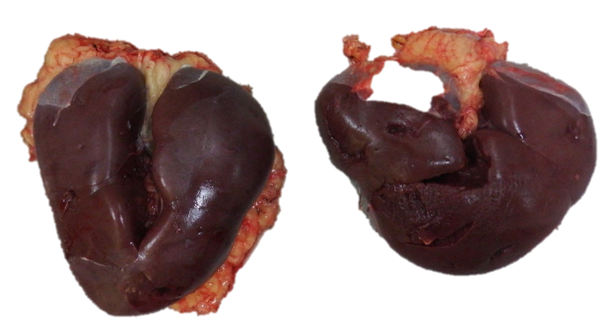
Horse kidneys
© Eddie Andriessen
Cattle - The kidneys in cattle are distinctly lobulated, each kidney consisting of 15-20 lobules. The weight of each kidney is approximately 200-300 g.
Pigs - The pig's kidneys are smooth and bean-shaped but flatter and larger than those in sheep. They each weigh about 100- 150 g.
Camels - Their kidneys are shaped like a sheep’s kidney but are the size of a horse’s kidney.
Kangaroos - The kangaroo’s kidneys are bean shaped dark red organs about 50-70 gms in weight.
Sheep and goats - The kidneys in these two species are extremely similar. They are both bean-shaped, dark-red organs. The goat's kidneys appear slightly more rounded and globular. Each kidney weighs about 60-80g.

Conducting post-mortem inspection of horses
What are the main reasons for post-mortem inspection?
The main reason for post-mortem inspection is to identify those conditions that can affect the suitability of a carcase and its parts for human consumption.
It is an organoleptic inspection i.e. it is an inspection by physical means of a carcase and all its parts using all of an inspectors senses, including:
- visual inspection (observation)
- palpation
- incision and
- smell where appropriate.
If any doubts arise as to the suitability of the meat for human consumption the carcase and its parts can be retained and samples taken and sent to a laboratory for analysis.
What are regulatory requirements associated with post-mortem inspection?
Schedule 2 of the AS4696:2023 Australian Standard for the hygienic production and transportation of meat and meat products for human consumption details the basic post-mortem inspection procedures that must be applied to all animals slaughtered at abattoirs in Australia, both export and domestic.
Some export markets have additional requirements. These are detailed later.
In Schedule 2:
- incise means to examine by observation and multiple slicing
- palpate means to examine by observation and palpation.
Note #1: Equivalent procedures are simpler procedures that can be used when either product is not being kept for human consumption or certain diseases have been officially declared as not present in the particular State or Territory.
Note #2: Additional procedures are procedures carried out when disease is detected or suspected. It also includes procedures for product that is not normally kept for human consumption.
What are the procedures for conducting post-mortem inspection?
The precise procedure for what has to be inspected during a post-mortem inspection will depend on whether the plant is domestic or export-registered. However, the general requirements that the meat safety officer must meet when carrying out the inspection are:
- ensuring only animals that have undergone ante-mortem inspection are presented for post-mortem inspection
- ensuring carcases and carcase parts are correctly identified and correlated for post-mortem inspection
- ensuring carcases and carcase parts are correctly presented for post-mortem inspection
- ensuring the resources and conditions necessary to effectively conduct post-mortem inspection are provided
- undertaking post-mortem inspection of carcases and/or carcase parts as directed
- making a disposition to the suitability of the carcase and its parts for human consumption
- retaining carcases and carcase parts for veterinary examination (export abattoirs only) or laboratory examination
- ensuring, where appropriate, the quality and integrity of the product is maintained.
There are four basic procedures used in meat inspection: observation, smell, incision and palpation.
Note: observation is sometimes referred to as visual inspection.
Observation
The Department of Agriculture definition of observation is “To visually inspect a carcase and its parts in such a manner that abnormalities capable of being located are detected. In all instances observation refers to each surface of the item being observed. Observation may require the physical handling and/or incision of the carcase and/or carcase parts to allow complete observation of all surfaces. Observation also includes the use of the sense of smell to detect abnormal odours.
All parts of an animal must at least be visually observed. It is important to look for changes in colour and symmetry and variations to the norm. The importance of this aspect of inspection is the main reason why people with colour blindness are generally not accepted as meat inspectors.
Visual inspection cannot be done from a distance. Since all surfaces of the carcase and organs need to be visually inspected it is necessary as part of the inspection procedure to handle and turn organs and parts as appropriate. Carcases must be carefully observed, paying particular attention to:
- colour
- odour
- symmetry
- general condition.
- age.
In the case of the internal surfaces particular attention should be paid to:
- the pelvic cavity
- the peritoneum and pleura
- the thoracic and abdominal surfaces of the thick and thin skirts
- the cut surfaces of the sternum and spine
- the ribs.
In the case of external surfaces particular attention should be paid to:
- the hocks
- the tail
- the sticking area
- the axillary regions
- the anus.
All surfaces of offal presented for inspection must be visually inspected, this means offal must be turned during inspection.
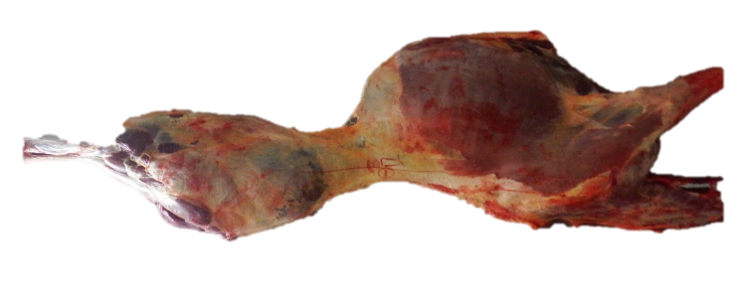
Horse carcase
© Eddie Andriessen
Incision
It may be for access purposes to improve observation or it may be a specific incision required by legislation to detect disease. It is essential that proper equipment be used for incision. Such equipment includes a keen knife, a safety hook and a well-dressed steel. Lymph nodes that require incision should be carefully sliced such that the cut surfaces are laid open for examination like the leaves of a book.
Unnecessary mutilation must be avoided and to facilitate a tidy `job', different knives may be used for different inspection procedures.
Palpation
Palpation is equally as important as observation and incision and must be carried out diligently. Organ palpation requires firm pressure by the fingers and palms of the hand over the entire organ surface. Organs palpated include the kidneys, liver, spleen and lungs.
Lymph-node palpation requires firm pressure with the fingers and thumbs, rolling the nodes between them.
Laboratory analysis
Sometimes samples may need to be sent to a laboratory for diagnosis. This may be:
- because the cause of the condition is unknown
- for laboratory confirmation of notifiable diseases, such as hydatids in Tasmania
- as part of routine sampling for residue sampling programmes etc.

What is the process for identifying and detecting abnormalities?
The AS4696:2023 Australian Standard for the hygienic production and transportation of meat and meat products for human consumption specifies the inspection requirements for animals slaughtered in domestic and export abattoirs in Australia.
The following tables from that standard detail the procedures that must be conducted to identify and detect abnormalities in all the relevant species.
In addition there are further procedures that need to be followed specifically for certain export markets. These are detailed after the tables.

Table 1. Carcase
 | Cattle & buffalo | Calves | Sheep & goats | Lambs | Pigs | Horses | Deer
All carcases | Observe internal and external surfaces of carcase (including tail, musculature, exposed bone, joints, serous membranes).
Lymph nodes
Superficial  Inguinal | See note #1 | Observe | See note #2 | Observe | See note #3 | Incise | Observe
Internal iliac | See note #1 | Observe | Palpate | Observe | Observe | Observe | Observe
Lumbar | — | — | Palpate | Observe | Observe | — | —
Ischiatic | — | — | Palpate | Observe | — | — | —
Precrural | — | — | See note #2 | Observe | — | Palpate | —
Superficial cervical | — | — | See note #2 | Observe | — | Palpate | —
Popliteal | — | — | Palpate | Observe | — | — | —
Prepectoral | — | — | — | — | — | Incise | —
Equivalent procedures
Note #1: Cattle and buffalo – Palpate the superficial inguinal and internal iliac lymph nodes or, for animals in an area in relation to which the relevant Commonwealth, State or Territory Authority requires minimal risk inspection for tuberculosis (other than animals subject to conditional slaughter or emergency slaughter), an equivalent procedure is to observe the nodes (other than in bulls and mature females).
Note #2 : Sheep and goats – Palpate the superficial cervical, precrural and superficial inguinal lymph nodes or, other than animals subject to conditional slaughter or emergency slaughter, an equivalent procedure is to excise and discard these nodes without inspection.
Note #3: Pigs – Observe the superficial inguinal lymph nodes or, other than animals subject to conditional slaughter or emergency slaughter, an equivalent procedure is to excise and discard these nodes without inspection.

Table 2. Viscera
 | Cattle & buffalo | Calves | Sheep & goats | Lambs | Pigs | Horses | Deer
Lymph nodes
Bronchial & mediastinal | See note #1 | Palpate | Palpate | Observe | Palpate | Incise | Palpate
Portal | Palpate | Palpate | Observe | Observe | Palpate | Palpate | Observe
Mesenteric | Observe | Observe | Observe | Observe | Observe | Observe | Observe
Lungs | Palpate, except in lambs where observe. Additionally, bronchi opened and internal surfaces observed when saved for human consumption.
Heart | Palpate. Incise internal musculature 3-4 times in cattle and buffalo.
Liver | Palpate, except in lambs where observe. Incise main bile ducts transversely and observe contents, except in pigs where inspection of bile ducts not required (see note #2 for option).
Gastrointestinal tract | Observe. Observation of oesophagus not required in cattle, buffalo, calves or deer unless recovered for human consumption.
Spleen | Observe | Observe | Palpate | Observe | Observe | Palpate | Observe
Kidney (enucleated) | Palpate | Palpate | Observe | Observe | Palpate | Palpate | Palpate
Other tissues and organs | Thymus, pancreas, non-gravid uterus, bladder, testicles and penis observed when recovered for human consumption.
Equivalent procedures
Note #1: Cattle and buffalo – Incise bronchial and mediastinal lymph nodes or, for animals in an area in relation to which the relevant Commonwealth, State or Territory Authority requires minimal risk inspection for tuberculosis (other than animals subject to conditional slaughter or emergency slaughter), an equivalent procedure is to observe the nodes.
Note #2 : All animals – Procedures for the incision of main bile ducts and observation of contents may not be required at a meat business by the controlling authority.

Table 3. Head
 | Cattle & buffalo (see note #3) | Calves (see note #1) | Sheep & goats (see note #1) | Lambs (see note #1) | Pigs (see note #1) | Horses (see note #1) | Deer (see note #1)
All carcases | Observe external surfaces. For cattle, buffalo and horses observe the oral, buccal and nasal cavities.
Lymph nodes
Submaxillary | See note #2 | — | — | — | See note #4 | Incise | —
Parotid | See note #2 | — | — | — | — | Incise | —
Retropharyngeal | See note #2 | — | — | — | — | Incise | —
Cervical | — | — | — | — | See note #4 | — | —
Masticatory muscles (internal and external) | Incise | — | — | — | — | — | —
Tongue | Palpate | — | — | — | — | Palpate | —
Gutteral pouch | — | — | — | — | — | Palpate | —
Other tissues | Tongue roots in cattle, buffalo and horses observed when recovered for human consumption
Equivalent procedures
Note #1: All animals – Other than cattle, buffalo, horses and animals subject to conditional slaughter or emergency slaughter, an equivalent procedure is to remove and discard the head without inspection where tissues, including tongue, are not recovered for human consumption.
Note #2: Cattle and buffalo – Incise submaxillary, parotid and retropharyngeal lymph nodes or, for animals in an area in relation to which the relevant Commonwealth, State or Territory Authority requires minimal risk inspection for tuberculosis (other than animals subject to conditional slaughter or emergency slaughter), equivalent procedures are:
1. observe only, or
2. excise and discard these nodes without inspection.
Note #3: Cattle and buffalo – Other than animals subject to conditional slaughter or emergency slaughter, for animals in an area in relation to which the relevant Commonwealth, State or Territory Authority requires minimal risk inspection for tuberculosis, an equivalent procedure is to discard the head without inspection when tissues, including tongue, are not recovered for human consumption.
Note #4: Pigs – Incise and observe submaxillary and cervical lymph nodes or, other than animals subject to conditional slaughter or emergency slaughter, equivalent procedures are:
1. observe only, or
2. excise and discard these nodes without inspection.

Table 4. Additional procedures when specific diseases are detected or suspected
Disease | Inspection procedure
Tuberculosis in cattle and buffalo | Incise atlantal, prescapular, prepectoral, suprasternal, superficial inguinal, iliacs, ischiatic, precrural, portal and mesenteric lymph nodes. Incise popliteal lymph node where necessary to determine the extent of infection. All viscera, serous membranes, spinal cord and severed vertebral column inspected by observation, palpation and, where necessary, incision. Udders incised and observed.
Tuberculosis in pigs | Incise retropharyngeal, parotid, bronchial, mediastinal, portal, gastric, mesenteric, superficial inguinal, , lumbar, precrural, prescapular and deep inguinal lymph nodes. Viscera and serous membranes inspected as above for cattle.
Tuberculosis in horses | As above for cattle.
Tuberculosis in deer | Incise submaxillary, retropharyngeal, parotid, bronchial, mediastinal, mesenteric, portal, superficial inguinal, iliac, ischiatic and suprasternal lymph nodes. Incise popliteal lymph node where necessary to determine the extent of infection. Viscera and serous membranes inspected as above for cattle.
Cysticercus bovis In cattle, buffalo and deer | Incise masseter and heart muscles, incise tongue, incise diaphragm after removal of serous membranes and observe all exposed muscle surfaces.
Cysticercus celluosae in pigs | As above for C. bovis.
Sparganosis in pigs | Observe retro-peritoneal tissues after removal of the peritoneum. Where further evidence of infestation revealed, also observe main muscle seams of the hind limbs. Incise as necessary to determine extent of infection.
Export inspection procedures
The AS4696:2023 Australian Standard for the hygienic production and transportation of meat and meat products for human consumption specifies the inspection requirements for animals slaughtered in domestic and export abattoirs in Australia. These have been described above.
These requirements form the minimum standard of inspection. However, the inspection procedures at export registered abattoirs may vary quite considerably from those specified in the Standard, as they have been negotiated with overseas countries over a number of years.
Basic inspection procedures according to the Australian Standard are required to be performed at all export registered plants for all basic markets.
The United States of America’s procedures are required to be performed at all times in US listed establishments.
European Union procedures are required to be performed when EU production is occurring, i.e. only when production is destined for the EU market and in EU listed plants.
It is worth noting that many markets insist on either the US or the EU standard for access to their markets.
For example Canada, Puerto Rico and Mexico require US listing before they will list an establishment.
EU listing is required by dependencies of most EU countries e.g. the Canary Islands a dependency of Spain requires EU listing before product will be accepted. Some EU membership hopefuls, such Romania and Croatia also require EU listing.
Other countries that require EU listing before product will be accepted or listing approved include Namibia, Switzerland and Mayotte.
Additional inspection procedures for European markets
All species
Viscera
If lungs are to be collected for edible purposes, the trachea and the bronchi must be incised along the longitudinal axis.
Carcase
Palpate superficial inguinal/ supramammary, precrural and superficial cervical lymph (prescapular) lymph nodes.
What WHS, hygiene and sanitation requirements apply when conducting post-mortem inspection?
The company work instructions will set down all the WHS and hygiene and sanitation requirements for working on the slaughter floor and when conducting post-mortem inspections.
These will require the inspector to:
- wash hands between carcases or when contaminated
- wear PPE such as aprons and boots which can be cleaned regularly and easily
- follow the sanitary sequence which is to handle edible product (heart, lung, kidney) before handling inedible materials (intestines)
- sterilise knife between carcases and when contaminated and after steeling
- change uniform if it is grossly contaminated
- wash hands before and after work.
These practices will protect health and minimise cross contamination.
Inspectors should always wear the Personal Protective Equipment (PPE) set down in the company work instructions or WHS policy.
PPE will include:
- hand protection like mesh and cut-resistant gloves
- hearing protection
- footwear
- aprons
- uniforms
- hair net.
It is important to handle diseased or contaminated product that may require trimming in a way that avoids contamination of clean parts of the carcase. This may involve holding the affected parts with a hook and trimming from a clean area to remove offending material.
The workplace will also have a ‘dropped meat policy’ for product that accidently contacts the floor. This will need to be followed if product is dropped.
What QA issues relate to post-mortem inspection?
There are a number of quality assurance issues that relate to post-mortem inspection. They will be detailed in the Company’s Quality Assurance program and in the work instructions. Issues that will be covered include:
- ensuring carcases and carcase parts are correctly presented for post-mortem inspection
- performing the correct procedure according to the Australian Standard and export market requirements if applicable
- ensuring only wholesome product is passed for human consumption
- ensuring trace-back requirements to ante-mortem inspection is maintained
- ensuring correlation is maintained between head, carcase and viscera until after disposition has been made.
- retaining carcases and carcase parts for veterinary examination (export plants only) or laboratory examination when required
- limiting cross contamination during inspection
- ensuring, where appropriate, the quality and integrity of the product is maintained
- the maintenance of records as required by the workplace instructions.
What are the signs of common conditions responsible for abnormalities at post-mortem and how are they detected
There are a range of conditions and abnormalities that can affect the wholesomeness of a carcase and its parts for human consumption. When passing judgement on a carcase and its parts during post-mortem inspection, several points must be taken into consideration. They are:
- the nature of any abnormality
- whether it is localised or generalised
- the possible cause of the condition/disease
- the possible risk to human health from any abnormal condition.
The list of abnormalities and the disposition to be taken at post-mortem inspection is detailed in the tables below reproduced from Schedule 3 of the AS4696:2023 Australian Standard for the hygienic production and transportation of meat and meat products for human consumption.
Note: words in italics have been added by the author for clarity.
Detection of these abnormalities is by following the stated procedures detailed previously.

Column 1 | Column 2
Diseases and other abnormalities | Dispositions for animals, carcases and carcase parts
 | The symbol [1] means carcase or carcase parts unfit for human consumption may be recovered for animal food subject to heat sterilisation. The symbol [2] means carcase or carcase parts unfit for human consumption may be saved either for animal food subject to heat sterilisation or for animal food subject to staining.
1. General findings
Dead animal |  | Animal condemned. If anthrax suspected see 2.1.
Dying animal or moribund state with subnormal temperature, weak pulse and disturbed senses. |  | Animal condemned
Fever, debility and general signs indicating acute disease |  | Animal condemned. Alternatively, withhold from slaughter until recovered provided no risk of spread of disease; no undue suffering and recovery considered likely with treatment.
When the above are detected at post-mortem |  | Carcase and all its carcase parts condemned
Advanced chronic conditions with generalised signs such as cachexia or loathsome appearance |  | Animal condemned
Injury or accidental trauma during transport to or while in vicinity of abattoir |  | Animal subject to emergency slaughter or condemned
Excitement, exhaustion without signs of acute disease |  | Animal withheld from slaughter and ante-mortem repeated after adequate rest
Generalised disease conditions such as emaciation, anaemia, oedema or degeneration of organs |  | Carcase and all its carcase parts condemned.
Septicaemia, pyaemia or toxaemia |  | Carcase and all its carcase parts condemned
Foetuses and undeveloped neonatal animals |  | Carcase and all its carcase parts condemned
Abnormal odour caused by metabolic conditions, feedstuff, chemicals or sexual odour
Pronounced odour |  | Carcase and all its carcase parts condemned[1]
Slight odour |  | Hold overnight, if odour dissipates it is fit for human consumption. May do a cooking test.
2. Aetiological listing
2.1 Bacterial and related diseases
Anthrax |  | Affected animals should not be admitted to an abattoir. When detected at ante-mortem, affected animal condemned. Companion animals isolated and withheld from slaughter
When detected at post-mortem, affected carcase and all its parts condemned
Blackleg |  | Carcase and all its carcase parts condemned
Botulism |  | Carcase and all its carcase parts condemned
Malignant oedema. |  | Carcase and all its carcase parts condemned
Enterotoxaemia |  | Carcase and all its carcase parts condemned
Tuberculosis:
In cattle and buffaloes  - Generalised with evidence of systemic involvement; more than one organ affected; miliary lesions in any organ; evidence of active infection or extensive infection of peritoneum or pleura. |  | Carcase and all its carcase parts condemned
- Localised infection |  | Affected carcase part, including drained part, condemned; or affected organ condemned
In pigs  - Generalised  - Localised in submaxillary or mesenteric lymph nodes (avian type) |  | - Carcase and all its carcase parts condemned  - Affected carcase part condemned
In horses and deer. |  | Carcase and all its carcase parts condemned
Actinomycosis and Actinobacillosis:
- Localised in head |  | Head and tongue condemned
- Evidence of generalisation such as lesions in lungs or other viscera, or other signs such as extreme loss of condition |  | Carcase and all its carcase parts condemned
Leptospirosis:
- Acute |  | Carcase and all its carcase parts condemned
- Chronic, localised |  | Affected kidneys condemned
Listeriosis |  | Carcase and all its carcase parts condemned
Salmonellosis |  | Carcase and all its carcase parts condemned
Swine erysipelas:
- Acute |  | Carcase and all its carcase parts condemned
- Localised arthritis or endocarditis without signs of systemic effects |  | Affected joint and associated lymph node condemned; when affected, heart condemned
Cutaneous lesions |  | Affected areas of skin condemned
White scours, omphalophlebitis, polyarthritis and other septicaemic conditions of new-born animals |  | Carcase and all its carcase parts condemned
Johne’s disease |  | Intestines and mesentery condemned
Strangles |  | Affected carcase parts condemned
Purpura haemorrhagica |  | Affected carcase parts condemned
Botryomycosis:
- Severe cases with evidence of systemic effects such as cachexia |  | Carcase and all its carcase parts condemned
- Less severe cases |  | Affected carcase parts condemned
Corynebacterial infections in submaxillary and cervical lymph nodes in pigs |  | Affected nodes condemned
Melioidosis |  | Carcase and all its carcase parts condemned
Caseous lymphadenitis:
- Generalised involvement in carcase and viscera with evidence of systemic effects such as cachexia |  | Carcase and all its carcase parts condemned
- Less extensive forms of the disease |  | Affected organs or carcase parts condemned
Infectious ovine epididymitis (B. ovis) |  | Affected testicles condemned
Necrobacillosis:
- Acute with lesions in a number of sites or evidence of systemic involvement |  | Carcase and all its carcase parts condemned
- Localised lesion in liver or other organ |  | Affected liver or organ condemned
Foot rot:
- Acute with secondary infection of organs or extreme loss of condition |  | Carcase and all its carcase parts condemned
- Chronic with encapsulated abscess in liver or lungs |  | Affected organs condemned
Anaplasmosis and Babesiosis:
- Acute with intense jaundice and other signs of systemic involvement including fever; liver enlargement; and kidney congestion |  | Carcase and all its carcase parts condemned
- Subacute with mild jaundice which dissipates within 24 hours of slaughter |  | Carcase parts condemned
Eperythrozoonosis:
- Acute with intense jaundice and other signs of systemic involvement including fever; liver enlargement; and kidney congestion. |  | Carcase and all its carcase parts condemned
- Subacute with mild jaundice which dissipates within 24 hours of slaughter |  | Carcase parts condemned
2.2 Parasitic conditions.
Cysticercus bovis:
- General infestation |  | Carcase and all its carcase parts condemned
- Light infestation, small number of degenerated cysticerci |  | Affected viscera condemned. Cysts and surrounding tissue trimmed from carcase and condemned. Remainder of carcase and parts passed conditionally fit for human consumption subject to treatment by freezing (no warmer than –12 °C deep muscle temperature for not less that 10 days in carcases and 20 days in boned meat)
Cysticercus cellulosae:
- General infestation |  | Carcase and all its carcase parts condemned
- Light infestation, small number of degenerated cysticerci |  | Affected viscera condemned. Cysts and surrounding tissue trimmed from carcase and condemned. Remainder of carcase and parts passed conditionally fit for human consumption subject to treatment by freezing (no warmer than –12 °C deep muscle temperature for not less than 5 days in carcases or boned meat).
Cysticercus ovis:
- General infestation (more than 5 cysts found in musculature). |  | Carcase and all its carcase parts condemned
- Light infestation, small number of degenerated cysticerci |  | Affected viscera condemned. Cysts and surrounding tissue trimmed from carcase and condemned.
Cysticercus tenuicollis |  | Cysts and affected serous membranes trimmed from carcase or carcase part and condemned
Sparganosis:
- General infestation |  | Carcase and all its carcase parts condemned
- Light infestation |  | Tissue trimmed from carcase and condemned. Remainder of carcase and parts passed conditionally fit for human consumption subject to treatment by freezing (no warmer than –12°C deep muscle temperature for not less than 5 days in carcases or boned meat).
Echinococcosis |  | Affected organs condemned
Pulmonary and gastrointestinal strongylosis |  | Affected organs condemned.[1] in case of lungs.
Oestrus ovis infestation in sheep
Myiasis |  | Animal condemned in severe cases with sepsis or necrosis. Otherwise withhold from slaughter for treatment and resubmit for ante-mortem after recovery.
Stephanurus dentatus |  | Affected carcase parts condemned
Onchocerciasis |  | Lesions and affected tissues trimmed from carcase and condemned
2.3 Protozoal diseases
Sarcosporidiosis |  | Affected carcase parts condemned
Coccidiosis |  | Affected intestines condemned
2.4 Viral diseases
Ephemeral fever |  | Animals withheld from slaughter for treatment. Resubmitted for ante-mortem after recovery.
Bovine virus diarrhoea/mucosal disease:
- Acute infection with evidence of systemic involvement |  | Carcase and all its carcase parts condemned
- Chronic infection with lesions localised to alimentary tract |  | Affected intestines condemned
Bovine para-influenza |  | Affected lungs condemned
Bovine leucosis:
- Multiple lesions or lesions in multiple organs |  | Carcase and all its carcase parts condemned.
- Localised lesion (e.g. mesentery) |  | Affected gastrointestinal tract or other organs condemned
2.5 Fungal diseases
Aflatoxicosis:
Acute with generalised signs including jaundice; swelling of liver; ascites and mesenteric oedema |  | Carcase and all its carcase parts condemned
Subacute |  | Affected liver and kidneys condemned
Epizootic lymphangitis. |  | Affected skin and related tissues condemned. Any affected organs condemned.
2.6 Non-infectious conditions
Tumours:
- Circumscribed benign tumours; neurofibromas of intercostals nerves and nerve plexes |  | Depending on extent, lesion trimmed and condemned or affected carcase part condemned[1]
- Malignant tumours (carcinoma, sarcoma) |  | Carcase and all its carcase parts condemned[1]
- Multiple tumours (evidence of metastasis or multiple lesions in different organs) |  | Carcase and all its carcase parts condemned[1]  Note any sign of spread from a primary site is a sign of malignancy
Metabolic disorders (transit tetany, ketosis, etc) |  | Animal condemned in severe cases. Withheld from slaughter in milder cases and resubmitted for ante-mortem after recovery.
Jaundice:
- Haemolytic or toxic |  | Carcase and all its carcase parts condemned
- Obstructive (slight, dissipate within 24 hours of slaughter |  | Carcase parts condemned
- Obstructive (severe) |  | Carcase and all its carcase parts condemned.
- Residues in excess of nationally established maximum limits |  | Carcase and all its carcase parts condemned. Companion animals and carcases tested for residue levels.
Delay in Evisceration:
- Evidence of deterioration or putrefaction |  | Carcase and all its carcase parts condemned
- Localised changes in viscera |  | Viscera condemned
Ecchymosis |  | Affected carcase parts condemned[2]
Foreign objects, including grass seeds:
- Accompanied by generalised signs such as fever or sepsis |  | Carcase and all its carcase parts condemned
- No evidence of generalised signs |  | Foreign object removed; affected tissues trimmed from carcase and condemned

3. Topographic listing
3.1 Nervous system
Acute encephalitis and meningitis | Carcase and all its carcase parts condemned
Brain abscesses:
- Associated with pyaemia | Carcase and all its carcase parts condemned
- Localised lesion | Affected brain condemned
3.2 Cardiovascular system
Acute pericarditis with accumulation of exudate; septicaemia; degenerative changes in organs or abnormal odour | Carcase and all its carcase parts condemned
Chronic pericarditis | Affected heart and pericardium condemned
Endocarditis:
- Associated with generalised signs | Carcase and all its carcase parts condemned
- Without complications. | Affected heart condemned
Heart lesions of non-infectious nature | Affected heart condemned
Worm aneurisms in horses:
- Infarction confined to hind leg | Affected quarter condemned
- Peritonitis, circulatory disturbances in mesentery and intestines | Carcase and all its carcase parts condemned
3.3 Respiratory system
Sinusitis. | Affected head condemned
Peracute pneumonia such as severe purulent bronchopneumonia; gangrene of the lungs; or necrotic pneumonia. | Carcase and all its carcase parts condemned
Multiple pulmonary abscesses | Carcase and all its carcase parts condemned.
Bronchitis | Affected lungs condemned
Pneumonia or bronchopneumonia | Affected lungs condemned[1]
Atelectasis, emphysema, pigmentation, aspiration of blood, scalding water or ingesta | Affected lungs condemned[1]
3.4 Pleura
Diffuse serofibrinous, suppurative or gangrenous pleurisy | Carcase and all its carcase parts condemned.
Adhesions and patches of fibrinous tissue | Affected serous membranes stripped and affected parts condemned
3.5 Gastrointestinal tract
Acute enteritis:
Septic, diphtheritic or haemorrhagic enteritis’ enlargement of spleen or degeneration of organs | Carcase and all its carcase parts condemned
With congested mesenteric lymph nodes without other signs | Affected intestines condemned
Chronic gastro-intestinal catarrh | Affected intestines condemned
Emphysema of mesentery in pigs | Affected mesentery and intestines condemned
3.6 Peritoneum
Peritonitis:
- Acute, diffuse or extensive | Carcase and all its carcase parts condemned
- Localised | Affected serous membranes stripped and affected parts condemned
Adhesions and patches of fibrinous tissue, localised encapsulated abscesses | Affected parts condemned
3.7 Liver
Telangiectasis, cyst formation | Affected liver or part of liver condemned[1]
Fatty infiltration, parenchymatous infiltration | Affected liver condemned[1]
Hepatitis of toxic, parasitic or non-specific nature | Affected liver condemned[1] for parasitic and nonspecific causes
Miliary necrosis of liver in calves | Carcase and all its carcase parts condemned
Parasitic lesions/nodules | Affected parts of liver trimmed and condemned
Abscesses | Affected liver condemned
3.8 Kidney
Calculi, cyst formation, pigmentation | Affected kidneys condemned[1]
Nephritis (including parasitic nephritis):
- Acute with evidence of uraemia, oedema or abnormal odour of urine | Carcase and all its carcase parts condemned.
- Chronic with no systemic effects | Affected kidneys condemned
Bladder rupture | Carcase and all its carcase parts condemned.
3.9 Genital tract
Inflammation of uterus:
- Acute metritis (septic or necrotic, putrefied foetus). | Carcase and all its carcase parts condemned
- Chronic metritis | Affected uterus condemned
Retention of placenta:
- Accompanied by fever or evidence of other systemic effects | Carcase and all its carcase parts condemned
- With no signs of systemic effects. | Affected uterus condemned
Prolapse, torsion or rupture of uterus accompanied by fever or peritonitis | Carcase and all its carcase parts condemned
Orchitis/epididymitis | Affected organ condemned
3.10 Udder Mastitis:
Septic, gangrenous | Carcase and all its carcase parts condemned
No signs of systemic involvement. | Udder condemned
Oedema | Udder condemned
3.11 Musculo-skeletal system
Fractures:
Uncomplicated (recent or healing) | Fracture trimmed from carcase and condemned
Infected with signs of generalised effects | Carcase and all its carcase parts condemned
Osteomyelitis:
- Gangrenous, suppurative or accompanied by metastasis | Carcase and all its carcase parts condemned
- Localised | Affected part trimmed from carcase and condemned
Myositis and Muscular Dystrophy | Affected parts condemned[1]
Abnormal pigmentation | Affected parts condemned[1]
Arthritis:
- Acute infectious | Carcase and all its carcase parts condemned
- Non-infectious, chronic with no systemic effects | Affected part condemned
3.12 Skin
Wounds and Cellulitis:
- Infected wounds and discharging lesions accompanied by generalised signs such as fever or sepsis | Carcase and all its carcase parts condemned
- Granulating wounds or no evidence of generalised signs | Affected tissues trimmed from carcase and condemned
Bruising:
- Generalised or secondary changes in carcase | Carcase and all its carcase parts condemned[2]
- Localised | Affected tissue trimmed from carcase and condemned. [2] for trimmings
Burns:
- With extensive oedema or systemic signs such as fever | Carcase and all its carcase parts condemned
- Localised | Affected tissue trimmed from carcase and condemned[1]
Eczema and chronic dermatitis in pigs | Affected skin trimmed from carcase and condemned
Erythema and acute dermatitis (e.g. photosensitisation):
- With systemic effects such as fever | Carcase and all its carcase parts condemned
- No evidence of systemic involvement | Affected skin trimmed from carcase and condemned[1]
What are the types and symptoms of emergency diseases that can be detected at post-mortem?
The range of emergency diseases that should be considered during ante mortem and post-mortem inspection has been detailed earlier in this document.
Most emergency diseases are more readily detectable at ante mortem inspection rather than post-mortem inspection.
But if at post-mortem inspection a number of animals from one lot showing symptoms of fever are noted, serious consideration should be given to the suspicion of an emergency disease.
The disease may be an endemic disease such as Salmonella but it could also be an exotic disease.
The holding of carcases while a decision is made is an important part of the process.
What regulatory requirements apply when handling an affected carcase?
Carcases may be identified at post-mortem inspection as having:
- a pathological condition
- gross contamination
- another abnormality requiring further treatment and/or a more detailed inspection.
They may be directed to the retain rail to undergo further treatment and inspection. The post-mortem inspector marks these carcases or carcase parts with the relevant retain tag, as per workplace procedures.
There needs to be an area set aside for re-inspection purposes. It should only be used for this purpose. The equipment needed is:
- lighting, to 600 lux
- handwash and equipment sterilisation facilities and liquid soap
- condemned meat bin/barrow/chute
- cutting equipment – saw, knife etc.
- product wash facilities
- quartering facilities.
The requirements to be met when retaining a carcase will depend on whether the plant is domestic-registered or export-registered. The requirements are generally as follows.

Action | Explanatory notes
Supervise | retain rail personnel in the detection and removal of pathology, contamination or other abnormality requiring treatment.
Inspect | all external and internal carcase surfaces, including cut muscle, to ascertain if the reason for retaining has been rectified  all carcase parts (viscera) that have been retained to assist with disposition.
Palpate | lymph nodes and suspect lesions and, where necessary, incise to detect disease conditions and/or pathological change.
Sanitary sequence | observe  palpate  incise.  NB: Wash hands after handling material unfit for human consumption. Thoroughly sterilise knife after trimming material unfit for human consumption.
Note: for further information refer to AMPA3046 Undertake retain rail operations.
The question of disposition i.e. what to do with the retained carcase and its parts is a question that should be addressed in conjunction with AS4696:2023 Australian Standard for the hygienic production and transportation of meat and meat products for human consumption, which offers good guidelines on disposition.
But in the end it is up to the meat inspector to make the decision. The decision should be made on good scientific principles.
When making disposition on a carcase, an organ or any other parts the inspector can make a disposition on:
- the total carcase (including its parts)
- a part of the carcase
- pass as suitable for human consumption and remove the retain tags
- retain requiring further inspection and apply a retain tag and supervise the segregation of the carcase and/or carcase parts in the retain facility
- retain requiring further treatment and apply a retain tag and supervise the segregation of the carcase and/or carcase parts in the chiller retain facility
- relegate to an inedible purpose other than condemnation, i.e. animal food or pharmaceutical purposes; identify the carcase and/or carcase parts as suitable for the designated purpose, e.g. pet food only and supervise the removal of the carcase and/or carcase parts to the designated processing area
- identify the carcase and/or carcase parts as condemned by the application of the condemned stamp or the application of ink and/or disposal in a condemned tub/bin or chute.
What hygiene and sanitation and WHS requirements apply when handling an affected carcase?
The company work instructions will set down all the hygiene requirements for working on the slaughter floor and for handling affected carcases.
These will require the inspector to:
- wash hands between carcases or when contaminated
- wear PPE such as aprons and boots which can be cleaned regularly and easily
- follow the sanitary sequence which is to handle edible product (heart, lung, kidney) before handling inedible materials (intestines)
- sterilise knife between carcases and when contaminated and after steeling
- change uniform if it is grossly contaminated
- wash hands before and after work.
These practices will protect health and minimise cross contamination.
Inspectors should always wear the Personal Protective Equipment (PPE) set down in the company work instructions or WHS policy.
PPE will include:
- hand protection like mesh and cut-resistant gloves
- hearing protection
- footwear
- aprons
- uniforms
- hair net.
It is important to handle diseased or contaminated product that may require trimming in a way that avoids contamination of clean parts of the carcase. This may involve holding the affected parts with a hook and trimming from a clean area to remove offending material.
The workplace will also have a ‘dropped meat policy’ for product that accidently contacts the floor. This will need to be followed if product is dropped.

Retaining carcases
What are the procedures for retaining carcases on the slaughter floor?
When minor defects cannot be removed by an inspector on the slaughter floor or if a carcase requires a more detailed assessment the carcase may be passed onto the retain rail for further treatment and assessment.
Carcases on the chain can be identified in a number of ways to indicate the pathology or defects that need to be removed or re assessed in the retain rail. This includes knife cuts, tie-on tags, stick-on tickets, plastic tags and formal approved retain tags (ECA4).
Workplace procedures will detail how this is to be done.
These tags are temporary tags and are removed by the trimmer on the retain rail after the defects have been addressed.
The ECA4 Tag or equivalent on the other hand can only be removed by an authorised person. It is generally used for more permanent control over product where more detailed assessments need to be done to determine the suitability of the product for human consumption.
What are the procedures for retaining carcases in a chiller?
If carcases are to be retained in the chiller because it may take some time for laboratory results to return, the carcases to be retained must not only be identified by tags but also need to be locked in such a way by a meat safety inspector or other authorised person, so that it cannot be used for human consumption until the results of tests have been received.
Carcases may be locked on the rail or in a special cage.
Records need to be maintained of any such actions.
Workplace procedures will detail how this is to be done.

PPE requirements for post-mortem inspection
What PPE is required to perform post-mortem inspection?
Personal Protective Equipment to be used will be set down in the work instruction and WHS procedures. PPE may include:
- protective hand and arm covering
- protective head and hair covering
- head wear
- coat and apron
- work safety or waterproof footwear
- protective boot covers
- ear plugs/muffs
- eye and facial protection
- waterproof clothing.

What workplace requirements apply when using PPE?
According to the National Guidelines for Health and Safety in the Meat Industry:
‘ PPE and clothing are those items of equipment worm by an employee to minimise or eliminate exposure to specific occupational hazards’
The emphasis is always on eliminating the hazards thereby making it unnecessary for workers to wear Personal Protective Equipment (PPE).
However, it is not always possible to eliminate the hazards, and PPE may be required to protect the worker from the consequences of exposure. For example, workers may be required to wear ear plugs to reduce the likelihood of deafness resulting from exposure to an excessively noisy environment. Workers in the meat industry are frequently required to wear PPE. In this case it is the employer’s responsibility to ensure PPE is:
- assigned to the worker for their exclusive use
- cleaned and maintained after use
- stored when not in use
- inspected and repaired regularly
- checked for continued functioning and effectiveness.
It is also the employer’s responsibility to ensure training is provided as appropriate. Workers should receive training about:
- proper use of PPE
- the deficiencies and restrictions of PPE
- fitting PPE and how to test for fit
- use of PPE
- maintenance of PPE
- storage of PPE
- identification of faults in PPE
- procedure for replacing PPE.
How should PPE be used, maintained and stored?
Workers are responsible to:
- wear PPE as instructed by the supervisor and as set out in the work instruction
- fit PPE to ensure it is used to maximum benefit
- check for any faults and replace it if faulty
- follow maintenance procedures as instructed by the supervisor and set out in work instructions
- store PPE as instructed.
Examples of specific PPE are included in the National Guidelines for Health and Safety in the Meat Industry.
Taking pathological and residue samples
How are lesions and tissues necessary for determining dispositions identified?
The type of lesions and tissues necessary for determining dispositions will depend on the nature of the abnormality and the nature of the suspected disease condition. For certain conditions such as granulomas, it is a regulatory requirement to take a sample for laboratory analysis for Bovine tuberculosis. It is vital under these circumstances that there is an accurate record of the property of origin of the animal so that trace back can be instituted if necessary.
For other conditions the list below indicates what suitable specimens should be taken.
What are the requirements for collecting and submitting specimens?
Sometimes in order to make a correct disposition on product at post-mortem inspection or to confirm suspicion of a notifiable disease it will be necessary to take samples for laboratory analysis.
In each State or Territory there is usually a Veterinary Laboratory where samples can be sent for analysis. Detailed information on the collection and handling of samples for each laboratory should be obtained directly from the laboratory. Most Laboratories have a manual that will outline the collection and handling requirements. The following is a brief guide of the samples required for various types of tests.
Bacteriology
Swabs of tissue e.g. heart blood, intestinal content, in transport medium and /or 30 ml of chilled lesion, fluid or tissue e.g. liver, lung, intestine in a screw-capped container.
Biochemical tests
Full 10 ml plain and Lithium/ heparin blood tube.
Gross Pathology
Representative samples of affected tissue with any adjacent normal tissue.
Haematology
Full 10 ml EDTA blood tube and blood smear.
Histopathology
A representative sample of affected tissue with adjacent normal tissue. Tissue should be 1 cm thick in ten times their volume of buffered formalin solution.
Parasitology
Approximately 30g of faeces for faecal egg count.

Serology
A full 10 ml plain blood tube.
Toxicology
Approximately 50 ml of ingesta, faeces or flesh tissue.
Virology
Full 10 ml plain tube and EDTA blood tubes.
30 ml of fresh chilled tissue e.g. heart, spleen or swab of lesion or tissue in PBGS.
How are specimens for residue testing taken?
Specimens for residue testing will vary according to the type residue that is suspected. For example if cadmium is suspected kidney samples will be taken. If pesticides are suspected samples could include meat or offal such as livers.
It is vital under these circumstances that there is an accurate record of the property of origin of the animal so that trace back can be instituted if necessary.
The workplace instructions will describe what samples to take. If not the relevant authority responsible for meat safety in each State will provide advice.
The relevant laboratory doing the testing will also advise what type of specimen they require.
How are results interpreted?
The interpretation of the results of residue sampling will be determined by the laboratory. They will advise if the result is below or over the regulatory limit for that residue.
If the result is over the regulatory limit public health authorities will decide what is to happen to the carcase.
What are the requirements for retaining carcases while waiting for results?
If carcases are to be retained in the chiller because it may take some time for laboratory results to return, the carcases to be retained must not only be identified by tags but also need to be locked in such a way by a meat safety inspector or other authorised person, so that it cannot be used for human consumption until the results of tests have been received.
Records need to be maintained of any such actions.
Workplace procedures will detail how this is to be done.

Bibliography
These publications were used to develop this training material.
Eddie Andriessen Meat Safety Quality and Veterinary Public Health in Australia 11th edition Penny Farthing Publishing PO Box 190 Woodville SA
Food Standards Australia New Zealand Australian Standard for the Hygienic Production and Transportation of Meat and Meat Products for Human Consumption FRSC technical report No 3 AS 4696:2023 CSIRO Publishing
AMIC National Animal Welfare Standards for Livestock Processing Establishments Preparing Meat for Human Consumption 2nd Edition (2010)
Model Code of Practice for the Welfare of animals: Livestock at Slaughtering Establishments
Commonwealth Department of Agriculture
Export Control Act 1982
Export Control (Prescribed good General) Order 2005
Export Control (Meat & Meat Products) Orders 2005
Manual of Importing Country Requirements – European Union
National Residue Survey – Approved Laboratories for Chemical Residue Testing
Meat notice 2015-03 Revised horse traceability requirements for access to the European Union
Note: Other than Eddie Andriessen’s book all of the above can be accessed at Elmer 3
http://www.agriculture.gov.au/export/food/meat/elmer-3

Additional resources
Registered Training Organisations (RTOs) should refer to the Unit-by-Unit listing of resources on the MINTRAC website www.mintrac.com.au for additional resources to support the delivery of this Unit.
RTOs which develop or identify additional resources are encouraged to advise MINTRAC so that these can also be added to the Unit-by-Unit listing.
The Exam Generator
The Exam Generator is a question bank containing hundreds of questions related to meat safety and Quality Assurance. There are two CDs in the set – one for RTOs (Albert) to create the exams and a student CD (Eddie) that creates electronic practice exams containing all the same questions.
Meat Inspection Currency tool
The Meat Inspector Currency exam generator generates quizzes for the assessment of the currency of a meat inspector’s knowledge.

