AMPMSY413
Recognise diseases and conditions during inspection of food animal
Training materials

Australian Meat Industry Training Package
Certificate III Meat Safety

Materials Development sheet for:
AMPMSY413 Recognise diseases and conditions during inspection of food animal
Required Knowledge:
Topic | Covered on pages
Common diseases and conditions, including arthritis, pleurisy, pneumonia, neoplasm, fever, septicaemia and gangrene
The nature, signs and causes of inflammation of animal body parts
The nature and causes of physical abnormalities in food animals
Signs of benign and malignant neoplasms in food animals
Signs and causes of poisoning in food animals
Common microbiological diseases in food animals
The different types of external and internal parasites, and their effects and relationship on a food animal host, including Arthropods, Trematodes, Cestodes, Nematodes
The importance of smell, touch and sight for identifying diseases and conditions
Requirements of post-mortem inspections as outlined in the relevant Australian Standard
Purpose of Livestock Data Link (LDL) and how information is uploaded to ensure timely sharing of carcase and animal disease information between processors and producers.

Elements and performance criteria

Element | Performance Criteria | Covered on pages
Identify the nature, signs and causes of common abnormalities and diseases in food animals | 1.1 Identify the nature and causes of physical abnormalities in food animal  1.2 Identify the nature, signs and causes of inflammation in food animal  1.3 Identify the nature and causes of tumours  1.4 Identify the ways in which food animals can be poisoned, and the signs of poisoning  1.5 Identify key characteristics of common microbiological diseases found in food animals
2. Identify the effects of parasites on food animals | 2.1 Identify the effects of parasite on food animals  2.2 Identify the relationship the parasite has to the host animal  2.3 Recognise common internal parasites  2.4 Identify the nature, life cycle and signs of internal parasites in food animals  2.5 Identify the nature, life cycle and signs of external parasites in food animals
3. Apply knowledge of animal diseases and conditions to the interpretation of ante and post-mortem procedures | 3.1 Identify the common food animal diseases and conditions that may be identified during ante and post-mortem inspection of major species, as specified in the relevant Australian Standard  3.2 Identify common abnormalities that may impact on food safety and wholesomeness of meat  3.3 Identify how information about animal diseases and conditions is communicated to producer

Table of contents
Training materials for AMPMSY413 Recognise diseases and conditions during inspection of food animal 9
Signs of diseases and conditions 9
Acute and chronic diseases 9
What is the difference between the acute, localising, resolving and chronic stages of a disease. 9
Inflammation 10
What are nature, signs and causes of inflammation? 10
Abnormalities 12
What are neoplasms? 16
What is the difference between benign and malignant neoplasms? 17
The nature, life cycle and signs of common parasitic diseases in food animals. 17
Poisoning 25
What are the signs of poisoning? 25
What are the possible causes of poisoning in food animals? 25
Microbiological diseases 26
What are the microbiological diseases common to a number of food animal species? 26
Common diseases in cattle 30
Bovine diseases of the musculoskeletal system – bones and muscles 30
Arthritis 30
Arthritis 31
Actinomycosis (lumpy jaw) 33
Osteomalacia softening of bones 35
Epithelioma (cancer eye) 36
Haematoma 37
Eosinophilic myositis 38
Inoculation abscess 38
Intestinal Adeno Carcinoma 40
Melanosis 40
Presternal calcification or putty brisket. 41
Imperfect bleeding. 42
Diseases and conditions associated with the circulatory system 42
Uraemia 42
The disposition for carcases affected by uraemia is to condemn the carcase and all the partsFevered carcases 43
Vegetative endocarditis 44
Oedema 45
Pericarditis 47
Haemangioma 48
Hob nail liver 49
Chondroma 49
Traumatic pericarditis 50
Xanthosis 50
Diseases associated with the Lymphatic System 51
Neoplasms 51
Grossly enlarged parotid lymph node 52
Diseases of the respiratory system 53
Pneumonia 53
Emphysema 54
Acute pleuritis 55
Malignant neoplasm in the lungs 55
Melanosis in the lungs 56
Septic pleurisy 57
TB in the thorax and lungs. 58
Diseases of the digestive system 59
Actino bacillosis in the tongue or woody tongue 59
Actino mycosis as also known as lumpy jaw 59
Portal Cirrhosis of the liver or hobnail liver 60
Fatty infiltration. 60
Telangectasis also known as sawdust liver 61
Intestinal adeno carcinoma (malignant cancer) 62
Peritonitis in bovine rumen 63
Lipoma (fat cancer) 64
Liver abscess 64
Hydatid or Echinococcosis cysts 65
Liver Fluke 66
Cysticercus bovis (beef measles) 67
Malignant liver cancer 69
Abscess in bovine liver 70
Acute gastro enteritis 70
Oesophagostomum Radiatum or pimply gut 72
Diseases of the excretory system 73
Hydro nephrosis in bovine kidneys 73
Enzootic (endemic among animals as a disease) bovine leucosis AKA bovine viral Leucosis, bovine lymphosarcomas 73
Renal infarcts. 74
Diseases of the reproductive system 75
Gangrenous metritis 75
Diseases associated with the nervous system 76
Melanosis in the spinal cord 76
The endocrine system 77
Goitre 77
The skin or integumental system 78
Congenital Alopecia 78
Melanoma 79
Sarcocystis Bovi (Dalmeny disease) 80
Enzootic bovine leukosis 80
Common diseases in sheep 82
Diseases associated with the musculoskeletal system – bones and muscles 82
Arthritis 82
Jaundice 86
Gangrene in bones 87
Calcium and phosphorus 87
Dog bites 88
Eosinophilic myositis 89
Ecchymosis 90
Jaundice 91
Cysticercus ovis 91
Myasis – flystrike 92
Osteosarcoma 92
Polycythaemia 93
Diseases and conditions related to the circulatory system 94
Emaciation 94
Melanosis 95
Ecchymosis 95
Cysticercus ovis or sheep measles. 96
The lymphatic system 97
Caseous Lymphadenitis (CLA) 97
Diseases related to the respiratory system 100
Pneumonia – Parasitic 100
Pneumonia in the live animal at ante mortem 103
Pneumonia at post mortem 103
Pneumonia – Chronic Suppurative 105
Pneumonia – Heavy-body Inhalation 106
Gangrene in lungs. 107
Diseases related to the digestive system 108
Anaemia. 108
Oedema 109
Dark liver 110
Acute peritonitis 110
Enteritis 111
Cirrhosis of the liver. 112
Phytobezoars or bezoars 112
Inguinal hernia 114
Diseases related to the excretory system 115
Infarcts 115
Polycystic kidney 115
Hydronephrosis 116
Gall stones 117
Diseases related to the reproductive system 118
Metritis 118
Remains of a dead foetus 118
Diseases related to the central nervous system. 119
Diseases related to the endocrine system 119
Goitre 119
Diseases related to the skin or integumental system. 120
Myiasis or fly strike 120
Contagious pustular dermatitis or Orf or scabby mouth 121
Diseases and conditions in Pigs 122
Diseases and conditions related to the Muscular skeletal system 122
Arthritis 122
Pale soft exudate (PSE) also known as fish muscle 123
Infections abscess formation 123
Tail bight infection 124
Jaundice (icterus) 125
Diseases related to the circulatory system 126
Swine erysipelas 126
Diseases related to the respiratory system. 127
Pneumonia and pleurisy 127
Diseases related to the urinary / excretory system 128
Poly cystic kidney and nephritis 128
Diseases related to the digestive system. 129
Miliary tuberculosis. 129
Hair ball 130
Ascaris lumbricoides also known as ascaris suum 131
Emaciated pig 131
Hernias 132
Emphysema pig intestines 132
Acute enteritis 133
Mild peritonitis 133
Diseases of the reproductive system 133
Diseases of the central nervous system 134
Diseases of the endocrine system 134
Diseases of the skin or integumental system. 134
Swine erysipelas (diamonds disease) 134
Melanoma on the skin 135
Poisoning of food animals 135
Plant poisonings 135
Facial Eczema 136
Lantana poisoning also known as pink nose 136
Sour sob poisoning or oxalic poisoning 136
What are the physiological and anatomical features required to be inspected in the Australian Standard for the major food species? 138

Training materials for AMPMSY413 Recognise diseases and conditions during inspection of food animal

Signs of diseases and conditions

Acute and chronic diseases
What is the difference between the acute, localising, resolving and chronic stages of a disease.
The key to being able to recognise diseases, conditions and abnormalities is knowing what is normal. The only way to achieve this is to practice under supervision, once the normal is fully understood the abnormal will be obvious. Never be afraid to ask questions of the senior meat inspector or the On Plant Veterinary Officer (OPV) in export works. Remember the only silly question is the one you don’t ask.
- Acute - Evidence of septicaemia indicated by such signs as petechial haemorrhage, polyserositis (straw coloured exudate with fibrin clots in cavities), reddened carcase (fever), abnormal discharges/body fluids, fever;
- Organising – Infection will be localising in susceptible organs
- Resolving - Infection will be resolving and the `
- Chronic - Gross abnormalities typically localised, walled off, may have multiple gross abnormalities (i.e. polyarthritis), adhesions/scarring, no evidence of septicaemia, no fever, carcase may be affected by cachexia (wasting).
If we use Bovine Respiratory Disease as an example the infection stages may take the following form:

Acute stage
In this disease stage the bacteria or virus is present in the blood.
At ante-mortem the animal may be showing signs of fever; e.g. Lethargy, reluctance to move, increased rate of breathing, elevated temperature.
At post mortem gross abnormalities will be present and the carcase will be showing signs of fever/septicaemia.

Organising stage
In this stage the primary bacteria or virus and secondary pathogens are localising to susceptible organs
At ante-mortem the animal may be showing signs of fever; e.g. Lethargy, reluctance to move, increased rate of breathing, elevated temperature.
At post-mortem at this stage there could be adhesions and pus present.

Resolving stage
In this stage the infection and lesions are localising i.e. scar tissue is forming abscesses are encapsulated and the pus is drying or solidifying. Little to no signs of redness indicating ongoing infections.
At ante-mortem the animal may be showing no signs of fever, but possible muco-purulent nasal discharge. The animal may have a possible cough. Could be separating itself from the rest of the herd
At post-mortem at this stage adhesions are well developed. Serosal erythema mild to moderate. Pus discharges will be resolving along with abscess formation. Arthritis is also possible. Scare tissue has formed where the infection was.

Chronic stage
Lesions are localised and then diminishing in extent until no residual tissue damage remains
At ante-mortem the animal will appear normal
At post-mortem at this stage there will possibly be localised pleurisy and peritonitis, chronic abscess and poly arthritis. At this stage the infection has healed and is non pathological except for the changes to tissue i.e. fibrous tissue formation.

Inflammation
What are nature, signs and causes of inflammation?
Inflammation is the body’s protective response to injury or destruction of body tissue. The response is in the specific area of concern with the body trying to wall off, destroy and/or dilute the cause and the damaged tissue. An inflammatory response happens because a physical, thermal, chemical or biological agent causing trauma to the tissue. Inflammation and infection should not be confused they are different response although they can happen together. For example the body has an inflammatory response to a cut, bacteria could enter the tissue through the cut causing an infection. The infection may even cause a second inflammatory response because bacteria can produce toxins.
Inflammation has two stages acute or right now and chronic or ongoing. In the Acute stage of inflammation of the body tissue is characterised by redness, swelling, heat initially and lose of function eventually. This is because:
- blood vessels dilate causing redness and heat and
- white blood cells, serum and antibodies (inflammatory exudate) move to the affected area causing swelling. This swelling pushes on nerves causing pain to begin with and lose of function eventually.
In the chronic stage of inflammation the surround tissues responds to repair the damaged area to start with by producing fibrous connective tissue and blood vessels to provide nutrients. This tissue is then replaced by the correct cell type for example skin cell in the skin, liver cells in the liver. If this happens quite easily then there is normally full function again. However if this replacement or regeneration cannot happen easily and the fibrous tissue remains then the area scars.
Abscesses may also occur. These are swellings, with or without discharge due to an injury and an infection causes by the introduction of micro-organisms. The body’s inflammatory response and the immune response to infection result in increased swelling. This swelling is due to the breakdown of tissue and white blood cells as they fight the infection.
In the Schedule 3 of AS4696:2023Australian Standard for the hygienic production and transportation of meat and meat products for human consumption the list of dispositions at ante- and post-mortem include a number of inflammatory responses. We know this because the name ends with ‘–itis’.

Type of inflammation | Inflammation of the
Arthritis and polyarthritis | joint or multiple joints
Balanitis | pizzle
Bronchitis | one or more bronchi
Cellullitis | tissue
Dermatitis | skin
Encephalitis | brain
Endocarditis | endocardium or lining of the inside of the heart
Enteritis | intestines
Hepatitis | liver
Lymphadenitis | lymph nodes
Lymphangitis | lymphatic vessles
Mastitis | mammary glands
Meningitis | meniges which the membrane that protects the brain and spinal cord
Metritis | uterus
Myositis | voluntary muscle
Nephritis | kidney
Omphalophlebitis | umbilical veins
Orchitis or epididymitis | testis
Pericarditis | pericardium
Peritonitis | peritoneum
Sinusitis | one or more of the paranasal sinuses

Abnormalities
What are abnormalities that may impact on food safety and wholesomeness of meat?
There are a range of conditions and abnormalities that can affect the wholesomeness of a carcase and its parts for human consumption. When passing judgement on a carcase and its parts during post mortem inspection, several points must be taken into consideration. They are:
- the nature of any abnormality
- whether it is localised or generalised
- the possible cause of the condition/disease
- the possible risk to human health from any abnormal condition.
The AS4696:2023 Australian Standard defines wholesome as:
‘when used in relation to meat and meat products means that the meat and meat products may be passed for human consumption on the basis that they:
(a) are not likely to cause food borne disease or intoxication when properly stored, handled and prepared for their intended use; and
(b) do not contain residues in excess of established limits; and
(c) are free of obvious contamination; and
(d) are free of defects that are generally recognised as objectionable to consumers; and
(e) have been produced and transported under adequate hygiene and temperature controls; and
(f) do not contain additives other than those permitted under the Food Standards Code; and
(g) have not been irradiated contrary to the Food Standards Code; and
(h) have not been treated with a substance contrary to a law of the Commonwealth or a law of the State or Territory in which the treatment takes place.’
The list of abnormalities and the disposition to be taken at post mortem inspection is detailed in the tables below reproduced from Schedule 3 of the AS4696:2023 Australian Standard for the hygienic production and transportation of meat and meat products for human consumption.
List 3 provides common abnormalities that may impact on food safety and wholesomeness of meat by physiological system.

3. Topographic listing
3.1 Nervous system
Acute encephalitis and meningitis | Carcase and all its carcase parts condemned
Brain abscesses:  - Associated with pyaemia  - Localised lesion | Carcase and all its carcase parts condemned  Affected brain condemned
3.2 Cardiovascular system
Acute pericarditis with accumulation of exudate; septicaemia; degenerative changes in organs or abnormal odour | Carcase and all its carcase parts condemned
Chronic pericarditis | Affected heart and pericardium condemned
Endocarditis:  - Associated with generalised signs  - Without complications. | Carcase and all its carcase parts condemned  Affected heart condemned
Heart lesions of non-infectious nature | Affected heart condemned
Worm aneurisms in horses:  - Infarction confined to hind leg  - Peritonitis, circulatory disturbances in mesentery and intestines | Affected quarter condemned  Carcase and all its carcase parts condemned
3.3 Respiratory system
Atelectasis, emphysema, pigmentation, aspiration of blood, scalding water or ingesta | Affected lungs condemned[1]
Bronchitis | Affected lungs condemned
Multiple pulmonary abscesses | Carcase and all its carcase parts condemned.
Peracute pneumonia such as severe purulent bronchopneumonia; gangrene of the lungs; or necrotic pneumonia. | Carcase and all its carcase parts condemned
Pneumonia or bronchopneumonia | Affected lungs condemned[1]
Sinusitis. | Affected head condemned
3.4 Pleura
Adhesions and patches of fibrinous tissue | Affected serous membranes stripped and affected parts condemned
Diffuse serofibrinous, suppurative or gangrenous pleurisy | Carcase and all its carcase parts condemned.
3.5 Gastrointestinal tract
Acute enteritis:  - Septic, diphtheritic or haemorrhagic enteritis’ enlargement of spleen or degeneration of organs  - With congested mesenteric lymph nodes without other signs | Carcase and all its carcase parts condemned  Affected intestines condemned
Chronic gastro-intestinal catarrh | Affected intestines condemned
Emphysema of mesentery in pigs | Affected mesentery and intestines condemned
3.6 Peritoneum
Adhesions and patches of fibrinous tissue, localised encapsulated abscesses | Affected parts condemned
Peritonitis:  - Acute, diffuse or extensive  - Localised | Carcase and all its carcase parts condemned  Affected serous membranes stripped and affected parts condemned
3.7 Liver
Abscesses | Affected liver condemned
Fatty infiltration, parenchymatous infiltration | Affected liver condemned[1]
Hepatitis of toxic, parasitic or non-specific nature | Affected liver condemned[1] for parasitic and nonspecific causes
Miliary necrosis of liver in calves | Carcase and all its carcase parts condemned
Parasitic lesions/nodules | Affected parts of liver trimmed and condemned
Telangiectasis, cyst formation | Affected liver or part of liver condemned[1]
3.8 Kidney
Bladder rupture | Carcase and all its carcase parts condemned.
Calculi, cyst formation, pigmentation | Affected kidneys condemned[1]
Nephritis (including parasitic nephritis):  - Acute with evidence of uraemia, oedema or abnormal odour of urine  - Chronic with no systemic effects | Carcase and all its carcase parts condemned.  Affected kidneys condemned
3.9 Genital tract
Inflammation of uterus:  - Acute metritis (septic or necrotic, putrefied foetus).  - Chronic metritis | Carcase and all its carcase parts condemned  Affected uterus condemned
Orchitis/epididymitis | Affected organ condemned
Prolapse, torsion or rupture of uterus accompanied by fever or peritonitis | Carcase and all its carcase parts condemned
Retention of placenta:  - Accompanied by fever or evidence of other systemic effects  - With no signs of systemic effects. | Carcase and all its carcase parts condemned  Affected uterus condemned
3.10 Udder
Mastitis:  - Septic, gangrenous  - No signs of systemic involvement. | Carcase and all its carcase parts condemned  Udder condemned
Oedema | Udder condemned
3.11 Musculo-skeletal system
Abnormal pigmentation | Affected parts condemned[1]
Arthritis:  - Acute infectious  - Non-infectious, chronic with no systemic effects | Carcase and all its carcase parts condemned  Affected part condemned
Fractures:  - Uncomplicated (recent or healing)  - Infected with signs of generalised effects | Fracture trimmed from carcase and condemned  Carcase and all its carcase parts condemned
Myositis and Muscular Dystrophy | Affected parts condemned[1]
Osteomyelitis:  - Gangrenous, suppurative or accompanied by metastasis  - Localised | Carcase and all its carcase parts condemned  Affected part trimmed from carcase and condemned
3.12 Skin
Bruising:  - Generalised or secondary changes in carcase  - Localised | Carcase and all its carcase parts condemned[2]  Affected tissue trimmed from carcase and condemned. [2] for trimmings
Burns:  - With extensive oedema or systemic signs such as fever  - Localised | Carcase and all its carcase parts condemned  Affected tissue trimmed from carcase and condemned[1]
Eczema and chronic dermatitis in pigs | Affected skin trimmed from carcase and condemned
Erythema and acute dermatitis (e.g. photosensitisation):  - With systemic effects such as fever  - No evidence of systemic involvement | Carcase and all its carcase parts condemned  Affected skin trimmed from carcase and condemned[1]
Wounds and Cellulitis:  - Infected wounds and discharging lesions accompanied by generalised signs such as fever or sepsis  - Granulating wounds or no evidence of generalised signs | Carcase and all its carcase parts condemned  Affected tissues trimmed from carcase and condemned

What are neoplasms?
Neoplasms are abnormal growths of body tissues. The main cause include:
- ultraviolet light
- radioactivity
- chemicals
- chronic physical irritation.
Some factors increase an animals predisposition to developing a neoplasm including:
- age as older animals seem more likely to have a neoplasm
- genetic susceptibility eg Herefords are more prone to cancerous eye.
What is the difference between benign and malignant neoplasms?
Neoplasms are either benign or malignant. Benign neoplasms (tumours) grow more slowly and usually are surrounded by a fibrous capsule. The benign tumour does not usually invade the surrounding tissue and tends not metastasise (spread through the body).
Malignant neoplasms (carcinomas) are not surrounded by a fibrous capsule they grow rapidly and spread into the surrounding tissue. A malignant neoplasm has secondary growths and usually a necrotic centre. When the blood supply is insufficient to sustain cell growth the centre of the tumour will die (necrosis) as in the second picture and clumps of cells will search for alternative blood supply.
Malignant tumours invariable metastasise and spread through the blood stream and grow in other organs. The “filter organs” the liver, kidneys and lungs are most often impacted by malignant neoplasms.
These tumours are not a food safety issue but affect the wholesomeness of the product and for that reason if the tumour is localised only the affect tissue is condemned. However, if there are signs of metastasise then the whole carcase is condemned.
The nature, life cycle and signs of common parasitic diseases in food animals.
Parasites live on ‘ecto’ or in ‘endo’ other organisms. Parasites live to their benefit gaining food, transport and/or shelter. Parasites cause damage to the host or animal. This damage can be due to loss of food or damage to tissue causes by consumption of the tissue, blockages of vessels and/or irritation of the tissue.
There are a number of different parasites that affect food producing animals. The common endoparasites are listed in the below table under their type, scientific and common names, with the species they affect and their effect on the host.

Type | Scientific Name | Common Name | Characteristics | Species | Where they are in the host | Effect on the host
Cestode  (Tapeworms) | Cysticercus bovis | Beef measels | Cysts: 2-10mm | Cattle, buffalo, deer | Muscles (most commonly heart, tongue, diaphragm and jaw muscles) | Cysts develop in affected muscles
 | Cysticercus cellulosae |  | Cysts: Pearly white | Pigs | Brain, liver, heart and skeletal muscles | Fever and muscle stiffness.  Cysts develop in affected tissues
 | Cysticercus ovis | Sheep measels | Cysts: Oval shape, up to 10mm long | Sheep, goat | Muscles (heart, diaphragm, jaw muscles, oesophagus and all skeletal muscle) | Cysts develop in affected tissues
 | Cysticercus tenuicollis | Bladder worms | Cysts: average 50mm | Cattle, sheep, goat, pig | Liver and abdominal cavity | Depression and weakness.  Cysts develop in affected tissues
 | Echinococcus | Hydatid tapeworm | Cyst/larval stage: 4-5mm @ 3 months, 20mm @ 6 months | Cattle, sheep, goats, pigs, kangaroo, deer, camel | Lungs, liver, kidneys, spleen, heart, brain, bone | Cysts develop in affected tissues.
Myiasis | Lucilia spp., Calliphora spp. | Blowfly strike | Fly: round to oval shape, length varies from 4.5–10mm  Maggots | Sheep most commonly however cattle also | Skin and deeper tissue | Invasion of the skin by fly larvae cause breakdown of the tissues, immune response fluid build up and strong odour normally followed by a bacterial infection.
 | Oestrus ovis | Sheep nose bot fly | Fly: grey/brown, appro 12mm long  Larvae: Clear/white, initially <2mm long | Sheep and goats | Nasal passages and sinuses | Nasal discharge.  Reduction in grazing time leading to loss of condition and emaciation
Nematode | Onchocerciasis  (eg. Onchocerca gibsoni) | Beef nodules |  | Cattle | Connective tissue of brisket, stifle and hip region | Fibrous nodules 10 – 20mm diameter
Nematode  Strongyles (round worms - gastrointestinal | Haemonchus contortus | Barber pole | When engorged with blood they look like a barbers pole, red and white strips | Cattle and Sheep |  | Sucks blood causing anaemia and oedema
 | Macracanthorhynchus hirudinaceus | Thorny headed worm | Flattended roundworm, 30cms | Pigs, normally wild pigs
Nematode  Stongyles (round worms) - lungworms | Dictyocaulus filaria | Large lungworm | Long, white worms (several cms in length) | Sheep | Lungs (Bronchi) | Pneumonia and bronchitis.
 | Muellerius cappillaris | Small lungworm | Fine, thin, tightly curled worms in lung tissue | Sheep | Lungs (Tissues of lungs) | Discharge in the lungs, enlarged lung lymph nodes. Grey-green nodules in the lungs. May cause emaciation and anaemia.
 | Sparganosis |  | Cysts: up to 6mm long  Spargana: ribbon like structures, up to 5cm in length | Pigs | Skeletal muscles | Cysts develop in affected tissues.
 | Stephanurus dentatus | Swine kidney worm | 2 – 4.5cm long | Pigs | Liver, kidney, ureters and perirenal fat. Lung damage also possible. | Adversely affect growth.  Liver damage (cirrhosis, scarring).
Trematode | Fasciola hepatica | Liver fluke | Leaf shaped, 2 – 12mm long | Sheep, cattle, alpacas, llamas | Bile ducts, gall bladder | Varies in severity from no symptoms through to sudden death. Liver damage (cirrhosis).  Thickened bile ducts (cattle).

Life cycles of some of these parasites are in diagram form below. The key point is that parasites move through infected animals body between the organs and tissue list under the heading ‘Where they are in the host’ in the table above.
Taenia ovis

Adult Tapeworm in the small intestine of the dog

Eggs passed in faeces

Eggs eaten by food producing animal (pig, sheep, cattle, kangaroo)

Dog eats infected offal from food producing animals

Stephanurus

Eggs passed in urine

Eggs hatch 3-5 days to be larvae

animal infected by skin penetration or ingestion

larvae enter the liver and move around for 3-9months

Larvae move out of the liver, through the abdomen to the kidneys and ureter and reproduce

Sheep nose bot fly

Larvae deposited by the female fly in and about the nostrils of sheep

Small clear/white larvae migrate into the nasal cavity where they stay from 1-10months

Larvae leave the nose sneezed out and drop to the ground and pupate for 3-9 weeks

Fly emerges and mating occurs

Cysticercus bovis

Cysts in rare beef eaten by humans

Develops into a tapeworm in the small intestines

Eggs from the tapeworm are passed in faeces

Eggs eaten by cattle on contaminated grass

Eggs develop into cysts in the muscle i.e. meat

Fasciola hepatica

Eggs are passed in faeces of affected sheep or cattle

Eggs hatch to form larvae

Larvae seek out and burrow into fresh water snails 4-6weeks

Emerges from the snail as a cercaria with moves up blades of grass

Cattle or sheep eat the grass and the cercaria which develops into a fluke.

Fluke burrows through the intestinal wall into the liver and move around for 3-4weeks

Adult fluke then moves to the gall bladder

Poisoning
What are the signs of poisoning?
The signs of poisoning are dependant on the amount of toxin or poison ingested or inhaled. With food producing animals, signs can include:
- sudden death
- sensitivity to light
- chronic diseases such as emaciation
- abnormal behaviour such as head pressing
- respiratory distress
- diarrhoea
- hair loss
- haemorrhage or bleeding
- break down of the blood called haemolysis
- liver necrosis.
Those signs bolded above are the most common for acute poisoning cases.
What are the possible causes of poisoning in food animals?
There are a number of potential sources of poisonings for livestock on-farm. These include:
- agricultural chemicals
- overdoses of veterinary chemicals
- contaminated sites
- farm waste such as batteries and empty chemical drums
- toxic plants.
In addition to causing poisoning of livestock chemical contamination and residues can cause unacceptable chemical levels in meat.
Agriculture chemicals
Agricultural chemicals include residues on fodder crops or pastures can cause poisoning of livestock. These chemicals can include insecticides, herbicides and fertiliser residues that livestock can eat.
Veterinary chemicals
Accidental overdosing livestock with veterinary chemicals/drugs used to treat animals can cause poisoning or unacceptable chemical residues. The information provided with veterinary products give details of dosage rates and withholding periods.

Contaminated sites
Old dip sites and yards where chemicals such as arsenic were used can contaminate pasture and then livestock that eat the pasture can be poisoned.
Farm waste
Farm waste such as machinery, batteries and discarded chemical containers left lying around on farms can result in livestock being poisoned or the environment becoming poisoned.
Toxic Plants
Tehe main conditions caused by plants of importance in meat inspection are poisoning due to :
- Ironwood
- Salvation Jane /Patterson’s Curse
- Zamia palm
- Soursob
- Mulga
Details of ante and post mortem signs are detailed in “Meat Safety Quality and Veterinary Public Health in Australia” by Eddie Andriessen.
Microbiological diseases
What are the microbiological diseases common to a number of food animal species?
Microbiological diseases can be bacterial, viral or fungal disease. The common diseases found in food animals are listed in Schedule 3 of the AS4696:2023Australian Standard for the hygienic production and transportation of meat and meat products for human consumption with their disposition. The table below provides information on each of the diseases common to most food animals. Other diseases affecting only one or two species can be found in the materials for species specific units.
Disease | Details
Bacterial and related diseases
Anaplasmosis | - Caused by Anaplasma phagocytophilum A bovis A marginale and A platys  - Effect depends on age of the animal. <1 yr old show no signs, in yearlings and 2-yr-olds it is moderately severe, and in older cattle it is severe and often fatal.  - Loss of coordination, breathlessness when moved,  - Progressive anemia due to destruction of the blood cells be the parasite, jaundice and bloody is thin and watery, fever; enlarged soft spleen, mottled yellow/orange liver; kidney congestion, distended gallbladder, brown hepatic and mediastinal lymph nodes, fluid in body cavities, pulmonary oedema, petechial hemorrhages in the heart  - Affects cattle, sheep, goats, buffalo, and some wild ruminants. Does not affect pigs
Babesiosis: | - Caused by B bigemina and B bovis  - Increased breathing rate, muscle tremors, anemia, jaundice, either constipation or diarrhea, enlarged and friable spleen; a swollen liver with an enlarged gallbladder containing thick granular bile; congested, dark-colored kidneys; and generalized anemia and jaundice. Other organs, including the brain and heart, may show congestion or petechiae.  - Affects cattle, horses, sheep, goats, pigs, and dogs
Anthrax | - Caused by Bacillus anthracis  - Sudden death with bloody discharge from eyes, nostrils, mouth, ears and anus. The carcase of dead animal blow up quickly  - Acute septicaemia or fever, grossly enlarged, fluid filled spleen  - Source of infection is normally contaminated soil, water or fodder  - Affects cattle and sheep, to a lesser degree pigs and man
Botryomycosis: | - Caused by Staphylococcus aureus  - Skin lesions that invade deeper muscle and bone with grainy exudate  - Affects horses, cattle, pigs and man. Does not affect sheep.
Botulism | - Caused by Clostridium botulinum types A-G  - Progressive muscle paralysis causing stilted gait, muscle tremors, recumbency, difficulty breathing, extension of the head and neck and decreased muscle tone (tail, tongue, jaw), drooling and death.  - Pulmonary oedema and congestion of the heart with excessive fluid of the heart contains free-floating strands of fibrin.  - Affects most animal species
Eperythrozoonosis: | - Caused by Mycoplasma suis (formerly Eperythrozoon suis) Mycoplasma parvum (formerly Eperythrozoon parvum) in Pigs, Mycoplasma wenyonii (formerly Eperythrozoon wenyonii) in Cattle, Mycoplasma ovis (formerly Eperythrozoon ovis) in Sheep and Goats and “Candidatus Mycoplasma haemolamae” in Alpacas and Llamas  - lethargy, fever, oedema of the mammary gland or scrotum and hind limbs and anaemia which is more severe in younger animals
Leptospirosis: | - Caused by Leptospirae hyos (pigs) Leptospirae Pomona, Leptospirae hardjo (cattle and sheep)  - Kidneys have white spots developing to double their size and be almost white in colour and then start to reduce in size and become fibrous, carcase fevered initial infection.  - Inflammation of the kidneys, abortion and mastitis in cows
Listeriosis | - Caused by Listeria monocytogenes  - Circling behaviour, abortion and death  - Affects birds, fish, cattle, sheep, horses and man
Malignant oedema. | - Usually caused by Clostridium septicum  - Excessive inflammation, resulting in severe oedema, dead tissue, and gangrene. Local lesions are soft swellings that pit on pressure and extend rapidly because of the formation of large quantities of exudate and gas that infiltrates the subcutaneous and intramuscular connective tissue of the affected areas leading to sloughing of the skin and tissue. The muscle in such areas is dark brown to black.  - Fever,  - Affects all species
Melioidosis | - Caused by Pseudomonas pseudomallei  - Multiple abscesses throughout the body, can cause death  - Affects all species
Salmonellosis | - Caused by Salmonella spp, commonly Salmonella enterica serovar Typhi (S Typhi) and S Paratyphi produce typhoid in people, S Gallinarum produces a similar disease in poultry, S Abortusovis in sheep, S Choleraesuis in pigs and S Dublin in cattle.  - Systemic septicaemia (also termed as typhoid) and an enteritis (inflammation of the intestinal lining). Depression, severe watery diarrhoea (putrid odor and contain mucus, fibrinous casts, shreds of mucous membrane, and in some cases, blood)  - Other less common signs include abortion, arthritis, respiratory disease, and meningitis.  - Fever  - Affects all species
Tuberculosis: | - Caused by Mycobacterium tuberculosis, Mycobacterium bovis, Mycobacterium avium  - The body’s immune system over-reacts to the Mycobacterium forming small abscesses around the organism, growing over time and describes as tubercle or ‘grape-like’ lesions. These are full of cream/white pus in pigs and golden yellow pus in cattle
White scours, omphalophlebitis, polyarthritis and other septicaemic conditions of new-born animals | - These conditions are due to varying bacteria and result in a fevered carcase. With ante mortem signs being diarrhoea (or dysentery) or swelling of the joints or swelling and infection of the umbilical area
Fungal diseases
Aflatoxicosis | - Caused by fungus Aspergillus flavus making aflatoxins  - Normal happens due to contaminated feed  - Chronic hepatitis, jaundice, unable to walk and bloody gastroenteritis, abortion and neoplasms

Common diseases in cattle
A wide range of diseases can be detected in the systems of bovine (cattle) animals. In this section we will look at the common conditions by body system that meat safety inspectors see at ante and post mortem inspection
Bovine diseases of the musculoskeletal system – bones and muscles
Arthritis
Arthritis at ante mortem
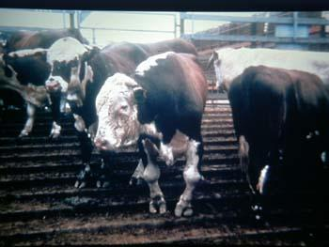
Arthritis at ante mortem.
Cases like this need special attention firstly talk to the stock handlers and establish if the animal can walk up the race at a normal pace if so, it can be put up as a suspect at the end of the day. If there is any doubt about its ability to walk normally then put it up as an emergency kill, shot it the yards don’t risk the animal getting part way up the race then stopping.

Arthritis at post mortem
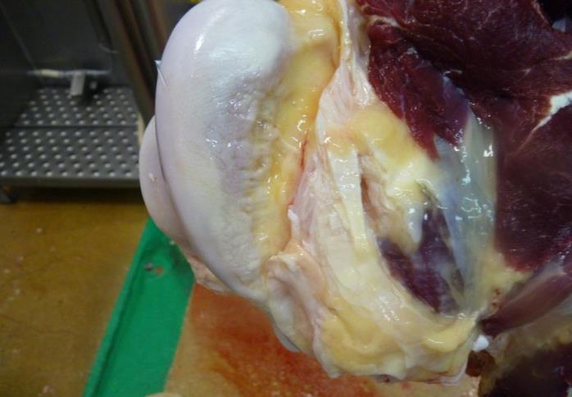

A normal joint surface

Arthritis
Arthritis is inflammation of the joints. It’s a common disease found in all species. Arthritis may be caused by:
- blood-borne infections of joints by bacteria and viruses, either blood-borne or as a result of an injury (infectious arthritis)
- contamination from the pasture of the umbilicus immediately following birth may allow entry of bacteria into the systemic blood circulation. This is a major cause of arthritis in young lambs.
- micro-organisms can enter the blood through minute perforations in the gastro-intestinal tract and be carried to joints, causing arthritis.
Using any of these modes of transport, the organisms may affect several joints, poly (many) arthritis. Continued use of the joint causes pitting of the articulating surface of the joint.
When invading micro-organisms infect a joint the synovial membrane becomes inflamed and inflammatory exudate (fluid) accumulates causing the joint to enlarge.
Chronic arthritic infections.
Chronic infections may have multiple affected joints as long as there is no evidence of septicaemia, or cachexia (wasting) then the disposition is to trim affected part(s) and the trimmings condemned.

Acute arthritis with systemic involvement
If infective arthritic organisms or their toxic by-products escape from an infective arthritic joint and are absorbed by the lymph and transported to the blood stream, there is a chance that the condition will become systemic
Systemic involvement is characterised by at least one infected joint and with:
- petechial haemorrhages
- or damage in organs, such as the kidneys
- or the carcass may be fevered.
When the infection is acute the disposition is that the carcase and all its parts are condemned

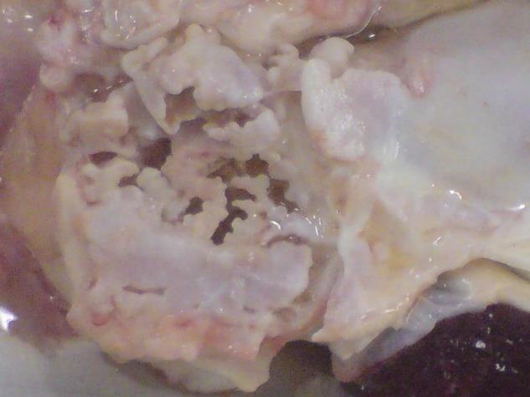
Typical hyaline cartilage eaten away in arthritic joint
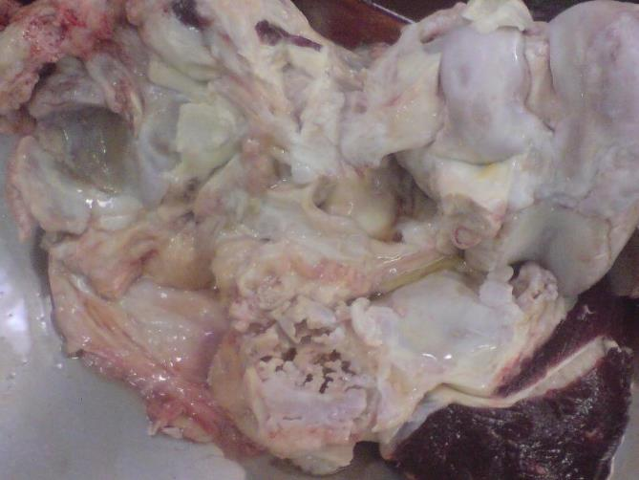
The image above shows a typical arthritic joint with the patella bone surface eroded. When trimming the affected area (where ever possible) the carcase should be inverted to allow for the joint to be removed cleanly. If the infected synovial fluid is spilt onto healthy tissue it will require heavy trimming.
Actinomycosis (lumpy jaw)
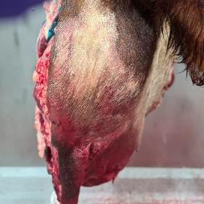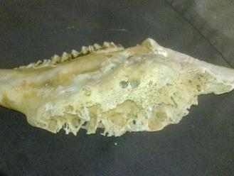

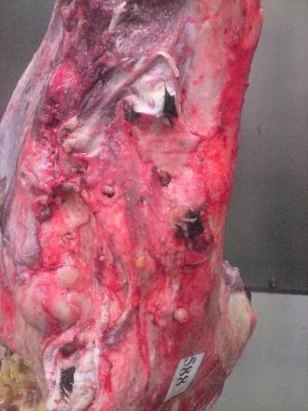 Yellow granulomatous lesions coming out of the head.

Actinomycosis (lumpy jaw) is characterised by chronic suppuration in which may usually be found granules of sulphur yellow lesions.
Disposition; Localised lesions in the bones of the head require condemnation of the head and a thorough search of the carcase to determine if the disease has become systemic. If it has become systemic it requires condemnation of the carcase and parts. In an export works this disposition can be made by the OPV only.

Osteomalacia softening of bones

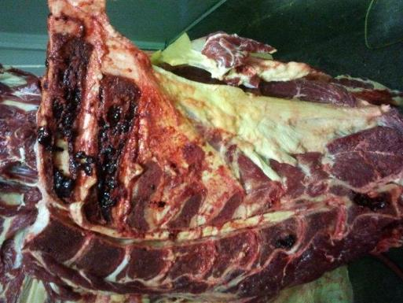

Osteomalacia is a disease similar to rickets. The diseases cause is a deficiency of calcium or phosphorus in the diet. It is often seen in dairy cows.
At ante mortem the cattle may be wasted and have difficulty in standing and walking, and prone to bone fractures. At post mortem the bones will be soft and can be cut with a knife.
The bones should be discarded and the remainder of the carcase judged on its merits.

Epithelioma (cancer eye)

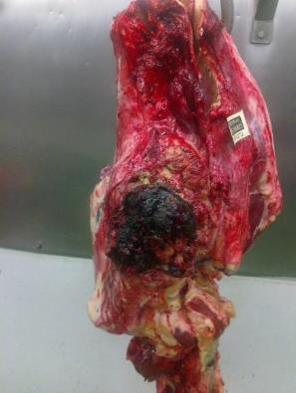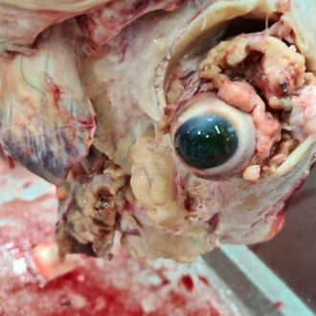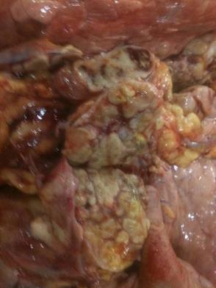
1. Epithelioma 2.Epi. with osseous tissue involved 3. Secondary lesion in lungs
Epithelioma (cancer eye) is caused by the uv sunlight attaching the eye its more common in Hereford cattle with white skin around the eye. Farmers try to breed from cattle with brown around the eye.
Disposition at post mortem should only be done by the OPV in export works. However involvement of the parotid lymph node is a sign of metastasis. A further check should be made of the lateral pharyngeal AKA atlantal and or the superficial cervical (prescapular) lymph nodes. This check is made when trying to establish in the neoplasm has metastasised.
They will also check the liver lungs and kidneys (filter organs) for secondary cancers. If it has spread either to terminal lymph nodes or filter organs it is enough evidence for total condemnation. The department disposition guidelines state if it has reached the parotid then it should be condemned.
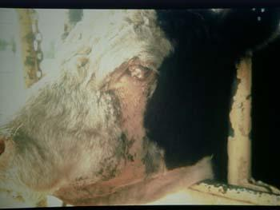
Epithelioma at ante mortem put up as suspect.

Haematoma
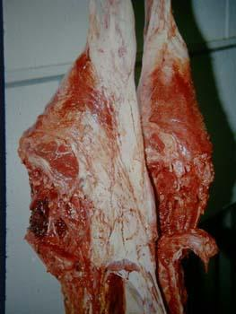

Haematoma this is basically a large bruise where excessive blood has become trapped within the muscles. It could be and animal welfare issue so should be investigated. Disposition is to trim the area heavily to remove all the bruising. In extensive cases like this it may not be worth trimming and total condemnation is warranted .
Eosinophilic myositis
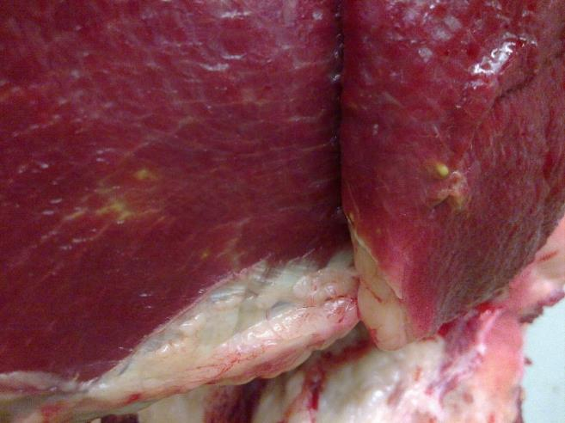

Eosinophilic myositis is the bodies reaction to a parasite sarcocystis cruzi. The carrier of the parasite is the dog. The reaction appears as small green spots in the muscles (it is not bovis) in advanced cases the spots can turn pale in colour.
In export works the disposition is to retain for the OPV. Mild cases can be boned under supervision with each piece of meat searched for lesions. These lesions are then removed but in advanced cases the carcase should be condemned as its not worth the cost of searching and trimming the entire carcase.
The producer needs to be notified so they can implement effective worming programs for their working dogs.

Inoculation abscess

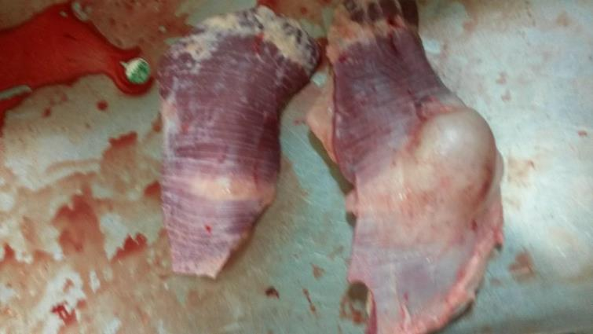

Inoculation abscess are common in all species. In cattle they are usually in the neck area and are the result of poor vaccination hygiene or as a reaction to the vaccine.
The disposition is to remove the affected area by trimming.

Intestinal Adeno Carcinoma
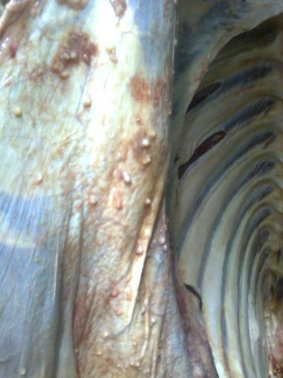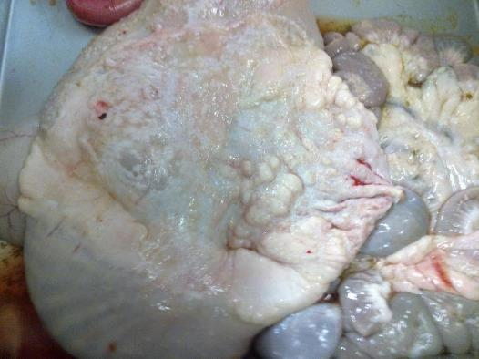
Intestinal Adeno Carcinoma occurs in cattle although more common in sheep . The carcinoma appears as white cancer lesions throughout the abdominal cavity. It should not be confused with peritonitis.
The disposition for this condition is the total condemnation carcase and parts.
Melanosis
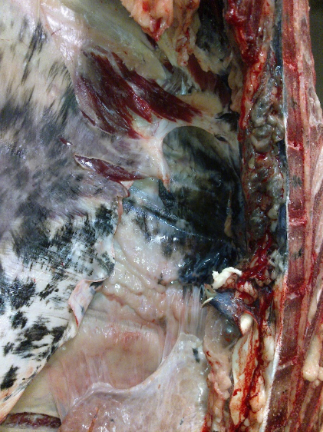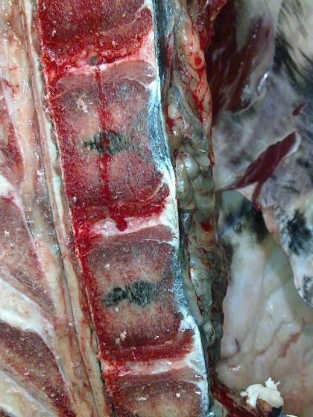
Melanosis is an over production of a normal pigment Melanin seen mostly in black angus cattle.
It starts in the spinal column in the sacral vertebrae and can be through the whole carcase it only affects the connective tissue between the muscles and looks like black grease.
Disposition; mild cases can be boned under supervision, extensive cases are condemned due to being unviable to bone and trim. In export works the OPV will decide the disposition.
Presternal calcification or putty brisket.
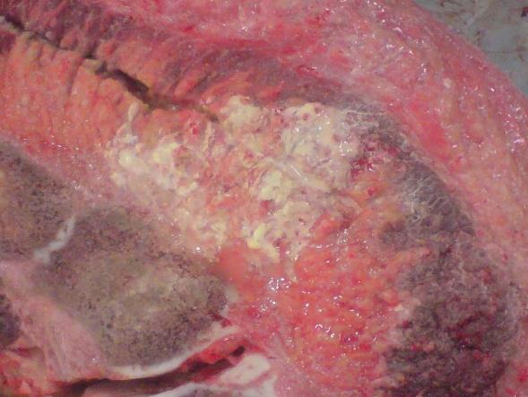
Presternal calcification is also known as “putty brisket”. This caused when cattle, particularly large animals, spend too lying much time on the ground. The pressure on the sternum cuts off the blood supply causing areas of necrosis.
The disposition for this condition is to remove the affected areas by trimming.

Imperfect bleeding.
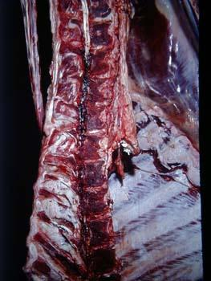
When there is imperfect bleeding the carcase appears dark without the other signs of fever. This condition can be due to the beast being shot in the yards as a downer suspect and bled while horizontal.
The disposition for this condition should be for the carcase to be directed to pet food or condemned because the meat is of low value and will have a short shelf life.

Diseases and conditions associated with the circulatory system
Uraemia
Uraemia is the accumulation of urea in the blood and tissues and is the result of damage to the kidneys. Kidneys removes waste from the blood and expels them as urine. This occurs in the kidney within microscopic structures called nephrons. However if the damage is to both kidneys, sufficient to make the nephrons ineffective, the waste products including urine will accumulate in the blood. When the blood becomes saturated with these waste products they will be deposited in the tissues, causing uraemia.
A carcass affected by uraemia has a strong odour, not unlike that of stale urine. In severe cases, fat and other tissues may appear a dirty brown-yellow colour.

The disposition for carcases affected by uraemia is to condemn the carcase and all the partsFevered carcases

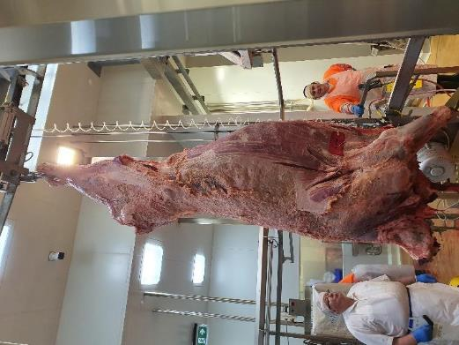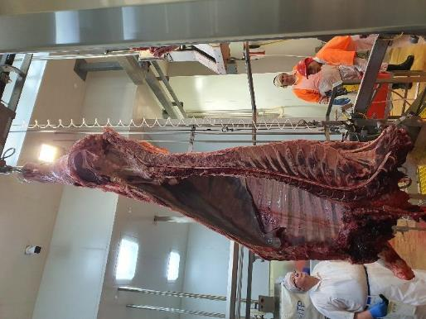
If a carcase is fevered the muscles and all parts will be darker due to retained blood – tissues engorged with blood. Fever is a general term to describe a dark carcase accurate cause can only be obtained with a Laboratory analysis.
The disposition for a fevered carcase is to condemn carcase and parts.
Vegetative endocarditis

Growths on the valves and atria of a cattle heart.
The liver may be affected by chronic venous congestion
Hob nail liver caused by chronic venous congestion
Backlog of un-oxygenated venous blood in the liver, caused by faulty heart action
Cirrhosis caused by chronic venous congestion is termed ‘hob-nail liver’
A condition of organs and parts that have impaired venous blood drainage
Commonly caused by faulty heart function, e.g. damaged valves, where instead of being pumped into the aorta and pulmonary artery, blood escapes back down the vena cava to the liver and head

Because this blood has a low oxygen content time tissues in the affected organs die and are replaced with fibrous tissue
The affected organs appear dark purple/blue due to the deoxygenated blood

Oedema
The capillary wall consists of a single layer of flattened cells that contain pores that allow the passage of water molecules from the blood into the tissues. Blood plasma containing water, dissolved nutrients and oxygen is forced by blood pressure through the capillary walls into tissue spaces to bathe the cells and supply the nutrients important for the growth and repair of tissues. This is tissue fluid. This tissue fluid is clear and does not clot.
Oedema is seen when there is an abnormal accumulation of fluids occurs in the tissue of the body. This can occur when there is increased blood pressure within the capillaries. This can occur when there is:
- an obstruction in the lymph drainage
- congestive heart disease
- malnutrition.
Different terms are used for oedema depending on where it occurs.
Anasarca – Generalised oedema under the skin
Ascites – Oedema in abdominal cavity
Hydrothorax- Oedema in the thoracic cavity
Hydropericardium – Oedema in the pericardial sac.
Disposition is dependent on the underlying cause of the oedema. This will be covered in detail in the Unit Perform ante and post mortem inspection - cattle

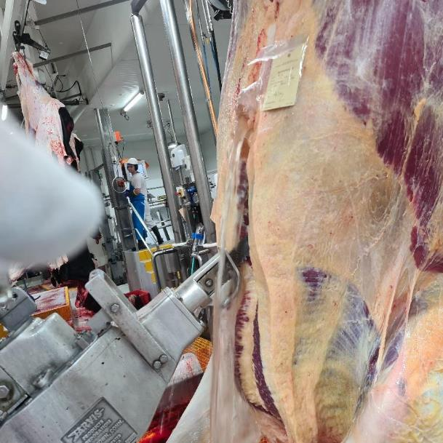
Fluid escaping from abdominal cavity
Ascites quite often not observed by the inspector as evidence of fluid is lost onto the viscera table prior to inspection. The condition is often associated with a diseased liver, cirrhosis quite often the peritoneum is thickened check for peritonitis and judge carcase on merits.

Pericarditis
Pericarditis is inflammation of the pericardium. Usually there is no systemic affect. The disposition is to condemn the heart and judge the carcase on its merits.
Haemangioma
Haemangioma is a non-cancerous growth that forms due to the abnormal collection of blood vessels. The disposition for this condition is to condemn the affected part/organ and judge carcase on its merits.
Hob nail liver
Hob nail liver may be affected by chronic venous congestion which is caused by a backlog of un-oxygenated venous blood in the liver, caused by faulty heart action e.g. damaged valves, where instead of being pumped into the aorta and pulmonary artery, blood escapes back down the vena cava to the liver and head.
Because this blood has a low oxygen content tissues in the affected organs die and are replaced with fibrous tissue. The affected organs appear dark purple/blue due to the deoxygenated blood .
Chondroma
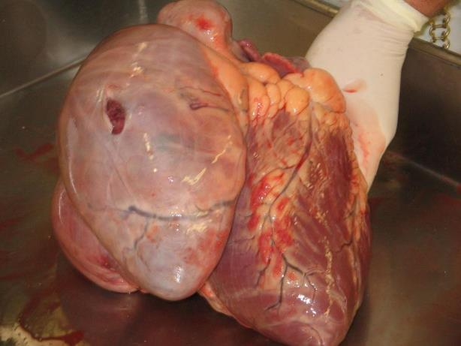
Chondroma is a benign tumour growing on the heat. Because it is benign the disposition is to condemn heart and judge the carcase on its merits.
Traumatic pericarditis
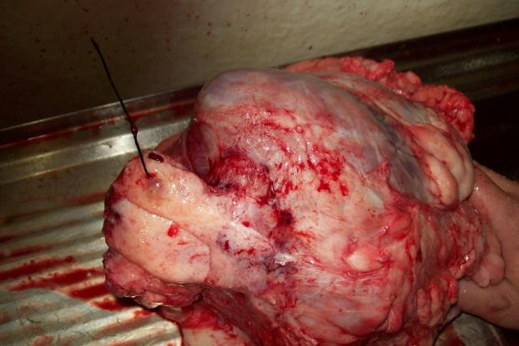
Traumatic pericarditis is caused by a piece of wire working its way from the stomach through the diaphragm into the heart. The disposition is to condemn heart judge carcase on merits.
Xanthosis
Xanthosis is the result of an over production of a pigment called xanthine and carotin. It happens mostly in old cows primarily in the heart but can be generalised throughout the carcase. Its not a pathological condition.
Mild cases require condemnation of the heart and the carcase is usually downgraded and used for pet food or blended into meat products.

Diseases associated with the Lymphatic System

Neoplasms
Diseases can spread by travelling via the blood or lymph and implanting on other organs and tissues.

Neoplasms spread in blood from gastrointestinal tract to the kidneys. The kidneys are a filter organ( i.e. with very small blood vessels) The clumps of cancer cells can’t pass though the small blood vesels and become lodged setting up secondary growths. This example is from a pig.

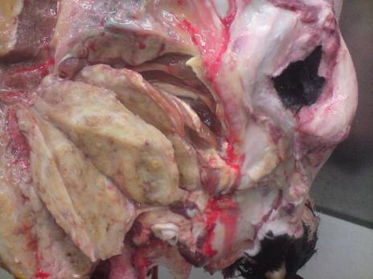
This neoplasm is typical of metastatic cancer (Epithelioma) in this example the eye has been surgically removed however some cancer has remained and spread to the regional lymph node (parotid) evidence of metastases. The disposition would be condemn of the carcase and parts
Grossly enlarged parotid lymph node

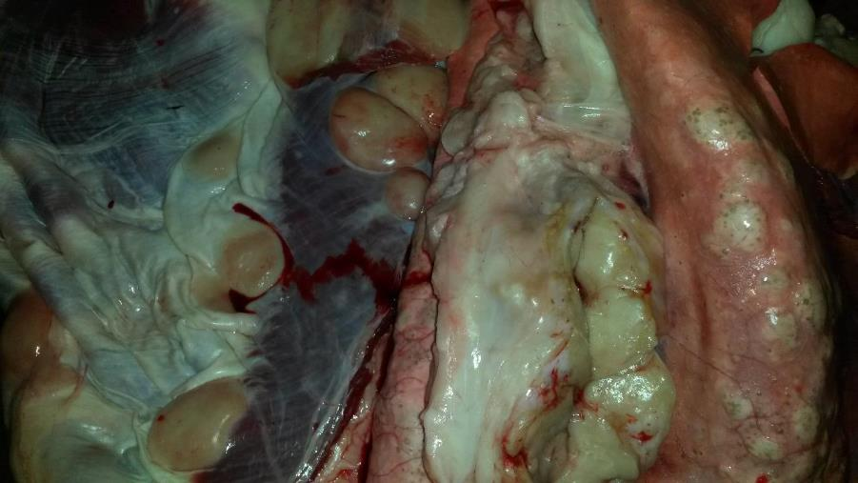
Lymphosarcoma malignant cancer of the lymphatics.
Disposition for this condition is the total condemnation of the carcase and its parts.
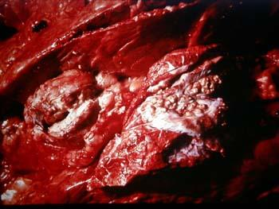
Tuberculosis in the lung lymph nodes in the image above. TB is now an Emergency Animal Disease.
It is very difficult to differentiate between actinobasilosis and TB. To the eye actino pus has granules of small club like structures whereas TB pus is smoother in all cases the OPV must be notified, and lab analysis conducted. In a domestic establishment the State DPI must be notified via the EAD contact number 1800 675 888
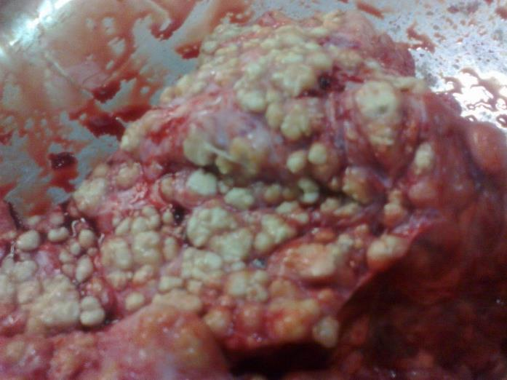
Actino pus showing the club like structures TB pus is creamier.
Diseases of the respiratory system

Pneumonia
Pneumonia is inflammation of the lungs and it can be a precursor to pleurisy and pericarditis so can often be seen in conjunction with pleurisy, pericarditis, abscesses and parasites
Because lungs are the first set of capillaries that blood passes through from the body, any bacteria, clumps of tumour cells or other pathogenic debris in the blood may be trapped in the lungs. For this reason any lesion in the lungs must exclude their use for human food.

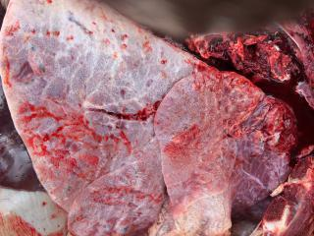

Emphysema
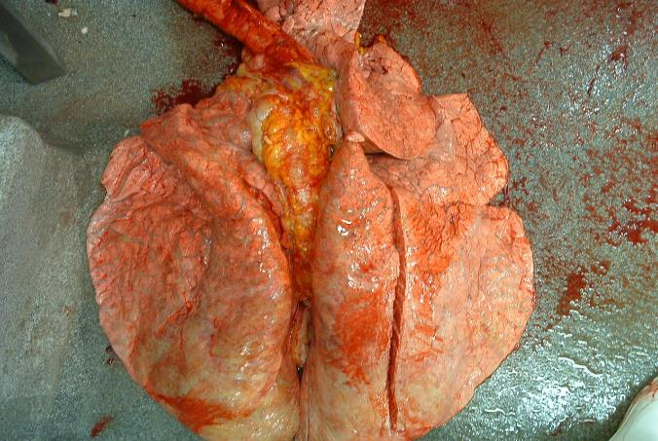
Emphysema is the abnormal presence of air trapped in the lungs. In cattle it can be caused by excessive bellowing .

Acute pleuritis
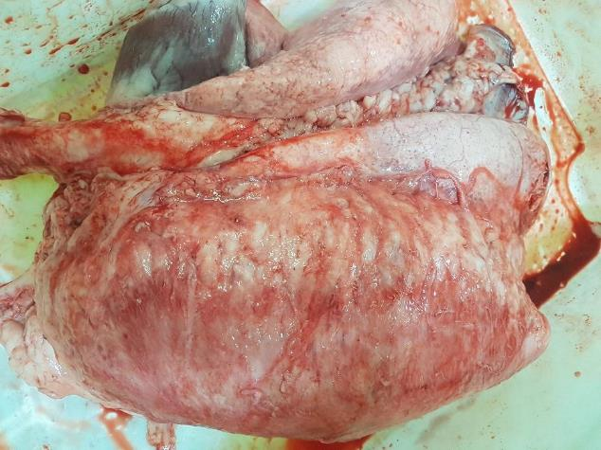
Acute pleuritis an infection like this would have a systemic affect.
The disposition would be to condemn lungs, remove infected pleura and check for signs of fever in the remaining organs and carcase. In an export works the carcase would be retained for the OPV to make the disposition.
Malignant neoplasm in the lungs
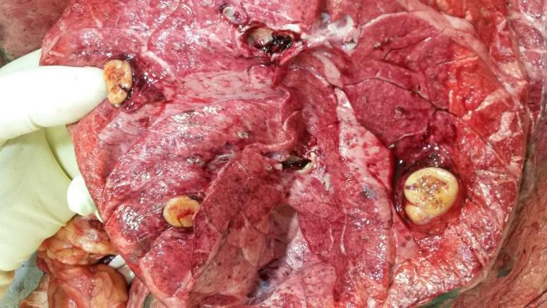
Malignant neoplasm in the lungs.
Disposition; In an export works the carcase and parts should be retained for the OPV who will search the carcase and parts for evidence of further neoplasms. Generally speaking neoplasms in the lungs are secondary to growths in other parts of the body.
If evidence of malignancy is found the carcase and parts are condemned.
Melanosis in the lungs
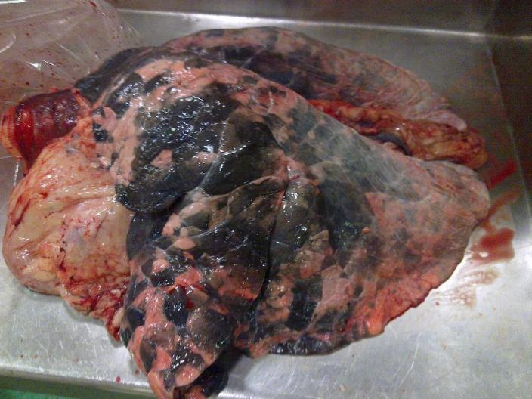
Melanosis in the lungs.
Melanosis is an over production of a normal pigment Melanin seen mostly in black angus cattle.
It starts in the spinal column in the sacral vertebrae and can be through the whole carcase. It only affects the connective tissue between the muscles and looks like black grease.
Disposition; mild cases can be boned under supervision, extensive cases are condemned due to being unviable to bone and trim. In export plants the OPV will decide the disposition.

Septic pleurisy
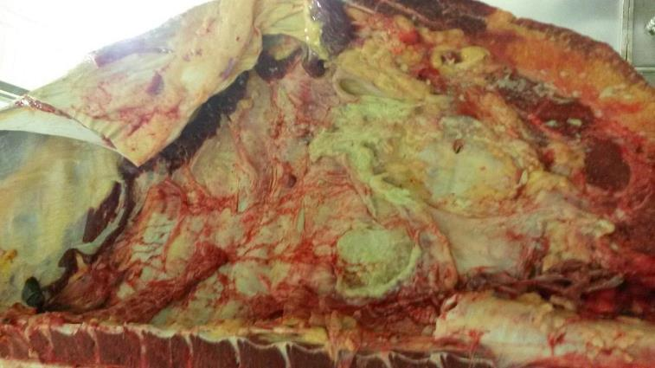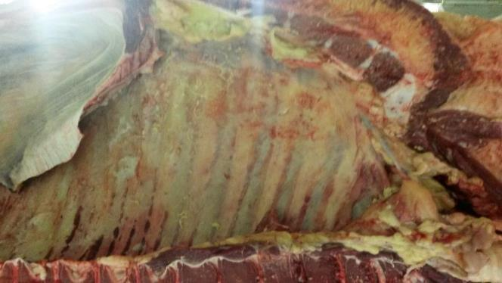
Septic pleurisy is also known as bovine respiratory disease (BRD)
Disposition: If there is an acute infection with evidence of septicemia, petechial hemorrhage or polyserositis(inflammation of different serous membranes) then there will be a total condemnation of the carcase and its parts.
If it is a chronic infection with adhesions and patches of fibrinous material but no evidence of septicemia then the disposition is to strip pleura and judge the carcase on its merits.

TB in the thorax and lungs.

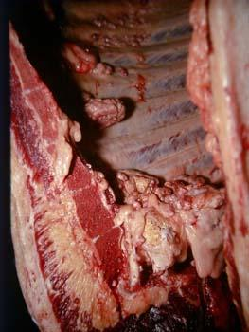
TB in the thorax and lungs.
Notifiable disease in Australia immediately notify the OPV who will call the emergency animal hotline on 1800675888. Domestic establishments must contact the State DPI on the same EAD hotline.

Diseases of the digestive system
Actino bacillosis in the tongue or woody tongue
Actino bacillosis in the tongue is also known as woody tongue. Severe cases can be seen at ante mortem. Actino of soft tissueis caused by infection with actinobacillus lignieresi. This condition is often associated with poor condition as the animal has difficulty eating.
Disposition; If the infection is only in the head then condemn the head and tongue. However, if the infection is generalised with evidence of spread to the lungs or other organs then it is a total condemnation of carcase and parts.
Actino mycosis as also known as lumpy jaw

Actino mycosis or lumpy jaw is caused by an infection with Actinomyces bovis in the bones. The bones becomes porous .
Disposition; If the infection is only in the head then condemn the head and tongue. However if generalised with evidence of spread to the lungs or other organs then it is a total condemnation of the carcase and parts.
Portal Cirrhosis of the liver or hobnail liver

Portal Cirrhosis of the liver is also known as hobnail liver due to the hobnail appearance on the surface. It is caused an irritant that the liver cannot cope with usually a poisonous plant.
Disposition: Condemn the liver and check the carcase for any systemic reaction. If the infection is systemic the carcase and its parts.
Fatty infiltration.

Fatty infiltration is caused by over feeding which cause a fat build up in the liver. It is more common in old cows. The disposition is to condemn the lliver and judge carcase on its merits.
Telangectasis also known as sawdust liver

Telangectasis also known as sawdust liver is caused by inflammation or degeneration of liver cells and is mostly seen in old cows. As the cells die the affected area becomes concave. The disposition is to condemn the liver or downgrade to pet food.

Intestinal adeno carcinoma (malignant cancer)

Intestinal adeno carcinoma (malignant cancer) is found in older stock and the disposition is the total condemnation of the carcase and its parts.

Peritonitis in bovine rumen

Both the above pictures are chronic (mild) peritonitis in bovine rumen; there is little to no evidence of inflammation the condition is almost healed.
The disposition is to condemn the affected part.

Lipoma (fat cancer)

The image is of a Lipoma (fat cancer) growing in the intestines. Lipomas are the most benign of neoplasms. Note it’s fully encapsulated with no secondary tumours.
The disposition is to condemn the affected organ and judge carcase on its merits.
Liver abscess
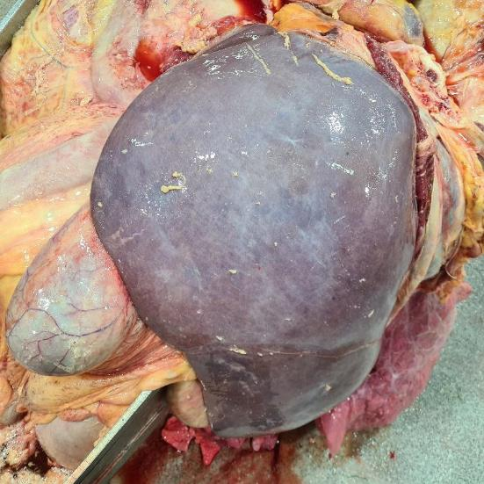
The image above is a massive liver abscess. The abdominal viscera looks partly infected. The liver being the detoxification organ of the body wouldn’t be working normally so toxaemia should be suspected in the carcase. In an export works this carcase and parts would be retained for the OPV .
For this reason a thorough examination is warranted and total condemnation of carcase and parts if there I s systemic infection.
Hydatid or Echinococcosis cysts
Hydatid cysts is easily the most important parasite to be familiar with as humans can be the intermediate host the same as animals. If a dog eats raw offal infected with hydatids then the parasite will develop in the dog’s gut and the eggs will pass out with the faeces. Hand contact with the dog or faeces or could transmit the eggs to a human and these cysts will develop in the liver lungs, and possibly the brain.
In advanced cases you’ll see what looks like grains of sand – granules, in early stages it will be clear fluid in older cysts the dry up and form yellow hard lumps which can look like actino. Lab analysis is often needed. Hydatids is a notifiable disease in some states especially Tasmania
The disposition is to condemn affected organs.

Liver Fluke
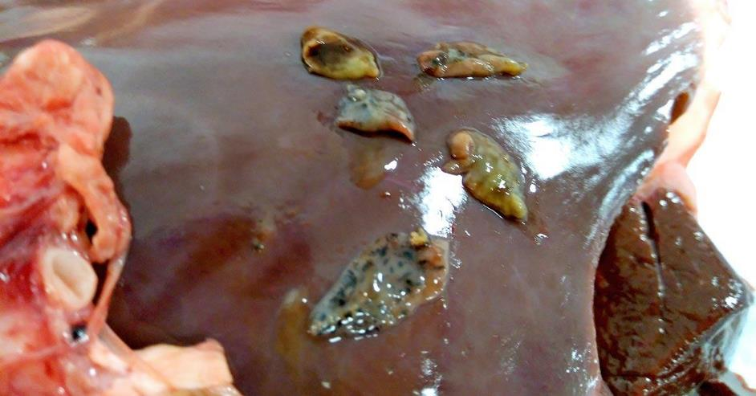
Liver fluke is a parasite (Fasciola hepatica) of the liver. It affects a range of animals including cattle and sheep (and occasionally humans). Adult fluke live in the bile ducts where they produce eggs which are passed out in the faeces.
Disposition: Condemn liver.

Cysticercus bovis (beef measles)
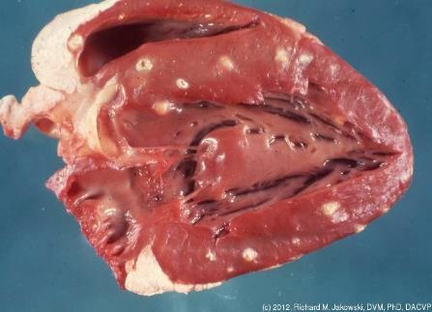
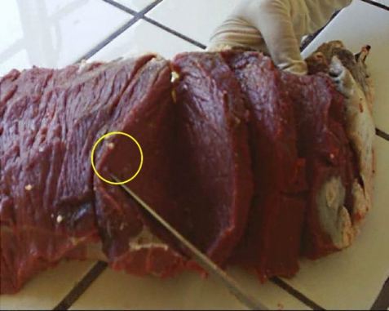

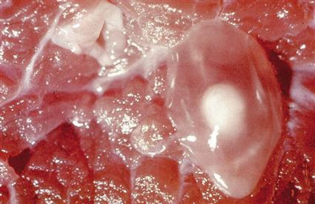
Viable cysts in muscle
Cysticercus bovis (formerly known as Beef Measles) causes small cysts in the muscles of cattle and their presence can lead to all or part of the carcass being condemned. Cattle get Cysticercus bovis from ingesting pasture contaminated with eggs passed from humans. The worm taenia saginata (beef tapeworm) lives in the human gut.
Disposition: With a general infestation the carcase and all its parts is condemned. With a light infestation disposition is:
- affected viscera condemned
- cysts and surrounding tissue trimmed from carcase and condemned
- Remainder of carcase passed as fit for human consumption subject to
- Treatment by freezing to at -12Degrees Celsius deep muscle temperature
- for a minimum of 5 days in carcase or boned meat.
Cysticercus bovis is a notifiable disease in all states and territories.
Malignant liver cancer
This malignant liver cancer has a necrotic centre and no clear exterior capsule.
In export works all these cases will be retained for the OPV who will to determine if metastases has occurred by searching primarily the liver lungs and kidneys.
This is a benign neoplasm growing in the lungs note the absence of secondary tumours. It has been cut open and shows no necrosis also the second picture shows the growth is fully encapsulated-.
The disposition for this condition is condemn the affected part and judge carcase on its merits.

Abscess in bovine liver
Abscesses in bovine livers are common in grain fed stock. The liver has amazing ability to perform its functions even when severely damaged.
The disposition is that if there are no signs of complete liver failure i.e. toxaemia or general fever the liver will be condemned, and the carcase judged on its merits.
Acute gastro enteritis
Gastro enteritis can occur when there is an infection of the abomasum and the intestines. The infection is caused by parasites, in most cases by a worm such as round worm in the abomasum and the intestines .
An acute infection like this would almost certainly result in the carcase showing signs of acute fever throughout. Disposition would be the condemnation of the carcase and its parts.
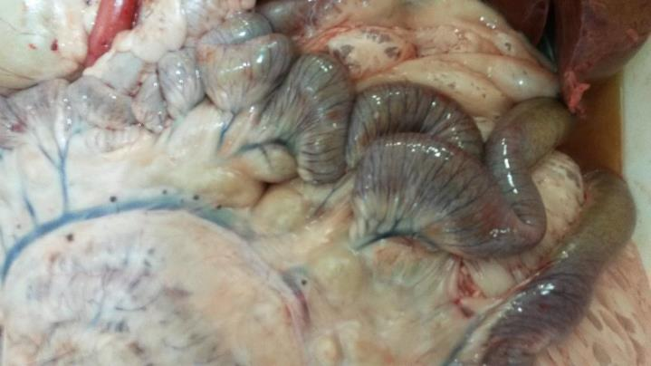
The image above is of enteritis but in a much milder form The blood vessels of the intestine are only slightly redder. Enteritis can range from the previous image to this one and everything in between. This level would have no effect on the carcase and would just require condemnation of the intestines. With practice inspectors learn how to make sound judgements on levels of infection.

Oesophagostomum Radiatum or pimply gut

Oesophagostomum Radiatum is also known as pimply gut or knotty gut. This is a condition of the intestines caused by the larval stage of the nodule worm (Oesphagostomum columbianum).
The disposition is that no action is needed unless bovine runners are being saved for human consumption then the intestines are condemned as unsuitable for processing.

Diseases of the excretory system
Hydro nephrosis in bovine kidneys

Hydro nephrosis in bovine kidneys is caused by a blockage in the urethra blocking the escape of urine.
Disposition; The kidneys would be condemned and carcase checked for signs of uraemia (smell of urea in the meat) and condemn carcase and parts if detected.
Enzootic (endemic among animals as a disease) bovine leucosis AKA bovine viral Leucosis, bovine lymphosarcomas

This is a malignant cancer that resist the action of the immune system. Infection can be spread by blood including biting insects, injection needles and tattooing equipment. This condition occurs in animals over 1 ½ years old.
The conditions should be reported back to farmers.
It’s a notifiable disease in all states.
Disposition; If only in one organ is affected with no evidence of spreading to other organs then ; the affected organ is condemned. If there are multiple lesions in multiple organs then condemn the carcase and its parts.
In all cases in an export plant retain for the on plant vet
This is a blocked urethra you can see the empty bladder there’s no infection so just the affected part needs to be condemned.
Renal infarcts.
Renal infarcts are wedge shaped areas of necrosis due to blockages to the blood supply servicing parts of the kidney mild cases just require the kidney to be condemned. In acute cases where the kidney function has been affected check the carcase for uraemia. This condition should not be confused with nephritis.
Disposition: Condemn affected organ and check the carcase for uraemia..

Diseases of the reproductive system
Gangrenous metritis

Acute metritis is a gross enlargement of the uterus and is usually caused by a trauma at birth or the retention of a dead calf or a piece of placenta.
Disposition: In case where the carcase is fevered then the disposition is the total condemnation of carcase and parts. In milder cases where there is no systemic involvement then the disposition is to trim and condemn the affected parts. In export works retain the carcase for the OVPs disposition.

Disposition; In a case this bad then again it requires total condemnation of carcase and parts, however slight cases require only the affected part to be condemned. In export plants retain for the OPV.

Diseases associated with the nervous system
Melanosis in the spinal cord

Melanosis in the spinal cord is caused by an excess production of melanin.
Disposition: Mild cases should be retained in export works then boned under supervision. In mild cases it is possible to recovery wholesome products as the conditions may only affect the bones of the spinal column.
In this case the pigment has spread to the connective tissue in the intercostal muscles. It would be unviable to try to recover wholesome tissue and so the carcase would be condemned on aesthetic grounds.

The endocrine system
Goitre
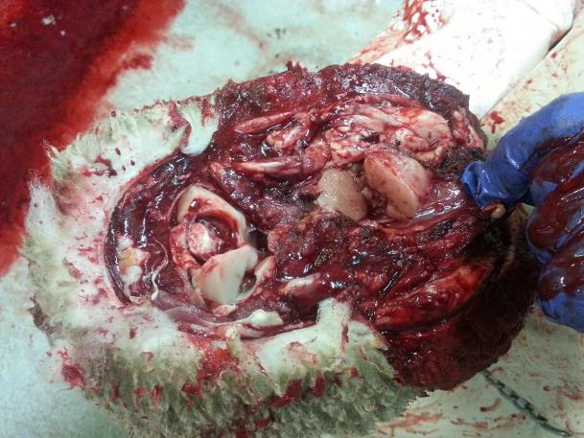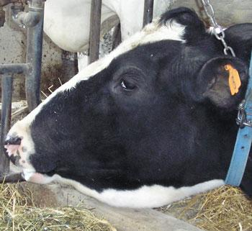
Goitre in a thyroid gland sheep head.

Goitre
The endocrine system rarely produces any pathological conditions. However, in areas of Australia where the pasture is low in iodine the thyroid glad cannot produce enough thyroxine the growth hormone. The only evidence the inspector will see is enlargement of the thyroid gland.
Disposition: Remove the gland and judge the carcase on merits.

The skin or integumental system
Congenital Alopecia
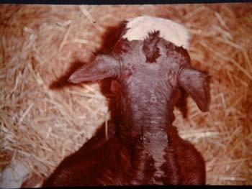
Congenital Alopecia only seen at antemortem has non affect on the carcase no action needed except notifying the producer of the condition.
Melanoma
Melanoma; more common in Black Angus cattle. Would normally be picked up at ante-mortem and put up as a suspect.
Disposition; it’s a malignant form of cancer and if generalised i.e. found in other parts of the carcase the disposition is the total condemnation of carcase and parts.
Malignancy is based on whether the signs of melanoma spreading (enlarged darkened lymph nodes) has not spread beyond the immediate draining lymph node. If it has reached a terminal lymph node then it’s malignant i.e. entered the circulatory system.
In an a export establishment retain for the OPV and be prepared to assist with the search of lymph nodes.

.

Sarcocystis Bovi (Dalmeny disease)

Although this is not a skin disease symptoms of this condition can be seen at ante mortem. The sarco is spread by canines the eggs pass out with the faeces.
At ante mortem loss of hair on the end of the tail (rat tail syndrome) bulging eyes and emaciation are signs of the disease. The lesions are oval shaped can be up to 10mm long and are an off white to green colour and can be seen in this image of a beef weasand. They prefer areas of the body with rich blood supply i.e. heart, masseter muscles, diaphragm and oesophagus.
Disposition in the export works is to retain for the OPV and bone under supervision unless heavily infested necessitating total condemnation of carcase and parts.
Enzootic bovine leukosis
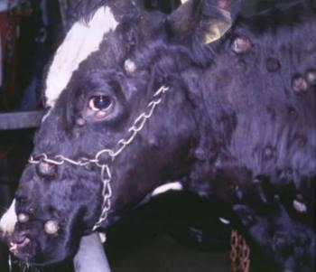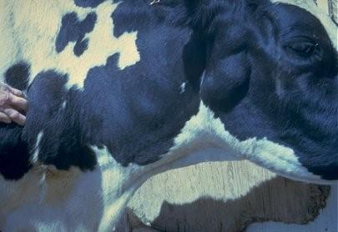
Lesions seen at ante mortem
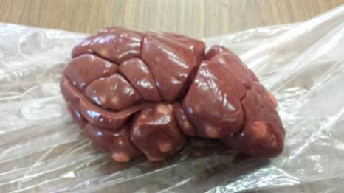
Enzootic bovine leucosis (EBL) is caused by the retrovirus, bovine leukaemia virus (BLV). This virus is transmitted horizontally through contact with body fluids containing infected cells
It’s a malignant cancer that resist the action of the immune system. Infection can be spread by blood including biting insects, injection needles and tattooing equipment it occurs in animals over 1 ½ years old.
Disposition: Where there are multiple lesions or lesions in multiple organs then condemn the carcase and its parts. If there are localised lesions condemn the affected organ.
It is a notifiable disease in all states.

Common diseases in sheep
A wide range of diseases can be detected in the systems of sheep and goats
Diseases associated with the musculoskeletal system – bones and muscles
Arthritis
Arthritis in the stifle of a lamb (note the enlarged internal iliac lymph node).

Normal healthy joint of a lamb

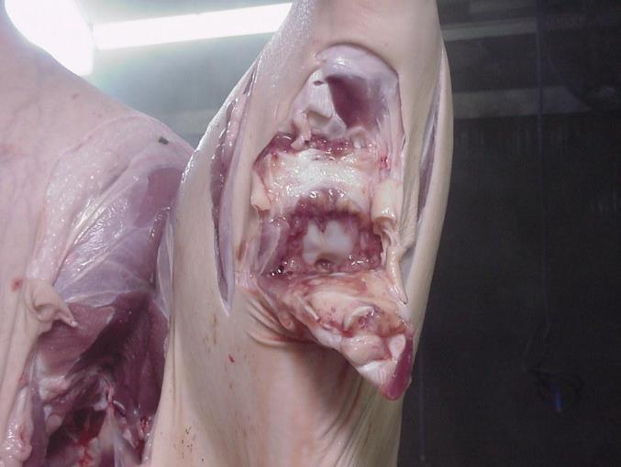
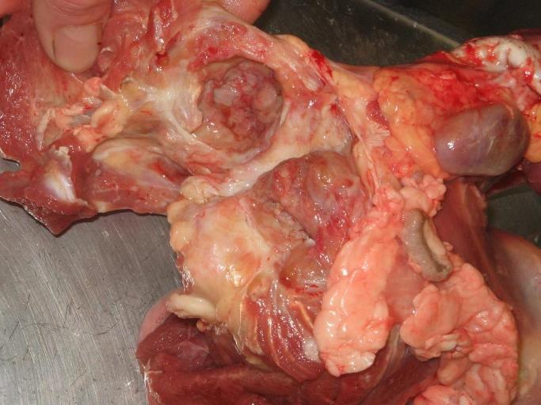
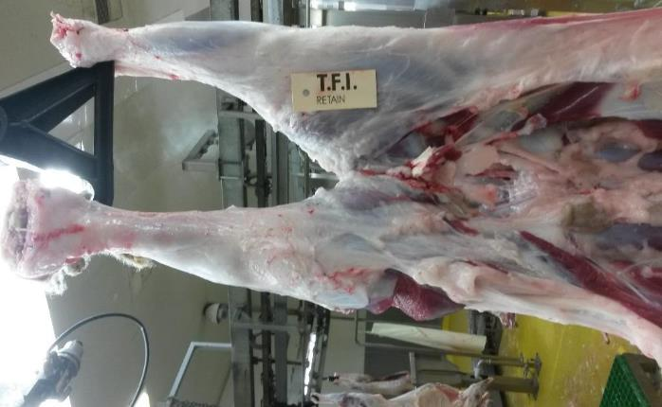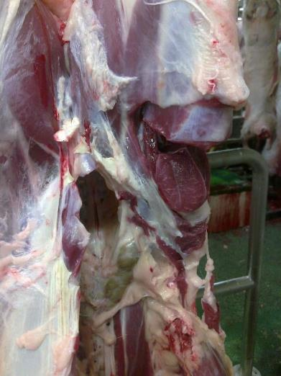
Note the enlarged internal iliac lymph node evidence of an infection in its drainage area
Arthritis in hind quarter- disposition is to remove the affected part with a small amount of normal tissue and judge carcase on merits.
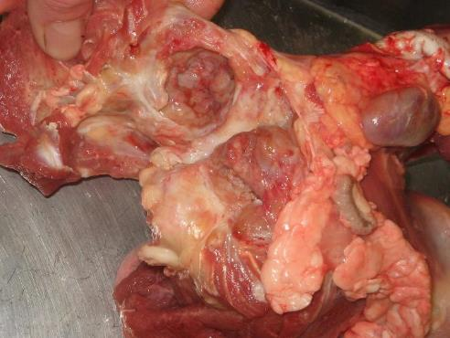
Normal internal iliac placed for comparison.
Enlarged internal iliac – enlarged due to the system fighting the infection

Arthritis in ball and socket joint
In chronic infections the animal may have multiple affected joints but as long there is no evidence of septicaemia or cachexia (wasting). The disposition in these cases is to condemn the affected part(s).
If there is systemic involvement then it is an acute infection with evidence of septicaemia, petechial haemorrhage and polyserositis (inflammation of serous membranes). In these cases the disposition is that the carcase and all its parts are condemned.
Jaundice
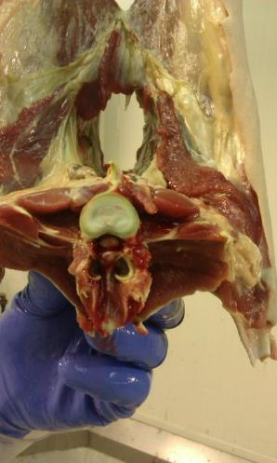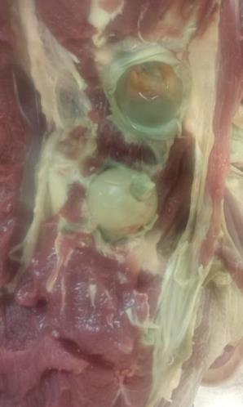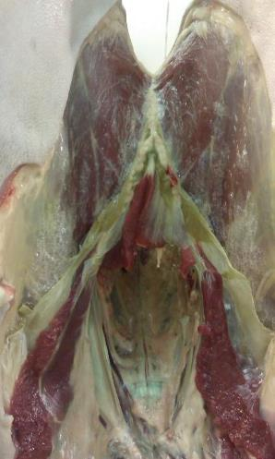
This a rare form of Jaundice in normal yellow Jaundice the cartilage turns a yellow colour due to the pigment in bilirubin however if this pigment oxidises it creates biliverdin the cartilage turns green.
Disposition: This is the same for all jaundice cases condemn the carcase and parts.

Gangrene in bones
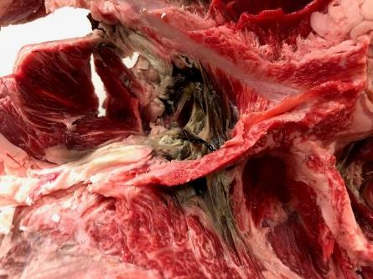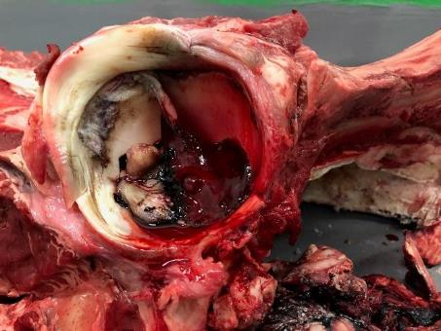

Gangrene in bones occurs when tissue become necrotic (dead) because it has no blood supply so is no longer under the bodies defence system. Putrefactive organisms gain entry and the bone starts to rot.
Disposition: Condemn the affected part along with a reasonable amount of surrounding tissue. Any evidence of septicaemia (septic blood) or sapraemia (blood poisoning caused by toxins of putrefactive bacteria) requires the total condemnation carcase and parts.
Calcium and phosphorus
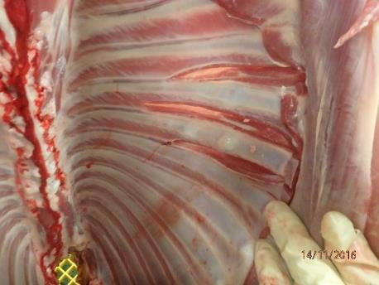
In a line of lambs one or two rib sets like this is are probably just rib fractures however if a line presents with rib fractures being common its almost certainly diet related. This information should be relayed to the producer.
Disposition Remove the affected ribs and judge carcase on merits.

Dog bites
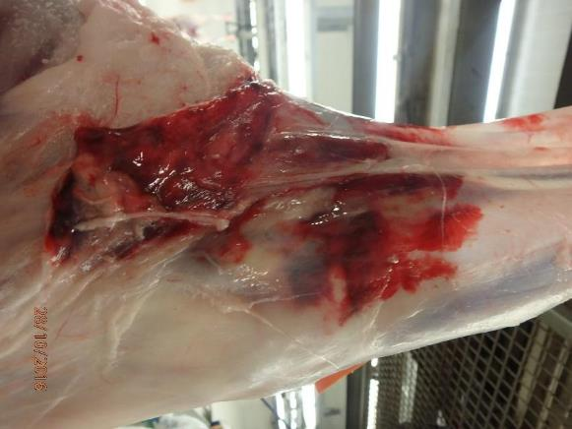
Dog bites like these will usually present as a line with frequent bites.
This is an animal welfare issue and needs to be investigated by the establishment’s Animal Welfare Officer and in export works the OPV.
Disposition: Remove by trimming around the bites.
Eosinophilic myositis
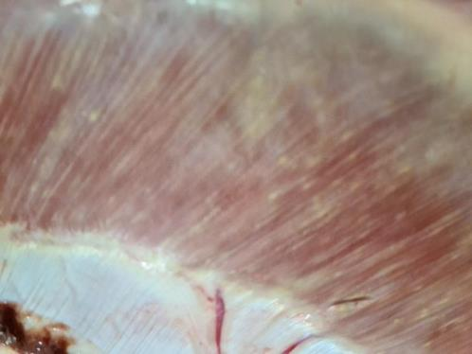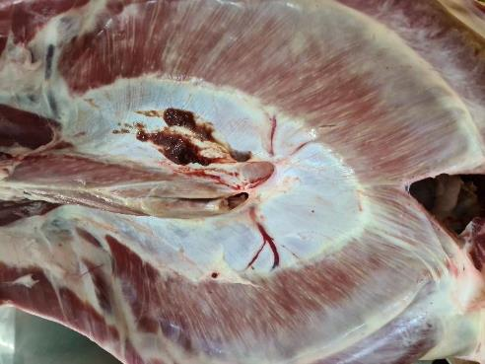
Eosinophilic myositis the bodies reaction to a parasite sarcocystis cruzi the vector being a dog. The producer needs to be notified.
Disposition. Mild cases can be boned under supervision of OPV but advanced cases are usually condemned to avoid the costs of boning and searching and trimming every piece of meat.

Ecchymosis
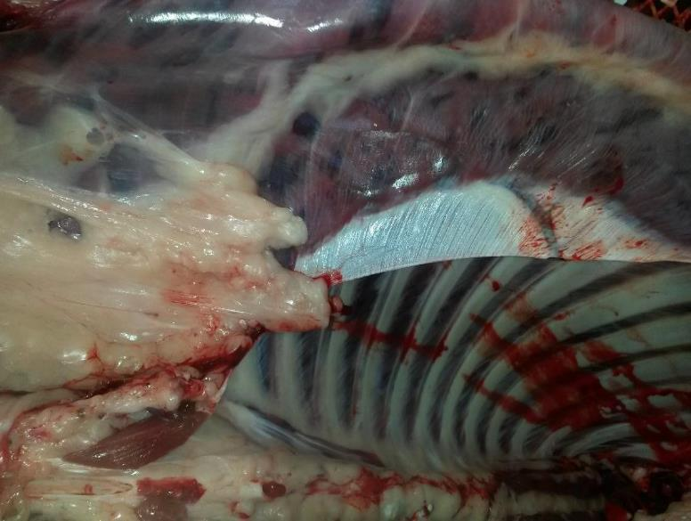
This condition is normally termed ecchymosis. True ecchymosis is caused by toxins breaking down the walls of small blood vessels allowing blood into the surrounding tissue, generally lesions are about the size of fingernails. If the ecchymosis is caused by toxins, the animal will have toxaemia and show definite signs of fever. Disposition would be total condemnation carcase and parts.
The above picture is petechial (small) haemorrhage generally caused by incorrect stunning.
Disposition: This is to remove the affected parts by trimming.

Jaundice
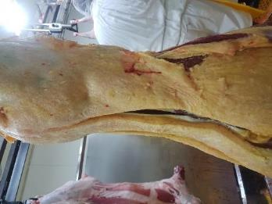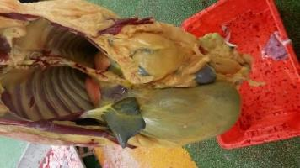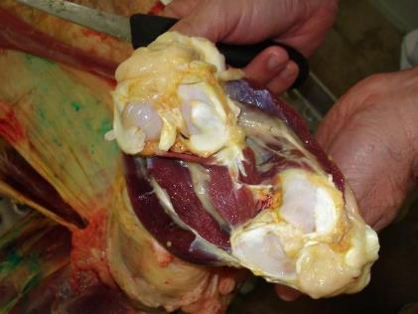
Jaundice caused by and obstruction in the flow of bile (obstructive jaundice. The bile (pigment bilirubin) enters the lymphatic system and reaches the blood circulation staining the tissues yellow.
Disposition: Condemn the carcase and parts.
Cysticercus ovis
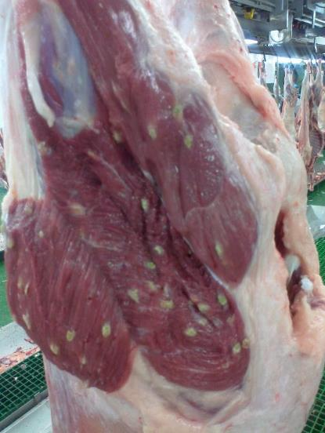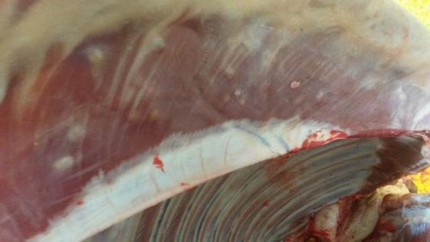
Cysticercus ovis. In the intermediate stage of parasite taenia Ovis found in canines and then passed on to sheep by the faeces on pasture.
The predilection sites are the heart and diaphragm. However, they can be throughout the muscles as well.
Disposition: If five or less are found by the inspector on the carcase muscles, then retain for a thorough search of muscles by palpation then bone under supervision.
If there are more than five in the carcase muscles condemn the carcase. If found on the heart condemn the heart.
Myasis – flystrike
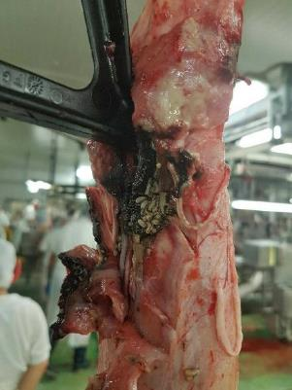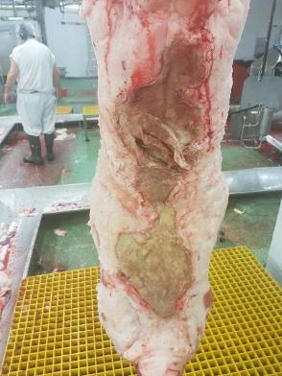
Fly strike partly healed fly strike
Myasis – flystrike would normally be picked up at ante mortem where mild cases can be treated and when healed processed and inspected by the OPV.
The above cases both require condemnation of carcase and parts.
Osteosarcoma
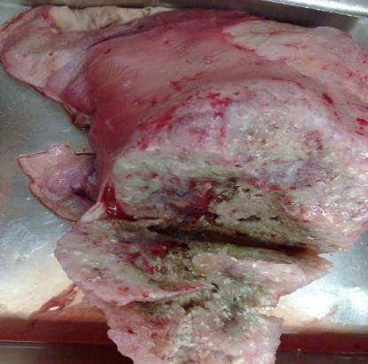

Osteosarcoma is a malignant cancer of the bones.
Disposition: This condition requires the condemnation of the carcase and parts
Polycythaemia
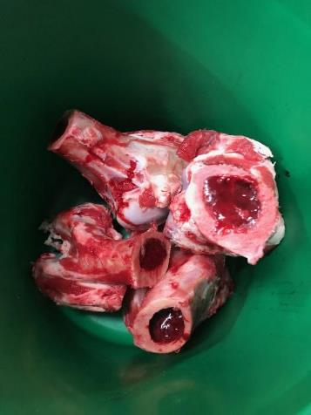
Polycythaemia is the result of an overproduction of red cells in bone marrow.
Disposition: The disposition is to discard the bones but the muscle meat can be judged on its merits.

Diseases and conditions related to the circulatory system
Emaciation
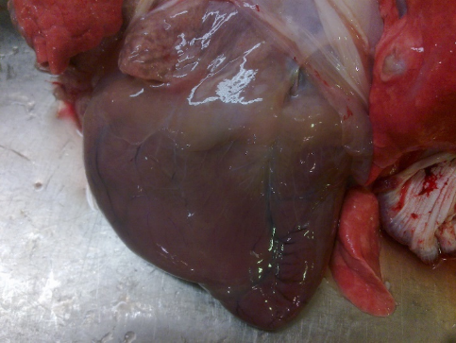
When an animal is wasting the heart is the last place an animal will lose fat. The fat around the top of the heart is watery the meat is of little nutritional value.
Emaciation is often secondary to other conditions i.e. Johnes Disease or simply malnutrition.
Disposition: Condemnation of carcase and parts. Border line cases can be chilled overnight and if set the next morning are passed for human consumption. However, the carcases are of no value as an export product in carcase form but can be boned out for boneless meat or as an ingredient in a meat product. Most processors have little use for these carcases.

Melanosis
Melanosis in the heart the abnormal deposit of a normal pigment melanin, this was once rare but is becoming more common.
Disposition; check the carcase for evidence of more dark patches mild cases can be boned under supervision extensive cases are condemned due to it not being viable to process and search all cuts.
Ecchymosis
This condition is mostly termed ecchymosis, true ecchymosis is when toxins in blood weaken the blood vessel walls and blood escapes into tissue resulting in areas about the size of a finger nail.
Petechial (small) haemorrhage is what is in this picture it’s the result of incorrect stunning.
Disposition; the hearts can be saved for pet food or if the company has a market for hearts like this they can be passed as it’s non pathological.
The OPV and QA Manager should be consulted in export works.
Pericarditis
Pericarditis in ovine hearts are caused by an infection of the pericardium.
Disposition: Condemn the heart and check for systemic fever.

Cysticercus ovis or sheep measles.
Taenia ovis (otherwise known as Cysticercus ovis, ovis or sheep measles) is a tapeworm parasite which can cause significant economic loss due to the rejection or trimming of sheep carcasses.
The parasite is carried by dogs and is harmless to the dog, however the larval stage in sheep muscle results in an unsightly cyst which is not acceptable to consumers. Control involves preventing transmission of the tapeworm from dogs to sheep.
Disposition: Condemn the heart. Carcase can have up to five in the muscles and be boned under supervision more than five in the carcase and the carcase is condemed.

The lymphatic system

Caseous Lymphadenitis (CLA)
Caseous Lymphadenitis (CLA) in a lymph node
Caseous lymph adenitis in ovine kidney.
Caseous lymphadenitis is an infectious disease caused by a bacteria that affects the lymphatic system, resulting in abscesses in the lymph nodes and internal organs. It is found mostly in goats and sheep Although rare these days due to gland vac, it still can be seen in unvaccinated mobs.
Disposition; Condemn the kidneys and check for further abscesses if extensive total condemnation carcase and parts
This carcase would be condemned for pyaemia
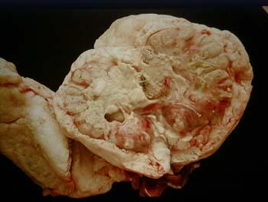
The image above is CLA in a lymph node. Note the capsule around the outside, this is how the body tries to stop the spread, Also the lymph node attempts to close its outflowing vessels to prevent it spreading to the next lymph node. If it is not successful pyaemia can result. Pyaemia (or pyemia) is a type of sepsis that leads to widespread abscesses.

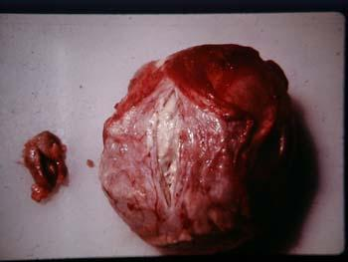
The above image is of CLA in a prescapular lymph node with a normal lymph node on the left for comparison.

The above image is of CLA in a spleen and there are abscesses visible in the liver (upper left of image). This is typical of pyaemia with abscesses forming in the lymphatics

The above image is of CLA in the lymph nodes of the lungs. Lung lymph nodes are terminal so a further search for other infected nodes in needed.
Disposition; condemn lungs and judge carcase on merits.
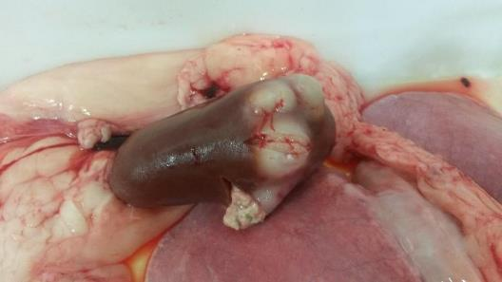
The above image is of CLA in a kidney. This is a sign that the infection has spread through the body.
Disposition: Condemn the kidneys and check the carcase.

Diseases related to the respiratory system
Pneumonia – Parasitic
This image is of Dictyocaulus filaria or lamb worm in a lamb’s lungs with associated pneumonia

Pneumonia can result from infestation of the lungs by parasitic worms in sheep, lambs and goats . There are two main species:
a) Muellerius capillaris or nodula lung worms, a tiny round worm is found in alveoli and appears as small round lesions
b) Dictycaulus filaria or lung worm is a tiny thread like worm.

The exudate in this diagram is fluid that leaks out of blood vessels into the nearby tissues of the lungs. Exudate may ooze from areas of infection or inflammation.

This is what happens when alveoli become filled with exudate and form the dark areas in lung tissue.
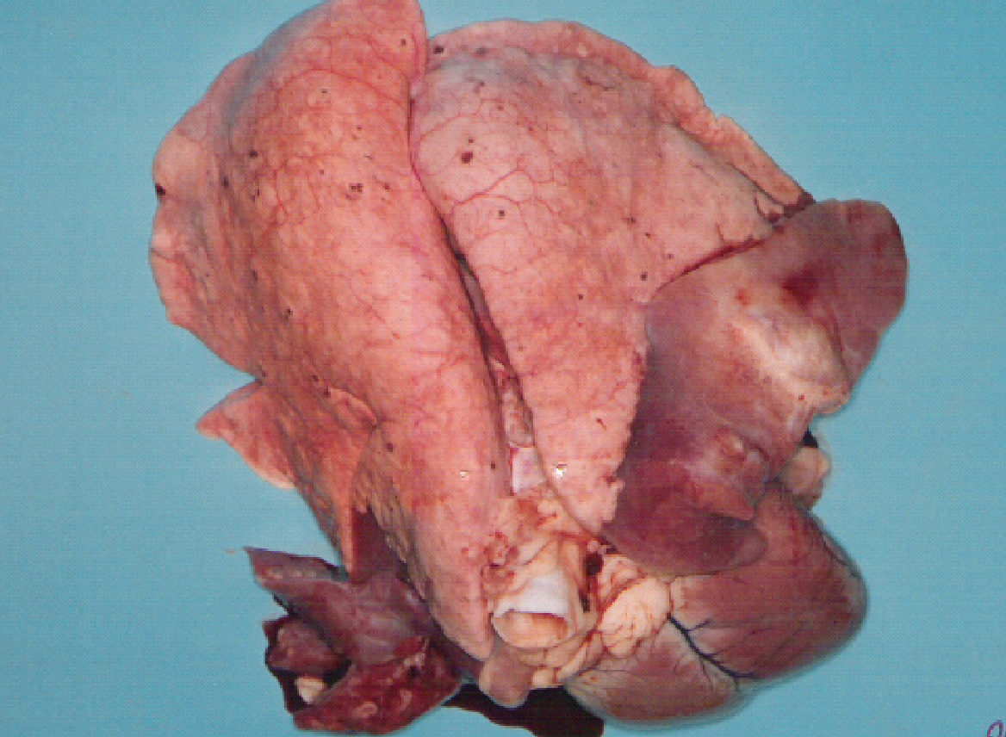
Pneumonia in a lamb lungs, showing the distinct line of demarcation.
Disposition: Condemn the lungs.

Pneumonia in the live animal at ante mortem
In mild cases of pneumonia the animal will be coughing, have difficulty breathing, and may suffer from shivering fits. In cases with severe infection the animal will have a severe cough, may be feverish, breathing short, quick pants and will be physically weak. The sheep’s neck will be outstretched, its nostrils dilated and the sides of its chest lifting. As the disease progresses a thin watery nasal discharge appears and can become thick, whitish and purulent.
Pneumonia at post mortem

Acute Pneumonia

The affected lung above is hyperaemic (excessive blood) and deep bright red.

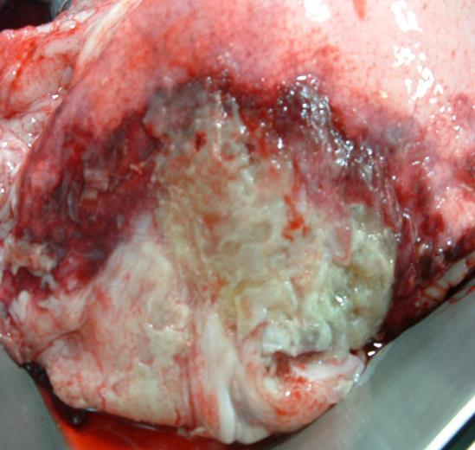
Acute pneumonia will have following signs:
- affected lung tissue thickens, hardens and becomes hyperaemic
- the affected lobe/s fill with bright red inflammatory exudate (pus)
- the infection may localise or extend throughout entire lung affecting both lungs.

This image shows how the exudate gravitates to the lung’s extremities. Because the animal stands so that the lung extremities point toward the ground the exudate gravitates to the lung tips.

Pneumonia – Chronic Suppurative

Abscesses form in lung tissue if pyogenic (pus generating) bacteria are present at the time of infection. These abscesses can be detected by palpating the affected area.
As abscesses increase in size they may erode onto the lung surface, however they usually localise within the tissue and cause no further problems to the animal.

Pneumonia – Heavy-body Inhalation

This is the result of heavy-body inhalation pneumonia, with both sides of the thoracic cavity affected
Pneumonia is inflammation of the lung tissue and pleurisy/pleuritis is inflammation of the serous membrane lining the thorax or covering the lungs – the pleura.
Generally, the disposition is to strip the pleura and or condemn the lungs. However, if the infection is acute with evidence of septicaemia, petechial haemorrhage, or polyserositis (inflammation of most serous membranes) condemn the carcase and parts.
Other conditions of the respiratory system seen at post mortem include:
- atelectasis (collapsed lung)
- emphysema ( over inflated lung)
- pigmentation of lungs
- aspiration of blood, scalding water or ingesta
- bronchitis
The

Gangrene in lungs.

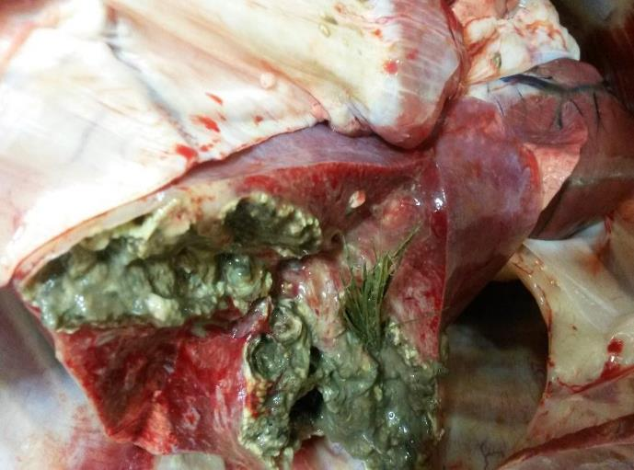
The cause of the gangrene is the spear grass that has been sucked into the lungs. Gangrene itself is usually not a problem as it rarely has a systemic affect.
Disposition: In this case the lungs are condemned and the carcase judged on its merits

Diseases related to the digestive system
Anaemia.

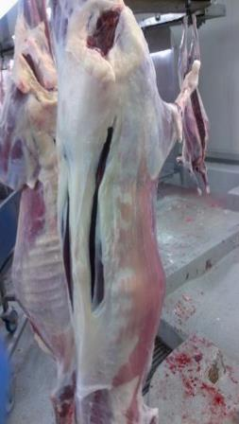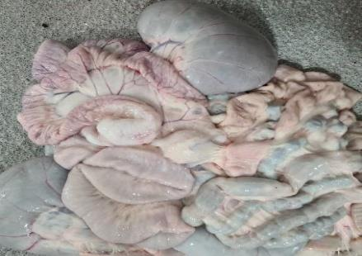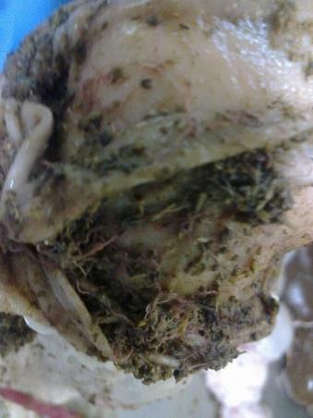
Look closely and you can see the worms. There are usually huge numbers

Aneamia is caused by the blood sucking worm haemonchus contortus (barbers pole worm). It lives in the abomasum (fourth stomach) and robs the animal of its red blood cells.

Disposition; In advanced cases the disposition is the condemnation of carcase and parts. With mild cases the carcase can be saved.
The farmer should be informed he has a problem with this parasite.

Oedema

Oedema is a build-up of fluid in the body which causes the affected tissue to become swollen. This image shows Oedema in the abdominal cavity of a ewe. This form of oedema is commonly associated with intestinal cancer in sheep, and may be attributable to blockage of lymph vessels.

Dark liver
Dark liver caused by drinking bore water. Has been associated with melanosis.
Disposition; Condemn the liver and judge the carcase on its merits.

Acute peritonitis
Acute peritonitis in a lamb gut which has spread to the abdominal wall in the carcass. Peritonitis is an inflammation of the serous membranes of the peritoneal cavity. Different agents (infectious and non-infectious) can cause peritonitis.
Disposition: The total condemnation of carcase and parts.
Enteritis
Lamb intestine with haemorrhagic enteritis. Enteritis can be caused by a range of agents including viruses and bacteria. In this case the infection is due to Clostridium perfringens type C.
At post-mortem inspection the instestines are reddened and inflamed while the mesenteric lymph nodes will be enlarged. The intestine is distended with gas and haemorrhagic fluid.
Disposition; Inflammation this bad would have a systemic reaction and the entire carcase would be fevered. The disposition would be condemnation of the carcase and its parts.

Cirrhosis of the liver.
Cirrhosis of the liver occurs when severely damaged liver cells are replaced by scar tissue. . This is a mild case and would have no effect on the carcase.
Disposition: Condemn the liver and judge carcase on merits.
Phytobezoars or bezoars
These unusual formations are called phytobezoars or bezoars . They can be seen in animals from drought affected areas where the animal has been searching for food in dirt the shapes are a combination of dirt and plant material. They are always found in the abomasum.
Disposition; Check the carcase for emaciation.

Oesophagostomum columbianum also known as pimply gut and knotty gut
Oesophagostomum columbianum also known as pimply gut or knotty gut is a parasite that attches to the mucosa on the inner lining of the gut.
Disposition; Condemn the intestines.
The producer should be informed they have a parasite problem.

Johne’s disease
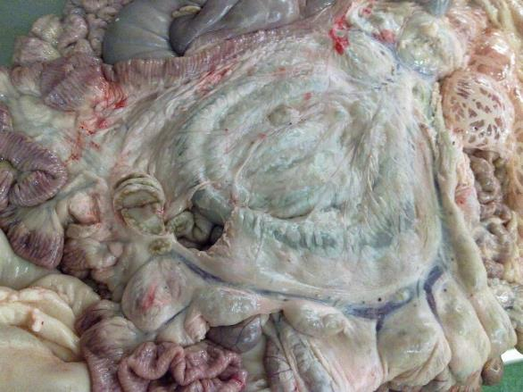
Johnes disease note the thickened ileum and the enlarged caudal mesenteric lymph node typical of this disease. This disease has to be confirmed by laboratory testing.
Disposition: Condemn intestines and judge the carcase on its merits.

Inguinal hernia
An inguinal hernia as seen at ante mortem. Always put such sheep up as suspect and inform the slaughter floor of possible contamination risks.
On the slaughter floor the gut should be pushed back through the hernia if possible and processed normally. If not possible remove the gut with minimal contamination and check for any perrritonitis and judge the carcase on its merits.
Diseases related to the excretory system
Infarcts
Infarcts due to a small blockage in the blood supply to a part of the kidney the area dies (necrosis) and appears wedge shaped.
Disposition: Condemn kidneys. In extreme cases the kidney function could be impaired and a check of the carcase for uraemia is warranted.
Polycystic kidney

Poly cystic kidney has been caused by small blockages in the kidney and the urine is retained in cysts.

Disposition; Condemn the kidneys and judge the carcase on its merits.
Hydronephrosis
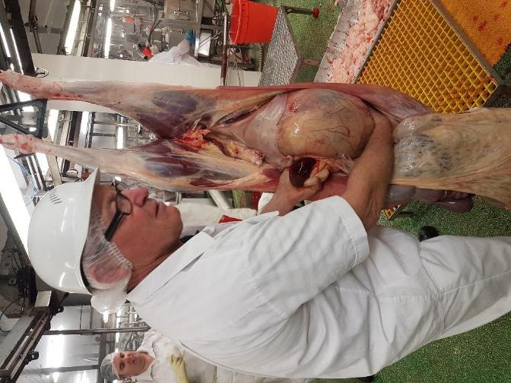
Hydronephrosis. In this case the kidney has grown to an enormous size due to the ureter being blocked trapping the urine in the kidney. If the swelling burst the animal would have died from peritonitis. In this case the other kidney was functioning ok so the carcase was passed after checking for uraemia.
This is a blocked urethra you can see the empty bladder there’s no infection so just the affected part needs to be condemned.
Gall stones
Gall stones. They don’t usually cause problems unless both kidneys are grossly affected.
Disposition: In mild cases condemn the kidneys and judge the carcase on its merits.
In extreme cases condemn the affected parts and check the carcase for uraemia.

Diseases related to the reproductive system
Metritis
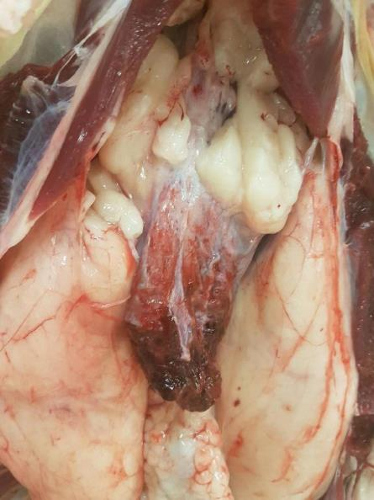
Metritis is the inflammation of the uterus and is caused by microbial infections.
Disposition: In acute cases with evidence of being septic, necrotic or putrefied condemn the carcase and its parts. In chronic metritis cases condemn the affected part and judge carcase on its merits.
Remains of a dead foetus
The remains of a dead foetus are in the uterus.
Disposition: if the body has completely encapsulated the foetus and there is no systemic affect then condemn the affected area and judge the carcase on its merits.

Diseases related to the central nervous system.
The only lesions an inspector could see at post mortem are neurofibromas which appear as small white benign growths often found on the ribs.

Diseases related to the endocrine system
Goitre
Goitre in a thyroid gland
The endocrine system rarely produces any pathological conditions, however areas of Australia where the pasture is low in iodine thus the thyroid glad cannot produce enough thyroxine the growth hormone the only evidence the inspector will see is enlargement of the thyroid gland.
Disposition: Remove the gland and judge carcase on merits.

Diseases related to the skin or integumental system.
Myiasis or fly strike
Myiasis or fly strike is normally picked up at ante mortem inspection. It si caused when wounds in the skin get flyblown.
Disposition: At ante mortem the animal would be rejected from slaughter. On the slaughter floor the carcase and its parts are condemned.

Contagious pustular dermatitis or Orf or scabby mouth
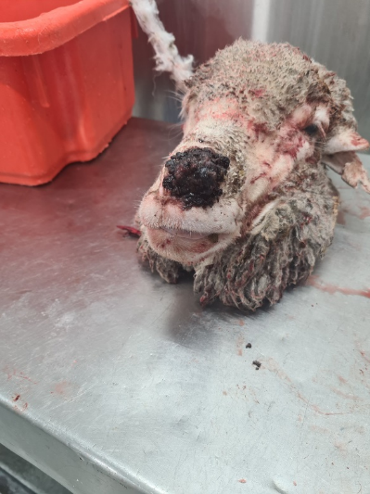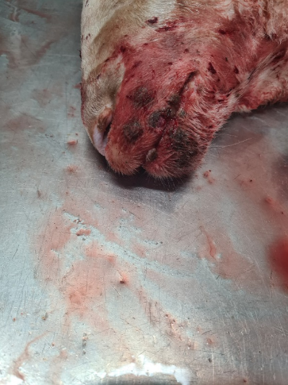
This is a highly infectious disease of sheep. Lesions are usually on the skin of the muzzle and the legs. It can also be seen in the udder due to infected lambs suckling on mother
The main cause is when sheep graze on rough pasture and the skin gets scratched and the virus enters through cuts. In the early stages scabby mouth can look like FMD lesions.
This disease is zoonotic and people who contract orf typically develop ulcerative lesions or nodules on their hands.

Diseases and conditions in Pigs
Diseases and conditions related to the Muscular skeletal system
Arthritis
Arthritis in pigs can be caused by bacterial infection. Above there are two images of typical arthritic joints. The image on the right has had the joint opened releasing the infected synovial fluid which has run down the carcase contaminating healthy tissue. Meat inspectors and trimmers should avoid this as it causes the need for unnecessary trimming.
If the infection is acute with evidence of septicaemia (fever) the carcase will
- look darker than normal
- internal organs will be inflamed.
There may also be petechial haemorrhage or inflammation of most serous membranes (polyserositis).
The disposition in acute cases is that the carcase and parts should be condemned.
Chronic infections, may have multiple affected joints but if there is no evidence of septicaemia, or cachexia (wasting) then the affected parts should be trimmed and condemned with care taken not to release the infected synovial fluid.

Pale soft exudate (PSE) also known as fish muscle

PSE is the result of the pig being stressed prior to slaughter and this causes the body temperature to rise which destroys the structure of the muscle. The product is useless for any form of processing.
The disposition PSE is to remove all the affected muscles by trimming and judge the remainder on merits. Meat inspectors should report this to an OPV in an export works or the QA manager in a domestic plant as this condition is a result of bad animal handling practices.
Infections abscess formation

Infections in pigs that originate in the skin either from wounds or inoculations can look small from the outside but can travel through the muscles resulting in large abscesses.
The disposition is to carefully remove all infected areas and check the carcase for signs of further infection or fever. If the carcase is normal remove the infected areas and judge carcase on its merits. If the carcase shows signs of fever or septicaemia condemn carcase and parts.

Tail bight infection

Tail bight infections are one of the more common muscular/bone infections. The cause of tail biting can be diet related or boredom. The important thing for inspection is the infection can spread along the spine causing large, abscessed areas.
The inspector should direct the carcase to the retain rail for a thorough inspection.
Jaundice (icterus)
Jaundice is normally caused by an obstruction in the liver (obstructive jaundice). This causes the bile pigments bilirubin to be transported around the body via the lymphatic system into the blood system staining the body tissue yellow.
The disposition is if haemolytic or toxic the carcase and parts are condemned .
If the obstruction is slight it will dissipate within 24 hours . The disposition is to retain in retain cage in chillers using ECA4 or company retain system and check if colour has gone in 24 hours. If the colour has not gone condemn the carcase and ist parts.
If the obstruction is severe condemn the carcase and its parts. In export works the OPV will make the disposition.

Diseases related to the circulatory system
Swine erysipelas

The images are of a heat affected by swine erysipelas .
The disposition is to condemn the heart only but in cases of acute swine erysipelas the complete condemnation of carcase and parts is required. Acute erysipelas- septicaemia will be marked by high fever and changes in the skin.
Swine erysipelas in its mildest form of the disease is also known as Diamond Disease. If there is no systemic affect remove the raised lesions by trimming or in extensive cases may require removal of the entire skin.

Diseases related to the respiratory system.
Pneumonia and pleurisy
Acute pneumonia Pleurisy resolved acute pleurisy.
Pneumonia is inflammation of the lung tissue and pleurisy/pleuritis is inflammation of the serous membrane lining the thorax or covering the lungs – the pleura.
Generally, the disposition is to strip the pleura and or condemn the lungs. However, if the infection is acute with evidence of septicaemia, petechial haemorrhage, or polyserositis (inflammation of most serous membranes) condemn the carcase and parts.
Other conditions of the respiratory system seen at post mortem include:
- atelectasis (collapsed lung)
- emphysema ( over inflated lung)
- pigmentation of lungs
- aspiration of blood, scalding water or ingesta
- bronchitis
- sinusitis.
For these conditions the disposition is to condemn the affected lungs.

Diseases related to the urinary / excretory system
Poly cystic kidney and nephritis
Poly cystic kidney Nephritis
A poly (many) cystic kidney is caused by blockages in the kidney not allowing the urine to the ureter
The disposition is to condemn the affected kidneys. In a severe case check the carcase for uraemia. Nephritis inflammation of the kidney is generally associated with a systemic condition i.e. fever in which case the disposition is to condemn the kidneys and check the carcase for uraemia and fever Judge the carcase on merits.
Diseases related to the digestive system.
Miliary tuberculosis.

Miliary tuberculosis is a notifiable disease and the disposition is to retain the carcase and all parts and contact the OPV immediately or in a domestic plant call 1800675888.

Hair ball

The image above is a hair ball in a pig’s stomach. The cause is diet related and the pig has licked hair from their own body or bodies of other pigs. The condition is usually associated with emaciation. The disposition is to judge all affected areas of the carcase on merits and inform the producer.

Ascaris lumbricoides also known as ascaris suum
Normal liver Affected liver
The parasite is found in the duodenum section of the small intestine where they wait for the stomach to release food into the intestine then consume it. Consequently, the condition is often associated with emaciation. Part of the life cycle is the eggs pass through the liver causing white scar tissue sometimes referred to as milk spots.
Occasionally the inspector will see milk spot livers with no worms in the intestines all this means is the producer has wormed the pigs.
The disposition is to condemn the affected parts and judge the carcase on its merits. If worms present inform the producer.
Emaciated pig

Emaciated pig
Emaciation can be caused by a variety of agents including worms, a hair ball, or a digestive system problem.
Disposition; In extreme cases condemn the pig in the yards, milder cases can be put up as suspect animals and the cause identified on the slaughter floor.
The disposition is to judge the carcase and parts on their merits. There is little value in an emaciated pig in most cases it’s not worth processing.
Hernias
Hernia at ante mortem Hernia hole in abdominal wall
A hernia is a common condition seen at ante mortem. The intestines have fallen through a hole in the abdominal wall.
The disposition at antemortem is to put up as a suspect and inform the slaughter floor to take extra care to avoid contamination from spilled gut contents.
Emphysema pig intestines
Emphysema in pigs instestines appear as balls of gas in the intestinal wall. The cause is thought to be bacterial infection or vitamin deficiency. The gut proper is usually normal.
The disposition is to condemn as they can not be used to produce runners.

Acute enteritis
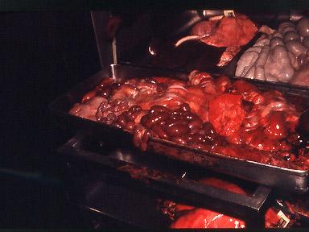
Enteritis is inflammation of the intestines. This case would almost certainly be associated with a generalised fever and the disposition would be to condemn the carcase and its parts
Mild peritonitis

Peritonitis is inflammation of the peritoneum and in this flare fat. The disposition in mild cases like this only require condemnation of the flare fat. More intensive cases associated with fever require condemnation of carcase and parts.

Diseases of the reproductive system
Balanitis is an infection of the penis while orchitis is an infection of the testicles not normally seen in pigs . Acute metritis is a gross enlargement of the uterus and is usually caused by a trauma at birth or the retention of a piece of placenta.

;
Diseases of the central nervous system
Rarely seen in pigs the only disease that does affect pigs is nuro sarcoma which appears as small white benign growths on ribs.
Diseases of the endocrine system
The only disease of an endocrine gland the inspector is likely to see is simple goitre. If the diet is deficient in iodine goitre can result and the thyroid gland will be bigger than normal.
The only indication in the carcase is stunted growth and general weakness.
Diagnosis should only be made by a veterinarian who may send samples for lab analysis and inform the producer of the results.
Diseases of the skin or integumental system.

Swine erysipelas (diamonds disease)
The disease gets its common name from the diamond shaped lesions caused by infection with erysipelothrix rhusiopathae it’s a zoonotic disease transmissible to man so care is needed when handling infected carcases.
The disposition is that if the condition associated with a systemic involvement e.g. fever, septicaemia, polyserositis then the carcase and its parts are condemned
If the skin lesions are only mild then trim lesions when there are more extensive lesions the entire carcase would need to be skinned.
Melanoma on the skin
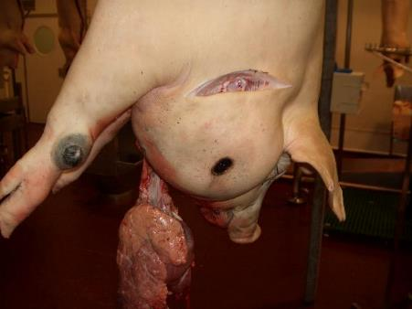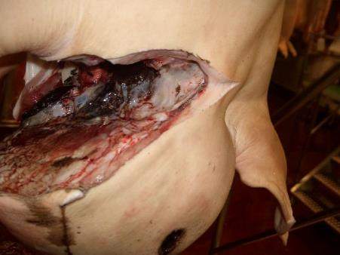
Melanoma is a tumour originating in pigmented cells normally found between the epidermal cells of the basal layers of the skin. They are benign growths – neoplasms.
Disposition; if the lesion (dark areas) have not progressed beyond the immediate draining lymph node. Trim the lesions and condemn the trimmings.
If evidence of further spread to the next lymph node then the disposition is to condemn the carcase and its parts.

Poisoning of food animals
Plant poisonings
Photosensitisation may occurs when animals with unpigmented skin are exposed to sunlight after eating plants such as trefoil or St John’s wort.
Pigs show areas of hairless purple discolouration and scabs may develop. This can be confused with sunburn. This is more common in pigs up to four months of age.
The disposition requires trimming minor areas of affected skin. In extensive cases the entire skin would be removed and the carcase judged on merits.
Facial Eczema
The cause of facial eczema is grazing on lush green pasture which can on occasions produce a toxin.
The symptoms are that animals are restless, shaking their heads, ears droop and have fluid build up in the eyelids, face, tongue, lips, submaxillary space. The legs are occasionally swollen. The body temperature of animals will be elevated. Animals will seek shade and rub the affected parts causing abrasions. The animal’s urine will be dark and frothy.
At post mortem the affected areas will reveal copious serous exudation fluid being straw coloured . The kidneys may be congested with exudate in the renal area.
The disposition in an export works will be made by the OPV only.
Lantana poisoning also known as pink nose
Lantana crocea is a deadly poisonous grass found in Queensland and northern NSW. At
ante mortem there will be necrosis in the rim of the muzzle and mouth (pink nose). At post mortem there will be icterus (jaundice) and ecchymosis in mucus membranes. The mucous membrane of mouth will be pink and may have necrotic tumors. The regional lymph nodes wil be enlarged and congested. The liver will be pale, friable and swollen while the gall bladder will be dilated.
Disposition in the export works is to be done by OPV only.
Sour sob poisoning or oxalic poisoning
Soursobs contain large quantities of oxalic acid.
At antemortem the sheep may have difficulty rising possible knuckling over of the fetlocks and joint stiffness.
At post mortem the affect is confined to the kidneys which show varying degrees of nephritis. The kidneys will be greatly swollen with fluid build-up and the capsule falls off when incised. Renal lymph nodes will also be enlarged.
Disposition; condemn kidneys and judge the carcase on merits and notify the producer.

Applying knowledge of anatomy and physiology to the interpretation of post mortem procedures
What are the physiological and anatomical features required to be inspected in the Australian Standard for the major food species?
The AS4696:2023Australian Standard for the hygienic production and transportation of meat and meat products for human consumption and the Australian Standards for other species detail the post-mortem inspection requirements for all animals slaughtered at abattoirs both domestic and export.
There are extra inspection procedures to meet certain export market requirements that are in addition to those detailed in the standard. These extra requirements will be provided by the controlling authority work instructions.
Important note: In 2020 the Australian Meat Regulators Group (AMRG) approved 14 alternative techniques and procedures for post mortem-inspection and dispositions outlined in Schedules 2 and 3 of the Australian Standard. AMRG released the following guidelines Guideline 2020:1. Post-Mortem Meat Inspection – Alternative techniques to Schedule 2 and 3 of AS 4696:2023 which for domestic abattoirs means there are changes to some current inspection and disposition practices. These changes include more visual inspections and less requirements for incisions in Schedule 2 as well as more detail regarding acute and chronic nature of conditions with regard to disposition judgements in Schedule 3
In export plants the amendments set out in the guidelines will apply only after the standard AS4696: 20 23is formally amended. However, for export plants even after standard is formally modified the matter of importing country requirements means that an equivalence argument will have to be had on a market by market basis before the changes to Schedule 2 and 3 can be implemented.
More information about this Guideline and associated Fact Sheets can be found on the MINTRAC website: www.mintrac.com.au
The carcase and viscera must be inspected. Only the heads of cattle and buffalo require inspecting unless part of the head including the tongue is going to be kept for human consumption. An approved batching program negates the need to inspect the head only the recovered parts.

In the Schedule 2 of the Australian Standard details are given in table form as below:
buffalo means any bubaline greater than 50kg dressed weight
calf means a young bovine or bubaline no greater than 50kg dressed weight
cattle means any bovine greater than 50kg dressed weight
incise means to examine by observation and multiple slicing
palpate means to examine by observation and palpation.
Note #1: Equivalent procedures are simpler procedures that can be used when either product is not being kept for human consumption or certain diseases have been officially declared as not present in the particular State or Territory.
Note #2: Additional procedures are procedures carried out when disease is detected or suspected. It also includes procedures for product that is not normally kept for human consumption.
Table 1. Carcase
 | Cattle & buffalo | Calves | Sheep & goats | Lambs | Pigs | Horses | Deer
All carcases | Observe internal and external surfaces of carcase (including tail, musculature, exposed bone, joints, serous membranes).
Lymph nodes
Superficial inguinal | See note #1 | Observe | See note #2 | Observe | See note #3 | Incise | Observe
Internal iliac | See note #1 | Observe | Palpate | Observe | Observe | Observe | Observe
Lumbar | — | — | Palpate | Observe | Observe | — | —
Ischiatic | — | — | Palpate | Observe | — | — | —
Precrural | — | — | See note #2 | Observe | — | Palpate | —
Superficial cervical | — | — | See note #2 | Observe | — | Palpate | —
Popliteal | — | — | Palpate | Observe | — | — | —
Prepectoral | — | — | — | — | — | Incise | —
Equivalent procedures
Note #1: Cattle and buffalo – Palpate the superficial inguinal and internal iliac lymph nodes or, for animals in an area in relation to which the relevant Commonwealth, State or Territory Authority requires minimal risk inspection for tuberculosis (other than animals subject to conditional slaughter or emergency slaughter), an equivalent procedure is to observe the nodes (other than in bulls and mature females).
Note #2 : Sheep and goats – Palpate the superficial cervical, precrural and superficial inguinal lymph nodes or, other than animals subject to conditional slaughter or emergency slaughter, an equivalent procedure is to excise and discard these nodes without inspection.

Note #3: Pigs – Observe the superficial inguinal lymph nodes or, other than animals subject to conditional slaughter or emergency slaughter, an equivalent procedure is to excise and discard these nodes without inspection.
Table 2. Viscera
 | Cattle & buffalo | Calves | Sheep & goats | Lambs | Pigs | Horses | Deer
Lymph nodes
Bronchial & mediastinal | See note #1 | Palpate | Palpate | Observe | Palpate | Incise | Palpate
Portal | Palpate | Palpate | Observe | Observe | Palpate | Palpate | Observe
Mesenteric | Observe | Observe | Observe | Observe | Observe | Observe | Observe
Lungs | Palpate, except in lambs where observe. Additionally, bronchi opened and internal surfaces observed when saved for human consumption.
Heart | Palpate. Incise internal musculature 3-4 times in cattle and buffalo.
Liver | Palpate, except in lambs where observe. Incise main bile ducts transversely and observe contents, except in pigs where inspection of bile ducts not required (see note #2 for option).
Gastrointestinal tract | Observe. Observation of oesophagus not required in cattle, buffalo, calves or deer unless recovered for human consumption.
Spleen | Observe | Observe | Palpate | Observe | Observe | Palpate | Observe
Kidney (enucleated) | Palpate | Palpate | Observe | Observe | Palpate | Palpate | Palpate
Other tissues and organs | Thymus, pancreas, non-gravid uterus, bladder, testicles and penis observed when recovered for human consumption.
Equivalent procedures
Note #1: Cattle and buffalo – Incise bronchial and mediastinal lymph nodes or, for animals in an area in relation to which the relevant Commonwealth, State or Territory Authority requires minimal risk inspection for tuberculosis (other than animals subject to conditional slaughter or emergency slaughter), an equivalent procedure is to observe the nodes.
Note #2 : All animals – Procedures for the incision of main bile ducts and observation of contents may not be required at a meat business by the controlling authority.
Table 3. Head
 | Cattle & buffalo (see note #3) | Calves (see note #1) | Sheep & goats (see note #1) | Lambs (see note #1) | Pigs (see note #1) | Horses (see note #1) | Deer (see note #1)
All carcases | Observe external surfaces. For cattle, buffalo and horses observe the oral, buccal and nasal cavities.
Lymph nodes
Submaxillary | See note #2 | — | — | — | See note #4 | Incise | —
Parotid | See note #2 | — | — | — | — | Incise | —
Retropharyngeal | See note #2 | — | — | — | — | Incise | —
Cervical | — | — | — | — | See note #4 | — | —
Masticatory muscles (internal and external) | Incise | — | — | — | — | — | —
Tongue | Palpate | — | — | — | — | Palpate | —
Gutteral pouch | — | — | — | — | — | Palpate | —
Other tissues | Tongue roots in cattle, buffalo and horses observed when recovered for human consumption
Equivalent procedures
Note #1: All animals – Other than cattle, buffalo, horses and animals subject to conditional slaughter or emergency slaughter, an equivalent procedure is to remove and discard the head without inspection where tissues, including tongue, are not recovered for human consumption.
Note #2: Cattle and buffalo – Incise submaxillary, parotid and retropharyngeal lymph nodes or, for animals in an area in relation to which the relevant Commonwealth, State or Territory Authority requires minimal risk inspection for tuberculosis (other than animals subject to conditional slaughter or emergency slaughter), equivalent procedures are:
1. observe only, or
2. excise and discard these nodes without inspection.
Note #3: Cattle and buffalo – Other than animals subject to conditional slaughter or emergency slaughter, for animals in an area in relation to which the relevant Commonwealth, State or Territory Authority requires minimal risk inspection for tuberculosis, an equivalent procedure is to discard the head without inspection when tissues, including tongue, are not recovered for human consumption.
Note #4: Pigs – Incise and observe submaxillary and cervical lymph nodes or, other than animals subject to conditional slaughter or emergency slaughter, equivalent procedures are:
1. observe only, or
2. excise and discard these nodes without inspection.
Table 4. Additional procedures when specific diseases are detected or suspected
Disease | Inspection procedure
Tuberculosis in cattle and buffalo | Incise atlantal, prescapular, prepectoral, suprasternal, superficial inguinal, iliacs, ischiatic, precrural, portal and mesenteric lymph nodes. Incise popliteal lymph node where necessary to determine the extent of infection. All viscera, serous membranes, spinal cord and severed vertebral column inspected by observation, palpation and, where necessary, incision. Udders incised and observed.
Tuberculosis in pigs | Incise retropharyngeal, parotid, bronchial, mediastinal, portal, gastric, mesenteric, superficial inguinal, , lumbar, precrural, prescapular and deep inguinal lymph nodes. Viscera and serous membranes inspected as above for cattle.
Tuberculosis in horses | As above for cattle.
Tuberculosis in deer | Incise submaxillary, retropharyngeal, parotid, bronchial, mediastinal, mesenteric, portal, superficial inguinal, iliac, ischiatic and suprasternal lymph nodes. Incise popliteal lymph node where necessary to determine the extent of infection. Viscera and serous membranes inspected as above for cattle.
Cysticercus bovis In cattle, buffalo and deer | Incise masseter and heart muscles, incise tongue, incise diaphragm after removal of serous membranes and observe all exposed muscle surfaces.
Cysticercus celluosae in pigs | As above for C. bovis.
Sparganosis in pigs | Observe retro-peritoneal tissues after removal of the peritoneum. Where further evidence of infestation revealed, also observe main muscle seams of the hind limbs. Incise as necessary to determine extent of infection.
When carrying out post mortem inspection there are four basic procedures used in meat inspection:
- observation or visual inspection
- smell
- palpation
- incision.
Note: observation is sometimes referred to as visual inspection.
Important note: In 2020 the Australian Meat Regulators Group (AMRG) approved 14 alternative techniques and procedures for post mortem-inspection and dispositions outlined in Schedules 2 and 3 of the Australian Standard. AMRG released the following guidelines Guideline 2020:1. Post-Mortem Meat Inspection – Alternative techniques to Schedule 2 and 3 of AS 4696:2007 which for domestic abattoirs means there are changes to some current inspection and disposition practices. These changes include more visual inspections and less requirements for incisions in Schedule 2 as well as more detail regarding acute and chronic nature of conditions with regard to disposition judgements in Schedule 3
In export plants the amendments set out in the guidelines will apply only after the standard AS4696: 2007 is formally amended. However, for export plants even after standard is formally modified the matter of importing country requirements means that an equivalence argument will have to be had on a market by market basis before the changes to Schedule 2 and 3 can be implemented.
More information about this Guideline and associated Fact Sheets can be found on the MINTRAC website: www.mintrac.com.au
Observation
The Department of Agriculture Water and the Environment definition of observation is “To visually inspect a carcase and its parts in such a manner that abnormalities capable of being located are detected. In all instances observation refers to each surface of the item being observed. Observation may require the physical handling and/or incision of the carcase and/or carcase parts to allow complete observation of all surfaces. Observation also includes the use of the sense of smell to detect abnormal odours.
All parts of an animal must at least be visually observed. It is important to look for changes in colour and symmetry and variations to the norm. The importance of this aspect of inspection is the main reason why people with colour blindness are generally not accepted as meat inspectors. Visual inspection cannot be done from a distance. Since all surfaces of the carcass and organs need to be visually inspected it is necessary as part of the inspection procedure to handle and turn organs and parts as appropriate. Carcases must be carefully observed, paying particular attention to:
- colour
- odour
- symmetry
- general condition.
- age.
In the case of the internal surfaces particular attention should be paid to:
- the pelvic cavity
- the peritoneum and pleura
- the thoracic and abdominal surfaces of the thick and thin skirts
- the cut surfaces of the sternum and spine
- the ribs.
In the case of external surfaces particular attention should be paid to:
- the hocks and trotters
- the tail
- the sticking area
- the axillary regions
- the anus.
All surfaces of offal presented for inspection must be visually inspected, this means offal must be turned during inspection.
Incision
The Department of Agriculture Water and the Environment definition (Meat Manual Volume 3) of an incision is “To cut with a knife. Wherever incisions are specified the inspecting officer is also required to observe incised surfaces and may also be required to palpate cut/exposed surfaces”.
It may be for access purposes to improve observation or it may be a specific incision required by legislation to detect disease. It is essential that proper equipment be used for incision. Such equipment includes a keen knife, a safety hook and a well-dressed steel. Lymph nodes that require incision should be carefully sliced such that the cut surfaces are laid open for examination like the leaves of a book.
Unnecessary mutilation must be avoided and to facilitate a tidy `job' different knives may be used for different inspection procedures, for example a short thin blade may be used for pig-head inspection, whilst a long broad blade may be preferred for cattle-carcass inspection.
Palpation
The Department of Agriculture Water and the Environment definition (Meat Manual Volume 3) of palpation is “To examine by the sense of touch and feel all surfaces of any carcase and/or carcase parts so that any abnormality on or within the carcase or carcase part which is able to be detected by palpation is detected. Palpation refers to every surface of the carcase or carcase parts being palpated”
Palpation is equally as important as observation and incision and must be carried out diligently. Organ palpation requires firm pressure by the fingers and palms of the hand over the entire organ surface. Organs palpated include the kidneys, liver, spleen and lungs.
Lymph-node palpation requires firm pressure with the fingers and thumbs, rolling the nodes between them.
Laboratory analysis
Sometimes samples may need to be sent to a laboratory for diagnosis. This may be:
- because the cause of the condition is unknown
- for laboratory confirmation of notifiable diseases such as hydatids in Tasmania
- as part of routine sampling for residue sampling programmes etc.
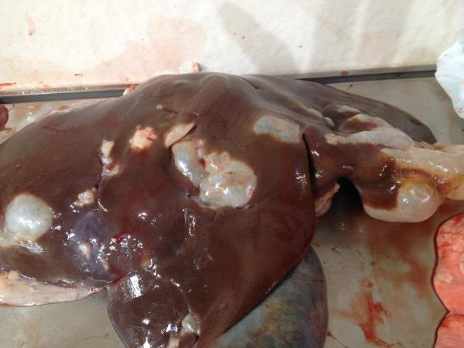
Evidence of hydatids in a liver
© MINTRAC
General requirements
Action | Explanatory notes
Identifying incoming carcases by viewing | - appropriate ante-mortem card  - approved correlation system, e.g. tag, ticket, pencil marking.

Action | Explanatory notes
Monitor presentation | - correlation of carcases and head with offal until final disposition  - dressed carcases:  - except for kidneys, with thoracic & abdominal viscera removed  - except for pigs, with the extremities separated from the carcase at a point distal to the carpal and tarsal joints  - if presented with the kidneys in situ, the kidneys must be separated from the kidney capsule and perirenal fat  - viscera and internal organs:  - with, if practicable, the alimentary tract separate from other viscera intended to be saved for human consumption  - with the heart separated from the pericardial sac  - with the enucleated kidneys separated from the perirenal fat  - in the case of cattle, buffalo and solipeds, with the liver separated from other viscera  - in the case of mature males or castrates, the associated parts of the reproductive system completely removed  - heads if being inspected  - must be skinned to the extent necessary to remove the brain or completely skinned if head meat is to be saved  - if nothing is saved the head must be skinned sufficiently to allow inspection to take place  - tongues of calves, sheep, lambs or goats:  - if separated from the head and presented on a viscera table, must be washed clean and trimmed free of any pieces of hide or skin.
Carry out inspection | - routine:  - observe  - palpate  - incise  - sample and analyse  - options as detailed in the Standard  - additional requirements for particular conditions as detailed in the Standard  - Special procedures for specific export markets  - carry out a complete inspection of all carcases and/or carcase parts, even if grossly contaminated and ultimately condemned
Make disposition | - according to Schedule 3 of the AS 4696:2007 Australian Standard for the hygienic production and transportation of meat and meat products for human consumption and according to the any specific market requirements on export registered plants
Retain, where applicable | - total carcase – including its parts  - For disposition by a veterinarian on export registered establishments or for laboratory diagnosis
Report deficiencies | - to management and request corrective action.
The precise requirement of what has to be inspected during a post-mortem inspection will depend on whether the plant is domestic or export-registered. However, the general requirements that the meat safety officer must meet when carrying out the inspection are:
- ensuring only animals that have undergone ante-mortem inspection are presented for post-mortem inspection
- ensuring carcases and carcase parts are correctly identified and correlated for post-mortem inspection
- ensuring carcases and carcase parts are correctly presented for post-mortem inspection
- ensuring the resources and conditions necessary to effectively conduct post-mortem inspection are provided
- undertaking post-mortem inspection of carcases and/or carcase parts as directed
- making a disposition to the suitability of the carcase and its parts for human consumption
- retaining carcases and carcase parts for veterinary examination (export plants only) or laboratory examination
- ensuring, where appropriate, the quality and integrity of the product is maintained.
Post mortem inspection is:
- to identify diseased and unwholesome meat, to prevent it from being sold for human and animal consumption
- to identify and break the cycle of many diseases, preventing transmission between humans and animals, and animals to animals
- to assist with the trace-back of diseases to the property of origin
- to assess whether hygiene and good manufacturing practices are being followed during slaughter and dressing, to maintain the wholesomeness of the product.
It ensures that only clean and disease-free carcases or parts are accepted for human consumption.
Post-mortem inspection is also important for ensuring that animals are handled humanely. For example, a post-mortem inspection can find out if multiple stuns have occurred to the one animal. Likewise post-mortem inspection can reveal evidence of dog bites or signs of recent bruising.

