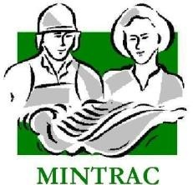

AMPQUA301
Comply with hygiene and sanitation requirements
Training support materials

Australian Meat Processing Training Package
Certificate III in Meat Safety

Elements and performance criteria

Element | Performance Criteria | Covered on pages

1. Identify requirements for hygiene and sanitation in the workplace | 1.1 Identify regulatory requirements for hygiene and sanitation relevant to own work area  1.2 Identify the workplace hygiene and sanitation requirements in place in own work area  1.3 Identify the purpose of the hygiene and sanitation requirements
2. Clean and monitor own work area | 2.1 Hygienically clean own work area during operations to workplace health and safety, food safety and regulatory requirements  2.2 Hygienically clean equipment and surfaces to regulatory and workplace requirements  2.3 Monitor cleanliness of work area according to workplace requirements  2.4 Complete routine monitoring records
3. Identify sources of contamination and spoilage | 3.1 Identify contamination risks and take steps to reduce the risk  3.2 Take corrective action, according to workplace and regulatory requirements, when contamination is identified
4. Follow personal hygiene and sanitation requirements | 4.1 Follow personal hygiene practices to workplace requirements  4.2 Handle product according to workplace and hygiene and sanitation requirements  4.3 Conduct work hygienically according to workplace requirements  4.4 Process products according to regulatory requirements

Required Knowledge:
Topic | Covered on pages
This includes knowledge of:
- key hygiene and sanitation requirements included in relevant Australian Standard
- hygiene and sanitation requirements for work area
- common microbiological, physical, chemical and other hazards related to meat handled in the work area, including the types of hazards likely to occur, the conditions under which they occur, possible consequences, and control methods to prevent occurrence
- time, temperature and moisture requirements for microbial growth
- causes of food spoilage and poisoning
- possible sources of contamination in own work area
- visual evidence of contamination
- workplace procedures for:
- hygiene and sanitation in work area
- responding to contamination
- consequences of contaminated or spoiled meat leaving the premises
- consequences of failing to follow workplace requirements for hygienic handling and processing of meat
- purpose of hygiene and sanitation monitoring
- hygiene and sanitation monitoring methods
- the difference between cleaning and sanitation.

Training support materials for AMPQUA301 Comply with hygiene and sanitation requirements
What are hygiene and sanitation practices?
Hygiene and sanitation practices are the things we do to keep ourselves, the plant and the meat we process clean. This includes:
- hand washing
- clean uniforms
- following work instructions
- cleaning the plant during and after production.
Hygiene and sanitation is all about producing safe food. All food processors including meat workers have a responsibility to produce food which is safe to eat. Consumers expect to be able to eat meat products without becoming ill or eat products containing a disease.
Food safety is achieved through the hygiene and sanitation procedures that we follow to ensure our food remains wholesome and as free from contamination as we can make it.

What are the key hygiene and sanitation requirements included in Australian Standard AS4696: 2023?
Minimum standards of hygiene and sanitation are law and laid down in the AS 4696:2023 Australian Standard for the hygienic production and transportation of meat and meat products for human consumption..
Student Exercise with AS4696
What are the importing country requirements above the Australian Standard AS4696: 2023
Importing countries also have specific hygiene requirements such as the EU’s two knife policy and the Suth Korean requirement to have a separate carton forming room
Contamination
What is contamination?
Contamination is anything on or in a meat product that should not be there. These are usually things which affect the food safety of the product.
What are the three main types of contamination?
There are three main types of contamination:
- physical – e.g. jewellery, rail dust, hair
- chemical – e.g. agricultural chemicals used on farms, cleaning chemicals not properly rinsed off equipment that get onto the meat.
- microbiological – e.g. any bacteria or bug that gets on the meat from us or the processing plant.

Physical contamination
What are the types of physical contamination that can happen in a meatworks?
Meat products can be physically contaminated. The types of physical contaminants found in meat include:
- jewellery
- pens
- band aids
- make up – nail polish etc.
- boning hooks
- grass seeds
- metal shavings, staples
- rail dust
- dirt
- condensation.
How does physical contamination happen?
Workers can cause physical contamination by dropping items such as pens or jewellery into cartons of meat.
Faulty machinery can cause metal shavings to fall onto the product. Rail dust can contaminate the product if cleaning programs are not good enough. The incorrect use of high pressure hoses can also blast dirt off the floor and all over a carcase.
If the carcase is not dressed or gutted properly, then wool or hair can cause physical contamination. Parts of the guts can be left in the carcase such as liver under the thin skirt in cattle. This is regarded as physical contamination.
Condensation is the water that drips down off the ceiling in slaughter floors, chillers and freezers. If this water falls on the carcase it can bring dust and dirt with it onto the meat.
Why is physical contamination a problem?
Consumers do not like finding physical contamination in food. Physical contaminants can choke them or break teeth, but it also tells them that the product was prepared in a plant where people did not take proper precautions.
When the product is to be further processed into smallgoods or hamburger mince, physical contamination like boning hooks and bone chips can cause damage to processing machinery.
If an export meat shipment has physical contamination such as grass seeds then the whole shipment or container load can be rejected at a big cost to the meat processor.
Physical contamination is also an issue for retail butchers who have to trim carcases of wool, hair, dust, dirt, grease etc. These trimmings have to be thrown out and means lost dollars to the butcher.
Most importantly, physical contamination can put more bacteria onto and into the product.
Student Exercise on physical contamination
Chemical contamination
What are the main types and sources of chemical contamination?
Agricultural chemicals
Agricultural chemicals such as insecticides and herbicides can find their way into the food chain and end up in meat products.
The Commonwealth government has a chemical residue testing program running in the industry to detect farms and animals affected by these chemicals.
Veterinary chemicals
These include drenches, dips, hormonal growth promotants and animal antibiotics. Veterinary chemicals can contaminate the meat if the slaughter occurs too soon after the chemicals were used on the animal. There is a testing and educational program to try and eliminate this problem.
Cleaning chemicals
Detergents and sanitisers are used to clean meat plants after each day’s operation. Only chemicals with documentation from the manufacturer stating that they are suitable for the food industry can be used in and around meatworks. If these chemicals are not used properly, they can leave residues on surfaces which will contaminate the meat. All companies have very strict procedures for using and storing chemicals.
Lubricants
Oils and grease can contaminate carcases leaving black or brown smears on the meat. This has to be trimmed off. Faulty or poorly maintained machinery will drip grease and oil onto the product.
Why is chemical contamination a problem?
If meat is contaminated by chemicals it might make people sick either in the short term or in the long term.
Consumers want to eat foods that are wholesome and free of dangerous chemicals. For this reason the Australian government and governments overseas regularly check meat products. It is important for the meat industry to always supply meat free of chemical residues. Scares about chemical residues have affected Australian meat exports in the past and the meat industry is doing a great deal to make sure this does not happen again.
Student Exercise on chemical contamination
Microbiological contamination
What are the main types of microbiological contamination found in a meatworks?

Moulds, virus and bacteria can all cause contamination of meat but bacteria are the main types of biological contamination in a meatworks.How does microbiological contamination occur?
There are a number of ways in which microbiological contamination can occur. Transfer of bacteria from:
· A food worker to the meat
· A physical contaminant to the meat
· The animal hide, hair or wool to the meat
· The animal guts to the meat

What are bacteria?
Bacteria – sometimes called germs or bugs – are very small single-cell creatures. Six million bacteria could fit on a match head and they can live almost anywhere.
There are three types of bacteria.
Food poisoning bacteria
Bacteria is the most common cause of food poisoning. The chart over the page shows some of the bacteria associated with food poisoning caused by meat products. Bacteria, such as E. Coli, also produce toxins or poisons which remain on the meat. Cooking does not destroy the toxins. So you can get food poisoning by eating the bacteria or eating the toxins produced by the bacteria. You cannot see or smell food poisoning bacteria.
Food spoilage bacteria
These are the bacteria which turn meat green and slimy and produce that strong ‘off’ smell. They are a major factor in reducing the ‘shelf life’ of meat products.
Harmless bacteria
Some of these are used to make cheese and yoghurt. Other bacteria live in our stomach and help us to digest our food.

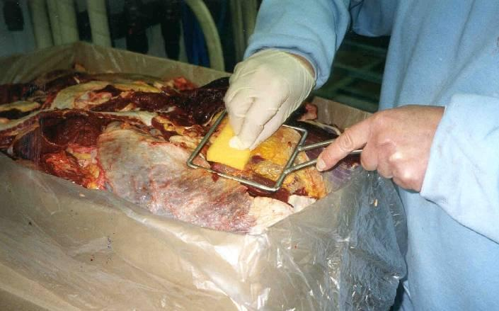
Swabbing carton meat during boneless meat reinspection
© MINTRAC
Both carton and carcase meat samples are tested to identify bacterial contamination.
What types of bacteria are there?
The following definitions of the different types of bacteria that can contaminate meat products are taken from The Problem of Foodborne Illness.
Botulism
These bacteria produce toxin only in an environment of little acidity. They are found in canned goods e.g. liver pate and also in luncheon meats, ham, sausage etc.
Campylobacteria
These bacteria found on poultry, cattle and sheep and can contaminate meat of these animals. Chief raw food sources include:
- raw poultry
- meat
- unpasteurised milk.
Clostridium perfingens
In most instances, this bacteria is present because of a failure to keep food hot. A few organisms are often present after cooking and multiply to toxic levels during cool down and storage of prepared foods. Meats and meat products are the foods most frequently implicated.
Salmonella
Found in and on raw meats, poultry, milk and other dairy p roducts.
E.coli 0157 and other Shiga toxigenic Escherichia coli (STECs)
The principle source of this bacteria is the gut content of animals. Found in and on the raw meat, this bacteria has been associated with major outbreaks of food poisoning. STEC infection can cause serious disease, including bloody diarrhoea, and sometimes chronic kidney damage or death from kidney failure.
Staphylococcus aureus
The toxin produced when food contaminated with this bacteria is left too long at room temperature is a major cause of food poisoning. Meat is a good environment for these bacteria to produce toxin.
Entamoeba histolytica
These protozoa exist in the intestinal tract of humans and are expelled in faeces. Poor personal hygiene can transfer this protozoa onto meat.
Listeria species
Listeria is common throughout the environment and is found in man, animals, soil and water. This causes a very dangerous form of food poisoning and pregnant women are particularly at risk. It is transmitted by eating contaminated food products, usually dairy products, pâté or uncooked vegetables.
Giardia lamblia (water contamination)
Giardia lamblia may be transmitted by uncooked foods that become contaminated while growing or after cooking by infected food handlers. Cool, moist conditions favour the protozoa’s survival.
What do bacteria need to grow?
Like most other living creatures, bacteria need warmth, moisture, food and time to survive and multiply.
Temperature
Bacteria will grow in temperatures between 4ºC and 60ºC. Below 4ºC the bacteria do not multiply, but they will not die either. Temperatures over 60ºC also stop bacteria from multiplying. Sterilisers on the slaughter floor and in boning rooms are used to kill bacteria on equipment and to stop bacteria multiplying.
Moisture
Most bacteria need water to grow; they cannot survive in dry conditions. That is why we try to keep boning room work surfaces dry.
Food
Bacteria need food to grow. Meat and fat are ideal foods for bacteria. It is essential we get meatworks totally clean at night to remove all possible food sources for the bacteria.
Time
Bacteria reproduce by splitting in half and forming two new bacteria. When there is warmth, food and moisture, bacteria can multiply every twenty minutes.

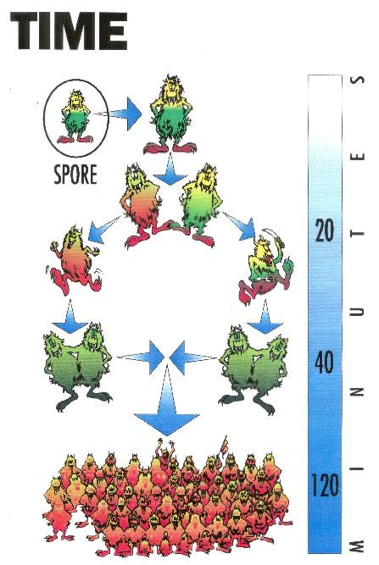
Time graph of bacterial reproduction
Courtesy of AQIS
Air
Not all bacteria need air to grow so even vacuum packed products can be contaminated.
Where do bacteria come from?
Bacteria live just about anywhere where there is moisture and food. In a meatworks there are five most likely sources of bacteria.
Humans carry all sorts of bacteria on and in them. They are often carriers of Staphylococcus aureus or Staph. This lives in the hair, ears, nose, armpits, groin, cuts, pimples and boils as well as under jewellery. The intestines of humans can also have Salmonella and E.Coli which is in the faeces.

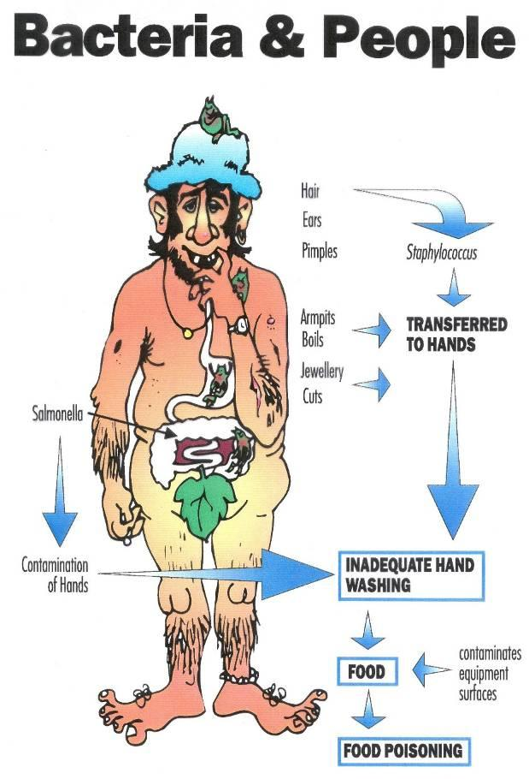
Sources of bacteria on humans
Courtesy of AQIS

Animals or livestock carry bacteria like Salmonella and E.Coli. These bacteria are in the gut content and in the faeces. The manure or faeces on the outside of the hide or pelt is also a source of bacteria which can get on the meat during dressing of the carcase.
Soil and grass around the meatworks are home to a lot of different types of bacteria.
Walls, equipment and floors which are not regularly and properly cleaned carry bacteria.
Rodents, birds and insects can carry disease and will bring bacteria into the plant and onto the product.
How does bacteria spread?
Bacteria are great hitchhikers and will use any number of ways to move about meatworks.
Humans carry bacteria on their bodies, boots and clothing. They pick up bacteria from one place and spread it around by touching and brushing against surfaces. They also cough and sneeze, further spreading bacteria. Infected sores always contain bacteria. If they are not covered they will contaminate work surfaces and product.
If high pressure hoses are not used correctly they can blast dirt and bacteria off the floor and onto work surfaces and meat.
Insects, birds and rodents like rats and mice carry bacteria which they can spread wherever they go.
How does bacteria get onto meat?
Meat under the hide or pelt is free from bacteria unless the carcase is diseased. It is only during dressing and processing that contamination happens. There are a number of causes including the following.
Workers who do not keep their hands, clothes and equipment clean can spread bacteria from themselves to the meat and from carcase to carcase.
If the plant and equipment is not cleaned properly this will provide a breeding ground for bacteria. The meat will be contaminated when it comes into contact with the dirty surfaces and equipment.
The hides or pelts of all livestock are covered with dust, dirt and manure. Bacteria breed on the hide or pelts of these animals. Bacterial contamination will be caused if workers let the hair or wool of an animal brush against the meat as can happen with flapping hides on cattle and roll back on sheep during dressing.
Rodents, insects and birds landing on equipment, walking around and defecating can spread bacteria in a plant and onto the product.
Even well dressed carcases have some bacteria on them after dressing. This is not a problem if it is kept to a minimum. However the problem occurs when even small amounts of bacterial contamination are allowed to multiply. Incorrect storage of meat is a major cause of microbial or bacterial growth. If not kept at a temperature below 4ºC bacteria grows rapidly and meat goes ‘off’ very quickly.

What are the consequences of a food poisoning outbreak?
If a serious outbreak of food poisoning can be traced to a meat product then there will be large amounts of negative publicity for:
- the meat industry in general
- the specific meat product for example salami or hamburger mince
- the meat processor responsible.
This will result in:
- a general decrease in meat consumption
- a marked decrease in sales of the particular product
- litigation
- serious problems for the processor responsible, with the processor going out of business almost immediately in some cases.
Food safety is everybody’s business in the meat industry because all our jobs are dependent on consumers trusting meat processors to produce meat products free from contamination.
How can the meat inspection process contaminate meat with bacteria?
If the meat inspection work instructions and SOPs are followed then the meat inspection process will not spread significant bacteria onto meat products. Meat under the hide or skin of an animal is sterile unless there is an infected wound or if the meat becomes contaminated due to poor dressing technique. Likewise the surface of offal is sterile unless there is a disease present or the paunch has been broken.
Where issues can arise is when an inspectors hands, uniform or knife becomes contaminated and this then causes cross contamination of other carcases or offal. Contamination can occur when a meat inspector’s hand or knife comes in contact with faeces on the carcase or paunch content. The meat inspector’s hand or knife can then spread contamination onto other meat and offal.
The inspector’s work instruction will spell out how a meat inspector responds to becoming contaminated, how they wash their hands and sterilise their knife.
How do we control the growth of microbes in a meat processing plant?
There are two ways in which bacterial growth is controlled in a meatworks:
- we control the number of bacteria on the product by good hygiene and sanitation practices
- we store the product at a temperature below 4ºC so the bacteria that are there do not multiply.

Preventing contamination
How do we prevent physical and bacterial contamination?
The main causes of contamination are:
- people
- plant and equipment
- livestock.
Most people do not want to deliberately contaminate meat. Workers can reduce the risk of accidentally contaminating the product by following:
- the rules for general hygiene and sanitation practices around the plant called Standard Operating Procedures (SOPs)
- specific instructions for each job called task descriptors or work instructions.
What is in the personal hygiene SOP?
There are many SOPs, but the one that affects all workers in the plant every day is the personal hygiene SOP.
It is essential that every worker knows the personal hygiene rules in his or her plant. These rules are based on the requirements of the AS4696:2023 Australian Standard for the hygienic production and transportation of meat and meat products for human consumption. In addition, export workers have to meet the Department of Agriculture Export Meat Orders and the requirements of the individual importing countries.
Below is an example of a personal hygiene SOP like those used in meat works throughout the country.
Sample only
Standard Operating Procedure for personal hygiene
Personal hygiene
- Clean outer protective clothing must be worn in all processing areas.
- All personal/street clothing must be fully covered.
- A clean set of company issue clothing must be collected each day from the clothing store.
- Clothing must be changed daily or whenever excessively soiled.
- Soiled clothing must be placed in the receptacles provided.
- Company issue protective clothing must not be worn off the establishment.
- Sitting is only permitted on the seating provided. Sitting on the grass or any other structure is prohibited, to prevent contamination of clothing.
- Footwear must be cleaned whenever entering or leaving the production area.
- All hair must be fully contained at all times when in production areas. This will require wearing a medicap and if necessary a beard snood.
- Rubber boots must be worn in all edible processing areas.
Lockers
- No clothing issued from laundry to be stored in lockers.
- Each employee is provided with a locker which must be kept clean and free of dust.
- Dirty protective clothing, dirty or rusty equipment and food scraps and other rubbish must not be stored in lockers.
- Personal or street clothes and company issue protective clothing must not be stored together. Footwear must be placed on the bottom of the locker and must not contact any other item.
Personnel access
- Employees must not move from an inedible or dirty area to an edible or clean area without first changing into clean outer protective clothing and footwear and thoroughly washing hands with soap and water. This also applies to visitors and livestock personnel.
- Maintenance staff and livestock personnel must not enter production areas without donning clean dust coat and hair covering.
- Visitors must be suitably attired for the area which they wish to visit. Traffic pattern will be to visit ‘clean’ areas first, i.e. boning room, chillers, load out, vacuum packaging and offal before entering ‘dirty’ areas. However, when classing the kill floor as a ‘dirty’ area, it will be visited before areas such as products, stockyards etc.
Personal equipment
- Personal equipment including knives, steels, pouches, hooks and mesh gloves must be cleaned and sanitised at the end of production each day and sterilised or resterilised before commencing work each morning.
- Mesh gloves when worn during processing on the kill floor prior to final inspection and when handling known contaminated product, e.g. kill floor final check trim, dropped meat, boning room pre trim, must be covered by an overglove made of rubber or PVC to allow washing with soap and water.
- Cut resistant gloves which are worn on an employee’s knife hand when worn in edible processing areas like the kill floor and tripe rooms must be completely covered by and overglove to allow washing with soap and water.
- All equipment must be cleaned before being hung on the racks provided at each break. Exceptions are cut resistant gloves and cloth aprons.
- Equipment must be washed and sterilised at regular intervals during production and whenever contaminated.
- Knives and implements that come in contact with carcases or carcase parts during dressing must be washed and sterilised:
  - after each hide opening cut
  - between carcases
  - after removal from pouch
  - after steeling (knives)
  - as directed by an authorised officer.
- Knife, hook and steel handles must be made from an approved material and be maintained in a good condition, free of fat or protein build-up.
- Knives and steels must be maintained free of rust or protein build-up.
- Equipment must not be worn outside production areas during breaks and must be hung on the racks provided in designated areas and not left on work tables, wash basins etc.
- Hand washing – means washing hands with soap and warm potable water.
- Wash hands with the hand soap and water provided at the commencement of each production shift.
- Wash hands with soap and water provided after using the toilet.
- Wash hands with soap and water every time you enter or leave a production area.
- Wash hands with soap after handling any type of contamination and before handling edible product.
- Wash hands immediately after coughing or sneezing into hands, wiping nose, scratching head, face or body under protective outer clothing and before handling edible product.
- Dry hands with the paper towels provided and dispose of towels in the receptacle provided.
- If engaged in the dressing of carcases and/or carcase parts, wash your hands and if necessary your arms:
  - when contaminated
  - when changing knife hand if hand was holding hide
  - as directed by an authorised officer.
Personal health
Any person suffering from the following ailments:
- severe cold or flu symptoms
- stomach cramps, vomiting and/or diarrhoea
- contagious or infectious diseases
- infected wounds or sores
- dermatitis, rashes, or skin irritations
- must see a doctor or consult with the occupational health nurse prior to commencing work.
All cuts and abrasions incurred at work must be immediately reported and dressed with a waterproof dressing.
All cuts, abrasions and wounds must be checked and dressed by the occupational health nurse each day before commencement of work.
You must present yourself for a medical examination as and when required by your employer.
Consumption of food and drink and smoking
- The consumption of food and drink is only permitted in the designated canteen areas, except where employees are permitted to drink from water dispensers provided in processing and adjacent areas.
- The consumption of food including confectionary in all non-designated areas is prohibited.
- Smoking is only permitted in the designated areas.
- Butts must be disposed of in the receptacles provided.
Jewellery and cosmetics
- All jewellery including watches, sleepers and keeper studs, must be removed before entering a processing area. Difficult to remove wedding bands must be covered with an impervious dressing. Medi alert identification is currently exempt.
- Nail polish, heavily scented hand creams and any other cosmetics that could contaminate the product must be removed before entering the processing area.
Personal habits
- Spitting, urinating or defecating in any place other than the sanitary facilities provided, is not permitted and will result in harsh disciplinary action.
- Employees must not use their mouth to hold items that come in contact with edible product or edible product contact materials.
- Employees must not blow air for the purpose of inflating or opening bags or coverings used to hold edible products.
Student exercise on Work Instructions and hygiene SOP for Meat Inspection staff
What are the general rules for personal hygiene in all meat plants?
Protective clothing
The protective clothing you wear is to protect the product from the bacteria you are carrying on your body and to protect you from the product.
The AS4696:2023 Australian Standard for the hygienic production and transportation of meat and meat products for human consumption requires that employees start work with a clean uniform and if the clothes become excessively dirty during the day, they must be changed. Hair nets are compulsory in all processing areas of meatworks.
It is important that you avoid contaminating your clothing which in turn could contaminate the product. Footwear carries a heavy load of bacteria picked up from the floor and should be thoroughly washed before entering meat processing areas. Footwear should also be washed before leaving an area so meat, fat and blood are not dragged through the plant attracting insects, rats and birds.
Lockers
All plants have detailed rules about lockers to make sure your street clothes do not contaminate your work clothes. Lockers should also be kept free of food scraps that would encourage insects and rodents. Most plants have a random inspection of lockers to ensure they are kept clean and neat.
Movement around the plant (personnel access)
Some areas in a meat works are heavily contaminated with bacteria, dust and dirt. These include:
- stockyards
- rendering plants
- skin sheds
- runner and paunch rooms
- pet food areas.
People who work in these areas are not permitted to go into other processing areas without changing their clothes and washing their hands. Likewise, maintenance people must be dressed so they don't contaminate the product and they must wear a head covering.
Personal equipment
The SOP also details when workers have to clean and sterilise personal equipment including:
- knives
- steels
- aprons
- gloves
- arm guards.
Equipment must be washed or sterilised when it has come into contact with contaminated items such as the hide or pelt of the animals or dropped meat. This equipment must usually be stored either in the processing area during breaks, or in a locker after work. It cannot be worn into toilet areas.
Hand washing
Hand washing is one of the most important hygiene tasks you perform.
The SOPs explain when you have to wash your hands, that is before or after you leave a processing area. The general rule is if you are handling meat products you must wash your hands every time they become contaminated. For example in the boning room, you should wash your hands after handling dropped meat.
Washing hands has to be done thoroughly, otherwise a lot of bacteria are left on the skin. The correct method of hand washing involves the following steps:
- turn on the tap
- wet your hands with hot water
- use soap to lather your hands and then rub lather up to your elbows
- scrub under your finger nails with a brush
- rub the lather between your fingers and rub your hands all over for at least 30 seconds
- rinse off all soap with warm water
- dry your hands
- don't touch your face, clothes or other parts of your body after you have washed and dried your hands.
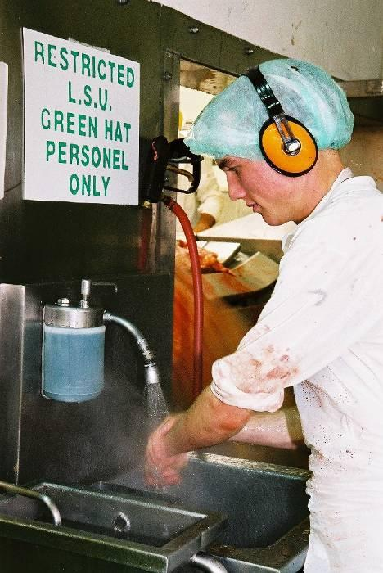
Hand washing
courtesy of Meat and Livestock Australia
Personal health
It is important that people handling or processing meat are fit and healthy. Quite a number of outbreaks of food poisoning have been caused by people who are sick contaminating the meat product. You are required to tell management if you are suffering from diarrhoea or have infected wounds, sores or respiratory diseases.
If you cut yourself at work you must get the cut dressed immediately so the open wound does not contaminate the meat. The dressing put on the wound must be waterproof and brightly coloured.
Eating, drinking or smoking
Eating and smoking are restricted to designated areas – in some meatworks smoking is prohibited.
Only drink from the water dispenser and never from a hose in a meatworks because:
- it has been lying on the ground and the end will be contaminated
- it could be a hot water or high pressure hose
- many plants recycle water and it could be unfit to drink.
Jewellery and cosmetics
The SOPs will tell you what you can and can't wear in the way of jewellery or cosmetics. However, if there is any chance of the jewellery or cosmetics causing contamination, it should not be worn.
Personal habits
Spitting and fat throwing can contaminate the plant and the product and are banned in all meatworks. In addition, employers expect you to present yourself for work fit to handle food. There are several additional things which will improve your personal hygiene including:
- brushing your teeth and gums daily
- showering or taking a bath daily
- washing your hair regularly
- cleaning and trimming your fingernails
- using a handkerchief when you sneeze or cough
- changing your underwear daily
- not picking your nose or biting your nails.
Cleaning your body
Your body is continually producing sweat to control its temperature. Sweat is not just water. It has oils and odours in it as well. Areas that stay wet longer like armpits and crutches are ideal places for bacteria to grow.
Regular washing with soap will reduce the likelihood of bacteria multiplying on your body and reduce the risk of you contaminating the product.
Washing your hair
Oil and dead skin are caught and build up in your hair. This build up is an ideal place for bacteria to grow. Regularly washing your hair removes oil and skin.
You should keep your hair trimmed or controlled. This will reduce the chances of it contaminating product, or being a safety problem.
Keeping your fingernails cleaned and clipped
The area under your nails provides a warm moist place for bugs to grow. Regularly clipping and cleaning your nails with a brush reduces the chance for bugs to grow.
Using a handkerchief or tissue
If you have a cough or flu, it is possible to spread disease by coughing or sneezing. Bacteria are spread into the air and can be caught by others near you. You should not sneeze or cough into the open air. You should always use a handkerchief or tissue. Remember to wash your hands afterwards.
Cleaning your teeth
If you do not clean your teeth each day, you risk tooth decay and gum disease. Gum disease is painful and expensive to correct. Not only that, your teeth look yellow and your breath will usually smell (although not to you). You should visit the dentist regularly.
Wearing clean underwear
Wearing clean underwear everyday will stop the build-up of bacteria on these clothes and reduce the chances of disease.
Wearing clean clothes
You are issued with a uniform to protect you from the environment and protect the environment from you. It is up to you to keep your uniform clean. You should change and wash your personal clothes regularly.
Scratching
Some parts of your body are naturally unclean; your nose and mouth to name a few. Do not put your hands near these areas as bugs will pass from them to your hands.
What are the specific hygiene requirements for the meat inspection tasks?
Each job or task has a list of work instructions or task descriptions which tell you how to do your job as well as the hygiene and sanitation practices required.
The work instructions or task descriptions will tell you when equipment has to be cleaned and sanitised and when you have to wash your hands. It will also tell you what protective clothing you must wear in your area.
The work instructions for each task are written to meet the government requirements laid down in the AS 4696:2007 Australian Standard for the hygienic production and transportation of meat and meat products for human consumption and any other relevant government requirements.

Cleaning, sanitation and housekeeping
What is good housekeeping?
Housekeeping is the practice of 'cleaning as you go'. Continually cleaning up is the best way of reducing the likelihood of contamination.
Good housekeeping means we remove fat, meat scraps and blood from the work area and amenities on a regular basis. Fat, meat and blood are a food supply for the bacteria. Fat and meat scraps should be put in the correct tubs and chutes.
Inedible product must be kept separate from edible product and is usually stored in red tubs.

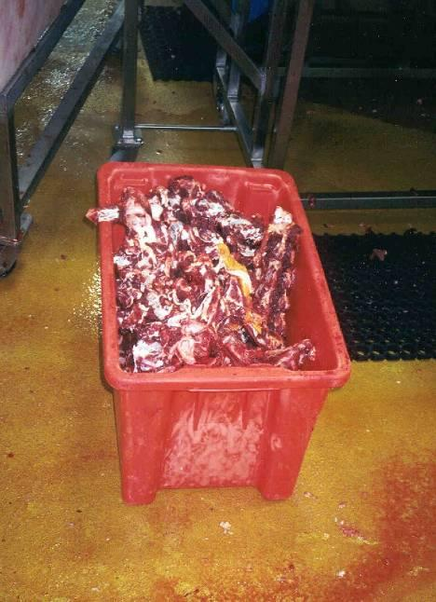
Inedible product is usually stored in red bins
© MINTRAC

Edible trimmings and off-cuts are stored in white tubs in boning rooms and on slaughter floors. These tubs must be kept on stands off the floor to minimise the possibility of accidental contamination.

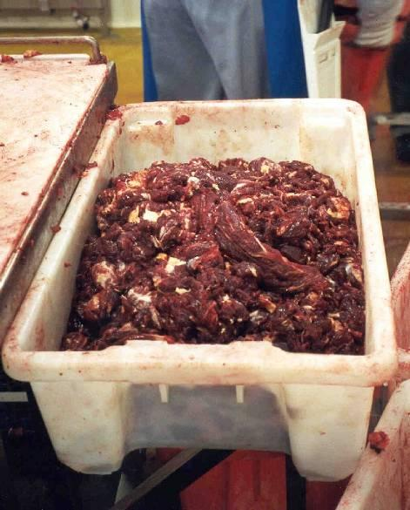
Edible product is usually stored in white bins
© MINTRAC
Water on the floor and work surfaces is also a source of potential contamination. Bacteria like Salmonella and E.Coli breed in water and this can contaminate the product. Work surfaces must be kept dry and water lying in pools should be swept or pushed into drains.
All tools, equipment and spare parts should be put away when not in use. Hoses should always be rolled up out of the way when not in use. In many plants tools and cleaning equipment are colour coded for the area it is to be used in, for example red for slaughter floor, blue for boning room, green for offal room. Never use tools from other work areas as you may cause cross contamination.
The purpose of this next section is to give a broad understanding of cleaning and sanitising.
What is cleaning?
The basic aim of cleaning is to remove material that is harmful to the product, unsightly or likely to provide food for bacteria.
There are generally two types of material that have to be removed:
- water soluble – may be rinsed with water. The material dissolves into the water and is rinsed away, e.g. dirt and dust
- water insoluble – material which will not dissolve in water, but will dissolve in detergents, e.g. blood, scale on metal surfaces.
This is why we dry clean first, then hose down, then use detergents.
What is sanitising?
After cleaning plant and equipment thoroughly it has to be sanitised. Sanitisers are used to destroy micro-organisms like bacteria and moulds. We use two types of sanitisers in abattoirs:
- hot water at 82ºC or more
- chemicals which are applied as foams or sprays.
Some plants use a combined detergent and sanitiser.
Why do we clean abattoirs and boning rooms?
The main reasons we clean are:
- to minimise the risk of food poisoning
- to meet government regulatory requirements
- to improve the work environment
- to produce a good quality product.
How do we clean during operations?
Most cleaning undertaken during operations is essentially good housekeeping and a dry clean when required. A dry clean involves cleaning as much fat, meat, blood and any waste without using water.
In a dry clean:
- liquid waste is pushed to the appropriate drain
- all solids are collected and put in the tubs or chutes
- all paper and plastic waste is put in the correct bin for inedibles
- blood in the bleeding area should be carefully pushed into the blood drain
- a minimum amount of water should be used near the blood drain, because blood diluted with water is harder to turn into bloodmeal.
Water, especially from high pressure hoses, should never be used to clean during processing or near product, unless you are specifically instructed to because:
- it can splash contamination off the walls and floor onto the product
- it provides the moisture bacteria need to grow.
How do we clean after production?
In abattoirs and boning rooms there is generally a six step cleaning plan:
Step one – dry clean
In a dry clean:
- solids i.e. fats and meat scraps are gathered and put in the tubs marked for ‘inedible product’
- paper and plastic waste is put in the correct bins
- blood from the bleeding area is pushed down the blood drain
- water is pushed down the correct drains
Tools are often colour coded for the area of use and cannot be used in different parts of the plant, e.g. equipment used in ‘inedible’ areas such as rendering, cannot be used in edible meat processing areas.
Step two – cold water wash
In a cold water wash:
- use cold water (less than 45°C) under pressure, to wash walls, floors and equipment
- start from the corners and work towards the drain, (top to bottom) to reduce the spread of contamination.
This removes as much soluble soil as possible and softens any materials on the surface.
Step three – apply detergents and sanitisers
Detergents and sanitisers are applied to surfaces starting from the floor and moving up the walls and equipment and observing contact times according to manufacturer’s instructions.
This step removes some of the material that remains after the cold wash and kills more bacteria present.
Step four – manual scrub
Equipment and surfaces are scrubbed using the approved food grade detergent and cleaning pads and sponges. Any build-up of materials e.g. around hand basins and sterilisers is removed.
Step five – hot water rinse
Rinse all detergent and sanitiser from the surfaces using hot potable water (greater than 82°C) under pressure from the top down. This removes dirt and cleaning products from the surfaces so that they do not contaminate the product.
Step six – inspect and oil
Any metal surfaces are inspected and oiled with oil approved for the purpose. Then any remaining surfaces are checked for possible sources of contamination. In some plants a sanitiser spray is used at the end of the clean-up.
How is hygiene monitored?
Monitoring is the checking we do to make sure the cleaning of personal protective equipment, premises and equipment is effective.
There are two basic methods for monitoring hygiene.
- Inspection using the senses such as sight, smell, and touch (organoleptic inspection). These inspections are usually carried out before operations commence to determine if the surfaces are visually clean.
- Microbiological sampling where swabs, petri film, protein sticks etc are used to detect micro-organisms on the surface being tested. Sampling is carried out to determine if the cleaning program has reduced the number of micro-organisms to an acceptable level.
How are cleaners and sanitisers stored?
The main on-plant chemical contamination risk is from cleaning chemicals. As a rule, detergents and sanitisers should be kept in a dark, cool place. Heat can cause the sanitisers to lose their effectiveness, or in the case of some powders, produce a gas which can build up and possibly explode.
Chemicals should be stored in correctly labelled sites and Material Safety Data Sheets (MSDS/SDS) should be available and used. There is a MSDS/SDS for every potentially dangerous chemical.
The MSDS/SDS tells you:
- how the chemical should be stored
- properties and uses of the substance
- health hazard information
- precautions for use
- safe handling requirements.
Activity seven: Housekeeping, cleaning and sanitation
Materials and specialist personnel
Company SOPs covering:
- cleaning during operations
- storage of chemicals.
Relevant work instruction.
Method
Demonstrate and explain the housekeeping requirements for various work areas including the disposal of inedible product, the use and storage of hoses.
Demonstrate and explain use of tubs, chutes and cleaning equipment during production.
Explain the nature and role of post operation cleaning, the pre-operational hygiene checks and the dry cleaning at the end of production.
Trainee activities
Get the trainee to explain and demonstrate:
- the general housekeeping rules for the work area
- the correct disposal method for inedible product, waste cardboard, plastic etc.
Ask the trainee to explain colour coding of tubs, chutes, cleaning equipment etc.

Handling and storing the product
The meat product has to be handled with care after it leaves the processing area.
What risks of contamination are there for carcases after dressing?
Handling
The carcase pushed off the slaughter floor can still be contaminated by:
- being dropped off the rail
- being brushed up against the walls
- the carcase pushers not having good personal hygiene.
Storage
Temperature is one of the abattoir's main weapons in controlling bacteria growth. Carcases must be put into the freezers or chillers as soon as possible. The quicker the surface temperature gets below 4°C the less the chances of bacteria growing.
If carcases are packed too tightly into a chiller, then the chilled air can not circulate properly and hot air pockets form. The temperature of the carcases does not drop quickly and bacteria can multiply. This has a dramatic impact on the shelf life of the product. The temperature of carcases is checked regularly.
Boned meat and offal is packed in cardboard boxes with plastic liners to protect it from contamination. Like carcase meat, it is essential that the meat remain chilled to control growth of bacteria. The temperature of carton meat is carefully checked.
Carton meat is only protected from contamination while the carton is intact. As soon as a hole is made in the carton the product can be contaminated. All companies have a repack procedure to make sure the product leaves the plant protected in a clean undamaged carton.
Activity eight: Handling and storage
Materials and specialist personnel
Company SOPs and work instructions dealing with the storage and load out of products.
Relevant sections of the AS4696:2023 Australian Standard for the hygienic production and transportation of meat and meat products for human consumption.
Facilities and equipment to take and culture swabs from product.
Personal Protective Equipment (PPE).
Method
Display cultured swabs from carcases and explain the carcase microbiological monitoring program.
Demonstrate and explain product temperature monitoring in storage.
Demonstrate personal hygiene and clothing.

Pest control
Why are rodents, insects and birds a threat to product?
Pests represent a real risk to the food safety of a meat product. Insects such as cockroaches and flies spread bacteria. Blowflies lay maggots in the meat.
Rodents like rats and mice attack the packaging, eat the meat product, leave droppings, spread contamination and destroy insulation and electrical wiring.
Birds on the slaughter floor or in the boning room are a relatively rare problem, but birds nesting and living in covered stockyards are a real problem at some sheds. Their droppings contaminate the stock and the general environment around the plant. Birds can be kept out of nesting and roosting sites by netting. However, getting rid of birds once they are established is a difficult process.
How are they controlled?
Government regulations require all meatworks to have an effective pest control program. All pests can be discouraged by making sure that fat or meat scraps are not left to attract them. The plant should also be kept in good order to make sure there is no place for them to live or hide.
It is important that if you see signs of pests it is reported to the supervisors immediately. Pests in a plant can threaten the operating licence of an abattoir, especially if external reviewers or auditors see the signs. These include droppings, chewed packaging and paper as well as polystyrene leaking from sandwich-board insulation.
All around abattoirs and boning rooms, you will see bait boxes for rodents and/or insects. The poison in these boxes can harm or kill people. It must be kept away from the product and the surfaces that meat comes in contact with. Broken or split bait boxes must be cleaned up and disposed of immediately in accordance with the workplace procedures.
Insects such as flies are kept out of processing areas by draft or air curtains. Meat plants are also periodically 'fogged' to control insects such as cockroaches.
Activity nine: Pest control
Materials and specialist personnel
The company SOP covering pest control bait boxes.
Method
Discuss the hygiene hazards presented by pests.
Discuss the pest control programs in place.
Discuss the responsibilities of workers to report pigeons or vermin or broken bait boxes.
Trainee activities
The trainee identifies types and location of bait boxes used in his or her work area.
Trainee identifies the possible signs of vermin that must be reported.

Water quality
Why is water quality important in a meatworks?
Water is used to wash the plant, the equipment, employees and product. If the water has bacteria or dirt in it, the washing process will only spread contamination.
The main way the purity of the water is achieved is by the addition of chlorine. Chlorine kills the bacteria and doesn't hurt the product or people.
Meatworks use huge quantities of water each day. This costs the company in two ways:
- the water has to be bought from a council or water authority
- the water has to be treated after it is used in a series of filters and settling ponds.
What is potable water?
Potable water is water that is fit for humans to drink. It is essentially free of harmful bacteria and will not contaminate the product.
What is recycled water?
Abattoirs use vast amounts of water each day and this waste water has to be treated before it is used for irrigation or before it makes its way into creeks or rivers.
Many plants nowadays recycle water after treatment to reduce the cost of buying water. Recycled water is used in these abattoirs to wash stockyards and sometimes to give stock a preliminary wash.
Training record sheet
Trainers can use this page to record completed training activities.
Activity one: Food safety

Date ___ / ___ / ___

Activity two: Physical contamination

Date ___ / ___ / ___

Activity three: Chemical contamination

Date ___ / ___ / ___

Activity four: Microbiological contamination

Date ___ / ___ / ___

Activity five: Swabbing for bacteria

Date ___ / ___ / ___

Activity six: Preventing contamination

Date ___ / ___ / ___

Activity seven: Housekeeping, cleaning and sanitation

Date ___ / ___ / __

Activity eight: Handling and storage

Date ___ / ___ / ___

Activity nine: Pest control

Date ___ / ___ / ___

Bibliography
These publications were used to develop this training material.
AS 4696:2007 Australian Standard for the hygienic production and transportation of meat and meat products for human consumption.
The Problem of Foodborne Illness, United States Food and Drug Administration.

Additional resources
Registered Training Organisations (RTOs) should refer to the Unit-by-Unit listing of resources on the MINTRAC website www.mintrac.com.au for additional resources to support the delivery of this Unit.
RTOs which develop or identify additional resources are encouraged to advise MINTRAC so that these can also be added to the Unit-by-Unit listing.

