AMPQUA304
Perform carcase Meat Hygiene Assessment
Training support materials

Australian Meat Processing Training Package
Certificate III in Meat Processing

Table of contents
Training support materials for AMPQUA304 Perform carcase Meat Hygiene Assessment 3
What are the relevant regulatory and workplace requirements for carcase Meat Hygiene Assessment? 3
What is the purpose of MHA carcase monitoring? 3
When are MHA carcase assessments undertaken? 4
What types of defects are to be identified on carcase product? 4
What number of carcases are sampled ? 5
How are carcases scanned and defects scored? 6
How are defect ratings calculated? 10
How are the MHA monitoring results recorded? 12
What is a corrective action? 12
What corrective actions are taken when defects are found? 13
How are MHA carcase ratings for boning rooms calculate? 14
How are the results of carcase MHA monitoring recorded? 15
What are the workplace health and safety & hygiene and sanitation requirements when MHA carcase monitoring product? 15
Bibliography 17
Additional resources 17

Training support materials for AMPQUA304 Perform carcase Meat Hygiene Assessment
These notes should be NB read in conjunction with the DAFF document “MEAT HYGIENE ASSESSMENT OBJECTIVE METHODS FOR THE MONITORING OF PROCESSES AND PRODUCT 3RD EDITION”
What are the relevant regulatory and workplace requirements for carcase Meat Hygiene Assessment?
The Meat Hygiene Assessment (MHA) program was developed in 1996 to assist the Australian red meat export industry in formulating systems that monitor its ability to produce wholesome product.
MHA consists of two monitoring programs:
- process monitoring to assess compliance with the documented processes in the production of the meat
- product monitoring to assess the physical condition of meat.
The MHA system utilises standardised methods to:
- assure consistency in the outputs from monitoring
- provide an objective approach to assessing meat hygiene.
The MHA program is now in its 3rd Edition. The MHA documents are available on the Department of Agriculture, Fisheries and Forestry (DAFF) web site.
What is the purpose of MHA carcase monitoring?
The MHA carcase monitoring program is put into place to ensure that physical contamination is being controlled in the slaughtering, dressing and evisceration processes.
Monitoring physical contamination helps confirm that the physical standards of meat hygiene have been satisfied including the control of Zero Tolerance defects ( ingesta, excreta, milk and urine).
By checking that an acceptable level of hygiene has been achieved it proves that the slaughtering and carcase dressing process is being conducted in accordance with good manufacturing practice.
The MHA carcase monitoring also give carcase hygiene a score and this score indicates when carcase hygiene standards have not been met. These scores are used to trigger corrective and preventative actions. The scores also can track trends that allow management to detect and warn when the process is no longer in control.
By matching product monitoring trends with process monitoring trends managers can gain an insight into potential causes when the required hygiene.
Product monitoring applies to all export meat establishments in the following categories:
- abattoirs, including integrated establishments.
- boning rooms
- meat processing establishments
- ratite establishments.
When are MHA carcase assessments undertaken?
The initial MHA assessment is performed on carcases / sides after final trim but before the final wash on the slaughter floor.
Additional assessments are made after the final wash during
- the bagging of carcases and quarters
- during packing of telescoped carcases (lambs, sheep and goats)
- at load out and load in of unwrapped product
- entry into independent boning rooms and meat processing establishments,
What types of defects are to be identified on carcase product?
MHA carcase monitors are looking for a range of physical contamination. These include:
- Zero Tolerance contamination faeces, milk, ingesta and urine
- pathology (any signs of disease left on the carcase eg infected pleura)
- bruises / blood clots
- seed
- rail dust,
- specks, hide & wool dust
- smears & stains (incl. bile, oil & grease)
- hair & wool strands
- hair & wool clusters
- hide
- scurf
- stains
- toenails (pigs)
- foreign objects
- extraneous tissue including parts of other organs
- loose/attached mucosa
- pathology.
The table below shows where the defects are most common.
Table 4 Common defects
(from the DAFF document “MEAT HYGIENE ASSESSMENT OBJECTIVE METHODS FOR THE MONITORING OF PROCESSES AND PRODUCT 3RD EDITION”)

Zone | Area included | Common
Hock | Hock, shank, hook hole | Hair, wool, scurf, hide, grease, rail dust, stains, toenails
Hindquarter outside | Tail area, back, flank | Rust, grease, hair, wool, hide, scurf, faeces, inoculation abscesses
Forequarter outside | Plate, ribs, chuck, neck, outside brisket fore, shank | Hair, wool, hide, grease, stains, nodules, inflamed grass seeds, scurf, ingesta
Forequarter inside | Diaphragm, thorax, spine, neck, jugular groove, inner forearm end of shank, brisket, pleura | Hair, hide, grease, stains, nodules, inflamed grass, seeds, scurf, ingesta
Hindquarter inside | Inside round, aitch bone pelvic canal, spine, cod fat, lumbar area, kidney, abdominal surfaces, pizzle, peritoneum | Hair, wool, hide, grease, rust, faeces, blood clots, mature udder fragment

What number of carcases are sampled ?
The number of carcases processed in a shift can be divided into lots. A lot can be all or part of a shift’s production. The number of carcases in a lot may be dictated by the category of stock being processed and can vary from day to day. However, regardless lots sizes will be determined in conjunction with the regulator. However, a sample that has an unacceptable hygiene rating means a corrective action is necessary to be implemented for the whole lot. The table below shows the sample size for any given lot size. The carcases sampled must be selected at random and representative of the category or type of stock within the lot.

Table 1 Sample numbers
(from the DAFF document “MEAT HYGIENE ASSESSMENT OBJECTIVE METHODS FOR THE MONITORING OF PROCESSES AND PRODUCT 3RD EDITION”)
Number of animals in a lot | Sample size (units)¹
1-25 | 5
26 – 50 | 8
51 – 90 | 13
91 – 280 | 20
281 – 500 | 32
> 500 | 50
- ¹ The number of carcases monitored for the ZT CCP is always as per the approved HACCP plan.

The table below shows what unit of a sample will be assessed in each species
Table 2 Sample unit
(from the DAFF document “MEAT HYGIENE ASSESSMENT OBJECTIVE METHODS FOR THE MONITORING OF PROCESSES AND PRODUCT 3RD EDITION”)
Species sampled | Sample unit
Horses / cattle / camel | A side or fore- and hind-quarter combined
Pigs / ratites | A whole carcase or the 2 sides when split
Lambs / sheep / goat / deer / rabbits / bobby calves/ wild game | A whole carcase

Independent boning rooms will treat each delivery from an abattoir as a separate lot.
How are carcases scanned and defects scored?
When looking for defects the QA officer must scan the carcase in a consistent manner every time. The operator will follow these scanning lines and record the defects as soon as they are observed.
The scoring can be done either manually on recording sheets or electronically. The QA officer who undertakes the assessment must sign the score sheet either physically on a paper score sheet or with an e signature on electronic records.
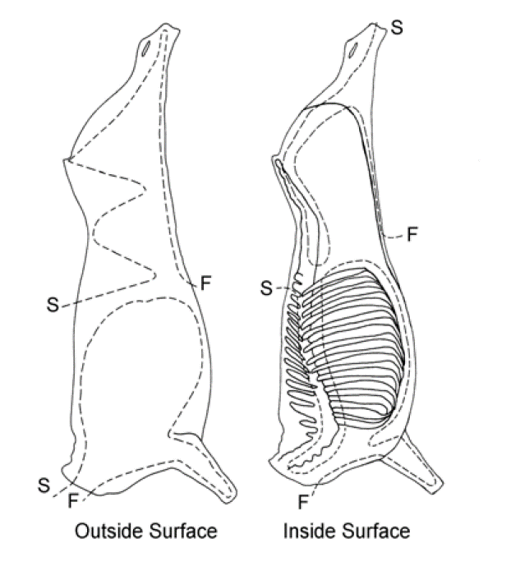
Figure 1: Horse and bovine scanning lines

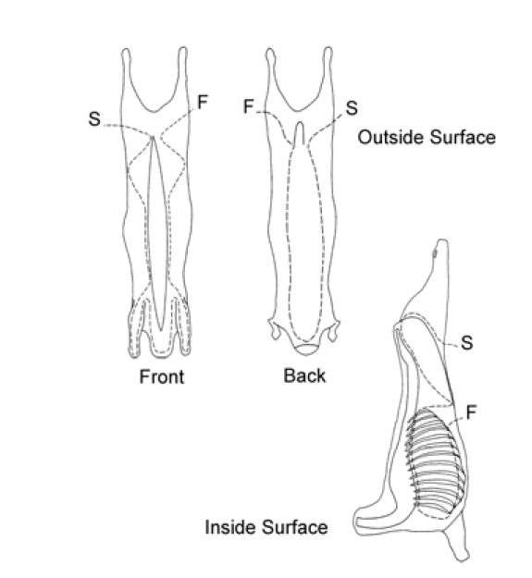
Figure 2: Sheep and goat scanning lines

Figure 3: Pig scanning lines
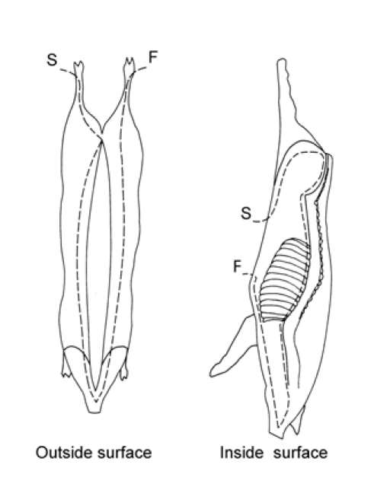
Defects are scored as individual occurrences and count as 1. The table below show when a defect is to be scored. So for instance 5 specks of rail dust on a carcase would not be counted because it is less than 11 specks. These specks will be removed but not scored.
For example a stain with a diameter of 8cm will be recorded because it has a diameter greater than 1 cm.
Table 3 Classification of carcase contamination defects
(from the DAFF document “MEAT HYGIENE ASSESSMENT OBJECTIVE METHODS FOR THE MONITORING OF PROCESSES AND PRODUCT 3RD EDITION”)

Defect criterion | Detection of a likely food safety relevant defect
Faeces, Milk, Ingesta (ZT)¹ | Any amount
Pathology² | Any
Contamination – urine | Any amount
Contamination – rail dust, specks, hide dust and wool dust | ≥ 11
Contamination – smears and stains (including bile, oil and grease) | ≥ 1 cm diameter
Contamination – hair³ and wool strands | ≥ 11 strands
Contamination – hair and wool clusters, hide, scurf, toenails | ≥ 2  Hide ≥ 1 cm diameter
Contamination – foreign objects | Any non-animal material

How are defect ratings calculated?
These scores will be added up and divided by the number of carcases/sides in a sample. Any detection of a Zero Tolerance contamination will make the lot unacceptable and corrective actions will be implemented. If a zero tolerance defect has been detected, a defect rating is still required to be calculated and recorded.
The total number of defects is divided by the number of samples to establish the defect rating.
If the MHA monitoring is being done on the slaughter floor then a rating of equal to or less then (≤) 0.25 is an acceptable ratio. If the carcase monitoring is being performed as a pre-boning boning room inspection then the
Pre-boning room inspection ≤ 0.1 Acceptable
Pre-boning room inspection >0.1 Unacceptable.

The below is an example of a sample monitoring form. (from the DAFF document “MEAT HYGIENE ASSESSMENT OBJECTIVE METHODS FOR THE MONITORING OF PROCESSES AND PRODUCT 3RD EDITION”)

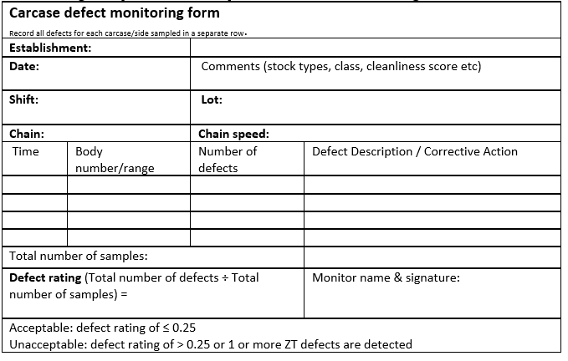
EXAMPLE 1.
If the lot size was 250 beef carcases a sample of 20 sides is monitored and the following defects were detected:
4 x hide dust with more than 5 specks
2 x bile smears (diameter greater 1cm)
5 x clusters with more than 11 hairs
0 x Zero Tolerance contaminations
11 Total number of defects.
Rating = Total number of defects = 11 = 0.5 defect rating UNACCEPTABLE
Sample size 20

EXAMPLE 2.
If the lot size was 1200 sheep a sample of 50 carcases is monitored and the following defects were detected:
1 x rail dust with more than 5 specks
1 x bile smears (diameter greater 1cm)
1 x clusters with more than 11 hairs
0 x Zero Tolerance contaminations
3 Total number of defects.
Rating = Total number of defects = 3 = 0.06 defect rating ACCEPTABLE
Sample size 50
EXAMPLE 3.
If the lot size was 800 sheep a sample of 50 carcases is monitored and the following defects were detected:
1 x rail dust with more than 5 specks
1 x bile smears (diameter greater 1cm)
0 x clusters with more than 11 hairs
1 x Zero Tolerance contaminations
3 Total number of defects.
Rating = Total number of defects = 3 = 0.06 defect rating but 1 ZT makes the
Sample size 50 defect rating UNACCEPTABLE

How are the MHA monitoring results recorded?
When a sample is assessed then a record of the defects must be recorded in the appropriate columns either electronically or manually on a recording sheet. Other details such as the establishment identifier; species; date and time of sample checking; name, position and signature of the person undertaking the check should also be recorded. All defects should be removed during the assessment process by trimming.
Non-scoring defects are not recorded but they must also be removed by trimming.
What is a corrective action?
A corrective action is an action that is taken in the short run to address the immediate contamination issues with the unacceptable product that has been sampled and assessed. The corrective action will be documented in the company’s Approved Arrangement which will also describe how the corrective action will be recorded and verified.
The longer-term corrective actions or preventative actions will investigate and address the root cause.
What corrective actions are taken when defects are found?
As the sample of the lot is being assessed all contamination must be trimmed immediately. If the sample is assessed as unacceptable then there will be an additional trim on all related product (carcases/sides) in the monitored lot.
If a zero tolerance is identified, part of the corrective action shall include a review to determine the root cause and correction of the process controls. Records must be made of the immediate corrective actions and preventative actions as well as the verification of the outcomes.
If the carcases are to be boned on the same establishment then the establishment must intensify the pre-boning trim. The trimmers should be given instruction to concentrate on the identified problem areas. This intensified trim should be documented in the approved arrangement and followed by the trimmers. The intensified trim must be verified by sampling and assessing the trimmed carcases and the verification recorded.
Hot boning
If carcases are to be hot boned and cannot be retrimmed before entering the boning room, then the boned product from these carcases are to be subject to a double intensity of carton meat sampling, i.e., inspection of high-risk carton meat product is increased to every 30 minutes.
The sampling of boned product from these “unacceptable “ carcases are recorded separately and continued until 5 consecutive average monitoring sequences from carcases are rated acceptable.
Hot bagging of carcases
If a sample is assessed as having an unacceptable rating and the carcases in the lot were to be bagged straight from the slaughter floor then will be subject to further assessment before bagging.
Load out and cold bagging
All carcases (sides and quarters) shall be assessed prior to bagging. Unacceptable lots shall be trimmed in accordance with the corrective action procedure for carcases described in the establishment’s approved arrangement.
Independent boning rooms
When independent boning rooms load-in carcases (quarters/sides) lots should be assessed using the method used on slaughter floors. If carcases come from different slaughtering establishments then they should be treated as different lots and sampled accordingly. Likewise individual loads will also be treated as separate lots

If any sample is rated as unacceptable then the lot should be trimmed in accordance with the corrective action procedure for carcases described in the establishment’s approved arrangement. The unacceptable rating and the nature of the defects should be reported to the establishment of origin.
How are MHA carcase ratings for boning rooms calculate?
“The desired outcome of an MHA program in a boning room is to ensure each carcase/side/quarter entering a boning room after the pre boning trim is free of ZT defects, pathology and significant contamination” ( Export Meat Operational Guideline 16.1 Meat hygiene assessment – product monitoring (3rd Edition)).
Sample Size
The QA officer will sample at least 10 carcases/sides, selected at random, to assess the meat hygiene rate of the lot and the effectiveness of the pre-boning trim.
The size of the lot can be the all the carcases boned in a shift or a part of the shift’s through put and this can change from day to day. The lot size will be approved by the regulator.
The defect rating
The defect rating is calculated by dividing the total number of defects by the total number of units (carcases/slides) in the lot. If a lot’s MHA defect rating > 0.1 then the lot is unacceptable and the whole lot will be subject to the corrective action. An acceptable defect rating is ≤ 0.1. All defects identified during inspection should be trimmed immediately.
A ZT detection in the sample selected will give the whole lot an unacceptable rating but an MHA carcase rating must still be calculated and recorded for the lot.
A zero tolerance detection on carcases/sides also triggers immediate corrective action in the form of increased monitoring and adjustment of the operation.
Corrective action
If the further investigation confirms that pre-trim has failed and contaminated product has entered the boning process, the establishment must implement the approved corrective action immediately. This may include but not be limited to the following:
- identification and cleaning of all contaminated benches, surfaces
- contaminated product in the room that has not yet been packed should be subject to re-trimming
- packed product back to the last clear check should be re-examined and reworked if necessary, and
- feedback provided to the slaughter floor to ensure that any necessary corrective action is taken.

How are the results of carcase MHA monitoring recorded?
The establishment’s Approved Arrangement will determine how MHA carcase ratings are recorded. In most large export works MHA monitoring is recorded and stored electronically.

What are the workplace health and safety & hygiene and sanitation requirements when MHA carcase monitoring product?
The company work instructions will set down all the WHS and hygiene and sanitation requirements for working on the slaughter floor, chillers and boning rooms and when conducting MHA carcase monitoring.
These will require you to:
- wash your hands between carcases or when contaminated
- wear all your PPE like aprons and boots which can be cleaned regularly and easily
- follow the sanitary sequence which is to handle edible product (scan, remove contamination, sterilise knife and inspection hook and wash hands as required) before handling inedible materials (intestines)
- change your uniform if it is grossly contaminated
- if you are using a pen, clip board or i-pad register them as foreign objects according to work-place requirements
- wash your hands before and after work.
These practices will protect your health and minimise cross contamination.
You should always wear the Personal Protective Equipment (PPE) set down in the company work instructions or WHS policy.
PPE will include all or some of these:
- hand protection like mesh and cut-resistant gloves
- hearing protection
- footwear
- aprons
- uniforms
- hair net
- helmet/bump hat.
It is important to handle diseased or contaminated product that may require trimming in a way that avoids contamination of clean parts of the carcase. This may involve holding the affected parts with a hook and trimming from a clean area to remove offending material.
The workplace will also have a ‘dropped meat policy’ for product that accidently contacts the floor. This will need to be followed if product is dropped.

Bibliography
These publications were used to develop this training material.
Agriculture and Resource Management Council of Australia and New Zealand, AS 4696:2007 Australian Standard for the hygienic production and transportation of meat and meat products for human consumption, CSIRO publishing, Collingwood, Vic.
MINTRAC 2011 Meat Hygiene Assessment Kit (3rd Ed) www.mintrac.com.au

Additional resources
Registered Training Organisations (RTOs) should refer to the Unit-by-Unit listing of resources on the MINTRAC website www.mintrac.com.au for additional resources to support the delivery of this Unit.
RTOs which develop or identify additional resources are encouraged to advise MINTRAC so that these can also be added to the Unit-by-Unit listing.

