AMPQUA311 Assess effective stunning and bleeding
Training support materials

Australian Meat Processing Training Package
Certificate III in Meat Processing

Table of contents
Training support materials for AMPA3003 Assess effective stunning and bleeding 5
Introduction to the assessment of stunning and bleeding 5
Why is stunning and bleeding at abattoirs assessed for effectiveness? 5
What is covered in this Unit? 5
What is the connection between stunning, bleeding and animal welfare? 6
What are the animal welfare requirements when slaughtering animals? 6
Where are animal welfare needs managed in the slaughtering process? 8
How is animal welfare managed during the slaughtering process? 8
Monitoring procedures 9
What has to be monitored to ensure animals are slaughtered humanely? 9
What definitions are used during the stunning and slaughter of animals? 11
What are the signs of unconsciousness and insensibility? 12
Common mistakes during the assessment of unconsciousness and insensibility 14
How is the monitoring and assessment of stunning recorded and reported? 14
Understanding the processes that lead to good welfare 15
Restraining animals 15
Why are animals restrained? 15
What are the main animal welfare aspects of restraint? 16
What equipment is used to restrain animals? 17
How are mechanical restrainers used? 20
How are restraint methods monitored? 21
What other checks must be made when using a restrainer? 22
Stunning 22
Why do we stun? 22
What equipment can be used to stun animals? 22
Mechanical stunning 23
What effect does mechanical stunning have? 23
How does mechanical stunning work? 23
Captive bolt stunning equipment 24
How can an effective captive bolt stun be achieved? 26
Shot position 27
Firearms 30
How is mechanical stunning equipment prepared and maintained? 30
How should the effectiveness of mechanical stunning be monitored? 31
What are the signs of an effective mechanical stun? 31
Electrical stunning 33
What are the general principles relevant to the electrical stunning of animals? 33
What are the effects of the electrical current passing through an animal? 35
How does the choice of current pathway and frequency affect the outcome of an electrical stun? 36
What species are electrically stunned? 36
How is the electrical stunning equipment operated? 39
How do you achieve an effective stun using electricity? 40
How should electrical stunning equipment be maintained? 40
How should the effectiveness of electrical stunning be monitored? 41
Gas stunning 44
What is carbon dioxide stunning? 44
How is a carbon dioxide stunning system operated? 44
How should the effectiveness of CO₂ gas stunning be monitored? 45
Issues common to all stunning methods 47
Who should perform the stunning operation? 47
What if the stun is not effective? 48
Post-stunning issues 48
What is the stun to stick interval? 48
What is electro-immobilisation? 49
Sticking and bleeding 50
Why are animals bled at slaughter? 50
How are animals bled? 50
Religious slaughter 53
What are the legislative requirements for religious slaughter without prior stunning? 54
Why is a quick, complete bleed important? 54
How is equipment prepared for use? 54
How can the effectiveness of the bleeding process be monitored? 55
Shackling 56
Why are animals shackled? 56
When are animals shackled? 56
What is a shackle? 56
How is an animal shackled? 57
What workplace procedures are important when shackling an animal? 58
WHS issues associated with assessing stunning and bleeding operations 60
What are the WHS issues associated with the operation of a restrainer? 60
What are the common WHS hazards in the stunning operation? 60
What are the common WHS hazards when bleeding animals? 60
What are the common WHS hazards during the shackling process? 61
How can WHS risks be reduced? 61
Zoonotic diseases 63
What is a zoonotic disease and what zoonotic diseases is an abattoir worker likely to be exposed to? 63
What can be done to minimise the risk of contracting a zoonotic disease? 64
Slips, trips and falls 66
What are the types of hazards that may result in slips, trips and falls? 66
Bibliography 67

Training support materials for AMPA3003 Assess effective stunning and bleeding
Introduction to the assessment of stunning and bleeding
Why is stunning and bleeding at abattoirs assessed for effectiveness?
Traditionally, animals are slaughtered to produce food for human consumption by a two-stage process. They are initially stunned and then killed by bleeding to death (exsanguinations). The object of pre-slaughter stunning is to render an animal immediately unconscious (so that they cannot experience pain and distress) for sufficient time for the major vessels in the neck or thorax (thoracic stick) to be severed and the resultant blood loss to kill the animal.
The death of an animal is recognised through the irreversible loss of brain function. It is vital that bleeding is done effectively so that the animal dies quickly before the stun wears off (and the animal regains consciousness) especially in the case of reversible stunning.
The community expects and the law requires that the abattoir addresses animal welfare issues. The monitoring of the stunning and bleeding processes is a critical part of any abattoir’s QA procedures for ensuring animal welfare standards are being met.
In addition to regulatory requirements, corporate customers such as fast food chains and supermarkets also require that abattoirs have a stunning and slaughter monitoring program. The EU has introduced legislation that requires companies exporting meat to EU countries not only have a monitoring program for stunning but also requires that this monitoring has to be undertaken by staff with formal, nationally accredited training.
What is covered in this Unit?
In order that a staff member is able to assess stunning and bleeding they have to have a good understanding of:
- monitoring procedures and assessment techniques
- the processes that contribute to good welfare
- restraint
- stunning
- bleeding
- shackling
- workplace health and safety (WHS) risks associated with monitoring procedures.
What is the connection between stunning, bleeding and animal welfare?
All slaughtering establishments are required by law (the Australian Standard AS4696 2023) to ensure that animals are treated humanely in lairage and during slaughter. This is done by minimising the potential stress, pain and suffering that the livestock experience at a processing works. It requires that animals are handled and restrained properly and then stunned effectively so they feel nothing as they are bled to death. The bleeding process has to be quick and effective so it kills the animal as quickly as possible, while it remains unconscious.
By ensuring that every animal is effectively stunned and bled, a processing plant can be sure that the animal has been slaughtered humanely and that the best possible animal welfare outcome has been achieved. Note: Unstunned slaughter is only permitted with specific approval of a regulatory authority and is rarely done in Australia.

WI | What are the animal welfare requirements when slaughtering animals?

Slaughterers need to know the animal handling and welfare requirements at their workplace. There are National and State laws, Codes of Practice and industry animal welfare standards, all of which are built into the company’s approved arrangement or quality assurance system.
All people who slaughter livestock are required by the law and the standards to make sure that animals are not mistreated or placed under undue stress. By following the relevant work instructions and SOPs at their plant workers will slaughter animals to the required standards. This will help ensure that animal welfare requirements are met.
There are two standards which are applicable to meat processing plants follow.

AS 4696:2023 Australian Standard for the hygienic production and transportation of meat and meat products for human consumption.
All meat processing plants are required to comply with the AS 4696:2023 Australian Standard for the hygienic production and transportation of meat and meat products for human consumption.
The Part 3 Section 7 of the AS 4696 2023 has its Outcome :The minimisation of the risk of injury, pain and suffering and the least practical disturbance to animals. Under the heading of Handling of animals it deals with the requirements for:
- premises and equipment
- animal handling
- segregation of different classes of stock
- provision of feed and water
- provision of shelter and protection from the elements
This section also sets the requirements for dealing with young, injured, sick or stress susceptible animals
The slaughter requirements of this section require:
- prevention of unnecessary pain, injury and suffering
- animals to be stunned before sticking
- animals to be restrained before stunning.
The Standard allows for the provision of unstunned ritual slaughter under an approved arrangement with the controlling authority.
The requirements for the use of working animals in lairage including:
- the use and accommodation of working animals in lairage minimises the risk injury, pain and suffering and causes the least practical disturbance to animals
- working animals are accommodated separately from slaughter animals
- dogs are effectively muzzled and are restrained when not working.
The requirements of the Australian Standard AS4696 2023 are mandatory for all establishments slaughtering animals for human consumption. The implementation of animal welfare measures and outcomes will be assessed by the QA staff in a plant when they do internal process monitoring and auditing. Additionally, key regulatory authorities (such as Department of Agriculture and State DPIs) will monitor and or audit the animal welfare standards achieved.
In addition to AS4696 2023 a mandatory animal welfare standard for all slaughtering establishments is currently being developed.
AMIC Industry Animal Welfare Standard for Livestock Processing Establishments Edition 3
This is a voluntary standard that most larger plants also comply with. This standard aims to assist industry to continually improve animal welfare outcomes for Australian livestock. The Standard has an Implementation guide, a separate document, which helps establishments to identify best practice performance indicators for animal welfare inputs and outcomes.
The documents assist companies to clearly define:
- the animal welfare standards they are aiming for in terms of measurable performance criteria
- how these will be achieved through work instructions and standard operating procedures
- how they will be monitored and audited.
The AMIC Industry Standard also assists company in meeting the requirements of corporate customers, such as supermarkets or fast food chains, have specific animal welfare requirements.
The AMIC Industry Standard cover the features of a system that needs to be in place to achieve the required animal welfare standards:
Management systems
This standard covers the development of a documented system including :
- work instructions and SOPs which deal with the management of livestock on a daily basis
- document control
- monitoring and auditing of animal welfare performance measures and indicators
- non conformities and corrective measures
- contingencies to deal with emergencies to minimise risks to animal welfare
- reviewing of management system.
Resource requirements
The establishment has to ensure it has adequate
- HR resources of trained workers competent in the tasks including:
- livestock receival
- livestock handling and management in lairage
- emergency slaughter and humane killing
- animal welfare monitors
- animal welfare officer(s)
- documented training for personnel, supervised training and competency assessment
- infrastructure and equipment that assist in delivering the desired animal welfare outcomes including;
- adequate lairage facilities
- flooring
- lighting
- maintenance programs
- adequate pen size and access to water and feed (where applicable)
- yards/pens available for appropriate segregation of livestock
- equipment for emergency kills or humane destruction
- video surveillance at unloading, laneways, forcings pens restraint and stunning
sticking.

The management and care of livestock
These management systems will cover:
- sourcing of suitable livestock
- receival of livestock
- low stress livestock handling
- monitoring animal handling and animal welfare outcomes including slips and falls and vocalisations
- goad use
- working animals
- adverse weather conditions
- water and feeding of livestock
- initial and ongoing inspection of livestock during their time in lairage
- treatment of weak, ill or injured livestock animals.
Humane stunning and sticking
The requirements for humane stunning and sticking include:
- effective restraint
- stunning
- monitoring of effective stunning
- re-stunning arrangements
- sticking
- bleed chain monitoring
- foetal blood recovery.
Where are animal welfare needs managed in the slaughtering process?
The key areas in the slaughtering process where animal welfare needs to be managed and safeguarded at the processing plant include:
Point in the process | Aspects of the process that need to be managed to maximise animal welfare
Restraint | - humane loading of the restrainer  - the operation of the restrainer  - effectiveness of the restrainer  - positioning of the animal for stunning  - identifying problems with the restraint process  - demonstrated staff competencies
Stunning | - operation, maintenance and cleaning of facilities and equipment  - effective stunning  - contingencies including back-up stunning  - routine checking of effectiveness of the stun  - demonstrated staff competencies
Slaughter | - effective and humane slaughter procedures  - maintenance and design of equipment and facilities  - contingences for emergencies  - demonstrated staff competencies
What definitions are used during the stunning and slaughter of animals?
Monitoring stunning and slaughter is mainly based on the evaluation of unconsciousness and insensibility of the animals.
Stunning
Stunning means any intentionally induced process which causes loss of consciousness and sensibility without pain.
Unconsciousness
Unconsciousness is a state of unawareness (loss of consciousness) in which there is temporary or permanent disruption to brain function. As a consequence the individual is unable to respond to normal stimuli, including pain.
Insensibility
Insensibility is also used to describe the disruption to brain function, during which the animal is unable to feel pain.
The terms ‘unconscious’ and ‘insensible’ are both terms used to describe the state of the animal following effective stunning. This means that to assess stunning procedures we need to be able to recognise and understand signs of unconsciousness (and consciousness) and insensibility (and sensibility).
How is animal welfare managed during the slaughtering process?
There are four things the operator needs to monitor to ensure that animals do not suffer unnecessarily:
- animal handling and the effectiveness of the restraint process
- stunning effectiveness
- stun/stick interval
- effectiveness of the bleeding process.
If stunning is carried out correctly there should be no sign of consciousness/sensibility in animals prior to or throughout the whole bleeding process. This may occur occasionally and needs to be managed appropriately. It is primarily the responsibility of the persons doing the stunning to ensure that all animals are insensible, though it is also the responsibility of all operators working in the area (for example, the shackling operative) to observe bodies for signs of an ineffective stun and arrange immediate re-stunning when this is observed.
The operator responsible for sticking must, before making a cut, check for any sign of sensibility. If there are any signs of an ineffective stun the animal must be re-stunned immediately with back-up equipment and the supervisor notified.
The recommended guidelines for stun/stick intervals are detailed in the Industry Animal Welfare Standards, and will be detailed in the company’s work instructions or SOPs.
The stun operator and sticker should check their own performance against these targets on a regular basis. If they find that they cannot meet these targets they should discuss it with their supervisor.
The effectiveness of the sticking process is also monitored by looking for bleed chain sensibility and if any sensibility is seen in animals on the bleed chain then the animal must be immediately re-stunned and bled again if necessary.
People causing unnecessary pain to animals risk being prosecuted.
Monitoring procedures
What has to be monitored to ensure animals are slaughtered humanely?
When monitoring the effectiveness of the stunning and bleeding operations it is important to monitor both the inputs and output of each process. The inputs constitute the equipment and operational procedures. The outputs involve assessing the animal after restraint, stunning or slaughter to provide information about the effectiveness of the procedure. The following table provides an overview of the inputs and outputs associated with each process. These are covered in more detail in each chapter.
Process | Inputs | Outputs
Restraint | - the effectiveness of the restrainer  - time in restraint minimised  - the competence and training of the operator  - the operator following the relevant work instructions and SOPs | - animal presented correctly for stunning  - no vocalisation  - no struggling behaviour  - no slips and falls
Mechanical stunning | - the charge used or compressed air setting  - the maintenance and effectiveness of the equipment  - the position of the shot  - the competence and training of the operator  - the operator following the relevant work instructions and SOPs  - other environmental and animal factors, e.g. animals with horns, thick hair on the skull etc. | - the indicators of the animal’s insensibility:  - the animal collapses immediately  - no rhythmic breathing  - fixed, glazed expression in the eyes  - no corneal reflex  - relaxed jaw  - tongue hanging out (mainly in cattle)
Electrical stunning | - the placement of the electrodes on the animal  - the amplitude and frequency of the current (amps) flow  - the voltage setting  - management of the electrical resistance between the electrode and the animal  - stun duration (2 -3 seconds)  - the maintenance and cleaning of the equipment  - the competence and training of the operator  - the operator following the relevant work instructions and SOPs |  | - the signs of the epileptic fit including;  - the initial collapse  - loss of rhythmic breathing (except in cattle)  - the rigid phase or “tonic phase” with front legs tucked up  - the “clonic phase” where kicking and paddling occur for 15 to 45 seconds.
CO₂ Stunning | - the dwell time/speed of the carousel (minimum of 3 mins)  - loading of gondolas (number of pigs loaded)  - gas concentration levels (position of the sensors)  - the competence and training of the operator  - the operator following the relevant work instructions and SOPs  - maintenance and testing of equipment (details of alarm systems) |  | - determined by scoring or observing insensibility on exit from the gas chamber:  - pigs will be completely limp  - eye will have a fixed, glazed appearance  - some animals might exhibit slow limb movement, kicking or gasping  - no rhythmic breathing  - no spontaneous eye blinking  - no righting reflex  - no corneal reflex  - no response to stimulus applied to the nose (i.e. nose pinch or prick)
Sticking | - stun to stick interval  - vessels severed  - condition of the knife  - size of the sticking wound |  | - No signs of recovery from the stun:  - no rhythmic breathing  - no spontaneous eye blinking  - no righting reflex  - no corneal reflex  - no response to stimulus applied to the nose (i.e. nose pinch or prick)
If stunning is carried out correctly there should be no sign of sensibility in animals presented for sticking. If the bleeding is carried out correctly there should be no sign of sensibility in animals on the bleed rail.
Persons responsible for stunning or other nominated staff should carry out regular checks to ensure that the animals do not present any signs of consciousness or sensibility in the period between the end of the stunning process and death. The checks should be carried out on a sufficiently representative sample of animals and frequency of checking should take into account the outcome of previous checks and any factors which may affect the efficiency of the stunning process.
What are the signs of unconsciousness and insensibility?
These can be separated into the following areas:
- physical signs
- observations of the animal’s eye
- respiration
- vocalisation
- response to pain.
Physical signs
During the process of stunning and slaughter, physical collapse is an important early indicator of unconsciousness. During stunning, the methods used affect the part of the brain that is responsible for maintaining a standing posture. After stunning and/or slaughter, attempts to stand, righting movements (e.g. arched back and attempts to lift the head) and looking around are indicators that the animal has regained consciousness. It should be remembered when making an assessment of physical collapse that some restraining methods (e.g. v-restrainer) may restrict some of the initial physical responses.
Observations of the eye
Assessment of unconsciousness by observing the animal’s eye can be unreliable and should never replace the checks for rhythmic breathing. They should always be used alongside other assessment methods. They are summarised in the table below.

Observation | What is it? | What does it mean?
Corneal reflex (also called eye reflex) | Touching the cornea or the lid of the eye and a blink response occurs | Positive eye reflexes alone do not indicate consciousness, but can be taken as a sign of brain activity. This method should not be used after electrical stunning
Wide open eye | The eye is wide open with a fixed blank stare | This indicates unconsciousness
Blinking | Rapid closing and opening of the eyelid. This must not be confused with ‘eye-flicker’ (Nystagmus) | Absence of blinking is a good sign of unconsciousness. Blinking may be a sign of consciousness, especially if it occurs with other eye movements
Flickering eyeball (Nystagmus) | Eye is open or partially open and the eyeball is vibrating/flickering | This may be observed during electrical stunning during the epileptic fit, however, it cannot be relied upon as a sign of unconsciousness
Focused eye movement | The eye follows movement or focuses on activity in the area | The presence of a focused eye movement means that the animal is conscious
Reaction to a visual threat | The animal reacts to a visual threat (eg. rushing the hands towards the animal’s eyes) by closing the eyes or moving the head | A positive response to a visual threat means that the animal is conscious
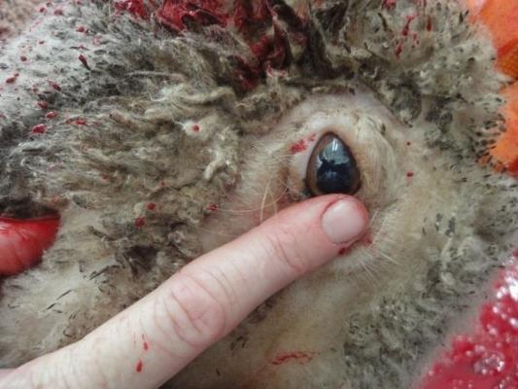
Checking for a corneal reflex by lightly touching the corner of the eye
© L.Hewitt
Respiration
Gasping (single irregular mouth opening) is a sign of a dying brain and does not indicate consciousness. However, gasping after gas stunning may lead to recovery. The absence of rhythmic breathing (with ventilation of the lungs) indicates unconsciousness. It cannot be assumed that an animal that is breathing rhythmically is conscious, but it can indicate the first signs of recovery.
Vocalisation
Vocalisation indicates consciousness, however after neck cutting, noises caused by fluids bubbling in the trachea must not be interpreted as vocalisation.
Response to pain
Response to pain, for example a nose prick or pinch, indicates possible return to sensibility. This can be a useful measure of sensibility on the bleed line, when animals are shackled and hanging vertically.
Common mistakes during the assessment of unconsciousness and insensibility
With some stunning methods animals may display a weak corneal reflex post-stun. Providing that there are no other signs of consciousness then it is likely that the animal is insensible. Animals showing a weak corneal reflex must still be re-stunned and if a number of animals show a corneal reflex then corrective action must be taken to check and adjust the stunning and slaughter parameters. When cattle are stunned using electricity, the death process starts with the initiation of a cardiac arrest during the second cycle (if the cardiac arrest cycle is employed ie head to body ).
Rhythmic breathing can be seen in unconscious and dying cattle usually when and after the animals are stuck. This is the only situation when the presence of rhythmic breathing is not a welfare concern.
How is the monitoring and assessment of stunning recorded and reported?
It is vital that records are kept of all stunning monitoring operations to ensure that corrective actions are put in place and followed up when required. Properly kept monitoring records also demonstrate to auditors that the company is adequately controlling this aspect of animal welfare. When developing monitoring systems, consult the AMIC Industry Animal Welfare Standards for Livestock Processing Establishments and refer to each section of this training material to ensure that the assessment methods selected are appropriate for your particular system.
Understanding the processes that lead to good welfare
In an abattoir, a living animal is converted to meat. The living animal is susceptible to stress, both physiological (the body’s response to its environment and activity levels), and psychological (how the animals brain interprets the signals it receives in the form of sight, sound and smell). An animal that is under stress adjusts its body function in a coping strategy, and these coping mechanisms can lead to poor meat quality.
For example, an animal that is under exercise stress or exhaustion due to long distance transport or galloping ceaselessly round yards has used up its energy stores (glycogen levels) that are needed to produce good, tender meat. An animal that is frightened activates its ‘flight or fight’ response, speeding up its heart rate, breathing and muscle activity. This also leads to meat quality issues such as dark cutting carcases.
So, both for animal welfare and for meat quality reasons, it is important that animals are handled calmly with respect for their nature, right up to the point at which they are killed.
In the abattoir, animal handling begins with unloading on arrival. During their time in lairage animals may experience mustering in holding paddocks then there will be droving from pen to pen, moving single file in a race and ultimately restraint and slaughter. It is imperative that all personnel involved in any part of this live animal chain handle animals properly.
For the person monitoring and assessing the process, it is important to understand the underlying principles of good animal handling, restraint, stunning and bleeding, so that any deficiencies noticed can be traced and corrected. It is essential that any monitoring procedures themselves adhere to good welfare practice.
Restraining animals
WI | Why are animals restrained?

Animals are restrained prior to stunning in order to ensure that:
- an effective and humane stun can be achieved
- product quality is maintained
- relevant state and national regulations and workplace procedures are met
- the risk of injury to workers is reduced.
The relevant regulations should be included in workplace procedures for each individual site.
WI | What are the main animal welfare aspects of restraint?

Livestock should be handled in a manner that reduces stress. This may be achieved by:
- moving them into the restraint with minimum excitement
- exploiting natural behaviour as much as possible
- using goads as little as possible – battery operated as opposed to mains operated are preferred
- appropriate use of passive handling techniques, such as rattles, paddles, flags etc.
- never using sticks, metal pipes, clubs or pointed objects
- locating lighting so as to encourage animals to move forward
- never forcing lame animals up the race into the restraint
- using restraint equipment appropriate to the species being slaughtered
- having one animal at a time in the knocking box
- avoiding having animals waiting in restraint equipment or in the race leading up to the restraint for prolonged periods
- reducing time in the restraint by ensuring that the stunning and sticking operatives are ready to carry out the processes immediately
- not using restraint that causes pain or discomfort.
When in operation the restrainer should allow:
- animals to enter the restrainer easily
- animals to be effectively restrained, without slipping or falling or losing balance
- effective restraint without causing injury (due to protrusions or trapping), pinching or the application of excessive pressure
- effective placement of the stunning apparatus, and easy access by the stun operator (where appropriate).
If animals are consistently vocalising when restrained or baulking when entering, the restrainer should be examined as this can be an indication of a problem with the equipment itself that is causing discomfort/distress.
The animal should not be restrained until the slaughter person is ready, and also, because head restraint can be very stressful, where applicable the animal needs to be stunned as soon as the head is restrained.
Animals must never be left in restrainers during breaks.

WI | What equipment is used to restrain animals?

A range of equipment is used to restrain animals prior to stunning. The type of equipment used at each site will depend on the scale of the operation, and the species and type of stock being processed.
Types of restraining equipment currently used in the industry include:
- knocking or stunning box
- v-belt restrainers
- head restrainers and positioners
- manual restraint in an open catching pen
- monorail/double-rail restrainers
- squeeze boxes.
Knocking or stunning box
This is a box usually constructed from steel or concrete and designed to hold one animal comfortably in order for the stunning process to be performed. The size of the box will depend on the type and size of stock – vealers, bulls – or species – cattle, deer etc– being processed. These boxes are usually fitted with mechanically operated sides and/or floors which open to release the animal after it has been stunned. The knocking box is usually fed by a narrow race leading from the holding pens. Knocking boxes are usually fitted with a form of head restraint and occasionally also incorporate rump pushing equipment to help position the animal for stunning.

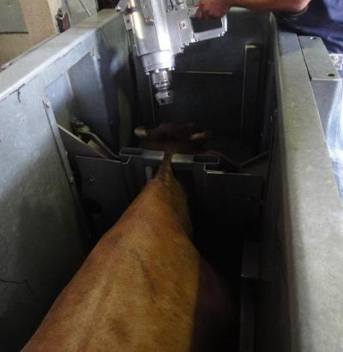
Knocking box
© L. Hewitt
Head restraint
Head restrainer/positioning units are normally an integral part of the knocking box and only used on large stock such as cattle. Their use is usually confined to plants that process significant numbers of cattle from large holdings or stations. Cattle from northern Australia are often easily excitable due to their previous lack of contact with people, and therefore require a more specialised restraint process.

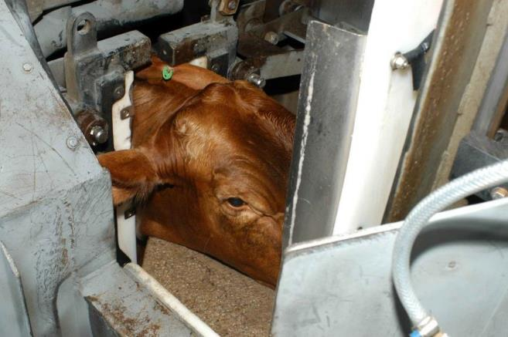
Head restrainer unit
© MINTRAC

There are four types of head restraint devices commonly used:
- the passive ‘fixed’ shelf or head positioning device
- the cantilever yoke system with two vertical moving bars
- Semi-passive neck restraining bar to restrict lateral movement of the head
- the head yoke and chin lift system which holds the head fast.
These systems can improve stunning placement accuracy, but if poorly designed and poorly used, can result in increased stress to the animal (particularly active head restraint, such as head yoke and chin lift). The passive devices available (fixed shelf) do not physically restrain the head, but encourage the animal to place its head in the correct position and restricts downward movement. The passive restraint has no moving parts, although the effectiveness can be improved by the use of a rump-push device behind the cattle. Head restraint is an important prerequisite for ritual slaughter of large stock.
V-belt restrainers
V-belt restrainers are mechanical devices fed by a narrow race from the holding pens. They consist of two conveyors which are wider on the top. The conveyor belts are usually constructed from plastic slats on rubber belting. As the animal enters the conveyor, the floor drops away such that they are suspended under their own weight. They are then conveyed to the stunning point.
The size of the conveyor will depend on the type or species of stock being processed. Some types of conveyor can be adjusted for different sizes of animals within the species, e.g. lambs and adult sheep. Conveyors can be used for most species of stock but are most commonly used in sheep, goat and pig plants. This type of restraint works better for sheep and goats than for pigs. Mechanical stunning, head-only electrical stunning or head to back electrical stunning can be used when livestock are restrained in this type of system.
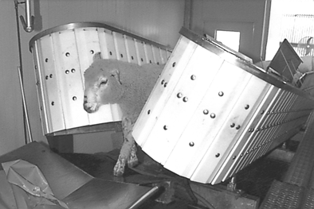
V-belt conveyor for mutton - front view
© Wodonga Institute of TAFE

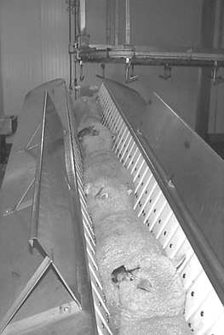
V-belt conveyor for mutton - view from above
© Wodonga Institute of TAFE
Catching pens
Catching pens are usually found in small scale operations that don't need a conveyor or knocking box. They are only used for small stock such as sheep, goats, calves and pigs. Catching pens should be small enough to ensure that animals can be sufficiently manually restrained and stunned prior to sticking. Mechanical stunning and head-only electrical stunning (using scissor-type tongs) can be used on animals restrained in a catching pen.
They should only be permitted for use when the arrangement is such that the relevant stun/stick interval for the species is always achieved.
Monorail and double rail restrainers
Rail restrainers differ from the V-belt restrainer in two ways. They consist of a central rail conveyor between enclosed vertical sides. The system holds the animal in a straddle position over the central rail(s), with their belly and brisket resting on the moving conveyor. When operated correctly, this type of restraint has been shown to be less stressful that the v-belt restrainer.
Rail restrainers can be used for cattle and pigs; the type and species will determine the size of the system. Rail restrainers designed for each species can be adjusted to suit different types of stock, e.g. vealers or cows.
Squeeze boxes
This method involves holding the animal by pressure from the sides. Usually one side moves. It is not a commonly used restraint method, though it is very effective for large sows and boars.

WI | How are mechanical restrainers used?

Stock handlers must always operate mechanical restrainers according to workplace procedures.
Mechanical restrainers require frequent monitoring as stock handlers may need to make adjustments. When stock handlers use mechanical restrainers, make sure that:
- restrainers are adjusted to suit the size of the animal being handled, for example, when changing from a run of sucker lambs to calves, the restrainer is adjusted so that calves do not escape over the top
- animals are not placed into the restrainer on top of one another, as this may cause stress and/or injury (bruising) to animals.
WI | How are restraint methods monitored?
Monitoring procedures should be incorporated into the establishment’s existing animal welfare arrangements.

Monitoring restraint | Checks | Outcome
Pre-start checks | Restrainer set-up for species and animal type | - In v-restrainers, the space between the moving belts should be suitable for the size of livestock.
 | Moving parts are covered | - Moving parts that could cause injury are covered.
 | No protrusions and obstructions | - Objects removed that could cause injury or baulking.
 | Approach race suitable | - Objects that could cause baulking are removed.  - Ventilation is not blowing towards the animal as it is moved up the race.  - Noise levels are minimised.  - No reflections on the floor surface of the race.
 | Appropriate lighting levels | - Entrance to restrainer well-lit.  - Light is not shining in animal’s eyes.
Operational checks | Movement into the restrainer | - Animals handling and use of aids is appropriate.  - Animals move well into the restrainer with only low levels of encouragement.  - No baulking, turning back or piggy-backing.
 | Restraint process | - Correct position for stunning.  - Low levels of vocalisation and struggling– no application of excessive pressure.  - Appropriate speed of the conveyor.  - Time in restraint minimised – stunning and sticking operatives ready.  - Procedures in place for breakdowns and delays.
What other checks must be made when using a restrainer?
WHS procedures must be followed when operating a mechanical restrainer. This is very important for operator safety. When operating the restrainer, it will be necessary to check that:
- workplace procedures are followed
- staff operating the restrainer are trained and competent
- any faults are dealt with according to workplace procedures
- work areas are kept neat and tidy.
Stunning
Why do we stun?
When animals are killed for food, it is imperative for welfare and ethical reasons that pain and distress is minimised. To comply with this requirement, animals should be rendered unconscious and insensible to pain before slaughter.
The period of insensibility must include the time when stunning is initiated, through the start of the slaughter process to the time taken for the animal to bleed to death. This is to ensure that animal welfare is protected and the requirements of AS4696 2023, Codes of Practice, relevant legislation are met. In most instances, except for certain forms of religious slaughter (where sticking without prior stunning may be permitted), unconsciousness (and insensibility) is achieved by stunning the animals prior to slaughter. The stunning of animals prior to slaughter is normally a mandatory requirement.
In each of the methods that are used for stunning and slaughtering animals, there should be means of verification that the procedures were adequately carried out. This should form part of the abattoirs routine monitoring process.
What equipment can be used to stun animals?
A range of equipment can be used to stun animals. The type of equipment used at each site will depend on the type and size of stock or species being processed.
It is important that the correct workplace procedures for using the stunning equipment at your site are followed.
There are three main categories of stunning equipment used:
- mechanical stunners
- electrical stunners
- controlled atmosphere or gas stunners.
Mechanical stunning
What effect does mechanical stunning have?
The objective of mechanical stunning methods is to induce immediate unconsciousness by the administration of a severe blow to the head of the animal. The unconsciousness produced must last until death (by bleeding).
There are different means to achieve the force needed for this blow, i.e. a free bullet or a captive bolt. Mechanical stunning produces unconsciousness through the induction of a concussed state. The blow to the head accelerates the skull. The brain, which is floating in a bag of fluid, accelerates a fraction of a second after the skull.
This causes increases and decreases in pressure within the skull/brain which disrupts brain activity and produces the stunned state (concussion). The primary effect of mechanical stunning methods is therefore the impact of the bolt onto the head, rather than the penetration of the bolt or bullet into the brain. Studies on brain activity have shown this to occur within approximately 1.5 milliseconds, i.e. before the animal can perceive any pain associated with the stunning method or any slaughter process.
The duration of concussion depends upon the amount of damage done and the degree of disruption to blood supply. If the damage is too extensive the animal will not regain sensibility, instead falling into a permanent state of insensibility or even die.
With correct positioning, so that physical damage to the cortex and midbrain is caused, stunning with a penetrating captive bolt pistol will be irreversible. However, this irreversibility should not be relied upon and captive bolt stunning should always be regarded as a stunning method only and therefore always followed by prompt sticking.
How does mechanical stunning work?
To be effective, mechanical stunning has to deliver a maximum amount of energy in the shortest possible time to the correct part of the animal’s brain. For this the kinetic energy of the bullet or captive bolt has to be transferred to the animal’s head.
The kinetic energy (KE) is the movement energy of a travelling object. It is proportional to the mass (m) and the velocity (v) of the object. The formula below expresses this relationship:
KE = ½ mv²
This illustrates that the speed of the moving object (bullet or captive bolt) has a far greater influence on the resulting kinetic energy than its weight.
Therefore the utmost care has to be taken to ensure the maintenance of the appropriate captive bolt or free bullet velocity as even an apparently minor reduction of the velocity can mean the difference between an effective and an ineffective stun.
Captive bolt stunning equipment
What are captive bolt stunners?
The main functional component of a captive bolt stunner is a steel bolt that moves inside a barrel without being able to leave that barrel (ie held captive). The bolt is propelled forward by the expansion of gases and projects forward through an opening in the front of the barrel. It transfers its kinetic energy to the skull of an animal and afterwards retracts into its starting position.
Captive bolt stunners can be classified by their mode of action into penetrating and non-penetrating, by their source of energy, into cartridge powered and pneumatic, and by their firing mode, into trigger fired, contact fired or a combination of both.
What are the two modes of action for captive bolt stunners?
Penetrating captive bolt stunners
Penetrating captive bolts cause physical damage to the brain (by penetration) in addition to the concussion caused by the impact of the bolt onto the skull. Penetrating captive bolt stunning is therefore an effective stunning method that can result in the death of the animal when carried out correctly. However, this effect should not be relied upon and the method still requires proper bleeding of the animal to ensure its death. The use of penetrating captive bolts for the humane destruction of animals in the lairage allows pithing (insertion of a rod through the bolt hole to destroy the brain) in the absence of sticking.
Non-penetrating captive bolt stunners
Non-penetrating captive bolts are designed to transfer their entire kinetic energy into movement of the skull and the resulting concussion (concussive stunning). This is achieved by using a bolt with a larger surface area or a steel plate at the tip of the bolt. The tip is convex in shape, which is why they are also called “mushroom head stunners”. Subsequent destruction of brain tissue is not a primary feature of concussive stunning, although this sometimes happens by bone fragments from the skull being driven into the brain or the sheer force of the impact. An effective stun results in a temporary loss of consciousness, which requires a fast and effective bleeding of the animal in order to prevent recovery.
Non-penetrating captive bolt stunners have a number of drawbacks in comparison with penetrating ones. There is a smaller margin for error in the application – due to its larger footprint more care needs to be taken to apply the stunner at a 90 degree angle to the forehead. Fracture to the skull during stunning (for example in young cattle, older cows) can absorb some of the energy of the impact, which can in turn have an effective on the success of the stun. If the skull is too thick (old bulls, buffalo) or has bony ridges over the area of the brain (sheep, goats) or is covered by thick, matted hair, then percussive forces may not be transferred effectively. This form of stunning is therefore only recommended for cattle slaughtered for Halal markets where a reversible stun is desired. Stunning with a non-penetrating captive bolt pistol is not recommended for sheep, pigs and goats.
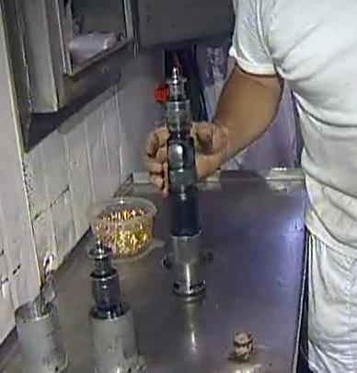
Captive bolt gun
© Des Bowler
What are the two sources of energy for captive bolt stunners?
Cartridge
The vast majority of the captive bolt stunners in use are cartridge powered. They are usually powered by blank cartridges (.22 or .25 calibre) with a gunpowder load but no bullet. Cartridges of varying power loads (resulting in different bolt speeds) are used for different classes of stock. As a rule of thumb heavier powder loads are used for heavier/bigger animals with larger skulls. Different charges are usually marked with a different colour.
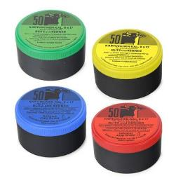
The advantages of cartridge powered captive bolt stunners are that they are relatively cheap, easy to handle and maintain, and most importantly very portable. They are therefore very flexible and can be used in almost any environment. This has made them the stunner of choice for small to medium sized cattle slaughter plants, for any application outside (yards, trucks, etc), and as a back-up device for other stunning equipment.
In large cattle slaughter plants with high throughput the cost of ammunition and the mechanical strain on the equipment (resulting in overheating) has become a major drawback of these guns. Also the problem of recoil with non-penetrating stunners has become an WHS concern.
Compressed air (pneumatic stunners)
Captive bolt stunners that are driven by compressed air were developed for large throughput plants,. The major advantage of the pneumatic stunning devices is their low operating and maintenance cost per animal. The stunners are relatively large and heavy which gives them considerably less recoil but also makes them harder to operate and not as versatile in their application. Being tied to a fairly powerful air compressor is restricting their use to medium to large cattle slaughter plants where they are common.

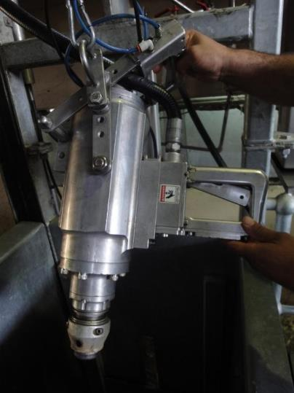
Pneumatic stunning device
© L.Hewitt
What are the different firing modes of captive bolt stunners?
Most cartridge-powered captive bolt pistols are fired by the operator squeezing a trigger as soon as the gun is in place. Some captive bolt guns are fired on making contact with the animal’s head. The use of head restraint can increase the likelihood of accurate placement, particularly with contact-fired captive bolt devices.
Some pneumatic captive bolt stunners have two triggers, one that is activated when the stunner touches the animal’s forehead and another one that is operated by the operator’s hand. This is to ensure firm contact with the head is made before the stun – ensuring good placement and less chance of recoil.

WI | How can an effective captive bolt stun be achieved?

The stunning operations at each site will be governed by the site workplace procedures. These workplace procedures and policies will depend on the species and category of stock being processed.
To achieve an effective stun, workers need to have an understanding of the stunning process and be trained in the correct use of the stunning equipment. Effective stunning with a captive bolt stunner depends on five main factors:
- trained and competent operatives
- accurate positioning of the equipment over the target area
- use of the correct strength of cartridge/air pressure for the animal being stunned
- the velocity and diameter of the bolt
- proper maintenance and daily cleaning of the equipment.
The main cause of improper captive bolt stunning is incorrect positioning of the equipment. This is often due to the animal moving its head at the last moment so that the bolt is not in the correct spot when fired. To overcome this problem, operators must be adequately trained and the restraining equipment must be constructed to:
- prevent substantial movement of the animal forwards, backwards and sideways
- restrict movement of the animal's head
- allow for the stunning device to be applied to the target area on the animal’s head.
The use of the correct strength of cartridge/air pressure is vital for proper stunning and the manufacturer’s specific instructions should be followed at all times.
The explosive materials used in the cartridge powered captive bolt stunners will cause a residue that can reduce the performance of the device and will, if not removed, result in ineffective stunning and excessive wear of the equipment. So, daily checking and cleaning of the equipment is vital for proper use. If all these elements are addressed, stunning should be routinely effective.
Shot position
In order for a mechanical stunning device to be effective it needs to be aimed at the correct target area. The location of this area varies from species to species and sometimes also within species. This is because of the relative position of the brain to identifiable surface features. We need to target a centre point over the brain as described by some simple rules. Equally important, the trajectory of the bolt is a component of the shot which must be taken into consideration.
Cattle
The brain of cattle is situated high in the head and the ideal placement for a penetrating captive bolt or a free projectile is the middle of the forehead. To determine this spot it is best to use the crossing point of two imaginary lines drawn from the top of the eyes to the base of the opposite horns.
The ideal spot for a non-penetrating captive bolt is slightly above (20mm) this crossing point. Captive bolt stunners should always be applied at right angles to the skull.
A poll shot (aiming behind the ridge between the ears towards the nose) should never be used in cattle. The ridge itself absorbs too much kinetic energy so the stun is ineffective, and below the ridge, it is too easy to miss the brain, and just cut through the spinal cord. This leads to a paralysed but fully conscious animal.

Correct stun position
(frontal position)
Incorrect stun position
(Poll position)

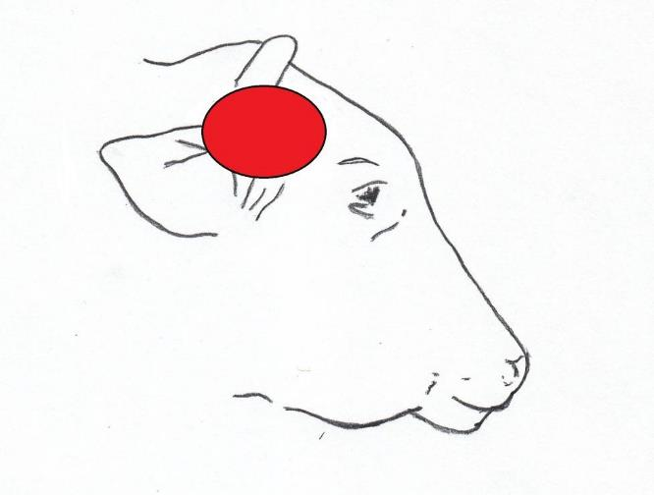
Diagram showing the approximate position of the brain in cattle and
the correct stunning position © L. Hewitt
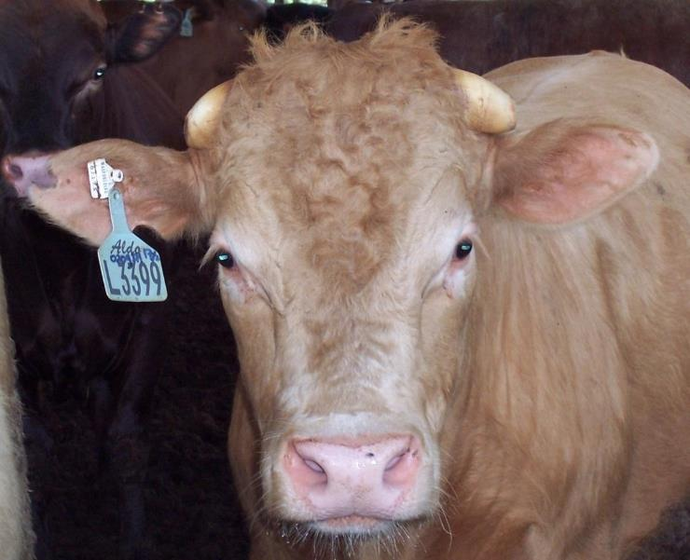

Stunning position for a penetrating captive bolt (red dot) and
non-penetrating captive bolt (Yellow dot)
© L. Hewitt

Sheep, lambs, goats, calves (small stock)
After being suitably restrained, small stock are stunned by applying the appropriate captive bolt to the correct position on the animal's head and/or body.
In sheep correct shot placement is dependent on whether they have horns or are polled. Polled sheep should be stunned with a penetrating captive bolt gun in the midline and at the highest point of the head aiming straight down (A). A free projectile should be aimed at the midline slightly above the eyes and down the spine (B). Horned sheep should be shot from behind the poll position (C) and the stunner or free projectile should be aimed at the angle of the lower jaw.
B
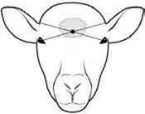
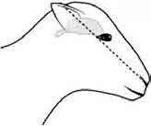
^{A}

C
B

A

Courtesy of AusMeat 2014

Goats
The correct position for stunning goats (both horned and polled) is the same as for horned sheep. The captive bolt device should be positioned on the midline, behind the bony ridge and aimed towards the base of the tongue (poll position). When animals are shot in the poll position they must be bled within 20 seconds.
Pigs
In young pigs the shot position is at a point 2 cm above the rear margin of the eyes, on the midline and aim towards the tail. With pigs, effective mechanical stunning with a penetrating captive bolt pistol can produce immediate clonic (uncontrolled kicking) activity. This activity makes assessment of the effectiveness of the stun a difficult procedure and can delay the stun to stick interval with subsequent consequences for animal welfare. It is for these reasons that mechanical stunning is not usually the method of choice for pigs. However, mechanical stunning is effective with pigs and is therefore suitable as a back-up to the main-line stunner or for humane destruction of an animal for example, in yards or on a truck. Stunning with a captive bolt is not recommended for very large sows and boars.
Firearms
When are firearms used for stunning?
In some circumstances, firearms are the preferred method of destruction, e.g. large boars or sows, escaped animals and emergency destruction in stockyards, paddocks or stock transports. A current firearms licence must be held.
Firearms work on the same principal as captive bolts except that the mass of the projectile is smaller, the projectile is not restrained and the velocity is higher than a captive bolt. The firearm delivers far more impact than the captive bolt and is thus considered the most effective means of killing livestock. However, WHS issues preclude its routine use in abattoirs.
The bullet has both a concussive and a destructive effect on the brain and effectively kills the animal. There is no stipulated maximum stun/stick interval for animals shot by firearm, as the animal is effectively already dead. However, a stick as soon as possible after shooting is considered best practice to achieve a good bleed.

E | How is mechanical stunning equipment prepared and maintained?

All stunning equipment should be carefully maintained according to workplace procedures and manufacturer's specifications.
Stunners should be checked prior to the commencement of operations to ensure they are working correctly and safely. Mechanical stunners must be dismantled and cleaned according to the workplace requirements. In general the stunner should be cleaned at the end of each shift and the back-up stunner maintained routinely. Daily checks and maintenance must include:
- dismantling of the stunner
- cleaning the stunner
- checking parts for wear
- lubricating the stunner according to the manufacturer’s specification.
The ability of mechanical stunners to deliver an effective stun is largely dependent on the velocity of the bolt. In cartridge-powered stunners the velocity of the bolt can be affected by the build-up of residues in the firing chamber. If the equipment is not serviced properly these residues build up to the point that the bolt cannot retract fully. This increases the relative size of the expansion chamber and thereby reducing the force of impact of the next shot. Likewise excessive wear of the buffers, piston, cylinder or flange can reduce the effectiveness of the equipment.
Most manufacturers of mechanical stunners also supply equipment that measures the bolt velocity. Larger abattoirs should consider buying this equipment. Smaller operators should at least have a representative of the supplier perform a bolt velocity check on a regular basis.
WI | How should the effectiveness of mechanical stunning be monitored?
What are the signs of an effective mechanical stun?
Certain physical signs should be observed in the stunned animal in order to satisfy the operator that the stun has been effective.
These are:
- the animal collapses immediately
- a tonic and clonic phase can be observed – at first the legs are all tucked under, and then the front legs will extend, but the hind legs will remain tucked under, and only slowly extend. This is the ‘tonic phase’. Over a period of time, the animal will start to convulse and the legs may kick violently. This is the ‘clonic phase’. Note that in pigs, the tonic phase is very short, and the violent kicking starts almost immediately
- no rhythmic breathing
- fixed, glazed expression in the eyes
- no corneal reflex
- relaxed jaw
- tongue hanging out – mainly observed in cattle.
In animals shot with a free projectile there may be additional signs:
- profuse bleeding from mouth, nose and/or entry wound
- after first being completely still, violent convulsions of the carcass may occur up to one minute after the shot (clonic phase).
Those monitoring the stunning of animals using a mechanical method should check the following:
Monitoring mechanical stunning | Checks | Outcome
Pre-start checks | Equipment | - clean and in working order
 | Power source | - correct powerload/air pressure for animal type
 | Restraint | - see previous section
Operational checks | Shot position | - animals are shot in the correct position – placement on head and trajectory of the bolt. It is very important to remember that all the examination of skulls tells us is how accurate the shot position was. The bolt trajectory cannot be determined by simply examining an animal’s head (post-slaughter) and measuring the position of the shot hole. It is impossible to determine the angle of the trajectory, simply by measuring the two-dimensional position of the shot. Assessment should always be carried out by inspecting the effectiveness of the stun on the animal at the time it is shot
 | Effectiveness of stun | - animals show signs of an effective stun (no eye reflexes, rhythmic breathing or righting reflex when shackled)  - the stun operator checks every animal for signs of an effective stun, usually by checking that the animal has collapsed immediately and by checking for the absence of the corneal reflex  - all operators working in the area observe bodies for signs of rhythmic breathing and/or head righting  - the operator responsible for sticking must, before making a cut, check the corneal reflex on every animal  - number of animals re-stunned is recorded
 | Stun to stick interval | - meets regulatory requirements  - rate of stunning is at a level that maintains chain speed but does not allow excessive build-up of bodies in the stun/stick area; so that there is no delay between stunning and sticking
 | Back-up stunning | - the stun operator checks after every stun that the captive bolt retracts to the fully primed position. If it does not, it must be replaced and not used again until it has been repaired and cleaned  - any sign of an eye reflex upon checking and the animal is immediately re-stunned and the supervisor notified  - back-up stunner is readily available

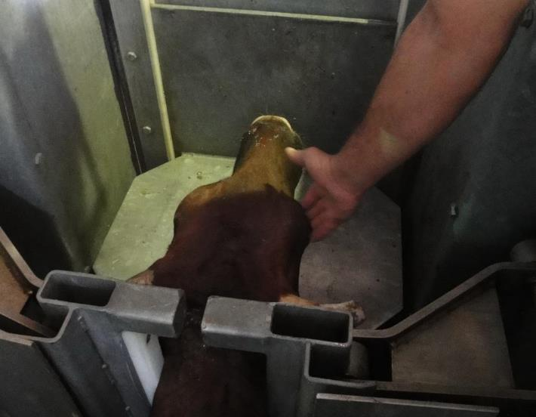
Checking the corneal reflex after mechanical stunning
© L.Hewitt

Monitoring of stunning is usually done both at the beginning and end of a shift to determine the effects of employee fatigue. An unacceptable rating results in immediate corrective action and review of the relevant standard operating procedure, work instructions, individual performance and/or equipment.
Electrical stunning
What are the general principles relevant to the electrical stunning of animals?
Electrodes must be placed so that they span the brain and sufficient current applied to cause immediate unconsciousness. When sufficient current is applied to the brain, an epileptic fit will be produced during which the animal is unconscious. The use of electricity can have a number of physiological effects on an animal depending on the level of current and voltage, the waveform and frequency, and the pathway through the animal. These can range from a painful stimulus (when the stun is ineffective) to a loss of sensibility for varying durations and even death.
Ohm’s Law
When electricity flows through an object or body there are a number of factors determining what happens. The amount of current that flows is known as current (I) and is measured in amperes (A). The driving force behind the current flow is known as the potential difference or voltage (U) and is measured in volts (V). A material’s ability to limit the flow of current is known as its resistance (R) and is measured in ohms (Ω).
The relationship between these factors is described in Ohm’s Law:

Current = Voltage / Resistance

I = U / R

There are a number of implications of this relationship that apply to the electrical stunning of animals. For an animal to lose sensibility a sufficient amount of current needs to flow through its brain for a certain period of time. To achieve this adequate voltage needs to be applied to the system in order to overcome the resistance that is inherent to the animal. Measures can also be taken to reduce the electrical resistance of the animal (wetting of skin/fleece, shearing/cleaning of electrode contact areas) although this is not common in Australia.
Waveform and frequency
Electrical current is utilised to stun animals in two different waveforms: either as a pulsed direct current (DC) or an alternating current (AC). A direct current is one where the electrons flow in one direction and in order to achieve a pulsed DC the power source is periodically turned on and off. An alternating current is one where the electrons periodically change direction and it is the type of current that is utilised in the mains supply.
The frequency of an electrical current is the number of times that its waveform is repeated (cycle) per second. It is measured in hertz (Hz) and 1Hz means one completed cycle per second.
Pathways through the body
The effects of an electric current (provided it is of sufficient strength and has the right waveform and frequency) on an animal are dependent on the path that the current takes through the animal’s body. The pathways most commonly utilised in the pre-slaughter stunning of animals are head-only, head and heart, and head and body.
What are the effects of the electrical current passing through an animal?
Depending on which parts of the body the electrical current passes through the consequences for the animal vary as follows:
Head-only
The application of an electrical current to the head needs to be done with two electrodes that span the brain. If appropriate current flows through the brain the result will be a state of over stimulation similar to an epileptic seizure. This stops the normal functioning of the brain and the animal looses consciousness. If done properly the effect of the electrical current on the brain is instantaneous and causes unconsciousness before any pain stimulus associated with the application of the equipment can be registered.
The seizure as the outward symptom of the brain’s inability to function normally typically runs its course in three stages (upon removal of the electrodes from the animal’s head):
- The tonic (rigid) phase where the head is tilted back, the front legs are extended, and the hind legs are either tucked into the body or are also stretched out.
- The clonic (moving) phase, which is characterised by quite violent muscular spasms and these spasms cause the animal’s legs to paddle wildly.
- The recovery or exhaustion phase, during which the animal becomes quiet and starts to breath regularly again. After a while the animal becomes visually aware and attempts to stand up. This phase should never be seen in an abattoir situation.
The first two phases of the seizure are incompatible with sensibility. The resumption of regular breathing at the start of the third one indicates that the animal is about to regain consciousness.
The head only stun is fully reversible and unless the animal is bled fast and effectively it will recover completely within a few minutes.
Head and heart
If current flows from head to brisket, head to back, or head to front leg then the heart of the animal is also in the current pathway. The application of sufficient current (at the appropriate frequency) to the heart puts it into ventricular fibrillation. All the muscle fibres of the heart are now contracting in an uncoordinated way instead of the usual coordinated fashion. This prevents the ventricles (chambers of the heart) from filling between two pumping actions and the blood ceases to flow. Unless this state is reversed very quickly it will lead to cardiac arrest.
An animal stunned in this way is unable to recover and will eventually die whether it is bled or not.
Head and whole body
If the spinal column is involved in the flow of the current (past a certain point at the back of the ribcage) the reflex movements following the stun will be suppressed through the depolarisation of the spinal nerves (spinal discharge). This is sometimes utilised for worker safety reasons.
It is important to note that for animal welfare reasons no current should pass through any part of the body before current has passed through the brain. This is to ensure that the animal is rendered unconscious before the cardiac arrest is induced, as this would otherwise be very painful (i.e. like a heart attack).
How does the choice of current pathway and frequency affect the outcome of an electrical stun?
Type of stunning | 50 Hz | High frequency (800 Hz +)
Head Only | Epilepsy | Epilepsy
Head and heart  (head to back, head to brisket, head to front leg) | Epilepsy  Cardiac arrest  Spinal discharge | Epilepsy  Spinal discharge
Head and whole body  (head to back leg, head to ground) | Epilepsy  Cardiac arrest  Spinal discharge | Epilepsy  Spinal discharge
What species are electrically stunned?
Generally, sheep, goats and calves are stunned – head only – using the two pin type stunners. Pigs are usually stunned – head only – using two pin prong and scissor-type stunners, or – head to back – three electrode stunners. Ostriches and emus are usually electrically stunned with scissor-type tong stunners.
Electrical stunning of cattle is very common in New Zealand, but far less so in Australia and cattle are restrained in a box before being stunned. The electrodes are applied automatically rather than manually because of the size of the animals involved.
The Australian Animal Welfare Standard recommends minimum current levels and stun durations necessary to elicit an epileptic fit and cause reversible unconsciousness (head only stun).
The stunning equipment should be provided with adequate power to continuously achieve the minimum current levels recommended for stunning and it is essential to follow the established workplace procedures to achieve an effective stun.
Sheep, lambs, goats, calves (small stock)
After being suitably restrained, small stock are stunned by applying the electric stunner to the correct position on the animal's head or head and body.
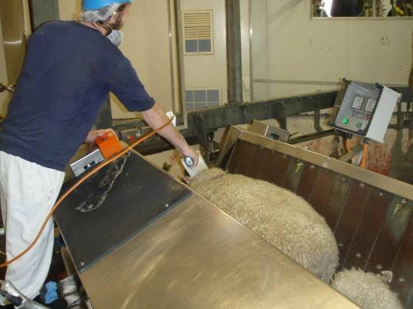
Electrical stunning of sheep
© S. Fitzgerald
Pigs
The most common electrical stunning methods for pigs are the two pin head only, three pin head to back, or scissor type electrodes. The scissor type electrodes can be applied to free-standing pigs in a stun pen, however, the two pin fixed electrodes can only be used when the pig is restrained (for example, on a v-restrainer). The head-to-back stunning method was developed as an alternative to the head only application of the tongs to eliminate the effect of the large variations in the delay between stunning and sticking which could allow the pig to regain consciousness before it dies through bleeding (exsanguinations). This technique simultaneously stuns the animal and induces cardiac arrest. In addition, the application of electrical current to the chest area affects the spinal cord and can prevent the expression of convulsions (kicking) during the clonic phase of epilepsy. The application of the electrodes must be in a position that spans both the brain and the heart to ensure that the animal is unconscious before cardiac arrest is induced.
Fully automatic high voltage stunning systems incorporated into restraining conveyors have also been used for high throughput pig operations. The restraining conveyor receives the pigs from a race. The slower moving first conveyor transfers the pigs to the faster moving second conveyor which separates pigs within the system. High voltage stunning electrodes, mounted on a carriage, make contact with the head of pigs and maintain contact for the duration of the stun. Voltages of more than 600 volts are applied and the resultant current can be as high as 10 amps.

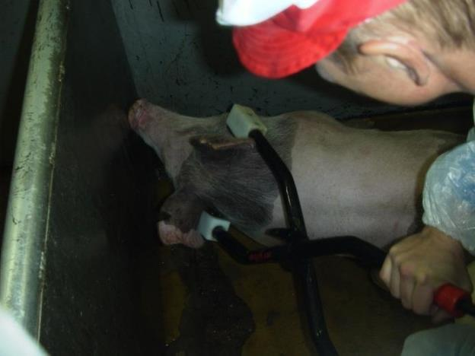
Head-only electrical stunning
© L.Hewitt

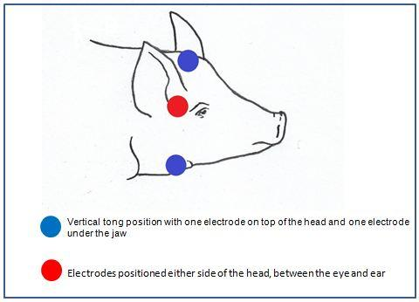
Head-only electrical stunning tong positions – to span the brain
© L.Hewitt
Cattle
Electrical stunning systems are also available for cattle. The beef electrical stunner is a stand-alone cattle knocking box with pneumatically-operated head restraint through a neck yoke and chin lift. Electrical contact with the brisket is made through an electrode that is applied pneumatically, between the animal’s forelegs. Water is used on the nose, neck and brisket electrodes to aid conductivity. It can be programmed to run in either a head-only cycle (when reversible stunning is required), or three cycles sequentially; a head only cycle, to stun the animal, a cardiac arrest and a spinal discharge cycle, employed to reduce post kill convulsions.

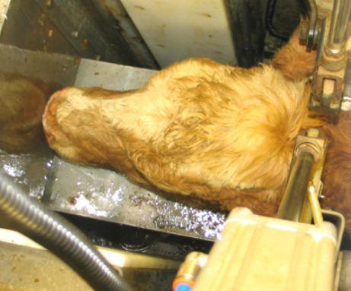
Electrical stunning of cattle
© L.Hewitt
How is the electrical stunning equipment operated?
Operators responsible for stunning and stun equipment must ensure that:
- the animal is adequately restrained, then stunned as soon as possible
- stunning equipment must be checked prior to each shift, regularly cleaned, maintained and stored appropriately
- the stunning equipment is operated properly and in accordance with the manufacturer’s instructions and that the signs of effective stun are recognised
- back-up stunning equipment, for example a captive bolt gun, must be available and ready for use as required (i.e. ineffective first stun).
The stunning operations at each site will be governed by the site workplace procedures. These workplace procedures and policies will depend on the species and categories of stock being processed.
To achieve an effective stun, workers need to have an understanding of the stunning process and be trained in the correct use of the stunning equipment.

WI | How do you achieve an effective stun using electricity?

There are a number of factors that affect the effectiveness of electrical stunning:
- applied voltage and current
- stun duration
- frequency of applied current
- proper placement of electrodes on the animal’s head/body (spanning the brain)
- training of operator
- animal factors (that can affect resistance to current flow).
In order to ensure that the equipment is operating correctly stunning operatives should check the amp and voltmeter regularly.
Operators should never attempt to stun animals if the equipment is not working to the specifications in the work instruction or operating procedures.
Common causes of an ineffective stun (head only) include:
- wrong positioning of the electrode
- amperage that is too low
- dirty wool and skin (increases resistance)
- stray current
- poor electrode contact with the animal
- dirty electrodes
- electrode contact areas that are too small
- animal dehydration
- long hair or wool
- interrupted contact during a stun.
How should electrical stunning equipment be maintained?
Electrical stunning equipment must be cleaned regularly to ensure that a good electrical contact occurs between the stunning electrode and the animal. The minimum cleaning schedule is once per day but electrodes must be regularly checked for the build-up of carbon deposits and cleaned as required.
The Background Notes from the Animal Welfare Standards recommend that:
- regular checks of electrical continuity and insulation should be carried out to ensure current flow to the electrodes is adequate and there is no current leakage
- electrical stunning equipment should be tested prior to use to ensure the power output is adequate to stun animals
- electrodes should be cleaned regularly to enable optimum electrical current flow to be maintained
- the equipment should where possible, incorporate a device that monitors and displays stunning current delivered to the animals. There should be a gauge, dial or light that operates during the stun and is visible in the bleeding area. These should be checked as part of the maintenance program
- the unit should incorporate a visible signal that the stun is complete, so that the prongs are not removed before stun is complete
- the effectiveness of stunners should be monitored throughout the operating period. Any stunners which fail during operations must not be used until after they have been repaired. Spare stunning units should always be available at the point of use in case of failure
- records should be kept of all maintenance on stunners as part of a company's Approved Arrangement Program
- any problems with the operation of stunners need to be reported to the appropriate person, as required in the workplace procedures.

WI | How should the effectiveness of electrical stunning be monitored?
What are the signs of an effective electrical stun?
When sufficient current is applied to the brain a tonic/clonic (previously known as ‘grand mal’) epileptic fit results. The animal is initially tonic (rigid) particularly during the current application but also afterwards for up to around 15 seconds from the start of the stun. If possible it is best to stick the animal during the tonic phase. After the tonic phase the animal enters a clonic phase which is seen as uncontrolled physical activity (kicking). The epileptic fit will last for a finite period of time that will vary from animal to animal. In humans, tonic/clonic epilepsy is always associated with unconsciousness and the physical symptoms are similar to those observed in animals following successful electrical stunning. If the animal shows any sign of kicking or paddling movements as soon as the current is stopped, then it is possible that the animal has not been effectively stunned (Animal Welfare Standards), though it could also indicate that the stun duration (application of the electrodes on the animal’s head) has been excessively long and the animal has immediately entered the clonic phase following removal of the electrodes.
The clonic phase normally lasts for between 15 and 45 seconds. The presence of the tonic, followed by the clonic stage indicates that the stun has been successful. It should be noted that the clonic phase is normally less pronounced following head to back stunning than with head only stunning. Following these two phases, a quiet phase sets in, where the animal is quite still before the first signs of recovery will appear. The quiet phase should never be observed in an abattoir situation.
Eye reflexes or movements cannot be used at this stage to assess the effectiveness of the stun because eye movements are part of the epileptic fit. When cattle are stunned using electricity the signs of an effective stun are slightly different to other livestock species. The following signs of an effective stun should be verified as cattle are hoisted and slaughtered:
- decreasing muscle tone in fore limbs
- decreasing muscle tone in free hind leg (dropping)
- ears lowering slowly
- tongue extending from mouth
- fixed glazed expression of eyes ( no corneal reflex).
- those formally monitoring the effectiveness of electrical stunning will be monitoring according to the company or regulatory requirements. They will be doing so against the “inputs” and “outputs” of the stunning process. The guidelines are detailed in the Industry Animal Welfare Standards.
Those monitoring the stunning of animals using electrical stunning should check the following:
Monitoring electrical stunning | Checks | Outcome
Pre-start checks | Equipment | - clean and in working order  - maintenance records up to date
 | Voltage, current and frequency | - correct for species and animal type in accordance with company procedures
 | Restraint | - see previous section
Operational checks | Electrode application | - electrodes applied in the correct position spanning the brain  - electrodes applied firmly to overcome initial contact resistance  - correct stun duration
 | Effectiveness of stun | - animals show signs of an effective stun (no rhythmic breathing)  - the stun operator checks every animal for signs of an effective stun, usually by checking for tonic/clonic epileptic fit and absence of rhythmic breathing  - all operators working in the area observe bodies for signs of rhythmic breathing  - the operator responsible for sticking must, before making a cut, check the rhythmic breathing is absent  - number of animals re-stunned is recorded
 | Stun to stick interval | - meets regulatory requirements  - rate of stunning is at a level that maintains chain speed but does not allow excessive build-up of bodies in the stun/stick area; so that there is no delay between stunning and sticking
 | Back-up stunning | - any sign of rhythmic breathing or other sign of ineffective stunning upon checking and the animal is immediately re-stunned and the supervisor notified
Monitoring is usually done both at the beginning and end of a shift to determine the effects of employee fatigue.
An unacceptable rating must result in an immediate corrective action and review of the relevant standard operating procedure, work instructions, individual performance and/or equipment.
Gas stunning
In this form of stunning the animal is exposed to an atmosphere that cannot sustain life. Brain function is affected by the gas level in the system and the animal will lose consciousness after a certain period of time in such an atmosphere.
Nowadays there are a number of different gases used in this form of stunning but the most commonly used one is still carbon dioxide.
What is carbon dioxide stunning?
Stunning with carbon dioxide (CO₂) gas is only used for pigs. Because this method is very costly to set up and maintain, it is normally only used in high volume processing plants.
In carbon dioxide stunning, pigs pass through a gas chamber – a CO₂ stunner – on a moving conveyor or in cages called gondolas. Exposure to the gas (of a certain concentration) makes the pigs unconscious in approximately 15 seconds. The longer they are in contact with the gas the longer they will stay unconscious. CO₂ stunning is very effective. Pigs are in a relaxed state as they exit the chamber reducing the risk of injury to the worker performing the sticking process.
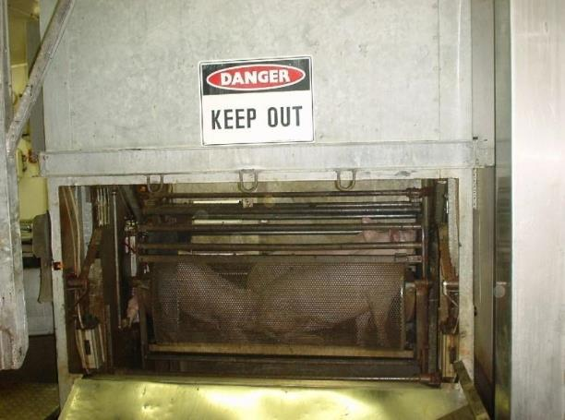
Lowering pigs into a gas chamber
© QAF Meats
How is a carbon dioxide stunning system operated?
The gassing of pigs is achieved by an automated process. It is important that this process is always performed according to manufacturer's requirements and workplace procedures.
The CO₂ stunner must be checked at the start of each day to ensure that it is functioning correctly. This check should include the following:
- correct operation of all mechanisms, including alarm systems and gas sensors
- carbon dioxide concentration is at the required concentration, according to workplace procedures. The carbon dioxide concentration should be monitored throughout the day. Any malfunctioning of the gassing procedure should be dealt with and reported according to workplace procedures. This may include stopping the stunner if the gas level drops below requirements. At all times while stunning operations are in progress, a back-up stunner should be available if the stunner malfunctions or pigs show signs of recovery upon exit from the stunner. The back-up stunner is usually a set of hand-held electrical stunning tongs
- gondolas in the chamber should not be overloaded, in other words there should be sufficient space for animals to stand or lie down without being on top of each other. Overloading the gondolas can also have the effect of increasing the stun to stick interval
- sufficient dwell time to result in unconsciousness.
In summary the following features of a system utilising CO₂ are considered good practice:
- the CO₂ chamber and the equipment used for conveying the pigs should be designed, constructed and maintained in such a way as to avoid injury or unnecessary stress to the animals
- the conveyor and the chamber should be adequately lit to allow the animals to see their surroundings and if possible, each other
- there must be alternative back-up stunning equipment for emergencies
- the chamber should be equipped to continuously measure and display the CO₂ concentration and the time of exposure
- the chamber should also give a clearly visible and audible warning if the concentration of CO₂ falls below the required concentration and action must be taken immediately to fix the problem
- the design of the stunning operation must ensure that animals are loaded into the carriage and lowered in a manner to achieve an effective stun
- pigs should be conveyed to the maximum concentration of gas as soon as possible.

WI | How should the effectiveness of CO₂ gas stunning be monitored?
What are the signs of an effective CO₂ stun?
The animal exiting the chamber should be checked for an effective stun by observing signs of unconsciousness/insensibility. The pig should be off its feet, generally relaxed and must not display rhythmic breathing, righting reflex or response to a painful stimulation, e.g. a pinprick to the nose. Some animals might exhibit slow limb movement or gasping. The jaw must be relaxed (occasionally with the tongue hanging out of the mouth). The eye will have a fixed, glazed appearance and there must be no spontaneous blinking or positive corneal reflex.
Those formally monitoring the effectiveness of CO₂ stunning will be monitoring according to the company or regulatory requirements. They will be doing so against the “inputs” and “outputs” of the stunning process. The guidelines are detailed in the Industry Animal Welfare Standards. Those monitoring the stunning of animals using CO2 stunning should include the following checks:
Monitoring gas stunning | Checks | Outcome
Pre-start checks | Gas concentration | - correct gas concentration profile (such that pigs are conveyed to the maximum concentration as soon as possible)
 | Speed of carousel | - speed of carousel is such that time in the gas ensures effective stunning
 | Alarms and gas sensors | - tested and recorded
Operational checks | Effectiveness of stun | - the operator checks the gas levels and dwell time  - animals show signs of an effective stun (no eye reflexes, rhythmic breathing or righting reflex when shackled)  - the shackling operative checks every animal for signs of insensibility when the pigs exit the gas chamber  - the operator responsible for sticking must, before making a cut, check the corneal reflex on every animal  - number of animals re-stunned is recorded
 | Stun to stick interval | - meets regulatory requirements  - rate of stunning is at a level that maintains chain speed but does not allow excessive build-up of bodies in the stun/stick area; so that there is no delay between stunning and sticking  - gondolas are not overloaded as this can increase the stun to stick interval
 | Back-up stunning | - any sign of an eye reflex upon checking and the animal is immediately re-stunned and the supervisor notified
Monitoring is usually done both at the beginning and end of a shift to determine the effects of employee fatigue. An unacceptable rating results in immediate corrective action and review of the relevant standard operating procedure, work instructions, individual performance and/or equipment.

Issues common to all stunning methods

WI | Who should perform the stunning operation?

Only employees who are trained and competent in performing the stunning process correctly should perform stunning operations. These employees need to:
- where relevant hold the appropriate licence/s according to state and/or territory requirements
- understand WHS issues relevant to the stunning process
- understand the relevant animal welfare issues and legislation relating to the workplace
- understand relevant quality and hygiene and sanitation issues
- have been assessed as competent.
What are the target for achieving effective stunning of animals?
The AMIC industry animal welfare standard recommends that a sample size of 50-100 animals with the following targets for effective stunning.
Stunning method | Species | Target
Penetrating and non-penetrating mechanical stunning -first shot | Cattle and buffalo | 96%
Electrical stunning | All species | 98%
CO2 Stunning | Pigs | 98%

What if the stun is not effective?
Animals may suffer when stunning procedures fail. There must be provision for appropriate back-up stunning equipment to be available to minimise pain, distress or suffering to the animals.
If the initial stun is not fully effective then a number of actions have to be taken. These will be described in the work instructions. They must cover both corrective action (i.e. resolving the immediate issue) and preventive action (i.e. preventing it from happening again). The immediate action, upon the discovery of an ineffectively stunned animal or an animal showing signs of sensibility on the bleed-line, must be to re-stun. Animals showing signs of sensibility on the bleed-line must also be re-stuck after re-stunning.
If ineffective stunning becomes a recurring or consistent problem then it is important to:
- report this to the supervisor
- check the voltage/charges/air pressure being used
- check the placement of the stunner
- check the routine maintenance of the stunner.
In most plants, stunning is monitored daily to ensure:
- that the animals are being stunned effectively first time
- that the stun/stick intervals are observed
- that excessive numbers do not build up in the stun/stick areas
- the use of incorrect voltages, cartridges, air pressure or gas levels or the incorrect placement of stunning equipment.
Post-stunning issues
What is the stun to stick interval?
This is the time it takes to stick or bleed an animal after it has been stunned. Stunned animals must be bled as soon as possible. For reversible stunning it is recommended that the following stun to stick periods should not be exceeded. The stun to stick interval should also be monitored as part of a company’s QA program.
Stunning method | Maximum delay for bleeding to be started
Head-only electrical stun | Calves | 10 seconds
 | Sheep | 10 seconds
 | Cattle | 10 seconds
 | Pigs | 15 seconds
CO₂ (pigs) | 60 seconds (after leaving the chamber)
Non-penetrating captive  bolt (concussion stun) | 20 seconds in all species

After a reversible stun all animals should be bled by either cutting both carotid arteries or cutting the vessels from which they arise (e.g. thoracic stick). After the head-only electrical stunning of cattle (all ages) it is necessary to follow up a neck cut with a thoracic stick. This is because in cattle the anatomy of the blood vessels in the neck in relation to the head is different from that of sheep and goats. In cattle the vertebral arteries provide a blood supply to the brain. Therefore, after severance of the vessels in the neck of cattle, this artery can still supply blood to the brain; particularly if the carotid arteries become occluded (a clot in the end of the cut artery prevents blood flow). This is the major anatomical cause for delayed loss of brain function in cattle and return to consciousness.
After irreversible stunning, for example shooting with a free bullet, the stun/stick intervals are less critical from animal welfare perspectives. However regardless of this an effective stun must be checked for with every animal.
In addition the stun/stick period should still be kept as short as possible as a matter of good practice in case there is a return to consciousness. Another consideration is WHS – within the first 30 seconds of a captive bolt stun, the animal is usually in the tonic (rigid) phase, so it is easier and safer to stick the animal then when it has entered the clonic (kicking) phase.
What is electro-immobilisation?
This is a process where a very small current is applied to the animal after stunning, before or while it is being bled out. The purpose of this process is to immobilise the animal so as to control convulsions and avoid injury to staff. The current is not sufficient to maintain or extend the state of unconsciousness of the animal.
While this procedure increases the safety of workers it also has the potential to mask an ineffective stun. For animal welfare reasons it is therefore mandatory that every animal is checked and confirmed as properly stunned before the immobilisation current is applied. It is also important that the stun/stick interval is not exceeded while immobilisation is being used.
Sticking and bleeding
Why are animals bled at slaughter?
Traditionally the act of slaughter has been considered to be the process by which we bring about the death of the animal. With the exception of some religious slaughter, it is a requirement that animals are rendered unconscious prior to the slaughter act.
Fast and effective bleeding is an essential part of the slaughter process. It is usually achieved by opening major blood vessels and the process is specific to each species.
If the meat is to be used for human consumption the removal of blood from the carcass is very important to ensure product quality and shelf life.
If a reversible form of stunning is used bleeding becomes particularly important for ensuring animal welfare. The aim here is to bleed the animal to a state of irreversible unconsciousness before the stun wears off. In other words, one form of unconsciousness (stun) leads straight into another (blood loss) without the animal ever becoming conscious again.
Only in those cases where the animal is not for human consumption (e.g. euthanasia, killing for disease control purposes) it might be desirable to avoid the bleeding of an animal. If a stunning technique is used that also kills the animal (free projectile, cardiac arrest electrical current) and the animal is confirmed dead by a competent operator then the carcass does not have to be bled.

WI | How are animals bled?

The two common methods of bleeding or ‘sticking’ are the transverse stick and the thoracic stick. Religious or ritual slaughter may also have specific methods of slaughter.
Transverse stick
Before any cut is made, the sticking operative must check that the animal remains effectively stunned.
The transverse stick is when the knife is drawn across the throat, i.e. the knife transverses the throat. This is done just behind the angle of the jawbone, severing all blood vessels, the weasand (oesophagus or gullet) and windpipe or trachea.
Halal slaughter is slaughter performed according to the Muslim faith, and uses the transverse stick. Halal slaughter uses reversible stunning and so it is very important that the ‘sticking’ method is effective. The animal should not return to consciousness (not even temporarily) while the effect of the blood loss takes over from the stun.

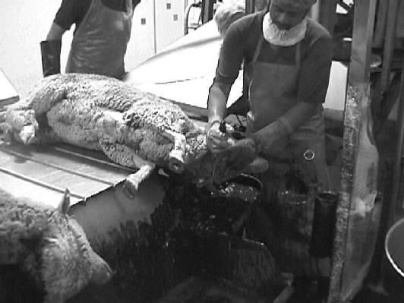
Halal slaughter of sheep
© Wodonga Institute of TAFE
It is important to monitor that there is a good blood flow from both carotid arteries after the transverse stick; especially if it is used after a reversible form of stunning (head only electrical or non-penetrating captive bolt stunning). Sometimes the arteries retract into the neck wound or clots are formed at the cut ends. This will slow down or stop the blood flow completely, which in turn will delay the onset of unconsciousness from blood loss. This is a particular problem in cattle, and there is evidence that it also occurs in sheep.
The transverse stick is used routinely in sheep and goats, and in cattle it is used for religious slaughter.
Thoracic stick for pigs
Before any cut is made, the sticking operative must check that the animal remains effectively stunned.
The normal method for sticking pigs is by thoracic stick. The knife should penetrate the centre line of the throat, just forward of the breastbone. This will sever the major blood vessels – the aorta and anterior vena cava – just in front of the heart. When the knife is inserted, the operator should avoid penetrating the shoulder of the pig and damaging and devaluing parts of the carcase. The welfare of pigs must be protected by ensuring that the sticking wound permits a good bleed out. A long sticking wound allows sufficient blood loss before potential recovery from the stun. Stick wounds should be trimmed later in the process. Pigs should be bled for at least 5–6 minutes prior to entering the scald tank.

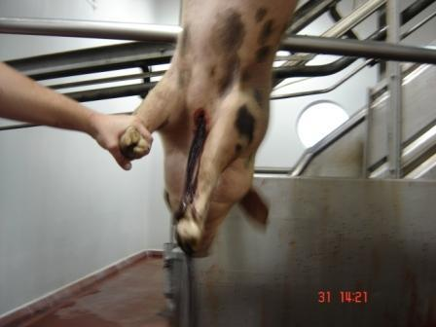
Sticking pig
© TAFE SA Regency Campus, courtesy Big River Pork
Thoracic stick for cattle
Before any cut is made, the sticking operative must check that the animal remains effectively stunned.
The correct location for this stick is the third of the neck that is closest to the thoracic inlet. Ideally the skin should first be opened over the stick area with a spear cut. Then the knife should be sterilised or changed. The actual stick should be performed at an angle towards the spine and the result should be a gushing flow of blood out of the stick wound. The blood vessel that is being opened with this stick is called the brachiocephalic artery. It branches off the Aorta (large blood vessel out of the heart) and supplies the head, neck and front limbs with blood. The vertebral arteries stem from this blood vessel, and therefore the alternative blood supply to the brain is also cut off when using this method.
This method of sticking is routinely used as a primary means of bleeding in conventionally slaughtered cattle. It is also used as a secondary stick after the transverse stick, to ensure that blood is drained from the vertebral arteries.
‘Thoracic stick’ or ‘chest stick’ are somewhat unfortunate choices of name for this kind of stick. In fact the opening of blood vessels inside the chest cavity should be avoided in animals other than pigs. Especially in cattle the vacuum inside the thorax (to keep the lungs expanded) would lead to blood retention. As a consequence the blood flow cannot be monitored after the stick and the lymph nodes that need to be inspected may be flooded with blood.
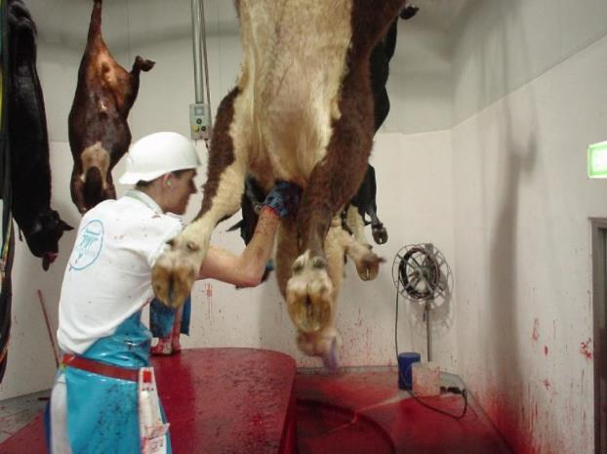
Sticking cattle
© MINTRAC

WI | Religious slaughter

There are large markets, both domestic and export, for animals to be slaughtered for various religious and ethnic groups.
The two most common types of religious slaughter are:
- Halal for the Muslim faith. This is performed by an approved Muslim slaughterman. There is variation in the way halal slaughter is practised especially with regard to pre slaughter stunning.
- Shechita for the Jewish faith. Animals must be slaughtered and prepared in accordance with the rabbinical laws. Slaughter is carried out by an approved slaughterman of the Jewish faith, called a shocet.
Cattle, calves, goats, sheep and lambs are the common animals killed using religious slaughter. Pigs are not killed using religious slaughter processes because the eating of pig meat is forbidden by Jews and Muslims.
In Australia, for most religious slaughter, the animal can be stunned prior to sticking, so long as the stunning is reversible. Reversible stunning means that the animal can regain consciousness after stunning if it is not killed by bleeding.
In limited circumstances, sticking may take place without prior stunning for religious slaughter. Permission for this can only be granted by the relevant meat regulatory authority and is subject to strict conditions.
WI | What are the legislative requirements for religious slaughter without prior stunning?

The AS 4696:2023Australian Standard for the hygienic production and transportation of meat and meat products for human consumption only permits slaughter without pre-stunning to be performed at an abattoir, under a special approval from the relevant controlling authority. This is to ensure that it is performed in a manner that minimises stress to the animal. The following criteria are based on the Guidelines for ritual slaughter produced by the Meat Standards Committee.
- There should be a written requirement from a particular market religious authority. Most halal markets for example accept prior stunning so long as it is reversible.
- There should be appropriate restraint to minimise stress.
- The quality of live animal handling should be of a high order.
- Large animals (cattle) should be stunned as soon as possible after sticking
- Sheep and goats should be allowed to bleed out for at least 15 seconds under minimal physical restraint before shackling to ensure insensibility at the time of shackling.
Workplace procedures for each abattoir need to detail exactly what processes have been approved, what processes take place and who will perform them.
Why is a quick, complete bleed important?
It is important that the bleeding out of the animal takes place immediately after stunning, so that the onset of brain death is rapid.
It is important to have trained and skilled slaughters to perform the sticking operation. The blood vessels must be completely severed so that there is no chance of the animal regaining consciousness prior to brain death. Unskilled labour or blunt knives can cause unnecessary suffering, and affect food safety and product quality.
An animal regaining consciousness on the chain is also a major WHS hazard.

E | How is equipment prepared for use?

Equipment is ready to use and in good condition when it is:
- clean
- sharp (if applicable)
- in good working order.
Knives and other equipment should be sharpened before starting work. They must be kept sharp during operations so that tasks can be performed efficiently and safely. Knives used for sticking should be sharpened to workplace requirements to ensure an effective and humane sticking is carried out.
The operation of any other equipment, such as hoists, should be checked before starting work. This is so that the operator knows everything is in good working order.
It is important that the operator knows who to report any equipment problems to. Then the equipment can be cleaned, repaired or replaced promptly so that production is efficient and the equipment is safe to use.
The workplace instructions for the preparation and operation of equipment must be followed.
How can the effectiveness of the bleeding process be monitored?
Although the stunning process renders the animal unconscious and insensible it is usually the bleeding process which kills the animal. This is obviously the case with reversible stunning. Therefore it is essential that the animal bleeds to death before regaining sensibility.
For this reason abattoirs also monitor bleed chain sensibility. Once the animal is shackled and hanging on the bleed chain:
- the carcase should hang straight down
- the head should be limp and floppy
- the tongue should be hanging limply from the mouth (if the tongue is curled, this is a sign of possible sensibility)
- there should be no righting motion
- there should be no rhythmic breathing although an insensible animal may gasp
- no eye reflexes in response to touch (although animals in the clonic phase of electrical stun may have random eye and eyelid twitching, though this should only ever been seen in the absence of rhythmic breathing)
- any animal showing any sign of sensibility must be immediately re-stunned (according to the company’s work instruction).
What is the target for achieving effective bleeding of animals?
The AMIC industry animal welfare standard recommends that 50 -100 animals (for all species) should be assessed to calculate the number of animals that remain stunned on the bleed rail. The target is 100% and if an animal appears to be regaining consciousness then the back up stunner should be used to re-stun the animal and it should be rebled before dressing commences.
Shackling
Why are animals shackled?
An animal is shackled so that it can be raised and hung on a rail. This can help:
- bleeding because the animal is in a vertical position
- dressing as it saves lifting and other handling when the animal may still be moving, and makes the carcase more accessible for other tasks down the chain
- avoiding contamination from blood, dirt, ingesta and other contamination on the slaughterfloor.
When are animals shackled?
The order for shackling and sticking can vary. It will depend on:
- the species being slaughtered
- workplace procedures.
Shackling prior to effective stunning is not permitted.
What is a shackle?
A shackle is used to hang an animal from the dressing rail by one hind leg. The shackle consists of a clasp which grips the foot of the animal. The clasp is connected to a roller or slide that connects to a hanging rail.
The following diagrams show some examples of shackles used on different species.

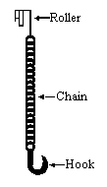
Chain and hook
The chain is wrapped around the hind foot of cattle, hooked through itself and tightened by lifting.

Chain and sleeve
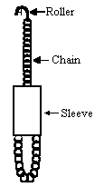
The chain is looped over the hind foot of a pig. The sleeve is pushed down and tightened by lifting.

Steel hook
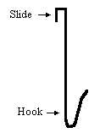
The hook is slipped under the hoof of small stock, then hung by the slide on a rail.

WI | How is an animal shackled?

All shackling must be done according to workplace procedures.
The method of shackling depends on:
- the species
- the design of the plant.
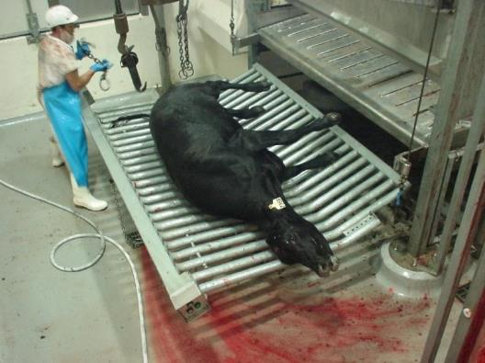
Preparing to shackle
© MINTRAC
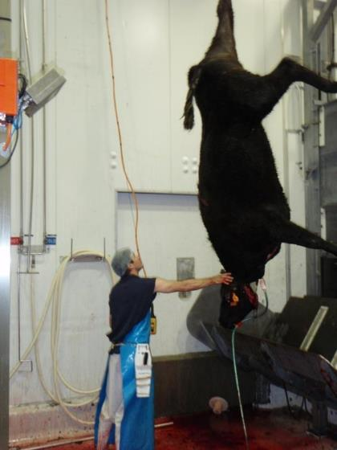
Cattle shackled and hoisted
© MINTRAC

WI | What workplace procedures are important to animal welfare when shackling an animal?

The shackler has a number of responsibilities.
Check animal is stunned
The shackler should make sure the animal is properly stunned before shackling. Legislation insists that the animal must be effectively stunned before shackling and sticking. This is usually done by checking there is no eye reflex. This is to avoid:
- cruelty
- undue kicking and movement that can cause accidents, poor bleeding and damage to the carcase through fever and bruising.
The eye reflex is checked by touching the eye. If the animal blinks or reacts in any way the animal must be immediately stunned again.
In the event of an ineffective stun or stunner malfunction, it may be necessary to implement emergency procedures, particularly if an animal escapes as a result.
Emergency procedures could include:
- sounding the alarm to other workers
- emergency evacuation
- destruction of partially stunned and/or escaped animals.
WHS issues associated with assessing stunning and bleeding operations
What are the WHS issues associated with the operation of a restrainer?
Stock handlers must follow WHS procedures when operating a mechanical restrainer. This is very important for their safety. When operating the restrainer, stock handlers may need to check that:
- all moving parts (which can potentially trap livestock) are covered
- any faults are dealt with according to workplace procedures
- work areas are kept neat and tidy.
What are the common WHS hazards in the stunning operation?
Some common WHS hazards that operators may come across during the stunning process are:
- noise
- physical injuries from escaped animals
- sprains and strains through 'overuse syndrome' from repetitive movements such as pushing, pulling, lifting, twisting and bending
- zoonotic diseases, e.g. brucellosis, Q fever
- slips, trips and falls
- confined spaces such as CO₂ gas chambers, blood pits
- accumulating CO₂ gas on the slaughter floor
- injury by using equipment such as electric or powered stunners and firearms, also overuse syndrome from recoil
- burns and scalds from sterilising equipment (when moving to or from a workstation)
- injury from powered equipment, e.g. hydraulic rams
- injury from falling animals and/or shackles.
What are the common WHS hazards when bleeding animals?
Some common WHS hazards that during the sticking process are:
- knife cuts
- sprains and strains through:
- ‘overuse syndrome’ from repetitive knife movements
- frequent gripping and pulling
- pushing, pulling, lifting, twisting and bending
- zoonotic diseases, i.e. brucellosis, Q fever
- slips, trips and falls
- injury by using equipment such as electric hoists
- burns and scalds from sterilising equipment
- animals falling and/or kicking
- falling shackles or chains
- confined spaces
- unstunned animals escaping.
What are the common WHS hazards during the shackling process?
Some common WHS hazards that during the sticking process are:
- knife cuts
- sprains and strains through:
- frequent gripping and pulling
- pushing, pulling, lifting, twisting and bending
- zoonotic diseases, i.e. brucellosis, Q fever
- slips, trips and falls
- injury by using equipment such as electric hoists
- animals falling and/or kicking
- falling shackles or chains
- confined spaces
- unstunned animals escaping.

WI | How can WHS risks be reduced?
As well as your employer having a responsibility to make sure that you have a safe workplace to work in, the employee, have a responsibility for your own and others' safety and wellbeing. You must report any existing hazards or potential hazards to your WHS representative or appropriate personnel, as required in your WHS policy.
To be able to do these things, you must know and follow your workplace WHS procedures.
By following workplace WHS policies and procedures and actively taking part in accident/injury prevention, workers will reduce the most common injuries in the meat industry, i.e. knife wounds, sprains and strains. This will keep them safe and reduce the burden of the high cost of insurance premiums on their employer.
Some examples of workplace WHS policy and procedures that operators should be aware of and apply are:
- confined spaces
- accident prevention
- emergency procedures in case of injury
- personal protective equipment (PPE)
- equipment malfunction procedures
- electrical fault procedures
- emergency evacuation procedures.
Personal Protective Equipment (PPE)
Personal protective equipment to be used will be set down in the work instruction and WHS procedures. PPE may include:
- protective hand and arm covering
- protective head and hair covering
- head wear
- coat and apron
- work safety or waterproof footwear
- protective boot covers
- ear plugs/muffs
- eye and facial protection
- waterproof clothing.
Knife cuts
To prevent an accident/injury in your workplace from knife cuts, your knives must be handled, used, maintained and stored correctly. For more details, refer to the training materials for AMPCOR204 Follow safe work policies and procedures.
Strains and sprains
To learn how to prevent strains and sprains, refer to the training materials for AMPCOR204 Follow safe work policies and procedures.
Emergency procedure if an animal escapes
It is important to know what to do if an animal escapes in the sticking area (especially cattle) and how to raise the alarm.
Zoonotic diseases
What is a zoonotic disease and what zoonotic diseases is an abattoir worker likely to be exposed to?
Zoonotic diseases are diseases which can be contracted from animals and animal products.
Zoonotic diseases include Brucellosis, Leptospirosis, Q Fever, Hydatid disease, Erysipeloid and Orf. The three principal diseases of concern are Q Fever, Leptospirosis and Brucellosis.
Q Fever
Q Fever is the most likely disease to be contracted from animals or animal products. It may be contracted from foetuses, placenta, faeces and milk of infected cattle, sheep and goats. The most common form of transmission is inhalation of contaminated aerosols or dust. Q Fever can also be passed on by contact with infected animals and contaminated articles such as straw, wool, hair and hides. The time between breathing in the organism and the onset of the illness is generally 19–21 days.
Many of the symptoms of Q Fever are typical of influenza, so it may be misdiagnosed. The symptoms include fever, sweats, severe headaches, myalgia, fatigue, nausea and photophobia and weight loss. For some there is no illness, for others it is like a bad dose of the flu. In general the illness may last from one to six weeks. It can be treated with appropriate antibiotics started as soon after the onset as feasible.
However, there are people who have serious and ongoing symptoms. Their life may never be the same. These complication include:
- Endocarditis – which may not become apparent for up to five years
- chronic granulomatous hepatitis
- post Q Fever fatigue syndrome (QFS) a form of chronic fatigue syndrome where symptoms are still evident three to five years after the acute illness.
All new workers in the meat processing industry should be vaccinated against Q Fever. The vaccination process is a two step process. The first step is a skin and blood test which identifies people who have had previous exposure to Q-Fever. People with previous Q Fever exposure are not vaccinated as this could cause a serious reaction to the vaccine. It also means they are likely to be immune to Q fever infection.
It is possible to be positive on either the skin test or blood test and negative on the other. To avoid the risk of a severe reaction, the vaccine should only be given to those who are negative on both tests.
More detail can be gained on this web site https://www.health.nsw.gov.au/Infectious/factsheets/Pages/q-fever-vaccine.aspx
Leptospirosis
Leptospirosis is contracted through direct contact with infected urine of infected cattle, pigs and horses. The leptospirosis organism can enter the body via eyes, mouth and damaged skin.
Brucellosis
Brucellosis is contracted by direct or indirect contact with infected material from foetuses, placenta, faeces, raw flesh and milk of infected cattle, goats and feral pigs. Cattle are declared brucellosis free in all states except the Northern Territory. The organism may enter the body via the skin, eyes, mouth and by breathing in infected dust and aerosols.
What can be done to minimise the risk of contracting a zoonotic disease?
Hazard control program
Q Fever is the most common zoonotic disease. This disease may be controlled by a pre-screening and vaccination program.
As it is not possible to identify animals infected with Q Fever and leptospirosis, a hazard control program may be introduced at the workplace.
Hazard assessment
Assessment of potential high risk areas will identify specific tasks where there is a likelihood of direct splashes of urine, faeces, milk or birth fluids, the creation of infective aerosols or generation of infective dusts that put the worker at risk of exposure.
For Q Fever human infection mainly occurs when inhaling the organism, as a result of direct or indirect exposure to contaminated aerosols, the entire plant and its surrounds have the potential to be a source of human infection. Therefore, non-immune visitors, especially those making random visits to the workplace, are also at risk of developing the disease.
Risk control
Employers should, in consultation with health and safety representatives and employees, develop risk control measures and the time frames for implementing those measures.
Currently, the National Guidelines for Health and Safety in the Meat Industry, and the Q Fever Information Kit for the Australian Meat Industry provide information and should be consulted for more detail.
Design
The workplace and individual work station should be designed to reduce the risk of contamination and infection with aerosols and dust. The employer should ensure that:
- hand washing facilities are provided and are readily accessible to all workers
- ventilation, exhaust and air conditioning system are installed
- chutes for offal, slinks and carcase remnants are properly fitted with flaps or covers
- the plant, including yards, pens, rendering areas and skin sheds are designed and maintained to ensure easy cleaning and efficient quick drainage
- areas readily accessed by workers or visitors, for example the canteen, are not positioned near the yards or exposed to air ducted from the slaughter floor or condemned room.
Work practices
The employer should ensure that work practices minimise or reduce the risk of contamination and infection. This may be achieved by:
- washing stock down on the race entering the slaughter floor
- improving methods of handling animals
- careful removal of the paunch, stomachs, etc. to ensure they do not burst
- lowering of the guts to the eviscerating table to maintain the integrity of the released organs
- the early removal of any type of contaminant from carcases
- prohibiting the storage of personal and soiled work clothing together in lockers
- laundering of work clothing by the employer
- muzzling of dogs used to move livestock
- no eating, drinking, smoking or nail biting in stock holding or processing areas.
Access to the workplace should be strictly restricted to workers required to be there. Non-essential visitors, for example school, university or tour groups, should be discouraged as they may not have immunity to Q Fever. Proof of vaccination or existing immunity is now a pre-requisite by some plants before allowing entry to contractors and regular visitors. If access is permitted without proof of immunity, appropriate respiratory protection is recommended.
Slips, trips and falls
What are the types of hazards that may result in slips, trips and falls?
The meat industry has a high incidence of injuries caused by slips, trips and falls. Many slips and trips occur during manual handling activities.
The most common are:
- floor surfaces – slippery, uneven or damaged
- ramps – slippery or damaged, the gradient (or slope)
- stairs – slippery, no hand rail support or barrier to stop people falling over the edge
- platforms – slippery, no barrier to stop people falling over the edge
- drains and gutters – differences in levels of adjoining surfaces, pooling or build up of material
- obstructions or obstacles in any work area or pathways, including electrical cords, hoses and any other piece of mobile equipment such as trolleys
- lighting.
The meat industry has particular issues to consider as fat, blood, meat scraps, water and other waste products will tend to make floors, platforms and walkways slippery. Other hazards include the use of hot water and detergents, as they are a necessary part of the cleaning and washing down process.

Bibliography
These publications were used to develop this training material.
Agriculture and Resource Management Council of Australia and New Zealand, AS 4696:2023Australian Standard for the hygienic production and transportation of meat and meat products for human consumption, CSIRO publishing, Collingwood, Vic.

