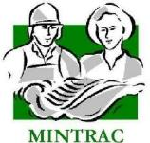

AMPQUA401
Support food safety and quality programs
Training support materials

Australian Meat Processing Training Package
Certificate IV in Meat Processing

Table of contents
Training support materials for AMPQUA401 - Support food safety and quality programs 5
Hazard Analysis Critical Control Point (HACCP) 5
HACCP based Quality Assurance systems 5
Quality assurance (QA) 5
Hazard Analysis Critical Control Point (HACCP) 5
What regulations govern the meat industry? 5
What are the various standards for meat processing? 7
What is an Approved Arrangement? 7
What is a HACCP based QA system? 8
What are the minimum elements of a HACCP based QA system? 10
What is HACCP? 10
Developing a HACCP system 11
How is a HACCP system developed? 11
What are the preliminary steps to introducing a HACCP system? 12
How is a product description developed? 13
What is a flow diagram? 14
What does a flow chart look like? 16
How do we confirm the accuracy of a flow diagram? 16
What do we do with the documentation generated during the five preliminary steps? 17
HACCP Principle 1: Conduct a hazard analysis 17
What are the three types of hazard classifications associated with a HACCP system? 17
What is a hazard analysis? 19
What are the steps in conducting a hazard analysis? 19
What are preventative measures? 23
HACCP Principle 2: Determine Critical Control Points 26
What are Critical Control Points? 26
How are Critical Control Points established? 26
What are critical limits? 29
How are critical limits established for each Critical Control Point? 30
HACCP Principle 4: Establish a system to monitor control of the CCP 32
What is the role of a monitoring system? 32
How are monitoring procedures developed? 33
HACCP Principle 5: Establish corrective action procedures 34
What are corrective actions? 34
Why does corrective action have to be rigorous? 36
HACCP Principle 6: Establish verification procedures 37
What is the difference between verification and validation? 37
Why are critical limits and the HACCP plan validated? 37
How is the effectiveness of a HACCP system verified? 39
HACCP Principle 7: Establish record keeping procedures. 40
Why keep records? 40
Facilitating the implementation of a QA system 41
How do we facilitate a QA system its implementation? 41
What is the role of training in the QA process? 41
What is structured and documented training and assessment? 42
Monitoring, inspection and test results 42
What is a variation? 42
What is monitoring? 43
What tests are performed on meat products? 43
What is inspection? 43
What elements of the Quality Assurance system require monitoring? 44
Why monitor Quality Assurance? 49
How do you monitor a Quality Assurance system? 49
How is this monitoring undertaken? 50
Analysing the results of monitoring programs 50
How do you know whether your process is controlled? 50
How do you identify trends? 51
What are histograms? 52
What are run charts? 54
What is a process control chart? 56
How are control limits calculated? 56
What are the types of control charts? 57
How are X charts constructed? 57
How are R charts constructed? 59
Calculate yields 61
How are yields calculated? 61
How are actual yields compared with expected yields? 66
What is wastage? 67
What is productivity? 67
Sampling 67
Why are samples collected? 67
How are product samples collected? 68
How can you be sure samples are representative of the lot being tested? 69
How can post-collection mishandling of samples affect test results? 70
Calibration of instruments 72
Why calibrate instruments? 72
What equipment requires calibration? 72
How do you test instrument accuracy? 73
How is instrument accuracy verified? 74
Identifying causes and problem solving 75
What do we do once we detect a process out of control? 75
How can quality improvement activities be prioritised? 75
What techniques can you use to solve problems? 77
How can you present proposals for quality improvement to management? 81
Implementing process changes 82
Why do you need process changes? 82
What is required to implement process changes? 82
Changes to Standard Operating Procedures (SOPs) and work instructions 85
Why are changes made to the QA manual? 85
What is a Standard Operating Procedure? 85
Why have SOPs? 86
How are SOPs developed? 86
Who should be part of the team developing SOPs? 86
What does a SOP look like? 87
What must be done before issuing a new or changed procedure? 88
How do you make changes to SOPs? 89
Instrument calibration 91
How do you validate SOPs? 93
What are work instructions? 93
How are work instructions developed? 93
Electronic systems in the meat industry 94
What is a Variable Weight Carton Label? 95
What are Variable Weight Carcase labels? 96
What are GS1 Logistics (pallets) Labels? 97
What are the Electronic Meat Transfer Certificates (eMTC)? 101
Bibliography 104
Additional resources 104

Training support materials for AMPQUA401 - Support food safety and quality programs
Hazard Analysis Critical Control Point (HACCP)
HACCP based Quality Assurance systems
Quality assurance (QA)
QA establishes policies and procedures that maintains set requirements for developing or manufacturing reliable products. A Quality Assurance system is meant to increase customer confidence and a company's credibility, while also improving work processes and efficiency, and it enables a company to better compete with others.
Hazard Analysis Critical Control Point (HACCP)
HACCP is a production control system for the food industry. It is a process that identifies where potential contamination can occur and strictly manages and monitors these points to ensure the process is in control and that the safest product possible is being produced.
What regulations govern the meat industry?
There are now minimum mandatory standards for the meat industry. The Agricultural Resource Management Council of Australia and New Zealand (ARMCANZ) with the Standing Committee on Agriculture and Resource Management (SCARM) and Standards Australia have endorsed the standards. You may know this set of Australian Standards as the SCARM reports.
In addition to developing these Australian Standards, ARMCANZ decided that all meat processing establishments in Australia would be required to have Hazard Analysis Critical Control Point (HACCP) based Quality Assurance (QA) systems.
Since the standards were first developed, ARMCANZ has been disbanded. The Meat Standards Committee (MSC), which developed the standards, has also been disbanded.
There are three levels of government in the food regulatory system and each level of government plays a role in protecting public health and safety through regulating food (including imported food) for human consumption.
The Commonwealth Government
Through the Australia and New Zealand Ministerial Forum on Food Regulation, the Commonwealth Government works collaboratively with the New Zealand government and state and territory governments to develop food regulation policy.
The Department of Health (DoH) sets government policy on food in consultation with the Department of Agriculture and Water Resources and Australian state and territory governments.
Food Standards Australia New Zealand (FSANZ) develops food standards in line with this policy, which are then published in the Australia New Zealand Food Standards Code.
The Department of Agriculture and Water Resources administers relevant legislation at the border. All imported food must meet Australian quarantine requirements (under the Quarantine Act 1908) and is then subject to the requirements of the Imported Food Control Act 1992. Labelling on imported food is assessed for compliance with the requirements under the Imported Food Inspection Scheme.
State and territory governments
The state and territory governments develop and administer food legislation, which gives legal force to the requirements of the Food Standards Code. Regulation of food production at the farm level is typically covered by primary production legislation. State or territory food acts usually cover food processing requirements through to retail sale requirements.
Local government
Along with the state and territory governments, local governments are responsible for monitoring the compliance of food in their jurisdiction.
Manufacture of meat and smallgoods
Some of the regulations and bodies governing the processing and manufacture of meat and smallgoods are:
- the Food Standards Australia New Zealand (FSANZ) Food Standards Code
- State and Federal meat authorities
- departments of health
- State departments of primary industry
- departments of consumer affairs
- the Department of Agriculture
- Australian standards (ANZFRMC/FRSC standards).
When developing a HACCP plan it is important to identify all of the regulations relating to the product and processes being considered in the plan.
What are the various standards for meat processing?
Food safety requirements for all meat processing in Australia are based on the Australian standards. The main one for abattoir-slaughtered meat is:
The Australian Standard for the hygienic production and transportation of meat and meat products for human consumption
For poultry the standard is:
The Australian Standard for the Construction of Premises and Hygienic Production of Poultry Meat for Human Consumption
For ratites (emus & ostriches) the standard is:
The Australian Standard for the Hygienic Production of Ratite (Emu & Ostrich) Meat for Human Consumption
For game the standard is:
The Australian Standard for the Hygienic Production of Game Meat for Human Consumption
For crocodiles the standard is:
The Australian Standard for the Hygienic Production of Crocodile Meat for Human Consumption
For rabbits and hares the standard is:
The Australian Standard for the Hygienic Production of Rabbit Meat for Human Consumption
What is an Approved Arrangement?
All these standards require an “Approved Arrangement” with the relevant controlling authority.
State and Territory meat authorities are the controlling authorities for domestic plants and Department of Agriculture is the controlling authority for export-registered plants.
NOTE: The Export Control (Meat & Meat Products) Orders 2005 call up the AS4696:2023 Australian Standard for the hygienic production and transportation of meat and meat products for human consumption as the basis for food safety issues on export-registered plants.
The orders do not cover food safety issues but certification issues such as product integrity and overseas country requirements.
NOTE: The Game Poultry and Rabbit Meat Orders call up the other relevant Australian Standards as the basis for food safety issues on export-registered plants.
Approved Arrangements must be based on HACCP. But there is no requirement for them to be based on ISO standards.
A set of guidelines has been drawn up to show how an Approved Arrangement should be drawn up. These guidelines are broadly based on the previous Department of Agriculture Meat Safety Quality Assurance (MSQA) guidelines and are generally consistent with the ISO standards which are:
- ISO/FDIS 22000(2005) Food Safety Management Systems- Requirements for organizations throughout the food chain.
- ISO 9001: 2000 Quality Management Systems-Requirements
In order to be approved by Department of Agriculture the scope of the Approved Arrangement must cover all operations from the receival of livestock to export. Key elements include:
- management commitment, organisational structure and operational programs
- every stage of production including HACCP
- importing country requirements
- export certification controls
- structures and facilities.
HACCP is a key element for food safety under all jurisdictions, as required under all the Australian Standards.
What is a HACCP based QA system?
A HACCP based QA system that is an Approved Arrangement consists of the following main elements:
- management responsibilities and procedures – which provide for management commitment and control including internal audit and management review
- process control– which includes pre-requisite programmes based on Good Hygienic practices and HACCP, based on the Codex guidelines.
- product integrity and certification procedures –these only apply on export-registered plants.
The Approved Arrangement guidelines require the QA systems of export meat processing plants to address the following issues.
System commitment
Policy objectives and commitment
Organisational structure
System support
Internal audit
Management review
Corrective action
Training
Process control
Process steps based on Good Hygienic Practice (GHP) work instructions
Standard Operating Procedures:
- plant sanitation
- personal hygiene
- vermin control
- water quality
- chemical control
- waste management
- refrigeration
- maintenance.
HACCP
Calibration
Laboratory testing
Animal welfare
Product integrity/ certification
Product integrity
Overseas country requirements
The final system structure will often depend on:
- customer requirements – e.g. food safety specifications, third party certification such as Lloyd’s Register Quality Assurance
- regulatory requirements – e.g. Department of Agriculture, FSANZ and state meat authorities
- importing country requirements
- company objectives for food safety.
For example product integrity/certification has little relevance for domestic meat operators.
Some customers may require QA systems based on the ISO 9000 standard.
The Approved Arrangement guidelines are broadly consistent with the various ISO 9000 Quality system standards.
What are the minimum elements of a HACCP based QA system?
There are a number of QA system elements that are used to support HACCP systems. The choice rests on the needs of stakeholders. In general, the following should be seen as minimum system content of any HACCP based QA system.
Management elements
These are:
- management commitment as expressed in policy documents
- management structure and responsibility
- training and verification procedures.
Prerequisite programs
Sufficient prerequisite programs should be developed to make sure that hazards associated with the environment in which the process is conducted are controlled.
Generally in the food industry, the following minimum procedures are developed:
- water
- pests and rodents
- chemicals and food additives
- personal hygiene
- cleaning and sanitation
- waste disposal
- calibration.
Good Hygiene Practice (GHP)
The requirements for GHP are a little less clear. However, as a minimum, the food safety hazards identified during hazard analysis as not being critical, but still important, and regulatory requirements not addressed by other system elements should be controlled as a part of this mechanism.
HACCP system
The HACCP system elements are:
- the five preliminary steps
- the seven HACCP principles.
What is HACCP?
The balance of this document will focus on the development of the HACCP system. It has been assumed that the elements required to be in place to allow sustainability of the system are in place. These elements will be referenced throughout the document where needed.
The Hazard Analysis and Critical Control Point System or HACCP (pronounced ‘hass-up) is a system based on prevention. It is both a logical and scientific approach to controlling food safety problems throughout the production process. HACCP is an essential element of a food industry quality management system.
It relies on a systematic approach of documenting and analysing each step in the manufacturing process to identify where actual or potential hazards to food safety may exist. Once the hazards have been identified, measures are put in place to control them.
Food safety hazards include:
- microbiological hazards
- chemical hazards
- physical hazards.
Sources of hazards include raw materials, the processing equipment, staff, processing procedures, handling procedures, storage conditions, etc.
The key goals of HACCP are:
- identification of all sources of hazards to food safety
- the development of procedures and controls to eliminate or reduce hazards.
Developing a HACCP system
How is a HACCP system developed?
A HACCP system is developed by applying the five preliminary steps and seven principles of HACCP to the process under consideration.
These steps include:
1.  5 Preliminary steps. | Assemble the HACCP team and define the scope of the HACCP plan.
2. | Describe the product and its distribution method.
3. | Describe the intended use of the product.
4. | Construct a detailed flow diagram of the process.
5. | Conduct on-site verification of the flow diagram.
6. | List all potential hazards associated with each step, conduct a hazard analysis and consider any control measures to control hazards. | Principle 1
7. | Determine Critical Control Points (CCPs). | Principle 2
8. | Establish Critical Limits for each CCP. | Principle 3
9. | Establish a monitoring system for each CCP. | Principle 4
10. | Establish corrective action plans for CCP deviations that may occur. | Principle 5
11. | Establish verification procedures. | Principle 6
12. | Establish record keeping and documentation. | Principle 7
References that should be consulted include:
- A Guide for the Preparation of Approved Arrangements- Department of Agriculture.
- Codex Alimentarius Alinorm 97/13A, Appendix II
- Andriessen E.H., 2006, Meat Safety Quality and Veterinary Public Health in Australia, eighth edition

What are the preliminary steps to introducing a HACCP system?
Step 1: Assembling the HACCP team.
The importance of a team approach cannot be overstated. This element of the development phase will, to a large extent, dictate the validity of the outcomes.
The number of people on the HACCP team will depend on the size of the organisation. As many people as practicable should be involved. In large organisations there will be too many people in a particular process to involve everyone in the development of the HACCP plan. When this situation occurs, it is essential that those not involved are made aware of what is going on, and are given an opportunity of having input into the process.
Having senior management actively supporting the development team will reinforce the importance of the HACCP process.
Skills and knowledge requirements
People who need to be involved may include the QA manager, staff, supervisors, engineers, senior management and key people from the production line. Regardless of the number of people involved, it is very important that the HACCP team includes individuals who have a good understanding of:
- the HACCP process
- food/meat manufacturing
- food/meat microbiology
- stakeholder needs.
Team members must also have knowledge of the products manufactured in the plant and the equipment and processes used to make them. All team members should receive training in the basic principles of HACCP.
Only once the team has been selected and trained can the process move to the next step.

How is a product description developed?
Steps 2 and 3: Describe the product and its intended use
When developing a HACCP plan, it is necessary to describe the food, its method of distribution, its intended use and who will consume it.
This will enable you to develop an appropriate risk profile that takes into account any hazards that exist in the product and/or packaging materials. It will also highlight any areas, such as special handling considerations, that may need to be included for the particular product.
The first part of this process is to develop a complete list of ingredients and raw materials. It may involve listing all raw materials by type and condition, e.g. boneless frozen meat. The second part of the process is to describe the product, its method of distribution including the intended use, and the consumers of the food.

Product description and intended use
Common name: | The common name of the product e.g. diced pork, ground beef, etc
How it is to be used: | Describes how the consumer must store, handle and prepare the product for consumption
Packaging – primary: | Indicates the type of packaging the actual product is contained in, e.g. vacuum bags
Packaging – secondary: | This is the outer container for individual packaged units, e.g. clean cardboard cartons
Shelf life: | This relates to the effect time and temperature has on the product: 3 months at 0ºC or below, 14 days at 0–4ºC
Distribution methods: | This describes how the product will be delivered to customers, e.g. refrigerated van at 0–4ºC
Sensitive customer: | This usually refers to the young, the elderly, pregnant women, immune-compromised and the infirm
Labelling instructions: | This is how the product is to be labelled, including:  - keep frozen  - thawing instructions  - safe food handling label  - cooking instructions.
Microbiological standards | Specify customer requirements.
What is a flow diagram?
Step 4: Construct flow diagram or chart
If a HACCP plan is to be effective, all parts of the process must be reviewed so that all hazards associated with the product can be identified.
Diagrammatic view of a process:

Output
Manufacture

In the case of an integrated meat establishment, the process steps may include:
- raw material – livestock.
- manufacture – slaughter, chill, bone and refrigerate
- output – refrigerated product despatched from the plant.
This process is broken down into its component parts and the process flow diagram is used to provide a simple description of each step involved in the process.
The diagram is essential in assisting the HACCP team in determining the presence of hazards in the process. It will also serve as a future guide for auditors who must understand the process for their verification activities.
The flow diagram must cover all the steps in the process that are directly under the control of the organisation.
The flow diagram should consist of symbols and words, not complicated engineering drawings. While there are a number of internationally recognised symbols for developing process flow charts organisations may choose to develop their own.
Some common sense rules associated with process flow charting are:
- keep it simple
- limit the side branches to those essential for clarification
- number each step – this is essential to assist cross referencing to work instructions/GMP or the HACCP plan
- provide a brief description of each step
- don’t use arrows.
Examples of internationally recognised flow chart symbols
Operation | This symbol represents any kind of operation or group of operations that result in an intentional change in the form or arrangement of the material which brings it nearer completion
Inspection | This symbol represents an inspection made to determine conformance with an in line specification.
Delay  D | This symbol represents a delay to material when conditions do not permit the immediate performance of the next planned step. This does not include any planned change to its physical or chemical characteristics.
Storage | Storage is where material is kept in an unchanged form and protected against unauthorised removal.
Transport | Transportation occurs when a material is moved from one place to another, except when such movements are part of an operation, or are caused by a worker at a workstation, during an operation or inspection.
Combined activity | When it is desired to show activities performed either concurrently or by the same worker at the same work station, the symbols for these activities are combined. For a combined operation and inspection, the activity is depicted by the circle within the square.

What does a flow chart look like?
Below is one example of a process flow chart.

- Receive & inspect cartons of meat.

- Weigh product.

- Transfer to chiller.

- Chiller storage.

- Load out – inspect – unpack.

- Deliver to production.

How do we confirm the accuracy of a flow diagram?
Step 5: Confirm accuracy of flow diagram
The flow diagram must fully reflect the process. It is best developed on site using the people responsible for the process. It is essential to confirm the draft flow chart developed in step four, against the actual process to ensure all steps are covered. An effective means of confirming the flow chart is to have the team walk through the process, to ensure that each step undertaken is included.
Remember, if a step is left out any hazards that may be present in the omitted step will not be considered during later hazard analysis. If a hazard is not considered at this point, the potential exists for a critical element of the process to pass unchecked.
Once the flowchart has been confirmed, the team leader or other nominated person should sign and date the flow chart. This ensures that only the accurate flow chart is used for further analysis.
Example of a verified (confirmed) flow chart

- Receive & inspect cartons of meat.

- Weigh product.

- Transfer to chiller.

- Chiller storage.

- Load out – inspect – unpack.

- Deliver to production.
Verified by: H. Prion

Date: 12/11/2016

What do we do with the documentation generated during the five preliminary steps?
All documentation associated with the five preliminary steps should be maintained in an orderly file. This allows a logical path to be followed through the decision making process.
Auditors will usually look at this information when assessing the decision making processes. It is also an essential resource to have available when validating or reviewing the HACCP plan.
HACCP Principle 1: Conduct a hazard analysis
What are the three types of hazard classifications associated with a HACCP system?
For the purposes of HACCP, hazards can be considered as anything biological, chemical or physical in a food that could contaminate the food.
Biological hazards
Biological hazards are living organisms and include micro-organisms.
Agricultural products and food animals carry a wide range of bacteria that is normally harmless to humans. Unfortunately, some bacteria such as pathogenic micro-organisms can cause illness or even death to consumers.
The number and type of bacteria will vary according to the type of product, its ingredients, production methods and even the geographic region. Micro-organisms can also be introduced through contamination of the food from processing equipment, other foods, handling by humans, etc.
In general, micro-organisms need certain conditions to grow and produce harmful toxins. The factors which help their growth can also be used to control or limit growth. These factors include:
- temperature – cooking, cooling, refrigerated storage
- time – microbial growth is affected by time
- moisture – lack of moisture inhibits growth
- oxygen levels – vacuum and modified atmosphere packing
- other microbes –competitive factors
- microbial load – initial number of microbes present.
It is important that someone with a knowledge of microbiology be involved in developing control measures for biological hazards.
Chemical hazards
Chemical hazards can be divided into two groups
- naturally occurring chemicals – that are not caused by environmental, industrial or other means, including aflatoxins, mycotoxins and shellfish toxins
- added chemicals – that have been introduced to the foods at some point in growing, processing, storage, packing or distribution.
Added chemicals may include:
- agricultural chemicals – either excessive levels of approved chemicals, or the presence of unapproved chemicals including:
  - pesticide residues such as CFZ, DDT, Dieldrin
  - antibiotic residues
- cleaning chemicals – inappropriate use or storage
- pest control chemicals – baits (rodenticides) and sprays (pesticides.)
- heavy metals – lead, arsenic, copper, mercury, cadmium, etc
To identify and detect any chemical hazards it may be necessary to consider:
- the types of drugs and pesticides routinely used in raising the animal
- water, feeds and supplements fed to the animals
- environmental contaminants, natural and introduced that the animals may have come into contact with.
Physical hazards
A physical hazard is any physical material that can cause illness or injury to the consumer. Physical hazards include a variety of foreign materials:
- glass, including thermometers, lighting tubes, dial faces on equipment, etc
- metal, including mincer blade pieces/shavings, gunshot pellets
- stones, sand or dirt
- hair, bone chips, manure etc.
- wood, including splinters from pallets, cutting blocks, etc.
- insects
- plastic, including bags that wrap frozen and chilled block meat
- personal effects, including jewellery, pens, and wound dressings.
What is a hazard analysis?
A hazard analysis is a review of a process or operation to identify any potential or actual hazards and, once identified, prioritise those hazards according to the risk they pose to consumer health.
In a HACCP system, the analysis is conducted by critically assessing each step of the process flow diagram and listing any hazards that do, or could, occur. At this time any preventative or control measures should also be documented.
The analysis should consider all factors that may affect the safety of the food, including factors that may be beyond the control of the processor, i.e. temperature control in vehicles delivering meat from the supplier.
What are the steps in conducting a hazard analysis?
There are three steps in conducting a hazard analysis.
Step 1: Document potential hazards for each step identified on the flow chart
- Check the product description to identify how this information could affect the hazard analysis as in preliminary step, i.e. have specifications for the hazards under consideration been specified? Will the packaging or raw ingredients introduce hazards?
- Review the intended use of the products, as in preliminary step, i.e. is the product to be subjected to further processing or will it be consumed in its finished form? Is the product specifically intended to be sold to high risk consumer groups?
- Determine if a biological, chemical or physical hazard exists at each step in the process flow diagram developed in preliminary steps, by answering the following questions.
  - Could the product be contaminated in this step? For example, by handling contaminated equipment or materials, cross-contamination from raw materials, water overspray, etc?
  - Could pathogens multiply to the point where they become a hazard, for example, product temperature, hold time, etc?
  - Could an ingredient, work in progress, or finished product become contaminated with pathogens?
  - Could this step introduce a chemical hazard to the product?
  - Could this step introduce a physical hazard to the product?
- Fully describe the hazards identified at each step.
- Find out the following information about the product/process
  - Could the addition/use of rework cause a hazard?
  - Will the water activity of the finished product affect microbial growth?
  - Should the product be kept refrigerated during transit or in storage?
  - Are there any chemical or physical hazards associated with packaging materials?
- Fully describe the hazards identified.
Step 2: Document actual hazards for each step identified on the flow chart
The second step involves reviewing the actual operations in the workplace:
- observe the actual operation associated with the hazard to ensure that it is the usual process or practice
- review work practices where raw or contaminated product could cross contaminate other materials/products via hands, gloves or equipment used for finished products
- observe product-handling procedures for potential cross-contamination, including reviewing traffic patterns – people and equipment – in the establishment
- check workplace records for any past incidents of physical, biological, or chemical contamination to determine the cause, seriousness and the frequency of the contamination.
When all steps of the hazard analysis have been completed, transfer the available information to a Hazard Analysis working sheet (or your equivalent). An example follows.
Hazard analysis working sheet (example only)
Process step | Hazards  B – Biological  C – Chemical  P – Physical | Likelihood | Severity | Significance | Preventative measures | Is this step a Critical Control Point (CCP)?
1. Receiving meat | B – Insufficient temperature control will result in unacceptable microbial growth.  B – The immediate container is damaged.  P – Visible foreign material that could affect product safety.
The forms you use will depend on the type of products and the processes used to manufacture them.
Step 3: Evaluating the risk
After the lists of hazards have been assembled they should be evaluated to determine significance. This is the process of separating the important few from the trivial many.
One of the failures of early HACCP systems was that they overlooked the significance rating. The result was that all hazards were treated as having the same risk and severity, with many hazards being identified as a CCP. This was not a manageable outcome and led to HACCP being downgraded as a food safety system of choice in many sectors of production.
The use of a risk-rating model is an aid to objectivity during this process.
The Standard AS/NZS/ISO 4360:2004 Risk Management offers the best risk-rating model and is the risk-rating model most commonly used in developing HACCP plans in Australian meat plants.
Note: there are many variations of this model. You and your company should pick the one that suits your circumstances.
Risk rating model
This is an example of a risk-rating model from the Australian Standard: Risk Management.
The following definitions apply to the risk-rating model used in this example:
- likelihood – the frequency of the hazard occurring
- severity – the seriousness of the hazard to the consumer
- significance – the combined effect of occurrence and severity of a hazard to food safety.

 | Likelihood
Severity | A | B | C | D | E
1 Fatality
2 Serious illness
3 Product recall
4 Customer complaint
5 Not significant
Key:
Significant hazard
Likelihood
A Common repeating occurrence
B Known to occur or it has happened (own information)
C Could occur or I’ve heard of it happening (published information)
D Not expected to occur
E Practically impossible
Using a risk rating model

The following is a typical example of how significance ratings are recorded.
Hazard analysis working sheet (example only)
Process step | Hazards  B – Biological  C – Chemical  P – Physical | L’Hood | Severity | Significance | Preventative measures | Is this step a Critical Control Point (CCP)?
1. Receiving meat | B – Insufficient temperature control will result in unacceptable microbial growth.  B – The immediate container is damaged.  P – Visible foreign material that could affect product safety. | C  B  B | 1  4  4 | Significant  Not  Significant  Not  Significant

For the first hazard identified it was determined that, based on published information, this hazard could occur and so a likelihood rating of ‘C’ was assigned to the hazard.
In terms of severity, it was considered that if poor temperature control existed for an extended period of time, then the product may cause death. The assigned severity rating was therefore determined to be ‘one’. The intersection of C and 1 on the risk model identifies the hazard as having a significant risk to consumer health.
Your team may, based on the facts available to them, arrive at different significance ratings. It should also be noted that the Risk Rating Model contained in this example has been used to provide an example of how the concept of significance is determined.
It should not be considered the best available. Always look for alternative rating models. There are many variations of this theme to found in food processing plants across Australia.
Note: to make the process easier, if the hazards found at the steps of the process are the same the same severity of 1, can be applied at every step.
What are preventative measures?
Preventative measures can be defined as any ‘physical, chemical, or other means used to control an identified food safety hazard.’
Typical measures for preventing chemical hazards include:
- sourcing raw materials from suppliers who process under an approved QA/HACCP system
- statistically based sampling and testing of raw materials at receival
- only using approved chemicals
- ensuring all chemicals used in the plant have detailed product specifications
- maintaining letters of guarantee from suppliers
- properly labelling and storing all chemicals
- properly training employees who handle chemicals
- maintaining up-to-date procedures for the use and handling of chemicals.
Typical methods for reducing physical hazards are:
- sourcing raw materials from suppliers who process under an approved QA/HACCP system
- statistically based sampling and testing of raw materials at receival
- ensuring plant specifications for buildings design and operations are up-to-date
- confirming letters of guarantee for ingredients and product supplies are current
- conducting regular random inspections of incoming product and materials.
- using magnets and metal detectors where possible to detect metal contamination
- where possible, using stone traps and bone separators
- maintaining all equipment according to manufacturer’s requirements
- training and encouraging operators to identify and correct potential hazards.
Typical methods for reducing biological hazards are:
- sourcing raw materials from suppliers who process under an approved QA/HACCP system
- statistically based sampling and testing of raw materials at receival
- developing and auditing supplier specifications
- developing cold chain management systems
- developing and implementing hygiene and sanitation, GMP’s and prerequisite programs.

Preventative measures are normally recorded on a hazard analysis working sheet. The following is a typical example:
Hazard analysis working sheet (example only)
Process step | Hazards  B – Biological  C – Chemical  P – Physical | L’Hood | Severity | Significance | Preventative measures | Is this step a Critical Control Point (CCP)?
1. Receiving meat | B – Insufficient temperature control will result in unacceptable microbial growth.  B – The immediate container is damaged.  P – Visible foreign material that could affect product safety. | C  B  B | 1  4  4 | S  NS  NS | Maintain product temperature at a level sufficient to stop bacterial growth.  Accept only meat from plants with a viable HACCP system in place.  Visual inspection of containers to ensure that immediate container is not damaged.  Visual inspection of product to ensure no foreign material is
HACCP Principle 2: Determine Critical Control Points
What are Critical Control Points?
A Critical Control Point (CCP) is defined in Codex Alimentarius Alinorm 97/13A, Appendix II as:
‘A step at which control can be applied and is essential to prevent or eliminate a food safety hazard or reduce it to an acceptable level.’
CCPs can vary even in the processing of the same meat product. This is normally because of differences in plant layout, equipment used, selection and sources of raw material or the processes used.
How are Critical Control Points established?
An aid to the identification of Critical Control Points is the CCP decision tree. The CCP decision tree was developed to help separate CCPs from other less important control points identified in the process. The CCP decision tree provides a method for determining if an identified significant hazard requires a Critical Control Point.
It should be well understood that strict adherence to the decision tree can often lead to the development of a meaningless and unmanageable HACCP system.
The following errors are common.
- Trivialised CCP’s, where every hazard that is worked through the tree is identified as a CCP. This can occur where a significance rating is not undertaken or where a subsequent step that eliminates or reduces the hazard does not exist.
- The slaughter and boning processes have few, if any, steps specifically designed to eliminate or reduce hazards.
- An acceptable level of hazard is difficult to determine. This is particularly so where many customers demand zero contamination, yet the processes in common use are unable to consistently deliver a zero outcome.
The slaughter and boning processes employed in Australia do not have available to them, within the current regulatory framework, validated steps that will eliminate many of the hazards identified. Elimination steps are often referred to as ‘intervention steps.’
The difficulties involved in using the decision tree have also been highlighted in Codex Alimentarius Alinorm 97/13A, Appendix II, where it is stated, in part:
‘…while the tree has been useful to explain the logic and depth of understanding needed to determine CCP’s, it is not specific to all food operations, e.g. slaughter, and therefore it should be used in conjunction with professional judgement, and modified in some cases.’
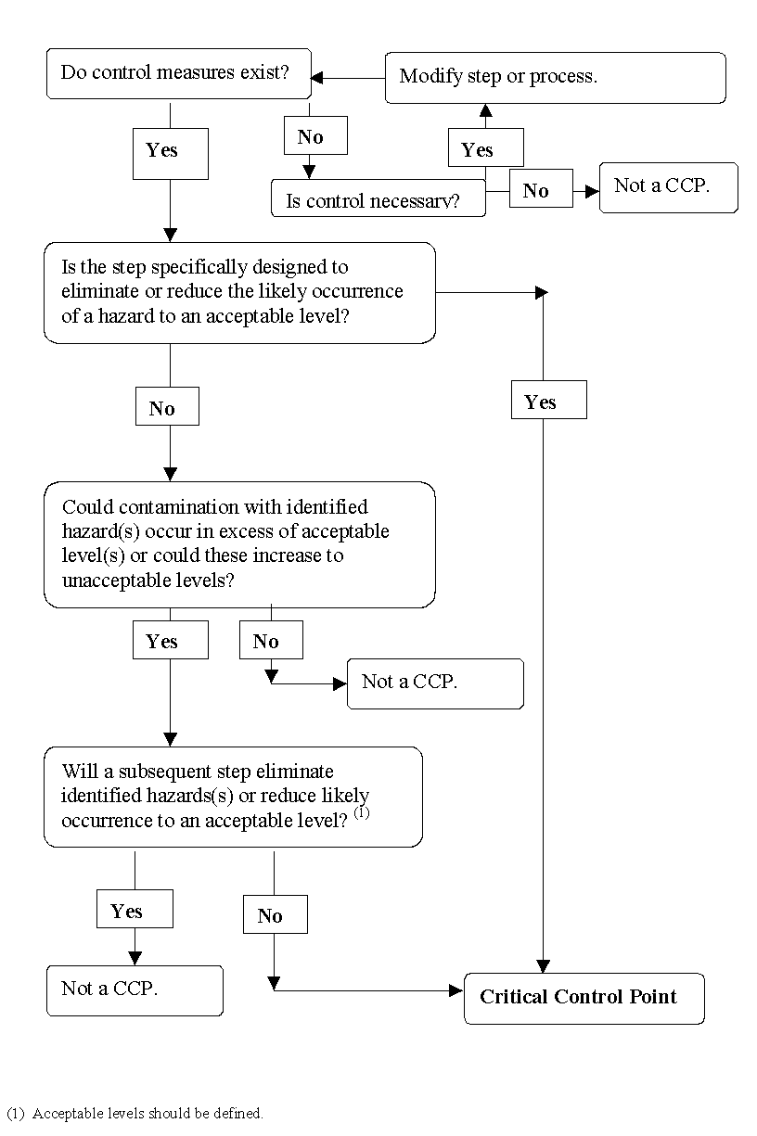

Example of a CCP decision tree
Once a Critical Control Point has been identified, it is normally recorded on a hazard analysis working sheet. The following is a typical example.
Hazard analysis working sheet (example only)
Process step | Hazards  B – Biological  C – Chemical  P – Physical | Likeli-hood | Severity | Signif-  icance | Preventative measures | Is this step a Critical Control Point (CCP)?
1. Receiving meat | B – Insufficient temperature control will result in unacceptable microbial growth. | C | 1 | S | Maintain product temperature at a level sufficient to stop bacterial growth.  Accept only meat from plants with a viable HACCP system in place. | No  WI- 04
 | B – The immediate container is damaged. | B | 4 | NS | Visual inspection of containers to ensure that immediate container is not damaged. | WI-01
 | P – Visible foreign material that could affect product safety. | B | 2 | S | Visual inspection of product to ensure no foreign material is | WI-2

Control points not determined as critical but still requiring control should be cross referenced to the appropriate control mechanism, e.g. work instructions or SOPs. The summary on the next page shows the control mechanisms that emerge from the hazard analysis process.
In practice only intervention steps such as initial refrigeration and decontamination procedures should be treated as Critical Control Points, since they can be validated. Most other steps in the processing of raw meat cannot be validated so should not be declared CCPs.
Overview of hazard analysis
The hazard analysis process can be presented diagrammatically
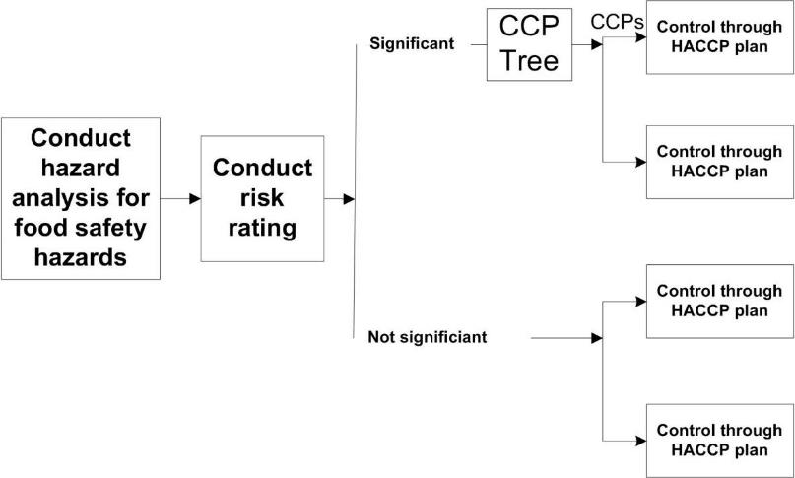

HACCP Principle 3: Establish critical limits
What are critical limits?
Critical limits are defined in the Australian Smallgoods Food Safety Guidelines, Vol. 1 as
‘The maximum or minimum value to which a physical, biological, or chemical hazard must be controlled at a Critical Control Point to prevent, eliminate, or reduce to an acceptable level the occurrence of the identified food safety hazard.’
A critical limit separates acceptability from unacceptability. This in effect means that any breach of a critical limit renders the product unfit for human consumption in that form.
This is an issue that needs to be carefully considered when establishing both CCPs and critical limits. For example if the time and temperature limits in a cooking process are breached, then a decision can be made to prolong the cooking process to ensure product safety.
In the case of the slaughtering and boning process however, such corrective action is not generally available. If, for instance, the equipment sterilisation temperatures of ≥ 82˚ C is a critical limit, then what action can be taken to make product safe if that an individual steriliser falls below this limit between monitoring events, or if an individual operator forgets to use the facility as required? Should the product be removed from the human food chain? How are the items identified? Does the process have a step that can correct microbial contamination? Basically it is not a critical limit, but important nonetheless.
Examples of critical limits include:
- time
- temperature
- humidity
- water activity
- acidity (pH)
- salt concentration
- chlorine level.
In certain products, more than one critical limit may be required to control a particular hazard, e.g. time and temperature requirements for a cooking process.
Critical limits should be measurable and capable of validation (see Principle six). If you cannot measure a critical limit or validate it, it is not a critical limit and the point is not a Critical Control Point.
This eliminates most steps in processing of animals and meat as Critical Control Points, other than initial chilling and any intervention steps such as decontamination and cooking,
How are critical limits established for each Critical Control Point?
The first step in setting critical limits is to determine if there is a regulatory limit for the hazard.
Regulatory limits should be seen as minimum requirements and in many circumstances may not meet the needs of the processing company or other stakeholders. The adoption of regulatory limits as critical limits may also indicate a lack of rigour in the development phase. For these reasons it is important that the multi-disciplinary team use their knowledge and experience to establish meaningful critical limits that, if complied with, will provide product that consistently meets food safety objectives.
To establish and validate critical limits the following sources of information may be useful.
General source | Examples
Surveys and scientific literature | - literature searches  - computer databases  - internet  - predictive models
Government agencies & scientific committees | - Department of Agriculture  - FSANZ
Experts | - CSIRO  - Food Science Australia  - consultants  - equipment manufacturers  - university and government agencies
Experimental studies | - challenge and inoculation studies
Company information | - records of past practice  - microbiological predictive modelling  - data trace/log records  - microbiological analysis of trial outcomes
Adapted from L. Moberg, in Pierson & Corlett, HACCP Principles and Application 1992
When you have developed your critical limits, it is time to transfer some the information you have gathered onto the HACCP plan. The information you have should now include:
- process step
- type of hazard
- preventative measures
- Critical Control Points
- critical limits.
Note: in this example the critical limit is the regulatory limit from the AS4696:2023 Australian Standard for the hygienic production and transportation of meat and meat products for human consumption.
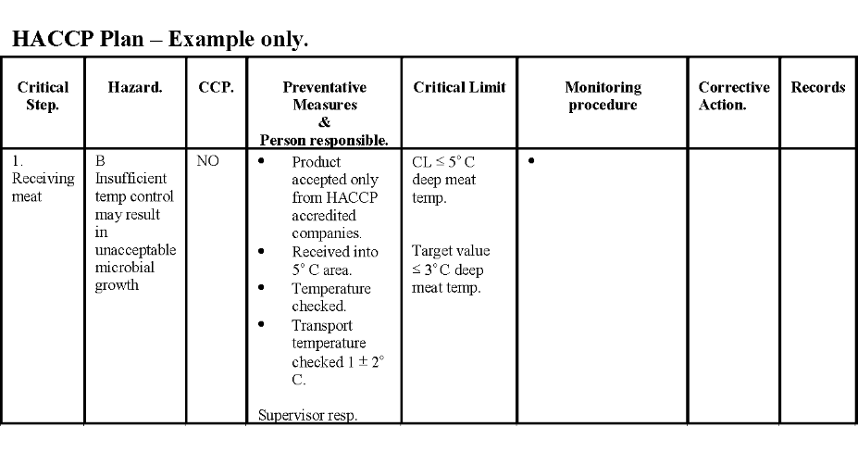
In this example, target value has been established in this example to provide the company with an early warning signal that there is a risk of breaching the critical limit. Where possible it is advisable to set target limits. This assists in tightening control and minimising the risk of failure at a critical limit.
Note: The ‘critical’ limit shown is actually a legislative limit and not a true critical limit, as it is not associated with a CCP.
HACCP Principle 4: Establish a system to monitor control of the CCP
What is the role of a monitoring system?
Adequate monitoring is essential in a HACCP system. Monitoring needs to be a planned process that assesses whether a CCP is under control and also to assess if other control points are under control.
It is preferable to monitor a CCP on a continuous basis. Obviously if we have decided that the variable being monitored is critical then we should be assured that if it is out of control we know immediately. It would not make sense to establish a critical limit then monitor it only once a day. If this were the case we could have a full day’s production that is deemed unfit for human consumption.
Monitoring serves three essential purposes.
Monitoring test results will indicate if the process is trending out-of-specification. It will allow you to take the necessary action to correct the problem before the critical limit is exceeded.
An example of this situation could be that, after monitoring the temperature level of a product chiller, it is noted that the temperature is slowly increasing towards the upper control limit. Monitoring the test results will show if you will have to take corrective action if the product is to be saved before critical limits have been exceeded.
It is wise to set target limits below actual critical limits to act as a warning signal that action is required before the critical limit is breached. E.g. the critical limit may be ≤ 5º C but a target or action limit could be established at ≤ 3º C. (See example HACCP plan on page 32).
Monitoring will also determine when there has been a loss of control and the need for subsequent corrective action.
Monitoring records provide the basis for both internal and external verification activities. e.g. record review, audit etc.
Monitoring can be done with automatic devices such as temperature and time charts or by manual systems, e.g. visual inspections and sampling and testing. Whichever system of monitoring is used, you must establish a schedule of monitoring that ensures that the CCP is always under control.
An effective monitoring system will require you to:
- nominate the people responsible for the monitoring
- ensure they understand the purpose and importance of monitoring.
This can be done through a training program, which would include:
- the critical limits
- how test results are recorded
- what to do if critical limits are exceeded.
How are monitoring procedures developed?
Developing monitoring procedures for your HACCP plan may require specialist advice. Generally they can be developed by doing the following:
- identifying the type of monitoring to be done, e.g. temperature check
- deciding the type of monitoring, e.g. random, scheduled or continuous
- determining how often monitoring should occur if it is not continuous
- deciding on the record keeping required for each monitoring task.
Once the team has decided on the appropriate monitoring program the relevant information should be entered into the HACCP plan.
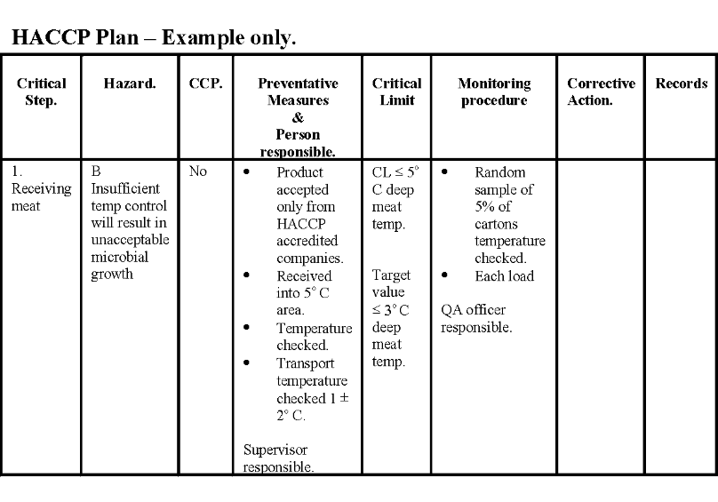
Note: Monitoring is not generally regarded as a verification activity.
Microbiological testing is seldom a useful monitoring system. This is due to the time delay between sampling and test results being available and the difficulties associated with collecting a representative sample.
If microbiological testing is unavoidable, as it is for some export markets for further processed products, then it should be used on a test and hold approach. This means that the product is not released until after the test results are known.
HACCP Principle 5: Establish corrective action procedures
What are corrective actions?
Corrective actions are simply what must be done when there is a deviation from a critical limit. A deviation occurs when a critical limit is not met. Corrective actions are decided in advance.
HACCP is designed to correct problems before they affect the safety of food. Therefore, when the system fails and a deviation occurs, there must be procedures in place that will explain the necessary corrective action to take.
Corrective actions should include:
- immediately adjusting the process and ensuring no more defective product will be produced
- quarantining the product for further evaluation/rework/disposal
- checking that action taken to regain control of the process has been effective
- investigating the cause of the incident and taking appropriate action to prevent it happening again
- documenting all action.
The HACCP plan should describe the corrective action for each CCP and detail the recording action required. In practice, due to space constraints, the corrective action column of the HACCP plan may only contain a reference to a corrective action procedure – see next page.
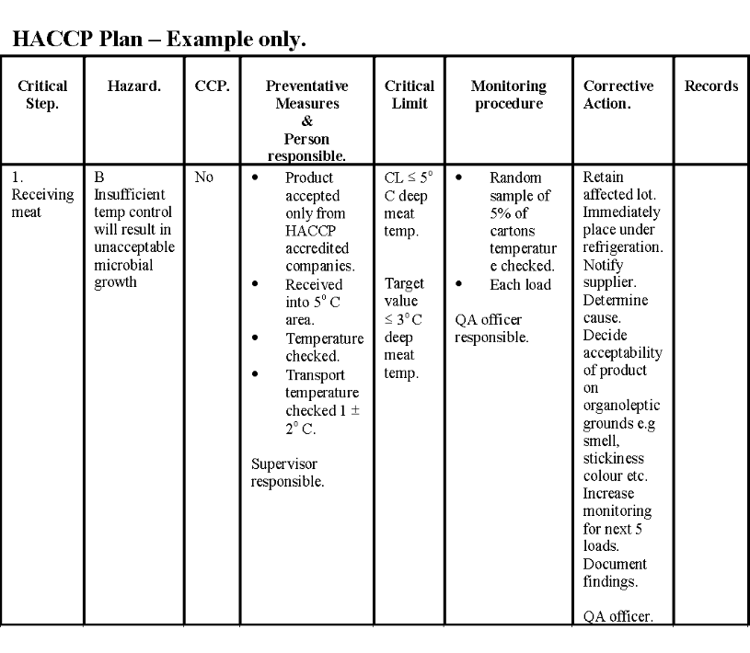
Example only
HACCP Plant | Procedure | WI - 1 CCP 1
Issued on: 10/09/00 |  | Revision No:
Person responsible:  QA Manager | Corrective action- failure to meet critical limit | Page 1 of 1

Immediately on detecting or being notified of a failure of product to comply with a stipulated critical limit the following action must be taken.

- Notify regulatory authority as appropriate.

- Take whatever action is necessary to regain control of the process to ensure critical limits are not again breached.

- Identify affected product and retain.

- Check the warmest cartons.

- Open 5% of cartons and assess smell, colour, stickiness and general condition.

- If OK accept product if not reject and return to sender or condemn.

- Product tested as acceptable will be cleared from retention.

- Product found unacceptable will be treated in accordance with direction from the appropriate regulatory body.

- Check that the action taken to regain control of the process is effective.

- Investigate the cause of the incident and, where possible, take what longer-term action is necessary to prevent the incident happening again.

- Document all action on the HACCP Plant Corrective Action Record.
Why does corrective action have to be rigorous?
If we work back through our process, we have decided that if we are to produce a safe product it must be received on plant at a temperature less than 5º C. We established this limit by in house testing and reference to authoritative scientific publications. By not achieving this limit we are effectively saying that the product poses a significant risk to consumer health. In this example then, anything less stringent than that provided above may lead to unsafe product entering the human food chain. This would obviously be an unacceptable outcome for a company operating under a HACCP program.
It should be said at this point that the steps involved in an effective corrective action program need to be considered when rating significance and determining CCP’s during the hazard analysis process.

HACCP Principle 6: Establish verification procedures
What is the difference between verification and validation?
The AS4696:2023 Australian Standard for the hygienic production and transportation of meat and meat products for human consumption has the following definitions.

Validate | Means obtain evidence to demonstrate the effectiveness of a system
Verify | Means to apply methods, procedures, tests and other evaluations in addition to monitoring to determine whether a requirement is complied with or a matter is met
Why are critical limits and the HACCP plan validated?
A vital aspect of verification is the initial validation of the critical limits and HACCP plan to determine that the plan is scientifically and technically sound, that all hazards have been identified and that if the HACCP plan is properly implemented, these hazards will be effectively controlled. Information needed to validate the HACCP plan often includes expert advice and scientific studies, and in-plant observations, measurements and evaluations.
Validation is about obtaining evidence that control measures are capable of being effective and about checking the effectiveness of the control measures on a regular basis. Control measures include all activities that are used to prevent or eliminate a food safety hazards. Some control measures reduce the level of hazards, some prevent an unacceptable increase in levels and some ensure control of initial level of hazards.
They include not only those measures at Critical Control Points but also all other control measures including those that have been established as Good Manufacturing Practice (GMP), Good Hygiene Practice (GHP) or Standard Operating Procedures (SOPs) at a particular plant.
Validation of SOPs is largely achieved by measuring performance against industry performance standards. It is important to note that the control measures that require validation include controls along the whole supply chain i.e. from paddock to plate and includes suppliers of other goods such as packaging etc.
There are two issues that need to be understood for an effective validation.

Performance Objective (PO) | This is the maximum frequency of a hazard at a specific step in the production process e.g. 7°C for meat within 24 hours of slaughter
Performance Criteria (PC) | This is the effect to be achieved by control measures at CCPs and SOPs to achieve the identified performance objective

Performance Objectives are set by the controlling authorities and are self-validating and do not need to be proven.
Performance Criteria are the main standards that HACCP plans on meat processing plants need to be validated against. PC need to be developed by a company for each control measure. These PCs may be industry standards for a particular process e.g. For values in retorting or set by the machine manufacturer.
The Refrigeration Index is an example of a performance criterion where the maximum increase of the hazard (E. coli growth) in the temperature control of product, is established from mathematical modelling. This PC is designed to meet the performance objective of 7°C for meat within 24 hours of slaughter as set by legislation that translates into an Appropriate Level Of Risk (ALOP) for the consumer.
Validation of CCPs can encompass all of the following approaches:
- reference to previous studies or historical knowledge of performance of control measures
- scientifically valid experimental trials
- the collection of biological, chemical and physical hazard data during normal operations
- statistically designed surveys
- mathematical modelling e.g. predictive microbiological tools such as the refrigeration index
- control measures dictated by controlling authorities e.g. 7°C surface temperature in 24 hours for meat.
A mixture of approaches is better than reliance on just one approach.
HACCP reassessment and revalidation must occur:
- if new technology, equipment or other control measures are introduced
- on the identification of new pathogens
- a build up or change in pathogenicity of current pathogens
- when monitoring or verification demonstrates failures above acceptable levels
- changed market requirements e.g. US require a CCP on the slaughter floor.
All HACCP plans should at the very minimum be revalidated annually.
In theory all control measures should be validated both individually and in combination. But this approach could be very expensive, so a more targeted approach is acceptable. The priorities for validation should be determined by reference to the following parameters:
- essential control measures e.g. CCPs must be given a priority
- if historical experience shows that certain control measures are universally effective they can be given a lower priority e.g. many GHPs.
- if the risk for food safety is high for a particular control measure, it should be given a higher priority.
How is the effectiveness of a HACCP system verified?
After the HACCP plan has been introduced, it is important that ongoing verification occurs. The purpose of establishing verification procedures is to ensure that the HACCP System is working correctly and therefore prevent food safety hazards.
For abattoirs, clause 3.6 of the AS4696:2023 Australian Standard for the hygienic production and transportation of meat and meat products for human consumption states that:
‘A system is in place at the premises to verify whether the matters in this standard that apply to the operation are met by the proprietor and that the results of verification are documented.’
The aim of the testing is to verify CCPs are under control and that the pre-requisite programmes are working. Verification activities are carried out in addition to monitoring procedures.
Verification activities in an Approved Arrangement are a part of the management and control of the system.
Verification should be a scheduled activity and may include the following activities outlined in the table below.
Verification activities & schedule (example only)
Activity | Frequency
- internal audit of HACCP system. | - quarterly
- review of monitoring records. | - daily
- management review of the system | - every six months
- review of deviations & records | - each deviation
- *HACCP review | - annually
- random microbiological analysis as appropriate. Sample selection must be statistically based. | - random
- random checks of compliance with critical limits. | - random
- review of modifications to the HACCP plan – can be combined with annual HACCP review. | - as required
* In addition to the ongoing verification activities there should be a process for reassessing the HACCP plan to confirm it is working correctly. This reassessment should be done annually.
Reassessment of the HACCP plan may also be necessary after any changes to the process that could affect the original hazard analysis, or when potential new hazards have been identified as a result of changes to:
- processes
- processing equipment or systems
- raw materials or the source of raw materials
- formulations
- production volume
- packaging
- product distribution
- customer, regulatory or company needs.

HACCP Principle 7: Establish record keeping procedures.
Why keep records?
One of the key principles of HACCP is the establishment of record-keeping procedures that document the HACCP system.
Accurate and complete HACCP records can assist in a number of areas. They:
- can confirm compliance with your HACCP plan
- assist traceability of ingredients, processes and finished products in the event of problems occurring
- help to identify products that may be trending towards control limits
- help identify and narrow the scope of a product recall
- provide a defence for legal claims against an organisation
- assist with both internal & external verification activities.
Finally, it should be noted that although HACCP record-keeping documentation might vary according to individual manufacturing requirements, they are a vital part of any HACCP-based Quality Assurance (QA) system.

Facilitating the implementation of a QA system
How do we facilitate a QA system its implementation?
All meat processing establishments have a Quality Assurance (QA) system to ensure that products produced are safe and meet specifications.
If a QA process is to be successful then all employees must have:
- an understanding of their role and responsibility in the process
- the training and resources to be able to implement the process
- monitoring, inspection and testing procedures to check that the QA process is in place and working.
Supervisors, therefore, have a clear Quality Assurance responsibility to ensure that the workers in their section have:
- an understanding of the QA system
- know the relevant standard operating procedures and work instructions
- understand the food safety hazards and how they can reduce these hazards in their work – preventative measures
- know what to do if a food safety hazard occurs i.e. a burst paunch or dropped meat.
Supervisors also have the responsibility to react to monitoring, inspection and testing results which indicate that the process is achieving unacceptable or marginal results. A supervisor’s reaction to these results must involve a systematic approach to problem solving.
This unit deals with the tools and methods which help supervisors to understand and use when facilitating a QA process.
What is the role of training in the QA process?
QA systems need and require training of workers. The training of all workers is needed for:
- operational reasons – because QA systems cannot function without it
- regulatory reasons – because the Department of Agriculture and State meat authorities require evidence that workers have been trained and are competent in the tasks they undertake.
It is essential that all workers receive structured training and assessment in:
- the standard operating procedures that cover their activities
- the individual tasks they perform and the work instructions that cover them
- the food safety hazards in their area and the ways they are controlled.
In addition, there are significant WHS reasons why workers must be trained in the tasks they perform. It is required by law that employers provide a safe work environment and exercise a duty of care to workers. This means that workers must be properly trained before being required to perform any particular task.
For both QA and WHS reasons, an employer must be able to document the training workers receive and how they are assessed.
What is structured and documented training and assessment?
Structured training requires that employers have documented:
- clearly stated training objectives
- methods for delivering the training
- methods for assessing competency
- records of delivering the training and assessing the individual.
Structured training enables a company to be sure that individual workers:
- have received adequate training and understand the relevant Standard Operating Procedure (SOP) and work instruction
- understand the food safety hazards involved
- can perform the task safely and hygienically.
Structured training also means that the company can prove to an external auditor that training and assessment does take place.
Monitoring, inspection and test results
What is a variation?
Variation is when the product does not meet the specification. In a meatworks this might be such things as wool on a lamb carcase or bone chips in a carton of meat. All product varies but there is a point when this variation becomes unacceptable to the customer, the company or government regulators, e.g. the Department of Agriculture.
Specifications identify what is considered to be acceptable variation. The maximum variation from the standard that will be accepted is called the critical limit. Some variations have a zero tolerance e.g. no excreta is acceptable on the product, whereas one hair on a carcase would be acceptable.
A variation that is greater than the critical limit is called a deviation.
What is monitoring?
Monitoring is the checking we do to make sure the product and the processing is up to standard. The product is checked to ensure it is meeting specifications and workers are monitored to check they are following SOPs and work instructions.
Monitoring and testing is done on a sample, not the whole of production.
What tests are performed on meat products?
Samples are taken to test for chemical residues, species, product hygiene, diseases, Chemical Lean, product temperature and bacteria counts on carcases.
What is inspection?
In all abattoirs in Australia an inspection is made of all livestock, carcases and viscera –guts – processed. In export works this is performed by the Department of Agriculture officers, and in domestic works, by company employed inspectors – WA has State inspectors for domestic works.
This inspection is part of product monitoring and is aimed at detecting diseases and contamination that represent a health risk to consumers.
The meat inspector decides if the offal is fit:
- for human consumption
- only for animal (pet) food
- has to be condemned.
Likewise, the meat inspector decides if the carcase is:
- fit for human consumption
- to be trimmed on the retain before it is passed for human consumption
- fit only for animal (pet) meat
- to be condemned.
Company employees also perform other types of inspection such as pre-operation hygiene inspection and boneless meat reinspection.

What elements of the Quality Assurance system require monitoring?
Traditional Quality Assurance monitoring inspection and testing activities relate mainly to compliance in three specific areas:
- food safety
- trade description such as compliance with AUS-MEAT standards or customer requirements
- legislated requirements.
Food safety
Safety is the principal quality attribute of all food products. The monitoring of process and product to assure safe food is a responsibility of the Quality Assurance department, however, food safety will not be specifically addressed in this material.
Food safety is covered in the training materials for AMPQUA402 Maintain good manufacturing practice in meat processing and AMPQUA423 - Participate in the ongoing development and implementation of a HACCP based QA system.
These units deal with other aspects of assuring customer satisfaction. It should be noted food safety and product specification requirements frequently overlap.
Trade description – AUS-MEAT standards
Assuring customer requirements or specifications relating to product descriptions is a major QA responsibility.
Meat trade description in Australia is the responsibility of the national industry organisation known as AUS-MEAT. It was established in 1987 to develop a national system of livestock, carcase and meat cut descriptions to cover beef, sheep, pork and goat. AUS-MEAT stands for Authority for Uniform Specification of Meat and Livestock.
Although AUS-MEAT administers the regulation of trade description, the ultimate responsibility for trade description matters rests with the Department of Agriculture as the controlling authority for export meat. The Department of Agriculture regularly audits AUS-MEAT to ensure compliance with export requirements.
AUS-MEAT has developed a system of description called AUS-MEAT language. The language is based on objective measurement and assessment of various traits such as hot weight, fat depth, sex and age. The language also covers descriptions for primal cuts and offal products.
AUS-MEAT language forms a basis for both processor and customer trading, pricing and ordering of consistent product.
AUS-MEAT language is based on three standards:
- standard carcase for each species
- standard carcase categories for each species
- standard range of primal cuts of meat for each species.
Most of the QA activities apart from food safety and the hygienic application of good manufacturing practices, are associated with monitoring the application of the AUS-MEAT standards or compliance with workplace or customer specifications where AUS-MEAT standards are not utilised.
Quality attributes or variables are monitored to ensure accurate trade descriptions. AUS-MEAT standards come under two categories:
- mandatory
- optional.
Mandatory – carcase | Optional – carcase
- dentition  - sex  - category  - weight i.e. hot standard carcase weight. | - electrically stimulated  - fat depth and colour  - muscle colour and marbling  - butt shape  - grain fed status  - religious slaughter status e.g.Halal, Kosher.

Mandatory – packaged meat | Optional – packaged meat
- primary category e.g. Beef ‘A’  - type of meat cut/item e.g. rump  - net weight/net contents  - product of Australia  - registered establishment number  - name and address of packer/processor  - date of packaging  - mandatory overseas country markings e.g. ‘E-in-circle’ – EU destinations  - Australia inspected stamp  - refrigeration statement e.g. ‘Keep frozen’. | - fat depth range  - weight range  - fat class  - weight class  - Chemical Lean content (CL)  - number of cuts/portions  - slaughter date  - type of packaging e.g. individually wrapped – IW – and vacuum packed – Vac  - grain fed – GF  - grass fed  - milk fed – MF  - temperature state in conjunction with refrigeration e.g. ‘Store at 0°C’  - electrically stimulated – AC  - fat measurements  - meat colour  - marbling.

Meeting legislative requirements
Another major QA responsibility is ensuring legislative requirements are met.
Legislative requirements for all meat processors are documented in the Australian Standards. For the red meat and pork industry the relevant Standard is AS4696:2023 Hygienic production and transportation of meat and meat products for human consumption.
In addition export registered establishments are required to comply with the export meat orders and importing country requirements. Compliance with these standards have to be monitored.
Legislative requirements cover a broad range of responsibilities across all aspects of meat processing. The breadth of these requirements is demonstrated in the following table, which lists the areas of operation covered by legislative requirements.
Areas of operation covered by legislative requirements
Livestock receipt and handling  Ante-mortem inspection facilities and procedures  Unloading facilities  Stock identification and traceability  Kill sheets  Reject animal procedures  Emergency slaughter procedures  Condemn animal procedures  Lairage cleaning/conditions  Food/water availability  HPG (Hormone Growth Promotant) procedures  Slaughter floor  Live animal presentation  Animal welfare – stunning  Carcase identification  Correlation system – carcase, head, viscera  Sanitary dressing – hide removal, evisceration bung removal  Sterilisation/water temperatures  Personal equipment and hygiene  Heads preparation  Viscera preparation  Offal collection  Carcase retain procedure  Additional country requirements  Post mortem inspection  Inspection facilities  Specific species identification  Lighting at inspection points  Retail procedures  Condemn carcase procedures  Offal room  Offal handling  Offal packing  Triple/paunch handling  Runner production  Time/temperature parameters  Offal reinspection  Carton room handling.  Post Mortem  Load out  Loading facilities  Load in/out procedures  Product temperature  Domestic product handling  Specific country endorsements  Product descriptions  Vehicle cleanliness  Vehicle security  Animal food handling  Pharmaceutical handling  Transfer documents  Inspection/monitoring procedures  Loading for export  Product temperature control  Product description  Production expiry date  Product temperatures  Container security  Export documents  Hygiene and sanitation  Cleaning and sanitation program  Contact surface swabbing  Pre-operational hygiene  Chemical approval/use (cleaning chemicals, branding inks, lubricants)  Chemical storage/pesticides  Packing material receipt and storage  Wrapping material receipt and storage  Consumable material receipt and storage  Food additive receipt and storage  Personal hygiene practices  Personal equipment/cleaning/storage  Protective gear use/storage  Handwash facilities/use  Amenities/dining room/canteen  Locker hygiene  Pest control program/reports  Maintenance program/equipment  Floor drainage  Waste/effluent disposal  Bulk carton storage  Pallet/rack use and storage  Construction and equipment  Plant submission and approval  Equipment approvals  Maintenance program  Plant improvement program  Floors/drainage  Microbiological testing  Water rest program review  Micro surface testing  Pathogen reduction program Salmonella testing – specific country requirement  Water supply  Water supply plans  Water line identification  Water sampling procedures  Water sampling results  Chlorination system/alarm  Chlorine records residual  Can cooling water  Meat product water use  Storage tanks and lines  Anti-back siphonage devices  Potable water re-use  Waste water disposal  Water temperatures | Boning  Product temperature  Room temperature  Pre-trim procedures  Time/temperature parameters  Dropped meat handling  Product build-up/product flow  Brisket/forequarter preparation  Meat assessment procedures  Inedible waste handling  Personal hygiene  Carton room hygiene  Importing country requirements  Quartering procedures  Chilling  Hygiene of chillers  Temperature measuring devices  Chiller practices/spacing  Chiller management  Offal chilling  Condensation  Dropped carcases procedures  Product stamping and identification  Carcase bagging procedures  Freezing /cold storage  Time/temperature control and measurement  Storage temperature monitoring devices (thermographs)  Freezer practices  Segregation of goods  Product repack procedures  Damaged carton control]  Thawing/tempering procedures  Product time/temperature parameters  Additional country requirements  Security – official marks and accountable items  Resemblances and facsimiles  Security of official marks  Application/Use of ‘One’ seals  Application/Use of security seals  Inventory control/daily issue  Security cabinet and keys  Document control  Seals register  Premise sealing  Retain meat/inedible material  Product retention procedures  Storage of retained carcases and cartons  Animal food identification/records  Security/segregation of animal food  Identification of pharmaceuticals  Foetal blood collection  Condemned material collection  Use of retain tags  Analytical Programs  National Residue Sampling program review  Calf testing program review  Individual suspect testing  TRT program review  HGP program review  CFZ program review  Species testing review  Pathological testing  Laboratory specimens  GSP (Granuloma Survey Program) review  TSE (Transmissible Spongiform Encephalitis) review  Quality System  Standard operating procedures  HACCP for each production area:  slaughter floor  offal room  boning room  refrigeration  Work instructions  Process monitoring results  SOP monitoring  Controls/corrective actions  HACCP verification  Product monitoring facilities  Product monitoring results  Trend analysis  Internal audit  Management review  Staff training.  Approved programs  Halal program review  Entry of goods (non-export meat)  Establishment security  Hot boning  Cool cutting/warm cutting  Frozen cooked meat  Disposal by rendering  Computer stamp security  Entry of domestic runners  Animal food security  Foetal blood security
Why monitor Quality Assurance?
Monitoring is a critical part of a Quality Assurance program or Approved Arrangement to ensure compliance with:
- statutory requirements overseen by Commonwealth and State meat authorities
- AUS-MEAT requirements
- workplace requirements
- customer specifications.
Monitoring will identify non-compliance of the process or product so that corrective action can be taken to prevent the ongoing production of non-conforming product.
Analysis of monitoring results will identify trends which may indicate that the Quality Assurance programs are moving out of control, so that corrective measures can be made to prevent non-conformance.
The analytical tools used for monitoring are introduced in this unit but are covered in greater detail in the training material for AMPX405 Conduct statistical analysis of process.
How do you monitor a Quality Assurance system?
A range of activities are necessary to monitor a Quality Assurance system. These include:
- sampling of product
- examination of process
- inspections of premises, personnel and equipment.
How is this monitoring undertaken?
Monitoring of Quality Assurance usually consists of three techniques:
- organoleptic evaluation (sensory)
- measurement
- laboratory analysis.
Organoleptic methods include:
- visual inspection
- touch, feel
- smell.
A pre-operational hygiene check is an example of organoleptic monitoring where the visual cleanliness of a plant is checked, surfaces are touched to check for residual fat and the premises are check for odours.
Measurements include:
- fat depth
- weighing
- pH
- temperature.
Carcase or carton temperatures are monitored to ensure the chilling process achieving the time/temperature requirement.
Laboratory analysis includes:
- species testing
- chemical lean testing
- chemical residue testing
- microbiological counts.
Swabbing of surfaces and equipment is a good example of this type of monitoring to ensure the cleaning program is effective.

Analysing the results of monitoring programs
How do you know whether your process is controlled?
Monitoring data is essential for analysing your process. Analysis will allow you to establish whether or not your process is controlled. If your process is out of control, you will be able to apply quality management tools to achieve process control. Once control has been achieved other quality management tools discussed in this material will assist you to maintain control and even implement quality improvement strategies. The following flow chart describes the process analysis decision tree which can be used to achieve continuous improvement.

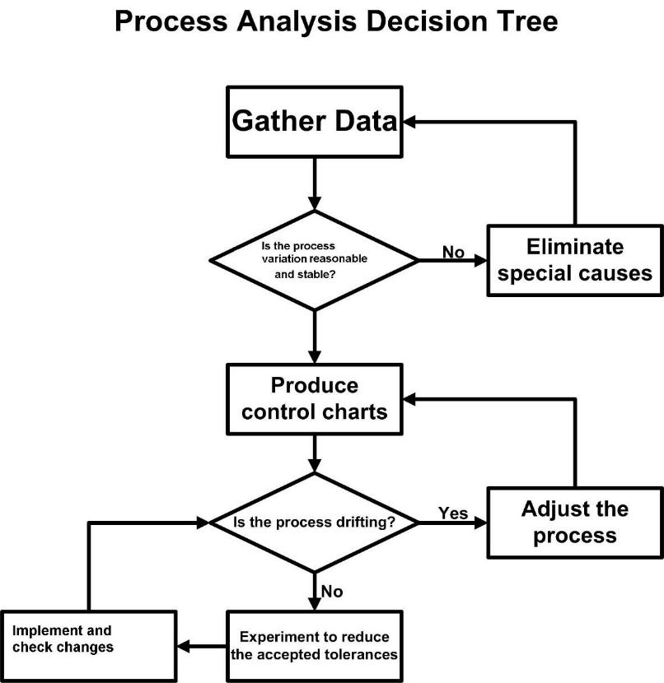
Process Analysis Decision Tree
How do you identify trends?
Trend analysis involves plotting monitoring data on a chart to provide a visual presentation of variation in process variables such as product temperature and carcase defects.
Histograms, run charts and control charts are Quality Assurance tools useful in monitoring variations and identifying trends away from process control.
What are histograms?
A histogram is a graph that shows the pattern of variation in a process. Histograms are used for finding out the:
- pattern of variation
- point of central tendency
- spread of results
- capacity to meet specification.
Before gathering the data for a histogram it is necessary to calibrate measuring equipment, or establish consistent assessment criteria and techniques such as carcase defect rating process.
Then a large number of consecutive measurements must be taken. This data can be used to establish the range of results and then plotted on graph paper. A bell shaped pattern will indicate a normal pattern of distribution which indicates a degree of process control.
To make the interpretation of this data easier, it helps to mark specification limits on the graph. Then it is possible to see clearly if the results are centred within the specification limits and if the results spread outside the specification limits.
The example below shows how measurements of carcase defect ratings can be plotted on a histogram. This data set of carcase defects will be used for all the exercises in this section on data analysis.
Carcase defect ratings are given to sample lots and scores given according to contamination defects found, therefore the higher the score, the greater the contamination found.
Meat hygiene assessment evaluation over a three week period
Defect rating values for beef sides before wash (one shift per day)
Shifts | Value for lots
 | 1 | 2 | 3
1 | 0.6 | 0.7 | 0.8
2 | 0.65 | 0.75 | 0.7
3 | 0.45 | 0.65 | 0.5
4 | 0.8 | 0.7 | 0.65
5 | 0.85 | 0.75 | 0.8
6 | 0.7 | 0.8 | 0.75
7 | 0.6 | 0.7 | 0.6
8 | 0.8 | 0.6 | 0.7
9 | 0.6 | 0.65 | 0.75
10 | 0.7 | 0.8 | 0.75
11 | 0.9 | 0.85 | 0.9
12 | 0.9 | 1.00 | 0.95
13 | 1.2 | 1.15 | 1.1
14 | 1.6 | 1.7 | 1.5
15 | 2.1 | 2.00 | 1.8

Range = Highest rating – Lowest rating.
Range = 2.10 – 0.45 = 1.65
Distribute results across range.
Defect rating values for beef sides before wash.

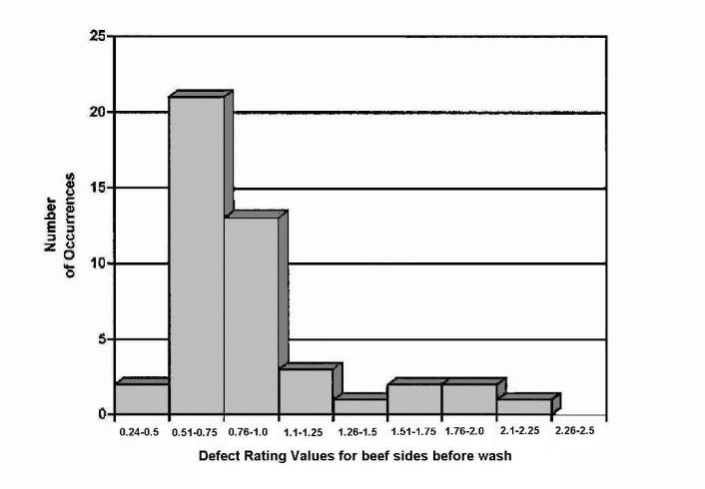
Defect rating values (beef sides before wash)
Courtesy of the Department of Agriculture
You can see from the table (Carcase Meat Hygiene Assessment second edition) below that a carcase defect rating of less than 1.5 is acceptable and a score greater than 2.5 is unacceptable.

Target defect rating before the final wash for cattle
Acceptable | <1.5
Marginal | 1.51 to 2.5
Unacceptable | >2.5

Although the monitoring results all fall within the acceptable and marginal areas, the histogram indicates a tendency towards a loss of control. The spread of results indicates a trend away from the norm of 0.5-1.0, towards the unacceptable result of greater than 2.5. Some investigation is required to determine the cause of the variation and to develop a strategy to correct the problem and prevent recurrence.
What are run charts?
A run chart is a simple graph which shows how a process changes with time. The run chart is useful in bringing a process under control by eliminating or minimising factors contributing to variation in the process. The run chart requires no calculations.
Run charts are used on variables:
- with unknown patterns of variation
- where only one measurement is obtained at each sampling time
- where calculations are inconvenient
- which may be used to gather data for the calculation of control limits for a control chart.
The development of a run chart requires the following steps:
- calibrating measuring equipment or establishing consistent assessment criteria and techniques
- taking measurements at each step
- plotting the measurement on the run chart
- joining consecutive points with straight lines.
Defect rating values for beef sides before wash (one shift per day)
Shifts  (days) | Value for lots |  |  | Value for shift
 | 1 | 2 | 3
1 | 0.6 | 0.7 | 0.8 | 0.7
2 | 0.65 | 0.75 | 0.7 | 0.7
3 | 0.45 | 0.65 | 0.5 | 0.53
4 | 0.8 | 0.7 | 0.65 | 0.72
5 | 0.85 | 0.75 | 0.8 | 0.8
6 | 0.7 | 0.8 | 0.75 | 0.75
7 | 0.6 | 0.7 | 0.6 | 0.63
8 | 0.8 | 0.6 | 0.7 | 0.7
9 | 0.6 | 0.65 | 0.75 | 0.67
10 | 0.7 | 0.8 | 0.75 | 0.75
11 | 0.9 | 0.85 | 0.9 | 0.92
12 | 0.9 | 1.00 | 0.95 | 0.95
13 | 1.2 | 1.15 | 1.1 | 1.15
14 | 1.6 | 1.7 | 1.5 | 1.6
15 | 2.1 | 2.00 | 1.8 | 1.97

Once the run chart has been plotted it is possible to examine the pattern of points to determine trends. After the trend has been established, the causes of the trends can be isolated and eliminated.
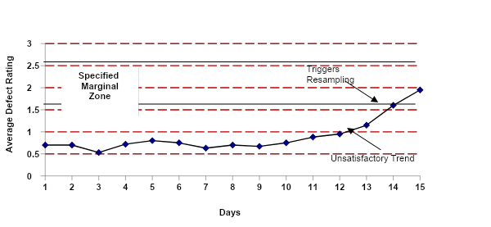Run chart – defect ratings (beef sides before wash)
Courtesy of the Department of Agriculture
The chart above plots the defect ratings of beef sides over 15 production days. The upward movement on the run chart indicates an unsatisfactory trend developing. The continued upward trend, commencing on the tenth day, triggers some remedial activity, in this case increased sampling.
Using a process control chart
There are a number of fundamental points to consider when using process control charts. They include:
- average and range control charts only apply to variable data (measured) and not attribute data (counted)
- Upper Control Limits (UCL) and Lower Control Limits (LCL) are used to determine if the process is in control
- if data points are located inside the Upper and Lower Control Limits, then the variation is due to random or common causes. Adjusting the process corrects random or common cause variation
- if data points are located outside the Upper and Lower Control Limits, then the variation is due to special causes are corrected by applying a problem-solving model to correct the special cause
- should data points be located inside the upper and lower control limits, then our process is said to be ‘in control’
- basic calculations are required to develop an average and range control chart.
What is a process control chart?
In a manufacturing process the most common day-to-day use of data and information is for process control. We have looked at ways to determine if a process is ‘in statistical control’ using run charts and histograms.
However, a histogram represents a ‘snapshot’ of the process at the moment in time the data was collected. A control chart provides us with similar data but it is able to represent our process over a period of time. A control chart is like a series of histograms.
When there is a large amount of data involved it would take too much time to continually produce histograms to determine if the process is in control. To overcome this problem we can use an average and range control chart – X and R chart.
Another advantage of process control charts is that they provide an opportunity to determine the cause of a variation from common or random causes or a special cause.
How are control limits calculated?
Control limits are the boundaries for acceptable performance set by the company, not the regulatory authority. For instance, the regulatory authority may set a specified unacceptable level of defect ratings at 3.0. The company will calculate is critical limits significantly less than that as an ‘early warning’ when the process starts to get out of control.
Essentially the limits are calculated by using formula involving the mean and/or range and a constant, which is obtained from tables that take into account the number of samples taken.
The calculation of the control limits is covered in detail in training material AMPX405 Conduct statistical analysis of process.
For the X chart the:
Upper Control Limit (UCL) = the grand average +A₂ x range
Lower Control Limit (LCL) = the grand average –A₂ x range,
where A₂ is the constant derived from a table available in the the Department of Agriculture Meat Hygiene Assessment publication.
For the R chart the:
Upper Control Limit (UCL) = D₄ x average range
Lower Control Limit (LCL) = D₃ x average range,
where D₄ and D₃ are constants derived from the the Department of Agriculture Meat Hygiene Assessment publication.
What are the types of control charts?
There are two types of control charts that can be constructed.
X charts
X charts plot the overall average in product standards. This means that:
- by plotting the overall average, variation can be tracked
- if a process is in control, then values should fall within control limits.
R charts
R charts plot the range of product standards. This means that:
- by plotting the average range against the individual range of observations, the degree of process control can be assessed
- the R chart differentiates between constant and variable components of a process – displayed as a total in the X chart.
Variable components are inputs such as incoming livestock and constant components are machine operations that usually run with little change.
How are X charts constructed?
In the example below the X chart plots the average rating of beef side defects against average defect rating.
Shifts  (days) | Value for lots |  |  | Value for shift  (Average)
 | 1 | 2 | 3
1 | 0.6 | 0.7 | 0.8 | 0.7
2 | 0.65 | 0.75 | 0.7 | 0.7
3 | 0.45 | 0.65 | 0.5 | 0.53
4 | 0.8 | 0.7 | 0.65 | 0.72
5 | 0.85 | 0.75 | 0.8 | 0.8
6 | 0.7 | 0.8 | 0.75 | 0.75
7 | 0.6 | 0.7 | 0.6 | 0.63
8 | 0.8 | 0.6 | 0.7 | 0.7
9 | 0.6 | 0.65 | 0.75 | 0.67
10 | 0.7 | 0.8 | 0.75 | 0.75
11 | 0.9 | 0.85 | 0.9 | 0.92
12 | 0.9 | 1.00 | 0.95 | 0.95
13 | 1.2 | 1.15 | 1.1 | 1.15
14 | 1.6 | 1.7 | 1.5 | 1.6
15 | 2.1 | 2.00 | 1.8 | 1.97
 |  |  |  | 13.54
Grand Average |  |  |  | 0.9
Grand average 13.5/15 = 0.9 (mean)
Range 2.10 – 0.45 = 1.65
UCL = grand average + (A2 x range)
UCL = 0.9 + (0.22 X 1.65)
ULC = 1.26
LCL = grand average – (A2 x range)
LCL = 0.9 – (0.22 X 1.65)
LCL = 0.54

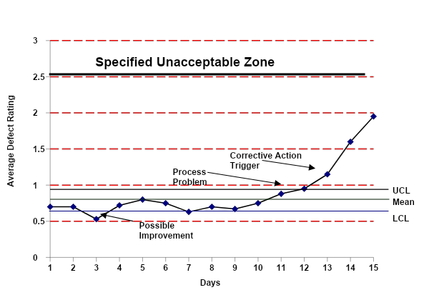X Chart – defect ratings (beef sides before wash)
Courtesy of the Department of Agriculture
Fluctuations on the X chart relate to components of the process – constant and variable.
When interpreting the X chart, averages that fall within the upper control (UCL) and lower control limit (LCL) can be considered . There is a change in the process only when a value moves outside the UCL and LCL.
For example, on day three, the average defect rating fell below the LCL. This may be area for improvement in the system. The source of the fluctuation could be identified and used to improve the process, i.e. may have been a day where there were four trimmers instead of two trimmers.
The points that fall outside the UCL are possible process faults indicating intervention is needed. This action may not have been taken if the data was plotted in a simple trend chart.
By instituting action early, the process may be brought back into control before prescribed responses are triggered for marginal and unacceptable zones.
Specified zones, i.e. marginal and unacceptable, are obligatory or regulatory units. They are totally separate from UCL and LCL which are management parameters to give early indication of a process under pressure.
How are R charts constructed?
In the example below the R chart plots the range of defect ratings each day. On day 1, for example, the defect ratings for the lots 1, 2 and 3 were 0.6–0.8 and therefore the range difference between highest and lowest was 0.2. The smaller the range, the more the process is in control – the greater the average range, the less control.
Shifts | Value for lots |  |  | Range
 | 1 | 2 | 3
1 | 0.6 | 0.7 | 0.8 | 0.2
2 | 0.65 | 0.75 | 0.7 | 0.1
3 | 0.45 | 0.65 | 0.5 | 0.2
4 | 0.8 | 0.7 | 0.65 | 0.15
5 | 0.85 | 0.75 | 0.8 | 0.1
6 | 0.7 | 0.8 | 0.75 | 0.1
7 | 0.6 | 0.7 | 0.6 | 0.1
8 | 0.8 | 0.6 | 0.7 | 0.2
9 | 0.6 | 0.65 | 0.75 | 0.15
10 | 0.7 | 0.8 | 0.75 | 0.1
11 | 0.9 | 0.85 | 0.9 | 0.05
12 | 0.9 | 1.00 | 0.95 | 0.1
13 | 1.2 | 1.15 | 1.1 | 0.1
14 | 1.6 | 1.7 | 1.5 | 0.2
15 | 2.1 | 2.00 | 1.8 | 0.3
 |  |  |  | 2.15
Average Grand Range |  |  |  | 0.14

Upper control limits (UCL)
= D4 X average grand range
= 1.65 x 0.14 = 0.23

Lower control limits (LCL)
= D3 X average grand range
= 0.35 x 0.14 = 0.05

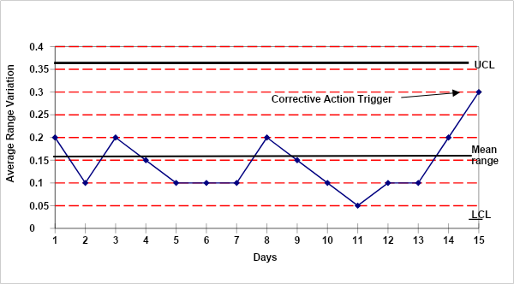R chart defect ratings (beef before wash)
Courtesy of the Department of Agriculture
Fluctuations on the R chart generally relate to variable inputs of the process. These inputs can include, for example, differences in the cleanliness of incoming stock or in the type of stock, or the competency of a new operator.
Using X and R charts together
Fluctuations outside control limits on the X chart can be cross-referenced with the R chart to narrow the possible source of a fault to constant or variable inputs.
If control limits on the R chart are exceeded, then fluctuations in a process shown by the X chart are related to variable inputs.
If control limits on the R chart are not exceeded, fluctuations shown on the X chart are likely to relate to constant inputs, e.g. faulty scales.
Each time a process is changed to improve product standards, the mean and control limits will need to be recalculated to reflect the newly achieved average of the establishment. This can be the basis for measuring continuous improvement.
Calculate yields
How are yields calculated?
Apart from monitoring the quality of the product, it is also necessary to monitor the efficiency of the process. Yield is one of these measures.
Slaughter floor – carcase mass balance
The mass balance or yield of an animal is achieved by weighing a live animal before slaughter, processing the animal, weighing each discrete retrievable part, and adding them up to see that they equal the starting mass. This process repeated over a number of animals of the same class and mass provides an average mass balance for calculating expected yields.
This averaging of yields over a number of the same type, grade or class of animal enables us to calculate an expected yield for each grade of animal processed in the plant.
The charts below gives us an example of the expected yield for a particular grade of livestock.
Beef animal – expected yield
Mass balance for beef  Mass 430 kg liveweight | Kilograms
Carcase to chiller | 250
Edible offals | 12.6
Hides (greens) | 28.2
Rendering | 94.5
Gut contents | 44.7
Effluent | 0.5
Total | 430

These figures may be easily converted into percentages.
Example of calculation
Percent rendered = 94.5 x 100 = 22%
- 1
Carcase to chiller = 250 x 100 = 58%
430 1
In the case of this class of livestock the expected edible offal yield is 12.6kg. This in turn may be broken down to calibrate the average yield of the various types of offal.
Beef offal – expected yields
Edible offals yield from a  430 kg liveweight | Kilograms
Tongue | 1.34
Heart | 1.71
Liver | 5.8
Cheeks | 1.32
Headmeat | 0.24
Kidneys | 1.15
Thick skirt | 0.45
Tails | 0.59
Total | 12.6

The same calculation may be performed for any species slaughtered and any grade or category of animal.
Lamb – expected yields
This table details the expected yield from a 28.2 kg live weight lamb.
Mass balance for lamb  Mass 28.2 kg live weight | Kilograms
Carcase to chiller | 14.091
Edible offals | 0.68
Pelts (green) | 2.656
Rendering | 10.061
Casings | 0.712
Total | 28.2

This table details the expected breakdown of the product yields for this category of lamb.
Mass balance for lamb 28.2 kg live weight

 | Kilograms
Tongue | 0.109
Heart | 0.118
Lungs | 0.141
Liver | 0.479
Kidneys | 0.083
Spleen | 0.017
Brain | 0.065
Sweetbreads | 0.006
Hooves | 0.818
Heads | 1.212
Gut content | 3.528
Caul fat | 1.62
Runners | 0.628
Condemned runners | 0.006
Caecum | 0.084
Large intestines | 0.818
Trim kill floor | 0.107
Blood | 1.27
Pelt | 2.656
Dressed carcase | 14.091
Gullet | 0.344
Total | 28.2

This table has been converted into percentage expected yields.
Percentage yield for lamb 28.2 kg live weight

Percentage
Yield
Dressed carcase | 50%
Pelt | 9%
Blood | 5%
Runners | 2%
Caul fat | 6%
Gut content | 13%
Heads | 4%
Large intestines | 3%
Hooves | 3%
Lungs | 1%
Gullet | 1%
Other | 3%

Boning room – expected yield
Expected boning room yields are calculated by breaking down a carcase of known weight and weighing all retrieved product including trimmings, fat and bone. This is repeated for a number of animals of the same class to derive an average expected percentage meat yield for each class of stock.
The table below breaks down the expected yield for a particular category of carcase.
Young beef yield – total carcase Mass 220 kg
Cut | Mass/Piece  (kg) | Piece Yield  %
Inside | 13.288 | 6.04%
Outside | 13.42 | 6.10%
Knuckle | 7.81 | 3.55%
Rump | 7.766 | 3.53%
Striploin 1 Rib | 6.292 | 2.86%
Tenderloin S/on | 3.476 | 1.58%
Flank steak | 1.166 | 0.53%
Flap meat | 2.024 | 0.92%
Knuckle side | 1.056 | 0.48%
Inside skirt | 1.606 | 0.73%
Clod | 12.98 | 5.90%
Full chuck | 14.19 | 6.45%
Cube roll 7 rib | 5.236 | 2.38%
Point end brisket 6 rib | 9.152 | 4.16%
Naval end brisket 6 rib | 8.316 | 3.78%
Chuck tender | 2.002 | 0.91
Chuck meat | 7.744 | 3.52
Shin/Shank | 12.914 | 5.87%
Rib fingers | 2.222 | 1.01%
Heel muscle | 1.716 | 0.78%
Trimmings 65CL | 1.98 | 0.90%
Trimmings 75CL | 13.024 | 5.92%
Trimmings 80CL | 1.98 | 0.90%
Percentage meat yield | 151.36 | 68.80%
Fat | 15.928 | 7.24%
Bone | 52.712 | 23.96%
Total | 220 | 100.00%

The piece yield is calculated as follows:
Inside yield = 13.288 x 100
220 1

= 6.04%
The following is an example of the type of sheet used to gather the yield information.

YIELD SHEET
BODY # __________ |  | KILL DATE:____/____/_____
P8 FAT:__________mm |  | BUTT SHAPE: ________
SIDE WEIGHT:__________(Kg) HSCW |  | SIDE WEIGHT:__________(Kg) HSCW
COLD WEIGHT MINUS HOOK |  | COLD WEIGHT MINUS HOOK
HINDQUARTER: ________ kg - ________ kg |  | HINDQUARTER: ________ kg - ________ kg
FOREQUARTER: ________ kg - ________kg |  | FOREQUARTER: ________ kg - ________kg
TOTAL: ________ kg |  | TOTAL: ________ kg
PRODUCT | KGS |  | LESS TUB  (kg) (kg) | KGS
inside | _ _ _ _ |  |  | _ _ _ _
outside | _ _ _ _ |  |  | _ _ _ _
silverside | _ _ _ _ |  |  | _ _ _ _
eye round | --------- (_ _ _ _kg) |  |  | --------- (_ _ _ _kg)
outside flat | --------- (_ _ _ _kg) |  |  | --------- (_ _ _ _kg)
knuckle | _ _ _ _ |  |  | _ _ _ _
thick flank | _ _ _ _ |  |  | _ _ _ _
rump | _ _ _ _ |  |  | _ _ _ _
d/rump | _ _ _ _ |  |  | _ _ _ _
striploin | _ _ _ _ |  |  | _ _ _ _
shortloin | _ _ _ _ |  |  | _ _ _ _
tenderloin s/on | _ _ _ _ |  |  | _ _ _ _
butt tenderloin | _ _ _ _ |  |  | _ _ _ _
flank steak | _ _ _ _ |  |  | _ _ _ _
inside skirt | _ _ _ _ |  |  | _ _ _ _
knuckle side | _ _ _ _ |  |  | _ _ _ _
flap meat | _ _ _ _ |  |  | _ _ _ _
clod | _ _ _ _ |  |  | _ _ _ _
chuck | _ _ _ _ (_ _ _ _CL) |  |  | _ _ _ _ (_ _ _ _CL)
chuck roll | _ _ _ _ |  |  | _ _ _ _
chuck meat | _ _ _ _ (_ _ _ _CL) |  |  | _ _ _ _ (_ _ _ _CL)
chuck tender | _ _ _ _ |  |  | _ _ _ _
cube roll | _ _ _ _ |  |  | _ _ _ _
point end brisket | _ _ _ _ (_ _ _ _CL) |  |  | _ _ _ _ (_ _ _ _CL)
navel end brisket | _ _ _ _ (_ _ _ _CL) |  |  | _ _ _ _ (_ _ _ _CL)
short plate ‘a’ | _ _ _ _ |  |  | _ _ _ _
trimmings | _ _ _ _ (_ _ _ _CL) |  | _ _ _ _ _ _ | _ _ _ _ (_ _ _ _CL)
trimmings | _ _ _ _ (_ _ _ _CL) |  | _ _ _ _ _ _ | _ _ _ _ (_ _ _ _CL)
trimmings | _ _ _ _ (_ _ _ _CL) |  | _ _ _ _ _ _ | _ _ _ _ (_ _ _ _CL)
shank 90 cl | _ _ _ _ |  |  | _ _ _ _
shin flexor | _ _ _ _ |  |  | _ _ _ _
conical m. | _ _ _ _ |  |  | _ _ _ _
shank b | _ _ _ _ |  |  | _ _ _ _
shank d | _ _ _ _ |  |  | _ _ _ _
heel muscle | _ _ _ _ |  |  | _ _ _ _
rib finger | _ _ _ _ |  |  | _ _ _ _
TOTAL | _______ |  |  | _______
 | YIELD:_ _ _ _ % |  |  | YIELD:_ _ _ _ %
fat | _ _ _ _ |  |  | _ _ _ _
bones | _ _ _ _ |  |  | _ _ _ _
loss | _ _ _ _ |  |  | _ _ _ _
TOTAL | ________ |  |  | ________

How are actual yields compared with expected yields?
Yields are usually calculated for all classes of stock processed at the abattoir, for example:
- yearling
- grainfed yearling
- light prime
- heavy prime
- heavy steer
- second grade cow
- third grade cow
- bull.
Expected offal production yields are calculated, and actual yields monitored and reviewed to determine wastage and productivity. The variance between expected and actual yields can be used to calculate wastage and productivity.
The comparison between actual and expected yields allows the efficiency of the process to be monitored and various factors checked. In a boning room these factors might include:
- poor boning technique resulting in too much meat being left on the bone
- excessive pre-boning trimming
- excessive trimming by slicers.
When expected offal production yields are calculated, for example, the results indicate the yield of offal that may be expected from the processing of stock of a particular grade. The expected figures must be compared with actual yields. A significant difference may be due to:
- high condemnation rates
- shortage of labour to recover offal.
What is wastage?
When actual yields of high value items such as a dressed carcase or edible offal fail to meet expected yield rates, then there is wastage.
If carcases have to be heavily trimmed because of contamination caused by poor dressing, then actual yields will be less than expected yields and the trimmings represent wastage.
If boners leave meat on the bone then the increase in bone weight is wastage. If boners do not follow cutting lines properly, then weight may be lost from valuable cuts and gained on less valuable cuts. This is also wastage.
The goal of investigating differences between actual and expected yields is to find the causes of wastage and find ways to minimise the wastage.
What is productivity?
Productivity is usually defined in terms of output/person/unit of time.
In abattoirs and boning rooms this is usually interpreted as how many carcases are processed per hour. This definition of how well a team is working has led to a clash between output and quality, as the emphasis is on throughput rather than quality.
It is possible to increase chain speed to increase throughput but this is usually at the expense of both yield and quality. As the chain speed increases beyond an optimal level, slaughterers boners, slicers and labourers struggle to complete their tasks properly. This may result in the loss of the more valuable elements of yield of carcase meat, edible offal and carton meat. Actual yields of these items decline, wastage increases and profit/unit decreases. Therefore, if the productivity of a team is being assessed it needs to be done in terms of:
- the number of heads/carcases processed
- the actual yields achieved.
In some instances a team may improve its productivity by increasing the yields without increasing the throughput.
Trends in productivity are often used as indicators of the efficiency of teams and supervisors.
Sampling
Why are samples collected?
Meats need to be sampled to undergo analysis for composition, chemicals and/or microorganisms, including the following:
- microbiological analysis
- TVC (Total Viable Count) or SPC (Standard Plate Count) – product and processing equipment
- Coliforms and E.coli H:0157 – US Pathogen Reduction Program in US listed export establishments
- Salmonella – US Pathogen Reduction Program in US listed export establishments
- chemical analysis
- heavy metals e.g. cadmium, mercury, lead etc. as part of the National Residue Sampling program
- antibiotics as part of the National Residue Sampling program
- agri-chemical residues as part of the National Residue Sampling program
- compositional analysis
- chemical lean testing
- species testing.
How are product samples collected?
Laboratory results may be meaningless if the samples are not properly collected, prepared and despatched or are not representative of the lot.
Where possible samples should be collected as a discrete unit i.e. a cryovac rump, a can of corn beef etc.
In other instances portions will need to be drawn from a larger unit e.g. a carcase, a carton of meat etc. As the external packaging will need to be breached great care is required to prevent sample contamination from outside sources during sample collection.
Aseptic sampling
To keep samples aseptic/free from contamination:
- conduct sampling in clean surroundings
- find a work area free from potential contaminants e.g. dust, exhaust fumes
- choose a work surface that can be covered and/or sterilised with alcohol.
Personal hygiene
The personal hygiene requirements for sampling include:
- keeping yourself clean
- wearing a clean hat and coat
- washing hands with soap and warm water
- putting on latex or plastic gloves after washing hands.
Common sense
When taking samples, use common sense:
- plan the sequence of sampling e.g. collect packages for sampling before setting up for sampling
- have a range of sterilised containers and sampling equipment available, including:
- sterile bags, templates, forceps, tongs, knives, scissors etc.
- a means of sterilising equipment should accidental contamination occur e.g. alcohol.
- draw the sample from an opened carton quickly, so as to minimise the potential for contamination.
How can you be sure samples are representative of the lot being tested?
An essential aspect of sampling is the concept of the representative sample. A sample must be representative of the lot being tested i.e. from a production lot of 500 cattle, the 50 selected for sampling will be a true representation of the total 500.
Sampling programs are established for all sampling exercises. The simplest method of ensuring a representative sample is to sample randomly. Random sampling can be applied if the product can be identified by numbering. This can be achieved using the random sampling tables from AS 1399:1973.
Example:
From a lot of 600 cartons – a container load – 10 samples need to be selected and the temperature checked.
In order to randomly select the cartons to be sampled, the table below may be used. Starting at the top of the first column, disregard the last number and record the first three numbers under 600. The numbers will represent the cartons to be sampled. As the cartons are scanned and tallied the carton corresponding with each random number is temperature tested.

TABLE 1 (PART 1). RANDOM SAMPLING NUMBERS

0110 | 9140 | 2804 | 8046 | 7142 | 8910 | 3585 | 5655 | 1904 | 0681
5321 | 3946 | 6289 | 6117 | 0060 | 8439 | 1052 | 5883 | 9283 | 1053
5373 | 8259 | 4956 | 8185 | 0135 | 4691 | 6787 | 4107 | 5073 | 8503
9244 | 9452 | 8324 | 8062 | 9817 | 1034 | 1157 | 5888 | 0213 | 2430
4148 | 3948 | 5399 | 8687 | 3568 | 7472 | 4581 | 3837 | 8961 | 7931
2403 | 4351 | 8240 | 3554 | 3568 | 2950 | 7419 | 6874 | 1128 | 5108
1828 | 1956 | 1646 | 1370 | 9096 | 1312 | 7297 | 3848 | 4767 | 5386
7249 | 9634 | 4263 | 4345 | 0567 | 8734 | 4921 | 6201 | 5057 | 9228
7116 | 9731 | 2195 | 3265 | 9542 | 2907 | 0737 | 8496 | 7509 | 9304
6659 | 8200 | 4135 | 6116 | 3019 | 1294 | 4883 | 2536 | 2351 | 5860
2267 | 0362 | 5242 | 0261 | 7990 | 8886 | 0375 | 7577 | 8422 | 5230
9460 | 9812 | 8325 | 6031 | 1102 | 2825 | 4899 | 1599 | 1199 | 0909
2985 | 3541 | 6445 | 7981 | 8796 | 9480 | 2409 | 9456 | 7725 | 0183
4313 | 0666 | 2179 | 1031 | 7804 | 8075 | 8187 | 6575 | 0065 | 2170
6930 | 5368 | 4520 | 7727 | 2536 | 4166 | 7653 | 0448 | 2560 | 4795

Using this table, the cartons to be tested are: 11, 532, 537, 414, 240, 182, 226, 298, 431, 394.
Most scientific calculators have a random number feature and this can be used to randomly select samples.
How can post-collection mishandling of samples affect test results?
Post-collection handling of samples is important to ensure that the sample is not adulterated in any way that renders the sample as non-representative of the lot samples.
The sample needs to be:
- protected against contamination during post-collection handling, storage and transportation
- prepared so that microbial growth of microorganisms present on the sample is prevented during post collection handling, storage and transportation
- prepared, handled, stored and transported in a manner that has no bactericidal effect on the sample, to enable correct microbiological analysis
- protected from physical and chemical deterioration during transportation.
Example of a transport of sample procedure
Where samples are to be transferred to an off-site laboratory for analysis the following procedures are usually undertaken:
- samples must be dispatched on the day of collection and analysed no later than the day following collection
- samples must be maintained at refrigerator temperatures until shipped. Samples must not be frozen
- the laboratory is to be instructed to discard samples which arrive above 7°C or late, as samples cannot be analysed the day following collection
- bags containing sample sponges are to be firmly secured and enclosed within a second firmly closed bag
- samples may be transported in rigid plastic ‘esky’ six-pack type containers – not in foam plastic containers as these can break during transport.
To pack samples:
- place a frozen gel pack in the bottom of the container
- place a corrugated cardboard divider above the gel pack
- place the sample(s) on the divider – crushed paper may be used to protect the sample(s) and hold them upright
- place a second divider above the samples
- place a second and/or third gel pack above the divider
- fill the vacant space with crushed paper
- seal the container securely with adhesive tape
- label as ‘meat samples’
- tick the ‘does not contain dangerous goods’ box on the consignment note.
Dividers are used to prevent contact freezing of the samples. Sufficient gel packs must be used to ensure that the samples arrive at the laboratory at a temperature of 7°C or below.
It is suggested that each plant validate their procedure by testing the temperature of a test sample after being held in a shipping container for 24 hours and 36 hours at ambient temperatures.
Activity two: Monitoring, inspection and testing
Materials and specialist personnel
Quality Assurance manual.
AUS-MEAT Standards.
Work instruction for monitoring.
Sampling programs.
Inspection procedures.
Quality Assurance manager.
Method
Explain the purpose and nature of monitoring, inspection and testing.
Identify and explain what monitoring, inspection and testing is performed in the various work areas.
Explain how the results of these monitoring, inspection and testing process are recorded.
Explain the concept of sampling and sampling programs. Discuss how samples are selected for monitoring, inspection and testing. Explain the sampling procedures for each and where they are documented.
Take the relevant examples of monitoring data and:
- develop tables
- calculate the mean, UCL and LCL
- plot the data on histograms, run charts, X and R charts.
Discuss the concept of a process being in control and the purpose of UCLs and LCLs.
Discuss how unacceptable levels are established for such things as carcase defects and how these levels relate to UCL and LCL.
Take the participants to their work area to observe and participate in the range of monitoring/inspection/testing activities undertaken. Explain:
- the frequency
- the relevant work instruction
- the recording process
- the hygiene requirements
- the WHS requirements
- the data collection and presentation procedures.
Trainee activities
Present the trainee with raw monitoring data for a period, and ask them to:
- present the material in table form
- plot histograms, run charts, and where relevant, X and R charts
- determine if the process is in control
- establish what trends are indicated by the data.
Ask the trainee to undertake a series of process or product monitoring activities in their own work area, then
- record the data
- present the data in appropriate tables and graph
- analyse the trends evident in the data
- identify the relevant sampling plan or procedure for this activity.

Calibration of instruments
Why calibrate instruments?
Meat processing industries have a variety of instruments for measuring processes and ensuring they are under control. The accuracy of these instruments is critical to the quality of the product being produced. As a general rule it can never be assumed that instruments are accurate. In critical situations, the assumption that industrial thermometers and thermographs are accurate can be dangerous.
It is dangerous to assume that instruments are accurate in the case of:
- determining product storage temperatures to prevent the growth of pathogens such as Salmonella on fresh meat
- determining thermal process temperatures to destroy potential pathogens such as Clostridium Botulinum in canned meat.
What equipment requires calibration?
The main instruments used in meat processing that require calibration are:
- thermometers – fixed and portable
- chlorine dosage equipment
- chlorine measurement equipment
- fat measuring equipment – chemical lean and fat depth
- hygrometer – effective for chilling and prevention of condensation
- hydrometers – measurement of A_{w} (water activity) in fermented smallgoods
- scales
- carcase chiller assessment – colour charts
- automated detergent measuring equipment.

WI/  SOP | How do you test instrument accuracy?

Instrument calibration is performed by measuring instrument accuracy against a certified or recognised standard. Details on calibrating each piece of equipment are located in the site's work instruction.
The work instruction provides steps on:
- calibrating the equipment
- frequency of calibration
- records to be kept on calibration.
The Standard Operating Procedure (SOP) for instrument calibration explains the broad process to be followed when calibrating, and the instruments that must be calibrated. Instruments that must be calibrated include fat probes, thermometers and scales.
An example of a work instruction for calibrating a thermometer follows.
There are two physical standards of water at standard temperature and pressure i.e. 1 atmosphere:
- water freezes at 0°C
- water boils at 100°C.
A high quality certified (NATA) glass thermometer is calibrated against these two fixed standards. The process thermometer is then checked against the certified glass thermometer. The variance between the process thermometer and the certified glass thermometer at these two points is recorded. It is important to note that the process thermometer is calibrated for accuracy at 0°C and at 100°C not across the range of 0°C and 100°C.
To calibrate across the range the standard thermometer bulb is placed in a variable temperature water bath, in close proximity to the bulb/sensor of the process thermometer and readings taken over the range of the temperatures of interest. A graph of actual temperature versus indicated temperature is then drawn and corrections made to the process thermometer.

Indicated reading °C | Actual reading 0°C | Correction °C | Corrected reading °C
-50.0 | -50.0 | 0.0 | -50.0
-25.0 | -24.9 | +0.1 | -25 + 0.1=24.9
0.0 | 0.0 | 0.0 | 0.0
+50.0 | +49.8 | -0.2 | +50-0.2=+49.8
+100.0 | +99.9 | -0.1 | +100-0.1=+99.9

The range of variation is +0.1°C – -0.2°C = +0.3°C.
The estimated uncertainty of values at a 95% confidence level of +0.3°C.
Some equipment is best calibrated by a third party e.g. automatic detergent measuring equipment and scales. If third parties are used it is important that proper records are kept of calibration tests and calibration certificates.
How is instrument accuracy verified?
Calibration is part of any quality system and Quality Assurance managers need to maintain a calibration log in which is recorded the results of all calibrations on all inspection and test equipment.
Verification of accuracy of measuring and test equipment, as well as operator technique in the use of such equipment will need to be reviewed on a regular basis to maintain the currency of inspection and test data. A schedule specifying frequency of calibration for individual items of inspection and test equipment needs to be developed and regularly (probably weekly) reviewed to make sure calibrations occur and that the results of calibration are recorded to ensure any correction required in use is specified. Individual items of inspection and test equipment should be labelled with the date of the last calibration and any correction required.
Monitoring variation between in-place inspection equipment and random product/process inspections may provide evidence of inaccuracy during actual work performance, e.g. in-chiller deep butt temperature monitoring probes versus QA deep butt temperature checks on entry to boning room.
In-place inspection equipment should be regularly checked against a calibrated instrument. The greater the hazard associated with the measured parameter, the more frequent the verification.
Internal audit activities are also a useful verification activity in checking the accuracy of instrument adjustment.

Identifying causes and problem solving
What do we do once we detect a process out of control?
In order to solve a process problem it may be necessary to employ one or more problem solving techniques to settle on a solution.
One of the first steps may be to determine which problem should be tackled first and then to prioritise the issues to be addressed. Pareto Analysis is a useful tool to place the problems to be solved in the order in which they should be dealt with.
How can quality improvement activities be prioritised?
A useful method of collating monitoring data and setting problem solving priorities is Pareto Analysis. It can be used by managers and teams to work out which improvement projects should be completed first. This method can also be used to demonstrate the effectiveness of improvement actions.
When performing Pareto Analysis:
- identify problems to be solved
- collect data on the problems
- arrange opportunities for improvement, in numerical order
- construct the Pareto chart
- make the high ranking concerns into projects
- tackle one project at a time
- re-draw the Pareto chart when the project is finished and select a new high ranking project.
The following data based on personal hygiene monitoring gives us an example of how Pareto Analysis can be used in a meat processing area.
Personal hygiene – monthly monitoring results
Problem | Occurrence | % Occurrence
Non-hand washing | 25 | 30
Jewellery/cosmetics | 5 | 4
Eating in production areas | 9 | 10
Protective clothing | 7 | 6
Non-sterilisation | 35 | 37
Dirty knives, steels, gloves, boots | 13 | 13
TOTAL | 94 | 100%

Once the data has been collected it is possible to calculate the % occurrence. It is then possible to re-write the data into the table below with the problems in descending order and calculate the cumulative %.

Problem | Occurrence % | Cumulative %
Non-sterilisation | 37 | 37
Non-hand washing | 30 | 67
Dirty knives, steels, gloves, boots | 13 | 80
Eating in production areas | 9 | 89
Protective clothing | 6 | 95
Jewellery/cosmetics | 5 | 100

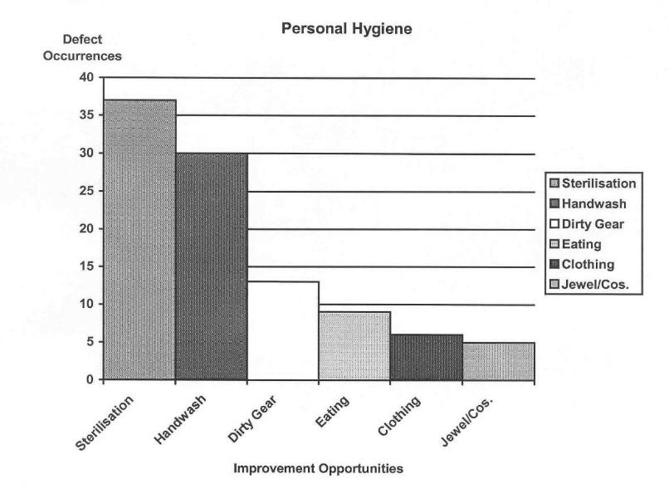
Personal hygiene – improvement opportunities

The general rule of thumb with Pareto Analysis is called the ‘80/20’ rule. This means that 80% of your faults or defects are caused by 20% of the problems.
In this example the 37 incidences of non-sterilisation, 30 incidences of non-hand washing and 13 incidences of dirty equipment make-up 80% of the problem, but only 50% of the causes. Concentrating on rectifying these aspects will achieve the greatest improvement in personal hygiene practices.
Having identified the most important problems, it is then necessary to analyse these problems, identify their causes and implement solutions.
What techniques can you use to solve problems?
Having used histograms, run charts and control charts to identify problems and/or areas for improvement we need to apply some different tools to solve the problem, or clarify the quality improvement opportunities.
These tools give us a structure to:
- analyse a problem
- identify the causes
- identify solutions
- implement solutions
- review the outcomes.
The tool or method you choose that most suits your situation doesn't matter, but whatever you choose, it is important that you use a structured, systematic approach to problem solving.
The problem solving/quality improvement strategies examined here include:
- the 9-step problem solving cycle
- brainstorming
- ask ‘Why?’ five times
- Ishikawa cause and effect diagrams
- HACCP – Hazard Analysis and Critical Control Points.
9-step problem solving cycle
The 9-step method is used for:
- dealing with difficult problems
- team-based problem solving
- major improvement opportunities.
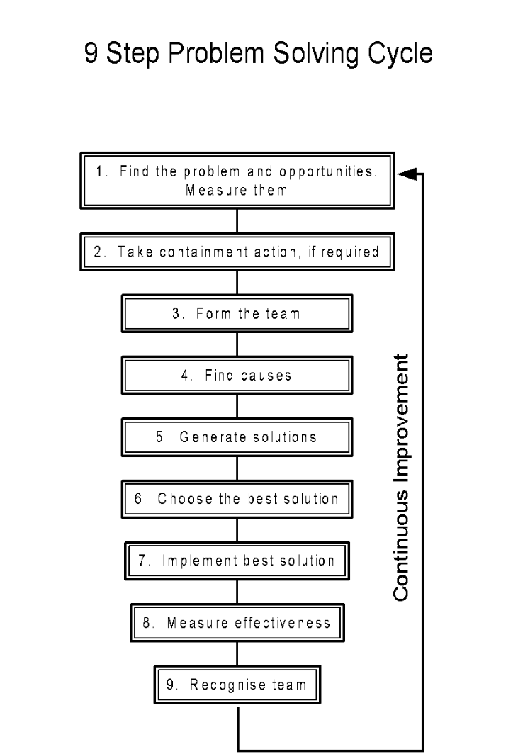
9-Step Problem Solving Cycle
Brainstorming
Brainstorming is a team-based method for generating ideas. It is a good method for finding:
- causes of a complex problem
- possible solutions
- possible risks and hazards.
This technique involves the following steps:
- gathering the facts
- assembling the team then present and define the problem to them
- collecting and recording all ideas with no discussion and no criticism then vote on ideas.
- preparing a shortlist
- discussing the shortlist
- conducting a final vote – one vote per person
- writing down the final choice.
Ask ‘Why?’ five times
Asking ‘why?’ five times is a method for separating symptoms from causes and defining the ‘real problem’. This process requires:
- defining the ‘apparent problem’
- asking ‘why?’ until there is no clear answer, or many theories
- working on the problem identified in the last clear answer
- using the fishbone method to solve the problem.
An example of this method is as follows:
Step 1
The apparent problem is evidence of spoilage at boning pre-trim.
Step 2
Why? – microbial growth occurring on necks and shoulders.
Step 3
Why? – refrigeration turned off after deep butt temperatures reach 20°C.
Step 4
Why? – to save power.
Step 5
Real problem = cost savings jeopardising product safety and wholesomeness.
Ishikawa fishbone cause and effect diagrams
An Ishikawa fishbone cause and effect diagram is a team-based method for finding the most likely cause of a complex problem. This technique is best used on problems which:
- are difficult to solve
- may be controversial
- have many possible solutions
When preparing an Ishikawa fishbone diagram and implementing solutions, the following process is employed:
- present and define the problem asking ‘why?’ five times
- draw a fishbone diagram on paper
- choose fishbone labels such as material, machine, method, measurement
- brainstorm for possible causes
- select key causes by voting or by collecting more data
- select the solution by voting
- implement the solution
- check the solution's effectiveness
- retain the fishbone diagram for presentation if required.
The example below examines the possible causes of poor cleaning and sanitation.
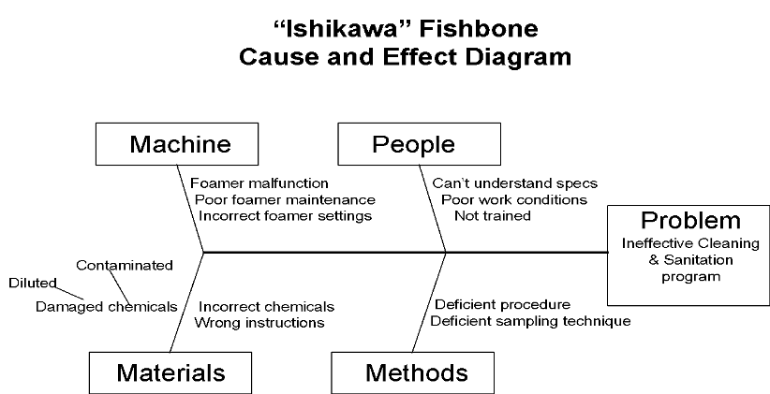
Ishikawa fishbone cause and effect diagram
HACCP – Hazard Analysis And Critical Control Points
HACCP is the premier method for identifying and controlling hazards affecting food safety within a process. HACCP is a quality planning tool to be used by product developers, process designers and problem solvers to predict and prevent food safety hazards, or control the effects of the hazards. The HACCP development program involves the following steps:
- assembling the HACCP team and defining the scope of the HACCP plan
- describing the product and its distribution method
- describing the intended use of the product
- constructing a detailed flow diagram of the process
- listing all potential hazards associated with each step, conduct a hazard analysis and consider any control measures to control hazards
- determining Critical Control Points (CCP)
- establishing and validate critical limits for each CCP
- establishing a monitoring system for each CCP
- establishing corrective action plans to deal with CCP deviation that may occur
- establishing verification procedures
- establishing record keeping and documentation.
The application of HACCP technology is covered in more detail in the training material for AMPX420 Participate in ongoing development and implementation of a HACCP and Quality Assurance system.
It is important to remember that HACCP is applied to food safety hazards associated with the food and its production process. Quality Assurance hazards associated with people and premises are controlled by good manufacturing practice standard operating procedures.
How can you present proposals for quality improvement to management?
To implement improvement programs it is important to gain the support of senior management. This can best be achieved by giving a presentation to management detailing:
- the problem
- the consequences of the continuation of the problem
- the identified causes of the problem
- the solutions to the problem
- the planned implementation of solution
- the follow-up to assess long-term success of quality improvement.
Management presentation
Making a presentation to management is a method of presenting the results of a quality improvement project.
The purpose of a presentation is to:
- communicate to management and others the selection, analysis, findings, recommendations and actions arising from an improvement project
- obtain further support for the project.
When planning and developing a presentation, have a structured approach which may include the following directions to:
- retain all documents generated during the project including graphs and charts
- select people to present the information – members of the team
- assemble the information in a logical order
- plan the presentation
- practise the presentation
When delivering any presentation there are a number of points to remember that will improve the impact of your presentation. These include:
- know your audience and what they want to hear
- be sincere
- speak clearly
- avoid annoying mannerisms e.g. playing with the change in your pocket
- do not read to the audience
- look at the audience – make eye contact
- talk to the audience and encourage audience participation
- answer questions clearly, if unsure of an answer, say so – do not make up an answer that may be challenged
- seek assistance from other project team members where appropriate
- ensure transparencies and materials handed out are clear, concise and easy to read
- actively seek feedback and suggestions from the audience.
Conduct an evaluation within the project team on the conduct of the presentation and seek ways of improving the presentation.

Implementing process changes
Why do you need process changes?
Having analysed a problem or opportunity for improvement the solution may require a process change. A process change may involve a change in equipment, materials or procedures.
These changes may result from a need to:
- implement a long term corrective action to an ongoing problem
- improve the process, product and/or productivity and profitability
- conform with new regulatory requirements.
What is required to implement process changes?
All process changes should be conducted as part of an ongoing continuous improvement program.
The Plan, Do, Check, Act (PDCA) model
Quality improvement is usually described as taking place within the plan, do, check, act model. This model, which is also known as the Deming cycle, can be applied to every facet of a business. By rotating the Deming wheel, we continually improve the process. The plan, do, check, act (PDCA) model requires a team approach to be effective.
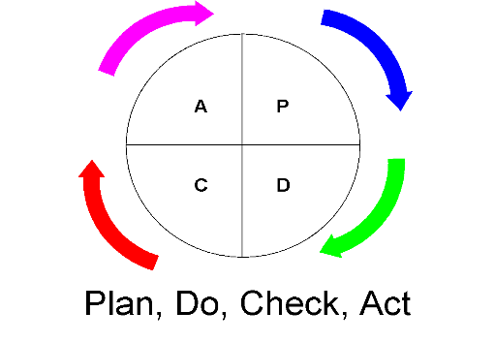

The Plan, Do, Check, Act model for quality improvement
PLAN – the planning stage
The planning stage requires you to:
- select the project or problem
- clearly define the problem/project and the aim of the problem/project
- conduct a mini-investigation of the project
- establish an action plan
- register the project with facilitator/management.
DO – the activity stage
The activity stage probes the cause and/or solutions or projects/problems and trial solutions.
This stage requires:
- collecting information
- analysing and evaluating the information
- deciding on the best possible solution
- communicating the solution
- trialling and testing the solutions.
CHECK – the validation stage
To validate improvements:
- collect data from tests/trials
- analyse and verify solutions.
If valid, go to the next stage, if not, review the problem.
ACT – the implementation stage
In the implementation stage:
- you prepare a report for management
- you present the report to management
- the solution is approved or rejected
- implementation is initiated if solution is approved
- the solution to the problem or quality improvement plan is put into practice.
The follow-up stage
The follow-up stage to the PDCA cycle requires you to:
- evaluate the new results after the plan has been in place
- standardise the quality management system – write new procedures, provide training
- plan for the future – continue the PDCA cycle.
The following diagram illustrates the PDCA cycle as a technique for lifting the organisation to higher levels of Quality Assurance performance. The diagram also illustrates how a documented quality system helps to sustain improvement by not from slipping back into the inferior practices of the past.

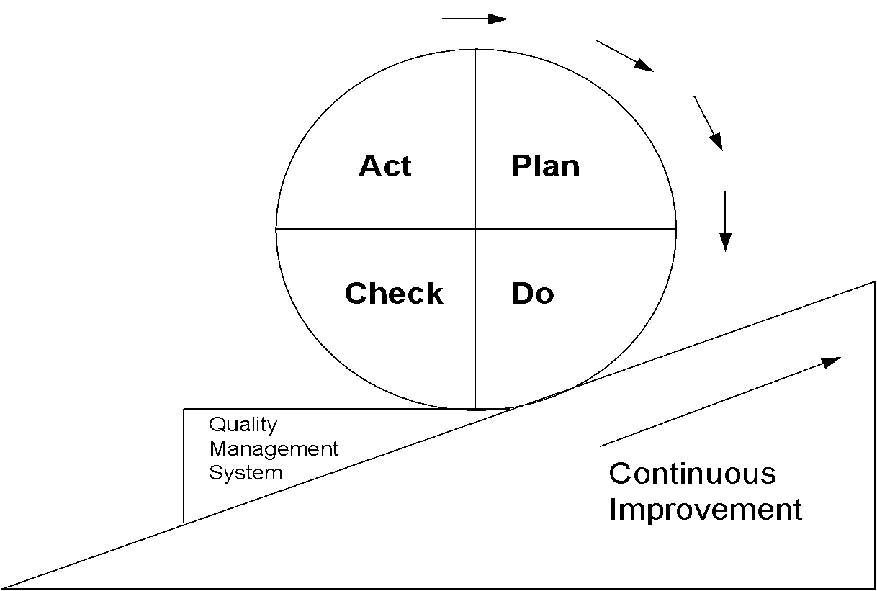

PDCA cycle
It is extremely important to involve the operators who are required to implement the change of process. If the change is developed by management in isolation from the workplace, implementation will be very difficult, if not impossible, to achieve.
Operational staff should be involved the following seven step process to maximise the chances of successfully achieving the desired change:
- inform – staff need to be informed of the reason for the need for change
- consult – staff need to be involved in the nature of the change i.e. the solution to the problem
- trial – the agreed solution needs to be trialed to evaluate effectiveness in achieving the aim of the change
- train – staff need to be trained in the implementation of the change
- implement – an implementation period where staff are assisted in the adoption of the changed procedure
- monitor – ongoing monitoring of the procedure to ensure universal implementation
- follow-up – review of the change and implementation to evaluate long-term effectiveness in achieving long term goals.
Changes to Standard Operating Procedures (SOPs) and work instructions
Why are changes made to the QA manual?
Once we have analysed a quality problem or opportunity for improvement it may be necessary to change the process, equipment or materials. These changes have to be included in the QA manual.
What is a Standard Operating Procedure?
Under a quality system all process requirements will be documented in the form of Standard Operating Procedures (SOPs), with support work instructions.
Procedures describe what must be done and by whom, how, when, where it shall be done; what materials, equipment shall be used; and how it will be controlled and recorded. Procedures are written to control a process e.g. how calibration of testing equipment like scales and thermometers, is performed and documented. Procedures do not describe a single process such as how to calibrate a thermometer – this task should be written as a work instruction that is referenced in the procedure.
SOPs in abattoirs cover such things as personal hygiene, cleaning, calibration and pest control.
Why have SOPs?
Procedures provide instruction for employees, guiding them through processes to achieve quality objectives.
Procedures provide uniform information regarding the process. This assists in reducing variation in the process and, subsequently, the product. Everyone in the organisation is doing things the same way.
Procedures are useful in distributing information, particularly when process changes occur. They are also a useful training resource.
How are SOPs developed?
A team approach is recommended for the development of SOPs. This helps:
- people to perform the procedure and be aware of how practical any proposed changes are
- people from different work areas to identify different hazards and different aspects of the process
- provide a broader knowledge base than would be achieved by a single person or a single group e.g. the Quality Assurance department, working in isolation
- foster a team spirit and involves all personnel in process and product improvement.
Who should be part of the team developing SOPs?
The team should include:
- managers
- the Quality Assurance manager
- technical experts
- supervisors/foremen/leading hands
- workers.
The size of the team should be limited to five, but with a minimum of three members. Small operators will be limited by the number of people available.
SOP team members will require some training to enable them to participate in the development, implementation and maintenance of the SOPs.
Roles of team members
The team leader is generally the QA manager.
The team leader's duties include:
- coordinating the development, implementation and maintenance of the SOPs
- providing training in the development of quality systems, and more specifically SOPs to other team members
- having a sound knowledge and understanding of the relevant standards/codes.
Duties of other team members are as follows:
- manager – provides managerial support for the development of the SOPs and ensures that the necessary resources are available and maintained
- technical expert - assists where technical expertise is required e.g. laboratory technician/pest controller
- supervisors/leading hands/foreman/worker - provide hands-on input on the practicality of the implementation of procedural requirements and liaise with processing staff on the content and the implementation of procedures.
What does a SOP look like?
Procedures need to be written to a standard format. The ISO standard does not prescribe the format to be used. However, the following section headings have evolved over the years to be widely accepted universally as the unofficial standard for the presentation of procedures. These headings are:
- purpose
- scope
- references
- definitions
- responsibilities
- procedure – description – actions
- documentation/records/appendix.
This structure can be varied to suit the organisation e.g. Meat Safe Quality Assurance (MSQA) recommends the inclusion of:
- corrective actions
- verification activities.
Purpose
This section describes why the procedure has been written, including its intentions and objectives.
Scope
This section describes the location, job function, group to which the procedure is applicable, and the extent of the activities to be controlled.
References
References detail other documents which have a bearing on the activities within the procedures or are referred to in the procedures.
Definitions
These detail specific terms that are unique to the particular procedure.
Responsibilities
Responsibilities identify ownership for the procedure, i.e. individual/s responsible for implementation, applying the procedural requirements, monitoring and maintaining records on the procedure.
Procedure description
These describe the actions of those involved in the process. It should identify, where applicable, who does what, and how, why, where and when the activity is carried out.
Activities should be described in order of performance. The amount of detail in the procedure is important. The document should be written with sufficient detail to describe the process of the procedure. The procedure should not include detailed description of each task associated with the process. This information should be included in referenced work instructions.
Procedures can be written in a variety of styles:
- descriptive
- flowchart
- a mixture of description and flow charts.
Documents/records/checklists
These usually list documents used to:
- monitor the performance of the procedure
- record procedural conformance
- cross-reference the work instruction.
What must be done before issuing a new or changed procedure?
Before a new or changed procedure is issued, it must be reviewed and approved by a senior person in the organisation who has the authority to carry out the review and give approval. Approval comes in the form of a signature and dating, usually on the cover page of the procedure.
How do you make changes to SOPs?
Procedures need to be developed with staff involvement, using a team approach.
Procedures will need to be drafted and then circulated amongst staff who will be implementing them. This approach will ensure that:
- the system is practical and achievable
- implementation will occur as the system is developed
- a sense of ownership will be fostered
- feedback allows continual improvement.
Once the draft amendment has been circulated, commented upon, amended, reviewed and approved, it needs to be implemented. Implementation requires all involved parties being familiar with all their responsibilities under the procedure. This means training is required to ensure all involved parties are aware of, and able to implement, requirements.

Below is an example of a SOP for instrument calibration:
ACME Pty. Ltd.

Calibration of Test Equipment/Instruments

QUALITY SYSTEM OPERATING PROCEDURE 4.11

Authorised By | Name |  | Signature
National Manager | Paul Nixon
No. of Pages: 7 | Issue: 1 | Revision: 0 |  | Date: 13/01/1998

CONTENTS
- Instrument Calibration
  - Purpose 77
  - Scope 77
  - References 77
  - Definitions 77
  - Documentation 77
  - Responsibilities 78
  - Procedure 78
    - Calibration of thermometers 78
    - Calibration of scales 78
    - Calibration of records 78
  - Corrective action 79
  - Verification 79

Instrument calibration
1.1 This procedure describes how test instruments at Acme Pty. Ltd. are calibrated to ensure accuracy.
1.2 This procedure applies to the calibration of thermometers used at ACME Pty. Ltd to monitor the temperature of:
- product
- processing areas and
- refrigerated storerooms.
    - This procedure applies to the calibration of scales at Acme Pty. Ltd.
  - Acme Quality Manual
Australian Food Standards Code
NSW Food Act 1989
NSW Food General Regulations (1997)
Meat Research Newsletter (CSIRO Division of Food Processing – Meat Research Laboratory) No. 91/2 – Thermometers.
1.4 All definitions are defined in Glossary of Terms, Page 05/08 of the Acme Quality Manual.
1.5 Thermometer Calibration Monitoring Form
- Scales Check Sheet
- weights and measures receipt for set weights
- WI 4-11.1 Thermometer Calibration
    - The Quality Coordinator is responsible for ensuring that this procedure is implemented.
    - The Quality Coordinator is responsible for ensuring calibration activities are carried out in accordance with requirements.
    - The Quality Coordinator is responsible for maintaining and controlling instrument calibration records.
1.7.1 Calibration of Thermometers
The Quality Coordinator will be responsible for calibrating thermometers used to monitor product and product storage facilities at Acme Pty. Ltd.
- Thermometers will be calibrated each calendar month, or as required.
- Product thermometers are calibrated by the method described in Work Instruction 4.11-1.
- Refrigerated product storage facility thermometers will be calibrated against a calibrated product thermometer, left in the storage facility overnight and checked against the in-site thermometer first thing next morning.
- The results of calibration including degree of correction with the standard temperature (0°C of ice slurry) will be recorded on the Calibration Monitoring Sheet e.g. thermometer #1 +0.5°C from standard.
1.7.2 Calibration of scales
Scales are calibrated daily pre-operation by the Quality Coordinator. The Quality Coordinator will record the results of calibration activities on the Scales Check Sheet.
- Scales calibration involves the testing of scales using standard weights.
- The scales are zeroed.
- Set weights are placed on the scales, the results are read and recorded - a minimum of two incremental weight increases are tested and recorded.
1.7.3 Calibration records
The Quality Coordinator will maintain on file all documentation relating to calibration for a minimum of two (2) years.
1.8 Where non-conformance with requirements or documented procedures are observed during calibration activities corrective action will be taken.
Corrective action will:
- regain control e.g. make adjustments to instruments to improve accuracy, record inaccuracy and make adjustments in measurements to compensate for inaccuracy
- isolate and deal with non-conformance eg. Stop using instrument, inform scales/refrigeration maintenance company to rectify problem; re-assess product measured by defective instruments, re-work as required
- determine cause of non-conformance to prevent recurrence
- document the corrective action taken in order to analyse non-conformities, establish possible trends, establish preventative measures; corrective action will be documented on the Thermometer Monitoring Sheet/Scales Check Sheet.
1.9 The effectiveness of the calibration program will verified by periodic management review of Thermometer Calibration Monitoring Sheet/ Scales Check Sheet and Documented Corrective Actions.
Thermometer Calibration Monitoring Sheet

Thermometer/Location | Date | Accurate  ✔ or  | Correction   or -
Product #1 Load in/out Bay

Product #2 Processing Room

Raw Material Chiller

Process Room

Display Cabinets

Dispatch Chiller

Freezer Store

Signed: _________________________________________________

Quality Co-ordinator
How do you validate SOPs?
SOP content needs to be validated before approval. Validation requires reviewing SOPs against relevant industry standards to verify their suitability.
Relevant industry standards include:
- AS 4696:2023 Australian Standard for the hygienic production and transportation of meat and meat products for human consumption
- Export Meat Orders.
What are work instructions?
Work instructions are known by a variety of different terms throughout the industry. Examples of a few are:
- job descriptions
- task descriptions
- operating instructions.
Work instructions are a step by step description of the performance of a specific task. Where a procedure describes a process, a work instruction describes a step in the process.
How are work instructions developed?
Work instructions need to be developed with the operator in mind. They should be simply written – dot points, short sentences commencing with a verb. They should also incorporate preventative measures and limited corrective actions.
Work instructions as an essential training tool and are critical for process monitoring.

Electronic systems in the meat industry
The red meat supply chain has adopted the GS1 standards for Numbering, Bar coding and Electronic messaging for specific red meat supply chain activities such as:
- carton labelling
- carcase ticketing
- pallet labelling
- electronic messaging for National Vendor Declarations (eDEC)
- Electronic Meat Transfer Certificates (eMTC).

Many meat processing plants have commenced introducing these electronic systems. Meat processing supervisors need not only be aware of the nature and general requirements of these systems, but also be able to identify and rectify errors and to take responsibility for the smooth operation of the system at the plant.

The diagram below shows the red meat supply chain and identifies each of the activities, what the relationship is of each of the activities and their respective importance along the supply chain.
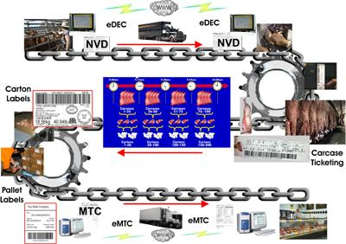
© Meat and Livestock Australia

The implementation is being coordinated by the Red Meat Supply Chain Committee. To date the committee has produced the Australian Red Meat Numbering and Bar coding guidelines for non retail meat products, Message Implementation Guidelines, technical fact sheets, case studies, interactive CDs and a cost benefit analysis relating to project outcomes.
What is a Variable Weight Carton Label?
The Australian red meat industry Standard Variable Weight Carton Label uses Bar code symbology known as GS1-128. The GS1-128 bar code allows primary item information and secondary attribute information to be represented in the bar code. Application Identifiers (AIs) effectively act as prefixes for this information and define the meaning and structure of the embedded data.
GS1 Australia allocates a parcel of numbers to member companies. These numbers include a GS1 Company Prefix to identify the company and a range of numbers to identify products (which members themselves allocate sequentially), followed by a Check Digit which is mathematically calculated to verify that the details of the GS1 number (GTIN) are correct.
The system also allows the meat processor to represent attribute information such as batch numbers, serial numbers, expiry dates and weight in a standard format. This ensures that the attribute information encoded by one company can also be scanned and interpreted by any other company in the supply chain.
Below is an explanation of the construction of the bar code.

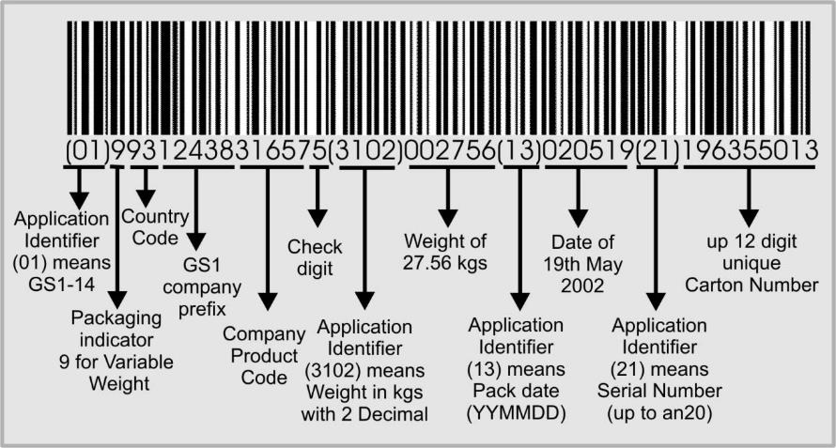
© Meat and Livestock Australia
What are a supervisor’s responsibilities in relation to Variable Weight Carton Labels?
The supervisor has a responsibility to ensure:
- that the minimum bar code information required (represented by Application Identifiers (AIs)) is accurate and is formatted correctly
- that the maximum length, magnification and height of bars of the bar codes conforms to the requirements described in the Technical Fact Sheet
- that the Application Identifiers (AIs) are clearly recognisable by placing them in brackets in the human readable interpretation
- that the bar code symbols are placed according to the specifications in the Technical Fact Sheet.
What are Variable Weight Carcase labels?
Australian red meat industry standard Variable Weight Carcass Labels use bar code symbology known as GS1-128.
The GS1-128 Bar Code Symbol allows primary item identification and secondary attribute information to be represented in the bar code. Application Identifiers (AIs) effectively act as prefixes for this information and define the meaning and structure of the embedded data which follows.
The system also allows a processor to represent attribute information such as weight, slaughter date and serial numbers in a standard format. This ensures that the attribute information encoded by one company can also be scanned and interpreted by any other company in the supply chain.
An example of a carcase label appears below.
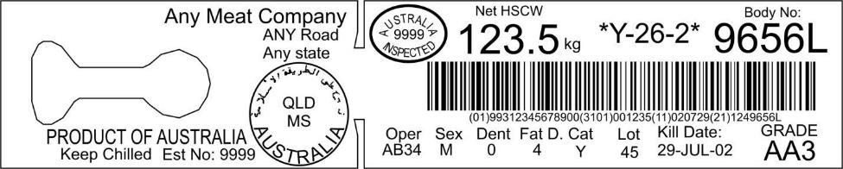
© Meat and Livestock Australia
What are a supervisor’s responsibilities in relation to Variable Weight Carcase Labels?
The supervisor has a responsibility to ensure:
- that the minimum bar code information required (represented by Application Identifiers (AIs)) is accurate and is formatted correctly
- that the maximum length, magnification and height of bars of the bar codes conforms to the requirements described in the Technical Fact Sheet
- that the Application Identifiers (AIs) are clearly recognisable by placing them in brackets in the human readable interpretation.
What are GS1 Logistics (pallets) Labels?
The GS1 Logistics label provides information about the unit to which it is fixed. The GS1 Logistics Label can be applied to a single item, or a grouping of several items made up to facilitate the operation of handling, storing and shipping. This can be a carton, a pallet, a container or any other similar type of packaging created for the purpose of handling, storing or shipping.
This information on the Logistics Label is supported and complimented by Application Identifiers (AIs) and the GS1-128 Symbology. These are important components of the Logistics Label and apply to all of the specifications relating to the logistics label.
The core information on the label should be represented both in bar code and human readable form. There may be other information, which is represented in human readable form only.
Some trading partners may request additional information in a separate bar code above the SSCC. Major supermarket chains may have specific pallet label requirements that are additional to the basic requirements for pallet labels. Check for any specific pallet label requirements and ensure that they are included in the company work instructions and quality assurance programs.
The SSCC is a unique, non-significant, eighteen-digit number, which is assigned by the company constructing the logistic unit. It remains the same for the life of the logistic unit.
Below is an example of a pallet label.
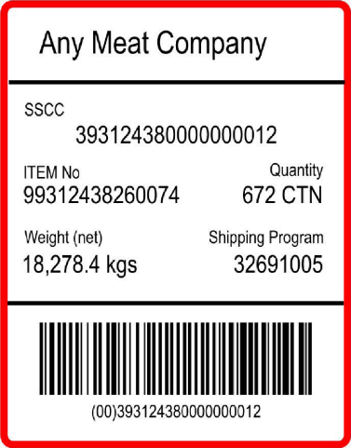
© Meat and Livestock Australia
What are a supervisor’s responsibilities in relation to GS1 Logistics (pallets) Labels?
The supervisor must ensure that:
- the allocated SSCC ( a unique, non-significant, eighteen-digit number, which is assigned by the company constructing the logistic unit) is encoded in a GS1-128 Bar Code Symbol, and is identified by the Application Identifier (00)
- that an individual SSCC number is not reallocated within one year of the shipment date from the SSCC assignor to a trading partner
- the accuracy and placement of the Application Identifier (AI)
- the accuracy and placement of the Extension Digit
- the accuracy and placement of the GS1 Company Prefix
- the accuracy and placement of the Serial Reference
- the calculation of the Check Digit which ensures the whole number is correct
- that any other labelling information over and above the SSCC complies with the specification of the Technical Fact Sheet and with the proper use of AIs
- that the label layout conforms to the specification in the Technical Fact Sheet
- that the Bar Code Symbol specifications, including magnification, height of bars, human readable information, and label location are correctly applied.
What is the electronic Messaging for Cattle and Sheep National Vendor Declaration (eDEC) System?
The eDEC system is a means to communicate between trading partners:
- producer to producer
- producer to saleyard
- producer to feedlot
- producer/ feedlot/ saleyard to abattoir)
- using common standards. The eDEC system is based on the use of the GS1 system and specifically EANCOM messaging standards.
The livestock declarations (NDV, Waybill, MSA declaration) and commercial consignment information can be represented in the standard EANCOM Despatch Advice message that is used for information related to consignments and commercial information transmission between businesses.
The requirement for efficiently sending industry and company specific commercial information electronically between businesses is also included in the eDEC system.
The electronic Livestock Declaration (NDV, Waybill, MSA declaration and NFAS declarations) eDEC system works by recording the required declaration and commercial information by the consignor (sender). The information is then sent electronically to the consignee. A duplicate declaration docket is generated and is signed by the consignor. The original is sent with the consignment and the duplicate is kept with the consignor.
When the consignee (receiver) receives the physical shipment they check it against the eDEC and if all is correct then generate a receipt message. This message is automatically emailed back to the consignor (sender).
The eDEC system uses the EANCOM Despatch Advice message for the consignment details and the EANCOM Receiving Advice message for the proof of delivery.
Below is a diagrammatic explanation of the eDec system.
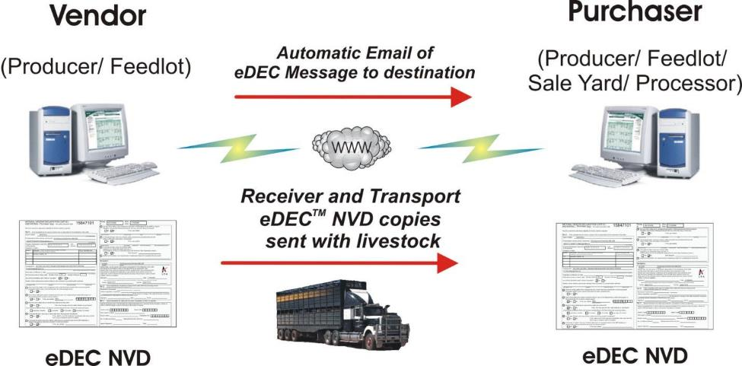
© Meat and Livestock Australia
What are the supervisor’s responsibilities in relation to the eDEC system?
The supervisor should be familiar with the technical elements of the eDEC system, security issues to be considered, methods to send and receive messages and the regulatory considerations.
The specifications for the eDEC system are described in the Australian Red Meat Industry Technical Fact Sheet - the electronic Messaging for Cattle and Sheep National Vendor Declaration (eDEC) System.
In particular, the supervisor’s responsibilities include:
- ensuring the security and application of the company password
- management and storage of original and duplicate documents
- correlating actual numbers received on site with what was provided in the emailed NVD, following up inconsistencies in members and recording discrepancies
- identifying errors or possible issues with the way questions have been answered in the emailed NVD and taking appropriate action according to company procedures (e.g. telephoning the producer to seek additional information)
- checking that all critical pieces of information have been correctly entered (including signatures) and any invalid information is identified and correct information provided
- ensuring that the common information (such as the trading names, address and phone number of a specific property) held in the eDEC message creator tool is accurate
- ensuring that reports printed showing the consignment details are matched to the physical consignment
- checking that the EANCOM Receiving Advice receipt message Department of Agriculture recipient
- addressing and resolving errors identified in the reports
- ensuring that records of matched messages are filed electronically and manually and held for the statutory period
- ensuring that the EANCOM Quality Test Report message is generated, checked and provided to the consignee, according to company procedures.
What are the Electronic Meat Transfer Certificates (eMTC)?
The eMTC system is a means to communicate between trading partners using common standards. The eMTC system is based on the use of the GS1 system and specifically GS1 EANCOM messaging standards.
The Electronic Meat Transfer Certificate (eMTC) system is based on industry trials that involved the development of the EANCOM Despatch Advice message for the export of carton product matching the health certificates MLA trial completed in 2003.
The EANCOM Despatch Advice message implementation guidelines for export product were expanded to take into account the specific requirements of Meat Transfer Certificates. This included the requirements for an EANCOM Receiving Advice message for the proof of delivery (Attestation of Receiving Official).
The requirement for efficiently sending commercial information electronically between businesses was also considered and included in the eMTC system.
The Electronic Meat Transfer Certificate (eMTC) system works by recording the required MTC information by the consignor (sender). The information is then sent electronically to both the consignee (receiver), the Department of Agriculture central recording systems and where relevant to the nominated Department of Agriculture on-plant email address.
A ‘look-a-like’ MTC form can be printed to accompany the consignment and/or for record keeping.
When the consignee (receiver) receives the physical shipment the consignee checks it against the eMTC and if all is correct generates a receipt message.
This message is automatically emailed back to the consignor (sender) and the Department of Agriculture officer.
The eMTC system uses the EANCOM Despatch Advice message for the consignment details and the EANCOM Receiving Advice message for the proof of delivery.
Below is a diagrammatic explanation of the eMTC process.
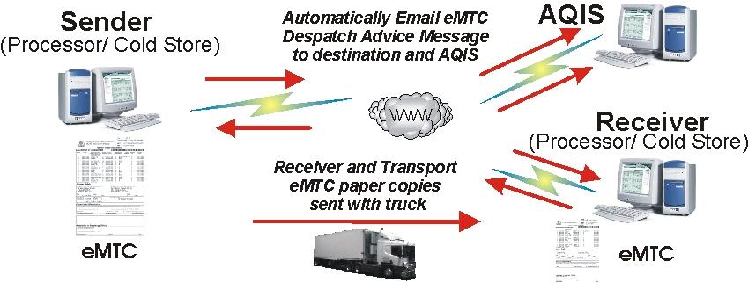
© Meat and Livestock Australia
What are the supervisor’s responsibilities in relation to the eMTC?
The supervisor has a responsibility to ensure that the technical elements of the eMTC system are observed, security issues are managed, methods to send and receive messages and the regulatory (Meat Export Orders, acts and codes of conduct) are observed.
These requirements are described in detail in the Australian Red Meat Industry Technical Fact Sheet - the electronic Meat Transfer Certificate (eMTC)
In particular, these responsibilities include ensuring:
- the security and application of the company password
- that emailed GS1 EANCOM messages for each consignment are matched to the physical consignment
- that any errors identified between the GS1 EANCOM message and the physical consignment details are identified, reports are created showing the errors and action taken on the identified errors
- that the nominated Department of Agriculture recipient of the eMTC messages about consignments receives the messages
- that Message Details conform to the EANCOM Despatch Advice Message Implementation Guidelines and the EANCOM Receiving Advice Message Implementation Guidelines
- that System Vendor solutions print a paper MTC in the format that is approved by the Department of Agriculture and which conform, to the specifications described in the Technical Fact Sheet - the electronic Meat Transfer Certificate (eMTC)
- that all printed documents conform to the specifications described in the Technical Fact Sheet - the electronic Meat Transfer Certificate (eMTC), and are stored appropriately.

Bibliography
These publications were used to develop this training material.
Agriculture and Resource Management Council of Australia and New Zealand, AS 4696:2023 Australian Standard for the hygienic production and transportation of meat and meat products for human consumption, CSIRO Publishing, Collingwood, Vic.
Department of Agriculture, Notice Meat 2000/09 NSFS Ref. 16.17 Carcase microbiological monitoring program (ESAM) – consolidated manual, Technical Services and Operations Branch, Canberra.
AUS-MEAT Standards.

Additional resources
Registered Training Organisations (RTOs) should refer to the Unit-by-Unit listing of resources on the MINTRAC website www.mintrac.com.au for additional resources to support the delivery of this Unit.
RTOs which develop or identify additional resources are encouraged to advise MINTRAC so that these can also be added to the Unit-by-Unit listing.

GS1 Australia is a not-for-profit organisation that locally administers the global multi-industry system of identification and communication for products, services, assets and locations - the GS1 System.
Australian Red Meat Industry Technical Fact Sheet - Variable Weight Carton Label, available at http://www.gs1au.org/industry/meat.asp
Australian Red Meat Industry Technical Fact Sheet - Variable Weight Carcase Label, available at http://www.gs1au.org/industry/meat.asp
Australian Red Meat Industry Technical Fact Sheet - Pallets Labels, available at http://www.gs1au.org/industry/meat.asp
Australian Red Meat Industry Technical Fact Sheet - the electronic Messaging for Cattle and Sheep National Vendor Declaration (eDEC) System http://www.gs1au.org/industry/meat.asp
Australian Red Meat Industry Technical Fact Sheet - the electronic Meat Transfer Certificate (eMTC) http://www.gs1au.org/industry/meat.asp

