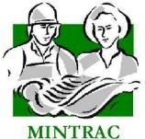

AMPWHS301
Contribute to workplace health and safety processes
Training and assessment support materials

Australian Meat Processing Training Package
Certificate III in Meat Safety

Training support materials for AMPWHS301 Contribute to workplace health and safety processes
Why is health and safety in the workplace so important?
The main reason why health and safety is so important in the workplace is to keep people safe and healthy at work. No-one should be injured or have poor health affects as a result of work.
Unfortunately workplaces are often dangerous and people are sometimes injured or become ill in the course of their work. The number of fatalities alone are a sobering statistic. Safe Work Australia reports worker fatalities for the year to December 2023 as 195 which is approximately the same as 2022 and 195 too many. Everyone in the workplace needs to work together and follow health and safety requirements to make sure the workplace is as safe as possible and no-one is injured at work. Additionally governments have work health and safety laws in place to make sure that health and safety is managed in the workplace.
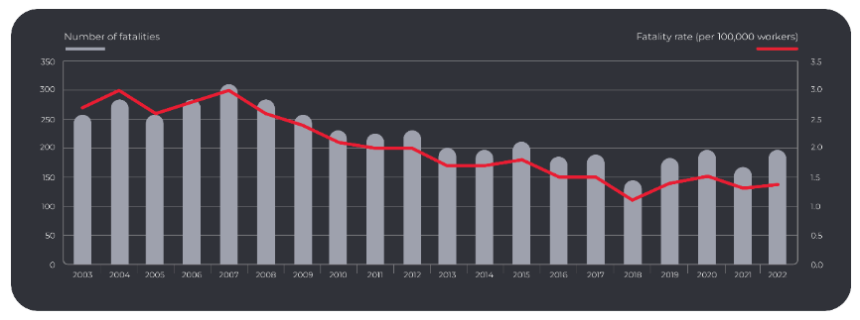
Trends in worker fatalities, 2003 to 2022 data and graph from Safe Work Australia
Why do companies manage health and safety?
The primary reason why companies manage health and safety is to ensure the health and safety of their workers and everyone else associated with their business. In order to ensure companies do manage health and safety and to make sure companies know what they need to do to ensure a healthy and safe workplace, governments have health and safety laws in place that companies must comply with. There are additional reasons for companies to ensure a healthy and safe workplace. These include:
Financial reasons
Accidents and injuries are costly in terms of staff resources, time, financial outlays, equipment damage, disruption to operations and even public relation issues. Figures released by Safe Work Australia estimate the cost associated with work-related injury and illness to be $61.8 billion dollars per year.
Public relations
If the company is regarded locally as a poor performer in health and safety they may have a bad reputation in the community. This may impact on their ability to attract employees to work in the company especially considering the increasing competition for employees in regional locations where our companies are located.
Ethical and moral obligations
Responsible employers have an obligation to protect the health and safety of their employees and anyone else affected by their work activities.
Industrial relations
Poor health and safety may impact on the industrial relations at a site and subsequently affect the operation of the business.
Employee engagement and satisfaction
Involvement of employees in health and safety matters raises awareness and promotes conscious attention to personal safety and the safety of others.
What is the extent of workplace illness and injury in Australia?
Australian Workers Compensation Statistics, 2022-23 provide an indication of the extent of workplace injury in Australia with approximately 130 195 serious workers’ compensation claims in Australia and approximately 195 deaths.
‘Employees working as Labourers had the highest incidence rate of serious claims of all occupations in 2012–13p: 27.0 serious claims per 1000 employees, more than twice the national rate. Machinery operators & drivers made 24.4 serious claims per 1000 employees. Injuries and musculoskeletal disorders led to 90% of serious claims in 2012–13 and the most common type was Traumatic joint/ligament & muscle/tendon injury (45%)… Muscular stress while lifting or handling objects caused 33% of serious claims in 2012–13p, while Falls, trips & slips of a person caused 22% of serious claims… The median time lost from work for a serious claim …was 5.4 working weeks.’
For the injured person, a serious back injury, loss of hearing or loss of a limb are injuries that no amount of money can adequately compensate. Although workers receive some financial assistance after a work related injury through workers compensation payments, there are generally additional financial costs that may include loss of full wages, financial hardship, and a whole variety of personal, social and psychological costs They may affect ability to enjoy life, favourite pastimes, marriage and family life.
For companies, workplace injuries and accidents can result in higher workers compensation premiums, lost production, plant downtime, the costs of rehabilitating injured workers and/or the costs of training replacement workers and may lead to low plant morale.
For the community as a whole, workplace accidents place a huge burden upon our health system, lower the productivity of our economy and increase the burden on taxpayers. Clearly there are no winners.

Activity: Worksite health and safety performance
Materials and specialist personnel
Invite the company’s WHS manager to present to the company’s WHS performance and what the company is doing to improve the WHS performance.
Method
The WHS manager presents the company’s WHS performance and what the company is doing to improve the WHS performance.
The WHS manager discusses the role of trainees/workers in maintaining a healthy and safe workplace.
WHS legal requirements
What legislation covers WHS?
Work health and safety is primarily the responsibility of state governments in Australia. This meant that different states had different work health and safety laws. Over the past few years there have been major changes to work health and safety laws. These changes have been directed towards all work health and safety laws being the same across Australia.
This has been achieved by Safe Work Australia (the national policy body responsible for the development of model work health and safety laws) bringing all the states together to develop model work health and safety laws that all states and territories agree on. The model work health and safety laws then had to be enacted or passed by Parliament in each State and Territory to become legally binding.
As at August 2015 all states and territories in Australia had introduced the new nationally consistent WHS Act and WHS Regulations, with the exception of Victoria and Western Australia.
The states and territories are responsible for regulating and enforcing the law in their jurisdictions. The new WHS law provides greater consistency across the whole of Australia making it easier for companies operating across state boundaries.
The new nationally consistent WHS Act sets out general duties of all parties in regard to WHS. Regulations support the Act. The Regulations provide some detail around what companies need to do to comply with the Act. This is particularly important in view of the changes introduced in the new Act. For example the Regulations include a new provision for companies to provide audiometric testing of workers who are frequently required to wear hearing protection to protect the worker against noise above the exposure standard.
The new nationally consistent legislation includes national codes of practice that are passed through parliaments in each state and provide a guide to employers to comply with specific areas of the WHS Act. Examples of national codes include:
- managing the risks of falls at the workplace
- first aid in the workplace
- managing risks of hazardous chemicals in the workplace.
Other publications that support implementation of the WHS legislation continue to be Australian Standards and guidelines covering specific WHS issues or industries. These are not legal requirements but may be used under law to demonstrate compliance with legislation.
The meat industry has National Guidelines for Health and Safety in the Meat Industry. These guidelines were developed through a cooperative arrangement between the Australian Meat Industry Employees' Union and the National Meat Association of Australia. The guidelines provide practical guidance on measures that may be put in place to reduce the incidence of occupational injury and disease in the meat industry. This is a useful publication as it is meat industry specific however it was developed in 1995 and is now well out of date in many areas. The documentation is available online at http://meatiesohs.org/files/information/guidelines.pdf
Who has responsibilities under WHS legislation and what are those responsibilities?
Achieving the vision of a healthy, safe and productive working life for all, relies on everyone in the workplace meeting their health and safety responsibilities. The WHS Act sets out those responsibilities. These requirements are called Duty of Care.
In general, duties are placed on
- the CEO or most senior manager in the workplace (called person in control of a business or undertaking in WHS legislation). The CEO has overall responsibility for providing a workplace that is safe and without risks to health, as far as practicable
- senior managers who make, or participate in making, decisions that affect the whole, or a substantial part, of the business are deemed to be ‘officers’ in WHS legislation. As ‘officers’ they must exercise ‘due diligence’ to ensure the CEO complies with their duty of care to provide a healthy and safe workplace
- other managers including foremen and supervisors who are responsible for ensuring health and safety in their areas. They implement health and safety procedures in their areas including the induction, training and supervision of workers. Workers should go to supervisors about any health and safety matters.
- ‘workers’ who are employees of your company AND others such as contractors, trainees etc. who are not employees of your company but they may be working there. All ‘workers’ are required to perform their duties in a manner that ensures their health and safety, and that of others in the workplace
- any others who may influence WHS in the workplace, including contractors, manufacturers, suppliers and installers of plant, equipment or materials used in a workplace.
What are the WHS responsibilities of senior managers?
Under the WHS Act the CEO is given the title person in control of a business or undertaking. The reason for this change is that there may be a number of ‘CEOs’ who have employee relationships with personnel working in your company at any one time. For example there may be contractors, personnel working for a labour hire company, trainees, personnel working for a registered training organisation etc. The CEO of your company is responsible to provide you and everyone else working in the company with a safe workplace and the CEOs of the contractors, labour hire company etc are also responsible for their workers conducting their work safely and following your WHS requirements.
CEOs or persons in control of a business or undertaking bear the ultimate responsibility for health and safety in their organisation. They are responsible to set up the systems to manage health and safety and to hold their senior managers accountable for implementing the systems in their workplace.
Under the new WHS legislation senior managers (that is managers who make decisions that affect the whole, or a substantial part of the organisation) are given the title ‘officers’. They are responsible to exercise ‘due diligence’ to ensure that the systems are implemented and are effective in providing a safe environment. They must take action on unsafe practices or incidents. They must be able to report on safety performance and they must ensure that their personnel have the health and safety expertise they need to do their work.
What are the WHS responsibilities of supervisors?
Supervisors are responsible for health and safety in their own work areas. They must implement the organisation’s health and safety systems in their work area. In practice this means that supervisors must:
- implement the risk management process in their areas through regular workplace inspections and risk assessments by identifying and fixing hazards before they cause problems
- consult with their workers and others such as contractors and trainees working in their area to involve them in health and safety matters so everyone is working safely and contributing to safety in the area
- model exemplary behaviour that demonstrates their commitment to health and safety and their commitment to treat everyone in the workplace equally, fairly and with respect
- act on any unsafe condition or incident or any health and safety issue that they are aware of. If they can’t solve it then they should report it to their manager or as appropriate, e.g. to the maintenance manager
- train their staff so that they work safely and don’t endanger the safety of others
- have a detailed understanding of the safety performance of their own area and be able to report on that performance.
It is most important for supervisors to act on matters reported to them, to do everything in their power to reduce or eliminate hazards. Supervisors should also take pro-active action to reduce or eliminate hazards before they cause problems.
What are the WHS responsibilities of workers?
Workers responsibilities include:
- taking reasonable care of their own health and safety
- taking reasonable care that their own conduct does not adversely affect others
- following reasonable instructions such as work instructions
- cooperating with workplace policies and procedures such as wearing personal protective equipment.

Activity: WHS responsibilities
Materials and specialist personnel
Invite the site’s WHS manager and/or appropriate WHS representatives to participate in this activity.
Method
Take each of the workers WHS responsibilities and ask the trainees to identify examples of what each duty means in terms of what workers do in their work to meet those responsibilities. For example:
- taking reasonable care of their own health and safety by wearing personal protective equipment (PPE), following work instructions, being constantly aware of their surroundings and checking that there are no hazards, fixing simple hazards or reporting hazards they can’t fix, following safety signs and emergency procedures etc
- taking reasonable care that their own conduct does not adversely affect others by not skylarking or taking undue risks that may affect co-workers, cleaning up after themselves so that they don’t create any hazards for others, following work instructions etc
- following reasonable instructions such as work instructions. Other instructions may be safety signs and marked pathways, emergency instructions, SOPs, wearing PPE, feet and hand washing procedures, cleaning and sanitising procedures etc
- cooperating with workplace policies and procedures such as wearing personal protective equipment.
Invite the WHS manager and/orhealth and safety representative to discuss the responsibilities of everyone in the workplace, as per legislation.
Discuss the responsibilities of the supervisors.
Develop a number of scenarios relevant to the site:
- A worker is making unpleasant remarks and excluding a foreign worker on the team.
- A worker is injured at a machine. The accident investigation establishes a guard was missing. The injured worker was unaware a guard was possible as there had never been one on the machine.
- You become aware that a worker has an alcohol problem and you can smell alcohol on their breath when they start their shifts.
- A supervisor notices that many staff do not wear hearing protection in a noisy area where it is required.
- A supervisor receives reports of slips in a particular area on a regular basis. No injuries have occurred and the supervisor tells workers to be more careful.
Discuss the chosen scenarios with the participants. Discuss who is responsible and what should be done to manage these scenarios. Discuss the role of workers or trainees in these scenarios in particular.
How is WHS legislation enforced?
WHS legislation is regulated by each state and territory government WHS authority. These are:
- WorkCover NSW: www.workcover.nsw.gov.au
- NT WorkSafe: ntworksafe@nt.gov.au
- Workplace Health and Safety Queensland: www.worksafe.qld.gov.au
- SafeWork SA: www.safework.sa.gov.au
- WorkSafe Tas: www.worksafe.tas.gov.au
- WorkSafe Vic: www.worksafe.vic.gov.au
- WorkSafe WA: www.commerce.wa.gov.au/WorkSafe/
The authorities aim for compliance with the legislation. They employ inspectors to provide advice on compliance. The inspectors make every effort to assist companies to comply with the legislation but if the company is not co-operating or if there are breaches of the legislation the WHS Act provides a range of graduated enforcement options. This includes:
- issuing a non-disturbance notice, e.g. it is a requirement of the legislation that areas where there has been a notifiable accident (ie an accident where someone is injured and requires hospitalisation) are not disturbed in any way until otherwise directed by an authority inspector
- issuing an improvement notice, e.g. an inspector may observe workers on the legging stand and issue an improvement notice requiring all workers on the legging stand wear fall restraint personal protective equipment because no engineering controls can be put in place that still enable the work to be done
- issuing a prohibition notice, e.g. an inspector may see that a piece of equipment has a guard removed. The inspector may issue a prohibition notice that the equipment cannot be used until the guard has been replaced and is operating
- issuing an undertaking for the company to take remedial action
- issuing an injunction. Where the court finds a person guilty of an offence, the court may issue an order (an injunction) requiring the person to take corrective actions
- issuing an enforceable undertaking. This means the inspector may accept a written undertaking from the person that the person must then comply. This allows businesses to implement effective work health and safety initiatives and improve work safety as an alternative to prosecution.
- issuing a penalty notice. A penalty notice may be issued for certain serious offences, for example removing asbestos without a licence. Because they do not involve court proceedings, they are a quicker option for dealing with offences under WHS laws. The amount is specified in legislation and is much lower than the maximum penalty that may be issued by the court.
- initiating prosecution. Legal prosecutions may be conducted through the courts against individuals, employers or businesses who have broken WHS laws. Prosecutions through the courts are a last resort, and only carried out in the most serious cases.
In the event of a prosecution the reverse onus of proof has been removed. Under the old legislation if you were prosecuted you had to prove you had made every effort to comply with the legislation. Under the new legislation the burden of proof rests with the prosecution that is the prosecution must prove beyond reasonable doubt that you failed to comply with the legislation.
Penalties for breaches of the WHS legislation may incur fines to the company and/or fines and gaol sentences to individuals including directors, managers, supervisors or anyone associated with the business. Prosecutions are under criminal law. Fines to corporations may be as high as $3 million and fines to individuals may be as high as $600,000 to CEOs and $300,000 to other individuals. Gaol sentences to individuals may be up to a maximum of five years.
Workers compensation legal requirements
What happens if you have a work related illness or injury at work?
The primary goal of WHS legislation is the prevention of work-related illness and injury. This goal is reflected in WHS legislation. In the event of failure to prevent illness and injury then workers compensation legislation provides for the rehabilitation of workers and compensation for losses arising from the illness or injury. Rehabilitation and workers’ compensation are covered in each state and territory under workers compensation acts. Rehabilitation focuses on returning a worker to their pre-illness or injury status as soon as possible. This involves covering the costs and providing for medical and any other treatments (e.g. physiotherapy, drugs, etc.) and helping the worker to return to their former duties or find alternative duties if this is not possible. Compensation provides for loss of income due to inability to work and may include some financial payment related to disability incurred and/or pain and suffering.
If you are sick or injured at work you should report immediately to your supervisor or first aid officer. The supervisor or first aid officer will organise the treatment you need for the illness or injury.

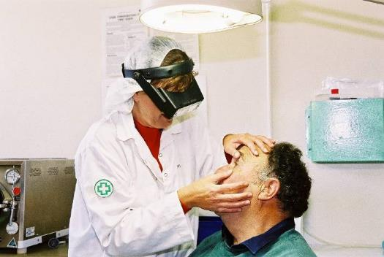
On-site nurse attends to a worker
Courtesy of Meat and Livestock Australia
If you have a work-related injury and cannot work for a period then you may be entitled to workers compensation. In this case you should talk with your supervisor or go to the human resources (HR) department and ask for a worker’s compensation claim form. You will also need a medical certificate from a medical practitioner. Your supervisor or the HR department can help you fill out the form and explain the process of lodging a claim. You may also need assistance to return to work. For example, your doctor may advise you to return to work initially on a part-time basis and build the time you work gradually until you are fully fit to resume fulltime work. This process is called rehabilitation.
Workers compensation is set out in workers compensation laws in each state and territory of Australia. It is compulsory for employers to hold workers compensation insurance to provide coverage for their employees in the event of a work-related illness or injury. Insurance coverage is provided irrespective of the cause of the illness or injury or of the contribution of the worker to the accident.
Benefits under workers compensation legislation are based on the nature of the injury and the average wage paid to the employee. Depending on the nature and seriousness of the accident or illness, entitlements for sick or injured workers may include:
- the cost of medical treatment
- related expenses such as pharmaceutical and pathology tests
- hospital costs
- replacing lost personal effects damaged in the accident
- weekly payments to compensate for lost wages
- a lump sum payment to compensate for permanent disability
- payment to compensate for pain and suffering
- payment for permanent disfigurement
- rehabilitation/return to work costs.
What assistance is given to return to work after a work related injury?
If you have a work related injury and your doctor advises that you are unfit for normal duties and need assistance to help you to return to your normal work then you are entitled to rehabilitation in the form of a return to work program.
The rehabilitation sections of the relevant state workers compensation act stipulate that employers must provide rehabilitation services to employees who are off work or not fully fit for their normal duties, as a result of a workplace related event.
To do this, your workplace is required under the legislation to have:
- a policy and procedures for rehabilitating workers
- a coordinator of the rehabilitation/return to work program in the workplace
- access to the services of rehabilitation providers who can assist with the return to work program.
A work-related injury or illness may have a big impact on your life. Research has shown that getting back to work is important for your health and wellbeing. The earlier you start planning to return to work, the better your chances of getting back sooner.
You may not have to wait until you are 100 per cent recovered to return to work. It’s important to try to keep positive and motivated – focus on what you can do, rather than what you can’t. Whether it’s on reduced hours in your regular job or on modified or alternative duties, getting back to work is part of your rehabilitation. Talk to your treating doctor about what will help you to get back to your pre-injury status. Take the medical certificate to your HR department. They will direct you to the Return to Work Coordinator. You can work with your Return to Work Coordinator and supervisor to plan your return to work program. Rehabilitation service providers may be involved if required. Rehabilitation service providers are external experts with technical expertise in returning injured workers to work. Return to work is a team effort and communication between everyone involved in your return to work is essential.

The management of health and safety in the workplace
How is health and safety managed in the workplace?
Health and safety is managed in companies in a similar way to any other aspect of business through general management systems and specific health and safety management systems. The goal is to integrate the management of health and safety into the ways people do their work so that it is a part of everything we do on a day to day basis. For example, work instructions for the operation of plant and equipment not only include start up procedures, steps in the operation of the plant and equipment and shut down procedures but they also include instructions on how to set up, operate, clean, maintain and shutdown the plant and equipment safely as well as what to do in an emergency.
The Chief Executive Officer (CEO) and other senior managers are primarily responsible for health and safety in the workplace. However everyone in the workplace has a role to play to ensure their safety and the safety of others. In general, the roles of each workplace group include:
- Senior management sets up the work health and safety policies and procedures to ensure a healthy and safe workplace
- Supervisors and other frontline and middle managers implement the procedures with their workers by ensuring their workers are trained in the procedures, are supervised to follow the procedures and follow the procedures
- Workers follow the procedures to work safely, raise and report health and safety matters to their supervisors.
For example, senior managers may identify that work instructions need to be developed in order for equipment to be operated safely.
- Senior management may then appoint one manager responsible for ensuring that work instructions are developed for all equipment in the workplace. That manager would then develop a plan for work instructions to be developed and identify a team that would develop work instructions in each area.
- The team of middle managers in each area would then develop the work instructions and ensure that workers receive training.
- Supervisors and other frontline managers would train and supervise workers to follow the work instructions.
- Workers follow the work instructions to operate the equipment safely, raise and report any issues.
What is the goal of health and safety in the workplace?
The goal of health and safety in the workplace is expressed well by the federal government organisaiton responsible for health and safety in Australia, Safe Work Australia, as two principles that shape the vision for health and safety.

“The first: all workers regardless of their occupation or how they are engaged have the right to a healthy and safe working environment. The second: well-designed, healthy and safe work will allow workers to have more productive working lives.”
The vision for achieving this as reflected in work health and safety legislation is based on prevention of work-related illness and/or injury through consultation, communication and coordination of health and safety matters in the workplace with all personnel involved, and taking a risk management approach to eliminate the risk of injury wherever possible or if this is not possible to minimize the risks.
Consultation
The WHS legislation recognises that workplaces have better health and safety outcomes when workers have input into health and safety matters that affect them. The legislation requires CEO s(or persons who conducts a business or undertaking as the CEO is known in the legislation) to consult with workers who carry out work for the business and who are (or are likely to be) directly affected by a work health or safety matter. Consultation on health and safety matters is conducted directly with workers and through workers representatives which may include health and safety representatives (HSR) and/or health and safety committees.
You should know who your health and safety representative is in your workplace. You may raise health and safety matters with them and they will work with appropriate workplace personnel to help resolve the matters.
You will also participate directly in health and safety matters relevant to your work area. Direct participation may include tool box meetings, meetings about changes to your work area, results of work inspections, emergency drills etc. You are encouraged to report and/or raise health and safety matters with your supervisor or health and safety rep.
What are the powers and functions of health and safety representatives?
The WHS Act sets out specific powers and functions that a HSR can perform in the interests of the workers they represent. The powers and functions are intended to enable HSRs to effectively represent the interests of the members of their work group and to contribute to work health and safety matters.
The powers and functions of HSRs are to:
- represent the workers in their work group in relation to work health and safety matters
- monitor the measures taken by the CEO/PCBU to comply with the WHS Act in relation to their work group members
- investigate complaints from work group members about work health and safety
- inquire into anything that appears to be a risk to the health or safety of work group members, arising from the conduct of the business or undertaking.
Who else does the CEO consult with on health and safety?
Under the new WHS legislation CEOs/PCBUs are required not only to consult with their own employees but they are also required to consult with anyone else who is associated with your workplace (such as contractors) to ensure that everyone works together to control work health and safety risk. This means for example that companies must consult with contractors to ensure they are meeting their duty of care to provide a safe environment when they are doing work for the company and they are also complying with the health and safety requirements of your company.

Activity: Workplace consultation on WHS
Materials and specialist personnel
Invite the WHS manager, at least one HSR and a WHS committee member (if the workplace has a WHS committee) to speak to the groups about their roles.
Method
Discuss the purpose of consultation and the methods used in the trainees’ workplace for representation and participation of workers in health and safety matters at the workplace.
Ask the trainees for examples of WHS issues they’ve raised and/or discussed and the outcomes.
Ask the HSR and WHS committee member to discuss their roles and give examples of what they’ve achieved in the workplace.
Summarise and clarify exactly who the trainees/workers should go to first if they have WHS matters they want to discuss (ie their supervisor) and then explain when they might go to the HSR and the role of the HSR. Finally explain the role of the WHS committee if there is one at that workplace.
Give examples of WHS scenarios and ask the trainees who they could discuss these matters with. For example:
- a guard is missing from the equipment the trainee is using
- the trainee has asked the supervisor to replace the guard but the supervisor said no because the guard slows down the work
- a valve from a steam line is leaking
- the light in a stairwell is not operating
- the fire exit door is blocked by pallets of product.

WHS risk control
What do companies do to control risks?
The focus of company WHS programs is on the prevention of work related illness and injury. In order to prevent injury, the company has programs focusing on identifying hazards before they result in accidents and rectifying any factors that may contribute to accidents. This is called risk management. WHS programs focusing on identifying risks and rectifying factors that may contribute to accidents include:
- Conducting workplace inspections and audits and eliminating hazards wherever possible
- Conducting risk assessments of jobs, plant and equipment and other high-risk areas such as possible emergencies and eliminating hazards wherever possible
- Encouraging the workforce to report hazards or incidents
- Illness and injury statistics including:
- incidence of workplace illness and injury compiled from accident report forms and workers’ compensation statistics
- costs of workers’ compensation claims and/or workers’ compensation insurance or premium costs
- results of workplace inspections and audits
- statistics related to specific programs, e.g. manual handling
- statistics on rehabilitation.
Your company will keep site illness or injury statistics covering these areas.
What is risk control?
A safe and healthy workplace does not happen by chance or guesswork. It is senior management’s responsibility to think about what could go wrong at the workplace and what the consequences could be. Then they do whatever they can (in other words, whatever is ‘reasonably practicable’) to eliminate or minimise health and safety risks arising from the work that is conducted at the workplace.
This process is known as risk management or risk control and involves four steps. These steps are:
- identify hazards – find out what could cause harm
- assess risks if necessary – understand the nature of the harm that could be caused by the hazard, how serious the harm could be and the likelihood of it happening
- control risks – implement the most effective control measure that is reasonably practicable in the circumstances
- review control measures to ensure they are working as planned.
Risk control means taking action to eliminate health and safety risks so far as is reasonably practicable, and if that is not possible, minimising the risks so far as is reasonably practicable. Eliminating a hazard will also eliminate any risks associated with that hazard.

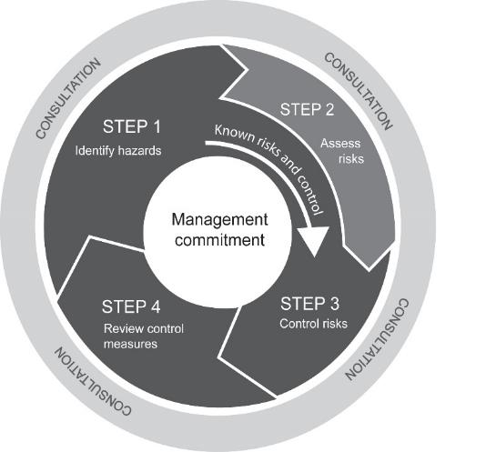
The risk management or risk control process
‘How to manage work health and safety risks – Code of Practice’ Safe Work Australia
What is a hazard?
A hazard is anything at the workplace with the potential to cause harm. The presence of the hazard does not necessarily mean it will cause harm. Examples of hazards include machinery, tools, vehicles, noise, temperature extremes, bacteria, conflict, harassment, discrimination, workload and people affected by drugs and alcohol.
What is risk?
Risk is the possibility that harm (death, injury or illness) might occur when exposed to a hazard. Risk is a measure of the likelihood of an accident occurring and the severity or the consequence of that accident. If, for example, no one is exposed to the hazard then it is unlikely to cause harm. For instance, consider asbestos sealed in a well maintained administration roof space. The asbestos is unlikely to cause harm because it is sealed and the seal is maintained. No one is exposed to the hazard.
Considering well installed and serviced electrical equipment used in a dry environment. In this case, the risk of electrocution may be deemed low. However, if the electrical equipment is poorly maintained with frayed electrical cord dangling in water then the likelihood of electrocution is dangerously high and as the consequences of electrocution may be death, then the equipment should be immediately removed or locked out and replaced.
The employer is legally required to provide and maintain a working environment that is safe and without risks to health and safety.
What is done at each step in the risk control process and what is the role of workers at each step?
The four steps in controlling risks to eliminate them or reduce them to the lowest possible levels before they cause injuries are to:
- identify the hazards
- assess the risks
- control risks
- review control measures.
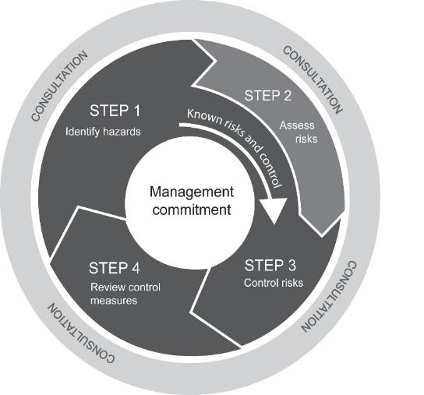
The risk management or risk control process
‘How to manage work health and safety risks – Code of Practice’ Safe Work Australia
Step 1 – Identify hazards
Identifying hazards in the workplace involves finding things and situations that could potentially cause harm to people. Hazards generally arise from the following aspects of work and their interaction:
- physical work environment
- equipment, materials and substances used
- work tasks and how they are performed
- work design and management.
In general, a number of methods are used to identify hazards. These include workplace inspections, consultation with employees by both formal structures and informal discussions, safety audits and observation, risk assessments of plant, equipment, tasks etc, injury and illness records, accident and incident investigations.
Workers doing tasks and/or operating machinery are most familiar with that task and machinery, and may be the first to identify any hazards or risks associated with their work and work area. You don’t want to be injured as a result of the hazard. You should report the hazard to your supervisor immediately and the supervisor should take action to eliminate or reduce the hazard. If you are still not satisfied you may report the hazard to your health and safety representative, the health and safety manager or the union.
Step 2 – Assess risks
A risk assessment involves considering what could happen if someone is exposed to a hazard and the likelihood of it happening. A risk assessment can help you determine:
- how severe a risk is
- whether any existing control measures are effective
- what action you should take to control the risk
- how urgently the action needs to be taken.
Risk assessment is the responsibility of management. Management will generally consult with workers about the hazards that may be associated with the work they are doing. As the operator of that task you have the knowledge and experience to help management assess the risks associated with your job and help identify control measures to reduce the risks.
Step 3 – Control risks
The most important step in managing risks involves eliminating them if possible, or if that is not possible, minimising the risks as low as possible.
Workers and their representatives who will be directly affected by this decision are consulted about possible controls. For example operators of plant and equipment are trained and experienced and most likely to have ideas about suitable control measures and their implementation.
There are many ways to control risks. Some control measures are more effective than others. It is important to select control measures that eliminate the risks or reduce them to the lowest possible levels. This may involve a single control measure or a combination of different controls that together provide the highest level of protection.
Some problems can be fixed easily and should be done straight away, while others will need more effort and planning to resolve. Of those requiring more effort, you should prioritise areas for action, focusing first on those hazards with the highest level of risk.
The various ways of controlling can be organised from the most effective method to the least effective. This is called the hierarchy of control as detailed in the following table.
Hierarchy of control measures
Effectiveness | Types of control | Examples
Most effective | Elimination | Eliminate manual transport of hooks by installing a hook line
 | Substitution | Substitution of metal hooks with lightweight durable plastic hooks on the chain will reduce noise levels
 | Isolation | A noisy machine may be enclosed to reduce the noise levels
 | Engineering controls | Acid treatment of floors to lift absorbed fatty substances followed by resurfacing using resin and graphite mix to reduce slip hazards
 | Administrative controls | Rotation of trained workers
Least effective | Personal Protective Equipment | Moisture resistant aprons, abdominal protective aprons, hand protection, head protection

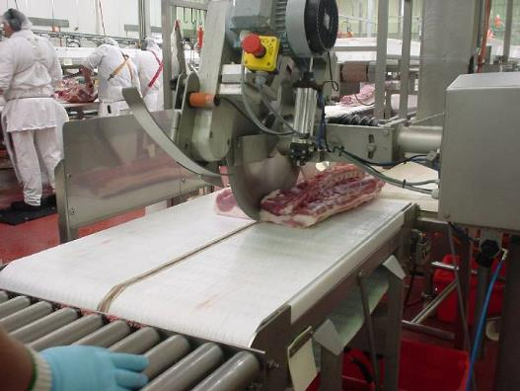
Controls such as laser-guided circular saws are most effective because they eliminate the risks of injury
© QAF Meats
In most cases there will be a combination of controls. Some less effective controls may be put in place in the short term, e.g. wearing ear plugs, before effective controls can be in place in the long term, e.g. replacing the noisy machine.
Step 4 – Review control measures
The control measures that are put in place should be reviewed regularly to make sure they work as planned. In some cases controls may not work as planned and/or the controls may result in new risks. For example the introduction of a robot to perform a task may eliminate the risks associated with operating that task but may lead to new risks such as risks associated with servicing and maintaining the robot.
Management is responsible to review the effectiveness of control measures and identify and control any new risks that have been introduced as a result of the controls. As a worker in the area or operator of equipment you may be the person who is implementing the controls and you may become aware of new risks. You should raise any health and safety issues with your supervisor. Don’t wait for an accident to happen. Report hazards and risks to your supervisor.
What is the role of workers in controlling risks?
Legally workers are required to look after their own health and safety and to take care of the health and safety of others around them. As part of achieving this you should notice hazards in your work area and the environment around you. If you are able to fix them, do so. If you cannot, then they should be reported to your supervisor. For example, rubbish on the floor may be a trip hazard. You may be able to remove the rubbish and eliminate the hazard. If you are unable to remove the rubbish you should report it to your supervisor. The supervisor is responsible for fixing the hazard. If you do not get satisfaction from the supervisor, you have the options of reporting the problem to the WHS representative, the WHS committee, the WHS coordinator or the union.
You should be made aware of progress and action taken to reduce the hazards you have reported.
Activity: Applying the hierarchy of controls to eliminate risk or reduce risk to the lowest possible levels
Materials and specialist personnel
Take a series of photos of hazards in the trainees’ workplace such as a worker lifting a carton of product, a forklift operating on site.
Method
Show one photo demonstrating a hazard. Ask the group to define what a hazard is and what the hazard is in that photo.
Ask the group to define risk and explain what the risk is in that photo.
Ask the group whether they would classify the risk as low, medium or high in the photo and to explain why they have classified the risk in this way.
Ask the group what controls could be put in place to reduce the risk of injury from that hazard. List all the controls on the whiteboard.
Ask the group which controls are the most effective and why they are most effective.
Ask the group to explain what they believe management should do to eliminate the risk if possible in relation to this hazard. Discuss.
Explain what the role of management is in risk control and the role of workers.
Ask the group to list the role of workers in regard to reducing the risk associated with the hazard in this photo.
Continue identifying, assessing and controlling hazards in the remainder of photos with particular focus on identifying the most effective controls and reinforcing the role of workers in each case.
This exercise may be conducted together or in small groups, with each small group presenting their findings.

How are workplace inspections conducted?
Regularly conducting workplace inspections is one method of identifying and controlling hazards before they cause accidents. Generally a standardised procedure in the form of a checklist is used to conduct inspections. This is to make sure that no area is left out.
Supervisors generally conduct regular inspections of their work area. Inspections may also be conducted by the WHS representatives, the WHS committee and the WHS coordinator. Workers should report any hazards they see to their supervisors and raise health and safety matters when the inspections are being conducted. Workers may also be involved in identifying and implementing control measures to reduce the risks of accidents as a result of inspections.

Activity: Conducting a workplace inspection
Materials and specialist personnel
Invite the WHS manager, supervisor and HSR to lead groups of no more than three trainees on an inspection of an area.
Copies of a workplace inspection form for an area of the site.
Permission to conduct an inspection of that area.
Method
Discuss the reasons why inspections are conducted.
Discuss how inspections are conducted and who conducts inspections.
Hand out copies of the inspection checklist and discuss how you’d go about conducting the inspection.
Explain the actual inspection that the participants are now going to conduct.
Conduct the inspection in groups of no more than 3 trainees with the WHS manager, HSR or supervisor. Encourage the trainees to identify as many hazards as they can themselves and complete the inspection form themselves. Provide support if they miss hazards.
On return from the inspection work with the participants to identify controls and an action plan to implement the controls.
Discuss the controls and plans with the supervisor. The supervisor should discuss what they are going to do in response to the inspection to control the risks identified.
Trainees’ activities
The participants conduct the inspection and record the results on the form.
The participants return to the classroom and working in small groups identify control measures for the hazards they identified and draw up an action plant to implement those controls.
What are common hazards in the meat processing industry?
There are two general categories of hazards. These are hazards to health and hazards to safety. Health hazards may result in illness or disease. For example, personnel in meat processing plants may be exposed to bacteria such as E. Coli, viruses such as HIV or Hepatitis B or diseases such as Q Fever contracted from animals. Hazards to health may not be clear cut. Presenting symptoms may vary from individual to individual, may be slow to develop or may be cumulative.
Safety hazards may lead to an accident with damage to a person, property, plant or equipment. Safety hazards tend to be easier to find. There is usually a direct relationship between the safety hazard and its consequences.
Every industry has hazards which are common. Some hazards are common across many industries. For example manual handling hazards are significant cause of injury and subsequent workers’ compensation claims across Australia.
Hazards generally arise from the following aspects of work and their interaction:
- physical work environment (e.g. electricity, lighting, exposure to noise, heat, cold and radiation, confined spaces, contact with moving objects)
- equipment, materials and substances used (e.g. installation, use, maintenance and storage of equipment, use of knives)
- work tasks and how they are performed (e.g. manual handling)
- work design and management.
The next section applies the risk control process to the management of common hazards in the meat industry to reduce the risks to the lowest possible levels. The common hazards covered are:
- zoonotic diseases
- manual handling
- hazards that cause slips, trips and falls
- hazards related to plant, equipment and tools
- hazards of working with a knife
- extremes of temperature – cold and hot
- hazardous substances
- working at heights
- noise.

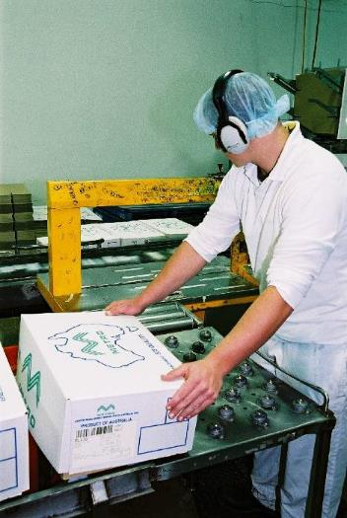
Conveyor belts are engineering controls to reduce manual handling injuries
Courtesy of Meat and Livestock Australia
Zoonotic diseases
What is Q fever and how is it managed in the workplace?
Zoonotic diseases
Zoonotic diseases are diseases that may be contracted from animals and animal products. Zoonotic diseases include Brucellosis, Leptospirosis, Q fever, Hydatid disease, Erysipeloid and Orf. The three principal diseases of concern are Q fever, Leptospirosis and Brucellosis.
How is Q fever contracted?
Q fever is the most likely disease to be contracted from animals or animal products. People can be infected by close contact with any material contaminated with the Q fever bacteria. It may be contracted from foetuses, placenta, faeces and milk of infected cattle, sheep and goats. Inhalation of contaminated aerosols or dust is the most common form of transmission. Q fever can also be passed on by contact with infected animals and contaminated articles such as straw, wool, hair and hides.
An individual who has not developed an immunity to Q fever, either naturally or by immunisation, is at risk of becoming infected. Those most at risk of becoming infected will be new workers to the industry and visitors to sites.
Signs and symptoms of Q fever
The time between breathing in the organism and the onset of the illness is generally 19–21 days.
Many of the symptoms of Q fever are typical of influenza, so it may be misdiagnosed. The symptoms include fever, sweats, severe headaches, myalgia, fatigue, nausea and photophobia and weight loss.
For some there is no illness, for others it is like a bad dose of the flu.
A smaller number of people may develop more severe or debilitating illness following initial Q fever infection. As many as 10-20% of people with acute Q fever illness may go on and develop signs of chronic fatigue called Post Q Fever Fatigue Syndrome (QFS). A smaller number of people may develop severe illness such as pneumonia or endocarditis and other conditions.
Treatment
Appropriate antibiotics, commenced soon after the onset of the illness, may be useful to improve recovery. Prolonged therapy may be required for chronic disease.
Prevention- vaccination against Q fever
The most effective control measures for Q fever is pre-screening and vaccination program for every person entering the premises of meat processing plants.
Every meat processing plant in Australia provides Q fever vaccination for workers. Generally no-one is allowed on plant without Q fever vaccination. As trainees or workers you should not enter the plant without being vaccinated against Q fever.
Before vaccination, people must have skin and blood tests to check if they have previously been infected with Q fever. Immunity to Q fever typically develops 15 days after vaccination.
Note that Q fever vaccine should not be given to people who have previously had Q Fever or who have tested positive on skin or blood tests, people who have previously been vaccinated against Q fever, people with known hypersensitivity to egg proteins, pregnant women and children younger than 15 years of age.
Follow good hygiene practices
People working with animals or materials that may carry the Q Fever bacteria should be aware of general principles of infection control through practising good hygiene practices including handwashing, cough hygiene and not touching the face. They should also use effective personal protective equipment where appropriate and avoid or minimise risks of exposure to potentially infective material.
For more detailed information on the symptoms and complications see the Q Fever Information Kit for the Australian Meat Industry.
What can be done to minimise the risk of contracting a zoonotic disease?
Leptospirosis
Leptospirosis may be contracted through direct contact with infected urine of infected cattle, pigs and horses. The leptospirosis organism can enter the body via eyes, mouth and damaged skin.
Brucellosis
Brucellosis may be contracted by direct or indirect contact with infected material from foetuses, placenta, faeces, raw flesh and milk of infected cattle, goats and feral pigs. Cattle are declared brucellosis free in all states except the Northern Territory. The organism may enter the body via the skin, eyes, mouth and by breathing in infected dust and aerosols.
Risk control program
Employers are required by law to reduce risks to the lowest possible levels. Zoonotic diseases have the potential to cause harm to meat processing workers. Employers should have a risk control program in place to minimise the risks to workers of exposure to zoonotic diseases. The risk control program involves identifying the situations that may lead to exposure to potentially infective material such as body fluids of sheep, cattle and goats and introducing controls to reduce or eliminate exposure of workers to these materials.
Ideally the control measures focus on eliminating exposre to potentially infected materials through engineering controls such as:
- ventilation, exhaust and air conditioning system are installed
- chutes for offal, slinks and carcase remnants are properly fitted with flaps or covers
- the plant, including yards, pens, rendering areas and skin sheds are designed and maintained to ensure easy cleaning and efficient quick drainage
- areas readily accessed by workers or visitors, for example the canteen, are not positioned near the yards or exposed to air ducted from the slaughter floor or condemned room.
It is also critical that workers follow work practices that reduce the risk of contamination and infection. This may be achieved by measures such as:
- washing stock down on the race entering the slaughter floor
- improving methods of handling animals
- careful removal of the paunch, stomachs, etc. to ensure they do not burst
- lowering of the guts to the eviscerating table to maintain the integrity of the released organs
- the early removal of any type of contaminant from carcases
- prohibiting the storage of personal and soiled work clothing together in lockers
- laundering of work clothing by the employer
- muzzling of dogs used to move livestock
- no eating, drinking, smoking or nail biting in stock holding or processing areas.
- workers wearing personal protective equipment where appropriate to avoid or minimise risks of exposure to potentially infective material.
Access to the workplace should be strictly restricted to workers required to be there. Non-essential visitors, for example school, university or tour groups, should be discouraged as they may not have immunity to Q fever. Proof of vaccination or existing immunity is now a pre-requisite by some plants before allowing entry to contractors and regular visitors. If access is permitted without proof of immunity, appropriate respiratory protection is recommended.
Activity: Zoonotic diseases
Materials and specialist personnel
Fact Sheet – Australian Q fever Register
Booklet Q fever, Your Questions Answered.
Method
Define the term zoonosis and give examples of zoonotic diseases in the meat industry.
Explain the incidence of the diseases, particularly Q fever and why the company insists on workers being vaccinated.
Work through an example of a case of Leptospirosis including:
- How could a worker contract Leptospirosis?
- What can a worker do to reduce the likelihood of contracting Leptospirosis?
- What treatment is the worker likely to receive if Leptospirosis is confirmed?
- What path is the disease likely to take?
- What complications of the disease may occur?
- What measures should be taken at the workplace to reduce the chances of other workers contracting Leptospirosis?
Summarise the WHS legal responsibilities and roles associated with reducing the risk of zoonotic diseases and the role of workers in the process.
Manual handling
What is manual handling or manual tasks?
Most tasks and activities in the meat industry involve some form of manual handling or physical effort to move or hold an object, people or animals. Manual tasks cover a wide range of activities such as handling live animals, using equipment, pushing and pulling cuts of meat, transferring meat into cartons, load out activities, working on a conveyor line and entering data into a computer.
What are hazardous manual tasks?
Some manual tasks are hazardous and may cause musculoskeletal disorders. These are the most common workplace injuries across Australia.
A hazardous manual task, as defined in the WHS Regulations, means a task that requires a person to lift, lower, push, pull, carry or otherwise move, hold or restrain any person, animal or thing involving one or more of the following:
- repetitive or sustained force
- high or sudden force
- repetitive movement
- sustained or awkward posture
- exposure to vibration.
These factors directly stress the body and can lead to injury.
What injuries may be caused by manual handling or hazardous manual tasks?
Some manual tasks are hazardous and may cause musculoskeletal disorders. These are the most common workplace injuries across Australia.
A musculoskeletal disorder, as defined in the WHS Regulations, means an injury to, or a disease of, the musculoskeletal system, whether occurring suddenly or over time. These injuries may include conditions such as:
- sprains and strains of muscles, ligaments and tendons
- back injuries, including damage to the muscles, tendons, ligaments, spinal discs, nerves, joints and bones
- joint and bone injuries or degeneration, including injuries to the shoulder, elbow, wrist, hip, knee, ankle, hands and feet
- nerve injuries or compression (e.g. carpal tunnel syndrome)
- muscular and vascular disorders as a result of hand-arm vibration
- soft tissue hernias
- chronic pain.
These injuries may occur in two ways:
- gradual wear and tear to joints, ligaments, muscles and inter-vertebral discs caused by repeated or continuous use of the same body parts, including static body positions
- sudden damage caused by strenuous activity, or unexpected movements such as when loads being handled move or change position suddenly.
Injuries can also occur due to a combination of these mechanisms, for example an acute injury to the back that has been worn down over years of heavy lifting.
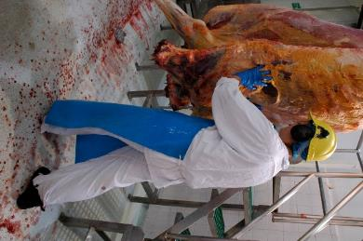
Repeated and continuous motion can cause strain
© MINTRAC
What are the legal requirements for controlling manual tasks?
Hazardous manual tasks (or manual handling) are specifically covered by Part 4.2 – Hazardous Manual Tasks – of the model Work Health and Safety Regulations. Regulation 60 states that senior managers must manage risks to health and safety relating to a musculoskeletal disorder associated with a hazardous manual task.
There is also a Code of Practice - Hazardous Manual Tasks. The Code explains how to identify hazardous manual tasks, assess the risks of musculoskeletal disorders and eliminate or minimise those risks. To have legal effect in a jurisdiction, the Code of Practice must be approved as a code of practice in that jurisdiction.
How are the risks associated with manual tasks controlled?
Hazardous manual tasks are controlled in the same way as other hazards in the workplace through a risk control program. The four steps in controlling risks to eliminate them or reduce them to the lowest possible levels before they cause injuries are to:
- identify the hazards
- assess the risks
- control risks
- review control measures.

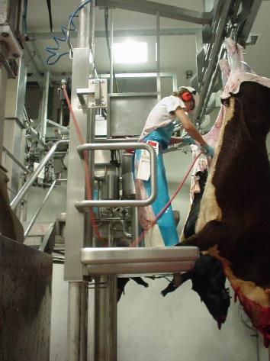
Rise and fall platforms reduce risk of manual handling injury
© MINTRAC
Step one: Identify the hazards
Hazards may be identified by measures including:
- direct observation
- consultation with workers
- analysis of historical data
- risk control program of manual tasks
Direct observation
Direct observation of a task or process may be completed using a checklist or other survey tool. Observation should occur while the usual work is being performed. It may identify risks overlooked in the daily routines.
Consultation with employees and their representatives
Employees should participate in all stages of identifying, assessing and controlling the risks associated with manual handling. Employees are likely to be aware of the risks associated with their work and are often able to put forward practical suggestions.
Analysis of historical data
This includes injury records, but also accident reports, previous audits, surveys, inspection by occupational health and safety staff, WHS committees or outside consultants. Meat industry experience may indicate trends to be considered.
Risk control program of manual tasks
A risk control program of manual tasks should be undertaken by senior management of all manual handling tasks.
Step two: Assessing the risks
Assessment of risk is undertaken to identify the specific factors that may pose a risk of injury. Generally a number of factors combine to increase the risk. One way to take a systematic approach to the identification of risk factors is to consider.
The task factors – what is being done:
- working posture, actions and movements
- duration and frequency of the activity
- location of the loads and the distance it is moved
- characteristic of the load and equipment
- weight and forces.
Work environment factors – where the task is performed:
- layout of the workplace
- condition of the workplace.
Work organisation factors – how the task is organised:
- work flow
- work loads
- work breaks.
Worker factors – who is doing the task:
- skills and experience of the worker
- specific clothing and other personal protective equipment (PPE)
- age and fitness level.
Step three: Controlling the risks
Once management have identified the hazardous manual tasks and assessed the factors that make them hazardous, then they are in a position to be able to identify the most effective control measures to eliminate the risks where possible or if that is not possible to reduce the risks to the lowest possible levels.
Purchasing to eliminate or minimise risks
Companies generally have a purchasing policy that focuses on purchasing plant and equipment has been designed so that it can be used safely and best matches the needs of your workers. For example a robot may eliminate a hazardous manual task.
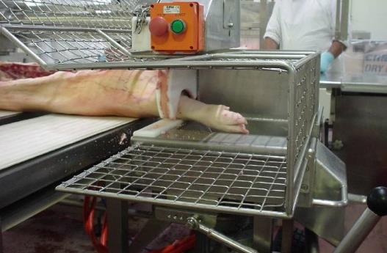
Automated hock cutter
© QAF Meats
Changing the design or layout of work areas
A well-designed work area will assist in eliminating or reducing the risk factors associated with a hazardous manual task, such as the degree of reaching, twisting or bending.
Changing the nature, size, weight or number of items handled
Examples of control measures that may be considered when handling loads include:
- purchasing products in smaller loads for manual handling or larger loads to be shifted mechanically
- reducing the size or capacity of containers
- using grip devices adapted to the particular object to be carried.
Using mechanical aids
Mechanical equipment may eliminate or reduce the need for workers to lift, carry or support items, animals or people. A wide range of mechanical aids is available for example:
- conveyors such as roller conveyors, elevating conveyors, belt conveyors, screw conveyors, chutes, monorails or trolley conveyors
- cranes such as overhead travelling cranes, gantry cranes or jib cranes, stacker cranes, industrial manipulators and articulating arms
- lifting hoists
- loading dock levellers
- turntables
- springs or gas struts, mechanical devices such as hand winches, hydraulic pumps, and battery powered motors
- forklifts, platforms trucks, tractor-trailer trains, tugs and pallet trucks
- lift tables, mechanical and hand stackers, lift trolleys, two-wheel elevating hand trucks, and vacuum or magnet assisted lifters.

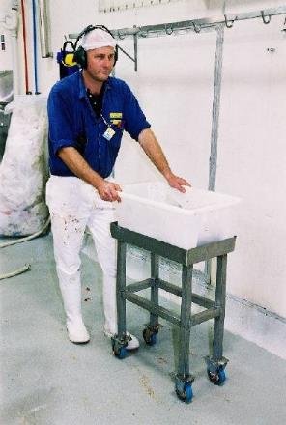
Tub on wheels reduces the risk of manual handling injury
Courtesy of Meat and Livestock Australia

Handling animals
When animals are being handled consider the following:
- using mechanical devices or other restraining aids for lifting, transporting or restraining animals
- moving the animal to a place that constrains or minimises the movement of the animal before commencing the task
- where handling is required, assessing the needs of the task including the specific type of mechanical aids and personnel, and planning it in a manner that avoids double-handling
- where the use of a mechanical aid or assistive device requires two or more people, providing adequate resources so that workers under time pressure don’t try to complete the task on their own.
Changing the system of work
The workload and pace should accommodate the physical demands of the manual task. Workers should not have to work at a rate that is at the limit of their ability. Task design should take account of the range of human dimensions and capabilities such as height, reach and weight.
Changing the work environment
This includes controls to reduce risks associated with areas including:
- extremes of temperature
- floors and surfaces
- lighting
Using administrative control measures
Administrative control measures do not address the source of the risk – they only attempt to reduce risk by reducing exposure to those risk factors. Administrative controls include:
- job rotation
- rest breaks
- team handling
- information, instruction and training
- work instructions, SOPs.
Step four: Review control measures
Control measures that have been put in place need to be reviewed to check that they have actually achieved what they were designed to do and eliminated or reduced the risks to the lowest possible levels. Management also needs to review the control measures to ensure the controls have not introduced different risks.
Workers or operators of plant and equipment are well positioned to help management review control measures as it is the operators who are most familiar with the work being done and can provide feedback needed.
What is the worker’s role in reducing the risks associated with manual tasks?
There is a general duty of employees to take reasonable care for their own health and safety and avoid harming others. Duties of employees include:
- following instructions
- using personal protective clothing and equipment provided by employers
- taking care of equipment
- reporting hazards.
Workers’ responsibilities in regard to manual tasks include:
- reporting to their supervisors any hazards associated with manual tasks
- participating in discussions about problems, identification, implementation and review of possible solutions
- implementing control measures relevant to their jobs and providing feedback about the effectiveness (or otherwise) of the controls
- participating in training related to reducing the risks.

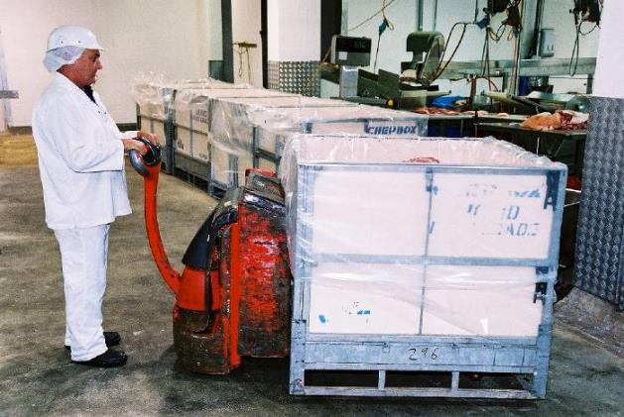
A mechanised pallet jack eliminates lifting bulk meat packs
Courtesy of Meat and Livestock Australia

Activity: Manual handling
Materials and specialist personnel
A copy of a DVD dealing with manual handling, e.g. Dealing with Manual Handling; Manual Handling for Industry and Reducing the Risks, Australian Meat Industry Manual Handling training resource (MINTRAC).
A copy of National Guidelines for Health and Safety in the Meat Industry.
Method/Trainee activities
Show the DVD and discuss the issues raised.
Emphasise the definition of manual handling or manual tasks – it is more than just lifting.
Ask the trainee to list manual tasks that they perform in their workplace or that are performed in their work area. Provide examples such as push/pulling, moving/carrying, lifting/lowering and holding/restraining.
Either select a number of tasks listed by the trainees or tasks listed on pages 38–45 of Examples of Possible Risk Factors and Control Ideas of the National Guidelines for Health and Safety in the Meat Industry and discuss the worker’s role in this process.
Select a work area in the plant and use the worksite’s Safe Manual Handling Checklist or the checklist in the National Guidelines for Health and Safety in the Meat Industry to conduct an inspection and work through the risk control process. Discuss the risk factors and the possible controls.
Discuss what controls should be implemented, and who would be responsible.
Explain to the trainee that you will pass the completed checklist onto the appropriate personnel at the worksite.
Discuss the costs to workers and the company of not reducing or eliminating risks associated with manual tasks.

Slips, trips and falls
What are the types of hazards that may result in slips, trips and falls?
The meat industry has a high incidence of injuries caused by slips, trips and falls. Slips, trips and falls may occur during manual tasks.
The most common hazards that increase the risks of slips, trips and falls are:
- floor surfaces – slippery, uneven or damaged
- ramps – slippery or damaged, the gradient (or slope)
- stairs – slippery, no hand rail support or barrier to stop people falling over the edge
- platforms – slippery, no barrier to stop people falling over the edge
- drains and gutters – differences in levels of adjoining surfaces, pooling or build-up of material
- obstructions or obstacles in any work area or pathways, including electrical cords, hoses and any other piece of mobile equipment such as trolleys
- inadequate or poor lighting.
Additional factors that make floors, platforms and walkways slippery and may contribute to slips, trips and falls in the meat industry include:
- fat, blood, meat scraps, water and other waste products
- hot water and detergents in the cleaning and washing down process.
What can be done to reduce the incidence of slips, trips and falls?
As with all hazards the process is to:
- Identify areas or processes where slips, trips and falls may occur. Records of previous incidents and injuries, as well as consideration of industry information, the consultation with employees about areas of concern, and observation by inspections, audits or surveys.
- Assess all the factors that may contribute to an accident. When thinking about the floor surfaces, platforms, ramps, stairs, drains and gutters, obstructions and lighting, think about maintenance as well as housekeeping. Each workplace is different. A checklist may help but also always be on the alert to identify hazards and do something about them before they cause accidents
- Identify appropriate controls. Remember to consider the most effective controls from the hierarchy of controls to ensure risks are reduced to the lowest possible levels. Substitution and engineering controls are effective controls and include:
- replacing the floor surface
- treating existing floors to improve grip
- fitting stairs, steps and ramps with slip resistant tread
- fitting stairs with handrails
- fitting platforms with a guard rail.
- Other controls include:
- maintenance procedures including prompt repair of damaged surfaces, equipment, fittings and leaks, blocked gutters and drains
- restricted access, where feasible, to areas that pose risks and providing signposting
- personal protective equipment of suitable footwear with slip resistant soles; as with all PPE a procedure is necessary to make sure footwear is maintained and in good condition.
A combination of control measures is often necessary.
What is the role of the worker with hazards that pose risks of trips, slips and falls?
Employees play an important role by:
- fixing simple hazards such as removing obstacles in walkways
- reporting to the supervisor any damage to surfaces, drainage issues, fittings and equipment that require repair, and incidents where slips and trips have occurred even though no injury or damage has occurred
- following all procedures and work practices that impact on the hazards, from following signage to care for footwear.
Activity: Slips, trips and falls
Materials and specialist personnel
Copy of a cleaning and/or maintenance procedure.
A list, compiled from accident/incident reports, of areas where slips and falls have occurred.
Method
Ask the trainee to list all the areas at their site where there are hazards that may lead to slips, trips and falls. Provide information from the company records.
From the list obtained choose two areas. For each example ask the trainee to list the reasons why slips, trips and falls may occur – the risk factors. If for example, one of the reasons given is that the floor is slippery, ask the reasons why the floor is slippery. Discuss the similarities or differences in the risk factors for the two areas.
Ask the trainee to list the controls (engineering controls, procedures, safe work practices etc) that are already in place. Discuss whether these are being followed and are effective.
Discuss with the trainee all other possible controls and their feasibility.
Discuss the effectiveness of these controls. Identify the most effective controls and discuss why they are most effective.
Choose a procedure such as maintenance or cleaning and discuss the impact it has on hazards that pose risks of slip and fall injuries.

Hazards related to plant, equipment and tools
What is the definition of plant?
The Code of Practice, Managing Risks of Plant in the Workplace’ (September 2013) defines plant broadly as:
‘Plant includes any machinery, equipment, appliance, container, implement and tool, and includes any component or anything fitted or connected to any of those things. Plant includes items as diverse as lifts, cranes, computers, machinery, conveyors, forklifts, vehicles, power tools and amusement devices.
Plant that relies exclusively on manual power for its operation and is designed to be primarily supported by hand, for example a screw driver, is not covered by the WHS Regulations. The general duty of care under the WHS Act applies to this type of plant.
Certain kinds of plant, such as forklifts, cranes and some pressure equipment, require a licence from the WHS regulator to operate and some high-risk plant must also be registered with the WHS regulator.’
What are the hazards associated with plant?
Plant is a major cause of workplace death and injury in Australian workplaces. There are significant risks associated with using plant and severe injuries can result from the unsafe use of plant including:
- limbs amputated by unguarded moving parts of machines
- being crushed by mobile plant
- sustaining fractures from falls while accessing, operating or maintaining plant
- electric shock from plant that is not adequately protected or isolated, and
- burns or scalds due to contact with hot surfaces, or exposure to flames or hot fluids.
Other risks include hearing loss due to noisy plant and musculoskeletal disorders caused by manually handling or operating plant that is poorly designed.
What are the legal requirements related to plant?
The Model Work Health and Safety Regulations (which have been passed into legislation in most states of Australia) state that:
‘Regulation 203: A person with management or control of plant at a workplace must manage risks to health and safety associated with the plant.
Regulation 34-38: In order to manage risk under the WHS Regulations, a duty holder must:
- identify reasonably foreseeable hazards that could give rise to the risk
- eliminate the risk so far as is reasonably practicable
- if it is not reasonably practicable to eliminate the risk, minimise the risk so far as is reasonably practicable by implementing control measures in accordance with the hierarchy of control
- maintain the implemented control measure so that it remains effective, and
- review, and if necessary revise, risk control measures so as to maintain, so far as is reasonably practicable, a work environment that is without risks to health and safety.’
It should be noted that there is a legal requirement for control measures to be the most effective controls from the hierarchy of controls wherever possible. For example, plant such as robots may be installed that eliminate risks to workers. Engineering controls such as conveyor belts replacing manual tasks are also preferred options to administrative controls which only put barriers between the risks and the operators. Administrative controls should only be used in association with other more effective controls.

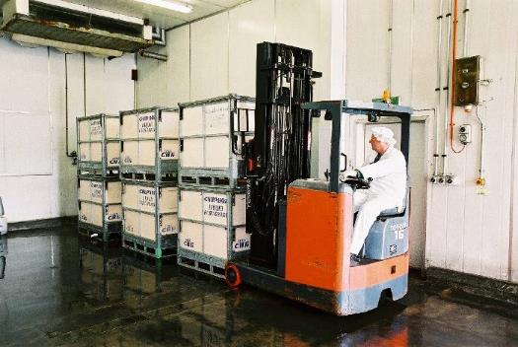
Forklifts eliminate the risk of manual handling injuries carrying heavy loads
Courtesy of Meat and Livestock Australia
Monitoring implementation of safe work practices

Workers are legally required to follow work instructions. Operators may be legally required to undertake training and certification to operate some plant. The certification may need to be updated regularly.
How are risks associated with plant controlled?
Management takes a planned and systematic approach to identify, assess and control risks associated with plant on site. The risk control process is also re-assessed:
- before and during the introduction of plant
- before and during any alteration to plant or change in the way plant or an associated system of work is used, including a change in the location of the plant, which is likely to involve a risk to health and safety
- when new information regarding health or safety becomes available to the employer.
The risk control process is conducted in consultation with employees and their health and safety representatives and includes:
Hazard identification
Management takes a systematic approach to identify and maintain a register of all plant used on site and systematically identify all the hazards associated with each item of plant.
Hazards associated with plant generally arise from:
- The plant itself, for example hazards associated with a forklift would include hazards relating to its mobility, its electrical, hydraulic and mechanical power sources, moving parts, load-carrying capacity and operator protection.
- How and where the plant is used. The forklift, for example may have hazards arising from the kind of loads it is used to lift, the size of the area in which it is used and the slope or evenness of the ground.
Risk assessment
Risk assessment is undertaken in consultation with the employees who use the plant, equipment or tool, and also with those who clean and/or maintain it. The assessment includes consideration of all the factors that may contribute to the risks including:
- frequency and duration of exposure to the risk and risks identified
- work organisation, including the complexity and repetitive nature of the task and the number of employees using the particular plant
- layout and condition of the workplace, including lighting, work space, noise levels, pedestrian traffic, etc.
- condition and maintenance record of the plant, tool or equipment
- manufacturer’s operating instructions, if any, and the usual circumstances of its use, cleaning and maintenance
- guarding and safety device requirements
- the capability, skill and experience of the person using the plant, tools or equipment.
Risk control
Control measures need to be identified for each of the risk factors that have been identified. The most effective controls eliminate the risk of injury by replacing plant and equipment so that the task is automatic. Automatic hock cutters eliminate the risk of injury associated with cutting hocks. The automated carton forming machine eliminates the risk of injury associated with forming cartons, applying glue, etc.
Workers or operators of plant should be consulted about controls. They also need to be trained in implementation of the controls. Workers should also give feedback to management on the effectiveness of the controls.
Reviewing controls
The WHS Regulations state that:
‘Regulation 37: Control measures must be maintained so that they continue to protect workers and other people from the hazards associated with plant. The control measures must be:
- fit for purpose
- suitable for the nature and duration of the work, and
- installed, set up and used correctly.
Regulation 38: A person conducting a business or undertaking must review and as necessary revise control measures:
- when the control measure is not effective in controlling the risk
- before a change at the workplace that is likely to give rise to a new or different health and safety risk that the control measure may not effectively control
- if a new hazard or risk is identified
- if the results of consultation indicate that a review is necessary, and
- if a health and safety representative requests a review’

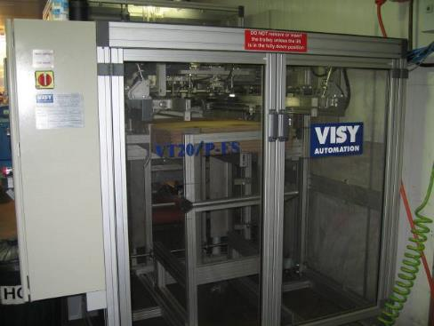
Automated carton forming machine eliminates the risk of injury
Courtesy Fletcher International © MINTRAC
How do workers operate equipment safely?
Workers are legally required to work safely and protect others from injury. This includes operating equipment safely. The safe operation of plant includes:
- participating in training in operation of the plant to gain competency
- following work instructions and any other workplace procedures related to the operation of plant
- reporting any issues related to plant to your supervisor
- participating in consultation on the plant you operate
- Following emergency procedures related to plant.
What are some of the safety controls on plant?
The WHS Regulations refer to some of the specific safety controls on plant. These include machine guards and emergency stops.
Machine guards
A guard is a physical or other barrier that can perform several functions including:
- preventing contact with moving parts or controlling access to dangerous areas of plant
- screening harmful emissions such as radiation
- minimising noise through the application of sound-absorbing materials, and
- preventing ejected parts or off-cuts from striking people.
Plant and/or components of plant that require guarding include:
Type A Non-operational plant/components of plant which transmit power and motion:
- belts and pulleys (e.g. refrigeration rooms)
- gear wheels (e.g. chain drive mechanisms)
- shafts and spindles (e.g. viscera tables and conveyor belts)
- flywheels (e.g. motors, etc.)
- slides and cams
- chain and sprocket gears (e.g. conveyor belts).
Type B Operation parts/components of plant:
- tools and dies of power presses
- blades of guillotines (e.g. head splitters)
- circular saw (e.g. horn removal saws)
- band saws (e.g. carcase splitting saw, boning room band saws)
- drills and chucks (e.g. maintenance section, core sampling of frozen cartons)
- elevating platforms (e.g. kill floors).

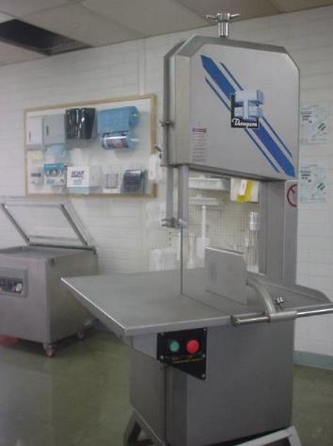
Bandsaw with guard
© MINTRAC
Permanently fixed physical barriers provide the highest level of protection against hazards. They provide permanent non-moving guards that cannot be removed without the use of tools.
This is practical when access is not necessary during the operation, maintenance and cleaning of equipment and prevents access to the moving parts of the machine.
Interlock physical barriers are linked to the operation so that the machine will not operate until the guard is fully closed. They can be electrical, mechanical, pneumatic or hydraulic. This is practical when access is necessary during operation, maintenance and cleaning.
Physical barriers may be either fixed enclosing guards, which prevent access to a particular part of a machine, or fixed distance guards which reduce the possibility of access to any dangerous part or area by their size and ability to keep all parts of the operator at a distance from the hazard.
Presence sensing systems, also known as photoelectric guards, are presence sensing or proximity sensing guards. They have a proximity reaction, i.e. the machine can be deactivated when someone enters or interrupts the barrier. The barriers may include electro-optic action (light barriers, light curtains, light screens) and ultra sonic and protective devices such as pressure mats. These devices may protect the operator from objects ejected from the machine.
Emergency stops
Emergency stop buttons are designed to stop driven machinery or equipment in a situation when a person’s health is at risk. Emergency stop devices should not be the only method of controlling risks. They should be designed as a back-up to other control measures.
What in general should you do in a plant/machinery emergency?
In an emergency the following steps should be taken:
- The first priority is to engage the emergency stop system, e.g. emergency stop button and, if possible, isolate the power to the plant and equipment
- make sure that other people in the area are protected
- alert others, primarily your supervisor and the first aid officer (if required)
- respond in accordance with your workplace procedures to any injuries that may have occurred (as a worker this generally means that you alert your supervisor and/or first aid officer).
Activity: Plant, equipment and tools
Materials and specialist personnel
Invite the supervisor and health and safety representative of the area to participate in the activity and organise a date and time that best meets production needs.
Relevant work instruction.
Standard Operating Procedure (SOPs).
Manufacturer’s specifications for appropriate equipment and tools.
Method
Take the trainees to the equipment that they would be likely to use in their work area. Hand out a copy of the work instruction and manufacturer’s specification for the equipment involved.
Point out the guard on the machinery (if present) and explain why the guard is there. Discuss the worker’s responsibility in relation to the guard and discuss the type of guard. Point out the emergency stop system (if present) and discuss the steps that should be taken in an emergency.
Use the work instructions to demonstrate start up and stopping for that piece of equipment. Point out the safety requirements related to starting and stopping the equipment.
Discuss the worker’s responsibility (in accordance with the work instruction) in relation to the cleaning and servicing of the equipment.
Discuss the worker’s role when the equipment is locked or tagged out.
Trainee activities
Ask the trainees to list and identify machinery and consequent hazards in the work area, e.g. the guards that should be in place and the emergency stop buttons for this machinery.
Ask the trainees to list and identify SOP and work instruction requirements that aim to control machinery hazards in the work area.

What should you do when cleaning and servicing plant?
Cleaning and servicing equipment may be dangerous. You should only undertake cleaning and servicing of plant if you are fully trained and authorised to do so. You should always follow work instructions related to cleaning and servicing of plant. Particular attention should be paid to the isolation and tagging procedures of the particular machine.
In order to protect the person cleaning and servicing the machinery it is important to make sure the machinery cannot be started when cleaning and servicing is taking place. To achieve this the machinery must be locked out and tagged out (LOTO), and power isolated at the source before cleaning or servicing begins.
If the machinery was operating during the cleaning or servicing the operator might fall into the machinery, body parts may be caught in machinery and articles of clothing or cleaning or servicing equipment may be dragged into the machinery. If the machine is not locked out, then another person may inadvertently turn the machinery on while the operator is cleaning or servicing the machinery.
Activity: Use of hot water
Materials and specialist personnel
Obtain all work instructions that involve the use of hot water – hot water pressure hose cleaning, personnel protective equipment and hygiene practices including boot and apron wash, equipment wash, sterilisers, etc.
Method
Show the trainees all the work instructions. Explain the common thread is the use of hot water. Detail the water temperature required by the different processes. Discuss the safety requirements.
Explain the hygiene requirements with regard to the hot water. Detail the hygiene and quality assurance and consequences if correct practices are not followed.
Take the trainees to observe one or more uses of the hot water.
Ask the trainees to list the potential WHS hazards and associated risks. Generate a list of possible injuries and their seriousness.
Discuss any preventative measures or controls currently in place.
Identify other controls that may be possible. Discuss how these would be implemented and who would be responsible.
Reducing the risks of working with a knife
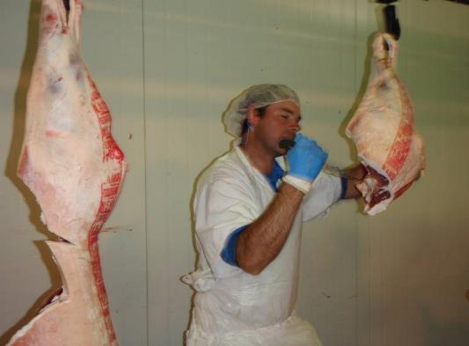
Hazards and risks may arise from handling knives
© MINTRAC
What risks are associated with knife use?
Knives are used across the whole meat industry. There are risks associated with the use of knives if they are not handled and used correctly and safely. Knives may cause injuries to the knife handler as well as those in close proximity to the knife handler.
The most common types of injuries are cuts and stab wounds. These often require medical attention and may need suturing, skin grafting and reattaching tendons.
How are risks associated with knives reduced to the lowest possible levels?
Management takes a risk management approach to all situations in plants where knives are used. This includes:
- identifying the hazards associated with each task
- assessing the risks by identifying each of the factors that may have contributed to the risk
- identifying and implementing controls that reduce the risks to the lowest possible levels.
- Checking that the controls have reduced the risks and haven’t created any new risks.
What can workers do to reduce the risks of injury using knives?
Workers must receive training in the use of knives. You must always receive training and follow work instructions for the particular task you are doing. You should always concentrate when using a knife. You are most at risk of an accident when you are tired and not concentrating on the job you are doing. It is very easy to cut yourself when you become distracted or careless in your approach to work. There are some general principles about using knives safely. These include:
- don’t use a blunt knife as you will need to use more force which gives you less control
- never take your eyes off the cutting path of the knife, if you must look away, stop cutting
- never cut towards yourself or towards another individual
- if you drop your knife let it fall, don’t try to catch it
- always place your knife in the scabbard or pouch when not in use
- always be aware of the movement of people around you
- never fool around with a knife in your hand or fool around with others who may have a knife in their hand
- keep the handle of the knife clean and free of fat and grease at all times.
Personal protective equipment is a vital part of knife safety and workers should always use PPE when working with a knife. The PPE used at your plant will be set out in work instructions for the task. You must be trained in each task that you do and you must follow work instructions for that task. The range of PPE equipment used can include:
- mesh gloves
- mesh aprons
- cut resistant gloves
- arm guards.
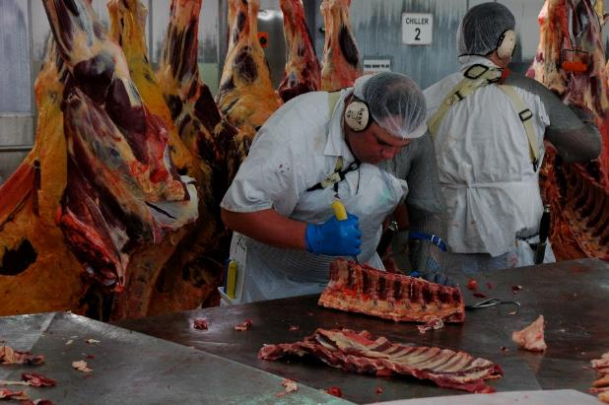
Cut resistant mesh and rubber gloves reduce the risk of knife injury
© MINTRAC
How do you sharpen knives safely?
You should complete the unit of competency AMPX209 Sharpen knives and follow work instructions related to sharpening knives at your plant. Some general principles related sharpening knives include:
- when using a sharpening stone, make sure the stone is on a slip-proof, flat surface
- when using a stone, always keep your free hand away from the stone and knife
- make sure your steel has a safety guard between the handle and the body of the steel
- when using a grindstone, make sure the rotation of the stone and the cutting edge of the blade are away from your body.
Eliminating or reducing hazards associated with extremes of temperature

What effects may occur from exposure to extremes of temperature?
Workers in meat processing plants are frequently exposed to cold temperatures. Work is carried out in cold temperatures in areas including boning rooms, despatch areas, chillers, freezers and sometimes outdoors.
The body reacts to exposure to cold by trying to maintain its temperature by constricting blood flow to the skin. The skin changes, shivering and postural changes may lead to a loss of coordination and feeling. This is turn may increase the risk of accidents and soft tissue damage. Similarly, cold may aggravate the effects of other workplace hazards.
Exposure to cold may result in hypothermia, where the body’s core temperature may drop to a dangerous level. Frostbite is another risk in cold areas.
Exposure to high temperature and excessive humidity may also occur at meat processing plants in areas such as yards and pens, rendering areas and scalding and singeing areas where pigs are processed.
Exposure to high temperatures may lead to rashes, cramps, fainting, heat exhaustion and heat stroke.
How are the risks of exposure to extremes of temperature controlled?
Risks associated with working in areas where there are extremes of temperature are controlled in the same way as all other risks are managed in the work place by the implementation of a risk control program for extremes of temperature. This involves:
Identifying the hazards
Management takes a planned and systematic approach to identify all the areas and situations of extreme temperature at the site.
Assessing the risks
Once the hazards have been identified then all the factors that may contribute to the risk are identified. In extremes of temperature these may include:
- air temperature, air movement and humidity
- length of exposure
- nature and level of work
- types of clothing and footwear
- levels of fluid loss and replacement
- personal factors - for example, use of certain medications and/or pre - existing medical conditions, level of physical fitness and obesity can affect the risk of heat stress. Pregnancy can also reduce tolerance to heat.
Identifying and implementing controls
It is generally not possible to eliminate exposure to cold temperature, as it is a legal requirement for meat to be stored at low temperature to meet food safety and preservation requirements. Control measures to reduce risks to the lowest possible levels may include:
- restricted entry to cold areas for essential activities only or only by authorised persons
- wearing suitable clothing, footwear and PPE
- following work instructions, Standard Operating Procedures (SOPs) and any other workplace procedures
- undertaking training including emergency procedures
- gaining permission to enter the area
- not working alone in a freezing chamber.
Management is responsible to implement the most effective controls particularly focusing on engineering controls such as:
The indoor working environment
- ventilation and mechanical cooling methods, such as air conditioning and/or air circulating fans;
- provision of mechanisms external to the workplace to assist in temperature control, such as planting shade trees, and the use of eaves and verandahs;
- insulating the roofs and walls of the work place
- insulating or shielding sources of radiant heat in the work place, e.g.. insulation around ovens, furnaces or other sources of radiant heat; and/or insulated barriers between hotter and cooler parts of the workplace
- exhaust ducts for venting hot air from the work place. The outdoor working environment.
Arrangements for outdoor working environments should include:
- erection of shelters, tents and/or windbreaks (in the case of hot, dry winds) and provision of suitable clothing, hats etc., to protect outdoor workers from the heat and exposure to UV radiation
- provision of air-conditioned work vehicles.
What is the role of workers in reducing risks in extreme temperatures?
Workers are responsible for cooperating with control measures to eliminate or reduce risks. For example, workers should wear suitable clothing when entering or working in freezers and only enter when authorised and trained to do so.

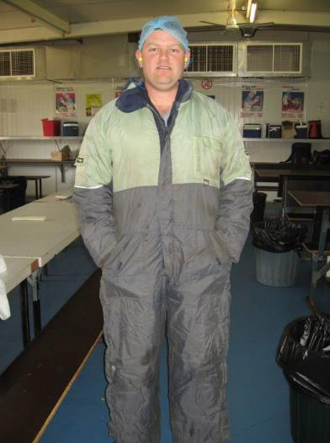
Cold room clothing
Courtesy Fletcher International © MINTRAC
In heatwave conditions management will advise you of precautions that should be taken. If you feel that you are a danger to yourself or others because of the heat you should report to your supervisor. Controls to reduce risks in high temperatures include taking rest and fluid breaks.

Activity: Working safely in extremes of temperature
Material and specialist personnel
Relevant standard operating procedures and work instruction for working in cold and, where relevant, hot environments.
Method
Ask the trainees to cite examples from their workplace of areas where work is required in cold temperatures.
Discuss the possible effects of exposure to extremes of cold temperature.
Discuss the precautions taken for workers in cold temperatures.
Ask the trainee to cite examples from their workplace of areas where work is required in hot temperatures.
Discuss the possible effects of exposure to extremes of hot temperature. Discuss the precautions taken for workers in hot temperatures.
Eliminating or reducing hazards associated with exposure to hazardous chemicals

What is a hazardous chemical?
Hazardous chemicals are substances that may harm people, property and the environment. They may affect a worker’s health causing illness, disease or injury.
They include many common industrial, commercial, pharmaceutical, agricultural and domestic chemicals. Examples of hazardous chemicals in meat processing plants include cleaning agents, sanitisers, ammonia, caustic soda and acids. They may be solids, liquids or gases.
What health effects may be associated with exposure to hazardous chemicals?
Hazardous chemicals may enter the human body in three ways:
- swallowing
- breathing
- skin or eye contact.
Health effects may be immediate, i.e. acute or short term, or chronic, i.e. a result of long term or continuous exposure or the body eventually reacts to an exposure which may have occurred a long time in the past.
Immediate effects of exposure include headaches, dizziness, nausea, vomiting or burns.
Chronic health effects include asthma, dermatitis, cancer and bronchitis.
What are the legal requirements related to managing hazardous chemicals?
There are general requirements under the WHS Act for senior managers to provide a healthy and safe working environment primarily through the implementation of risk management programs to manage risks (such as hazardous chemicals) in the workplace. There are also specific requirements related to the management of hazardous chemicals in the WHS Regulations covering areas such as the use, handling and storage of hazardous chemicals at a workplace including duties for keeping a hazardous chemical register, safety data sheets, labels, placarding, fire protection and equipment. There is also a ‘Managing risks of Hazardous Chemicals Code of Practice’ that provides a practical guide to achieving the standards of health, safety and welfare required under the WHS Act and Regulations.
How are hazardous chemicals managed in the workplace?
In order to meet obligations under the Work Health and Safety Act and Regulations senior management is responsible to put a risk management program in place to minimise the risks of exposure to hazardous chemicals that includes storing, handling and managing them correctly to avoid harm to workers, members of the public, property and the environment. The risk management program includes:
- identifying the hazardous chemicals in the workplace
- assessing the risks
- implementing controls to eliminate and/or minimise the risks
- reviewing the control measures and keeping up to date with work health and safety codes of practice and legislation.

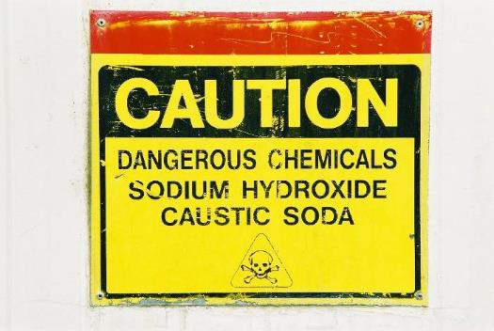
Signage indicating dangerous chemicals
Courtesy of Meat and Livestock Australia
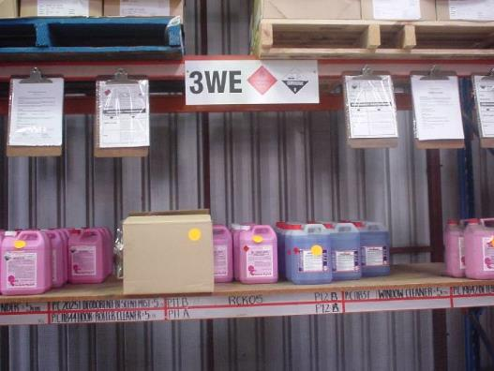
Chemical storage with material safety data sheets
© MINTRAC
What are the workers’ responsibilities in relation to hazardous chemicals at work?
Employees should take reasonable care for their own health and safety and avoid harming others. For hazardous chemicals this includes:
- following work instructions and any safety procedures associated with the use of chemicals
- reporting any issues with hazardous chemicals to the supervisor
- using any personal protective equipment provided for use with chemicals
- following safety instructions such as the removal of contaminated clothing before eating, drinking or smoking.
Under WHS legislation all workplaces must have a register of chemicals used in the workplace that includes safety data sheets (SDS) for each chemical that includes specific information on the chemical such as health hazard information, precautions for use, safe handling information, contact details, what to do in an emergency such as a spill or exposure to the chemical etc.

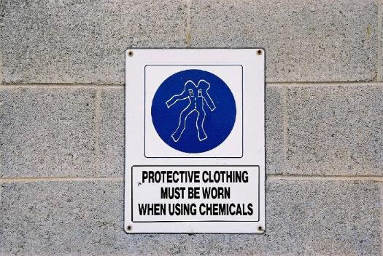
Signage requiring protective clothing to be worn when handling chemicals
Courtesy of Meat and Livestock Australia
Activity: Hazardous chemicals
Materials and specialist personnel
Safety Data Sheets for sample chemicals used by the trainee in their workplace.
Method
Ask the trainees where copies of the SDSs are located in their workplace.
Discuss the worker’s responsibilities in regard to hazardous chemicals.
Refer to one of the SDS sample and discuss with the trainees how they use the chemical and the precautions they take using it and the training they’ve had.
Identify the sections of the SDSs that are important for the worker including:
- health hazard information
- potential consequences of exposure above recommended limits
- first aid procedures
- precautions for use
- safe handling information
- managing emergency situations such as spills.
Discuss a scenario about introducing a new cleaning substance to the worksite. Trainees to obtain a SDS for a chemical used in their work area, and working with another trainee, study the SDS to identify:
- the possible health hazards
- precautions for use
- first aid procedures
- safe handling.
Explain the procedure that should occur prior to the chemicals introduction, what should happen when it is introduced and whose role it is to carry out these procedures.
Ask the trainees to give an example of a hazardous chemical used in the workplace, e.g. ammonia, and work through the risk control process with them for this chemical.
Explain:
- the methods for identifying the hazards associated with the substance
- the health and safety risks associated with this substance
- control measures that may be put in place to minimise the risks.
Ask the trainees to identify the roles of different workplace groups in this process at the worksite.
Eliminating or reducing noise hazards in the workplace
What is the extent of the noise problem in meat processing plants?
The meat processing industry is a ‘noisy’ industry. As a guide, if you have to raise your voice to communicate with someone about one metre away, the noise is likely to be hazardous to hearing. The industry does have a number of hazards that may result in exposure to noise above acceptable levels. Sources of noise in the meat industry include:
- live animals
- knocking devices
- movement of metal hooks
- power tools
- compressed air
- metal screws for conveying product.
Hazardous noise can destroy the ability to hear clearly and can also make it more difficult to hear sounds necessary for working safely, such as instructions or warning signals. The potential for noise-induced hearing loss occurs in two main ways:
- prolonged exposure, that is, eight hours exposure to noise levels of 80 dB (A) and above
- exposure to a one-off noise, which can cause immediate hearing damage; the upper limit to which a person may be exposed is 140 dB.
Noise-induced hearing loss is an insidious problem, usually developing slowly over many years. Although employees may think that they have become used to noise, this tolerance is due to temporary hearing loss. Repeated exposure to excessive noise over a period of time will eventually lead to permanent hearing loss.
This hearing loss results when tiny hair-like cells in the inner ear are permanently damaged by too much noise for too long. The damaged cells can then no longer send messages to the brain and hearing is lost. The damage often remains unnoticed until it is too late.
Not only does excessive noise result in permanent hearing loss, it can create other problems such as stress leading to tiredness, irritability and headaches. It can cause dizziness, raise blood pressure and increase heart rate. Noise increases the risk of accidents by disguising sounds of approaching danger or warnings, and negatively affective balance, concentration and communication among co-workers.

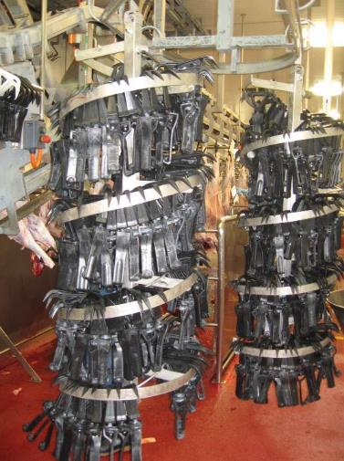
Substitution of light weight durable plastic hooks reduce noise
Courtesy Fletcher International © MINTRAC
What are the legal requirements to reduce exposure to noise in the workplace?
Senior managers have the primary duty under the WHS Act to ensure, so far as is reasonably practicable, that workers and other persons are not exposed to health and safety risks arising from the business. They also have more specific obligations under the WHS Regulations to manage the risks of hearing loss associated with noise at the workplace, including:
- ensuring that the noise a worker is exposed to at the workplace does not exceed the exposure standard for noise
- providing audiometric testing to a worker who is frequently required to use personal hearing protectors to protect the worker from hearing loss.
Workers have a legal responsibility to take reasonable care for their own health and safety and that they do not adversely affect the health and safety of other persons. Workers must comply with any reasonable instruction and cooperate with any reasonable policy or procedure relating to health and safety at the workplace. For example, if personal hearing protectors are provided the worker must use them in accordance with the information, instruction and training provided on their use.
How are the risks of hearing loss controlled in the workplace?

The ‘Managing Noise and Preventing Hearing Loss Code of Practice’ provides guidance on how to manage the risks of hearing loss associated with noise with management following a systematic process that involves:
- identifying sources of noise that may cause or contribute to hearing loss
- assessing the risks associated with these hazards
- implementing risk control measures
- reviewing risk control measures.
Identifying sources of hazardous noise
Source of noise may be identified by conducting workplace inspections and talking with workers. Available information such as workers compensation claims, manufacturers specifications and industry risk information may help identify sources of excessive noise.
Assessing risks
  - Senior management may then contract a competent person to assess the risks by carrying out a noise assessment to:
- identify which workers are at risk of hearing loss
- determine what noise sources and processes are causing that risk
- identify if and what kind of noise control measures could be implemented
- check the effectiveness of existing control measures.
Implementing risk control measures
The WHS Regulations require duty holders to work through a hierarchy of control to choose the control measure that most effectively eliminates or minimises the risk in the circumstances. The most effective control measure is to eliminate the source of noise completely, for example by ceasing to use a noisy machine, changing the way work is carried out so hazardous noise is not produced or by not introducing the hazard into the workplace.
If it is not reasonably practicable to eliminate the source of noise, you must minimise the risk associated with hearing loss so far as is reasonably practicable. This includes ensuring that the noise does not exceed the exposure standard by choosing one or more of the following measures:
- substitute the hazard with plant or processes that are quieter
- modify plant and processes to reduce the noise using engineering controls
- isolate the source of noise from people by using distance, barriers, enclosures and sound- absorbing surfaces.
If there is a remaining risk, it must be minimised so far as is reasonably practicable by implementing administrative controls, and if a risk still remains, then suitable personal protective equipment must be provided and used. These two types of control measures, when used on their own, tend to be least effective in minimising risks because they rely on human behaviour and supervision.

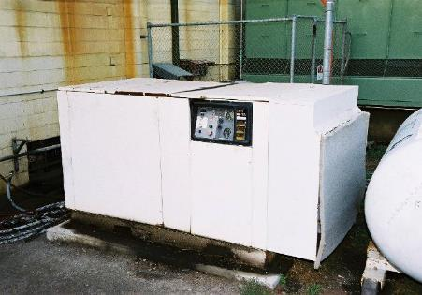
Machinery noise is reduced by enclosing the machine
courtesy of Meat and Livestock Australia
What is the worker’s role in reducing or eliminating noise hazards?
In general, it is the worker’s role to work in a healthy and safe manner and take care of the health and safety of others. Applying this to noise, it is important to wear hearing protection in designated noise areas and report to the supervisor any noisy areas or changes in noise levels, e.g. equipment that has suddenly become noisier. Workers should cooperate in all activities aimed at hearing protection.
Hearing protection should be regularly tested for defects, properly fitted and worn, cleaned and maintained, replaced as appropriate and properly stored.

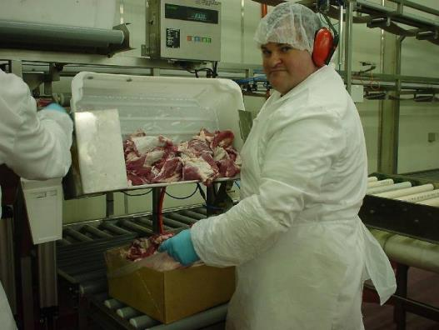
Worker packing trim wearing hearing protection
© MINTRAC

Personal Protective Equipment
What are the requirements related to personal protective equipment (PPE)?
According to the National Guidelines for Health and Safety in the Meat Industry:
‘ PPE and clothing are those items of equipment worn by an employee to minimise or eliminate exposure to specific occupational hazards’
The emphasis is always on eliminating the hazards thereby making it unnecessary for workers to wear Personal Protective Equipment (PPE). However, it is not always possible to eliminate the hazards, and PPE may be required to protect the worker from the consequences of exposure. For example, workers may be required to wear hearing protection to reduce the likelihood of hearing loss resulting from exposure to an excessively noisy environment. Workers in the meat industry are frequently required to wear PPE. In this case it is the employer’s responsibility to ensure PPE is:
- assigned to the worker for their exclusive use
- cleaned and maintained after use
- stored when not in use
- inspected and repaired regularly
- checked for continued functioning and effectiveness.
It is also the employer’s responsibility to ensure training is provided as appropriate. Workers should receive training about:
- proper use of PPE
- the deficiencies and restrictions of PPE
- fitting PPE and how to test for fit
- use of PPE
- maintenance of PPE
- storage of PPE
- identification of faults in PPE
- procedure for replacing PPE.
Workers are responsible to:
- wear PPE as instructed by the supervisor and as set out in the work instruction
- fit PPE to ensure it is used to maximum benefit
- check for any faults and replace it if faulty
- follow maintenance procedures as instructed by the supervisor and set out in work instructions
- store PPE as instructed.
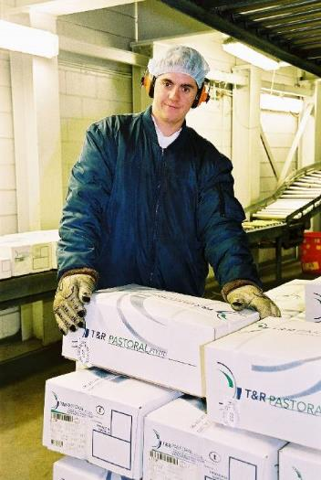
Worker wearing clothing for cold room
Courtesy of Meat and Livestock Australia
Examples of specific PPE are included in the National Guidelines for Health and Safety in the Meat Industry.
Accident management
What is an accident?
An accident is any event that results in:
- injury or illness to a person
- damage to property.
What is an incident?
An incident is when the same event occurs but there was no injury or damage. Incidents may be described as ‘near misses’. Incidents are warning signs and indicate an accident may happen. This is why incidents are reported in addition to accidents.
What happens after an accident or incident?
All incidents/ accidents must be reported to supervisors and an investigation conducted as soon as possible to identify and rectify factors that may have contributed to the accident. In addition, WHS legislation requires the reporting of serious accidents (that result in hospitalisation of an injured worker) to the relevant WHS authority.
Following an accident:
- first aid and medical assistance is provided to the injured person as appropriate
- any faulty equipment or machinery should be tagged and locked out
- the accident or incident report form should be filled in
- an investigation into the factors contributing to the accident should be conducted
- control measures identified and implemented to rectify the factors contributing to the incident/accident.
In cases of serious injury or death, inspectors from the relevant government WHS regulatory authority will conduct an investigation.
The goal of accident or incident investigation is to identify the factors that may have contributed to the accident, and put in place appropriate controls so the accident will not happen again.
What is the worker’s role after an accident?
An employee should seek treatment for any injury and should report all workplace accidents to their supervisor according to their workplace procedures.
Activity: Preventing incidents/accidents by rectifying factors that may have contributed to the incidents/accidents
Materials and specialist personnel
Copy of the company accident report form.
Method
Discuss the difference between accidents and incidents.
Discuss the reasons why incidents should be reported.
Ask the trainee whether he or she has been involved in, or witnessed, an accident. Discuss what happened and what action resulted.
Give the trainee a copy of the company’s accident form and have him or her fill it in for a fictitious accident.
Discuss the procedure for obtaining and handling in a completed accident report form.
Explain the procedure to ensure that the accident investigation process occurs.

Emergency procedures
What types of emergencies may arise at work?
Emergencies that may arise at any meat processing workplace include:
- fire
- natural disasters such as flood, cyclone or heatwave
- explosion
- live animals escaping on the slaughter floor
- bomb threat
- chemical spillage
- explosive gas leak
- escape of ammonia gas
- a first aid or medical emergency.
In most cases, these emergencies will require evacuation of the workplace.
All companies should have well established and documented emergency and evacuation procedures.
What is the worker’s role in an emergency that requires an evacuation?
All workers need to be aware of evacuation procedures. The best way to gain familiarity is to participate in regular fire drills, so that action in a real emergency is automatic. In particular, workers should be familiar with the fire exits, phone numbers of key personnel, location and use of fire extinguishers.
The procedure to raise an alarm should be clearly displayed in all work areas. All employees should be familiar with the procedure to raise the alarm and to evacuate.
In an emergency you may be told by a supervisor or fellow worker to evacuate or you may hear the evacuation siren or fire warning.
When you hear the siren you should:
- always put personal safety ahead of all else
- quickly turn off machinery but do not delay your evacuation of the building to do this
- do not turn off the lighting
- close any fire doors in the immediate area
- leave the building through the nearest EXIT and go to the assembly area
- ensure your name is marked off
- do not leave the assembly area until advised to by the Chief Fire Warden or appropriate person from your company.

D | What do workers need to know about fires?
There are many different types of fires. Fires may be fuelled by a variety of substances including:
- wood
- paper
- flammable liquids such as petrol, oil and diesel
- flammable gases such as propane and butane
- combustible metals such as sodium and magnesium.
Fires may also be started by electrical faults.
Fire extinguishers
Only use a fire extinguisher if you have been trained to do so. Your work site will have trained personnel who are authorised to use fire extinguishers.
There are different types of fire extinguishers for each type of fire. The six most common types of fire extinguishers are water, foam, dry chemical powder, carbon dioxide, wet chemical and vaporising liquid. Care should be taken with electrical fires to first turn off the electricity. Extinguishers that contain water, foam or wet chemicals cannot be used on fires with an electrical hazard, as the electrical current would be carried to the operator. Water and wet chemicals will spread any fire involving flammable liquids.
Therefore, before a fire can safely be put out, the type of fire needs to be identified so that the correct extinguishers can be used.
Fires may only be extinguished by personnel who have been trained to do so. Trained personnel may only extinguish fires if it is safe to do so. Factors to be considered in deciding whether it is safe to fight a fire include:
- the size of the fire. The fire must be small to fight it – don’t risk personal safety
- consider exit and alternate exits
- considering the type of fire to use the correct extinguishers.

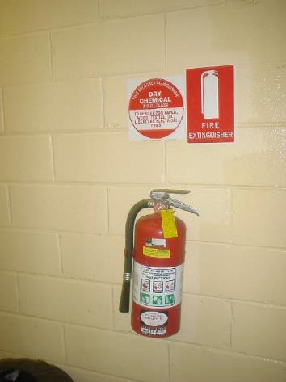
Use correct fire extinguisher for type of fire
© MINTRAC
Activity: Understanding evacuation procedures
Materials and specialist personnel
Copy of the company’s evacuation plan.
A plan showing the relevant work areas and assembly points.
Method
Explain the different types of emergencies that may occur in the workplace.
Explain the measures for controlling each type of emergency and evacuating the premises.
Invite either the company fire warden to demonstrate:
- the site evacuation plan
- procedures in the event of a fire or emergency
- what to do if you discover a fire
- the operation of fire extinguishers.
Conduct an inspection of the worksite indicating all items associated with emergencies, including:
- emergency stops
- evacuation plans
- location of fire exits
- location of fire extinguishers
- location of assembly points
- location of hoses.
Ask the trainees to mark the above locations on their copy of the plan of the workplace.

Table of contents
Note to users 6
Companion Volume 6
Please help to keep these materials current 6
Using these support materials 7
What are the materials for? 7
How can they be used? 7
How are the materials organised? 7
Additional resources 8
Customising the MINTRAC Training and Assessment materials 8
Adding company-specific information 8
Incorporating changes to legislation and regulations 9
1. Training support materials 9
2. Suggested activities 10
3. Sample assessment tools 10
Australian Core Skills Framework information 13
What is the Australian Core Skills Framework? 13
The Workplace Health and Safety website 15
Training support materials for AMPCOR204 Follow safe work policies and procedures 17
Reasons why health and safety is so important 17
Why is health and safety in the workplace so important? 17
Why do companies manage health and safety? 18
What is the extent of workplace illness and injury in Australia? 19
WHS legal requirements 20
What legislation covers WHS? 20
Who has responsibilities under WHS legislation and what are those responsibilities? 21
What are the WHS responsibilities of senior managers? 22
What are the WHS responsibilities of supervisors? 22
What are the WHS responsibilities of workers? 23
How is WHS legislation enforced? 24
Workers compensation legal requirements 25
What happens if you have a work related illness or injury at work? 25
What assistance is given to return to work after a work related injury? 27
The management of health and safety in the workplace 28
How is health and safety managed in the workplace? 28
What is the goal of health and safety in the workplace? 29
Consultation 29
What are the powers and functions of health and safety representatives? 29
Who else does the CEO consult with on health and safety? 30
WHS risk control 31
What do companies do to control risks? 31
What is risk control? 31
What is a hazard? 32
What is risk? 32
What is done at each step in the risk control process and what is the role of workers at each step? 33
What is the role of workers in controlling risks? 36
How are workplace inspections conducted? 37
What are common hazards in the meat processing industry? 38
Zoonotic diseases 39
What is Q fever and how is it managed in the workplace? 39
What can be done to minimise the risk of contracting a zoonotic disease? 41
Manual handling 42
What is manual handling or manual tasks? 42
What are hazardous manual tasks? 43
What injuries may be caused by manual handling or hazardous manual tasks? 43
What are the legal requirements for controlling manual tasks? 44
How are the risks associated with manual tasks controlled? 44
What is the worker’s role in reducing the risks associated with manual tasks? 49
Slips, trips and falls 51
What are the types of hazards that may result in slips, trips and falls? 51
What can be done to reduce the incidence of slips, trips and falls? 51
What is the role of the worker with hazards that pose risks of trips, slips and falls? 52
Hazards related to plant, equipment and tools 53
What is the definition of plant? 53
What are the hazards associated with plant? 53
What are the legal requirements related to plant? 54
How are risks associated with plant controlled? 55
How do workers operate equipment safely? 57
What are some of the safety controls on plant? 57
What in general should you do in a plant/machinery emergency? 59
What should you do when cleaning and servicing plant? 60
Reducing the risks of working with a knife 61
What risks are associated with knife use? 61
How are risks associated with knives reduced to the lowest possible levels? 62
What can workers do to reduce the risks of injury using knives? 62
How do you sharpen knives safely? 63
Eliminating or reducing hazards associated with extremes of temperature 64
How are the risks of exposure to extremes of temperature controlled? 64
What is the role of workers in reducing risks in extreme temperatures? 66
Eliminating or reducing hazards associated with exposure to hazardous chemicals 67
What health effects may be associated with exposure to hazardous chemicals? 67
What are the legal requirements related to managing hazardous chemicals? 67
How are hazardous chemicals managed in the workplace? 68
What are the workers’ responsibilities in relation to hazardous chemicals at work? 69
Eliminating or reducing noise hazards in the workplace 71
What is the extent of the noise problem in meat processing plants? 71
What are the legal requirements to reduce exposure to noise in the workplace? 72
How are the risks of hearing loss controlled in the workplace? 73
What is the worker’s role in reducing or eliminating noise hazards? 74
Personal Protective Equipment 75
What are the requirements related to personal protective equipment (PPE)? 75
Accident management 76
What is an accident? 76
What is an incident? 76
What happens after an accident or incident? 76
What is the worker’s role after an accident? 77
Emergency procedures 78
What types of emergencies may arise at work? 78
What is the worker’s role in an emergency that requires an evacuation? 78
What do workers need to know about fires? 79
Training record sheet 81
Bibliography 84
Additional resources 85
WELL resources for the level II core units 85
Assessment materials for AMPCOR204 Follow safe work policies and procedures 86
Selecting and briefing Workplace Referees 86
What to consider when using a Workplace Referee 86
Recording assessment information 88
Notations 88
Photos 88
Recordings 88
Addressing the Language, Literacy and Numeracy (LLN) requirements of this unit 89
Reasonable adjustment 89
The MINTRAC sample assessment tools 90
Key assessment requirements for this Unit of Competency 90
Are the MINTRAC sample assessment tools ‘validated’? 90
How to use the sample assessment tools 90
The Evidence Guide 92
Evidence guide 92
AMPCOR204 Follow safe work policies and procedures 92
Test or quiz 95
AMPCOR204 Follow safe work policies and procedures 95
Answer sheet (for assessor use only) 98
On-the-job demonstration with assessor observation 101
AMPCOR204 Follow safe work policies and procedures 101
Workplace referee's report 104
AMPCOR204 Follow safe work policies and procedures 104
Record of completed assessment 107
AMPCOR204 Follow safe work policies and procedures 107

Note to users
These training and assessment support materials must be read in conjunction with the Australian Meat Processing Training Package, as described on www.training.gov.au.
In particular, trainers and assessors must address the requirements described in:
- the complete training package, as presented on www.training.gov.au
- the complete Unit of Competency, as presented on www.training.gov.au.
Companion Volume
A Companion Volume has been developed to assist trainers with the delivery and assessment of training in the meat processing industry. The Companion Volume is available as a pdf document from MINTRAC.
Please help to keep these materials current
MINTRAC intends to regularly update these materials to ensure that they continue to reflect current practices and regulatory requirements in the industry.
Please assist in this process by taking the time to notify MINTRAC of any errors, changed requirements, incorrect information, additional materials, or any other ways in which these materials might be improved, by emailing mintrac@mintrac.com.au.

Using these support materials
What are the materials for?
The materials are for the Australian Meat Processing Training Package.
How can they be used?
The support materials can be used by trainers to:
- plan and deliver training
- give additional information to trainees
- keep a record of the training they have delivered.
The support materials can be used by assessors to:
- plan assessment – after training and for recognition of current competence/prior learning
- show trainees the areas they need to work on to be competent
- keep a record of the evidence used in assessment.
Some parts of these training materials can be used by trainees:
- as a resource during training
- to review knowledge, understanding and learning
- to prepare for assessment.
How are the materials organised?
Each booklet covers one unit of competence from the Training Package. The unit title identifies which unit the materials support.
The Training Support materials provide an overview of the subject/process and the underpinning knowledge applicable to the Unit. Topic headings are used to break the training material into sections.
The questions and answers cover the required knowledge that trainees need to know for the particular unit. Trainers need to understand this information before the training starts. Assessors also need to understand this material before they assess anyone for this unit.
Green boxes with suggested activities include on and off-the-floor activities that trainers can use to help the trainees understand the information.
Trainers can also develop their own ideas for training, to suit the trainees.
The Training record sheet is for trainers to keep a record of the training activities they have completed.
The Assessment section provides general information on how to approach and prepare for Assessment. It is important that this section should be read in conjunction with the advice provided in the Companion Volume.
The Evidence Guide maps the Elements and Performance Criteria to the sample Assessment Materials provided for this unit. It is important to note that assessors may need to modify the Evidence Guide after they have customised the materials to suit each individual assessment situation.
The Assessment Materials are sample materials which can be customised and used to assess the requirements of this Unit of Competency. Assessors can also develop their own Assessment Materials to suit the trainees.
The Bibliography lists the books and other sources of information that were used to write the training materials.
Additional resources
Please refer to the Companion Volume for generic resources and references in relation to Training and Assessment.
A range of industry-produced materials plus resources developed by other organisations may be available to support this Unit. For an updated list of available resources, please refer to the Unit-By-Unit listing of resources on the MINTRAC website at www.mintrac.com.au
Customising the MINTRAC Training and Assessment materials
The entire document of Training and Assessment materials for a Unit of Competency is a trainer resource and should never be reproduced and handed to trainees without customisation.
Below are some important guidelines to assist with customisation.
Adding company-specific information
Every meat processing company is different. The training and assessment should match the operations of the company and the requirements of the units of competence. The material in this booklet must be customised to the company's and trainee's needs by including the:
WI | Company work instructions for the tasks in the material.
SOPs | Company standard operating procedures for the tasks in the material.
E | Company equipment used for the tasks in the material.

D | Any company documents or forms used for the tasks in the material. This includes safety signs, Material Safety Data Sheets (MSDSs), quality assurance checklists and company memos.
Incorporating changes to legislation and regulations
These training materials must be updated for any changes in relevant legislation, regulations, guidelines and codes of practice – for example, Managing electrical risks in the workplace Code of Practice (March 2015)
1. Training support materials
The information contained in the training materials is essentially a resource for trainers. Usually the material is not suitable for reproduction and handing out to trainees without modification.
However, segments can be used with trainees, in the following ways.
- Develop short handouts or information sheets.
- Insert your own company photos.
- Insert information from your own company SOPs or Work Instructions.
- Create PowerPoint presentations using the headings, adding photographs and then use the general text to speak to the PPT presentation.
- Create one-page revision sheets with essential information.
- Add your company letterhead to the materials.
- Remove non-essential information not relevant to your company (but take care to ensure that the unit requirements are still met – check the Unit of Competency).
- Add in useful materials you have accessed from other sources.
- Modify the text and make it electronically available to students to use as reference material.
- Adjust the language and style of the text to suit your trainees' reading skills.
- Develop a short photographic or DVD sequence demonstrating the process/product/skill as used in your company.
- Use the materials only as a quick-reference for yourself, to ensure that you have provided accurate, complete information during training sessions and on-the-job instruction.
- Update any legislation or regulations which may have changed.
- Add materials which may be needed to support language, literature and numeracy skills of trainees.
- Translate segments of the materials into the trainee's first language.
2. Suggested activities
- Create a 'task sheet' modifying the activity to suit your own company workplace.
- Add further instructions and guidelines to suit your student group.
- Modify the activity to be suitable for pairs or groups.
- Modify the activity to be completed electronically.
- Develop new activities and add to your bank of training resources.
- Add information/exercises relevant to your own Work Instructions or SOPs.
- Develop problem-solving exercises or challenges for your trainees to address using given resources.
- Add activities which help develop the language, literacy and numeracy skills of trainees, as required.
- Use a language, literacy and numeracy specialist to team teach.
3. Sample assessment tools
For the most part, three sample assessment tools are provided. If used, these will meet the requirements for three different forms of assessment. However, it is essential that they are modified before use.
Remember that whenever an assessment task is modified, it must be re-mapped in the Evidence Guide.
Modifications might include the following.
Workplace referee's report
- Remove or add questions to suit your own company SOPs and Work Instructions.
- Add your own company photographs and letterhead.
- Modify the format so that there is plenty of room for the Referee to write comments.
- Discuss the report with the referee and add comments of your own from the conversation.
- DVD the trainee at work and then discuss their performance with the referee.
Explanation, question and answer of underpinning knowledge
- Remove or add questions to suit your own company SOPs and Work Instructions.
- Divide into several shorter tests.
- Add your own instructions so that trainees are clear on the assessment requirements, what is required to 'pass', and how feedback will be provided.
- Add your own company photographs and letterhead.
- Select test questions to use as a written test – with spaces provided for trainees to write their answers.
- Create sample questions sheets for trainees to test each other.
- Use the test as an oral test, and record the answers electronically.
- Put the test on-line, so that students can enter their answers electronically, and then print off their completed test paper.
- Have the test translated into the trainee's first language.
- Allow the trainee to have access to reference materials to complete some parts of the test in 'open book' style.
- Change the test into more of an 'assignment' by allowing trainees a couple of days to seek answers to the questions by talking to work colleagues, supervisors, and reading reference materials.
- Explain how to complete the test to trainees from other cultures, for example explain what to do with multiple choice.
On-the-job assessment with assessor observation
Important note: Most of these sample assessment sheets have been written with the assumption that the assessor will have an opportunity to talk to the trainee during the assessment. In many situations, this will not be practical. If the assessor is not able to speak to the trainee during the assessment, the assessment task must be modified, and re-mapped to the Evidence Guide.
- Remove or add questions to suit your own company SOPs and Work Instructions.
- DVD the trainee performing the task, and then at a separate time, meet with the trainee to discuss the trainee's performance and address the underpinning skills and knowledge requirements.
- If safe, ask the trainee to talk about the task as they are working; you can ask probing questions to address underpinning skills and knowledge areas.
- Make detailed notes of your observations as the trainee works, and then separately discuss your observations with the trainee, and ask questions to address underpinning skills and knowledge requirements.
- Address the underpinning skills and knowledge requirements by taking the trainee off-line, but remain on the floor and discuss underpinning skills and knowledge areas with them as they observe other workers.
- Modify the assessment sheet to ensure that you have plenty of space to make notes about your observations.
- Observe the trainee several times to ensure consistency of performance; ensure you record the date, time and location of each observation.
- Use an interpreter to assist with translations during the assessment.
- Observe the trainee on more than one occasion to compensate for 'assessment nerves'.
Classroom activity
- Remove or add questions to suit your own company SOPs and Work Instructions.
- Add your own company photographs and letterhead.
- Adjust the activity to be an individual, paired or group exercise.
- Use photographic or DVD segments to add interest to the activity.
- Use a problem-solving approach – show an example of poor performance or product and ask the trainees to identify the issues and causes.
- Develop new activities more suited to your trainee group.
- Re-write the activity as an assignment task.
- Use an interpreter to assist with translations.
- Team teach with a literacy/numeracy trainer.
- Rephrase instruction to compensate for different cultural understandings.
Create your own assessment tasks
Three is not the magic number. Your trainees might be better suited to four or five shorter assessment tasks. Look at the suggestions in the Companion Volume for additional assessment approaches which might be used for that unit. Then, write your own assessment tasks. Don't forget to re-map to the Evidence Guide.

Australian Core Skills Framework information
What is the Australian Core Skills Framework?
The Australian Core Skills Framework (ACSF) provides a detailed picture of real life performance in five core skills:
- learning
- reading
- writing
- oral communication
- numeracy.
The ACSF describes performance in each of the core skills at five levels of performance.
It can be used in vocational training to identify:
- what level of skill a trainee has
- what level of core skill is required to successfully perform a task in the workplace
- what skills gaps exist between the trainee's skills and the required skills.
[Insert unit code and name]
 | Level | Example
Learning | 1 | - checks product against specification to get a match  - understands levels of contamination  - follows instructions
Reading |  | - reads and applies appropriate policies, specifications and work instructions with assistance
Writing |  | - signs work instructions
Oral |  | - communicates with trimmers and supervisors regarding defect problems and listens to and accepts feedback
Numeracy |  | - Identifies mathematical concepts, such as measurements in work instructions or specifications  - reports to trimmers on out of specification product, possibly involving numerical language  - understands levels of contamination
Level 1 assumes the trainee is working alongside an expert/mentor where prompting and advice can be provided. The tasks are highly familiar with a very limited number of steps (1 to 2 steps).
Level 2 assumes the trainee may work with an expert/mentor where support is required if necessary. The tasks are familiar and in predictable contexts.
Level 3 requires the trainee to work independently in a range of contexts including some that are unfamiliar.

The Workplace Health and Safety website
In 2012 MINTRAC developed the Workplace health and safety for meat industry supervisors’ website. This website was designed specifically for meat industry supervisors who carry significant responsibility and accountability under the new legislative and regulatory changes, but at the same time find it difficult to access specialised training.
The website includes information about the regulatory environment, supervisor responsibilities, WHS induction, training activities, PPE and a series of factsheets on critical risks in the meat industry. These factsheets can be downloaded and used in training, printed and displayed in lunch rooms and accessed from your phone.
The fact sheets include:

- Knife handling
- Plant – Bandsaws, mincers and other equipment
- Slips, trips and falls
- Manual Tasks – involving repetitive tasks
- Manual tasks – involving heavy loads
- Plant – forklift trucks/vehicles
- Hazardous chemicals
- Stock handling
- Alcohol and other drug
- House keeping
- Working at heights
- Bullying
- Fatigue
- Hot water and steam
- Noise
- Working alone.

The website can be accessed from the MINTRAC website or directly at http://www.mintrac-whs.com.au/
Throughout the website, there are links to various meat industry resources from AMPC, MLA, AMIC and MINTRAC as well as links to various WHS sites such as SafeWork Australia and WorkCover.

Training record sheet
Trainers can use this page to record completed training activities.
Activity: Safe work policies and procedures

Date ___ / ___ / ___
Activity: Injury statistics

Date ___ / ___ / ___
Activity: WHS legislation

Date ___ / ___ / ___
Activity: Identification of hazards, assessment and control of
risks

Date ___ / ___ / ___
Activity: Zoonotic diseases

Date ___ / ___ / ___
Activity: Manual handling

Date ___ / ___ / ___

Activity: Slips, trips and falls

Date ___ / ___ / ___

Activity: Plant, equipment and tools

Date ___ / ___ / ___

Activity nine: Use of hot water

Date ___ / ___ / ___

Activity: Confined space entry

Date ___ / ___ / ___

Activity: Extreme temperature

Date ___ / ___ / ___

Activity: Hazardous substances

Date ___ / ___ / ___

Activity: Preventing incidents/accidents by rectifying factors that may have contributed to the incidents/accidents

Date ___ / ___ / ___

Activity: Understanding evacuation procedures

Date ___ / ___ / ___

Bibliography
These publications were used to develop this training material.
Meat Research Corporation, 1995, National Guidelines for Health Safety in the Meat Industry, Australian Meat Industry Employees Union and the Meat and Allied Trades Federation of Australia, Sydney.
Meat Research Corporation, 1997, Q Fever Information Kit for the Australian Meat Industry, Meat Research Corporation, Sydney.
Manual Handling in the Meat Industry Reducing the Risk, Department of Occupational Health, Safety and Welfare and Workers Compensation and Rehabilitation Commission.
National Occupational Health and Safety Commission, 1993, National Standard for Occupational Noise [NOHSC:1007(1993)], National Occupational Health and Safety Commission, Canberra.
National Occupational Health and Safety Commission, 1993, National Code of Practice for Noise Management and Protection of Hearing at Work [NOHSC:2009(1993)], National Occupational Health and Safety Commission, Canberra.
Standards Association Australia, Australian Standard AS:1269 Acoustics – Hearing Conservation, Standards Association Australia, Homebush, NSW.
Standards Association Australia, Australian Standard AS2659 A Guide to the Use of Sound Measuring Equipment, Standards Association Australia, Homebush, NSW.
National Occupational Health and Safety Commission, 1990, National Code of Practice for Manual Handling [NOHSC:2005(1990)], National Occupational Health and Safety Commission, Canberra.
National Occupational Health and Safety Commission, 1993, National Code of Practice for the Prevention of Occupational Overuse Syndrome [NOHSC:0213(1993)], National Occupational Health and Safety Commission, Canberra.
National Occupational Health and Safety Commission, 1990, National Standards for Manual Handling [NOHSC:100(1990)], National Occupational Health and Safety Commission, Canberra.
National Occupational Health and Safety Commission, 1994, National Code of Practice for the Control of Workplace Hazardous Substances [NOHSC:2007(1994)], National Occupational Health and Safety Commission, Canberra.
National Occupational Health and Safety Commission, 1993, National Code of Practice for Noise Management and Protection of Hearing of Work [NOHSC:2009(1993)], National Occupational Health and Safety Commission, Canberra.

Additional resources
Registered Training Organisations (RTOs) should refer to the Unit-by-Unit listing of resources on the MINTRAC website www.mintrac.com.au for additional resources to support the delivery of this Unit.
RTOs which develop or identify additional resources are encouraged to advise MINTRAC so that these can also be added to the Unit-by-Unit listing.
WELL resources for the level II core units

In 2010, MINTRAC in partnership with Goulbourn Ovens Institute of TAFE, developed activity booklets for use with people who need additional assistance with language, literacy of numeracy.

The booklets contain a wide variety of reproducible worksheets and activities, as well as a facilitator guide to assist trainers in using the booklets.

The booklets were produced with funding under the Workplace Language and Literacy program (WELL) and are available as a single CD, free of charge from MINTRAC.

Assessment materials for AMPCOR204 Follow safe work policies and procedures
Selecting and briefing Workplace Referees
Evidence is often collected by the assessor. However, other people (third parties)—such as supervisors, trainers, team members, clients or consumers—can report what they see or hear to the assessor. Evidence collected in this manner is called ‘third party evidence’.
Involving a Workplace Referee in the collection of evidence allows assessors to gather authentic and valid evidence in difficult circumstances in a cost-effective way.
In the meat industry it is common to use Workplace Referees for evidence-gathering in cases where workplace evidence is required, but where it is not possible for the assessor to directly observe the learner at work. For example, in cases where:
- the presence of an observer may compromise workplace safety, or
- where work activities involve issues of student confidentiality and privacy.
The use of third-party evidence is also a valuable strategy for collecting evidence of ‘everyday performance’ rather than performance carried out as part of the formal assessment process. It also attests to the student ability to conform to requirements over a period of time
If an agreement has been reached with a Workplace Referee to collect evidence to complement other evidence gathered by the assessor, it is still the role of the assessor to make the judgement about whether competency has been achieved. Remember that the workplace referee needs to be inducted and briefed about the role.
What to consider when using a Workplace Referee
The RTO should first determine that it is appropriate to involve a Workplace Referee in the collection of evidence.
The RTO must then ensure its assessment processes lead to the collection of quality evidence.
The RTO must provide sufficient guidance to both assessors and the Workplace Referee by addressing the following requirements.
- Provide assessors with comprehensive guidance about how to select the best Workplace Referee: the appropriate person to observe or report on the performance of the learner is someone who is in a position to make a valid comment on the learner’s performance, for example, a line manager.
- Provide quality materials for collecting evidence: these materials must seek/solicit/allow for feedback that is directly related to the relevant unit(s) of competency on the learner’s performance.
- Provide Workplace Referees with comprehensive information about their role in the evidence-gathering process: this includes providing clear guidance and instruction on when, how, how often and over what period of time the evidence is to be collected. The materials must explain the form in which the evidence is to be collected—for example, a structured third party report or an observation checklist that clearly identifies what was observed or performed.
- Obtain confirmation that the Workplace Referee understands their role in the process: this should include confirmation that the Workplace Referee has agreed to participate in the evidence gathering process and that they understand when and how to collect evidence.
- ‘Interpret’ training package information to be relevant to the Workplace Referee: Training package Units of Competency describe work outcomes. Each of these Units describes:
  - a specific work activity
  - the conditions under which this work activity is conducted, and
  - the evidence that may be gathered in order to determine whether the activity is being performed in a competent manner.
Training package information is written to guide assessors in making competency judgements, and the language is sometimes complex. Therefore, the behaviours and/or knowledge that the Workplace Referee is being asked to collect evidence of must be ‘interpreted’.
The ‘interpreted’ information should describe how a competent worker would perform the task described by the unit. This may include describing how a competent worker might meet standards in effect in the workplace (for example, standards relating to the speed or amount of work to be undertaken or other quality measures).
- Set requirements for assessors in confirming the authenticity and currency of evidence provided by a candidate: That is, setting requirements for assessors to confirm that evidence is the candidate’s own work.
Recording assessment information
Notations
If using a checklist, it is recommended that the assessors make notations to record aspects of the assessment such as:
- date, time and location
- context – e.g. product, species, production speed
- notes about specific performance of the trainee – areas of skill; errors; confidence
- notes from the trainee’s answers to questions.
Photos
Photographs can be a useful visual record of an assessment. When using photographs, consider the following:
- the trainee must give permission to be photographed
- if the location is identifiable, then it is appropriate also to seek permission from the enterprise
- ensure the trainee is identifiable
- photograph the final product as well as aspects of the process – as relevant to the Unit
- dating and recording the photograph.
Recordings
Live recordings can also be a useful form of evidence. When using live recordings consider:
- the trainee must give permission to be recorded
- if the location is identifiable, then it is appropriate also to seek permission from the enterprise
- the safety and location of the person filming
- dating and recording the film
- storage and security of the film.
Addressing the Language, Literacy and Numeracy (LLN) requirements of this unit
Language, literacy and numeracy skills associated with this unit include:
- writing routine explanations and reports on workplace health and safety issues
- read and follow workplace health and safety policies and procedures
- reading and interpreting relevant regulatory requirements
- read and follow work instructions and SOPs
- communicate safety information to fellow employees
- understand and follow safety signage
- read and apply relevant industry documentation relating to operating new machinery and equipment safely.
Reasonable adjustment
‘Reasonable adjustment’ is a term used in the education, employment and VET sectors to refer to any modification made to the learning environment, certification requirements, training delivery or assessment method used to help students with disability to access and participate in education and training on the same basis as those without disability.
RTOs are obliged by law to make reasonable adjustment to ensure maximum participation of students with disability in teaching, learning and assessment activities. This includes:
- ensuring that course activities are sufficiently flexible
- providing additional support where necessary
- offering a reasonable substitute within the context of the course where a student cannot participate.
Numerous resources on reasonable adjustment, published by State Governments, are available and RTOs are urged to access these resources if in doubt of their obligations.
The MINTRAC sample assessment tools
Key assessment requirements for this Unit of Competency
Assessors should note that in the transition from the MTM to the AMP versions of the Australian Meat Processing Training Package, significant changes have been made to the Assessment Requirements for this unit. They should ensure that they have downloaded a current version of the Assessment Requirements from www.training.gov.au before commencing the assessment process.
The Evidence Guide and Sample Assessment Tools provided in these materials may have slight differences from the Assessment Requirements, and assessors should ensure that their customised Assessment Tools match the current version of the Assessment Requirements from www.training.gov.au.
Are the MINTRAC sample assessment tools ‘validated’?
No. The MINTRAC sample assessment tools are just ‘samples’. While they will be a useful starting point in developing your own customised assessment tools, they should never be used without modification, and should be validated as part of your own RTO validation processes.
How to use the sample assessment tools
1. Customise them to the trainee's work situation
This is compulsory and customisation may include:
- adding or removing questions
- inserting relevant work instructions
- adjusting the language to suit the individual workplace
- adding sections for additional assessors to sign off
- adjusting the assessment task to suit the learning needs of individual learners.
2. Adjust and re-check the Evidence Guide
You will need to ensure that the Evidence Guide is updated to include any changes you have made to the assessment tools.
3. Use the assessment sheet
Remember:
- record your own comments as a record of the assessment situation
- collect the relevant signatures
- retain the completed assessment sheet as part of your assessment evidence.

The Evidence Guide
The Evidence Guide provides a means of ensuring that the selected assessment tasks collectively address the Unit of Competency and the Assessment requirements. The Evidence Guide provided in these tools has been checked against the sample assessment tools contained in this document. However, before using this Evidence Guide, Assessors must:
- make alterations to reflect any changes they have made to the assessment tools
- verify that the notations entered by MINTRAC are an accurate reflection of the assessment tasks.
Evidence guide
Trainee:
Assessor:
Company/workplace:
Registered Training Organisation:
AMPCOR204 Follow safe work policies and procedures
 |  | Test or quiz | Workplace demonstration | Workplace referee’s report
Elements and performance criteria
Element 1: Understand and fulfil workplace health and safety responsibilities
Meet workplace health and safety responsibilities according to regulatory and workplace requirements | 1.1 |  |  | Y
Recognise and explain workplace health and safety responsibilities of key personnel | 1.2 | Y |  | Y
Element 2: Follow workplace health and safety policies and procedures
Follow workplace health and safety policies, procedures and programs | 2.1 | Y | Y | Y
Use, maintain and store Personal Protective Equipment (PPE) is as appropriate | 2.2 | Y | Y | Y
Element 3: Follow legal provisions related to workplace health and safety
Follow relevant provisions of workplace health and safety legislation and codes of practice | 3.1 | Y |  | Y
Element 4: Contribute to workplace health and safety
Raise workplace health and safety issues with designated personnel in accordance with workplace requirements and relevant legislation | 4.1 |  |  | Y
Contribute to WHS through participation appropriate to the scope of own responsibilities and competencies | 4.2 |  |  | Y
Element 5: Follow workplace requirements for hazard identification and risk control
Recognise and report hazards to health and safety in the work area to designated personnel according to workplace requirements | 5.1 | Y | Y | Y
Follow workplace requirements for controlling risks to health and safety | 5.2 | Y |  | Y
Element 6: Follow emergency procedures
Follow emergency procedures according to workplace requirements | 6.1 | Y | Y
Follow reporting procedures for emergencies according to workplace requirements | 6.2 |  | Y
Element 7: Operate machinery safely
Operate machinery according to safe work practices and procedures | 7.1 |  | Y | Y
Operate and maintain machinery according to manufacturer specifications and workplace requirements | 7.2 |  | Y | Y
Assessment requirements
Performance evidence
The candidate must demonstrate the ability to:
work safely as an individual and as a member of a team | AR1 |  | Y | Y
explain and report on workplace health and safety issues | AR2 |  | Y | Y
demonstrate safe work practices in all work site activities | AR3 |  | Y | Y
follow workplace health and safety policies and procedures | AR4 | Y | Y | Y
identify and apply relevant regulatory requirements as applicable | AR5 |  | Y
identify and follow emergency procedures, including evacuation procedures, according to workplace requirements | AR6 | Y | Y
identify workplace health and safety especially slips, falls and manual handling | AR7 | Y | Y
list hazards at the work site and control measures that have been implemented | AR8 | Y
outline and observe own workplace health and safety legal responsibilities | AR9 |  |  | Y
outline the employer's workplace health and safety legal requirements | AR10 | Y
seek advice from more experienced colleagues or from manuals in order to operate new machinery and equipment safely | AR11 |  | Y | Y
use relevant communication skills | AR12 |  | Y | Y
Knowledge evidence
The candidate must demonstrate knowledge of:
use, maintenance and storage of PPE required for different areas at the worksite, according to workplace requirements and manufacturer specifications | AR13 |  | Y | Y
ways of minimising manual handling hazards | AR14 | Y | Y | Y
safe operating procedures for machinery at own work station | AR15 |  | Y | Y
procedures for reporting accidents at the work site | AR16 | Y | Y
functions of workplace health and safety committees and representatives at the work site | AR17 | Y | Y
PPE that must be worn for different areas at the work site | AR18 |  | Y | Y
process for making suggestions for improvement | AR19 |  |  | Y

Test or quiz

Trainee:
Assessor:
Company/workplace:
Registered Training Organisation:

AMPCOR204 Follow safe work policies and procedures
Information for assessors
- The test or quiz can be conducted as either a written or oral assessment depending on the Unit requirements, and context and capability of the trainee.
- This sheet should never be provided to the trainee. Assessors should use the questions to make up their own test instruments.
- The sample questions need not be used for a single test – see the customisation suggestions earlier in this document for suggestions on how to modify the test.
Assessment requirements
Sample questions | Map to Assessment Requirements
- What are safe work policies and practices? | 2.1
- What is a WHS policy? | 2.1
- What is a WHS committee? | 2.1  3.1  AR17
- What legislation covers WHS? | 3.1
- Who has responsibilities for WHS? | 1.2
- What are the first aid facilities? | AR4
- What is a WHS hazard? | 5.1
- What is risk? | 5.2
- What are common hazards in the workplace? | 5.1  AR7  AR8
- How can hazards be fixed? | AR8
- How are hazards controlled? | 5.2  AR14
- What is the worker’s role in controlling hazards? | 5.2  AR8
- What are the employer’s responsibilities related to PPE? | 1.2  2.2  AR10
- What is an accident? | 2.1  AR4
- What is an incident? | 2.1  AR4
- What happens after an accident or an incident? | 2.1  AR4  AR16
- What is the worker’s role after an accident or incident? | 2.1  AR4  AR16
- What types of emergency may arise at work? | 6.1  AR6
- What is the company’s emergency procedure for your plant? | 6.1  AR6
- What do you need to know in the event of a fire? | 6.1

Answer sheet (for assessor use only)
Note: the suggested answers are provided as a guide only. It is not mandatory that every aspect of the suggested answer be covered by the trainee and the assessor should use their own judgement to determine whether the question has been sufficiently and accurately answered. Remember also, that trainees may propose answers that are different to what has been suggested here – again these should be considered on merit.
Question No | Sample questions | Suggested answer
 | - What are safe work policies and practices? | - rules that cover the way you work  - set out in the WHS policies, SOPs and work instructions.
 | - What is a WHS policy? | - outlines responsibilities of managers, supervisors and workers.
 | - What is a WHS committee? | - a committee of management and workers to identify and resolve WHS problems.
 | - What legislation covers WHS? | - each state has its own WHS legislation and deals with prevention, rehabilitation and compensation.
 | - Who has responsibilities for WHS? | - employers to provide a safe workplace  - outsiders such as contractors and suppliers of machinery  - employees to work safely.
 | - What are the first aid facilities? | - persons trained to administer first aid in the case of an accident  - dedicated rooms/locations for first aid
 | - What is a WHS hazard? | - anything that can cause harm to the worker.
 | - What is risk? | - the chance of an accident happening.
 | - What are common hazards in the workplace? | - zoonotic diseases  - knife cuts  - slips and falls  - electricity  - confined spaces  - noise  - heat or cold  - equipment and machinery  - manual handling  - hazardous substances  - dangerous work practices.
 | - How can hazards be fixed? | - identify them  - access them  - control them.
 | - How are hazards controlled? | - elimination  - substitution  - isolation  - engineering  - administrative.
 | - What is the worker’s role in controlling hazards? | - work safety  - identifying hazards  - reporting to supervisors and WHS committee representatives.
 | - What are the employer’s responsibilities related to PPE? | employers must ensure:  - PPE is available  - cleaned and maintained  - stored  - inspected and repaired  - provide training and the use of PPE.  workers are responsible to:  - wear PPE  - check it for faults  - follow maintenance procedures  - store PPE as instructed.
 | - What is an accident? | when an incident results in:  - the injury or illness of a worker  - damage to property.
 | - What is an incident? | - a “near miss” when nobody is hurt or injured.
 | - What happens after an accident or an incident? | - both should be reported and investigated  - if the accidents results in death or serious injury a government investigation will follow.  - if the company’s found at fault it can be fined.
 | - What is the worker’s role after an accident or incident? | - seek first aid if required  - report the accident or incident using the official report form
 | - What types of emergency may arise at work? | - fire  - explosion  - live animal escape  - bomb threat  - chemical spill  - ammonia leak  - first aid or medical emergency.
 | - What is the company’s emergency procedure for your plant? | - identify fire exits and fire doors  - location of fire fighting workers  - procedure for raising alarms  - assembly areas  - roll call procedures.
 | - What do you need to know in the event of a fire? | - the type of fire  - wood  - electrical  - petrol, fuel, etc  - chemical.  - types of extinguisher that should be used on each  - when to fight a fire.

On-the-job demonstration with assessor observation
Trainee:
Assessor:
Company/workplace:
Registered Training Organisation:

AMPCOR204 Follow safe work policies and procedures
Guidance to assessors
It is expected that when conducting this form of assessment you will observe the trainee performing the tasks associated with the Unit of Competency at least once in the workplace (or elsewhere if allowable in this Unit).
It is also expected that you will discuss the trainee’s performance either during the observance, or in a separate conversation if this is not feasible. During this conversation you will also verbally test the trainee’s underpinning knowledge and understanding of the tasks.
The assessor should make notes of the time, place, situation and actual tasks observed, in addition to the proficiency of the trainee during the period of observation.
Assessment requirements
Details of assessment
Date and time:
Location:
Tasks observed:
Evidence: |  | Map to E&PC | Comments:
Does the trainee:
Use the appropriate PPE? |  | 2.2  AR13  AR18
Maintain and store PPE in accordance with workplace requirements? |  | 2.2  AR13
Follow workplace WHS policies and procedures? |  | 2.1  6.1  AR4  AR6
Work safely:  - not endangering him or herself?  - not endangering fellow workers? |  | AR1  AR3
Use and maintain any equipment and machinery used according to workplace requirements? |  | 7.1  7.2  AR15
Identify common WHS hazards in the workplace? |  | 5.1  AR7
Identify nearest emergency exits and assembly areas? |  | 6.1  AR6
Identify plant first aid officer? |  | AR4
Demonstrate ability to work safely as an individual and as a member of a team? |  | AR1
Explain and report on workplace health and safety issues? |  | AR2
Demonstrate safe work practices in all worksite activities? |  | 2.1  7.1  AR3
Demonstrate the use, maintenance and storage of PPE required for different areas at the work site, according to workplace requirements and manufacturer’s specifications? |  | 2.2  AR13  AR11  AR18
Demonstrate ways of minimising manual handling hazards? |  | AR14
Explain and demonstrate safe operating procedures for machinery at own work station? |  | 7.1  AR3  AR15
Explain and demonstrate the procedures for reporting accidents at the work site? |  | 6.2  AR16
Explain the functions of WHS committees and representatives at the work site? |  | AR17
Explain the PPE that must be worn for different areas at the work site? |  | AR18
Identify and apply relevant regulatory requirements as applicable? |  | AR5
Identify WHS hazards in own work area and around general plant or worksite especially slips, falls and manual handling? |  | 5.1  AR7
Use relevant communication skills? |  | AR12
Assessor comment and signature: |  |  |  | Date:
Trainee comment and signature: |  |  |  | Date:

Workplace referee's report
Trainee:
Assessor:
Company/workplace:

AMPCOR204 Follow safe work policies and procedures
Instructions to the Workplace Referee
The Workplace Referee is an experienced supervisor or colleague of the trainee who is able to provide evidence about:
- the trainee’s ability to carry out the tasks described in the Unit of Competency at the speed and to the level of proficiency expected in the workplace
- consistency of performance over time
- application of the Employability Skills, as described under ‘Required Skills and Knowledge’.
The Workplace Referee’s Report forms an essential part of the overall assessment of the Unit, and should only be completed and signed when the Workplace Referee is confident that competency has been achieved.
The Workplace Referee is encouraged to record notes and observations related to the assessment onto the recording sheet.
Information about the Workplace Referee (please print clearly)
Name
Job title
Contact number
Period of time when Trainee was observed by Workplace Referee
Evidence: | Map to E&PC | Referee’s comments:
Does the trainee consistently:
Follow WHS policies? | 1.1  2.1  AR4
Follow WHS procedures for their specific task? | 2.1  AR4
Use required PPE? | 2.2  AR13  AR18
Work safely:  - not endangering him or herself?  - not endangering fellow workers? | 1.1  2.1  AR1
Use equipment/machinery safely according to work place requirements? | AR15
Maintain equipment and machinery used according to workplace requirements? | 7.2
Show an awareness of workplace hazards? | 5.1  5.2
Show an awareness of own safety? | AR9  AR19
Show an awareness of safety of others? | 1.2  4.1  4.2
Show an awareness of the importance of following policies and procedures? | 3.1  AR4
Demonstrate ability to work safely as an individual and as a member of a team? | AR1
Explain and report on workplace health and safety issues and make suggestions for improvement? | AR2  AR19
Demonstrate safe work practices in all activities at the work site? | 1.1  AR3  AR19
Demonstrate the use, maintenance and storing of PPE required for different areas at the work site, according to workplace requirements and manufacturer’s specifications? | 2.2  AR13
Demonstrate ways of minimising manual handling hazards? | AR14
Demonstrate safe operating procedures for machinery at own work station? | 7.1  AR3
Follow workplace WHS policies and procedures? | 2.1  AR4
Seek advice from more experienced colleagues or from manuals in order to operate new machinery and equipment safely? | 7.2  AR11
Use relevant communication skills? | AR12
Referee comment and signature: |  |  | Date:
Trainee comment and signature: |  |  | Date:
Assessor comment and signature: |  |  | Date:

Record of completed assessment
Trainee:
Assessor:
Company/workplace:
Registered Training Organisation:

AMPCOR204 Follow safe work policies and procedures
Elements and performance criteria | Assessor’s initials |  | Date
Element 1
1.1
1.2
Element 2
2.1
2.2
Element 3
3.1
Element 4
4.1
4.2
Element 5
5.1
5.2
Element 6
6.1
6.2
Element 7
7.1
7.2
Assessment requirements
Performance evidence
Knowledge evidence
Compliance with Company requirements
Complies with company work instructions and/or standard operating procedures.

Forms of evidence used to assess competence
Context of assessment (if applicable)
Equipment/machinery:
Species:
Technique:
Signatures
This trainee has been assessed according to the requirements of the unit of competence identified above. Competence has been demonstrated.
Trainee sign off: |  | Date:
Assessor sign off: |  | Date:

The information contained in this section is based on an Australian Skills Quality Agency (ASQA) Fact Sheet: Using third-party evidence to assess competence. Version 1.0 February 2013

