


Companion Volume
Implementation Guide Part 1





AMP Australian Meat Processing
Training Package
Release 9.0

December 2025
Contents
Disclaimer 5
Implementation Guide modification history 6
Introduction 8
1. Overview 8
2. Implementation 8
Note about Part 2 9
Companion Volume Assessment Guide 9
Structure of Companion Volume Assessment Guide 9
Overview 10
Endorsed products 11
Non-endorsed products 11
Training package development 12
Key stakeholder roles 12
The development process 13
Unit of competency codes 20
Key work and training requirements in the industry 21
Sector overview 28
Processors 28
Smallgoods manufacturing 28
Leadership 29
Meat wholesaling/Food services 29
Meat retailing 30
Meat safety inspection 31
Quality Assurance/Management 31
Wild game harvesting 32
Poultry processing 32
Feedlots 33
Occupational outcomes for industry sectors 33
Abattoirs 33
Smallgoods 35
Food Services 36
Meat Retail 36
Game Harvesting 37
Poultry Processing 37
Key features of the training package and the industry that will impact on the selection of training pathways 39
Training and assessment pathway 39
Pathways into different meat safety workplaces 40
RPL pathway 40
Australian apprenticeships/traineeships 40
VET for secondary students 41
Progression between qualifications 42
AMPSS00082 Pathway to Certificate IV in Meat Skill Set 42
Entry requirements for qualifications 54
Selecting electives to enable different occupational outcomes 55
Mandatory requirements for specialisations 56
Choosing electives for specialisations 56
Training package delivery and assessment 61
Amount of training and volume of learning 61
Access and equity considerations 62
Considerations specific to learners with disability 63
Foundation skills in units of competency 63
Frameworks used 64
A ‘meat processing’ work environment 65
Training and assessing environments 66
Risks of zoonotic diseases 66
Colour blindness 66
‘Simulated’ assessment 66
Assessment Conditions 67
Workplace referees 69
Knowledge assessments 69
On-the-job demonstration 69
Workplace projects 70
Legal considerations for learners in the workplace/on placements 70
Importing country requirements 70
Key meat safety legislative implications for implementation 70
Meat Safety Inspection 75
Australian Standards that apply to meat processing 77
References to Australian Standards at entry level 78
Meat Inspection standards 78
Professional accreditation in the industry 78
National Feedlot Accreditation Scheme 78
Note about ‘Industry standards’ 79
Usage of terms 79
Training Package developer’s quality assurance process for Companion Volumes 79
Links 79
Industry links 79
State and Territory Training Authorities 81
General 81

Disclaimer 7
Implementation Guide modification history 8
Introduction 10
1. Overview 10
2. Implementation 10
Note about Part 2 11
Companion Volume Assessment Guide 11
Structure of Companion Volume Assessment Guide 11
Overview 12
Endorsed products 13
Non-endorsed products 13
Training package development 14
Key stakeholder roles 14
The development process 15
Unit of competency codes 22
Key work and training requirements in the industry 23
Sector overview 30
Processors 30
Smallgoods manufacturing 30
Leadership 31
Meat wholesaling/Food services 31
Meat retailing 32
Meat safety inspection 33
Quality Assurance/Management 33
Wild game harvesting 34
Poultry processing 34
Feedlots 35
Occupational outcomes for industry sectors 35
Abattoirs 35
Smallgoods 37
Food Services 38
Meat Retail 38
Game Harvesting 39
Poultry Processing 39
Key features of the training package and the industry that will impact on the selection of training pathways 41
Training and assessment pathway 41
Pathways into different meat safety workplaces 42
RPL pathway 42
Australian apprenticeships/traineeships 42
VET for secondary students 43
Progression between qualifications 44
AMPSS00082 Pathway to Certificate IV in Meat Skill Set 44
Entry requirements for qualifications 56
Selecting electives to enable different occupational outcomes 57
Mandatory requirements for specialisations 58
Choosing electives for specialisations 58
Training package delivery and assessment 63
Amount of training and volume of learning 63
Access and equity considerations 64
Considerations specific to learners with disability 65
Foundation skills in units of competency 65
Frameworks used 66
A ‘meat processing’ work environment 67
Training and assessing environments 68
Risks of zoonotic diseases 68
Colour blindness 68
‘Simulated’ assessment 68
Assessment Conditions 69
Workplace referees 71
Knowledge assessments 71
On-the-job demonstration 71
Workplace projects 72
Legal considerations for learners in the workplace/on placements 72
Importing country requirements 72
Key meat safety legislative implications for implementation 72
Meat Safety Inspection 77
Australian Standards that apply to meat processing 79
References to Australian Standards at entry level 80
Meat Inspection standards 80
Professional accreditation in the industry 80
National Feedlot Accreditation Scheme 80
Note about ‘Industry standards’ 81
Usage of terms 81
Training Package developer’s quality assurance process for Companion Volumes 81
Links 81
Industry links 81
State and Territory Training Authorities 83
General 83

Disclaimer
This work has been produced with the assistance of funding provided by the Commonwealth Government through the Department of Employment and Workplace Relations (DEWR).
The views expressed in this work do not necessarily represent the views of the DEWR. In addition, the DEWR does not give warranty or accept any legal liability in relation to the content of this work.
For further information about this Companion Volume or any other work being undertaken by Skills Insight, please visit:
www.skillsinsight.com.au

Skills Insight Ltd
ABN: 26 664 163 017

Suite 1.02, Level 1, 1010 La Trobe Street
Docklands 3008
PO Box 466
NORTH MELBOURNE VIC 3051

p. (03) 9321 3526
e. inquiry@skillsinsight.com.au
w. www.skillsinsight.com.au

Implementation Guide modification history

Implementation Guide Release Number | Implementation Guide Release Date | Author | Comments
9.0 | December 2025 | Skills Insight | Implementation Guide updated to accompany release of AMP Australian Meat Industry Training Package Release9.0.  Major update to 2 qualifications (2 merged to become 1), 11 skill sets (2 new skill sets, 9 updated), and 153 units (34 units merged and split to become 19 units, and 3 deleted units). Minor updates to 1 qualification, 1 skill set and 1 unit of competency.  Creation of Companion Volume Assessment Guide, some content moved from this document.
8.0 | January 2023 | Skills Impact | Implementation Guide updated to accompany release of AMP Australian Meat Industry Training Package V8.0.  Major update to 8 qualifications (5 merged into 2) and 114 units of competency (7 new, 3 deleted, 107 reviewed with 15 merged to become 2). Minor updates to 2 qualifications, 2 units of competency, 1 Skill Set and addition of 2 new Skill Sets.
7.0 | June 2021 | Skills Impact | Implementation Guide updated to accompany release of AMP Australian Meat Industry Training Package V7.0.  Major update to one qualification and minor updates to five qualifications. Twelve units of competency updated, and one unit of competency deleted. Addition of three new skill sets and minor update to six skill sets.
6.0 | April 2021 | Skills Impact | Implementation Guide updated to accompany release of AMP Australian Meat Industry Training Package V6.0.  Entry requirements for qualifications updated and information about the Diploma and Advanced Diploma in Meat Processing updated.
5.1 | February 2021 | Skills Impact | Implementation Guide updated to accompany release of AMP Australian Meat Industry Training Package V5.1.  Updated to remove components deleted as part of meeting Skills Ministers’ priority of removing training products with low or no enrolments, as agreed by the AISC.
5.0 | December 2020 | Skills Impact | Implementation Guide updated to accompany release of AMP Australian Meat Industry Training Package V5.0.  Typographical errors corrected, information about Halal certification added, information about training in the poultry processing sector added, and industry links updated.
4.0 | August 2019 | Skills Impact | Implementation Guide updated to accompany release of AMP Australian Meat Industry Training Package V4.0.
3.0 | December 2017 | Skills Impact | Implementation Guide updated to accompany release of AMP Australian Meat Industry Training Package V3.0.
2.0 | July 2016 | Skills Impact | Implementation Guide created to accompany transition of AMP Australian Meat Processing Training Package to new standards for training packages completed with this release.
1.0 | December 2015 | Skills Impact | Implementation Guide created to accompany release of AMP Australian Meat Industry Processing Training Package V1.0.

Introduction
About this Guide
This Companion Volume Implementation Guide (Implementation Guide) is designed to assist assessors, trainers, Registered Training Organisations (RTOs) and workplaces to use the Training Package.
Structure of this Guide
This Implementation Guide for the AMP Australian Meat Processing Training Package consists of two parts. Each part can be downloaded from National Training Register (NTR) at: https://training.gov.au/training/details/AMP/summary
This document is Part 1 and it contains two sections.

1. Overview
This section includes information about:
- what training packages are, and how they are developed
- the qualifications, skill sets and units of competency (including imported and pre-requisite units of competency) in the training package
- mapping between previous and current releases of the qualifications and units of competency
- key work, training and regulatory/licensing requirements in the industry.
Note: Lists of qualifications, skill sets and units of competency, together with mapping information for qualifications, skill sets and units of competency, are in the Appendices section.

2. Implementation
This section explains some of the key features of the AMP Australian Meat Processing Training Package and the industry that will impact on the use of the Training Package. It includes information about:
- training pathways
- occupational outcomes of qualifications
- entry requirements for qualifications
- choosing electives, including specialisations
- access and equity considerations
- resources and equipment requirements
- mandatory workplace requirements
- legislation requirements
- training package delivery and assessment, including assessment methods
- resources and equipment requirements.

Note about Part 2
Please refer to the AMP Australian Meat Processing Training Package Implementation Guide Release 9 Part 2: Component Details file for:
- lists of qualifications, skill sets and units of competency in the AMP Australian Meat Processing Training Package R9.0
- units of competency from the AMP Australian Meat Processing Training Package R9.0 with pre-requisite requirements
- units of competency from the AMP Australian Meat Processing Training Package R9.0 with recommendations in Application
- units of competency from the AMP Australian Meat Processing Training Package R9.0 with mandatory workplace requirements
- units of competency imported from other training packages included in qualifications in the AMP Australian Meat Processing Training Package R9.0
- mapping information, providing a summary of the key changes between current and previous versions of the training package components (qualifications, skill sets and units of competency).

Companion Volume Assessment Guide
In addition to the Companion Volume Implementation Guides, a Companion Volume Assessment Guide has been developed to assist Registered Training Organisations (RTOs) in effectively assessing units of competency from the AMP Australian Meat Processing Training Package.
The guide covers several important aspects of assessment within the Australian Meat Processing industry and specifies industry expectation for quality assessment and can be downloaded from National Training Register (NTR) at: https://training.gov.au/training/details/AMP/summary

Structure of Companion Volume Assessment Guide
This guide includes the following sections:
Section 1: Assessment methods
Section 2: Mandatory Workplace Requirements
Section 3: Foundation Skills in units of competency
Section 4: A ‘meat processing’ work environment
Section 5: Pre-requisites
Section 6: Assessment of Certificate II units
Section 7: Assessment of Certificate III and IV units (Meat Safety)

Overview
About training packages
Training packages specify the skills and knowledge (known as competencies) that individuals need to perform effectively in workplaces. Training packages:
- reflect identified workplace outcomes
- support national (and international) portability of skills and competencies
- reflect the core, job-specific and transferable skills, required for job roles
- enable the awarding of nationally recognised qualifications
- facilitate recognition of peoples’ skills and knowledge, and support movement between school, VET and higher education sectors
- promote flexible modes of training to suit individual and industry requirements.
Note: To make them easy to interpret, training packages are written in simple, concise language, with delivery and assessment requirements clearly described. Training package products do not prescribe how an individual should be trained so that users can develop training and assessment strategies to suit the needs of their learners.
Training package products
Training packages are composed of endorsed and non-endorsed products.
Although all products must be developed to comply with the Standards for Training Packages 2022, endorsed products must be submitted for approval by the Skills Minister before they are released for use.
A summary of endorsed and non-endorsed products is provided on the following page.

Endorsed products
Product | Description
Qualification | A qualification combines the skills standards (called units of competency) into meaningful groups that meet workplace roles and align to the Australian Qualifications Framework (AQF).
Unit of competency | A unit of competency describes the requirements for effective performance in a discrete area of work, work function, activity or process. They specify the standard against which training delivery and assessment of competency can take place.
Assessment requirements | Assessment requirements accompany each unit of competency and include the performance evidence, knowledge evidence and conditions for assessment.
Credit arrangements | Credit arrangements provide details of existing arrangements between training package qualifications and higher education qualifications in accordance with the AQF.  Note: There are currently no nationally applicable credit arrangements between any Skills Insight training package qualification and higher education qualification.

Non-endorsed products
Product | Description
Skill set | A skill set addresses a particular industry need or a licensing or regulatory requirement. A skill set is not endorsed but includes endorsed units of competency.
Companion volume | This general term refers to any quality assured product (including this Implementation Guide) which supports training and assessment.
Training and assessment products | Training and assessment products are not part of the formal ‘Training Package’. They are developed to support the units of competency and assessment requirements. Sometimes called ‘support materials’.

Training package development
Training packages are developed through a process of national consultation with industry. There are some key stakeholders that drive training package development.

Key stakeholder roles
Skills Ministers | Skills Ministers work with the VET sector on reforms to improve VET quality and relevance, strengthen engagement, and deliver more meaningful evidence to inform skills policy.
Jobs and Skills Council (JSC) | JSCs identify skills and workforce needs, map career pathways across education sectors, develop VET training products, support collaboration between industry and training providers to improve training and assessment practice and act as a source of intelligence on issues affecting their industries. (Australian Government, 2023)
Commonwealth and state/territory Senior Responsible Officers (SROs) | Senior government official nominated by a Commonwealth, state or territory department with responsibility for skills and training policy.
Assurance Body | The Assurance Body is responsible for assessing training products for compliance with the Training Package Organising Framework (TPOF), using the completed submission pack as the main source of evidence.
State /Territory Training Authorities (STAs/TTAs) | STAs/TTAs canvass stakeholder views about training packages, provide implementation advice, identify issues and develop purchasing guides for training providers.
Australian Skills Quality Authority (ASQA) | ASQA are responsible for regulating VET providers in all states (except providers in Victoria and Western Australia who do not offer any online courses or courses for interstate and overseas students).
Vocational education and training regulators | VET regulators are independent bodies that ensure training providers satisfy set requirements in order to operate in the Australian VET system.  A VET Regulator, as defined by the National Vocational Education and Training Regulator Act 2011 means:  - the National VET Regulator; and  - a body of a non-referring State that is responsible for the kinds of matters dealt with by this Act.

The development process
package products are validated by industry
The process used to develop and endorse training products is based on the following principles:
- open and inclusive industry participation in development and endorsement of training products
- strong stakeholder engagement and the opportunity for industry to drive change
- highly responsive and capable of meeting industry needs and priorities for new skills
- clear and transparent arrangements for resolving disputes
- accountability of all stakeholders for the role that they play in the process.

The following diagram summarises the process of training product development.

Contents of this training package
The AMP Australian Meat Processing Training Package contains AQF aligned qualifications, skill sets and units of competency.
Imported units
Qualifications include units of competency from different training packages, including:
- ACM Animal Care and Management
- AHC Agriculture, Horticulture and Conservation and Land Management
- BSB Business Services
- CPC Construction, Plumbing and Services
- CPP Property Services
- FBP Food, Beverage and Pharmaceutical
- HLT Health
- MEM Manufacturing and Engineering
- MSL Laboratory Operations
- MSM Manufacturing
- MSS Sustainability
- MST Textiles, Clothing and Footwear
- NWP National Water
- SIR Retail Services
- TAE Training and Education
- TLI Transport and Logistics
- UEE11 Electrotechnology.

Please refer to Appendix 1 in AMP Australian Meat Processing Training Package Implementation Guide Release 9 Part 2 Component Details, which is a separate document, for details of components in the AMP Australian Meat Processing Training Package, including lists of:
- qualifications, skills sets and units of competency
- units of competency with pre-requisite requirements
- units of competency with recommendations in Application
- units of competency with mandatory workplace requirements
- imported units of competency.
This file can be downloaded from VETNet (https://vetnet.gov.au/Pages/TrainingDocs.aspx?q=5e2e56b7-698f-4822-84bb-25adbb8443a7)

Mapping information
Mapping to previous releases of a training package is useful for delivery and assessment because it:
- outlines the changes between current and previous releases of qualifications, skill sets and units of competency
- states whether the vocational outcomes of the current and previous releases of units of competency and qualifications are equivalent
- shows any products that have been added to, or removed from, the training package.
Note: The mapping tables are summary documents only and cannot be used alone to determine an individual’s competence.
Please refer to Appendix 2 from AMP Australian Meat Processing Training Package Implementation Guide Release 9 Part 2 Component Details for mapping between previous and current qualifications, skill sets and units of competency.
This file can be downloaded from VETNet: (https://vetnet.gov.au/Pages/TrainingDocs.aspx?q=5e2e56b7-698f-4822-84bb-25adbb8443a7)
Registered Training Organisation (RTO) use
An RTO may use the mapping information to help design training and assessment strategies, including recognition of prior learning (RPL) systems. In addition to the mapping information, RPL processes must consider other evidence of current competency; for example, how long ago an individual was awarded a superseded unit of competency, and current work experience.
Employer use
An employer might use the mapping information to determine whether there are gaps between a qualification held by workers and the current expectations of a job role. Once gaps are identified, this could assist in planning professional development activities.

How equivalence is determined
Units of Competency
The training package developer determines equivalence based on the definition provided in the Training Package Products Policy which states that:
‘Training package developers are responsible for mapping units and determining their equivalent or not equivalent status.
- Where a unit of competency is superseded and the workplace outcome of the unit has changed, the superseding unit must be deemed ‘Not Equivalent’.
- The workplace outcome can be determined to have changed when the skills and knowledge (reflected through the elements, performance criteria and assessment requirements) required to achieve the workplace outcome of the superseded and superseding units cannot be mapped to each other.
- Determinations of ‘Not Equivalent’ may also be used to support licensing, regulatory, legislative or certification requirements. The equivalence table must list the units of competency and clearly identify the status of each unit according to the following categories:
- Equivalent – the workplace outcomes of the superseded and superseding units are equivalent
- Not Equivalent – the workplace outcomes of the superseded and superseding units are not equivalent (refer Section 2.5)
- Newly created – the unit has been created to address an emerging skill or task required by industry
- Deleted – the unit is deleted as the skill or task is no longer required by industry”.
If two units are determined to be equivalent, an RTO can recognise an ‘old’ unit as satisfying the outcomes of a new unit (including RPL). However, an RTO cannot assume that no changes are needed for the training and assessment of the new unit.
If a unit of competency is not equivalent to its predecessor, this means that there are significant changes in the new unit. These changes would need to be addressed; for example, through training, providing additional RPL evidence.

Qualifications
“Training package developers are responsible for mapping qualifications and determining their equivalent or not equivalent status.
- Where a qualification is superseded and the occupational outcome and/or the AQF level of the qualification has changed, the superseding qualification must be deemed ’Not Equivalent’.
- The occupational outcome can be determined to have changed when the skills and knowledge required to achieve the occupational outcome of the superseded and superseding qualifications cannot be mapped to each other.
- Determinations of ‘Not Equivalent’ may also be used to support licensing, regulatory, legislative or certification requirements.
- The equivalence table must list the qualifications and clearly identify the equivalence status of each qualification according to the following categories:
  - Equivalent – the occupational outcomes of the superseded and superseding qualifications are equivalent
  - Not Equivalent – the occupational outcomes of the superseded and superseding qualifications are not equivalent
  - Newly Created – the qualification has been created to address an original skill or occupational outcome required by industry
  - Deleted – the qualification is deleted as the skill or occupational outcome is no longer required by industry.”
Superseded and deleted training package products
A product is superseded when another training product replaces it. This happens if the skill needs of industry change, so training package developers need to alter a qualification, unit of competency or skill set.
A product is deleted when another training product does not replace it. This happens if industry determines that there is no longer sufficient demand for a qualification, unit of competency or skill set.
For further information, RTOs are to refer to 2025 Standards for Registered Training Organisations - https://www.dewr.gov.au/standards-for-rtos
For further information on transition periods and transition extensions, RTOs are to refer to their relevant regulator’s website.

Coding conventions
There are agreed conventions for the national codes used for training packages and their products.
Training package codes
Each training package has a unique three-letter national code assigned when the Training Package is endorsed. For example, AMP is the code used for the Australian Meat Processing Training Package.
The practice of assigning two numbers to identify the year of endorsement is no longer used as it is not consistent with national policy.
Qualification codes
Within the training package, each qualification has a unique eight-character code that is used to identify the qualification, along with its title. The table explains the format of a qualification code for the AMP Australian Meat Processing Training Package.

Identifiers | Description | Example for AMP50221
Training package identifier | Three letters | = AMP
AQF level identifier | One number identifying the Australian Qualifications Framework level | = 5
Sequence identifier | Two numbers identifying the sequence of the qualification at that level in the Training Package | = 02
Release identifier | Two numbers identifying the year in which the qualification was endorsed. | = 21

Unit of competency codes
Within the training package, each unit of competency has a unique code (up to 12 characters). The code, as well as the title, is used to identify the unit of competency. The table explains the format of a unit of competency code for the AMP Australian Meat Processing Training Package.
Identifiers | Description | Example for AMPQUA311
Training package identifier | Three letters | = AMP (Australian Meat Processing)
Sector identifier | Two to four letters | = QUA (Quality Assurance)
AQF level indicator | One number that is a guide as to the type and depth of skills and knowledge described in the unit. This identifier is loosely tied to the Australian Qualifications Framework and can range from 1 (indicates Certificate 1) to 8 (indicates Graduate Certificate/Graduate Diploma) | = 3
Sequence identifier | The final numbers identify the sequence of the unit in the particular unit sector and AQF level, and allows each unit to have a unique code | = 011
Cross-sector unit | Cross-sector units must have ‘X’ as the final character | = X

In training.gov.au the release history of each unit is shown in both the web view of the unit and in the unit modification history and mapping tables.

Key work and training requirements in the industry
The Australian meat processing industry is comprised of processors, retailers and exporters who together are responsible for guaranteeing the supply of meat to domestic and international markets.
Australia exports $6 billion worth of beef and cattle annually, making this sector one of the country’s most valuable farm contributors. Sheep meat and sheep exports are worth around $1.6 billion, and goat meat and goats approximately $145 million. Combined, these represent around 23 per cent of total Australian farm exports. Over 70 per cent of red meat production is exported to 110 countries worldwide.
The Australian red meat industry has a total annual value of over $17 billion and is one of the world’s largest exporters of red meat and livestock. Approximately 350,000 people are involved either directly in the supply chain or in businesses that service the industry. The Australian domestic market is the industry’s largest single market.
The pork industry is focused predominantly on a domestic market while maintaining a small export industry to New Zealand and Singapore. Competition with increasing volumes of subsidised imports from North America and Europe continue to be an issue for the industry.
The Australian production system is diverse, offering a wide variety of products to customers and consumers. Products range from high-quality, tenderness-guaranteed eating products, to hides and pharmaceutical ingredients.
The industry is renowned for its efforts in meeting customer requirements. Major international customers for Australian beef are China, Japan, the US and Korea, while the US and the Middle East are the dominant export markets for lamb, mutton and goat meat.
The Australian meat industry has an enviable international reputation as a leader in food safety, animal welfare and disease control. This earns the trust of domestic and international consumers and allows access to all global markets, where collectively over three million tonnes of Australian product are consumed each year.
The chicken meat industry is predominantly vertically integrated, meaning that individual companies own almost all aspects of production – breeding farms, multiplication farms, hatcheries, feed mills, some broiler-growing farms, and processing plants. The Poultry Processing industry is projected to grow further over the next five years due to demands for organic and free-range chicken as well as value-added products. Growth within the industry participants will likely increase by catering to the consumers seeking locally produced goods. Revenue is forecast to increase over the next five years.
Smallgoods, including sausages, salamis, bacons, hams, pâtés and dried, roasted and preserved meat products are mainly consumed by the domestic market. IBISWorld estimates the total revenue of the industry at $4 billion, with the three top players accounting for less than 50 per cent of the total revenue. A significant amount of Australian smallgoods product continues to be manufactured by smaller, speciality processors.
The meat wholesaling sector is a growing sector of newly emerging companies primarily made up of boning rooms and value-adding establishments servicing the hospitality and supermarket industries.
Meat retailers in Australia include traditional independent butchers, supermarkets, butcher shop chains, and gourmet and specialist retail meat outlets. The Australian Meat Industry Council (AMIC) estimates that there are about 2,800 independent butchers throughout Australia, employing about 8,500 people. Woolworths and Coles dominate the supermarket distribution of meat products, with figures produced by Meat and Livestock Australian (MLA) in 2012 indicating that these two organisations accounted for about 58 per cent of beef and lamb sales.
A cattle feedlot is a managed facility where livestock are provided a balanced and nutritious diet for the purpose of producing beef of a consistent quality and quantity. At any one time, there are around 2 per cent of Australian’s cattle population located in feedlots.
Beef and veal
Australia is one of the world’s most efficient producers of cattle and the world’s third largest exporter of beef. The off-farm meat value of Australia’s beef industry is $19.6 billion. The gross value of Australian cattle and calf production is estimated at $10.9 billion.
Australian cattle slaughter is expected to decrease to 7.2 million head, as persistent difficult conditions continue for many producers with breeding heads reduced heavily. The national herd numbers are the lowest since the mid-1990s, with much of the rebuilding that has been achieved since the 2013–2015 drought now undone.
Australia exports over $9 billion worth of beef and cattle annually, making this sector one of the country’s most valuable farm contributors. Over the next five years, the major markets will continue to be the United States, Japan, Republic of Korea, and China.
Sheep meat
As of June 2024, Australia is the world’s leading producer of lamb and mutton, and the largest exporter of mutton and lamb. The Australian public are among the biggest consumers of lamb in the world. The off-farm meat value of the Australian sheep meat industry is $6.6 billion.
The national flock is estimated to be at its lowest level in more than a century, with breeding ewes being offloaded due to prolonged drought, and feed and water availability; and the downward trend is likely to continue. Prices remain strong for the export market, and as such, more product has been directed away from the domestic market.
Once weather conditions improve, producers will be able to gradually rebuild their breeding flocks.
Sheep meat exports are worth around $1.6 billion, with strong export demand expected to keep prices high at around 510 cents a kilogram. Demand from the United States, the Middle East and China is likely to remain particularly strong, while the smaller markets of Japan, South East Asia and the European Union will continue as important markets to the Australian industry.
Domestic lamb consumption has been in a long-term decline, from 23.8 kilograms per person in 1971 to 1972, to 8.9 kilograms per person in 2013 to 2014. The current rate of consumption is currently 6–7 kilograms per person despite the rise in domestic prices, and lamb captures a 12 per cent share of the domestic fresh meat retail sales.
Goat meat
Over the past 20 years, the Australian goat meat industry has experienced strong growth, largely underpinned by the sale of goats derived from rangeland or extensive production systems. Australia is the world leader in goat meat exports, with around 95 per cent of Australian goat meat sent offshore (mostly to the US and Asia) and accounting for around 50 per cent of the global goat meat trade.
Around 90 per cent of Australia’s meat production is derived from rangeland goats, the majority of which are mustered from semi-arid western regions of the eastern states. The goatmeat industry was worth over $182 million in 2018, with approximately 1.6 million head slaughtered.
Pork processing
The pork industry is one of the few Australian food industries operating in a truly global marketplace, maintaining a small export industry to New Zealand and Singapore, and competing with increasing volumes of subsidised imports from North America and Europe. Increasing competition from imports is regarded as one of the major challenges facing the industry. The industry is currently exploring access to new markets such as China for the export of fresh pork.
ABARES predicts pig meat prices to be higher year on year, partly as a result of strong export demands from Asian countries affected by the African swine fever outbreaks that continue to affect the global production and trade.
All fresh pork is Australian, but “imported pig meat accounts for around 45% of all pork consumed in Australia. All imported pig meat must be cooked, meaning all imported meat is processed” like ham and bacon..
Current industry initiatives are focused on country of origin labelling and consumer awareness as to the extent of imported products that can be found in store – and encouraging Australians to buy Australian pork with the introduction of the Australian Pork Mark logo.
Other species
Australian animals, such as kangaroos, possums and introduced animals such as rangeland goats, horses and pigs are the basis of significant commercial industries for human consumption and pet food.
Other species such as ratites (emus and ostriches), deer, crocodiles, llamas and alpacas, mutton birds and rabbits are also processed in Australia. Most of the meat is processed for domestic consumption, although skins, feathers, oils, etc. are often speciality export products.
Where they can be harvested humanely and, in the case of native animals, sustainably, wild animals can be profitable supplements or alternatives to domestic animals. Their commercial use can also contribute to pest management objectives.

Implementation information
Industry sectors
The AMP Australian Meat Processing Training Package includes the following industry sectors:
Code | Unit Sector
ABA | Abattoirs
AUD | Auditing
CRP | Carcase Processing
CLE | Cleaning
COM | Communication
ENV | Environment
GAM | Wild Game
HSK | Hides and Skins
LDR | Leadership
LOA | Loadout Product
LSK | Livestock
MGT | Management
MSY | Meat Safety
OFF | Offal Processing
OPR | Operational
PET | Pet Meat Processing
PKG | Packaging
POU | Poultry Processing
PMG | Pest Management
QUA | Quality Assurance
REN | Rendering
RET | Retail
SMA | Smallgoods
WHS | Work Health and Safety
Note: The following sector references currently exist in AMP, however they will be revised and updated once these components are updated; A, G, R, S and X (July 2025).
Occupational outcomes of qualifications
The units of competency, skill sets and qualifications in the AMP Australian Meat Processing Training Package cover a diverse range of work activities within the industry.
The following table lists the qualifications and provides an overview of occupational outcomes for each qualification.
Qualification | Overview of occupational outcomes
Graduate Diploma (level 8)  AMP80215 Graduate Diploma of Agribusiness | The Graduate Certificate reflects the role of advanced practitioners who require high-level knowledge in a range of contexts to carry out highly skilled/specialist work. It is also a pathway to further learning.
Graduate Certificate (level 7)  AMP80115 Graduate Certificate in Agribusiness | The Graduate Certificate reflects the role of advanced practitioners who require high-level knowledge in a range of contexts to carry out highly skilled/specialist work. It is also a pathway to further learning.
Advanced Diploma (level 6)  AMP60122 Advanced Diploma of Meat Processing | The Advanced Diploma reflects the role of managers and leaders who are required to apply specialised knowledge in a range of contexts and undertake advanced skilled or paraprofessional work. The Advanced Diploma also serves as a pathway for further learning.
Diploma (level 5)  AMP50221 Diploma of Meat Processing | The Diploma qualification reflects the role of individuals who apply integrated technical and theoretical concepts in a broad range of contexts and undertake skilled or paraprofessional work. The Diploma is suitable for supervisors, managers and specialist job roles. The Diploma also serves as a pathway for further learning.
Certificate IV  AMP40222 Certificate IV in Meat Processing  AMP40522 Certificate IV in Meat Safety Inspection | The Certificate IV qualification reflects the role of individuals to undertake work in varied contexts using a broad range of specialised knowledge and skills. Certificate IV is suitable for senior workers and technicians who supervise or lead teams. Certificate IV also serves as a pathway for further learning.
Certificate III  AMP30116 Certificate III in Meat Processing (Boning Room)  AMP3021616 Certificate III in Meat Processing (Food Services)  AMP30322 Certificate III in Meat Safety Inspection  AMP30421 Certificate III in Meat Processing (Rendering)  AMP30516 Certificate III in Meat Processing (Slaughtering)  AMP30622 Certificate III in Meat Processing  AMP30815 Certificate in Meat Processing (Retail Butcher)  AMP30916 Certificate in Meat Processing (Smallgoods – General)  AMP31016 Certificate in Meat Processing (Smallgoods – Manufacture)  AMP31116 Certificate in Meat Processing (Livestock Handling)  AMP31216 Certificate III in Meat Processing (Packing Operations) | The Certificate III qualification reflects the role of individuals required to apply a broad range of knowledge and skills in varied contexts and undertake skilled work. Certificate III is suitable for experienced operators, technicians and trades workers. Certificate III serves also as a pathway for further learning.
Certificate II  AMP20125 Certificate II in Meat Processing  AMP20425 Certificate II in Meat Retailing | The Certificate II qualification reflects the role of individuals who undertake mainly routine work. Generally, Certificate II is used as an induction into the industry and is aligned to operator, production and assistant roles. Certificate II serves also to offer a pathway for further learning.

Sector overview

Processors
The red meat sector is dominated by five major participants, including significant foreign ownership, large scale, and multinational operations:
- JBS Australia Limited
- Teys Australia Limited
- NH Foods Australia
- Thomas Foods International
- Fletcher International Exports.
In addition, there are over 140 meat processing establishments of varying sizes across Australia.
While there are processing plants throughout Australia, the highest concentration is on the eastern seaboard. Most processors are situated in regional towns, although there are some large processors in the outer metropolitan areas of Brisbane and Melbourne. In many regional locations, the meat processing workplace will be one of the largest employers and will have a significant impact on the local economy.
The sector features a growing level of technological development and computerisation, particularly in relation to workplace health and safety and production line efficiencies. A high level of capital investment has been undertaken to reduce the environmental impact of the sector over the past decade through solutions involving energy efficiency, wastewater and biomass systems. As a matter of process, implications and adjustment to the training system are considered and addressed as part of the implementation processes. This includes consideration of the workplace health and safety implications of the introduction of new technologies.
A need for further development has been identified in the engineering maintenance area. The introduction of automation and digital technologies is placing pressure on maintenance staff, particularly in the area of cross-trade skills, leading to the industry demand for broader technical training for maintenance staff.

Smallgoods manufacturing
Smallgoods are meat products where the meat has been manufactured to form new products, such as sausages, salamis, bacons, hams, pâtés and dried, roasted and preserved meat products. Smallgoods are made from pork meat and other meats, such as poultry, mutton and beef. Pork represents anywhere from 60 to 80 per cent of the smallgoods sector’s meat input, of which 60 percent comes from imported pig meat.
Australian-produced smallgoods products are mainly consumed by the domestic market. The largest product segment offered by the industry is bacon.
Continuing expansion of smallgoods product range and growing demand for high-value goods is anticipated to continue growth within the industry over the next five years, with the industry to benefit from the consolidation that occurred over the previous five-year period.
Australia’s $4 billion cured meats and smallgoods industry includes 247 businesses and employs more than 7,950 people. The three major processors are:
- Primo Smallgoods (now part of JBS Australia)
- George Weston Foods
- Bertocchi Smallgoods.
The industry has experienced significant consolidation over the last five years. However, a significant proportion of Australian smallgoods product continues to be produced by smaller speciality processors.
The Cured Meat and Smallgoods Manufacturing industry is concentrated along the eastern seaboard, with Victoria, New South Wales and Queensland combined accounting for a little over 70 per cent of the total number of establishments.
Technological changes through adoption of new equipment and the computerisation of processes have been implemented in the sector, particularly by the larger businesses with a focus on efficiency of production.

Leadership
The meat industry is now faced with more challenges, such as increased operating costs, staff shortages and decreased profits. The Australian meat industry has highlighted leadership skills as a key area of improvement. These days, managers are extremely time-poor due to the day-to-day operational tasks that need to be meet. In most cases managers often lack the vital skills needed to interpret data and then use it help benefit the business and industry.
The common pathway for leaders in the meat industry is to work their way up through the system, which hasn’t allowed them to benefit from the training that is often provided to apprentices and trainees.
Leadership roles within any business are critically important, as they help to provide support and direction. Effective management techniques will help provide purpose, clarity and motivation, and guide the organisation to its goals.
There are several behaviours that will often set an effective leader apart: the ability to solve problems effectively, to seek different perspectives, to support other team members, and to operate with a focus on delivering results to the workplace.

Meat wholesaling/Food services
The meat wholesaling sector is a growing sector of newly emerging companies primarily made up of independent boning rooms and value-adding establishments servicing the hospitality industry and supermarkets. These establishments supply restaurants, fast-food outlets, food chains, hotels, airlines and supermarkets. They also fill niche markets, making specific products such as portion control products, organic meat products, native meat products, meat patties, pizza toppings, meat products with health benefits, kebabs and trimmed and pre-packed shelf-ready trays of meat.
IBISWorld estimates the sector to generate an annual revenue of $16 billion across 1,579 businesses, but it should be noted that these figures include poultry and smallgoods wholesaling.
There is an increasing trend for major processors to add boning, wholesale and value-adding processing facilities to their operations, often in more metropolitan locations. Some of the major supermarkets are also moving towards introducing more centralised wholesale meat preparation facilities.
Businesses are increasingly being located in metropolitan areas close to retail outlets in Victoria, New South Wales, South Australia and Queensland. There are no dominant businesses.
Technological changes through adoption of new equipment and the computerisation of processing have been implemented in the sector, particularly by the larger businesses with a focus on efficiency of production. Although there has been no direct need for new units, this has encouraged a greater uptake of the Food Services qualifications as a result.

Meat retailing
Meat retailing workplaces are located in nearly every community across Australia. Meat retailers in Australia include traditional independent butchers, supermarkets, butcher shop chains and gourmet and specialist retail meat outlets. There are about 3,000 individual workplaces, and most of these are represented through their peak body, the Australian Meat Industry Council (AMIC).
The meat retailing sector focuses on producing and supplying meat products to meet customer needs, and further processing and value-adding to meat products to meet demands for prepared and pre-cooked products. There is a growing interest in the origin of livestock, such as whether it is grass-fed and free-range. Meat retailers increasingly provide food preparation, storage and cooking advice to customers, in response to a growing resurgence of interest in home cooking and non-traditional meat dishes.
There is also a growing trend towards further processing and supplying meat products from a variety of different animal species, including poultry, game meat, rabbits and native animals, and combining meat with other food products to produce specific product to meet local needs.
The meat retailing sector is facing increasing regulation, particularly in food safety and quality assurance. There are changes in work organisation and work arrangements, including longer opening hours, and increasing skills demands in technology, food safety, quality assurance, workplace health and safety, marketing, customer service and finances.
Many meat retailers are diversifying their businesses to provide whole meal solutions; pre-cooked or partially cooked meals; grocery; bakery and consumable items; and café-style dining options. There is also increasing evidence of food trucks and pop-up restaurants. These trends will have an impact on the range of skills required.
Retailers are also adopting alternative forms of packaging such as vacuum-seal pouches and thermoform packaging that offers shelf-life advantages and novel display opportunities, and packaging that includes stronger plastic materials that are puncture resistant.
There is a growing trend towards the use of electronic financial systems, and the increasing impact of information technologies, particularly on marketing and supply of products, e.g., using the internet and social media.

Meat safety inspection
The main role of meat safety inspectors is to perform ante-mortem inspection of animals prior to slaughter to ensure they are not affected by any disease or condition that would make the meat from these animals unsuitable for human consumption, and to perform post-mortem inspection of animal carcases at slaughter to identify any disease, parasite or condition and to remove those carcases or parts from the food chain that are unsuitable for human consumption.
Other roles include the surveillance of animals and their carcases at slaughter to detect the presence of any emergency diseases (exotic disease), participation in monitoring carcases and their parts for diseases, parasites and conditions, and reporting this information back to producers so they can take action to control or eliminate them from their animals.
Meat safety inspectors are employed to perform these roles by Commonwealth, state and territory governments, third-party meat inspector companies and meat processing companies.
Additionally, Commonwealth, state and territory governments employ meat inspectors in a regulatory role to oversee meat processing companies to ensure they are complying with the regulatory requirements.
People wanting to undertake a career path as a meat safety inspector should contact the relevant Commonwealth, state or territory authority to make sure they are up-to-date with the latest requirements.

Quality Assurance/Management
Since the 1990s, meat processing companies have been required to have a HACCP-based documented arrangement approved by the controlling authorities, called an Approved Arrangement (AA).
An Approved Arrangement is a system or set of procedures that covers every step of production from commencement of processing to delivery to the customer.
Part of the process is the development of Standard Operating Procedures (SOPs) and Work Instructions (WIs), which detail the steps workers must follow when performing each task.
One of the requirements is that companies must monitor their own Approved Arrangement, and this is performed by company Quality Assurance (QA) officers. These officers will check regularly to see everyone is following their standard operating procedures and work instructions. They may also perform tests, take samples, measurements and temperatures, weigh product or record how a worker has performed their task.
Another requirement in large companies is that they must perform an audit on their Approved Arrangement at least once per year. This is called an ‘internal audit’ and is usually performed by a person from the company’s QA department with internal audit qualifications. In micro meat processing companies, they have to perform a management review at least once a year.
An audit is used by companies to evaluate and assess their processes to ensure efficiency, effectiveness, and compliance with company and regulatory requirements.
Audits can also be performed on the company by people outside the company, and these audits are called ‘external audits’.
External audits can be performed by:
- Customers (e.g. Woolworths, Coles, McDonalds) to check their specification are being met. These audits are usually performed by independent audit companies.
- Regulators (e.g. state/territory authorities or Australian Government Export Agency) to check that the company is following its Approved Arrangement; for export companies, they check that importing country (e.g., USA, EU, Japan, China) requirements are being met.
People wanting to undertake a career path as an auditor in the meat industry must have experience in the industry and have auditor qualifications. Internal auditors are usually selected from within the company, while external auditor positions are advertised widely.
People wanting a career path as a government auditor should contact the relevant Commonwealth, state or territory authority to make sure they are up-to-date with the latest requirements.

Wild game harvesting
A wild game animal is an animal that has not been owned, controlled, herded, penned or confined before shooting. This sector includes licensed wild game harvesters, field depots and game meat processing premises that harvest and process wild game such as kangaroos, wallaby, wild boar, deer, rabbits, hares and brushtail possums for both pet food and human consumption and for domestic and a limited export market. This sector does not include farmed game.
For the most part, wild game harvesters are individual operators who cover broad geographical areas such as western Queensland, Tasmania, Northern Territory, western New South Wales, northern South Australia and Western Australia. The ‘depots’ are chillers that receive shot game and transport the product to processors.

Poultry processing
Companies in the industry process live poultry (including chickens, ducks, turkeys, geese, guinea fowl, partridges, pheasants, pigeons and quail) into carcases, portions and value-added products. Industry operations begin when live poultry is purchased for processing (usually aged between five and eight weeks) and includes abattoir operation, dressing, frozen poultry manufacturing, poultry meat manufacturing and poultry packing.
The four largest industry workplaces account for a little over 65 per cent of industry revenue. Market share concentration has been increasing significantly since the early 1980s due to the continual development and growth in size of the major industry players. The industry is largely dominated by two larger companies (Ingham’s and the Baiada Group). Baiada operates eight processing plants and Ingham’s operates seven processing plants. These, along with several medium to small-size operators, are mostly located in regional areas of Australia.
Investment in the automation of processing plants and the ensuing economies of scale have contributed to ongoing industry rationalisation.

Feedlots
The cattle feedlot industry has a value of production of approximately $2.5 billion and employs about 28,500 people.
Cattle are generally taken to feedlots for two main reasons. Firstly, Australia’s dry seasons and/or dry years result in pastures that have insufficient nutritional value to allow cattle to reach customer requirements in a timely and sustainable manner. Notably, cattle require increasing nutrition as they get older, and this places greater pressure on pastures and the environment. Secondly, customers in both Australia and our export markets actively demand grain-fed beef due to the industry’s ability to consistently meet market requirement in terms of quality and quantity (irrespective of seasons or droughts).
The feedlot industry has grown over the past 20 years. The ability to deliver consistency with respect to quality and quantity (regardless of seasons) is a desirable trait for customers in both domestic and international markets. Approximately 40 per cent of Australia’s total beef supply and 80 per cent of beef sold in major domestic supermarkets is sourced from the cattle feedlot sector.
There are around 450 accredited feedlots throughout Australia, with the majority located in areas that are near cattle and grain supplies.
Queensland is the largest state in terms of cattle numbers on feed, with approximately 60 per cent, followed by New South Wales with 30 per cent, Victoria with 7 per cent and the remainder shared between South Australia and Western Australia.
Current investment includes research in the areas of disease detection, pen cleaning and feeding.

Occupational outcomes for industry sectors
The following tables provide typical occupational outcomes of each AQF qualification in each industry sector.

Abattoirs
Qualification | Typical occupational outcomes
AMP20125 Certificate II in Meat Processing | Boning room packer  Stock handler  Processor/packer  Meat packer  Production labourer  Cleaner  Store person  Offal room worker  Food services worker
AMP30116 Certificate III in Meat Processing (Boning Room) | Boner  Slicer
AMP30216 Certificate III in Meat Processing (Food Services) | Food services operator  Wholesale meat preparation
AMP30322 Certificate III in Meat Safety Inspection | Meat Inspector
AMP30421 Certificate III in Meat Processing (Rendering) | Renderer
AMP30516 Certificate III in Meat Processing (Slaughtering) | Slaughterer
AMP30622 Certificate III in Meat Processing | Supervisor  Team Leader  Laboratory worker  Quality Assurance officer
AMP31116 Certificate III in Meat Processing (Livestock Handling) | Livestock handler  Livestock supervisor
AMP31216 Certificate III in Meat Processing (Packing Operations) | Packing room supervisor
AMP40222 Certificate IV in Meat Processing | Technical supervisor  Section manager  Quality Assurance manager
AMP40522 Certificate IV in Meat Safety Inspection | Meat Inspector
AMP50221 Diploma of Meat Processing | Meat processing manager
AMP60122 Advanced Diploma of Meat Processing | Middle and senior meat processing manager
AMP80115 Graduate Certificate in Agribusiness | Senior meat processing manager
AMP80215 Graduate Diploma in Agribusiness | Senior meat processing manager

Smallgoods
Qualification | Typical occupational outcomes
AMP20125 Certificate II in Meat Processing | Food services worker  Processor/packer  Meat packer  Production labourer
AMP30216 Certificate III in Meat Processing (Food Services) | Food services operator  Wholesale meat preparation
AMP30622 Certificate III in Meat Processing | Supervisor  Team Leader  Quality Assurance officer
AMP30916 Certificate III in Meat Processing (Smallgoods - General) | Smallgoods maker
AMP31016 Certificate III in Meat Processing (Smallgoods – Manufacture) | Smallgoods maker
AMP40222 Certificate IV in Meat Processing | Technical supervisor  Section manager  Quality Assurance manager
AMP50221 Diploma of Meat Processing | Meat processing manager/leader
AMP60122 Advanced Diploma of Meat Processing | Middle and senior meat processing manager
AMP80115 Graduate Certificate in Agribusiness | Senior meat processing manager
AMP80215 Graduate Diploma in Agribusiness | Senior meat processing manager

Food Services
Qualification | Typical occupational outcomes
AMP20125 Certificate II in Meat Processing | Food services worker  Processor/packer  Counter hand  Meat packer  Production labourer
AMP30622 Certificate III in Meat Processing | Food services operator  Wholesale meat preparation  Poultry processor

Meat Retail
Qualification | Typical occupational outcomes
AMP20125 Certificate II in Meat Processing | Food services worker  Processor/packer  Meat packer  Production labourer  Meat retail assistant  Counter hand
AMP30216 Certificate III in Meat Processing (Food Services) | Food services operator  Wholesale meat preparation  Poultry processor
AMP30622 Certificate III in Meat Processing | Supervisor  Team Leader  Laboratory worker  Quality Assurance officer
AMP31016 Certificate III in Meat Processing (Retail Butcher) | Retail butcher
AMP31216 Certificate III in Meat Processing (Packing Operations) | Packing room supervisor
AMP40222 Certificate IV in Meat Processing | Technical supervisor  Section manager  Quality Assurance manager
AMP50221 Diploma of Meat Processing | Middle and senior meat retailing manager

Game Harvesting
Qualification | Typical occupational outcomes
AMP20125 Certificate II in Meat Processing | Food services worker  Wild game harvester

Poultry Processing
Qualification | Typical occupational outcomes
AMP20125 Certificate II in Meat Processing | Food services worker  Processor/packer  Meat packer  Production labourer  Poultry processor
AMP30216 Certificate III in Meat Processing (Food Services) | Food services operator  Wholesale meat preparation  Poultry processor
AMP30322 Certificate III in Meat Safety Inspection | Meat Inspector
AMP30622 Certificate III in Meat Processing | Supervisor  Team Leader  Laboratory worker  Quality Assurance officer
AMP30916 Certificate III in Meat Processing (Smallgoods – General) | Smallgoods maker
AMP40222 Certificate IV in Meat Processing | Technical supervisor  Section manager  Quality Assurance manager
AMP40522 Certificate IV in Meat Safety Inspection | Meat Inspector
AMP60122 Advanced Diploma of Meat Processing | Middle and senior meat processing manager
AMP80115 Graduate Certificate in Agribusiness | Senior meat processing manager
AMP80215 Graduate Diploma in Agribusiness | Senior meat processing manager

Key features of the training package and the industry that will impact on the selection of training pathways
A pathway is the route or course of action taken to get to a destination. A training pathway describes learning activities or experiences used to attain the competencies needed to achieve career goals.
AQF Qualifications Pathways Policy requirements
The AQF Qualifications Pathways Policy, as part of the Australian Qualifications Framework, supports students’ lifelong learning by aiming to:
- recognise the multiple pathways that students take to gain AQF qualifications and that learning can be formal and informal
- enhance student progression into and between AQF qualifications, both horizontally (across AQF qualifications at the same level) and vertically (between qualifications at different levels)
- support the development of clear pathways in the design of qualifications.
Multiple pathways to gain qualifications
In line with requirements of the AQF Pathways Policy, the AMP Australian Meat Processing Training Package allows for individuals to follow a training and assessment pathway, or recognition of prior learning (RPL) pathway (or combinations of each pathway) to complete the units of competency needed to be awarded a qualification.
Units of Competency
Training and assessment pathway
RPL pathway
Record of results
Statement of Attainment
AQF Qualification
These pathways are shown in the following diagram.

Training and assessment pathway
Training and assessment pathways usually incorporate a mix of formal, structured training and workplace experience to build skills and knowledge together with formative and summative assessment activities through which individuals can demonstrate their skills and knowledge. Structured training and assessment courses may be conducted:
- face-to-face
- by distance or e-learning
- in the workplace.
- by combining face-to-face, distance, e-learning and/or workplace delivery.

The AQF Qualifications Pathways Policy is available to download from the Australian Qualifications Framework website:
https:///www.aqf.edu.au/download/416/aqf-qualifications-pathways-policy/10/aqf-qualifications-pathways-policy/pdf

Pathways into different meat safety workplaces
Meat inspectors who hold one of the ‘micro’ units who want to transition to work in large domestic or export meat premises will need to upgrade their qualifications to hold at least one species-specific unit with the 100 hour assessment requirement. This will involve being enrolled in the relevant unit with an RTO that has the relevant unit, or units, on their scope of registration. This scenario is the same for meat inspectors who hold just one species-specific ‘Ante and post-mortem inspection’ unit, who want to transition to work in plants that cover other species.
By way of example, an individual who holds one of the ‘micro’ units, such as AMPMSY402 Perform ante and post-mortem inspection – Bovine, and who wants to work in a plant that processes sheep and goats, will need to be enrolled (and consequently assessed) for the unit AMPMSY401 Perform ante and post-mortem inspection – Ovine and Caprine. If this is the first unit the individual has undertaken with the 100 hour requirement for assessment, then the 100 hour logbook must be completed. If the second unit also has the 100 hour requirement, then the hours can be reduced to 50 hours logged for assessment (see details in Assessment Requirements of units). More background information about what these micro units are and how they can be used is included on p82.

RPL pathway
RPL acknowledges that individuals may already have the skills and knowledge required for all or part of a qualification. Individuals can gain credit towards a qualification by providing evidence of their current competency, which may have been gained through formal or informal learning, work experience or general life experience.

Australian apprenticeships/traineeships
Apprenticeships and traineeships are legally binding training arrangements, between an employer and employee, which combine training with paid employment. Australian Apprenticeships are delivered through a cooperative arrangement between the Australian Government, state and territory governments, industry employers and RTOs. Each State or Territory Training Authority (STA/TTA) is responsible for apprenticeships and traineeships in its jurisdiction.
Industry stakeholders consider that the qualifications listed below may be suitable for delivery as apprenticeships/traineeships. RTOs should contact relevant jurisdictional agencies to clarify available support for implementation of qualifications.
- AMP20125 Certificate II in Meat Processing
- AMP20425 Certificate II in Meat Retailing
- AMP30116 Certificate III in Meat Processing (Boning Room)
- AMP30216 Certificate III in Meat Processing (Food Services)
- AMP30322 Certificate III in Meat Safety Inspection
- AMP30421 Certificate III in Meat Processing (Rendering)
- AMP30516 Certificate III in Meat Processing (Slaughtering)
- AMP30622 Certificate III in Meat Processing
- AMP30815 Certificate III in Meat Processing (Retail Butcher)
- AMP30916 Certificate III in Meat Processing (Smallgoods – General)
- AMP31016 Certificate III in Meat Processing (Smallgoods – Manufacture)
- AMP31116 Certificate III in Meat Processing (Livestock Handling)
- AMP31216 Certificate III in Meat Processing (Packing Operations)
- AMP40222 Certificate IV in Meat Processing
- AMP40522 Certificate IV in Meat Safety Inspection.

The Australian Apprenticeships website has information about traineeships and apprenticeships. Visit www.australianapprenticeships.gov.au for more information.
STA contact details are provided in the Links section of this Implementation Guide.

VET for secondary students
Vocational Education and Training (VET) programs enable students to acquire workplace skills and knowledge while they are still at school. Successful completion of a VET program provides a student with a nationally recognised AQF qualification (or units of competency), usually as part of a senior secondary certificate. VET programs are packaged and delivered in various ways across Australia. The three main delivery arrangements used are:
- schools hold RTO status
- school sectoral bodies (such as Boards of Studies or regional offices) hold RTO status on behalf of a group of schools
- schools work in partnership with RTOs.
The qualifications that are suitable for delivery to secondary students include:
- AMP20125 Certificate II in Meat Processing
- AMP20425 Certificate II in Meat Retailing.
In this VET in Schools environment, users must be aware that many elective units include mandatory workplace requirements, so assessment must occur in a workplace.
Delivery of qualifications under traineeship or apprenticeship arrangements may also begin in secondary schools.

Progression between qualifications
Qualifications have been designed to allow learners to progress into and between qualifications. The following diagrams show the various options for movement into and between qualifications in the AMP Australian Meat Processing Training Package.
Skill sets are presented within each key industry sector pathway slide where they are most relevant.
There are other skill sets that provide targeted skills and knowledge for tasks that may be relevant across more than one industry sector or workplace setting.

AMPSS00082 Pathway to Certificate IV in Meat Skill Set
This skill set was created as a pathway for people outside of the meat industry to complete before they enter into Certificate IV qualifications, particularly for the AMP40522 Certificate IV in Meat Safety Inspection.

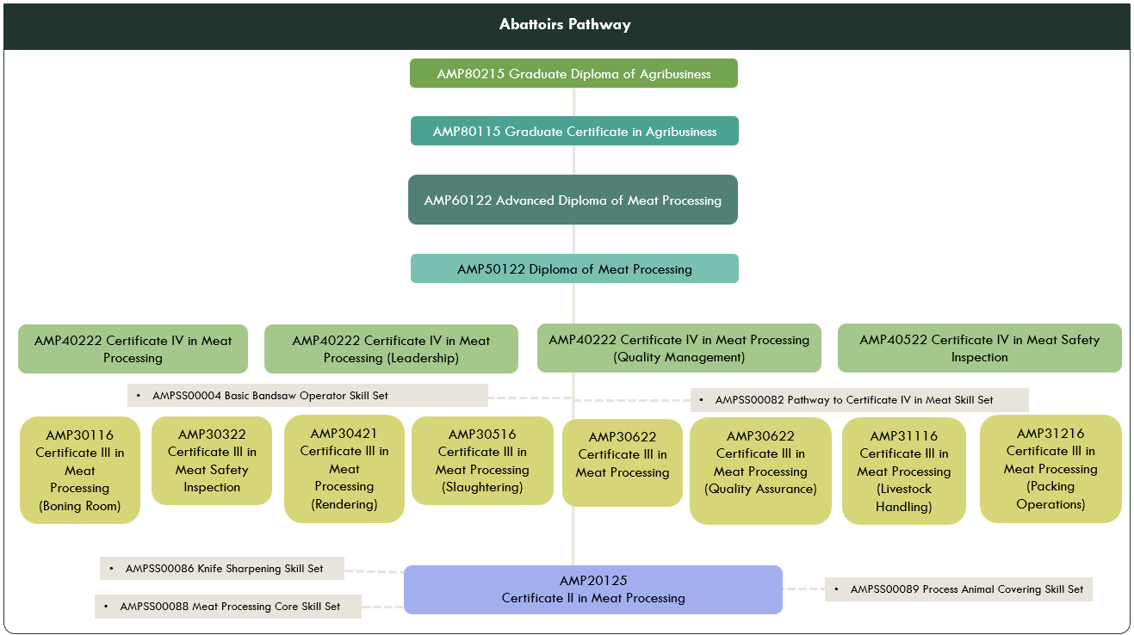

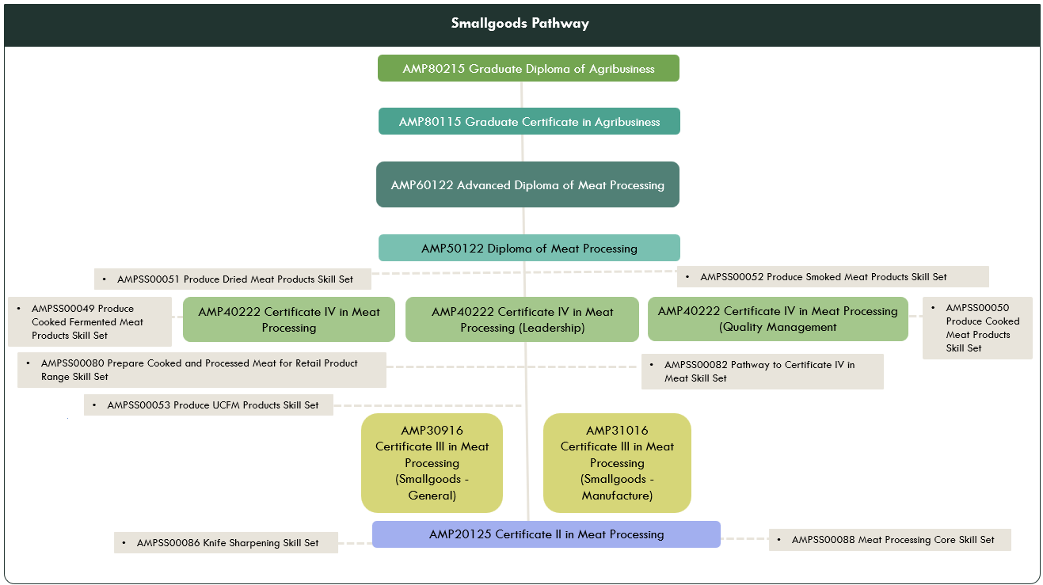

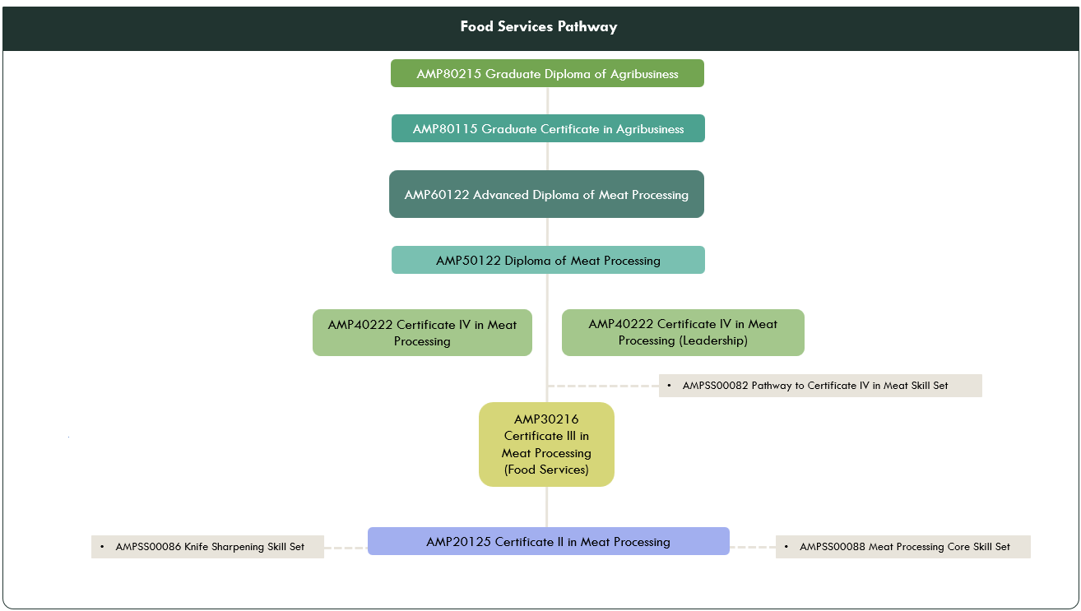

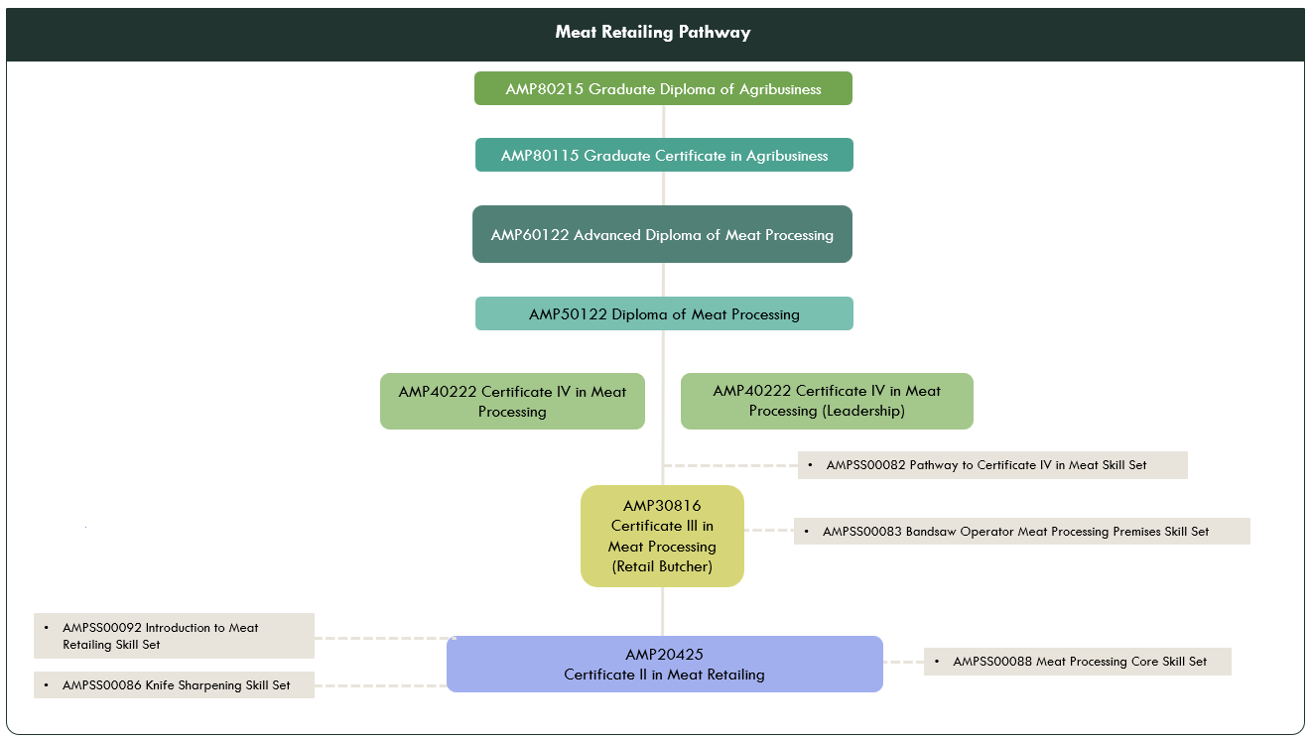

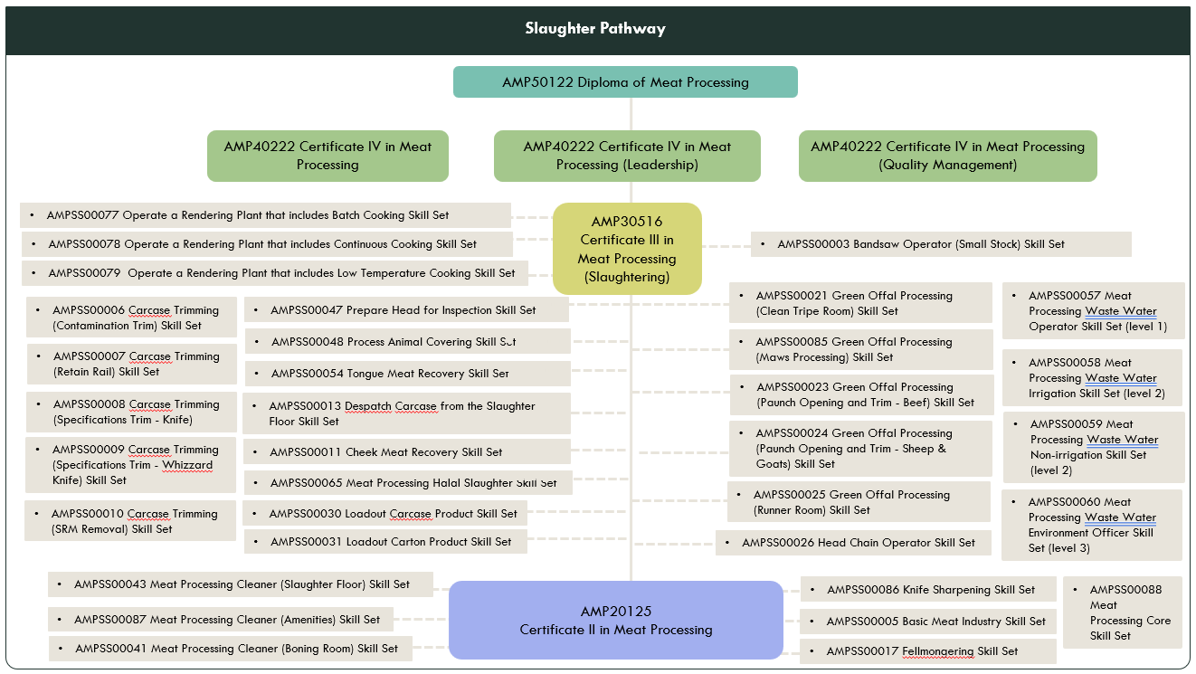

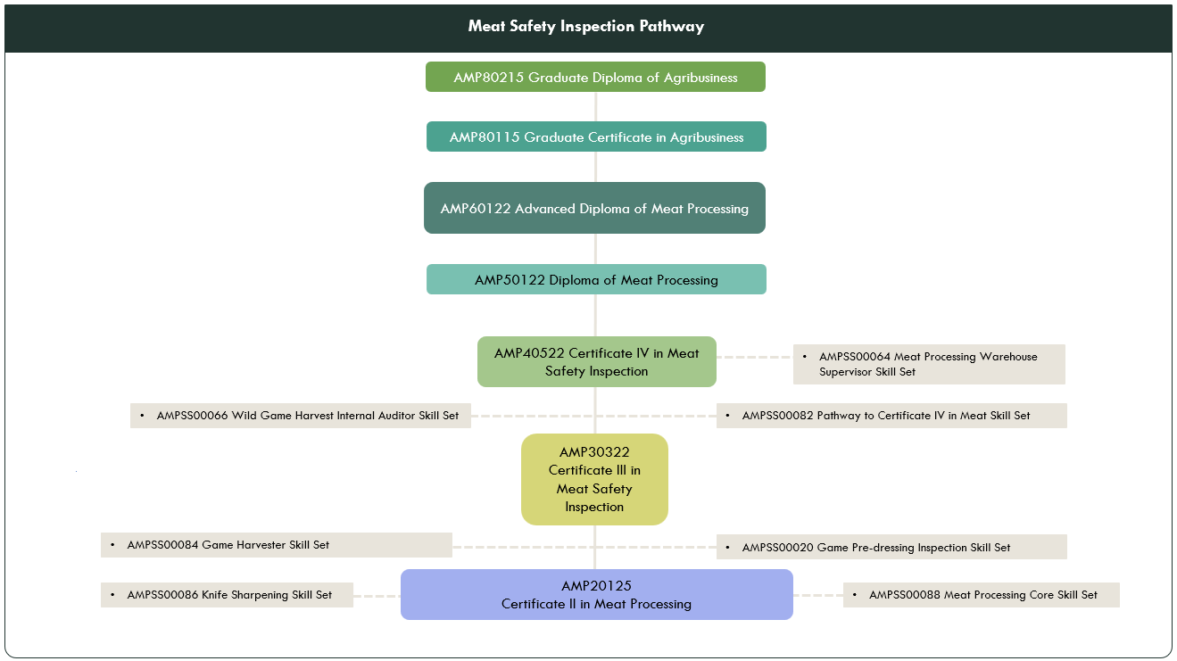

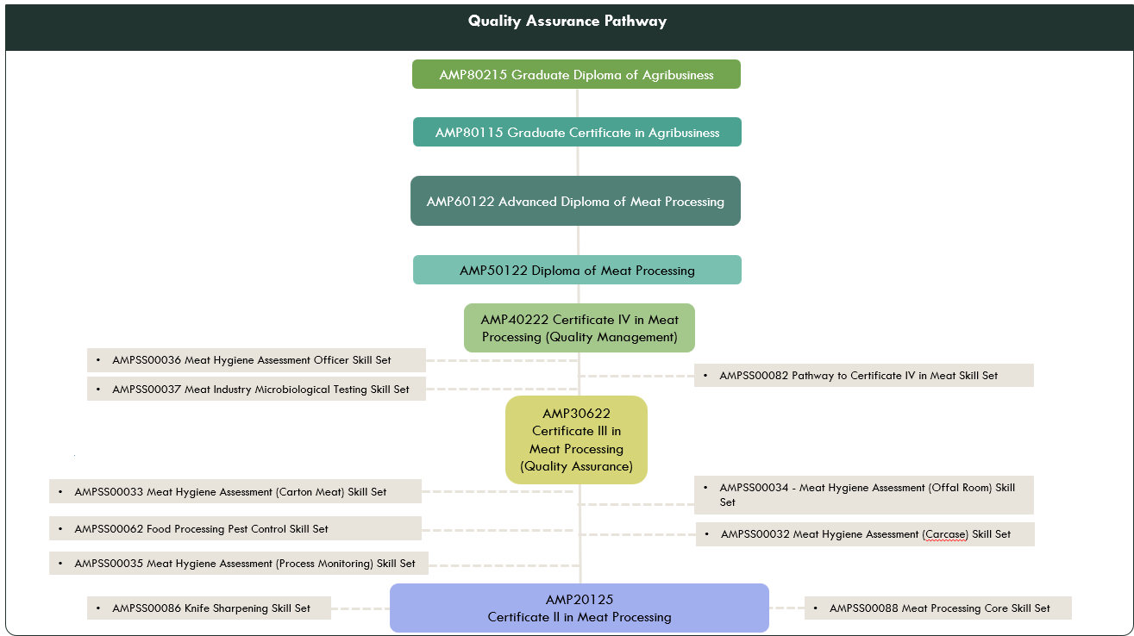

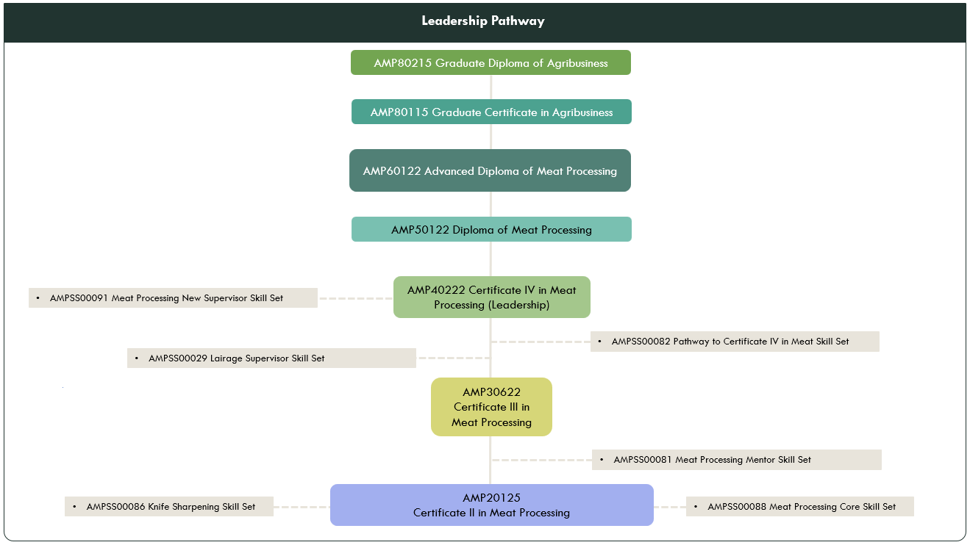

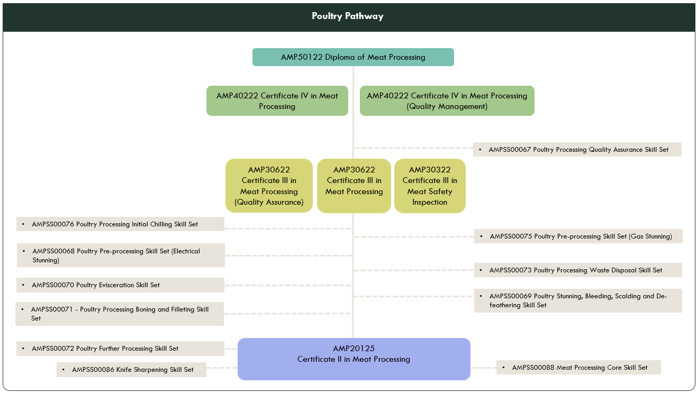

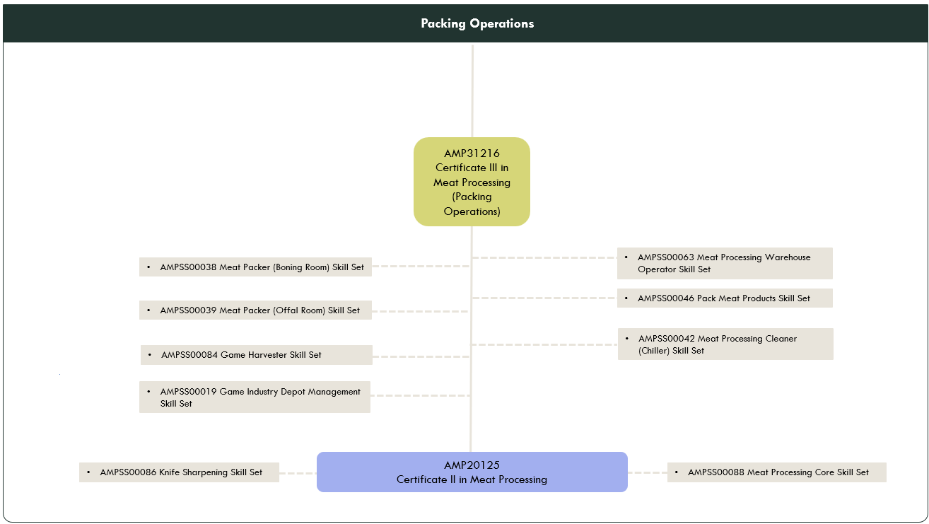

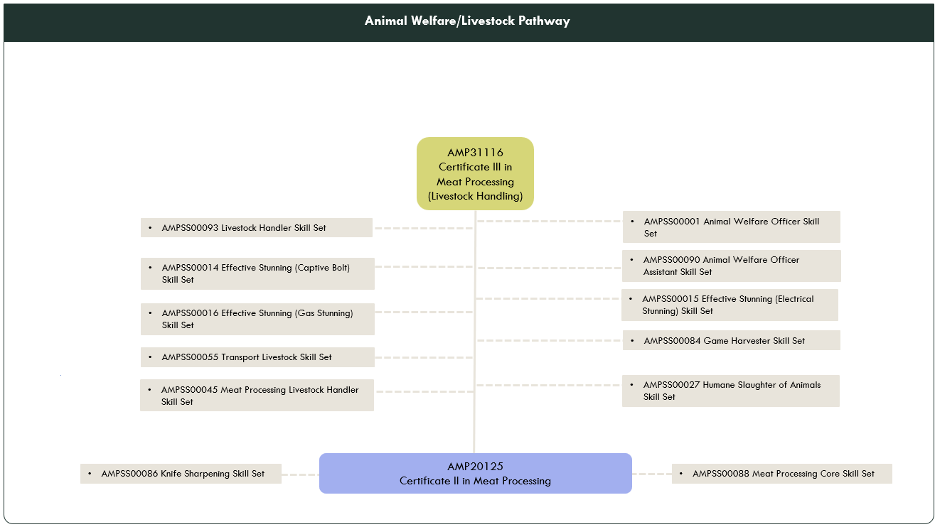

Entry requirements for qualifications
Any specific entry requirement for qualifications in the AMP Australian Meat Processing Training Package are included in each qualification. These entry requirements ensure an individual has the skills and knowledge required to undertake the qualification.
The table provides a summary of those qualifications with entry requirements.

Qualification | Entry requirements
AMP31216 Certificate III in Meat Processing (Packing Operations) | The following units, or their equivalents, must be completed before starting this qualification:  - AMPA2068 Inspect meat for defects  - AMPA2070 Identify cuts and specifications  - AMPA2071 Pack meat product.
AMP50221 Diploma of Meat Processing | Entry into this qualification is open to an individual who can demonstrate the skills and knowledge and to:  have completed the following units of competency prior to commencement of this qualification:  - AMPCOR401 Manage own work performance  - AMPCOR402 Facilitate Quality Assurance process  - AMPCOR403 Participate in workplace health and safety risk control process  - AMPCOR404 Facilitate hygiene and sanitation performance  Or  - may have acquired the skills and knowledge through industry experience or through the completion of a Certificate IV Meat Processing qualification or equivalent.
AMP60122 Advanced Diploma of Meat Processing | Prior to commencing this qualification an individual must:  have completed the following units of competency:  - AMPLDR404 Manage own work performance and development  - AMPQUA401 Support food safety and quality programs  - AMPQUA402 Maintain good manufacturing practice in meat processing  - AMPWHS401 Monitor workplace health and safety processes  Or  - have equivalent skills and knowledge acquired through industry experience or through the completion of a Certificate IV Meat Processing qualification or equivalent.
AMP80115 Graduate Certificate in Agribusiness | Individuals must enter the qualification through one of the following entry points which demonstrate their potential to undertake study at graduate level:  - an Advanced Diploma or Diploma qualification relevant to an Agrifood industry  - relevant extensive vocational experience in middle management in an Agrifood industry at a skill level commensurate with the AQF level 6 attributes and criteria  - higher education qualification (e.g., bachelor’s degree), with relevant experience in an Agrifood industry.
AMP89215 Graduate Diploma of Agribusiness | Individuals must enter the qualification through one of the following entry points which demonstrate their potential to undertake study at graduate level:  - an Advanced Diploma or Diploma qualification relevant to an Agrifood industry  - relevant extensive vocational experience in middle management in an Agrifood industry at a skill level commensurate with the AQF level 6 attributes and criteria  - higher education qualification (e.g., bachelor’s degree), with relevant vocational experience in an Agrifood industry.

Selecting electives to enable different occupational outcomes
Qualifications include elective units that should be selected according to the needs of the learner. The choice of elective units may be negotiated between the learner and/or employer, and the RTO conducting the training program.
Some qualifications allow electives to be selected from within the training package, and also from other training packages and accredited courses. Wherever they are selected from, elective units should provide a vocational focus for the qualification and be relevant to the:
- AQF qualification level
- job role
- work outcomes
- local industry needs
- area of specialisation (if required).

Mandatory requirements for specialisations
Some qualifications in the AMP Australian Meat Processing Training Package have been designed to allow specialisations. The area of specialisation can be included on a testamur to certify attainment of an AQF qualification as shown in the example.
This is to certify that
John Smith
has fulfilled the requirements for
AMP Certificate III in Meat Processing
(Quality)

Choosing electives for specialisations
Electives must be chosen to ensure the integrity and occupational outcomes of the qualification. In almost all qualifications, the packaging rules will have been deliberately written to prevent an RTO from delivering a qualification totally comprised of ‘easy options’ (i.e., to make the delivery of the qualification easier at the expense of disregarding the occupational outcomes required by the job role, workplace requirements and industry practices).
Where the packaging rules might make this possible, the RTO must structure the electives to ensure the integrity of the qualification is not compromised, and will deliver to the individual the outcomes required by the workplace and job role, not make it easier for the RTO to deliver and assess. For example, it has been identified that packaging rules for the AMP30516 Certificate III in Meat Processing (Slaughtering) may make it possible to select very similar units but for different species in order to compromise the overall integrity of the qualification. The qualification is not limited to a single species in order to enable broad usage; however, care should be taken if selecting units covering more than one species so that the qualification continues to meet the occupational outcomes, and not just create an ‘easy’ qualification to deliver and assess.
Units not to be delivered in the same qualification
The updated qualifications include some units that include similar skills and knowledge but cover work in different contexts. These units should not be delivered in the same qualification:

Unit of competency | Must not be delivered in the same qualification with: (and vice versa)
AMPABA303 Use standard product descriptions – sheep and goats | AMPQUA413 Specify sheep product using AUS-MEAT language
AMPABA304 Use standard product descriptions – beef | AMPQUA412 Specify beef product using AUS-MEAT language
AMPABA305 Use standard product descriptions – pork | AMPQUA422 Specify pork product using AUS-MEAT language

Elective choices in the AMP40522 Certificate IV in Meat Safety Inspection
The packaging rules for the AMP40522 Certificate IV in Meat Safety Inspection include the following:
The electives are to be chosen as follows:
at least 1 unit from Group A
up to 2 units from Group B or from this or any other endorsed training package or accredited course. Elective units must ensure the integrity of the qualification’s Australian Qualification Framework (AQF) alignment and contribute to a valid, industry-supported vocational outcome.
Of the 3 electives chosen, only one may be completed through a Recognition process.
The requirement for at least two of the electives not to be completed through a Recognition process ensures that those who have completed a AMP30322 Certificate III in Meat Safety Inspection would then complete different units to achieve the AMP40522 Certificate IV in Meat Safety Inspection qualification. This helps to distinguish the qualifications from each other and also ensures that any funding utilised for delivery does not double up with the Certificate III.
RTOs should ensure that the elective units chosen for the AMP4022 Certificate IV in Meat Safety Inspection broaden the skills and knowledge base of learners, and also support the overall AQF alignment of the qualification. Choosing any of the units from Group A or Group B that are coded at AQF4 would fulfil that requirement.

Qualification | Specialisation | Mandatory elective choices
AMP30622 Certificate III in Meat Processing | Quality | At least 5 Group A elective units:  - AMPABA303 Use standard product descriptions – sheep and goats  - AMPABA304 Use standard product descriptions – beef  - AMPQUA304 Perform carcase Meat Hygiene Assessment  - AMPQUA305 Perform process monitoring for Meat Hygiene Assessment  - AMPQUA306 Perform boning room Meat Hygiene Assessment  - AMPQUA307 Perform offal Meat Hygiene Assessment  - AMPQUA308 Grade beef carcases using MSA standards  - AMPQUA309 Perform manual chemical lean testing  - AMPQUA313 Perform pre-operations hygiene assessment  - AMPQUA312 Assess meat product in chillers  - FBPFSY3005 Control contaminants and allergens in food processing  - FBPPPL3005 Participate in audit process
AMP40222 Certificate IV in Meat Processing | Leadership | At least 6 Group A elective units:  - AMPLDR402 Supervise new recruits  - AMPLDR404 Manage own work performance and development  - AMPLDR405 Oversee export requirements  - AMPLDR406 Foster a learning culture in a meat processing workplace  - BSBCMM412 Lead difficult conversations  - BSBCUS402 Address customer needs  - BSBHRM413 Support the learning and development of teams and individuals  - BSBHRM415 Coordinate recruitment and onboarding  - BSBINS402 Implement workplace information system  - BSBLDR411 Demonstrate leadership in the workplace  - BSBLDR412 Communicate effectively as a workplace leader  - BSBLDR414 Lead team effectiveness  - BSBLDR521 Lead the development of diverse workforces  - BSBOPS402 Coordinate business operational plans  - BSBOPS404 Implement customer service strategies  - BSBPEF402 Develop personal work priorities  - BSBPMG423 Apply project cost management techniques  - BSBSTR402 Implement continuous improvement  - BSBXCM401 Apply communication strategies in the workplace  - FBPPPL4007 Manage internal audits  - MSS405013 Facilitate holistic culture improvement in an organisation  - SIRRRTF002 Monitor retail store financials
AMP40222 Certificate IV in Meat Processing | Quality Management | At least 6 Group B elective units:  - AMPAUD401 Conduct an animal welfare audit of a meat processing premises  - AMPLSK401 Oversee humane handling of animals  - AMPMGT515 Develop and implement a TACCP and VACCP plan  - AMPQUA316 Collect and prepare standard samples  - AMPQUA403 Utilise refrigeration index  - AMPQUA404 Maintain a Meat Hygiene Assessment program  - AMPQUA405 Oversee compliance with Australian Standards for meat processing  - AMPQUA406 Apply meat science  - AMPQUA407 Conduct and validate pH/temperature declines to MSA standards  - AMPQUA410 Manage the collection, monitoring and interpretation of animal health data  - AMPQUA411 Calculate carcase yield in a boning room  - AMPQUA412 Specify beef product using AUS-MEAT language  - AMPQUA413 Specify sheep product using AUS-MEAT language  - AMPQUA414 Coordinate a product recall  - AMPQUA415 Undertake chiller assessment to AUS-MEAT requirements  - AMPQUA416 Conduct an internal audit of a documented program  - AMPQUA417 Establish sampling program  - AMPQUA418 Conduct a document review  - AMPQUA422 Specify pork product using AUS-MEAT language  - AMPQUA423 Participate in the ongoing development and implementation of a HACCP and QA system  - AMPX431 Oversee meat processing establishment’s Halal compliance  - FBPAUD4004 Identify, evaluate and control food safety hazards  - FBPFST4004 Perform microbiological procedures in the food industry  - FBPFSY3005 Control contaminants and allergens in food processing  - FBPFSY4005 Conduct a traceability exercise  - FBPOPR4001 Apply principles of statistical process control

Training package delivery and assessment
RTOs must ensure that both training and assessment complies with the relevant standards. In general terms, training and assessment must be conducted by individuals who:
- have the necessary training and assessment competencies
- have the relevant vocational competencies at least to the level being delivered or assessed
- can demonstrate current industry skills directly relevant to the training/assessment being delivered
- continue to develop their VET knowledge and skills, industry currency and trainer/assessor competence.
Assessors of some units of competency may have to meet requirements in addition to those of the Standards for Registered Training Organisations (RTOs) 2025/AQTF requirements for assessors.
Check the Assessment Conditions section (provided in the assessment requirements that accompany each unit of competency) for specific assessor requirements.
For further information, RTOs are to refer to 2025 Standards for Registered Training Organisations - https://www.dewr.gov.au/standards-for-rtos
The guide covers several important aspects of assessment within the Australian Meat Processing industry and specifies industry expectation for quality assessment. This guide should be read in conjunction with the Companion Volume Implementation Guide Part 2 and Companion Volume Assessment Guide.
This Companion Volumes for the AMP Australian Meat Processing Training Package can be downloaded from National Training Register (NTR) at: https://training.gov.au/training/details/AMP/summary

Amount of training and volume of learning
RTOs must create a training and assessment strategy for delivery of AQF qualifications that reflects the complexity required of that qualification. An essential consideration in the training and assessment strategy is to ensure the amount of training provided is sufficient so that the learner can:
- meet the requirements of each qualification
- gain the skills and knowledge specified in the units of competency.
The amount of training involves all the formal learning activities provided to a learner; for example, classes, tutorials, fieldwork, lectures, online or self-paced study, as well as workplace learning. Training should take into account the need to allow learners to reflect on and absorb the knowledge, to practise the skills in different contexts and to learn to apply the skills and knowledge in the varied environments that the ‘real world’ offers before being assessed.
AQF qualifications differ in terms of their complexity. The complexity of a qualification is defined by:
- the breadth and depth of the knowledge
- skills required
- application of knowledge and skills, and
- the AQF volume of learning.
The AQF volume of learning describes how long a learner, without any competencies identified in the qualification, would normally take to develop all the required skills and knowledge at that qualification level. The volume of learning includes all teaching, learning and assessment activities that are undertaken by the typical student to achieve the learning outcomes of the particular qualification.

Access and equity considerations
An RTO’s training and assessment practices should minimise any barriers to training and assessment by considering the individual needs of learners. Some needs that could affect an individual’s participation in training and assessment include:
- age
- gender
- cultural or ethnic background
- disability
- sexuality
- language, literacy or numeracy skills
- employment status
- geographical location.
While the design and content of this training package supports equitable access and progression for all learners, it is the responsibility of the RTO delivering and assessing qualifications to:
- ensure that training and assessment processes and methods do not disadvantage individuals
- determine the needs of individuals and provide access to any educational and support services necessary.

Some practical ways that access and equity issues could be addressed include:
- modifying assessment processes for learners located at a distance from a campus location
- checking that materials are culturally appropriate for learners, and amending as necessary
- making sure that activities and assessments are suitable for the language, literacy and numeracy skill levels of learners (while meeting the requirements of the unit of competency).

Considerations specific to learners with disability
RTOs must take steps to provide the same training opportunities for learners with recognised disabilities as those without disabilities.
In some cases, ‘reasonable adjustments’ are made to the training environment, training delivery, learning resources and/or assessment tasks to meet the needs of a learner with a disability. An adjustment is ‘reasonable’ if it can accommodate the learner’s particular needs, while also taking into account factors such as:
- the views of the learner
- the potential effects of the adjustment on the learner and others
- the costs and benefits of making the adjustment to the RTO.
Adjustments must:
- be discussed and agreed to by the learner with a disability
- benefit the learner with a disability
- maintain the competency standards
- be reasonable to expect in a workplace.
Adjustments are not required if they could:
- cause the RTO unjustifiable hardship
- harm other learners.
Further information on providing quality training and assessment to learners with disabilities can be found at:
Providing quality training and assessment services to students with disabilities | Australian Skills Quality Authority (ASQA)

Foundation skills in units of competency
Foundation skills are the ‘non-technical skills’ that individuals need so they can participate effectively in workplaces, in education and training, and in their communities.
Under the Standards for Training Packages 2022, training package developers must include foundation skills in units of competency; however, the method and format for doing this has not been prescribed.

Frameworks used
The foundation skills are derived from The Australian Core Skills Framework (ACSF) which is used to identify learning, language, literacy and numeracy (LLN) skills.
The skills included in the framework are:
- Learning
- Reading
- Writing
- Oral Communication
- Numeracy.
The five skills are identified separately with descriptions explaining how the skill underpins the performance criteria. The foundation skills table in each unit:
- identifies applicable underpinning skills
- describes the application of each skill in the context of the performance criteria.
Only those foundation skills that ARE NOT explicit in the performance criteria appear in the foundation skills mapping table.
The foundation skills are an integrated part of the unit for training and assessment purposes. Therefore, it is important that users look closely at both the foundation skills and the performance criteria, to make sure that all foundation skills are considered during delivery and assessment.
In the AMP Australian Meat Processing Training Package (and all training packages developed by Skills Insight) the foundation skills are shown in a table format as shown in the following example.
Foundation Skills
This section describes those language, literacy, numeracy and employment skills that are essential for performance in this unit of competency but are not explicit in the performance criteria.
Skills | Description (examples)
Learning | Understand the main tasks, responsibilities and boundaries of own work role. Organise self for work.
Reading | Read and understand workplace requirements, workplace instructions, standard operating procedures, site safety instructions, etc.
Writing | Complete checklists, record processing information, note maintenance requirements – on paper or in digital format
Oral Communication | Interact verbally with others on site, ask questions to clarify information, give instructions, participate in meetings, etc.
Numeracy | Carry out calculations when required of job role, monitor time, temperature, etc.
Not all units include all of these skills. The intent of the information in this field is to pick up on the foundation skills that are not explicit in the Performance Criteria of the units, highlighting that the skill is important to carrying out the overall job task described in the unit of competency.
For example, in the unit AMPQUA411 Calculate carcase yield in a boning room, the following skills are noted in the foundation skills field.
Foundation Skills
This section describes those language, literacy, numeracy and employment skills that are essential for performance in this unit of competency but are not explicit in the performance criteria.
Skills | Description
Reading | - Interpret workplace procedures and legislative responsibilities
Writing | - Record weights using digital and/or paper-based formats
Numeracy | - Carry out calculations to identify yields, including percentages (%)  - Weigh cuts of meat (g, kg)  - Calculate actual and expected carcase yields

The skills noted in the table must be addressed as part of the training for this unit, in the context of the job task. There is no industry requirement for these skills to be separately assessed, unless specifically noted in the Assessment Requirements for the unit.
For further information about the Australian Core Skills Framework, go to: https://www.dewr.gov.au/skills-information-training-providers/australian-core-skills-framework.

A ‘meat processing’ work environment
In several units of competency, the work environment has been noted as ‘meat processing’ or in a ‘meat processing premises’. This generic phrase, covers any or all of the following work environments:
- boning room
- chilling and freezing areas
- cold storage business
- farmed game processing premises
- food service operations
- game meat processing establishment
- knackery
- meat storage facility
- mobile abattoir
- mobile butcher
- offal processing room
- pet food processing premises
- poultry processing premises
- rendering premises
- retailing premises
- slaughtering premises
- smallgoods processing premises
- value-adding premises
- wholesale butchery
- wild game field depot
- wild game field harvester vehicle
- wild game meat processing premises.

Training and assessing environments

Risks of zoonotic diseases
There are risks of exposure to zoonotic diseases, when working to process meat, especially for those working in slaughtering premises, wild game animal processing premises, wild animal field harvesting or storage sites where cattle, sheep, goats, horses, camels, alpacas and kangaroos are processed.
Personnel at high risk of Q Fever are those that handle live animals, or come in contact with wool or hides, animal faeces, urine or birth products. Personnel involved in boning, slicing, packing, manufacturing and retail are not at risk provided these operations are not conducted on the same site as the slaughtering.
Workers should use personal protective equipment (including gloves), especially when working on the following tasks:
- Working with small stock, especially ovine – risk of ‘scabby mouth’
- Ante-mortem and post-mortem on pigs – swine erysipelas (or diamonds disease), which is contagious to humans
- Evisceration of pigs and calves including kidney removal – risk of leptospirosis (organisms are found in the urinary system: bladder, kidneys, urethra, and can spread during removal of these parts of the body)
- Handling slinks or opening placentas – risk of brucellosis
- Head and tongue removal of sheep and goats – risk of pustular dermatitis (also known as orf)
- Field harvesting of wild boar – possible leptospirosis.

Colour blindness
Job tasks or units of competency that include identifying defects or contamination require that individuals see colour. This check should be carried out by the RTO before enrolling students. Note that adaptive technologies are emerging to assist individuals to see colour with accuracy.

‘Simulated’ assessment
The Assessment Conditions section of the Assessment Requirements states whether assessment must take place in a real workplace or whether an environment that ‘accurately represents workplace conditions’ can be used.
An environment that accurately represents workplace conditions is one that offers real-life working conditions with the actual characteristics of that working environment, including equipment, interactions with other people, and completion of tasks within timeframes, if these are requirements of the working environment.
Sometimes conducting training and assessment in a real workplace is not possible or practical. If conducting training and assessment in a non-workplace environment, trainers and assessors must make sure that learners have opportunities to complete tasks:
- to the quality standards, and within the acceptable timeframes, required by the industry
- in a manner that meets the industry’s safety standards.

Assessment Conditions
Assessment of the skills in this unit of competency must take place under the following conditions:
- physical conditions:
- skills must be demonstrated in lairage or an environment that accurately represents workplace conditions
- resources:
- real animals for ante-mortem inspection
- specifications:
- workplace procedures, including advice on safe work practices and animal welfare and safety
- relationships:
- interactions with work team.

Assessment for this unit must include at least three forms of evidence.

Assessors of this unit must satisfy the requirements for assessors in applicable vocational education and training legislation, frameworks and/or standards.
Example Assessment Conditions from unit AMPLSK301 Handle animals humanely while conducting ante-mortem inspection.
The ‘physical conditions’ noted refer to the physical environment where the assessment must take place. The skills in some units must be assessed in a particular setting; a slaughtering premises, for example. Where a particular setting is specified, the physical environment cannot be varied – this is a mandatory work requirement for assessment.
Several units include ‘or an environment that accurately reflects workplace conditions’. This means that the assessment can be simulated, but the environment for that simulation must be ‘work-like’ and include the equipment and documentation that would be available in a typical workplace – for example, work instructions, SOPs or guidelines for work tasks, real animals and team members to work alongside.
Simulated assessment is appropriate for units where the content covers situations that are dangerous or unlikely to occur during everyday work, such as with the unit AMPMSY302 Recognise signs of emergency animal diseases. Many emergency animal diseases are not seen in Australia and so the assessment for this unit needs to include graphic images or photos of the signs and symptoms of disease that may occur and must be reported.
The assessment methods (such as quizzes, third party reports, exams) referred to in previous versions of the units have been removed, to ensure compliance with the Standards for Training Packages 2022. RTOs can determine which assessment methods are used to assess the content of the unit. However, the meat processing industry, through the Meat Industry Reference Committee (IRC), insist that assessment of units included in the AMP Australian Meat Processing Training Package must be robust and meet best practice standards for assessment, including meeting the Principles for Assessment and the Rules of Evidence, as outlined in the 2025 Standards for RTOs.

For Certificate II and Certificate III level qualifications, most of the task-related training will occur in the workplace, as part of the daily work schedule. This is particularly the case in the meat processing sector. This is because the nature of the work and licensing laws means it is difficult to create a simulated workplace. The trainee will be working at a specific station in the production line, alongside an experienced supervisor or other skilled worker. Training will be provided by the RTO trainer during visits to the production site – during these visits it is highly likely that the RTO trainer will be working with several trainees. Training will be supported by the supervisor or another skilled worker who has been tasked with providing guidance, direction and training of the trainee as they work.
The size of an organisation in which the individual is undertaking training may have an impact on training delivery, particularly if the organisation is particularly large or small. While the job roles and processes might be the same, they might be carried out in a different order of operations. This may mean that the order of the delivery and assessment of performance criteria or other parts of a unit of competency might need to be rearranged to suit a particular workplace. As long as the entire unit is covered by the training and assessment processes overall, then that is acceptable to do.
Some parts of the theory training are likely to occur in a training room, facilitated by an RTO trainer. This training may be incorporated into the trainee’s induction process and involve presentations from several people, including workplace personnel. It may occur as a block of up-front training before the trainee goes onto the processing line, or it may be a series of short sessions intermixed with work on the production line.
Training in meat retailing premises is often delivered on-site also. Training is delivered under supervision using the workplace location and equipment. Only those aspects which cannot be delivered at work are undertaken elsewhere – sometimes off-site at a training facility, sometimes in a separate room at the workplace.
This training may also include the trainee accessing self-paced online or printed training programs addressing theory components, viewing short videos, or completing online quizzes.
In some cases, trainees may be given reference materials and/or small research assignments to complete – this is more likely to occur at Certificate III level.
Some methods a trainer can use to monitor the quality and consistency of the training support provided by a supervisor or another skilled worker include:
- regularly reviewing the trainee’s performance and progress with the supervisor or work colleague
- observing the trainee’s progress during regular visits to the workplace (note that direct communication with the trainee may not always be possible, especially where this may pose health and safety risk, such as when a trainee is using a bandsaw)
- regular conversation with the trainee, either on or off the job as appropriate, to discuss their progress and confidence in the quality of training provided.
In cases where training and assessment in a real workplace is not possible or practical, trainers and assessors must make sure learners have opportunity to complete tasks:
- to the quality standards, and within the acceptable timeframes, required by the industry
- in a manner that meets the industry’s safety standards.
When individuals are undertaking training in higher level qualifications, such as Certificate IV and above, some aspects of the training, such as workshops consisting of a half or full day of training or blocks of training that may occur over several days, may be conducted away from the workplace. There may also be projects and research that will need to be undertaken at work or in their own time.

Workplace referees
Workplace referees are expected to be well briefed by the assessor, including the legal implications of any statements they are signing. Suitable referees are usually an immediate supervisor or experienced work colleague who has ample opportunity to observe the trainee’s performance.
Their key role is to testify to consistency of performance over a period of time. Therefore, they must view the trainee working in a production context long enough for them to confidently say the trainee can work at production speed and at a level of accuracy and efficiency expected in the workplace.
A workplace referee can be more than one person.
There is no requirement that workplace referees hold TAE Training and Assessment units or qualifications.

Knowledge assessments
Knowledge assessments can be used to check understanding of the underpinning knowledge. These are questions an auditor/overseeing reviewer might expect a worker to answer during a workplace audit.
Knowledge assessments are expected to reflect language and literacy requirements of the workplace. They can be administered either orally or in writing, and may allow the use of reference material, depending on the requirements of the job.
Knowledge assessments could include a written exam, where assessors identify that mode of assessment is appropriate.

On-the-job demonstration
On-the-job demonstration with assessor observation can be used to assess both skills and knowledge. It enables assessment within the context of the work instruction, regulatory requirements, chain speed, etc. The assessor is expected to discuss performance with and debrief the trainee.

Workplace projects
Workplace projects are often used where a real-time workplace activity is not available; for example a product recall. They may involve simulation; however, simulated assessments are generally not recommended for the AMP Australian Meat Processing Training Package.
Workplace projects enable application of knowledge to the workplace context. They encourage use of the tools and systems used in the workplace as well as analysis and problem-solving that will benefit the workplace.
All assessment must be conducted according to the applicable Australian meat industry standards and regulations.

Legal considerations for learners in the workplace/on placements
Legal requirements that apply to specific sectors covered by this Training Package vary across each state and territory and can change from time to time. Contact the relevant state or territory department/s to check. STA contact details are provided in the Links section of this Implementation Guide. The Fair Work Ombudsman has some general guidelines and fact sheets about unpaid work.
Work placements should always involve the appropriate supervision and guidance from individuals in the workplace and trainers and assessors from the RTO, and must adhere to required legislation that applies in the jurisdiction, e.g., learners must be supplied with the appropriate personal protection equipment (PPE) and training on how to use the PPE effectively prior to undertaking tasks that include health and safety risks.
Resources and equipment lists
RTOs must make sure that all resources and equipment required to train and assess units of competency are available. Details of specific resources, including equipment and materials essential for assessment, are listed in the Assessment Conditions sections of Assessment Requirements documents. Where units of competency require assessment in the workplace, the workplace must include the full range of equipment required to do the task, as listed in the Assessment Conditions.

Importing country requirements
Some AMP units of competency and skill sets cover the skills and knowledge required under trade deals set up with countries that import Australian meat. Examples include:
- AMPCLE204 Clean amenities and grounds (meets importing requirements for EU)
- Animal Welfare Officer Skill Set
- Animal Welfare Assistant Skill Set.

Key meat safety legislative implications for implementation
Regulatory or licensing requirements are identified in the Application field of units of competency and the Qualification description field in qualifications. If there are no particular requirements, then the statement ‘No licensing, legislative or certification requirements apply to this unit/qualification at the time of publication’ will appear.
The following table lists the particular requirements that may impact on qualifications and/or skill sets in the AMP Australian Meat Processing Training Package.
Some units of competency (and their associated assessment requirements) contain references to ‘industry standards’. ‘Industry standards’ may relate to:
- existing legislative instruments
- current industry ‘good’ practice.
Note: Selection of elective units of competency that specify particular licensing, legislative or certification requirements may impact on qualifications. This includes all qualifications, not just those listed in the table.
Qualification/Skill set/Unit of competency | Description of requirement
AMP303122 Certificate III in Meat Safety Inspection | To work as a meat inspector, individuals must register with their state authority, or with the Commonwealth authority, the Department of Agriculture, Fisheries and Forestry.
AMP40522 Certificate IV in Meat Safety Inspection | To work as a meat inspector, individuals must register with their state authority, or with the Commonwealth authority, the Department of Agriculture, Fisheries and Forestry.
AMPAUD401 Conduct an animal welfare audit of a meat processing premises | Animal welfare audits conducted under this unit must be carried out in accordance with the Industry Animal Welfare Standards for Livestock Processing Establishments Preparing Meat for Human Consumption.
AMPGAM303 Use firearms to safely and humanely harvest wild game | Individuals undertaking this unit must hold a current firearms/shooters licence.
AMPLSK205 Perform emergency kill | Where firearms are used to perform emergency kills, the unit must only be undertaken by individuals who already hold a current firearms licence. No other licensing, legislative or certification requirements apply to this unit at the time of publication.
AMPOPR218 Transport meat and or meat products | Individuals undertaking this unit must have a driver’s licence appropriate for the vehicle being used. The vehicle must also be registered as a meat delivery vehicle following state/territory requirements.
AMPOPR305 Operate a forklift in a specific work area | Prior to undertaking this unit, individuals must have gained a licence or permit to operate a forklift.
AMPQUA403 Utilise refrigeration index | This unit references to the Export Control Rules for meat and meat products, which came into effect in March 2021 and require the validation of all chilling processes using the refrigeration index.  The refrigeration index refers to the value obtained by using a recognised predictive model to calculate the potential growth of E. coli at a site of microbiological concern.
AMPQUA405 Oversee compliance with Australian Standards for meat processing | This unit is applicable to meat inspectors, supervisors and quality assurance personnel responsible for ensuring a meat processing premises complies with the relevant Australian Standards.  Some state government departments or meat authorities will require competency in this unit to prove currency when meat inspectors who have been out of the industry for some time seek re-registration.
AMPSS00084 Game Harvester Skill Set | Individuals undertaking this unit must hold a current firearms/shooters licence. Other legislative and regulatory requirements also apply to wild game harvesting and are enforced through state/territory jurisdictions. Users must check with the relevant regulatory authority before delivery.
AMPSS00089 Process Animal Covering Skill Set | The mandatory requirement to obtain a national High Risk Work Licence to operate a forklift applies to this skill set.

Regulatory or licensing requirements may be mentioned in the Application field of units of competency (UoCs), but completing the unit alone does not provide a licence.
Although some UoCs reference licensing, they do not grant or fulfill licensing requirements.
Licences are issued by state or territory licensing bodies, which may impose additional requirements beyond the UoC. Users must check with the relevant regulatory authority before delivery.

Firearms
Firearms licensing and registration department details are listed in this table.
Firearms licensing and registration departments | Email | Telephone
ACT Firearms Registry | actfirearmsregistry@afp.gov.au | 02 6133 2122
NSW Polic Firearms Registry | firearmseng@police.nsw.gov.au | 1300 362 562
NT Firearms Policy & Records Unit | firearmsregistry@pfes.nt.gov.au | 08 8922 3543
Qld Weapons Licensing Branch | weaponslicensing@police.qld.gov.au | 07 3015 7777
SA Firearms Branch | sapol.firearmsbranch@police.sa.gov.au | 08 7322 3346
Tas Police Firearms Services | Firearms.services@police.tas.gov.au | 03 6173 2720
Vic Licensing & Regulation Division | licensingregulation@police.vic.gov.au | 1300 651 645
WA Police Licensing Services | licensingservicesfirearms@police.wa.gov.au | 1300 171 011

Forklifts
To legally operate a forklift in Australia, individuals must obtain a High Risk Work Licence (HRWL) specific to forklift operation. This licence is issued by the relevant state or territory work health and safety (WHS) authority, not by Safe Work Australia, which is the national policy body and does not issue licences.
Training Requirements:
- Training to obtain a forklift HRWL must be completed through an accredited RTO.
- Individuals enrolled in forklift training may operate a forklift at their workplace if they are:
- Enrolled with an RTO to train as a forklift operator, and
- Directly supervised while operating the forklift by a person who holds the appropriate licence and has suitable workplace experience.
Each state and territory in Australia has its own WHS authority responsible for issuing HRWLs. While the licence is nationally recognised, the application process and requirements may vary between jurisdictions. For example, in New South Wales, the licensing body is SafeWork NSW.
Operating a forklift without the required HRWL is illegal and can result in significant legal consequences.
For detailed information on obtaining a forklift HRWL, refer to your local WHS authority's guidelines.
Name | State/Territory | Website
Access Canberra | ACT | High risk work licences - Access Canberra
SafeWork NSW | NSW | High risk work licences | SafeWork NSW
NT WorkSafe | NT | High risk work licence | NT WorkSafe
Workplace Health and Safety Queensland | QLD | Apply for a high risk work licence | WorkSafe.qld.gov.au
SafeWork SA | SA | High risk work licences | SafeWork SA
WorkSafe Tasmania | TAS | High risk licensing
WorkSafe Victoria | VIC | High risk work licence | WorkSafe Victoria
WorkSafe WA | WA | Important information for forklift operators in Western Australia - WorkSafe – DEMIRS  High risk work licence - WorkSafe – DEMIRS

Users of this Implementation Guide are advised to keep up-to-date with changes to legislative requirements by checking with the relevant regulatory authority.

Health and safety requirements
In general, health and safety requirements are addressed in specific work health and safety units of competency or embedded in particular units of competency in the AMP Australian Meat Processing Training Package.
Include specific information for this training package if it is not covered by the generic information above; otherwise just delete this instruction.
RTOs must make sure that delivery of health and safety content is contextualised to comply with the relevant legislation in the state/territory in which they are training. Details of state and territory regulators, together with some useful workplace health and safety organisations, have been included in the following tables.
State/Territory Regulators
State/Territory | Regulating Body | Website
Australian Capital Territory | WorkSafe ACT | http://www.worksafe.act.gov.au
New South Wales | SafeWork NSW | http://www.safework.nsw.gov.au
Northern Territory | NT WorkSafe | http://www.worksafe.nt.gov.au
Queensland | Workplace Health and Safety Queensland (WHSQ) | http://www.worksafe.qld.gov.au
South Australia | SafeWork SA | http://www.safework.sa.gov.au
Tasmania | WorkSafe Tasmania | http://worksafe.tas.gov.au
Victoria | WorkSafe Victoria | http://www.worksafe.vic.gov.au
Western Australia | WorkSafe WA | http://www.commerce.wa.gov.au/WorkSafe

National organisations
Name | Function | Website
Safe Work Australia | Leads the development of national policy to improve work health and safety and workers’ compensation arrangements across Australia. | http://www.safeworkaustralia.gov.au
Comcare | The Comcare scheme provides rehabilitation and workers' compensation and occupational health and safety arrangements for Australian Government employees and for the employees of organisations which self-insure under the scheme. | http://www.comcare.gov.au
Australian Industrial Chemicals Introduction Scheme (AICIS) | AICIS protect Australians and our environment by finding out the risks of industrial chemicals and recommending ways to promote their safer use. | https://www.industrialchemicals.gov.au/

Meat Safety Inspection
The Australian meat industry operates under a range of Acts, regulations and/or industry standards.
Following is a summary of key requirements.
Seventy per cent of meat consumed in Australia is produced in export-registered abattoirs under the control of the Australian Department of Agriculture, Fisheries and Forestry. The Department of Agriculture regulates export operations in all states and territories. Apart from export certification, the Department of Agriculture supplies both a meat inspection service (including veterinarians and meat inspectors) and a regulatory oversight by Area Technical Managers.
In order to supply meat to the domestic market, all meat processing plants must be licensed with the relevant state/territory authorities. Most authorities have different classes of licence depending on the type of animal/meat being processed.
Since the early 1990s, the regulation of the domestic meat industry in each state and territory has been conducted by state government departments or meat hygiene authorities. While there are variations in requirements, all abattoirs must meet the agreed Australian Standards, which are referenced in the legislation in each state/territory. The responsible bodies are:
Jurisdiction | Responsible department
Commonwealth | Department of Agriculture, Fisheries and Forestry
Queensland | Safe Food Production Queensland
New South Wales | Department of Primary Industries
Australian Capital Territory | Health Protection Service
Victoria | PrimeSafe
Tasmania | Department of Natural Resources and Environment Tasmania, Primary Produce Safety Program, Biosecurity Tasmania
South Australia | Department of Primary Industries and Regions
Western Australia | Department of Health
Northern Territory | Department of Primary Production
Note that the regulations for meat safety, and the qualifications required of meat safety inspectors, vary between the states and territories. Users should check local requirements.
All state and territory meat hygiene authorities base their legislation on the Australian Standards, in particular AS 4696:2007 Australian Standard for the hygienic production and transportation of meat and meat products for human consumption or its successor.
The Australian Standards largely apply to wholesale businesses handling raw meat. Once a product is further processed by cooking, drying or fermentation, it is regulated by food authorities applying the Australian New Zealand Food Standards Code, although the AS 4696:2007 Australian Standard for the hygienic production and transportation of meat and meat products for human consumption also applies.
Meat Standards Australian (MSA) is a voluntary eating-quality grading system proven to take the guesswork out of buying and cooking Australian beef and lamb. All products identified with the MSA symbol have met strict criteria to ensure they achieve consumer expectations for tenderness, juiciness and flavour. Only licensed producers can apply the MSA grading system. Australian brands can choose to underpin the eating quality of their products by using the MSA standards and grading specification. These brands may also have additional specifications, which can be applied at grading.
Most retail activity is controlled by state or territory food authorities and by local councils.

Australian Standards that apply to meat processing
There are a number of Australian Standards (AS) that apply to meat processing. As mentioned above, meat that is further processed by cooking, drying or fermentation must also meet the requirements of the Australian New Zealand Food Standards Code.
There are many references to the ‘relevant Australian Standard/s’ throughout the units of competency. Because the Australian Standard/s relevant to the meat processing industry are updated from time to time, the codes and details of particular Australian Standards is not included. In each situation, the most recent version of the Australian Standard applies. At the time of writing, this includes:
- AS 4696:2007 Australian Standards for the hygienic production and transportation of meat and meat products for human consumption
- AS 5812:2017 Manufacturing and marketing of pet food provides requirements for the manufacture and marketing of pet food intended for consumption by domesticated cats and dogs
- AS 4464:2007 Hygienic production of game meat for human consumption applies to game animals shot in the field and processed at game processing plants
- AS 4466:1997 Hygienic production of rabbit meat for human consumption applies to rabbits and hare, both those shot in the field and those raised commercially
- AS 5010:2001 Hygienic production of ratite (emu and ostrich) meat for human consumption applies to emus and ostriches processed at specialist abattoirs, with full ante-mortem and post-mortem inspection
- AS 4465:2006 Construction of premises and hygienic production of poultry meat for human consumption applies to all poultry processing, including further processing such as boning and packing
- AS 4.2.2 Primary Production and Processing Standard for Poultry Meat
- Australian Animal Welfare Standards and Guidelines for Poultry
- AS 5011:2001 Hygienic production of natural casings for human consumption applies only to casing manufactured from animal intestines, not artificial casings
- AS 5008:2007 Hygienic rendering of animal products applies to rendering of meat by-products from slaughtering and processing for the production of inedible tallow and meat meal
- Standard for the Hygienic Production of Pet Meat: PISC Report 88 – Amended 2009
- AS 1199.1:2003 Sampling procedures for inspection by attributes.
The Biosecurity Act 2015 has replaced the Quarantine Act 1908 and sets up new requirements and regulatory powers that will affect how the department manages the biosecurity risks of goods, people and conveyances entering Australia.
The Land Transport Standards and Guidelines are being regulated into law by state and territory governments. Currently the Standards are implemented in all states except for Western Australia.
All cattle, sheep and goats processed in Australia and destined for Muslim markets are slaughtered under the Australian Government Supervised Halal Program, which is administered by the Department of Agriculture, Fisheries and Forestry. A list of recognised Islamic Organisations that have an Approved Arrangement with the Department for the certification of red halal meat and red meat products for export is available online from the Department of Agriculture.
Note: There are many references to specific Australian Standards throughout the units of competency. If and when these standards are updated, then reference must be made to the successor.

References to Australian Standards at entry level
During the projects to review units of competency at AQF Level 2, feedback was received to say that references to the Australian Standards and ‘regulations’ at this level was inappropriate. As such, most units and Assessment Requirements at Level 2 include several references to ‘workplace requirements’ or ‘workplace instructions’, which will include the requirements of appropriate standards and regulations.

Meat Inspection standards
There are two tiers of meat inspection standard in Australia, based on the level and type of meat inspection system in place:
- Tier 1 – Applies to domestic meat establishments that are registered to export meat and meat products to applicable markets under the Australian Standards
- Tier 2 – Other export markets require that export registration and oversight of establishments is administered by the Australian government, and this is referred to as Tier 2

Professional accreditation in the industry
The only sector-specific occupation requiring a licence is the role of Meat Inspector, and the registration can be with a Commonwealth or state authority, depending on the nature of the workplace.
However, this industry also employs electricians, plumbers and forklift drivers, which are all licensed occupations.

National Feedlot Accreditation Scheme
The National Feedlot Accreditation Scheme (NFAS) is an independently audited quality assurance scheme that was initiated by ALFA and is managed by an industry committee, the Feedlot Industry Accreditation Committee (FLIAC). Participation in the NFAS is voluntary.

Note about ‘Industry standards’
Many units refer to ‘industry standards’ in the Performance Criteria and sometimes in the Assessment Requirements. Industry standards set the standard for the work to be performed, and may include documents such as Work Instructions, Safe Work Method Statements (SWMS), Standard Operating Procedures (SOPs), or they may be broader statements of standards, such as AUS-MEAT Standards, Meat Standards Australia (MSA) Standards, or standards set by regulators.

Usage of terms
Some of the language used in the training package components has been updated to align with the AS 4696:2007 Australian standard for the hygienic production and transportation of meat and meat products for human consumption, or its successor. For example, the word ‘plant’ has been replaced with ‘premises’ on many occasions, and ‘workplace’ has often been replaced with ‘workplace’.

Note: Users of this Implementation Guide are advised to stay updated with changes to legislative requirements by checking with the relevant regulatory authority.

Training Package developer’s quality assurance process for Companion Volumes
Companion Volumes are developed in consultation with industry representatives and trainers and assessors. These key stakeholders provide and review content to ensure that information is relevant and useful.
The Companion Volumes undergo continuous improvement in response to feedback lodged on the Skills Insight website (https://skillsinsight.com.au).

Links

Industry links
State/Territory | Organisation | Website
AUS-MEAT | AUS-MEAT and AUS-QUAL are Australia and New Zealand’s leading providers of agribusiness auditing, certification and training services, supporting over 70 different programs. | https://www.ausmeat.com.au
Australasian Meat Industry Employees Union (AMIEU) | The Australasian Meat Industry Employees Union is the union that represents the interests of workers in the meat industry. | https://amieu.asn.au
Australian Capital Territory Health Protection Service | ACT meat safety regulator. | https://www.health.act.gov.au
Australian Chicken Meat Federation | A peak coordinating body for participants in the chicken meat industry in Australia. ACMF represents all elements of the industry, including chicken growers and processors, at the national level. | https://www.chicken.org.au
Australian Lot Feeders’ Association | A peak body representing the Australian cattle feedlot industry. | https://www.feedlots.com.au
Australian Meat Industry Council (AMIC) | AMIC is the peak body representing retailers, processors and smallgoods manufacturers across the country. | https://amic.org.au
Australian Meat Processor Corporation (AMPC) | AMPC is the specialist R&D provider for Australian meat processors – wherever they are, whatever their markets, no matter their size. | https://www.ampc.com.au
Australian Pork Limited | A rural industry service body for the Australian pork industry. | http://australianpork.com.au
Australian Wild Game Industry Council (AWGIC) | A peak body representing the wild game industry in Australia. | https://www.awgic.org.au
Biosecurity Tasmania | Tasmania meat safety regulator. | https://nre.tas.gov.au/biosecurity-tasmania
Department of Agriculture, Fisheries and Forestry | The Commonwealth regulatory authority. | https://www.agriculture.gov.au
Department of Health (WA) | State regulatory authority for Western Australia. | https://ww2.health.wa.gov.au
Department of Primary Industries | New South Wales meat safety regulator. | https://www.dpi.nsw.gov.au
Department of Primary Industries and Resources (NT) | State regulatory authority for the Northern Territory. | https://dpir.nt.gov.au
Department of Natural Resources and Environment (Tas) | State regulatory authority for Tasmania. | https://dpipwe.tas.gov.au
Meat Branch of NSW Food Authority | State regulatory authority for NSW. | https://www.foodauthority.nsw.gov.au/industry/meat
Meat & Livestock Australia (MLA) | MLA is a producer-owned company providing marketing and research and development services to the meat industry. | https://www.mla.com.au
National Association of Testing Authorities Australia | The authority that provides assessment, accreditation and training services to laboratories and testing facilities. | https://www.nata.com.au
National Meat Industry Training Advisory Council Limited (MINTRAC) | MINTRAC represents the meat industry on training matters.  MINTRAC's role is to improve the skills of workers in the industry through the provision of recognised and accredited training from entry level through to senior management.  MINTRAC provides services to the red meat, pork, poultry and game meat industries. | https://www.mintrac.com.au
PrimeSafe (Vic) | State regulatory authority for Victoria. | https://www.primesafe.vic.gov.au
Red Meat Advisory Council | A peak body representing beef, sheep meat and goat meat businesses from paddock to plate. | https://rmac.com.au
Safe Food Queensland | State regulatory authority for Queensland. | https://www.safefood.qld.gov.au
South Australian Meat Hygiene Unit | State regulatory authority for South Australia. | http://www.pir.sa.gov.au/biosecurity/food_safety/meat

State and Territory Training Authorities
State / Territory | Website
Australian Capital Territory | https://www.education.act.gov.au
New South Wales | https://www.education.nsw.gov.au
Northern Territory | http://www.education.nt.gov.au
Queensland | https://desbt.qld.gov.au
South Australia | http://www.education.sa.gov.au
Tasmania | http://www.skills.tas.gov.au
Victoria | http://www.education.vic.gov.au
Western Australia | http://www.dtwd.wa.gov.au

General
Organisation/Resource | Details | Website
Australian Qualifications Framework: Second edition, January 2013 | National policy for regulated qualifications in Australian education and training. | http://www.aqf.edu.au
Training.gov | National register of training packages. | http://www.training.gov.au
Australian Apprenticeships | Quick and easy access to information about Australian apprenticeships. | www.australianapprenticeships.gov.au
Australian Skills Quality Authority (ASQA) | National regulator for Australia’s vocational education and training sector. | http://www.asqa.gov.au
Training Accreditation Council Western Australia (WA TAC) | Regulates vocational education and training in WA. | http://www.tac.wa.gov.au
Victorian Registration and Qualifications Authority (VRQA) | Regulates vocational education and training in in Victoria.  Regulates apprenticeships and traineeships in Victoria. | http://www.vrqa.vic.gov.au
Safe Work Australia | Leads the development of national policy to improve work health and safety and workers’ compensation arrangements. | http://www.safeworkaustralia.gov.au/sites/SWA

The training package development and endorsement process policy can be downloaded from the Department of Employment and Workplace Relations website: <https://www.dewr.gov.au/skills-support-individuals/resources/training-package-products-development-and-endorsement-process-policy>
The policy is available from the Department of Employment and Workplace Relations website at: <https://www.dewr.gov.au/skills-support-individuals/resources/training-package-products-policy-0>
Source: IBISWorld, 2019, <https://www.ibisworld.com.au/industry-trends/market-research-reports/manufacturing/food-product/poultry-processing.html>
Source: IBISWorld, 2019, <https://www.ibisworld.com.au/industry-trends/market-research-reports/manufacturing/food-product/cured-meat-smallgoods-manufacturing.html>
Meat and Livestock Australia, 2019, <https://www.mla.com.au/globalassets/mla-corporate/prices--markets/documents/trends--analysis/fast-facts--maps/mla-beef-fast-facts-2019.pdf>
Meat and Livestock Australia, <https://www.mla.com.au/globalassets/mla-corporate/prices--markets/documents/trends--analysis/cattle-projections/mla-australian-cattle-industry-projections-2019.pdf>
Meat and Livestock Australia, <https://www.mla.com.au/globalassets/mla-corporate/prices--markets/documents/trends--analysis/fast-facts--maps/mla-beef-fast-facts-2019.pdf>
Meat and Livestock Australia, 2024, Australia’s sheep meat industry, <https://www.sheepcentral.com/nz-lamb-output-expected-to-moderate-as-australian-turn-off-peaks>
Meat and Livestock Australia, 2020, <https://www.mla.com.au/globalassets/mla-corporate/prices--markets/documents/trends--analysis/sheep-projections/mla_feb-2020-australian-sheep-industry-projections-1.pdf>
Meat and Livestock Australia, 2020, <https://www.mla.com.au/globalassets/mla-corporate/prices--markets/documents/trends--analysis/sheep-projections/mla_feb-2020-australian-sheep-industry-projections-1.pdf>
Meat and Livestock Australia, 2020, <https://www.mla.com.au/extension-training-and-tools/going-into-goats>
Australian Pork, 2016, <australian-pork-limited.PDF>
As above
IBISWorld, Cured Meat and Smallgoods Manufacturing in Australia: Market Research Report
IBISWorld, Meat, Poultry and Smallgoods Wholesaling in Australia: Market Research Report
IBISWorld, June 2016, ‘Poultry Processing in Australia <https://www.ibisworld.com/au/industry/poultry-processing/91>
Information provided as a guide only. Some information is sourced from The Australian Apprenticeships & Traineeships Information Service <https://www.apprenticeships.gov.au>, which is funded by the Australian Government Department of Education and Training.
The Australian Apprenticeships website <www.australianapprenticeships.gov.au>.
RTOs regulated by Australian Skills Quality Authority (ASQA) must comply with the Standards for Registered Training Organisations (RTOs) 2015. RTOs regulated by the Western Australian Training Accreditation Council (WA TAC) or the Victorian Registration and Qualifications Authority (VRQA) must check with their regulator for current requirements.
Information sourced from Australian Government, ASQA, <https://www.asqa.gov.au/faqs/what-appropriate-volume-learning-qualification-type>, viewed May 2025
The Disability Standards for Education, 2005, and accompanying guidance notes can be downloaded at <https://www.education.gov.au/swd/resources/2010-report-review-disability-standards-education-2005>.
Source: <http://www.animalwelfarestandards.net.au/land-transport>
Source: <https://www.agriculture.gov.au/export/controlled-goods/meat/elmer-3/list-islamic-halal-certification>

